Climate Change Plan
2022-2032

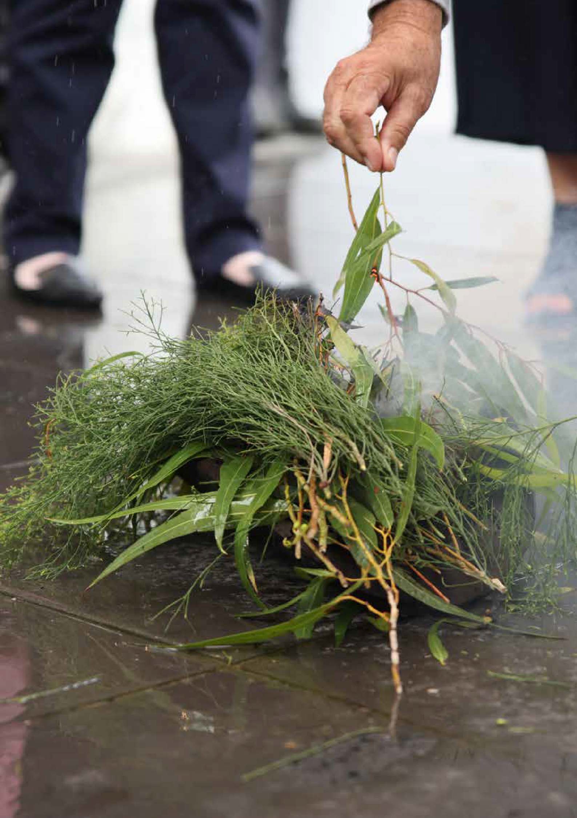
Table of contents
Acknowledgement of Traditional Owners Table of contents
About this document
How this plan was developed
The big picture: why climate matters Our local context
Building on our current climate action
The net zero and climate resilient future we want Our priority areas for action
Our principles
Implementation and monitoring Glossary
Endnotes
2
3
5
9
13
16
21
27
31
38
40
44
46
Left page photo:
Smoking Ceremony
Climate Change Plan Draft 2022-2032 / 3

Acknowledgement
of Traditional Owners
We recognise the rich Aboriginal heritage of this country and acknowledge the Wurundjeri Willum Clan and Taungurung People as the Traditional Owners of lands within the City of Whittlesea.

2 / City of Whittlesea
2 / City of Whittlesea

About this document

Responding to climate change: a shared responsibility
Climate change presents an unprecedented challenge, both globally and locally. The frequency and severity of extreme weather events such as bushfires, floods, storms and droughts are on the rise. As greenhouse gas (GHG) emissions from human activities such as
burning fossil fuels for generating electricity, transport, and manufacturing, are the dominant cause of climate change, urgent climate action is required to stabilise the changing climate.
Council and community must work together to reduce overall emissions, create a climate resilient future
and help limit global temperature rise to 1.5 degrees Celsius as outlined in the 2015 Paris Agreement and strengthened in the 2021 Glasgow Climate Pact.

This plan outlines Council’s role in minimising its own emissions, and supporting the community to take climate action to mitigate and adapt to climate change to 2032. It presents an analysis of trends impacting our climate and environment, is informed by feedback from our institutional stakeholders and wider community, and contributes to the following Whittlesea 2040
‘key directions’ for the Sustainable Environment Goal:
- Valued natural landscapes and biodiversity
- Climate ready
- Leaders in clean, sustainable living

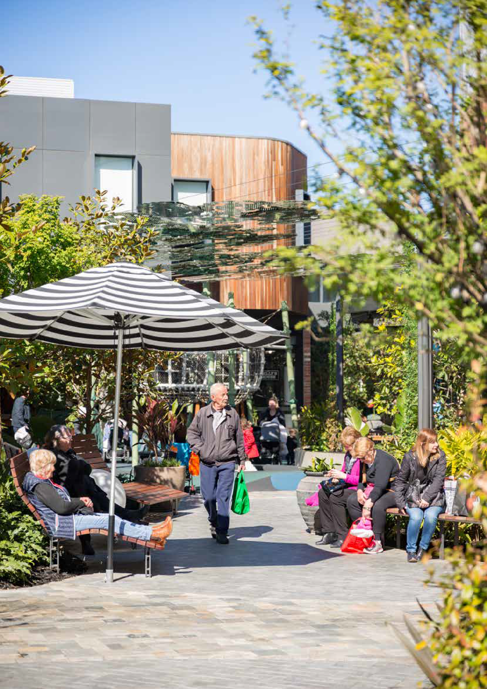
4 / City of Whittlesea

Key Terms
Climate change – long term change in global or regional climate patterns attributed largely to the increased levels of greenhouse gases in the atmosphere, particularly carbon dioxide, produced by the use of fossil fuels. Every corner of the planet is already being affected by climate change, through rising temperatures, sea level rise, and changes in rainfall patterns.
Mitigation – A human intervention to reduce greenhouse gas emissions or remove greenhouse gases from the atmosphere. It is what we do to stop climate change from getting worse.
Adaptation – Adjustments that are made in response to the impacts of climate change. It is the changes that we make to live with the impacts of climate change.

Climate Change Plan Draft 2022-2032 / 5

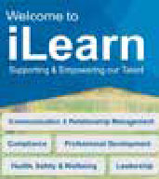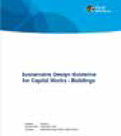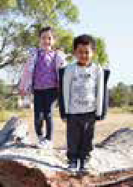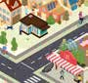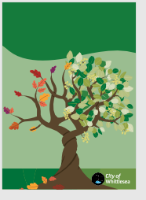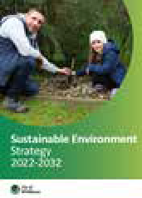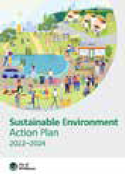
Level 1: Vision
Council’s overaching vision
Whittlesea 2040
Community Plan
Level 2: Strategy
Strategic direction and action plan
Using this plan
The City of Whittlesea’s approach to creating a sustainable environment is provided in three parts:
Sustainable Environment Strategy 2022-2032 –
Outlines Council’s overall strategic direction across six areas related to environmental sustainability: biodiversity, city forest (greening), climate change, Green Wedge, waste and recycling and water.
Sustainable Environment Action Plan 2022-2024 – A two-year Action Plan which sets out Council’s commitments to delivery on the Sustainable Environment Strategy 2022-2032. The Action Plan will be periodically reviewed.
Climate Change Plan 2022-2032 (this document) – Detailed supporting evidence including consultation outcomes and an in-depth analysis of the trends, challenges and opportunities for climate change action explored in the Sustainable Environment Strategy 2022-2032.
Sustainable
Environment Strategy
Sustainable
Environment Action Plan
Level 3: Approach
Long term plans, detailed analysis and detailed rationale

Greening Whittlesea
City Forest Strategy
2020-2040
Rethinking Waste Plan 2021 - 2030
Our plan for a low waste city through waste avoidance, resource recovery and environmental protection.
Biodiversity
Water For All
City Forest
Rethinking
Waste
Green Wedge
Climate Change
Level 4: Operations
Operational programs, guidelines and technical documents
Processes
Systems
Professional Environmentally Sustainable
Development Plans Design Guidelines
6 / City of Whittlesea
Peter Hopper Lake, Redleap Reserve, Mill Park
Whittlesea
Water for all
Our water strategy 2020-2030
A Place For All
WHITTLESEA

Biodiversity Strategy
2019-2029
Community Plan
2021-2025

Incorporating the Council Plan, Public Health and Wellbeing Plan, Pandemic Recovery Actions and Disability Action Plan

Strategic context
Climate change
This Plan is one of the six long-term plans that underpin the Sustainable Environment Strategy 2022-2032.
Developed under Council’s new Integrated Planning Framework, the Sustainable Environment Strategy outlines Council’s strategic directions across six areas related to environmental sustainability: biodiversity, city forest (greening), climate change, Green Wedge, waste and recycling, and water. Community empowerment is a key part of all six plans, contributing to their success.

City forest

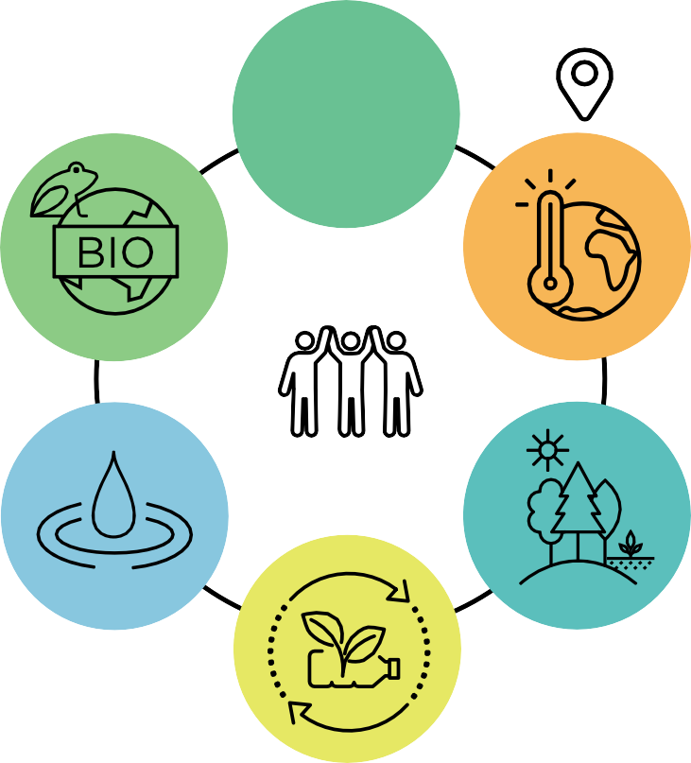Biodiversity
Community
empowerment

Water Green Wedge

Waste and recycling

Climate Change Plan Draft 2022-2032 / 7

How this plan was developed

The climate planning process
This Plan was developed through five steps, with community and stakeholder input essential throughout.

Community and stakeholder engagement and consultation

Step 1: Assessment and research
Develop understanding of Whittlesea’s past, current and future climate change context.

Step 2: Visioning and target setting
Create visions and set targets for emissions reduction and adaptation.

Step 3: Strategy and focus areas
Identify focus areas and strategic directions for the most impactful action.

Step 4:
Action planning and prioritisation

Identify and prioritise potential action options.

Step 5:
Public exhibition and endorsement
The draft Plan released for community feedback before Council endorsement.

Overview
One overarching vision
By 2036, the City of Whittlesea is a net zero emissions municipality, and our communities, businesses, and environments are resilient to the changing climate.
Our transition to net zero and climate resilience is collaborative, inclusive, and equitable.
Two pillars
- Net zero:
Council is a net zero emissions organisation and supports the community to transition to net zero emissions by 2036.
- Climate resilience:
Our communities, businesses, and environments are resilient to the changing climate.
8 / City of Whittlesea

7 priority areas

- Renewable energy and energy efficiency

- Sustainable and active transport

- Sustainable farming practice and carbon sequestration

- Low waste and circular economy

- Climate resilient communities and businesses

- Climate resilient built environment and infrastructure

- Climate resilient natural environment and biodiversity

3 principles

- All level leadership

- Fairness and equity

- Aboriginal empowerment

Climate Change Plan Draft 2022-2032 / 9

Engagement
To develop the Plan, community and stakeholder consultation took place between March and September 2021, and September and October 2022, which involved a range of engagement activities.

More than 800 contributions from our community members and businesses provided us with a strong understanding of the community’s concerns and priorities regarding climate action.

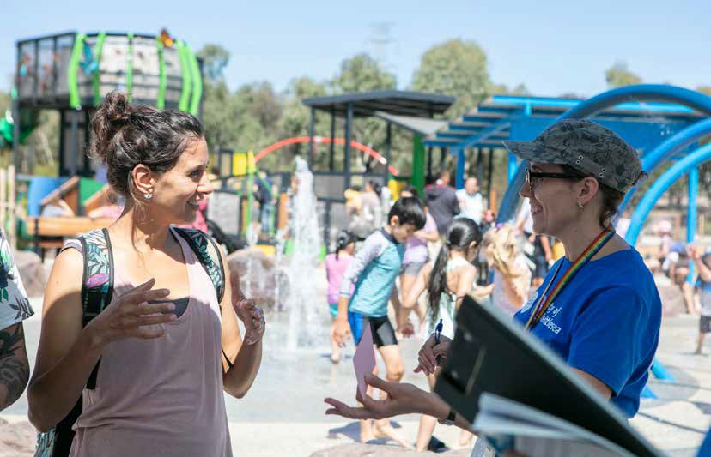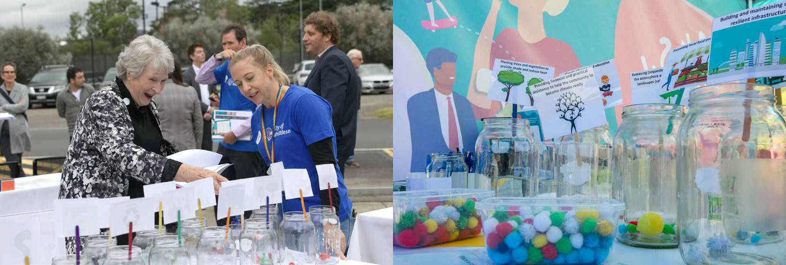

This page Pop-up event at the 2021 Council Meeting at the Whittlesea Community Activity Centre.
Next page Top: Chatting with residents about climate change action at the Mill Park All Abilities Play Space.
Bottom: Voting on climate change priorities at pop-up events.

10 / City of Whittlesea Climate Change Plan Draft 2022-2032 / 11

The big picture:
why climate matters

Get ready for our climate future
Unprecedented bushfires, heatwaves, droughts, and floods. Australia and many other places around the world have been experiencing more frequent and severe extreme weather events in recent years. Climate change is the major driver. The latest climate science tells us that greenhouse gas (GHG) emissions from human activities are responsible for approximately 1.2°C of warming since the industrial revolution. Averaged over the next 20 years, global temperature is expected to reach or exceed 1.5°C of warming.^{i} These changes are being observed globally across every region and the entire climate system.

Climate change is affecting human health
The changing climate has significant impacts on human health, public safety, infrastructure, primary production, settlements, the natural environment, and biodiversity.
The World Health Organisation regards climate change as ‘the greatest threat to global health in the 21st Century’.

Heatwaves are already Australia’s deadliest natural hazard, which is being further exacerbated by climate change. Research shows that, since 1900, extreme heat events have killed more people than the sum of all other natural hazards.^{ii} As temperature continues to rise, we will have to face more heat extremes. Unless action is taken, heatwaves are estimated to cause an additional 402 deaths annually in Victoria by 2050.^{iii} Such loss, according to a climate model by the Commonwealth Scientific and Industrial Research Organisation (CSIRO), translates to an additional $218 million loss per year.^{iv}

Climate change is also affecting people’s mental health both directly and indirectly. Children and young people are particularly affected as research shows that climate change is causing distress, anger, and other negative emotions among young people.
A survey on climate anxiety among children and young people aged 16-25 years revealed that climate anxiety among Australian youth is widespread, with 94 per cent respondents expressing some level of worry about climate change, including 28 per cent very worried,
25 per cent extremely worried, and 32 per cent experiencing impact on functioning.^{v}
Citizens, strongly led by young people, are increasingly demanding governments to take real actions to mitigate and adapt to climate change. People are concerned about the impacts of climate change on future generations, the state of the planet, and their health and quality of life.

It is imperative that we work together to prepare for, and adapt to, the current and future impacts of climate change.

A snapshot of community and stakeholder consultation
390
Participated in the Community Plan survey for the Sustainable Environment Goal
91
Responded to the climate change surveys
13
Attended the online Climate Change Community Focus Group
93
Participated in the place-based community popup events*
11
Participated in the online Youth Forum
176
Participated in the Community Plan targeted focus groups
550+
Visited the online engagement webpage and 102 downloaded the Plan
33
Made online contributions through climate change map and Post-it-notes
15
Participated in the online Climate Change Business Breakfast
55
Participated in the first institutional workshop
48
Participated in the second institutional workshop
61
Participated in the Climate Change Risk Assessment workshops
*The number of popup event participants were calculated based on the responses to the two activities offered at six pop up
events across the municipality.
12 / City of Whittlesea

Climate Change Plan Draft 2022-2032 / 13

All levels of government need to support efforts to adapt to climate change
The Australian Government has developed a new National Climate Resilience and Adaptation Strategy (2021-2025), which sets out a plan to support all levels of government, business and the community,
to better anticipate, manage and adapt to the impacts of climate change.
Victoria’s Adaptation Action Plans 2022 have been prepared across seven systems to ensure Victoria’s climate resilience, now and in the future. These seven systems include the natural environment, the built environment, the water cycle, primary production, transport, health and human services, education and training. Each plan sets out the challenges of climate change for each system, the extensive work already underway, and the key State Government priorities for the next five years.
Local government has important climate change adaptation responsibilities through duty of care under Victorian legislation, including
- Climate Change Act 2017
- Local Government Act 2020
- Planning and Environment Act 1987
Under Section 9 of the Local Government Act 2020, local government must give effect to a number of overarching governance principles in the performance of its role, including ‘the economic, social and environmental sustainability of the municipal district, including mitigation and planning for climate change risks, is to be promoted’.

Keep 1.5°C alive

The 2020s is our remaining window of opportunity to bring down global
warming to just below 1.5°C by the end of the 21st century.
To avoid the dangerous impacts of a warming climate, together we need to limit global warming to 1.5°C. The only way we can do this is to reduce emissions and remove greenhouse gases from the atmosphere.
The 2015 Paris Agreement^{vi} on climate change has set a long-term temperature goal, which is to keep the rise in mean global temperature to well below 2°C above pre-industrial levels, and preferably limit the
increase to 1.5°C. Before the 2021 Glasgow Climate Pact, countries were urged to limit global warming to 2°C.^{vii} Following updated research, the 2021 Pact noted that there is no safe limit for global warming, and called for strengthened climate action to limit global warming to 1.5°C, instead of the Paris text of well below 2°C.

The 1.5°C temperature goal is now the new normal for climate action ambitions. It can only be achieved by halving global emissions by 2030 and reaching net zero emissions by 2050.
Unfortunately, in 2022 there is a major gap between the emissions levels needed to limit global warming and the emissions projected to result from current pledges and policies.^{viii} The current 2030 target commitments made by individual countries will only limit global warming to about 2.4°C, according to the Climate Action Tracker, an independent scientific analysis that tracks government climate action and measures it against the Paris agreement temperature goal.
Just before the Glasgow Climate Summit, the Australian Government released its Net Zero Emissions Plan, committing to net zero emissions in 2050, with a 2030 target of 26 to 28 per cent reduction compared to the 2005 levels. In June 2022, the Australian Government updated its 2030 commitment, which will be to reduce emissions by 43 per cent by 2030. The Australian Government’s new 43 per cent emissions reduction target has been written in its Climate Change Bill 2022, which passed the House of Representatives on 4th August 2022.
Victoria’s Climate Change Strategy 2021 provides a roadmap to net-zero emissions and a climate resilient Victoria by 2050. It includes targets to reduce the state’s greenhouse gas emissions from 2005 levels by 28-33 per cent by 2025 and 45-50 per cent by 2030.
Immediate, rapid and large-scale reductions in greenhouse gas emissions are required to limit warming to 1.5°C or even 2°C. Our actions in the next decade
will shape what a 2040 future will look like for our community. A net-zero pathway to avoid even temporary temperature ‘overshoot’ can reduce multiple climate change risks and bring down long term mitigation costs and economic losses.^{ix}

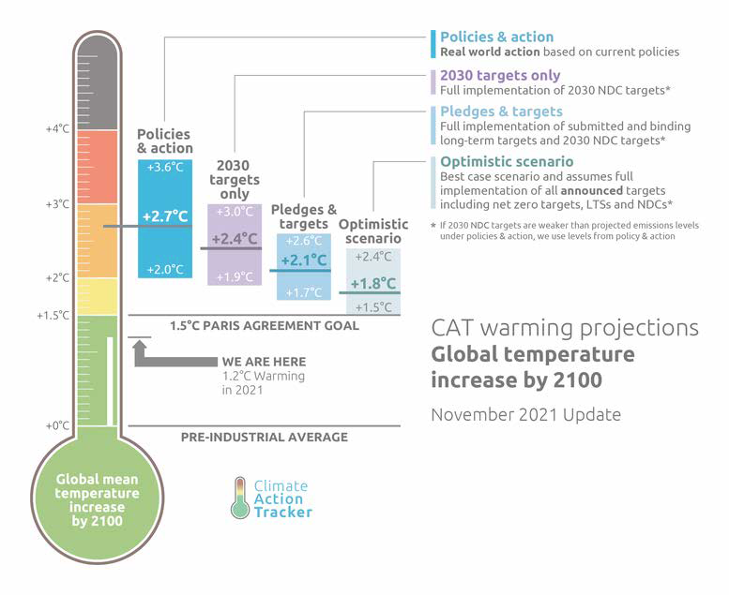14 / City of Whittlesea
(Source from Climate Action Tracker, 2021)
Climate Change Plan Draft 2022-2032 / 15

Our local context

Our changing climate
In recent decades, the City of Whittlesea has become hotter and drier. While efforts have been made to reduce emissions, this trend is expected to continue. If global greenhouse gas emissions continue to increase, in the 2050s, our city’s climate future may look like:

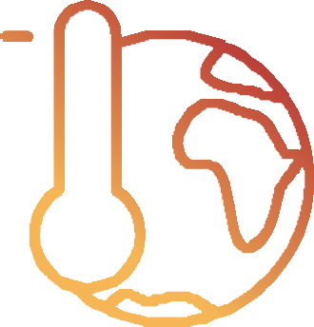2.30C
temperature increase
by 2050s

1.20C

temperature already increased since 1910

What we can expect:

By mid-century, we could see the number of extreme heat days (above 30°C) in the City of Whittlesea almost double compared to the 1990s.^{x}
The interactions between climate and our city are multiple, dynamic, and complex. Our city is exposed to multiple climate-related hazards which can occur simultaneously e.g. droughts, fires, and heatwaves. These are likely to occur while our community is experiencing other non-climatic risks, such as the Covid-19 Pandemic that started in 2020 and continued to affect our society in 2022. These compounding and
Exposure and sensitivity • Increase risk and vulnerability
Our weaknesses | High exposure to bushfire and heat risk | Concentration of vunerable groups in high exposure areas | Major economic sectors with high exposure | Major environmental values with high exposure
Pressures of rapid urban development | Negative changes in land use | Socio- economically disadvantaged population | Higher than average unemployment | Lack of community awareness and preparedness on climate risk
Resilience and adaptiveness • Reduce risk and vulnerability
Our strengths | Rich natural assets and big Green Wedge | Growing suite of policies addressing climate change | Active contribution to collaboration mechanisms
Functioning emergency response systems |  | Timely support for emergency recovery | Strong awareness of Council on climate risk | Increasing level of Council preparedness

cascading risks are more difficult to manage, highlighting the critical need to further adapt and increase our resilience as a community.

Our climate risk
The City of Whittlesea has its own unique climate risk. To better understand our city’s climate risk, we undertook an integrated vulnerability assessment.
Climate risk is a result of the interaction of hazard, exposure, and vulnerability. The vulnerability assessment explores ‘who may be vulnerable to what, and why?’, which allows us to understand the three dimensions of climate risk: hazard, exposure, and vulnerability.

Double the number of heatwave days
Longer fire season. More high fire danger days
More intense downpours. Less cool season rainfall

The integrated vulnerability assessment reveals
that our city is exposed and vulnerable to the effects of climate change due to variety of hazards, multiple exposed elements of our city, and the presence of different vulnerabilities.

We need to identify adaptation strategies to address these factors that contribute to our city’s climate risk.
Climate risk can be reduced through adaptation, which plays a key role in reducing our exposure and vulnerability to climate change. Adaptation is often organised around resilience as bouncing back and returning to a previous state after a disturbance.

A climate ready neighbourhood is…
‘A neighbourhood that can cope with a worsening climate that results in more heat stress, more dangerous
Resilience ‘describes not just the ability to maintain essential function, identity and structure, but also the capacity for transformation.’^{xi}
“
fires, damaging storms and flooding rain. ”
Quote from the Community Plan survey

16 / City of Whittlesea Climate Change Plan Draft 2022-2032 / 17

Our community-wide emissions
A community emissions profile is an important step for climate planning. By breaking down the sectors contributing to our city’s emissions, it allows us to understand the scale of the impact of our municipality, and identify key opportunities for emissions reduction.

In the financial year of 2018-19, Whittlesea’s community emissions were calculated as 2.422 million tonnes of CO₂-e.^{xii}
The major emissions source for our municipality is electricity consumption, largely from industrial electricity consumption (32%).

Council’s corporate emissions
Council as an organisation also contributes to our municipal emissions. In the 2018-19 financial year, Council’s corporate emissions were calculated
25,141 tonnes of CO₂-e, accounting for approximately one per cent of our total municipal emissions.

The main sources responsible for Council’s corporate emissions were electricity consumption by streetlights and buildings (66.5%).

Electricity

66.5%
Transport fuels

14.6%
Gas

7.9%

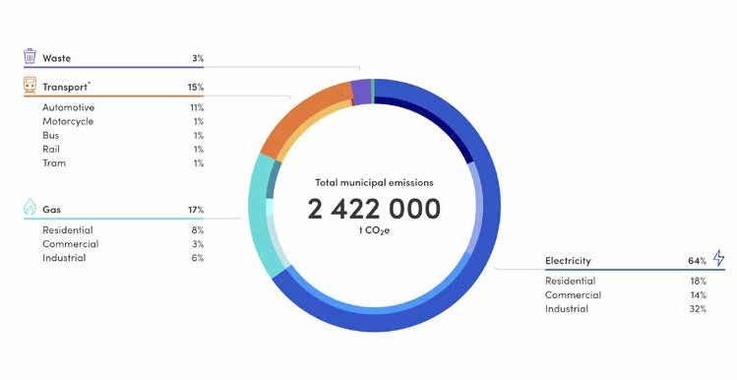
Electricity consumption
64%
Gas consumption On-road transport
17%
15%
Waste Agriculture
3% 0.4%
Whittlesea Community Emissions Profile
Council’s Corporate Emissions Profile

18 / City of Whittlesea 2022-2032 / 19
Climate Change Plan Draft

Building on our current climate action
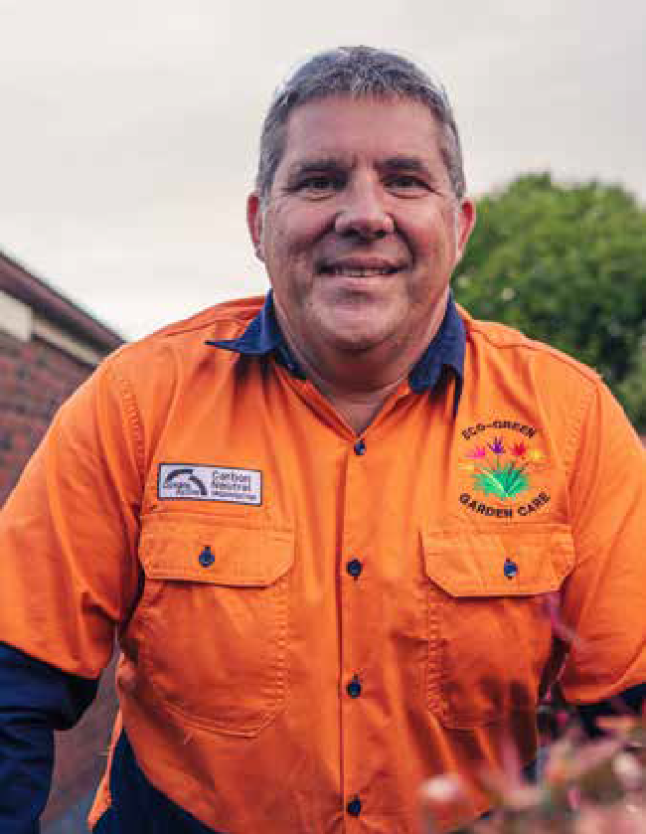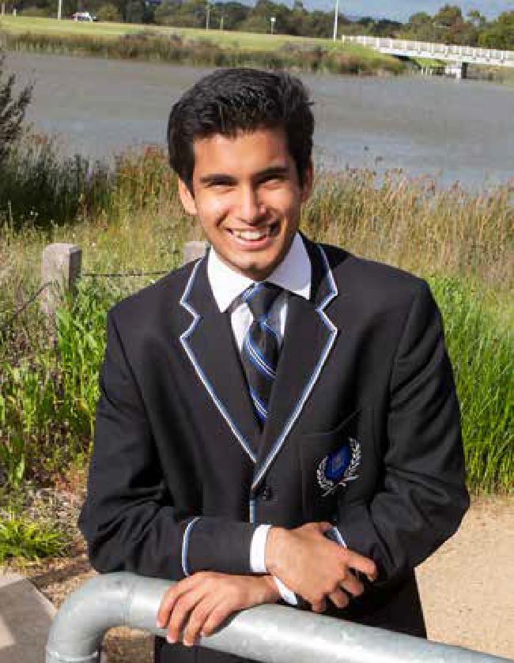In the City of Whittlesea, businesses, organisations, households, and Council have already been taking steps to reduce emissions and prepare for the changing climate. We have a strong foundation to build on and scale up our collective action to respond to the climate change challenge.

Our community’s climate action
Businesses and residents in our municipality have already been showing leadership in our climate action journey.

The city’s largest solar system
The Melbourne Market in Epping is Victoria’s wholesale fruit, vegetable and cut flower trading centre, one of six of its kind in Australia. Melbourne Market Authority set a target of 80 per cent of the market’s electricity supply to be generated by renewable energy sources by 2025.
The Authority was successful in applying for a 10 megawatt solar system on its 2.2 hectares of car park canopy, which will be the municipality’s largest
solar system.

Australia’s first carbon neutral tradie
Eco-Green Garden Care is a sole trader landscape gardening company based in Epping. Eco-Green Garden Care was certified as carbon neutral in March 2021 under the Climate Active initiative, as Australia’s first carbon neutral certified non-office based small business.

Schools leading sustainability and climate change initiatives
Harvest Home Primary School: part of the ResourceSmart Schools Program run by Sustainability Victoria.
St Monica’s College: ran a Youth Leading the World Environmental Leadership Program in partnership with OzGREEN and Darebin Creek Management Committee.
The Lakes South Morang College: an accredited Water Efficient School.

Youth Power
Whittlesea’s young citizens are leading the way in raising awareness about climate change and advocating for climate action. Local student, Rudra Sekhri from South Morang, has written a book called The Earth Needs You: What We Can Do To Stop Climate Change, published at Amazon.
This page
Top: Australia’s first carbon neutral tradie, Stuart Griffiths from
Eco-Green Garden Centre in Epping.
Bottom: Rudra Sekhri, local secondary school student and author of The Earth Needs You: What We Can Do To Stop Climate Change.

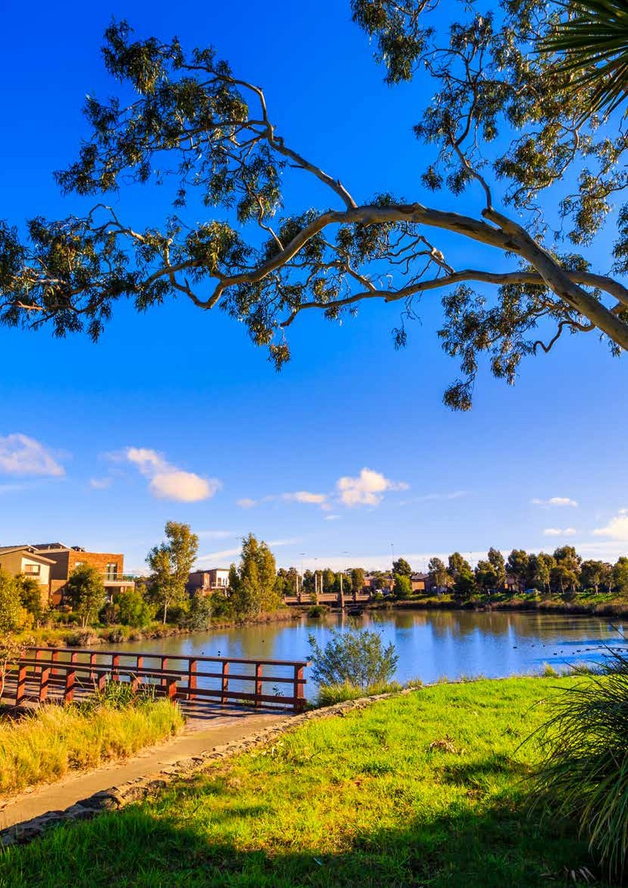
20 / City of Whittlesea

Climate Change Plan Draft 2022-2032 / 21

Over the last decade, Council has achieved a suite of emissions reduction and climate resilience initiatives, which focus on Council’s own operations, services, and assets.

How has Council reduced its corporate emissions?
Since 2011, Council has been reducing its emissions and working toward carbon neutrality by 2022 through its Zero Net Emissions Plan. Major highlights include:

Energy reduction
- Audited and upgraded existing Council buildings, saving 560 megawatt hour of electricity per year
- More than 16,000 streetlights were converted to energy efficient T5 Fluorescent, Compact Fluorescent (CFL), and Light Emitting Diode (LED) lamps. This represents approximately 60 per cent of Council’s streetlights

Energy substitution
- From 1 July 2021 100 per cent renewable electricity is used to power Council facilities, services and streetlights, reducing 66.5 per cent of Council’s annual emissions. This is achieved through a joint commitment from 46 Victorian councils to purchase renewable energy over the next 10 years through the Victorian Energy Collaboration Power Purchase Agreement – the largest ever emissions reduction
program undertaken by local government in Australia.
- Installed 1.83 megawatt of solar photovlotiac (PV) systems across 74 Council owned buildings, and 483 kilowatt hour of battery storage at 20 facilities
- Offset on average approximately 16 per cent of corporate emissions annually since the baseline year of 2011/12

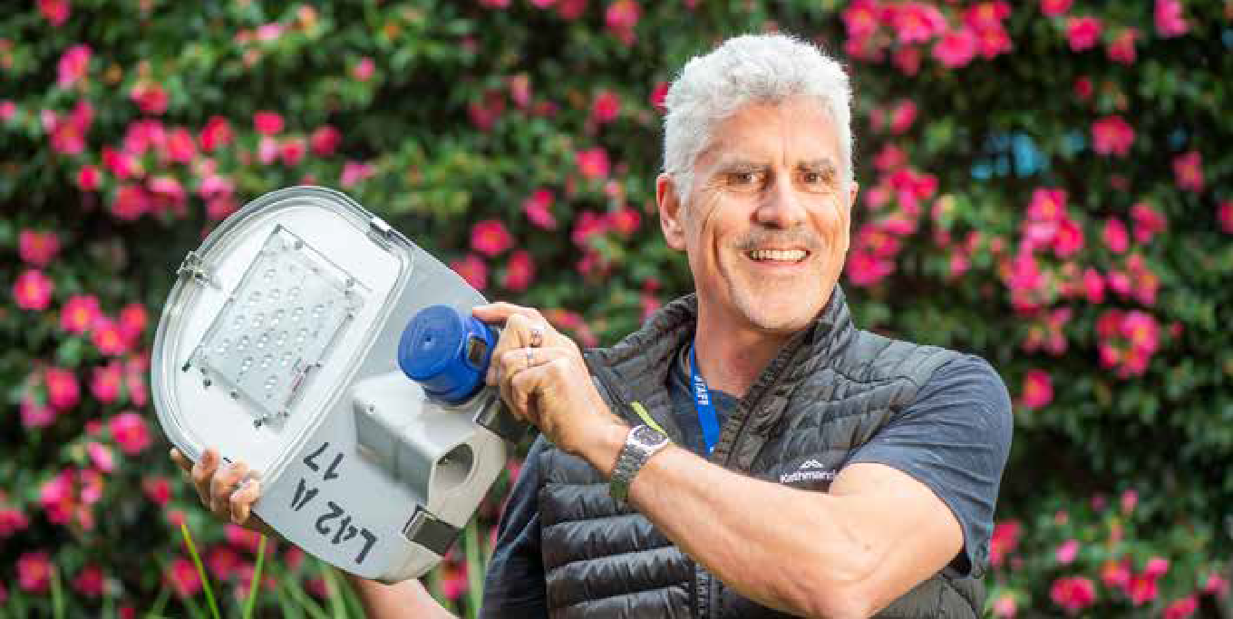What has Council done on adaptation?
This page
Over 60 per cent of Council’s streetlights have been converted to energy efficient lamps.
Previous page Top: The Melbourne Market’s 10MW solar system will be our City’s largest system.
Bottom: Environmental leaders from St Monica’s College pick-up litter and improve the health of their local reserve.
Council’s climate action
Emissions offsetting
- Climate Ready Whittlesea (2017) – Council’s first climate adaptation plan for Council services and assets.
- Cool It Project (2018) – Heat mapping to understand the City of Whittlesea’s vulnerability to heat risk
- How Well Are We Adapting project – A tool to monitor, evaluate and report on Council adaptation. Participated in development phase (2018-2020)
- Greening Whittlesea (2020-2040) – Council’s
20-year urban forest plan. Actions include updating Council’s tree planting lists to increase species diversity, increase fire resistance, incorporate native wildlife requirements and incorporate climate change resilience and adaptability
- Climate Change Risk Assessment and Risk Register (2022) – An assessment which identifies the economic, environmental and social impacts of changing climatic conditions on Council assets, operations and services, resulting in a new Climate Change Risk Register. The register will manage climate risk on Council’s assets, operations, and services
- Climate change adaptation pathways (2022) – Pilots of the climate adaptation pathways approach on a Council asset (Thomastown Recreation and Aquatic Center) and a Council service (reactive
tree maintenance).

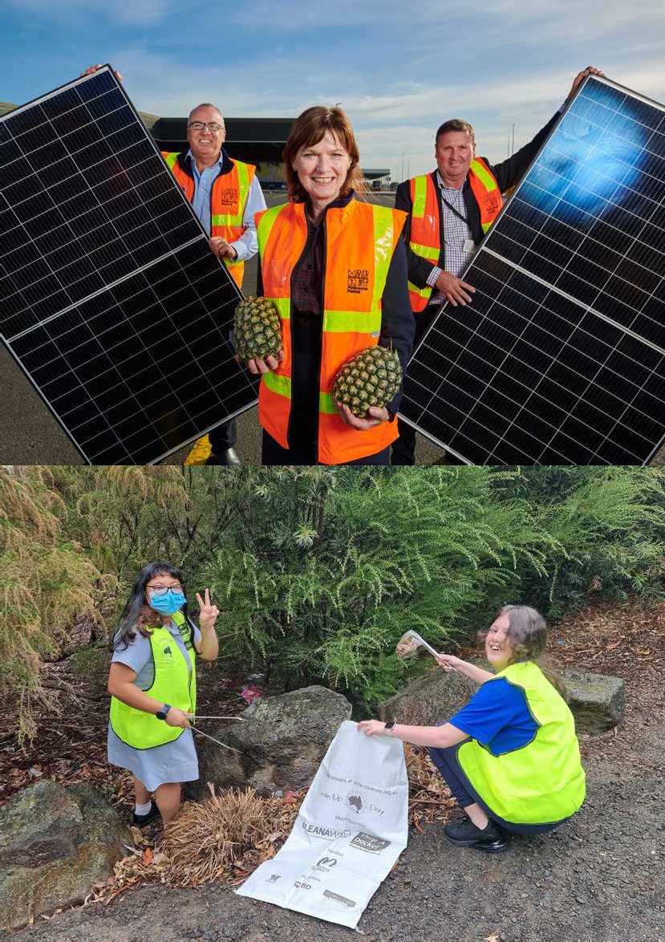
22 / City of Whittlesea
Climate Change Plan Draft 2022-2032 / 23

This page
The City’s first Repair Cafe, located at Mernda Community House, opened in 2022.

What new directions has Council taken in climate action?
  - Purchased offsets – Council’s buildings and vehicle fleets use natural gas, diesel, and petrol, which do not have readily available renewable alternatives. The emissions resulting from the use of these fossil fuels, currently accounting for 33 per cent of Council’s total emissions, will be offset to reach the corporate net zero target from the 2022-23 financial year
  - Commitment to a no gas future:
    - Council has committed to building only all-electric (no gas) new buildings, starting with the McLeans Rd and Spring St Kindergartens
    - Council will produce a 10-year plan to transition its existing buildings off gas to become all-electric
  - Zero emissions fleet – Council is transitioning to zero emissions vehicle fleets with its newly developed Light Fleet Policy and a regional collaboration via the Northern Council Alliance
  - Commitment to increasing canopy cover across the City to address heat risk
  - Commitment to enhancing climate resilience of Council’s assets, operations and services.

Partnership is key
While there have been many achievements in climate action, there is still more to do, improve and scale up over the coming decade. For the whole municipality to achieve net zero emissions and climate resilience, it will require everyone to work together.
Council is committed to taking a lead role in climate action. Council will:
- Continue to reduce organisational emissions and become certified as carbon neutral under the Climate Active Carbon Neutral Standard
- Build resilience of community assets and services
- Support and empower residents, businesses, and industries to contribute to the collective climate action efforts
- Continue to work with our partners, including neighbouring councils via regional networks such as Northern Alliance for Greenhouse Action (NAGA), Greening the North and Living Melbourne groups, as well as utility providers such as Melbourne Water and Yarra Valley Water.

By working together, we can achieve big things.

Repair Cafe
The City of Whittlesea partnered with Whittlesea Community Connections to launch the City’s first repair café at Mernda Community House. The café is run by skilled volunteers who use their craftmanship to repair a range of personal items, including jewellery, bikes, electricals, furniture, clothing, and guitars. The café operates monthly, and residents can book in a free repair session online.

Collectively Caring for Climate
A total of 330 local residents participated in the City of Whittlesea Collectively Caring for Climate Project, including people of all ages and from diverse cultural backgrounds. Individuals, schools, artists, community
groups and organisations across the municipality made their climate pledge through artworks, reflecting a change they could make to their everyday lives to help the environment.

Positive Charge – Australian Energy Foundation
From 2016 to 2019, City of Whittlesea residents, schools and businesses had free access to reliable, independent energy advice and support, and quotes from vetted solar suppliers ensuring quality systems at competitive prices. A total of 63 solar systems were installed over the
2016-19 period through this partnership with the Australian Energy Foundation.

Sustainable Subdivision Framework
Thirty-one councils including the City of Whittlesea, are currently involved in a trial of a new framework that seeks to provide a basis for measuring and
achieving stronger sustainability outcomes in residential subdivisions via the planning process.
The trial is supporting councils to work collaboratively with the development industry to deliver long lasting sustainable communities.

We all contribute to the City’s greenhouse gas emissions^{xiii}:
Businesses
55%
Households
26%
Council
1%

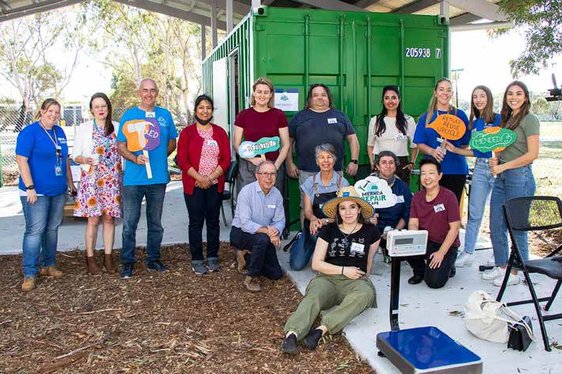
We’ve got to take everyone on the journey, that’s what it
“
comes down to. ”

24 / City of Whittlesea
Quote from the Climate Change Business Breakfast

Climate Change Plan Draft 2022-2032 / 25

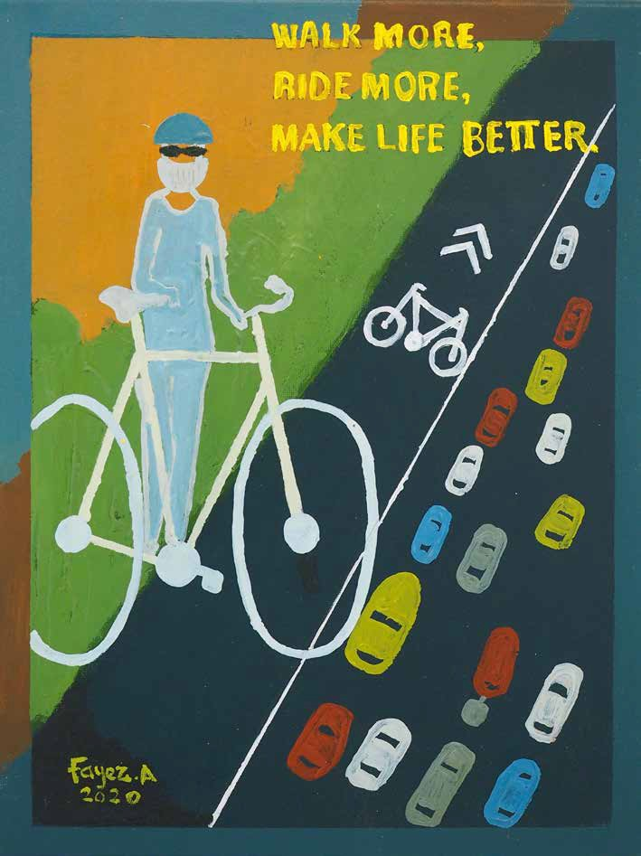
The net zero and climate resilient future we want

Our overarching vision

By 2036, the City of Whittlesea is a net zero emissions municipality, and our communities, businesses, and environments are resilient to
the changing climate. Our transition to net zero and climate resilience is collaborative, inclusive, and equitable.
A whole-of-municipal approach is required to achieve this vision. Council will lead these efforts through:
- Corporate climate action
- Supporting and empowering community action, and
- Advocating to all levels of government for broad systemic change.
The dual pillars below will enable Council to prioritise, resource, communicate, and evaluate our responses to climate change.

Credit: Fayez Assaf, City of Whittlesea’s ‘Collectively Caring for Climate’ Project, 2020.

Pillar 1: Net Zero Emissions

Council is a net zero emissions organisation and supports the community to transition to net zero emissions by 2036.

Net Zero Council
Council has already committed to becoming a net zero emissions organisation by 2022 through its Zero Net Emissions Plan. Council will pave the way for strong climate action across the community, as it achieves its corporate emissions reduction goal 14 years ahead of the community-wide 2036 target.
Council will not stop here, with more ambitious plans to pursue further reductions in its corporate emissions beyond the 2022 net zero emissions target year. In recognition of the importance to keep 1.5°C alive, Council will ramp up its action by:
- Employing best practice emissions accounting and reporting approaches
- Identifying opportunities to further reduce corporate emissions from sources previously excluded from reporting boundaries
- Complying Council’s emissions inventory with Climate Active^{xiv} by 2026
- Reducing reliance on offsetting by continuing to reduce Council’s residual emissions
- Creating local opportunities for accredited carbon offsetting and draw-down on public land
- Using Council’s influence in procurement processes to drive down emissions of our delivery partners.
“

Climate change action is Council’s responsibility too. To ignore climate change is plain negligent.
”
Quote from online consultation

26 / City of Whittlesea Climate Change Plan Draft 2022-2032 / 27

This page
The City of Whittlesea’s first electric vehicle charging station was installed in Whittlesea township in 2021.

Net Zero Municipality
The ‘carbon budget’ concept is what climate science has determined is necessary to avoid catastrophic climate change. A calculation of our city’s science-based emissions reduction target has revealed that our city would need to reduce its emissions by 5.38 per cent each year to stay within ‘budget’ and achieve net zero
emissions by 2036.^{xv} This target is aligned with the 1.5°C Paris temperature goal, reflective of the latest climate science and the most recent climate commitment momentum to keep 1.5°C alive.

The 2036 net zero target is reflective of the true scale and speed of emissions reduction required to avoid catastrophic climate change.
Transition to net zero emissions is a shared responsibility. Different levels of government, business and the community all have a role to play. As a community leader, Council is committed to driving collective action and whole-of-municipality efforts through leveraging our roles as the enabler, facilitator, and advocate to support community emissions reduction.

Our emissions reduction pathway to 2032

City of Whittlesea Emissions Reduction Pathway to 2032

3000000

2500000

2000000

With no action, by 2032 Whittlesea’s emissions are projected to be 2,960,000 tCO2-e

1500000

1000000
2032 1.50C Emissions
Target 1,160,000 tCO2-e

Where our corporate emissions target comes in. 1% Council Direct Control. Council’s main role is as Enabler, Facilitator, and Advocate.
500000

0
2018 2020 2022 2024 2026 2028 2030 2032

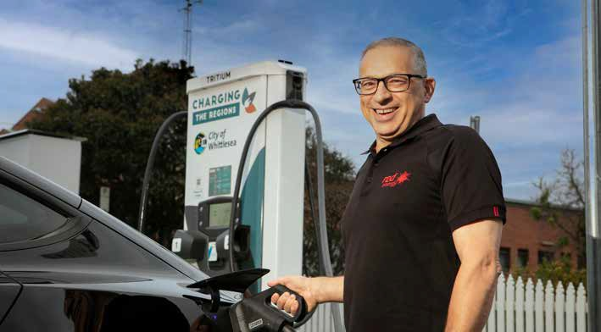
Business as usual (BaU) Emissions Trajectory 1.50C Emissions Reduction Trajectory

28 / City of Whittlesea Climate Change Plan Draft 2022 / 29

Our priority areas for action

Pillar 2: Climate Resilience

Our communities, businesses, and environments are resilient to the changing climate.

Climate resilient communities and businesses
Our climate is already changing as we face increased risks of bushfire, extreme heat, storm, drought, and flood. Urban heat island effects are exacerbated, posing serious health risks to our community. It is imperative to support our communities and businesses and help them build resilience and adaptive capacity. We will enhance our city’s tree canopy cover to reduce the
risk of extreme heat and make our open space cooler and safer during periods of extended heat. We will help communities and businesses to better understand and prepare for climate change impacts. We will also advance Council’s understanding and planning for climate risks so that we can continue to effectively service our community in a changing climate.

Climate resilient built environment and infrastructure
Climate change threatens the resilience of the built environment, the integrity of its assets, and ability to provide reliable services. We will ensure that our built environment and infrastructure are designed,
constructed, and maintained to support safe and healthy communities in a changing climate. We will collaborate with relevant partners to promote climate resilience
of new precincts, growth areas and suburbs, and retrofitting of existing infrastructure and buildings. We will also discourage new settlement in areas prone to extreme natural hazards in the Green Wedge.

Climate resilient natural environment and biodiversity
As a leading cause of the biodiversity crisis, climate change presents as a major threat to our city’s natural environment and ecosystems. Increasing climate resilience of our local natural environment and biodiversity also helps maintain clean air and water, and improves physical and mental wellbeing. We will continue to deliver our tree, shrub and understory planting programs for better conservation and biodiversity outcomes. We will improve our understanding and knowledge of local impacts of climate change and deliver management actions to
improve our local natural environment and biodiversity, and also support the community to contribute.

Priority 1: Renewable energy and energy efficiency

Why is this important?
Electricity and gas consumption is our city’s largest source of greenhouse gas emissions, accounting for 81 per cent of our total municipal emissions (electricity 64 per cent and gas 17 per cent).
Reducing this stationary energy use and switching to renewable energy sources are our biggest emissions reduction opportunities.
Residential, industrial, and commercial sectors all contribute to these stationary energy emissions, with most coming from the industrial sector
(47 per cent of our emissions from stationary energy across electricity and gas). With almost half (46 per cent) of our city’s emissions being electricity use by industry and commerce, there is great potential for local businesses to make big impacts by increasing renewable
energy use, improving energy efficiency, and phasing out gas. Households account for more than half of the total emissions for gas.
In July 2022, the Victorian Government released its Gas Substitution Roadmap, which details regulatory and policy reform to shift away from fossil gas and towards renewable energy alternatives. Households and businesses in Victoria will have more choice to cut
energy bills and emissions through a range of initiatives that aim to remove barriers to all-electric homes and new developments, as well as incentives for energy
I think the biodiversity in wetlands are
decreasing because of climate change
”

Priorities for action

Eliminate stationary energy emissions in Council operations
- Continue participating in the Victorian Energy Collaboration Power Purchase Agreement for 100 per cent renewable electricity
- Continue delivering the Solar Scale Up, energy efficiency, and streetlight bulk replacement programs
- Phase out gas in Council’s existing buildings
- Ensure all future assets are energy efficient and energy needs are sourced from renewable fuel types

Support the community to adopt renewable energy and improve energy efficiency
- Raise community awareness and develop community leadership on energy transition and energy efficiency
- Assist businesses and residents to adopt renewable energy and improve energy efficiency through programs, such as the Environmental Upgrade Agreements
- Increase community and business implementation of zero emissions and climate resilient developments through the planning scheme
- Support businesses and not-for-profit organisations to access renewable energy Power Purchase Agreements (PPAs)

Promote zero emissions buildings through
advocacy and partnership
- Advocate for increased standards to achieve zero emissions and climate resilient developments
- Support retrofitting programs to improve existing housing stock, particularly for the most disadvantaged people in the community

1
“
upgrades and electrification.
and human intervention.
Quote from the Community Plan survey
- Work with developers to implement zero
emissions buildings
- Work with developers to promote electric-only suburbs
- Advocate to other levels of government for retrofitting existing buildings for a net zero emissions and climate resilient future.

30 / City of Whittlesea
Climate Change Plan Draft 2022-2032 / 31

Priority 2: Sustainable and active transport

Why is this important?
On-road transport is 15 per cent of our total municipal emissions, making it our city’s second biggest source of greenhouse emissions. Reliance on cars is high with many local residents needing to travel elsewhere for work.^{xvi} Therefore, there are great opportunities to reduce transport emissions through sustainable and active transport initiatives. In 2020-2021, the
Covid-19 pandemic led to a temporary decline in transportation emissions because of lockdown and work-from-home, and more people walking and cycling. Great opportunities exist to take advantage of these everyday changes in routine for the longer lasting benefits to reduce emissions and create healthier,
more active communities.
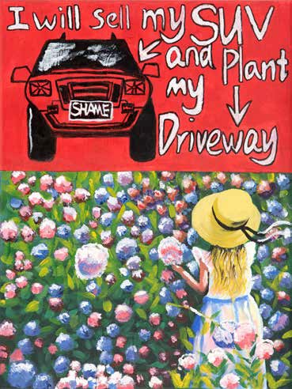

Credit: Yuhan Shi, City of Whittlesea’s ‘Collectively Caring for Climate’ Project, 2020.

Priorities for action

Reduce Council’s emissions from transport
2
- Transition Council fleet and plant to zero emissions
- Encourage Council staff to use active travel modes and/or public transport for work commute.

Provide opportunities for the community to adopt sustainable and active modes of transport
- Seek opportunities for planning and delivery of active transport infrastructure to enable greater use of sustainable and active transport by the
community, including through early incorporation of blue-green infrastructure
- Provide assistance and streamlining of electric vehicle (EV) charge point installation
- Encourage community uptake of EVs through education, planning mechanisms, bulk buys, and preferential parking
- Explore on-demand ride share solutions to reduce car usage and facilitate installation of carshare infrastructure
- Provide incentives, training, education, and support for active transport including walking, bike riding,
E-bikes, and E-scooters
- Ensure new developments offer early access to sustainable forms of transportation.

Promote sustainable and active transport through advocacy and partnership
- Advocate to the state government to provide all residents access to accessible, affordable and convenient forms of public transport options throughout the City
- Undertake behaviour change campaigns to encourage more people to use public transport in the municipality
- Partner with businesses and organisations to support community shuttle buses
- Partner with other Northern Region councils to develop a community wide EV transition plan to guide and support the changing fuel source of vehicles
- Support initiatives to create 20-minute neighbourhoods by collaborating with relevant partners.

Priority 3: Sustainable farming practice and carbon sequestration

Why is this important?
Carbon removal technologies will be essential to remain within the 1.5°C threshold, according to the most recent Climate Change Assessment Report by the Intergovernmental Panel on Climate Change (IPCC). To achieve net zero emissions, carbon removal is crucial to counterbalance hard-to-abate residual emissions.^{xvii} Put simply, we need to absorb or remove greenhouse gases from the atmosphere, while reducing emissions. Sustainable implementation of mitigation options in the agriculture, forestry and other land use (AFOLU) sector can deliver large-scale emissions reductions and enhanced removals. AFOLU carbon sequestration options, if done properly, can also deliver co-benefits for biodiversity and ecosystem conservation, food
and water security, livelihoods and land use rights of Aboriginal peoples and local communities. As an interface local government area with 60 per cent of
its land being Green Wedge, the City of Whittlesea has great potential to capitalise on carbon sequestration opportunities through sustainable farming practice and vegetation cover enhancement.

Priorities for action
- Support mass revegetation opportunities within the city through current and emerging offset programs
- Establish better understanding of carbon sequestration potential of our city by undertaking study on carbon storage potential of our
blue-green infrastructure
- Support landowners and local farmers to adopt sustainable farming practice, exploring carbon sequestration potentials, and seek external funding opportunities
- Promote and celebrate sustainable agricultural best practice land management and use them as an education tool
- Partner with landowners and other government agencies to improve soil health
- Avoid and minimise the removal of established trees, native vegetation and important habitats.

3

32 / City of Whittlesea Climate Change Plan Draft 2022-2032 / 33

Priority 4: Low waste and circular economy

Why is this important?
While only representing a minor source of our city’s municipal emissions (3 per cent of the total municipal emissions), the waste sector is a major contributor to methane emissions. Methane is a greenhouse gas far more potent than carbon dioxide as its global warming potential is more than 28 times higher than carbon dioxide when averaged over 100 years.^{xviii} Methane stays in the atmosphere for about nine years, which means that any action taken to reduce methane emissions today would bring rapid and significant results. Victoria recently passed new laws aimed at facilitating a circular economy, transitioning away from a linear model of production and consumption. The new Circular Economy (Waste Reduction and Recycling) Act 2021 provides the foundation for transition to a circular economy, and strengthened regulation of the waste and recycling sector. The circular economy approach has great mitigation potential by maximising the use of existing assets while reducing dependence on new raw materials and minimising waste.

Priorities for action
- Continue implementing the Rethinking Waste Plan
- Support the development of circular economy in the municipality
- Attract suitable business types for the circular economy
- Advocate and partner with other organisations to drive broader shift to the low waste and circular economy
- Continue sustainable procurement of goods and services by Council and encourage sustainable procurement for businesses and community
- Continue using recycled and sustainable materials for Council projects and services where available.

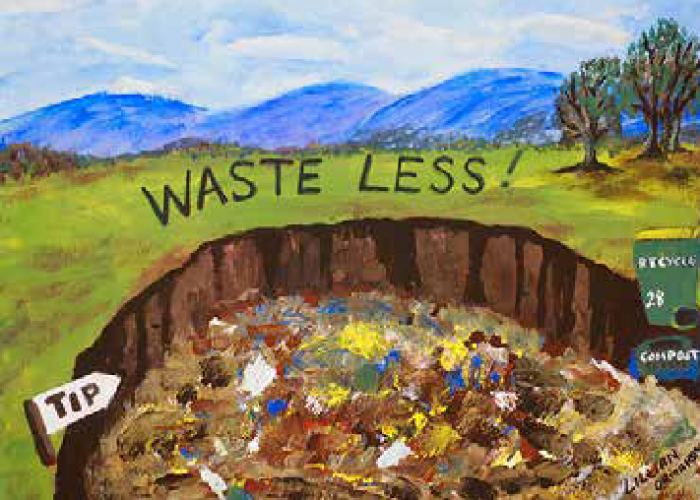
4

Priority 5: Climate resilient communities and businesses

Why is this important?
In a changing climate, our communities and businesses are increasingly faced with extreme weather events including extreme heat, bushfire, grassfire, storm, flood, and drought. Preparing for these risks is the best way to protect our community.
Climate change impacts disproportionately affect vulnerable communities. People on low incomes for example, are more likely to be trapped in energy debt, deprived of basic energy needs or at risk of service disconnection, making them particularly vulnerable
to extreme heat. Women are also at greater risk both during and after a climatic disaster as the climate risk is multiplied by women’s economic vulnerability. Family violence against women also increases during and after extreme climatic events such as heatwaves and bushfires due to high household tension, stress and
trauma experienced by perpetrators, and women being forced to spend more time with perpetrators. Statistics show that 21.5 per cent of our city’s total households are considered low income (earning less than $500
per week), significantly higher than 12.8 per cent of Greater Melbourne. Climate change also affects business productivity with supply chain disruption, asset and equipment damage and increased production costs.
Our major economic sectors, such as health and social services, manufacturing, construction, and agriculture are expected to be most affected. It is critical that our communities and businesses are supported to enhance their resilience to climate change.

Priorities for action
- Continue implementing actions from the Greening Whittlesea Plan to help the community adapt to a changing climate
- Continue to support and improve community access to sustainable green open spaces
- Manage and mitigate identified climate risks for Council assets, services, and operations to ensure continuous delivery of service to our community
- Complete flood mapping for the entire municipality
- Assist the community to reduce heat risk through prioritisation of equitable tree planting and green cover enhancement
- Support communities and businesses to better understand and prepare for localised climate change impacts and to implement potential solutions through education, technical and financial assistance
- Support local food security, the local agri-food sector and the visitor economy.
5

Credit: Lillian Ormandy, City of Whittlesea’s
‘Collectively Caring for Climate’ Project, 2020

34 / City of Whittlesea Climate Change Plan Draft 2022-2032 / 35

Priority 6: Climate resilient built environment and infrastructure

Why is this important?
Our homes and buildings, neighbourhoods and suburbs, and the supporting infrastructure and services form our built environment. In the face of increased climate risk, climate resilient built environment and infrastructure can save lives, reduce trauma, and minimise economic damage from disasters and the
associated recovery costs. Our city is one of Melbourne’s largest and fastest growing municipalities, expected
to home more than 150,000 new residents between 2020 and 2040. While the rapid population growth and urbanisation present major environmental
challenges, our city has a unique opportunity to embed sustainability principles right throughout the strategic master planning process and into every aspect of
the way new precincts operate, creating new, zero emissions, and climate resilient residential communities as well as future proof infrastructure.

6

Priorities for action
- Continue to implement the local environmentally sustainable design policies within the Whittlesea Planning Scheme and the development approval process
- Continue to embed sustainable and zero emission design into Council open spaces and leisure facilities
- Embed climate resilience across Council policies, strategies, plans, initiatives, design guidelines and technical specifications
- Continue to implement the Sustainable Subdivision Framework
- Partner with relevant bodies to establish and showcase climate resilient neighbourhoods
- Retrofit existing buildings and infrastructure to increase climate resilience
- Ensure our built environment is designed, built, and/ or retrofitted to support blue-green infrastructure in the long term
- Support the community with information, education, resources, and/or funding for climate resilient home design and retrofit
- Advocate for updated building standards to improve energy efficiency and reduce exposure to climate risks
- Discourage new settlements in areas prone to extreme natural hazards
- Encourage the development of climate resilient built environment and infrastructure
- Improve drought resilience for public open spaces by providing access to alternative water supplies and construction materials.

Priority 7: Climate resilient natural environment and biodiversity

Why is this important?
Fundamental to human health and wellbeing, our city’s precious natural environment is home to unique species and cultural heritage. It provides some of our most basic needs including clean air and water, productive soil, pollination, and flood mitigation. Our natural environment also has great potential for initiatives which remove carbon from the atmosphere, such as carbon sequestration. Climate change is predicted to
be one of the greatest long-term threats to this natural environment, with potential irreversible damage to ecosystems and biodiversity. There will be a wide range of impacts from climate change such as higher temperatures and droughts, increased fire frequency and intensity, changes in soil moisture and hydrology, food supply, and flowering and interactions between species. To help species and ecosystems cope with climate change, we also need to address the broad threats facing our natural environment. Climate resilience is part of environmental/ecological resilience of our environment, for which keeping a balance between ecosystem and human services is a significant
parameter that Council continues to focus on. Achieving climate resilience for our natural environment requires major contributions from our community as the natural environment system spans public and private land.
Council only manages 13.34 per cent of our city’s land, which means other public and private landowners will need to play a major role in caring for and restoring our biodiversity.

Priorities for action
- Continue managing and enhancing our tree canopy and green cover by improving retention, improving health and lifespan of Council trees and green cover and increasing community stewardship
- Increase climate resilience, usability and adaptability of open space network
- Increase resilience of Council’s city forest portfolio through selection of species to withstand storm events, drought and increased temperatures
- Better understand impacts of climate change on our local species, including identifying the role of complementary ecological land uses in biodiversity and climate resilience of our local species
- Identify and undertake management works to protect and improve the outlook of our local species against climate change across land tenures
- Reduce and eliminate existing threats to biodiversity to improve resilience to a changing climate
- Increase climate resilience and adaptability of our conservation areas through selection of species and genotypes
- Encourage community contribution to building climate resilience of our local natural environment, trees and biodiversity through education and collaboration
- Partner with landowners and other government agencies to improve soil health.

36 / City of Whittlesea Climate Change Plan Draft 2022-2032 / 37
7

Our principles

Our community and stakeholders told us that our transition to sustainable, net zero, and climate resilient future needs to be collaborative, inclusive, and equitable with a focus on at risk areas, groups and industries.
These principles set the foundation necessary for such a transition.

38 / City of Whittlesea
All level leadership

Everyone plays a role in climate action, and Council’s is to lead, support and facilitate municipal wide collaboration.
Everyone shares the responsibility for environmental sustainability and responding to climate change. While committed to lead by example, Council recognises the significance of community and business leadership.
Council will take the lead and develop leadership at all levels in the following ways:
  - Further reduce Council’s corporate emissions and seek opportunities to strengthen Council’s adaptive capacity in addressing climate risks
  - Establish a corporate Environmental Sustainability Committee to support sustainable environment initiatives and embed climate change responses into Council decision making
  - Progress opportunities for carbon sequestration and carbon-positive developments – which draw down historical emissions or emissions from sectors which currently have limited technology available to switch to low carbon emissions
  - Incorporate climate change responses, risks and costs into decision making and financial planning, and advocate for such incorporation to the
State Government
  - Embed environmental principles across the organisation, and provide more internal training and staff updates to ensure different departments contribute to delivering sustainability outcomes through their areas
  - Provide capacity building and networking opportunities to foster knowledge sharing and collaboration with landowners, businesses, industries, and other organisations
  - Continue to partner with NAGA to create a zero carbon society and provide maximum protection against climate change impacts across municipal boundaries
  - Encourage sustainable procurement across Council, selecting products that generate economic,
social and environmental benefits whenever it is practicable and achieves value for money.
Fairness and equity

We apply an equity lens across the municipality and population groups in development and implementation of climate change initiatives.
The City of Whittlesea is a large municipality with a diversity of demographics and geography. A place-based approach will enable Council planning, service and infrastructure delivery to be responsive to the distinct needs and aspirations of local communities. It is important to be respectful of different views of the community,
as well as making sure the way we communicate about climate change issues with our community is accessible. Everyone is impacted by climate change, water quality/ availability issues, lack of access to nature, habitat and species declines, however in different ways and to different extents. It is important to recognise that specific needs
and priorities for action may vary across the municipality and our population. We will ensure an equitable transition to a net zero and climate resilient future through:
  - Effective community programs that are accessible for all sections of the community
  - Application of place-based and equity approaches across all our work, so the different needs of our communities are considered
  - Prioritisation of adaptation actions for the most vulnerable people in areas more exposed to climate risk
  - Enabling and supporting local environmental leadership, for example citizen advocacy bodies, scholarship, grants and Climate and Environmental awards programs.
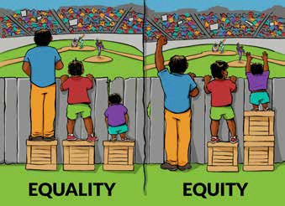

Credit: Interaction Institute for Social Change
Artist: Angus Maguire.
Aboriginal empowerment
We empower Traditional Owners
and Aboriginal communities to create self-determined actions to support the natural and built environment.
We learn from Aboriginal communities, integrate Aboriginal knowledge into our responses to climate change
and provide opportunities for meaningful partnership.
Aboriginal communities’ traditional ecological knowledge about the natural world can play a key role in our natural resource management and responses to climate change. There is much to learn from Aboriginal communities who have cared for Country for thousands of years. Aboriginal people practiced integrated land stewardship, meeting cultural objectives such as supporting the growth of culturally important plants and animals, improving and securing water supplies, and providing shelter for communities. It is important to enable Aboriginal self-determination through genuine, meaningful partnerships with Traditional Owners. We will work together with Aboriginal communities and incorporate their knowledge and world view in the fight against biodiversity decline and the climate crisis by:
- Engaging with the Traditional Owners and Registered Aboriginal Parties about the land, water and
sky of our city, with the aim of deepening our understanding of the ways in which Aboriginal cultural values and knowledge are linked to ecology and the environment
- Coordinating climate actions and land management priorities to align with Wurundjeri and Taungurung Country Plans and other position statements
- Working with Aboriginal communities to increase broad community’s awareness of traditional land management and climate resilience practices through education and engagement programs
- Exploring mechanisms to establish ongoing relationships with Traditional Owners and Aboriginal owned and controlled organisations for long term and coordinated collaboration and partnership.

Climate Change Plan Draft 2022-2032 / 39

Implementation and monitoring

Implementation summary

Implementation Category | Anticipated Timeframe | Delivery Responsibility | Key Partners for Success |  |  | Links to Priority Areas for Action |  |  |  |  |  |  | Links to Principles
 |  |  | Other levels of government | Business and industry | Community
Pillar One: Net Zero Council

100 per cent renewable electricity | O | Council
Energy efficiency in Council buildings and public lighting | S | Council
Climate Active Certification | M | Council
Zero emissions Council fleet and plant | M | Council | √
Electrification of Council buildings | L | Council | √
Pillar One: Net Zero Community
Switch to renewable energy and improved energy efficiency | M | Council | √ | √ | √
Zero emissions buildings and developments | M | Council | √ | √ | √
Electric vehicle ready infrastructure and developments | M | Council | √ | √
Zero emissions and active transport | M | Council | √ | √ | √
Generation of local offsets | M | Council | √ | √ | √
Transition to a circular economy | L | Council | √ | √ | √
Pillar Two: Climate Resilience
Mitigation and management of Council’s climate risk | S | Council
Climate resilient communities and businesses | L | Council | √ | √ | √
Climate resilient built environment and infrastructure | L | Council | √ | √ | √
Climate resilient natural environment and biodiversity | L | Council | √ | √ | √

Notes:
Anticipated Timeframe: O: Ongoing; S: Short term (1-2 years); M: Medium term (3-5 years); L: Long terms (6-10 years).
Priority Areas for Action: Priority 1: Renewable energy and energy efficiency; Priority 2: Sustainable and active transport;
Priority 3:
Priority 5:
Priority 7:
Sustainable farming practice and carbon sequestration; Priority 4:
Low waste and circular economy;
Climate resilient communities and businesses; Priority 6:
Climate resilient natural environment and biodiversity.
Climate resilient built environment and infrastructure;
Principles: Principle 1: All level leadership; Principle 2: Fairness and equity; Principle 3: Aboriginal empowerment.

40 / City of Whittlesea Climate Change Plan Draft 2022-2032 / 41

Monitoring progress

To ensure that our strategic directions and focus areas remain relevant for delivering impactful outcomes, this Climate Change Plan will be reviewed in 2027 and 2032, in line with the latest climate science, emissions profile and inventory updates, as well as new mitigation and adaptation technologies that become available.
The priorities for action outlined in this Climate Change Plan for the 2022-2024 period will be incorporated into the integrated Sustainable Environment Action Plan. The integrated Sustainable Environment Action Plan outlines the actions that Council is committed to delivering across the six themes, and how we will track our performance over time. Climate change is one of the six themes.
The Sustainable Environment Action Plan is a two- year plan, and will be renewed bi-annually in line with Council’s Community Plan and budget processes. The Climate Change Plan is a longer-term 10-year plan, therefore its actions will be reviewed and incorporated into the renewed Sustainable Environment Action Plan every two years.
Indicators are identified to track the progress towards the outcomes identified in the Sustainable Environment Strategy, which include those related to climate change, as highlighted below.

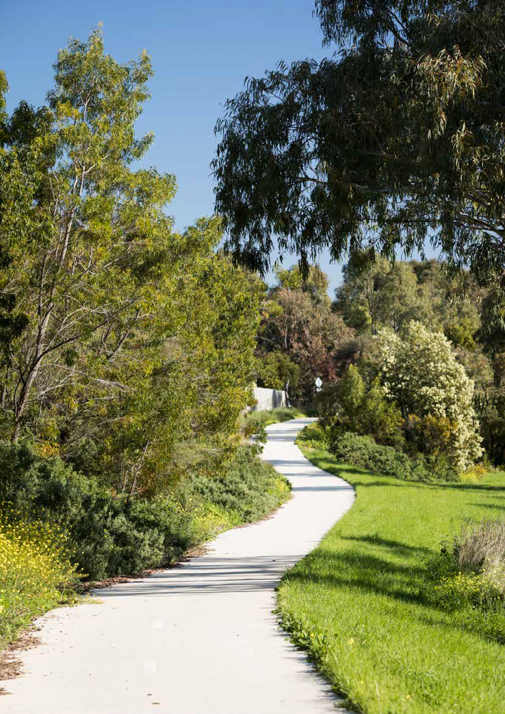

Pillar One: Net Zero
Reduced greenhouse gas emissions (both Council and community)
Reduced energy consumption (both Council and community)
Increase in uptake of renewable energy (both Council and community)
Increase in sustainable transport use Reduced waste and litter generation Increase in sustainable procurement Improved collaboration and partnerships

Pillar Two: Climate Resilience
Increased Council operations and services that consider climate change risks
Increased tree canopy cover
Improved biodiversity protection and management (public and private land)
Reduced areas of heat risk hotspots Decreased property impacts with floods
Improved connection between Traditional Owners and Country
Increase in the number of sustainable developments

42 / City of Whittlesea Climate Change Plan Draft 2022-2032 / 43

Glossary

Aboriginal – Throughout this document, the term ‘Aboriginal’ is taken to include people of Aboriginal and Torres Strait Islander descent. ‘Aboriginal’ is used in preference to ‘Indigenous’, ‘First Nations’, and ‘Koori’.
Active transport – Modes of transport that involves walking, cycling, scooting or other active ways of getting to and from a location as an alternative to motorised transport.
Adaptation – A process of adjustment to actual or expected climate and its effects in order to moderate harm or take advantage of beneficial opportunities. It is changes that we make to live with the impacts of climate change.
Agri-food – The agri-food sector encompasses all stages of the food and beverage life-cycle, from the on-farm production of primary commodities, through to manufacturing, retail, consumption and recycling (organics and packaging).
Biodiversity – The number and variety of living things on the planet. It is the mix of plants, animals, and other organisms that make up landscapes from deserts to oceans.
Blue-green infrastructure – Natural landscape elements which are harnessed by humanity as infrastructure and use water as a resource to sustain itself and flourish.
Built environment – The places and structures built or developed for human occupation, use and enjoyment.
Carbon budget – The estimated cumulative amount of carbon dioxide emissions to limit temperature rise to a given level, and the distribution of this amount to the municipal level based on considerations of fair share and equity.
Carbon dioxide equivalent – A metric measure used to compare the emissions from various greenhouse gases on the basis of their global warming potential,
by converting amounts of other gases to the equivalent amount of carbon dioxide with the same global warming potential.
Carbon offset – Compensation for emissions at one source by either avoiding and/or reducing emissions elsewhere, or removing carbon from the atmosphere.
Carbon sequestration – The removal of carbon from the atmosphere by capturing or storing it through biological, chemical and physical processes.
Circular economy – A model of production and consumption, which involves sharing, leasing, reusing, repairing, refurbishing and recycling existing materials and products as long as possible.
Climate anxiety – Negative emotions that people experience in relation to climate change and government responses to climate change.
Climate change – Long term change in global or regional climate patterns attributed largely to the increased levels of greenhouse gases in the atmosphere, particularly carbon dioxide, produced by the use of fossil fuels.
Climate resilience – The ability to anticipate, prepare for, respond to, absorb, recover from the disruptive effects of climate change, and make transformative changes
if necessary.
Climate risk – A result of the interaction of hazard, exposure, and vulnerability. Hazard refers to the potential occurrence of a natural or human-induced physical events or trends that may cause loss and damage. Exposure refers to the presence of people, livelihoods, species, ecosystems, services and resources, infrastructure, and assets in places and settings that could be adversely affected. Vulnerability refers to the propensity or predisposition to be adversely affected, which is determined by sensitivity or susceptibility to harm and lack of capacity to cope and adapt.
Environmentally Sustainable Design (ESD) – Design that seeks to improve building performance, reduce environmental impact, resource use and waste, and create healthy environments for occupants and users.
Food security – Food security means that all people, at all times, have physical, social, and economic access to sufficient, safe, and nutritious food that meets their food preferences and dietary needs for an active and healthy life.
Greenhouse Gas (GHG) – Gases such as carbon dioxide, methane, nitrous oxide, and others that cause the greenhouse effect by increasing the amount of solar radiation absorbed in the atmosphere, leading to global temperature rise.
Intergovernmental Panel on Climate Change (IPCC) – The United Nations body for assessing the science related to climate change. It provides regular assessment of the scientific basis of climate change, its impacts of future risks, and options for adaptation and mitigation.
Mitigation – A human intervention to reduce greenhouse gas emissions or remove greenhouse gases from the atmosphere. It is what we do to stop climate change from getting worse.
Natural environment – Ecosystems including animals and plants, and the interactions they have with each other and their physical environment.
Net Zero (emissions) – A state where greenhouse gas emissions are produced but balanced out with equivalent offsets. Net zero carbon dioxide emissions
is interchangeably used with carbon neutral or carbon neutrality.
Power Purchase Agreement (PPA) – An agreement between an electricity provider and a buyer for the sale of energy, used to secure a large amount of renewable energy at an agreed price over an extended period.
Renewable energy – Energy generated from renewable sources such as solar, wind, geothermal, and hydropower, in contrast to the energy from fossil fuels such as coal, natural gas, or oil.
Stationary energy – Combustion of fuels used in electricity generation, in the manufacturing,
construction and commercial sectors, and in other sources like domestic heating.
Tree canopy cover – The proportion of the municipality covered by the uppermost trees or branches of trees in a forest, forming an almost continuous layer of foliage. The topmost layer of bioactivity in a forest setting.
Visitor economy – Made up of businesses and organisations across a multitude of sectors, cities and regions, who provide or promote services to Australia’s domestic and international visitors.
Water Sensitive Urban Design (WSUD) – An approach to planning and design of urban areas to make use
of stormwater as a resource and reduce the harm it causes to our natural environment.
Zero emissions vehicles – Vehicles which do not use petroleum fuels, and therefore do not emit greenhouse gas emissions while operating, such as battery electric vehicles with no tailpipe, and hydrogen fuel cell electric vehicles.
20-minute neighbourhood – A concept about ‘living locally’, which gives people the ability to meet most of their daily needs within a 20-minute return walk from home, with access to safe cycling and local transport options.

44 / City of Whittlesea Climate Change Plan Draft 2022-2032 / 45

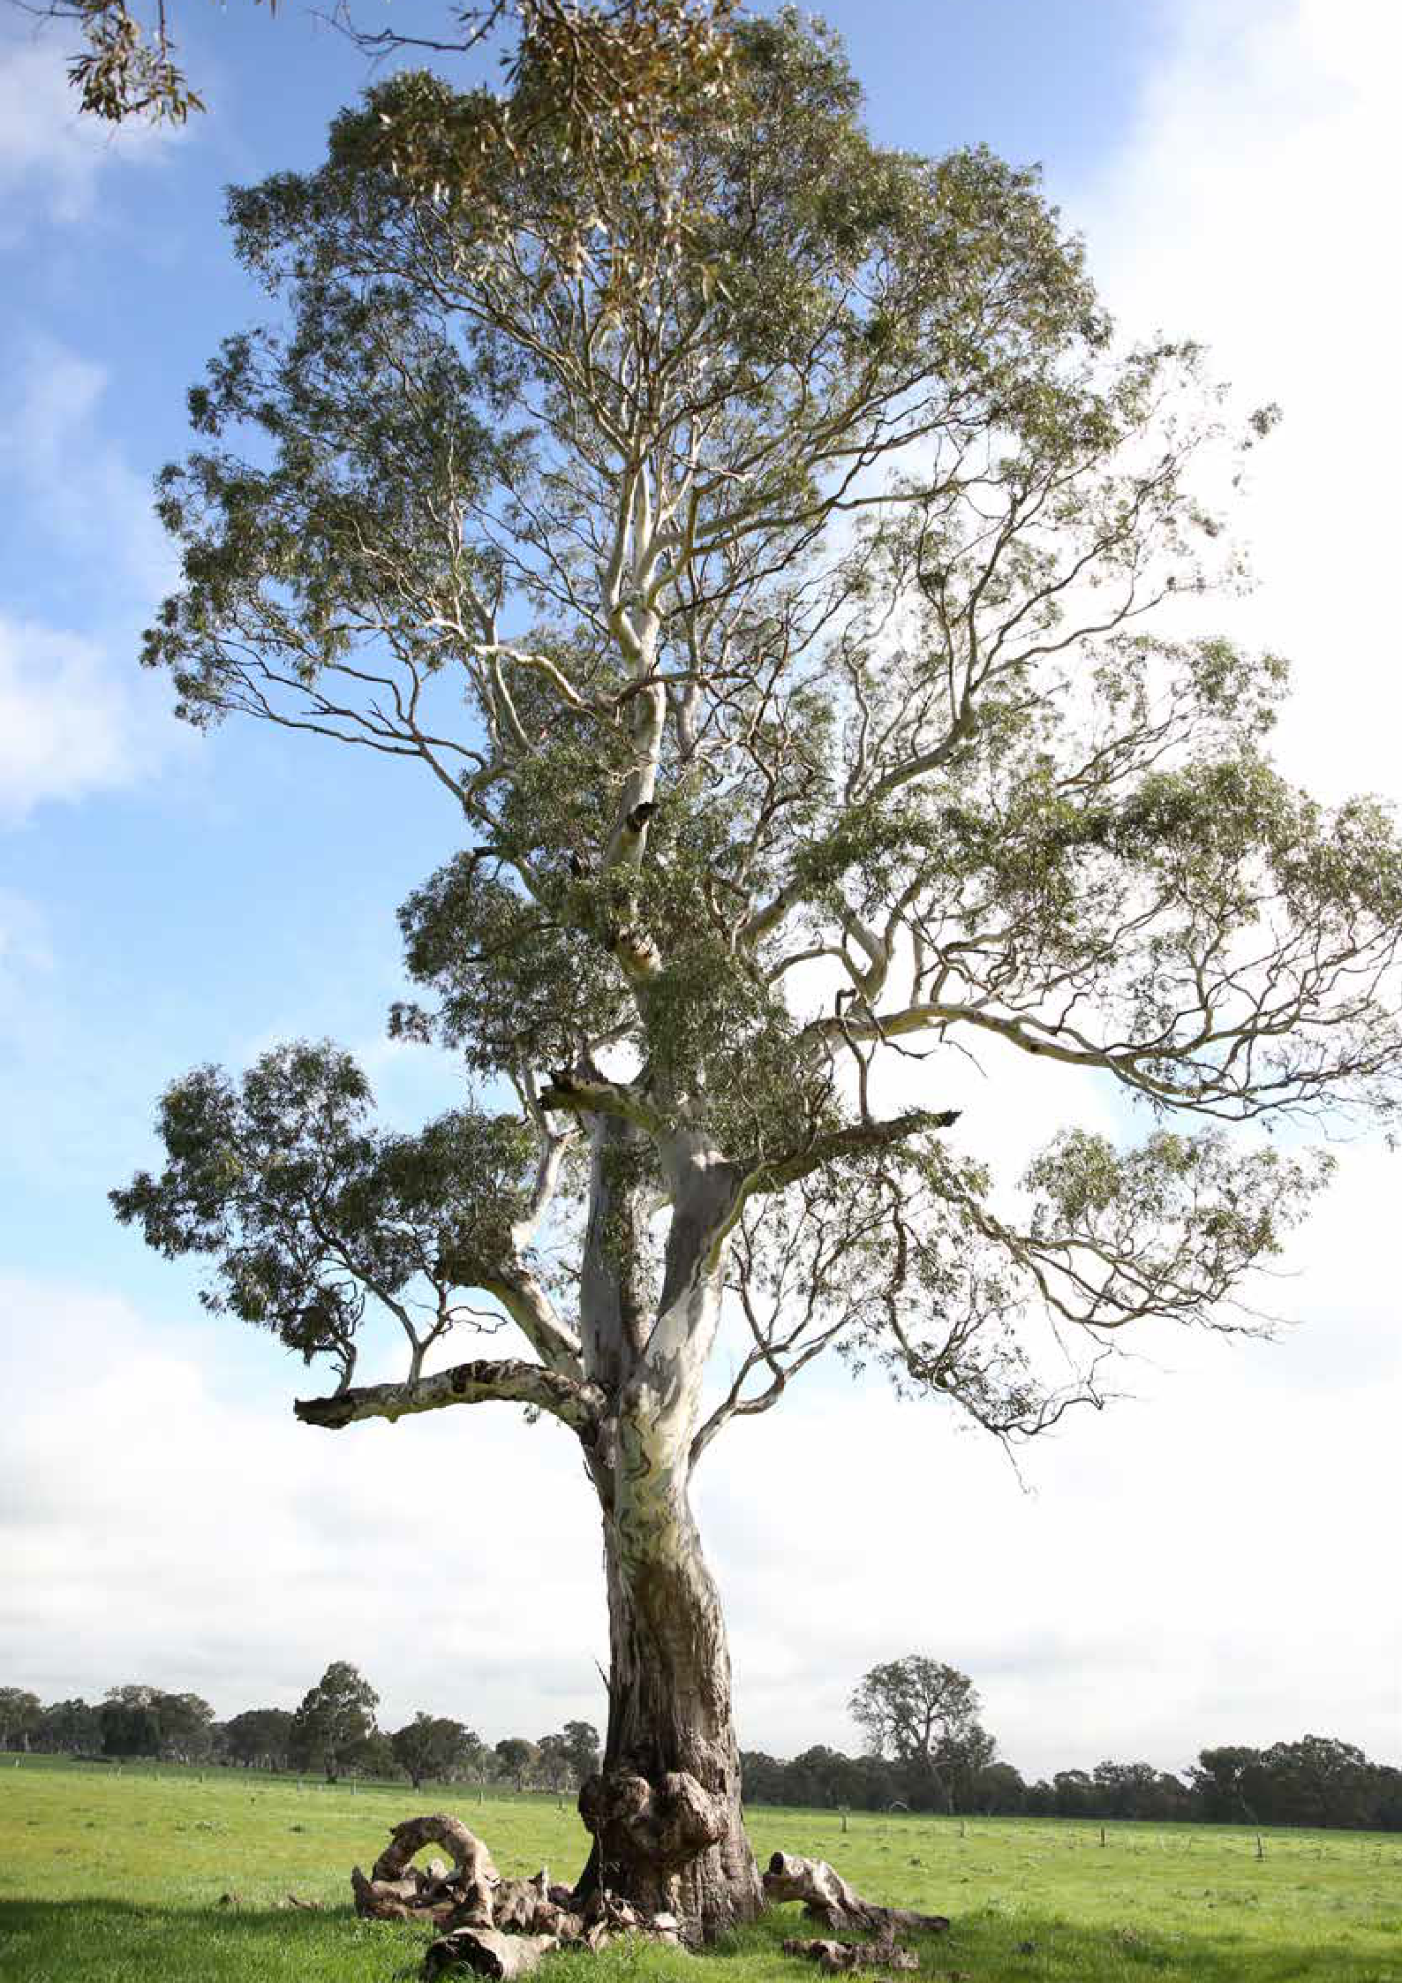

Endnotes

^{i} Intergovernmental Panel on Climate Change (IPCC). (2021). Climate Change 2021: The Physical Science Basis – Summary for Policy Makers, Working Group 1 Contribution to the Sixth Assessment Report of the IPCC.
^{ii} Coates, L. et al. (2014). Exploring 167 years of vulnerability: An examination of extreme heat events in Australia 1844- 2010, Environmental Science & Policy, 42, pp33-44.
^{iii} Steffen, W., Hughes, L., and Perkins, S. (2014). Heatwaves: Hotter, Longer, More Often, Climate Council, available online at: 9901f6614a2cac7b2b888f55b4dff9cc.pdf (climatecouncil.org.au)
^{iv} Ibid.
^{v} Hickman, C., et al. (2021). Climate anxiety in children and young people and their beliefs about government responses to climate change: a global survey, Lancet Planet Health, 5: e863-73. This large-scale global investigation of climate anxiety, first of its kind, surveyed 10,000 children and young people aged 16-25 years in ten countries (1,000 respondents in each country) including Australia.
^{vi} The Paris Agreement was negotiated at COP21 in 2015, the 21st Conference of the Parties for the United Nations Framework Convention on Climate Change (UNFCCC). As a legally binding international treaty on climate change, it was adopted by 196 Parties.
^{vii} The Glasgow Climate Pact was negotiated at COP26 in 2021.
^{viii} Climate Action Tracker. (2021). Glasgow’s 2030 credibility gap: net zero’s lip service to climate action. Available online at: climateactiontracker.org/publications/glasgows-2030-credibility-gap-net-zeros-lip-service-to-climate-action/
^{ix} Tandon, A. (2021). Avoiding Temperature ‘Overshoot’ Reduced Multiple Climate Change Risks, Say Scientists,
CarbonBrief.
^{x} City of Whittlesea. (2021). Climate Change Projections and Scenarios Report.
^{xi} IPCC. (2022). Climate Change 2022: Impacts, Adaptation and Vulnerability: Summary for Policymakers, Working Group 2 Contribution to the Sixth Assessment Report of the IPCC.
^{xii} The community emissions profile for the City of Whittlesea is based on the ‘Snapshot Community Climate Tool’ developed by Ironbark Sustainability and Beyond Zero Emissions, which provides a national database of community emissions for all local governments in Australia. Whittlesea, VIC :: Snapshot (snapshotclimate.com.au)
^{xiii} The shares across businesses and households in our municipal emissions are based on the consumption of electricity and natural gas. Emissions from waste and transport are not broken down into sectors.
^{xiv} Climate Active is best practice in greenhouse gas reporting in Australia. We choose to align with the standard rather than complying with it because we believe that the costs of achieving the certification can be used in other climate change initiatives that may make bigger impacts.
^{xv} City of Whittlesea. (2021). 1.5°C Science-Derived Target for Community Greenhouse Gas Emissions, prepared by Ironbark Sustainability.
^{xvi} City of Whittlesea. (2022). Strong Local Economy Strategy.
^{xviii} IPCC. (2022). Climate Change 2022: Mitigation of Climate Change: Summary for Policymakers, Working Group 3 Contribution to the Sixth Assessment Report of the IPCC.
^{xviii} Canadell, P. et al. (2020). Emissions of methane – a greenhouse gas far more potent than carbon dioxide – are rising dangerously, the Conversation, Emissions of methane – a greenhouse gas far more potent than carbon dioxide – are rising dangerously (theconversation.com)

Inside back cover photo:
One of Whittlesea’s iconic River Redgums.

46 / City of Whittlesea Climate Change Plan Draft 2022-2032 / 47

Council Offices
25 Ferres Boulevard South Morang VIC 3752
Email: info@whittlesea.vic.gov.au
Website whittlesea.vic.gov.au
Postal address
City of Whittlesea Locked Bag Bundoora MDC VIC 3083
Phone: 9217 2170
National Relay Service: 133 677
(ask for 9217 2170)
Connect with us in your preferred language:

