Sustainable Environment
Action Plan
2022–2024

1. Introduction

The Sustainable Environment Action Plan 2022-2024 (Action Plan) sets out the actions Council will focus on delivering in the first two years of the Sustainable Environment Strategy 2022-2032 (Strategy).
This includes both the ongoing services that support the delivery of the Goal 4 outcomes and new actions that support specific programs and initiatives.
It is made up of the key actions from the six
long-term thematic plans that underpin the Sustainable Environment Strategy. These six long-term plans cover the key focus areas related to environmental sustainability, namely, biodiversity, city forest (greening), climate change, Green Wedge, waste and recycling and water.
Community empowerment represents a cross-cutting element that enables us to deliver the outcomes identified for each of these six focus areas by delivering education and engagement programs for our community.
Majority of the actions listed in this Action Plan include actions that Council has already committed to for the delivery of Council’s endorsed long-terms plans as follows:
- Biodiversity Strategy 2019-2029
- Whittlesea Water For All 2020-2030
- Greening Whittlesea City Forest Strategy 2020-2040
- Rethinking Waste Plan 2021-2030
The Action Plan also includes proposed actions from the emerging Green Wedge Management Plan 2022-2032 and Climate Change Plan 2022-2032. (Notes: The Draft Green Wedge Management Plan was out for community consultation between 23 May and 3 July 2022, and is currently being finalised).
Actions are set out under each of the three key directions, the outcomes they are contributing to, and Council’s
role in delivering on each action. The outcomes and how we will monitor progress are detailed in the Sustainable Environment Strategy. An Action plan for every two years will be developed in line with Council’s Community Plan and annual budget process. Actions listed in this
document are subject to consideration in Council’s annual budget process.

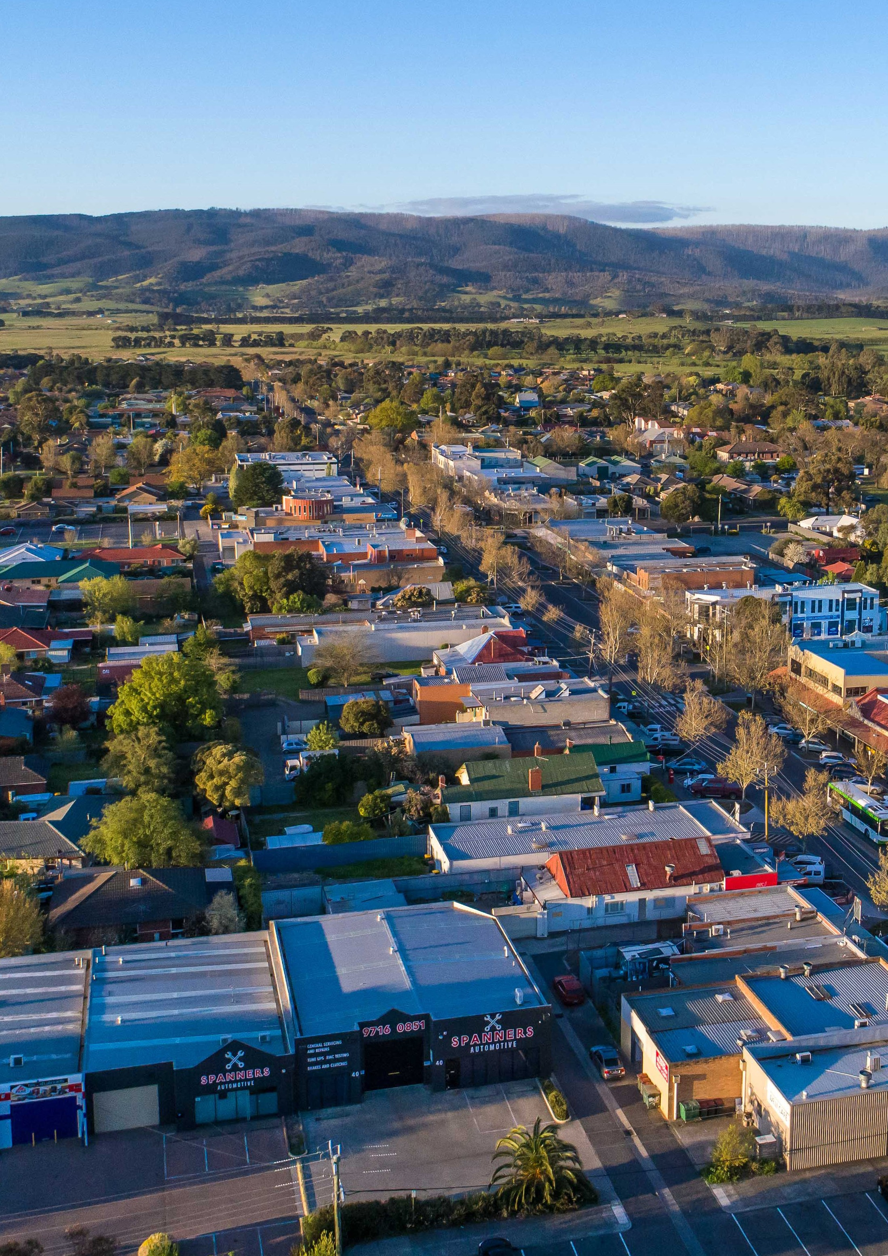
2 / City of Whittlesea

Sustainable Environment Action Plan 2022–2024 / 3

4. Action Plan Invitation for Partnership with Traditional Owners

Council recognises the rich history of environmental protection and custodianship of Traditional Owners of this land, waters and sky of the City of Whittlesea.
Council acknowledges that Traditional Owners have a different way of recognising Country. Western approaches to planning, land management and environmental protection can create fragments and divisions that are not reflective of Traditional Owner understandings.
Actions | Council’s Role | Links to Focus Areas
Explore land management partnership opportunities with Traditional Owners | Facilitator
Invite Traditional Owners to self-determine involvement and opportunities for collaboration and partnership within all sustainable environment actions | Facilitator
Coordinate environment, resource recovery, greening, water and climate actions to align with Wurundjeri and Taungurung Country Plans and to support indigenous communities to meet their social, cultural and economic needs (self-determination) | Facilitator
Invite Traditional Owners to share traditional climate resilient practices with Council, and when appropriate facilitate opportunities for this to be shared with the local Aboriginal community and broader community | Facilitator
Assist in identifying partnership opportunities with Traditional Owners to support the protection of Aboriginal cultural heritage, improve land and water management and other Caring for Country practices in the Green Wedge | Facilitator

Council acknowledges the recently released Victorian Traditional Owner Cultural Landscapes Strategy and the integrated approach to empower Traditional Owners
to lead planning and activate cultural knowledge and practices to manage Country.
Council acknowledges that supporting Traditional Owners to manage Country as a cultural landscape benefits people and benefits Country. Creating pathways for collaboration with Traditional Owners is critical for the success of all key directions and outcome areas within this action plan.
Role | Aim | What Council may do?
Provider | To implement projects, programs and campaigns for use by residents and businesses for a sustainable environment. | Initiate campaigns, incentives and education programs.
Facilitator | To establish partnerships and collaborate with stakeholders, to foster collective action to contribute to environmental sustainability. | Partner with key stakeholders and provide contributions (funding, knowledge and expertise, networking opportunities) to roll out programs.
Advocate | To support broad systemic changes required for a sustainable future through promotion and influencing decision-making, rather than direct involvement. | Educate key stakeholders including other levels of government to address provision gaps, influence policy and decision making.

2. Council services
Council delivers important services that help
achieve a sustainable environment.
Ensuring that Council delivers these services in an effective and efficient manner is critical to achieving the outcomes listed within the Sustainable Environment Strategy for the whole community.
Council will work to continuously improve these
services to ensure they meet legislative requirements and community expectations.
Across all Council services consideration and incorporation of corporate environmental sustainability must be considered.
3. Council’s role
Focus Area key:
Priorities key:
Community Reportable Action
Internal
Focused Action
Action that will transition to the
High Performing Organisation Action Plan
4 / City of Whittlesea
Biodiversity | City forest | Climate change | Green Wedge | Waste and  recycling | Water

Sustainable Environment Action Plan 2022–2024 / 5

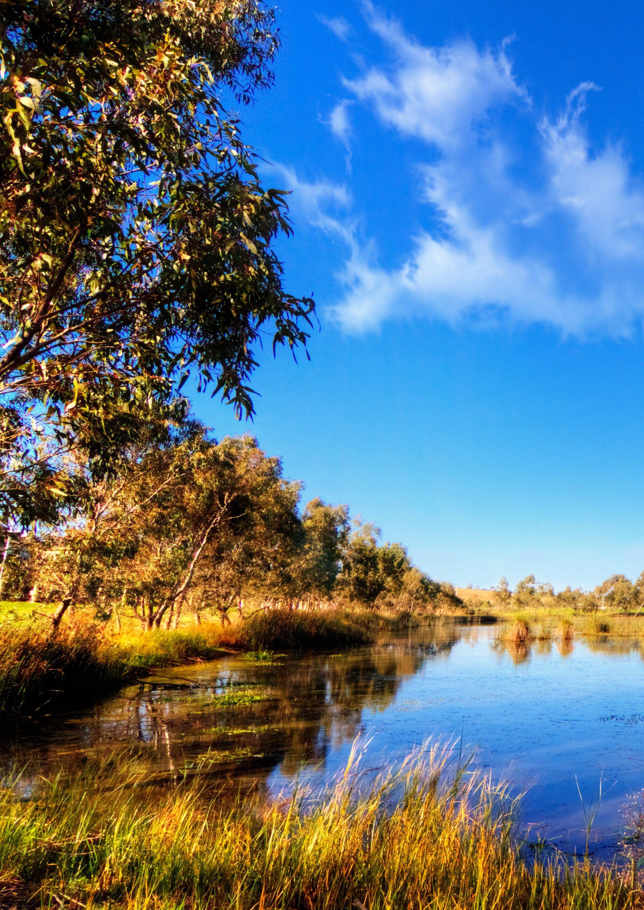
666 /// CCCiiitttyyy ooofff WWWhhhiiittttttllleeessseeeaaa
Key direction 1
Valued natural landscapes and biodiversity
Sustainable Environment Action Plan 2022–2024 / 7
6 / City of Whittlesea

Actions | Council’s Role | Links to Focus Areas
Outcome 1.1 Our landscapes, waters and species are protected, improved, and valued.
Continue to manage population of Matted Flax-lily relocated from the Mernda Rail site | Provider
Help our community learn and connect with the environment through the Nature Stewards Program | Provider
Advocate to protect the grassy eucalypt woodlands | Advocate
Better protect conservation reserves through rezoning | Provider
Map our biodiversity assets to help protect and enhance them throughout the planning process | Provider
Renew and upgrade Peter Hopper Lake in Mill Park | Provider
Implement a Planning Scheme Amendment to better protect biodiversity, waterways and landscapes using appropriate zones and overlays | Provider
Advocate to ensure all conservation areas identified within the Urban Growth Boundary are appropriately protected and managed | Provider
Develop a Biodiversity Planning Policy to ensure all new conservation reserves are handed over in an appropriate condition | Provider
Review all Council owned land for biodiversity and waterway values and ensure management and lease arrangements are appropriate | Provider

Key direction 1

Valued natural landscapes and biodiversity
Key direction 1

Valued natural landscapes and biodiversity

Actions | Council’s Role | Links to Focus Areas
Outcome 1.1 Our landscapes, waters and species are protected, improved, and valued. (cont.)
Ensure that all Council conservation reserves are managed effectively and support rare and threatened species conservation | Provider
Continue long-term targeted fauna survey program within conservation reserves | Provider
Enhance and improve the management of conservation and tree assets on rural roadsides to manage native vegetation, remove priority weeds, improve habitat connectivity, and reduce fire risk | Provider
Undertake a review of rural land, water and biodiversity incentives programs to maximise community and environmental benefits | Provider
Undertake a review and develop a business case into urban biodiversity and greening to encourage residents, schools, community groups and early years services to maximise community and environmental benefits | Provider
Undertake a review of the water education program to ensure investment to maximise community and environmental benefits | Provider

Actions | Council’s Role | Links to Focus Areas
Outcome 1.2 Our land management and land use are sustainable.
Work with Traditional Owners to obtain Aboriginal cultural heritage permits for land management works in conservation reserves | Facilitator
Explore opportunities to generate local carbon sequestration offsets on Council owned and private land | Provider
Continue to lead the Local Government sector in utilising Smart Sensors and citizen science to monitor waterway and ecological health of our city | Provider
Advocate for effective regional kangaroo management across land tenures and diverse stakeholders | Advocate
Support opportunities for the Aboriginal community and broader community to learn from Traditional Owner practice and Care for Country | Facilitator
Continue to provide specialist support and advice to rural land managers that maximises environmental and community benefit and highlights the value of sustainable land management and improves soil health | Provider
Outcome 1.3 Our natural environment and biodiversity are resilient to climate change.
Undertake a habitat connectivity study to better understand impacts of fragmentation, urban growth and climate change on our biodiversity, and to inform our incentive programs, land management and planning scheme for better biodiversity outcomes | Provider
Undertake study to understand the current and future carrying capacity of wildlife populations on Council owned and managed land | Provider
Continue to partner with neighbouring councils to act and advocate for biodiversity and waterway health including but not limited to via the Merri Creek Management Committee, Darebin Creek Management Committee, Melbourne Strategic Assessment Local Government Liaison Group, Biodiversity Planning Network and Bushland Managers Network | Facilitator

8 / City of Whittlesea SusSttarionnagblLeoEcnavl iErcoonnmoemnyt Action Plan 2022–20243 / 9

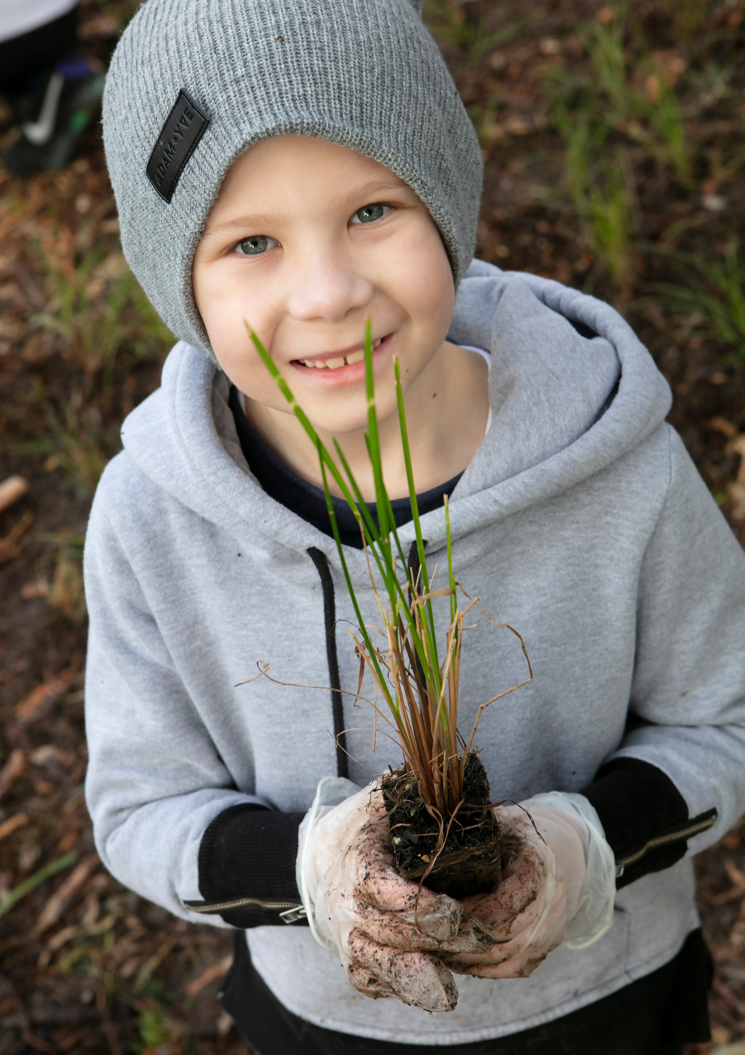
111000 /// CCCiiitttyyy ooofff WWWhhhiiittttttllleeessseeeaaa
Key direction 2
Climate ready
Sustainable Environment Action Plan 2022–2024 / 11
10 / City of Whittlesea

Actions | Council’s Role | Links to Focus Areas
Outcome 2.1 Our city’s green cover is enhanced to reduce the risk of extreme heat.
Deliver the annual tree planting programs including:  - Main Roads and High Profile Streetscapes Planting Program  - Parks Tree and Major Facilities Planting Program  - Conservation Reserves Tree Planting Program  - Residential Street Tree Renewal Planting Program | Provider
Participate in Greening the North to develop regional initiatives to deliver greening and urban heat mitigation outcomes and advocate for the protection of existing and future canopy | Advocate
Review planning controls and local laws and their enforcement to identify where tree and vegetation protection measures can  be strengthened at all development stages. Implement findings of review | Provider
Advocate for an evidence-based review of setback requirements of service providers (e.g. AusNet Services) that limit canopy and vegetation planting | Advocate
Undertake a review on the protection and management of publicly owned River Red Gums across the municipality to ensure their ongoing health in the landscape | Provider
Develop ‘shovel-ready’ concepts and supporting business cases to anticipate funding and grant opportunities for greening initiatives across public and private land | Provider
Develop a comprehensive Ten-Year Planting Program which addresses the recommendations from the equity focused health impact assessment | Provider
Develop a place-based guideline and approach to landscape planting programs across the city | Provider
Develop a green infrastructure policy to ensure canopy loss is compensated for within the city | Provider

Key direction 2

Climate ready
Key direction 2

Climate ready

Actions | Council’s Role | Links to Focus Areas
Outcome 2.1 Our city’s green cover is enhanced to reduce the risk of extreme heat. (cont.)
Ensure all canopy cover targets are met in all Urban Design Frameworks, Integrated Community Facilities Planning, Public Space  Planning and New Works Public Space projects | Provider
Carry out an assessment of community behaviours, perceptions, and barriers regarding tree and green cover planting on private land, and review the effectiveness of previous incentive schemes given the findings | Provider
Outcome 2.2 Our communities and businesses are supported to become climate ready.
Enhance understanding and knowledge about localised impacts of climate change and potential solutions including impacts on local food security and vulnerable groups | Provider
Deliver innovative, engaging and accessible education programs about climate risk and adaptation to communities and businesses | Provider
Develop a program to support vulnerable residents and communities to improve the sustainability, thermal comfort and efficiency of their homes | Provider
Continue to partner with the Northern Alliance for Greenhouse Action (NAGA) to achieve broad climate action across municipal boundaries | Facilitator
Advocate to the state government for incorporation of climate change responses, risks and costs into decision making and financial planning | Advocate
Develop and demonstrate environmental leadership in our community through a community environmental scholarship program and/or an awards program to recognise community achievements in environmental and climate action | Provider

Actions | Council’s Role | Links to Focus Areas
Outcome 2.3 Our built environment and infrastructure are built to support safe and healthy communities in a changing climate.
Ensure that all developments are assessed using the Sustainable Subdivision Framework | Provider
Ensure the Planning Scheme discourages new settlements in areas prone to extreme natural hazards | Facilitator
Work with State Government to provide for future infrastructure and energy needs within the Green Wedge | Advocate
Evaluate emergency relief centres and other community facilities to make sure they are climate resilient | Provider
Ensure that all Council design manuals address Environmentally Sustainable Design and climate change | Provider
Establish a corporate Environmental Sustainability Committee to support sustainable environment initiatives and embed climate change responses into Council decision making | Provider

12 / City of Whittlesea Sustainable Environment Action Plan 2022–2024 / 13

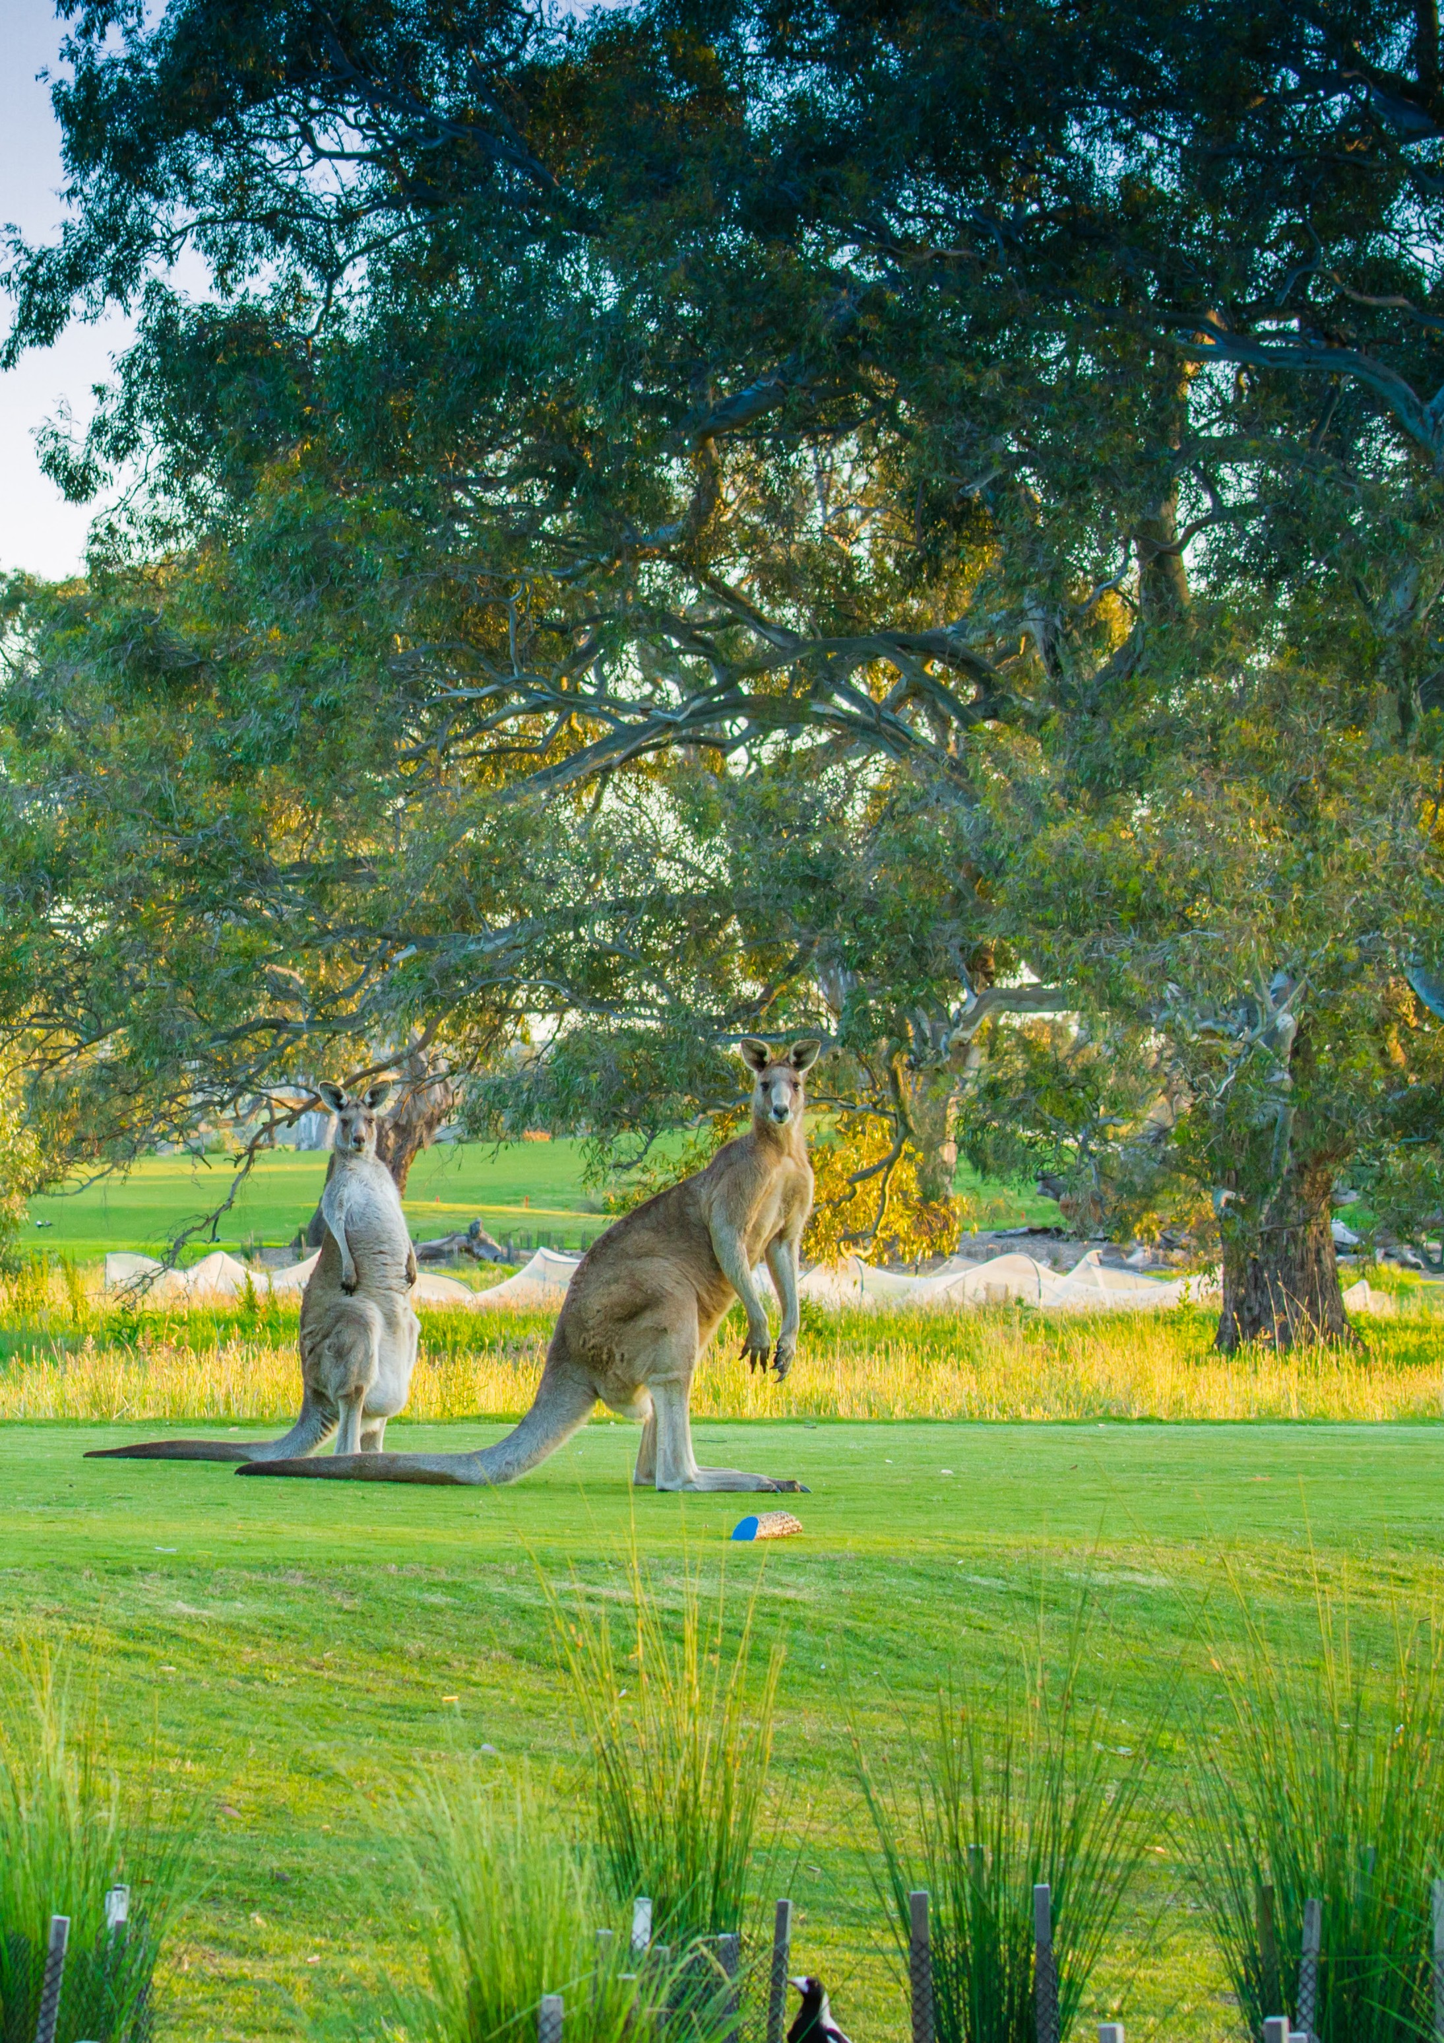
111444 /// CCCiiitttyyy ooofff WWWhhhiiittttttllleeessseeeaaa
14 / City of Whittlesea
Key direction 3
Leaders in clean, sustainable living
Sustainable Environment Action Plan 2022–2024 / 15

Actions | Council’s Role | Links to Focus Areas
Outcome 3.1 Our city becomes a net zero emissions municipality.
Support our business community to improve the sustainability of their facilities using Environmental Upgrade Agreements | Facilitator
Improve the energy efficiency of Council buildings and facilities including solar and lighting upgrades | Provider
Continue to replace our streetlights with energy efficiency bulbs | Provider
Support community renewable energy initiatives such as solar farms, micro-grids, and battery storages | Facilitator
Advocate for access to renewable energy Power Purchase Agreements for businesses and non-for-profit organisations | Advocate
Continue to partner with the Council Alliance for Sustainable Built Environment (CASBE) to  advocate for increased standards to achieve zero emissions and climate resilient developments | Facilitator
Advocate to other levels of government for retrofitting existing buildings for a zero emissions and climate resilient future | Advocate
Ensure Council capital programs integrate active transport supporting 20-minute neighbourhoods | Provider
Commence implementation of the Walking and Cycling Plan to enable more use of sustainable and active transport by the community including increasing tree planting along connected open space and pathways | Provider
Complete community wide EV Transition Plan and commence implementation | Provider

Key direction 3

Leaders in clean, sustainable living
Key direction 3

Leaders in clean, sustainable living

Actions | Council’s Role | Links to Focus Areas
Outcome 3.1 Our city becomes a net zero emissions municipality. (cont.)
Develop and implement a behaviour change campaign for the community to move towards more active and sustainable transport options, including investigating if incentives would assist in this transition and the use of community shuttle buses | Provider
Work with local schools and education institutions to develop Green Travel Plans | Facilitator
Advocate to the state government for more investment in more public transport options for the city | Advocate
Continue participating in the Victorian Energy Collaboration Power Purchase Agreement for 100% renewable electricity | Provider
Update and implement Environmentally Sustainable Design (ESD) standards for Council assets and facilities (i.e. Council ESD Guidelines for Council works) | Provider
Develop and implement a plan to eliminate gas use in Council facilities | Provider
Work with Council services owners to analyse and implement service improvements that address climate risk, zero net emissions and environmental sustainability | Provider
Complete and commence implementation of a Council fleet and plant Net Zero Emissions transition plan | Provider
Develop a program to encourage Council staff to use active travel modes and/or public transport for work commute | Provider
Develop a roadmap to comply with  Council corporate emissions inventory with Climate Active and implement the roadmap to ensure compliance | Provider

Actions | Council’s Role | Links to Focus Areas
Outcome 3.2 Our water resources are managed in an integrated way.
Construct Wilton Vale Wetland Boardwalk in South Morang | Provider
Refurbish Janefield Wetland Boardwalk in Bundoora | Provider
Trial and demonstrate Integrated Water Management (IWM) initiatives in  new Council buildings, facilities, and public realm projects | Provider
Develop a program to implement appropriate IWM responses and capital works actions in areas of flooding hotspots | Provider
Advocate for funding to undertake a feasibility study to provide rural areas access to alternative water supply within Whittlesea and neighbouring municipalities | Advocate
Continue to participate in the Yarra IWM Plan and the Upper Merri Sub-catchment Plan and contribute to action delivery | Facilitator
Complete and implement the water service plan to ensure that Council is resourced appropriately to manage the water service | Provider
Consider a policy position on composting toilets as part of the next review of the Domestic Wastewater Management Plan | Provider
Ensure the Water Sensitive Urban Design (WSUD) asset register is established, maintained, and responds to the Melbourne Urban Stormwater Institutional Arrangements (MUSIA) review | Provider
Collaborate with Melbourne Water to undertake functional design of stormwater harvesting schemes at strategically relevant sites | Facilitator
Ensure Council’s engineering and design manuals address integrated water management | Provider
Ensure that the Council projects meet the Healthy Waterways Strategy Integrated Water Management Targets | Provider

16 / City of Whittlesea SusSttarionnagblLeoEcnavl iErcoonnmoemnyt Action Plan 2022–20243 / 17

Key direction 3

Leaders in clean, sustainable living
Key direction 3

Leaders in clean, sustainable living

Actions | Council’s Role | Links to Focus Areas
Outcome 3.3 Our city is low waste and transitions to a circular economy.
Implement the Rethinking Waste Plan to support our community to become a leader in sustainable living | Provider
Investigate options for introducing a local resource recovery shop | Provider
Introduce a rebate program for reusable nappies, reusable sanitary products and composting tools | Provider
Implement a glass recycling bin service as a fourth kerbside collection bin for residents, to further decrease waste to landfill and improve resource recovery | Provider
Introduce an integrated waste policy that supports the community to understand how the waste charge is used, addresses organisational waste management approaches and ensures best practice waste service delivery | Provider
Undertake a feasibility study on providing alternative residential bin sizes and changing the collection frequency | Provider
Reduce barriers to participation in the food and garden waste service | Provider
Advocate to support our community and businesses to rethink waste and for investment in the circular economy | Advocate

Actions | Council’s Role | Links to Focus Areas
Outcome 3.3 Our city is low waste and transitions to a circular economy. (cont.)
Deliver innovative, engaging and accessible waste minimisation and resource recovery education programs to the community addressing contamination, service use and the container deposit scheme | Provider
Advocate for the introduction of Right to Repair legislation to avoid generation of unnecessary waste and reduce embodied carbon in goods | Advocate
Implement an annual contamination management plan to encourage the correct separation of waste | Provider
Enhance the hard waste collection service | Provider
Continue to encourage sustainable procurement across Council, selecting products that generate economic, social and environmental benefits whenever it is practical and achieves value for money | Facilitator

18 / City of Whittlesea SusSttarionnagblLeoEcnavl iErcoonnmoemnyt Action Plan 2022–20243 / 19

Council Offices
25 Ferres Boulevard South Morang VIC 3752
Email: info@whittlesea.vic.gov.au
Website whittlesea.vic.gov.au

Postal address
City of Whittlesea Locked Bag Bundoora MDC VIC 3083
Phone: 9217 2170
National Relay Service: 133 677
(ask for 9217 2170)
Connect with us in your preferred language:

