Community Safety and Crime Prevention Strategy

2016-2020

Acknowledgement of Traditional Owners
The City of Whittlesea recognises the rich Aboriginal heritage of this country and acknowledges the Wurundjeri Willum Clan as the traditional owners of this place.

A message from the Mayor
I am pleased to present the City of Whittlesea Community Safety and Crime Prevention Strategy 2016-2020. This strategy reflects a partnership approach to prevent crime and improve community safety for our residents.
We know that community safety is one of the most significant issues for our residents. Our Annual Household Survey consistently tells us that our community want Council to take action to prevent crime and improve safety. Negative perceptions of safety are a barrier to residents accessing local open space and impacts on the health and wellbeing of our community in many different ways.
Council has a role as a provider, facilitator and advocate to improve community safety and help to reduce crime. This Strategy will help us to work more collaboratively with our agencies and local police. Progress will only be made with sustained partnership and collaborative efforts.
This Strategy articulates 10 themes that we will deliver on over the next four years as we work together with our community and local agencies to prevent crime and improve community safety for all.
I would like to thank everyone who has been involved in the development of the Community Safety and Crime Prevention Strategy 2016-2020, and particularly recognise the invaluable role of the agency members of the Community Safety and Crime Prevention Committee.

Cr Stevan Kozmevski
Mayor

A message from the Local Area Commander Victoria Police
I am proud to have been involved in the development of the Community Safety and Crime Prevention Strategy because it is a critical step to progress a whole-of-community approach to policing issues. Sir Robert Peel, the founder of modern policing, is quoted as saying:
The police are the public and the public are the police; the police being only members of the public who are paid to give full time attention to duties which are incumbent on every citizen in the interests of community welfare and existence.
I know from my many years involved in community safety and crime prevention that Police cannot adequately address these issues on their own. We need the support of our local council, support agencies, community groups, business owners and the residents themselves. We are very lucky in the City of Whittlesea that we are predominantly a community who are prepared to be involved, who do support each other and who look after each other. In many ways, the CS&CP Committee is representative of those values because we are representatives of the community.
Agencies represented on the Committee, together with Council and Police, are involved in delivering services to and advocating for the residents of the City of Whittlesea. This Strategy outlines the broad themes we will focus on, what success will look like over time and tools to measure our progress. It is a structured representation of what we will be doing (and in many cases what we will continue to do) to keep the community safe and minimise crime.
I congratulate my committee partners for developing the Strategy and I look forward to its co-operative implementation.

Inspector Paul F. Tysoe B.A. Police Studies, GradCert Applied Mngt, GradDip Exec. L’ship
Co-Chair Community Safety & Crime Prevention Committee

Table of Contents
Community Safety and Crime Prevention Strategy 1
A message from the Mayor 3
A message from the Local Area Commander Victoria Police 4
Table of Contents 5
Executive summary 8
Background 9
Consultation and engagement 10
Policy context 11
Parliamentary Inquiry into Locally Based Approaches to Community Safety and Crime Prevention (2012) 11
National Crime Prevention Framework 11
Community Crime Prevention Framework 11
Local Government Act (1989) 11
Local Area Community Safety Plan (2012) 11
City of Whittlesea Community Building Policy 11
City of Whittlesea Council Plan & Municipal Public Health and Wellbeing Plan 2013-2017 12
City of Whittlesea policy links 12
Community Safety and Crime Prevention Policy 13
Policy statement 13
Policy principles 13
Demographics 14
Crime prevention theory and evidence 15
A snapshot 15
The role of local government in crime prevention 16
Approaches to preventing crime 17
Snapshot of local data 18
Perceptions of safety 18
Racism 18
Homelessness 19
Education and employment 19
Early childhood and Middle years’ development 19
Socio-economic status 21
Financial vulnerability 22
Alcohol and illicit drugs 22
Offender profile 23
Crime 24
City of Whittlesea Community Safety and Crime Prevention Strategy 2016-2020 26
Goal 1: The built environment is safe, welcoming and promotes community connection 26
Theme: Safety in the built environment, parks and public space 26
Goal 2: Crime against public and private property is minimised 26
Theme: Property crime and theft 26
Goal 3: Young people have education pathways and meaningful employment opportunities 27
Theme: Young people disengaged from education and employment 27
Goal 4: Dangerous driving is minimised 27
Theme: Unsafe driving 27
Goal 5: Harms and negative impacts of financial vulnerability on community safety are minimised 27
Theme: Financial vulnerability and debt 27
Goal 6: Harms from alcohol are minimised 28
Theme: Alcohol 28
Goal 7: Harms from illicit drugs are minimised 28
Theme: Illicit drugs 28
Goal 8: Women and children live free from family violence 28
Theme: Family violence 28
Goal 9: Employment programs are provided for key population groups 29
Theme: Education and employment 29
Goal 10: Negative community safety impacts from electronic and online crime are minimised 29
Theme: Electronic crime and online safety for children 29
References 30

Executive summary
Action to address crime and community safety has strong synergies with community building, good health and wellbeing and improved access to employment, education and training. When individuals feel safe within their community, they are more likely to experience greater levels of social connection and trust, and are more likely to become engaged with other members of the community. Perceptions of neighbourhood safety are linked with health outcomes.

This Strategy was developed in partnership with the Community Safety and Crime Prevention Committee and seeks to outline the City of Whittlesea’s commitment to improve community safety and minimise crime in partnership with local police and agencies. The Strategy seeks to prioritise social crime prevention approaches - approaches that support action to address socio-economic factors such as disengagement with education and unemployment which are correlated with incidence of crime.
There are ten goals outlined in the Strategy which will guide the work of the City of Whittlesea and the Community Safety and Crime Prevention Committee for the next four years.
Goals:
- The built environment is safe, welcoming and promotes community connection
- Crime against public and private property is minimised
- Young people have education pathways and meaningful employment opportunities
- Dangerous driving is minimised
- Harms and negative impacts of financial vulnerability on community safety are minimised
- Harms from alcohol are minimised
- Harms from illicit drugs are minimised
- Women and children live free from family violence
- Employment programs are provided for key population groups
- Negative community safety impacts from electronic and online crime are minimised

These goals inform the Community Safety and Crime Prevention Committee’s annual action plan. The Action Plan articulates crime prevention and advocacy actions to improve community perceptions of safety and minimise crime.

Background
In 2012, the City of Whittlesea and key external stakeholders were involved in a partnership with the Department of Justice and Regulation to develop a ‘Local Area Community Safety Profile’ which bought together key crime and safety data with social indicators to develop a profile outlining key areas of focus to prevent crime and improve safety. The City of Whittlesea was identified by the Department of Justice and Regulation for this work due to lower than Victorian average perceptions of safety, high levels of residents with outstanding warrants, the number of prisoners who identified City of Whittlesea as their place of residence upon incarceration and for exceeding the Victorian average of people on Community Correctional Services orders living in municipality.
Further to this, community consultations and data analysis undertaken for the City of Whittlesea Community Plan in 2012 identified community safety as a priority issue for Council to address. Subsequently, the City of Whittlesea Council Plan and Municipal Health and Wellbeing Plan 2013-2017 included a goal Council will support action to increase community safety, enhance perceptions of community safety and prevent crime across the municipality. From here, an action to develop a strategy to articulate Council’s role in community safety and crime prevention was included and work commenced in partnership with Victoria Police to establish a committee.

The Community Safety and Crime Prevention (CS&CP) Committee was established in 2015 and is a partnership between Victoria Police and City of Whittlesea. The CS&CP Committee is resourced by the City of Whittlesea’s Community Safety Officer and is co-chaired by the Local Area Commander of Victoria Police and the Director Community Services of City of Whittlesea. The CS&CP Committee agencies represent a range of community settings and population groups and work across the framework of crime prevention interventions.
Members of the CS&CP Committee:
- City of Whittlesea (Aged and Disability, Youth Services, Community Inclusion, Parks and Open Space, Jobs and Investment, Community Wellbeing, Local Laws)
- Department of Justice and Regulation
- Hume Whittlesea Local Learning and Employment Network
- Neighbourhood Watch
- Northern Hospital
- Plenty Valley Community Health
- Uniting Care ReGen
- Victoria Police
- Whittlesea Community Connections
- Youth Support and Advocacy Service

The City of Whittlesea developed this Strategy in partnership with the CS&CP Committee through a serious of facilitated workshops exploring evidence, local research and data. Themes were identified and tailored actions were developed to address the community safety and crime prevention needs identified. Early on in these workshops the CS&CP Committee identified extensive work being undertaken that is locally focussed on family violence, including:
- the Whittlesea CALD Communities Family Violence Project
- the ‘Hamdel Project’ – a prevention project working with the Iranian community
- City of Whittlesea’s Family Violence and Gender Equity Strategies
- Other agency’s strategies and plans
- the work of specialist family violence services, Victoria Police and many other agencies

The CS&CP Committee therefore concluded that this Strategy would not seek to include any additional actions to address family violence and as such includes a reference to implementation of the City of Whittlesea Family Violence Strategy. The Strategy will address engagement in crime and negative community perceptions of safety in partnership with the CS&CP Committee.

Further, during development of this Strategy, Council resolved to establish a Road Safety Committee and develop a Road Safety Strategy. As such, the CS&CP Committee concluded that particular action to address road safety issues and crime would be articulated through the Road Safety Strategy and are therefore not included in this Strategy.

This is a Council Strategy which articulates the important work of Council but particularly emphasises the partnerships and collaboration required to undertake successful crime prevention work. The accompanying Action Plan 2016-2017 outlines the collective work of the CS&CP Committee agencies including some actions for Council.

Consultation and engagement
Consultation will be held as required to shape implementation of actions within the plan to ensure responsiveness to community need. Continued engagement with community through the CS&CP Committee agencies will inform the implementation of the action plans to be developed annually. This Strategy must be flexible enough to take advantage of opportunities as they present and to adapt to emerging trends and issues.

In addition to consultation held as required on specific actions throughout the implementation phase, the CS&CP Committee decided that for the life of this Strategy, annual community safety forums or ‘open meetings’ will be held to ensure the community is invited to have a say on issues that affect them and how action is developed to address these.

Policy context

Parliamentary Inquiry into Locally Based Approaches to Community Safety and Crime Prevention (2012)
The inquiry focussed on the process and models through which effective crime prevention policy and programs can be developed and implemented at a local level and the partnerships that can be formed to make this happen. It provides specific recommendations for implementing crime prevention and community safety strategies for local governments.

National Crime Prevention Framework
A resource which outlines the most effective approaches to the prevention of crime; and provides guidance by way of information on best practice to assist with the development of appropriate policies, strategies and programs to address crime trends and issues.

Community Crime Prevention Framework
This framework from the Department of Justice and Regulation focuses on supporting local community crime prevention and outlines the State Government strategic priorities.

Local Government Act (1989)
The Local Government Act outlines that Council must have regard to the following facilitating objectives (as applicable to this Strategy):
(a) to promote the social, economic and environmental viability and sustainability of the municipal district
(c) to improve the overall quality of life of people in the local community
(d) to promote appropriate business and employment opportunities
The role of a Council includes:
(f) fostering community cohesion and encouraging active participation in civic life.

Local Area Community Safety Plan (2012)
In 2012, the North Metropolitan Regional Justice Reference group, a sub-committee of the North West Regional Management Forum, in partnership with the Department of Justice and Regulation, facilitated the development of a Local Area Community Safety Plan informed by local stakeholder consultations which identified good practice examples of work and key opportunities for action to address crime and community safety.

City of Whittlesea Community Building Policy
Community Building actively fosters strong, resilient and connected communities, amplifies local community voices, and enhances the capacity of communities and individuals to achieve their goals. A community building approach requires people, groups and organisations to work together to build connections, understanding and confidence. This enables shared identifies and aspirations to emerge and builds a sense of collective responsibility for community wellbeing.

City of Whittlesea Council Plan & Municipal Public Health and Wellbeing Plan 2013-2017
Local government plays a key role in creating the environment which supports health and wellbeing. The Public Health and Wellbeing Act 2008 requires councils to prepare a four-year municipal public health and wellbeing plan which sets goals and priorities to enable people living in the municipality to achieve maximum health and wellbeing. Feeling safe in the community enhances social connection and trust and improves health and wellbeing outcomes.

The Council Plan and Municipal Public Health and Wellbeing Plan 2013-2017 outlines the Council Goal 5.3 Council will support action to increase community safety, enhance perceptions of community safety and prevent crime across the municipality and; Actions:
- Partner with Victoria Police to establish a local community Safety Committee
- Prioritise opportunities in Local Area Community Safety Profile with a focus on social prevention and Crime Prevention Through Environmental Design (CPTED) in partnership with the Department of Justice

City of Whittlesea policy links
- Draft Advocacy Strategy (2016)
- Anti-Racism Policy and Strategy (2015-2019)
- Community Building Policy and Strategy (2016)
- Community Safety and Crime Prevention Policy (2016)
- Connect A municipal plan for children, young people and their families in the City of Whittlesea (2013 to 2018)
- Family Violence Strategy (2014-2018)
- Gambling Strategy (2014-2024)
- Growing Our Economy (in development)
- Open Space Strategy (2026)
- Preventing Alcohol Related Harm in the City of Whittlesea Policy and Action Plan (2016)
- Road Safety Strategy (in development)
- Social and Affordable Housing Policy and Strategy (2012-2016)
- Spaces 8 to 12+ (2013-2018)
- Youth Plan (2030)

Community Safety and Crime Prevention Policy

Policy statement
The City of Whittlesea is committed to working in partnership to improve community perceptions of safety and support crime prevention activities locally to strengthen community and social connectedness.

Policy principles
Evidence Council planning is responsive to community needs and the local context and is informed by evidence and good practice models.
Partnerships An integrated collaborative approach to planning across Council Departments, community organisations and the community with a broad range of relevant stakeholders is required to effect positive community outcomes. This will include but not be limited to Council Departments, residents, community organisations, Victoria Police and the Community Safety and Crime Prevention Committee.
Prevention Council has a focus on crime prevention. This requires a multi-level, (individual, organisational, community) multi-strategy approach and a focus on specific settings.
Consultation & engagement Planning is informed through engagement with a broad range of stakeholders, at the local level in key settings, to develop responsive relevant approaches which reflect community needs.
Advocacy Council in partnership with the Community Safety and Crime Prevention Committee and other stakeholders as determined will advocate for a police presence, justice and corrections services and improved community safety outcomes for the community.
Integrated planning Integrated planning and advocacy will support shared outcomes across Council priorities including Family Violence, Community Building and Prevention of Alcohol related Harm.

Demographics
The City of Whittlesea is one of the fastest growing and culturally diverse municipalities in Australia. The current estimated residential population is over 200,000 (50.4% female) which is expected to grow substantially by 2035 to 328,393 (an increase of 68.8%).

The Wurundjeri Willum people are the original inhabitants of this area and the Traditional Owners of this land. The Aboriginal community is one of the fastest growing communities within the City, with an increase in residents of 24 per cent between 2001 and 2006, and 33 per cent between 2006 and 2011. The City currently has the fourth highest Aboriginal population in Metropolitan Melbourne with 1,125 people, and is the second highest in terms of the percentage of Aboriginal people compared to the total number of residents with 0.73 per cent of the total population being Aboriginal.

The City of Whittlesea is a diverse community. With migrants from more than 140 countries, 30% of residents come from a country where English is not the first language (double the Victorian average) and 43% speak a language other than English at home.
There are approximately 63 births in the City each week and approximately 156 new residents move into the City each week this equates to approximately 8000 new residents a year. There is a high proportion of the population under 25 years of age (34.5%) and 27.1% of residents are aged 50 years old and above.

Crime prevention theory and evidence

A snapshot
Crime prevention can reduce the long term costs associated with the criminal justice system and the costs of crime, both economic and social, and can achieve a significant return on investment in terms of savings in justice, welfare, health care, and the protection of social and human capital. A safe and secure society is an important foundation for the delivery of other key services. Community safety and security is a prerequisite for sound economic growth through continuing business investment as well as community well-being and cohesion. International experience has shown that effective crime prevention can both maintain and reinforce the social cohesion of communities and assist them to act collectively to improve their quality of life.

Action to address crime and community safety has strong synergies with community building, good health and wellbeing and improved access to employment, education and training. There is no single factor or combination of factors that causes a person to get involved in crime, however there are risk factors that can increase the likelihood. Similarly, protective factors are positive influences that can keep people from becoming involved in crime.

Figure 1: Factors that influence the risks of crime

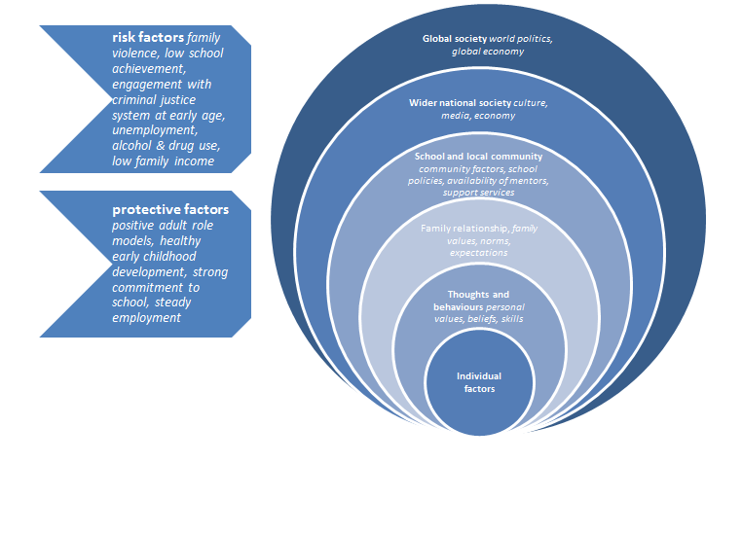

The role of local government in crime prevention
In Australia, federal and state governments are responsible for crime prevention policy and the overarching strategy or framework that outlines the goals, priorities and approaches to preventing crime. Relevant Departments typically then provide funding and technical advice to non-government organisations and local government authorities to plan and deliver crime prevention initiatives to support the implementation of these state and national priorities.

Local government plays a key role in creating the environment which supports health and wellbeing. The Public Health and Wellbeing Act 2008 requires councils to prepare a four-year municipal public health and wellbeing plan which sets goals and priorities to enable people living in the municipality to achieve maximum health and wellbeing. Feeling safe in the community enhances social connection and trust and improves health and wellbeing outcomes.

Local governments support community safety in many ways such as the provision of local services, creating opportunities for social participation, supporting culturally diverse communities and Aboriginal reconciliation, providing access to local facilities and undertaking strategic planning for health and wellbeing. Local government is well-placed to lead and participate in crime prevention activity. Most crime and immediate safety concerns for communities are local in nature, for example property crime, theft, antisocial behaviour and vandalism. Therefore the approach to preventing crime should also be locally tailored. Local government, due to its functions and relationships to the community and other key partners are well-placed to lead and coordinate this work.

Approaches to preventing crime
Effective crime prevention requires careful consideration of the evidence base with regard to identifying possible interventions, the circumstances in which these interventions will be delivered and how they will be adapted to suit local conditions. Crime prevention refers to the efforts to prevent crime and offending before it occurs. There are a variety of different approaches to preventing crime, and programs frequently involve multiple interventions delivered together.
Crime Prevention Approach | Description | Community Safety and Crime Prevention Committee agency
Information Gathering & Coordination | Needs identification, planning, collaboration, consultation, data and evidence gathering to inform local, tailored approaches | All
Criminal Justice Prevention | Traditional deterrence, incarceration and rehabilitation strategies within a law enforcement framework | Victoria Police  Department of Justice and Regulation
Situational Prevention | Improvements to physical environment - Crime Prevention Through Environmental Design, surveillance, 'target hardening'; strategies to increase the risk of offending behaviour | City of Whittlesea  Victoria Police
Social Prevention | Strategies designed to change social conditions that influence offending - social and economic drivers, strengthening community and social connection, improving education and employment opportunities; implementation of strategies aimed at preventing racism | City of Whittlesea  Hume Whittlesea Local Learning and Employment Network  Plenty Valley Community Health  Whittlesea Community Connections
Developmental Prevention | Intervening early to reduce risk factors and increase protective factors that affect the development of offending behaviour; prevention and early intervention programs, social support programs | City of Whittlesea  Northern Hospital  Plenty Valley Community Health  Uniting Care ReGen  Youth Support and Advocacy Service

Snapshot of local data

Perceptions of safety
Perceptions of neighbourhood safety are linked with health outcomes. When individuals perceive their neighbourhood as unsafe they are less likely to engage in outdoor activities and exercise and are more likely to experience increased anxiety, poor health outcomes and poor self-rated health. Conversely, when individuals feel safe within their community, they are more likely to experience greater levels of social connection and trust, and are more likely to become engaged with other members of the community.

The City of Whittlesea Annual Household Survey (2015) outlined that overall, a little less than one-third of respondents (30.9%) rated their perception of safety in public areas at night as ‘somewhat safe’ or ‘very safe’, whilst more than one-third (41.4%) rated their perception of safety at night as ‘somewhat unsafe’ or ‘very unsafe’. Their perception of safety in public areas during the day was rated as ‘somewhat safe’ or ‘very safe’ by a little more than two-thirds (69.6%) of respondents. Women, children, older adults and non-English speaking respondents were slightly more likely to rate their perception of safety at night in public areas as ‘unsafe’. Personal safety was identified as a barrier to visiting local open space by 13% of respondents. Compared to the previous survey in 2014, there was a large increase in 2015 in the number of households nominating safety, policing, crime and drugs as an issue – 14% of respondents compared to 8% in 2014.

This local data is supported by the Whittlesea Wellbeing Report developed as part of the VicHealth Community Indicators Survey 2012 which outlines residents’ perception of safety (walking alone during the day) is significantly lower than State average and that residents’ perception of safety (walking alone during the night) is less favourable than the State average.

Racism
Discrimination on the basis of race, religion, culture or ethnicity is a common occurrence for many members of the Victorian community. Racism can negatively impact a person’s ability to access resources and to positively contribute to the local community. There is evidence of strong links between racism and poor mental and physical health - experiencing racism in public spaces could be a barrier to using parks and open space and feeling engaged and accepted by the community more broadly. Research conducted by VicHealth in partnership with Melbourne University in 2014 found:
- 97% of those surveyed from the Victorian Aboriginal community had experienced racism in the previous 12 months and over 70% had experienced eight or more racist.
- Nearly two-thirds of those surveyed from CALD communities had experienced racism in the previous 12 months; with 40% experiencing six or more incidents.

Homelessness
Housing is a basic human need that contributes to individual and community safety, health and wellbeing. Contributing factors to homelessness include family violence, family breakdown, financial difficulties and unemployment. The homelessness population is more likely to be male; those ‘sleeping rough’ are more likely to be male although females are more likely to be engaged in a specialist homelessness service.
The rate of homeless persons in Victoria in 2011 was 42.6 per 10,000 population, compared to a national average of 48.9 per 10,000. Data specific for the City of Whittlesea is not readily available. Specialist Homelessness Services that provide support to people who are homeless report difficulties keeping up with the demand for housing and support services specifically for young people in the municipality aged 16 – 24 years.

Education and employment
The National Crime Prevention Framework identifies that the areas of greatest need for crime prevention interventions include communities with high rates of early school leaving and unemployment. In 2015, the percentage of the population unemployed in the City of Whittlesea was 7.4% for 25 to 44 year olds compared to 6.5% for the Northern Metropolitan Region of Melbourne and 5.7% for Victoria. For 45 to 64 year olds the percentage was 5.5% compared to 5.1% for the Northern Metropolitan Region and 4.4% for Victoria.

For young people aged 15 and 19 years old the percentage unemployed in 2015 increased to 32% from 25.9% in 2014; compared to 28% for the Northern Metropolitan Region and 21.5% for Victoria. For 20 to 24 year olds there are still higher rates of unemployment than the rest of the population in the City of Whittlesea; in 2015 21.5% were unemployed, up from 19.2% in 2014; compared to 14.5% for the Northern Metropolitan Region and 12.8% for Victoria. Data from 2011 reveals 9.2% of the City of Whittlesea's population aged 15 to 24 years were not employed or attending an education institute compared to 7.4% for Greater Melbourne. Further, this data outlines there are considerably fewer residents with a bachelor degree or higher degree compared with Greater Melbourne (13.5% and 23.6%, respectively).

Early childhood and Middle years’ development
Children's sense of safety and belonging at school has been shown to foster school success in many ways. When children feel their needs are being met at school, they are more likely to feel attached to their school. In turn, children who feel more attached to their school have better attendance and higher academic performance. These children are also less likely to engage in high-risk behaviours. The Australian Early Development Census (AEDC) measures children's health and development in their first year of full-time school. The domains are: physical health and wellbeing; social competence; emotional maturity; language and cognitive skills; communication skills and general knowledge. Taken together, these domains provide a holistic picture of children’s development and are important predictors of later health, wellbeing, and academic achievement. Investment in early and middle years during key transitions is a key social crime prevention approach.

The AEDC highlights what is working well and what needs to be improved or developed to support children and their families. Data for 2015 outlines that City of Whittlesea children are slightly more likely to be developmentally vulnerable on one or more domains, 20.9% compared to 19.9% for Victoria and; slightly less likely to be vulnerable on two or more domains, 9.7% compared to 9.9% for Victoria. Children developmentally vulnerable will experience a number of challenges in reading/writing, physical, emotional regulation, social and communication skills.

The time between 8 to 14 years is a period of important cognitive, social and emotional changes that establish their identity and set the stage for development in adolescence and adulthood. The Middle Years Development Instrument Well-Being Index is a composite score of five dimensions: optimism; happiness; self-esteem; general health and absence of sadness. The survey was developed in Canada and was trialed in Australia in 2013, with more than 6000 students from South Australia and Victoria taking part. The report for the City of Whittlesea shows 47% of Year 5 student respondents were rated as “thriving”, a further 25% rated “medium to high well-being” and 28% rated “low well-being”; compared to South Australian data where 40% were rated as “thriving”, 28% as “medium to high well-being” and 32% as “low wellbeing”.
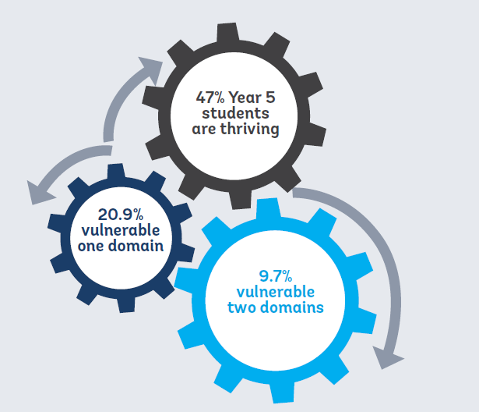

Socio-economic status
The Australian Bureau of Statistics broadly defines relative socio-economic advantage and disadvantage in terms of “people's access to material and social resources, and their ability to participate in society”. The Socio-Economic Indexes for Areas (SEIFA) are also used in models to assess risk factors for and impacts of crime. SEIFA ranks geographic areas across Australia in terms of their relative socio-economic advantage and disadvantage. The four indexes each summarise a slightly different aspect of the socio-economic conditions in an area. There are two general indexes of socio-economic disadvantage, an index for economic resources and an index for education and occupation.

SEIFA data from 2011 shows considerable socio-economic disadvantage within the City of Whittlesea. With a score of 989 on the Index of Relative Socio-Economic Disadvantage (IRSD), the municipality is the 38th most disadvantaged LGA in Victoria and the 6th most disadvantaged in Metropolitan Melbourne. This score indicates relatively greater disadvantage in general. For example, there are many households with low income, many people with no qualifications, or many people in low skilled occupations.

Financial vulnerability
Local contextual factors including financial vulnerability have been highlighted in data analysis and consultations. The high rates of residents with outstanding warrants (12.7%) and infringement notices (14.4%) of those issued in the Northern Metropolitan Region (2010-2011) contribute to higher crime rates for the municipality. Local stakeholder consultation determines this is both a contributor and an outcome of financial vulnerability. Additionally, there are other local financial vulnerabilities that could be contributing to increased risk factors for crime.
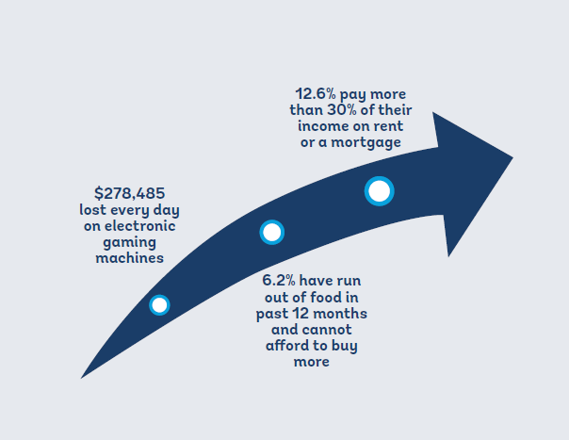

Alcohol and illicit drugs
Victoria Police data highlights the relationship between alcohol and crime (Figure 2):
- Almost half of all crime in Victoria in the last 12 months was committed by an offender processed for an alcohol-related offence that they had been charged for in the previous five years.
- One in three alcohol offenders are family violence offenders.
- Excessive consumption of alcohol is a driver of family violence assaults, property damage and justice procedure offences.

Figure 2: Alcohol and its impacts on crime and community safety

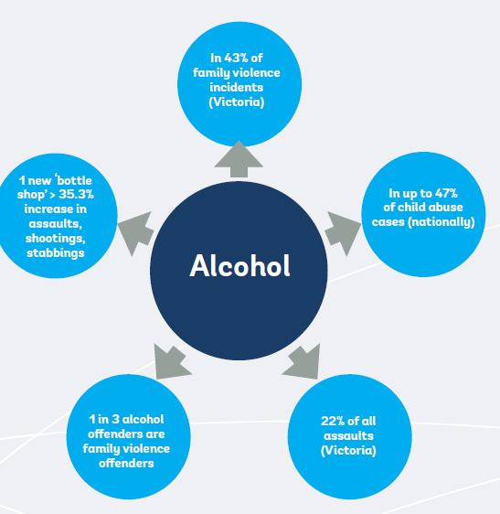

The City of Whittlesea accounts for 8.3% of drug offences for the North West Metropolitan Region offences and 3.1% for Victoria. While in the Northern Metropolitan Region the City of Whittlesea makes up 18% of the total number of drug offences.

Offender profile
The most recent data available outlines that at 30 June 2011, 2.7% of offenders on Community Correctional Services (CCS) orders or in prison were a resident of the City of Whittlesea at the time of sentence and 2.7% of parolees listed the City of Whittlesea as their place of residence upon release.

The Northern Metropolitan Region (NMR) as a whole exceeded the State average for the number of offenders living in the region at the time of sentence and parolees upon release per 100,000 of population as at 30 June 2011. The City of Whittlesea exceeded the State average only for the number of CCS offenders living in the LGA (not for parolees upon release).

It's promising to note that data for the period April 2015 to March 2016 alleged offender rate shows the City of Whittlesea has a lower offender rate compared to the North West Metropolitan Region (NWMR) and Victoria; 2,129 per 100,000 population compared to 3,072 for the NWMR and 2,842.2 for Victoria.

Crime
According to Crime Statistics Agency Victoria for the period of April 2015 to March 2016, the total number of offences for the City of Whittlesea was 14, 889 (refer Figure 3). Rates of crime are highest for Theft (2,652.1 per 100, 000 population, followed by Burglary/ Break and enter (851.7), Breaches of orders (679.5), Property damage (636.2) and Assault related offences (553.0) – refer Figure 4.

Figure 3: Offence categories (number) April 2015 to March 2016

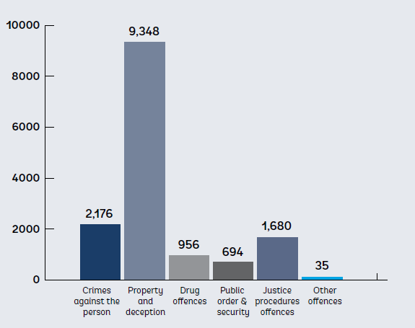
Figure 4: Offence types (rate per 100,000 population) April 2015 to March 2016
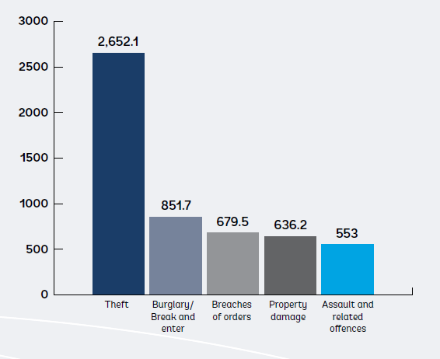

However, the rate of family violence incidents in the City of Whittlesea continues to be of concern with 1,392 incidents per 100,000 population; in comparison in Victoria the rate was 1,191.5 per 100,000. Alarmingly, family violence was the context for more than half of all recorded assaults and was the context for 38% of all sexual offences.

Further to this, despite the NWMR consistently having high rates of theft from motor vehicle offences, the City of Whittlesea has a rate of 921.9 per 100,000 population compared to 1,243.2. However, theft from motor vehicles remains a significant issue for local police and is one of the main drivers of local crime rates. The rate of residential burglary is also much lower than the rate for the NWMR and for Victoria, 449.3 per 100,000 population, compared to 627.7 per 100,000 and 520.0 per 100,000 for Victoria.
Despite the current lower rates of offending and of crime itself, is important to note that these rates change and fluctuate year upon year. When comparing the City of Whittlesea to only the Northern Metropolitan Region (NMR) which is seven municipalities (rather than the North West Metropolitan Region which is 14) the rates of crime and offending become more similar and in some cases are actually higher. For example the family violence incidents rates have been consistently higher than NMR for many years and even though in the most recent data theft from motor vehicles is lower than it has been, in previous years it has been one of the highest in the NMR – particularly in 2014.

City of Whittlesea Community Safety and Crime Prevention Strategy 2016-2020
The Community Safety and Crime Prevention Committee (CS&CP Committee) developed these ten goals and themes for the City of Whittlesea and the CS&CP Committee to work to achieve over the next four years. A detailed implementation plan for the CS&CP Committee has also been developed which outlines actions and evaluation measures and tools. The City of Whittlesea will continue to monitor crime and community safety perceptions data and trends as a tool to indicate progress and long term outcomes.

Goal 1: The built environment is safe, welcoming and promotes community connection

Theme: Safety in the built environment, parks and public space

Rationale: data and consultations identify varied perceptions of safety in suburbs across the municipality, negative perceptions of safety and experiences of racism in public spaces are barriers to residents using parks and open space

What success will look like over time: improved perceptions of safety

Tools to measure progress: Annual Household Survey perceptions of safety data

Goal 2: Crime against public and private property is minimised

Theme: Property crime and theft

Rationale: local data outlines public and private property crime and theft are the main drivers of the local crime rate; residents and police identify theft and break-ins as a significant concern

What success will look like over time: theft prevention approaches are effective and sustainable

Tools to measure progress: Evaluation and sustainability of local theft prevention approaches

Goal 3: Young people have education pathways and meaningful employment opportunities

Theme: Young people disengaged from education and employment
Rationale: local data outlines a concerning amount of young people disengaged and without meaningful pathways for education and/or employment; education and employment are key protective factors associated with crime

What success will look like over time: Increased employment opportunities and education pathways

Tools to measure progress: Hume and Whittlesea Learning and Employment Network data and trends, Reports from City of Whittlesea Jobs and Investment Strategy

Goal 4: Dangerous driving is minimised

Theme: Unsafe driving

Rationale: community consultations identify dangerous driving as a significant concern for residents’ safety; local support services also outline dangerous driving as a concern, particularly for young people

What success will look like over time: improved awareness of risk of unsafe driving

Tools to measure progress: Reports from City of Whittlesea Road Safety Strategy (in development)

Goal 5: Harms and negative impacts of financial vulnerability on community safety are minimised

Theme: Financial vulnerability and debt

Rationale: evidence outlines financial vulnerability is a key risk factor and an outcome of crime and negative community safety outcomes such as homelessness; local data reveals local factors exacerbating financial vulnerability

What success will look like over time: responsive initiatives reaching vulnerable groups

Tools to measure progress: Annual Household Survey financial vulnerability data, Reports from Department of Justice and Regulation on outstanding warrants and infringements and Victorian Sherriff data

Goal 6: Harms from alcohol are minimised

Theme: Alcohol
Rationale: alcohol use is a significant factor in many crimes; harms from alcohol use (either their own use or someone else’s) directly impact residents’ health, wellbeing and safety and local crime data

What success will look like over time: Responsive initiatives delivered in key settings to minimise harms from alcohol

Tools to measure progress: Victoria Police alcohol related family violence incidents data, ‘AOD stats’ – Turning Point, YSAS and ReGen data and trends, reports from Preventing Alcohol Related Harm in the City of Whittlesea Policy and Action Plan

Goal 7: Harms from illicit drugs are minimised

Theme: Illicit drugs

Rationale: like alcohol, illicit drug use is a significant factor in many crimes; harms from illicit drug use (either their own use or someone else’s) directly impacts residents’ health, wellbeing and safety and local crime data

What success will look like over time: Harms from illicit drugs are minimised

Tools to measure progress: ‘AOD Stats’ – Turning Point, YSAS and ReGen data and trends

Goal 8: Women and children live free from family violence

Theme: Family violence

Rationale: local family violence rates are higher than the State and many other municipalities; family violence is a contributor to other crimes and growing up within family violence significantly impacts children and young people’s development

What success will look like over time: Improved understanding and awareness of family violence, improved attitudes to gender equity

Tools to measure progress: Reports from City of Whittlesea Family Violence Strategy, Reports from City of Whittlesea Gender Equity Strategy, National Community Attitudes Survey

Goal 9: Employment programs are provided for key population groups

Theme: Education and employment

Rationale: local data outlines unemployment and disengagement; education and employment are key protective factors associated with crime

What success will look like over time: increased number of programs reaching residents who experience significant barriers to employment pathways

Tools to measure progress: number of programs available, reports from City of Whittlesea Jobs and Investment Strategy

Goal 10: Negative community safety impacts from electronic and online crime are minimised

Theme: Electronic crime and online safety for children

Rationale: stakeholder consultations outline limited local capacity and knowledge to address electronic and online crime; community consultations outline significant impacts and risks to the community particularly older adults and children;

What success will look like over time: Improved awareness of issues and impacts

Tools to measure progress: scoping reports outline local trends, number of education programs implemented and promoted

References

Warrants relating to Victorian Police issued (Type 1A, 1B and 1C), local government authority issued (Type 2) infringements and criminal and civil court (Type 3A and 3B) infringements.
Victorian Police issued (Type 1A, 1B and 1C) infringements
Municipalities of Banyule, Darebin, Hume, Moreland, Nillumbik, Whittlesea and Yarra
Municipalities of Banyule, Brimbank, Darebin, Hobson’s Bay, Hume, Maribyrnong, Melbourne, Melton, Moonee Valley, Moreland, Nillumbik, Whittlesea, Wyndham and Yarra
City of Whittlesea Community Safety and Crime Prevention Policy (2016)
Place Profiles City of Whittlesea Profile and Precinct Summary Snapshots, Version 2.1. Published January 2016
City of Whittlesea Reconciliation Action Plan 2014-2018
As above
City of Whittlesea Multicultural Plan 2014-2018
Place Profiles City of Whittlesea Profile and Precinct Summary Snapshots, Version 2.1. Published January 2016
Forecast.id (2014), City of Whittlesea Population Forecasts, http://forecast.id.com.au/whittlesea, accessed February 2014
National Crime Prevention Framework, 2012, Prepared by the Australian Institute of Criminology on behalf of the Australian and New Zealand Crime Prevention Senior Officers’ Group http://www.aic.gov.au/media_library/aic/ncpf/ncp_framework.pdf
Adapted from the United Nations Office on Drugs and Crime (2010) Handbook on the Crime Prevention Guidelines; Making them work. United Nations, New York. Cited in Community Crime Prevention Framework, Department of Justice, 2014, p. 8, http://www.crimeprevention.vic.gov.au/home/resources/the+community+crime+prevention+framework
National Crime Prevention Framework, 2012, Prepared by the Australian Institute of Criminology on behalf of the Australian and New Zealand Crime Prevention Senior Officers’ Group http://www.aic.gov.au/media_library/aic/ncpf/ncp_framework.pdf
VicHealth Safety Indicator Overview 2011
City of Whittlesea Annual Household Survey 2015 https://www.whittlesea.vic.gov.au/about-whittlesea/demographics-and-statistics/research-reports
Community Indicators Victoria 2012 Whittlesea Wellbeing Report http://www.communityindicators.net.au/wellbeing_reports/whittlesea
Building Respect: Whittlesea’s Anti-Racism Strategy 2015-2019, p. 4
Australian Bureau of Statistics, Census of Population and Housing: Estimating Homelessness, 2012 Australian institute of Health and Welfare, Specialist Homelessness Services 2012-13, 2013
ibid
City of Whittlesea Human Services Needs Analysis 2013
National Crime Prevention Framework, 2012, Prepared by the Australian Institute of Criminology on behalf of the Australian and New Zealand Crime Prevention Senior Officers’ Group http://www.aic.gov.au/media_library/aic/ncpf/ncp_framework.pdf
Source: Derived by NIEIR using ABS Census, ABS Labour force Survey, Australian Government Department of Employment Small Area Labour Market Statistics.
ibid
Source: Australian Bureau of Statistics, Census of Population and Housing, 2011 (Enumerated data) Compiled and presented in atlas.id by .id, the population experts.http://atlas.id.com.au/whittlesea#MapNo=10048&SexKey=3&datatype=1&themtype=1&topicAlias=disengaged-youth&year=2011
Middle Years Development Instrument Australia – Community Data Whittlesea LGA October 2013
Australian Early Development Index Community Profile Whittlesea 2015 https://www.aedc.gov.au/ClientData/CommunityProfiles/20075.pdf
About the ADEC domains https://www.aedc.gov.au/resources/detail/about-the-aedc-domains
South Australian Department for Education and Child Development 2013 Middle Years Development Instrument Australia https://decd-sa.govcms.gov.au/department/research-and-data/middle-years-development-instrument-mdi/about-middle-years-development
Middle Years Development Instrument Australia – Community Data Whittlesea LGA October 2013
Australian Bureau of Statistics SEIFA – Advantage and Disadvantage: The concepts http://www.abs.gov.au/ausstats/abs@.nsf/Lookup/by%20Subject/2033.0.55.001~2011~Main%20Features~Advantage%20&%20Disadvantage:%20The%20Concepts~10000
Australian Bureau of Statistics, 2013, 2033.0.55.001 Census of Population and Housing: Socio-economic Indexes for Areas (SEIFA), Australia 2011, Canberra: ABS
Department of Justice Infringement Management and Enforcement Services (IMES) Data 2010/11
Victorian Responsible Gambling Foundation (VRGF)
City of Whittlesea Annual Household Survey 2015 https://www.whittlesea.vic.gov.au/about-whittlesea/demographics-and-statistics/research-reports
Atlas i.d Social Atlas, City of Whittlesea: Housing Stress, 2011, http://atlas.id.com.au/whittlesea#MapNo=10215&SexKey=4&datatype=1&themtype=1&topicAlias=housing-stress&year=2011, accessed 29.01.14
Victoria Police Assistant Commissioner Luke Cornelius presentation to Local Government Alcohol and Other Drugs Forum (LGAODF) 2014
ibid
Turning Point AOD Stats Alcohol Family Violence, http://aodstats.org.au/VicLGA/ accessed 16.01.2015
Crime Statistics Agency Victoria, March 2015 to April 2016, http://www.crimestatistics.vic.gov.au/home/crime+by+location/
Source: City of Whittlesea Local Area Community Safety Plan 2012, Department of Justice Corrections Data 2010/11
Crime Statistics Agency Victoria ‘Recorded Offences’ http://www.crimestatistics.vic.gov.au/home/crime+statistics/year+ending+31+december+2015/recorded+offences
ibid
Crime Statistics Agency Victoria Alleged Offender Rate per 100,000 population by region and local government area, April 2011 to March 2016, http://www.crimestatistics.vic.gov.au/home/crime+statistics/year+ending+31+march+2016/download+data
Violence Against Women: Information and Facts 2014-2015, Women’s Health In the North, 2015, http://www.whin.org.au/images/PDFs/FViolence/FVFactsheets2014to2015/FV%20Factsheet%2015%20-%20Whittlesea.pdf
Crime Statistics Agency Victoria 2016, Steal from a motor vehicle offence rate per 100,000 population recorded in North West Metro region by LGA (data requested by City of Whittlesea)
Crime Statistics Agency Victoria Residential Burglary Offence Rate April 2014 to March 2015

