City of Whittlesea Cultural Heritage Strategy 2019-2025

Table of Contents

Acknowledgments

On behalf of the City of Whittlesea we recognise the rich Aboriginal heritage of this country and acknowledge the Wurundjeri Willum Clan and Taungurung Land and Waters Council as the Traditional Owners of this place.

Executive Summary
The City of Whittlesea Cultural Heritage Strategy 2019-2025 (CHS 2019-2025) is the second such strategic heritage document. It provides high level direction for Council’s work on tangible and intangible Aboriginal cultural and historic cultural heritage, community heritage, and the natural and landscape heritage of our city.
The Principles that underlie the CHS 2019-2025 are guides for how the organisation will identify, protect, manage and celebrate all forms of heritage. It is a whole-of-organisation Strategy that:
- Affirms that cultural heritage in all its forms is core business for the City of Whittlesea.
- Recognises Council’s roles for the protection, management and celebration of all aspects of cultural heritage.
- Identifies areas for action across relevant departments within the organisation to achieve Objectives over the next six years.

Our Objectives for 2019 to 2025 are to:
- Build knowledge and record tangible and intangible aspects of our heritage;
- Identify, protect and manage our cultural heritage places and assets;
- Promote and celebrate the diverse cultural heritage of our City;
- Build partnerships with external organisations and agencies and with our communities to extend and support heritage achievements; and

- Continue to take a leadership role in local government on strategies and innovations that address a range of entrenched and emerging cultural heritage problems and issues.

Our work will be undertaken using annual budget allocations, supplemented with grants and other support. The work will further benefit from strategic and operational partnerships with a range of external stakeholders.
We will continue to aim for a wide range of achievements to ensure that:
- Rapid growth in the municipality does not overwhelm Aboriginal, built and natural heritage places that are valued community assets;

- We take a leadership role to partner with external agencies, bodies and the development sector to capitalise on opportunities to protect and adapt heritage places;

- Increases understanding and promotes the role of cultural heritage as contributory to a sense of place, a design principle that highlights the values of built form and landscape for the future of our livable communities;

- We will take opportunities to support and promote all forms of community heritage;

- We will extend and promote protection, conservation and appreciation of all aspects of built and natural heritage through our statutory and community programs;

- We will focus on areas where greater protection is need such as dry stone walls and places that may have been overlooked in past heritage studies; and

- We will honour the cultural heritage of Aboriginal Traditional Owners by cooperating with community representatives and the State government to develop and adopt an Aboriginal Cultural Heritage Strategy.

Introduction
We acknowledge the rich and multi-facetted Aboriginal cultural heritage of Wurundjeri and Taungurung people who are the Traditional Owners of the place now known as Whittlesea. Figure 1 shows dark blue areas along the northern margins of the municipality that are traditional lands of Taungurung people. Taungurung lands are those where drainage from the top of the Great Dividing Range is to the north. Those areas where drainage is south toward Port Phillip Bay are Wurundjeri lands which cover the vast majority of the city.
Figure 1 Aboriginal Traditional Owner lands in City of Whittlesea
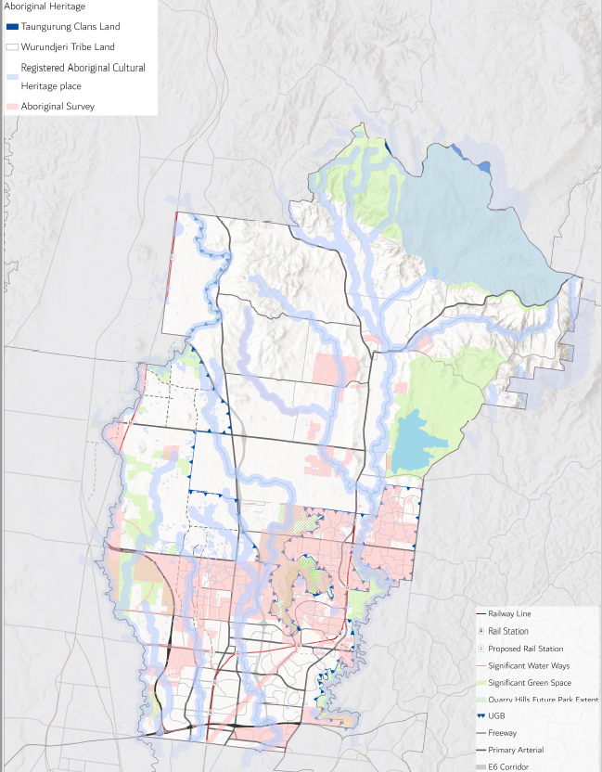
Source - Aboriginal Victoria

Aboriginal people would have moved and settled across the whole of the area now known as Whittlesea. Sites and areas of significance cover the entire municipality. Figure 2 shows the main areas of sensitivity for Aboriginal cultural heritage but these are not the only places where sites would be found. Identified sites and areas of Aboriginal heritage significance are everywhere, with concentrations along the Plenty River, Darebin, Edgars and Merri Creek corridors. These sites are substantial evidence of the wide ranging nature of the local subsistence and settlement pattern practiced by Australia’s people for tens of thousands of years, prior to the arrival of European and other settlers in the mid nineteenth century.

Figure 2 Areas of Aboriginal cultural heritage sensitivity in City of Whittlesea
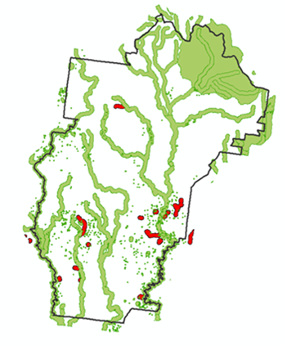
Source – Aboriginal Victoria https://achris.vic.gov.au/#/onlinemap

The CHS 2019-2025 also takes account of post-contact settlement history that begins in the mid-nineteenth century. Areas of Whittlesea were some of the very first where land sales took place and where people settled outside the original centre of Melbourne. Our dairying industry in particular was critical to population growth in Melbourne in the mid to late 19th century. The Yan Yean Water System located in Whittlesea, an engineering marvel of its day completed in 1864, was the first water storage and supply system for the city of Melbourne.

About 70 per cent of the City is our rural north, a designated as a Growth Area experiencing rapid change as traditional farming and grazing land is transformed by suburban expansion. The remaining 30 per cent represents our Established Areas, comprising residential developments, retail areas, industrial zones and large recreational facilities. For Council, this means that our heritage management issues must cover a wide range of challenges and opportunities for the protection and conservation of tangible assets in distinctly differing parts of Whittlesea, each with their own needs.

A full picture of cultural heritage also recognises the value of intangible heritage which provides the colour and meaning that enrich our understanding of community. Our heritage programs aim to capture and celebrate the cultural identity, traditions, events and interests of all members of our diverse community. The contributions of heritage to building and nurturing a sense of place are also important for long-time residents and businesses as well as new community members, business owners and visitors to Whittlesea.

Strategic Context
The CHS 2019-2025 is directly linked to Council’s Cultural Heritage Policy. The Vision of the Cultural Heritage Policy is that –
The City of Whittlesea is a vibrant and self-sustaining community where Aboriginal, natural and built heritage places are protected and where the heritage of our diverse community is valued and celebrated.

Links to Council policies, strategies and plans
A wide range of policies, strategies and plans support the objectives of cultural heritage at the City of Whittlesea including:

- Council Plan and Whittlesea 2040
- City of Whittlesea Municipal Strategic Statement
- City of Whittlesea Planning Scheme – including the Heritage Overlay, Clause 52. 33 for protection for Dry Stone Walls, and the River Red Gum Protection Policy
- Various Precinct Structure Plans, Urban Design Plans and Frameworks, endorsed or in development
- Cultural Heritage Policy 2015
- Integrated Cultural Plan 2006-2019
- Cultural Collection Strategy 2008-2012
- Multicultural Action Plan 2014-2018
- Festivals and Events Plan 2014-2017
- Tourism Strategy 2014-2019
- Stretch Reconciliation Action Plan 2017-2020
- Whittlesea Heritage Studies 1991 (Gould) and 2009 and 2013 (Context)
- Whittlesea Historical Archaeological Study, 2009
- Environmental Sustainability Strategy 2012-2022
- Green Wedge Management Plan 2011-2012 (in review)
- Open Space Strategy
- Whittlesea Township Strategy (in development)
- Roadside Management Strategy 1998 (in review)
- Local and Family History Strategic Framework, 2011-2016, at the Yarra Plenty Regional Library
- The Greater Whittlesea Framework Plan (in development)

Whittlesea’s CHS 2019-2025 draws on the Burra Charter (2013), a nationally recognised and applied set of principles and procedures for the conservation and management of Australia’s heritage places. https://australia.icomos.org/publications/burra-charter-practice-notes/

We also recognise and operate under the provisions of the following:

Commonwealth
- Aboriginal and Torres Strait Islander Heritage Protection Act 1987
- Environment Protection and Biodiversity Conservation Act 1999
State
- Planning and Environment Act 1987
- Heritage Act 2017
- Aboriginal Heritage Act 2006 and Guidelines 2018
- Taungurung Land Council Land Use and Activity Agreement and Natural Resource Agreement
- The State Planning Policy Framework
- Plan Melbourne (the metropolitan planning strategy)

Whittlesea 2040
Tangible and intangible cultural heritage fall broadly under two themes of Whittlesea 2040: A place for all, the over-arching document that sets out the long term vision for the City of Whittlesea and guides all of Council’s work and future partnerships with the community and others.

Theme - Liveable Neighbourhoods
Aboriginal cultural heritage places and areas of sensitivity, and historic cultural heritage places are protected by different legislation. All heritage places are visible reminders of our place on the historical continuum, and our care for them affirms that we value the past and the role it plays in our present and our future. Council’s role is to ensure that the provisions and requirements of heritage protection legislation are met by all relevant parties.

Heritage protection supports the contributions that places make to well-designed neighbourhoods and vibrant town centres. The cultural heritage policy in the City of Whittlesea planning scheme, along with compliance with local and state heritage protection legislation, provide foundations for retention and integration of places into the overall character, amenity and diversity of our urban growth areas. Redevelopment in the established areas affords opportunities for adaptive re-use and new life for heritage buildings as residences, childcare centres, commercial offices and other permitted uses. This has two-fold benefit: as contributors to sustainable development which retains existing structures rather than favouring demolition and new-build; and by contributing to housing diversity and amenity in our suburbs and developments. Integration of historic dry stone walls in housing developments contributes to landscape and open space character across the municipality and reminds us of the early farming heritage of our city.

Ongoing heritage research and studies are generated to inform planning scheme amendments that protect heritage in our urban and rural environments. Recent examples of work include the City of Whittlesea’s dry stone wall thematic history and mapping project. These pieces of work will build on Council’s heritage studies (Gould 1991 and Context 2009, 2013) which demonstrate the historical themes that link heritage places in the municipality.

In terms of tangible and intangible Aboriginal cultural heritage, the Aboriginal Heritage Study, commencing in 2020-2021 will enable Council to build a clearer picture of areas of sensitivity for Aboriginal site locations which will be more fine-grained and detailed than current information. Opportunities to work with our Traditional Owner groups on the project will support their own heritage objectives and will expand broader community understanding of the period before mid-nineteenth century contact. The Study will also highlight areas where partnerships with Traditional Owners will build knowledge and where further research and/or protection strategies are needed.

Theme - Connected Community
Recognising tangible and intangible cultural heritage for the Victorian Aboriginal community will be increasingly important as Treaty is negotiated between Traditional Owner groups and the State of Victoria. While we aim to embed understanding and initiate action on Aboriginal cultural heritage whenever opportunities are presented, Council will be guided by our Traditional Owners and Elders about the ways that we can support social and cultural identity and community cohesion.

Council plays an important role to support and celebrate contemporary cultural and community heritage in the City. Methods of connecting with traditions and the past include through public art and community festivals, and participation in local heritage programs and groups. We aim to build on traditions of the past in a variety of ways by enhancing connections in our city now. Support for the cultural heritage of our diverse community is an important opportunity to provide modes expression that affirm the multicultural, pluralistic make up of culture in our city. In turn that supports good mental health, family connections and community cohesion.

Council’s roles
Local government has a number of key roles when delivering outcomes, services, and programs for our communities:

Council can be a provider and directly undertake work to support a strategic objective. Council can advocate for works on behalf of its community. Council can support the work of others in the role of facilitator.

Local government plays an important role in heritage conservation, from statutory protection, to managing change, and celebrating Victoria’s diverse cultural heritage. Heritage roles and responsibilities for the City of Whittlesea include:

- Understanding the values of our heritage, for people today and in the future;
- Sustaining those heritage values into the future – through planning, protection, management, adaptive re-use, and interpretation;
- Communicating and educating about the values of our cultural heritage to residents and visitors;
- Celebrating and supporting the heritage and cultures of different communities; and
- Partnering with others – government, organisations, businesses and the community - to achieve mutual goals.

As a municipality spanning both rural and urban environments, the City of Whittlesea faces a broad range of heritage challenges. These include the pressures to identify and protect tangible and intangible Aboriginal and historic cultural heritage; ongoing expansion in our growth areas which affects heritage places and features such as dry stone walls; creating identity and a sense of place for new communities; and providing leadership and support for heritage in a rapidly changing environment.

Scope
The Project Plan, Objectives, Outputs and Measures of success for the CHS 2019-2025 were endorsed by the Executive Leadership Team of Council in November 2018. Following the format of the earlier Cultural Heritage Strategy, consultations for the 2019-2025 version were completed with Council departments and officers to nominate work that will take place. That work forms the annual internal Action Plan for Council departments, organised under the key Objectives of the 2019-2025 Strategy. Staff and budget resourcing for this forward plan of action are developed and endorsed each year.

Achievements
Appendix One summarises the Achievements of the first Cultural Heritage Strategy 2015-2018. Broadly we have been able to deliver the following outcomes:

Community outcomes
- Increased understanding of the values of our heritage, both internally and externally, and implications for our communities today and into the future.
- Alignment of Council’s strategies with community expectations about protection of heritage places, and celebration of our diverse community history and heritage.
- Increased communication and education about the values of our cultural heritage to residents and visitors through diverse channels (e.g. social media, exhibitions, television programs developed by Council, positive media stories – reach in the last two and half years was to 530,000+ people)..
- Increased knowledge and understanding of both tangible and intangible aspects of cultural heritage (e.g. diversity of heritage places, value of oral history, aims for conservation, increased access to archival resources, programs that include all cohorts of the population, increased attention to Aboriginal cultural heritage).
- Contributions to the ongoing development and vibrancy of our cultural heritage through support for community groups and organisations.
Compliance
- Protection, management and care for Aboriginal, natural and built environment heritage places (e.g. addition of heritage places and precincts to the Heritage Overlay; improved objectives, policies, mapping and data for heritage asset and site protection).
- Improved protection and integration of heritage values through our land use planning decisions, protection regime, place management, support for adaptive re-use, and requirements for cultural heritage interpretation.
- Delivery of studies, reviews and similar work that address gaps in our knowledge and protection of cultural heritage assets and places (e.g. dry stone wall research and mapping; preparations for the Aboriginal Heritage Study underway).

Organisational/business efficiencies

- Partnerships with state government agencies, developers and businesses, and the community significantly develop, increase and broaden our abilities to achieve mutual cultural heritage goals.
- Access to expert heritage advice which places Council in the best possible position to make strategic and operational decisions regarding cultural heritage objectives.

Looking Forward
This section presents the Vision, Mission and Principles that will underpin our work on cultural heritage through to 2025. The Vision is drawn from our Cultural Heritage Policy. It expresses the City of Whittlesea’s commitments. The Mission for the Cultural Heritage Strategy is the action statement that aligns with the policy Objectives. The Principles provide the guiding statements about how we will conduct business, focusing on the roles and responsibilities of the City of Whittlesea as a local government organisation.

Vision
The City of Whittlesea is a vibrant and self-sustaining community where Aboriginal, natural and built heritage places are protected and where the heritage of our diverse community is valued and celebrated

Mission
The City of Whittlesea is a place that respects all aspects of our tangible and intangible cultural heritage. Together with the Aboriginal Traditional Owners and the broader community we will:

- Identify and know the tangible and intangible aspects of our cultural heritage;
- Protect, manage and care for our Aboriginal, natural and built environment heritage places, material culture, history and traditions;
- Record and share our stories to promote and celebrate the diverse cultural heritage of our City;
- Communicate and celebrate the richness of our cultural heritage in all its forms;
- Contribute to the ongoing development and vibrancy of our cultural heritage; and
- Integrate heritage into the future of our new communities.

As a local government the City of Whittlesea carries out key responsibilities that will enable us to deliver on our Mission:

- A custodian and owner of a number of cultural heritage places, objects and collections which we will care for in a manner that follows best practice and continuous improvement, to acquit our responsibilities;
- A statutory planning authority, fulfilling statutory obligations to identify and protect cultural heritage places and the values they represent;
- A strategic planning authority, establishing decision-making parameters to support solutions designed to ensure heritage values are recognised and respected and that change, development and growth do not overwhelm important attributes of places;
- A leader in community building, fostering cultural development through a commitment to local heritage and its expression in all forms, both traditional and contemporary; and
- A repository of information and knowledge that enables us to build understanding, and share information about cultural heritage through public engagement, projects and initiatives and through partnering with other heritage agencies and external stakeholders.

Principles
The Principles of the Cultural Heritage Policy and Strategy 2019-2025 align with our corporate documents as well as sector and industry principles for cultural heritage protection, management and celebration in Victoria and Australia:

Making connections – connect residents, business owners, visitors and others through shared understanding about the value of heritage as a part of Australia’s culture. Council aims to support all aspects of cultural heritage in Whittlesea that contribute to maintaining traditions and the celebrating the cultures that make up our diverse City.

Creating identity and a sense of place - by identifying, protecting and celebrating tangible heritage and intangible expressions of culture we aim to sustain a sense of place for residents, workers and visitors to the city. Sense of place distinguishes what makes the City of Whittlesea unique and different from other places.

Sustaining places – we will fulfil legislative requirements and local government responsibilities for the identification and protection of places of Aboriginal, built and natural cultural heritage significance in our established suburbs as well as formerly rural areas where rapid growth is taking place.

Telling stories - reinforcing community values in the City by engaging our diverse community in cultural heritage in ways that are contemporary, inclusive and accessible.

Taking part – support for programs and activities that encourage community involvement with cultural heritage as participants, volunteers and active community members, increasing awareness about the need to identify, protect and celebrate the City of Whittlesea’s diverse cultural heritage.

Strategic Objectives and Performance Measures

The Strategic Objectives and Measures endorsed for the CHS 2019-2025 are presented below in Table 1.

Table 1 CHS 2019-2025 Objectives and Measures

Strategic Objectives | Measures
- Build knowledge and record tangible and intangible aspects of our heritage. | - Number of projects completed or implemented to increase staff and public access to documentation and other information about cultural heritage.  - Internal heritage database continually improved through the addition of reports, studies, and other information for listed heritage places in the City of Whittlesea.  - City of Whittlesea Aboriginal Cultural Heritage Study adopted and implementation commenced.
- Identify, protect and manage our cultural heritage places and assets. | - Amendments approved as required for the Whittlesea Planning Scheme to add new places to the Heritage Overlay.  - Activation and use of Whittlesea Courthouse and Ziebell’s Farm heritage places improved.  - Dry stone wall map, database and statements of significance completed to support existing policy and improve protection.  - Annual expenditure for the care and maintenance of Council-owned heritage places.  - Cultural heritage protection is incorporated in precinct plans, strategies, projects and programs as appropriate.  - Development proposals are reviewed to ensure protection of listed heritage places and celebration of community history and heritage.
- Promote and celebrate the diverse cultural heritage of our City. | - Annual support provided by Council to local organisations for cultural heritage events.  - Number of times Council’s communication tools promote information and access to Whittlesea’s cultural heritage to the public.  - Number of cultural heritage exhibitions annually.  - Elected members receive current information on Council’s heritage achievements.
- Build partnerships with external organisations and agencies and with our communities to extend and support heritage achievements | - Annual number and value of Cultural Heritage Program Grants provided to community organisations/groups.  - Number and value of projects, initiatives and presentations completed with external partners.
- Continue to take a leadership role in local government on strategies and innovations that address a range of entrenched and emerging cultural heritage issues | - Number of opportunities taken to assist other local governments, community organisations and others on heritage matters.  - Through our partnership with the Victorian Planning Authority, Precinct Structure Plan Guidelines are adopted for Victoria which include a new Heritage focus, linked to two Manuals to provide heritage guidelines and tools for users.  - Heritage Coordinator is a member of a Local Government committee(s) which supports heritage improvements in Victoria.

Rationale for the CHS 2019-2025
The CHS 2019-2025:
- Aligns with the adopted Cultural Heritage Policy, Vision, Mission and Principles;
- Provides the whole-of-Council framework to guide and coordinate the City of Whittlesea’s actions on the organisation’s diverse heritage roles;
- Sets out an overarching strategic Vision, Mission and Principles for decisions about how to protect and manage tangible and intangible heritage in the City of Whittlesea; and
- Celebrates living culture and contemporary forms of cultural expression, while acknowledging the value of past heritage to our community.

The following drivers have been identified:
- Research indicates that Australians overwhelmingly believe that heritage is an important part of Australia’s culture (87.1%) and identity (92.3%) [from Irons and Armitage 2011];
- Protection and management of heritage places (Aboriginal, built and natural) contributes to a sense of place, as well as community identity, pride and overall wellbeing;
- The CHS unifies all cultural heritage in one document, and identifies the diversity of heritage work done across the organisation;
- The CHS provides a strategy to address gaps, create programs, engage community members, and build partnerships that support the Vision; and
- Reconciles and connects Aboriginal, historical cultural, natural and community heritage under one strategic Vision.

The following service needs and issues will be addressed by the CHS:
- Nominates accountability for delivery of outcomes and objectives;
- Coordinates implementation across 15 departments/teams in all 5 Directorates, supported by the role of the Heritage Coordinator (governance);
- Ensures Council is in the best strategic position to fulfil our legislative obligations with regard to identification and protection of Aboriginal, built and natural heritage places, through access to expert advice and guidance, and additional staff training;
- Management of 26+heritage places owned by Council, including planning for adaptive re-use where applicable;
- Increases awareness across the organisation of the values that cultural heritage contributes to sense of place, community identity and overall community wellbeing; and
- Delivers specific projects – Aboriginal Heritage Study and implementation; Conservation Management Plans for more Council-owned heritage places; implement policy and guidelines to manage developer transfer of heritage places to Council ownership; support for private owners of heritage places; improved dry stone wall protection through use of LiDAR mapping, thematic history and classifications and statements of significance; adaptive re-use of Council-owned heritage places; alignment with urban design and community infrastructure objectives; and annual celebration of local history and archaeology.

Review and Monitoring

Performance Measures

Using measures to report against performance indicates both the efficiency and effectiveness of work done by the City of Whittlesea to deliver the Strategic Objectives of the Cultural Heritage Strategy through to 2025.

Table 1 sets out the Performance Measures that will be assessed annually to track performance, currency and relevance of the Cultural Heritage Strategy. We will also aim to ensure that the strategic directions and objectives remain relevant, achievable and measurable over time.

Appendix One presents a review of achievements of the Cultural Heritage Strategy 2015-2018 period. The review summarises:

- Achievements for cultural heritage, assessed against performance measures;
- Changing circumstances that may have had an impact on the City’s capacity to direct resources to this area; and
- Emerging issues and new priorities.
The Achievements Report assist s the organisation to build its reputation and credibility for action on cultural heritage with a range of stakeholders. In turn that will enable the City of Whittlesea to influence and advocate for improvements in cultural heritage with community partners, the development industry, and State and Commonwealth levels of government.

Implementation
Implementation of the Cultural Heritage Strategy 2019-2025 will be managed and monitored by the Heritage Coordination position. The role supports and contributes to an understanding of the broad responsibilities for cultural heritage in local government and at the City of Whittlesea.

Outputs, Consultation and Resourcing
Outputs
The outputs of the CHS 2019-2025 are:
- Summary of Achievements of the CHS 2015-2018;
- Strategy 2019-2025, organised under five key Objectives;
- Performance Measures;
- Staged annual implementation plan and timelines (internal);
- Identification of responsible departments and/or teams for deliverables and (internal); and
- Identification of works that can be accomplished with Council resources (staff, recurrent budget) and where external resources will be needed (internal).

Consultation
- Feedback and engagement of community members with Council through participation on formal committees (Westgarthtown Pioneer Precinct Committee; Cultural Heritage Committee in CCD) for management of Council-owned sites, and programs that address the cultural heritage of our diverse community;
- Integration of public comments on strategic land use planning and permits affecting heritage places; and
- Internal stakeholders are consulted/approve implementation plans – 15 departments/teams with responsibility for implementation.

Resourcing
The project to develop and adopt the CHS 2019-2025 was be undertaken by the Heritage Coordinator with existing budgeted salary.
The proposed resourcing of implementation of the CHS 2019-2025 will identify works that can be accomplished with Council resources (staff, recurrent budget) and where external resources will be needed. This follows the model of the CHS 2015-2018 in which 52 of 63 actions (82.5%) were resourced by Officer Time and recurrent budget:
- Expenditure across 15 (formerly 16) departments in the period 2015-2018 was calculated to be $100,000 annually (excluding salaries) including the fees for the use of external consultants to provide expert heritage advice (a Panel of Heritage Providers was established in 2015). Similar annual expenditure is anticipated for the 2019-2025 CHS;
- External funding of projects delivered through our partnerships in 2015-2018 is harder to calculate but it is estimated that the value of two Mernda archaeological projects with Heritage Victoria, Parks Victoria, and the Level Crossing Removal Authority would have been $72,000 (2016) and $85,000 (2017). An ANZAC commemorative project in Mernda was delivered with a $19,000 contribution from a developer. Objectives of the 2019-2025 CHS to build partnerships and deliver heritage outcomes would utilise a similar approach to funding heritage projects; and
- Major projects such as adaptive re-use of Council owned heritage places, requiring capital works, would be the greatest cost linked to the CHS 2019-2025. Such projects would aim to attract external funding for the development of community infrastructure and economic development (jobs and tourism).

References

Heritage principles and practice guides
- Australia ICOMOS, 1999. The Australia ICOMOS Charter for the conservation of places of cultural significance (The Burra Charter), Burwood.
- Australian Heritage Commission, 2002. Ask First: a guide to respecting Indigenous heritage places and values, Canberra.
- Australian Heritage Commission, 2002. Australian Natural Heritage Charter. Australian Heritage Commission, in association with the Australian Committee for the International Union for the Conservation of Nature (ACIUCN).
- Heritage Victoria, 2006. Victoria’s Heritage: strengthening our communities. Heritage Victoria, Melbourne.
- Heritage Victoria, 2010. Local Government Heritage Strategies. Heritage Victoria, Department of Planning and Community Development, Melbourne.
- Melbourne Water. Preserving and promoting our cultural heritage, Cultural Heritage Strategy 2008-2011
- Office of the Victorian Government Architect, 2016. Good Design + Heritage, Issue 07, Melbourne.

Strategic planning and policy documents
- City of Whittlesea Planning Scheme
- City of Whittlesea, Cultural Collection Strategy, 2008-2012
- City of Whittlesea, Draft Environmental Sustainability Strategy, 2012-2022
- City of Whittlesea Open Space Strategy
- Yarra Plenty Regional Library, Life Stories, Local and Family History Strategic Framework, 2011-2016
- City of Whittlesea, Green Wedge Management Plan 2011-2021
- City of Whittlesea, Strategic Community Plan 2025
- City of Whittlesea, Integrated Cultural Plan, 2006-2019
- City of Whittlesea, Local Conservation Strategy, 2000
- City of Whittlesea Planning Scheme, River Red Gum Protection Policy
- City of Whittlesea, John Patrick Pty Ltd, Street Tree Master Plan, 2000
- Heritage Victoria, 2010 Local Government Heritage Strategies Information Guide
- Heritage Victoria, 2007. The Heritage Overlay: Guidelines for assessing planning permit applications. Public Draft February 2007. Heritage Victoria, Melbourne.
- Moles, Jenny 2007. Review of heritage provisions in planning schemes: Advisory Committee Report.
- The Heritage Chairs and Officials of Australia and New Zealand, 2008. Supporting local government in heritage conservation. Discussion paper prepared by Lisa Rogers, Heritage Victoria as part of the HCOANZ Supporting Local Government Project.
- The Heritage Chairs and Officials of Australia and New Zealand, (no date). Making good local heritage decisions. Local government heritage guidelines: a national guide. Prepared as part of the HCOANZ Supporting Local Government Project.

Heritage Studies
- Context,2013. Whittlesea Heritage Study
- Context 2010. Whittlesea Historical Archaeology Study
- Gould M, 1990. Whittlesea Conservation Study
- Hicks, P. 1991. Whittlesea Heritage Study. Report prepared by Meredith Gould Architects.

Archaeological studies
- Du Cros, H and D. Rhodes. 1998. An Assessment of Aboriginal Archaeological Sensitivity of the Waterways and Floodplains of the Greater Melbourne Area. Report to Melbourne Water Corporation.
- Ecology Partners and Vincent Clark, 2006. Whittlesea Transit Corridor Project, Railway Reserve Keon Park to Whittlesea Station. Unpublished report.
- Ellender, I. 1989. The Plenty Valley Corridor. The Archaeological Survey of Aboriginal Sites. Unpublished report for the Victorian Archaeological Survey and the Ministry for Planning and Environment.
- Ellender, I. 1998. The Riverside Reserve, South Morang an archaeological assessment of heritage values. Isabel Ellender.
- Ellender, I. 1990. The Middle Yarra. An Archaeological Survey. A report to the Victorian Archaeological Survey and the Department of Planning and Urban Growth.
- Ellender, I. 1991. Regional Archaeological Investigation of the Plenty Valley Corridor. Occasional Report 40.
- Ellender, I. 1996. The South Morang Local Structure Plan Area: An Archaeological Survey of Aboriginal Sites. Report prepared for the City of Whittlesea Council.
- Hall, R. 1989. Merri Creek Parklands Aboriginal and Historical Heritage Study. Report prepared for the Merri Creek Bicentennial Committee and the Board of Works.
- Irons, J and L. Armitage. 2011. The value of built heritage: Community, economy and environment. Bond University, E Publications, Mirvac School of Sustainable Development. http://epublications.bond.edu.au/sustainable_development/47/
- Light, A. and Associates, 2002. Land Holding 3, Kelvin Grove Estate, Whittlesea. Report prepared for Lawlor and Loy Pty. Ltd.
- Marshall, B. 1998. An archaeological survey of Mill Park Lakes Residential Development, South Morang. Report prepared for Silverton Limited.
- Murphy, A and L. Amoris, 2007. Lots 65 and 10 Ridge Road Whittlesea, Cultural Heritage Assessment. Unpublished report.
- Nicolson, O. 2006. An archaeological and heritage survey of land west of Plenty Road, South Morang, Victoria. Report prepared for Coomes Consultant Group.
- Schell, P. 1999a. Northwood Residential Subdivision; Cultural Heritage Study. A report to Coomes Consulting Pty Ltd.
- Schell, P. 1999b. Oakbank Residential Subdivision; Cultural Heritage Study. A report to Kindest Pty. Ltd.
- Schell, P. 2002. Proposed Whittlesea Effluent Re-use Site. Unpublished report.
- Scollay, M. 2012. Lalor, The Peter Lalor Home Building Co-operative 1946-2012
- Tardis Enterprises 2003. Yea Road/Whittlesea Rd Flowerdale. Unpublished report.
- Thompson, M. 2003. An Archaeological Survey of a Property North of Grants Road, Whittlesea. Report prepared for Coomes Consulting Group Pty. Ltd.
- Weaver, F. 1991. The Lower Plenty River Archaeological Survey: A Survey for Aboriginal and Historical Archaeological Sites, forming the Heritage Component of the Lower Plenty River Concept Plan. A report to the Melbourne and Metropolitan Board of Works.
- Weaver, F. 1992. The Lower Darebin Creek archaeological survey a survey for aboriginal and historic archaeological sites, forming the heritage component of the Darebin Creek Concept Plan. Report prepared for Melbourne Water.
- Webb, C. 1997. An archaeological survey of a proposed sewer line in the Gresswell Forest. Report prepared for K.A. Reed and Co. Pty.

Websites
- http://wikinorthia.net.au/
- http://whittleseahistoricalsociety.com.au/
- https://www.whittlesea.vic.gov.au/
- http://www.unesco.org/services/documentation/archives/multimedia/?id_page=13&PHPSESSID=cdf1c1b605ebc498950fa399d2ed8658

Appendix One

Achievements of the City of Whittlesea Cultural Heritage Strategy 2015-2018

Cultural Heritage Strategy 2015-2018 Achievement Report
January 2019

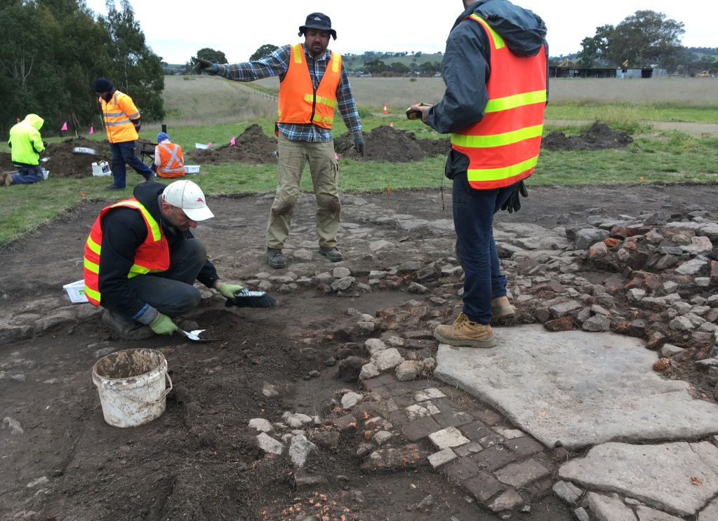

Excavation of the 1841 Old Bridge Inn Hotel, west shore of the Plenty River at Mernda, 2017. The project was a joint undertaking of the Level Crossing Removal Authority, Parks Victoria (the land owner), Heritage Victoria and Heritage Coordination at the City of Whittlesea.

1. Cultural Heritage Strategy 2015-2018

1.1 Background
The City of Whittlesea Cultural Heritage Strategy (CHS) 2015-2018 was the first overarching document adopted by Council which summarised a Vision, Mission, Principles, Aims and Objectives for the identification, protection and conservation, and celebration of all aspects of heritage. It is largely an internal strategic document although it nominates opportunities to work with external stakeholders to achieve outcomes. At the same time that the Strategy was endorsed in October 2015, Council also adopted the Cultural Heritage Policy.

1.2 Heritage Coordination
Implementation of the CHS is overseen by the Heritage Coordinator position which works across the organisation to support, advise and assist staff to fulfil obligations and deliver agreed actions in the CHS. The Heritage Coordinator is an internal reviewer of technical reports submitted for planning applications, and makes recommendation for heritage consulting work required by Council for internal purposes. The role also acts as a facilitator to assist and advise external authorities, organisations and community stakeholders on heritage matters.
The external focus of the role has also resulted in development and delivery of cooperative projects between Council and external agencies (Level Crossing Removal Authority, Yarra Plenty Regional Library Corporation, Heritage Victoria, Parks Victoria, Major Road Project Victoria, Working Heritage Inc) that have community heritage outcomes. The Heritage Coordinator also delivers strategic and operational projects within the portfolio, and represents the City of Whittlesea on external forums and committees.
The budget for Heritage Coordination increased threefold by 2018-19 but the global expenditure in terms of staff time and materials and services budget across the organisation is much greater. This reflects outputs as diverse as:
- completing studies and undertaking planning scheme amendments to add places to the Heritage Overlay;
- maintenance and upkeep at Ziebell’s Farm, a Council-owned heritage place listed on the Victorian Heritage Register for its state significance, and additional care of the grounds at the Westgarthtown Lutheran Church and Cemetery;
- designing and delivering a pocket park in Mernda that commemorates the service of ANZAC men and women in times of war;
- delivery of an annual calendar of heritage events;
- commencement of a project to enhance protection of drystone walls using LiDAR mapping; and
- participation in the excavation project for the 1841 Old Bridge Inn site on the Plenty River, and delivering a five week public exhibition about the project in cooperation with the Level Crossing Removal Authority.

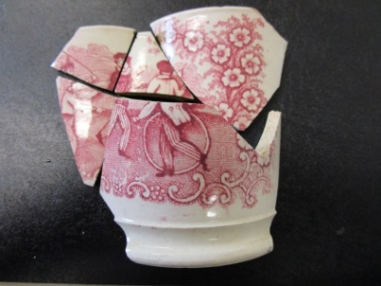

Artefacts excavated from the 1841 Old Bridge Inn site, Mernda: transferred-printed whiteware vessel; 1841 three pence coin; glass bottle stopers

2. Achievements of the CHS 2015-2018

  - Purpose

This report presents a summary of the achievements of the CHS 2015-2018 and sets the scene for the next Strategy from 2019-2025.

2.2 Achievements of the CHS 2015-2018

The term of the CHS 2015-2018 came to an end in November-December 2018. Achievements were reported to Councillors and the Executive of he organisation.

In the first two years of the CHS, work across the organisation:
- Generated increased enthusiasm for local history and heritage through our events and programs, new projects and increased opportunities for community engagement.
- Put in place strategic policies, development plans and formal guidelines, sourced expert advice, and provided training and resources for staff - all of which improve our decision-making capabilities for heritage protection.
- Placed Council in a leadership role in Victoria for heritage issues in the growth areas, and on broader issues such as the Heritage Act 2017 and Aboriginal Heritage Regulations.
- Provided opportunities and delivered programs that celebrate the diversity of cultural heritage of our residents, and found new ways to engage young people.
- Delivered innovative projects some of which were made possible because of our relationships with external partners, including two archaeological projects, and a place naming/community arts project to align with the national Centenary of ANZAC and WWI.
- Demonstrated that we incorporate heritage values into our strategic and statutory land use planning practices, and improved our protection of significant trees.
- Increased our comprehensive refurbishment, care and maintenance of heritage places owned by Council.
- Increased accessibility to our Civic History Collection through exhibitions and the Local History collection at our libraries.
- Provided coordination across the organisations and support for all staff addressing heritage issues, through implementation of the Cultural Heritage Strategy.
- Provided grants for local cultural heritage celebrations by community members.
- Established criteria for a major place naming review in the City of Whittlesea.

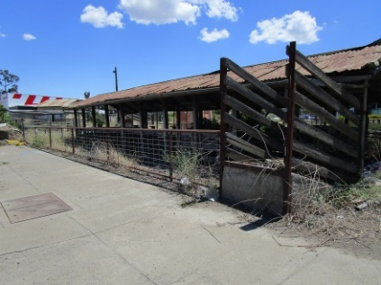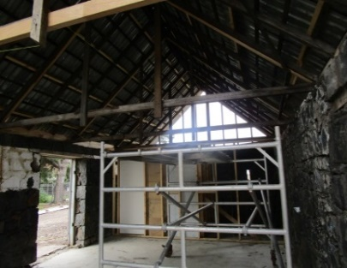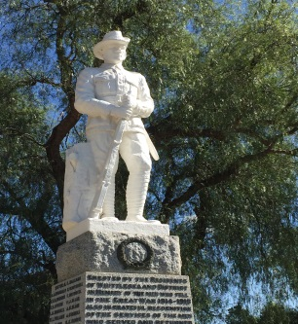

Early heritage fabric at the Morang Cattle Market, Plenty Road Mernda. Heritage Victoria and City of Whittlesea inspection of the redevelopment and conservation works at the Wuchatsch Farm site, Roberts Road, Thomastown, 2018. Whittlesea War Memorial, Church Street, Whittlesea.

In the final 12 months from November 2017 to November-December 2018 the Heritage Coordinator:

- Commenced for a project to examine the adaptive re-use of the Council-owned Whittlesea Courthouse; project stages included draft concept designs by heritage architect Peter Williams, completion of a feasibility study and ELT endorsement to proceed with developing a business case by June 2019;
- Lead changes that will improve heritage identification and protection in growth areas by working with the Victorian Planning Authority on final draft versions of a new Heritage section and Principles for statewide Precinct Structure Plan Guidelines, and two Manuals that will assist landowners and Councils to manage impacts on Aboriginal and historic cultural heritage;
- Marked the ANZAC Centenary by completing a place naming project in Mernda and restoring the Council-owned WWI Honour Board originally housed in Mernda School 488;
- Ensured Council planners have expert heritage advice for decision making – for the complex FABCOT application at Mernda; for drystone wall protection in Wollert; for developments in the Wollert area on Harvest Home Road, Saltlake Blvd, the Dance Palais and Post former Office, and two properties on Bindts Road, Wollert; on MacDonald’s Road, South Morang; for advice to owners of heritage places at Schultz Farm at Hansen Quarries in Mernda; and the former Morang Sale Yards site in Mernda and Pipeworks Park design in South Morang;
- Played a key ongoing role on the Local Government Advisory Committee to the Heritage Council of Victoria, especially to promote the use of Heritage Strategies by local government;
- Successfully raised the public profile of local heritage in cooperation with the Level Crossing Removal Authority to deliver the ‘Unearthed’ exhibition, a five week display on the history and archaeology of the Mernda area, including Aboriginal heritage and the results of excavation of the original 1841 Bridge Inn Hotel; approximately 14,000 people viewed the exhibition in Council’s Civic Center and the opening function was the launch of National Archaeology Week in Victoria in May; two days of public talks and hands-on heritage took place; media attention expanded the reach of key messages; and the exhibition received favourable mention in state parliament by local member Danielle Green;
- Established a supportive relationship with a state infrastructure delivery body, the Major Road Projects Authority, to help them understand and mitigate obligations to assess heritage impacts of four significant road widening projects in Whittlesea – Yan Yean Road, Plenty Road, Bridge Inn Road and Epping Road;
- Commenced Stage Two of a project to provide land use planners with improved tools to enhance protection of drystone walls; working with GIS team members, the project produced a LiDAR map of DSW across the municipality and developed an iPad app for easy standardised field recording; a consultant was appointed to write a Thematic Environmental History and statements of significance for DSW by June 2019; the aim is to draft planning scheme amendments in the following business year;
- Cooperated with community organisations in the City with an interest in history and heritage including the Whittlesea Historical Society, to gauge the size of their collection with a plan in mind to provide a home for them if development of the Whittlesea Courthouse site proceeds; and with the Whittlesea Agricultural Society to negotiate for them to receive some of the physical fabric of the former Morang Sale Yards for adaptive re-use at the Whittlesea Showgrounds;
- Developed external partnerships with organisations that can advance Council’s heritage agenda including commencement of discussions with Latrobe University Bundoora Archaeology Department about history and archaeology project opportunities for students and researchers in the City of Whittlesea; and
- Promoted community awareness of local history and heritage conservation through pre-approval of heritage street names for Mernda and Donnybrook sites, and a presentation to the Dry Stone Wall Association of Australia about Whittlesea’s project to enhance DSW protection.

Heritage work in other departments included:

- A focus on Planning Enforcement through cooperation with Heritage Victoria to inspect and monitor new residential developments at the Wuchatsch Farm site in Thomastown, to ensure conservation of the heritage fabric and landscape take place;
- Completion of the C209 planning scheme amendment by Strategic Planning and Design, including a successful Panel hearing, to add 9 sites and our first heritage precinct to the Heritage Overlay;
- Field views with Heritage Victoria and the Heritage Coordinator and completion of a draft report by Strategic Planning and Design to investigate archaeological sites shortlisted in a 2013 Context report, for possible inclusion on the Heritage Overlay;
- Support for public access to local history and heritage through a three year grant to the Friends of Westgarthtown from Leisure and Community Facilities ; the grant supports employment of an officer to assist the Committee to perform their volunteer work at the Council-owned Ziebell’s Farm and the Lutheran Church and cemetery at Westgarthtown;
- Cooperation by Information Management with two community members who wished to donate material to Council’s Civic History Collection;
- Inclusion of the Heritage Coordinator as a member of two new Council-wide coordination forums by Strategic Planning and Design – the Whittlesea Township Place Based Working Group and the Construction Management Plan Working Group; and
- A number of departments across the organisation now carry their own budgets for heritage work, an acknowledgement of increased awareness and commitment to heritage.

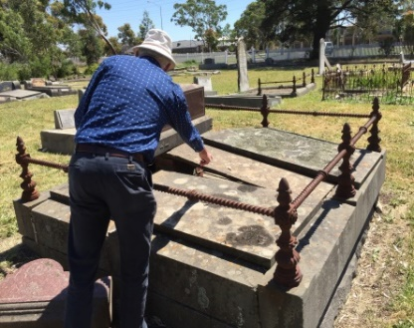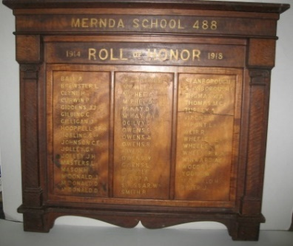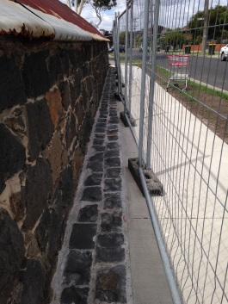

Material conservation specialist David Young at Epping Cemetery during training day for Council staff, 2016. Mernda School 488 WWI Honour Board before heritage restoration in 2018, coordinated by Information Management. Relocation of footpath adjacent to the barn at the Ziebell’s Farm site, Thomastown, by Parks and Open Space.

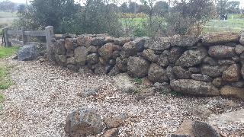

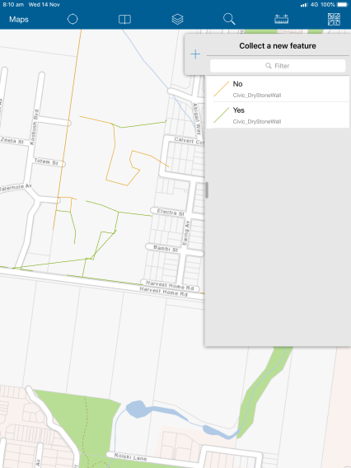

Dry stone wall mapping was advanced by the development of a field recording app by Council’s GIS Team and Heritage Teams.

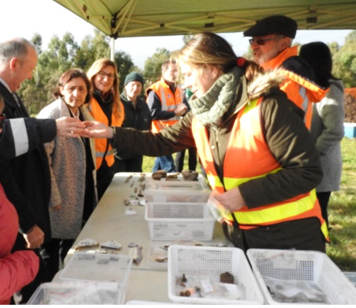

Community open day 2017 at the Old Bridge Inn excavations Mernda with Heritage Victoria Executive Director Tim Smith (looking at artefact), Minister and local Member Lily D ’Ambrosio, Local Member Danielle Green and Principal Archaeologists Dr Michelle Cleary and Dr Vincent Clark.

- Looking to the future

  - Outcome-focused achievements
The CHS 2015-2018 achieved a range of Outcomes around the following key themes:
Community outcomes
- Increased understanding of the values of our heritage, both internally and externally, and implications for our communities today and into the future;
- Alignment of Council’s strategies and plans with community expectations about protection of heritage places, and celebration of our diverse community history and heritage;
- Increased communication and education about the values of our cultural heritage to residents and visitors through diverse channels (e.g. social media, exhibitions, television programs, positive media stories – reach in three years was approx. 550,000 to 600,000 people);
- Increased knowledge and understanding of both tangible and intangible aspects of cultural heritage (e.g. diversity of heritage places, value of oral history, aims for conservation, increased access to archival resources, programs that include all cohorts of the population); and
- Contributions to the ongoing development and vibrancy of our cultural heritage through support for community groups and organisations.
Compliance
- Protection, management and care for Aboriginal, natural and built environment heritage places (e.g. addition of heritage places and precincts to the Heritage Overlay as needed; improved objectives, policies, mapping and data for heritage places, assets and site protection);
- Improved protection and integration of heritage values through our land use planning decisions, protection regime, place management, support for adaptive re-use, and requirements for cultural heritage interpretation; and
- Delivery of studies, reviews and similar work that address gaps in our knowledge and protection of cultural heritage assets and places

Organisational/business efficiencies
- Partnerships with state government agencies, developers and businesses, and the community that develop, increase and broaden our abilities to achieve mutual cultural heritage goals; and
- Access to expert heritage advice that places Council in the best possible position to make strategic and operational decisions regarding cultural heritage objectives.

  - Resourcing the future of cultural heritage
The proposed resourcing for implementation of the CHS 2019-2025 will identify works that can be accomplished with Council resources (staff, recurrent budget) and where external resources will be needed.
This follows the model of the CHS 2015-2018 in which 52 of 63 actions (82.5%) were resourced by Officer Time and recurrent budget. For example:
- Expenditure across 14 (formerly 15) departments in the period 2015-2018 was calculated to be $100,000 annually (excluding salaries) including the fees for the use of external consultants to provide expert heritage advice (a Panel of Heritage Providers was established in 2015).
- External funding of projects delivered through our partnerships in 2015-2018 is harder to calculate but it is estimated that the value of two Mernda archaeological projects with Heritage Victoria, Parks Victoria, and the Level Crossing Removal Authority would have been $72,000 (2016) and $85,000 (2017). An ANZAC commemorative project in Mernda was delivered with a $19,000 contribution from a developer. Objectives of the 2019-2025 CHS to build partnerships and deliver heritage outcomes would utilise a similar approach to funding heritage projects.
- Major projects such as adaptive re-use of Council owned heritage places, requiring capital works, would be the greatest cost linked to the CHS 2019-2025. Such projects would aim to attract external funding for the development of community infrastructure and economic development (jobs and tourism).
- From the foundations established since 2015, Council is in a strong position to apply for external grants to support heritage work.

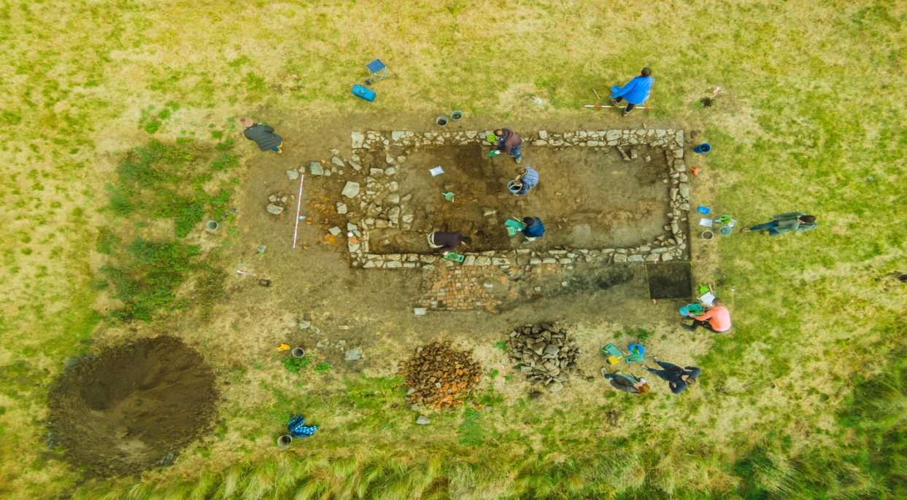

Aerial views showing remains of the Thomas Mill Cottage in 2015 (top) and 1841 Bridge Inn Hotel in 2017 (bottom) both located on the west side of the Plenty River, Plenty Gorge Park, Mernda and forming part of a significant historic cultural archaeological precinct.

