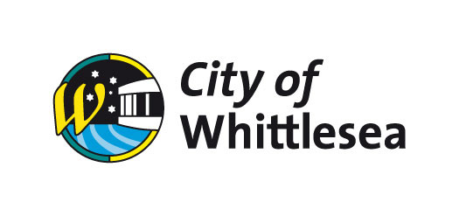

City of Whittlesea Gambling Strategy and Action Plan
2014 to 2024

Prepared by the City of Whittlesea in collaboration with Beverly Kliger & Associates:
- Meredith Carter
- Beverley Kliger
- Liss Ralston
- with expert advice from Professor David Hayward.

Table of Contents

Glossary 5
Foreword 6
Message from the Mayor 6
Introduction 7
Part One: Developing the Strategy 9
A vision for an integrated strategy 9
Our approach 10
The Broader Gambling Context 13
Online Gambling 13
Electronic Gaming Machines 15
Gambling on EGMs 16
A Community Health and Wellbeing Approach 17
Role of Local Government 19
Legislative Context 21
Local Government Context 21
Legislation Context of Gambling in Victoria 21
City of Whittlesea Policies 26
City of Whittlesea Shaping Our Future: Whittlesea 2030 Strategic Community Plan 26
City of Whittlesea Council Plan 2013-2017 Shaping Our Future 26
City of Whittlesea Recreation Strategy 2012-2017 27
Connect: A municipal plan for children, young people and their families in the City of Whittlesea 2013 to 2018 27
Local Planning Policies 28
Gambling in the City of Whittlesea 28
Electronic Gaming Machine maximum numbers 32
Regional Cap 32
Municipal Limit 32
Local Area Analysis 36
Measures of Vulnerability and Disadvantage 36
Local Area Analysis – Key Findings 40
Gaming Venue Type 41
Community Views 42
What the community said to inform the Strategy 43
Part Two: Gambling Strategy and Action Plan 2014 to 2024 45
Gambling Strategy and Action Plan 2014 to 2024 45
Actions and activities: 46
Objective one 46
Objective two 49
Objective three 51
Implementation 55
Monitoring and Evaluation 55
Appendix 56
EGM Licensing and Planning Permit Applications Process 56
Appendix A 56

Glossary
ABS: Australian Bureau of Statistics
ATM: Automated Teller Machine
ATSI: Aboriginal and Torres Strait Islander
CALD: Culturally and Linguistically Diverse
CBS: Community Benefit Statement
CSF: Community Support Fund
EGM: Electronic Gaming Machine
MAV: Municipal Association of Victoria
MSS: Municipal Strategic Statement
PGI: Propensity to Gamble Index
SEIA: Social and Economic Impact Assessment
SEIFA: A tool developed by the ABS that maps Social and Economic Indexes for Areas
VAMPIRE: Vulnerability Assessment for Mortgage, Petrol and Inflation Risks and Expenditure
VCAT: Victorian Civil and Administrative Tribunal
VCGLR: Victorian Commission for Gambling and Liquor Regulation
VCGR: Victorian Commission for Gambling Regulation
VLGA: Victorian Local Governance Association
Gambling: Gambling refers to any form of activity associated with gambling including gambling on electronic gaming machines and online gambling
Gaming : Gaming refers to gambling activity that is undertaken on electronic gaming machines
Problem Gambling: Problem gambling is characterised by difficulties in limiting money and/ or time spent on gambling which leads to adverse consequences for the gambler, others, or for the community.
Social Determinants of Health: The circumstances in which people are born, grow up, live, work, and age, and the systems put in place to deal with illness. These circumstances are in turn shaped by a wider set of forces: economics, social policies, and politics.

Foreword

Message from the Mayor
The City of Whittlesea is one of Australia’s fastest growing municipalities and a key issue facing the community is the impact of gambling – especially electronic gaming machines (EGMs) more commonly known as ‘pokies’.
The raw gambling figures for the City of Whittlesea can be sobering for anyone who reads them and concerning for a Council that exists to be of service to the community and to help that community achieve its aspirations.
In the 2013/2014 financial year, more than $96 million dollars was lost into EGMs in the City of Whittlesea. That’s over $260,000 per day – every day of the year.
The City of Whittlesea has a long-term commitment to reducing the harms associated with gambling, a position that works hand-in-hand with our goal of promoting health and wellbeing in the community.
This strategy reflects community concerns and expectations regarding gambling in the municipality and is a robust document that can be implemented and referred to for all matters relating to gambling in the City of Whittlesea
This strategy defines Council’s role and responsibilities over the next decade in managing gambling in the municipality and its commitment to supporting a ‘harm minimisation’ approach to gambling on EGMs and to a lesser extent, online gambling.
Council recognises that gambling is a legal recreational activity that forms part of a range of entertainment options available to our community, but understands that gambling has devastating impacts on the health and wellbeing of individuals, families and businesses throughout the City of Whittlesea.
I acknowledge and thank the many community members, service providers, community groups, local businesses, gaming venue operators and Council Staff for their contribution throughout the long consultation period to produce a considered, mature and responsible plan that addresses this important issue for the community.
Cr Ricky Kirkham
Mayor of City of Whittlesea

Introduction
Gambling is a multi-faceted industry that includes lotto, ‘scratchies’, table games, racing, sports betting, electronic gaming machines (EGMs) and online gambling. EGMs are the most dominant source of gambling losses in Australia.
The Productivity Commission Gambling Inquiry Report (2010) found that Australians spent $19 billion on gambling in 2008 to 2009 with $12 billion attributed to EGMs, this is an average of $1,500 per adult who gambled.
This Productivity Commission report found in Victorian the average EGM player today is spending more than was the case ten years ago. In Victoria the average EGM adult player was estimated to spend around $3,100.
EGMs are a common recreational activity and enjoyed by many, but they can have a detrimental effect. EGMs are associated with higher levels of gambling related problems than other gambling forms. Harm stemming from ‘problem gambling’ is not only upon the player (the individual), but can also affect family members, friends, local businesses and communities.
Local government has an important role in managing the impacts of gambling in local communities, particularly gambling on EGMs in hotels and clubs. The Planning and Environment Act 1987 and the Whittlesea Planning Scheme give Council the authority to assess applications for a planning permit in relation to gaming venues and EGMs within the municipality. The Gambling Regulation Act 2003 enables local government to make submissions to the Victorian Commission for Gambling and Liquor (VCGLR) on the social and economic impact assessment (SEIA) of an application for EGMs within its municipality or a neighbouring municipality.
Local government seeks to achieve the best outcomes for the local community, taking account of the long-term cumulative effects of their decisions in accordance with the Victorian Local Government Act 1989.
This Gambling Strategy and Action Plan 2014 to 2024 (the Strategy) supersedes the 2002 City of Whittlesea Responsible Gaming Strategy (2002 Strategy). This Strategy is Council’s commitment to ‘harm minimisation’ in association with gambling. Since the 2002 Strategy was developed, there have been significant regulatory and industry changes, new research, greater emphasis on harm minimisation approaches and community awareness. This Strategy aims to address the complex issues related to gambling or ‘gaming,’ while at the same time promoting healthy communities.
The Strategy responds to community concerns regarding the wellbeing of the community and in the context of legislation and regulation this includes the impact of gambling on EGMs occurring in hotels and clubs (venues) located in, or adjacent to, the municipality.
Importantly, the Strategy is consistent with the City of Whittlesea’s ‘social determinants of health’ approach that aims to protect community members who may be particularly vulnerable, including those who are socially isolated, live with mental illness, disability or on limited income. The Strategy recognises gambling on EGMs can harm the health and wellbeing of families and communities.
In 2012 to 2013 the City of Whittlesea experienced:
- The fourth highest net losses from gambling on EGMs in Metropolitan Melbourne $93,238,925
- Gaming losses that were 22.6 percent higher per capita than the average for Metropolitan Melbourne
- The highest losses per EGM for Metropolitan Melbourne at $153,353 which is 48.8 percent higher than the average losses for Metropolitan Melbourne
- The fourth highest Propensity to Gamble Index2 score for Metropolitan Melbourne
- The fourth highest losses by SEIFA index after Greater Dandenong, Brimbank and Hume.
The Strategy has two parts:
- Part One: Developing the Strategy
Outlines the methodology that developed and informed the Strategy, drawing on data, research and consultation findings documented in the City of Whittlesea Gambling Background Paper 2013 (Background Paper) and City of Whittlesea Gambling Strategy Consultation Report 2013 (Consultation Report).
- Part Two: City of Whittlesea Gambling Strategy and Action Plan 2014-2024
Defines Council’s role over a 10-year period in managing gambling in the municipality and commitment to supporting a harm minimisation approach to gambling on EGMs and to a lesser extent, online gambling. Additionally, it details recommendations for the Strategy’s implementation, monitoring and evaluation.

Part One: Developing the Strategy

A vision for an integrated strategy
In developing this Integrated Strategy, Council considered:
- The broader policy context and gambling trends
- Relevant State and Commonwealth government legislation and policies
- Alignment with Council’s corporate, social and land use policies; and,
- Community’s views via consultation and engagement.
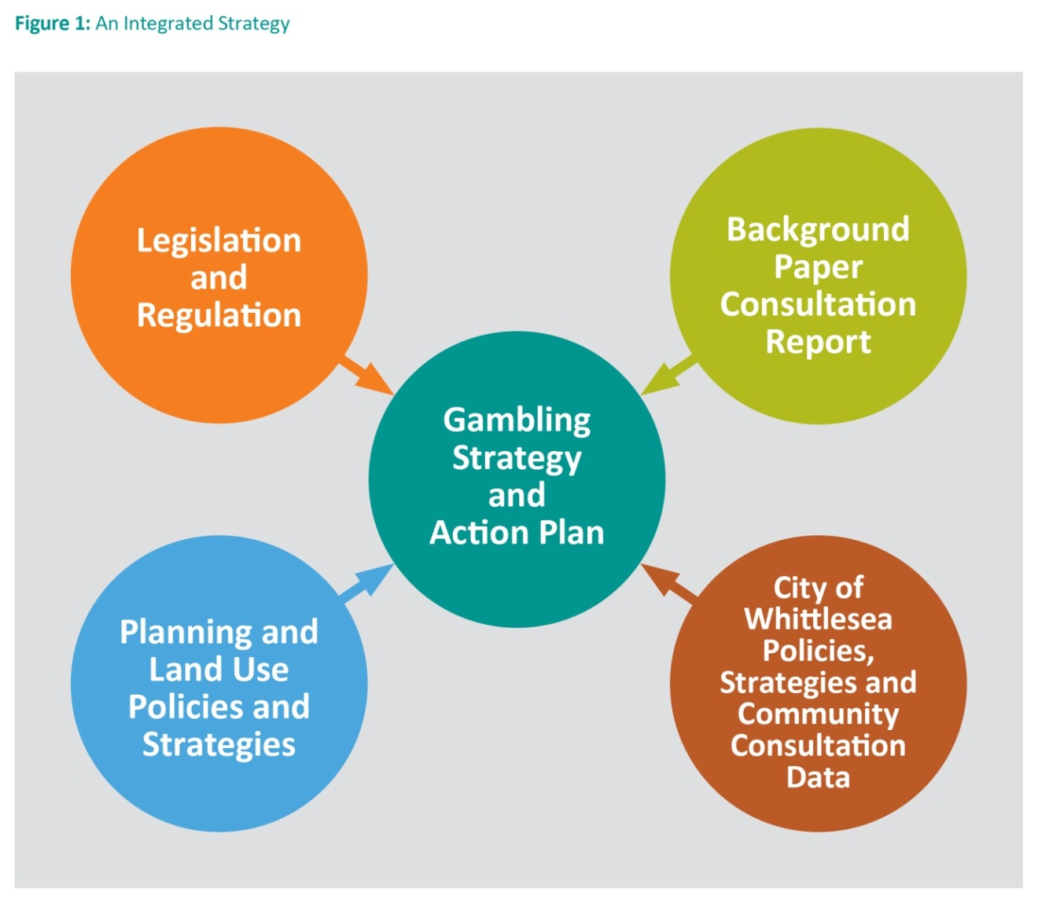

Our approach

Stage 1: Analysis and Consultation
A review of the previous 2002 City of Whittlesea Responsible Gaming Strategy (2002 Strategy) was undertaken. Since the 2002 Strategy was endorsed, there have been considerable changes to the gambling industry and the regulatory environment. In particular, the 2012 deregulation of the EGM market in Victoria, the increase of EGMs in the municipality and the very high losses (expenditure) on EGMs in the municipality.
This stage included the preparation of the:
- Background Paper
- Consultation Report
The Background Paper discussed the direction of the Strategy and includes information about EGMs in Victoria and the City of Whittlesea. It provides information on the Federal and Victorian Government’s actions, policies and legislative context related to gambling and clearly defines Council’s capacity, roles and responsibilities in reducing impacts related to EGM and online gambling. The Background Paper considers the social and economic impacts of gambling on local communities and current data showing the impact of EGM gambling in the City of Whittlesea.
The consultation focused on:
- EGM gambling data and trends in the municipality, including Council’s roles and responsibilities; and,
- Understanding local gambling issues and recommendations/opportunities for how Council can respond to gambling issues.
The Consultation Report summarised the key issues raised across the diverse stakeholder groups with regard to EGMs to a lesser extent online gambling and sets out recommendations for Council’s consideration.

Stage 2: Draft Gambling Strategy and Action Plan
The draft Gambling Strategy is the culmination of research and consultation. It outlined Council’s vision, position statement, objectives and actions focusing on EGM gambling and online gambling.

Stage 3: Final Strategy and Action Plan
Consultation focused on:
- Gambling issues that matter most to our community
- Prioritisation of actions
- Additional actions and gaps

Stage 4: Final Strategy and Action Plan
This stage incorporated community consultation feedback and key issues, ensuring the final Strategy reflects community concerns and expectations regarding gambling in the municipality.

Stage 5: Implementation Plan
An Implementation Plan to progress the actions outlined in this Strategy will be developed. It will also include monitoring and evaluation mechanisms to ensure that the Strategy is effectively being implemented in a changing legislative environment.

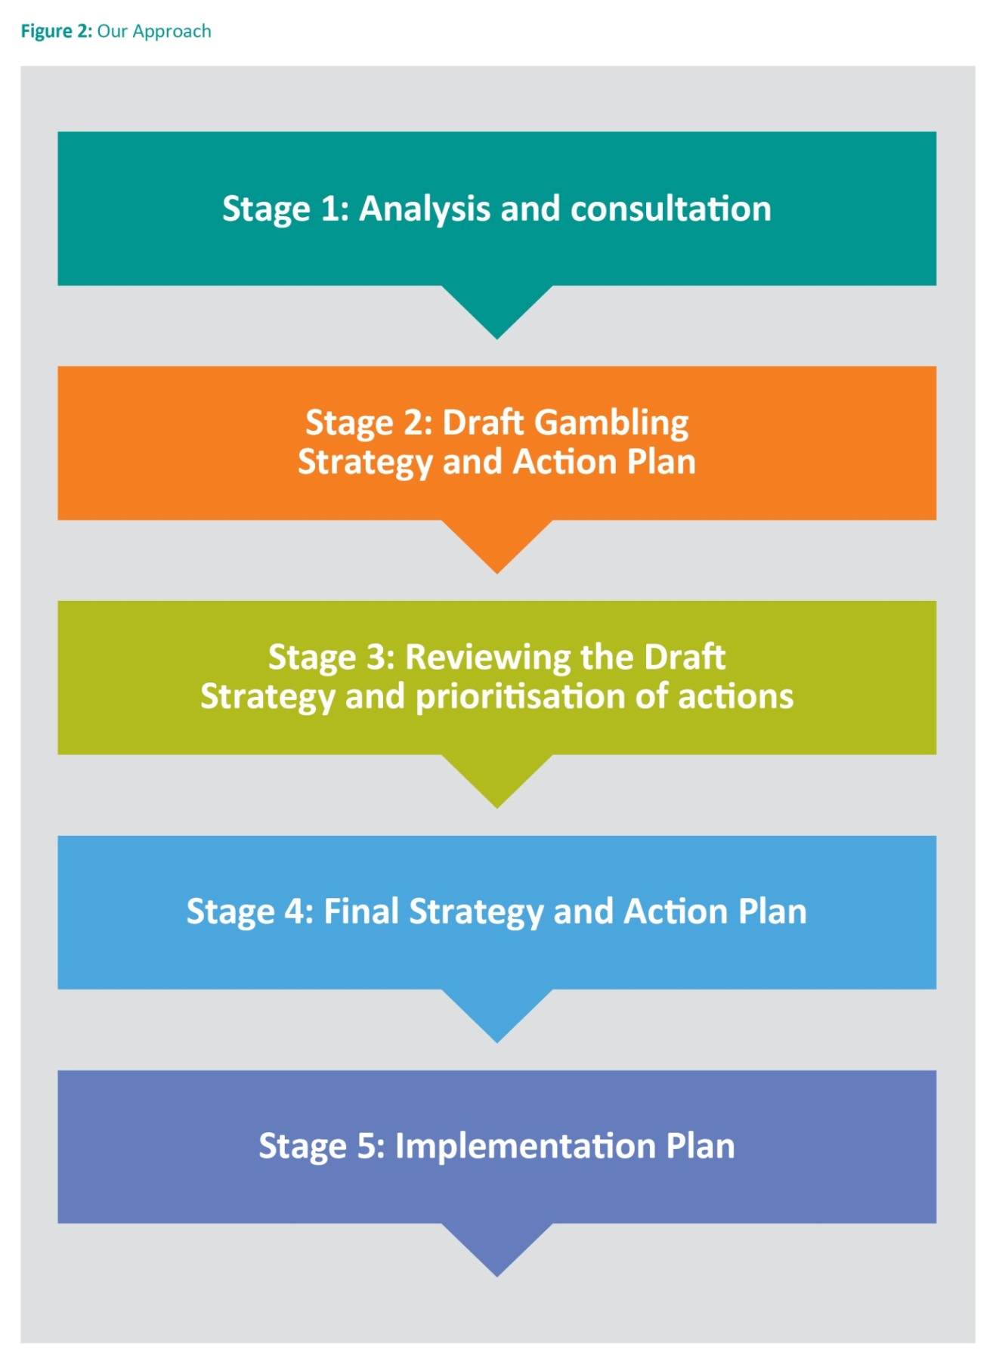

The Broader Gambling Context
Since the adoption of the previous 2002 City of Whittlesea Responsible Gambling Strategy numerous changes have occurred in the gambling industry, regulatory and local municipal environment:
  - the number of EGMs in the municipality has grown and expenditure per adult on EGMs per annum has risen
  - in 2006 State legislation gave authority to local government to determine planning permits for EGMs
  - in 2012 new arrangements to Victorian EGM licensing regime came into force
  - gambling has become more pervasive
  - in addition to EGMs there are a number of other legal gambling options available to the community. They include: Club Keno, lotteries, wagering (racing or sports betting), online gambling and bingo.

Online Gambling
Online gambling or internet gambling is essentially any gambling that occurs via the internet whether that is via a computer, mobile phone or other device.
Online gambling is regulated by the Commonwealth Government through the Interactive Gambling Act 2001 (IGA). The IGA targets the providers of interactive gambling services. It is an offence to provide interactive gambling service to Australian customers. However (the Act) does not prohibit access to online services, this means access to online gambling can be provided by overseas companies.
Online gambling includes the following:
- Online wagering – consisting of racing and sports betting
- Online gaming – poker, blackjack, baccarat, roulette and virtual EGMs
- Lotteries – such as Tattslotto, Ozlotto and Keno.
Many forms of online gambling are illegal in Australia, however it is estimated that Australians spend almost $1 billion on illegal internet casino, poker and bingo.
Online gambling may be bringing what was once an activity out of view of minors into the home. Research indicates online gambling attracts gamblers who tend to be male, younger, and wealthier, and have higher educational attainment than EGM gamblers.
Online gambling is not within the regulation of local government. It is the domain of Federal and State governments.

Electronic Gaming Machines
Losses on EGMs in the municipality have grown since 2002. The City of Whittlesea experiences very high losses compared to other Victorian municipalities.
Graph 1: EGM Gaming Losses per annum in the City of Whittlesea 1992-1993 to 2012-2013
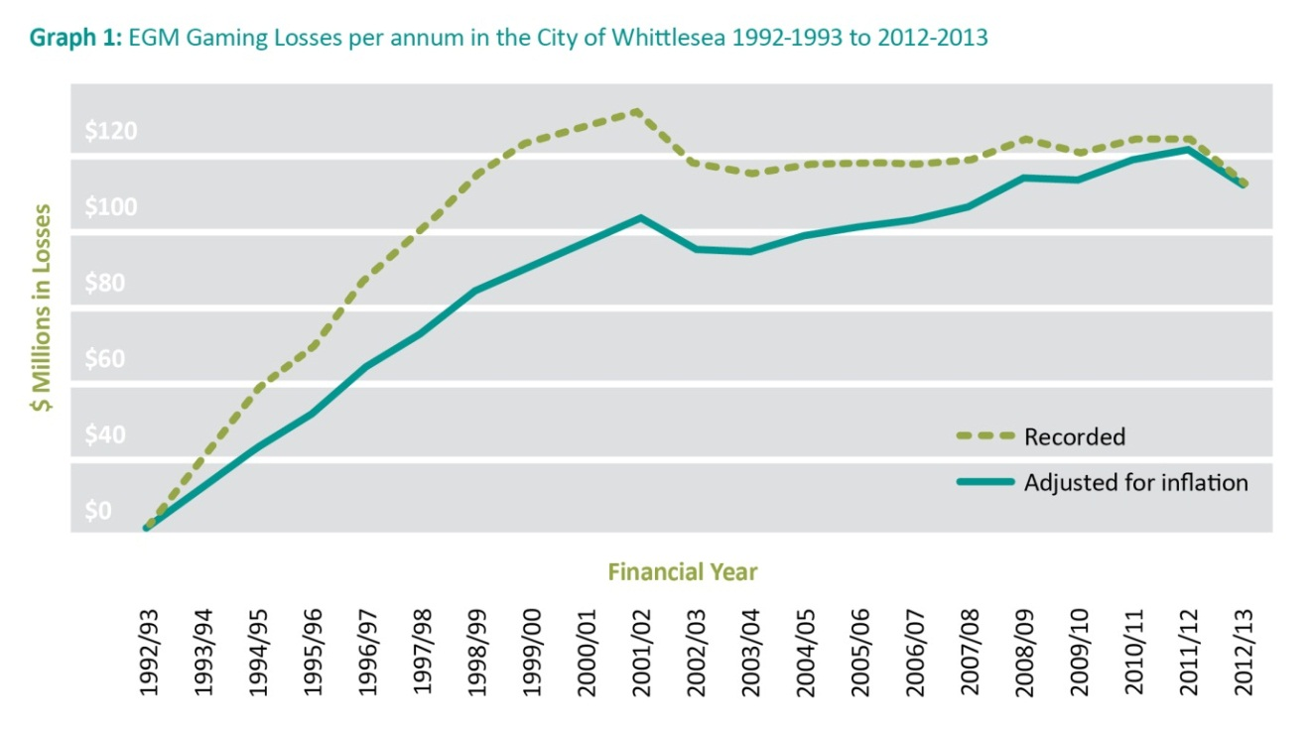
Source: VCGLR data and Statistical Data for Victorian Communities.
Graph 1 shows gaming losses reached a peak in 2001 to 2002 at $84 million. A decrease in gaming losses occurred across Metropolitan Melbourne between 2011 to 2013. It has been proposed the reduction is linked to the introduction of the State Government’s responsible gaming measure to ban the location of ATMs within gaming venues introduced on 1 July 2012.
There has been a significant increase in the number of EGMs licensed to operate in the municipality from 1992:
Year | Number of EGMs
1992 | 105
1994 | 295
1996 | 530
2000 | 616
2011 | 621
2013 | 651
2014 | 660
Following the changes to State legislation in 2012, there was some movement of EGMs out of the municipality.
There was also a Ministerial Order that determined the maximum number of EGMs for all municipal areas in Victoria not covered by a regional cap. Despite this, new venues continue to be established in the municipality and permits granted by the State government for additional EGMs at existing venues.
In 2012 to 2013 two venues in the City of Whittlesea had the highest EGM losses in Victoria (Epping Plaza Hotel and The Plough Hotel). Additionally the venue with the fifth highest losses in Victoria (2012 to 2013) was the Bundoora Taverner.
Gambling on EGMs occurs at venues located in or adjacent to the municipality and this directly impacts on local communities, individuals, families and businesses.

Gambling on EGMs
Gambling on EGMs can be characterised as an activity that:
- Is not a benign recreational activity (EGMs are designed to keep people playing and are located in venues that serve alcohol which can undermine players’ judgment)
- Has extremely low odds of winning and very high odds of losing
- Is primarily located in areas with a high proportion of disadvantaged households and can increase the disadvantage of individual gamblers, families, employers and community;
- Can redistribute local expenditure away from the economy to venue operators
- Is widely considered to be a public health issue as it could threaten the health of vulnerable individuals such as those suffering isolation, depression or limited income, and,
- Can have harmful effects on non-gamblers (for every problem gamblers 7 to 10 other people are affected).
- Factors known to exacerbate these risks include accessibility to gaming venues and extent of operating hours (e.g. based in shopping centres/strips and being open for 20 hours from 8am to 4am).
Council takes into account the whole community when there is an application to increase EGMs.
The impact of EGM gambling puts Australia well ahead of the rest of the developed world in terms of gambling expenditure. The detrimental effects of even modest gambling losses on affected families’ standards of living and on relationships within those families are well documented. The Australian Parliament research service has estimated that up to five million Australians may be affected each year, including friends, family and employers of people with a gambling problem.
There are many obstacles to quantifying the true social costs of problem gambling, however, the Productivity Commission assessed it as at least $4.7 billion nationally. The Victorian Competition and Efficiency Commission’s (VCEC) report estimates the social and economic costs in Victoria alone were likely to be between $1.5 billion and $2.8 billion in 2010 to 2011.
- The vast majority of the quantifiable costs came from costs associated with excess gambling expenditure by problem gamblers ($1 billion to $1.4 billion) and,
- The intangible costs associated with impacts on mental wellbeing, such as emotional distress due to depression and attempted suicides, for problem gamblers and their families ($400 million to $1.2 billion).

A Community Health and Wellbeing Approach
Many of the factors influencing health and wellbeing lie in the complex social, economic and physical environments in which people live.
A ‘social determinants of health’ approach identifies a critical need for action to address upstream social, physical, economic, and environmental factors such as education, employment, working conditions, income, and housing. This Strategy focuses on identifying priority areas and actions that facilitate and enhance healthy communities, recognising all Council departments have a role in creating positive healthy outcomes for the community.
Local government in Victoria has had a long-standing association with public health. Successful local public health strategies lead to the creation of communities and environments in which people can lead productive and rewarding lives.
Gambling on EGMs is widely considered a public health issue. The Department of Justice 2009: A Study of Gambling in Victoria Problem Gambling from a Public Health Perspective report states that ‘problem gambling is an important health and wellbeing issue for the Victorian community.
A comprehensive public health approach to gambling is being adopted by the City of Whittlesea. This approach considers the impact of gambling on the entire community, not just ‘problem gamblers.’ It applies a framework to develop a whole-of-community response to the harms caused by gambling.
This Strategy recognises that gambling is a lawful recreational activity that can impact the health and wellbeing of the community. This public health approach recognises the importance of prevention, community awareness, education, partnerships, policy, research development and targeted advocacy to achieve positive outcomes.
Consistent with the Productivity Commission 2010 report Council is committed to delivering strategies that focus on minimising the impacts related to gambling. This Strategy is underpinned by harm minimisation approaches that consider the health, social, environmental and economic consequences of gambling on both the individual and community. It will undertake a range of activities through partnerships to respond to the community, businesses and community organisations.

Role of Local Government
Governments at all levels have responsibility for gambling policy and strategy. Councils have specific roles relating to EGM gambling. This Strategy identifies four roles for Council outlined in Figure 3 below.
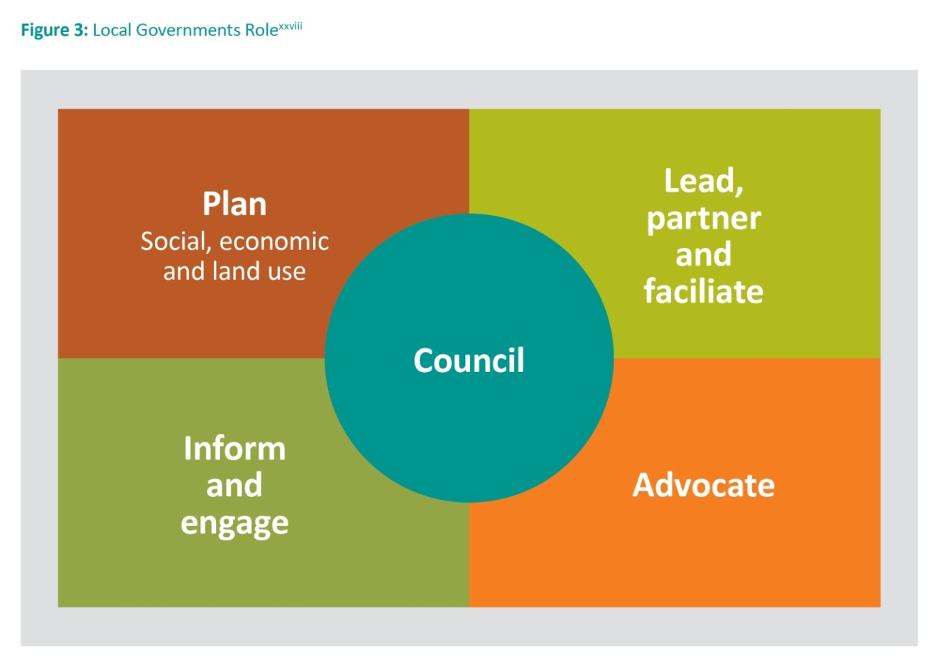

These four areas inform the vision, position statement and objectives contained within this Strategy.

Council Responsibility |  | Potential Actions
1 | Plan: Social, Economic and Land Use | - Review and analyse characteristics of the population and environment to determine any risks and impacts on public health as a result of new gaming machines and venues;  - Make determinations regarding planning permits and SEIA submissions to the Victorian Commission for Gambling and Liquor Regulation (VCGLR) for EGM license applications; and,  - Develop appropriate responses and strategies, such as a Local Planning Policy in Whittlesea Planning Scheme.
2 | Lead, Partner and Facilitate | - Work to develop a strong web presence aimed at engaging and informing the community and establishing a network of municipal leaders;  - Collaborate with Victorian local governments and community organisations; and,  - Engage with educational institutions to assess the impacts on the health and wellbeing of the community.
3 | Inform and Engage | - Educate and promote a range of alternative recreational and leisure activities; and,  - Collaborate with community, the business sector, residents and community organisations and other tiers of government.
4 | Advocate | - Consult, coordinate and facilitate Council’s participation in government, business and community alliances, working groups, forums and reviews.

Legislative Context
This section summarises the relevant legislation that relates to gambling in the municipality. It sets out recent review of State Government positions regarding local government’s role in relation to the social and economic impact of EGM gambling.

Local Government Context
Local government has a key role in promoting the general wellbeing of their community and has specific roles in relation to the management of electronic gaming in their municipalities.
Local government’s capacity to influence is linked to the current legislative framework as set-out below:

Victorian Local Government Act 1989
The primary objective of local government is to endeavour to achieve the best outcomes for the local community, taking account of the long-term and cumulative effects of decisions.
Consistent with this, Councils must develop a formal Council Plan and Strategic Resource Plans that address the needs of the community and have regard to the social, economic and environmental viability and sustainability of the local area.

Public Health and Wellbeing Act 2008
This legislation sets out the function of local government ‘to seek to protect, improve and promote public health and wellbeing within the municipal district.’
Further to this, the Act states the ‘precautionary principle’ – if a public health risk poses a serious threat, lack of full scientific certainty should not be used as a reason for postponing measures to prevent or control the public health risk.
Under this Act, local governments are required to develop a Municipal Health and Wellbeing Plan. The City of Whittlesea Health and Wellbeing Plan 2013-2017 is integrated in the Council Plan.

Legislation Context of Gambling in Victoria
The regulation of EGMs is also influenced by local governments. This arises from the interplay between two major pieces of State legislation; the Planning and Environment Act 1987 and the Gambling Regulation Act 2003.

Planning and Environment Act 1987
- The Act requires local governments to have a planning scheme to guide the use and development of land. The Whittlesea Planning Scheme provides this guidance through the State Planning Policy Framework, Local Planning Policy Framework (including the Municipal Strategic Statement), zones and overlays
- Councils also have a specific responsibility under the Planning Policy Framework to consider the social and economic impacts of EGMs in their municipality
- This Act gives Council as the responsible authority, the power to grant or refuse a planning permit for the installation or use of a gaming machine
  - Clause 52.28 of the Whittlesea Planning Scheme seeks to ensure:
  - That gaming machines are situated in appropriate locations and premises
  - That the social and economic impacts of the location of gaming machines in their municipality are considered
  - That gaming machines are prohibited in specified shopping complexes and strip shopping centres.

Gambling Regulation Act 2003
- This Act generally prohibits gambling and activities relating to gambling unless authorised under this Act or the Casino Control Act 1991. (s1.1(3)(a))
- It establishes a system for the regulation, supervision and control of EGMs
- The main objectives of this legislation are set out in section 1.1 (2) and include:
- To foster responsible gambling in order to:
- minimise harm caused by problem gambling; and
- accommodate those who gamble without harming themselves or others;
- To ensure that minors are neither encouraged to gamble nor allowed to do so;
- To ensure that gaming on gaming machines is conducted honestly;
- To ensure that the management of gaming equipment and monitoring equipment is free from criminal influence and exploitation.
- The Act established the VCGLR as an independent statutory body to oversee the conduct of gambling in Victoria and authority to grant or refuse an application for a gambling license; and,
- It enables Councils to make submissions to VCGLR in relation to the economic and social impact on community wellbeing and on surrounding municipal districts of applications by EGM operators for gaming machines or premises.

Victorian Commission for Gaming and Liquor (VCGLR) Bill 2011
This Bill allows for the regulation, investigation and discipline in line with the VCGLR Bill, Gambling Regulation Act 2013 and Liquor Control Reform Act 1998.
It is responsible for liquor licenses, registering EGM entitlements, approving venues as suitable gaming, and approving the operation of a specific number of EGMs in a specified venue.

Gambling Licensing and Planning Permit Applications
Having regard to the legislative context outlined above, two approval processes are required before a venue operator is permitted to operate a gaming premise and install EGMs.
These are:
- EGM licence approval through the VCGLR; and,
- EGM planning permit approval through local government. These processes are demonstrated in Appendix A.
It is at the discretion of the individual applicant whether these are sought at the same time or independent of each other. Depending on the type of application (planning permit or gaming licence) Council’s role, process and involvement differs.

Gaming Licensing – VCGLR Process
Venue operators must apply to the VCGLR when seeking to establish a new gaming venue or to vary a current gaming licence (additional EGMs). Pursuant to Sections 3.3.6 and 3.4.19 of the Gambling Regulation Act 2003 responsible authorities, typically the municipal Council may make a submission to the VCGLR regarding any application received.
In granting a gaming licence application, the VCGLR must be satisfied that the net social and economic impact will not be detrimental to the well-being of the community of the municipal district in which the premises are located. This is referred to as the ‘no net detriment’ test.
If a Council decides to respond to the VCGLR it needs to undertake an assessment to address the potential social and economic impact of the application on the local community. These assessments can often differ due to neighbourhood demographics and characteristics varying across the different parts of municipality.
Council’s submissions can indicate support or objection and/or request certain conditions, these must be considered within 60 days via the approved VCGLR Economic and Social Impact Submission Form.
The applicant or Council may seek a review of the VCGLR decision at the Victorian Civil and Administrative Tribunal (VCAT).
The VCGLR informs Council of a gaming licence application when it is submitted in neighbouring municipalities. Council can comment on or prepare a submission to the VCGLR on gaming licence applications in neighbouring municipalities, if the application is deemed to have an impact on the residents in the City of Whittlesea.

Planning Permit – Local Government Process
An application for a planning permit for a new venue or changes to an existing gaming venue must be submitted to the responsible authority. The Planning and Environment Act 1987 gives Council, the power to grant or refuse a planning permit for the installation or use of an EGM. Before deciding on an application any significant social and economic impacts must be considered. In addition Council must consider all other land use planning policies that may impact on the application, ie. its location, compatibility with adjoining and nearby land. Where Council decides not to issue a planning permit, the applicant may have the right to appeal at VCAT.
It is important to note that approval is required under both processes before the venue operator can install EGMs.

Review of Decisions from Authorities
The following points look at some of the commentary arising from the VCGLR, VCAT and Supreme Court hearing and appeal decisions related to EGM applications. Determinations made by VCAT and the Supreme Court provide important guidance for Councils. The following have been considered in the Strategy:
- A SEIA should be based on:
  - Well-grounded research that involves assessing net impact, balancing positive and negative social and economic impacts. As such the focus of the assessment must be on the expected impact of the approval, not on existing or average impacts. If the net impact of the test is positive or neutral, the test will be satisfied.
  - The net economic impact of problem gambling and the costs to families and/or of services dealing with problem gambling should be expressed.
  - The social and economic impacts do not need to be confined to the impact on already disadvantaged people as community wellbeing is important. Particular community apprehension about a gaming proposal may be highly relevant as community apprehension goes to the issue of social benefit or detriment.
  - Additionally, the impact of approval on surrounding localities is relevant.
- A local planning policy related to gaming in Council’s Planning Scheme is supported by VCAT.
- Gaming venues with existing use rights may not require a planning permit to ‘top up’ the number of EGMs. ‘Existing use’ rights may apply where there is no new development and the gaming venue has pre-2006 planning permits allowing a higher number of EGMs. The total EGMs after the increase must remain within 25 percent of the floor area available as per the existing liquor licence.
- Local government planning scheme controls such as the Municipal Strategic Statement, Structure Plans, Development Plans and Local Planning Gaming Policy are relevant for Planning permit decisions.
- Regional Caps and Municipal limits are not ‘aspirational’ levels for EGMs for an area. Being under the cap or limit does not imply that further EGMs can or should be approved by the VCGLR.
- Attending hearings at the VCGLR and the VCAT is imperative as reduced weight is given to Council submissions if Council is not present at a hearing.
- Blanket opposition to EGMs by local government will not be supported.
- VCGLR and VCAT will impose conditions on a grant of entitlement for EGMs or on a planning permit, such as transfer of EGMs from another venue in the municipality or increased specific community contributions.

City of Whittlesea Policies
The Strategy is strategically linked to a range of existing Council plans, policies and strategies:

City of Whittlesea Shaping Our Future: Whittlesea 2030 Strategic Community Plan
This was developed in collaboration with the community and sets-out a long-term vision to 2030 for the City of Whittlesea. It directly influences each four-year Council Plan along with other important Council decisions.
The Community Plan outlines seven future directions relating to:
- Inclusive and engaged community
- Accessibility in, out and around our city.
- Growing our economy
- Places and spaces to connect people
- Health and Wellbeing
- Living sustainably
- Good governance.

City of Whittlesea Council Plan 2013-2017 Shaping Our Future
This is integrated with the Municipal Public Health and Wellbeing Plan, due to the strong synergies between the provision of Council services and initiatives and the health and wellbeing of the community. Over the life of the Plan the actions will continue to build resilient communities and ensure that the City of Whittlesea remains an attractive, healthy and vibrant place to live, a desirable location to visit and a great place to do business.
The Council Plan adopts a social model of health, recognising that many factors influence both the health and wellbeing of individuals and of the community as a whole. It highlights that gambling losses in City of Whittlesea are close to the highest in the State.
Council’s commitment to public health and wellbeing priorities includes the strategic objective:
We take a preventative approach to health issues and health policy.
The specific Council goal states:
Council will work in partnership with community and service providers to reduce and minimise the negative social, economic and health impacts of gambling.
The preparation of the Strategy is in accordance with the Council Plan, goals and action plan.

City of Whittlesea Recreation Strategy 2012-2017
This aims to provide Council, in partnership with the community, a clear direction on how to create and fulfil a vision for leisure.
It contains thirty (30) recommended actions addressing:
- Policy
- Planning
- Built Facilities
- Programs and Services.
The Recreation Strategy articulates the need for alternatives to local EGM venues, often seen by people as local options for recreation that can alleviate feelings of disconnection or isolation. It is imperative that a range of non-EGM leisure and recreation venues and opportunities (such as libraries, sports clubs, and neighbourhood houses) are available.
The Recreation Strategy states:
Recreation plays an important role in promoting a sense of community, social inclusion and community wellbeing. Recreation facilities are recognised as important physical assets that contribute to providing a social focus and influencing people’s perception of their community.
Challenges to developing a full range of recreation and leisure opportunities and facilities include the considerable geographic distances and vast differences in community character and urban development of the municipality.
As well as supporting formal sport and recreation options, the Recreation Strategy acknowledges increasing trends towards informal leisure options. They include walking, aerobics/fitness, swimming and cycling.

Connect: A municipal plan for children, young people and their families in the City of Whittlesea 2013 to 2018
Connect is Council’s five-year plan to support the whole community with particular attention to children, young people and their families and carers. It is informed by demographic data, research evidence and community feedback, and has an emphasis on prevention, early intervention and creating resilient and cohesive communities.
The plan focuses on the following five strategic directions:
- Partnerships and continuous dialogue with children, young people, parents and the community;
- Family strengthening;
- Resilient and robust children and young people;
- Social and physical infrastructure for diversity, all ages and abilities; and,
- Opportunities to connect.

Local Planning Policies
Local planning policies provide guidance on how Council will use its discretion to make a decision under the Whittlesea Planning Scheme.
Council does not currently have a local gaming planning policy in the Whittlesea Planning Scheme to underpin planning permit decision-making with regard to applications for gaming permits. Clause 52.28 of the Planning Scheme sets out the decision guidelines for Council to consider before deciding on an application for a gaming venue.
Preparation of a local planning policy may enable Council to take account of:
- Social and economic impacts of the location of gaming machines;
- The compatibility of the proposal with adjoining and nearby land uses;
- What is encompassed in the full range of hotel or club facilities or services to members and patrons; and,
- Appropriate locations or premises for gaming.

Gambling in the City of Whittlesea
The City of Whittlesea is located on the urban fringe approximately 20 kilometres north of the Melbourne Central Business District. Covering 490 square kilometres, it is a large municipality containing established urban, growth and rural areas. The municipality includes the established areas of Lalor, Thomastown, Epping, Bundoora and Mill Park, the urban growth areas of Epping North, South Morang, Mernda and Doreen, the rural township of Whittlesea and the rural localities of Wollert, Beveridge, Donnybrook, Woodstock, Eden Park, Yan Yean, Humevale and Kinglake West.
The City of Whittlesea is a diverse community. With migrants from more than 140 countries, 30 percent of residents come from a country where English is not the first language (double the Victorian average) and 43 percent speak a language other than English at home. The most common languages used other than English are Italian, Macedonian, Greek, Arabic and Vietnamese.
To assist with analysis of the municipality, the City of Whittlesea has been divided into five areas using the Australian Bureau of Statistics (ABS) 2011 Census collection districts data³, allowing for long-term comparisons. The five areas are:
Established Bundoora | Bundoora North, Bundoora West
Urban Growth West | Epping, Wollert
Established West | Lalor, Thomastown
Eastern Whittlesea | Mill Park North, Mill Park South, South Morang Doreen, Mernda
Rural Whittlesea | Whittlesea Township, Donnybrook, Eden Park, Humevale, Kalkallo, Kinglake West, Woodstock, Yan Yean

In October 2013 there were nine gaming venues (five hotels and four clubs, see Map 1 for their locations) in the City of Whittlesea. At this time the VCGLR register recognised a total of 608 gaming machine entitlements and 651 EGMs ‘licensed’ in the City of Whittlesea (691 taking into account the 40 EGMs approved at the Bridge Inn Hotel, Mernda).
In 2012 to 2013 the City of Whittlesea experienced:
- The fourth highest net losses from gambling on EGM in Metropolitan Melbourne $93,238,925
- Gaming losses that were 22.6 percent higher per capita than the average for Metropolitan Melbourne
- The highest losses per EGM for Metropolitan Melbourne at $153,353 which is 48.8 percent higher than the average losses for Metropolitan Melbourne
- The fourth highest Propensity to Gamble Index score for Metropolitan Melbourne
- The fourth highest losses by SEIFA index after Greater Dandenong, Brimbank and Hume.
In the following year 2013 to 2014 the City of Whittlesea experienced:
- An increase in the number of EGMs from 608 to a total of 660 entitlements (691 licensed EGMs);
- An increase in the number of venues operating in the municipality from nine to ten;
- An increase in total net EGM expenditure to $96,219,037.65;
- A decrease in the number of adults (18 years +) per venue from 14,247 to 13,900;
- A gaming machine density of 4.75 EGMs per 1,000 adults, which is 15 percent less than the Melbourne Metropolitan average and 18.6 percent less than the Victorian average;
- Above-average gaming expenditure per head when compared with the Victorian and Melbourne Metropolitan averages;
- An average gaming expenditure per adult per annum of $692, which is 20.5 percent more than Metropolitan Melbourne and 27.3 percent more than the Victorian average.
A study by the Department of Justice (2009) found that 53.74 percent of EGM players travelled no more than 5 kilometres to a gambling venue, indicating that most people do not travel very far to access venues. Research shows that 90 percent of residents in Metropolitan Melbourne reside within 2.5 kilometres of a gambling venue (club or hotel), and 83 percent of players travel directly from home to a gaming venue.
Map 1 shows the location of EGM venues adjacent to the municipality as of June 2013. There are:
- 5 gaming venues with 273 operating EGMs, within a 2 kilometre radius
- 22 gaming venues with 1,275 operating EGMs, within a 5 kilometre radius
These venues had total gaming losses of $141,662,925. This is $48,424,000 more than the combined losses of all gaming venues in the City of Whittlesea in 2012 to 2013.
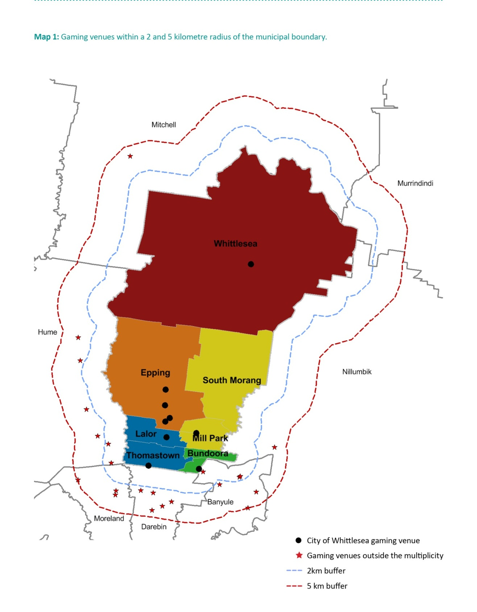

Electronic Gaming Machine maximum numbers
EGM caps and limits on entitlements were introduced by the State Government between 2001 and 2009 to restrict the number of EGMs in disadvantaged areas.
There are two forms of restrictions:
- A Regional Cap applies to areas that were ‘high ranking’ on measures of vulnerability to the potential harm caused by large numbers of gaming machines.
- A Municipal Limit applies to non-capped areas where the maximum number of EGMs is determined by using the benchmark of no more than 10 machines per 1,000 adults in the area. The calculation of adults in an area is based on the Australian Bureau of Statistics Estimated Resident Population.

Regional Cap
The City of Whittlesea has a ‘regional cap’ of 581 EGM entitlements in the southern part of the municipality.
This cap applies to the areas covered by the postcodes of 3074 (Thomastown), 3075 (Lalor), 3076 (Epping), 3082 (Mill Park) and 3083 (Bundoora section in the City of Whittlesea) which are designated as Region 19, Whittlesea A.

Municipal Limit
In 2009 the State Government introduced an additional cap, called a Municipal Limit. A Municipal Limit only applies to areas that are not already covered by regional caps.
The State Government determined a Municipal Limit of 212 on EGM entitlements in the north of the municipality outside the regional cap area.
This area is generally considered within the municipality’s growth area where the rate of new residential development is within the top five of Australia’s fastest growth suburbs. This area is encountering unique challenges associated with rapid population growth that is not supported by adequate infrastructure and services. The City of Whittlesea’s newest communities are facing liveability and social sustainability challenges highlighted by recent Parliamentary reports and notably by the Victorian Auditor General.
Map 2 highlights the City of Whittlesea Region cap and Municipal Limit areas for the 2013 to 2014 financial year. The maximum number of permissible EGM available in each Regional Cap and Municipal Limit area are set by the State Government Minister for Gaming.
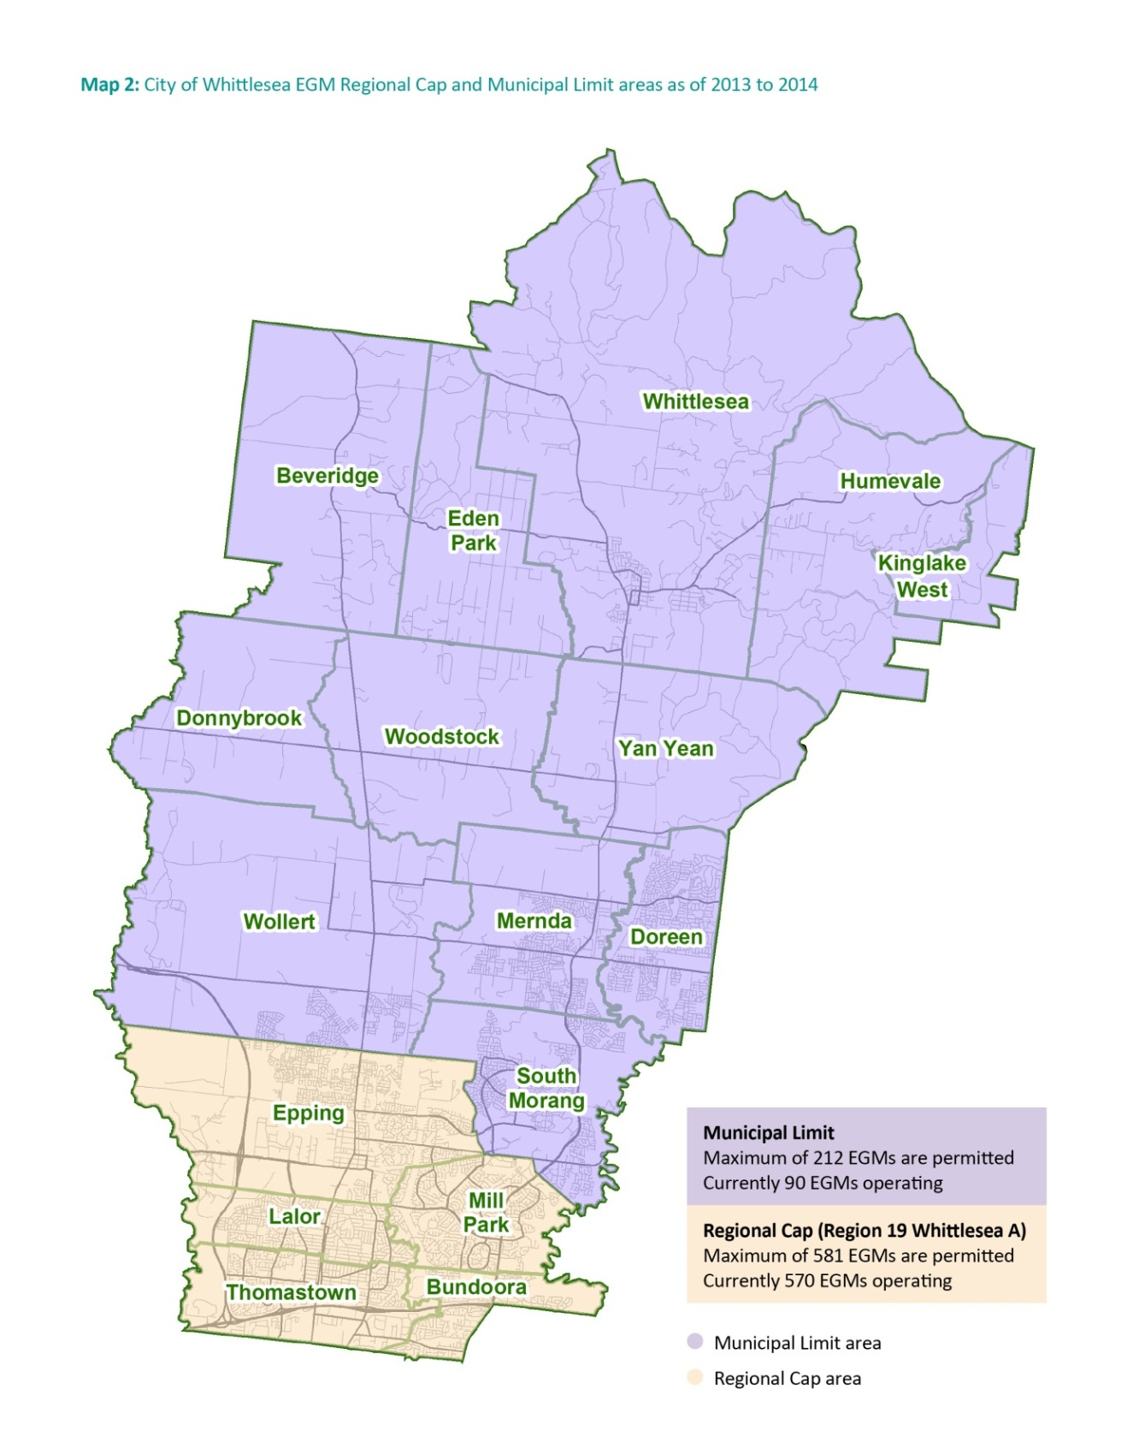

The below shows the location of EGM venues in the City of Whittlesea across the five local areas as of July 2013.
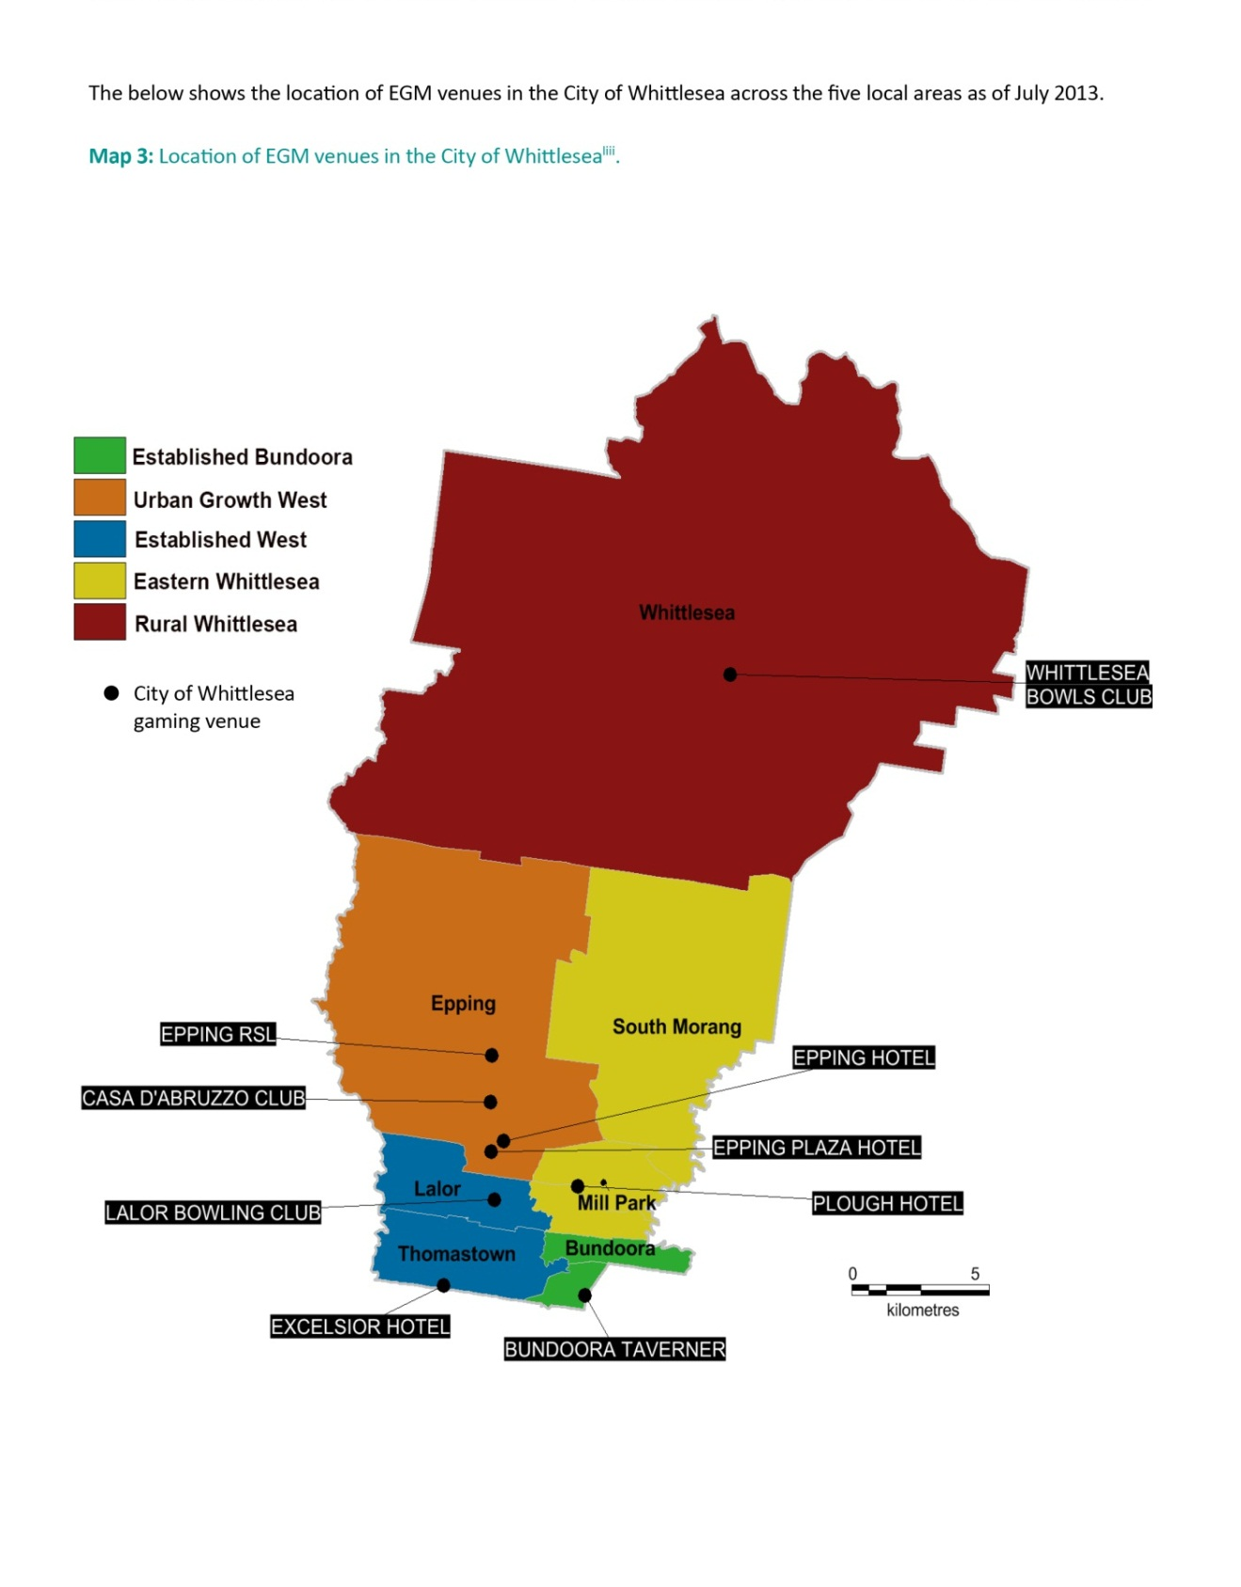

Table 1 below shows the type of gaming venues in the municipality, and the number of EGMs and expenditure for the period 2012 to 2013 and 2013 to 2014.
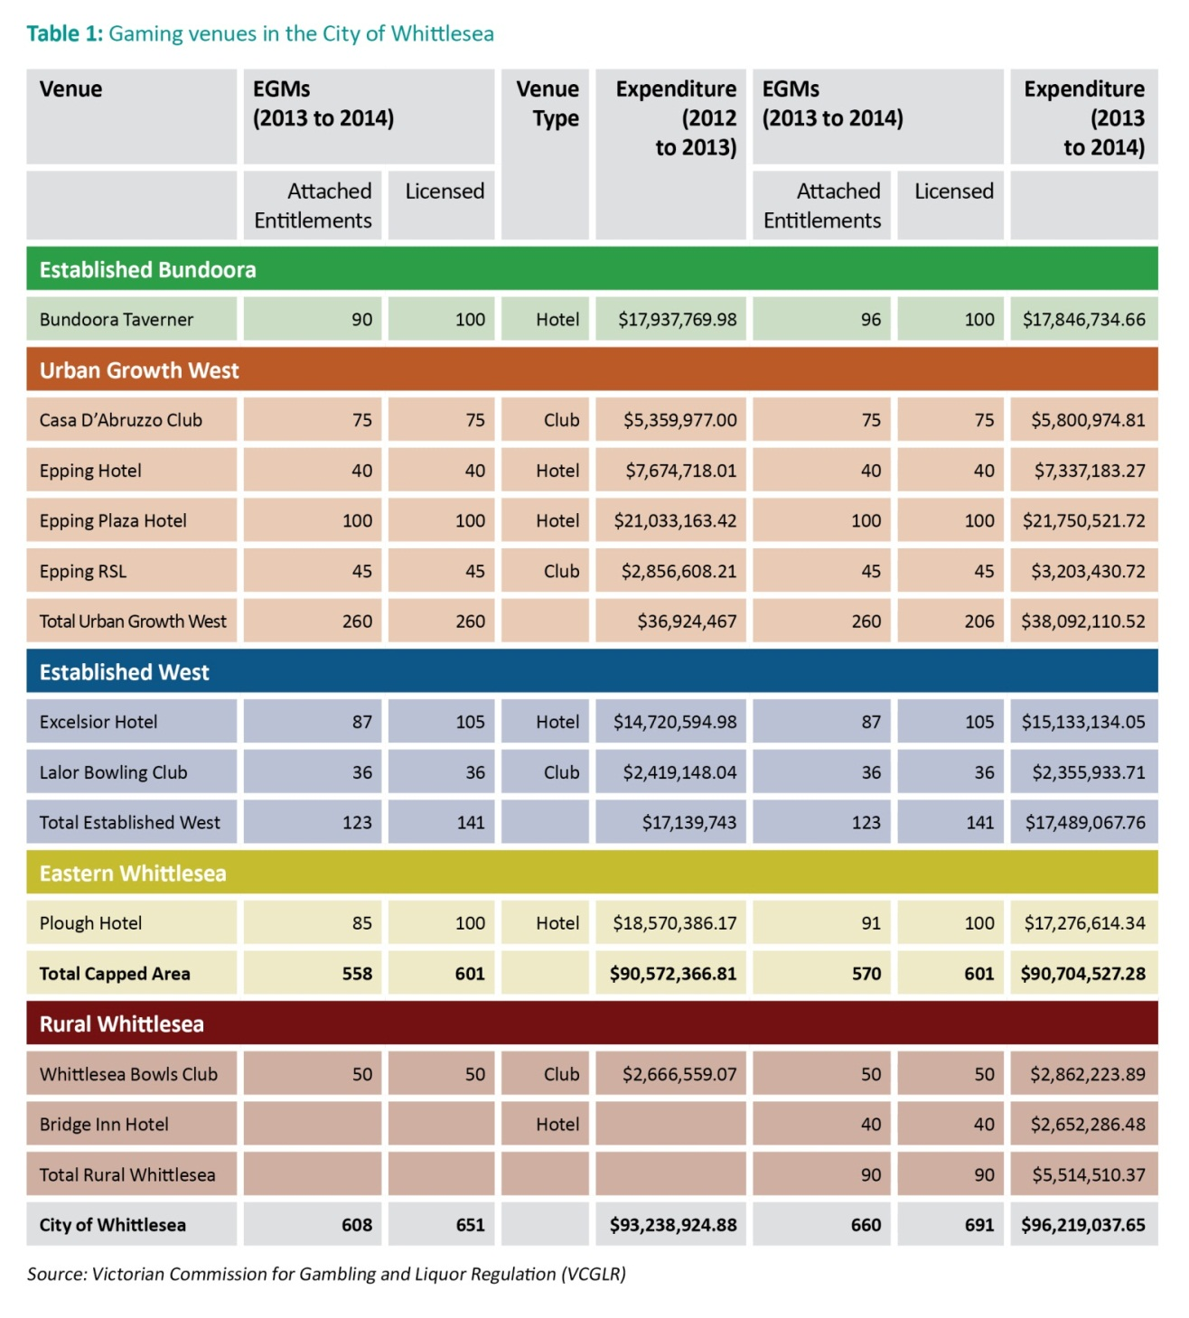

Local Area Analysis
The data shows different impacts on the five areas of the municipality. Local area analysis was undertaken considering a range of measures:
- Number and type of EGM venues
- Gaming losses per venue and density of EGMs
- EGM expenditure per adult
- Advantage-disadvantage (Socio-Economic Indexes for Areas (SEIFA)) rankings across the City of Whittlesea
- Propensity to Gamble Index
- Remodeled Vulnerability Assessment for Mortgage, Petrol and Inflation Risks and Expenditure (VAMPIRE) index.

Measures of Vulnerability and Disadvantage
Using ABS Census 2011 data, based on collector districts, the below map series, maps 4 to 6 set-out different measures of vulnerability and disadvantage in the City of Whittlesea.
Map 4 sets out the Propensity to Gamble Index for the City of Whittlesea.
It indicates that the areas susceptible to very high propensity to gamble are in Lalor and Thomastown, sections of Bundoora and Epping in the regional cap area. Additionally, there are areas with high propensity to gamble in Mill Park and Epping in the regional cap area and South Morang, Mernda and Rural Whittlesea in the municipal limit area.
Map 5 sets out the Advantage-Disadvantage Socio-Economic Indexes for Areas (SEIFA) rankings across the City of Whittlesea.
The map reveals the areas of greatest disadvantage in the capped region of the municipality, particularly in, Lalor and Thomastown as well as Bundoora. There are further areas of disadvantage in Mill Park and also within the municipal limit area of Rural Whittlesea.
Map 6 sets out the Vulnerability Assessment for Mortgage, Petrol and Inflation Risks and Expenditure (VAMPIRE) Index⁷ remodeled for the City of Whittlesea.
The above index reveals areas with a very high vulnerability to fuel price increases. This includes most of Rural Whittlesea, Mernda, Doreen, Mill Park, Epping North and parts of Thomastown and Bundoora. This population is also at risk of isolation, social exclusion and higher costs of living. These are characteristics shared by people who are vulnerable to harm associated with EGM gambling.

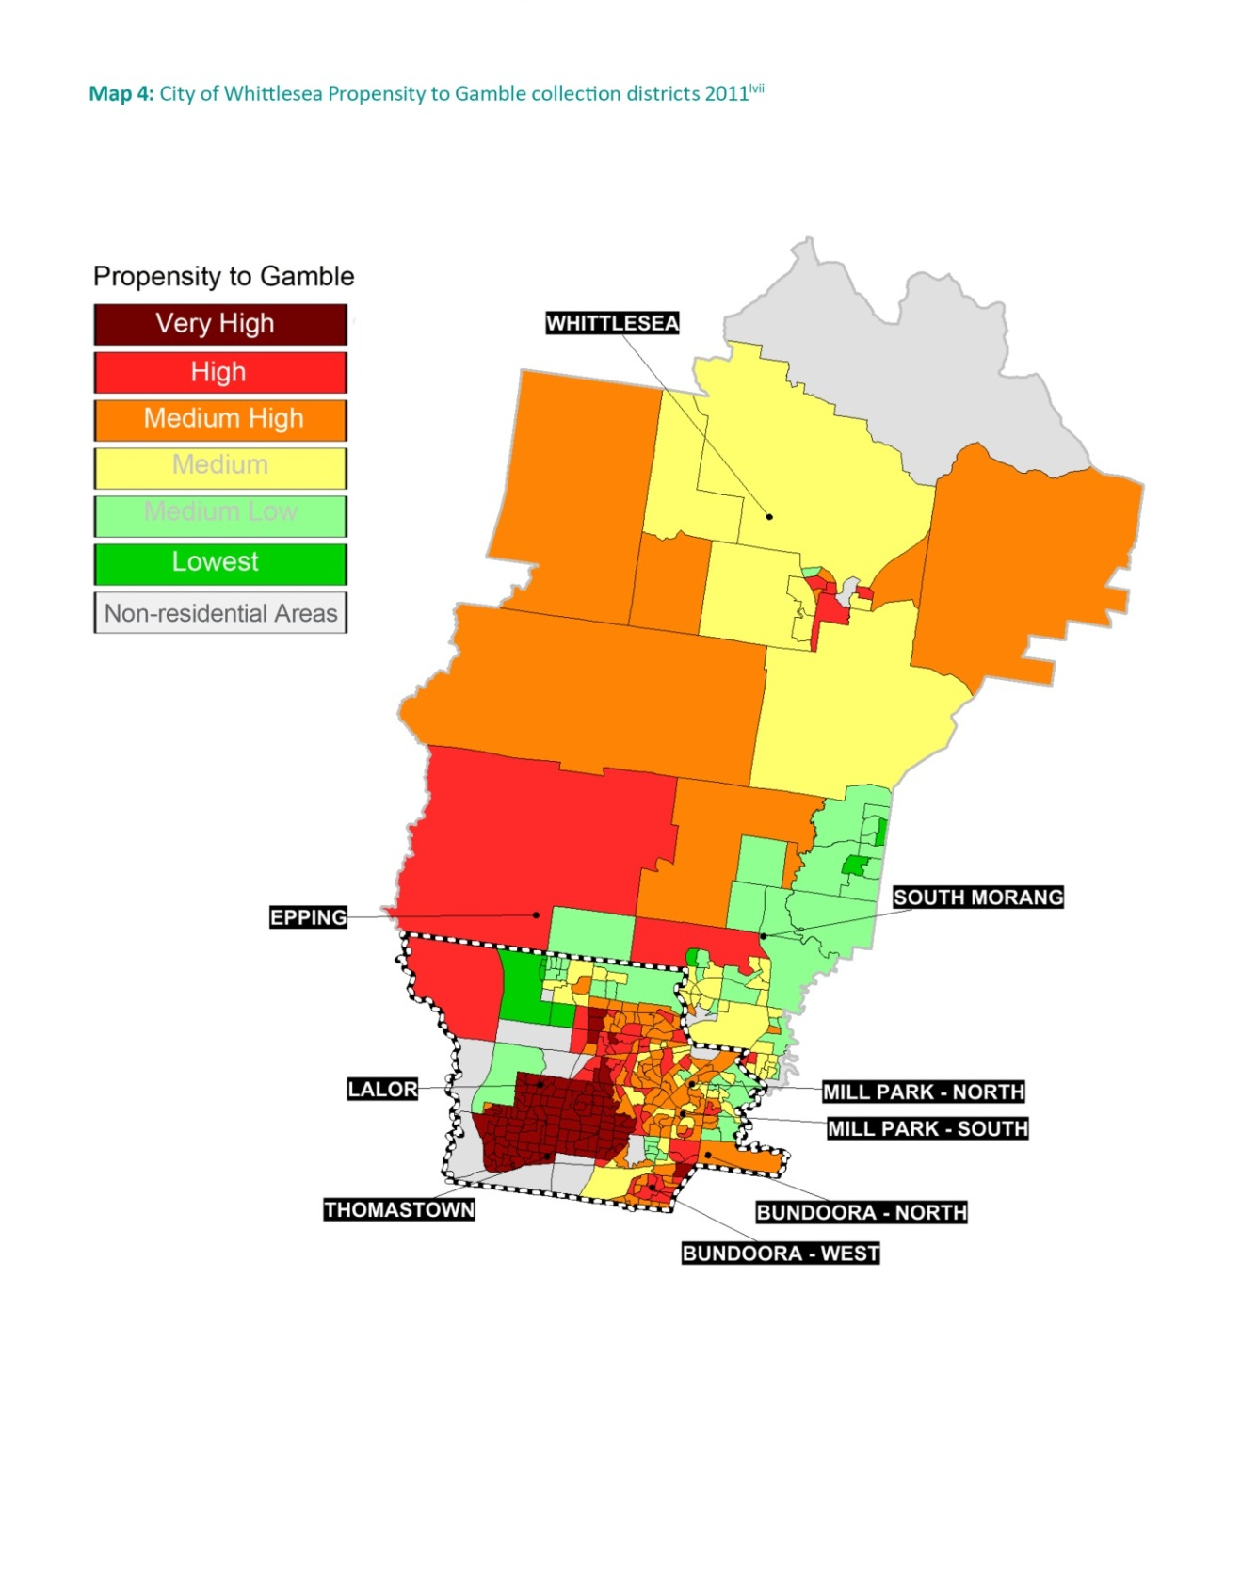

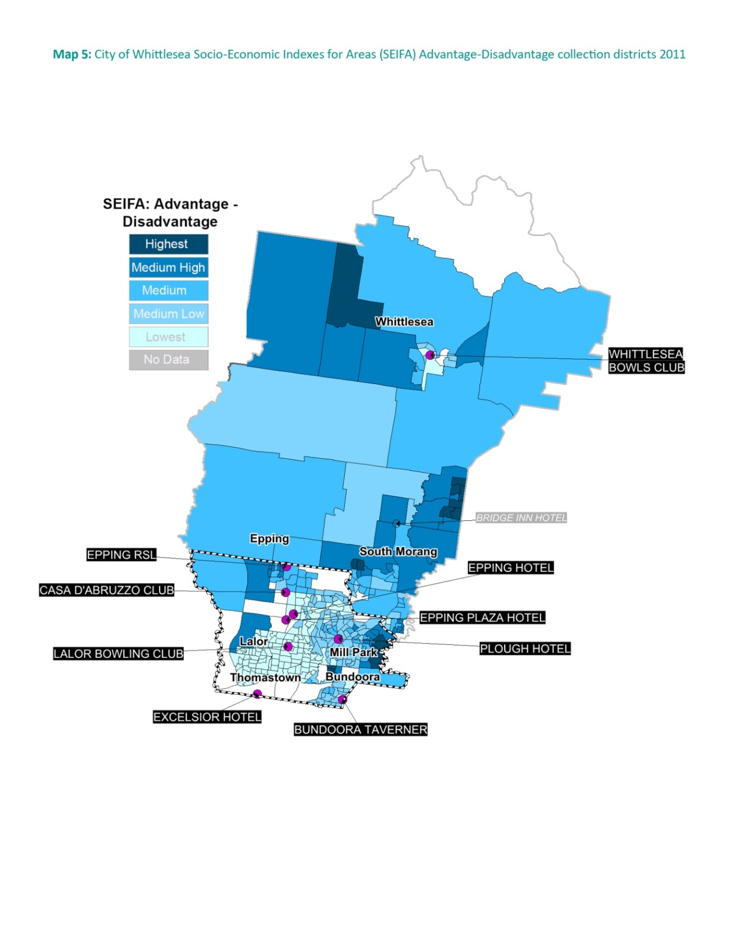

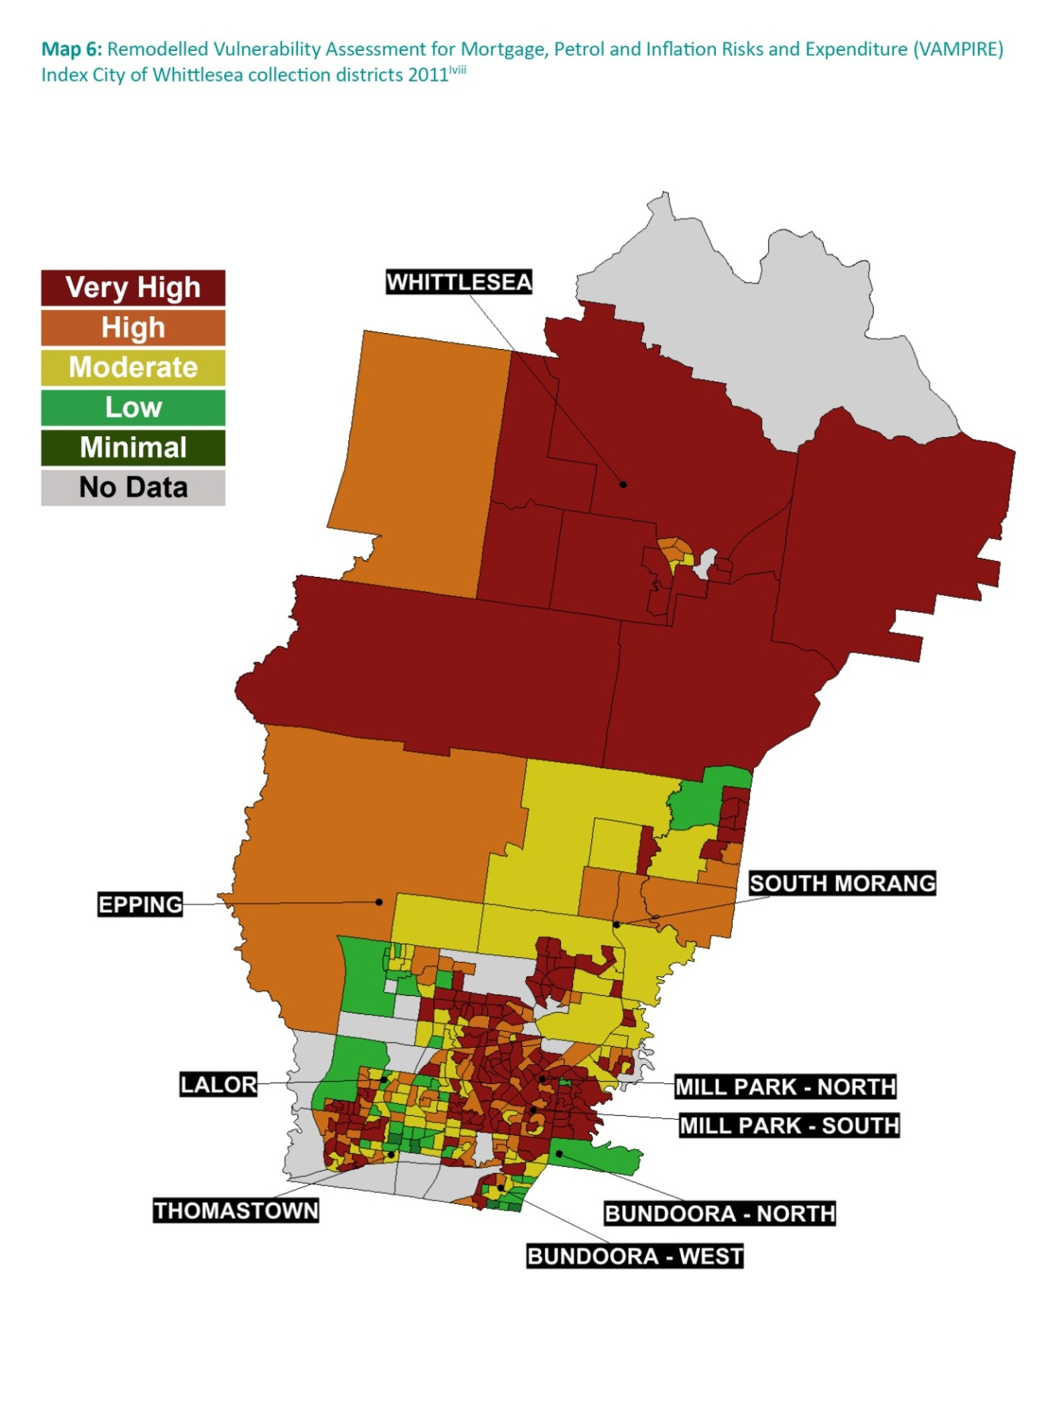

Local Area Analysis – Key Findings
Analysis of the local areas reveals a complex and diverse situation across the five local areas:

Established Bundoora
The Regional cap area for postcode 3083, contains Bundoora North, Bundoora West.
- This area has only one gaming venue but in 2012-13 it had the second highest density of machines per area (8.7);
- The highest losses per adult ($1,741) and per household ($3,732). The average losses per adult were $1,148 higher than the average losses per adult for Metropolitan Melbourne. This area had the second highest losses in the municipality at $17,937,770;
- There are selected collection districts of very high and high propensity to gamble; and,
- There are six venues within 5 kilometres and two venues within 2 kilometres, outside the boundary of Established Bundoora.

Urban Growth West
Encompasses Epping and Wollert and is within both the Regional Cap area for the postcode 3076 (Epping and Epping North) and in the Municipal Limit area for the post code 3750 (Wollert).
- In 2012 to 2013 this area had the highest losses for an area at $36,924,46 and the most gaming machines (260) spread across four venues;
- It has the highest density of gaming machines at 11.8, more than double the EGM density for Metropolitan Melbourne (5.7);
- It has the second highest losses per adult and per household in the municipality;
- The losses per adult are $1,076 which is higher than the average losses per adult for Metropolitan Melbourne; and,
- There are six venues within 5 kilometres and two venues within 2 kilometres outside the boundary of Urban Growth West.

Established West
Encompasses Lalor, Thomastown, and Keon Park within the Regional Cap area covering the postcodes 3075 and 3074.
- This area has the lowest SEIFA hence the greatest disadvantage in the municipality;
- In 2012 to 2013 the two venues had the second highest number of EGMs, but had lower than the municipal average losses per individual and per household;⁸
- From 2011 to 2012 and 2012 to 2013 the area experienced the greatest decrease in gaming losses in the municipality (20.8 percent);
- There are 11 venues within 5 kilometres and two venues within 2 kilometres outside the boundary of Established West.

Eastern Whittlesea
Encompasses both the Regional Cap and Municipal Limit area. Mill Park North and Mill Park South are situated in the Regional cap area for postcode 3082 (Mill Park). South Morang, Doreen and Mernda are situated in the Municipal Limit area.
- This area has the lowest density of gaming machines (1.6) for the municipality with one venue having 85 machines;
- The area had the highest losses per EGM in the municipality at $218,475 however, at the same time it has the lowest losses per individual ($339) and per household ($718);
- In 2013 a new venue opened in Mernda with a further 40 EGMs; and,
- There is one venue within 5 kilometres outside the boundary of Eastern Whittlesea.

Rural Whittlesea
This area includes Whittlesea Township, Donnybrook, Eden Park, Humevale, Kalkallo, Kinglake West, Woodstock, Yan Yean.
- This is the only area solely subject to the municipal limit in the City of Whittlesea that currently has a gaming venue;
- It has the lowest number of gaming machines (50) as well as the lowest losses per EGM ($53,331) yet it had the third highest density of gaming machines at 8.2;
- There is one venue within 5 kilometres outside the Rural Whittlesea boundary.

Gaming Venue Type
The City of Whittlesea has venues with the first, second and fifth highest EGM losses in Victoria in 2012 to 2013 respectively:
- The Epping Plaza Hotel, in Urban Growth West, with losses of $21,033,163 on 100 EGMs. This venue has the highest EGM losses in Victoria;
- The Plough Hotel, in Eastern Whittlesea, had the second highest EGM losses in Victoria at $18,570,386; and
- Bundoora Taverner, the only venue in Established Bundoora, with EGM losses at $17,937,770 had the fifth highest EGM losses in Victoria.
The Excelsior Hotel, in Established West had the greatest decrease in EGM losses in the municipality of -22.3 percent from 2011–2012 to 2011–2013.
Two clubs, the Epping RSL and Lalor Bowls Club, are located on Council owned land and have long-term lease agreements with the City of Whittlesea.
The Bridge Inn Hotel in Mernda is the first new gaming venue (40 EGMs) in the City of Whittlesea’s growth areas.

Community Benefit
In Victoria, under the Gambling Regulations Act 2003, hotels must contribute 8.33 percent of average monthly revenue per EGM towards the Community Support Fund (CSF). Clubs must contribute 8.33 percent of average monthly revenue per EGM towards community benefits. Clubs must submit annual Community Benefit Statement (CBS) to the VCGLR outlining what community benefit contributions have been made.
An analysis of EGM losses by each venue indicates that daily EGM losses are substantially higher in hotels than those at clubs. The lower EGM losses may be linked to the shorter operating hours, type of customer, and type of EGMs. Higher EGM losses occur at hotels even when a club has more EGMs than a hotel. For example Casa D’Abruzzo Club, in Urban Growth West had the highest EGM losses for a club at $5,359,977 and the most EGMs of all the clubs at 75 EGMs, in Whittlesea. However, Epping Hotel also in Urban Growth West had significantly higher EGM losses of $7,674,718 with only 40 EGMs.
Total EGM losses at hotels in the municipality in 2012 to 2013 were $79,936,632 (in five hotels). The estimated contribution to the CSF is $6,658,721.
The four clubs in the City of Whittlesea claim lower community benefit contributions (28.3 percent) than the Victorian average (33.5 percent). The highest claims in clubs community benefit statements were for operating costs, at 73 percent this was slightly below the average for Victoria (74 percent). However, clubs made lower contributions to donations and sporting activities than the average for Victorian clubs.

Community Views
Community consultation was undertaken to inform the development of the Strategy. These consultations took place in two stages. Stage One occurred in September 2013 and contributed to the background analysis. Stage Two occurred in May to June 2014 and sought feedback on the draft Gambling Strategy. Targeted approaches ensured
participation by diverse community groups. Consultation methods included workshops, written submissions, sending emails and letters, meetings and forums with community groups, drop in sessions at libraries and community activity centres, flyers, an article in Whittlescene (quarterly newsletter distributed to all City of Whittlesea residents), and an online survey.
This resulted in a diverse range of stakeholders participating in the consultation, including local residents, community groups such as seniors and culturally and linguistically diverse groups, young people, gaming venue operators, community service practitioners, content experts, and Council staff.
Stage One: Consultation September 2013
Key focus: To find out what the primary issues associated with gambling in the City of Whittlesea, particularly in relation to EGMs. | The aim of the first consultation was to inform the community of the extent of gambling in the municipality and to gain understanding of the main concerns of gambling, particularly in relation to gambling on EGMs, and to a lesser extent, online gambling. The objectives were to inform the community on:  - The nature and extent of gambling in the municipality  - The impact of gambling  - Council’s regulatory role and responsibility relating to gambling and specifically EGMs, and  - The proposed stages of developing the Strategy.  The feedback received during this stage of consultation was used to guide the preparation of the Strategy.

What the community said to inform the Strategy

What community leaders and community service practitioners said
- Education and information campaigns should be designed to raise awareness of the risks of gambling. These efforts should be:
  - Tailored for diverse target groups, including CALD and ATSI communities
  - Focusing on safe gambling, and
  - Delivered in partnerships with community organisations.
- The Strategy should be framed on a public health framework.
- Council should encourage the provision of recreational, entertainment and engagement opportunities, at community venues and meeting spaces, as alternative options to community socialising in EGM venues.

What gaming venue operators said
- The City of Whittlesea Responsible Gaming Charter and Forum 2002 is redundant. The gaming industry is highly regulated and operating under a new regulatory regime.
- Gaming venues provide a social community gathering place.

What young people said
- They are exposed to gambling at venues and are aware of online gaming. Some had experienced the impact of gambling by adults in their own family and friendship network. Generally the young people were negative about gambling.

What Council staff said
- Partnerships are needed to implement harm minimisation approaches (internally and externally with other organisations, such as other Councils and the Victorian Local Governance Association).
- We should inform and empower the community on gambling related matters in the municipality.
- Council should take a proactive role through partnerships to advocate for positive changes.
Stage Two: Consultation May to June 2014
Key focus: To obtain feedback on the Draft Gambling Strategy and Action Plan | The main aim of this second consultation was to gain feedback on the draft Gambling Strategy and Action Plan and:  - Enable the community to provide feedback regarding Council’s proposed directions related to EGM gambling  - Elicit comment on the proposed vision, position statement, objectives and actions within the draft Gaming Strategy  - Confirm priorities for Council’s role, and  - Identify stakeholder roles.  - The draft Gambling Strategy was modified to include this feedback.
- A land use planning policy should be developed.
- We should increase non-gambling social opportunities, including night-time recreational and leisure venues.

Part Two: Gambling Strategy and Action Plan 2014 to 2024

Gambling Strategy and Action Plan 2014 to 2024
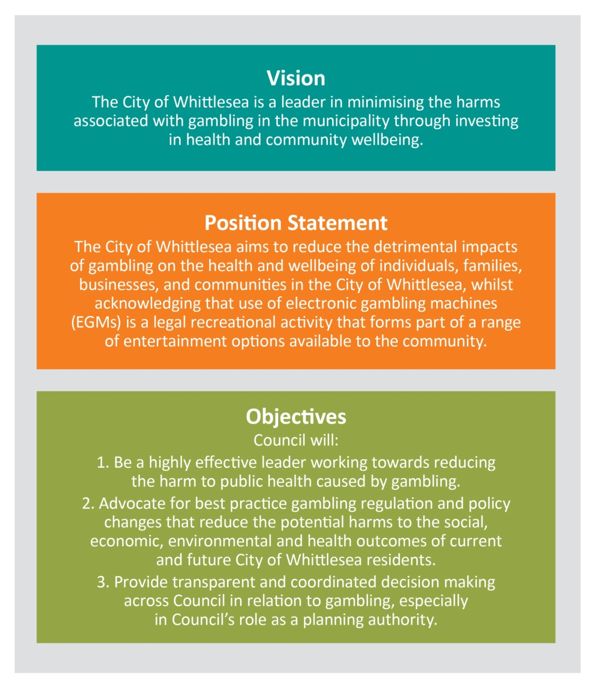

Actions and activities:
Having regard to the above objectives a series of actions and activities are detailed in this section. Council can play one of three roles in relation to the actions:
- Council can be a provider and directly undertake work to support a strategic Objective;
- Council can advocate for works on behalf of its community; and,
- Council can support the work of others in the role of facilitator.
The following timeframes have been allocated to actions on the following tables.
Time-frame
Short-term | Year 1 to 2
Medium-term | Year 3 to 5
Long-Term | Year 6 to 10

Objective one
Council will be a highly effective leader in working towards reducing the harm to public health caused by gambling.
Number | Action | Council’s Role | Activity | Time Line
1.1 | Partner with local services, community leaders and community and business organisations to inform the community about the health risks  of gambling. | Provider and Facilitator | Conduct community education and information campaigns in collaboration with local organisations including the Whittlesea Interagency Taskforce on Gambling, Gamblers Help Northern, the Whittlesea Community Leaders Network and the local police.  Key community information to be imparted in an accessible and culturally appropriate way to include (although not limited to):  - the level of the money lost/expended on EGM gambling in the City  of Whittlesea  - the danger of gambling products  (e.g. EGMs, online gambling)  - the health and wellbeing impacts of gambling on individuals, families and communities and business. | Short-term
1.2 | Work with local sporting, community clubs and organisations to develop and  promote accessible, cultural and recreational/leisure activities that enhance community connections and individual health and wellbeing. | Advocate  Provider | Advocate and prepare funding proposals to government (e.g. the CSF) and philanthropic organisations to expand existing and develop new community recreational facilities, meeting spaces and alternative community activities in partnership with local organisations (especially for the growth area of the municipality).  Investigate the development and dissemination of information that promotes recreational and entertainment alternatives to gambling. This can be  done by collaborating with State and local organisations (including but not limited to Whittlesea Interagency Taskforce on Gambling and Gamblers Help Northern).  Alternative activities and programs are focused to attract and engage vulnerable, socially isolated members of the community. | Short-term  Medium-term
1.3 | Promote and continue dialogue with gambling providers. | Facilitator | Establish an annual forum with gambling providers including EGM operators, to present and discuss  information about the City of Whittlesea socio-demographic characteristics, gambling data/trends, new initiatives regarding gambling activities and harm minimisation strategies. | Short-term
1.4 | Inform community leaders and community groups of electronic gaming activity in the municipality. | Facilitator | Promote community awareness on the opportunities to respond to EGM applications by gaming venues:  - Inform and engage the community when there is an application for a new gaming machine venue or an increase in EGMs;  - Establish a gambling information register of interested people  and groups;  - Circulate information about applications and the process to respond, to participants in  the register; and,  - Advertise on Council’s website the application, timeline and process for public comments.  Council will encourage applicants to:  - Conduct public information sessions about the application for which Council can assist in the distribution of invitations; and,  - Advertise any application in the public notices section of the local newspaper. | Medium-term
1.5 | In line with the City of Whittlesea Gender Equity Strategy, a gender lens is applied to information disseminated. | Provider and facilitator | Adopt a ‘gender analysis’ approach to ensure that education and information disseminated consider both womens’ and mens’ understanding and relationship with gambling. | Short to Medium-term
1.6 | Restrict access to online gambling on Council-owned internet access points. | Provider | Investigate filtering software and appropriate systems to stop access to online gambling sites at all Council provided, supported or sponsored internet access points.  Subject to appropriate software being identified implement necessary changes across Council (subject to business  case approval.) | Short-term  Medium-term

Objective two
Advocate for best practice gambling regulation and policy changes that reduce the potential harms to the social, economic, environmental and health outcomes of current and future City of Whittlesea residents.
Number | Action | Council’s Role | Activity | Time Line
2.1 | Undertake and participate in advocacy efforts  to reduce the harm of gambling to the City of Whittlesea community. | Advocate | In collaboration with key community Organisations advocate to other levels of Government for best practice gambling regulation and policy reform that reduces the harms associated with gambling. | Short to Long-term
2.2 | Advocate for reform of the community benefit contribution  made by gaming venue clubs. | Advocate | In collaboration with peak bodies/associations (such as VLGA, MAV and other local governments), advocate to the State government for reform of the allowable community benefits claimed by gaming venue clubs through the annual CBS. The community benefit claims should directly benefit the local community and not solely members  of the club through its operational costs. | Short-term
2.3 | Promote harm minimisation EGM strategies. | Advocate | In collaboration with peak bodies/ associations such as VLGA and MAV, advocate to the State government for:  - Best practice reform of the VCGLR’s administration of EGM. This could include improving the VCGLR decision- making process, transparency and accuracy of information provided on the website and at hearings regarding applications for EGMs;  - Adoption of the Productivity Commission’s 2010 recommendations including:  - EGM spin rates to be slowed;  - maximum bet be $1.00 with a maximum loss of no more than $120 per hour;  - reduction to the operating hours of gaming venues;  - Other measures to reduce the harm of EGMs including banning the ability to reserve an EGM in a local venue. | Medium to Long-term
2.4 | Advocate for a municipal wide EGM regional cap. | Advocate | Council to contribute to State-wide EGM cap discussions/reviews and state in accordance with current evidence the cap of 10 EGMs per 1,000 adults is too high as an effective harm minimisation strategy. | Medium to Long-term
2.5 | Stimulate and strengthen key stakeholder partnerships drawing on public health approaches to address the harms associated with gambling. | Advocate  Advocate | Continue involvement in working closely with Local Government Areas (LGAs)  (both neighbouring LGAs and growth area LGAs) as part of any gambling policy development or implementation.  Advocate to the Metropolitan Planning Authority for specific provisions regarding gaming venues in greenfield planning  and in the preparation of Precinct Structure Plans:  - To diminish the potential harm of EGM gambling on the health and wellbeing of local new communities;  - To ensure the first and/or only recreational venue in a newly developed suburb is not a gaming venue. | Medium-term
2.6 | Investigate Council’s role to apply harm minimization strategies to online (eg. sports betting) and other forms of gambling products and activities. | Advocate  Advocate | Investigate participation in advocacy avenues that aim to achieve tighter  controls of online advertising of gambling products and activities.  Work collaboratively with peak associations/bodies to advocate for the banning of gaming or gambling-like games available to children that introduce and normalise gambling at gaming venues,  at retail outlets and via online games.  Advocate for the reduction and removal of gambling and betting advertisements on television and radio at sporting events, on sports programs.  Increase the availability of information and resources to assist in raising the profile of the harms associated with online gambling and other forms of gambling products and activities for the community. | Medium-term  Medium-term  Long-term  Medium-term

Objective three
Provide transparent and coordinated decision-making across Council in relation to gambling, especially in Council’s role as a regulator and planning authority.
Number | Action | Council’s Role | Activity | Time Line
3.1 | Investigate and support quality research into the impacts of gambling and harm minimisation strategies. | Facilitator  Facilitator | Collaborate with peak bodies/associations such as VLGA, MAV and academic institutions to research the health and wellbeing impacts of gambling and mechanisms to reduce the harm.  Collaborate with local service agencies and community health organisations to explore capturing local gambling data and develop data capturing mechanisms as appropriate.  Develop questions for inclusion in the City of Whittlesea Human Service Needs Analysis Survey in order to:  - provide indicators over time of local community related gambling harm;  - capture new and emerging gambling related harm;  - capture of any service, programs gaps. Establish bi-annual meetings with key  stakeholders (eg. State Government and local  community organisations) focused on (although  not limited to):  - gambling and other relevant data,  - new research;  - best practice activities and programs;  - data gaps;  - opportunities to support collaborative research and initiatives.  Develop questions for inclusion in the City of Whittlesea Annual Household Survey regarding attitudes to gambling in order to:  - provide indicators over time of community attitudes to gambling;  - capture new and emerging gambling related harm.  Review EGM data produced by the VCGLR and report the data changes annually to Council and the community. | Medium- term  Medium- term
3.2 | Provide greater guidance on EGM gaming on Council owned or managed property/ land. | Provider | Investigate a fees and charges policy for clubs with EGMs located on Council owned or managed property or land. The policy should take into consideration:  - Income generated for the club from gaming machines and the application of a commercial rent for all or part of the premises; and,  - Community attitudes following a community exhibition process. | Medium- term
3.3 | Review existing Council policies (strategies/ plans/actions) to support and enhance a consistent and integrated Council response  to reducing gambling related harms. | Provider | Identify appropriate Council policies/strategies, and with relevant internal departments, establish a review program.  This would include the review of Council’s sponsorship policies taking into consideration:  - The level of sponsorship provided to Council from organisations/businesses that derive  a substantial proportion of their income from gambling.  - the programs, activities and initiatives that Council supports and sponsors. | Short-term
3.4 | Investigate the inclusion of a Local Gaming Planning Policy in the Whittlesea Planning Scheme. | Provider | Research and prepare a Local Gaming Planning Policy for the Whittlesea Planning Scheme that has regard to this Strategy and Action Plan  and guides the location and design of venues. | Medium- term
3.5 | Create a ‘whole-of-organisation’ approach to reducing gambling-related harm. | Provider | Develop and deliver information regarding Council processes, services and functions related to gambling for Councillors and staff that connects to Council’s Wellbeing@Work Initiative.  Information to include:  - Regulation, legislative and administrative governance of gambling in Victoria; and,  - Identification of the harm to health and wellbeing of individuals, families and community stemming from gambling (especially EGM and online gambling).  Integrate the Strategy into relevant Council documents. This includes as a reference document in key Council plans such as the Whittlesea Planning Scheme, Recreational Strategy and the Municipal Health and Wellbeing Plan. | Short-term
3.6 | Investigate Council’s funding mechanisms as an effective avenue to progress harm minimisation approaches. | Provider and Facilitator | Review and establish criteria for community groups and organisations in Council’s funding policies such as:  - Council’s Procurement/Social Policy;  - Community Grant guidelines; and,  - Senior Citizens Clubs’ Grants; and other relevant funding mechanisms. | Short-term
3.7 | Consider and respond to gaming license applications in the municipality. | Provider, Advocate and Facilitator | Undertake an independent SEIA and prepare submissions in response to a gaming license application in the municipality in the following scenarios:  - Applications to establish a new gaming venue;  - Applications to increase the number of EGMs in the municipal limit area;  - An increase of EGMs where the community is displaying social and/or economic disadvantage according to the latest SEIFA index being classified as medium-to-high;  - Applications to establish a new venue or increase EGMs on Council owned land, managed property or land;  - Applications that seek to transfer EGMs from one part of the municipality to a part of the municipality displaying greater social and/or economic disadvantage or a higher density of EGMs per adult population; and,  - Any other scenario where Council considers that a gaming license application may be considered to be detrimental to the economic and social wellbeing of the community. | Ongoing
3.8 | Council will consider a response to EGM gaming license applications in neighbouring municipalities. | Provider and Facilitator | Where Council is informed by the VCGLR of a EGM license application in neighbouring  municipalities, Council will review the EGM license application if it has direct impact on City of Whittlesea residents in proximity to the gaming venue (applicant). When required, Council will provide resources as appropriate to ensure a submission is prepared. | Ongoing

Implementation
The implementation of the preceding actions and activities will be monitored by Council and an Implementation Plan will be prepared.
The purpose of developing the Implementation Plan is to:
- Set-out how the Strategy objectives will be transformed into meaningful and achievable activities;
- Ensure that the timeframes and responsibilities for each action are appropriately coordinated;
- Set-up a framework for monitoring and reporting of the actions that enables identification of any issues and opportunities that can then be reviewed and addressed.
The Implementation Plan will assign responsibility, funding requirements, timing and priority levels for all actions and projects. Each action will be given an indicative timeframe for commencement.
The Implementation Plan will include the following:
- Implementation Governance: Roles and responsibilities will be clearly defined and a multidisciplinary working group established.
- Partnership Approach: Key partnerships will be identified.
- Resource Challenges: These will be identified and a position will be investigated that would collaboratively work across Council to effectively and efficiently deliver the Strategy.

Monitoring and Evaluation
As 2024 approaches Council will need to review how the vision and objectives are being met by continuing to check that the actions and priorities remain relevant.
The Strategy will require monitoring and ongoing review in response to any policy, regulatory and legislative changes that may occur in the different gambling sectors in Victoria and Australia, and current ‘best practice’.
The Strategy will be reviewed every three years. During the review process consideration will be given to any challenges to the implementation process and proposals to overcome the identified barriers to implementation. The scope of three-yearly reviews will largely be driven the changing context and will need to respond accordingly.
An overarching measure of the Strategy’s success will be:
- An overall reduction in the net EGM expenditure in the municipality
- A reduction in expenditure per adult per annum compared to that of the metropolitan average ($574 as of 2013 to 2014).

Appendix

EGM Licensing and Planning Permit Applications Process

Appendix A

VCGLR Process application for EGM licenses

Step one [Applicant process]
Applicant submits application to the VCGLR for EGM licenses in a venue. Applicant to notify and send Council the VCGLR application

Step two [VCGLR process]
VCGLR undertakes assessment and notifies Council of the application. If Insufficient information supplied by applicant, the Applicant to resubmit application to the VCGLR.
If step two is satisfied then step 3 [public participation in the process] Council and public (for example community members or groups) may make a submission to the VCGLR and call upon expert witness to be present at the public hearing.
Step four [public participation in the process]
Council may prepare a submission that assesses the social and economic impact of the application. Council either approves or refuses the application.
If Council refuses the application Council may be present at the VCGLR hearing and call upon expert witnesses.
Step five [VCGLR process]
VCGLR public hearing held VCGLR decision.
If step 5 decision is: VCGLR grants application with or without conditions then:
- Step 6 [Appeal process] Council can seek a review of the VCGLR decision at VCAT
- Step 7 [Appeal process] Matter heard at VCAT The application is approved, refused or amended
- Step 8 [Appeal process] Supreme Court of Victoria can review VCAT decision on points of law.
If step 5 decision is: VCGLR refuse application Applicant can seek a review of the VCGLR decision at VCAT then:
- Step 7 [Appeal process] Matter heard at VCAT The application is approved, refused or amended
- Step 8 [Appeal process] Supreme Court of Victoria can review VCAT decision on points of law.

Planning permit application process related to new EGM venue or increase of EGMs within an existing venue.
Step one [Applicant process] Submit Planning Permit Application for use/installation of EGMs and or development of a gaming venue
If step two is not satisfied then:
- Council to seek further information if insufficient information is submitted
- Application resubmitted
If step two is satisfied then:
- Council may advertise the proposal
Step three [public participation in the process] Council and public can object to the application. It there are objections as a result of advertising, Council may take these into consideration.
Step four [Council process] Council either approves or refuses application
If council approves step four then:
- If Council approves the application, the applicant can proceed with the development unless objector appeals the decision
If Council refuses step four then:
- If Council refuses the application, the applicant may appeal the decision
- Matter heard at a review at VCAT [Appeal process]
- The application is approved, amened or refused by VCAT [Appeal process]
Supreme Court of Victoria can review VCAT decision on points of law [Appeal process]

State Government of Victoria, Department of Justice (2009) A study of Gambling in Victoria Problem Gambling from a Public Health Perspective, p. 6, prepared by Sarah Hare (Schottler Consulting Pty Ltd) for the Department of Justice.
World Health Organization (WHO) (2014) Social determinants of health, http://www.who.int/social_determinants/en
Australia Government Productivity Commission (2010) Gambling Inquiry Report, Canberra http://www.pc.gov.au/_data/assets/pdf_file/0010/95680/gambling-report-volume1. pdf
Australian Government Productivity Commission (2010) Gambling Inquiry Report, Table 2.10 pp.2.21-2.23, Canberra,http://www.pc.gov.au/_data/assets/pdf_file/0010/95680/gambling-report-volume1.pdf
City of Whittlesea (2013) Gambling Background Paper p.3 prepared by Beverley Kliger & Associates for the City of Whittlesea.
City of Whittlesea (2013) Gambling Background Paper p. 3 prepared by Beverley Kliger & Associated for the City of Whittlesea
Ibid
Australian Government, Department of Communications, The Interactive Gambling Act 2001, The OffenceCanberra://www.communications.gov.au/online_safety_and_security/online_gambling/interactive_gambling_act_2001
City of Whittlesea (2013) Gambling Background Paper prepared by Beverly Kliger & Associates
Gainsbury, S., Wood, R, Russell, A., Hing, N., and Blaszcynski, A., (012) Digital revolution: Comparison of demographic profiles, attitudes and gambling behaviour of Internet and non-Internet gamblers’, Computers in Human Behaviour, 28,1388-1398 from City of Whittlesea (2013) Gambling Strategy Consultation Report prepared by Beverley Kliger & Associates.
City of Whittlesea (2013) Gambling Background Paper prepared by Beverly Kliger & Associates for the City of Whittlesea
Ibid
Ibid, p.51
Ibid, p.51
City of Whittlesea (2013) Gambling Background Paper prepared by Beverley Kliger & Associates for the City of Whittlesea
Ibid
Ibid
City of Whittlesea (2013) Gambling Background Paper prepared by Beverley Kliger & Associates for the City of Whittlesea, Parliament of Australia National Gambling Reform Bill Bills Digest no. 51 2012-13 http://www.aph.gov.au/Parliamentary_Business/Bills_Legislation/
City of Whittlesea (2013) Gambling Background Paper prepared by Beverley Kliger & Associates for the City of Whittlesea State Government of Victoria, Victorian Competition and Efficiency Commission (2012) Counting the Cost: Inquiry into the Costs of Problem Gambling released by the Treasurer 9 Sep 2013, http://www.vcec.vic.gov.au/Inquiries/Completed-inquiries/Problem-gambling
State Government of Victoria, Department of Human Services (2001) Environments for Health Promoting Health and Wellbeing through Built, Social, Economic and Natural Environments, Municipal Public Health Planning Framework, http://www.healthyplaces. org.au/userfiles/file/Environments%20for%20Health%20Victoria.pdf
City of Whittlesea (2013) City of Whittlesea Council Plan 2013-2017 Shaping Our Future, City of Whittlesea
State Government of Victoria, Department of Human Services (2001) Environments for Health Promoting Health and Wellbeing through Built, Social, Economic and Natural Environments, Municipal Public Health Planning Framework, p.9, http://www.healthyplaces.org.au/userfiles/file/Environments%20for%20Health%20Victoria.pdf
State Government of Victoria, Department of Human Services (2001) Environments for Health Promoting Health and Wellbeing through Built, Social, Economic and Natural Environments, Municipal Public Health Planning Framework, http://www.healthyplaces.org.au/userfiles/file/Environments%20for%20Health%20Victoria.pdf
State Government of Victoria, Department of Justice (2009) A Study of Gambling in Victoria Problem Gambling from a Public Health Perspective, p. 16, prepared by Sarah Hare (Schottler Consulting Pty Ltd) for the Department of Justice, Victoria.
Victorian Local Governance Association (2013) Factsheet #4 A public health approach to gambling, http://www.vlga.org.au/Projects___Campaigns/Responsible_Gambling.aspx
North East Primary Care Partnership (2009) Health Promotion Resource Guide for Problem Gambling in Melbourne’s North prepared by Susan Rennie at Banyule Nillumbik Primary Care Alliance, http://www.nepcp.org.au/sites/default/files/Health%20Promotion%20Resource%20Guide%20for%20Problem%20Gambling%20Prevention%20in%20Melbourn’s%20North.pdf
City of Whittlesea (2013) Gambling Background Paper prepared by Beverley Kliger & Associates for the City of Whittlesea
Victorian Local Governance Association (VLGA) (2013) Pokies Assessments:A ‘How to’ Guide 2nd edition Carlton, Victoria
State Government of Victoria (2008) Public Health and Wellbeing Bill 2008, Parliament of Victoria, http://www.austlii.edu.au/au/legis/vic/bill/phawb2008232/
City of Whittlesea (2013) City of Whittlesea Council Plan 2013-2017 Shaping Our Future, City of Whittlesea
Victorian Local Governance Association (VLGA) (2013) Pokies Assessments: A ‘How to’ Guide 2nd edition Carlton, Victoria
Ibid
Ibid
Ibid
City of Whittlesea (2013) Gambling Background Paper prepared by Beverley Kliger & Associates for the City of Whittlesea
Ibid
City of Whittlesea (2013) City of Whittlesea Council Plan 2013-2017 Shaping Our Future, City of Whittlesea,p.47
City of Whittlesea (2013) City of Whittlesea Council Plan 2013-2017 Shaping Our Future, City of Whittlesea, p.47
City of Whittlesea (2013) City of Whittlesea Council Plan 2013-2017 Shaping Our Future, City of Whittlesea
City of Whittlesea (2012) City of Whittlesea Recreation Strategy 2012-2017, City of Whittlesea https://www.whittlesea.vic.gov.au/your-council/plans-strategies-andpolicies/~/ media/Files/Your%20Council/Plans%20and%20strategies/Recreation%20Strategy.pdf
City of Whittlesea (2013) City of Whittlesea Council Plan 2013-2017 Shaping Our Future, City of Whittlesea
City of Whittlesea (2013) Gambling Background Paper prepared by Beverley Kliger & Associates for the City of Whittlesea
Ibid
State Government of Victoria Victorian Commission for Gambling and Liquor Regulation (VCGLR) http://www.vcglr.vic.gov.au/
State Government of Victoria, Department of Justice (2009) A Study of Gambling in Victoria Problem Gambling from a Public Health Perspective, prepared by Sarah Hare (Schottler Consulting Pty Ltd) for the Department of Justice, Victoria
Ibid
City of Whittlesea (2013) Gambling Background Paper p. 53 prepared by Beverley Kliger & Associates for the City of Whittlesea
State Government of Victoria, Victorian Responsible Gambling Foundation (VRGF) Gambling Information Resource Office Information Sheet (2014) Pokies Caps in Victoria http://www.responsiblegambling.vic.gov.au/information-and-resources
State Government of Victoria Victorian Commission for Gambling and Liquor Regulation (VCGLR) http://www.vcglr.vic.gov.au/
State Government of Victoria Victorian Commission for Gambling and Liquor Regulation (VCGLR) Municipal Limits, https://assets.justice.vic.gov.au/vcglr/resources/ebed5558-8d83-4744-88be-4a9576186453/ministerial_direction_muncipal_limits_2012.pdf
City of Whittlesea (2011) Submission to the 2011 Parliament of Victoria Outer Suburban Interface, Services Development Committee Inquiry into Liveability Options in Outer Suburban Melbourne City of Whittlesea
City of Whittlesea (2013) Gambling Background Paper prepared by Beverley Kliger & Associates for the City of Whittlesea
Ibid
Ibid
Ibid
Ibid
Ibid
Ibid
Ibid
Ibid
Ibid
Ibid
Ibid
Ibid
Ibid. p10
Ibid
Ibid. p. 56
State Government of Victoria, Victoria Responsible Gambling Foundation (2014) Guides to Application Processes For Electronic Gaming Machines, Understanding the Application Processes for Electronic Gaming Machines (EGMs) in Victoria, Application Process related to new EGM venues, or increased numbers of EGMs within an existing venue, VCGLR process, http://www.responsiblegambling.vic.gov.au/
State Government of Victoria, Victoria Responsible Gambling Foundation (2014) Guides to Application Processes For Electronic Gaming Machines, Understanding the Application Processes for Electronic Gaming Machines (EGMs) in Victoria, Application Process related to new EGM venues, or increased numbers of EGMs within an existing venue, Local Authority Council Process, http://www.responsiblegambling.vic.gov.au/

