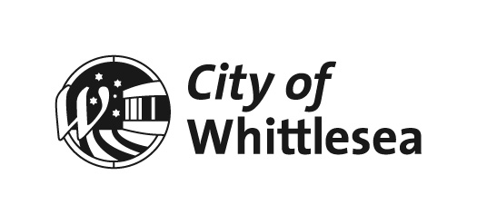
Minutes

OF Scheduled
COUNCIL MEETING
HELD ON
Monday 5 July 2021
AT 6.31pm
In Council Chamber, 25 Ferres Boulevard, South Morang

ADMINISTRATORS

LYDIA WILSON CHAIR OF COUNCIL
PEITA DUNCAN ADMINISTRATOR
CHRIS EDDY ADMINISTRATOR
On 19 June 2020 the Acting Minister for Local Government appointed the Panel of Administrators for the City of Whittlesea and appointed Lydia Wilson as Chair of the Panel. The Panel of Administrators comprises of Ms Lydia Wilson, the Honourable Bruce Billson and Ms Peita Duncan. On 3 March 2021, the Hon. Bruce Billson resigned from his position as Administrator with the City of Whittlesea. Effective from 12 May 2021, the Minister for Local Government appointed Mr Chris Eddy as the third Panel Member. Ms Lydia Wilson, Ms Peita Duncan and Mr Chris Eddy will undertake the duties of the Council of the City of Whittlesea until the October 2024 Local Government Election.

SENIOR OFFICERS

CRAIG LLOYD CHIEF EXECUTIVE OFFICER
KRISTI HIGH EXECUTIVE MANAGER PUBLIC AFFAIRS
FRANK JOYCE EXECUTIVE MANAGER GOVERNANCE
KATE MCCAUGHEY DIRECTOR COMMUNITY WELLBEING
AMY MONTALTI DIRECTOR CORPORATE SERVICES
JUSTIN O’MEARA DIRECTOR PLANNING & DEVELOPMENT
DEBBIE WOOD DIRECTOR INFRASTRUCTURE & ENVIRONMENT

ORDER OF BUSINESS

The Chief Executive Officer submitted the following business:

1. Opening 9
1.1 MEETING OPENING & INTRODUCTIONS 9
1.2 ACKNOWLEDGMENT OF TRADITIONAL OWNERS STATEMENT 9
1.3 NAIDOC WEEK 9
1.4 Present 10
2. Apologies 10
3. Declarations of Interest 10
4. Confirmation of Minutes of Previous Meeting 10
5. Questions, Petitions and Joint Letters 11
5.1 Public Question Time 11
5.1.1 SEX BASED SERVICES AND FACILITIES 11
5.1.2 LALOR DOG PARKS 11
5.1.3 RUBBISH AT PARTRIDGE STREET RESERVE, LALOR 12
5.2 Petitions 13
Nil Reports 13
5.3 Joint Letters 15
5.3.1 Joint Letter - Planning Permit Application Unit 7/24 Brand Drive, Thomastown 15
6. Officers’ Reports 17
6.1 Connected Communities 17
6.1.1 FOR DECISION: Arts and Culture in the City of Whittlesea 17
6.1.2 For Noting - Final progress report Council's Disability action Plan 2017-21 31
6.1.3 For Feedback - Aboriginal Gathering Place 43
6.1.4 For Decision - City of Whittlesea Community Awards Committee Representation 189
6.1.5 For Decision - COVID-19 Pandemic Recovery Fund 199
6.1.6 FOR DECISION - Construction of the Mernda Social Support Services Facility Contract 2021-17 - Tender Evaluation Report 211
6.1.7 For Feedback - Proposed Planning Scheme Amendment: Inland Rail Project - Tottenham to Albury 215
6.2 Liveable Neighbourhoods 251
6.2.1 For Decision - Local Area Traffic Management and Street Improvement Plan, Mill Park and Epping 251
6.2.2 FOR DECISION - Redevelopment of the Mill Park Basketball Stadium Contract 2021-15 - Tender Evaluation Report 265
6.2.3 For Noting - 165 - 185 Gordons Road, South Morang Development Plan 269
6.2.4 FOR DECISION - PLANNING APPLICATION 719837 - USE OF THE LAND FOR INDUSTRY (ASPHALT BATCHING PLANT) AND BUILDINGS AND WORKS, INCLUDING BUILDINGS AND WORKS WITHIN THE LAND SUBJECT TO INUNDATION OVERLAY AT 29 GRAYSTONE COURT EPPING 341
6.3 Strong Local Economy 371
6.3.1 FOR DECISION - Adoption of City of Whittlesea Investment Attraction Plan and 2021-2022 Actions 371
6.4 Sustainable Environment 453
6.4.1 For Decision - Cooper Street West Resource Recovery Hub - Proposals to Lease Community Engagement Outcome 453
6.4.2 For Decision - Response to Petition for Replacement of Trees along Fielding Drive, Mernda 465
6.5 High Performing Organisation 471
6.5.1 For Noting - Unconfirmed Minutes of Audit & Risk Committee Meeting 471
6.5.2 For Decision: Financial Hardship Policy 487
7. Notices of Motion 503
8. Questions to Officers 503
9. Urgent Business 503
10. Reports Council REPRESENTATIVES AND CEO UPDATE 505
10.1 ADMINISTRATOR PEITA DUNCAN REPORT 505
10.2 ADMINISTRATOR CHRIS EDDY REPORT 505
10.3 CHAIR OF COUNCIL LYDIA WILSON REPORT 505
10.4 For Noting - CEO Update - 5 July 2021 507

11. Confidential Business 509
11.1 Connected Communities 509
Nil Reports 509
11.2 Liveable Neighbourhoods 509
Nil Reports 509
11.3 Strong Local Economy 509
Nil Reports 509
11.4 Sustainable Environment 509
Nil Reports 509
11.5 High Performing Organisation 509
11.5.1 For Decision - Financial Reserves Review & Policy Development 509
11.6 Notices of Motion 509
Nil Reports 509
12. Closure 510

Note:
In these Minutes, Resolutions adopted by Council are indicated in bold text.

1. Opening
1.1 MEETING OPENING & INTRODUCTIONS
The Chair of Council, Lydia Wilson opened the meeting at 6.31pm.
“Welcome to this Council Meeting of 5 July 2021 which is being livestreamed.
I am Lydia Wilson, Chair of the Panel of Administrators and I would also like to introduce my Panel colleagues, Administrators Ms Peita Duncan and Mr Chris Eddy.
I would also like to introduce our Chief Executive Officer, Mr Craig Lloyd and ask that he in turn introduce the members of the Executive Leadership Team in attendance today.”
“Good evening everyone, we also have with us:
Executive Manager Public Affairs, Ms Kristi High;
Executive Manager Governance, Mr Frank Joyce;
Director Community Wellbeing, Ms Kate McCaughey;
Director Corporate Services, Ms Amy Montalti;
Director Planning & Development, Mr Justin O’Meara; and
Director Infrastructure & Environment, Ms Debbie Wood.
These members of the Executive Leadership Team will join us during the meeting.”
Following the Introductions, the Chief Executive Officer read the following prayer:
Almighty God, we ask for your blessing upon this council to make informed and good decisions to benefit the people of the City of Whittlesea.
Our father who art in heaven, hallowed be thy name, Thy kingdom come, Thy will be done on earth as it is in heaven. Give us this day our daily bread and forgive us our trespasses as we forgive them that trespass against us; and lead us not into temptation but deliver us from evil, For thine is the kingdom, the power and the glory, for ever and ever.
Amen
1.2 ACKNOWLEDGMENT OF TRADITIONAL OWNERS STATEMENT
The Chair of Council, Lydia Wilson read the following statement:
“On behalf of the City of Whittlesea I recognise the rich Aboriginal heritage of this country and acknowledge the Wurundjeri Willum Clan as the Traditional Owners of this place.
I would also like to personally acknowledge Elders past, present and emerging.”
1.3 NAIDOC WEEK
The Chair of Council, Lydia Wilson acknowledged the NAIDOC Week.
“NAIDOC Week is from the 4th to the 11th of July, and a critical theme is Heal Country. NAIDOC 2021 invites the Nation to embrace First Nations cultural knowledge and understanding of country as part of Australia's national heritage, and equally respect the culture and values of Aboriginal people and Torres Strait Islanders. As they do the cultures and values of all Australians. So it is important to note that it is NAIDOC Week.”
1.4 Present
Members:
Ms Lydia Wilson Chair of Council
Ms Peita Duncan Administrator
Mr Chris Eddy Administrator
Officers:
Mr Craig Lloyd Chief Executive Officer
Ms Kristi High Executive Manager Public Affairs
Mr Frank Joyce Executive Manager Governance
Ms Kate McCaughey Director Community Wellbeing
Ms Amy Montalti Director Corporate Services
Mr Justin O’Meara Director Planning & Development
Ms Debbie Wood Director Infrastructure & Environment
Ms Linda Martin-Chew Team Leader Strategic Projects & Infrastructure
Ms Jessica Higgins Statutory Planner
Ms Kate Weatherly Project Manager – Investment Attraction

2. Apologies
Nil

3. Declarations of Interest
NIL

4. Confirmation of Minutes of Previous Meeting
Council Resolution
Moved: Administrator Eddy
Seconded: Administrator Duncan

THAT the following Minutes of the preceding meeting as circulated, be confirmed:
Scheduled Meeting of Council held 1 June 2021
Carried

5. Questions, Petitions and Joint Letters
5.1 Public Question Time

The answers provided verbally by the Chief Executive Officer at the meeting in response to questions asked by members of the public are preliminary answers provided on a without prejudice basis. A formal written response to each question is sent following the Council meeting which contains Council official position on the matter.
5.1.1 SEX BASED SERVICES AND FACILITIES
MOIRA DEEMING
Under Victorian law, is it legal for Local Government Councils to provide sex based/targeted services and facilities separately to gender identity based/targeted services and facilities? If not, why not? For example, can we legally put signs on a set of public toilets declaring that one is for biological males (including males with an intersex condition), one is for biological females (including biological females with an intersex condition) and one is for people with transgender identities (of any biological sex)? If not, why not?

CHIEF EXECUTIVE OFFICER, CRAIG LLOYD
The City of Whittlesea’s shared vision with our community is to be ‘A place for all’.
As part of this vision, we have made a commitment to provide inclusive infrastructure and services for all residents and visitors.
Council aims to provide gender-neutral public toilets in its facilities wherever possible. Gender neutral facilities are available in our new Ganbu Gulinj Community Centre, our recently upgraded Mill Park Library and will be part of the redevelopment of Mill Park Basketball Stadium.
Council also adheres to laws that provide guidance on how to make Victoria a safer, fairer and more inclusive state.
This includes the Victorian Equal Opportunity Act 2010 and the Federal Sex Discrimination Act 1984 (amended in 2013).
These laws prohibit discrimination on the basis of sex, gender identity or intersex status. Under these laws, it is discriminatory to require a person who is transgender to use a toilet which does not align with their gender identity.
We are also very supportive of the Victorian Gender Equality Act 2020, which highlights the need to redress disadvantage, address stigma, stereotyping, prejudice and violence against persons of different genders, and to enhance social participation by persons of different genders.

5.1.2 LALOR DOG PARKS
THOMAS WATKINS AND LINH PHAM
There are more and more young couples and families moving to Lalor and bringing their dogs with them. However, there is only one dog park in Lalor that is on the far West side of the suburb. We would like to ask the council to create a dog park on the East side of the suburb, like those in Bundoora and Mill Park. Stockade Park is rarely used by residents. This space would be ideal for a dog park. So, my question to the council is:
Is it in the council’s power to make this happen?
Do I need a petition? If yes, how many signatures are required for council to genuinely consider this?

CHIEF EXECUTIVE OFFICER, CRAIG LLOYD
Thank you for your question. The City of Whittlesea’s future dog off-leash areas are guided by Council’s Dog Off-leash Area Policy & Management Plan, available on Council’s website. The Plan considers locations based on site attributes and features including minimum size requirements and existing infrastructure.
VR Michael Reserve in Lalor has been identified as a suitable location for a dog off-leash area and will be considered as part of the 2022/23 Annual Budget process. We would accept a petition of at least 12 signatures however we welcome residents to have their say as part of the budget process each year and will provide more information about how to do so in early 2022.

The Chair of Council, Lydia Wilson then invited Mr Watkins to address Council with a further question.

5.1.3 RUBBISH AT PARTRIDGE STREET RESERVE, LALOR
THOMAS WATKINS
I was at the Partridge Street Reserve today, which is on Partridge Street in Lalor, just east of the station, Lalor train station. Now, we moved into the area about 18 months ago, during COVID, it was quite clean, very, very nice because it wasn't being used. It was being regularly maintained as well, the lawns were being mowed regularly. Now Mill Park Soccer Club has moved in there maybe six months ago now. It is honestly filthy. It is quite disgusting most of the time. I understand that Partridge Street reserve is a council park. It seems quite bizarre that they are allowed to just leave rubbish everywhere all the time, broken glass, it looks like there might even be kids or teenagers drinking there at night, but generally it is quite filthy. I am talking about on the field, around the field, around the club in general. I wrote an email to council today with a number of photos, specifically they seem to have had an event on the weekend. They had split the fields up, looked like four sections, there was a lot of people there. The streets had hundreds of cars all over the place. I have never seen anything like this. My partner Linh and I, she is over there, we were picking up rubbish. They had literally attached plastic bags to the fences for people to put rubbish in. Did not seem to have achieved anything. Absolutely filthy. Hundreds of pieces of rubbish, chip packets, Tim Tam packs, Gatorade bottle, water bottles. I understand council gets quite a number of questions about rubbish in the area. But what can be done about this? This is obviously council land. Mill Park Soccer Club, I do not know if they pay a fee or they get it for free, but surely Mill Park Soccer Club has some sort of remit to keep it clean?

CHIEF EXECUTIVE OFFICER, CRAIG LLOYD
Thank you for your question Mr Watkins, I have to take that on notice to get a little bit more information but I will have one of our directors contact you and have a look for ourselves and we will also liaise with the relevant club there to see what occurred over the weekend as well, but we will get back to you in the next couple of days. Thanks for raising it.

5.2 Petitions
Nil Reports

5.3 Joint Letters
5.3.1 Joint Letter - Planning Permit Application Unit 7/24 Brand Drive, Thomastown
A Joint Letter from 11 residents of Thomastown was received advising Council of the following:
“We wish to formally document our joint strong objection to the planning application for the following reasons:
1. The nature of the application undermines our existing businesses given the fact that our premises are in an industrial 1 zone area. It is unsafe and unreasonable to have anyone living here. Some of us have heavy equipment and/or trucks coming and going at all hours of the day given the nature of our work. If we were operating in a residential area, this would be unacceptable, so it is illogical to allow a residential dwelling to be constructed in an industrial area.
2. In the past, there have been complaints of noise by people who were living in our factory complex. In fact, it is the applicant of this application that was the one complaining ate the time when he was living at factory 15. We fear that should the approval be given for a caretaker permit, further noise complaints would be made, and this will further restrict our trade, which under industrial 1 zoning should not be a concern we have.
3. Should this application be approved, the value of our property will suffer. Should the time come to sell up, it will be harder to sell when there is a residential dwelling in the complex. This may add to the time requires to sell the premises and may reduce the sale price. This is commercially unjust and hence forms another point of objection.
4. Approving the application would set a dangerous precedent where theoretically every factory could have residents. This would only serve to further deteriorate the industrial 1 zoning we have all bought and paid for and we therefore find this is a further unacceptable risk.
5. If people live here, then we expect that they will also have visitors here. This further adds to risk of the complex by having people around that would not otherwise need to be here. This adds to the risk of pedestrian traffic (and associated public liability risk), loss of carparking or even potential crime.
In summary, we strongly believe that approving this permit application will undermine our rights to use industrial 1 zones land as the planning scheme intended. Accordingly, we cannot stress enough that this planning application should be rejected. We all would wish to be notified of the decision.”
Council Resolution
Moved: Administrator Duncan
Seconded: Administrator Eddy
THAT Council resolve to receive the Joint Letter from 11 residents objecting to the Planning Permit Application No. 2021-719852 for Unit 7/24 Brand Drive, Thomastown and consider the Joint Letter in conjunction with the Council Report on this planning permit application at the Council meeting on 2 August 2021.

Carried

6. Officers’ Reports
6.1 Connected Communities
ITEM 6.1.1 FOR DECISION: Arts and Culture in the City of Whittlesea
Attachments: 1 2021/22 Festival and Events Program
Responsible Officer: Director Community Wellbeing
Author: Team Leader Arts Culture & Events

RECOMMENDATION SUMMARY
That Council resolve to:
• Endorse the place-based 2021/2022 Festival and Events program.
• Note the community consultation and engagement undertaken in developing the program.
• Prepare a draft W2040 Connected Communities Strategy addressing arts and culture priority actions (as described in Table 1) for Council's consideration by mid-2022. (This will include consideration of a dedicated arts space within the municipality.)
Brief overview
Council delivers a broad range of Arts and Cultural offerings including free public events that have a positive impact on increasing community cohesion, participant wellbeing and the local economy.
In December 2020, Council resolved to refocus and review the City of Whittlesea Festival and Events program with an aim to inform Council’s future approach to delivery within a COVID-19 recovery environment.
This report provides a recommendation for a place-based 2021/2022 City of Whittlesea Festival and Events Program and identifies opportunities for continuous improvement and evaluation to strengthen Council’s Arts and Culture portfolio.
rationale for recommendation
Arts and Culture programming, and more specifically festivals and events, play an important role in building community cohesion, a sense of belonging and the local economy. This is particularly important following the extensive impacts of COVID-19 on the community in the past 18 months.
The recommendations of this report will continue to implement Council’s COVID-19 recovery plan and further explore opportunities for more placed-based community reconnection and increased synergy across Council’s arts-based projects and services.
impacts of recommendation
• Council will continue to deliver a vibrant program of Arts and Cultural activities in the City of Whittlesea to support community creativity, connection and the local economy.
• Council will continue to deliver smaller and more localised events over the next 12 months to ensure COVID-19 safety compliance and increase a localised sense of connection to place.
• Council will continue to support destination focussed events that attract people from outside the municipality e.g. Whittlesea Show and the Whittlesea Country Music Festival.
what measures will be put in place to manage impacts
The following social benefits have also been identified and need to be considered and promoted throughout the implementation of the Arts and Culture program:
• Increased community engagement and participation in the arts; increased sense of belonging, community cohesion and local pride.
• Improved accessibility; increase in provision of place-based activities.
• A safer and inclusive environment; improved perceptions of safety and celebration of local culture and diversity.
• Stimulating the local economy; support and promotion of local business through engagement or promotion at local events.
Delivering arts and culture programs in partnership across Council and community fosters and supports other W2040 objectives such as celebrating diversity and inter-cultural understanding, contributing to wellbeing and positive health outcomes, tackling racism and prejudice and fostering local leadership, skills development and economic participation opportunities.

Report
Introduction
In December 2020 Council resolved to refocus its Festival and Events program and to undertake a Festival and Event Review (the Review) to be presented to Council in July 2021.
This report serves as the Review findings and identifies:
• The community consultation and engagement activities undertaken as a part of the Review.
• The strategic environment that underpins the provision of Arts and Cultural activities.
• Issues impacting the use and authorisation of fireworks at community events held on public land.
• The proposed Festival and Events Program 2021/2022.
• Ongoing opportunities for continuous improvement and evaluation to increase, support and improve the provision of arts and culture opportunities across the city.
Background
Local communities continually identify and support festivals and events as an important Council function; as a result, Council delivers a broad range of Art and Cultural opportunities. Historically, these events have been underpinned by Council’s Arts and Development Strategy and Festival and Events Policy.
City of Whittlesea Arts and Development Strategy 2016-2020
The City of Whittlesea Arts and Development Strategy 2016-2020 (the Strategy) was informed by four strategic directions (refer Figure 1) which identified the arts’ vital role in achieving social, cultural and economic outcomes (refer Policy Strategy and Legislation section).
The Strategy focused on key areas including:
• Aboriginal Reconciliation and healing.
• Supporting cultural diversity and building resilient communities.
• Evaluation and community feedback.
• Providing opportunities for local young people to participate in arts programs.
The Strategy resulted in the delivery of creative involvement of local artists and audiences via the development of a local creative practitioners' network, (the Creative Arts Practitioner of Whittlesea, CAPOW network), a local Studio Art trail, and greater activation of the Council Great Hall.
Surveys from recent Arts and Cultural activities found:
• 74 per cent of respondents reported that the event made them feel more connected to their community.
• 81 per cent of respondents reported that the event made them feel proud of their local area.
• 85 per cent of respondents agreed with the statement ‘Arts and Cultural activities make for a richer and more meaningful life’.

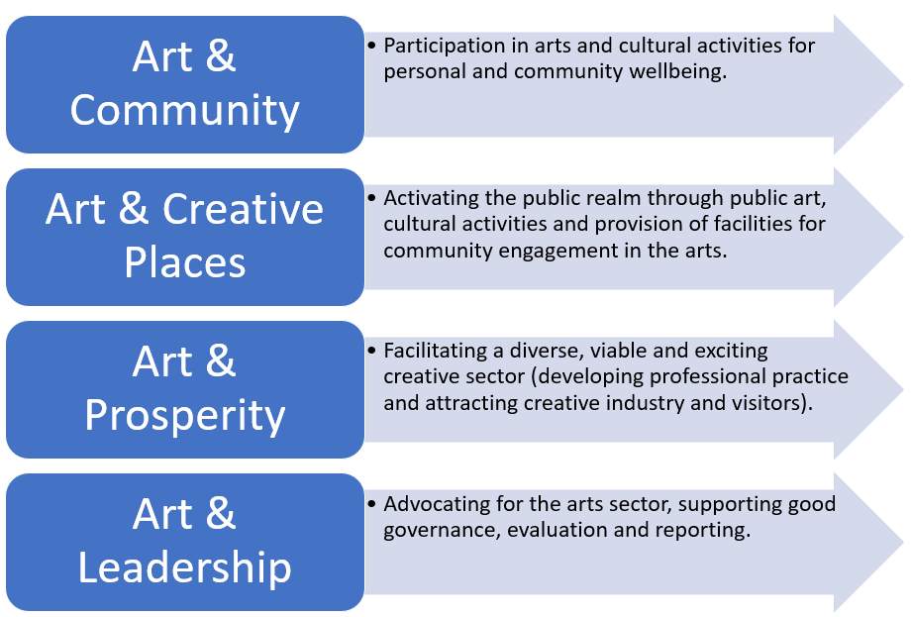Figure 1: Whittlesea Arts and Development Strategy 2016-2020, Strategic Directions
City of Whittlesea Festival and Events Policy
The City of Whittlesea Festival and Events Policy was adopted in July 2014 with a vision that ‘Festivals and Events in the City of Whittlesea celebrate and strengthen our diverse, vibrant communities and create opportunities for connections and belonging’. It recognises Council’s role as Facilitator, Provider and a Regulator of events and has three strategic objectives. They are:
• Whole of Council Approach
• Community Engagement and Capacity Building
• Synergies and Partnerships.
City of Whittlesea Integrated Planning Framework
In March 2021 Council adopted an integrated planning framework to consolidate 100+ adopted community-facing policies, strategies and plans within six major Whittlesea 2040 aligned strategies plus the Community Plan (refer Figure 2). Adoption of this framework means that Council:
• will no longer look to develop and adopt separate, stand-alone policies/ strategies but will develop actions and priorities across a smaller number of integrated Whittlesea 2040 Strategies.
• maximise resources and focus on actions rather than multiple policies and siloed plans.
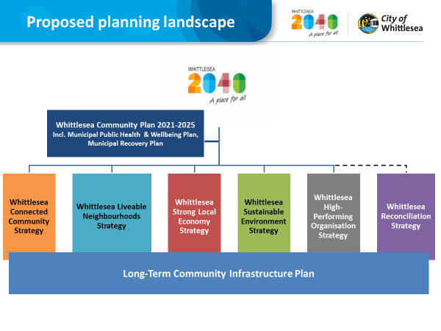
Figure 2: Integrated Planning Framework (adopted March 2021)

Plenty Ranges Arts and Convention Centre (PRACC)
PRACC is located next to the Civic Centre at 35 Ferres Boulevard, South Morang and is Council’s only purpose-built arts and convention centre in the municipality. At its meeting of December 2017 Council resolved to manage PRACC as an in-house commercially driven venue, noting the: ‘Overarching aims of the Centre are to achieve a cost neutral community facility’. This decision restricts the viability of use for many local artists and cultural and community groups. Several opportunities may exist for greater utilisation of PRACC to showcase Council run events and arts and cultural opportunities while balancing the financial imperatives.
In early June 2021, the Department of Health requested access to PRACC to host an ongoing vaccination service, delivered by Northern Health providing both AstraZeneca and Pfizer vaccines. This request was supported as PRACC is the most suitable venue in the City of Whittlesea to host this program. It has substantial floor space; is easily accessible and close to public transport; has commercial fridges and freezers and secure, lockable storage for the vaccines.
This decision will allow the local community to be vaccinated as quickly as possible however it will have a considerable impact on the many dance groups, schools, performers, regular PRACC users and staff. This impact is being monitored and alternative venues including the Council Great Hall, community centres and private bookable spaces are still being identified to best support local groups throughout 2021 and possibly into the 2022 event season.
Council’s Festivals and Events Program Review
The Review was completed in response to:
• Impacts of COVID-19 on arts participation, production and public events.
• The conclusion of the Whittlesea Arts and Development Strategy 2016-2020.
• Council’s December 2020 decision to refocus the City of Whittlesea Festival and Events program.
The Review aimed to examine the current context and key influences on the delivery of Council’s Festival and Events program to:
• Inform Council’s approach to the 2021/22 Festival and Events program moving forward.
• Revisit Council’s position on the use of fireworks at events in the wake of the Metropolitan Fire Brigade (MFB) and Country Fire Authority’s (CFA) amalgamation to form Fire Rescue Victoria (FRV).
• Identify opportunities for continuous improvement to ensure the City of Whittlesea can continue to respond to the changing local context and provide a gradual yet consistent post pandemic recovery program.

The Review was informed by extensive consultation, evaluation and engagement processes conducted prior to COVID-19 and across the last six months throughout the COVID-19 recovery phase. The consultation conducted provided critical insight into community views, opinions and preferences and more specifically:
• Into the type of arts and cultural activities the community would like to see incorporated into festivals and events.
• The broader impact these activities and programs had on their lives.
• The biggest barriers/issues experienced by local artists and creatives.
• The key focus areas that needed to be addressed to create safe and welcoming events post COVID-19.
Throughout the Review several key themes were identified including:
• The importance of community events in creating a sense of place and local pride (both in general and as a response to COVID-19 recovery).
• A high level of interest for greater engagement with First Peoples and cultural diversity through music, arts and crafts.
• The desire for more local festivals, events and broader arts and cultural participation opportunities for young people, families and local artists and creatives.
Key Review Outcomes
The Review identified three areas of activity including:
• Programming: A revised festivals and events program which adopts a local place-based approach complemented by larger events.
• Operations: The use of fireworks at community events.
• Future policy: Priority areas for arts policy and strategy development including the needs for a PRACC audience review, a strategically focused arts collection and infrastructure planning to foster inclusive and welcoming cities (including anti-racism initiatives); to be considered within Council’s adopted new Integrated Planning Framework.
Programming: 2021/2022 Festival and Events Program
To best support the community’s desire for more local festivals and events and to provide community support throughout the COVID-19 recovery phase and a more placed-based reconnection, the 2021/2022 Festival and Events program will focus on the delivery of smaller and more flexible events, including:
• One large annual community festival using PRACC and outdoor spaces as a major focus.
• Five small events with a geographical spread across the municipality.
• A Carols by Candlelight event in December.
• One night walking event (similar to Walking Thomastown).
• Continued online presence through the Whittlesea Arts website to support greater access to the festivals and events program such as livestreaming performances etc.
• Ongoing coordination and/or promotion of Council’s and key partner events such as the Whittlesea Country Music Festival, Whittlesea Show and libraries events program through the establishment of a Whittlesea Dates of Recognition Calendar which captures other key festivals and events including Sorry Day, NAIDOC Week, Refugee week, youth FREEZA events, etc.
Operations: The use of fireworks at community events
Fireworks can drive public attendance at events and play an important role in many cultures; especially in Chinese and South Asian communities and at popular cultural celebrations such as Diwali and Chinese New Year/Tet. However, they are an activity that increasingly divides community opinion. Anti-firework sentiment increased greatly following the 2020 bushfires, however the resulting cancellation of Council’s Australia Day fireworks in this year also heavily impacted attendance (with a decrease of 65 per cent recorded in comparison to previous years). There is also growing evidence that fireworks have an environmental footprint (releasing potentially harmful heavy metals, including lead and copper, into the air and over water bodies); and may increase hospitalizations for respiratory symptoms during firework periods (compared to non-firework periods).
Historically, Council has delivered two annual events with fireworks: the Australia Day celebrations in January and the Whittlesea Community Festival in March. The Community Festival changed its operating hours in 2018 to be a day only event (11am to 5pm) and Council’s decision in December 2020 to cease delivering a public event on Australia Day means that Council no longer has any designated events with fireworks.
Fireworks applications continue to be a part of large community run festivals and events with both the Whittlesea Country Music Festival and Vivid Diwali making annual applications for a firework display at their community events.
Council’s Fireworks Policy (2005) provides guidance on the manner in which Council will consider applications for permission to set off fireworks however it does not exclude fireworks provision across any events, instead adopting a case by case approach in line with a decision-making framework.
In addition to Council’s policy position, fireworks permits and processes have also been influenced by changes to the MFB/CFA regions. On 1 July 2020, the MFB and CFA career firefighters amalgamated to form FRV which now has the authority to approve fireworks on public land in metropolitan areas and during the fire danger period. These new arrangements have impacted Council’s role in authorising fireworks on public land as FRV permit conditions need to be taken into consideration. To enable this to take place, it is proposed that officers:
• Do not introduce any fireworks into the 2021/2022 Council run festivals and events program.
• Work with FRV on a case by case basis during 2021/2022 to authorise fireworks on public land.
Future Arts and Culture actions within the W2040 Connected Communities Strategy
The Review also identified a number of priority areas for any future Arts and Culture policy and strategy development to consider. These areas are summarised in Table 1.
New integrated arts and cultural priority actions within the W2040 Connected Communities Strategy | Following the adoption of the Integrated Planning Framework, it is not anticipated that a separate new Arts and Culture Strategy will not be developed. Instead key actions will be developed and identified to support a broader range of festivals and events such as smaller place based events (such as street parties) and visitor destination experiences. These actions will sit within the seven larger strategies (as well as the Community Plan). These new W2040 Strategies align to the key directions of Council’s previous art strategy. Some actions will also be consolidated under the other strategies such as the Strong Local Economy Strategy.
PRACC audience development and strategic focus review | Council has recently commissioned an arts and audience development specialist, Silver Lining Strategy, to provide specialist insight into current retention barriers and identify opportunities for connection with new client and audience groups across PRACC and Council’s Festivals and Events. The findings of the Audience Review will continue to inform Council’s post COVID-19 recovery and ongoing operations; as well as key actions within the new W2040 Strategies.
Arts collection and infrastructure planning | In addition to the above, there are further opportunities to undertake a review regarding collection and infrastructure planning, including opportunities to promote, display and store the collection; feasibility around a dedicated visual arts facility; links to other strategic planning and reviews such as the Ziebell’s farm; etc.
Arts and culture’s role in fostering inclusive and welcoming cities | There is a significant opportunity to build on existing programs and projects across Council which applies arts and culture to foster inclusive and welcoming cities (including anti-racism initiatives). As outlined above, key associated actions will be developed and sit across the seven larger strategies identified in Figure 2.
Support provided to arts and cultural industries | Council supports festivals and events in the municipality through annual grant rounds, expert advice and guidance; and the development of online resources to support the community to plan, deliver, manage and review their events.  The development of Council’s Visitor Economy Destination Plan will be key to identifying Council partnership opportunities with community events that drive the visitor economy such as the Whittlesea Show. It is anticipated a Visitor Economy Destination Plan will be developed as part of the W2040 Strong Local Economies Strategy.  A further internal review of Council’s grant program may provide opportunities for a revised program which further supports community/cultural industry run festivals and events.
Continuous improvement and evaluation | Consultation and evaluation are embedded into business as usual for Council’s festivals, events and broader arts and culture programs. However, with increasing demand for local and affordable arts and culture opportunities and a growing community of practicing artists wanting to be involved in local festival and events, evaluation is critical in guiding future practice.
Table 1: Emerging arts and culture priority areas
Proposal
The Review identified three areas of activity summarised in Table 2 below:
Programming | A revised festivals and events program which adopts a local place-based approach complemented by larger events. Attachment 1 provides information on the proposed 2021/2022 Festivals and Events program.  The 2021/2022 Festival and Events Program will be evaluated and modified as required. Council will be briefed if program evaluation identifies major shifts or changes in program delivery.
Operations | The use of fireworks at community events. Moving forward it is proposed that officers:  Do not introduce any fireworks into the 2021/2022 Council run festivals and events program.  Work with FRV on a case by case basis during 2021/2022 to authorise fireworks on public land.
Future arts and culture policy and planning | The Review also identified a number of priority areas for arts policy and strategy development as summarised in Table 1: Emerging arts and culture priority areas.  Priority areas for arts policy and strategy development include: PRACC audience review and strategic focus; arts collection and infrastructure planning; the role of arts and culture in fostering inclusive and welcoming cities (including anti-racism initiatives); development of new arts and cultural development priorities within Council’s adopted new Integrated Planning Framework.
Table 2: Activity areas identified in the Festival and Events review
Consultation
The Review adopted a multifaceted consultation methodology to capture a broader lens on what elements of arts, culture and events appeal most to the local community. A detailed summary of key findings is outlined in Table 3 below:
Method | Key Findings
Post event consultations  (January – April 2021) | When asked to identify what they would like to see at “Your Community Festival”, the 10 most common responses were:  • Music, street theatre, craft activities  • Sports activities, cultural dancing, carnival  • Food/food trucks, outdoor cinema and First Peoples.  Of the 437 respondents, 23 people selected fireworks.
Arts and Culture Survey  (March 2021) | Resident interest and self-identified need:  • Local festivals and events;  • Cultural engagement with Aboriginal arts and culture and local diverse cultures;  • Creative activities for children, young people and families; and  • Places for artists and creatives to exhibit or share work.  Art forms of interest to the community:  • Live music, theatre/performance, dance;  • Painting and Aboriginal craft; and  • Photography.
2021-2024 Council Plan development and Pandemic Recovery Plan  (March 2021) | • Providing local festivals and events was identified as the second most important action Council should be doing to support community recovery besides supporting local business.  • Effective COVID-safe guidelines and their application are critical to audience confidence in attending arts and cultural events (particularly physical distancing).  • Community desire for more local festivals and events, improved access to live music and arts and craft activities with a focus on activities from our Aboriginal and culturally diverse communities.
Post event evaluations  (Consolidated results and conducted prior to COVID-19) | • 70 per cent of people felt more connected to the community after attending a Council event or activity.  • Over 80 per cent of attendees felt proud of their local area after attending a local Council event or activity.
Direct consultation – Over 300 local artists and creatives  (Conducted prior to the establishment of CAPOW in 2017) | The top four issues local artists were facing:  • Lack of venues or spaces to exhibit/perform/share work;  • Ability (or lack thereof) to meet other artists and share; knowledge, stories, experience;  • Ability and support to set up an online social network; and  • Local professional development opportunities.
Table 3. Summary of consultation outcomes

In addition to the above, post event community evaluations, lessons learnt discussions and direct consultation with local community, artists and creatives, will continue to take place in the future to ensure Council programming remains reflective of local need.
Financial Implications
COVID-19 has had an immediate impact on the PRACC revenue with an estimated $1,200,000 loss in revenue due to booking cancellations and repurposing the facility. The detailed net impact of COVID -19 on the PRACC business will be known at the end of the 2020/2021 financial year.
Table 4 provides a high-level summary of the indicative program costs associated with the delivery of the annual Festival and Events program; noting these figures exclude other smaller Council run events such as Youth events, Reconciliation events, etc.
Carols by Candlelight | $50,000
Smaller local/place-based events | $100,000
Walking Event/s | $60,000
Large Community Festival | $120,000
Digital online presence – content creation | $20,000
TOTAL | $ 350,000

Table 4. Indicative budget allocation for the Festival and Events season 2021/2022
The forecasted budget for the 2021/2022 Festival and Events program is allocated for in the Council adopted 2021/2022 budget and consistent with previous years expenditure.
Policy strategy and legislation
Council’s Arts and Culture program is aligned and supported by the following Council policies and strategies:
• Whittlesea 2040: Goal 1 - Connected Community through creating a sense of community and belonging (Direction 1.1) and a participating community (Direction 1.3). Goal 2 – Liveable Neighbourhoods through well-designed neighbourhoods and vibrant town centres (Direction 2.2).
• Council’s Arts Policy, Visual Art and Civic History Collection Policy, Festival and Events Policy and Event Approvals Policy which govern the operations of the Arts, Culture and Events team.
• Community Building Strategy: A Place Based Approach – Direction 2 – Build Community Connections.
• Cultural Heritage Strategy: Objective 3 – Promote and celebrate the diverse cultural heritage of our City and Objective 4 – Support heritage in our communities.
• Stretch Reconciliation Action Plan.
• Thriving Children, Young people and Families strategies.
• City of Whittlesea Anti-Racism Strategy.
The program also aligns to the ‘Creativity Connects Us’ strategy; a federal five-year strategy for the Australian Council for the Arts and the Creative Victoria Act 2017, which explores the economic, cultural and social impact of Victoria’s creative industries.
link to strategic risks
Strategic Risk Service Delivery - Inability to plan for and provide critical community services and infrastructure impacting on community wellbeing
Arts and Culture participation opportunities contribute to a community’s overall wellbeing and Council’s commitment to building a socially cohesive community that embraces diversity and has a sense of belonging.
Strategic Risk Health, Safety and Welfare - Failure of safety and risk management systems resulting in serious injury or harm to staff or member of public
Council’s Arts and Culture programs have well developed safety and risk management systems and procedures and large events are planned with the assistance of local emergency services.
The ongoing threat of COVID-19 to the delivery of Council services, such as the arts, festivals and events; must be closely monitored to protect community health and safety.
Fireworks risks are managed by pyrotechnician registration with Worksafe and FRV and Council permit conditions. However, other associated risks with fireworks are less controlled and include:
• Impact on animals, stock and wildlife;
• Public amenity; and
• Increased fire risk during Summer.

Links to whittlesea 2040 and the CoUNCIL Plan
Goal Connected community
Key Direction A socially cohesive community

Whittlesea 2040 strives to achieve a connected community; a socially cohesive community, healthy and safe community and a participating community.
Council’s Arts and Culture program plays a pivotal role in the delivery of creative and cultural programming within the municipality. The benefits of participation in the arts are well documented, with participation linked to an increase in community cohesion, individual participant wellbeing and extending to the broader local economy.
Declarations of Conflicts of Interest
Under Section 130 of the Local Government Act 2020 and Rule 47 of the Governance Rules 2021, officers providing advice to Council are required to disclose any conflict of interest they have in a matter and explain the nature of the conflict.
The Responsible Officer reviewing this report, having made enquiries with relevant members of staff, reports that no disclosable interests have been raised in relation to this report.
Conclusion
The delivery of a modified Council Festivals and Events program in 2021/2022, review of Council’s current operational positions and the commissioning of a broader Arts and Culture Audience Review demonstrate how Council is responding to changes in local community needs to improve delivery outcomes and rebuild the community in a post COVID-19 environment.
This work, coupled with Council’s ongoing commitment to delivering an arts and culture portfolio that grows the local creative sector and uses art as a tool to aid recovery and wellbeing ensures the municipality will continue to develop into a vibrant and inclusive place to live – A Place For All.

RECOMMENDATION
THAT Council resolve to:
1. Endorse the place-based 2021/2022 Festival and Events program, as described in Attachment 1 of this report.
2. Note the community consultation and engagement undertaken in development of the 2021/2022 Festival and Events program.
3. Prepare a draft W2040 Connected Communities Strategy including arts and culture priority areas (as described in Table 1) for Council's consideration by mid-2022.
Council Resolution
Moved: Chairperson Wilson
Seconded: Administrator Eddy

THAT Council resolve to adopt the Recommendation.
Carried

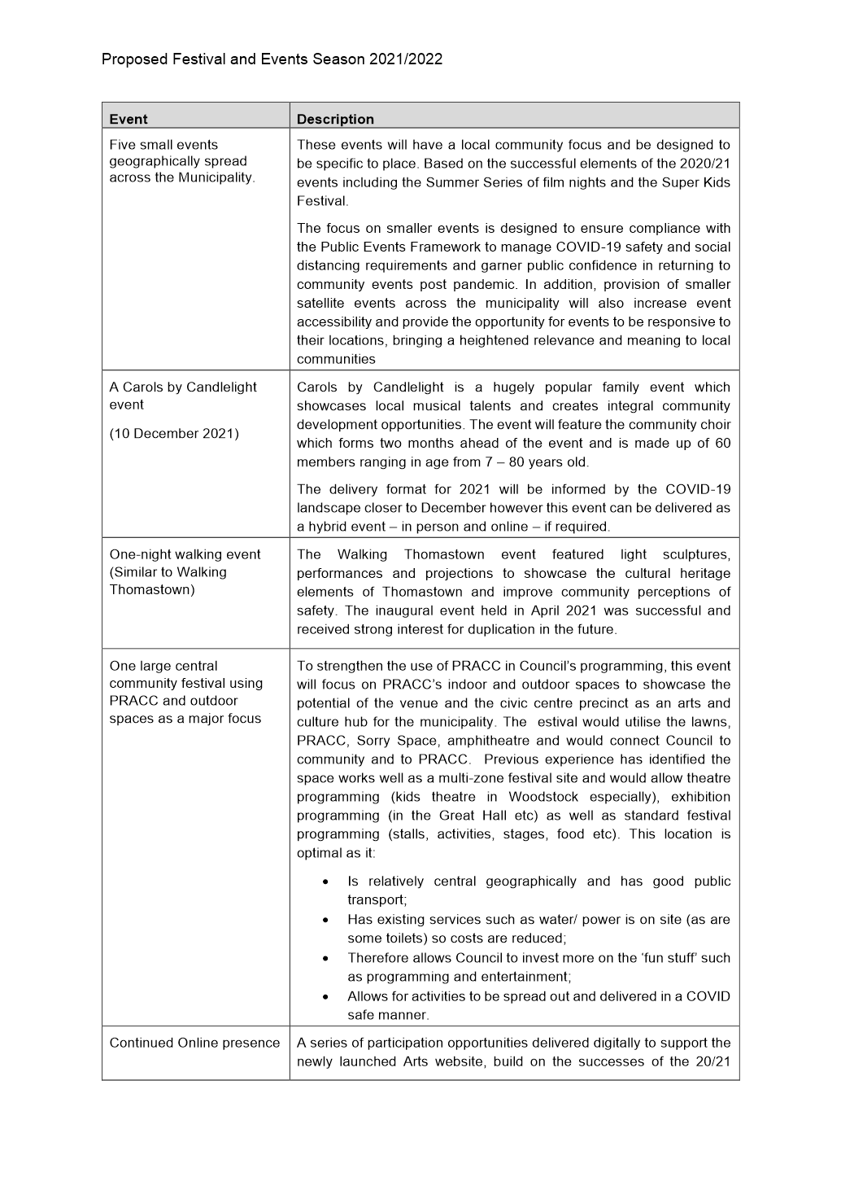

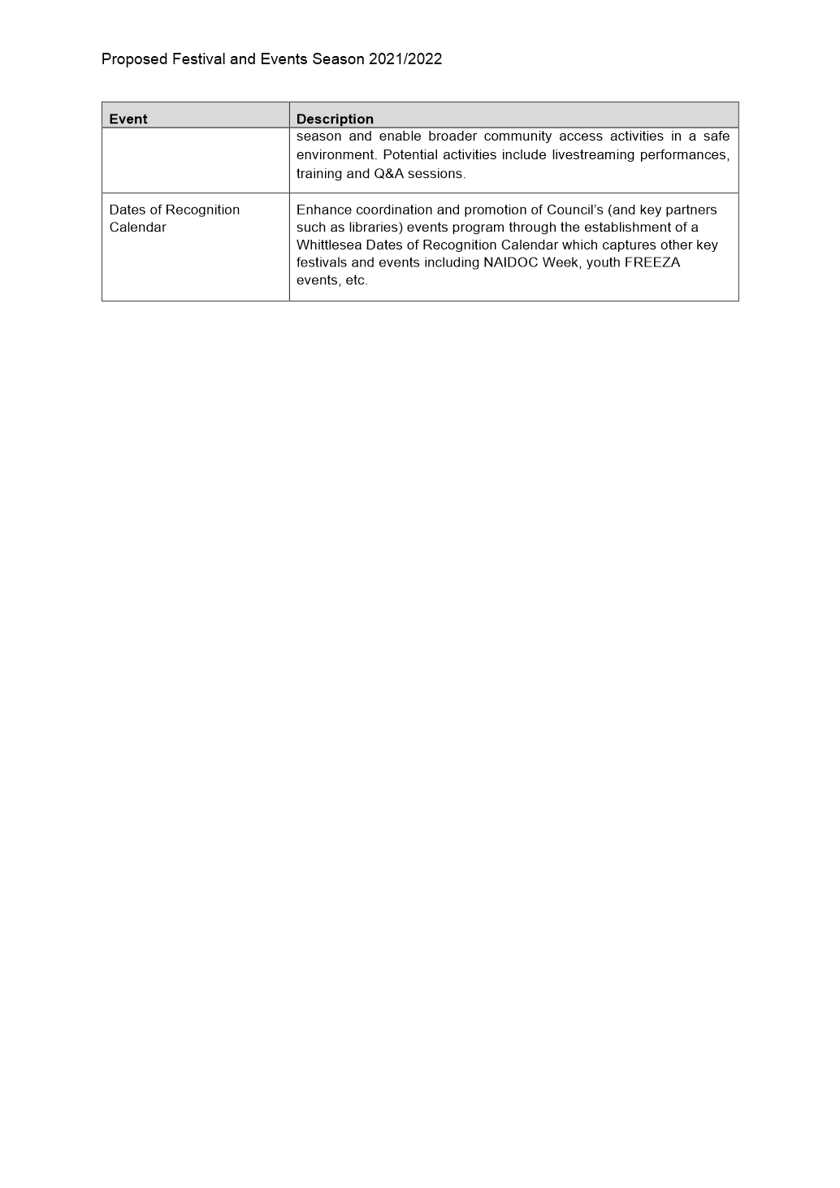

ITEM 6.1.2 For Noting - Final progress report Council's Disability action Plan 2017-21
Attachments: 1 2017 – 2021 Whittlesea Disability Action Plan - Outcomes summary
Responsible Officer: Director Community Wellbeing
Author: Team Leader Access

RECOMMENDATION SUMMARY
That Council note:
1. Note the outcomes from the Disability Action Plan 2017-21 (see Attachment 1)
2. Note the community feedback and emerging directions for Council in the next four years to increase participation opportunities and decrease discrimination for people with disabilities in our community.
3. Support the integration of future Disability Action Plan actions into the Community Plan 2021-25 and the Whittlesea 2040 (W2040) Strategies through alignment with the Council endorsed Integrated Planning Framework.
Brief overview
This report provides:
• A summary of the progress and outcomes of the City of Whittlesea Disability Action Plan (DAP) 2017-21
• The findings of the recent community consultation undertaken as a part of the Community Plan 2021-25 consultation
• A recommendation and rationale on the integration of the DAP into the Community Plan 2021-25.
rationale for recommendation
Integrating future Disability Plan actions into the Community Plan and W2040 Strategies will ensure a whole of organisation approach and ability to generate greater community outcomes. This will maximise health outcomes for residents with disabilities and carers while also meeting Council’s requirements under the Disability Act Victoria 2006.
impacts of recommendation
Benefits:
• A whole of Council and community approach to disability inclusion leading to improved outcomes for meeting the human rights of inclusion for people with disabilities in our community.
• Stronger reporting structures with links to the Community Plan 2021-25 and W2040 Strategies.
• Developing a holistic and proactive approach that will champion inclusion of people with disabilities across a larger number of initiatives throughout the organisation, which will have broader reach for all in our community
• Integrating the DAP with the Community Plan and the Municipal Public Health & Wellbeing Plan, gives Council the opportunity to achieve a strong health and wellbeing outcomes for the whole community.
Potential negative impact
• A possible negative impact is that the integration of Disability Plan actions may result in diminished visibility of those actions leading to stakeholders, including community members, feeling that Council has less of a commitment to disability inclusion.
what measures will be put in place to manage impacts
Council will brief the Whittlesea Disability Network (WDN) on the new process that is being undertaken and improved outcomes expected by integrating DAP actions into the Community Plan 2021-25.
A report which extracts all disability actions across the Community Plan 2021-25 and W2040 Strategies will be prepared showing the full extent of Council’s commitment across all W2040 goals.
For the life of the two previous DAPs, project managers have provided quarterly progress reports using Council reporting systems. This process will now be enhanced with monthly reporting for all actions in the Community Plan and quarterly reporting for all actions in the W2040 Strategies. An annual progress report, specifically on the DAP actions will be provided to Council and to the Whittlesea Disability Network.

Report
Background
The Disability Act Victoria 2006 requires each local government to develop a DAP or address the following requirements under the Council Plan (referred to in this report as the Community Plan 2021-25):
(a) Reducing barriers to persons with a disability accessing goods, services and facilities;
(b) Reducing barriers to persons with a disability obtaining and maintaining employment;
(c) Promoting inclusion and participation in the community of persons with a disability:
(d) Achieving tangible changes in attitudes and practices which discriminates against persons with a disability.
The City of Whittlesea has a large proportion of residents with disabilities. The Australian Bureau of Statistics (Disability, Ageing and Carers, Australia: Summary of Findings, 2018) identifies 35,249 (15.8%) of Whittlesea’s 222,973 residents have a disability. It also states that 22,874 (10.1%) of Whittlesea residents are unpaid carers. These figures compare to the National percentages on 17.7% residents with a disability and 10.8% are unpaid carers.
The Australian Government’s National Disability Strategy 2010-20 notes:
Australians with a disability have significantly worse life outcomes compared to others or compare to people with disability in similar countries. People with disability are more likely to experience:
• Relatively poor health
• Lower level of participation in education, training and employment
• Social exclusion
• Lack of access to goods, services and facilities
• Ongoing discrimination
Disability Action Plan 2017-21
In 2017, Council endorsed the DAP 2017-21 as a stand-alone cross-Council plan with actions under four key commitment areas:
• Inclusive communities;
• Good Health, housing and wellbeing for people with disabilities;
• Respect, equity and safety for all; and
• Contributory community living as a right for all regardless of ability.
The 2017-21 DAP consisted of 105 actions over four years, with 87 of these achieved on time and in their nominated year (including 3 on track to be delivered by June 2021). Fifteen actions were achieved outside of their scheduled timeline, with only 5 actions unachieved due to external factors
The significant outcomes achieved in the 2017 – 2021 DAP include:
• Development of the All-Abilities Playground at Mill Park (planned for over 15 years);
• Increasing access for residents with disabilities as a part of the Mill Park Leisure redevelopment;
• Delivery of the Marveloo portable change facility for events;
• Increase (from three to eight) in Changing Places facilities within the municipality, enhancing community participation for people with disability;
• Working with the Victorian Government on Accessible Parking Scheme reform;
• Undertaking the NDIS Gap Research Project that will support the service delivery market in the local area. This is a first for local government and will help strengthen service delivery in the local area to meet the needs of NDIS participants;
• Participation in the Australian Network on Disabilities Access and Inclusion Index Assessment which analyses Council’s confidence and capacity to employ and support people with disabilities. Council’s ranking increased from 29% to 51%, which puts Council in the top 20% of organisations that undertake the assessment.
• Provision of regular information to residents with disabilities and carers via direct newsletter and regular updates to the Whittlesea Disability Network (WDN). The WDN’s membership has evolved over the past four years and further work is required to ensure the forum continues to meet residents’ needs.
• Supporting isolated residents with disabilities and carers, during COVID lockdowns who are self-isolating and/or practicing physical distancing requirements.
• Additional outcome information is summarised in Attachment 1.
The five actions that were not achieved are outlined in the following Table
Action | Notes
Develop a Business Support Program that works with local business owners to encourage the inclusion of customers with disabilities (2018-19) | Council submitted two applications under the NDIS Information Linkages and Capacity Building (ILC) program in two funding rounds and was unsuccessful in each round. Information on how businesses could support customers with disabilities was provided and circulated in the “Business Resource Guide”. Further work in this area will be investigated in future plans.
Establish Disability Work Experience/ Employment Pilot Program with Council Departments for people with disabilities (Including people with disabilities from Aboriginal, CALD backgrounds and women with disabilities) (2018-19) | This action was also included in the ILC applications mentioned above that were unsuccessful. It will be investigated in future plans.
Develop a Community Disability survey to get baseline data on community attitudes around inclusion in our community. (2017-18) | Community attitudes on inclusion questions were added to a number of Council surveys over the life of the Disability Plan. This approach established better ongoing engagement feedback than a stand-alone survey.
Establish the Access and Inclusion Coordinating group which oversees the work to increase the employment opportunities for people with disabilities at Council (2019-20); | Due to numerous senior management changes and the focus on Council’s response to the pandemic for most of 2020, the Group was not established. This action will be revisited in future plans.
Develop Training program for staff that have community communication responsibility on the Accessible Communication Policy and inclusive Communication Protocol (including Communication toolkit) | This policy and protocol were put on hold due of changing priorities during the pandemic in 2020. This action will be revisited in future plans
Table 1: Unachieved Actions
Whittlesea Integrated Planning Framework
In March 2021, Council adopted a new Integrated Planning Framework. Adoption of this Framework means Council will no longer prepare and adopt separate, stand-alone strategies but will develop actions and priorities across a smaller number of integrated Whittlesea 2040 Strategies. The Framework includes the Disability Action Plan actions that will be integrated into the Community Plan 2021-25 and Whittlesea 2040 Strategies (rather than a separate document).
Proposal
By taking this approach it will mean that we will have two levels of actions on inclusion of people with disability.
- High level actions that will appear in the Community Plan.
- Next level actions that will appear in the Whittlesea 2040 Strategies.
It will also mean that instead of taking a disability specific focus in our actions, the organisation can respond across a number of disciplines with a human rights framework. The strength of this approach is that the increased scope will result in positive outcomes across a broader number of areas for residents with disabilities.
Measures to address potential community concerns regarding a change to Council’s policy framework will be addressed through further consultation with the Whittlesea Disability Network, and annual reporting which ensures Council’s progress on disability initiatives is maintained.
Consultation
Community consultation
In March 2021, the community consultation on the planning for the next DAP was incorporated in the Community Plan 2021-25 community engagement. Questions relating to people with disabilities were included in the broader community survey.
• 36 people who completed the survey identified as having a disability,
• 49 people identified as carers, and
• 8 of these people identified as being a person with a disability and a carer.
• Local Service providers (Whittlesea Community Futures partners) were also consulted via the Community Plan 2021-25 survey. 19 local services responded to this survey.

Further specific disability cohort consultation was undertaken via a series of four workshop sessions:
What |  | Who | How
Workshop 1 | External  Engagement | Whittlesea Disability  Network  (WDN) | Hybrid workshop (face to face and online)  12 Participants
Workshop 2 | Internal  Engagement | Disability Staff Advisory Group | Online workshop  8 Participants
Workshop 3 | Internal  Engagement | Broader Staff | Online workshop  42 Participants
Workshop 4 | External  Engagement | Local Area  Coordinators who are employed by Brotherhood of St Laurence. BSL is the organisation that oversees the implementation of the planning and plan development NDIS in the local area | Online workshop  16 Participants
Table 2. Summary workshop sessions
Key themes emerging from this consultation under each of the Whittlesea 2040 goals are summarised in Table 3 below; and have been incorporated into the Community Plan 2021-25 development.
Whittlesea 2040 Goals | Theme
1. Connected Community | Increase information-sharing on disability services, programs and events
 | Increase community capacity building for people with disability
 | Increase civic participation for people with disability
2. Liveable Neighbourhood | Improve Accessible Housing opportunities in local area
 | Improve the built environment and infrastructure for people with disability
3. Strong Economy | Increase employment opportunities for people with disability
 | Increase education opportunities including training for people with disability
 | Support entrepreneurs with disability
4. Sustainable Environments | Improve accessible communication on sustainable opportunities
 | Develop accessible sustainable programs
Table 3. Consultation Key Themes
Critical Dates
The current DAP 2017-21 expired on 30 June 2021 and The Disability Act Victoria 2006 requires each Local Government to develop a DAP or address the requirements above in the Council Plan. There is no legislation around the DAP date but Council responsibility under the Council Plan is October 31.
Financial Implications
Actions from the DAP that appear in the Community Plan 2021-25 will be funded via Council’s recurrent department budgets or as Community Plan 2021-25 initiatives. When actions require additional resources, these will be considered as a part of Council’s annual budget processes.
Policy strategy and legislation
The alignment to the National Disability Strategy (NDS) (updated version expected late 2021), Victorian Disability Act 2006, and the current State Disability Plan (2017-20) (new plan expected in late 2021) is outlined below.

W2040 Goal area | Disability Act 2006 Requirements | NDS Proposed Outcome areas | State Disability Plan Pillar (2017/20)
Connected Communities | Reducing barriers to persons with a disability accessing goods, services and facilities  Achieving tangible changes in attitudes and practices which discriminate against persons with a disability | Health and wellbeing  Rights, protection, justice and legislation  Personal and community support | Health, housing and wellbeing
Liveable Neighbourhoods | Promoting inclusion and participation in the community | Inclusive and accessible communities | Inclusive communities  Health, housing and wellbeing
Strong Local economy | Reducing barriers to obtaining employment | Economic security  Learning and skills | Contributing lives
Table 4. Summary of alignment
Note: The DAP will also include actions around W2040 Goal area Sustainable Environment but there is less of a link around this goal area with the Disability Act, NDS and the State Disability Plan.
link to strategic risks
Strategic Risk Governance - Ineffective governance of Council’s operations and activities resulting in either a legislative or policy breach
This integrated approach will ensure that Council meets its legislative requirements under the Disability Act Victoria 2006 while also meeting our requirements working towards eliminating discrimination in our community

Links to whittlesea 2040 and the CoUNCIL Plan
Goal Connected community
Key Direction A healthy and safe community

The new DAP has links to all Goal areas of the Whittlesea 2040. It has strong links to Goal areas 1) Connected communities, 2) Liveable neighbourhoods, 3) Strong Local Economy and 5) High Performing Organisation. It also links to 4) Sustainable Environment but not as strongly as the other four.
Declarations of Conflicts of Interest
Under Section 130 of the Local Government Act 2020 and Rule 47 of the Governance Rules 2021, officers providing advice to Council are required to disclose any conflict of interest they have in a matter and explain the nature of the conflict.
The Responsible Officer reviewing this report, having made enquiries with relevant members of staff, reports that no disclosable interests have been raised in relation to this report.
Conclusion
The City of Whittlesea has a long and proud history of supporting people with disabilities and their carers. It was one of the first Councils in Victoria to register a DAP with the Australian Human Rights and Equal Opportunity Commission in 2003.
This new structure of incorporating the DAP into the Community Plan is a strong next step in embedding the work on inclusion and disability from primarily one single team to the whole organisation and our community. It builds on the work that has been done in the four previous DAPs to achieve the best outcomes for all in our community.
The community and key stakeholders’ input into actions in the Community Plan has identified priorities for Council in the next four years to increase participation opportunities and decrease discrimination for people with disabilities in our community.

RECOMMENDATION
THAT Council:
1. Note the outcomes from the Disability Action Plan 2017-21 as described in Attachment 1.
2. Note community feedback and emerging directions for Council in the next four years to increase participation opportunities and decrease discrimination for people with disabilities in our community.
3. Support the integration of future Disability Action Plan actions into the Community Plan 2021-25 and the Whittlesea 2040 (W2040) Strategies through alignment with the Council endorsed Integrated Planning Framework.
Council Resolution
Moved: Administrator Duncan
Seconded: Chairperson Wilson

THAT Council:
1. Note the outcomes from the Disability Action Plan 2017-21 as described in Attachment 1.
2. Note community feedback and emerging directions for Council in the next four years to increase participation opportunities and decrease discrimination for people with disabilities in our community.
3. Support the integration of future Disability Action Plan actions into the Community Plan 2021-25 and the Whittlesea 2040 (W2040) Strategies through alignment with the Council endorsed Integrated Planning Framework.
4. Seeks a further report by October 2021 in relation to those actions not achieved within the current Disability Action Plan, namely the Business Support Program; Disability Work Experience Employment Pilot; establishment of an Access and Inclusion Co-ordinating Group; and a training program for staff.
Carried

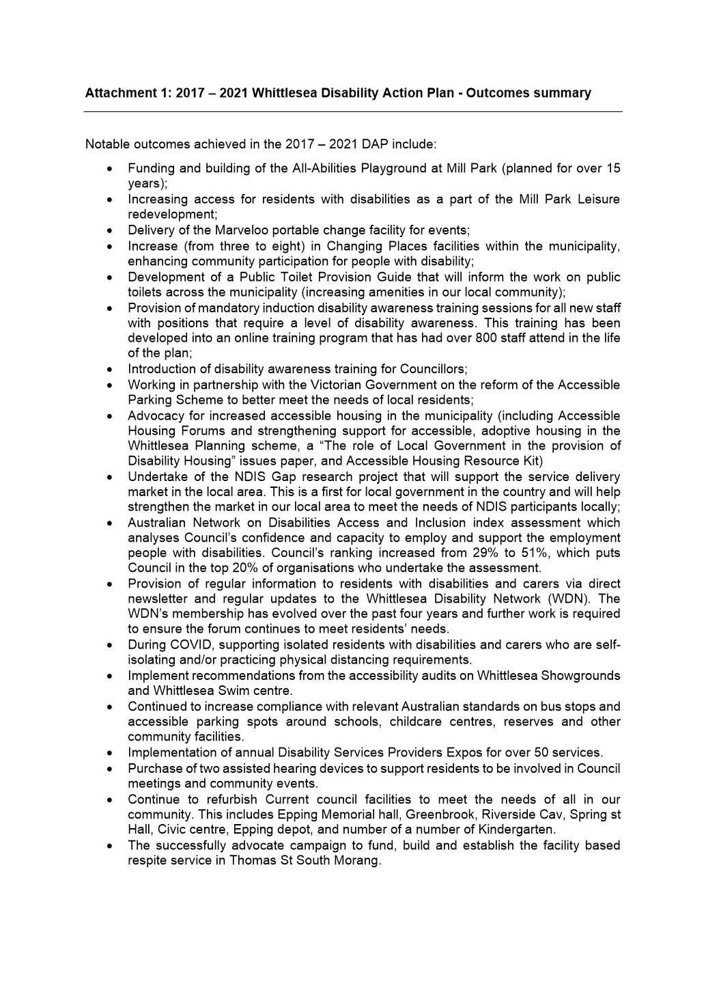

ITEM 6.1.3 For Feedback - Aboriginal Gathering Place
Attachments: 1 Aboriginal Gathering Place Community Vision
2 Aboriginal Gathering Place Investment Logic Map
3 Aboriginal Gathering Place Feasibility Study 2018
4 Aboriginal Gathering Place Draft Business Case 2021
5 Whittlesea Aboriginal Gathering Place Advisory Group (WAGPAG) Proposed Terms of Reference
Responsible Officer: Director Community Wellbeing
Author: Team Leader Aboriginal & Cultural Diversity

RECOMMENDATION SUMMARY
That Council resolve to:
1. Support the establishment of a purpose-built Aboriginal Gathering Place at Quarry Hills Park.
2. Provide funding to commence the project in the 2021/22 financial year.
3. Note a number of key documents prepared by Council and the local Aboriginal community over the past few years which inform this report and the Gathering Place project
4. Transition the existing Aboriginal Gathering Place Governance Group (AGPGG) to a formal advisory committee of Council and called the ‘City of Whittlesea Aboriginal Gathering Place Advisory Group (AGPAG)’.
5. Note Council will continue to explore external funding opportunities with other levels of government and other funding bodies.
6. Note a report will be brought to Council by March 2022 outlining a final Aboriginal Gathering Place Business Case, operational governance arrangements, detailed costings, and a site assessment update.
7. Note that completion of a Cultural Heritage Management Plan with the Wurundjeri Woi Wurrung Cultural Heritage Aboriginal Corporation will be commissioned and may impact on program delivery timeframes.
Brief overview
The vision (Attachment 1) for an Aboriginal Gathering Place (AGP) in the City of Whittlesea is for “a welcoming, inclusive and culturally safe space where all Aboriginal people have a sense of belonging and have access to activities, programs and services which strengthen culture and enhance wellbeing”.
The idea for a gathering place in Whittlesea was initiated by local community members over 20 years ago. There has been considerable work undertaken to date with the Whittlesea Aboriginal community including the establishment of AGPGG in February 2019.
The AGPGG in collaboration with other key stakeholders has worked with Council to develop the concept and identify potential sites.
This report proposes Council support the establishment of a purpose-built AGP at Quarry Hills as articulated in Option 4 (Attachment 4 as well as Table 2 of this report).
The proposed AGP is set to be included as a major initiative within Council’s Health Plan.
There is currently no allocation in Council’s long-term financial plan (LTFP) for this project. Consideration by Council of the work completed to date, a review of the project vision, proposed phasing, project governance, facility options and budget will be required as part of the final business case development.
rationale for recommendation
Establishing an AGP in Whittlesea has been the number one priority of the local Aboriginal community for over 20 years and remains the key priority of the Whittlesea Reconciliation Group (WRG).
Aboriginal people living in the City of Whittlesea have limited access to Aboriginal specific culturally appropriate services that respond to their immediate and long-term cultural needs. Recent population increases in the local Aboriginal community has resulted in an increase in the demand for services, as identified in the City of Whittlesea’s Human Services Needs Analysis Snapshot conducted in March 2018. There are 14 Aboriginal Gathering Places across Victoria; however, none of these are located in the Northern Metropolitan region.
A Gathering Place is seen as integral to improving the significant health and wellbeing deficits faced by our Aboriginal Community.
In addition, Reconciliation efforts between Aboriginal and non-Aboriginal people has a strong history in the City of Whittlesea, with the Whittlesea Reconciliation Working Group celebrating its 20th anniversary this year. This project is a significant initiative towards fostering greater understanding across our community on Aboriginal culture and history; and will offer wellbeing opportunities for all community members.
impacts of recommendation
The Aboriginal Gathering Place (AGP) project has been co-designed with the local Aboriginal and Torres Strait Islander community to:
• Respond to the adverse health and wellbeing profile of Aboriginal and Torres Strait Islander community members;
• Increase a sense of belonging and connection to culture
• Increase self-determination
• Increase health and wellbeing outcomes
• Increased economic participation opportunities
• Foster partnerships between Council, local Aboriginal and non-Aboriginal community members and Traditional Owners.
An evaluation of 13 Aboriginal Gathering Places across Victoria (commissioned by DHHS) found they create culturally safe environments and enable Aboriginal people to seek support and health care needs on their own terms. (Gathering places in the eastern metropolitan region of Melbourne: places for inclusion, connection and empowerment, Indigenous Health Equity Unit, University of Melbourne, 2016)
In addition, the AGP project has been designed to foster Reconciliation between Aboriginal and non-Aboriginal people living in Whittlesea through an increased awareness and understanding of Aboriginal culture.
If adopted, it is proposed that the AGP:
• Becomes a major health and wellbeing initiative of Council’s Municipal Health and Wellbeing Plan (to be incorporated in the 2021- 25 Council Plan).
• Plays a role in the activation of the Quarry Hills Park.
The report also identifies the project’s operational and financial impact for Council, and notes that further work will be required as part of the development of the final business case.
what measures will be put in place to manage impacts
A Major Initiative in the 2021-2022 Council Action Plan has been proposed to support this work including significant work around future governance and partnership development. This work will see a refinement of governance arrangements (between Council and the AGPGG), the level of service provision, the operating model and facility design to provide more detailed costings and clarity around roles and responsibilities. Key tasks moving forward will include:
• Develop a final Business Case (by March 2022) to inform development of the project and financial and operational requirements;
• Develop a Business Plan to build operational capacity over time;
• Confirm project governance, key stakeholders and relationships;
• Explore potential funding options including: Victorian and Australian Government grant opportunities, partnerships and philanthropy;
• On-going consultation with community (including the Gathering Place Governance Group, the Wurundjeri Woi Wurrung Cultural Heritage Aboriginal Corporation, Whittlesea Reconciliation Group and wider community).
To help manage the impacts of this complex project officers have established project governance including an elected community group (AGPGG), internal governance groups (AGP working and Control groups), an external intergovernmental working group and are members of the broader Quarry Hills project working group.
The design and delivery of the Gathering Place facility (outside of the master planning work) is not currently in the Major Projects Department Workplan for 2021/2022 and may require additional resources or may impact the delivery of existing Major Projects works.
If adopted the final Business Case will also develop an evaluation framework to assess the impact of the project.

Report
Background
Aboriginal and Torres Strait Islander - Health and Wellbeing
Whittlesea has an estimated population of 1,633 Aboriginal and Torres Straight Islanders. The population is increasing rapidly (growing by 46% between 2011 and 2016 compared with 33% for Melbourne as a whole). This trend is expected to continue.
Aboriginal people living in the City of Whittlesea have limited access to Aboriginal specific culturally appropriate services that respond to their immediate and long-term cultural needs. The population increase has resulted in an increase in the demand for services, as was reported in the City of Whittlesea’s Human Services Needs Analysis Snapshot conducted in March 2018. There are 14 Aboriginal Gathering Places across Victoria, however none of these are located in the Outer Northern Metropolitan region.
The Overview of Aboriginal and Torres Strait Islander Health Status 2015 (Health InfoNet 2016) presents indictors of Aboriginal health identified:
• Aboriginal people are 2.7 times more likely to feel high or very high levels of psychological distress;
• The death rate from intentional harm (suicide) is 2.2 times the rate reported for non-Indigenous people;
• The life expectancy is around 10 years less than the estimates for non-Indigenous people;
• Hospitalisation rates for circulatory disease are almost twice as high than for non-Indigenous people;
• Aboriginal people die from diabetes at six times the rate of non-Indigenous people; and
• In Victoria, Aboriginal adults make up 9% of the prison population despite only representing 0.8% of the population.
These challenges contribute to several negative social outcomes for residents when compared to the average for residents living in metropolitan Melbourne, including:
• Higher rates of family dysfunction and violence;
• Lack of social cohesion;
• Higher rates of physical and mental health problems; and,
• Higher incarceration rates.
The impacts of colonisation and past Australian government policies, particularly the forced removals and separation of families throughout the Stolen Generations, have resulted in trauma, grief and loss for Aboriginal and Torres Strait Islander people. This trauma is experienced across generations and impacts negatively on future generations; and has been widely documented, notably in the Australian Government’s 1997 'Stolen Children' National Inquiry, Bringing them Home’ report. Policies and actions that are developed with Aboriginal people and are specific to the needs of Aboriginal people are required if health and wellbeing outcomes are to be improved.
Aboriginal Gathering Places and the broader community
Beyond the critical health and wellbeing benefits for the Aboriginal community, Aboriginal Gathering places provide significant benefits to the broader community. Gathering places are fundamentally inclusive and welcoming spaces for all—by their very nature they attract and embrace anyone in need of support—including non-Indigenous people.
A 2016 Melbourne University study for the Department of Health and Human Services, Health and Wellbeing Outcomes of the Aboriginal and Torres Strait Islander Gathering Place Model in Victoria, found that the effect on the wider non-Indigenous community and other mainstream community and government services is pronounced, with most gathering places working hard to establish strong partnerships and networks with external programs
The vision for Whittlesea Aboriginal Gathering Place is of a place that serves the broader community and provides regular and ongoing opportunities for non-Aboriginal community members to learn and engage with local Aboriginal culture and history, including through school tours, cultural competency training for workplaces and cultural events and programming.
City of Whittlesea general population - Health and Wellbeing
The Eastern Melbourne Public Health Network (EMPHN) needs assessment identifies Whittlesea as having the highest rate of people aged over 18 years with high or very high psychological distress. Our municipality’s psychological distress rating for this age group is above the Victorian average. The Gathering Place proposal has been developed as an initiative designed to foster connection and belonging to land, culture and community for both indigenous and non-indigenous community members. For example, it is anticipated that the facility will have the potential to host multiple school groups each week as well as a range of other health and wellbeing programs. To this end, if endorsed the Gathering Place will be a major health and wellbeing initiative of Council’s Municipal Health and Wellbeing Plan (to be incorporated in the 2021- 25 Council Plan).
2016 Melbourne University study
In 2016, Melbourne University’s Indigenous Health Equity Unit were commissioned to prepare a study titled Gathering places in the eastern metropolitan region of Melbourne: places for inclusion, connection and empowerment for the Department of Health and Human Services. The study evaluated the health and wellbeing outcomes of the Aboriginal and Torres Strait Islander gathering place model in Victoria and found they have:
• Direct positive impacts on the health and wellbeing of individuals and community;
• Provide a safe and inclusive space to connect;
• Support the sharing of knowledge; and,
• Empower people through social, cultural and healing activities.
Gathering Places – Definition and Role
A Gathering Place is a physically, socially and culturally safe place for Aboriginal people. They are led by Aboriginal people and broadly aim to support enhanced outcomes, increase connection to culture, and facilitate healing for Aboriginal people.
‘Gathering Places are community owned and operated places that provide opportunities for people to connect and deliver services.’ (Aboriginal Victoria - Local Aboriginal Networks and Gathering Places)
Outlined below are examples of Gathering Places operating successfully in Victoria.
Mullum Mullum Indigenous Gathering Place, Croydon
Mullum Mullum Indigenous Gathering Place (MMIGP) is a community controlled Aboriginal organisation based in the Eastern Metropolitan Region of Melbourne. MMIGP is an Aboriginal Neighbourhood House and is designed with developmental model which evolves over time according to identified need. The MMIGP aims to support the enhanced outcomes for the Aboriginal community of the Eastern Metropolitan Region of Melbourne by providing a range of programs and activities that:
• Lengthen life
• Strengthening children, young people and families
• Have cultural integrity and safety
• Support to implement innovative community-based approaches and solutions
• Collaborative planning and decision-making based on community-driven priorities
• Stronger partnerships between Aboriginal and mainstream services; and
• Stronger partnerships with government.
Willum Warrain Aboriginal Gathering Place, Hastings
Willum Warrain (‘home by the sea’) Aboriginal Association is the voice of Aboriginal and Torres Strait Islander people on the Mornington Peninsula. It is a Gathering Place where Aboriginal people come together to realize community aspirations and forge shared identity.
Managed by an Aboriginal board, and supported by seven staff members, Willum Warrain is located in the coastal town of Hastings and provides information and referral services, charitable support, health and wellbeing programs, art and culture programs, and links between the Aboriginal community and the broader local community. The core strategic focus is cultural strengthening.
Gathering Place – Whittlesea
Council’s commitment to Reconciliation and improving the wellbeing outcomes of Aboriginal people living in the City of Whittlesea dates back to 2001 with the establishment of the Whittlesea Reconciliation Group (WRG). The WRG are strong advocates for the benefits and positive social and wellbeing outcomes provided by AGPs.
There has been considerable work with the Whittlesea Aboriginal community to date including the establishment of the Whittlesea Aboriginal Gathering Place Governance Group (AGPGG) in February 2019. Key activities completed to date include:
Year | Activity
2018 | 2018 Gathering Place Feasibility Study (Attachment 3).
2019 | Officers establish the AGPGG as a project group.
2020 | A draft Gathering Place Business Case presented to ELT and Council Briefings
 | A Council Action Plan initiative delivered leadership and governance training to the AGPGG.
Potential Gathering Place sites were identified and presented to the AGPGG:
• 1420 Plenty Rd, Mernda (known as Mayfield Farm), and
• 105/105W Hunters Road South Morang, known as Quarry Hills site (preferred).
 | A Gathering Place Community Vision and Investment Logic Map developed and endorsed by the AGPGG (Attachment 1 and 2).
Table 1: Recent activity
A Gathering Place within the Quarry Hills Regional Parkland
Following the identification of issues at the Preston Hall (Mernda) site, the AGPGG were presented with alternative location at 105/105W Hunters Road South Morang (known as Quarry Hills). The AGPGG have visited this site and strongly endorse it as the preferred site for the AGP (refer Attachment 4 - and Figure 1 below)
105 Hunters Lane South Morang is a large parcel of land (100.7 ha), which is planned to be part of Granite Hills Park (part of the larger Quarry Hills Regional Parkland). This parcel is comprised of two parcels - 105W Hunters Lane (the substantial component) and will become the parkland, and 105Y Hunters Lane (a small compound for Yarra Valley Water’s water tank).
The shaded area in Figure 2 below (6 ha) is located on an elevated plateau and has been identified as a suitable site for a Gathering Place and may contain outdoor places that support activities within a Gathering Place. Within this area, the red circled area (1 ha) contains the former farm residence and associated structures. This area is likely to be the best location for a future facility (refer Figure 3).
This is a high-level assessment only and will need further detailed assessment and consultation to identify the actual area needed and improvements required.
The site enjoys an elevated aspect, is zoned Rural Conservation Zone (RCZ); and has both Bushfire and Cultural Heritage Overlays. The property is owned by Council and currently has an existing (vacant) residential dwelling and sheds (see Figure 2). Enhanced road and other infrastructure and services to support public uses would be required if the project were to progress.
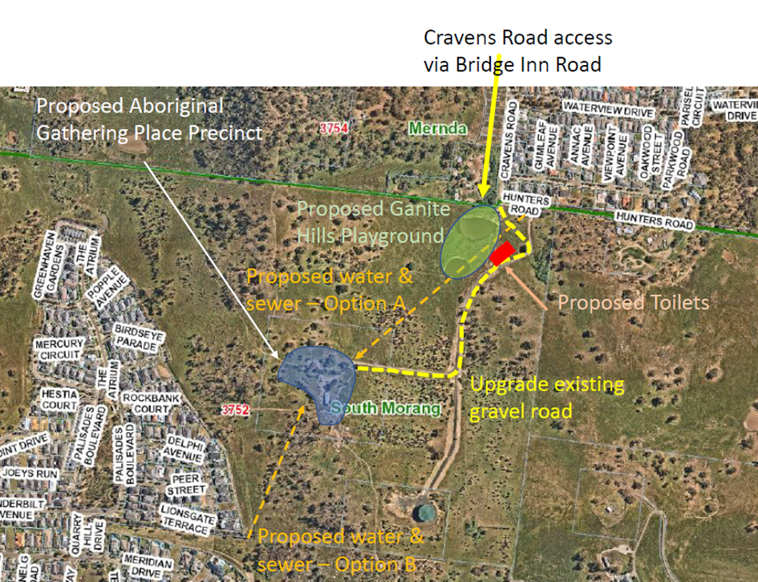
Figure 1: Site context

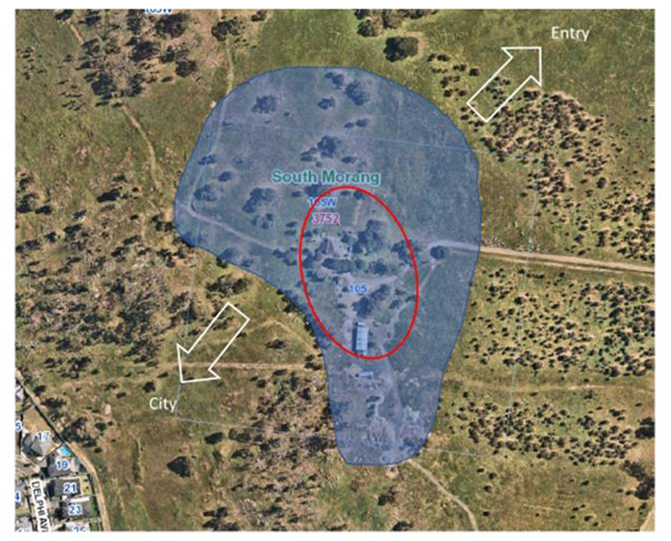
Figure 2: Gathering Place – shaded area (6 ha). Circled area = facility location
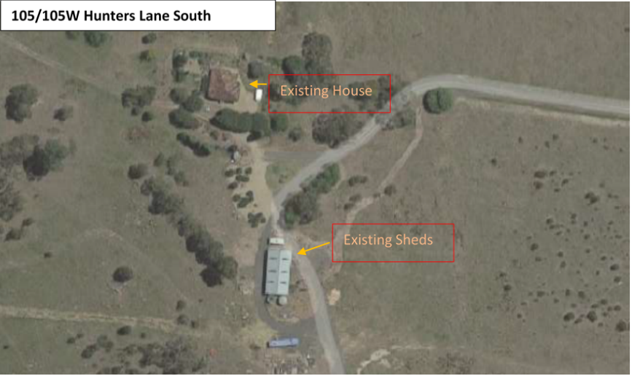
Figure 3: Gathering Place – existing facilities
The preferred site is adjacent (500m) the Granite Hills Playground development (currently under construction). A new facility at the Granite Hills Development has the potential to serve as a complimentary gateway to the AGP by providing an entrance and orientation. Based on the success of the All Abilities Play Space in Mill Park, the Granite Hills Playground has the potential to attract high numbers of people every week that could be connected physically and educationally to the AGP.
Moving forward there may opportunities to develop these facilities for mutual benefit including:
- Catering options and shelter for families at the playground
- A function room for hire for local families
- Interpretation providing cultural information about the AGP and local Aboriginal history and culture
- Providing long term sustainability to the AGP
This complimentary gateway project requires further investigation and feasibility.
proposal
This report proposes that Council:
• Support the establishment of a purpose-built Aboriginal Gathering Place at Quarry Hills.
• Transitions the AGPGG to become a formal advisory committee of Council and provide advice on the development of this facility and programs;
• Continue to liaise and consult with Traditional Owners including commissioning a Cultural Heritage Management Plan with the Wurundjeri Woi Wurrung Cultural Heritage Aboriginal Corporation;
• Continues to work with other levels of government and partners to identify other sources of funding and on-going income opportunities.
• Becomes a major health and wellbeing initiative of Council’s Municipal Health and Wellbeing Plan (to be incorporated in the 2021- 25 Council Plan).
A number of options for facility development were identified (Attachment 4 – Appendix A) with this report recommending Option 4. A brief summary of facility options is provided in Table 2 below:
Option Number | Description | Indicative Capital Cost | Benefits/ Constraints
Option 1 | Reuse of the existing dwelling on the site  Includes works to bring the building to public use standards (DDA, signage, parking, essential safety services, etc). | $450,000  +  services/ infrastructure costs (tbc) | Project would run small scale indoor programs and outdoor programs.  May involve considerable investment in facility without much scope for community access and use.  Option 1 has low fit-for-purpose outcomes and fails to meet the project objectives, except as an interim or pilot project.
Option 2 | Provision of a modular built facility  Demolish the existing dwelling and build a new modular facility with an approximate size of 545 sqm, including kitchen, amenities, large multi-purpose space and office. | $2,000,000  +  services/ infrastructure costs (tbc) | Option 2 allows for indoor and outdoor programs.  This model brings restrictions regarding shape and size for the site that may impact on functionality – this would need to be determined through site planning.  The approximate cost for this option would be $2 million for the building. External site works and services will be an additional cost (which could be as much as the building cost).  Modular buildings typically have a life span of between 10-15 years.
Option 3 | Provision of a purpose-built facility (base)  Includes:  • Total floor area of 545 sqm  • Medium meeting/event space for 50 people  • Meeting room for 15 people  • Small communal dining space  • Staff admin and storage areas  • Basic kitchen  • Car parking for 30 - 48 cars  • Basic landscaping  • 5-star building | $3,000,000  +  services/ infrastructure costs (tbc) | Options 3 and 4 meet the community vision for this project.  Option three allows for moderate capacity for the meeting room, events space, staff administration areas and carparking as well as basic kitchen and landscaping provisions.  This option currently doesn’t include provision for an indoor meeting/events area that would support more than 50 people.  External site works and services will be an additional cost (which could be as much as the building cost).  This option can include a footprint that is designed with flexibility that allows it to be expanded as the project grows and evolves.
Option 4 | Provision of a purpose-built facility (enhanced)  Includes:  • Total floor area of 1090 sqm  • Large meeting/event space for 100 people  • Meeting room for 30 people  • medium communal dining space  • Larger staff admin and storage areas  • Enhanced kitchen  • Car parking for 80 - 90 cars  • Enhanced landscaping  • 5-star building | $6,000,000  +  services/ infrastructure costs (tbc) | Options 3 and 4 meet the community vision for this project.  Option four:  • Is the preferred option of the AGPGG.  • Allows for larger capacity for the meeting room, events space, staff administration areas and car parking as well as enhanced kitchen and landscaping provisions.  • Includes provision for an indoor meeting/events area that has a capacity of 100 people – which may improve income potential/ sustainability for the facility (larger school groups etc).  • Would be similar to other community centres and Council could build upon existing operating learnings and systems.  Further work is required to develop a concept, accurate costings and clarify the impact of the assumptions and constraints.  External site works and services will be an additional cost (which could be as much as the building cost).
Table 2: Facility options
Phase 1 Operational model – roles and responsibilities
Attachment 4 (Appendix B) articulates a Project Phases Plan with operational and governance models moving towards greater community control and autonomy during Phase 2.
Council role
At this stage, the AGPGG have requested that Council play a central role in the provision of staffing, utilities, facility/site capital and maintenance costs. The final business case will also identify opportunities for the initiative to become more self-sustaining and identify other external funding sources from Council.
City of Whittlesea Aboriginal Gathering Place Advisory Group
Central to the successful delivery of this project will be the establishment of different governance arrangements which share leadership, responsibility and ‘power sharing’ between Council and local Aboriginal communities. This best practice as evidenced in the Uluru Statement of the Heart, the current Treaty Process in Victoria and the Closing the Gap Targets which each articulate that self-determination is critical not just to the process but to the outcome itself.
This is a different model for Council and requires an appetite for trying new approaches
To this end it is proposed that Council transition the AGPGG to become a formal advisory committee to Council, called the City of Whittlesea Aboriginal Gathering Place Advisory Group (AGPAG). The terms of reference are provided as Attachment 5 and illustrated in Figure 4. It is proposed that a modest honorarium be paid to WAGPAG community members (excluding staff members who may also be WAGPAG members).
This report recognises the Aboriginal community will be central to direction and decision-making, and that there will be a need to build community capacity and relationships in parallel to the facility planning.
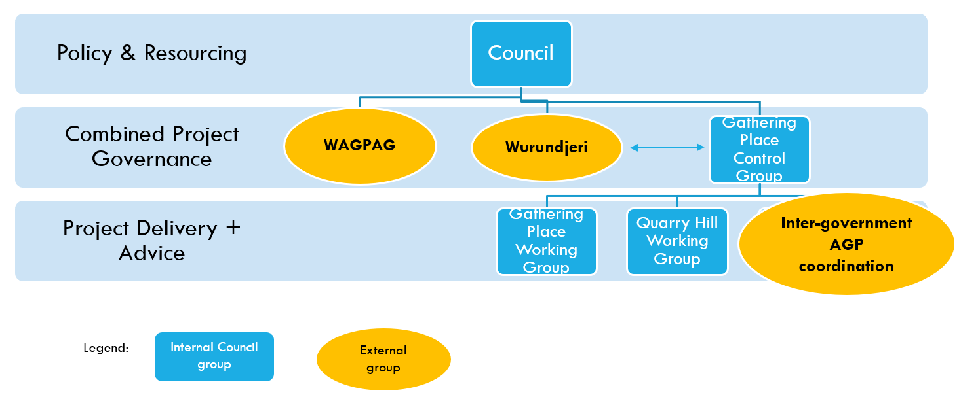
Figure 4: Proposed Phase 1 governance
Traditional Owners - Wurundjeri
The Wurundjeri Woi Wurrung Cultural Heritage Aboriginal Corporation (Wurundjeri) is the organisation representing the traditional owners of the land upon which the Gathering Place is proposed to be established. To date, several meetings have been held with Wurundjeri about the Gathering Place project and Wurundjeri have expressed strong support for the project.
Noting the critical nature of the relationship with Wurundjeri, the proposed establishment of the WAGPA includes two seats for Wurundjeri Traditional Owners.
In addition, Council will undertake a Cultural Heritage Management Plan with the Wurundjeri Woi Wurrung Cultural Heritage Aboriginal Corporation which will be commissioned in 2021 and may impact on program delivery timeframes. A Cultural Values Study for the broader Quarry Hills Regional Park has also been commissioned and Wurundjeri will inform future design, interpretation and opportunities in the Park.
consultation
Engagement to date
Extensive consultations took place for the 2018 Feasibility Study with over 67 community members and the Whittlesea Reconciliation Group (WRG).
The AGPGG has convened since 2019 on twelve occasions to discuss and develop the findings of the Gathering Place Feasibility Study and to articulate the community vision, operating model and governance model. The AGPGG also visited other Gathering Places to learn about different approaches, and in May 2020 completed intensive Leadership and Governance Training (Council Plan 2020/2021 Major Initiative: AGP Leadership).
Complimenting this AGPGG was an ILM working group that discussed high-level problems, benefits, solutions and responses across three workshops totaling over 10 hours.
A separate Gathering Place Project Working Group consisting of staff across multiple directorates and representatives from Department of Health & Human Services (DHHS), Aboriginal Victoria and WRG has provided strategic, partnership and funding advice.
Three meetings have been held with Traditional Owners from Wurundjeri as outlined above.
Ongoing engagement
The proposal for an Aboriginal Gathering Place involves a staged development in partnership with Aboriginal Gathering Place Governance Group, Traditional Owners (Wurundjeri), other levels of government and local community.
It is proposed that Council also establish an inter-government coordination group with Aboriginal Victoria, DELWP and other departments to align with the Victorian Government’s policy commitment to Gathering Places and self-determination including the Korin Korin Balit-Djak policy, Treaty process, Truth and Reconciliation Commission for Aboriginal Australians etc.
critical dates
Short term
Short term key project dates include:
Date | Activity
19 May 2021 | AGPGG Report workshop
6 July 2021 | Scheduled Council Meeting
Feb 2022 | Preliminary Phase - Completion of site investigations; site concept plan, service utility options; building scope and cost planning; and final Business Case.
March 2022 | Scheduled Council Meeting
Feb 2022 – March 2023 | Design Phase - RFT for design services (4 months), Delegated approval to award contract for design services (mid 2022), Concept Design, Design Development (sufficient to proceed to a Design & Construct contract for works in late 2022 – this could save 3-6 months, however there would need to be trade-offs with building functionality & architectural design), Detail Design, Detailed cost estimate, Permits & Approvals
Dec 2022 | Preliminary site works completed allowing for limited outdoor programming to commence.
Feb 2023 – October 2024 | Delivery Phase - RFT for works (4 months), Council award of contract for works (mid 2023), Construction, Commissioning, Fit-out
July 2023 | Completion of the WAGPAG’s initial term. At the end of this inaugural term, the WAGPAG will make recommendations to Council about future governance arrangements.
2024 | Facility and landscaping completed.

Considering the complexity of the site and the many unknown issues at this point (e.g. natural / environmental / cultural values of the site, contamination, etc), these timelines have an ‘optimism bias’. In addition:
• Outside of project visioning and initial works, facility design and development is not currently in the Major Projects Department workplan for 2021/22 and may impact on existing team resource requirements and/or delivery of other projects.
• The outcomes required in Phase 1 (to deliver a purpose-built facility) requires significant project fast tracking and prioritisation.
• Also note that completion of a Cultural Heritage Management Plan with the Wurundjeri Woi Wurrung Cultural Heritage Aboriginal Corporation will be commissioned and may impact on program delivery timeframes. Cultural Heritage Management Plan development currently have 4+ months’ delay with Traditional Owners.
Medium + Long Term – AGP Project Phases Plan
It is anticipated the AGP will have 3 key phases and work towards the establishing the centre as an independent community-run entity. Whilst subject to change and future Council decision making as the project evolves, it is anticipated the phases include:
Phase 1: Master Plan and Facility Establishment (July 2021 – October 2024)
Phase 2: Development and Partnership (2024 – 2028)
Phase 3: Independence and Sustainability (2028 - 2032)
Each phase has identified activities and outputs as summarised in Attachment 4 - Appendix B.
Financial Implications
Please note the figures in this report are high level and subject to change as site investigations and conditions are undertaken and will be captured in the final Business case.
The financial (capital and operational) and resourcing (planning, development and management) associated with the initiative will be significant. At this stage the project has been developed with Council as the primary funder for both capital and operational arrangements. Some external capital funding has been procured.
Council will continue to explore external funding opportunities with other levels of government and funding bodies. This includes the establishment of an inter-governmental coordination group as recommended in the 2018 Feasibility report.
This project has identified potential project costs of up to $14.9 million (capital and operating) over the next 25 years (Attachment 4 - refer draft Business Case). There is currently no long-term allocation in Council’s long term financial plan (LTFP) for this project. It is proposed that this would be reviewed following preparation of the final Business case (due March 2022).
Council’s Major Projects has provided high level indicative capital costs for four proposed options (Attachment 4 – Appendix A and Table 3 below) including:
1. Re-use of the existing dwelling
2. Development of a modular built facility
3. Development of a purpose-built (base – up to 50 indoor) facility
4. Development of a purpose-built (enhanced - up to 100 indoor) facility.

Requirement | Option 1 – Re-use of Existing | Option 2 – Modular Facility | Option 3 – Purpose Built (base) | Option 4 – Purpose Built (enhanced)
Capital Cost (estimate)
Upfront Capital Cost* | $450,000 | $2,000,000 | $3,000,000 | $6,000,000
Site Services & infrastructure Cost** | TBC* | TBC* | TBC* | TBC*
Table 3: Indicative capital costs (subject to change)
*Estimated facility capital estimates require conceptual design in order more accurately assess costs.
**Upfront services cost (including connecting power, water and sewage) require further assessment but could be between one to two million dollars.
2021/2022 Proposed Project Budget
The 2021/2022 financial year includes a proposed $250,000 in Council’s Capital Works Budgets and $300,000 grant from the DELWP’s Suburban Parks Infrastructure Fund.
DEWLP Grant ($300,000)
- $100,000 Access and Car parking upgrade at Gathering Place Precinct (105W Hunters Rd)
- $75,000 - Planning and Design - Includes high level master plan and concept design
- $75,000 - Open space infrastructure - Park seating, natural landscaping & firepit
- $50,000 - Signage - Interpretive/directional signage specific to the Gathering Place
Council’s capital works program ($250,000)
• $150,000 - Public Amenity - New portable amenity with two standard toilets and one accessible toilet
• $50,000 - Consultation & CMMP – Site concept planning, community consultation and cultural heritage management plan specific to the Gathering Place
• $50K – recommission existing dwelling for residential programs.
Opportunities for external funding and partnership
It is anticipated that there will be opportunities to work with other levels of government towards shared outcomes on this project (such as the Victorian Government’s Treaty and Truth and Reconciliation Commission processes; and the Australian Government’s Closing the Gap targets and outcomes). This may also identify external funding opportunities, and Council will actively work to optimise these opportunities including capital co-contribution targets of 50 per cent.
Policy strategy and legislation
The project directly aligns to Goal 1 a Connected Community within Whittlesea 2040 and is listed in the Council Action Plan 2018-2019 and 2019-2020 (Update 2019) within ‘1.2 A healthy and safe community’.
Other policy and strategy links include:
• Reconciliation Action Plan 2017-2022 (City of Whittlesea)
• Aboriginal Reconciliation Policy (City of Whittlesea)
• Community Building Strategy 2017 (City of Whittlesea)
• Equal and Safe, Family Violence Strategy (City of Whittlesea)
• Koolin Balit Aboriginal Health Strategy 2012 –2022 (Victorian Government)
• Korin Korin Balit-Djak Plan (Victorian Government) Details how DHHS will work with Aboriginal communities, community organisations, other government departments and mainstream service providers – now and into the future – to improve the health, wellbeing and safety of Aboriginal people in Victoria.
• The Australian Government’s National Agreement on Closing the Gap.
link to strategic risks
If the Aboriginal Gathering Place is not developed there is some risk that it would significantly impact on Council’s capacity to effectively increase community wellbeing and service delivery for the Aboriginal community.
Strategic Risk Community and Stakeholder Engagement - Ineffective stakeholder engagement resulting in compromised community outcomes and/or non-achievement of Council's strategic direction
This project also includes some significant other risks including:
- Complexity of the site: The preferred site at Quarry Hills is remote and elevated which adds to design and delivery complexity and could add to costs.
- Cultural risks: The current cultural significance of the site is unknown and requires a Cultural Heritage Management Plan
- Community Governance Risks: The project requires a new approach to community governance and self-determination which is new for Council and requires time, commitment and significant community capacity.
- Fast track risks: To achieve the outcomes proposed in Phase 1 requires fast tracking and prioritising the project which increases risks and limits scope around on-going community consultation and un-foreseen project changes.
- Complexity of the project: Council has not been involved in delivering an AGP before and will need adequate time and resources to develop sustainable and effective programs which achieve the proposed outcomes. History shows that most AGP build their success over a period of time and require on ongoing commitment from a range of stakeholders.
Each of these risks can be responded to with treatments including securing appropriate permits, completing cultural heritage management plans and providing regular and comprehensive community governance training and support; as well as regular communication with Council and future funders around resourcing and support.

Links to whittlesea 2040 and the CoUNCIL Plan
Goal Connected community
Key Direction A healthy and safe community

Declarations of Conflicts of Interest
Under Section 130 of the Local Government Act 2020 and Rule 47 of the Governance Rules 2021, officers providing advice to Council are required to disclose any conflict of interest they have in a matter and explain the nature of the conflict.
The Responsible Officer reviewing this report, having made enquiries with relevant members of staff, reports that no disclosable interests have been raised in relation to this report.
Conclusion
Establishing a Gathering Place in Whittlesea has been the main priority of the local Aboriginal community for over 20 years and remains a key objective of the Whittlesea Reconciliation Group. A Gathering Place is seen as critical to improve the significant health and wellbeing deficits faced by our Aboriginal Community.
This report proposes Council support the establishment of a purpose-built Aboriginal Gathering Place at Quarry Hills as articulated in option 4 (Attachment 4).
Critical to the success of the project is a commitment to shared governance model and responsibility for the facility with the Aboriginal Community. This is in-line with the long-term community vision for the project – with articulates a space operating on the principles of community control and self-determination.
Council will continue to explore external funding opportunities with other levels of government and other funding bodies and return to Council by March 2022 with a new report outlining a final Aboriginal Gathering Place Business Case which includes future (Phase 2) project governance arrangements, detailed costings, and a site feasibility update.

RECOMMENDATION
THAT Council resolve to:
1. Support the establishment of a purpose-built Aboriginal Gathering Place at Quarry Hills Park described as Option 4 in Table 2 of this report.
2. Note the following funding arrangements for the Gathering Place project:
a) Proposed Council funding of $250,000 in the draft 2021/22 budget;
b) External funding of $300,000 from the Department of Environment, Land, Water and Planning’s Suburban Parks Infrastructure Fund.
3. Note the following Gathering Place documents prepared with local community:
a) Aboriginal Gathering Place Community Vision (Attachment 1);
b) Aboriginal Gathering Place Investment Logic Map (Attachment 2);
c) Aboriginal Gathering Place Feasibility Study 2018 (Attachment 3);
d) Draft 2020 Aboriginal Gathering Place Business Case (Attachment 4);
4. Establish the City of Whittlesea Aboriginal Gathering Place Advisory Group (AGPAG) as per the Terms of Reference outlined in Attachment 5.
5. Note Council will pursue an external funding co-contribution target of 50 per cent to support the establishment of the Aboriginal Gathering Place described as Option 4 in Table 2 of this report.
6. Note a report will be brought to Council by March 2022 outlining a final Aboriginal Gathering Place Business Case, future operational governance arrangements, detailed costings, and a site assessment update.
7. Note that completion of a Cultural Heritage Management Plan with the Wurundjeri Woi Wurrung Cultural Heritage Aboriginal Corporation will be commissioned and may impact on program delivery timeframes.
Council Resolution
Moved: Administrator Duncan
Seconded: Chairperson Wilson

THAT Council resolve to:
1. Support the establishment of a purpose-built Aboriginal Gathering Place at Quarry Hills Park described as Option 4 in Table 2 of this report.
2. Note the following funding arrangements for the Gathering Place project:
a) Proposed Council funding of $250,000 in the draft 2021/22 budget;
b) External funding of $300,000 from the Department of Environment, Land, Water and Planning’s Suburban Parks Infrastructure Fund.
3. Note the following Gathering Place documents prepared with local community:
a) Aboriginal Gathering Place Community Vision (Attachment 1);
b) Aboriginal Gathering Place Investment Logic Map (Attachment 2);
c) Aboriginal Gathering Place Feasibility Study 2018 (Attachment 3);
d) Draft 2020 Aboriginal Gathering Place Business Case (Attachment 4);
4. Establish the City of Whittlesea Aboriginal Gathering Place Advisory Group (AGPAG) as per the Terms of Reference outlined in Attachment 5.
5. Note Council will pursue an external funding co-contribution target of 50 per cent to support the establishment of the Aboriginal Gathering Place described as Option 4 in Table 2 of this report.
6. Note a report will be brought to Council by March 2022 outlining a final Aboriginal Gathering Place Business Case, future operational governance arrangements, detailed costings, and a site assessment update.
7. Note that completion of a Cultural Heritage Management Plan with the Wurundjeri Woi Wurrung Cultural Heritage Aboriginal Corporation will be commissioned and may impact on program delivery timeframes.
8. Include the Whittlesea Aboriginal Gathering Place as a key advocacy priority for 2021/22 in partnership with the Aboriginal Gathering Place Advisory Group.
9. Amend the Terms of Reference for the Aboriginal Gathering Place Advisory Group to include, under Ordinary Meetings, the provision to formally meet with Administrators on a biannual basis.
Carried UNANIMOUSLY

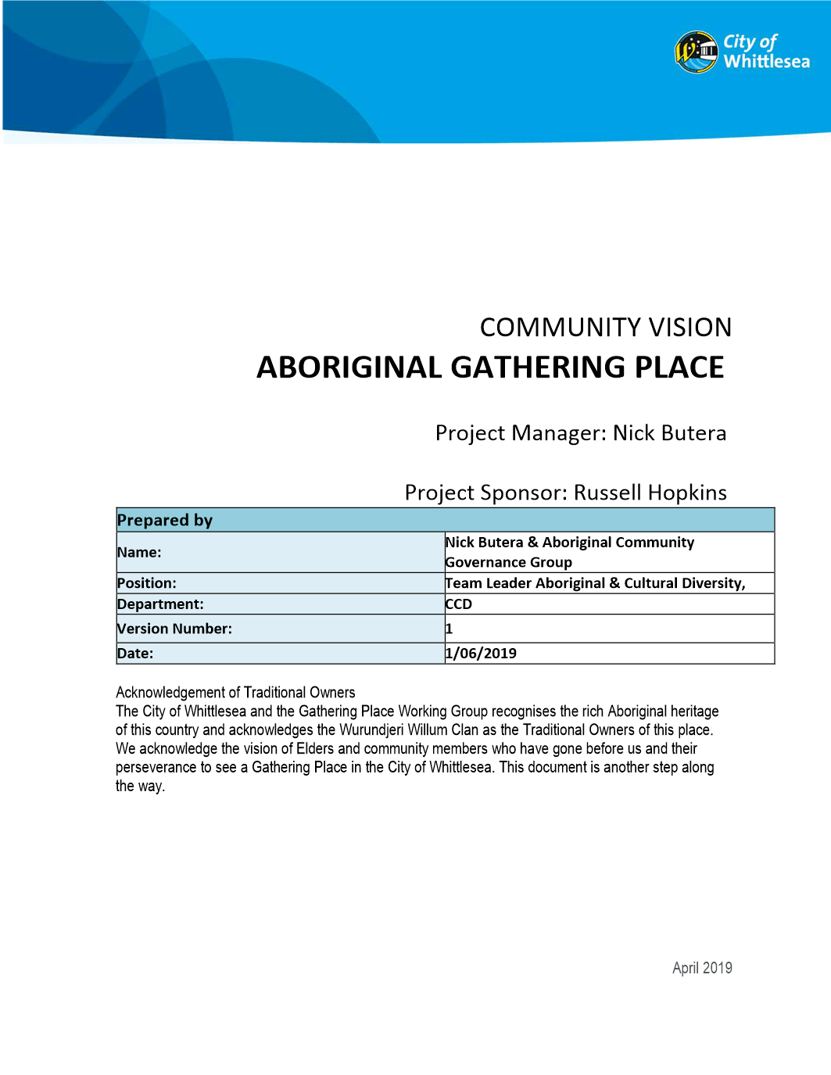

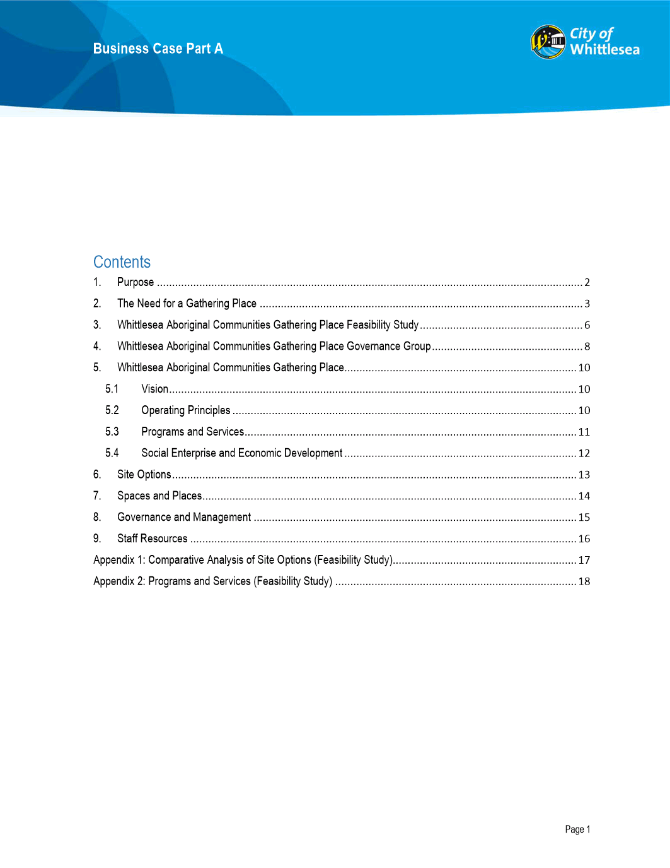

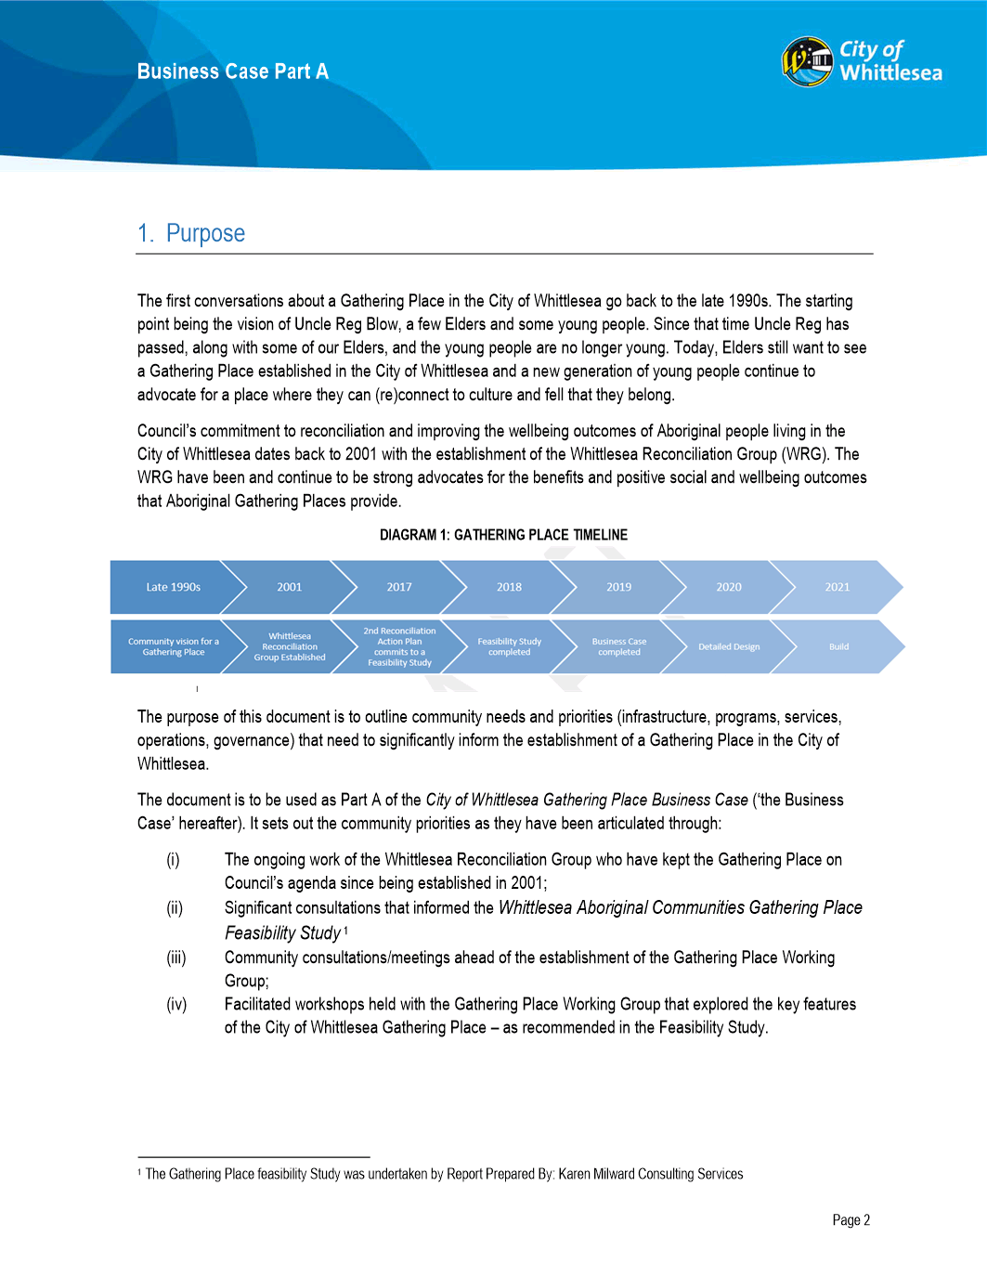

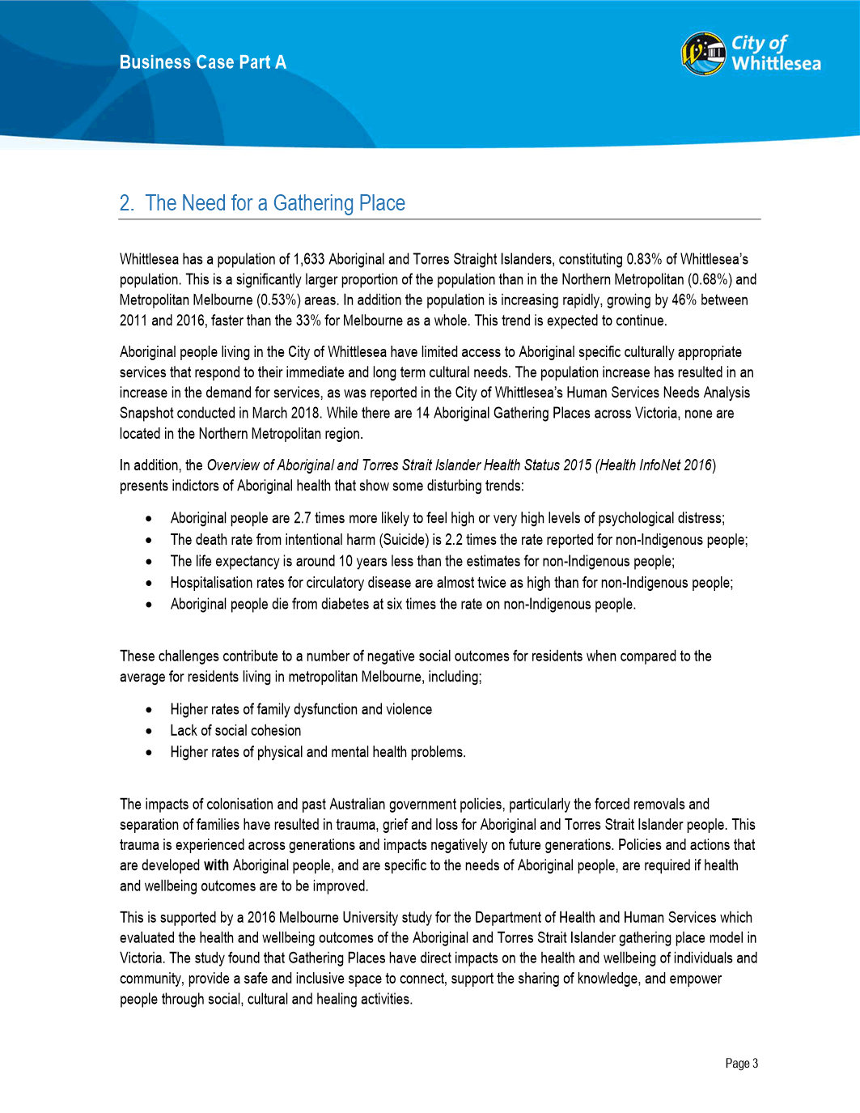

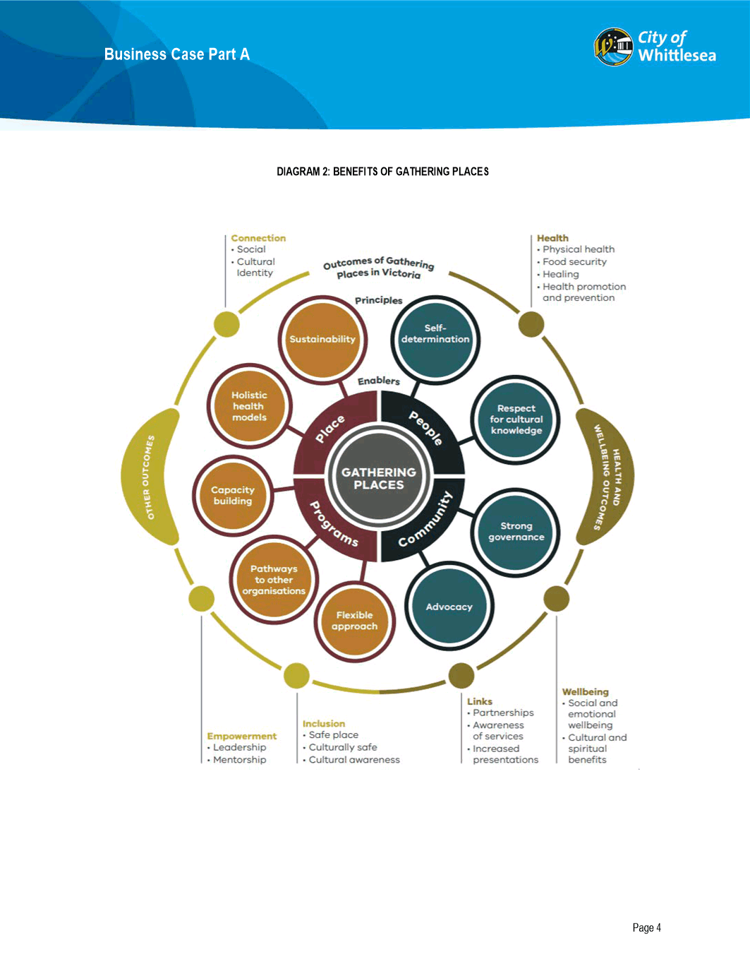

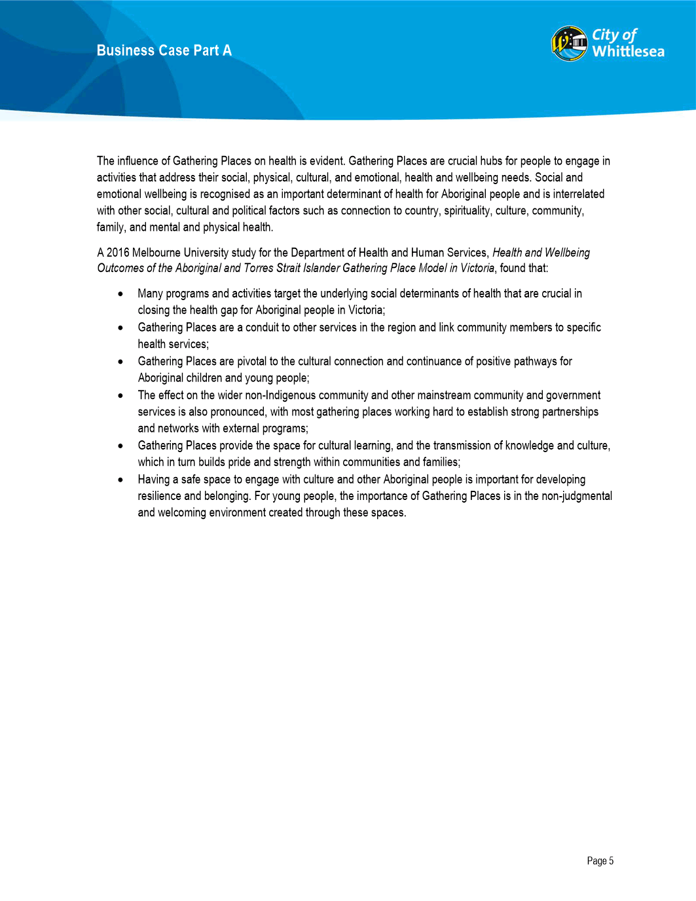

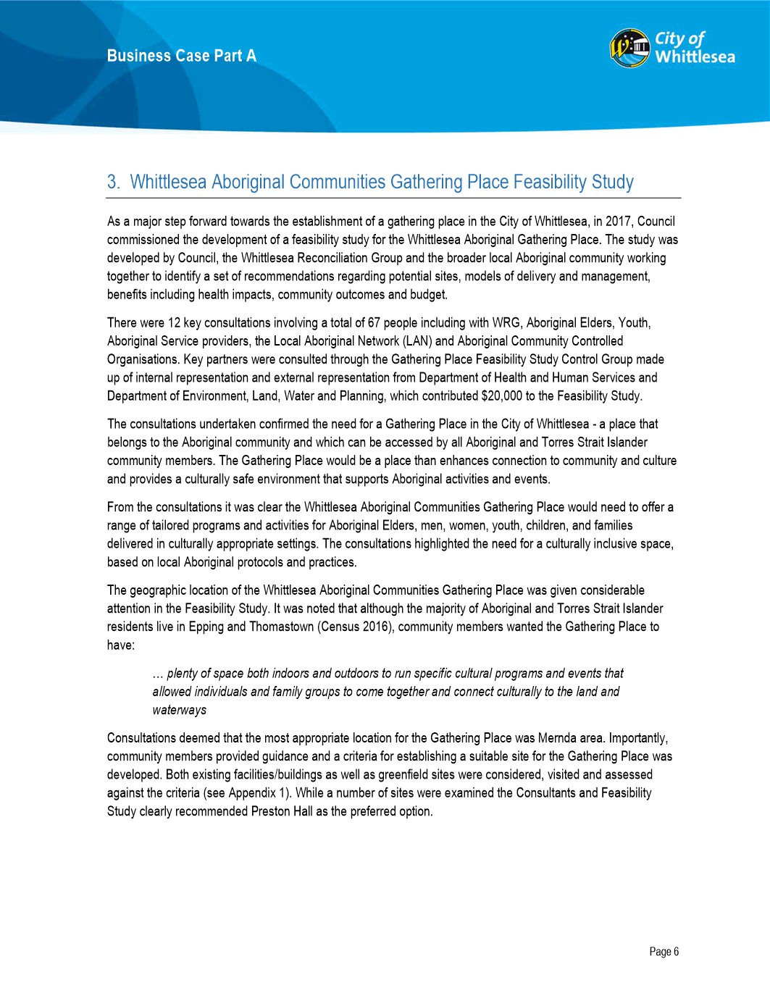

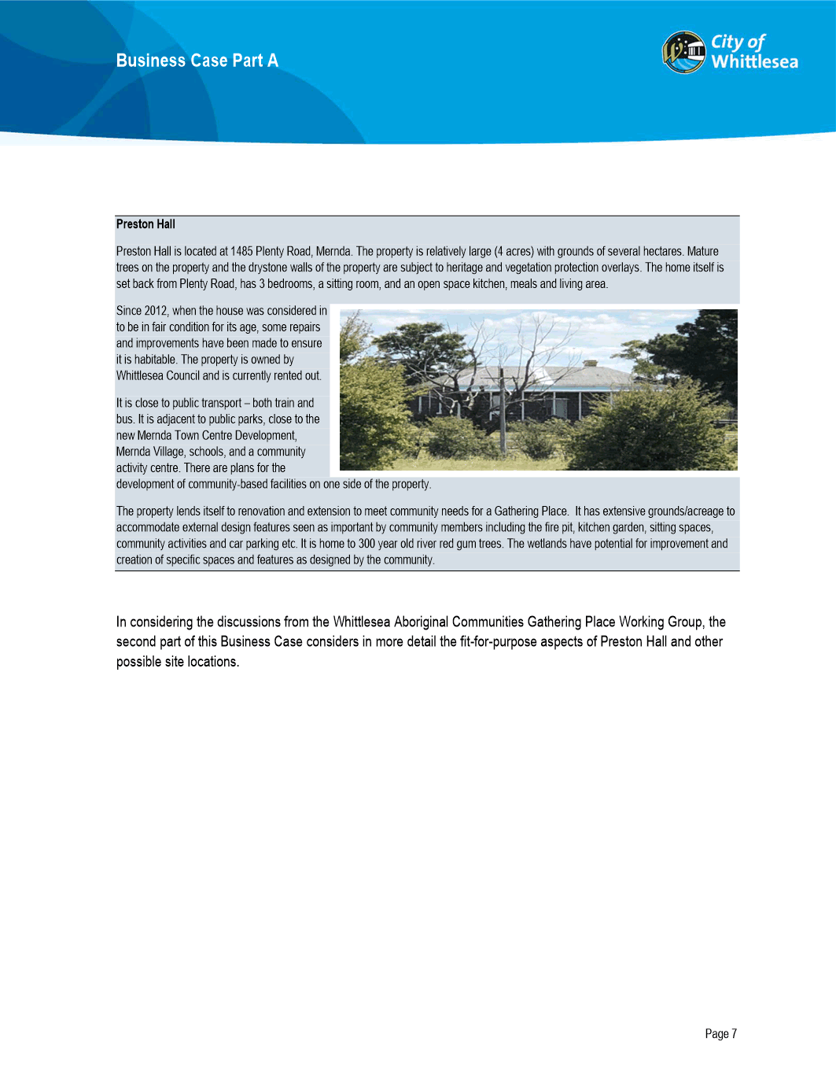

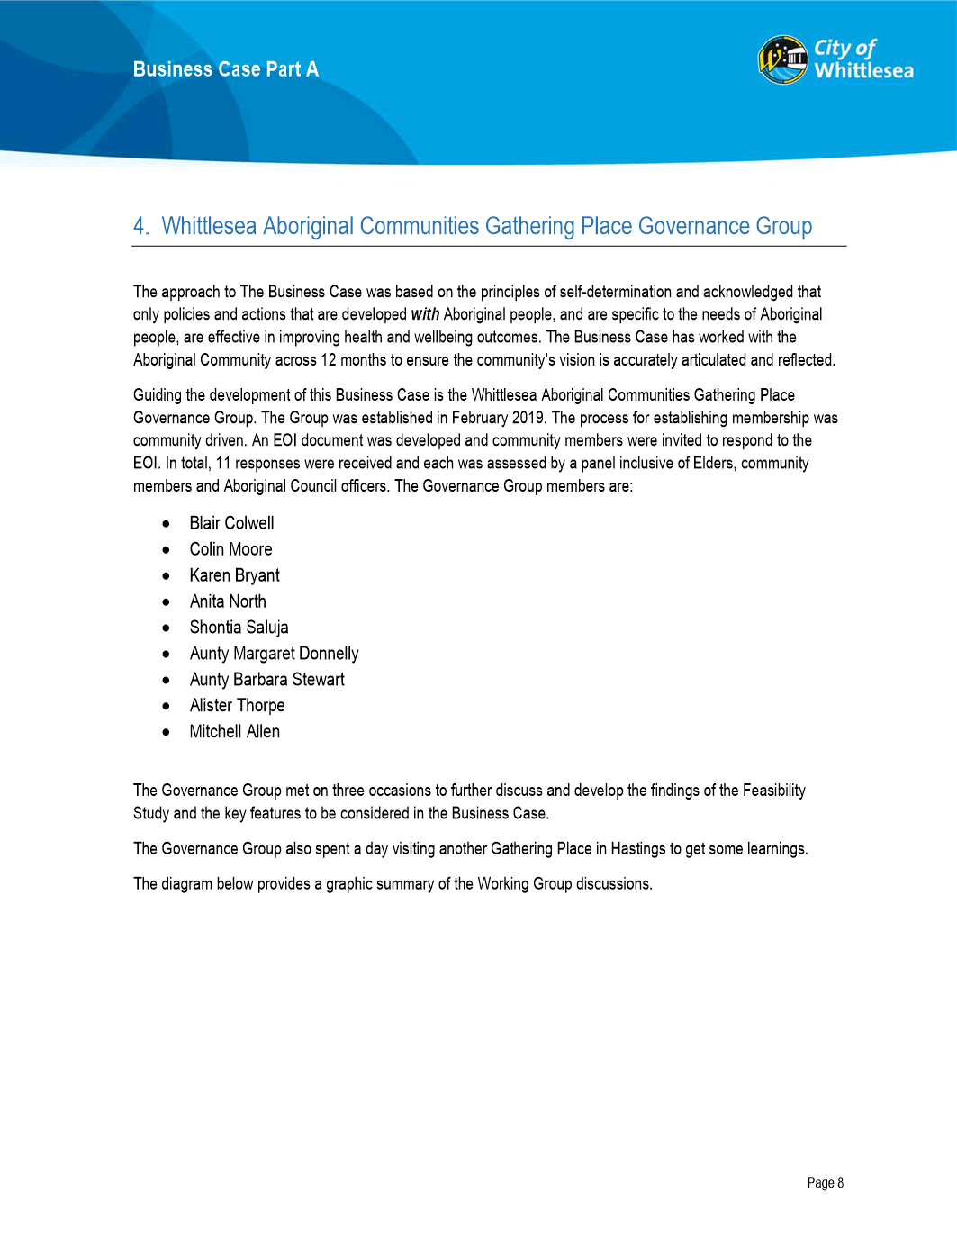

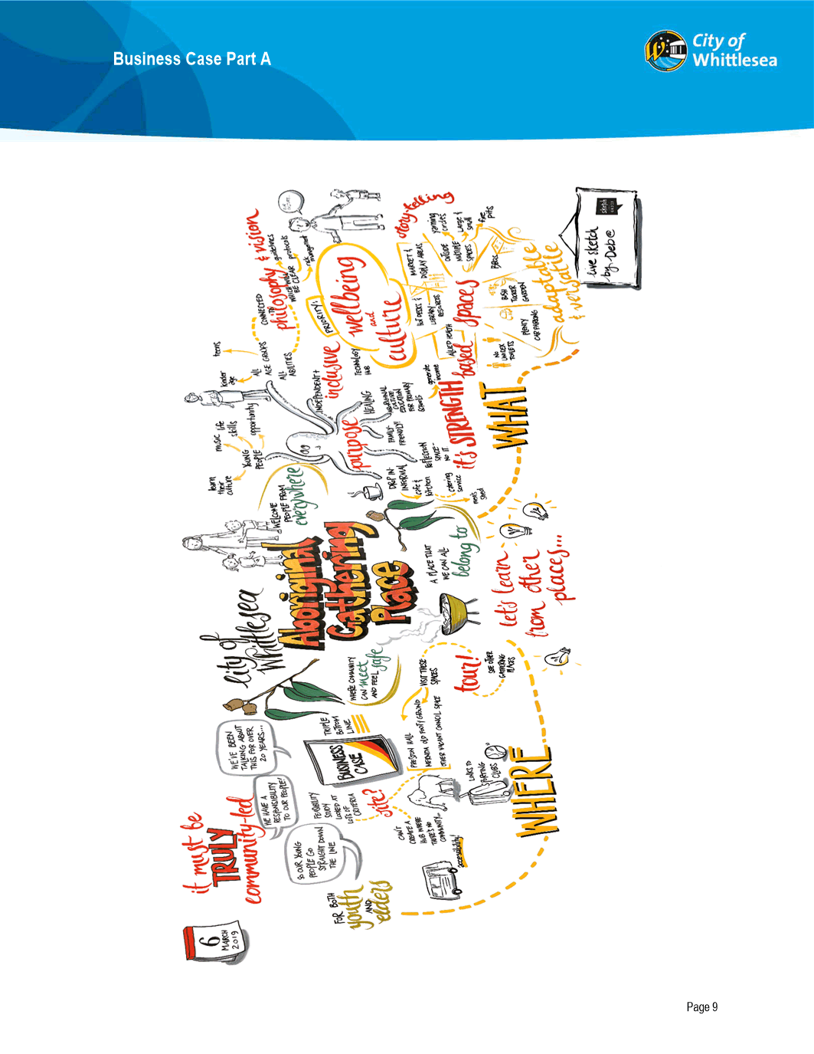

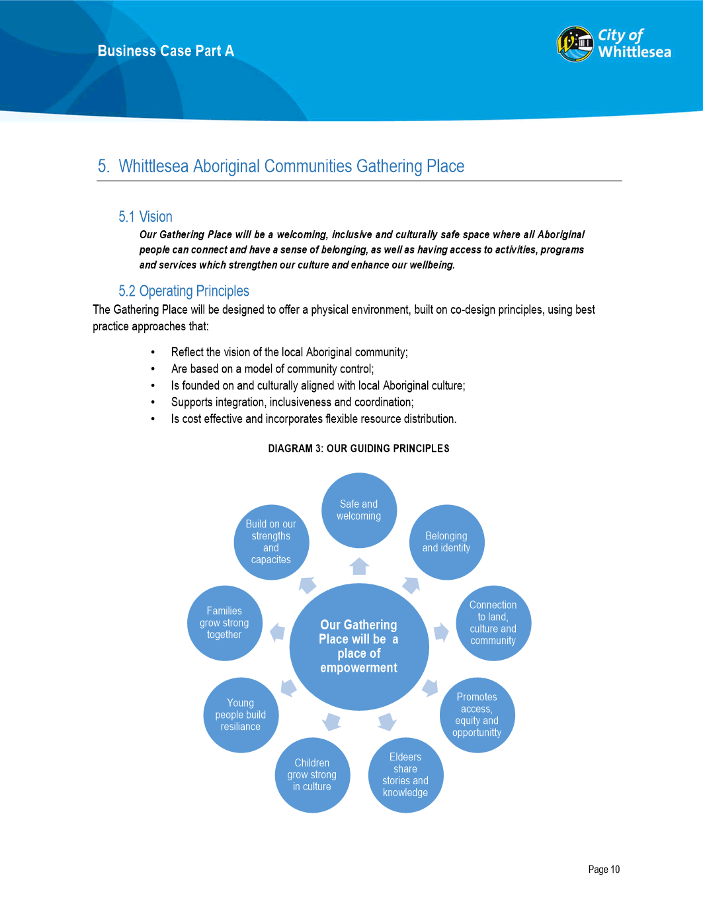

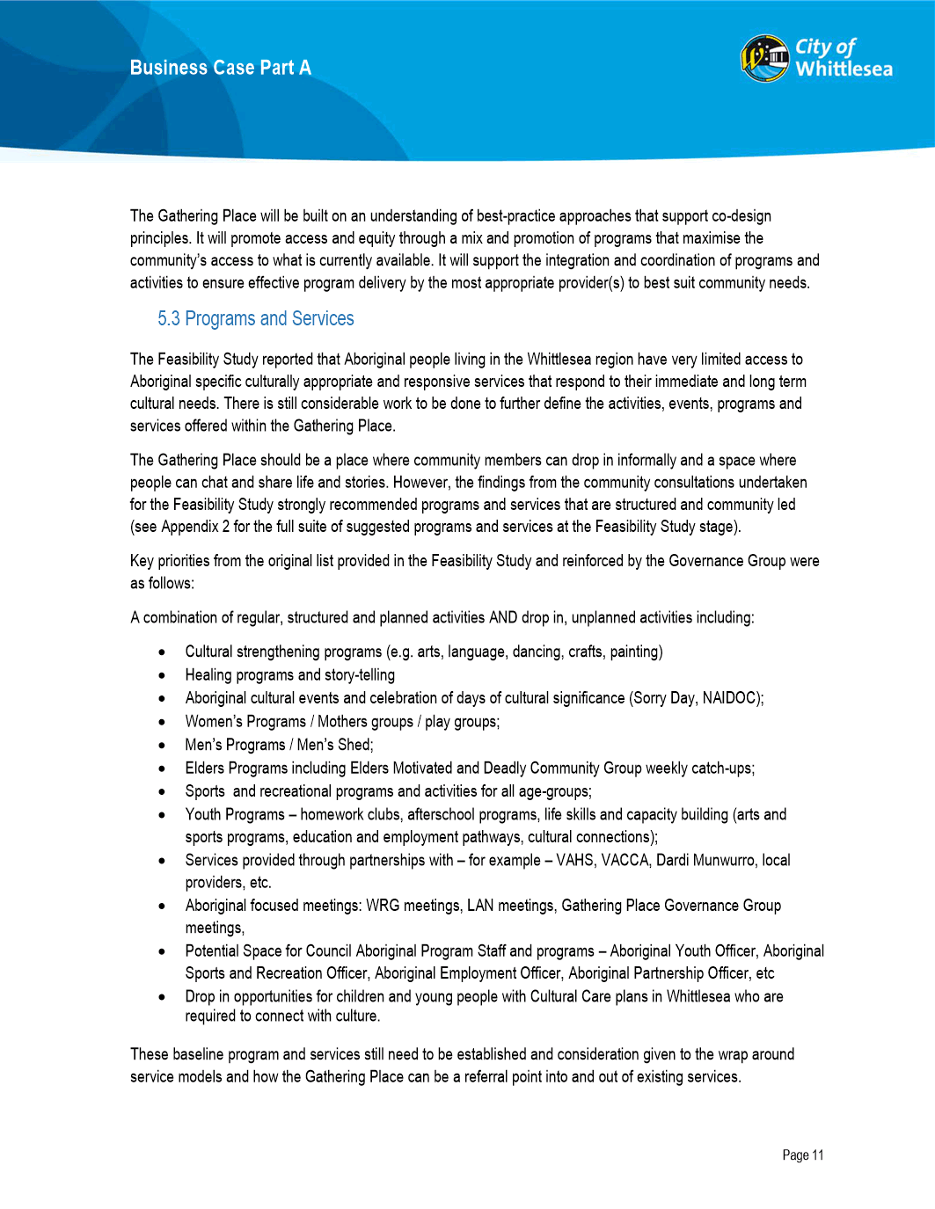

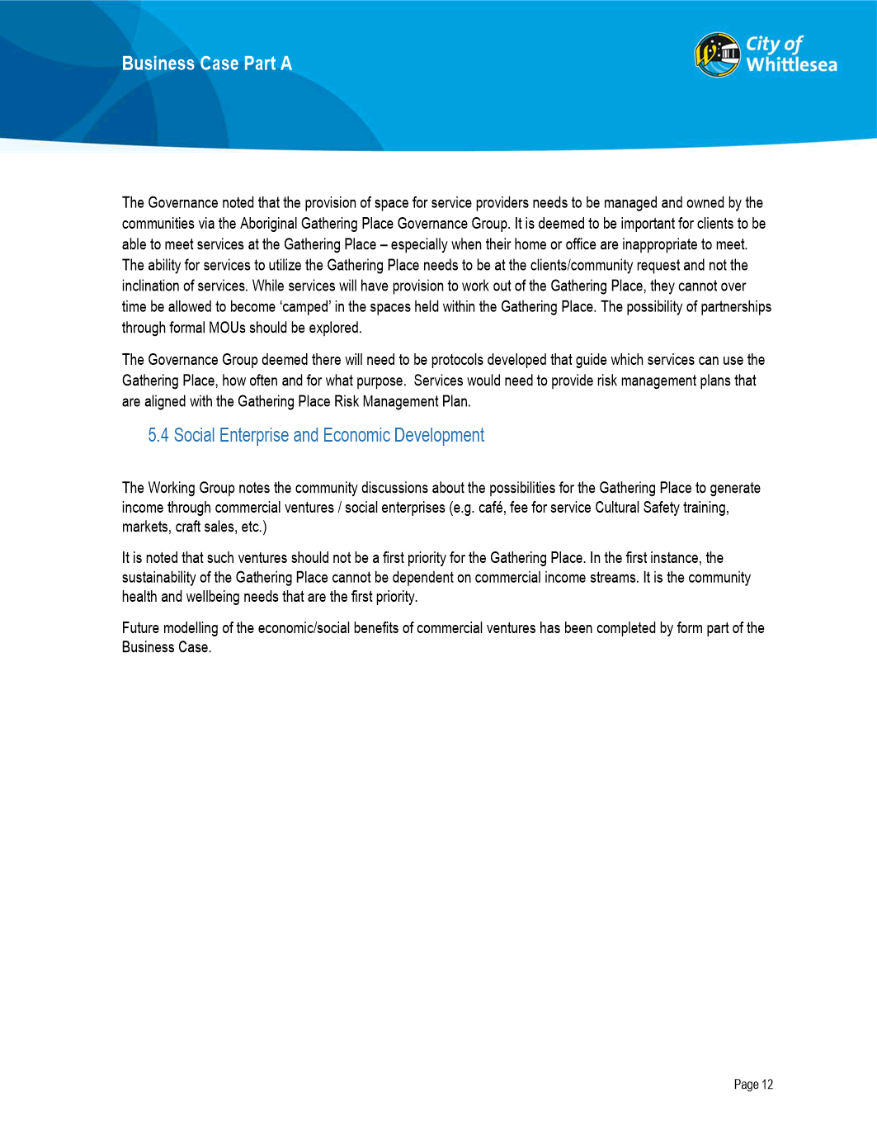

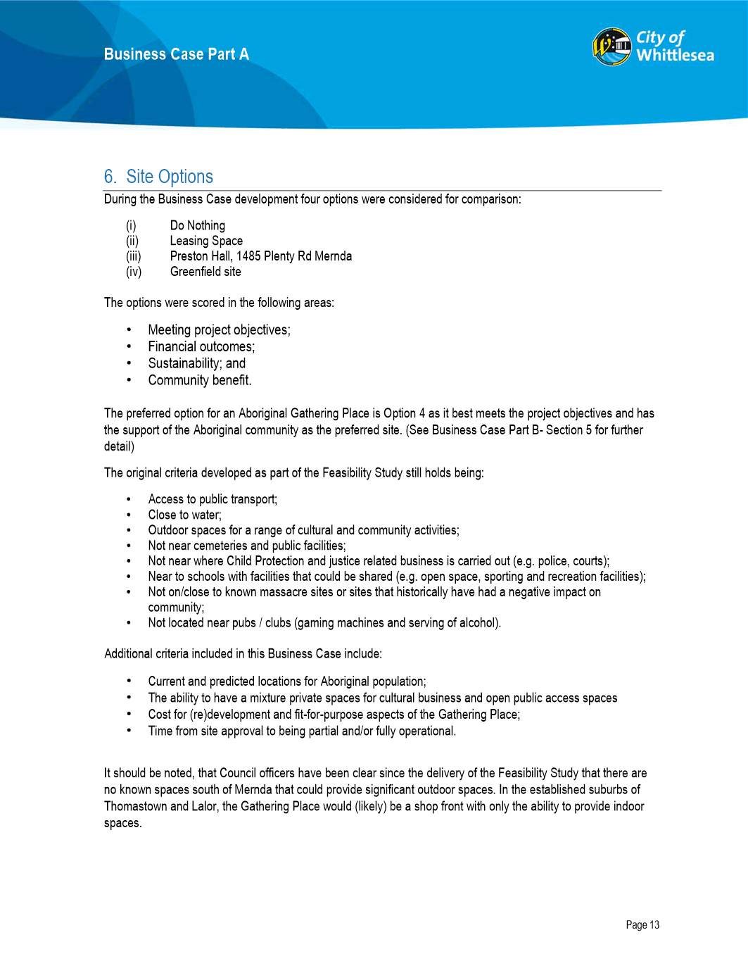

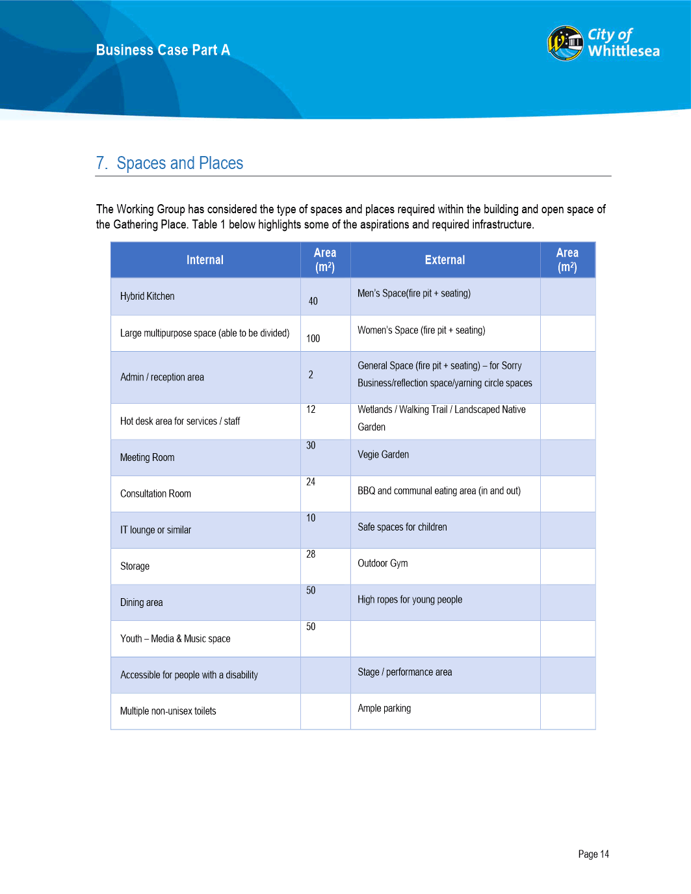

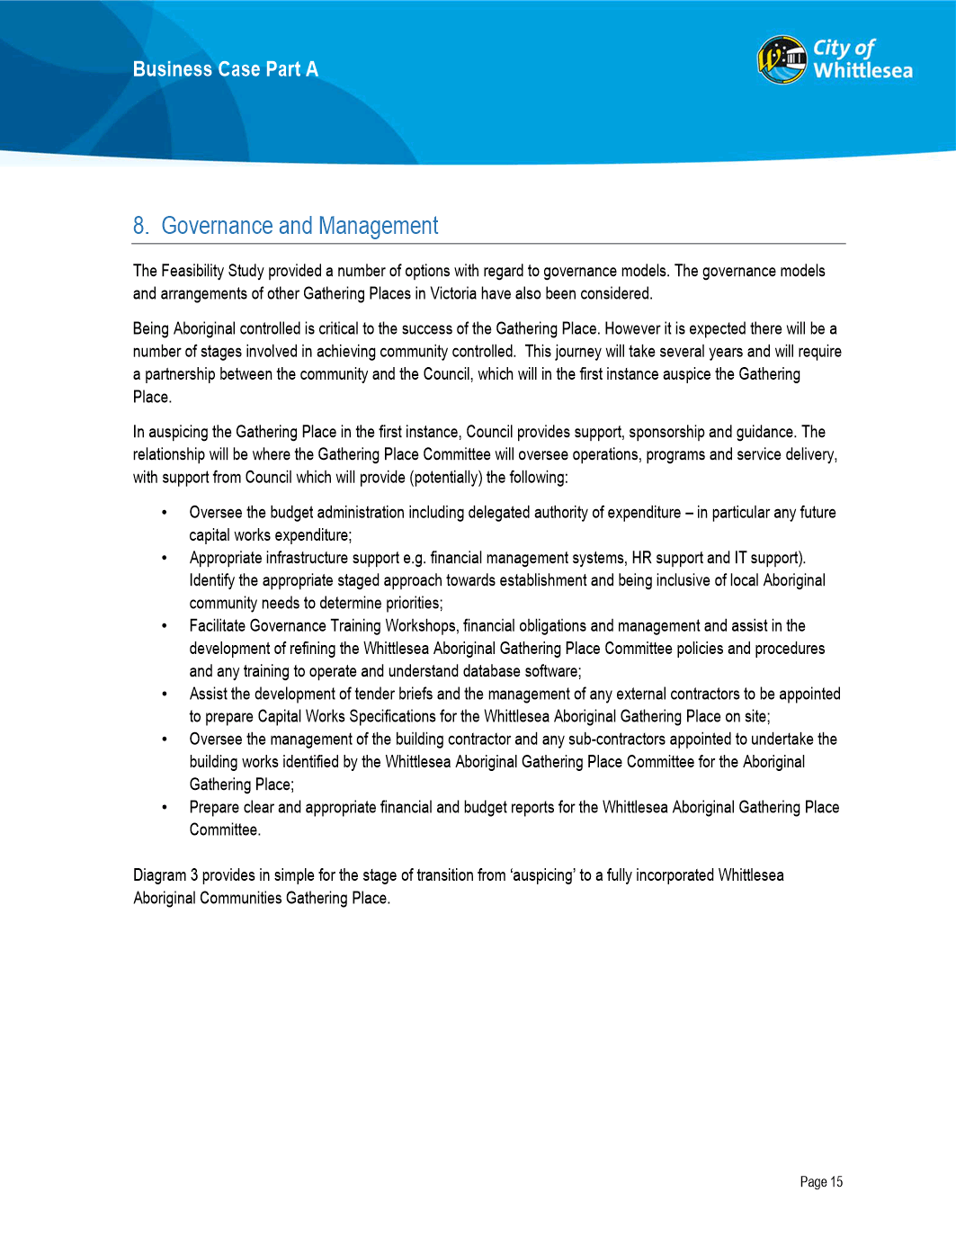

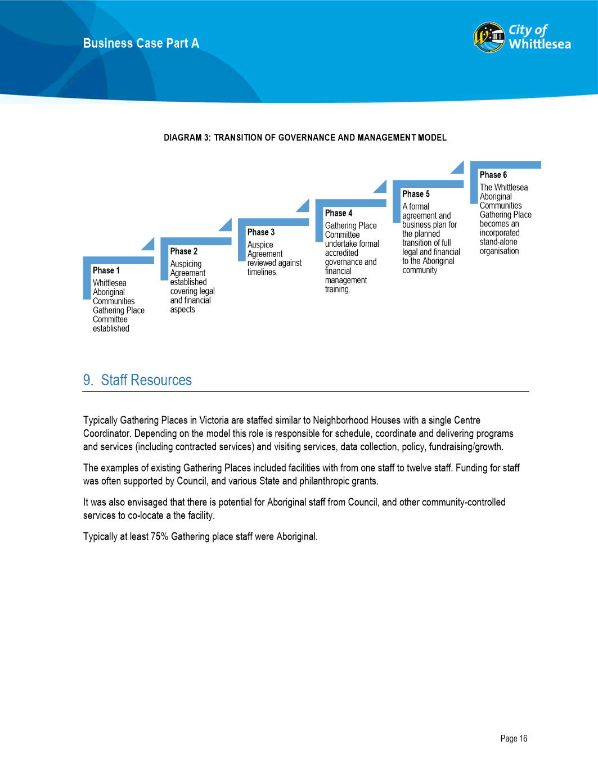

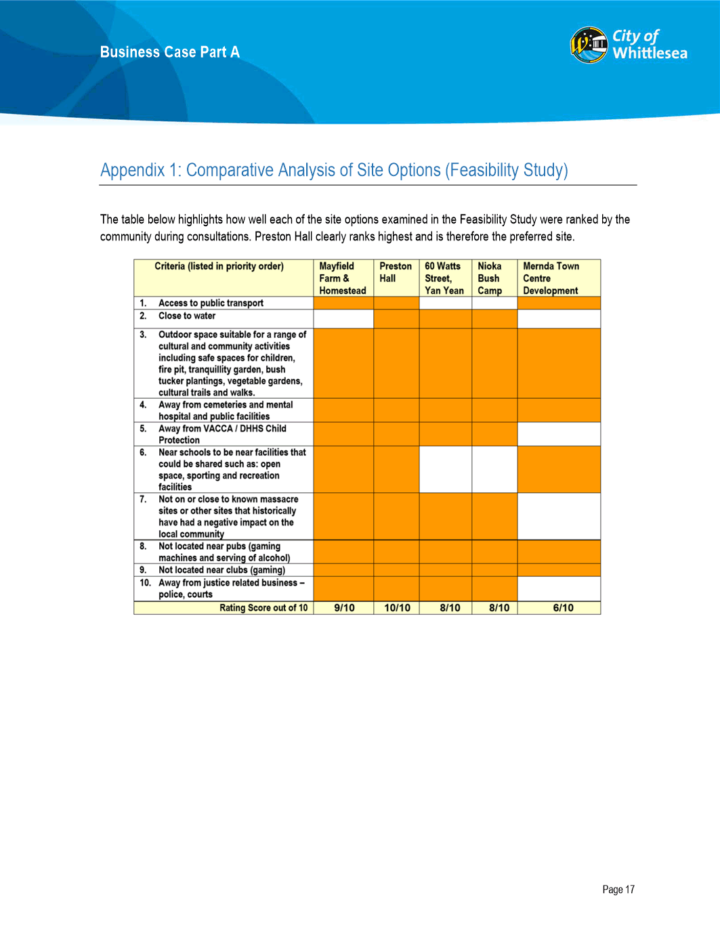

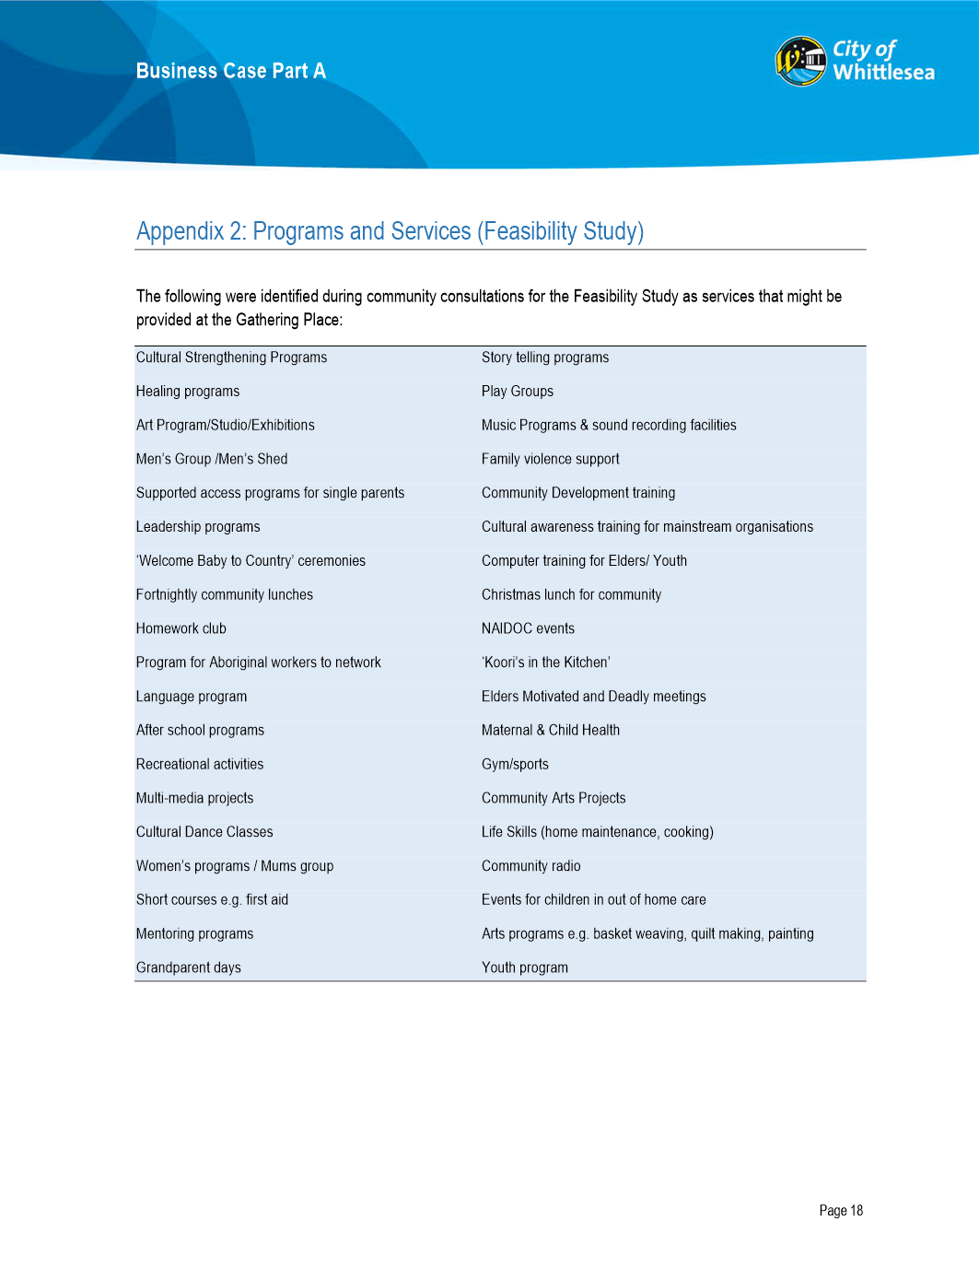

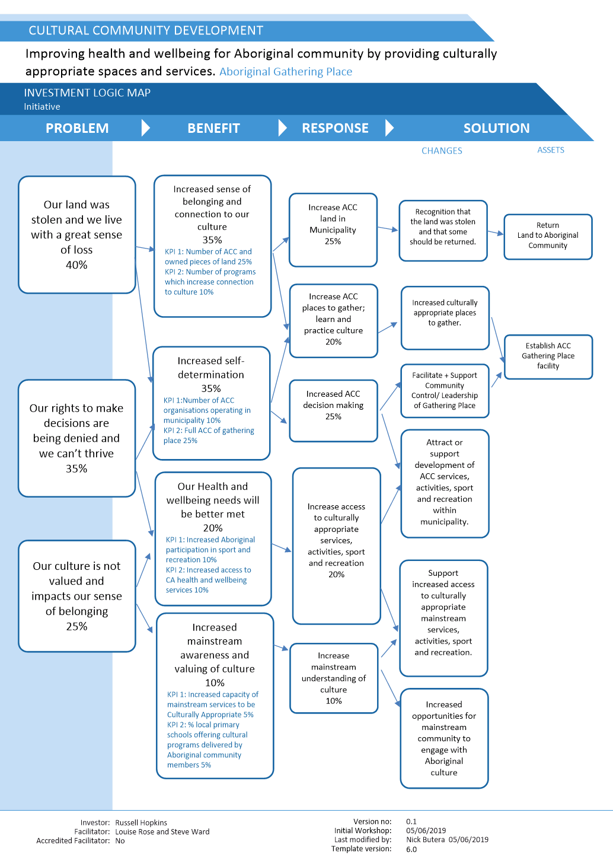
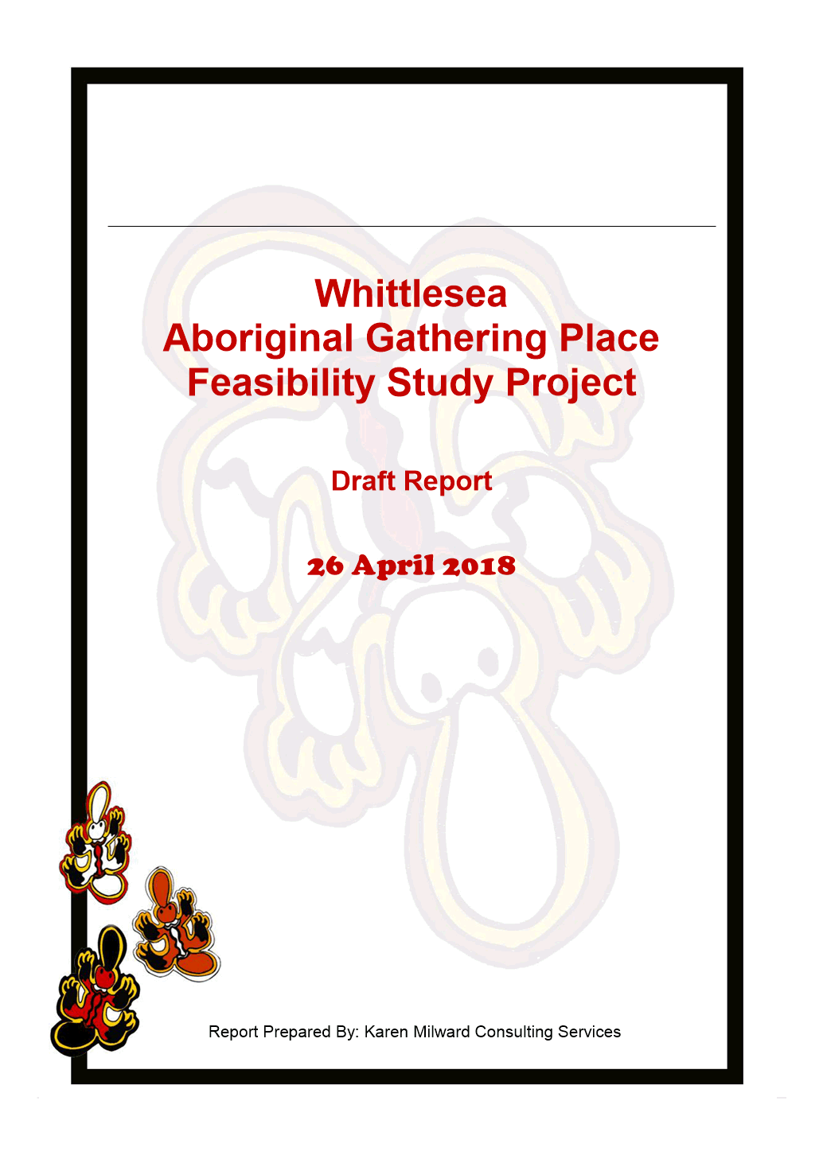

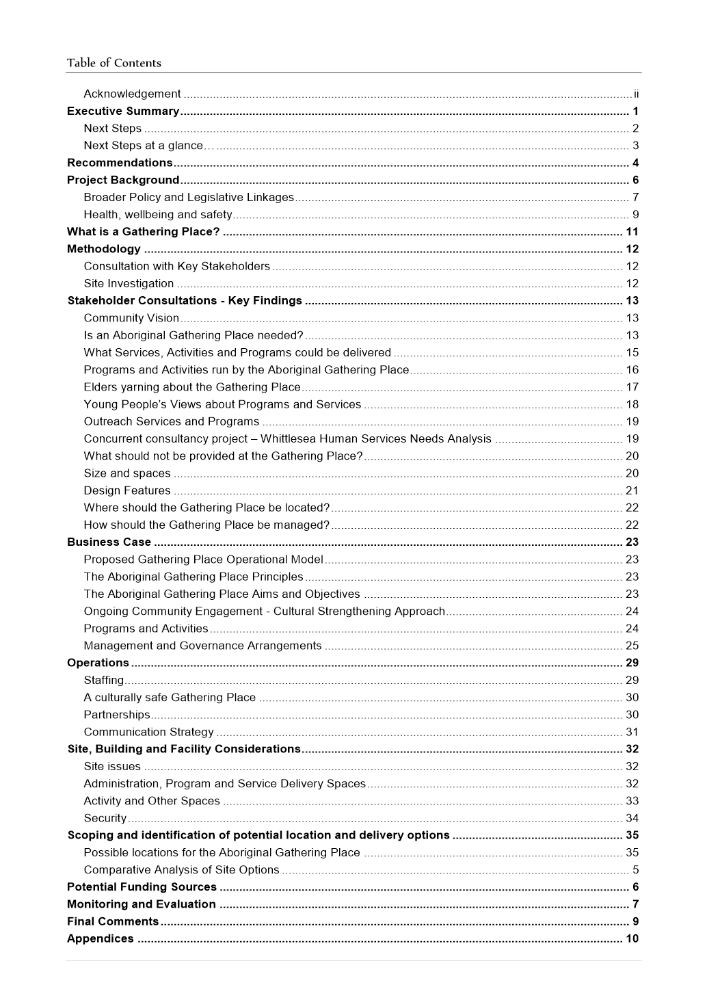

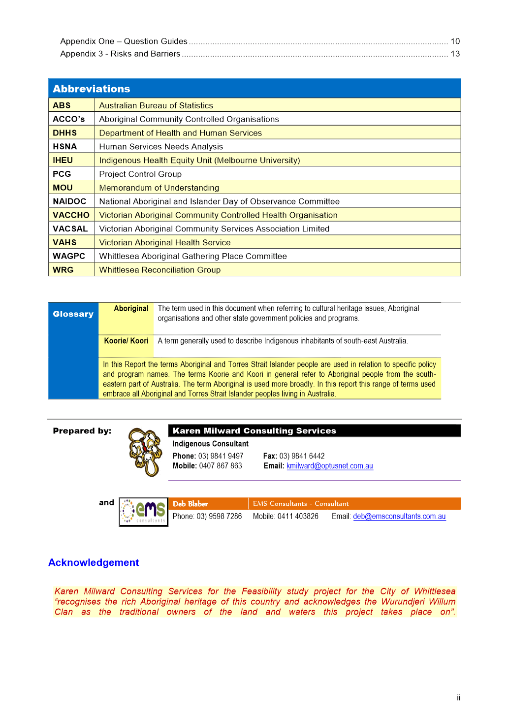

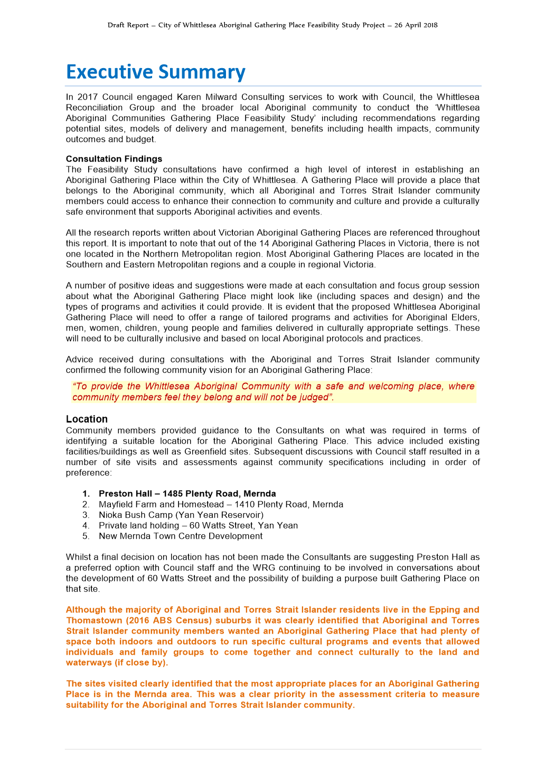

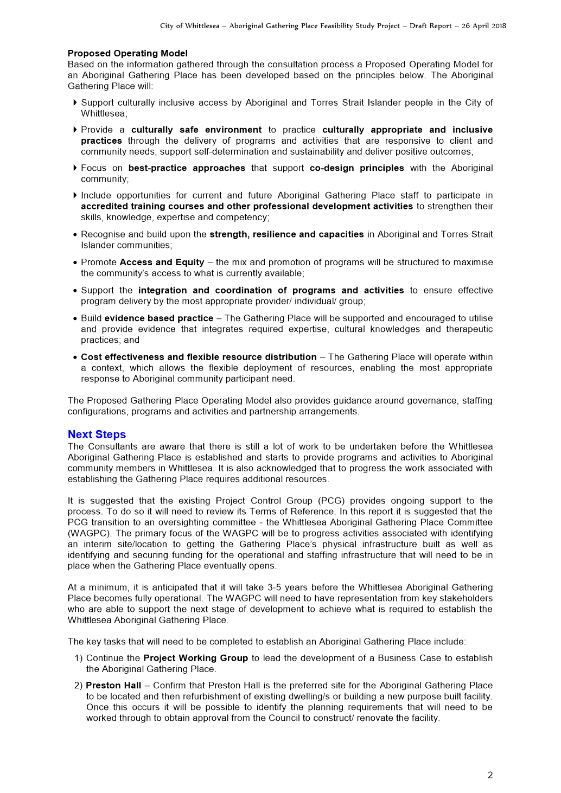

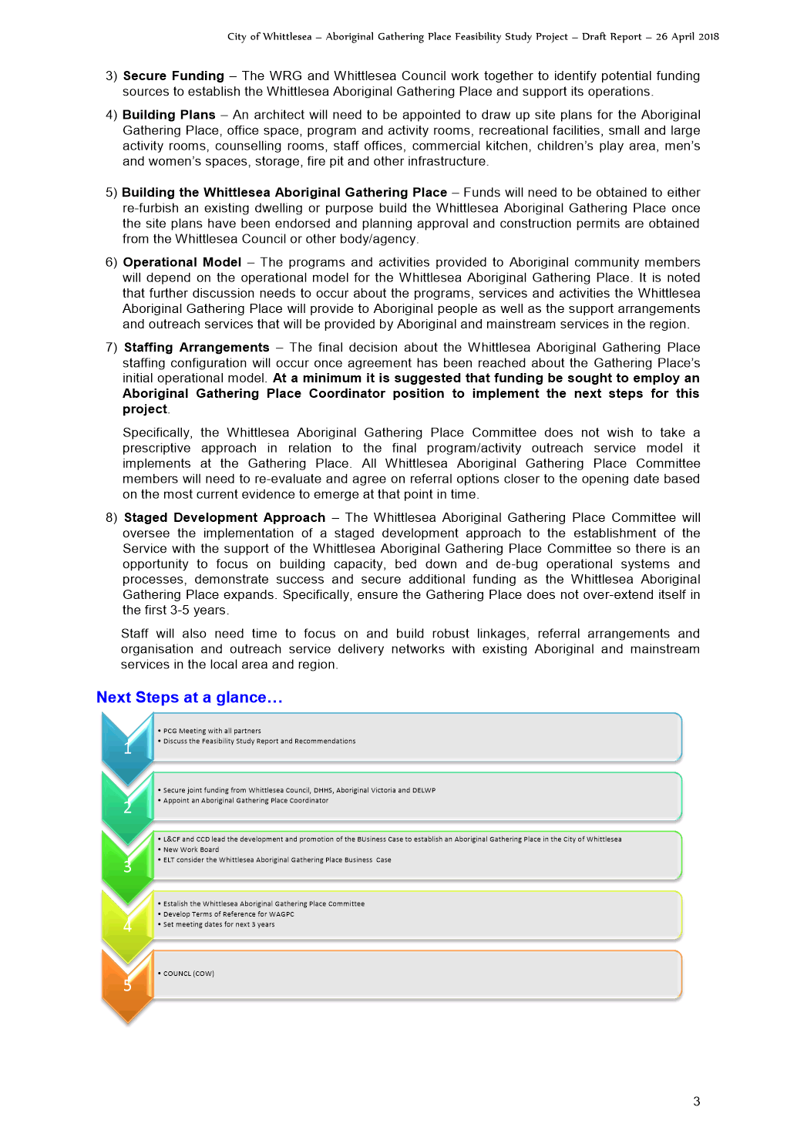

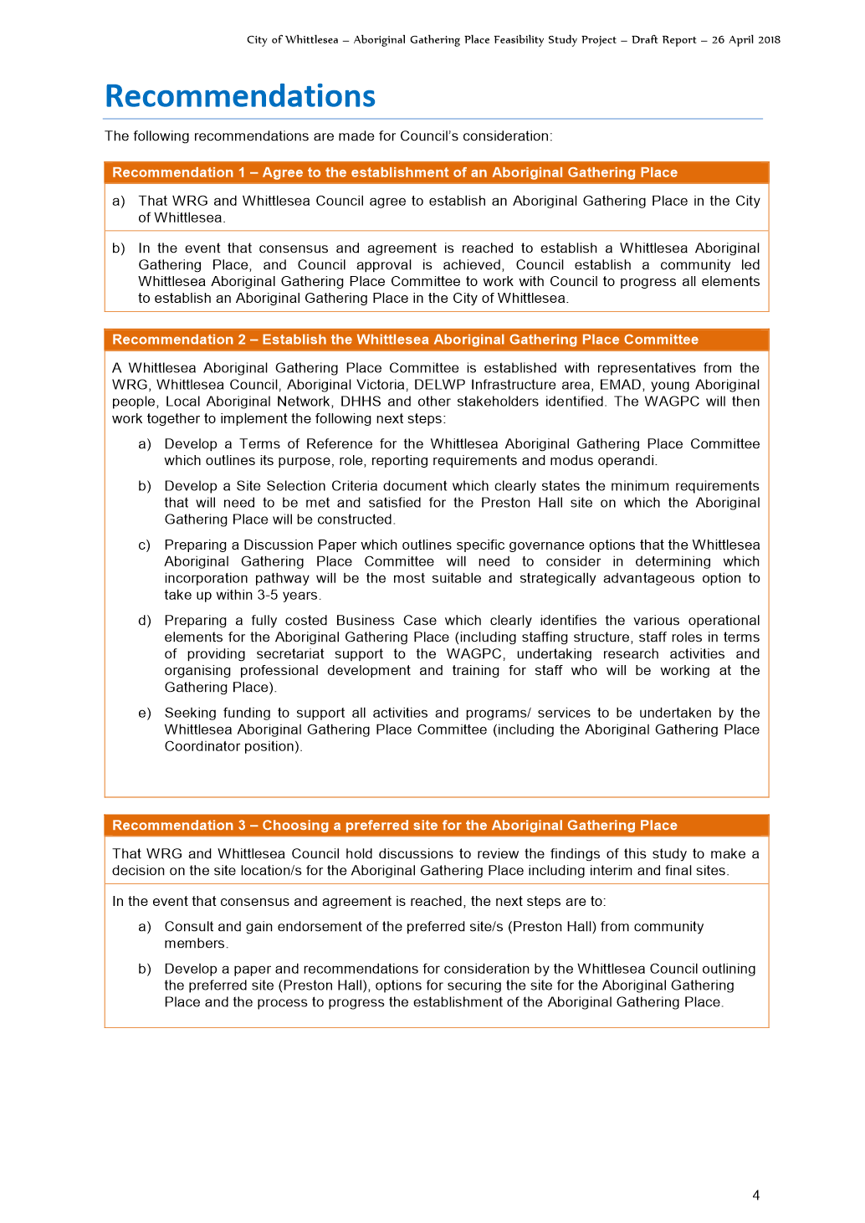

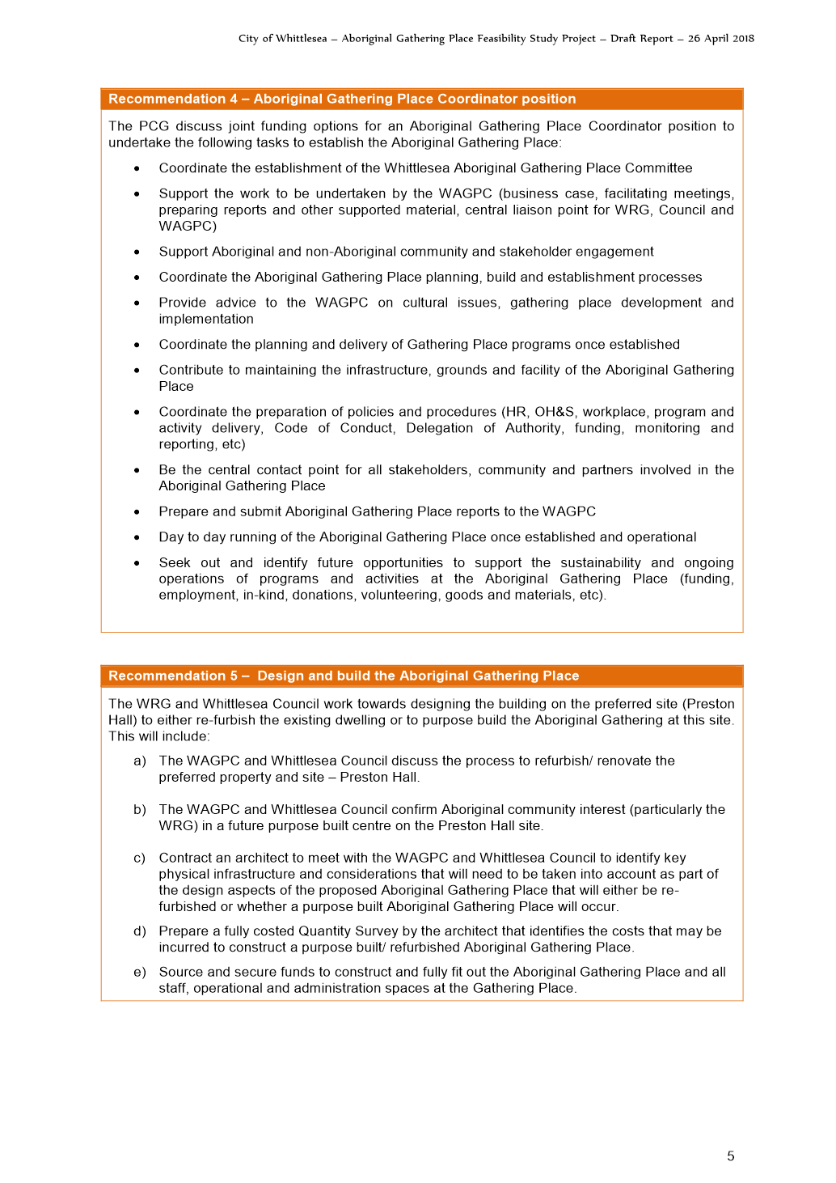

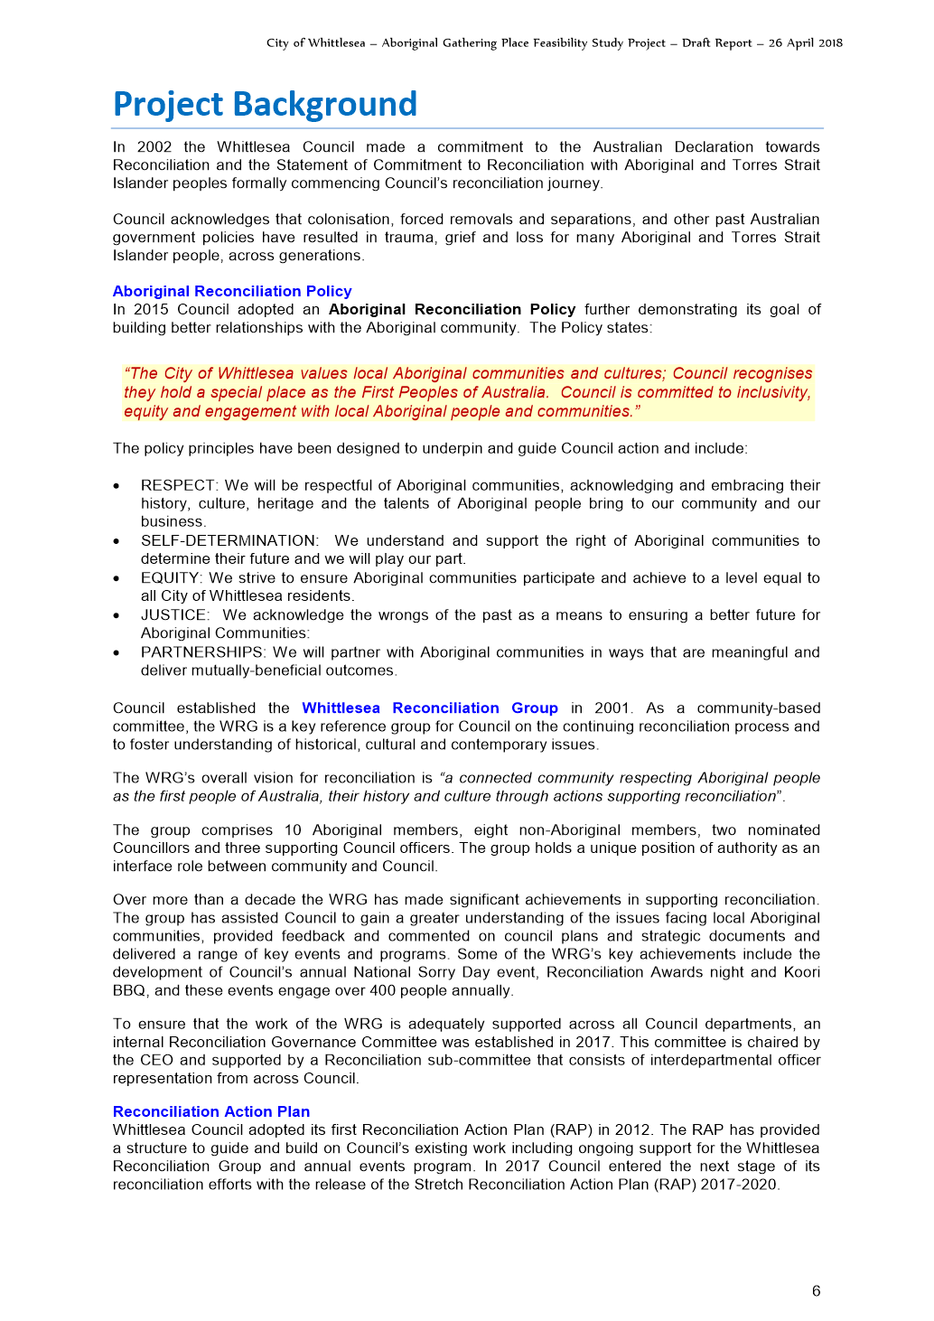

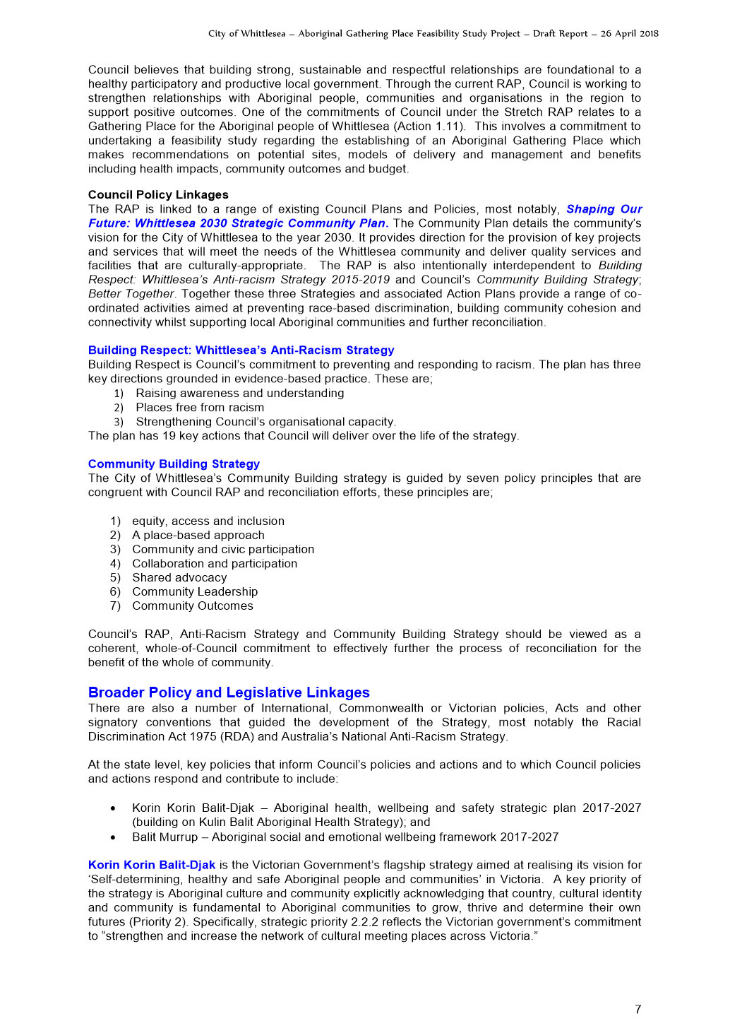

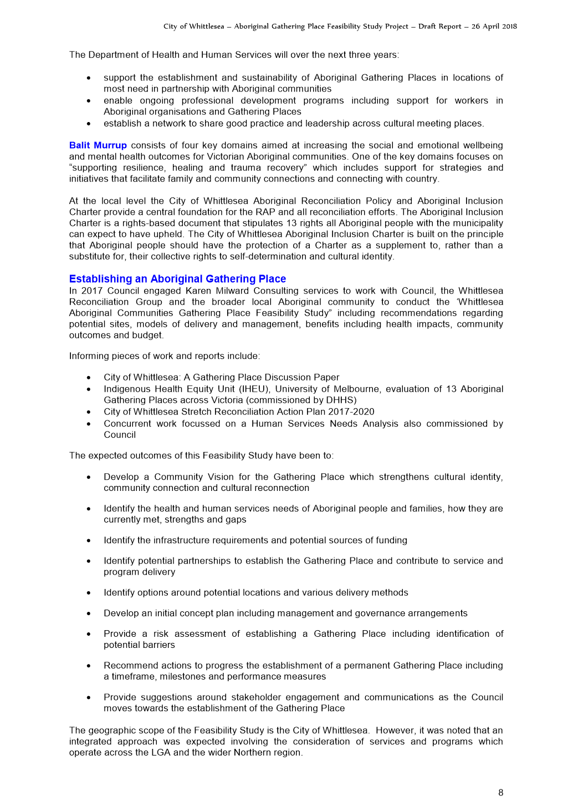

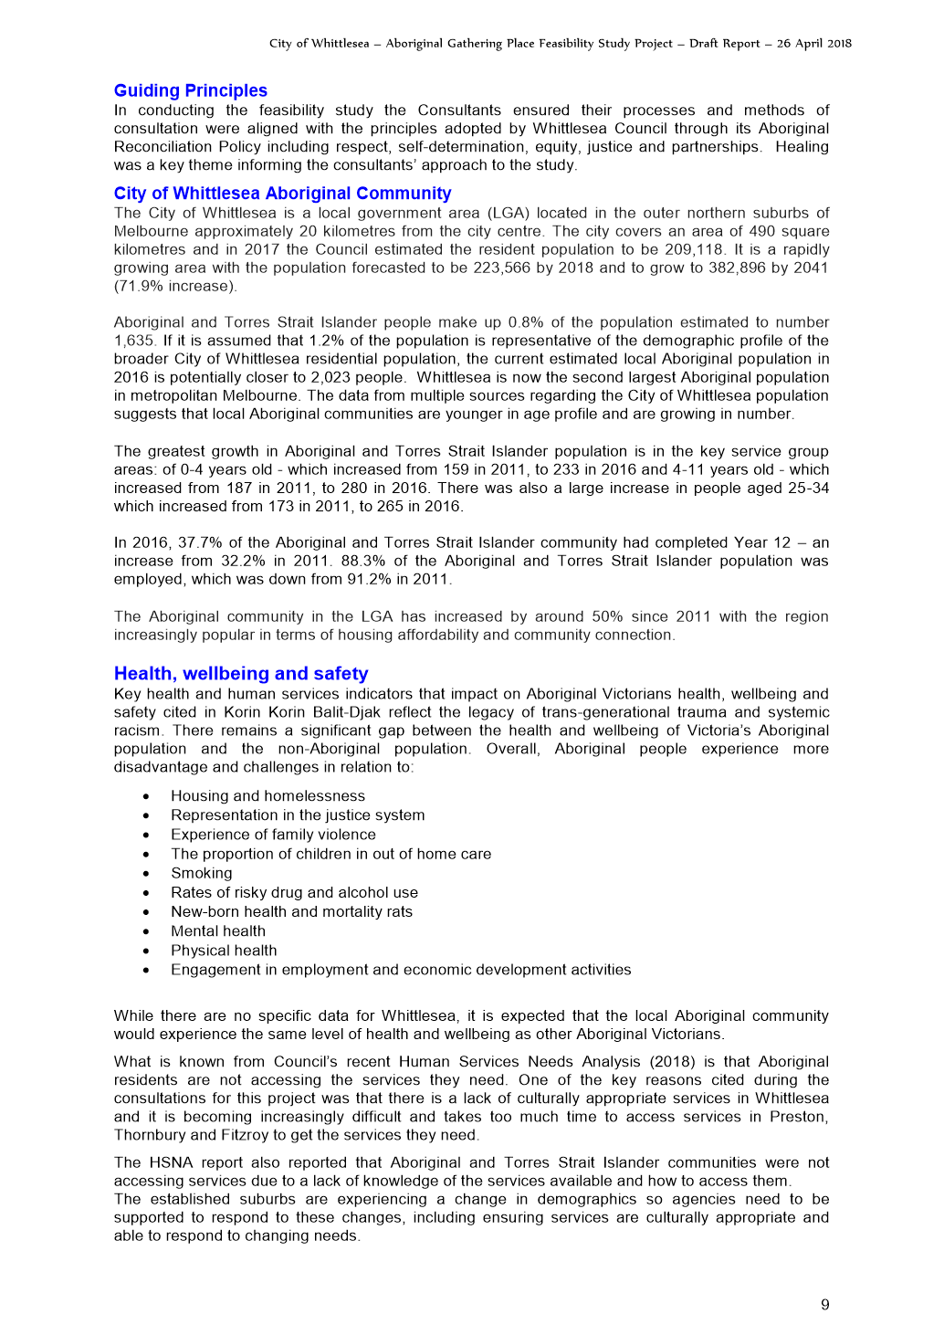

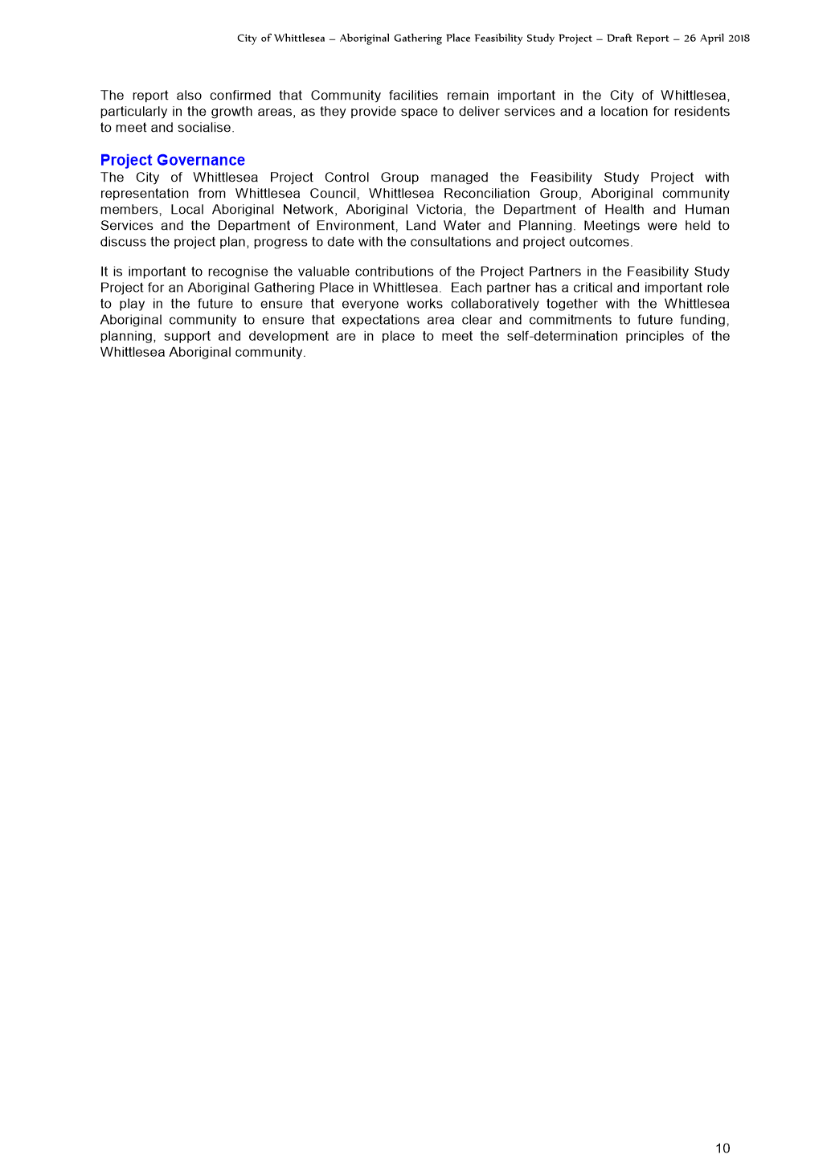

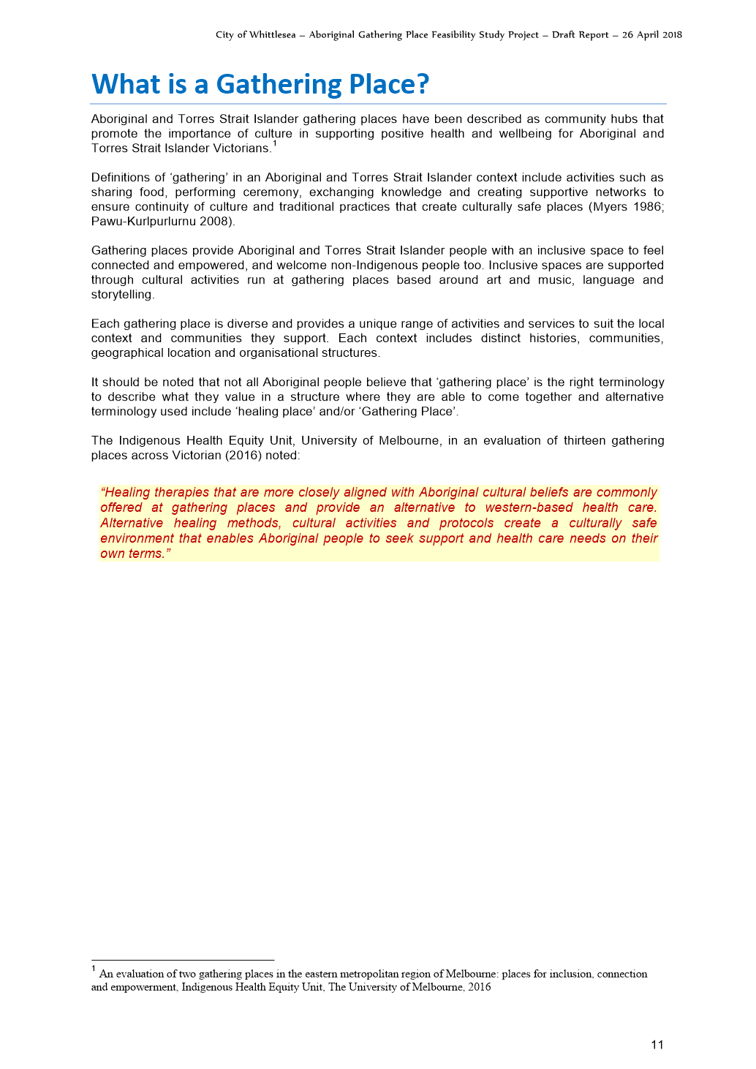

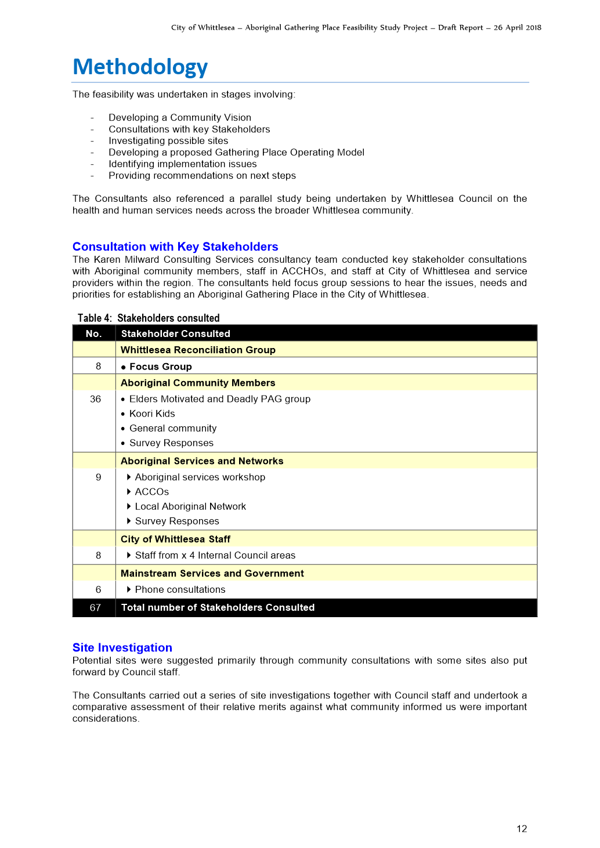

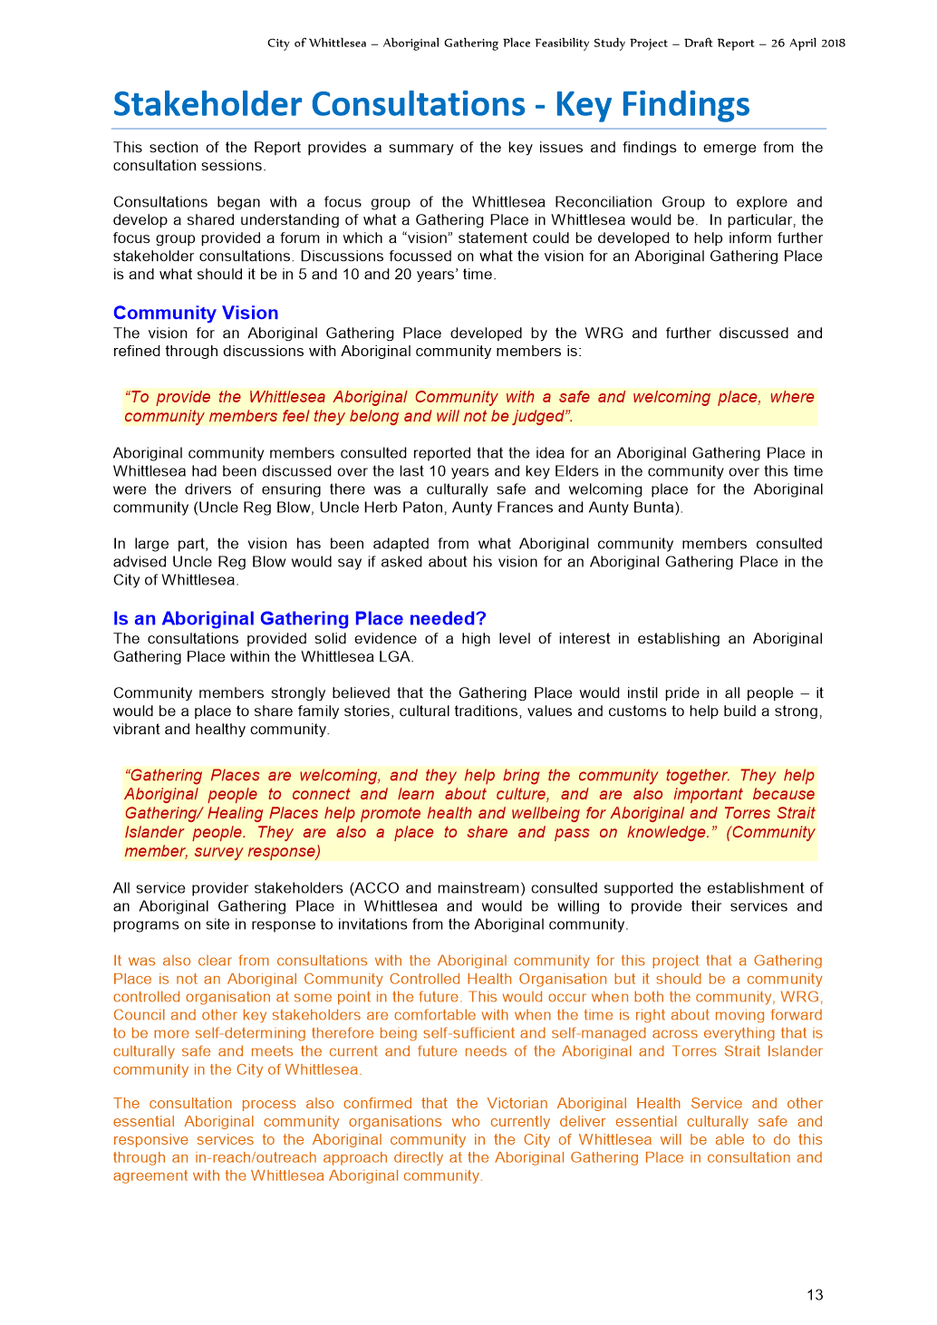

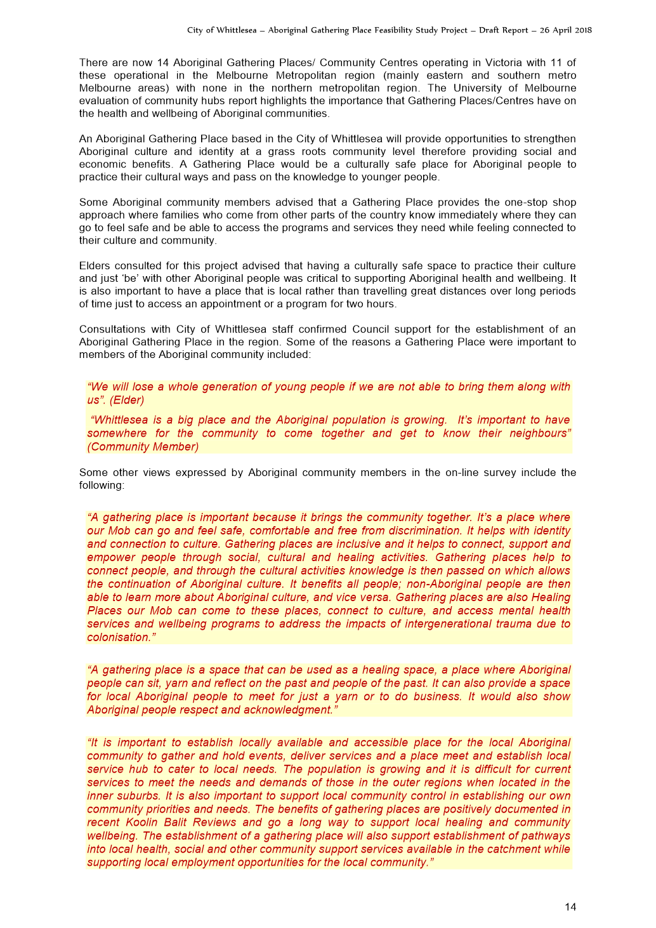

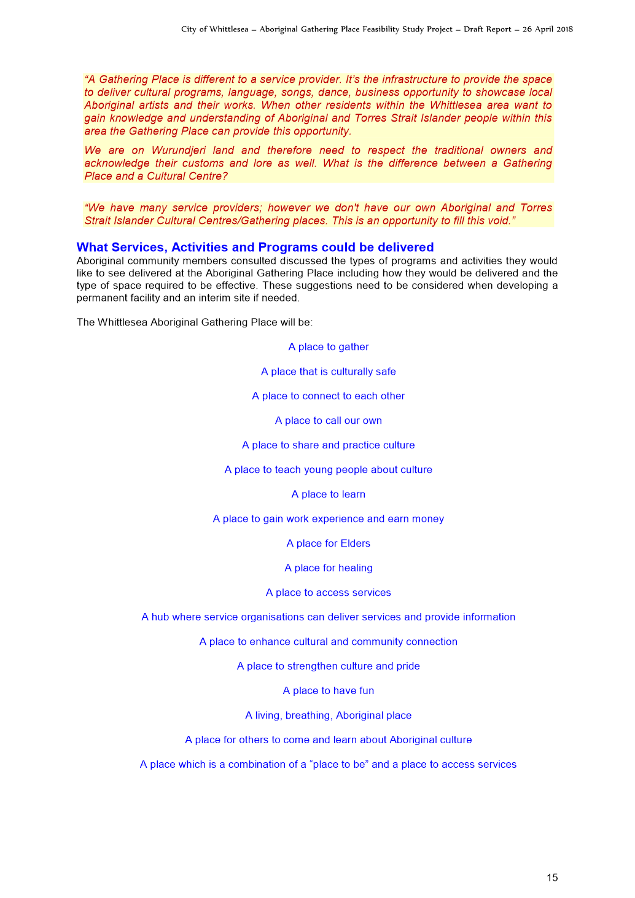

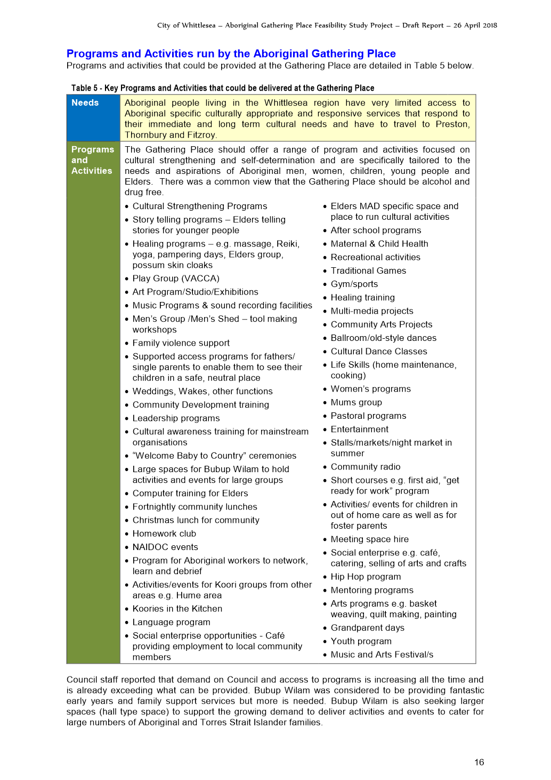

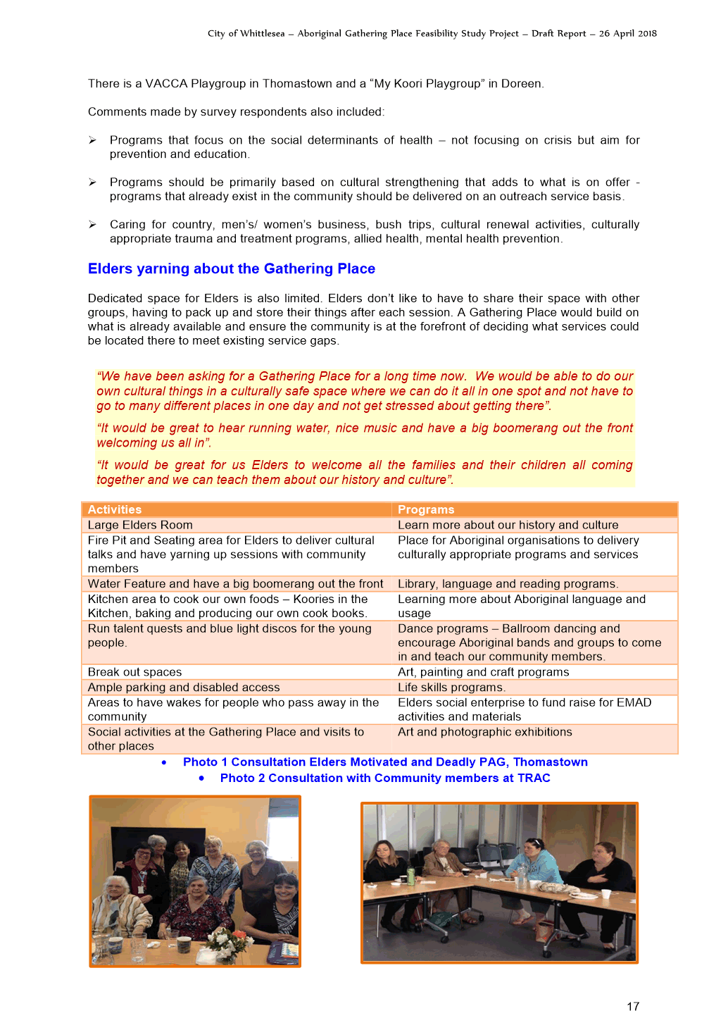

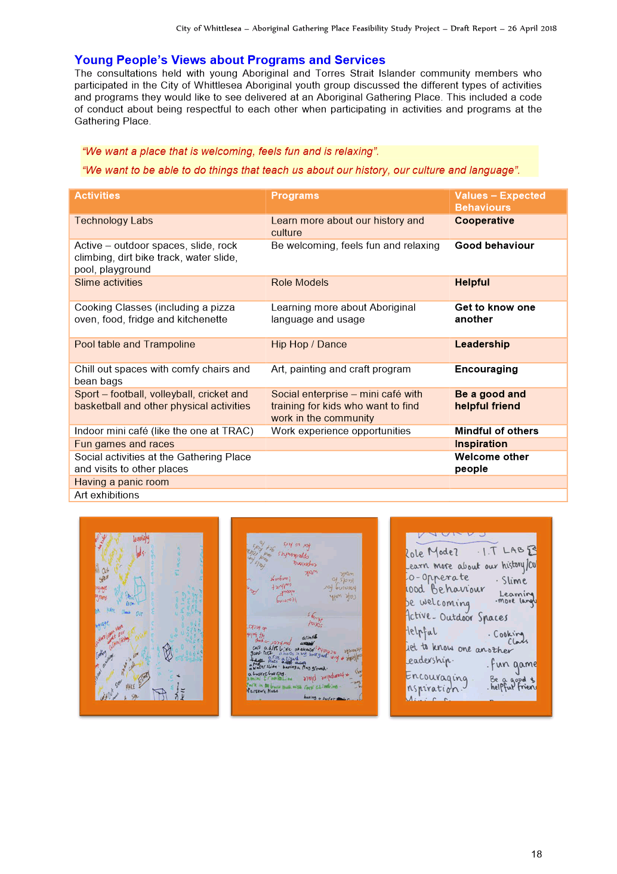

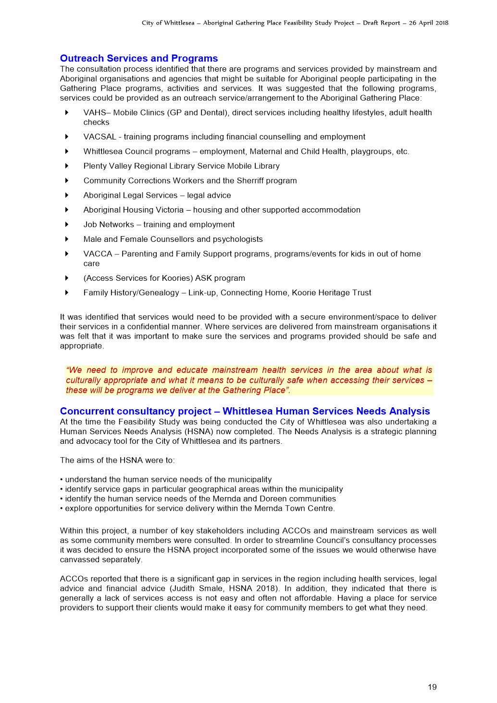

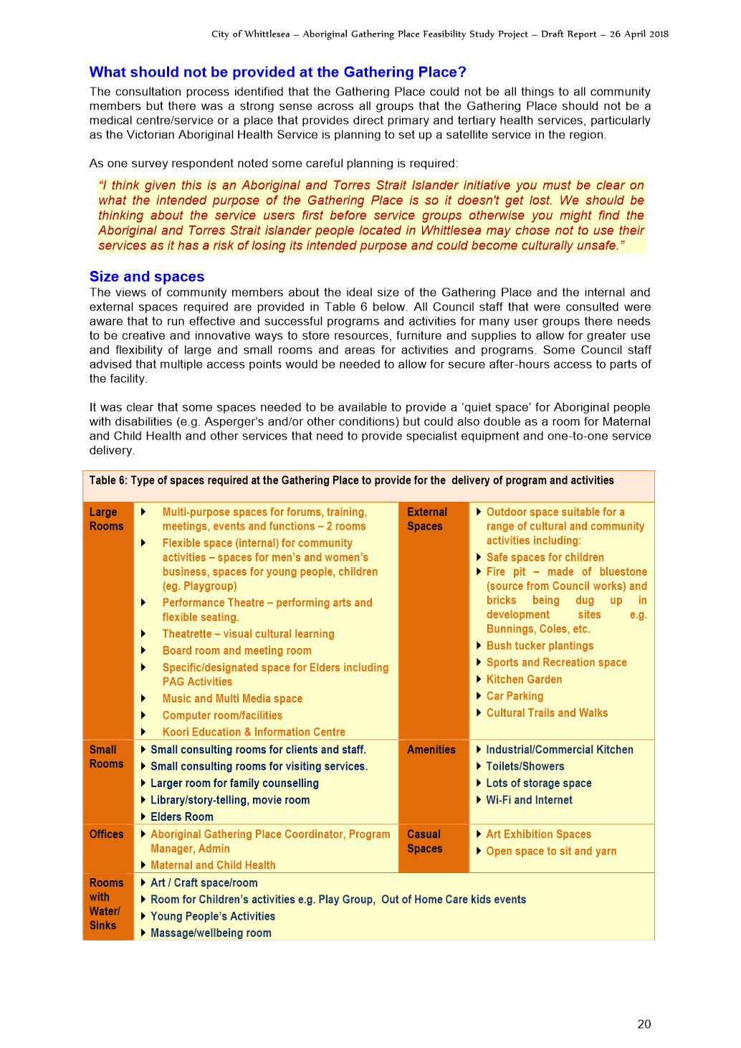

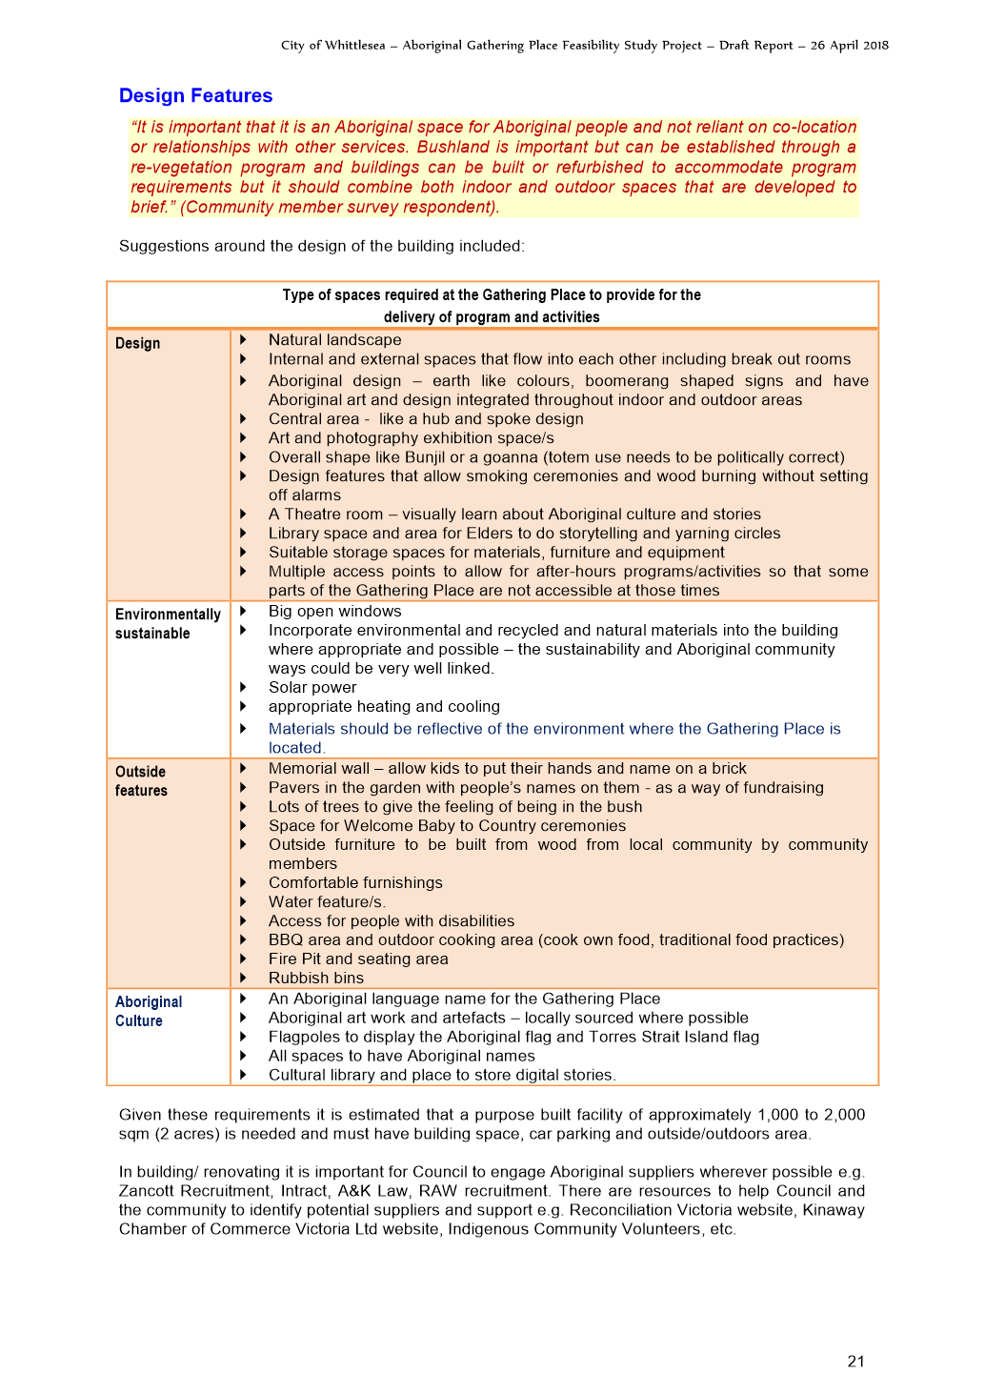

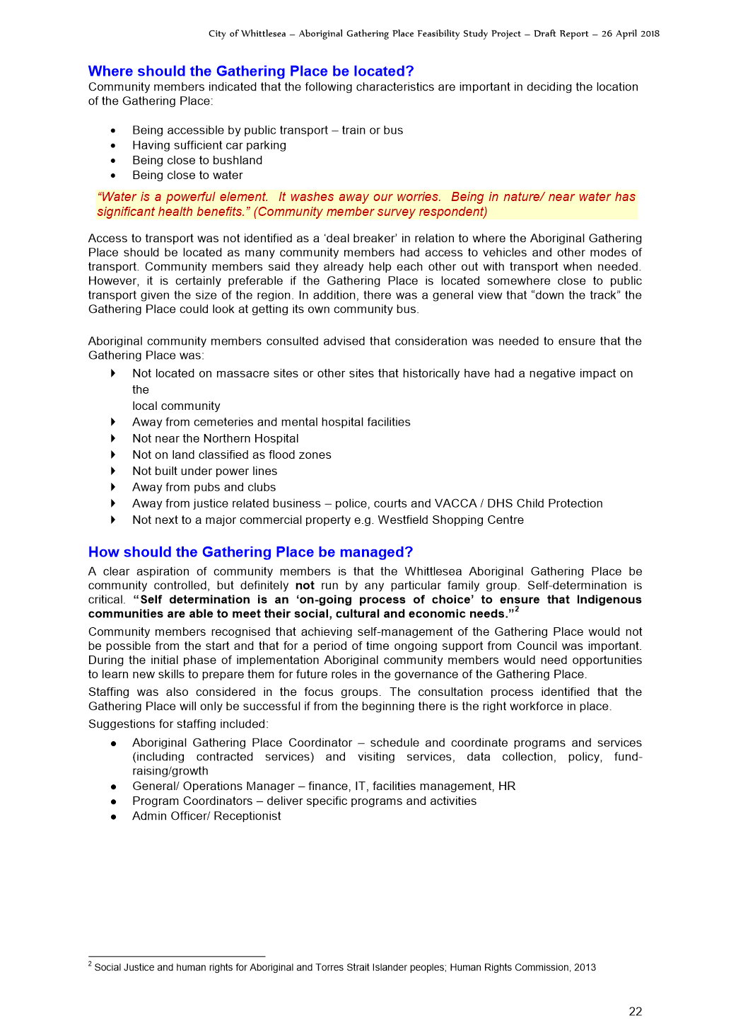

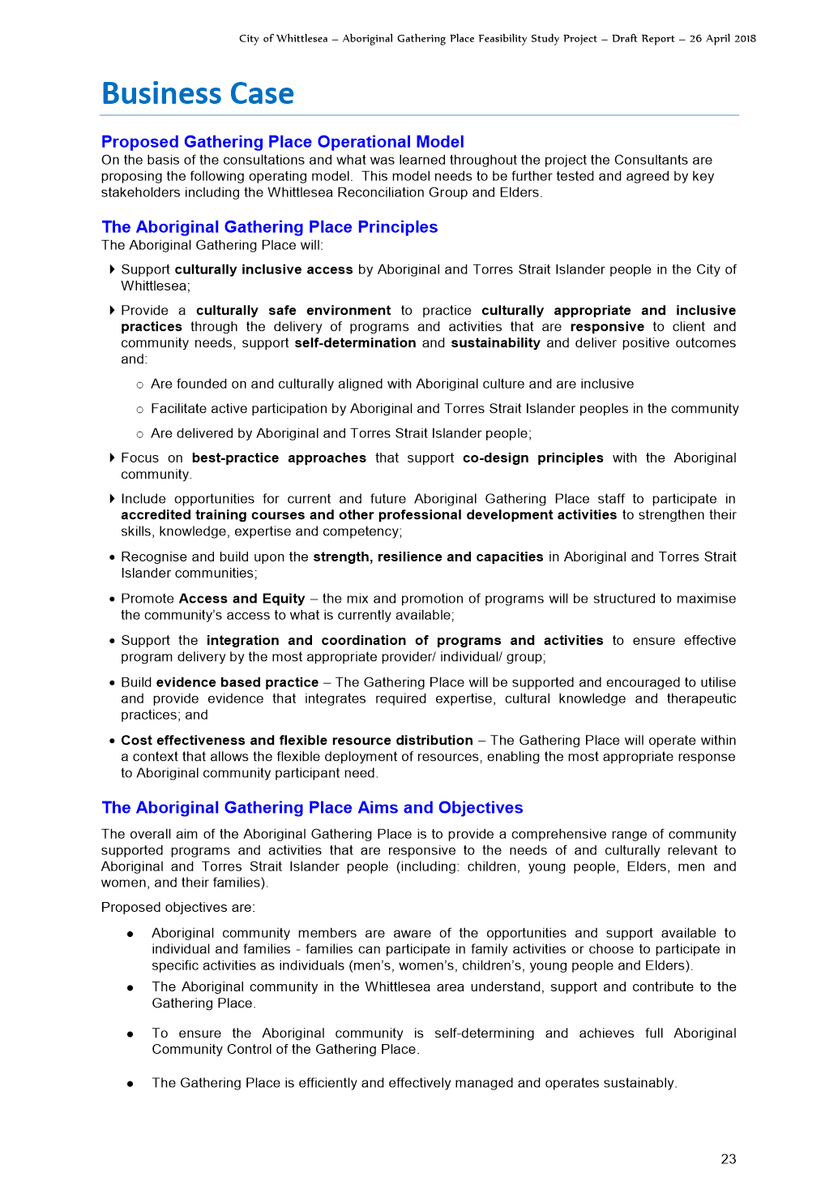

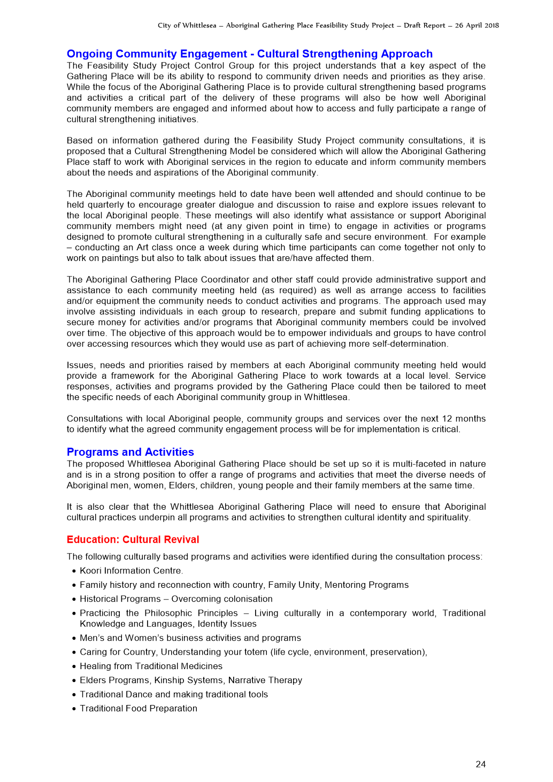

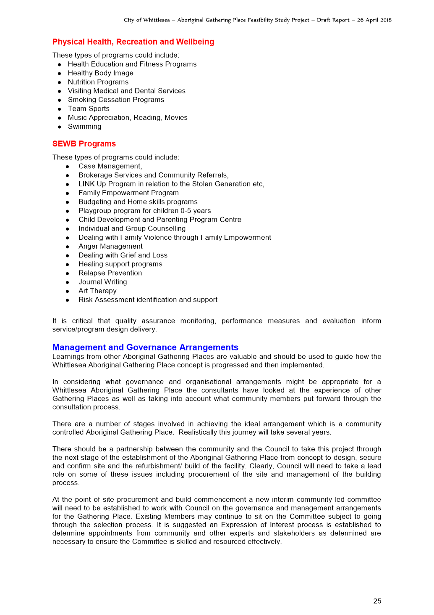

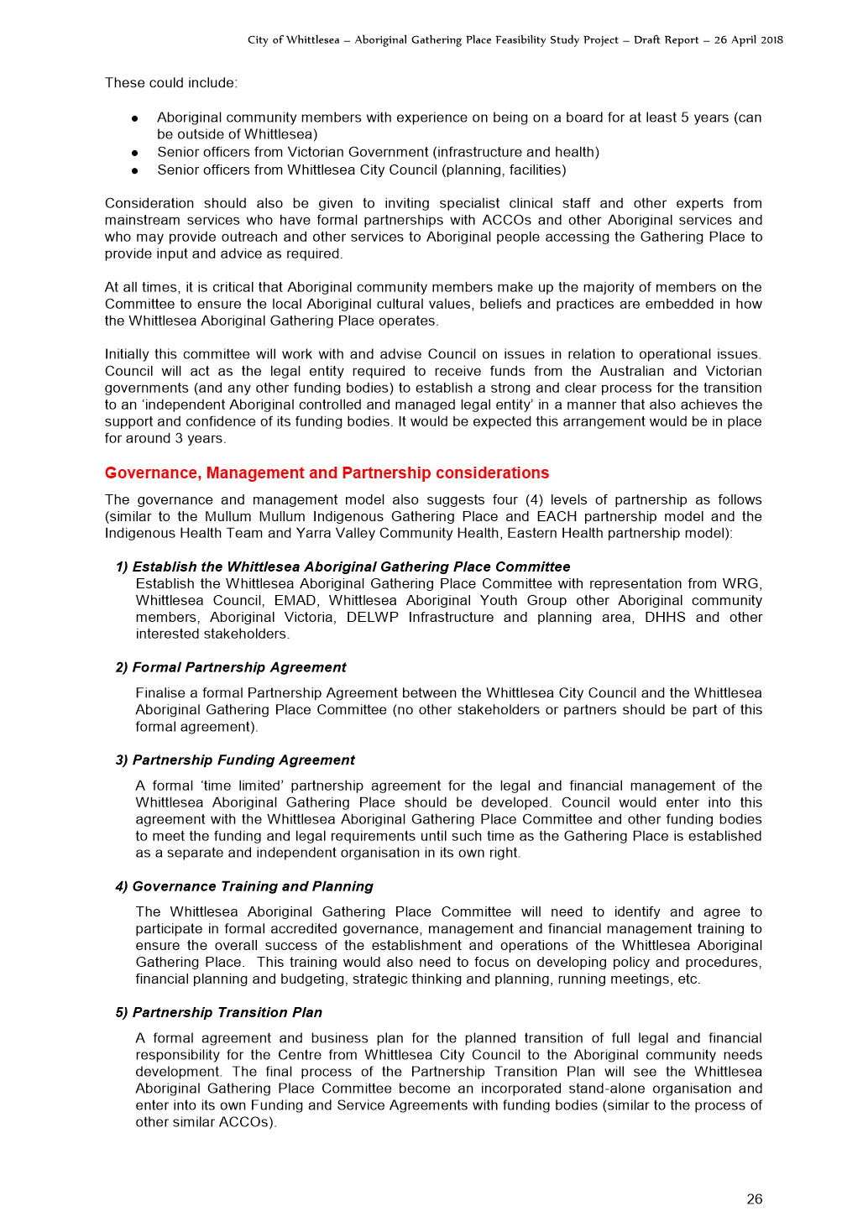

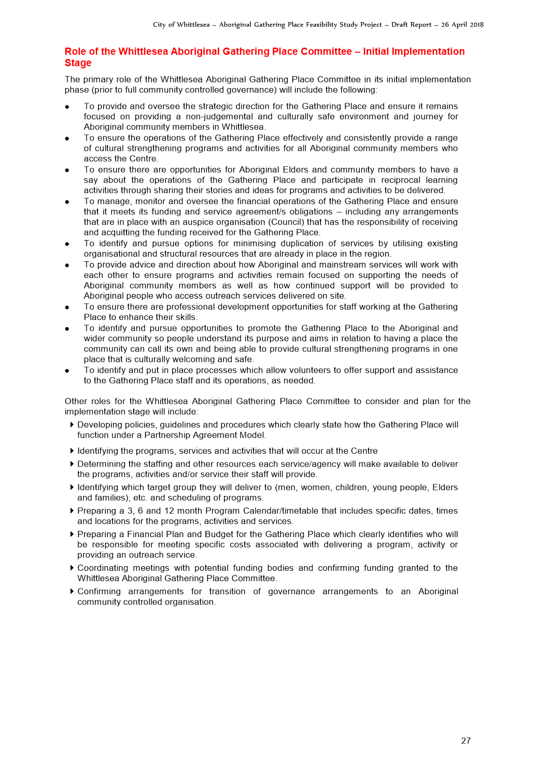

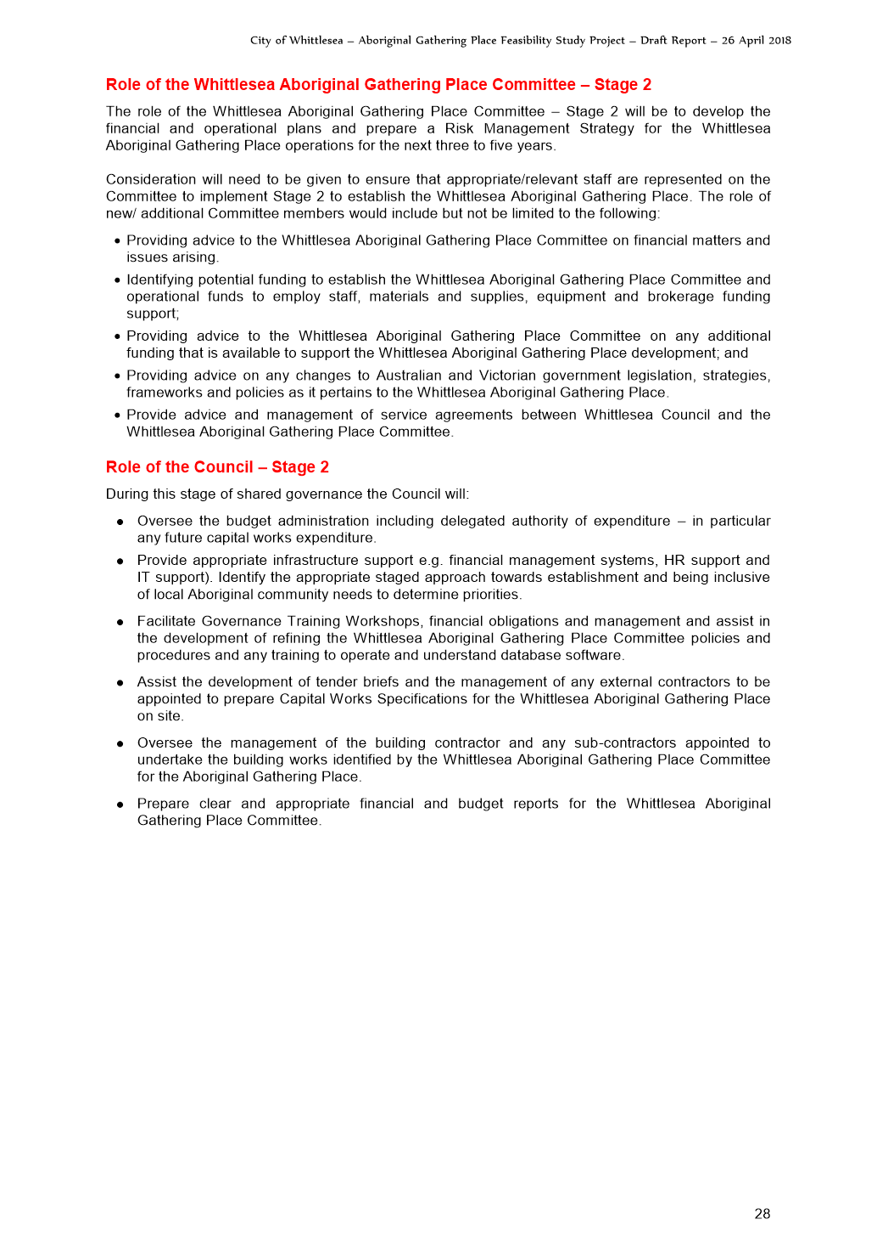

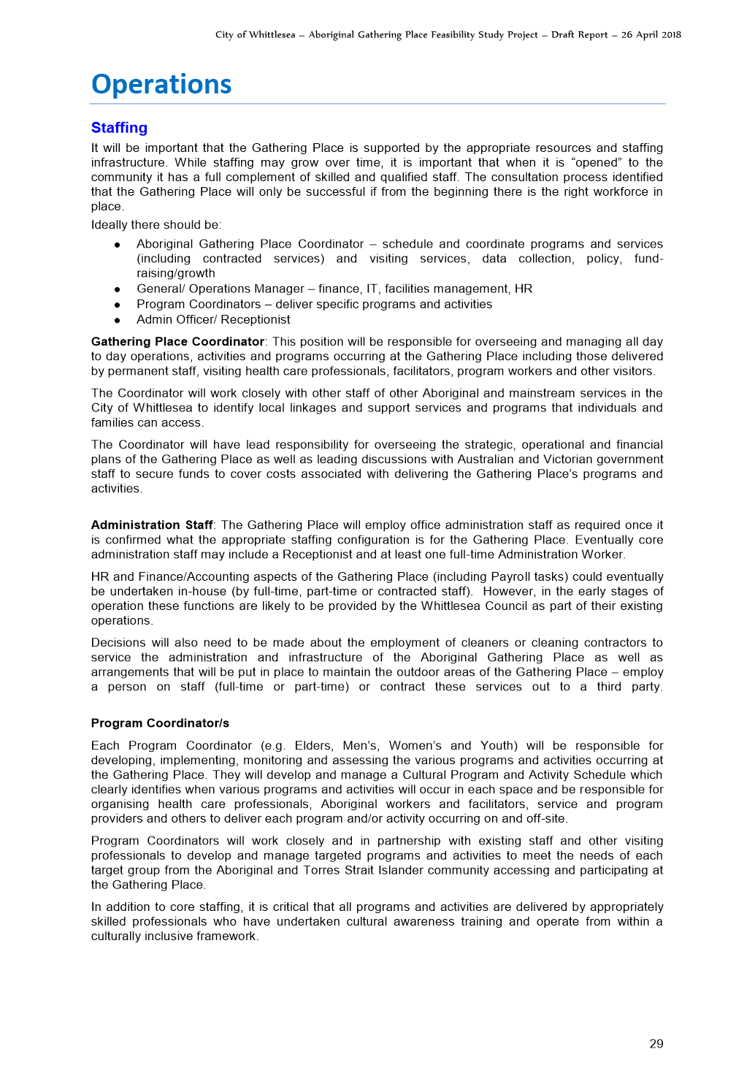

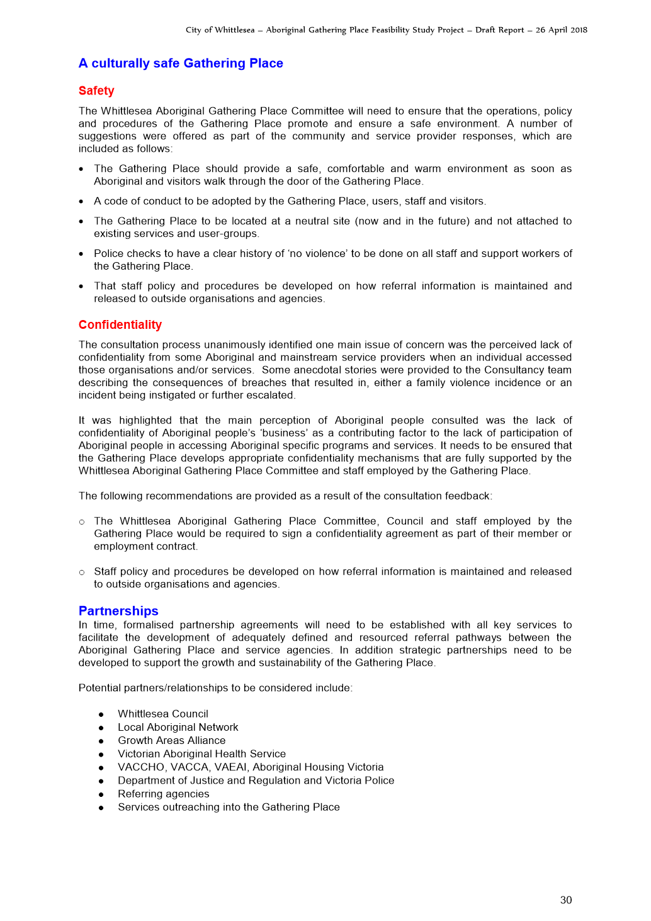

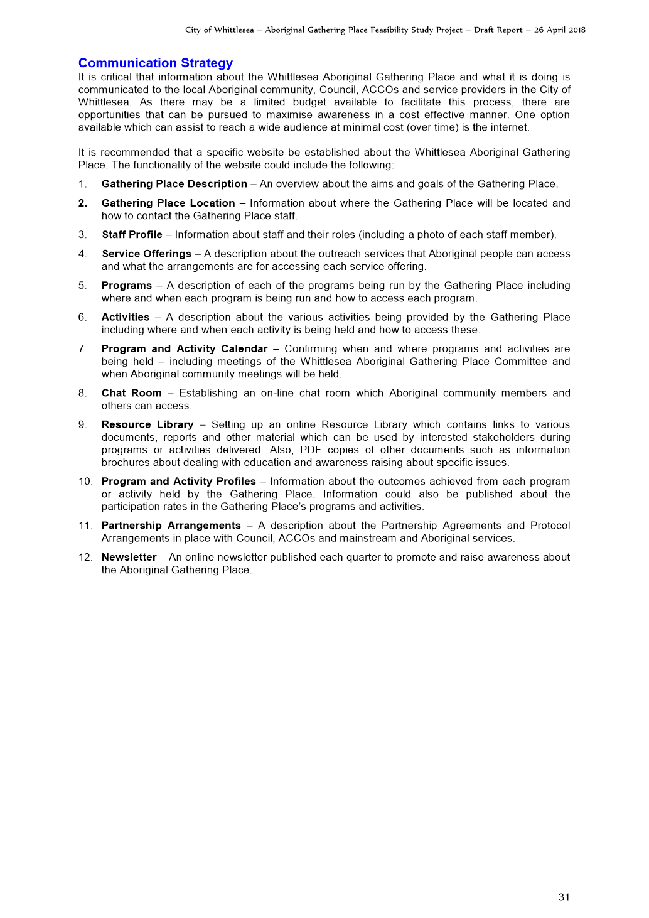

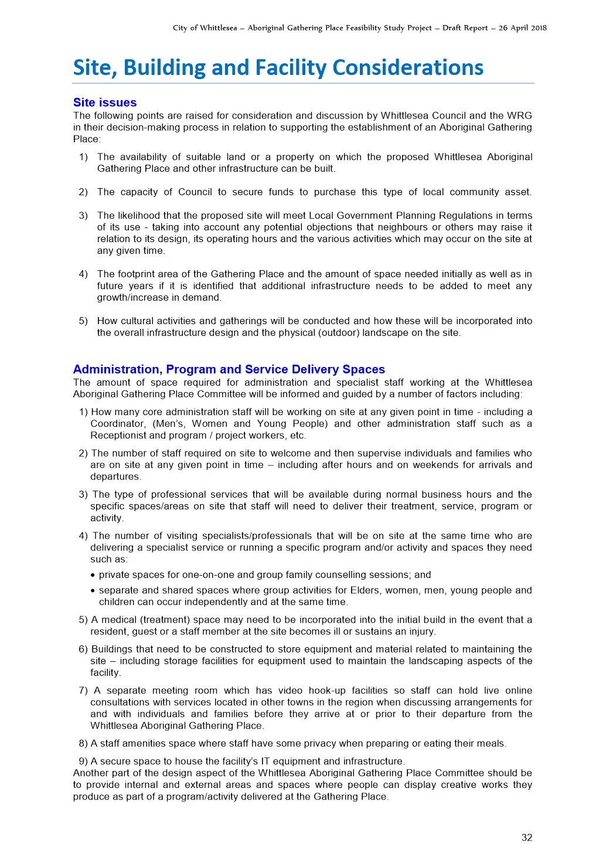

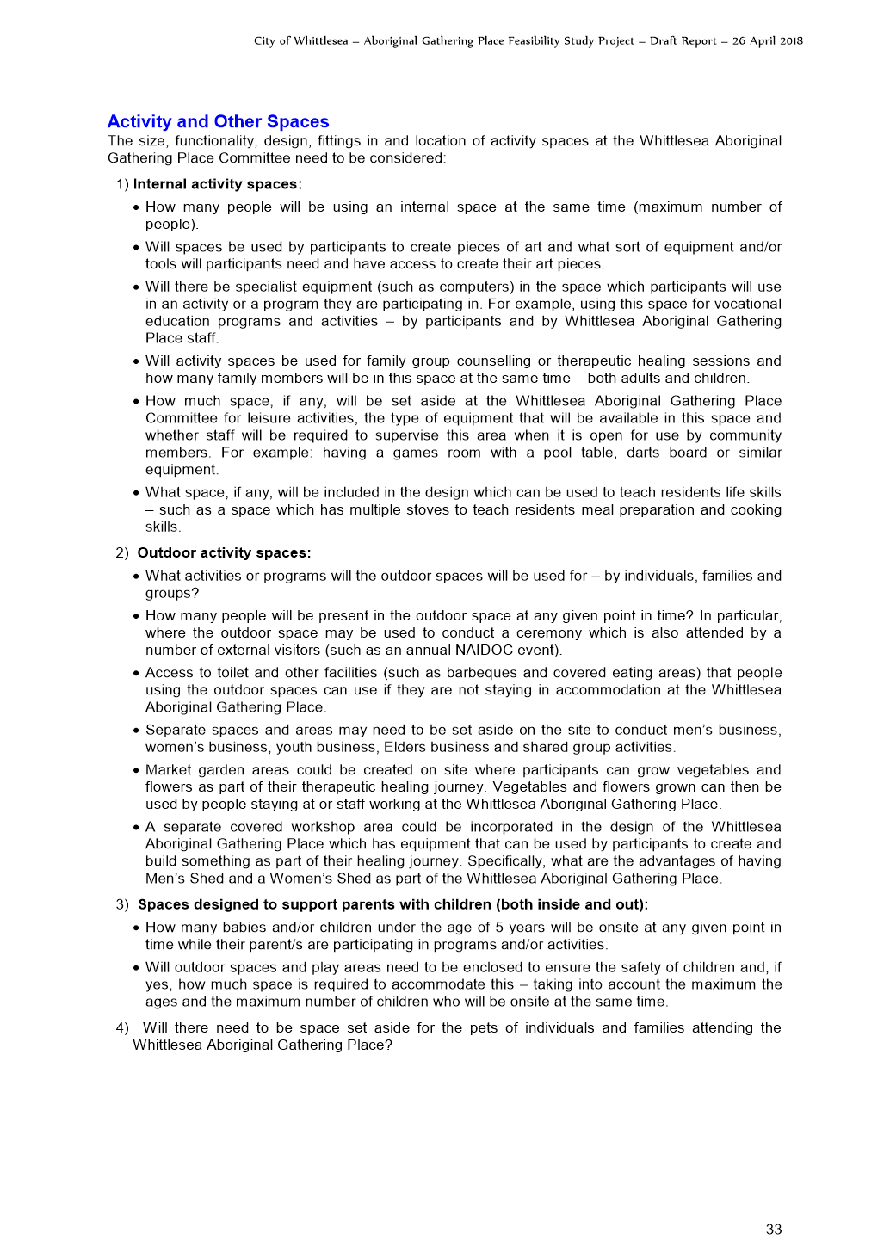

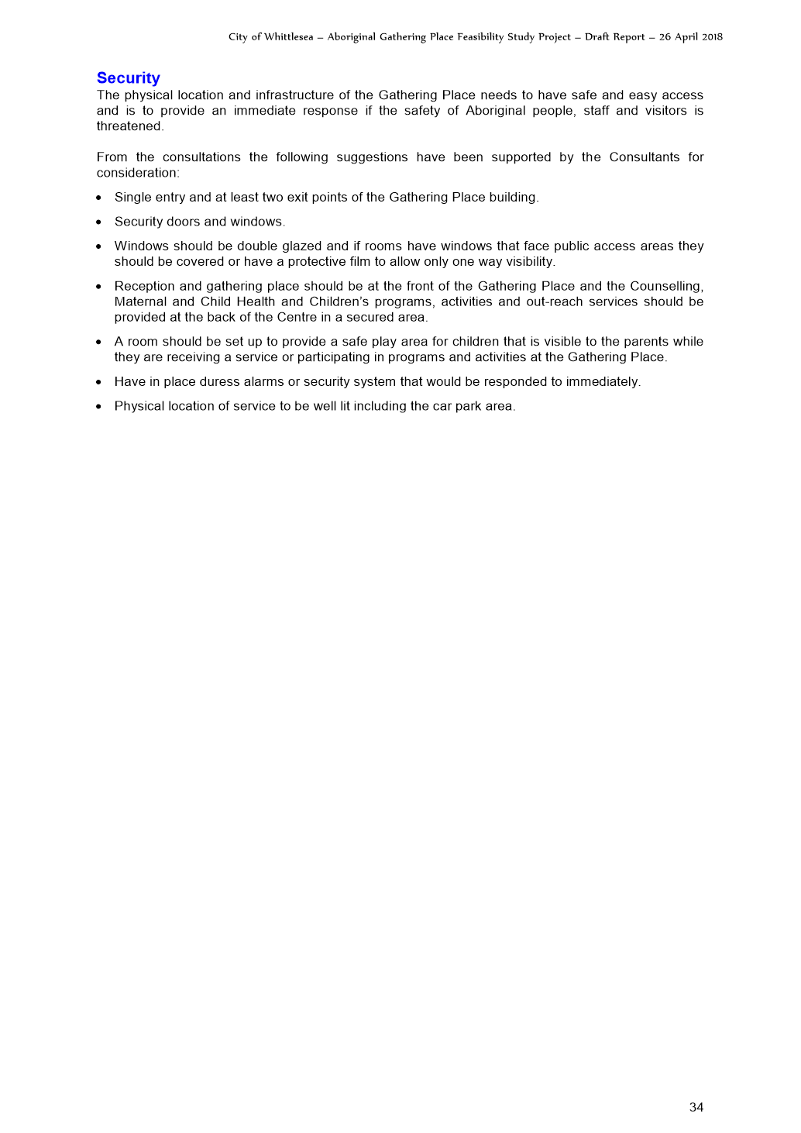

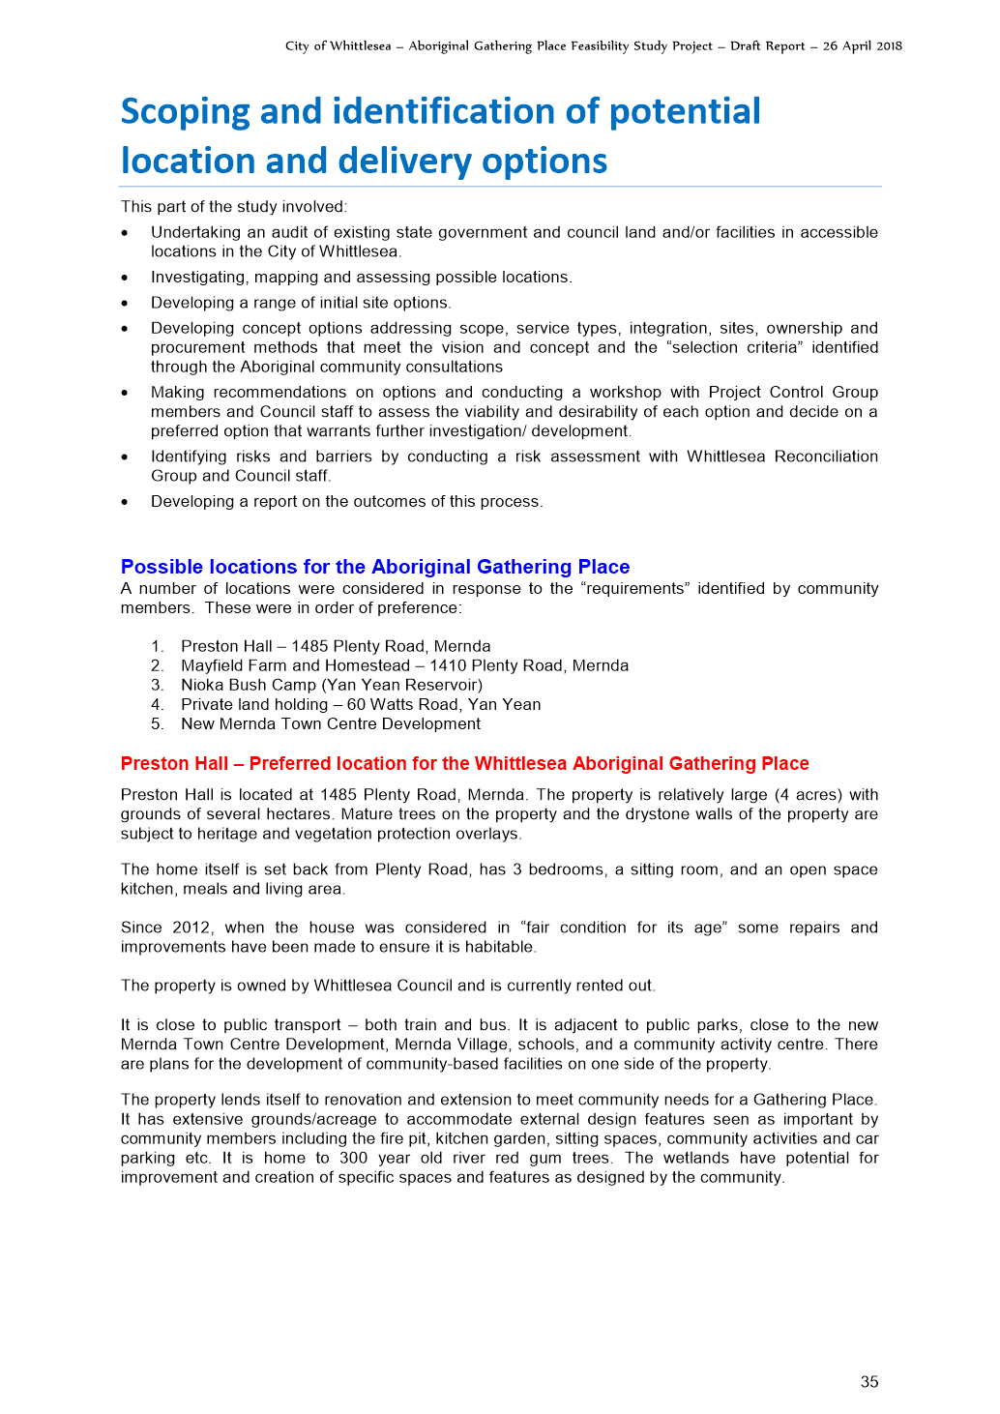

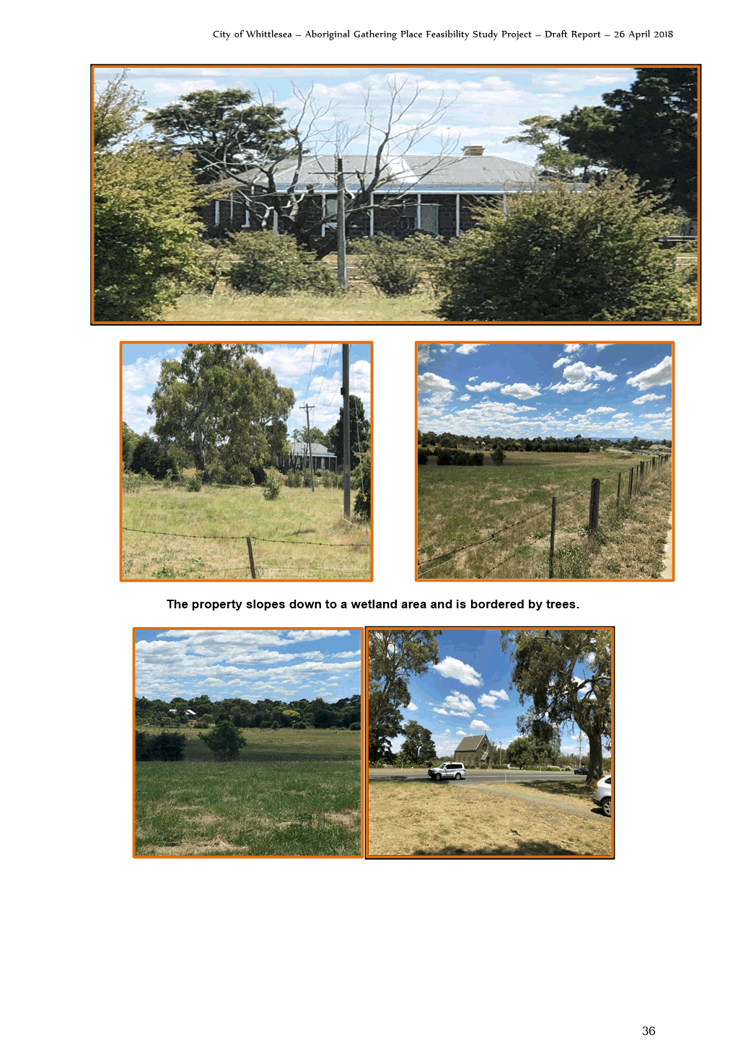

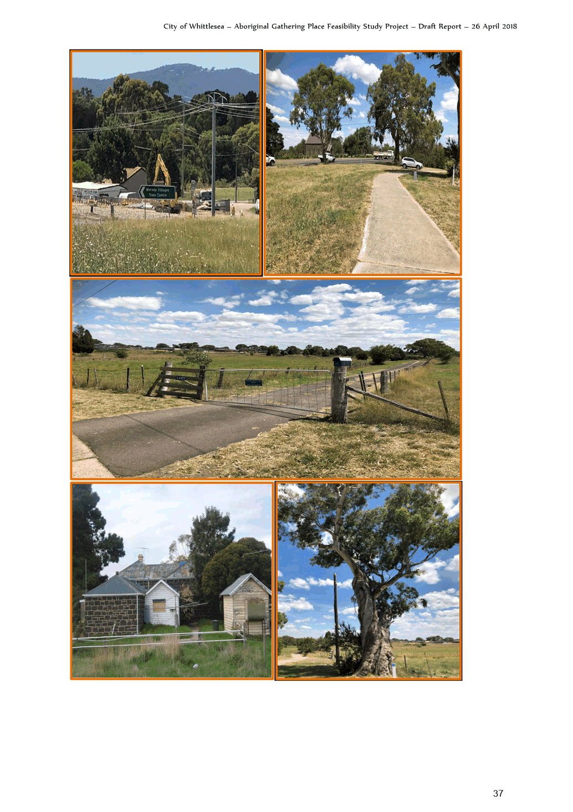
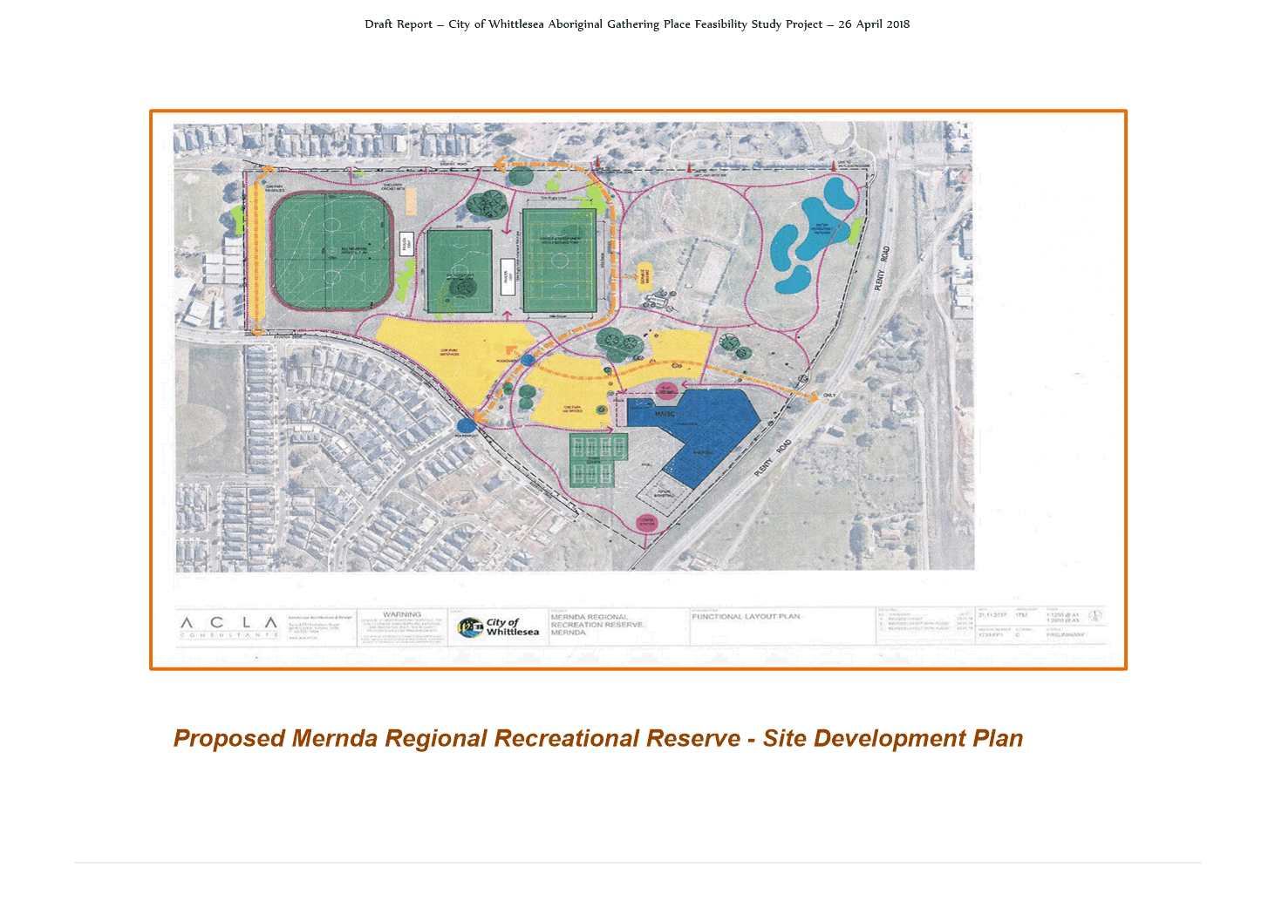
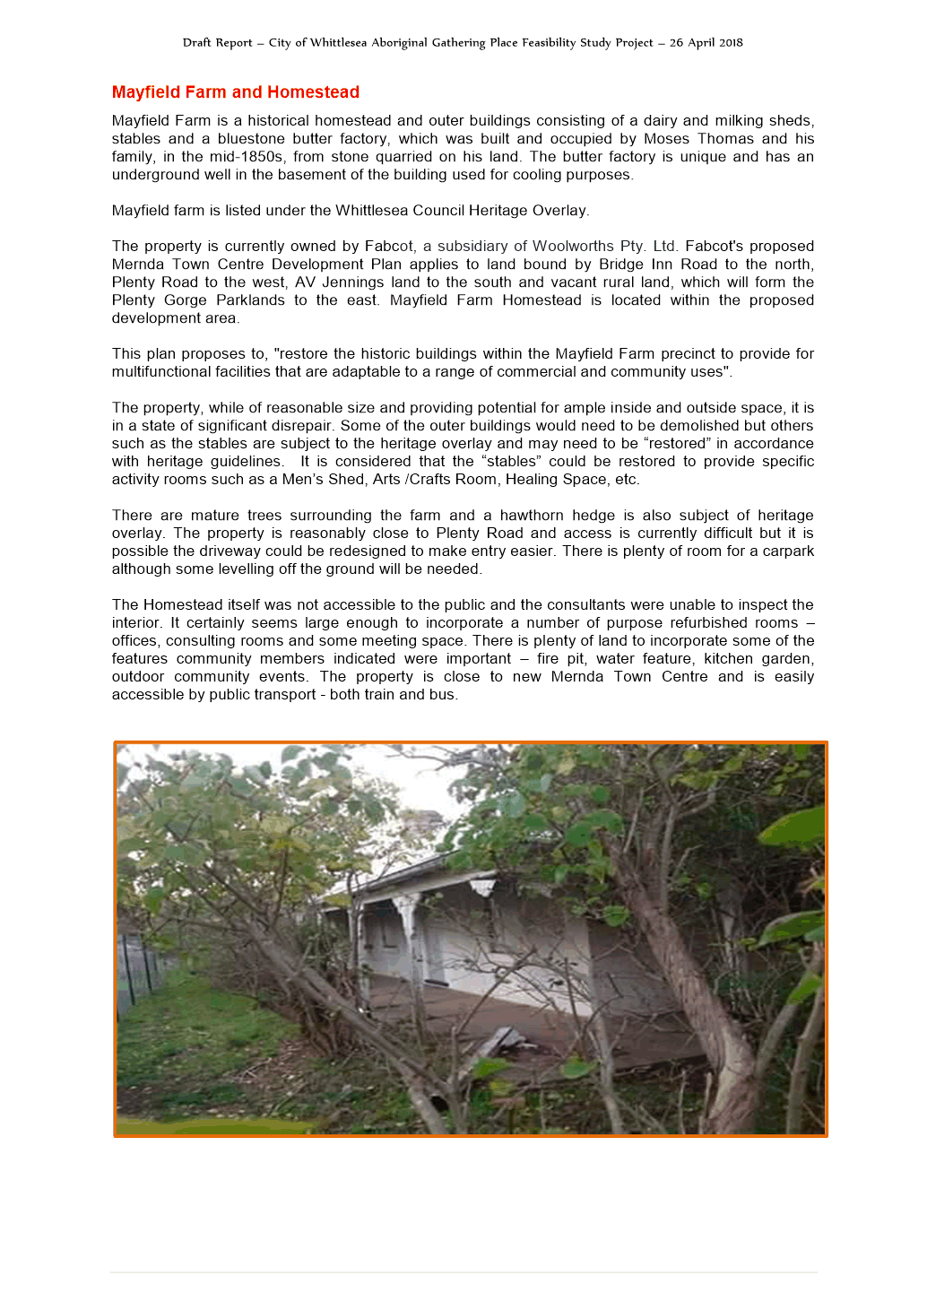

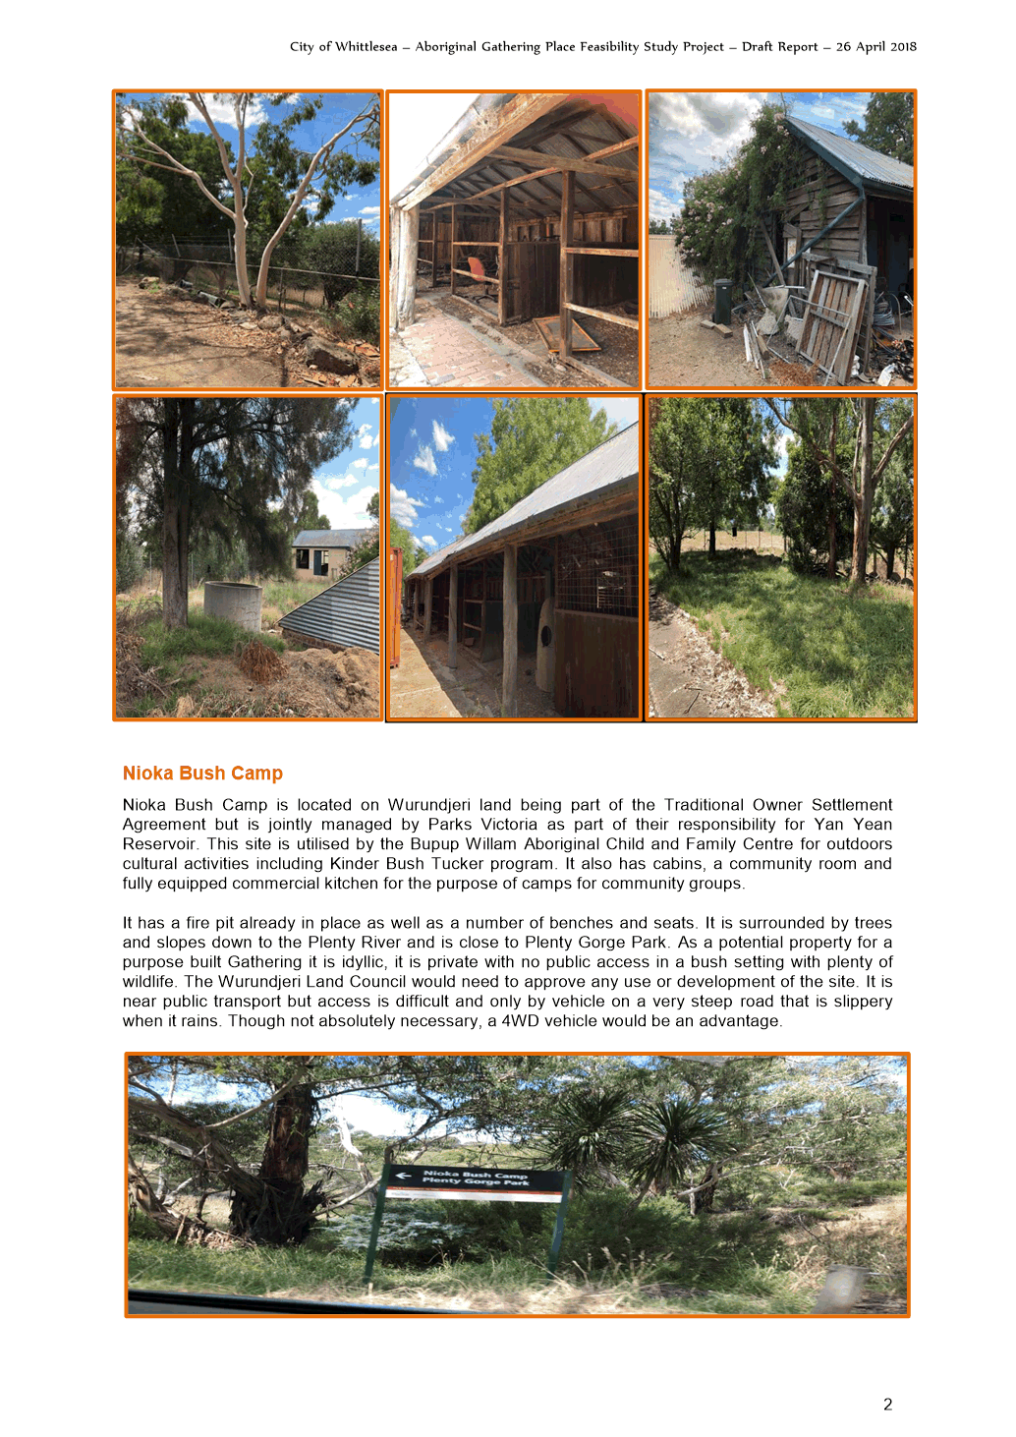

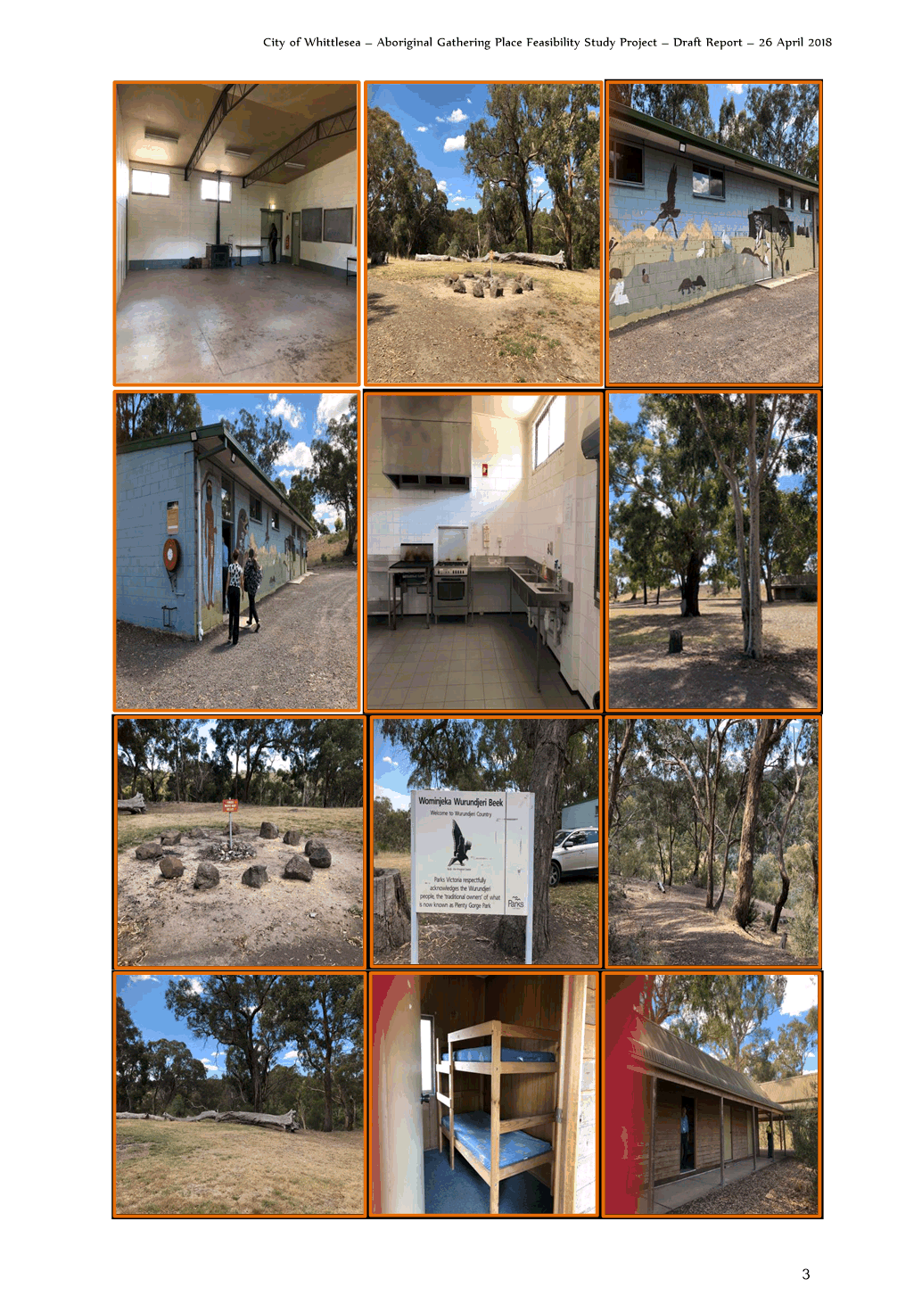

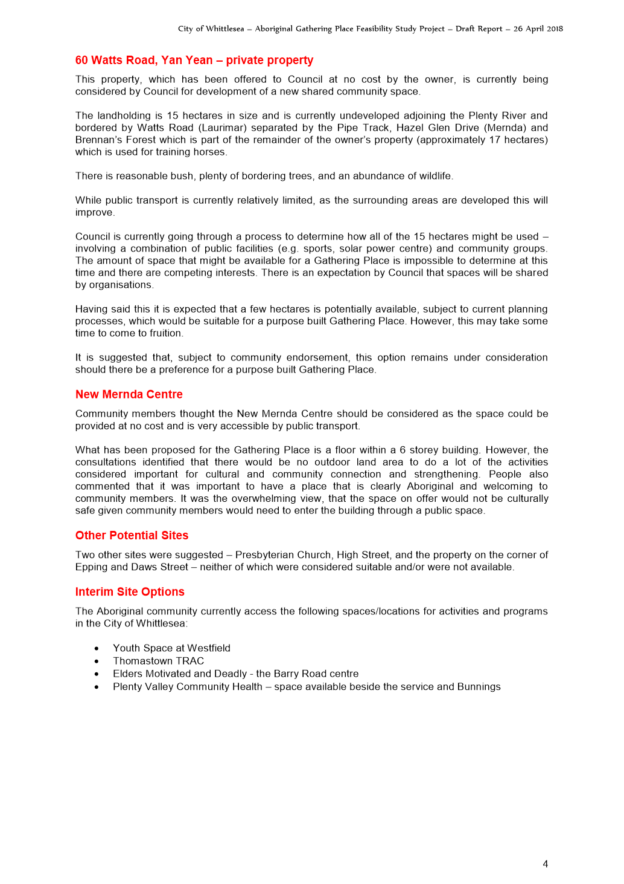

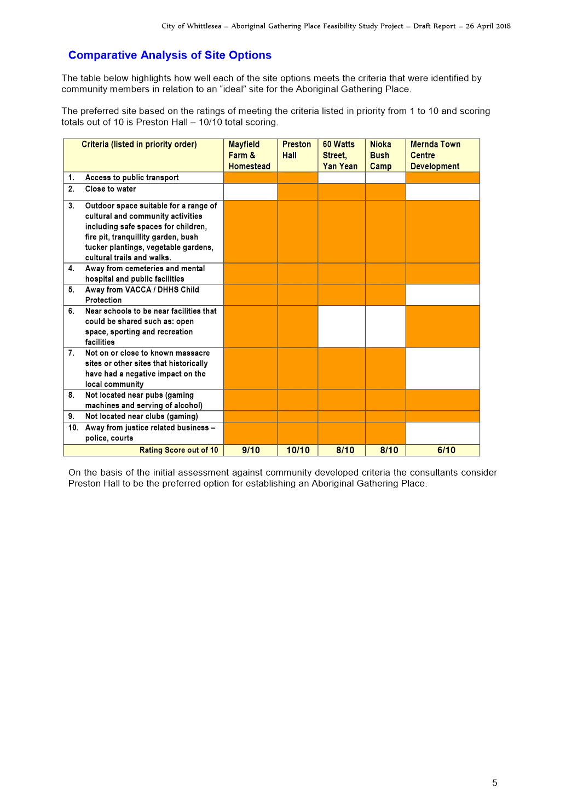

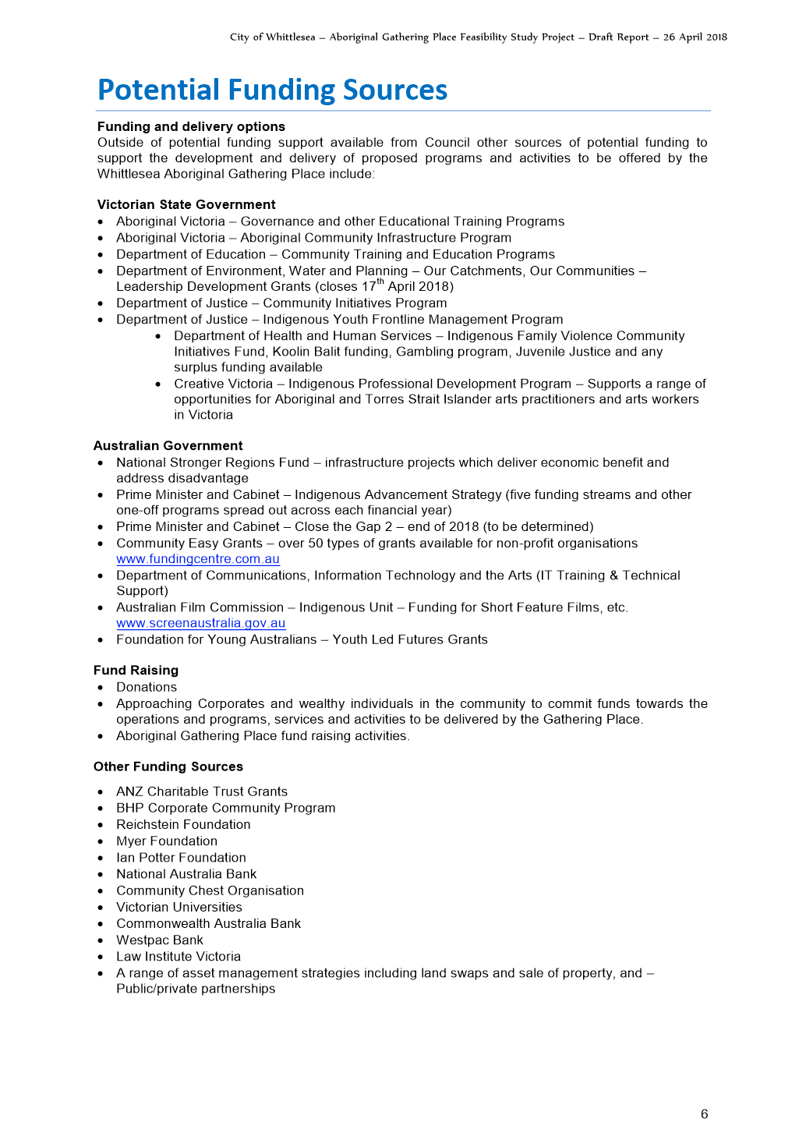

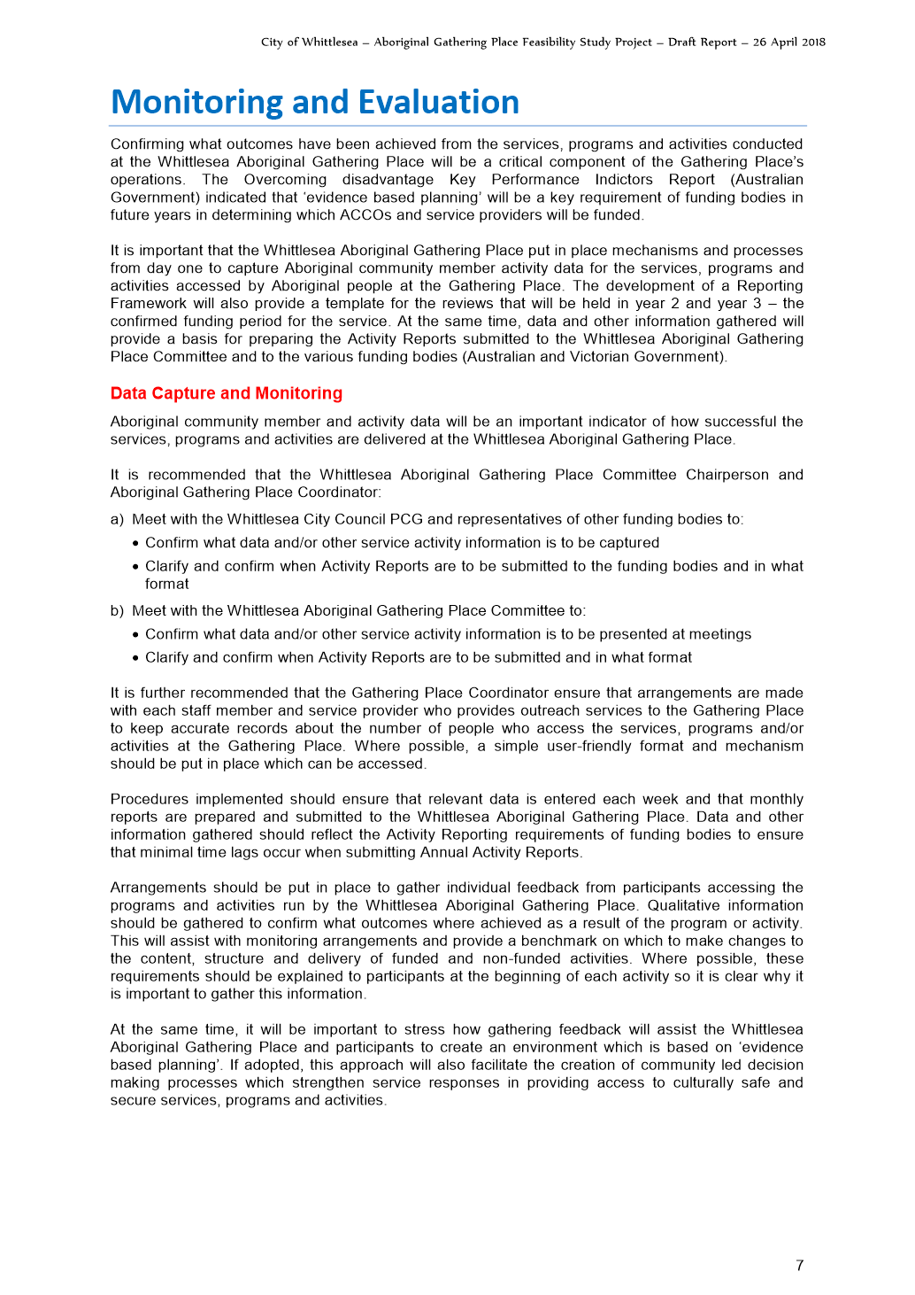

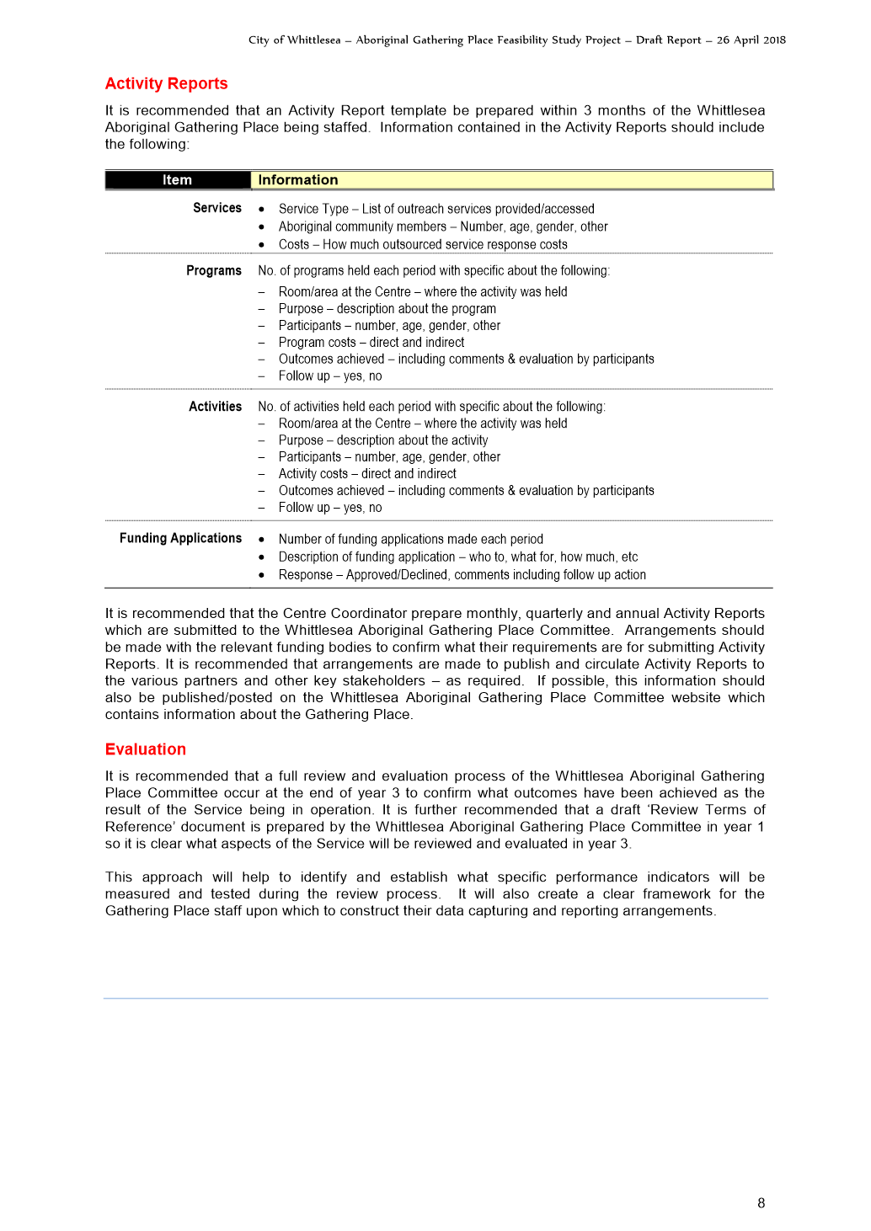

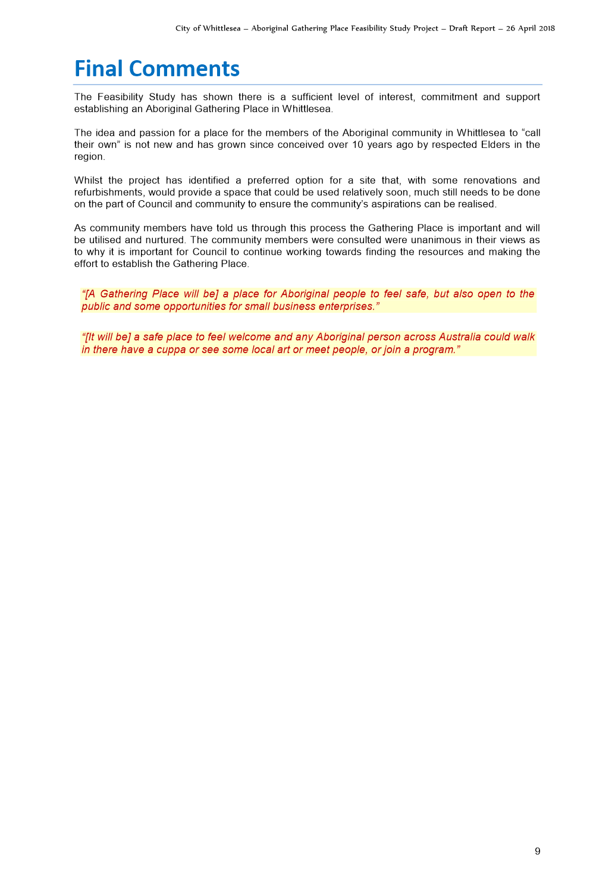

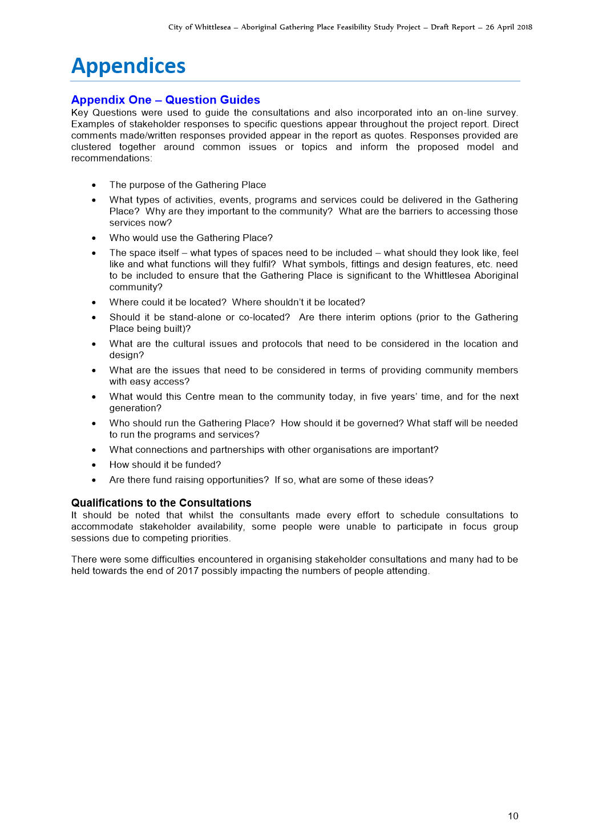

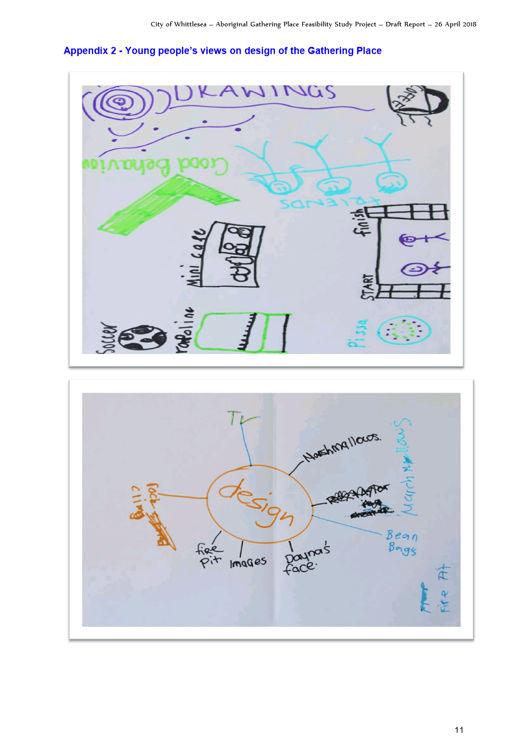

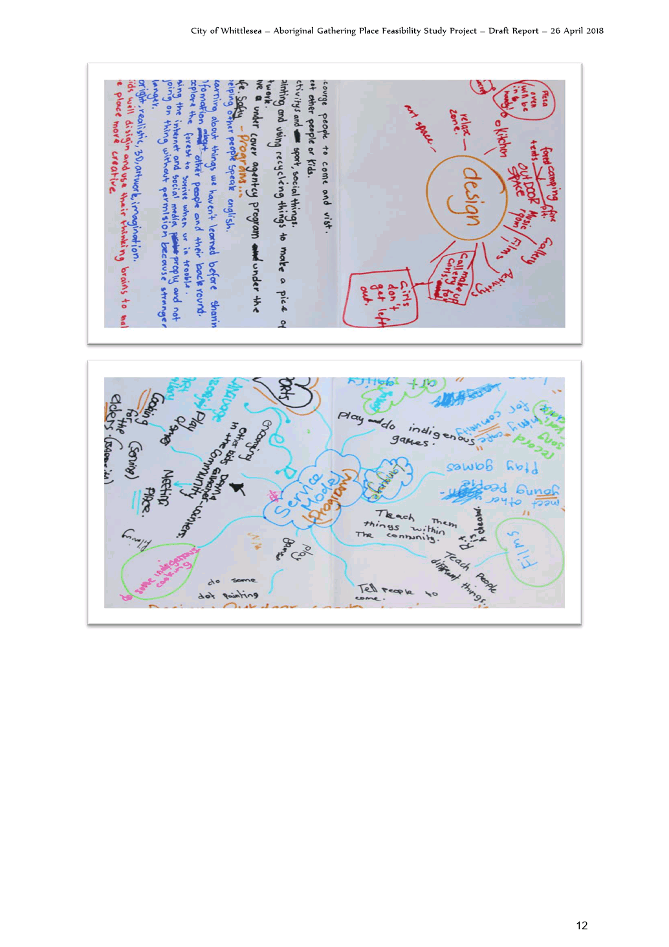

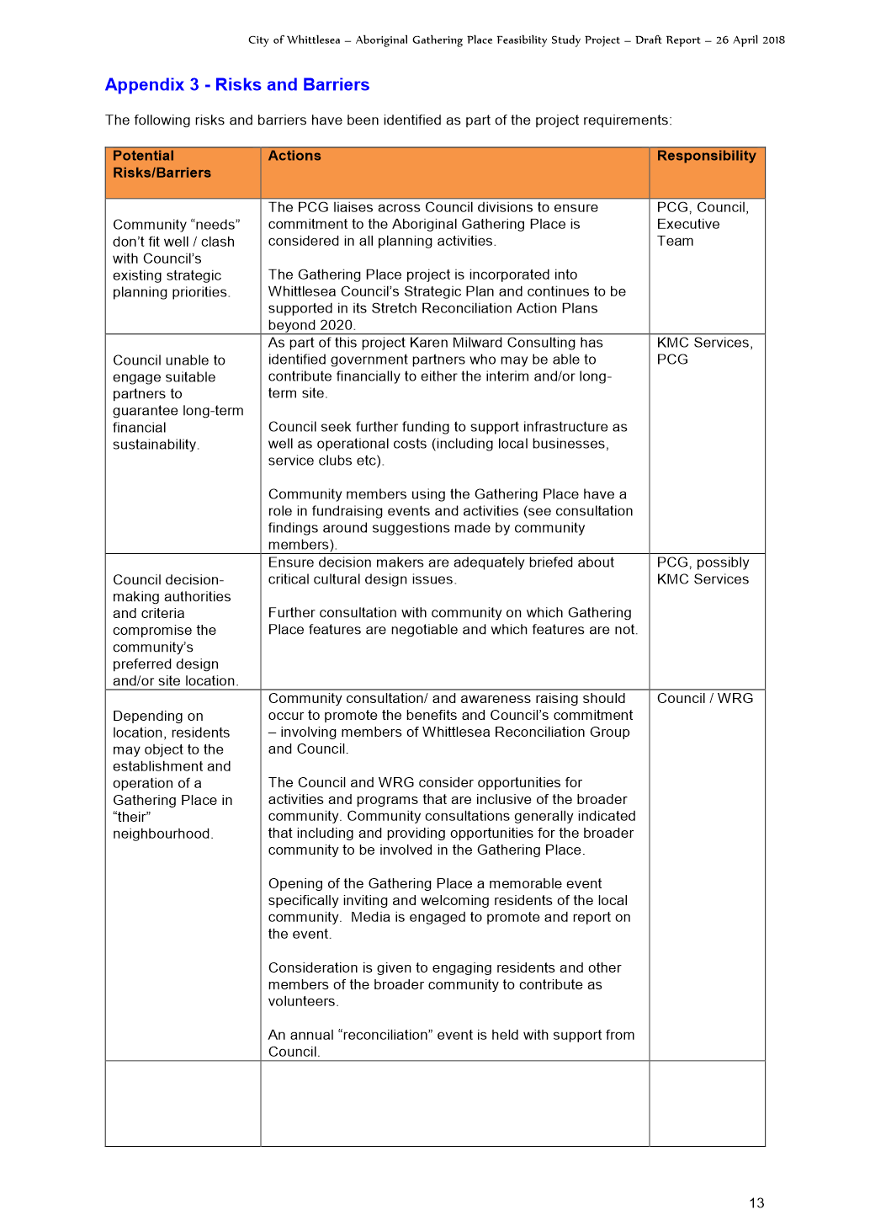

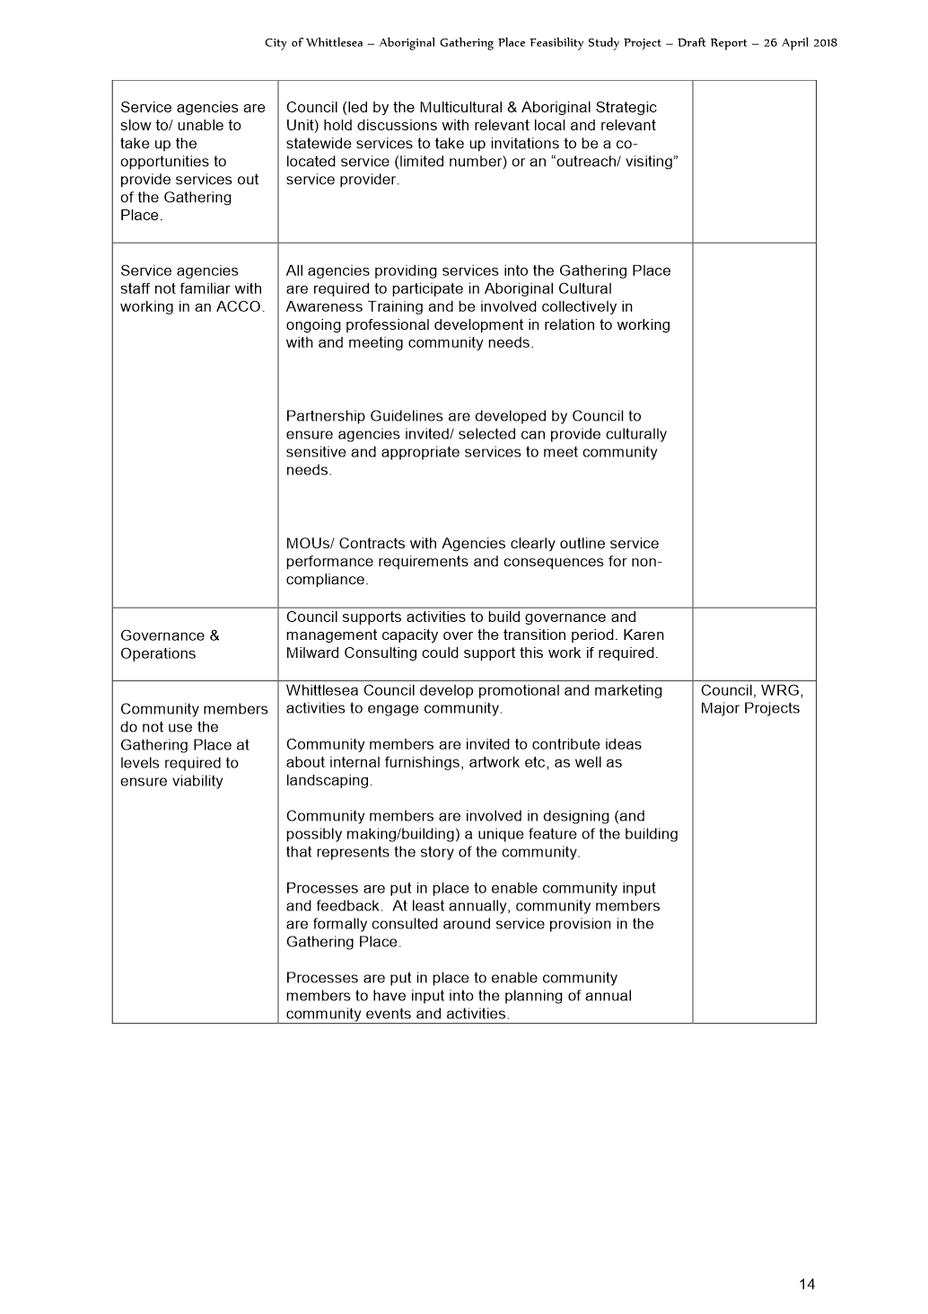

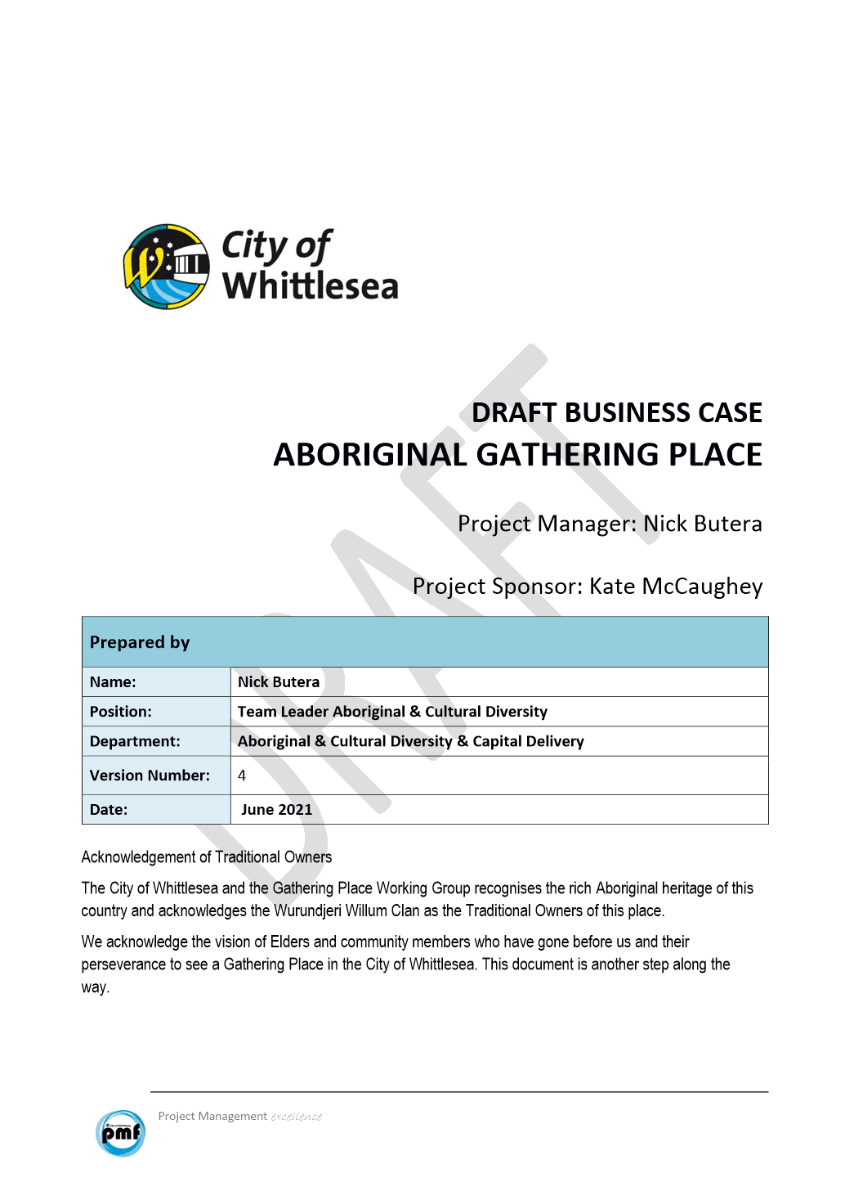

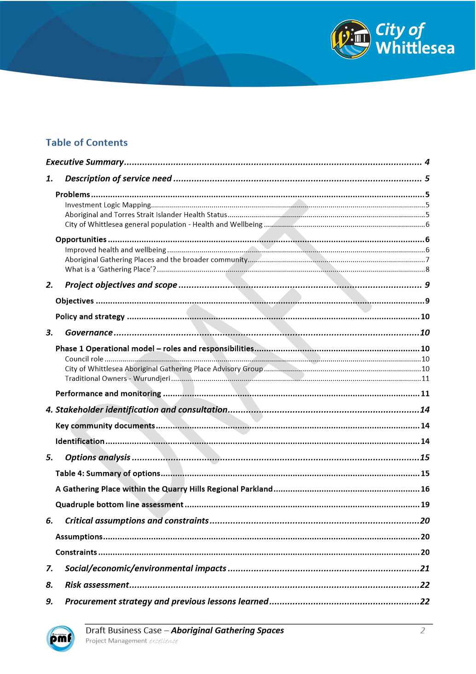

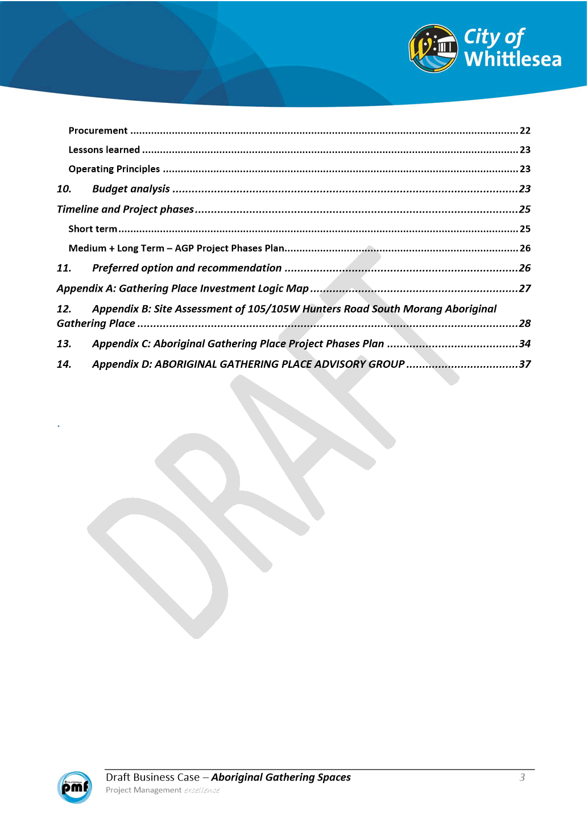

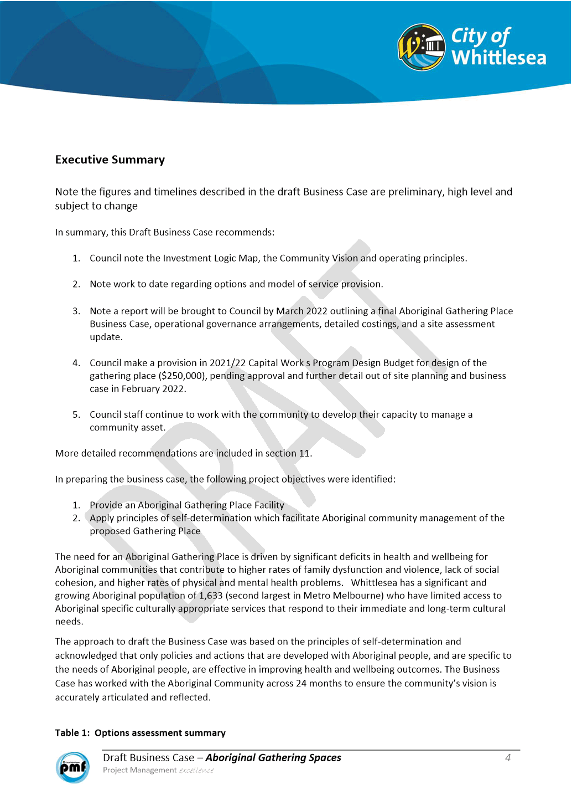

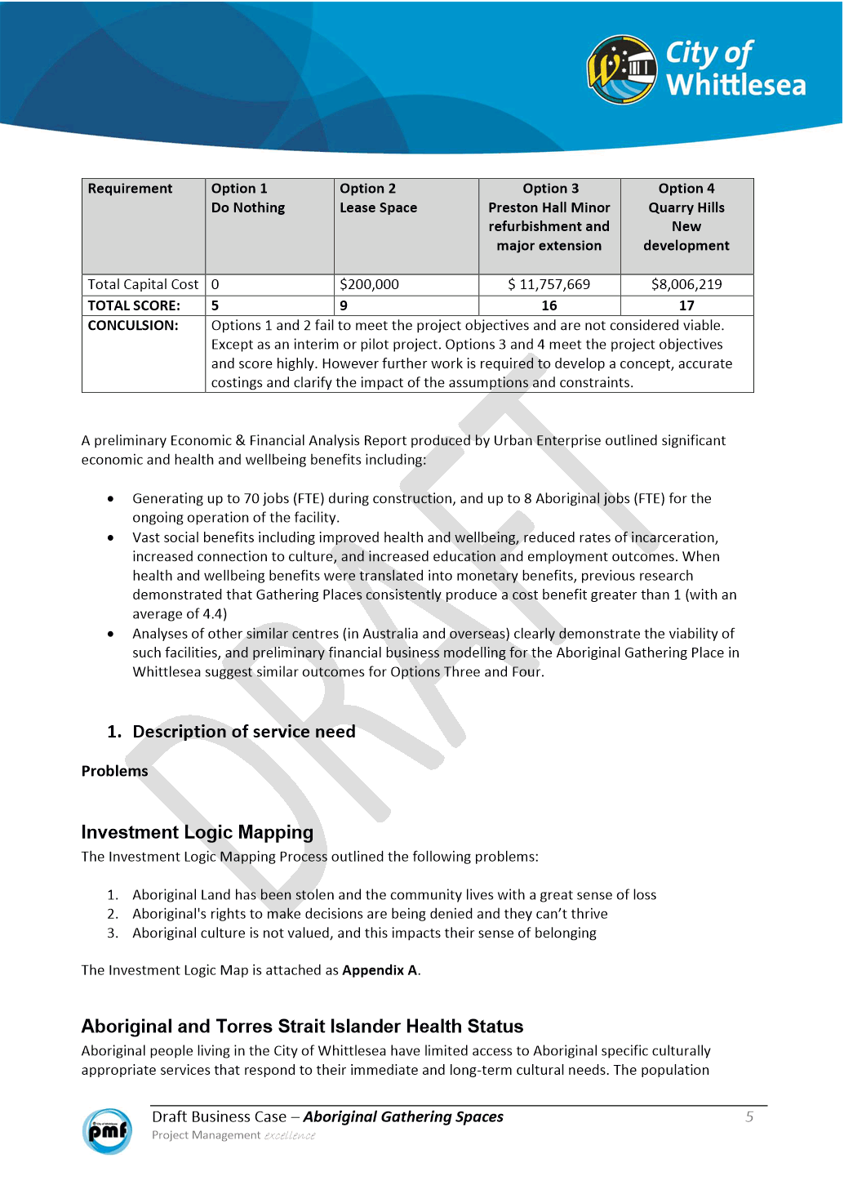

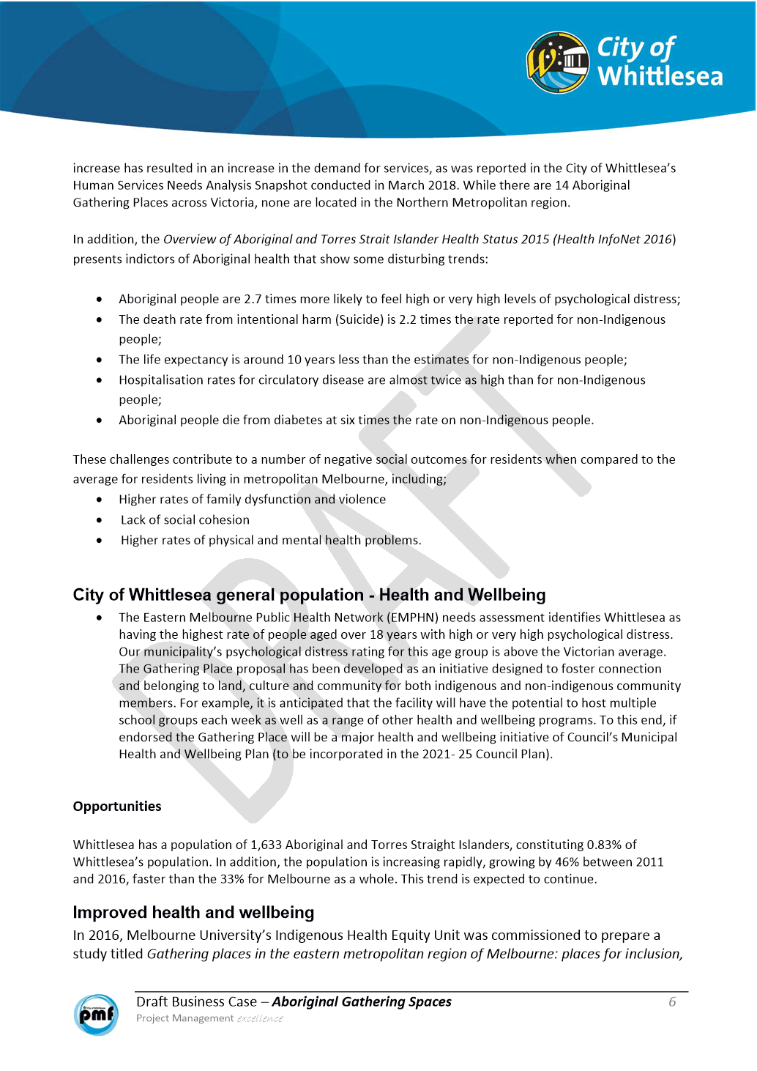

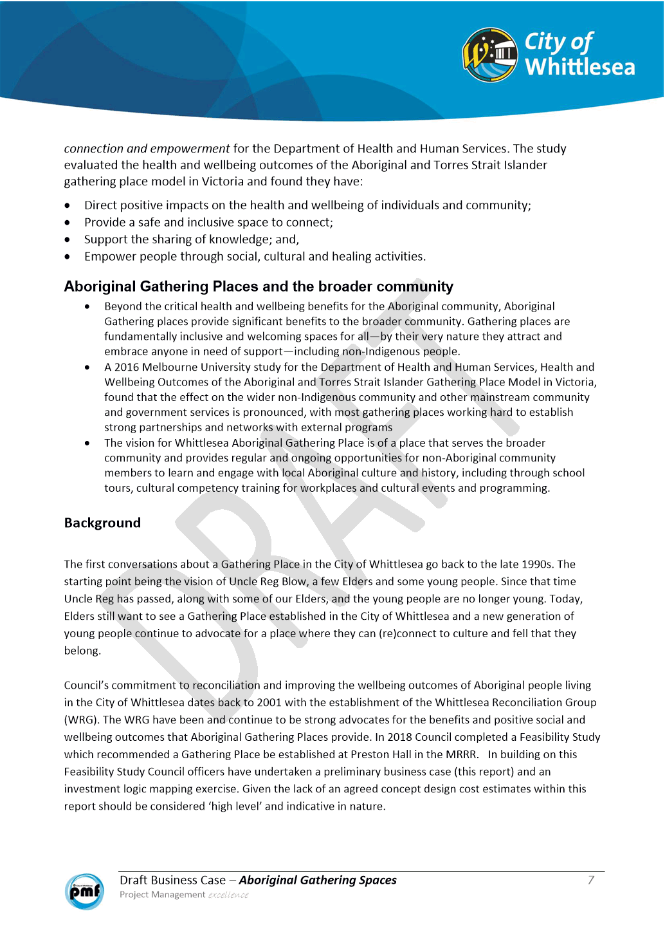

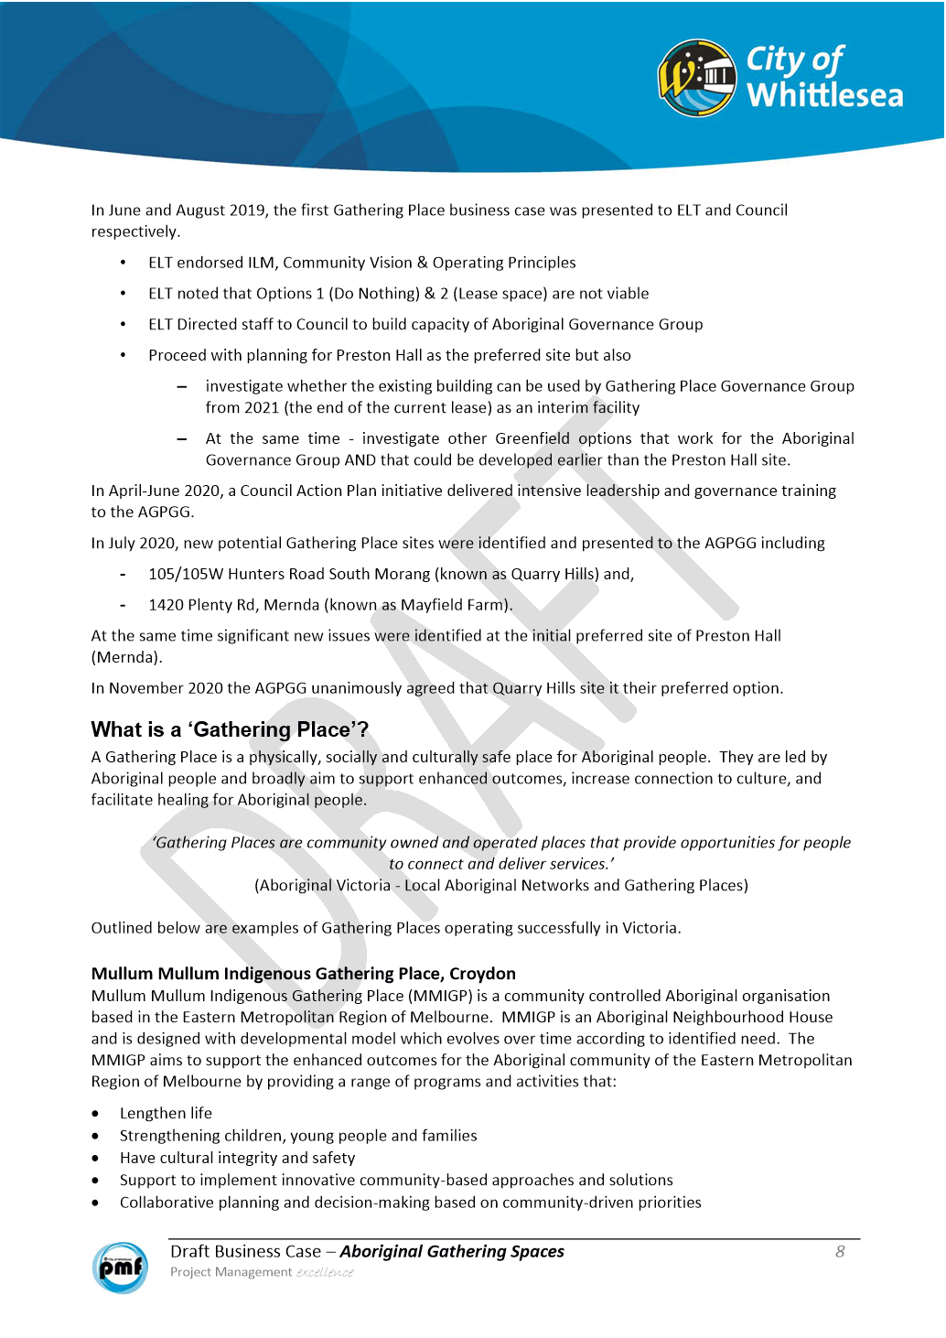

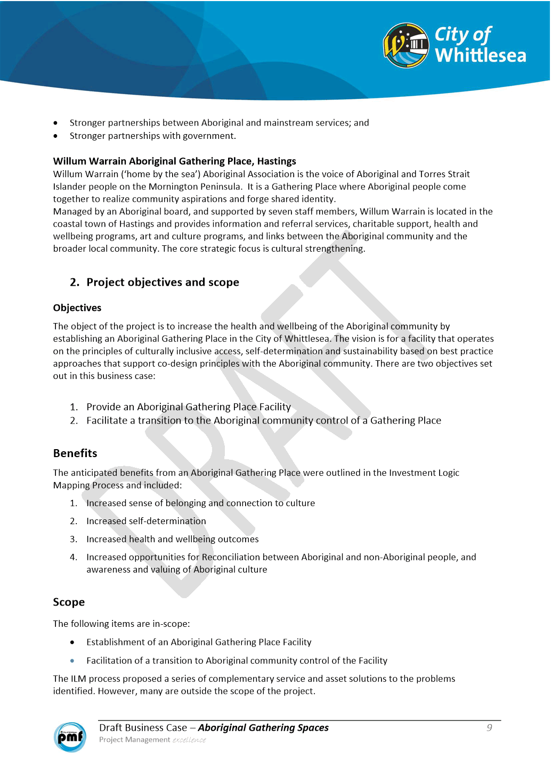

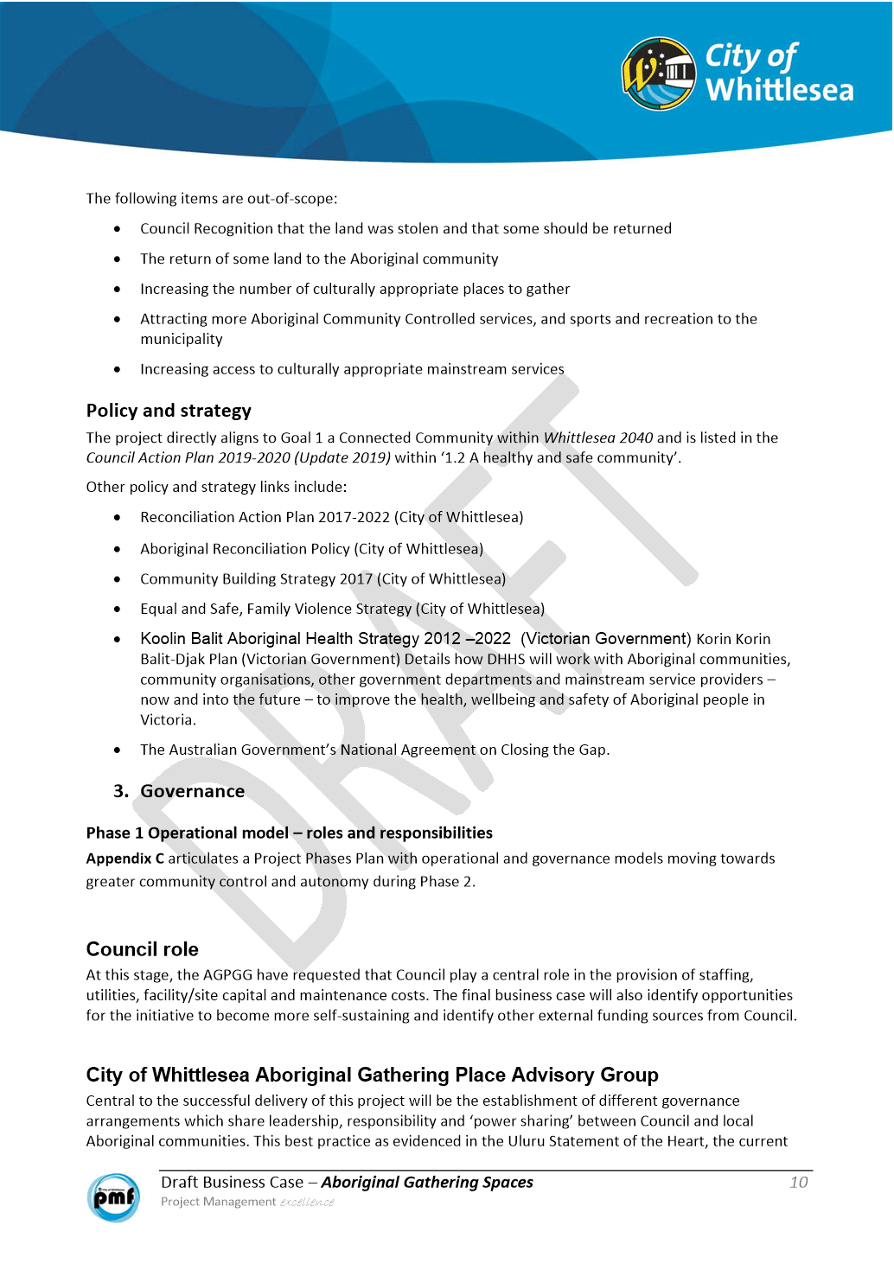

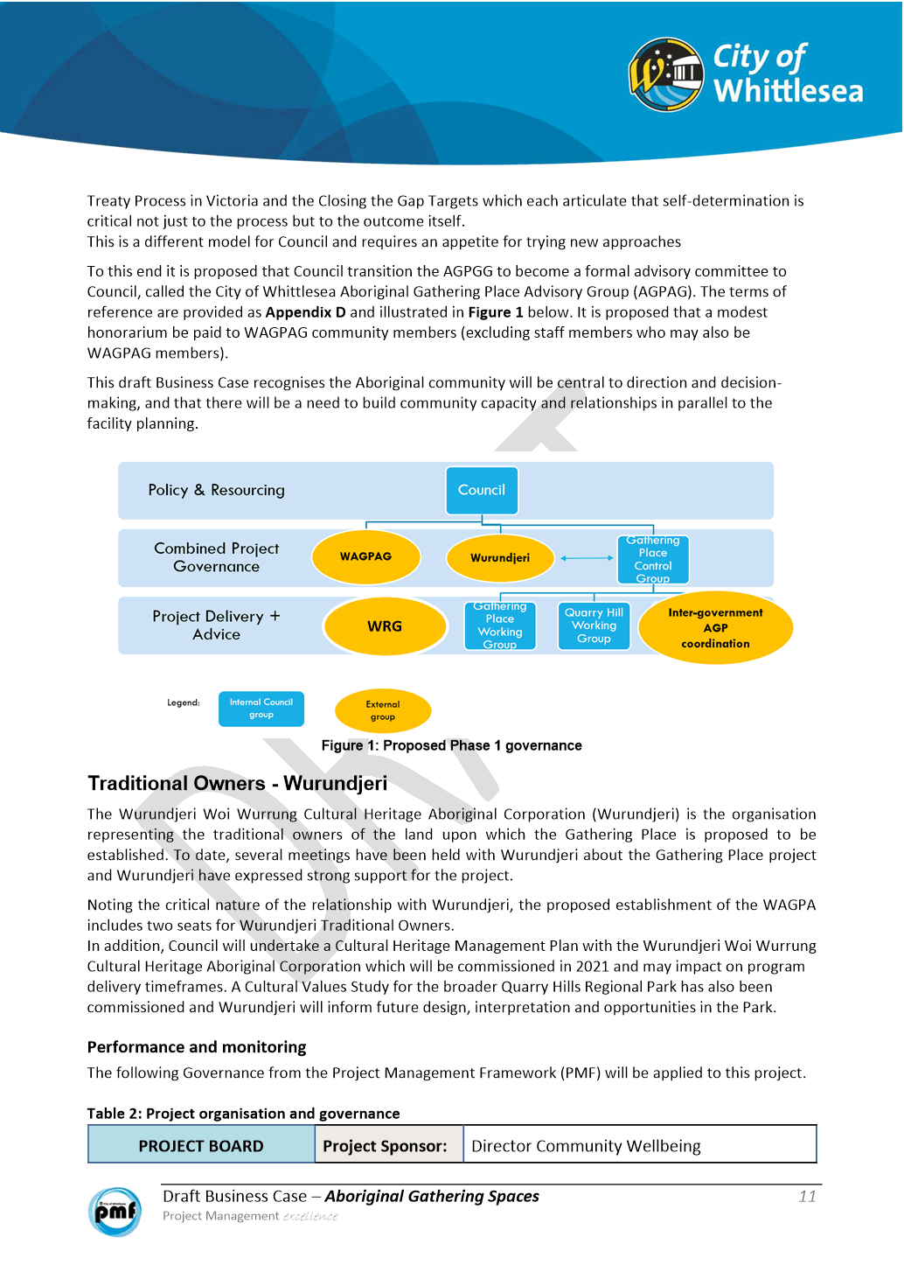

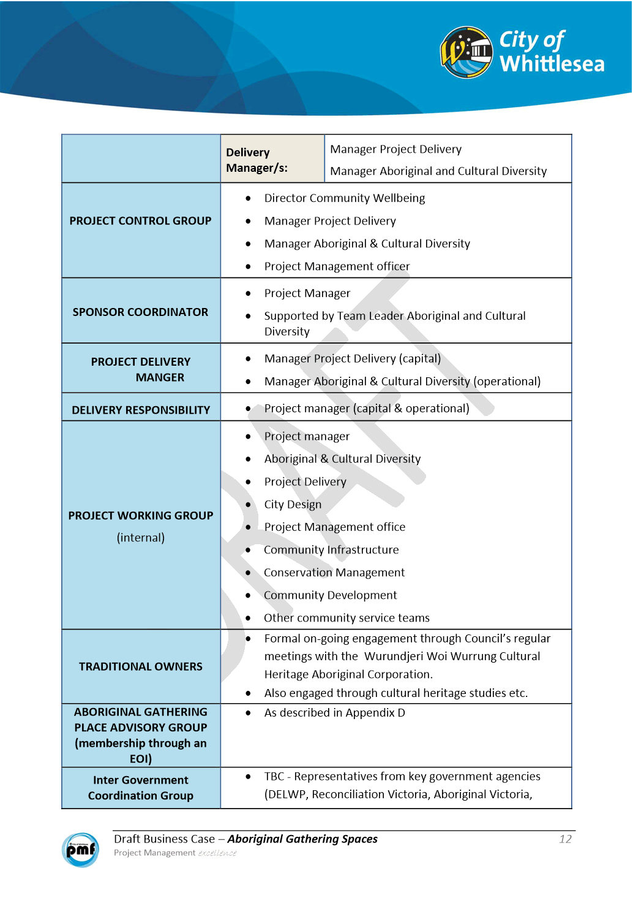

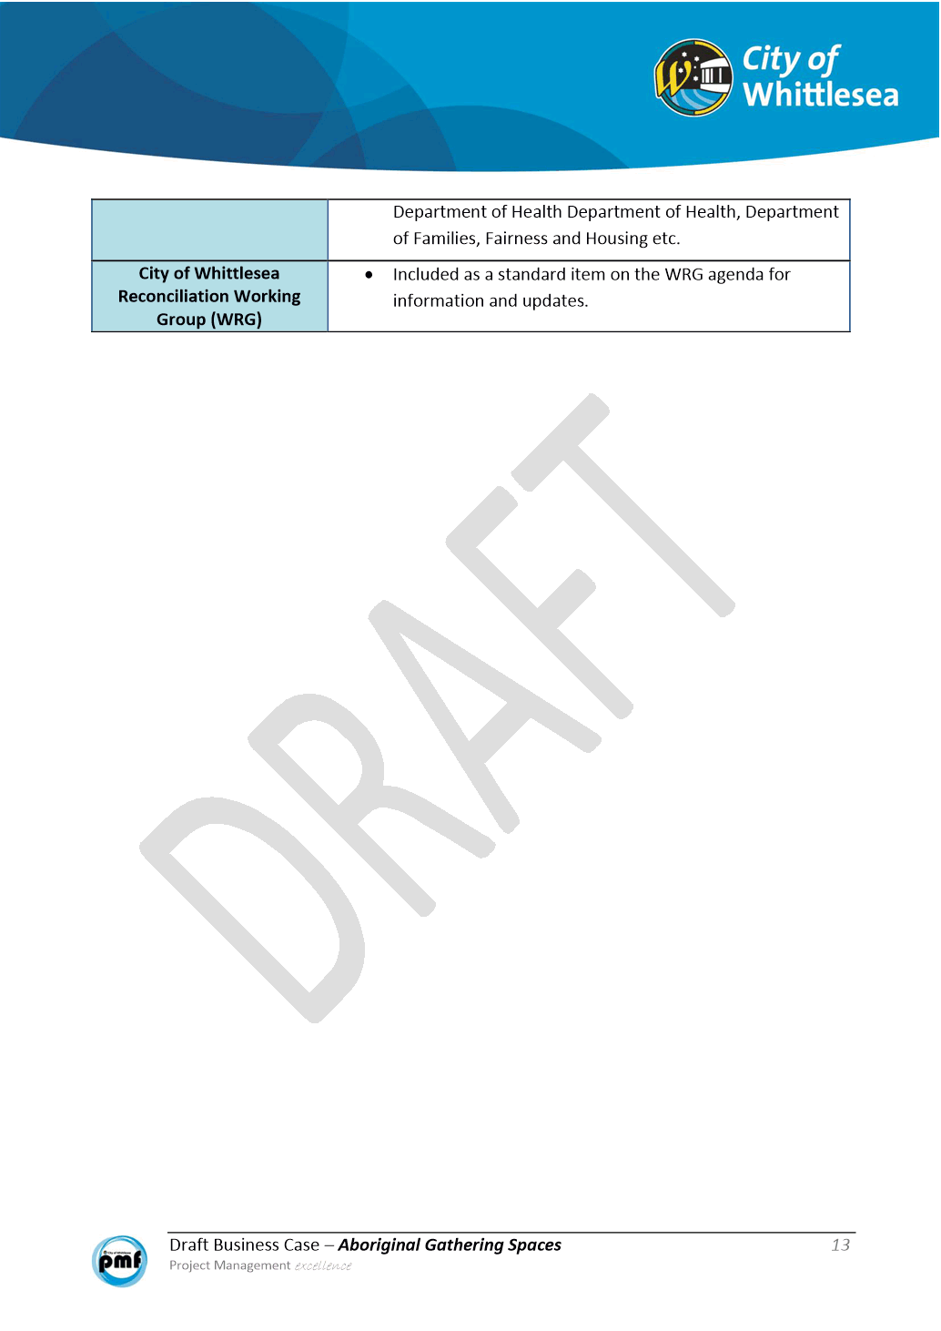

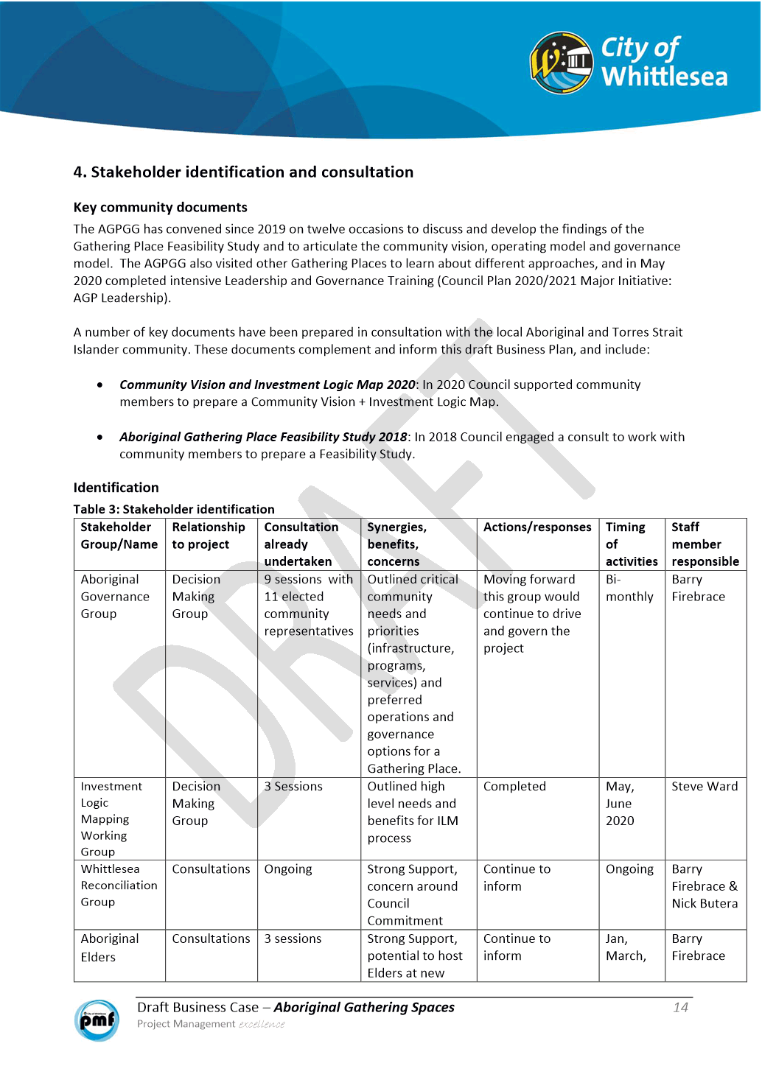

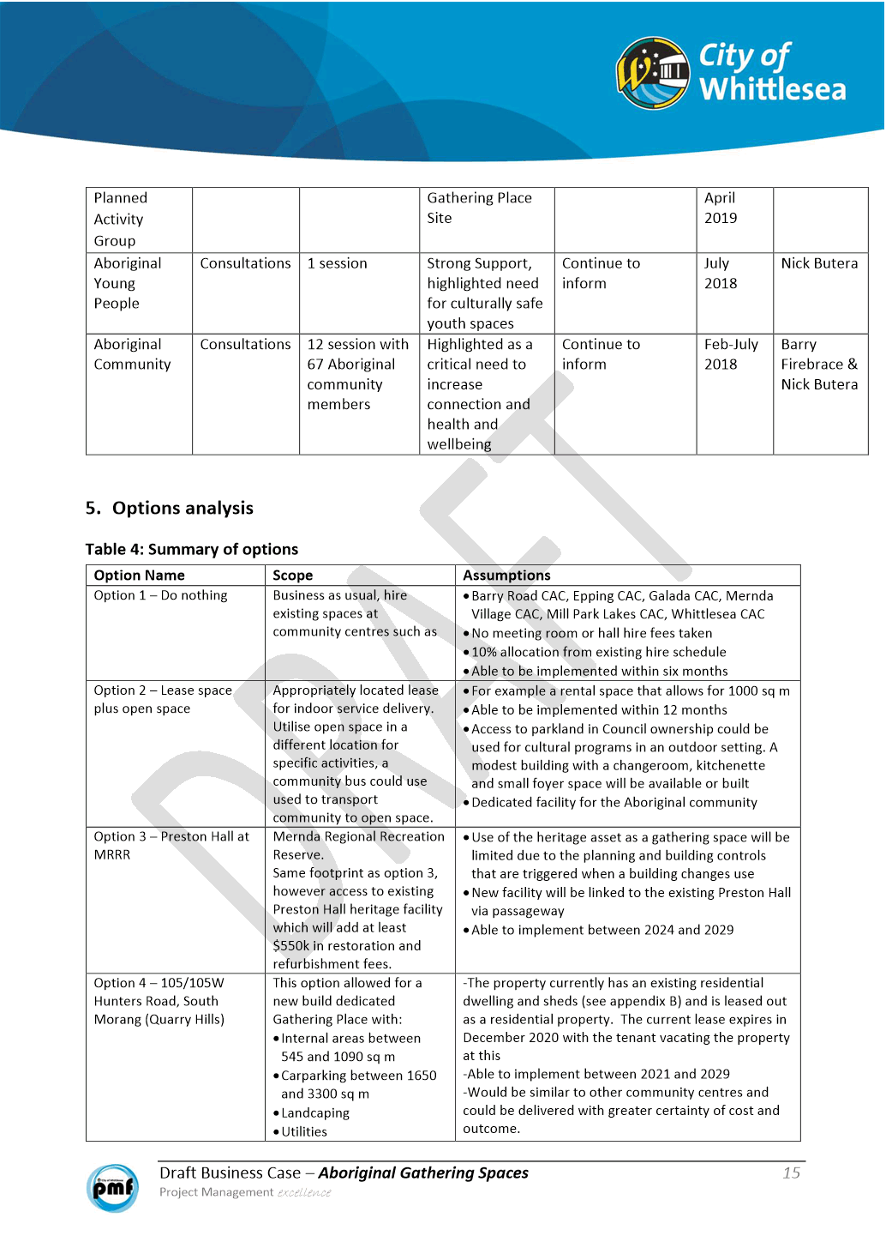

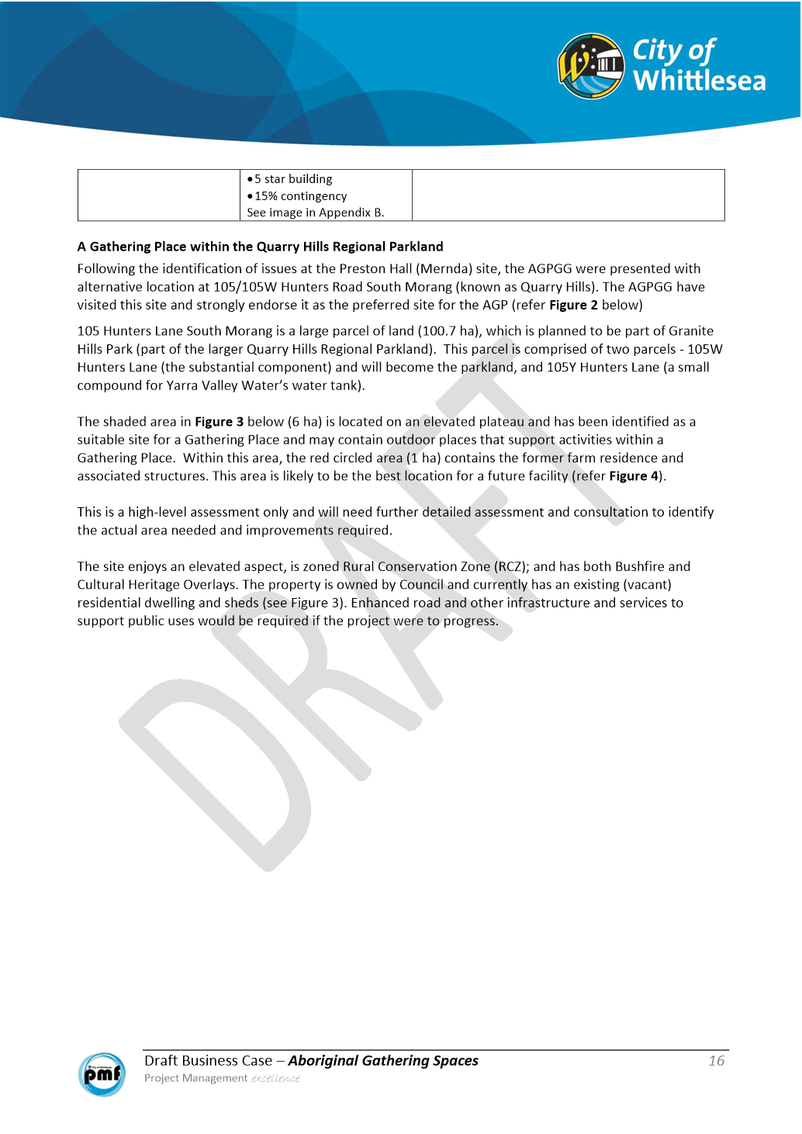

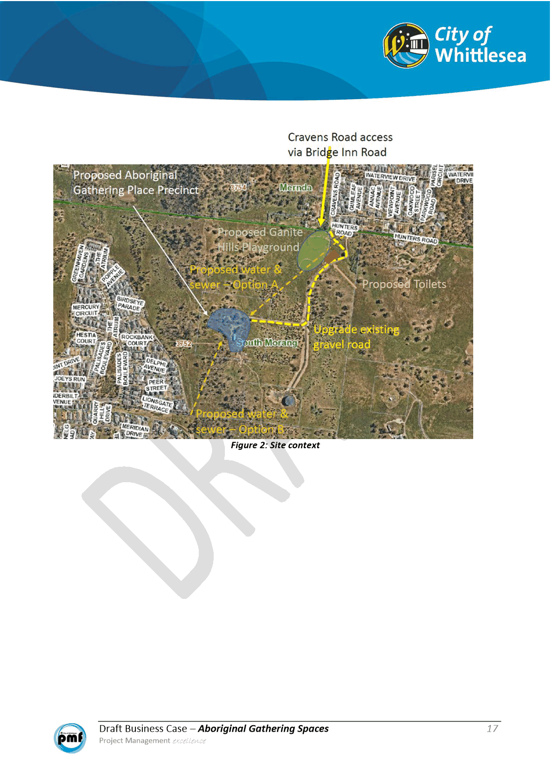

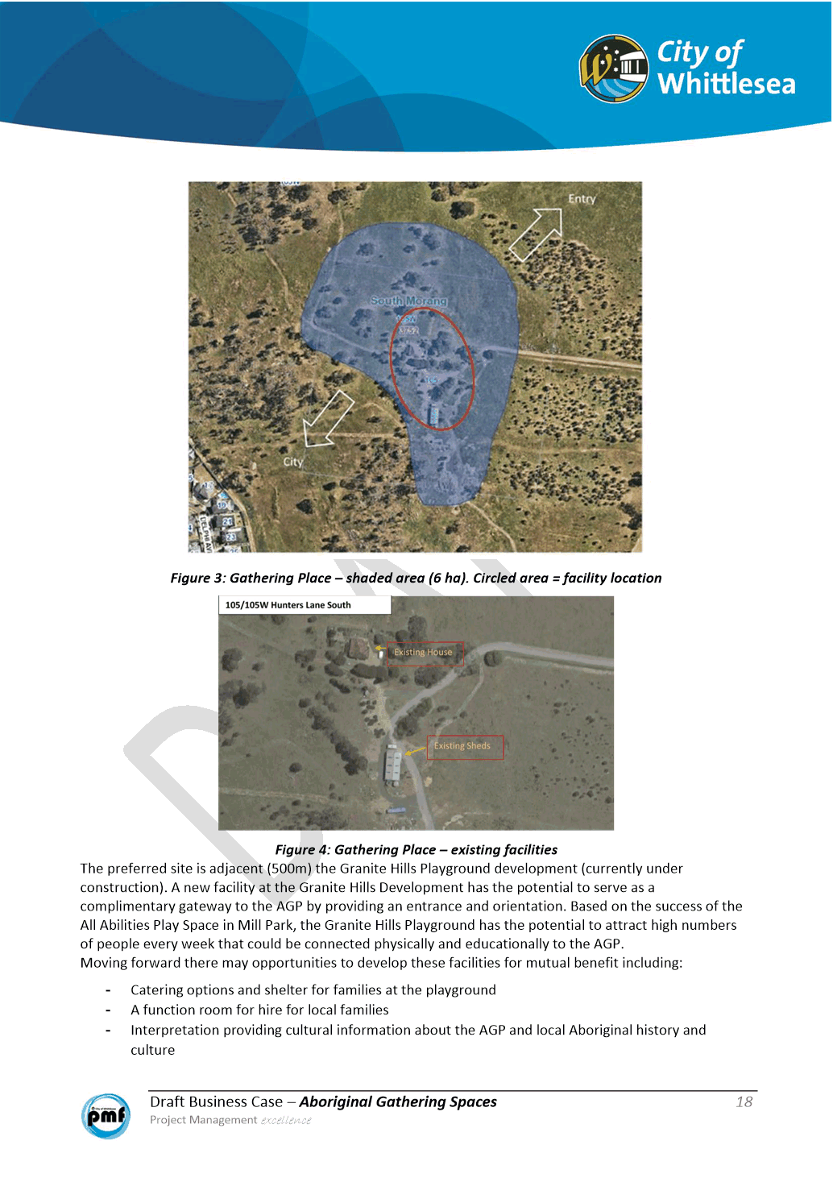

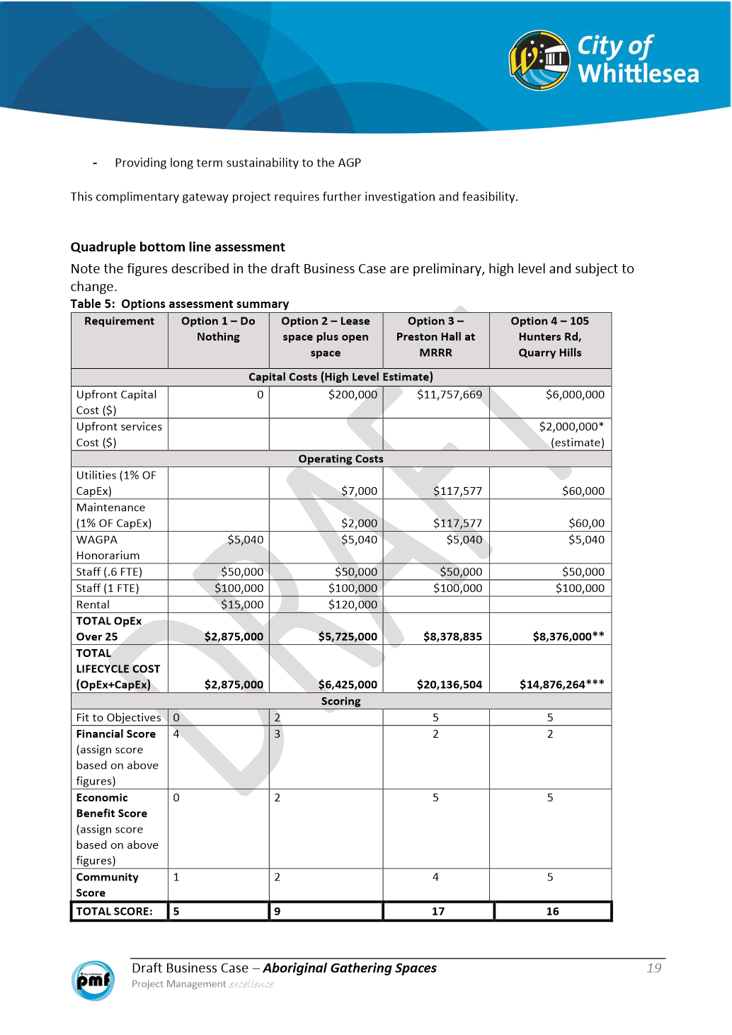

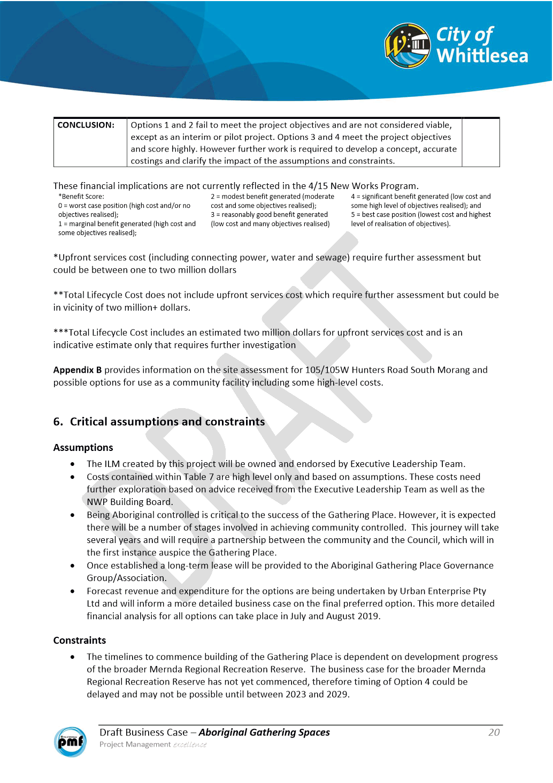

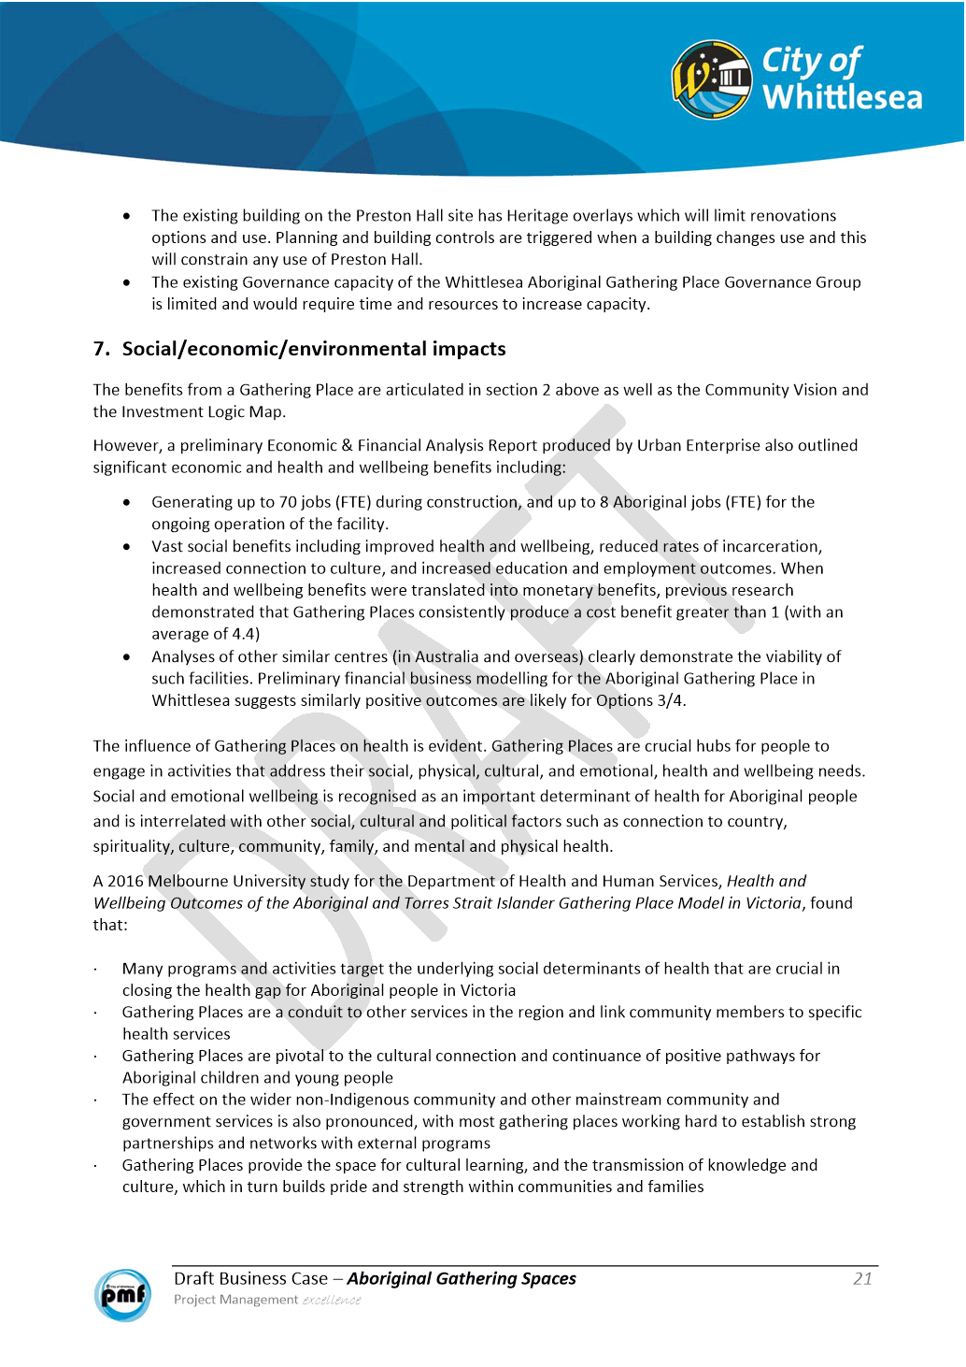

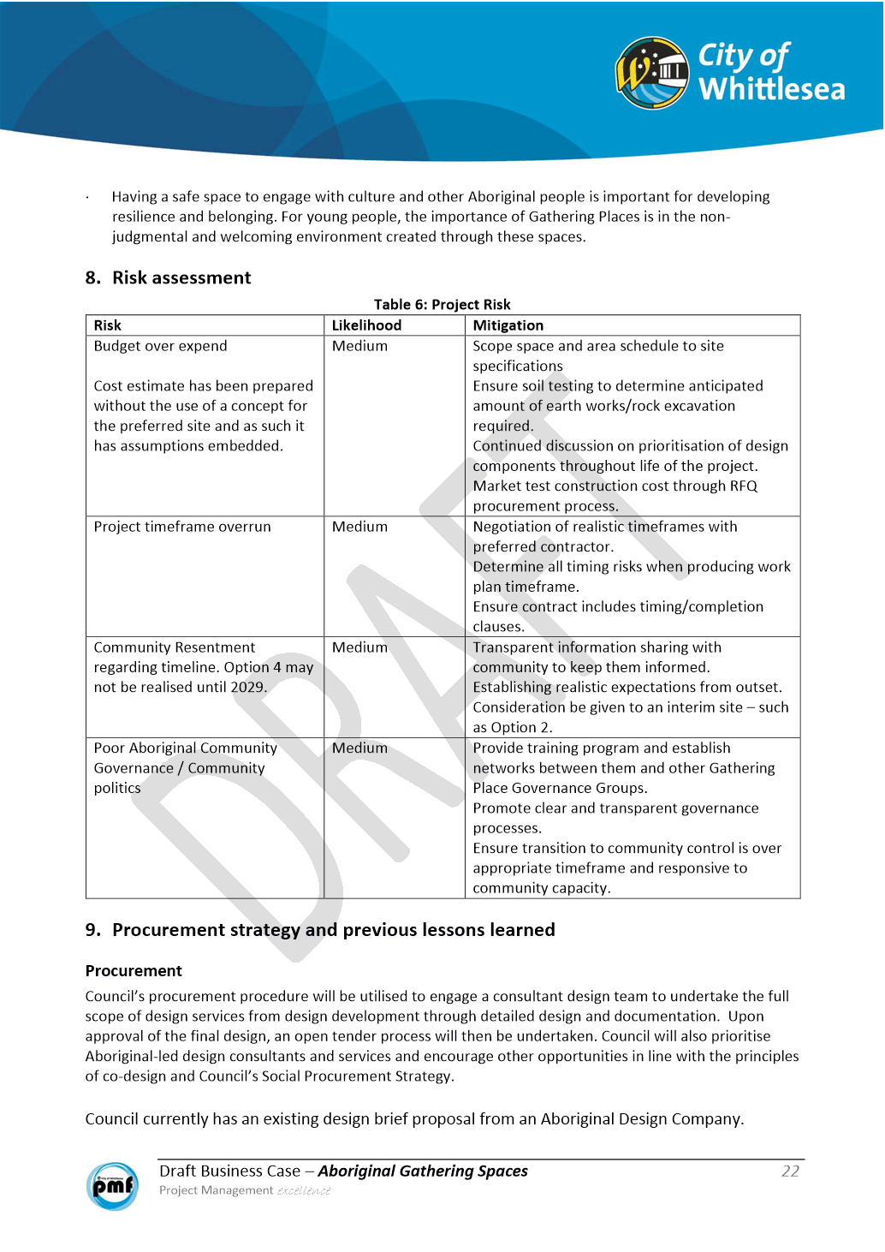

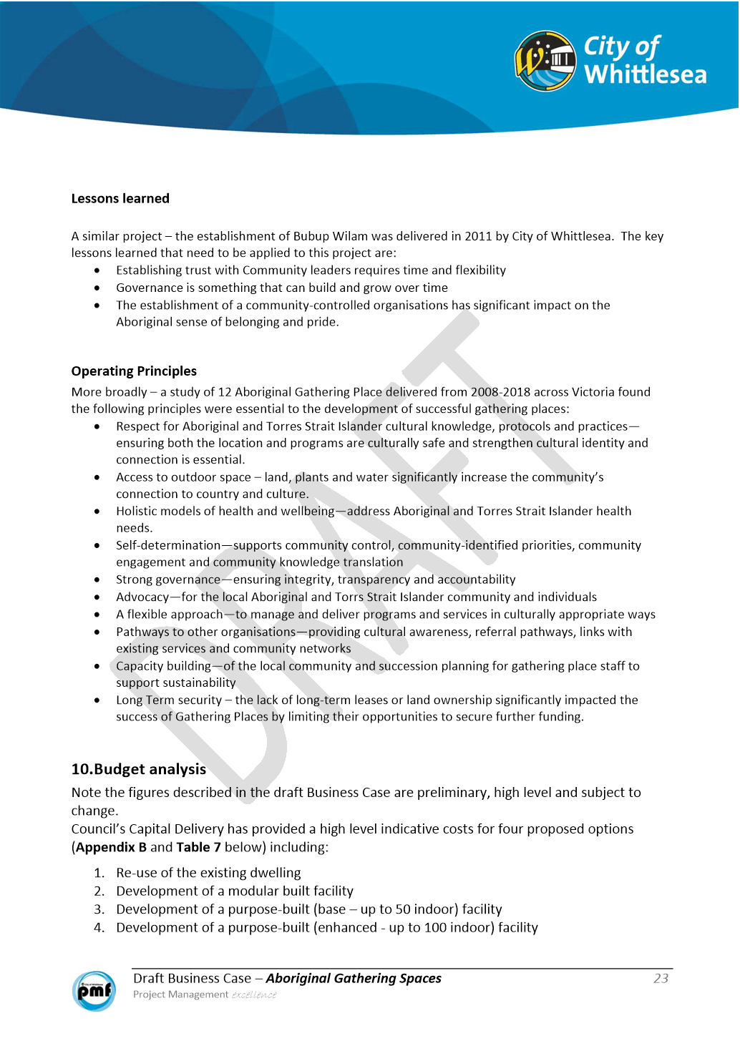

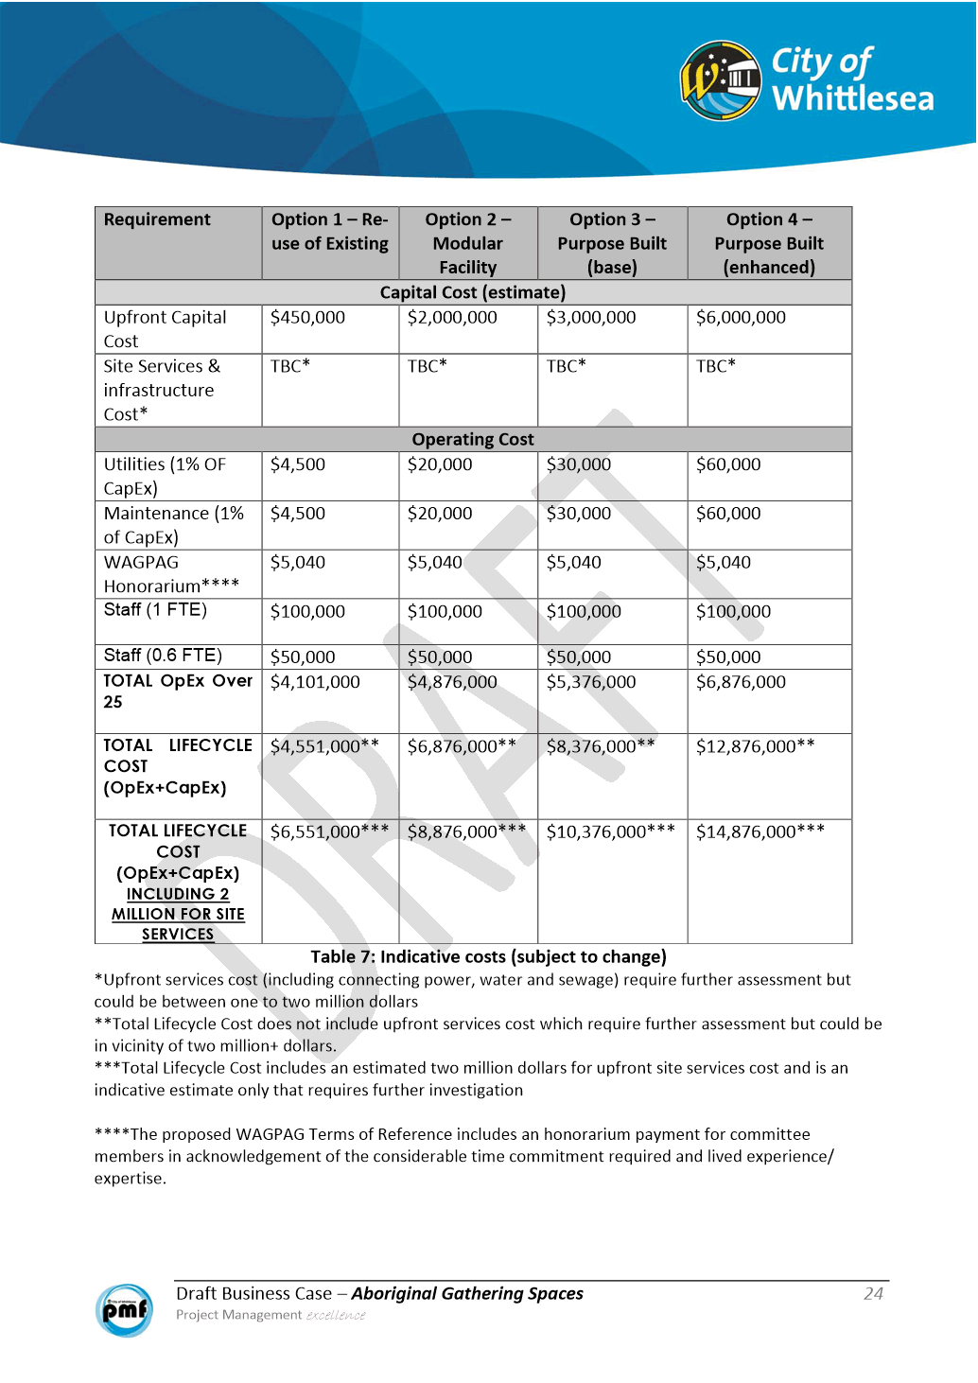

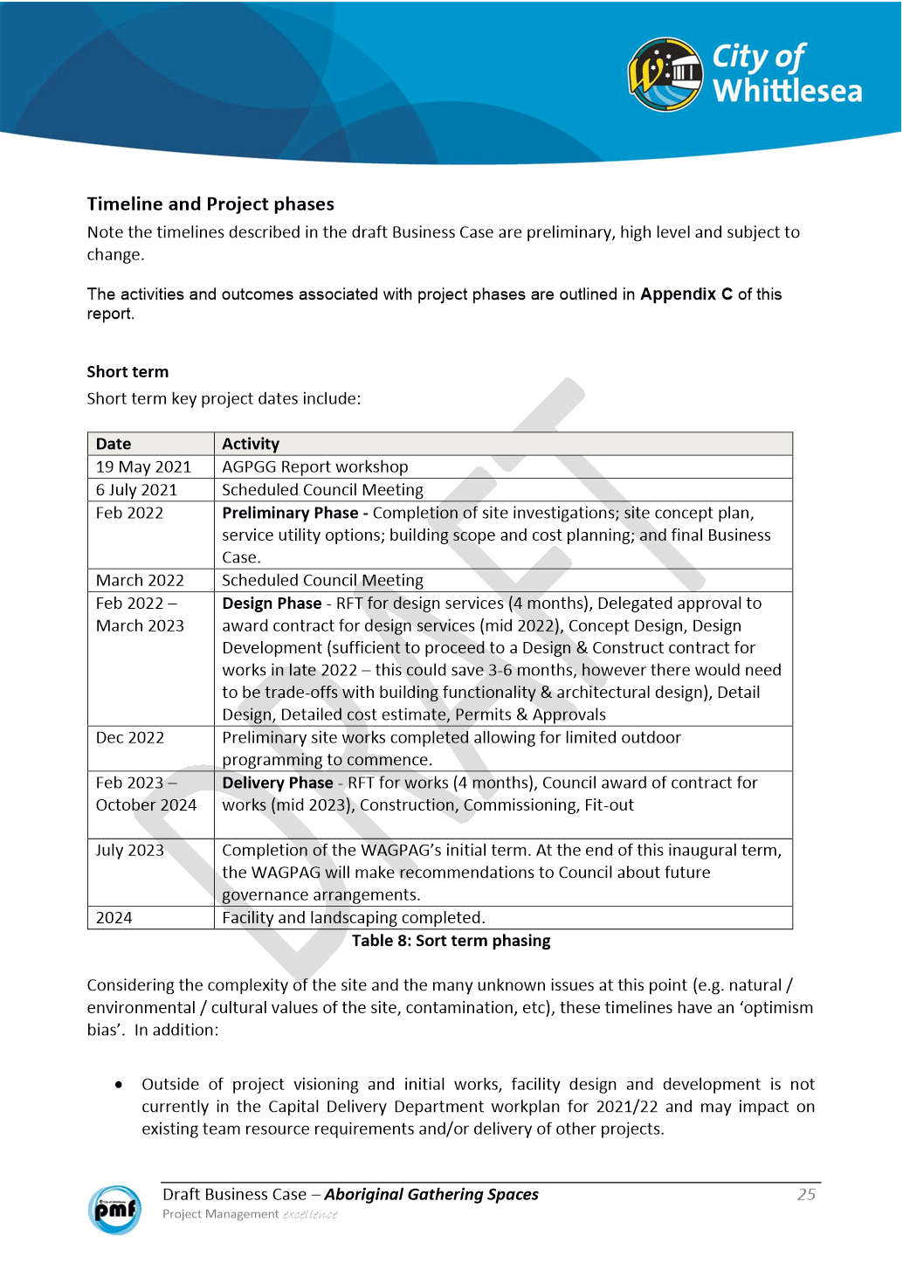

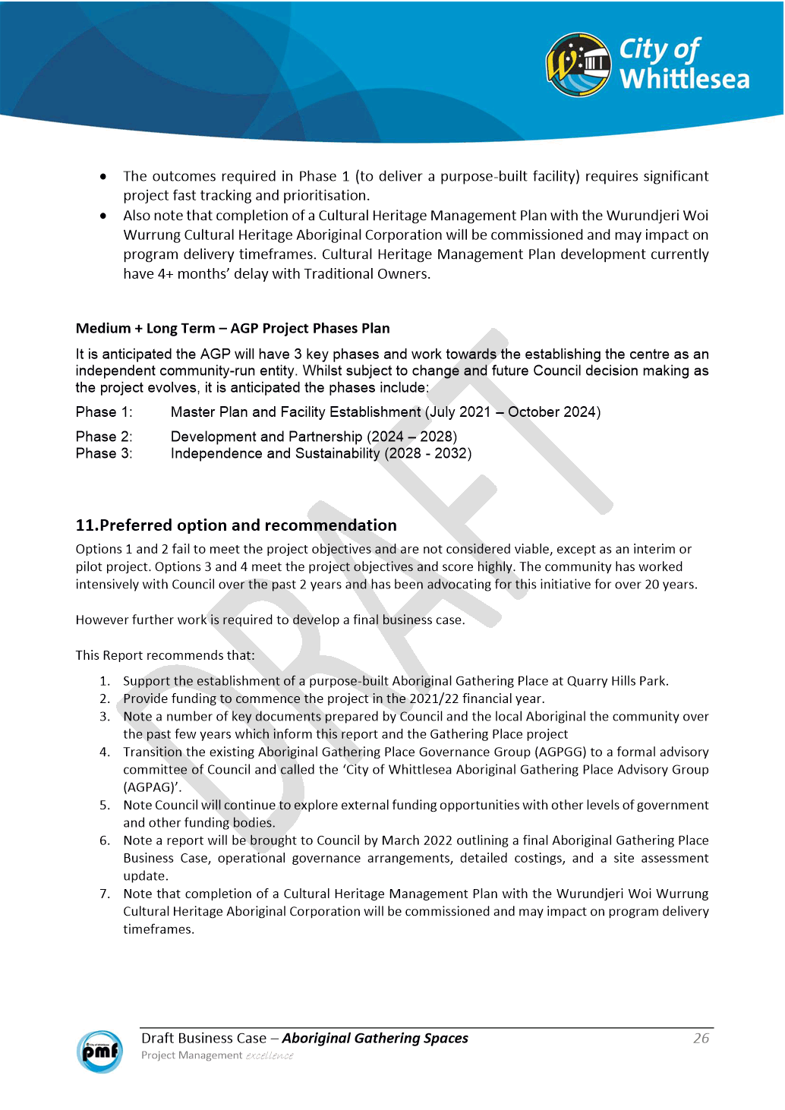

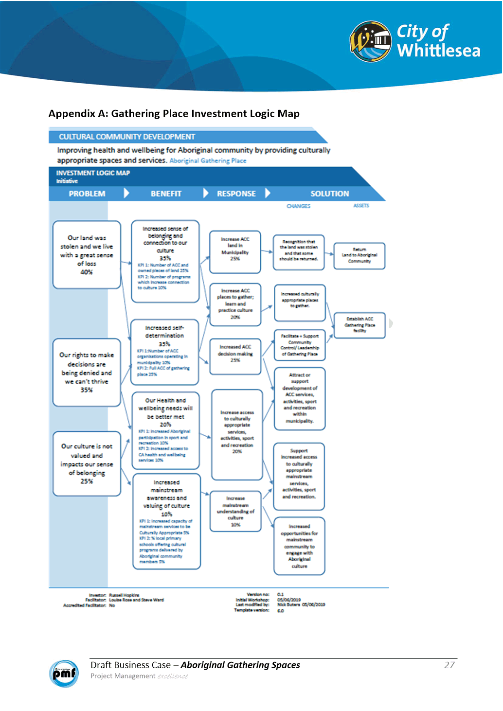

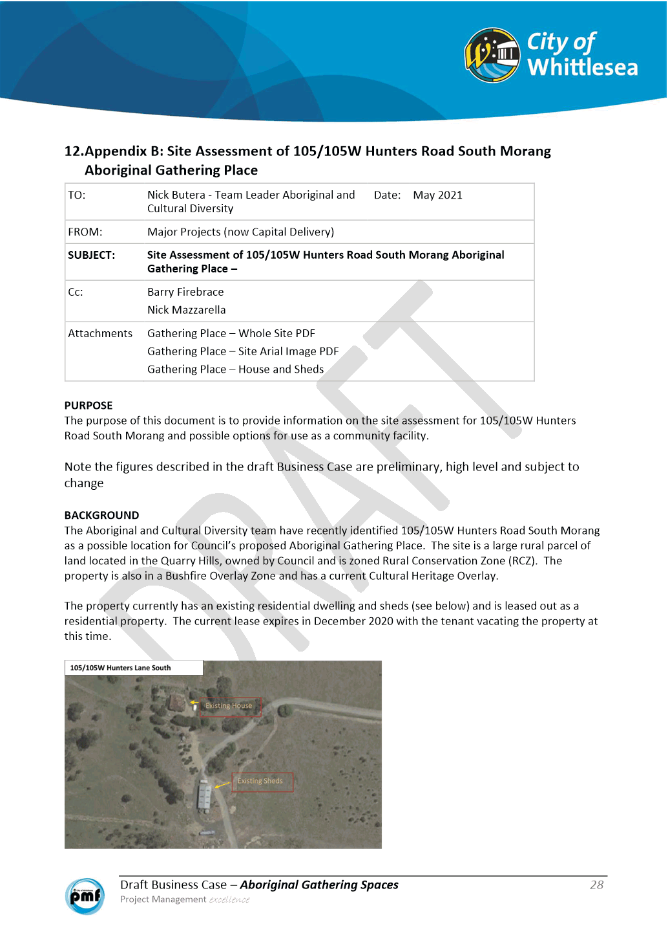

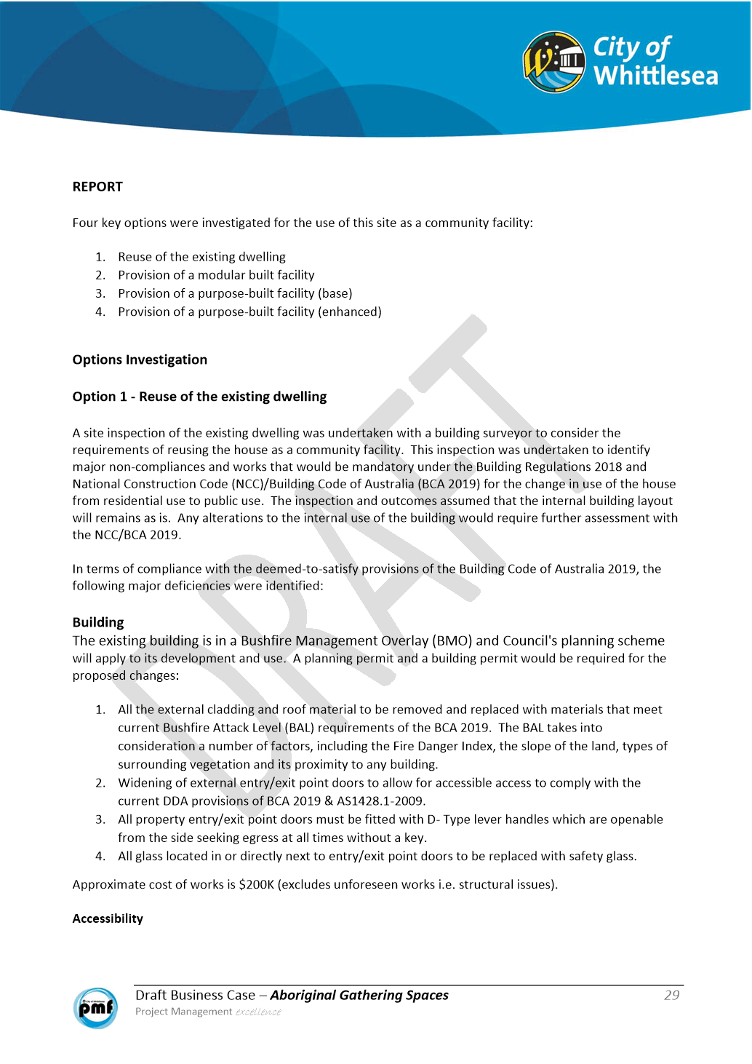

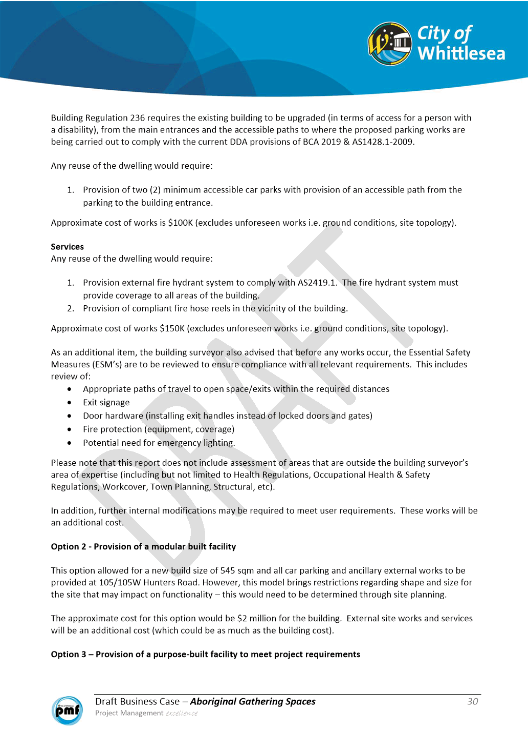

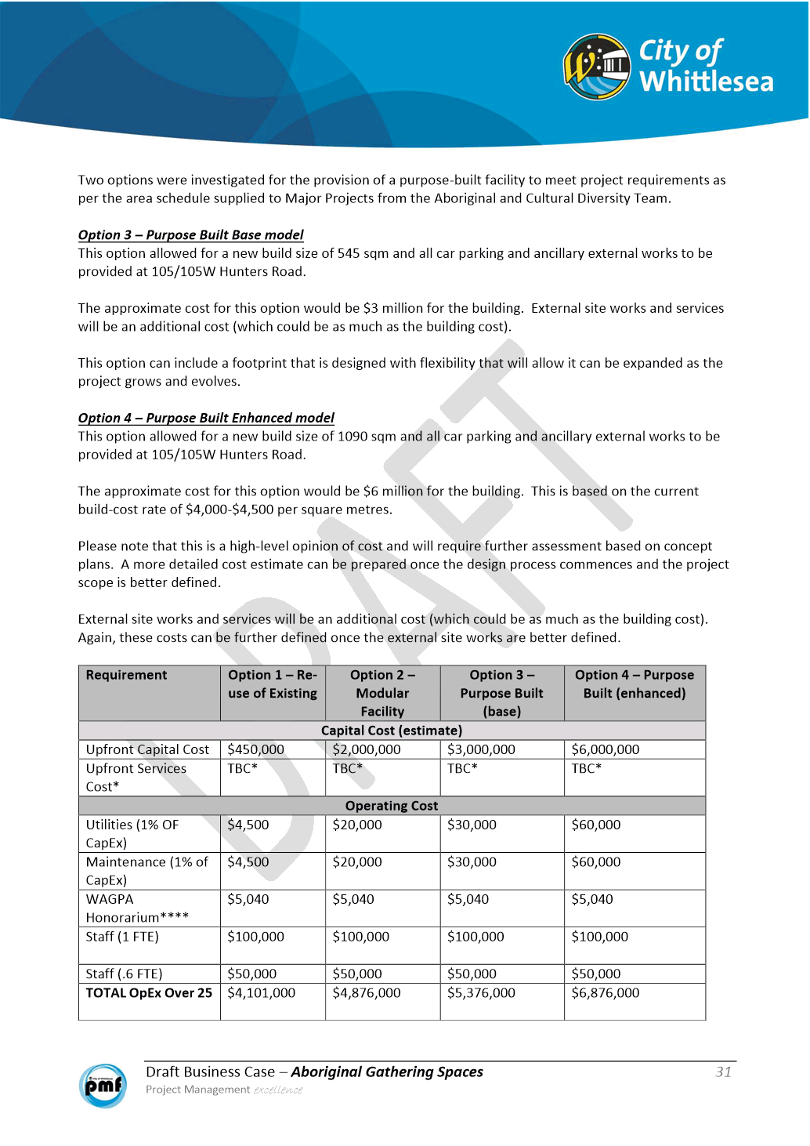

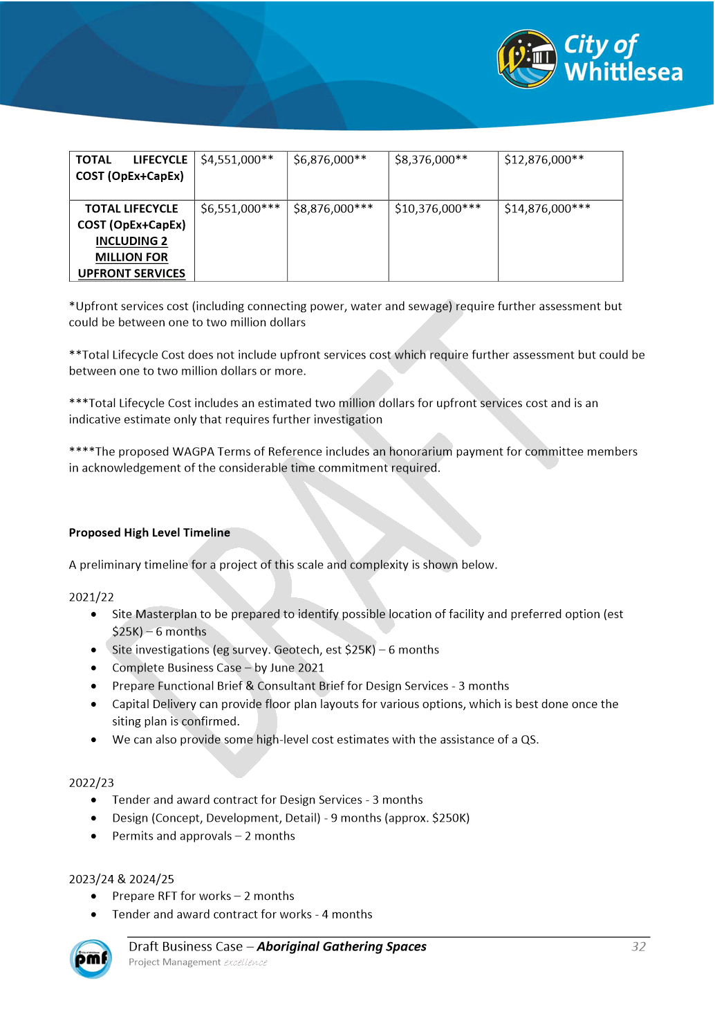

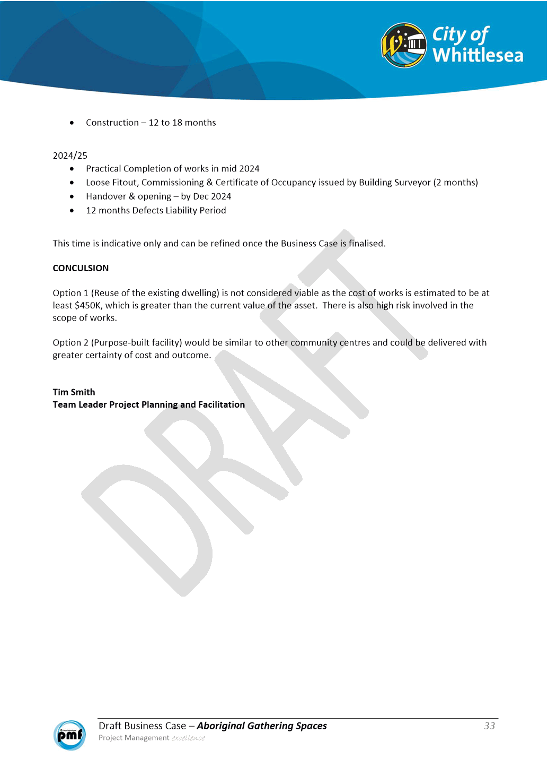

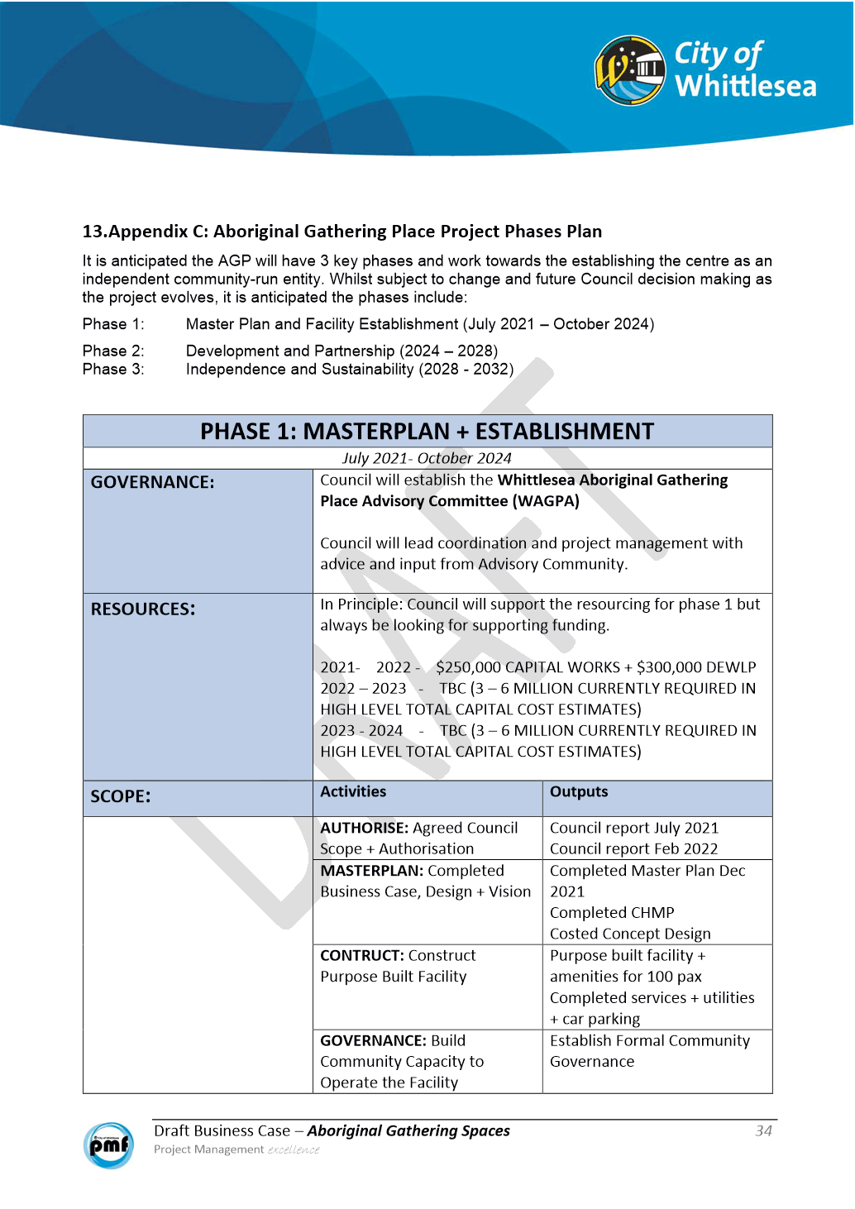

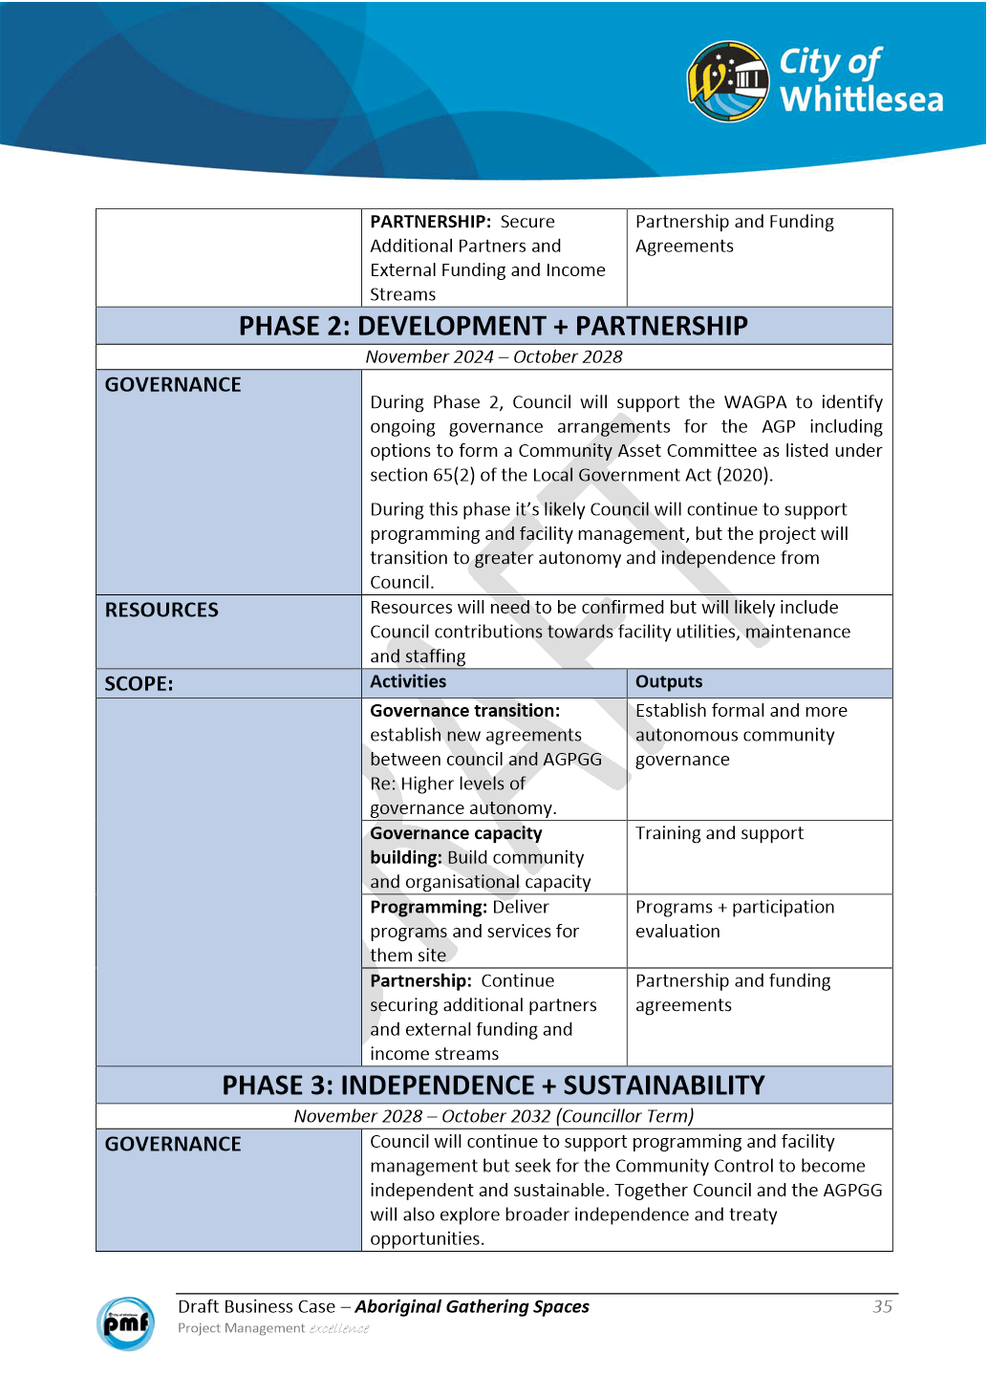

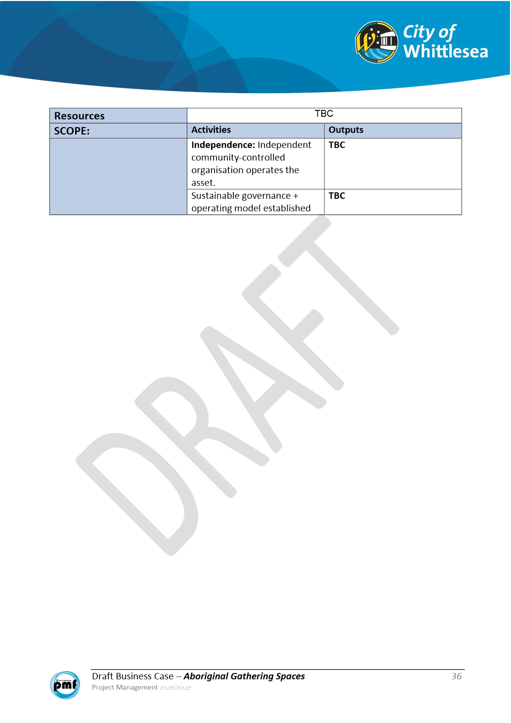

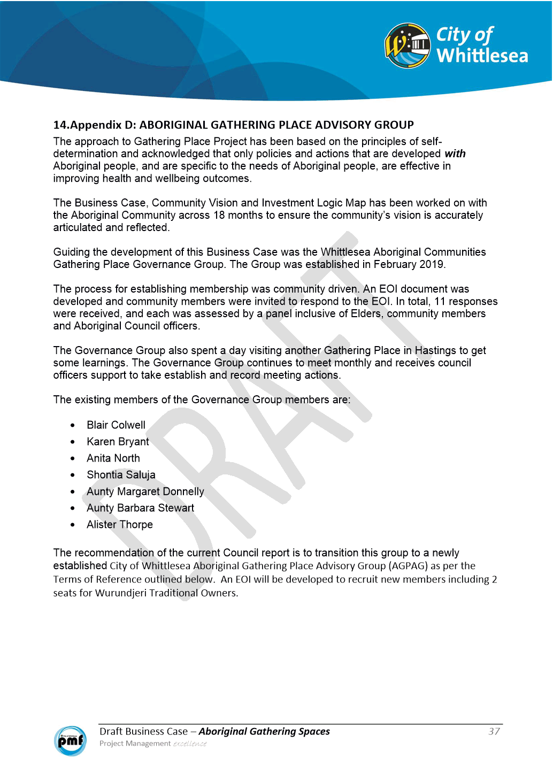

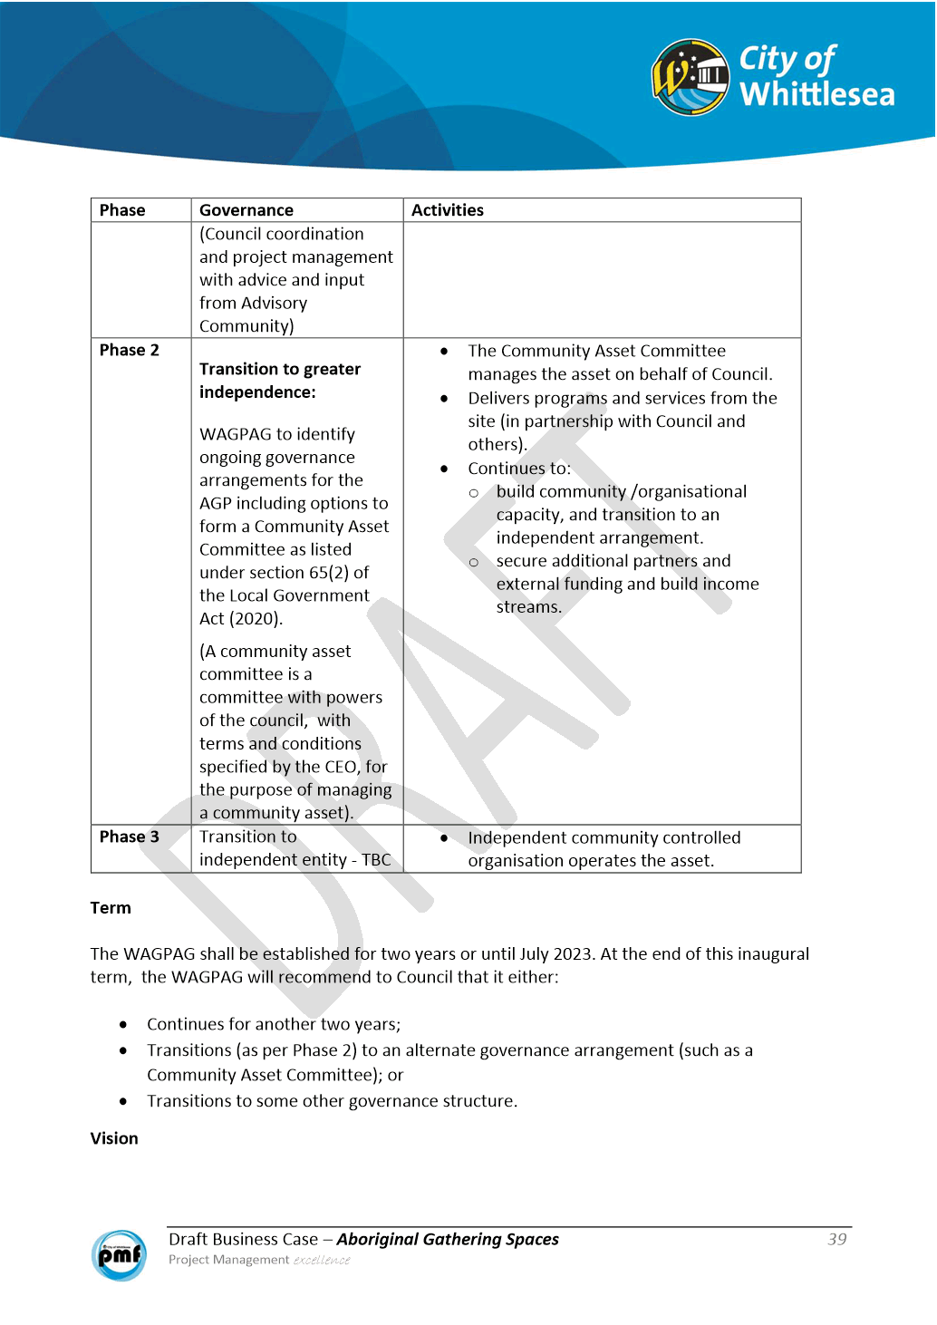

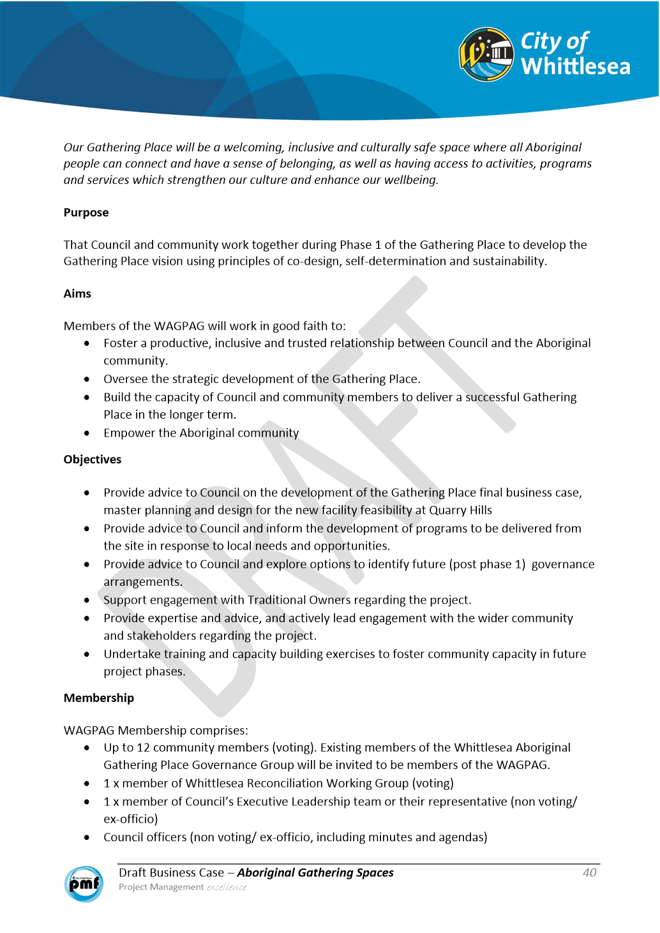

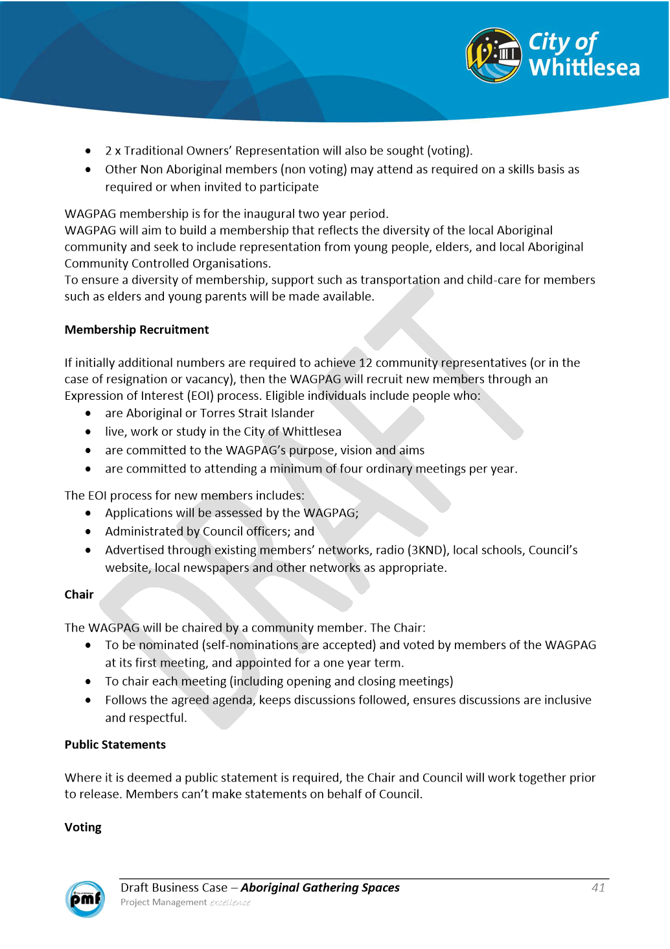

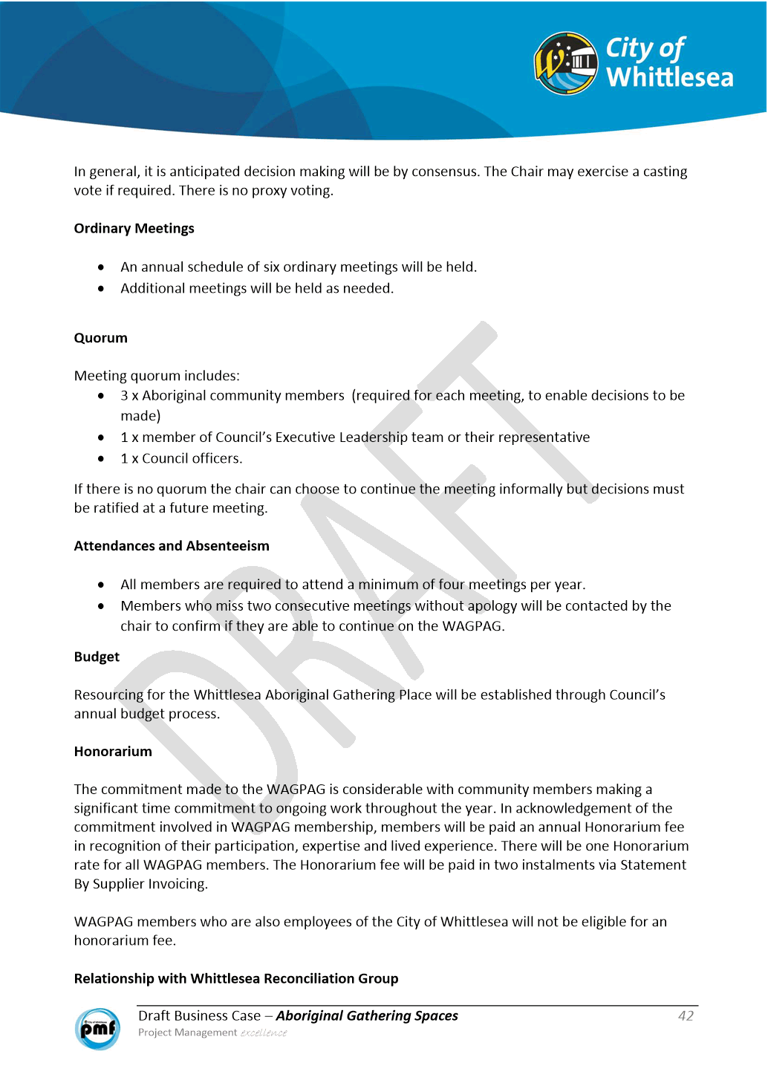

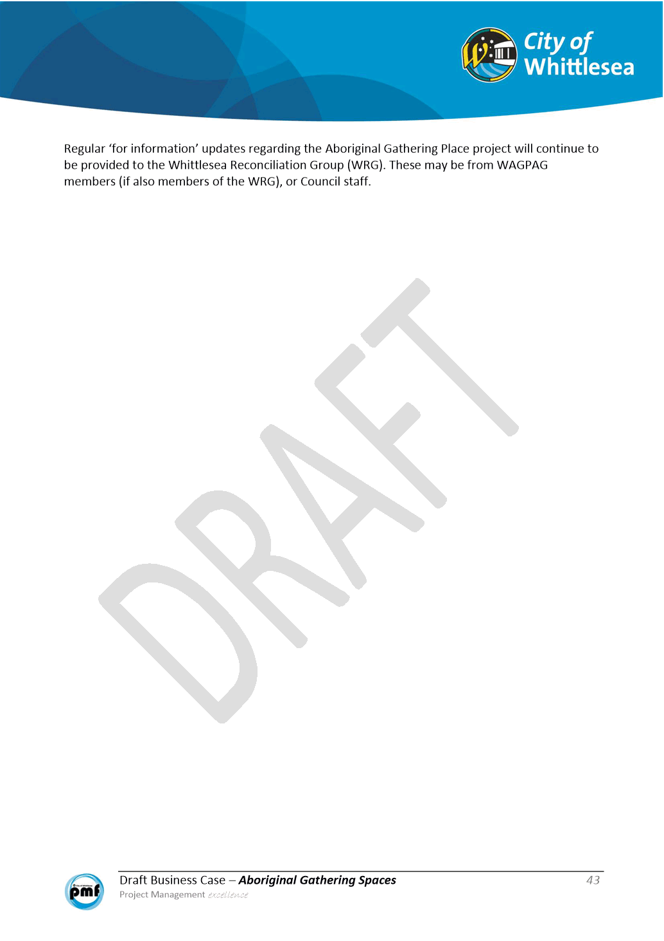

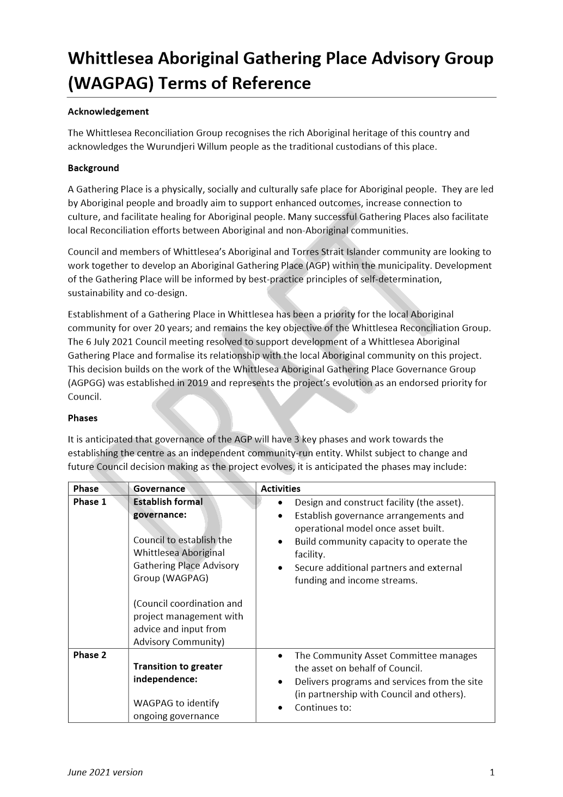

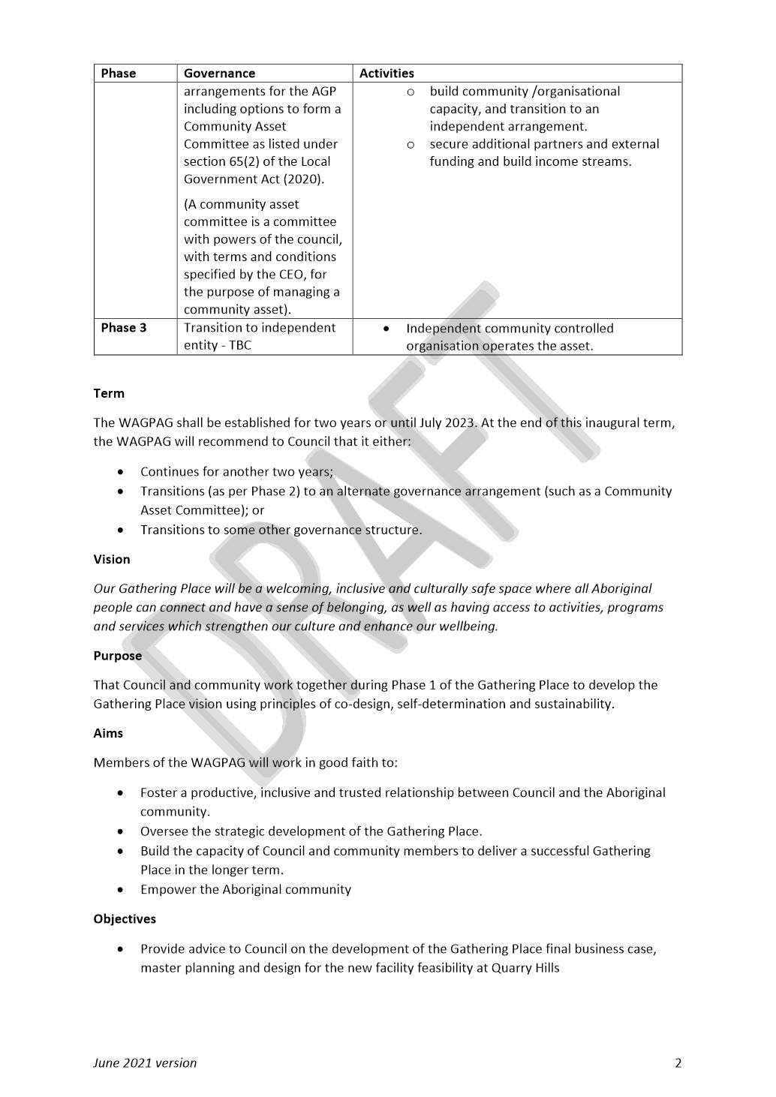

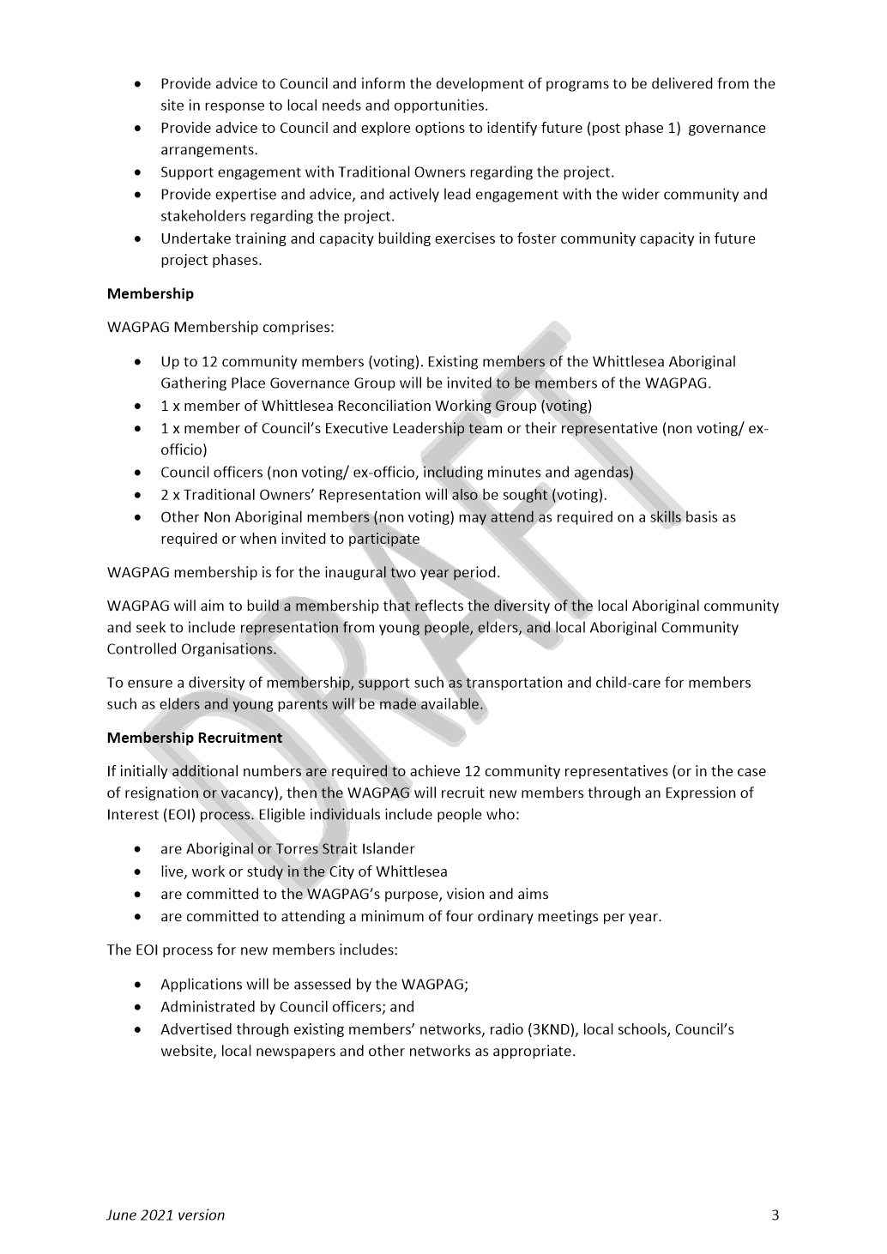

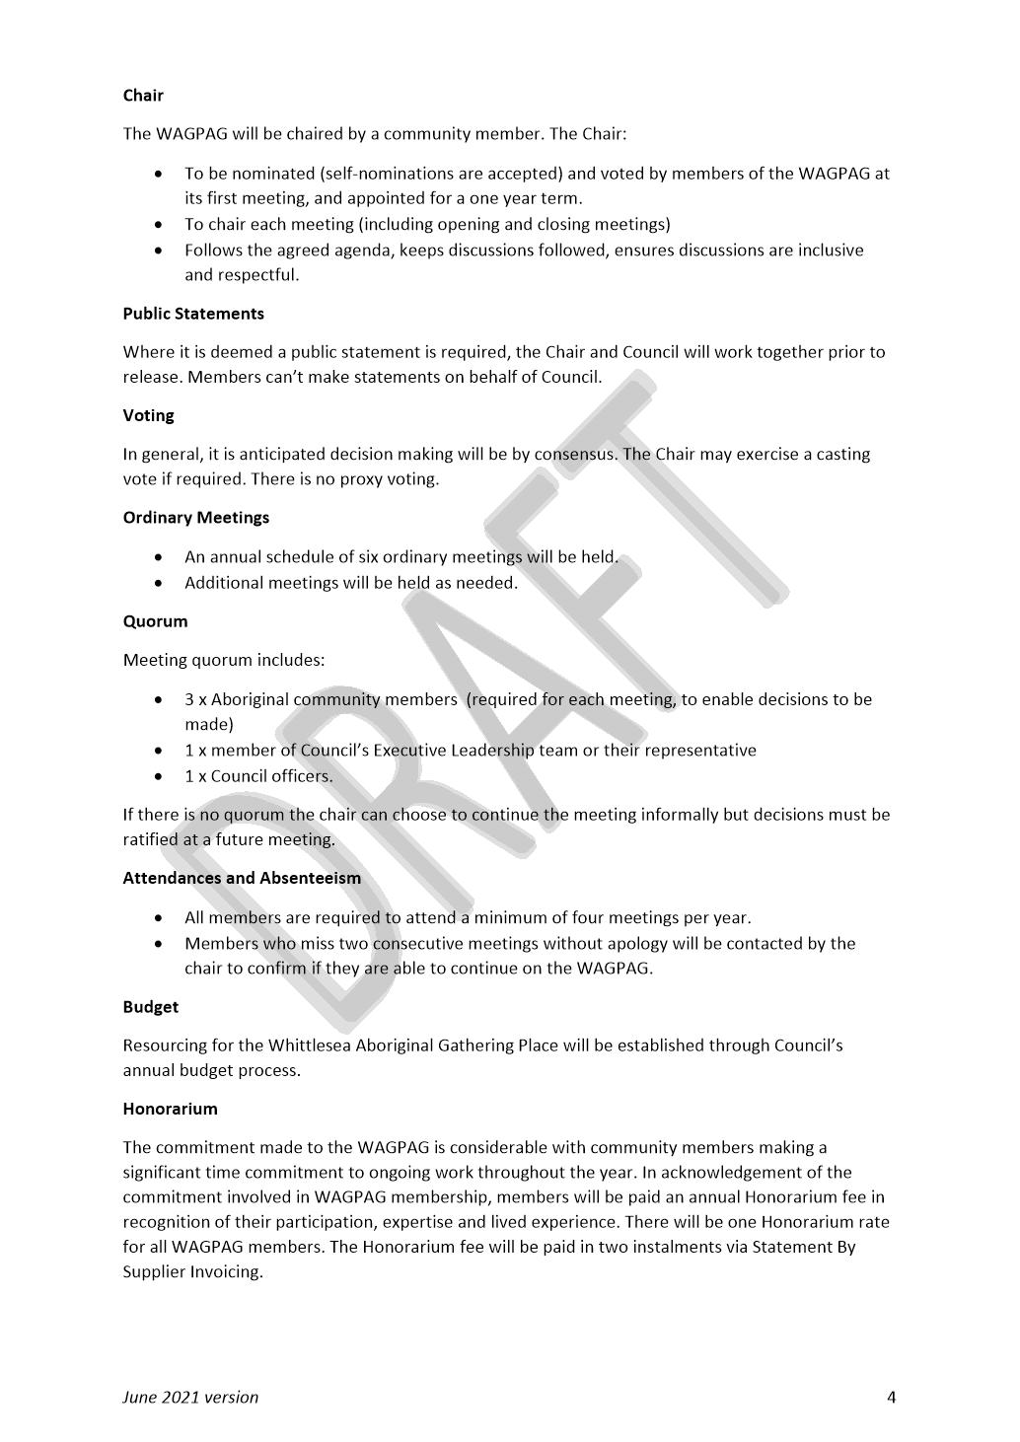

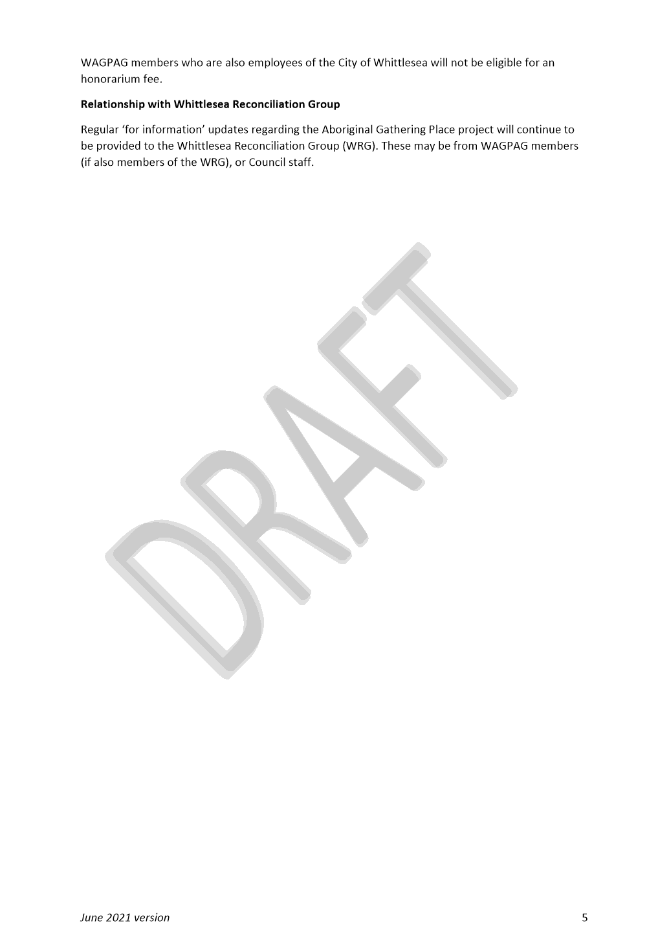

ITEM 6.1.4 For Decision - City of Whittlesea Community Awards Committee Representation
Attachments: 1 Terms of Reference
Responsible Officer: Executive Manager Governance
Author: Team Leader Governance Administration

RECOMMENDATION SUMMARY
1. The Community Awards Committee membership for 2021 be ratified by Council.
2. Committee members be notified in writing that their nominations have been ratified by Council.
3. The list of Committee members be published on Council’s website.
Brief overview
Seven former members of the Australia Day Awards Committee submitted an expression of interest to be members of the Community Awards Committee in its inaugural year.
rationale for recommendation
There was a positive response from members of the former Australia Day Awards Committee to participate in the Community Awards Committee. The nominations reflect Council’s diverse community and met the required numbers to form the committee. As such, Council did not proceed with advertising community member positions to the wider community.
The Terms of Reference of the Committee (attachment 1) require up to six community representative members. In future years, former awards recipients will also be invited to participate. The members bring a range of experience and skills to the Committee and as it is the inaugural awards with no former recipients invited, having seven community members is appropriate. It is therefore recommended that all nominees are accepted onto the Committee for 2021/22.
On 4 May 2021, Council appointed Administrator Peita Duncan as the Administrator representative on the Committee.
The Terms of Reference also identify one member of the Executive Leadership Team to be a non-voting member of the Committee.
impacts of recommendation
Once ratified successful submitters will be informed of the acceptance of their expression of interest and the first meeting of the committee will be conducted in the week commencing 19 July 2021, with awards ceremony planned for October 2021. At the first meeting in line with the Terms of Reference, there will be one appointment for a term of four years, three appointments for a term of three years, two appointments for a term of two years and one appointment for a term of one year.
what measures will be put in place to manage impacts
This is a positive move to enable the inaugural City of Whittlesea Community Awards. Members will be invited to attend the meeting and the nominations for awards and the awards ceremony will be widely publicised.

Report
Background
On 4 May 2021, Council adopted the City of Whittlesea Community Awards terms of reference and award categories and criteria and appointed Administrator Peita Duncan as the Administrator representative with voting rights on the Committee.
Current members of the former Australia Day Awards Committee (ADAC) were invited to submit an Expression of Interest to join the inaugural Community Awards Committee.
Proposal
Seven former members of the ADAC submitted an Expression of Interest to join the Community Awards Committee. It is proposed that all Expressions of Interest be accepted, and submitters be invited to join the inaugural Awards Committee.
summary of recommended awards committee members
The proposed committee members represent the diversity of the local Whittlesea Community in relation to age, ability, gender, cultural background and location within the municipality. They have all been recognised for their contribution to the community as either former Australia Day award recipients (senior citizen, young citizen, access and inclusion citizen), or community representatives. Through the expression of interest the committee members all showed passion for the local community and they have a range of expertise through work and volunteering to bring to the committee.
The proposed committee members are listed below:
Lillian McClelland - joint recipient of the Senior Citizen of the Year Award in 2016.
Mahendra Sukhdeo – appointed as a community member to the ADAC in 2017.
Jenny Nicholls – appointed as a community member to the ADAC in 2019.
Matthew Bui – appointed as a community member to the ADAC in 2019.
Raymond Rosales - recipient of the Senior Citizen of the Year Award in 2020.
Vivian Ly - recipient of the Young Citizen of the Year Award in 2020 (when a Year 12 student).
Dalal Sleiman – recipient of the Access and Inclusion Citizen of the Year in 2020.
Consultation
All existing members of the former Australia Day Awards Committee were contacted to inform them of the Community Awards initiative and to invite them to participate on the newly established Community Awards Committee.
In conjunction with the members of the Community Awards Committee and Council’s Public Affairs team, a communication and engagement plan will be developed for the promotion of the Awards and to seek nominations. This is expected to include a multipronged approach to encourage award nominations including use of Council’s website, social media sites, newsletter and notifications to community groups and organisations.
Critical Dates
Once ratified successful submitters will be informed of the acceptance of their expression of interest and this first meeting of the committee conducted in the week commencing 19 July 2021.
Monday 19 July 2021 | First meeting of the Committee. At this meeting term appointments will be confirmed in accordance with the terms of reference.
Tuesday 27 July 2021 | Open Award Nomination Period
Monday 27 September 2021 | Close Award Nomination Period
TBA October 2021 | Confidential meeting of Committee held to determine Award recipients
TBA October 2021 | Hold Award Ceremony in conjunction with a Community Event and/or Citizenship Ceremony
Financial Implications
Costs for the awards ceremony will be funded through Council’s event budgets.
Policy strategy and legislation
City of Whittlesea linkages include Whittlesea 2040: A Place for All, Council Plan 2017-2021, the Community Building Strategy and the A Voice for All: Community Engagement Policy 2021.
link to strategic risks
Strategic Risk Community and Stakeholder Engagement - Ineffective stakeholder engagement resulting in compromised community outcomes and/or non-achievement of Council's strategic direction
The purpose of the Community awards is to recognise the outstanding contributions of individuals for work to support the local community.

Links to whittlesea 2040 and the CoUNCIL Plan
Goal Connected community
Key Direction A participating community

Declarations of Conflicts of Interest
Under Section 130 of the Local Government Act 2020 and Rule 47 of the Governance Rules 2021, officers providing advice to Council are required to disclose any conflict of interest they have in a matter and explain the nature of the conflict.
The Responsible Officer reviewing this report, having made enquiries with relevant members of staff, reports that no disclosable interests have been raised in relation to this report.
Conclusion
The inaugural Community Awards will be a great opportunity to celebrate and recognise significant positive contributions by community members.
The inclusion of the diverse range of former members of the ADAC on the inaugural Community Day Awards committee will assist in the successful transition and conduct of these awards.

RECOMMENDATION
THAT Council resolve to:
1. Appoint the following people listed below, as Community Representatives to the City of Whittlesea Community Awards Committee for the conduct of the inaugural Community Awards for the 2021 period:
• Jenny Nicholls;
• Lillian McClelland;
• Mahendra Sukhdeo;
• Matthew Bui;
• Raymond Rosales;
• Vivian Ly; and
• Dalal Sleiman.
2. Notify the Committee members in writing that their nominations have been ratified by Council and thank them for their expression of interest.
3. Publish the list of Committee members on Council’s website.
Council Resolution
Moved: Administrator Duncan
Seconded: Administrator Eddy

THAT Council resolve to:
1. Appoint the following people listed below, as Community Representatives to the City of Whittlesea Community Awards Committee for the conduct of the inaugural Community Awards for the 2021 period:
• Jenny Nicholls;
• Lillian McClelland;
• Mahendra Sukhdeo;
• Matthew Bui;
• Raymond Rosales;
• Vivian Ly; and
• Dalal Sleiman.
2. Notify the Committee members in writing that their nominations have been ratified by Council and thank them for their expression of interest.
3. Publish the list of Committee members including Administrator Duncan on Council’s website.
Carried

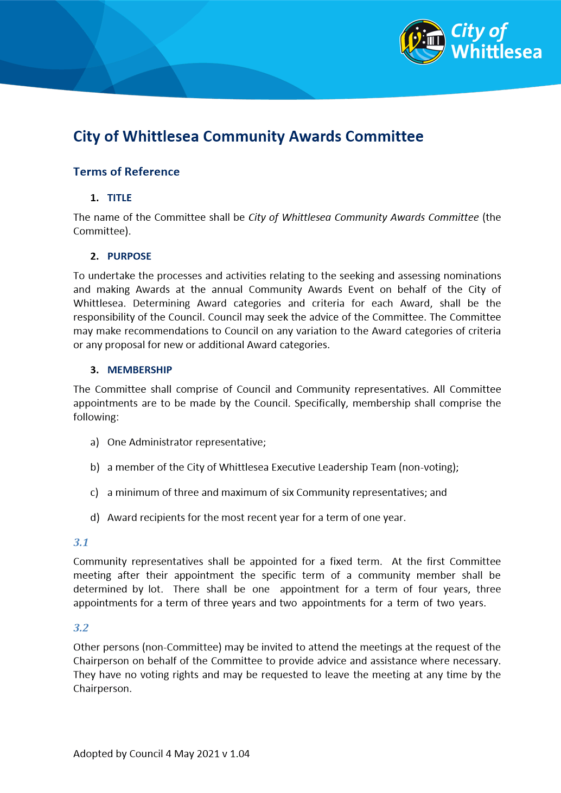

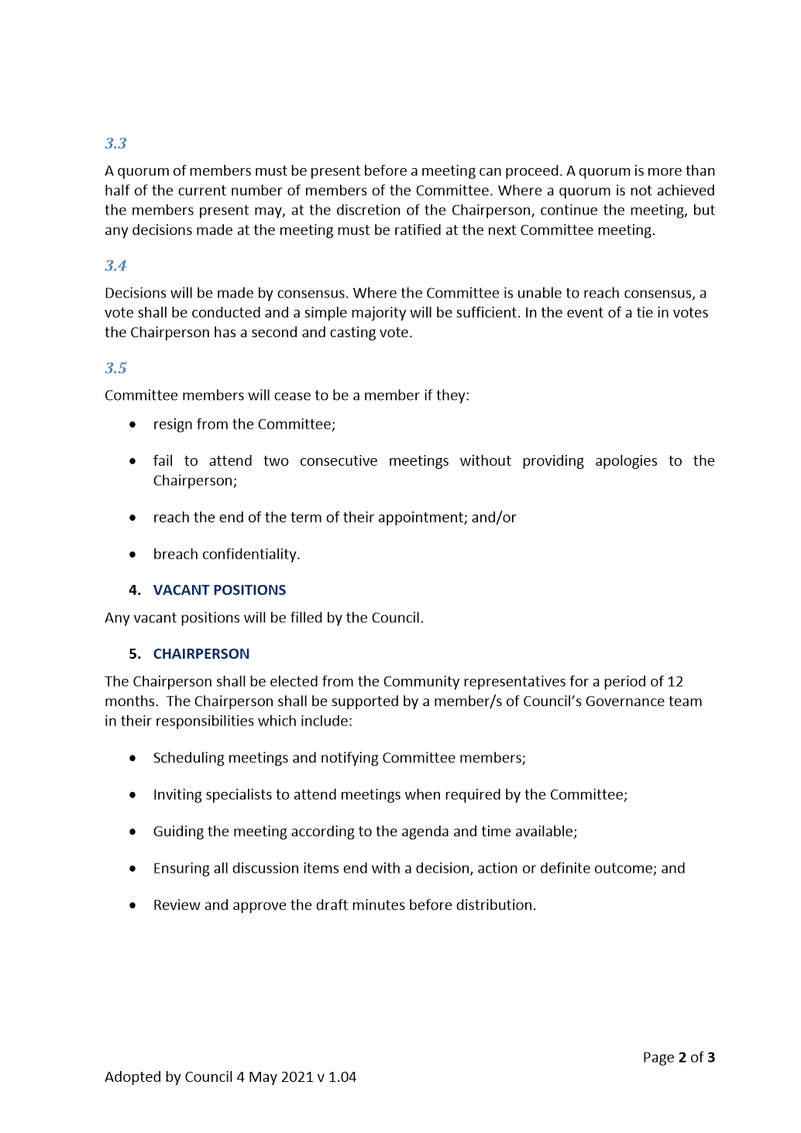

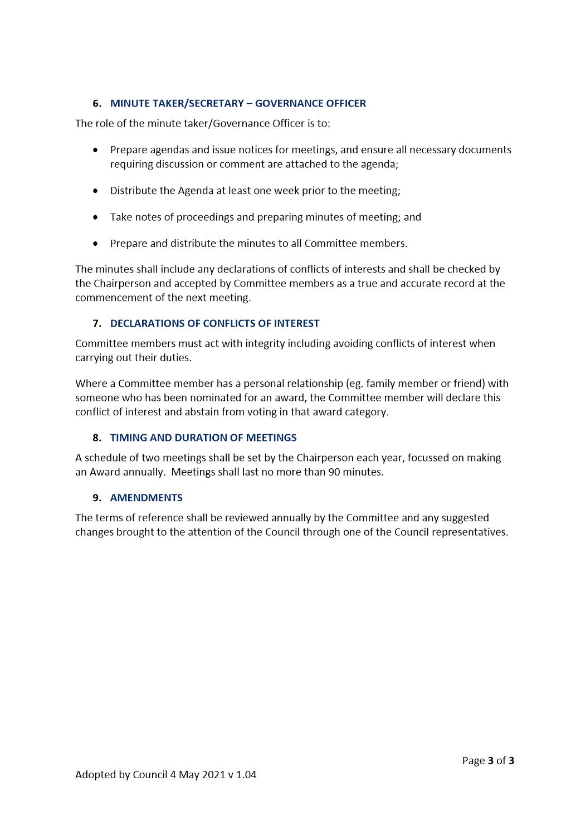

ITEM 6.1.5 For Decision - COVID-19 Pandemic Recovery Fund
Attachments: 1 COVID-19 Pandemic Recovery Fund Actions
Responsible Officer: Chief Executive Officer
Author: Emergency Management & Pandemic Recovery

Council has undertaken an extensive community consultative process to develop actions for the $2M Covid-19 Pandemic Recovery Fund. This consultation explored community perspectives to guide the roll out of the Fund via a community participatory budget working group, as well as community consultation via a survey, pandemic impact analysis, and ongoing liaison with key external stakeholders.
RECOMMENDATION SUMMARY
That Council resolve to:
1. Acknowledge the community participatory budget working group for their work in codesigning with Council the Recovery Fund Actions.
2. Adopt the COVID-19 Pandemic Recovery Fund Actions (Attachment 1).
3. Note that COVID-19 Pandemic Recovery Fund Actions will be reported on quarterly via the Community Plan reporting processes.
Brief overview
The Covid-19 Pandemic has impacted communities across the world and continues to keep local health authorities on alert for outbreaks which in turn hinder long-term community recovery. Council has committed $2 million in the 2021/22 budget year to a Community Recovery Fund in response to the scale of the impacts of the Pandemic and the understanding that the road to recovery would be long and complex.
An extensive community engagement process was established to consult with the community to codesign actions for the Recovery Fund. The subsequent Pandemic Recovery actions bring together the results from that process as well as community and business engagement, evidence and research gathered throughout the COVID-19 pandemic period, as well as specialist knowledge and insights from key stakeholders.
rationale for recommendation
The COVID-19 Pandemic will continue to have a profound health, social and economic impact globally and locally. Whittlesea’s response has been designed to respond to evidence and draw on the findings from Council’s Pandemic Impact Assessments, community engagements and is aligned with other Council plans, strategies and budgets to optimise Council’s capacity to support the community to recover from the pandemic.
The Pandemic Recovery Fund actions aim to support recovery across the four disaster recovery environments of social, economic, environment and built infrastructure.
impacts of recommendation
The Pandemic Recovery fund actions have been shaped and guided by various consultative processes ensuring that they are truly codesigned with the community and key stakeholders. The actions have a strong alignment with Whittlesea 2040 goals as well as the Disaster Recovery Environments. The predominate themes of economic development and local jobs, and support for vulnerable communities and local service providers will compliment programs already established in the relief phase such as the business mentoring program and the Emergency Relief Funds grant program.
what measures will be put in place to manage impacts
Many of the recommended actions will be integrated into the new Community Plan.
• Progress of the Pandemic Recovery fund actions will be reported to Council quarterly via the Community Plan reporting process.
• There will be ongoing monitoring of government, community and industry responses and updating of findings of Council’s Pandemic Impact Assessments

Report
Introduction
This report outlines Council’s COVID-19 Pandemic Recovery Fund actions and the community and key stakeholder codesign approach.
The COVID-19 pandemic has exacerbated key social and economic determinants of health, such as financial vulnerability, unemployment/underemployment, inequality and social isolation and has had an impact upon mental and physical wellbeing. Pandemic recovery actions align with the Whittlesea 2040 goals and have a strengthened focus on the social and economic environment.
A Municipal Pandemic Readiness and Recovery Plan was adopted by Council on 2 February 2021 to guide actions through to the end of the financial year. That Plan was consistent with the identified role of local government as the coordinator of local relief and recovery activities. It outlines key directions and actions under each of the four Whittlesea 2040 goal areas, designed to assist the community back to a state of normal functioning.
Background
Since the announcement of COVID-19 as a pandemic by the World Health Organisation on 11 March 2020, and the subsequent declaration of a state of emergency by the Victorian Government, the economic, health and social impacts of the disease have been significant.
Following any major emergency, Council works with the community and key stakeholder groups to coordinate response, relief and recovery planning which incorporates outcomes from community and key stakeholder engagement and local impact assessments.
The Municipal COVID-19 Pandemic Readiness and Recovery Plan was adopted by Council on 2 February 2021 for implementation through to 30 June 2021. This Plan has addressed the immediate response, relief and recovery needs of the community and progress will be reported to Council as part of the 2020/21 corporate reporting.
In response to the scale of the impacts and the understanding that the road to recovery would be long and complex, Council has committed $2 million to a Community Recovery Fund for the 2021/22 financial year.
Recovery actions are designed to assist the community to get back to a state of normal functioning – or ‘building back better’ which is the objective of all disaster recovery actions. Recovery can provide an opportunity to improve these aspects beyond previous conditions, by enhancing social, natural, built and economic environments contributing to a more resilient community. Recovery actions can support and build capacity, remove barriers, and use local knowledge and strengths.
An extensive community engagement process in line with Council Policy was established to consult with the community to codesign actions for the Recovery Fund. The subsequent Pandemic Recovery actions bring together the results from that process as well as community and business perspectives, evidence and research gathered throughout the COVID-19 pandemic period, as well as specialist knowledge and insights from key stakeholders.
The actions have strong alignment with the Disaster Recovery Environments. Table 1 below aligns these themes with Whittlesea 2040 goals.

Table 1: Alignment between Whittlesea 2040 and Disaster Recovery Environments
Whittlesea 2040 goals | Disaster Recovery Environments
Connected community | Social
Liveable neighbourhoods | Built infrastructure
Strong local economy | Economic
Sustainable environment | Natural

Additionally, the National Principles for Disaster Recovery (Australian Institute for Disaster Resilience) have been applied in the consultative process, impact assessment, development of actions, and in the ongoing coordination of recovery. These principles are as follows:
• Understand the context - successful recovery is based on an understanding of the community context, with each community having its own history, values and dynamics.
• Recognize complexity - successful recovery responds to the complex and dynamic nature of both emergencies and the community.
• Use community-led approaches - successful recovery is community-centred, responsive and flexible, engaging with community and supporting them to move forward.
• Coordinate all activities - successful recovery requires a planned, coordinated and adaptive approach, between community and partner agencies, based on continuing assessment of impacts and needs.
• Communicate effectively - successful recovery is built on effective communication between the affected community and other partners.
• Acknowledge and build capacity - successful recovery recognises, supports and builds on individual, community and organisational capacity and resilience (particularly for vulnerable groups).

These principles will continue to be applied as recovery actions are developed and implemented with the community.
Proposal
It is proposed that the COVID-19 Pandemic Recovery Fund actions be endorsed (refer to Attachment 1). These actions are structured around Whittlesea 2040 goals, the Disaster Recovery Environments and disaster recovery principles. The below table outlines focus areas for the pandemic recovery fund however Attachment 1 details the actions as well as budget allocation.
Whittlesea 2040 Goal | Pandemic Recovery focus areas
Connected community | • Coordination of recovery efforts across the municipality including COVID-19 safe messaging and mass vaccinations  • Grants program to support community service organisations as well as emergency relief  • Strengthen multichannel communications with community and local businesses  • Provide more local services for community to increase community connections and respond to local needs
Liveable neighbourhoods | • Create more community gardens and support local events  • Advocate for better public transport  • Provide more public amenities
Strong local economy | • Business support programs and incentives to buy local  • Enhanced learning and job ready opportunities for young people  • Increased training and support for unemployed and underemployed residents
Sustainable environment | • Environmental Upgrades Program to support uptake of renewable energy  • Continue solar panel and battery scheme for council buildings to reduce running costs to community groups
Consultation
As part of the Community Plan consultation process a group of residents were randomly selected to participate in budgeting workshops. This group was representative of the diversity of the municipality. 32 residents participated over three sessions of three hours each. At each workshop participants were briefed on the impact of the Pandemic across the four Whittlesea 2040 goals to inform the discussion. The Group were led through a series of facilitated activities and smaller group work over the three sessions through which they developed a final list of 17 recommendations, or action Items, that they then voted on as individuals to prioritise.
These suggested actions were then cross referenced with impact assessment data, key stakeholder engagement results, community survey results, and Council key strategic directions to ensure a consistent and targeted approach to recovery. 16 of the suggested actions were supported via this process. One action relating to large gatherings in public spaces was not supported.
The subsequent Pandemic Recovery actions bring together community and business perspectives, evidence and research gathered throughout the COVID-19 period, as well as specialist knowledge and insights from key stakeholders.
Council will continue to consult and coordinate recovery actions with key stakeholders during the recovery phase via the following avenues:
• Pandemic Recovery Subcommittee established under the City of Whittlesea Municipal Emergency Management Planning Committee and comprising agencies from the Whittlesea Community Futures Partnership.
• Whittlesea Emergency Relief Network
• Various Traders associations and business support networks
• Community groups and other community feedback avenues including place-based community committees.
• Internal pandemic recovery working group.
Critical Dates
It is envisaged that recovery fund actions will be implemented in this financial year, however given the unpredictable nature of this Pandemic, a flexible approach will be required. This will allow Council to move in and out of phases as conditions and restrictions change and might require the suspension or reorientation of actions as required.
CONSULTATION OUTCOMES
As part of the Community Plan consultation survey a section was included to gauge community views on pandemic recovery priorities. The survey was available online or via hard copy postcard. 478 response were received and table 2 below summaries the responses. These results are consistent with the priorities identified by the participatory budget working group and rate support for local businesses and vulnerable communities as the top two priorities.

Table 2: Community survey results for Covid-19 Pandemic recovery priorities
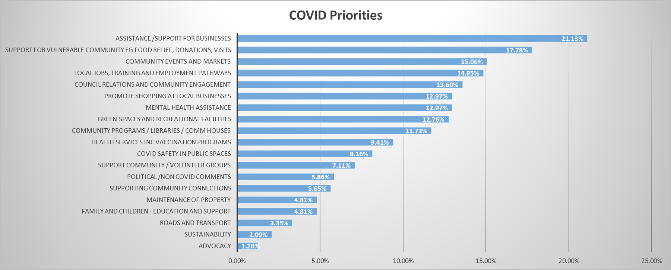

Additionally, eighteen local service providers responded to the survey in the free text area. Themes arising from their comments are as follows:
• Increase community connections and mental health support
• Support vulnerable communities via existing community and emergency relief service system
• Support local businesses and local employment (including young people and the unemployed)
• Build on the existing community strengths of our diverse community

IMPACT ASSESSMENT
During the development of pandemic recovery actions consultation occurred with key external partners and across the organisation. Impact assessments were derived from multiple sources including the Covid-19 Community Impact Survey and the Business Impact Survey. Key impacts are detailed in table 3 below.
Table 3: Pandemic impacts summary
 | Latest economic trends and impacts
JobKeeper and JobSeeker | • In April 2021, 6.9% of people in the City of Whittlesea aged 15 years and over were JobSeeker and Youth Allowance recipients (compared to 5.7% for Greater Melbourne). Only Hume and Mitchell have a higher share of people who are recipients of this scheme. 1  • Early economic indicators are that the end of the JobKeeper scheme has not had the significant negative economic impacts that many expected. 1
Labour Market Trends | • In the fortnight ending 22 May 2021, payroll jobs in the local Whittlesea-Wallen SA3 region rose by 0.2%, compared to a national increase of 0.3%. This follows a decrease of -0.3% in payroll jobs in the previous fortnight. 2
Unemployment | • The unemployment rate for the City of Whittlesea continues to rise, reaching 8.5% in March 2021, up from 7.8% from December 2020. Unemployment has steadily increased throughout the pandemic, from 5.2% in March 2020. 3  • At the local level, unemployment has increased, the most in Wollert and Epping, where it is now 9.9% and 12.6%, respectively. 4
 | Impacts on the community 5
Social connections | • 88% of people said the pandemic has had a negative impact on their social life.  • 56% of parents are very concerned about their children’s social wellbeing  • Three in five people feel less connected to their community
Health and wellbeing | • Two in three people said the pandemic has negatively impacted their mental health.  • Almost one in two people attended routine medical appointments less often.
Jobs and financial security | • Many people have faced challenges during the pandemic:  o 14% working fewer hours  o 10% have experienced reduced income  o 33% more stressed about finances  o 10% accessed superannuation
Businesses | • More than 80% of businesses have lost revenue and customers.  • For 72% of businesses it was impossible to operate remotely.  • One in three businesses have laid off casual workers and 16% stood down permanent staff. 6
Sources
1 Profile.id - https://profile.id.com.au/whittlesea/job-seeker
2 ABS 2021 - https://www.abs.gov.au/statistics/labour/employment-and-unemployment/labour-force-australia/latest-release
3 ABS 2021 - https://www.abs.gov.au/statistics/labour/earnings-and-work-hours/weekly-payroll-jobs-and-wages-australia/latest-release
4 Labour Market Information Portal - https://lmip.gov.au/default.aspx?LMIP/Downloads/SmallAreaLabourMarketsSALM
5 City of Whittlesea – COVID-19 Community Impact Survey
6 City of Whittlesea – COVID-19 Business Impact Survey

The Pandemic Fund Recovery Actions address issues raised in the various surveys and build a recovery platform to, in time, have a direct impact on some of the key community and economic indicators.
Financial Implications
Council has allocated $2M to the COVID -19 Pandemic Recovery Fund for the 2021/22 financial year.
Policy strategy and legislation
Under the Emergency Management Act, following any major emergency incident, Council is required to coordinate local recovery efforts which incorporates outcomes from community and key stakeholder engagement and ongoing impact assessments. Council will undertake this responsibility via the Pandemic Recovery fund actions and continuing to work with community and key stakeholders through the various forums to ensure a coordinated recovery approach.
Under the Act, the pandemic is a class 2 incident and local government is not eligible for resource re-imbursement for emergency relief and recovery expenditure from the Victorian Government. There are however ongoing discussions between Councils, the Department of Health, Emergency Management Victoria, and other Government Departments on funding and grants for specific pandemic recovery initiatives.
Whittlesea 2040 – A place for all Having Pandemic Recovery actions embedded within the new Community Plan will align with Whittlesea 2040 goals and other major Council strategies. In addition, Whittlesea 2040 goals align with the four disaster recovery environments identified in Table 1 of this report.
link to strategic risks
Strategic Risk Emergency Management - Failure to manage and respond to an emergency event which may be detrimental to community health and wellbeing
Allocating $2M to a Pandemic Recovery fund will support the community to recovery from the COVID-19 Pandemic.
Strategic Risk Governance - Ineffective governance of Council’s operations and activities resulting in either a legislative or policy breach
Developing Municipal Pandemic Recovery actions that are aligned with Whittlesea 2040 as well as wider emergency management frameworks avoids the risks associated with poorly coordinated services and maximises community outcomes.

Links to whittlesea 2040 and the CoUNCIL Plan
Goal Connected community
Key Direction A healthy and safe community

The Pandemic Recovery Fund Actions will specifically address Council’s commitments to create a healthy and safe community and support the achievement of Whittlesea 2040 goals by coordinating Council’s recovery actions into other key Council plans, resources and service delivery.
Declarations of Conflicts of Interest
Under Section 130 of the Local Government Act 2020 and Rule 47 of the Governance Rules 2021, officers providing advice to Council are required to disclose any conflict of interest they have in a matter and explain the nature of the conflict.
The Responsible Officer reviewing this report, having made enquiries with relevant members of staff, reports that no disclosable interests have been raised in relation to this report.
Conclusion
Council has undertaken an extensive community consultative process to develop actions for the $2M Covid-19 Pandemic Recovery Fund for 2021/22. The consultation gathered community perspectives to guide the roll out of the Fund via a community participatory budget working group, community consultation, impact analysis, and ongoing liaison with key external stakeholders. The Pandemic recovery actions have strong alignment with the Disaster Recovery Environments and with Whittlesea 2040 goals.
RECOMMENDATION
THAT Council resolve to:
1. Acknowledge the community participatory budget working group for their work in codesigning with Council the recovery fund actions.
2. Adopt the COVID-19 Pandemic Recovery Fund Actions (Attachment 1).
3. Note that COVID-19 Pandemic Recovery Fund Actions will be reported on quarterly via the Community Plan reporting processes.
Council Resolution
Moved: Chairperson Wilson
Seconded: Administrator Eddy

THAT Council resolve to:
1. Write to all members of the Community Participatory Budget Working Group to express Council’s appreciation for their time and commitment in co-designing with Council and making recommendations for the $2m community Recovery Fund.
2. Adopt the COVID-19 Pandemic Recovery Fund Actions (Attachment 1).
3. Note that COVID-19 Pandemic Recovery Fund Actions will be reported on quarterly via the Community Plan reporting processes.
Carried

Attachment 1
Pandemic Recovery Fund Actions

W2040 goal | Focus area | Disaster Recovery Domain | Budget | Action
Connected community | A healthy and safe community | Social | $400k | Provide COVID -19 emergency recovery grants to local community service organisations to support vulnerable communities and to provide emergency relief.
 |  | Social | $150k | Continue to work with partners to lead recovery from COVID19 pandemic including vaccinations and COVID-19 safe health messaging
 | A participating community | Social | $160k | 1. Maintain strong multichannel communication with community to promote access to services.  2. Develop a new Council website to be accessible, multilingual and mobile friendly to improve access to our services.  3. Create a mix of digital, online and print communications to reach our diverse communities.
 |  | Social | $150k | Provide more local services for community to access closer to home
 |  | Social | Within budget | Continue to improve local community engagement in line with Council’s Community Engagement Policy to inform Council programs and decision-making.
 |  | Social | Within Budget | Continue to support place-based events in parks and reserves including a bush kinder pilot, nature play programs and community tree planting days.
Liveable neighbourhoods | Well-designed neighbourhoods and vibrant town centres | Built infrastructure | $70k | Support the community to establish and sustain community gardens.
 |  | Built infrastructure | $200k | Develop and commence implementing a plan for public toilets making them accessible, useable and safe.
 | Smart, connected transport network | Built infrastructure | $30k | Advocate for better public transport, including better rail, tram and bus infrastructure and services
Strong local economy | Increased local employment | Economic | $400k | As part of COVID-19 recovery, deliver a ‘support local’ campaign and incentive program to support the community and local businesses.
 |  | Economic | $150k | Increase capacity building and training in the community to enhance employment opportunities for unemployed and underemployed residents.
 | Education opportunities for all | Economic | $110k | Work with community partners to deliver a series of educational workshops and resources to support young people in preparation for future job opportunities.
 | Successful, innovative local businesses | Economic | $50k | Strengthen and provide opportunities for local businesses to join and participate in networks to support new and existing businesses, whilst strengthening business-to-business connections.
 |  | Economic | Within Budget | Implement the Business Advisory Panel and other targeted forums with key business sectors to strengthen engagement and partnerships with Council.
High performing organisation |  | Economic | Within budget | Continue to implement Council’s Financial Hardship Policy to support financially vulnerable residents.
Sustainable environment | Leaders in clean, sustainable living | Natural | $70k | Introduce a program to support the uptake of renewable energy options using Environmental Upgrade Agreements.
 |  | Natural | $60k | Extend solar panel scheme for council buildings used by community groups to help minimise operational costs.

ITEM 6.1.6 FOR DECISION - Construction of the Mernda Social Support Services Facility Contract 2021-17 - Tender Evaluation Report
Attachments: 1 Detailed Evaluation - Confidential
This attachment has been designated as confidential by the Director Infrastructure & Environment, under delegation from the Chief Executive Officer, in accordance with Rule 53 of the Governance Rules 2021 and sections 66(5) and 3(1) of the Local Government Act 2020 on the grounds that it contains private commercial information, being information provided by a business, commercial or financial undertaking that— (i) relates to trade secrets; or (ii) if released, would unreasonably expose the business, commercial or financial undertaking to disadvantage. In particular the report/attachment contains information about tenderer's prices.
Responsible Officer: Director Infrastructure & Environment
Author: Senior Contracts Executive

RECOMMENDATION SUMMARY
It is recommended that contract number 2021-17 for the Construction of the Mernda Social Support Services Facility:
• is awarded to JR & BL Kendall Pty Ltd
• for the lump sum price of $2,152,811 (excl. GST)
Brief overview
The tender evaluation panel advises that:
• Three tenders were received
• The recommended tender was the highest ranked and is considered best value because it has demonstrated that it has the highest ability to deliver this project in accordance with Council’s specified requirements.
rationale for recommendation
The recommended tenderer demonstrated the highest capability and capacity to deliver this project, and with minimal impact on Council and the community.
impacts of recommendation
Approval of this contract award will enable the project to commence in a timely manner within the required timeframe of the Economic Stimulus Grant from the State Government.
what measures will be put in place to manage impacts
Regular communication with the community will continue to minimise the impact of the works.

Report
Background
The purpose of this contract is to engage a Contractor for the construction of the Mernda Social Support Services Facility.
The Mernda Strategy Plan (2008) identified a need to establish a purpose-built facility in the Mernda / Doreen urban growth area to provide social support programs for older residents and day respite for carers.
The delivery of this project will provide a Social Support facility which will include three activity rooms, an office, consulting room, quiet room, outdoor space, kitchen, storage and amenities.
Tenders for the contract closed on 27 April 2021. The tendered prices and a summary of the evaluation are detailed in the confidential attachment.
EVALUATION
No member of the Tender Evaluation Panel declared any conflict of interest in relation to this tender evaluation.
A Tender Probity and Evaluation Plan was designed specifically for this tender process and it was authorised prior to this tender being advertised. All tenders received were evaluated in accordance with that plan. The evaluation involved scoring of conforming and competitive tenders according to these pre-determined criteria and weightings:
Criteria | Weighting
Price | 50%
Capability | 23%
Capacity | 20%
Impact | 7%
The weightings reflect the relative importance of each element to this particular contract. They were determined as being most appropriate after considering numerous factors including (but not restricted to) the time, quality, risk and contract management requirements which were likely to have the most impact on the achievement of best value.
Only tenders that were conforming and competitive were fully scored. Tender submissions that were evaluated as non-conforming or not sufficiently competitive were set aside from further evaluation. In cases where this occurred the reasons for that outcome are detailed in the confidential attachment.
The evaluation outcome was as follows:
TENDERER | CONFORMING | COMPETITIVE | SCORE | RANK
Tenderer A  JR & BL Kendall Pty Ltd | Yes | Yes | 90.0 | 1
Tenderer B | Yes | Yes | 88.2 | 2
Tenderer C | Yes | Yes | 77.7 | 3
Refer to the confidential attachment for further details of the evaluation of all tenders.
FINANCIAL IMPLICATIONS
Sufficient funding for this contract is available in the budget for the Construction of the Mernda Social Support Services Facility.
link to strategic risks
Strategic Risk Not linked to the risks within the Strategic Risk Register.
Links to WHITTLESEA 2040 AND the CoUNCIL Plan
Goal Connected community
Key Direction A socially cohesive community
The facility is required to meet the increased ageing community.
Declarations of Conflicts of Interest
Under Section 130 of the Local Government Act 2020 and Rule 47 of the Governance Rules 2021, officers providing advice to Council are required to disclose any conflict of interest they have in a matter and explain the nature of the conflict.
The Responsible Officer reviewing this report, having made enquiries with relevant members of staff, reports that no disclosable interests have been raised in relation to this report.
CONCLUSION
The tender from JR & BL Kendall Pty Ltd was determined to be best value and it is considered that this company can perform the contract to the required standards.

Recommendation
THAT Council resolve to:
1. Accept the tender submitted by JR & BL Kendall Pty Ltd for the sum of $2,152,811 (excluding GST) for the following contract:
Number: 2021-17
Title: Construction of the Mernda Social Support Services Facility
subject to the following conditions:
a) Tenderer to provide proof of currency of insurance cover as required in the tender documents.
b) Price variations to be in accordance with the provisions as set out in the tender documents.
c) Tenderer to provide contract security as required in the tender documents.
2. Approve the funding arrangements detailed in the confidential attachment.

Council Resolution
Moved: Administrator Eddy
Seconded: Administrator Duncan

THAT Council resolve to adopt the Recommendation.
Carried

ITEM 6.1.7 For Feedback - Proposed Planning Scheme Amendment: Inland Rail Project - Tottenham to Albury
Attachments: 1 Attachment 1: Project Area and Site Context
2 Attachment 2: ARTC Rail Project Draft Explanatory Report
3 Attachment 3: ARTC Rail Project Draft Incorporated Document
Responsible Officer: Director Planning & Development
Author: Team Leader Strategic Projects & Infrastructure

RECOMMENDATION SUMMARY
That Council resolve to write to the Minister for Planning expressing support for the planning framework proposed by the planning scheme amendment to facilitate the nationally significant Inland Rail Project - Tottenham to Albury.
Brief overview
Australian Rail Track Corporation is proposing a planning scheme amendment to facilitate the nationally significant Inland Rail Project – Tottenham to Albury. The planning scheme amendment has been sent to Council for comment at the request of the Minister for Planning as part of the project approvals process.
rationale for recommendation
The planning framework being proposed by the planning scheme amendment the Amendment) will assist with facilitating the Inland Rail Project by avoiding the need for planning permits for ongoing works. The Amendment will apply the Specific Controls Overlay (SCO) to each project area, with an associated Incorporated Document providing conditions that must be met to the satisfaction of the Minister for Planning. An integral part of the approvals process with State Government is that each affected Council provide a letter of support to the Minister for Planning, including any views or feedback on the project and the proposed planning scheme amendment.
impacts of recommendation.
The recommendation provides support for an infrastructure project which will benefit both City of Whittlesea and the State of Victoria, noting that it aligns with national and metropolitan freight strategies. The Project also provides infrastructure improvements that will support the proposed Beveridge Intermodal Freight Terminal.
what measures will be put in place to manage impacts
The project area within the City of Whittlesea is confined to a narrow section of rail reserve with road access available from Beveridge Road, Beveridge. The Amendment will apply the SCO to the project area, with an associated Incorporated Document providing conditions that must be met to the satisfaction of the Minister for Planning.
The conditions include measures to ensure environmental and amenity effects are reduced and managed during construction of the project. These measures will be informed by an Environment Report prepared to the satisfaction of the Minister for Planning.
The Incorporated Document also provides a condition for expiry to cover the expected project period, and to allow the planning controls to lapse when they are no longer required.

Report
Introduction
Australian Rail Track Corporation (ARTC) is proposing a planning scheme amendment to facilitate the nationally significant Inland Rail Project (the Project), which will connect Melbourne and Brisbane via regional Victoria, New South Wales and Queensland and complete Australia’s national freight network.
The planning framework proposed by ARTC via the Amendment has a single purpose, to expedite the construction of the Project by removing the need for planning permits as works progress. The proposed Specific Controls Overlay (SCO) will be applied to the project areas and will be supported by an Incorporated Document to set conditions for the reduction and management of environmental and amenity impacts.
The Project is being delivered in Victoria in two phases. Stage 1 includes twelve rail enhancement sites between Beveridge and Albury. Stage 2 affects Metropolitan Melbourne and is temporarily on hold.
A number of Federal and State planning and environmental approvals are required prior to the Project proceeding. Before works can commence, ARTC will make a request to the Victorian Minister for Planning to amend the planning schemes for the Whittlesea, Mitchell, Benalla, Strathbogie, Wangaratta and Wodonga local government areas.
As part of this approvals process, ARTC has provided draft Amendment documents to Council and requested Council’s feedback about the Project and the Amendment. ARTC have also requested that a letter for support for the Project and Amendment be sent to the Minister for Planning.
This report seeks to provide the information required for Council to determine whether such a letter of support is warranted.
Proposal
Stage 1 of the Project provides for the upgrade of the North East Rail Line (Beveridge to Albury) to provide greater freight carrying capacity, designing in the ability to accommodate double stacked freight trains up to 1,800 metres long. The Project utilises the existing rail corridor, with the elements of the upgrade including:
• Structural compliances for the track.
• Height and width clearances.
• Relocation of overhead and underground utilities, signal gantries and track slew works.
In terms of the project area and construction impacts, this municipality is affected in a relatively minor way. One gantry and signal upgrade will be required on the eastern edge of the rail track in Beveridge, in the north of the municipality (refer Attachment 1). The project area is described in greater detail in the next section of the report.
In order to facilitate the Project, ARTC has requested that the Minister for Planning prepare a planning scheme amendment to apply the SCO to the project areas within each affected municipality. The Amendment also proposes the requirement for an Incorporated Document to provide conditions that must be met to the satisfaction of the Minister for Planning and which will ensure the Project can progress without the need for additional planning permits.
Ministerial approval is contingent upon ARTC undertaking a voluntary exhibition of the draft planning scheme amendment documentation and receiving a letter of support for the Project and the Amendment from each affected Council.
Council officers have reviewed the draft planning scheme amendment documentation and a summary has been provided later in the report.
THE PROJECT AREA
The project area to which the SCO will be applied within the City of Whittlesea is confined to a narrow section of rail reserve, east of the railway line, with road access to Beveridge Road, Beveridge (refer Attachment 1). The railway line forms the boundary between City of Whittlesea and Shire of Mitchell.
The area surrounding the project area is rural at present. Nevertheless, a change to this context will be delivered in the future via implementation of the following significant urban and infrastructure projects near the project area:
Within City of Whittlesea:
• Subject to a future Planning Scheme Amendment and planning permit approvals, the Beveridge Intermodal Freight Terminal (BIFT) is proposed to be constructed on land directly adjacent to the rail reserve to the east and south-east. This land is currently zoned and used for farming. The BIFT has been identified as a freight and logistics hub in the Victorian Freight Plan 2018 (State Government of Victoria), and the North Growth Corridor Plan (Victorian Planning Authority).
• The alignment of the Outer Metropolitan Ring/ E6 Transport Corridor – Rail Connections is identified on land east of the rail reserve through the Public Acquisition Overlay Schedule 7 (PAO7). The acquiring authority is the Director of Public Transport.
Within Shire of Mitchell:
• Lockerbie North Future Urban Structure will be implemented directly south of Minton Street, which forms the western extension of Beveridge Road within Mitchell Shire.
• The potential Beveridge Train Station would be located just south of the project area.
PLANNING CONTEXT
Current planning controls for the project area include the Public Use Zone Schedule 4 (PUZ4). The PUZ4 provides for the use of the land for transport.
The project area is partly affected by Public Acquisition Overlay Schedule 7 (PAO7) and Public Acquisition Overlay Schedule 9 (PAO9). PAO7 relates to the Outer Metropolitan Ring/ E6 Transport Corridor – Rail Connections as mentioned above. PAO9 relates to the Amaroo and Lockerbie Main Sewer Project. The acquiring authority is Yarra Valley Water.
The planning controls affecting the project area do not trigger planning permit approvals for the use of the land for a railway or a road. However, other permit triggers (such as native vegetation removal or cultural heritage) may apply. With respect to the latter, the Minister for Planning has determined that an Environmental Effects Statement (EES) is not required under the Environmental Effects Act 1978 (Vic) subject to conditions requiring the preparation of an Environment Report and Environmental Management Framework.
Aboriginal cultural heritage will be managed in accordance with the requirements of the Aboriginal Heritage Act 2006 (Vic), with four Cultural Heritage Management Plans under development for the Project.
In summary, the application of the Specific Controls Overlay with the associated Incorporated Document seeks to address all planning and environmental approvals at both State and federal levels to allow development to occur without planning permits if they comply with the conditions of the Incorporated Document.
Consultation
ARTC requested that Council provide property addresses for land parcels within 250 metres of the project area in order to provide written notification of the planning scheme amendment to those addresses. ARTC was provided with this information on 29 March 2021.
The Amendment documentation was provided to Council officers by ARTC on 14 April 2021 and was referred to the relevant internal departments for comment. There were no concerns raised other than to request confirmation that specialist reports had not identified any significant native vegetation within the project area. ARTC has provided this confirmation and also advised that the project area had recently undergone significant disturbance due to track upgrades.
It is also relevant to note that within the proposed Incorporated Document, the conditions relating to the preparation of the Environmental Management Framework require consultation with each affected Council, which would include City of Whittlesea.
THE DRAFT PLANNING SCHEME AMENDMENT
The Amendment facilitates the delivery of the Beveridge to Albury portion of the Inland Rail - Project, which will improve the efficiency and capacity of the Victorian freight network. The Project is also expected to improve the safety of road users by reducing the number of trucks on the Victorian road network. The planning authority for the proposed Amendment is the Minister for Planning.
The Amendment affects six Victorian planning schemes and seeks to apply the SCO to the affected land in each municipality. The SCO prevails over any contrary or inconsistent provision in the planning scheme and allows the use and development of the project areas for the purposes of the Project.
The Explanatory Report provides a detailed strategic assessment of the planning framework proposed by ARTC and is provided at Attachment 2. The conditions under which the use and the development of the Project is to be undertaken are listed in the associated Incorporated Document, which is provided at Attachment 3.
ARTC have exhibited the draft planning scheme amendment on a voluntary basis prior to seeking approval of the Amendment by the Minister for Planning pursuant to Section 20(4) of the Planning and Environment Act 1987. Key to receiving approval from the Minister for Planning is that each affected Council provides a letter supporting the Project and the Amendment.
An important consideration for Council in providing this support is to understand the level of rigour applied to the conditions for the use and development that have been included in the proposed Incorporated Document. These conditions are to be undertaken to the satisfaction of the Minister for Planning and comprise the following:
Environment Report
Preparation of a report in accordance with the conditions of the Inland Rail - Beveridge to Albury Environment Effects Statement Referral No 2020-07, dated 23 August 2020.
Environmental Management Framework
The Environmental Management Framework (EMF) must be prepared to the satisfaction of the Minister for Planning, be informed by the findings of the Environment Report and prepared in consultation with City of Whittlesea, Mitchell Shire Council, Strathbogie Shire Council, Benalla Rural City Council, Rural City of Wangaratta and Wodonga Council. The EMF will include:
• A set of Environmental Performance Requirements to define the environmental outcomes that must be achieved during the design and construction of the Project.
• The process and timing for the preparation of a Construction Environment Management Plan and any sub-plan that is required by the Environmental Performance Requirements.
• Performance monitoring and reporting processes, including auditing to ensure environmental and amenity effects are reduced and managed during construction of the Project.
• A statement of all environmental commitments for the Project.
Native Vegetation
Native vegetation removal deemed necessary for the Project, and required offsets, will be undertaken in accordance with the Guidelines for the removal, destruction or lopping of native vegetation (DELWP, December 2017) to the satisfaction of the Secretary to the Department of Environment, Land, Water and Planning (DELWP).
Flood Management
Not applicable to City of Whittlesea.
Heritage Management
Not applicable to City of Whittlesea as there are no heritage overlays affecting the project area.
Creating and altering access to roads
Not applicable to City of Whittlesea as the project area is not accessed via an arterial road or freeway.
Urban Design Framework
Not applicable to City of Whittlesea due to the rural context of the project area.
Preparatory Buildings and Works
These conditions relate to preparatory buildings and works that do not require a planning permit and include investigation, testing and survey work. Any native vegetation removed in preparatory buildings and works are subject to Guidelines for the removal, destruction or lopping of native vegetation (DELWP, December 2017) and relevant information about the native vegetation to be removed must be provided to the to the satisfaction of the Secretary to DELWP.
Financial Implications
There are no financial implications for Council as a result of the Project or the Amendment. The planning authority for the Amendment will be the Minister for Planning.
Policy strategy and legislation
Plan Melbourne 2017-2050
Policy 3.4.2 of Plan Melbourne seeks to increase the volume of freight carried on rail. This is a stated intention of the Project, although it should be noted that the proposed location of the BIFT will mean the distribution of freight to road versus rail is uncertain for this municipality.
North Growth Corridor Plan
The Growth Corridor Plans are high level integrated land use and transport plans that provide a strategy for the development of Melbourne’s growth corridors over the coming decades.
In the context of the project area, the North Growth Corridor Plan identifies future industrial land on the City of Whittlesea side of the railway line and future residential land on the Shire of Mitchell side of the railway line.
Integrated Transport Strategy 2014
The Integrated Transport Strategy states that “rail freight plays a limited role within Whittlesea, being primarily focussed on through movement on the interstate line and in the longer term through the proposed intermodal hub at Beveridge”.
The Project facilitates the improvement of freight carrying capacity through the interstate rail network. However, as noted above, the effect in relation to the distribution of freight to road versus rail is uncertain once the BIFT is established.
link to strategic risks
Strategic Risk Not linked to the risks within the Strategic Risk Register.
There are no strategic risk implications for Council as a result of the Project or the Amendment. The Project is being undertaken by ARTC and the planning authority for the Amendment will be the Minister for Planning.

Links to whittlesea 2040 and the CoUNCIL Plan
Goal Liveable neighbourhoods
Key Direction Smart, connected transport network

Noting that the Project achieves state and national freight objectives rather than being targeted to neighbourhoods, it broadly aligns with objectives from Whittlesea 2040 to extend networks and to provide better transport links.
Declarations of Conflicts of Interest
Under Section 130 of the Local Government Act 2020 and Rule 47 of the Governance Rules 2021, officers providing advice to Council are required to disclose any conflict of interest they have in a matter and explain the nature of the conflict.
The Responsible Officer reviewing this report, having made enquiries with relevant members of staff, reports that no disclosable interests have been raised in relation to this report.
Conclusion
ARTC has requested that the Minister for Planning undertake a Planning Scheme Amendment to apply the SCO to project areas that form part of the Inland Rail Project – Tottenham to Albury within six local government areas, including City of Whittlesea. Via the Amendment, an Incorporated Document will provide conditions that must be met to the satisfaction of the Minister for Planning, to ensure the Project can progress without the need for additional planning permits.
Ministerial approval for the Amendment is contingent upon ARTC undertaking a voluntary exhibition of the draft planning scheme amendment documentation and receiving a letter of support for the Project and the Amendment from each affected Council.
Council officers have reviewed the Amendment documentation and found it to be satisfactory, noting that the Project affects a relatively small area within City of Whittlesea. ARTC has proposed a planning framework that has incorporated the necessary considerations of environmental and amenity impacts. The Amendment will expedite a nationally significant infrastructure project and, on balance, should be wholeheartedly supported. As such, it is recommended that Council write to the Minister for Planning expressing support for the Inland Rail Project - Tottenham to Albury, and the proposed Amendment.

RECOMMENDATION
THAT Council resolve to write to the Minister for Planning expressing support for the planning framework proposed by the planning scheme amendment to facilitate the nationally significant Inland Rail Project - Tottenham to Albury.
Council Resolution
Moved: Chairperson Wilson
Seconded: Administrator Eddy

THAT Council resolve to adopt the Recommendation.
Carried

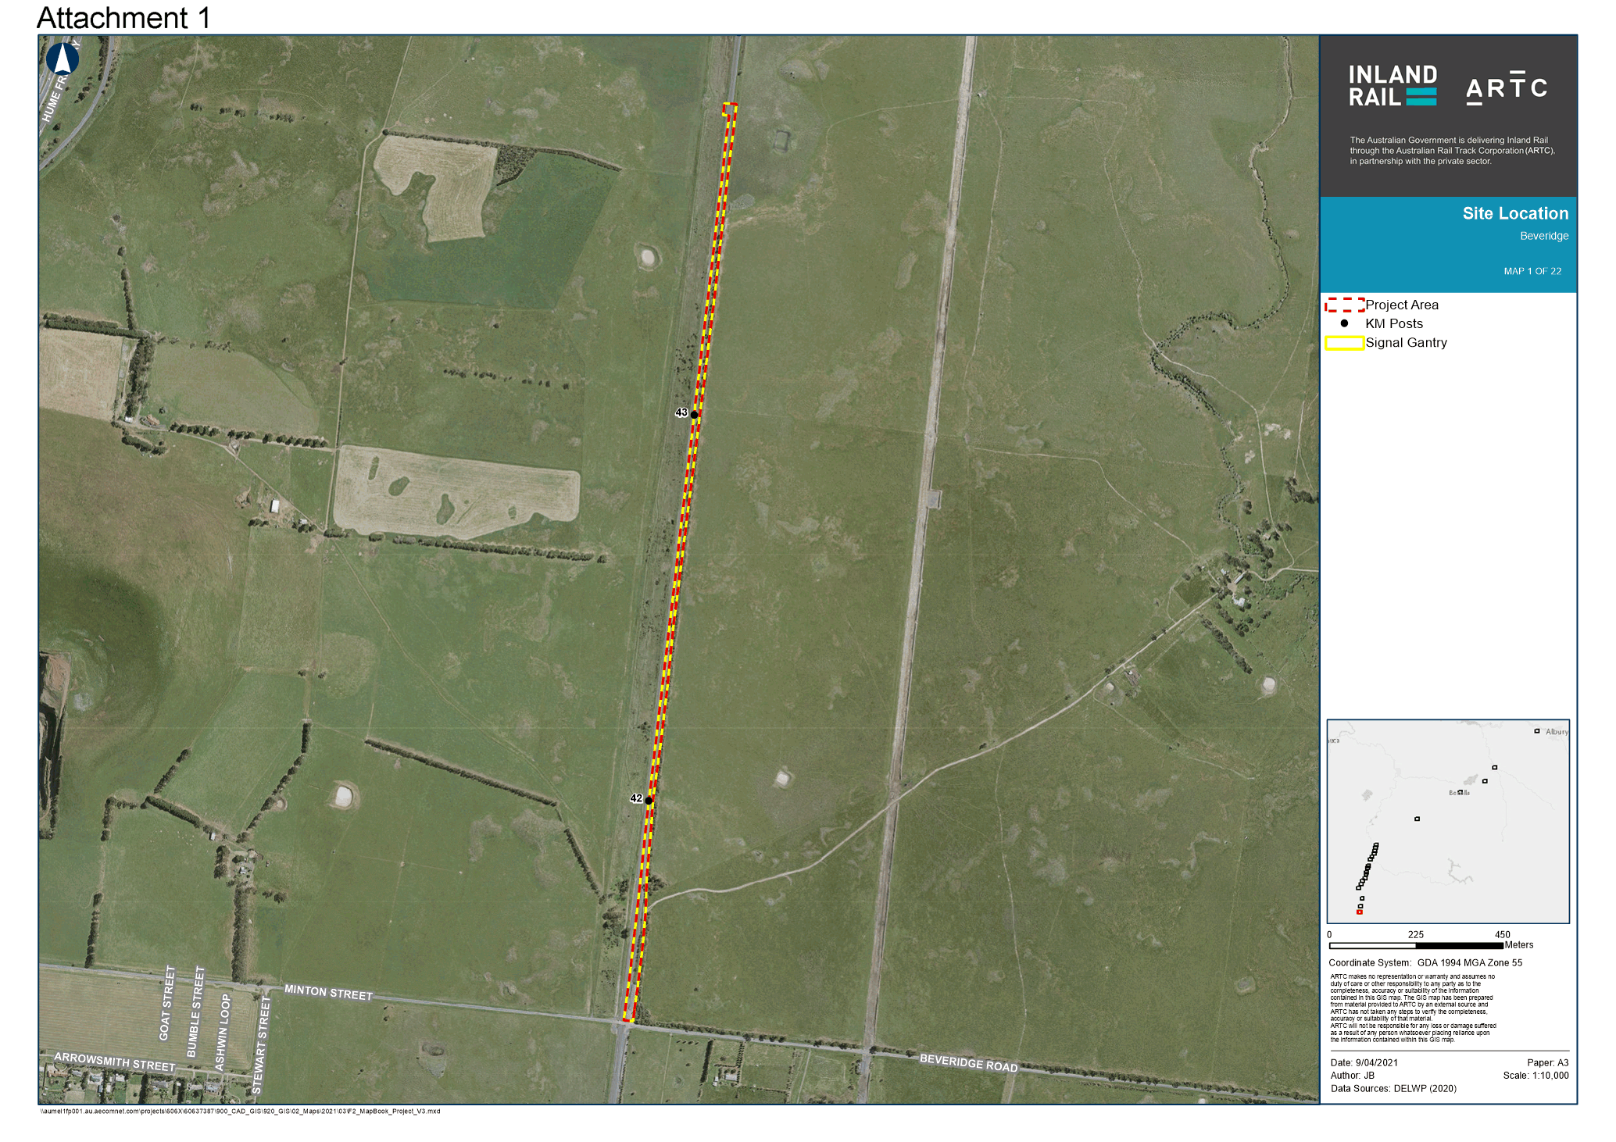
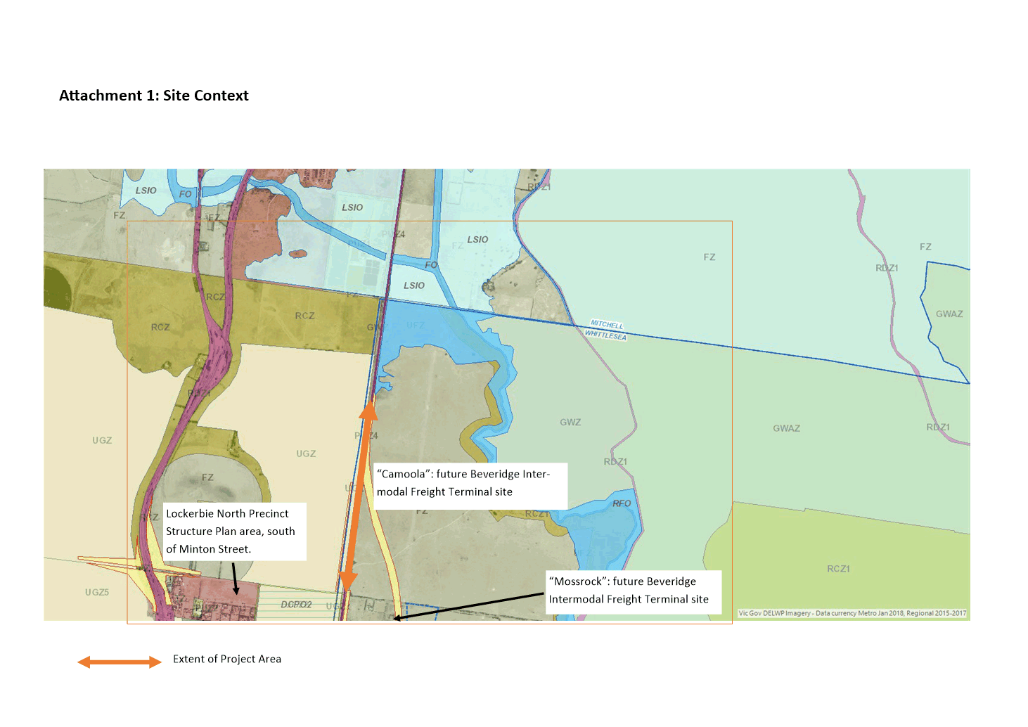
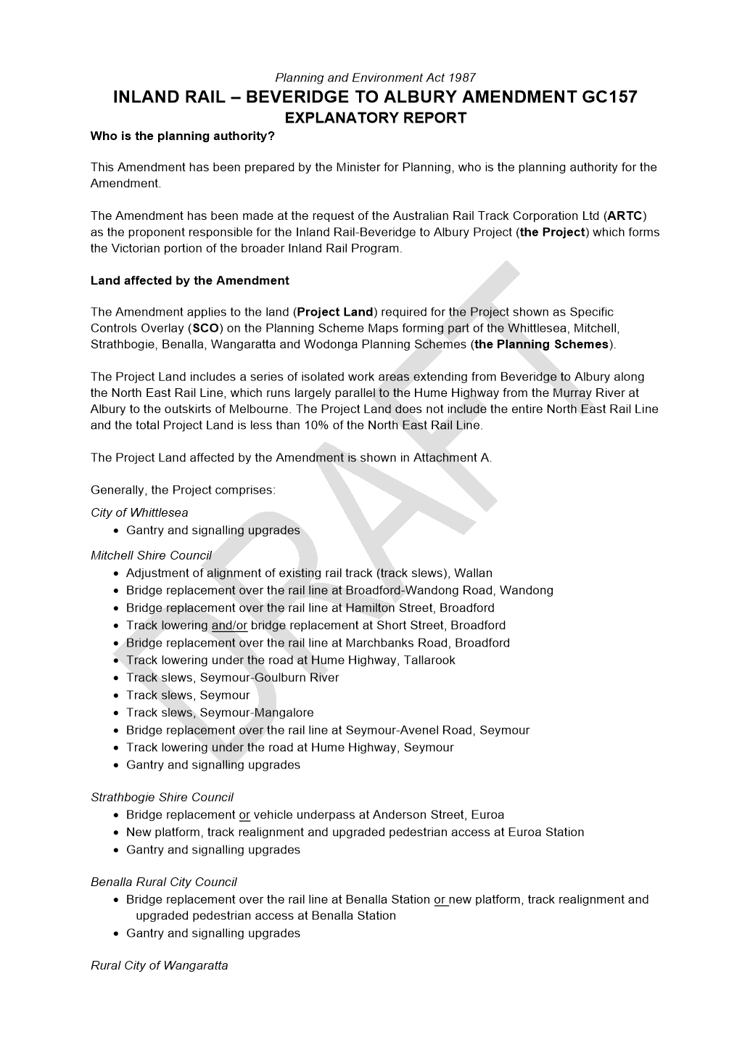

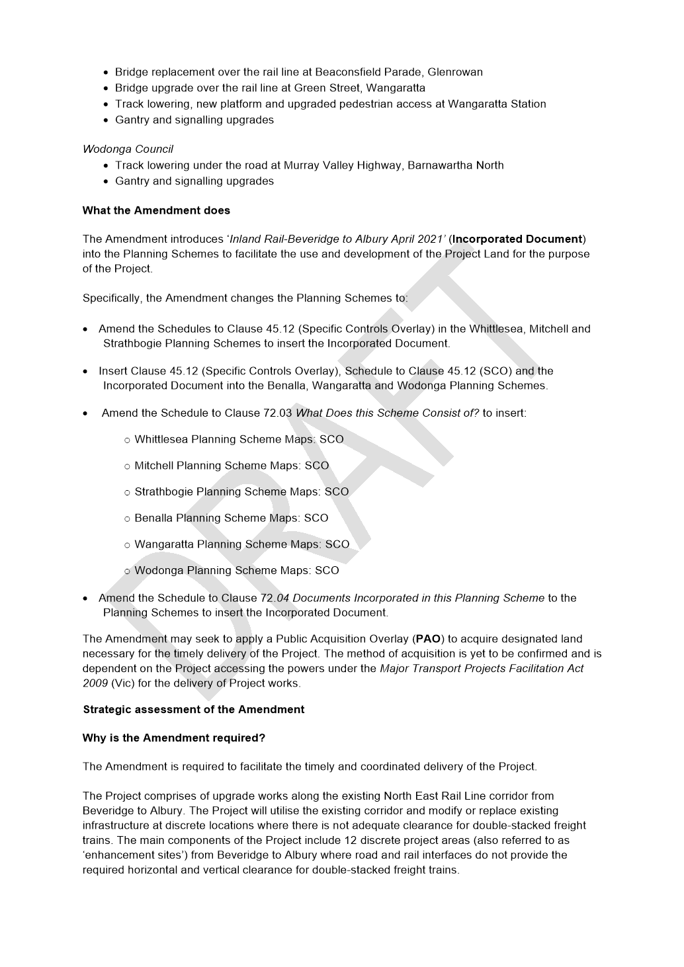

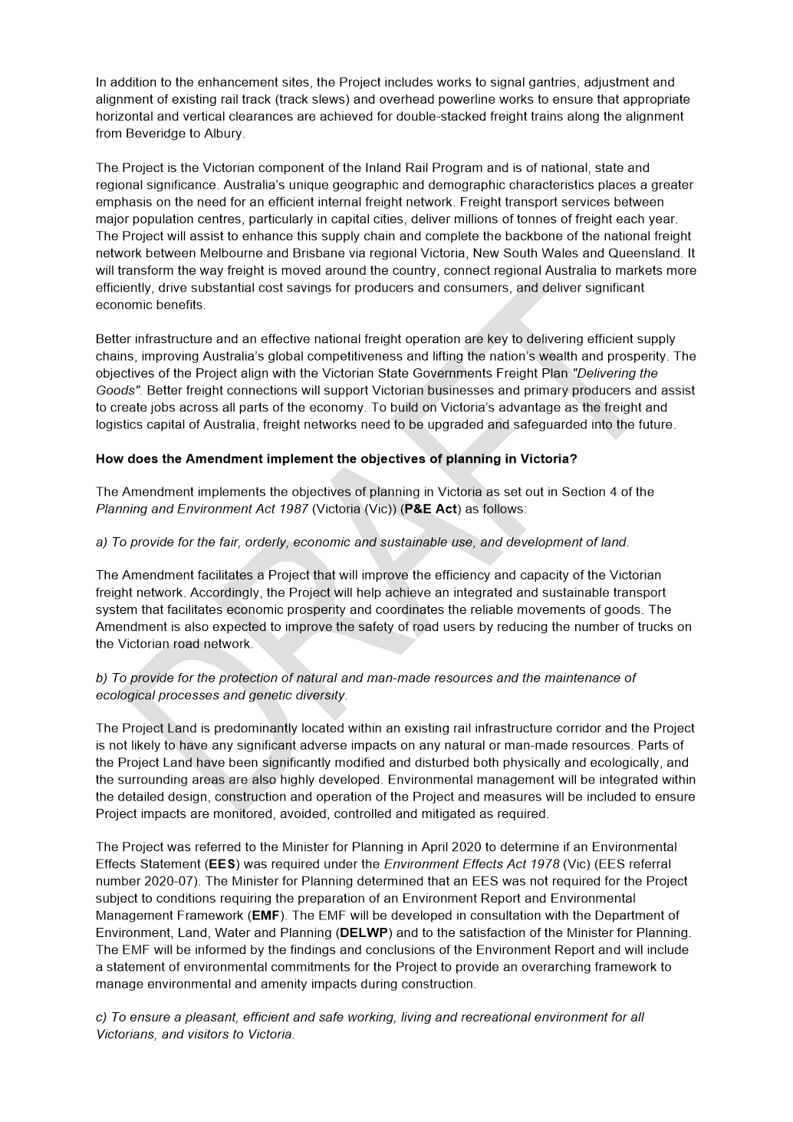

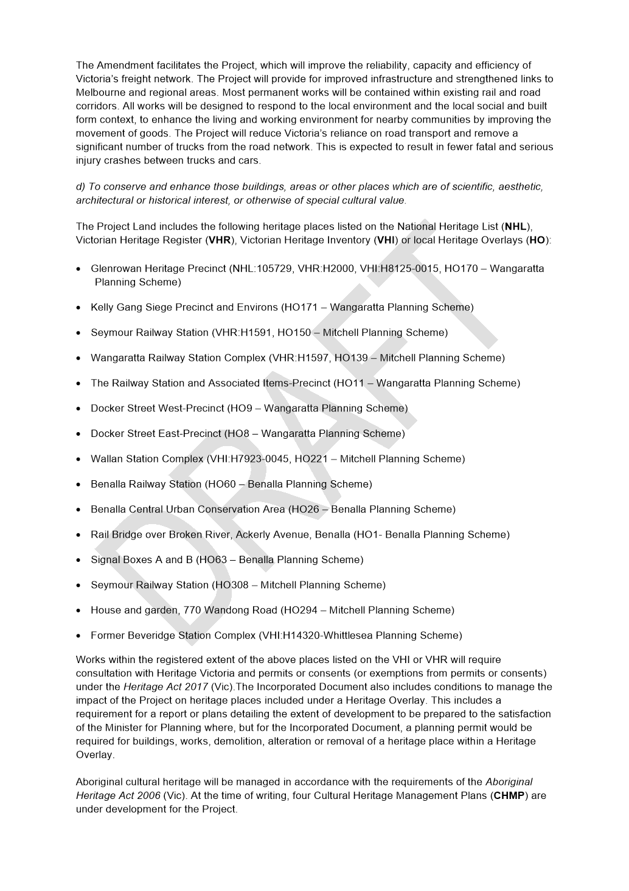

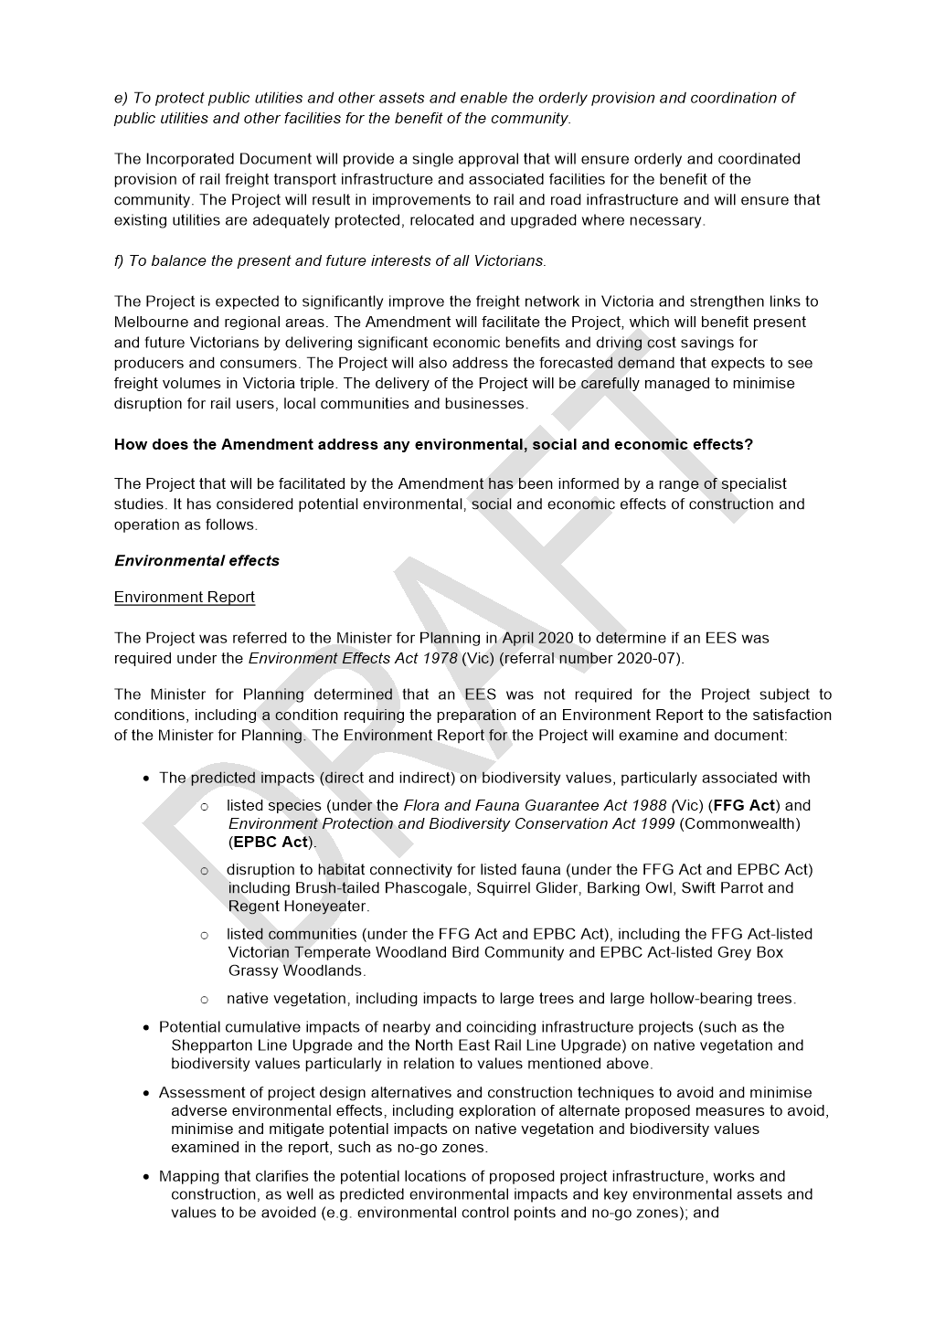

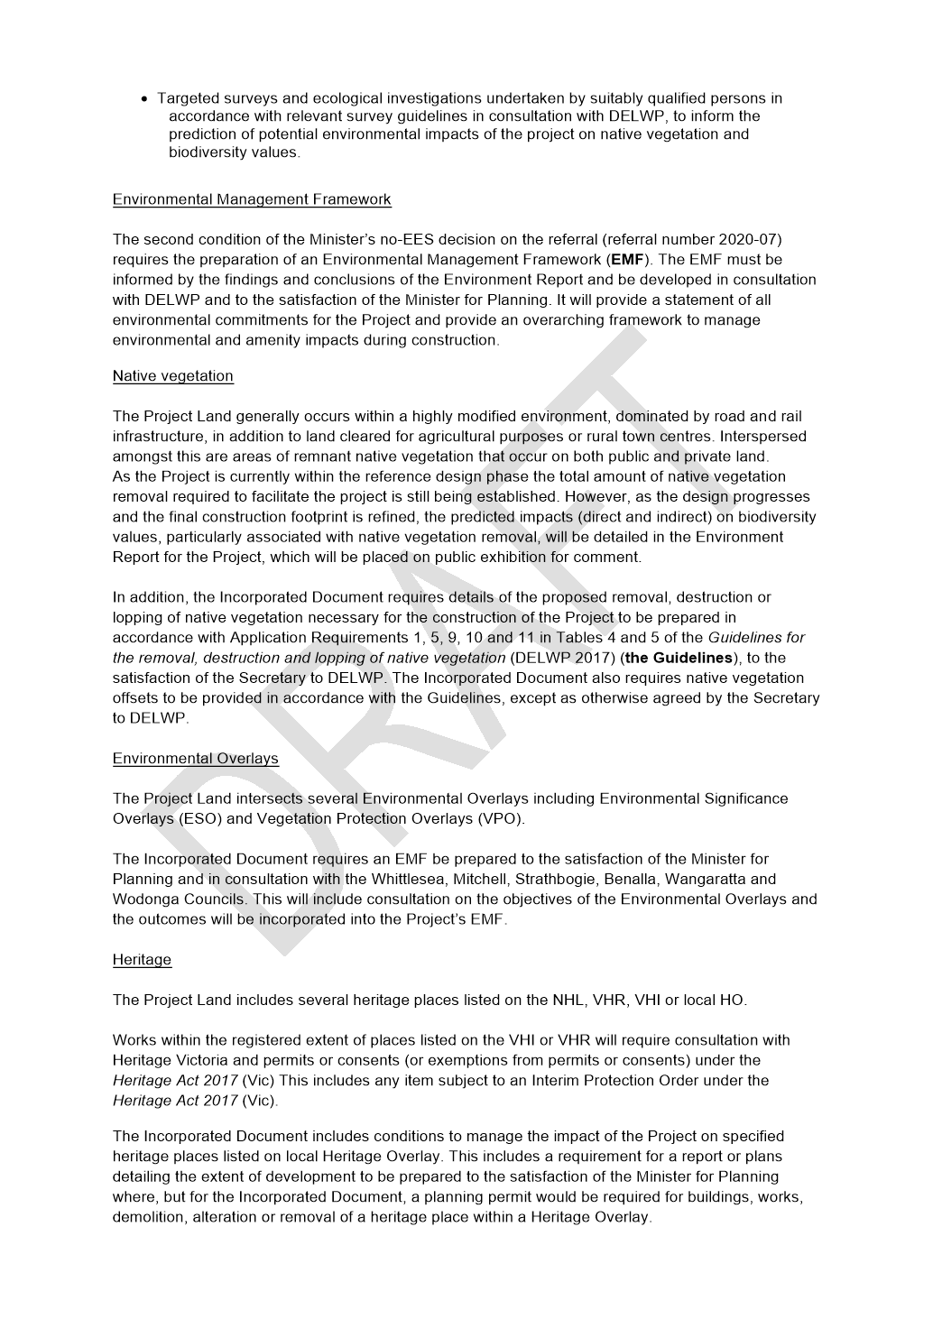

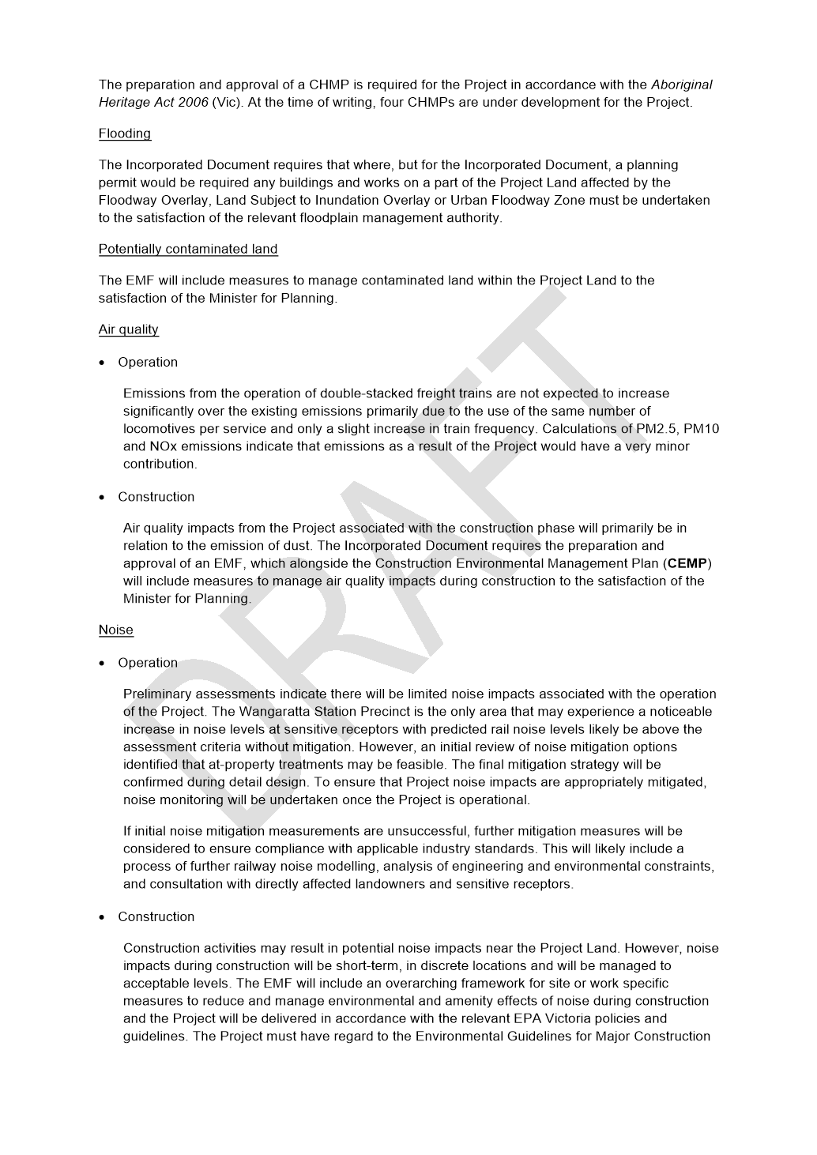

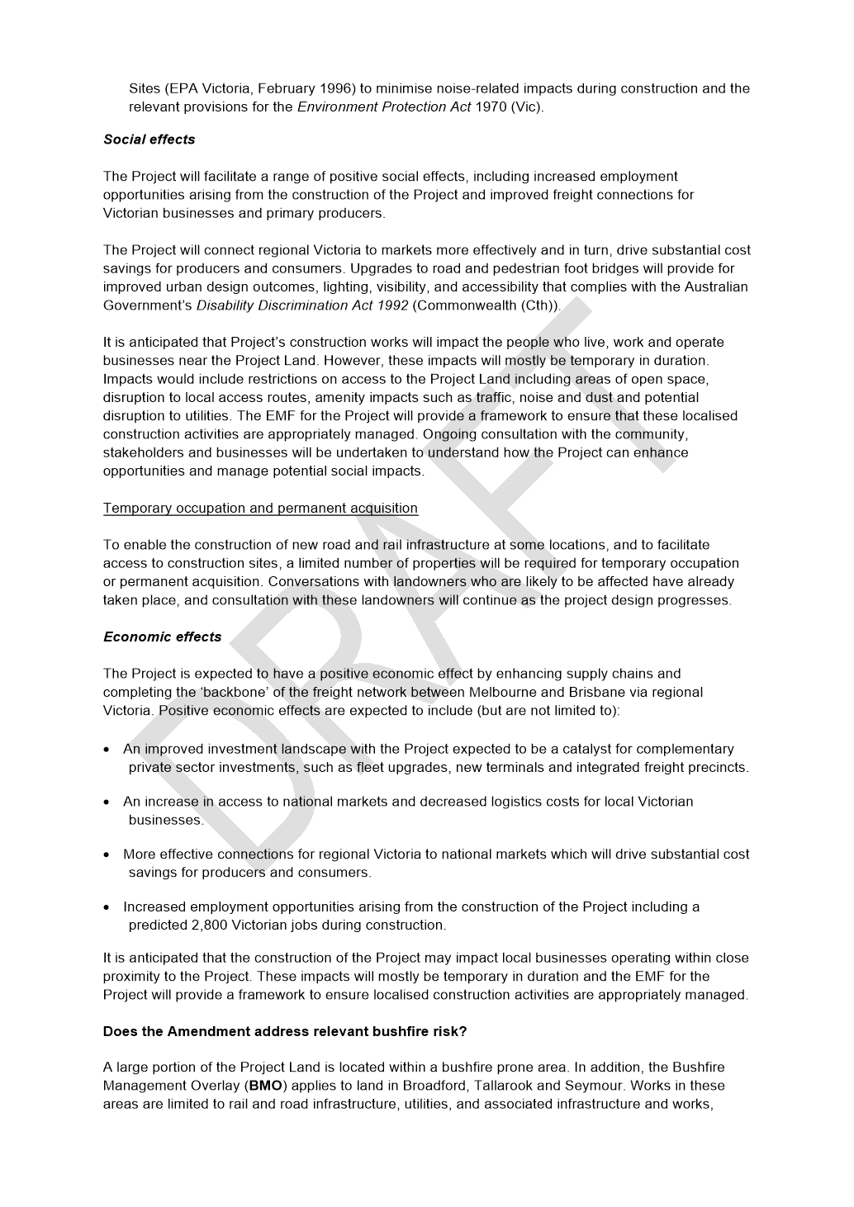

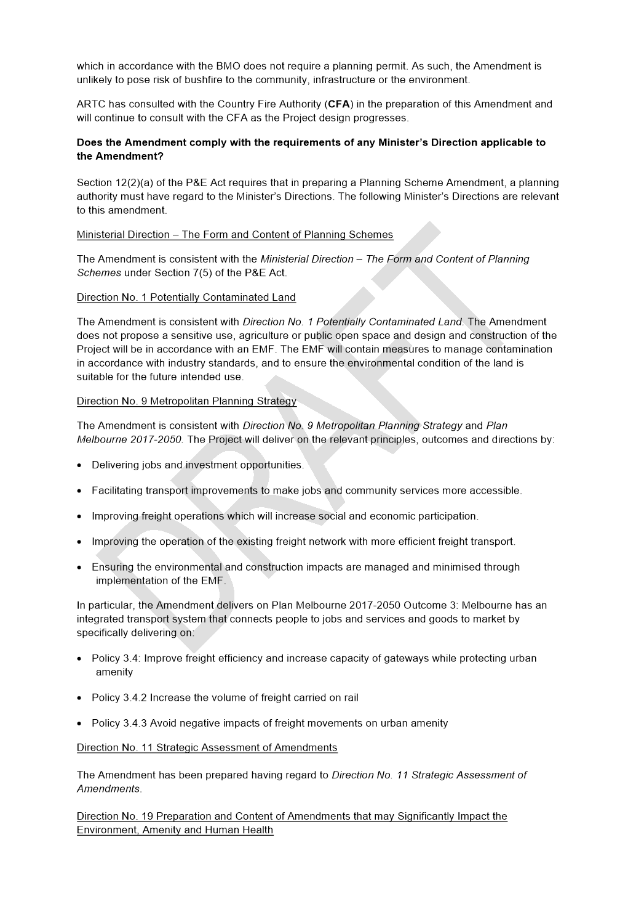

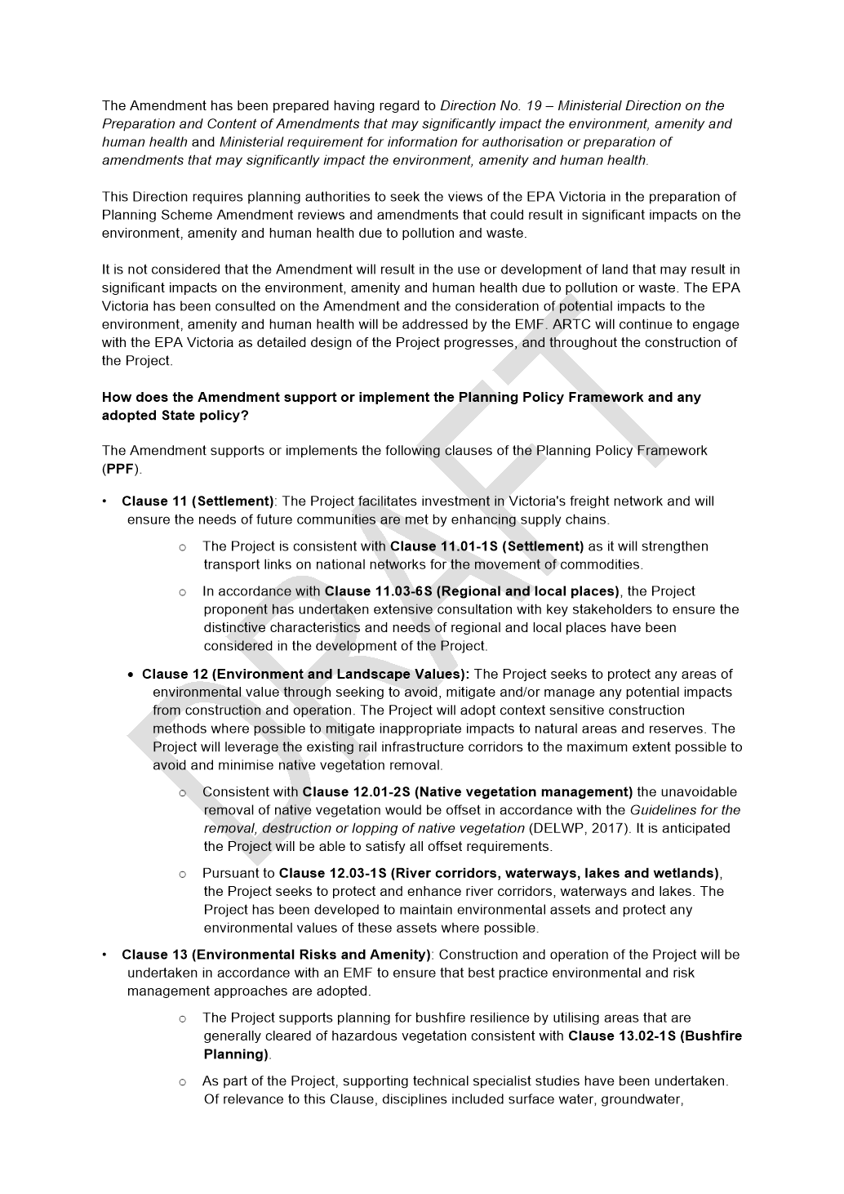

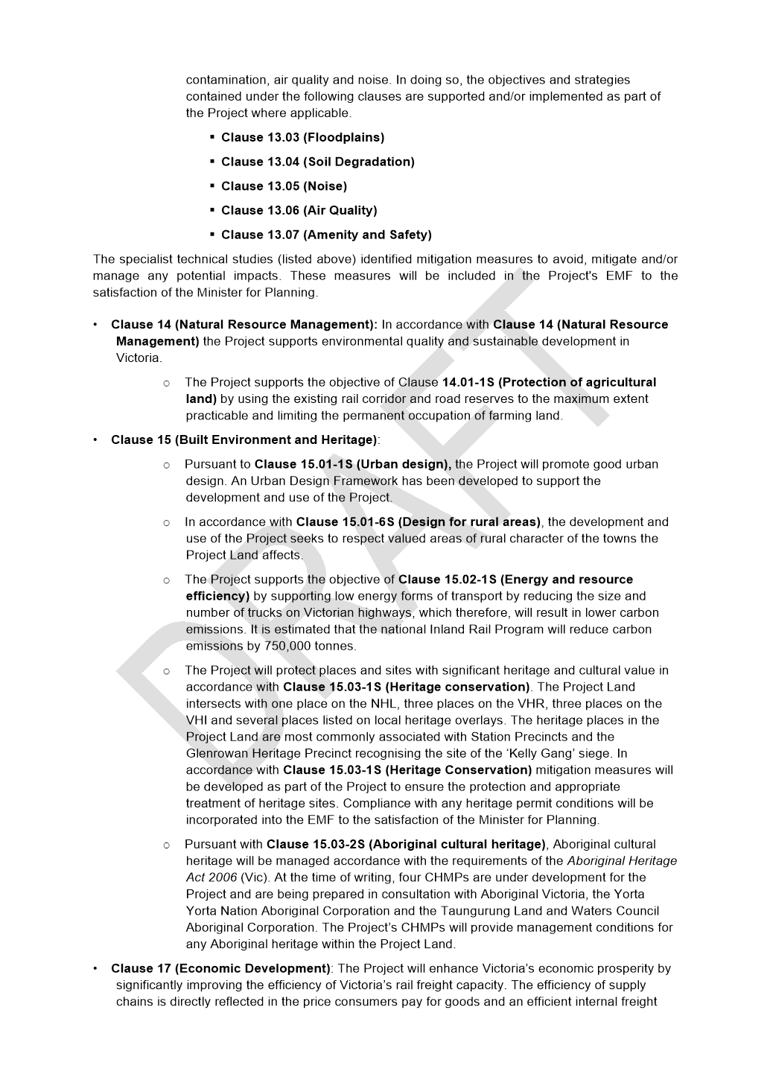

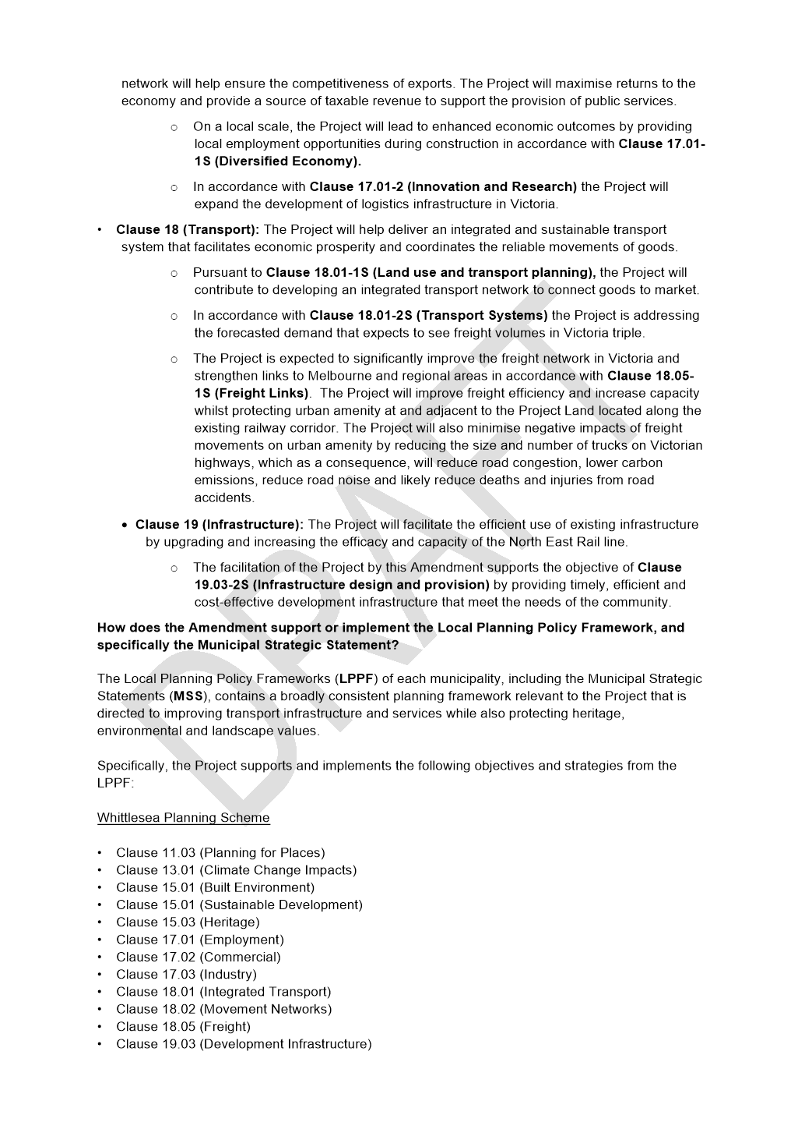

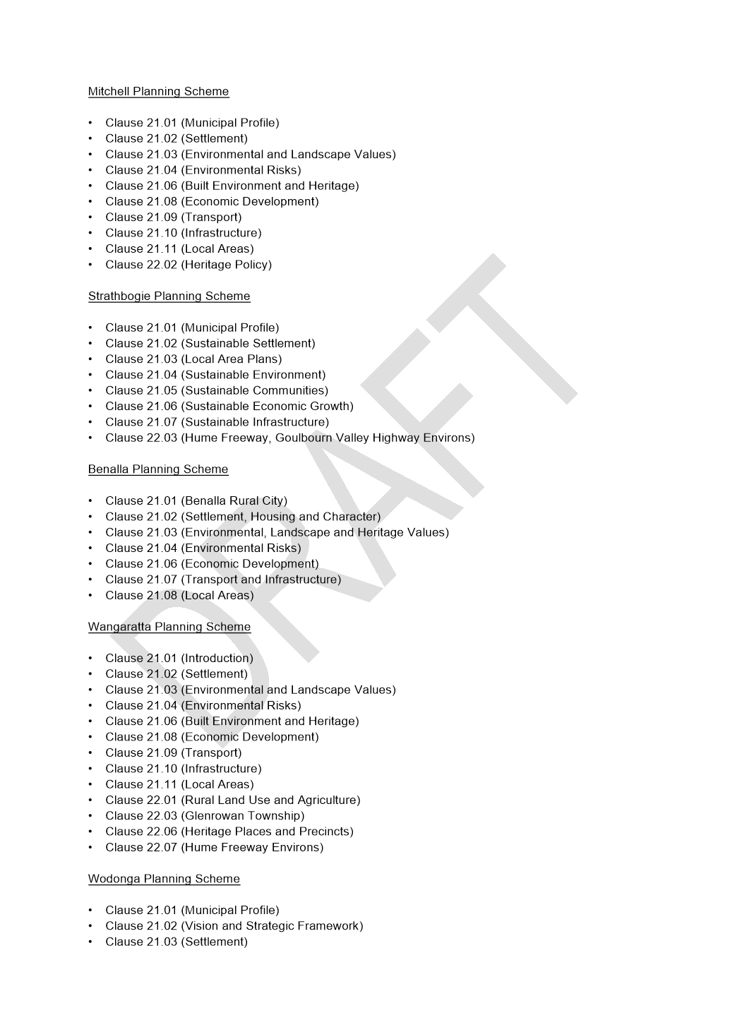

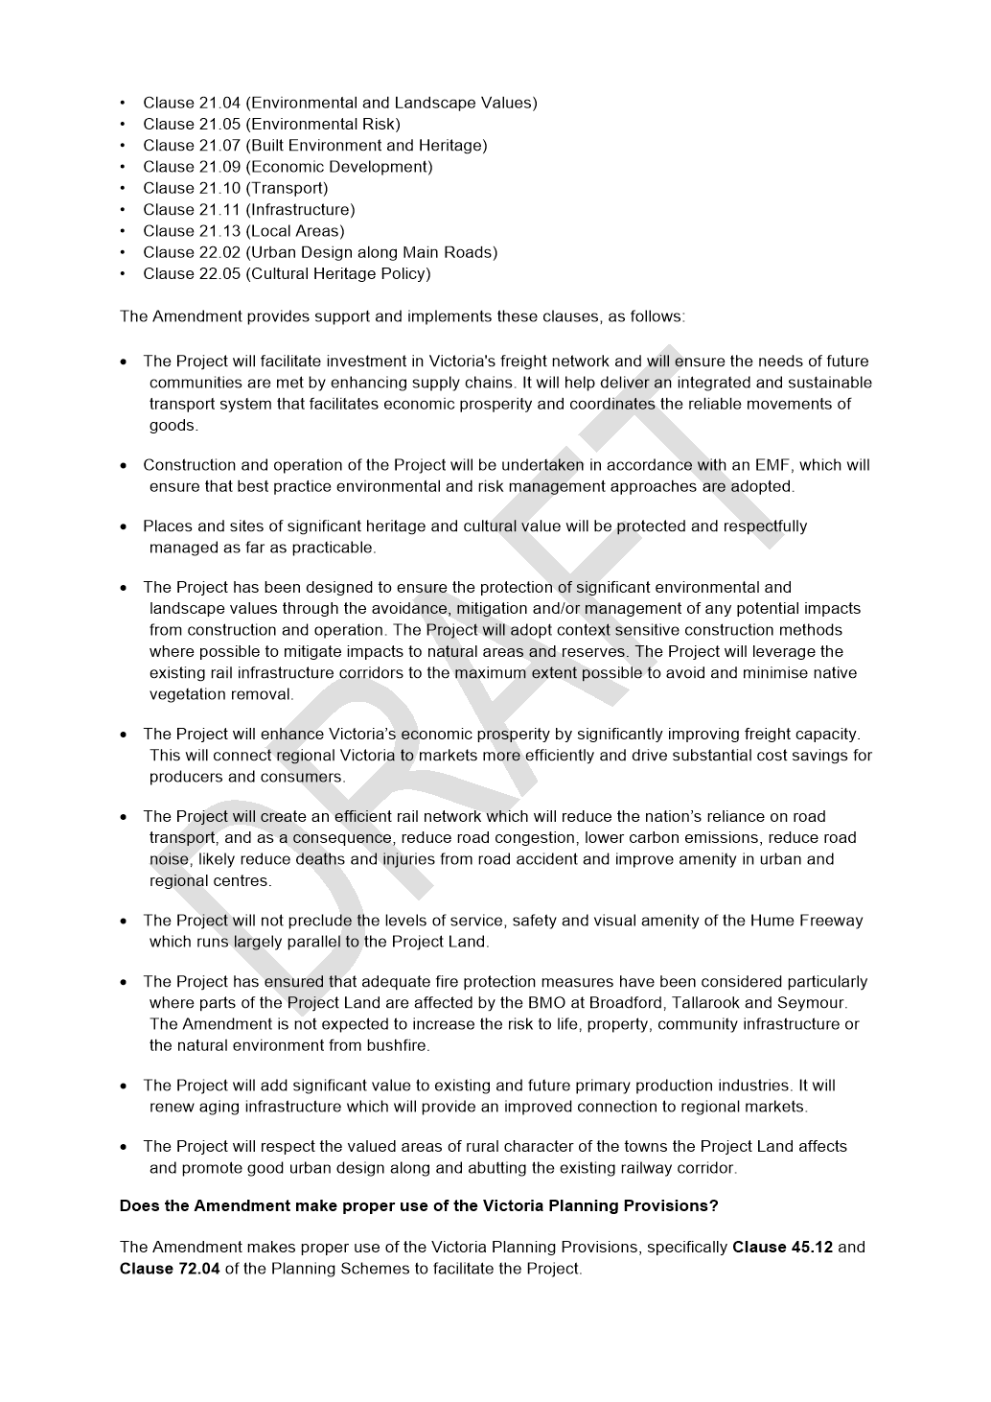

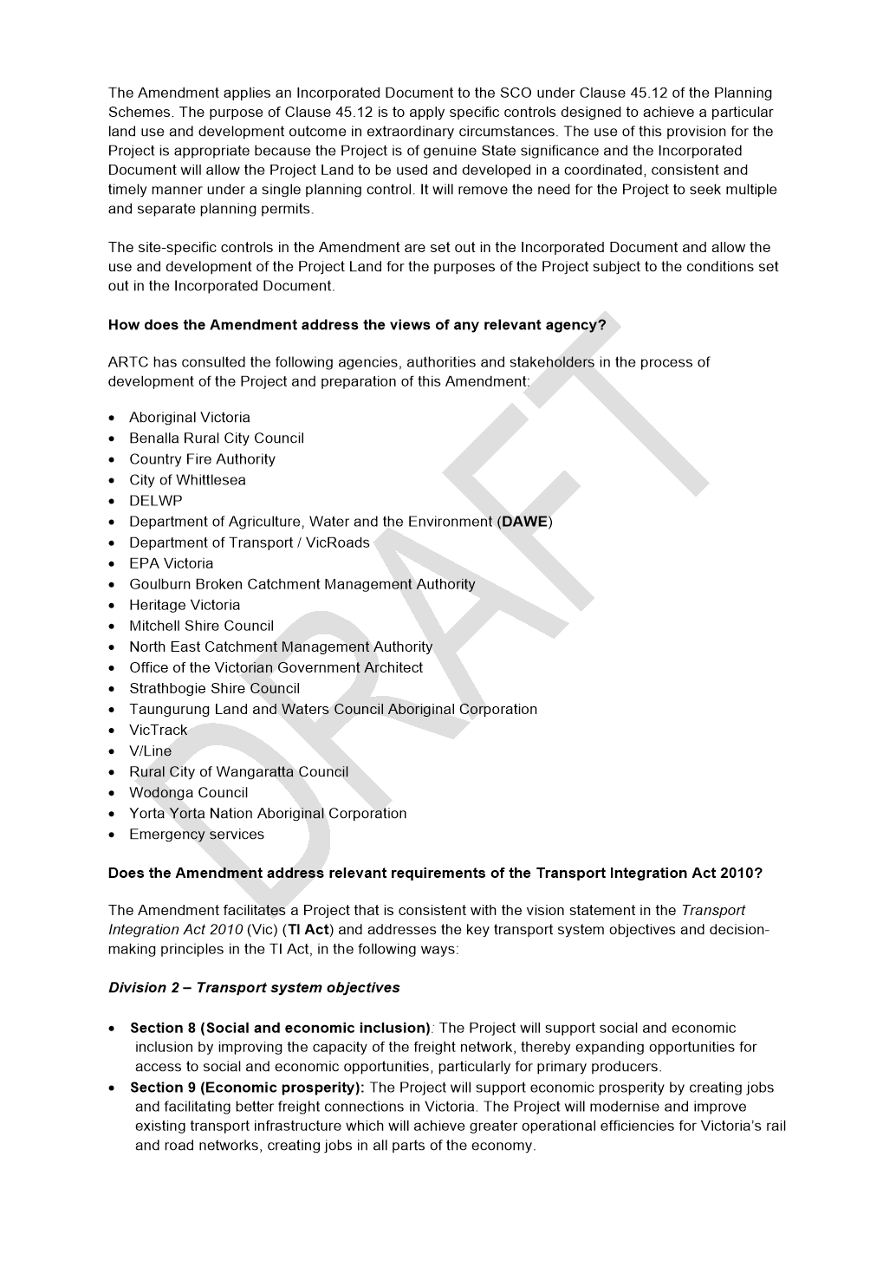

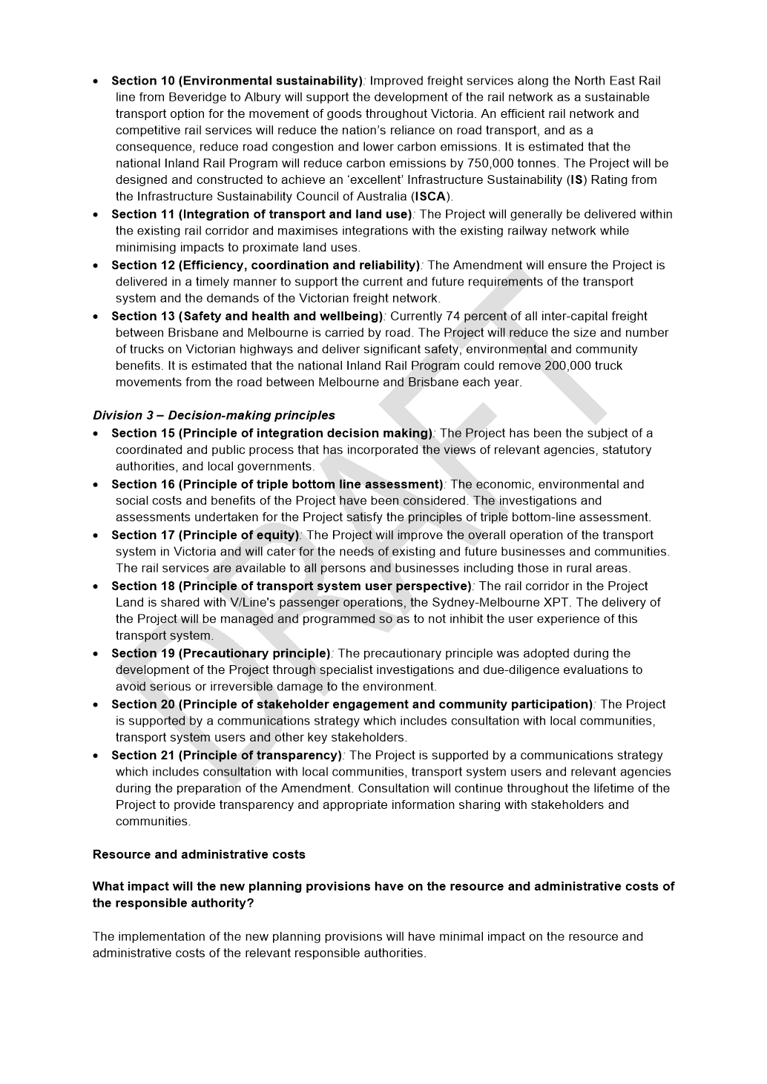

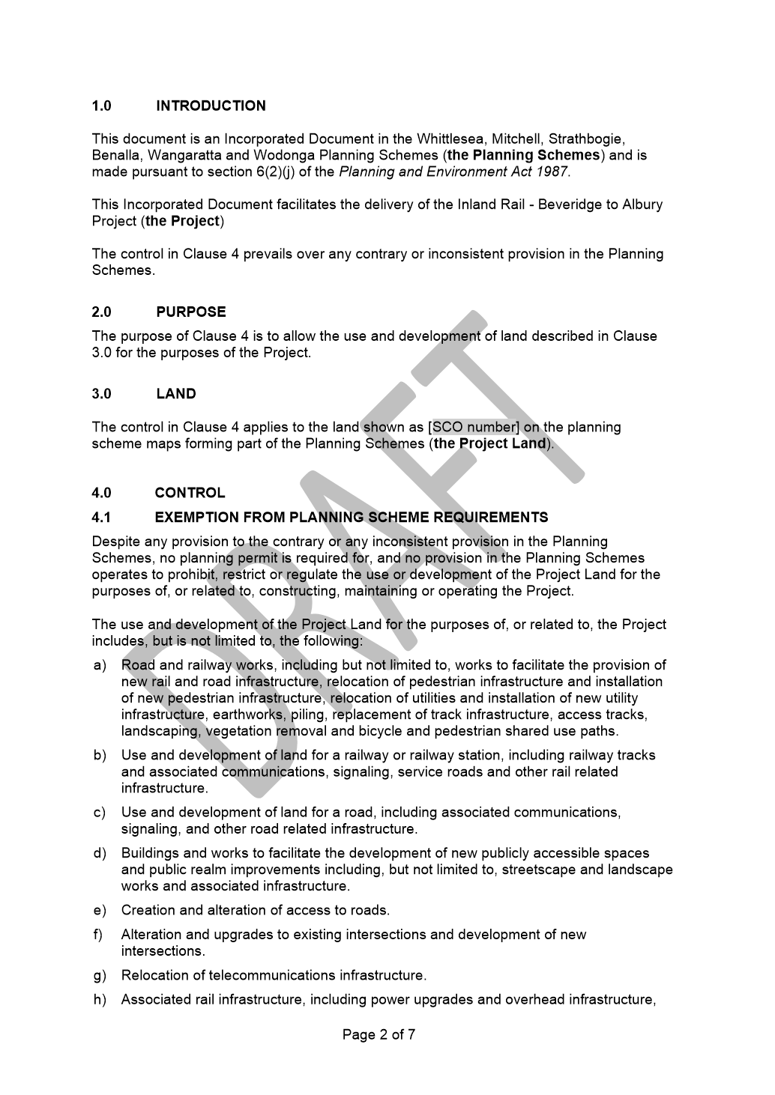

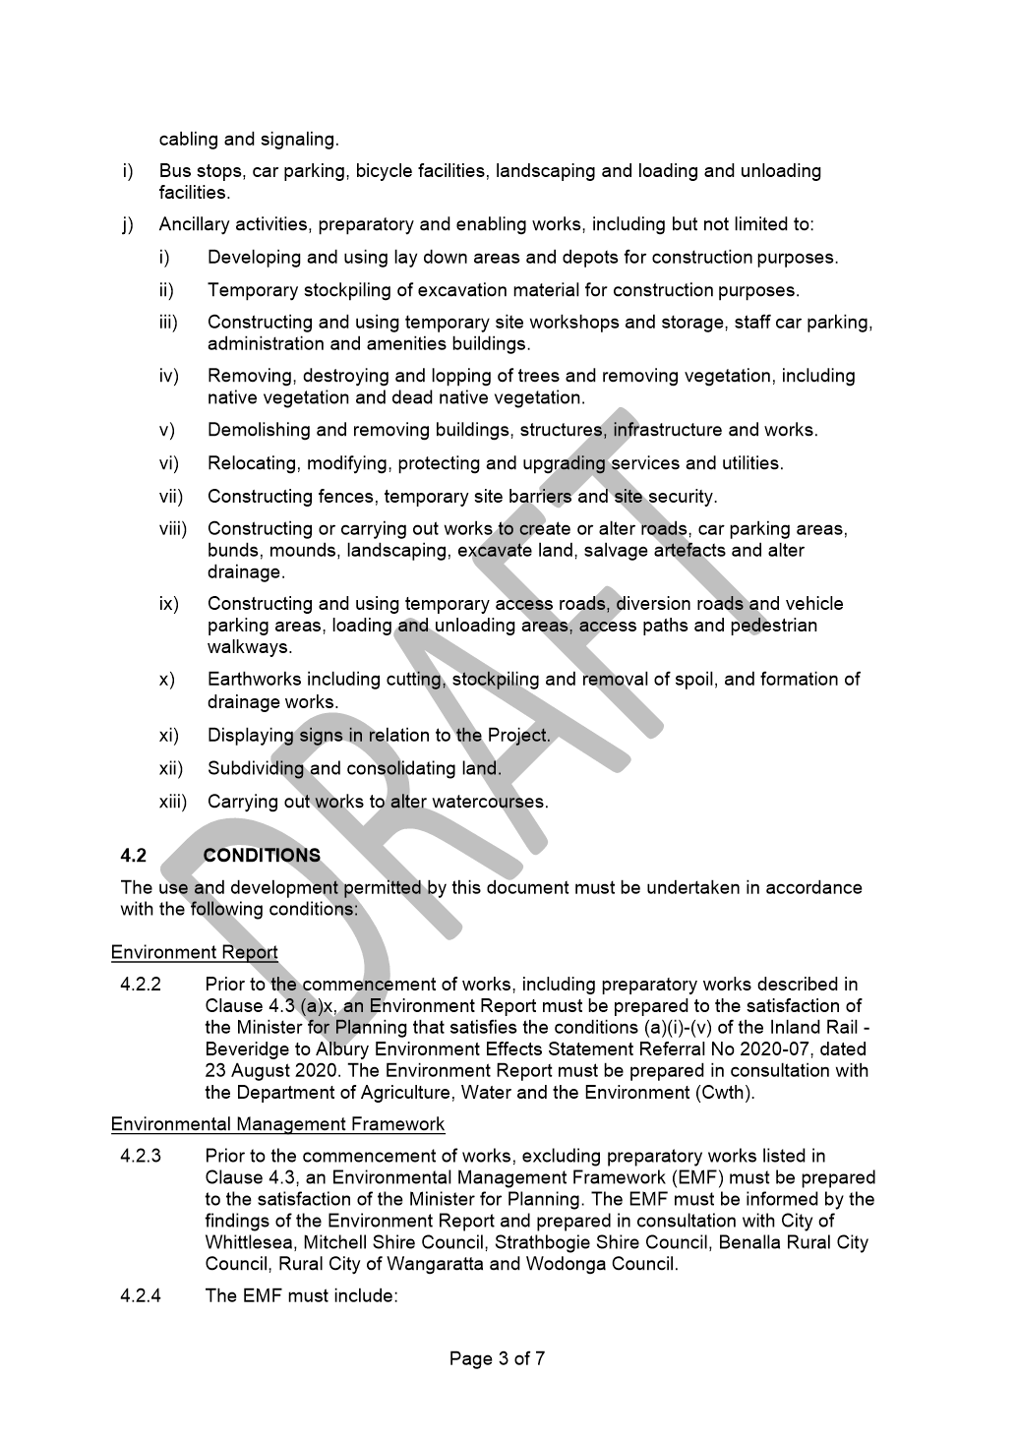

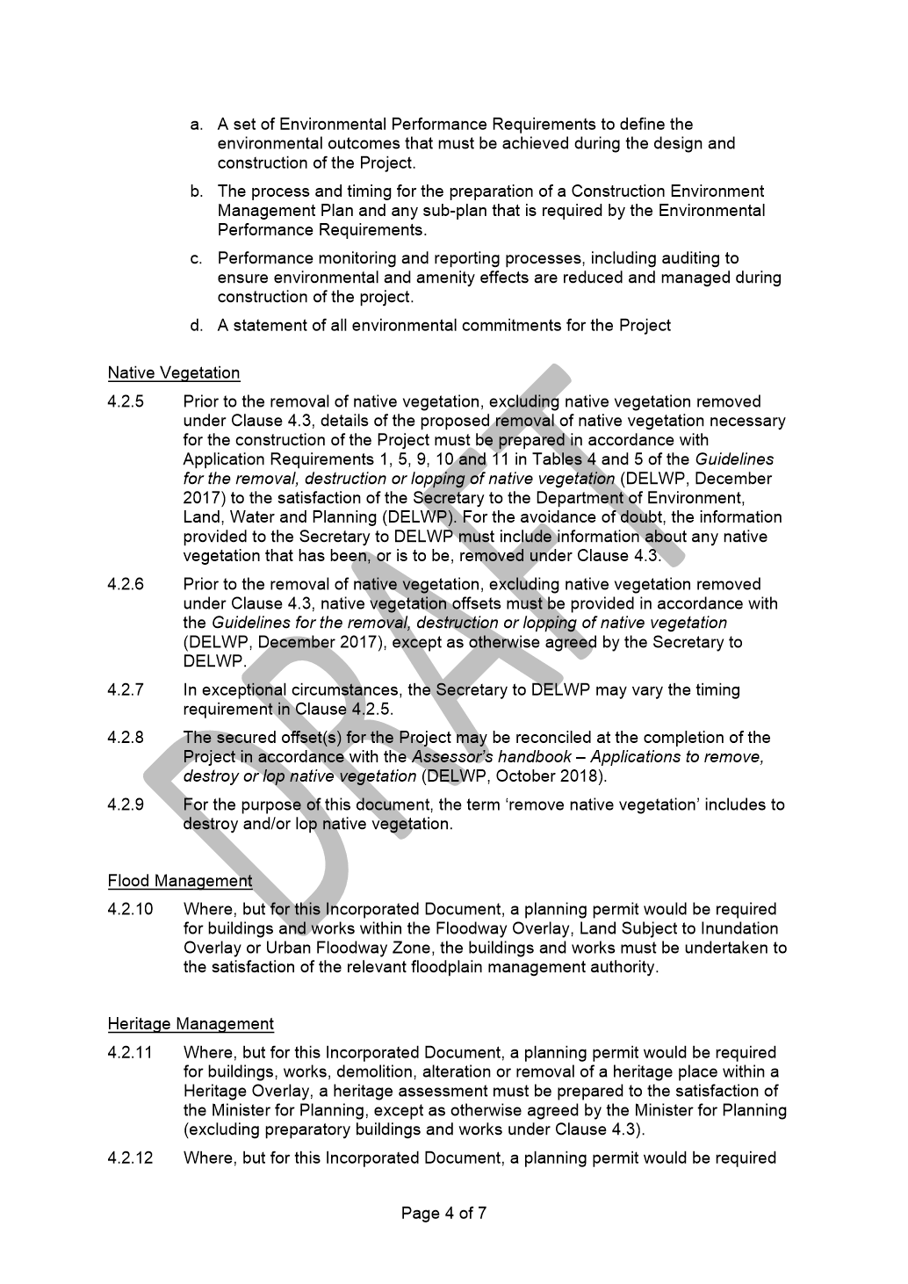

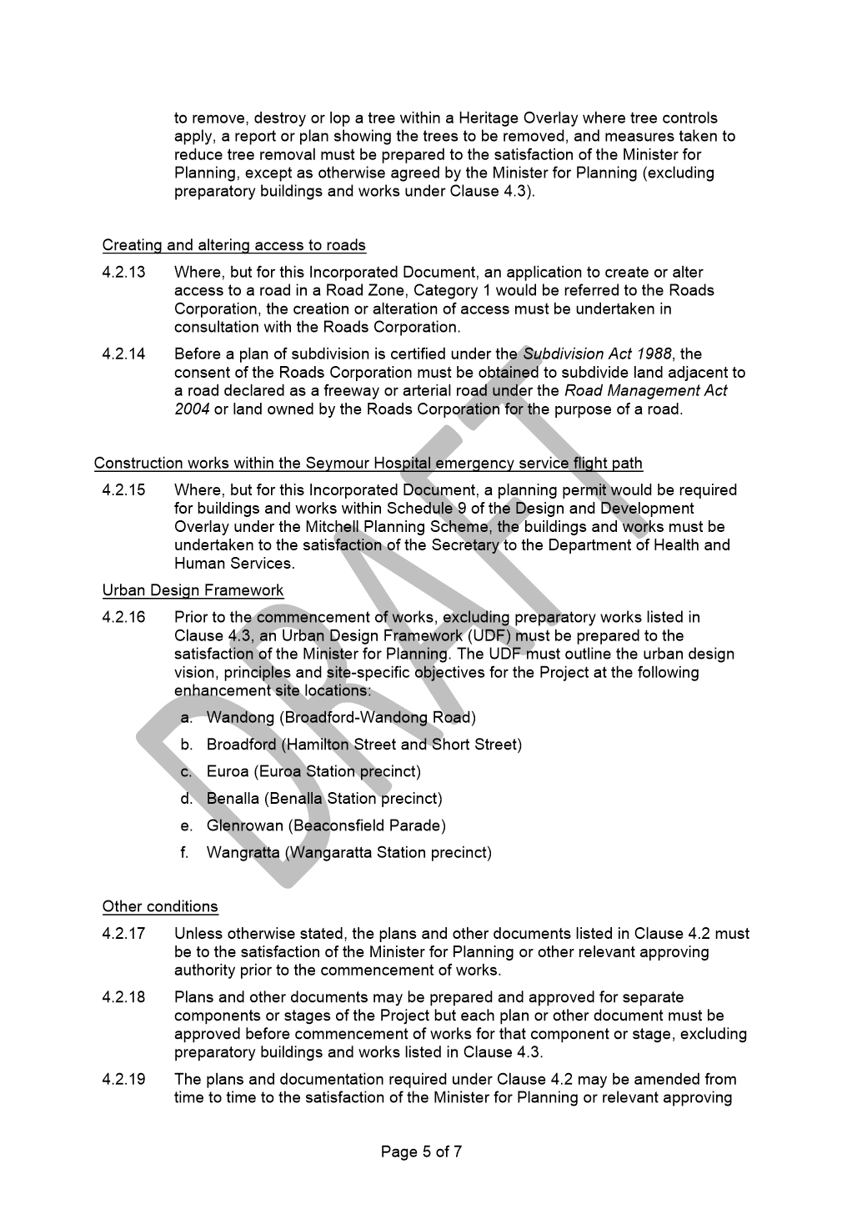

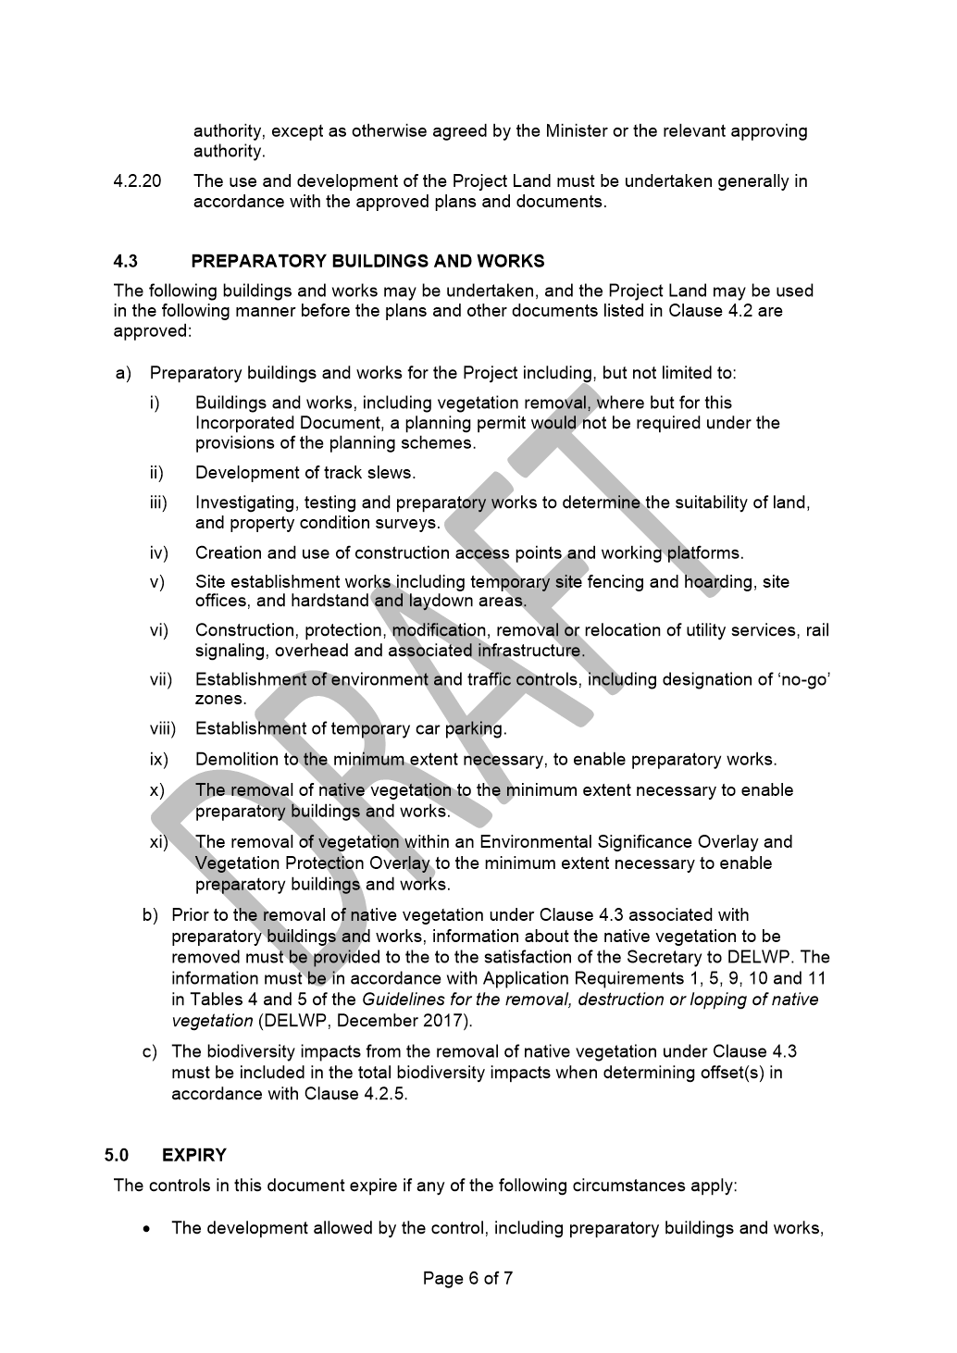

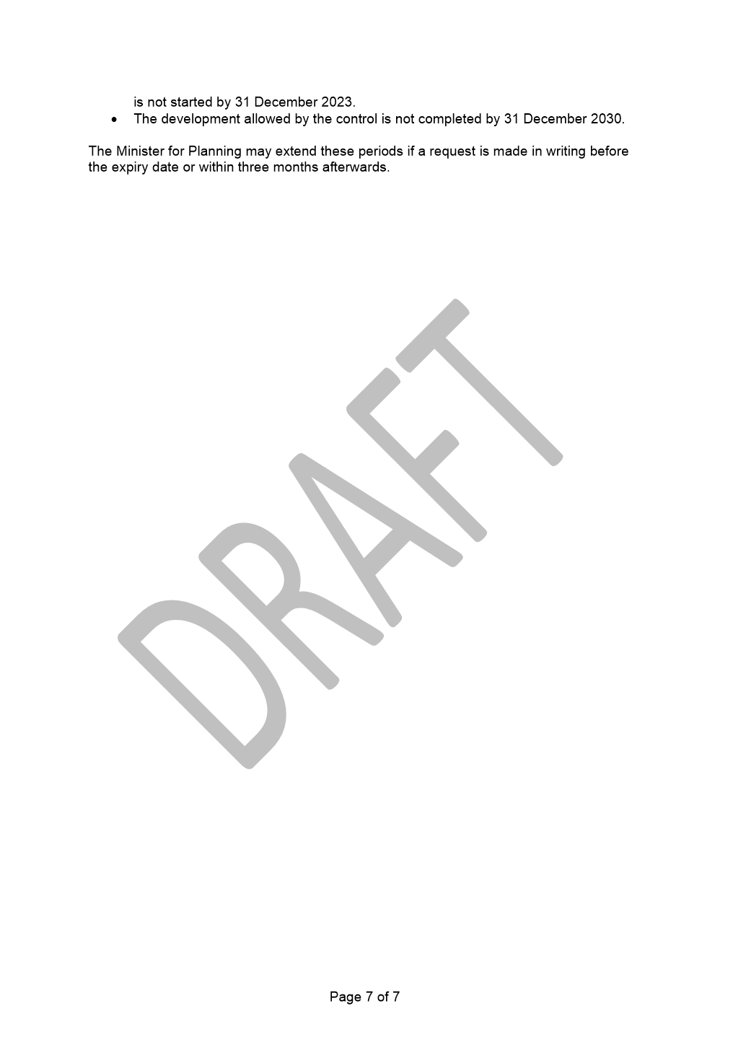

6.2 Liveable Neighbourhoods
ITEM 6.2.1 For Decision - Local Area Traffic Management and Street Improvement Plan, Mill Park and Epping
Responsible Officer: Director Infrastructure & Environment
Author: Traffic Transport Engineering Officer
Attachments: 1 Study Area and Concept Plan
2 Crash and Traffic Volumes Location Plan
3 Traffic Treatments Examples
4 Community Consultation Results

This report presents the investigation, findings and the extensive community consultation for the Local Area Traffic Management and Streetscape Improvement Plan (LATMSIP) recently conducted for the area bounded by McDonalds Road, Childs Road, Morang Drive and the future outer Metropolitan Ring Road/E6 corridor in Mill Park and Epping, known as LATM 26 & 32 (see Attachment 1).
RECOMMENDATION SUMMARY
1. Finalise the Draft Traffic Management and Streetscape Improvement Plan for the LATM 26 & 32 area;
2. Subject to Council decision, inform the community within the study area of the endorsed Plan and Council decision.
KEY FACTS AND / OR ISSUES
• Council has had a regular program to deliver Local Area Traffic Management since 1996.
• This project is identified in the 2020/21 Council Action Plan, under the theme Streets for people - Study and Implementation of LATM areas 26 and 32 in Mill Park.
• The project methodology expands the historical approach to Local Area Traffic Management Plans, which had the sole focus of traffic safety and improved mobility and access to active travel infrastructure.
• The project will be delivered through a combination of existing and revised New Works
• Program funding allocations within the study area, including:
o Local Road Safety;
o Street Lighting Upgrades;
o Pedestrian and Cycling Pathway Upgrades / Repairs;
Community consultation has been undertaken with a low overall response rate; however a good level of support was received for the proposed improvements from the directly affected residents in the area.

Introduction
The report outlines the status of the study and investigation process into the development of the Local Area Traffic Management and Streetscape Improvements Plan (LATMSIP) for the LATM 26 & 32 in Mill Park and Epping.
Background
The development of the plan was included as an action item in the 2020/21 Council Action Plan. The LATM 26 & 32 area is bound by McDonalds Road, Childs Road, Morang Drive and the future outer Metropolitan Ring Road/E6 corridor in Mill Park and Epping (Attachment 1).
Abutting Land Use
The area has a number of significant abutting land uses, including Mill Park Leisure Centre, Mill Park All Abilities Playspace, Mill Park Heights Primary School, Westfield Plenty Valley Shopping Centre and South Morang Train Station that generate significant pedestrian, cyclist and vehicular traffic and parking.
Road Function
The road network within the LATM area consists of two main collector roads (Prince of Wales Avenue and Pindari Avenue) with several curvilinear local access roads including cul-de-sacs and courts.
Road Safety and Traffic Conditions
The Department of Transports’ (formally VicRoads) casualty crash database (Crashstats) indicates that from 2016 to 2021 there were five (5) casualty crashes recorded within the study area (Attachment 2).
Traffic surveys have been undertaken on collector roads and local streets within the study area and indicate that whilst traffic speeds and volumes are within acceptable tolerances in most streets, they are unacceptable in Prince of Wales Avenue, Romano Avenue and The Fred Hollows Way, Mill Park (Attachment 2).
In this case acceptable tolerances are considered to be where the 85th percentile traffic speeds, i.e. the speed at which 85 per cent of the traffic is travelling at or below the speed limit; whereas unacceptable is where the 85th percentile traffic speeds are in excess of the designated speed limit.
Public Transport
The 569 (Epping Plaza Shopping Centre – South Morang Train Station) bus service operates in both directions along The Fred Hollows Way, Manning Clark Road, Romano Avenue, Pindari Avenue and the Prince of Wales Avenue.
Connectivity
The study area consists of some existing unsealed granitic sand paths within the Mill Park Recreation Reserve.
The Mill Park Recreation Reserve has no wayfinding along the paths.
Proposal
The aim of the study is to deliver a wide range of unprogrammed and programmed traffic management improvements that will improve road safety, pedestrian and cyclist connectivity and will provide opportunities for streetscape enhancements.
Some examples of the proposed devices are presented in Attachment 3.
The following planned project improvements have been considered within the study area:
• Local Road Safety Works;
• Street Lighting Upgrades; and
• Pedestrian and Cycling Pathway Upgrades / Repairs.
The preparation of a Draft Local Area Traffic Management and Street Improvement Plan included a technical assessment aimed at addressing ongoing concerns about traffic conditions and road safety. A detailed analysis of the reported casualty crashes, resident concerns, and recorded volume and speed data were key inputs into the development of the Plan.
The plan recommends the installation of:
• A suite of traffic calming devices in Prince of Wales Avenue, Romano Avenue and the Fred Hollows Way,
• Pedestrian and cycling connectivity improvements and installation of raised (wombat) crossings along Prince of Wales Avenue, Manning Clark Road and The Fred Hollows Way, and
• An upgrade of the existing unsealed paths within the Mill Park Recreation Reserve
• Installation of wayfinding signage to Council facilities.
Consultation
A consultation package (comprising of a cover letter, concept plan, examples of treatments, survey form, frequently asked questions fact page and a reply paid envelope) was distributed to 3,119 property owners and occupiers within the study area, inviting the community to provide feedback on the draft Local Area Traffic Management and Street Improvement Plan by completing and returning a questionnaire, visiting the Council ‘Have Your Say’ web page and / or by attending one of two a public drop in sessions held at the All Abilities Playspace in Mill Park on Wednesday 7 April 2021 and Thursday 8 April 2021.
A consultation package was also sent to the bus operator (Dyson Bus Company) and Victoria Police inviting feedback on the draft Local Area Traffic Management and Street Improvement Plan.
A summary of outcome of the results and feedback of the survey are provided in Attachment 4.
The overall response rate received from the LATMSIP 26 & 32 areas was 5%, with a response rate from owners and occupiers of the directly affected properties in close proximity to a proposed traffic calming device of 9%.
To improve response rates, Council officers telephoned and visited owners and occupiers who had not responded to solicit a response. A copy of the questionnaire and a note to call Council officers was left if residents were not at home. This additional approach resulted in an increase of the response rate from the directly affected property owners and occupiers to 52%. Community feedback on the Draft LATMSIP resulted in an average of 68% of respondents indicating their support for the range of traffic management devices proposed.
During the community engagement session and the home visits, a number of community members indicated that they felt no need to respond to the survey if they did not object to the proposal; many community members indicated that they are not overly concerned with this proposal and support Council’s decisions, therefore they have not participated in the survey. This provides some clarity with the initial low response rate to the community consultation.
The outcomes of the Council decision along with the final endorsed plan will be communicated through a mail out to the property owners and occupiers in the study area and those who provided feedback at the community information sessions. The broader community will be informed through an information flyer/poster being posted at the Mill Park Leisure Centre.
Critical Dates
The LATMSIP study for the LATM 26 & 32 areas is a 2020/21Council Action item with the following key dates:
• Completed study and DRAFT plan by the end of 2020/21 financial year
• Design and delivery commencing in 2021/22 financial year.
Financial Implications
The project will be delivered through a combination of existing and revised New Works Program funding allocations within the study area, as follows:
• Local Road Safety Works;
• Street Lighting Upgrades;
• Pedestrian and Cycling Pathway Upgrades / Repairs; and
Detailed design of the Local Area Traffic Management and Streetscape Improvement Plan will occur in 2021/22, with delivery to commence in the same financial year.
The estimated cost for delivery of this project is $1,250,000 over a three-year delivery program. In the 2021/22 New Works Program, $500,000 are allocated for this project.
Policy strategy and legislation
City of Whittlesea Road Safety Strategy (2017):
Address safety of all road and path users. Address driver behaviour and attitude towards vulnerable road users: pedestrian, cyclists and motorcyclists.
City of Whittlesea Bicycle Plan 2016 – 2020:
Key Direction 3: Build and maintain a high quality network.
City of Whittlesea Street Tree Management Plan (2016):
Action 14: Coordinate the Street Tree Renewal Program with the Road Rehabilitation Program.
City of Whittlesea Integrated Transport Strategy (2014):
Action RF 2.2: Manage local roads to improve amenity and safety for users.
City of Whittlesea Municipal Road Safety Strategy (2004):
Action Plan 3: Ensure that a safer road environment is developed and maintained.
link to strategic risks
Strategic Risk Community and Stakeholder Engagement - Ineffective stakeholder engagement resulting in compromised community outcomes and/or non-achievement of Council's strategic direction
The LATMSIP project is a Council Action item with aim to improve the road safety conditions and overall wellbeing of the community. Community and Stakeholder engagements are crucial element for the success of the project. Extensive community and stakeholders consultation was undertaken to mitigate this risk.
Strategic Risk Service Delivery - Inability to plan for and provide critical community services and infrastructure impacting on community wellbeing
The purpose of the Local Area Traffic Management and Streetscape Improvement Program is to review and improve road safety, local traffic movement and pedestrian connectivity and to improve the streetscape opportunities within a specific LATM area. To ensure consistency in the development of LATM schemes, in 1996 Council adopted a LATM Priority Program for the selection of LATM study areas. All data is updated and tabulated to determine annual LATM rankings for future budget allocation in the Council New Works program.
Links to whittlesea 2040 and the CoUNCIL Plan
Goal Liveable neighbourhoods
Key Direction Smart, connected transport network

The LATMSIP will result in a reduction in vehicle speeds, clearer definition of intersection priorities, improvements to existing devices and improved traffic conditions at a number of pedestrian crossing locations, a reduction in the number of motor vehicle crashes in the area and an opportunity for streetscape improvements to be implemented.
Declarations of Conflicts of Interest
Under Section 130 of the Local Government Act 2020 and Rule 47 of the Governance Rules 2021, officers providing advice to Council are required to disclose any conflict of interest they have in a matter and explain the nature of the conflict.
The Responsible Officer reviewing this report, having made enquiries with relevant members of staff, reports that no disclosable interests have been raised in relation to this report.
Conclusion
A comprehensive and rigorous study involving a technical assessment and community consultation process has been conducted for the LATM 26 & 32 areas to develop a draft Local Area Traffic Management and Streetscape Improvement Plan (LATMSIP).
The community that will be directly affected by this proposal indicated a good level of support for the draft LATMSIP.
Some flexibility is available with respect to the detailed design and positioning of the devices, however it is possible that, despite the information already provided, some residents may not want a device in close proximity or in front of their property, and will require further discussions.
The draft plan is expected to result in a significant reduction in traffic speeds, enhance road safety, and generally improve the residential amenity and liveability of the neighbour areas in the LATM 26 & 32.

RECOMMENDATION
THAT Council resolve:
1. To Finalise the Draft Traffic Management and Streetscape Improvement Plan for the LATM 26 & 32 area,
2. Subject to Council decision, directly inform the local community and provide information to the broader community, of the endorsed Plan and Council decision.
Council Resolution
Moved: Administrator Eddy
Seconded: Chairperson Wilson

THAT Council resolve:
1. To Finalise the Draft Traffic Management and Streetscape Improvement Plan for the LATM 26 & 32 area,
2. Directly inform the local community and provide information to the broader community of the endorsed Plan and Council decision including, but not limited to, through direct mail out to all property owners/occupiers in the study area and those who provided feedback at community information sessions and information where possible at the Mill Park Leisure Centre, All Abilities Playspace and Mill Park Heights Primary School.
Carried

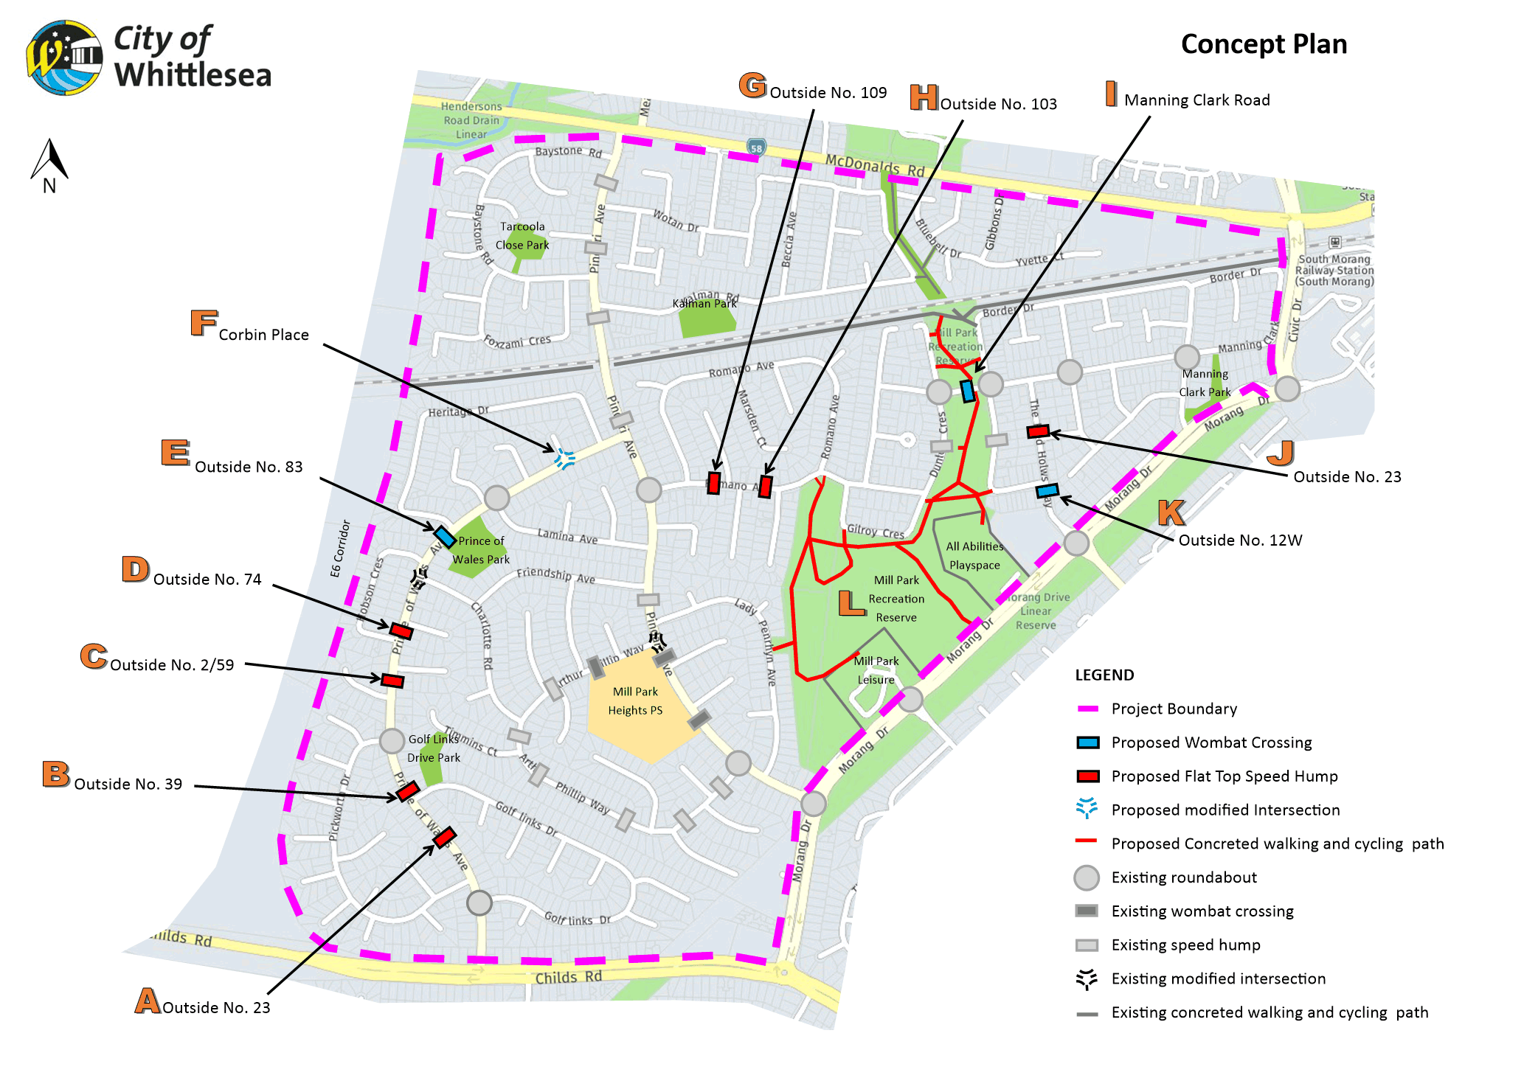
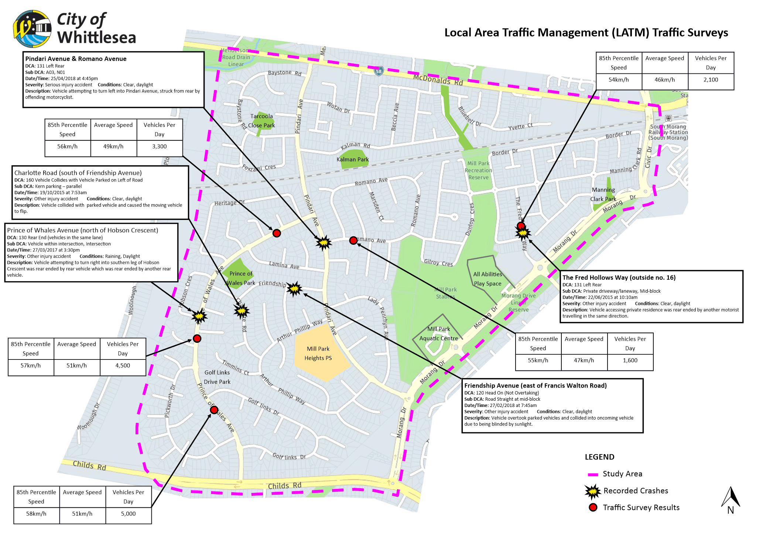
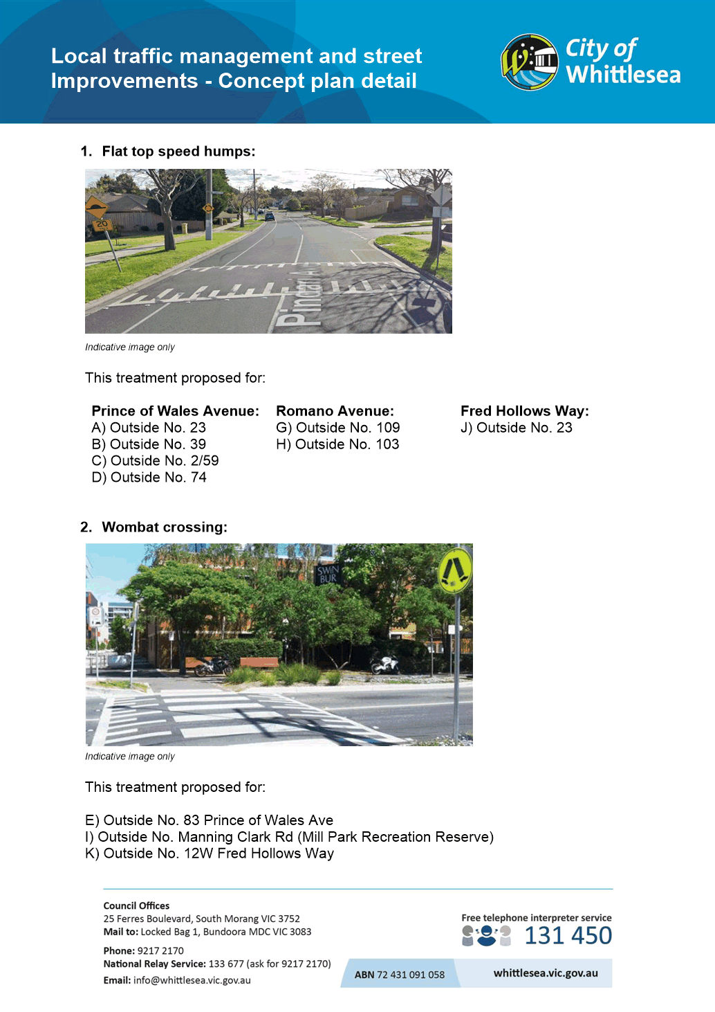

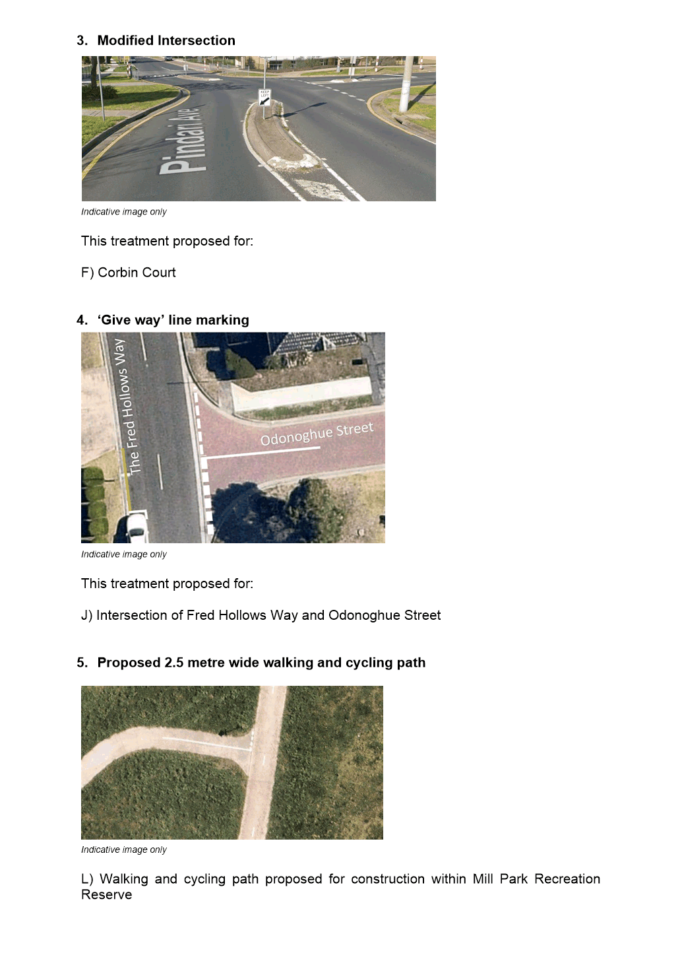

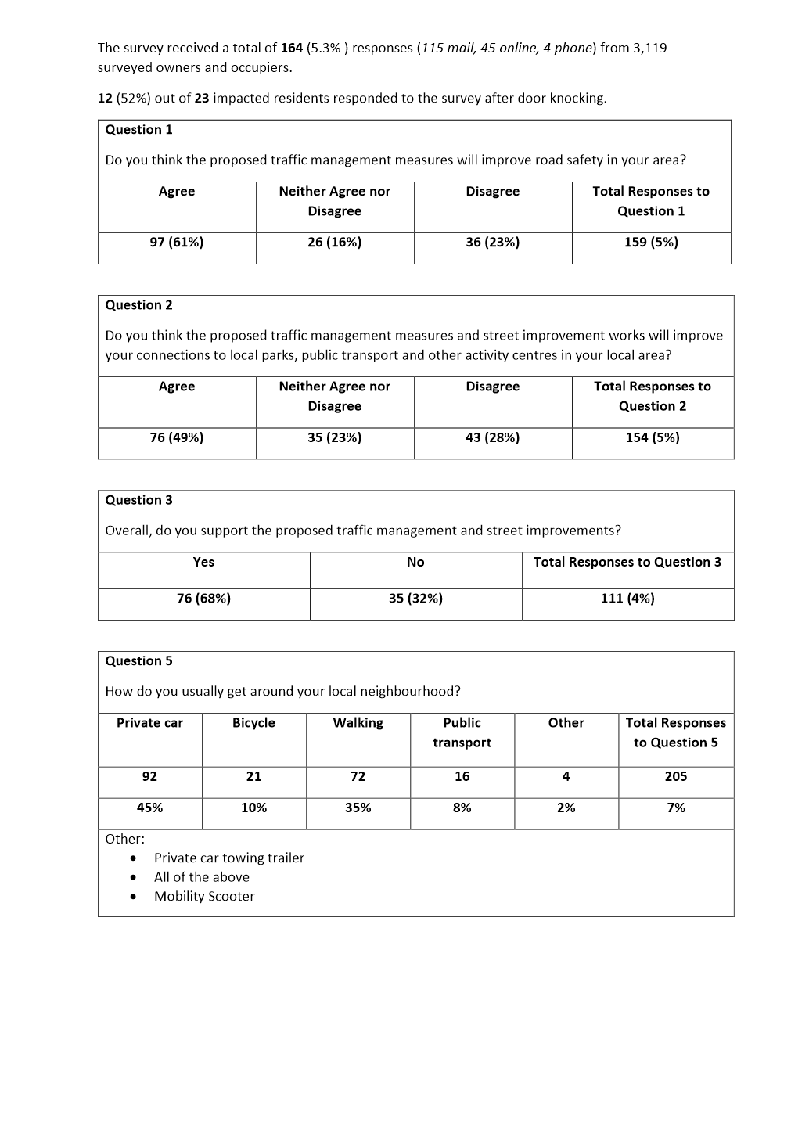

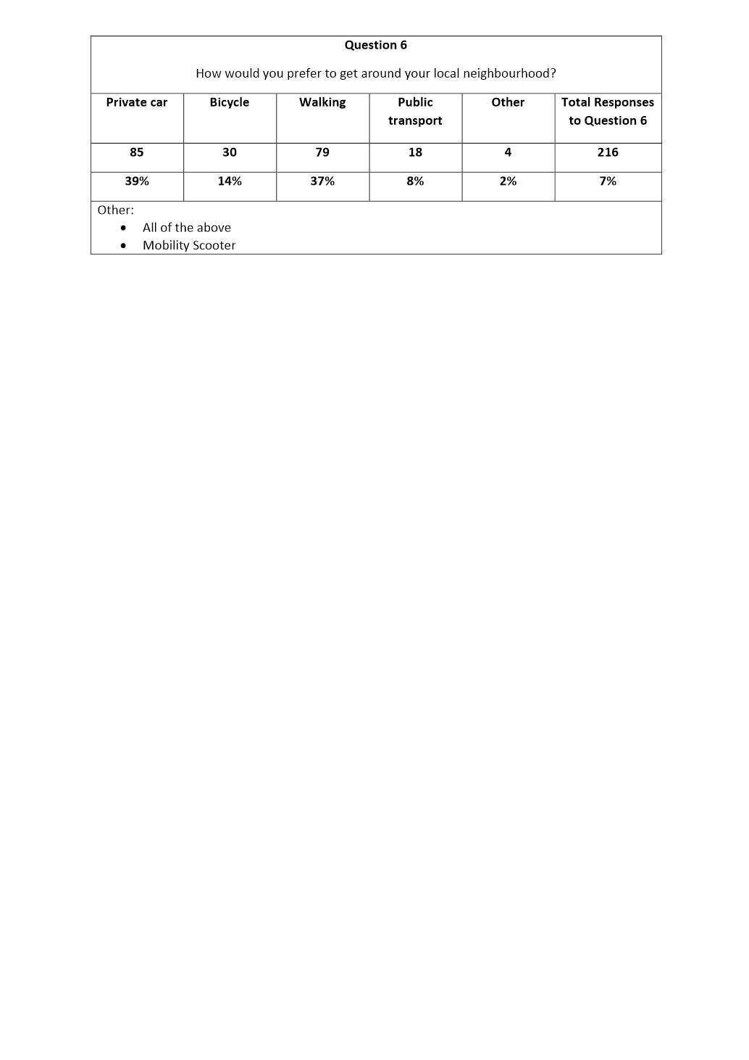

ITEM 6.2.2 FOR DECISION - Redevelopment of the Mill Park Basketball Stadium Contract 2021-15 - Tender Evaluation Report
Attachments: 1 Detailed Evaluation - Confidential
This attachment has been designated as confidential by the Director Infrastructure & Environment, under delegation from the Chief Executive Officer, in accordance with Rule 53 of the Governance Rules 2021 and sections 66(5) and 3(1) of the Local Government Act 2020 on the grounds that it contains private commercial information, being information provided by a business, commercial or financial undertaking that— (i) relates to trade secrets; or (ii) if released, would unreasonably expose the business, commercial or financial undertaking to disadvantage. In particular the report/attachment contains information regarding tenderer's prices.
Responsible Officer: Director Infrastructure & Environment
Author: Senior Contracts Executive

RECOMMENDATION SUMMARY
It is recommended that contract number 2021-15 for Redevelopment of the Mill Park Basketball Stadium:
• is awarded to Simbuilt Pty Ltd
• for the lump sum price of $2,121,695 (excl. GST)
Brief overview
The tender evaluation panel advises that:
• Six tenders were received
The recommended tender was the highest ranked and is considered best value because it has demonstrated that it has the highest ability to deliver this project in accordance with Council’s specified requirements.
rationale for recommendation
A redevelopment of the facilities at the Mill Park Basketball Stadium is essential to ensure that it meets the current standards required to encourage the growth and diversity in participation in sport. Functional improvements will also enable efficient and effective daily operations. A key role of Council is to provide opportunities for the community to participate in both structured and unstructured physical activity; and the provision of suitable facilities is a crucial requirement.
The recommended tenderer demonstrated the highest capability and capacity to deliver this project, and with minimal impact on Council and the community.
impacts of recommendation
Approval of this contract award will enable the project to commence in a timely manner within the required timeframe of the Economic Stimulus Grant from the State Government.
what measures will be put in place to manage impacts
Regular communication with the community will continue to minimise the impact of the works.
Report
Background
The purpose of this contract is to engage a contractor for the redevelopment of the Mill Park Basketball Stadium.
The Mill Park Basketball Stadium was constructed in 1991 by Council in partnership with Stadium Sport Victoria (‘SSV’) and the Department of Education. The facility is located on the grounds of Mill Park Secondary College, with a lease arrangement in place until 2041.
The Mill Park Basketball Stadium is the largest indoor stadium in the municipality and home to the Whittlesea City Basketball Association (‘WCBA’). As the municipality’s largest provider of basketball training, competition and facilitator of elite pathways, the WCBA services a current membership of 4500, which is expected to grow to over 7000 members by the end of the decade.
The non-compliant amenities at the facility are restrictive in allowing growth and diversity within the game. The redevelopment of Mill Park Basketball Stadium will provide a building that meets improved functional requirements, is accessible, inclusive and a sustainable facility. The scope includes the internal reconfiguration of the foyer, reception, canteen and office spaces, as well as refurbishment of existing public amenities, conversion of non-accessible player change amenities and an extension to create new player change rooms and amenities.
Tenders for the contract closed on 27 April 2021. The tendered prices and a summary of the evaluation are detailed in the confidential attachment.
EVALUATION
No member of the Tender Evaluation Panel declared any conflict of interest in relation to this tender evaluation.
A Tender Probity and Evaluation Plan was designed specifically for this tender process and it was authorised prior to this tender being advertised. All tenders received were evaluated in accordance with that plan. The evaluation involved scoring of conforming and competitive tenders according to these pre-determined criteria and weightings:
Criteria | Weighting
Price | 50%
Capability | 23%
Capacity | 20%
Impact | 7%
The weightings reflect the relative importance of each element to this particular contract. They were determined as being most appropriate after considering numerous factors including (but not restricted to) the time, quality, risk and contract management requirements which were likely to have the most impact on the achievement of best value.
Only tenders that were conforming and competitive were fully scored. Tender submissions that were evaluated as non-conforming or not sufficiently competitive were set aside from further evaluation. In cases where this occurred the reasons for that outcome are detailed in the confidential attachment.
The evaluation outcome was as follows:
TENDERER | CONFORMING | COMPETITIVE | SCORE | RANK
Tenderer A  Simbuilt Pty Ltd | Yes | Yes | 95.3 | 1
Tenderer B | Yes | Yes | 89.9 | 2
Tenderer C | Yes | Yes | 88.4 | 3
Tenderer D | Yes | Yes | 85.9 | 4
Tenderer E | Yes | Yes | 85.5 | 5
Tenderer F | Yes | Yes | 77.7 | 6
Refer to the confidential attachment for further details of the evaluation of all tenders.
FINANCIAL IMPLICATIONS
Sufficient funding for this contract is available in the budget for the Mill Park Basketball Stadium.
link to strategic risks
Strategic Risk Not linked to the risks within the Strategic Risk Register.
Links to WHITTLESEA 2040 AND the CoUNCIL Plan
Goal Connected community
Key Direction A healthy and safe community
The improved stadium is required to meet the population growth.
Declarations of Conflicts of Interest
Under Section 130 of the Local Government Act 2020 and Rule 47 of the Governance Rules 2021, officers providing advice to Council are required to disclose any conflict of interest they have in a matter and explain the nature of the conflict.
The Responsible Officer reviewing this report, having made enquiries with relevant members of staff, reports that no disclosable interests have been raised in relation to this report.
CONCLUSION
The tender from Simbuilt Pty Ltd was determined to be best value and it is considered that this company can perform the contract to the required standards.

Recommendation
THAT Council resolve to:
1. Accept the tender submitted by Simbuilt Pty Ltd for the sum of $2,121,695 (excluding GST) for the following contract:
Number: 2021-15
Title: Redevelopment of the Mill Park Basketball Stadium
subject to the following conditions:
a) Tenderer to provide proof of currency of insurance cover as required in the tender documents.
b) Price variations to be in accordance with the provisions as set out in the tender documents.
c) Tenderer to provide contract security as required in the tender documents.
2. Approve the funding arrangements detailed in the confidential attachment.

Council Resolution
Moved: Administrator Duncan
Seconded: Administrator Eddy

THAT Council resolve to adopt the Recommendation.
Carried

ITEM 6.2.3 For Noting - 165 - 185 Gordons Road, South Morang Development Plan
Attachments: 1 Development Plan - Location Plan
2 Development Plan - Concept Plan
3 Development Plan - Report
Responsible Officer: Director Planning & Development
Author: Senior Strategic Planner

RECOMMENDATION SUMMARY
1. Approve the 165 – 185 Gordons Road, South Morang Development Plan (June 2021), in accordance with Schedule 6 to Clause 43.04 of the Whittlesea Planning Scheme; and
2. Notify the proponent, landowners and submitters of the above.
Brief overview
• The consideration of a development plan for the area covered by the Development Plan Overlay (Schedule 6) has a long history.
o The proposed 165 – 185 Gordons Road, South Morang Development Plan has been prepared in accordance with the requirements of the relevant Development Plan Overlay (Schedule 6).
• The proposed Development Plan provides an acceptable layout and provides appropriate access and egress, roads, open space and vegetation protection that considers the fragmented nature of this development.
• The proposed Development Plan was placed on non-statutory exhibition between 12 January to 10 February 2021.
• A total of eight submissions were received; four submissions were non objecting submissions, two submissions from adjoining landowners outside of the development plan area and two submissions from landowners within the development plan area requesting changes to the Development Plan proposal.
rationale for recommendation
The proposed 165 – 185 Gordons Road, South Morang Development Plan has been prepared in accordance with the requirements of the relevant Development Plan Overlay (Schedule 6).
Non-statutory exhibition of the proposed Development Plan included notification of adjoining landowners/occupiers and landowners/occupiers of landholdings within the development plan area of the proposal and provided them with an opportunity to comment.
impacts of recommendation
Approval of the proposed Development Plan will allow for the consideration of subsequent planning permit applications for the development of the land for residential purposes in accordance with the subject Development Plan.
what measures will be put in place to manage impacts
Notification of Council’s decision on the proposed Development Plan will be provided to the proponent, all landowners within the development plan area all submitters.

Report
INTRODUCTION
The purpose of this report is to consider whether the 165 – 185 Gordons Road, South Morang Development Plan dated June 2021 (Development Plan), prepared by consultants Glossop Co on behalf of the owners of the land at 181 Gordons Road, South Morang (the proponent) is to the satisfaction of the responsible authority. The objective of the proposed Development Plan is to guide the future use and development of the land at 165, 171, 175,181 and 185 Gordons Road, South Morang.
The proposed Development Plan has been prepared in accordance with the provisions of Schedule 6 (DPO6) to the Development Plan Overlay. A Development Plan must be to the satisfaction of the responsible authority (Council) before a planning permit such as for subdivision and/or development on the site can be granted.
This report will discuss the background and the merits of the proposed Development Plan in the context of the applicable statutory framework and the submissions received from the non-statutory exhibition process.
SITE DESCRIPTION AND CONTEXT
The land in which the proposed Development Plan affects comprises of five parcels of land located at 165, 171, 175, 181 and 185 Gordons Road, South Morang. Each lot is separately owned and developed with single residential dwellings and associated outbuildings.
Attachment 1 identifies the Development Plan area.
Land within the Development Plan has an overall area of 4.47 hectares and is located on the southern side of Gordons Road between Vincent Recreation Reserve to the east and Evendrive Estate to the west.
The subject sites are affected by the General Residential Schedule 1 Zone and Vegetation Protection Overlay Schedule 1. The subject sites are also covered by the South Morang Local Structure Plan.
DEVELOPMENT PLAN PROPOSAL
A development plan was prepared and lodged with Council for the subject sites in August 2017. An assessment of that submission determined that a considerable amount of work was needed for the then development plan to address the requirements of Clause 43.04 and Schedule 6 to the Development Plan Overlay and the South Morang Local Structure Plan. Consequently at that time it was not suitable for endorsement. The proponent took the matter to the Victorian Civil and Administrative Tribunal (VCAT) and VCAT upheld Council’s decision.
Following this outcome, discussions between the proponent and Council continued. Revised versions of the proposed a development plan were prepared and lodged with Council in 2019 and 2020 which sought to address a series of concerns raised by VCAT and previous Council comments.
The key revisions of the development plan sought to address issues related (but not limited) to:
• Internal road network
• Access to the site
• Developable area
• Open space provision.
Consequently, a revised plan being the Development Plan was prepared and lodged with Council for the subject sites in December 2020. A consideration of the Development Plan by officer’s lead to a view that the Development Plan provided a reasonable response to the abovementioned issues.
Following this, in January 2021, the proposed Development Plan was placed on non-statutory exhibition between 12 January to 10 February 2021 to landowners within the Development Plan area and adjoining and abutting landowners and occupiers.
KEY FEATURES OF THE PLAN
The Development Plan, which includes an overarching Development Plan Concept Plan and accompanying text document, has been prepared in accordance with the Development Plan Overlay Schedule 6 to the Whittlesea Planning Scheme.
Attachment 2 shows the urban layout forming part of the proposed Development Plan.
In essence, the proposed development parcels are structured around a road and open space network which seeks to facilitate connections to the existing road network (Auburn Road and Gordons Road) and vehicle access and circulation within the relevant land parcels, provides open space and retains significant River Red Gums.
Specifically, the Development Plan proposes:
• A series of local parks which also serve to retain significant River Red Gums and provides a link to Vincent Recreation Reserve.
• An appropriate transition and interface between the development parcels, proposed open space and the adjoining Vincent Recreation Reserve.
• Internal road network which in the ultimate will connect residential development through from Auburn Road to Gordons Road.
• Resolution to access issues likely as a result of the staged development of the land through the provision of temporary site access options.
• Standard to medium density residential housing outcomes.
• Pedestrian and bicycle links throughout.
The ultimate build out of the Development Plan will result in approximately 100 new dwellings.
NON-STATUTORY EXHIBITION AND SUBMISSIONS
The proposed Development Plan was placed on non-statutory exhibition over a four-week period between 12 January to 11 February 2021.
Whilst there is no statutory requirement to advertise the proposed Development Plan, in accordance with Council practice a copy of the proposed Development Plan was sent to all land owners and occupiers of land adjoining the subject sites, landowners and occupiers of sites within the development plan area and relevant external authorities.
At the conclusion of the non-statutory exhibition period a total of eight submissions were received as follows:
• Four submissions were non objecting submissions from referral authorities
• Two submissions from adjoining landowners outside of the development plan area and;
• Two submissions from landowners within the development plan area.
The two submissions provided by adjoining landowners raised concerns beyond the scope of the proposed Development Plan and the two submissions provided by landowners within the development plan area sought changes to the exhibited version of the proposed Development Plan.
The following table details the submissions received and the officer response.
Submission Summary | Officer Response & Recommendations
Adjoining landowner – Tiandra Drive, South Morang
Raised concerns in respect to living next door to a future building site and the need for extra protective measures above standard requirements in order to minimise the impact of soil particles, building material particles, noise and increased traffic on their health, wellbeing and the environment. | No changes to the proposed Development Plan recommended.  In response to the review of the submission, Council officers communicated with the submitter the requirements and mitigation measures implemented as part of any future planning permit and building permit process, which ensures all amenity impacts to adjoining or nearby properties are reduced and managed to a level which appropriately protects human health and the environment.
Adjoining landowner – Auburn Road, South Morang
Raised concerns in respect to on street car parking impacts arising from the connection of Auburn Road into the proposed future street network.  The submission requested for access to the development plan area to only be facilitated off Gordons Road and for the proposal to only support low density/rural style future development outcomes. | No changes to the proposed Development Plan recommended.  It is noted that the adjoining Evendrive Development Plan (affecting the properties along Auburn Road) established a road network that would further support a future through connection to the adjoining properties affected by the proposed 165 – 185 Gordons Road, South Morang Development Plan.  Further to this, the Traffic Impact Assessment prepared as part of the proposed Development Plan considers the existing traffic conditions on connecting roads, traffic generation and access and supports the proposed internal road layout and access points.  The proposed Development Plan provides for an appropriate level of connectivity through and between the Development Plan areas. This is facilitated through two access/egress points which provide permeability and connectivity. It is not a desirable outcome for a Development Plan area to achieve only one access/egress point.  In respect to development density, it is noted that the area in which the proposed Development Plan falls is not a rural living precinct and zoning of the land parcels and the adjoining parcels is reflective of a more standard density residential outcome. To this end, it is considered that the development proposed is in keeping with the surrounding development densities.
Submission Summary | Officer Response & Recommendations
Landowner – 175 Gordons Road, South Morang
Raised concerns with respect to consultation between landowners, biodiversity matters and conservation area allocation and road layout within their land which is part of the proposed Development Plan.  The submission requested for further developable area to be included within the area allocated for conservation purposes within their land.  The submission further requested for public road construction to be removed from their land and included solely within 181 Gordons Road, South Morang. | Whilst there is no statutory requirement for the proponent to consult with affected landowners within the Development Plan, all affected landowners are consulted as part of the non-statutory exhibition process.  Upon review of the submission, Council officers negotiated changes to the proposed Development Plan as follows:  • Noting the relatively low habitat/conservation value of the portion of land within the south-western corner of the site. Council officers conclude that an increase in developable area of 175 Gordons Road within the south-western portion of the site can be achieved.  • Part of the site previously designated as ‘conservation reserve’ is now proposed to be designated as ‘open space’ and is to be subject to a series of tree protection and open space embellishment requirements.  No changes to the internal road layout are recommended in response to the submission, as it is considered that the proposed road layout provides appropriate site access to balance the future potential fragmented nature of development and ensures each landowner can develop independently.
Landowner – 185 Gordons Road, South Morang
Raised concerns with respect to open space allocation, stormwater outfall, temporary access and traffic management.  The submission provided an alternative concept proposal.  The submission requested for a reduction of open space allocation within their site and as a result an increase in developable area. | After reviewing the submission, Council officers negotiated the following changes to the proposed Development Plan:  • Council officers determine than an increase in developable area within the southern section of the site can occur, subject to achieving the retention of an area of open space in accordance with Council’s Open Space Strategy and the South Morang Local Structure Plan, achieving open space embellishment requirements and continued retention of River Red Gums (trees 255, 257, 258).
Submission Summary | Officer Response & Recommendations
Fire Rescue Victoria (formally Country Fire Authority)
Provided support for the proposed Development Plan. | No changes recommended to the proposed Development Plan.
Environmental Protection Agency
Raised no concerns with the proposed Development Plan. | No changes recommended to the proposed Development Plan.
Melbourne Water
Raised no concerns with the proposed Development Plan. | No changes recommended to the proposed Development Plan.
Aus-Net Services
Raised no concerns with the proposed Development Plan. | No changes recommended to the proposed Development Plan.
POST EXHIBITION FINAL REVIEW OF PLAN
In response to submissions to the proposed Development Plan, Council officers communicated to the proponent and both landowners at 175 and 185 Gordons Road, South Morang the changes required to the proposed Development Plan.
Council officers requested the proponent engage with both landowners at 175 and 185 Gordons Road, South Morang to discuss the concerns of both submissions and make changes to the proposed Development Plan in line with the officer response & recommendations as outlined in the above submission table.
As a result an amended version of the proposed Development Plan Report and Concept Plan (text and plans) was provided to Council officers for comment and is attached to this Report (Attachment 2 and 3).
CRITICAL DATES
Original Development Plan Submission | January 2017
Victorian Tribunal and Administrative Tribunal Hearing | September 2017
Victorian Tribunal and Administrative Tribunal decision on Development Plan | April 2018
Resubmission of Development Plan | November 2018
Further resubmissions of Development Plan proposals in response to Council Requests for Further Information | December 2019, February 2020, April 2020, July 2020
Latest resubmission of Development Plan proposal | December 2020
Non-statutory exhibition period | 12 January – 10 February 2021
DISCUSSION
One of the key issue affecting amended version of the proposed Development Plan as set out in Attachments 2 and 3 is site access considerations and how each separate landholding could be appropriately delivered in a staged development independently of each other given that the parcels comprising the proposed Development Plan are owned by different entities. As part of the consideration of the proposed Development Plan, it was important to ensure that road access to Gordons Road was practical and safe and that there did not end up being any isolated parcels which could not be developed. At the same time, it was also important to ensure that the development parcels were practical and the overall outcome was an appropriate outcome having regard to all of the other relevant planning considerations. (e.g. avoiding “back of fence” style outcomes for instance).
The various issues were considered at length as part of the VCAT Hearing.
Appropriate site access is required to balance the future potential fragmented nature of development and ensure each landowner can develop independently. Council required that the proposed Development Plan produced an outcome which achieved appropriate site access, a logical road network and pedestrian and vehicle connectivity throughout.
The Traffic Impact Assessment prepared as part of the proposed Development Plan considered that the existing private driveways currently providing access to individual lots, cannot appropriately service future development as proposed by the proposed Development Plan, and as a result a highly permeable road network is required across the entire development plan area. In addressing this point, the Development Plan provides a road network that connects Gordons Road to Auburn Road and achieves the following requirements:
• Facilitates a 7.3m public road carriageway in accordance with Council’s standards.
• Provides public road access to all five landholdings within the proposed Development Plan in both the interim and ultimate.
• Limits additional access points to Gordons Road to protect its functionality and safety.
• Designs roads to allow for the safe and convenient movement of pedestrians, cyclists and service vehicles (such as garbage trucks) both in the interim and ultimate.
In order to achieve the above, two interim road requirements for the properties at 171, 175 and 181 Gordons Road, South Morang are proposed and practical solutions have had to be provided to have regard to how development may transpire.
171 and 175 Gordons Road, South Morang interim and ultimate road requirements
To ensure either landowner can develop independent of the adjoining landowner an interim road construction is proposed for the Gordons Road connection within 171 and 175 Gordons Road.
The proposed Development Plan shows this road connection centred along both property boundaries, however, the exact location of the connection will be dependent on the sequencing of development. If both lots are to be developed at the same time the connection can be evenly located across both lots. If one lot is developed before the other a greater proportion of the road will need to be provided as follows:
• The first landholding to develop must construct a 6.0m carriageway and 4.5m nature strip along the boundary of the adjoining landholding, constructed as a public road to be transferred to Council.
• The second landholding to develop must construct a 1.3m carriageway extension and 4.5m nature strip within their property boundary to complete the road connection to Gordons Road.
181 Gordons Road, South Morang interim and ultimate road requirements
Should the landowners at 175 or 185 Gordons Road not wish to develop, the proposed public road network could result in the future development of land at 181 Gordons Road, South Morang being landlocked and not accessible by a public road.
Therefore, to ensure that 181 Gordons Road, South Morang can develop independent of an adjoining landholding interim site access is proposed as follows:
• Constructed along the eastern boundary of 181 Gordons Road, South Morang and must connect public access from Gordons Road to the internal public road network via a laneway to Council’s standards.
• Be facilitated through a series of agreements which provides Council and the public access over the temporary accessway, addresses public liabilities and secures the re-alignment of services and closure of the temporary access as part of the ultimate road configuration.
The landowner at 181 Gordons Road, South Morang will need to bear all relevant costs associated with the preparation of and execution of the above agreements to give effect to the above requirements before the grant of any planning permit for 181 Gordons Road prior to development of 175 and 185 Gordons Road.
Overall, it is considered that the proposed Development Plan in its amended form as per attachments 2 and 3 provides for a practical and positive way forward given the difficulties of the fragmentation of the land within the Development Plan Overlay area. Council officers have strived to ensure a reasonably balanced outcome for all landowners but have also been cognoscente of the constraints on each of the relevant land parcels. As far as practicable, officers think that the overall outcome is a fair and reasonable outcome with each parcel having appropriate levels of developable land, road infrastructure, open space and tree conservation and at the same time provides an acceptable outcome for the way that the overall area will be developed.
In addition to all of the above considerations, Council officers also had regard to the requirements of Clause 56 to ensure that any subdivision meets the requirements of this clause.
Policy strategy and legislation
It is considered that the 165 – 185 Gordons Road, South Morang Development Plan in its amended form, as set out in Attachment 2 and 3, is generally consistent with the objectives and general provisions of the State Planning Policy Framework.
Clause 11 – Settlement
The Development Plan is consistent with this clause by contributing to a number of facets of planning; including housing diversity, transport links and good urban design.
Clause 15 – Built Environment and Heritage
The Development Plan is generally consistent with this clause. The design of the development layout satisfactorily responds to the site features and constraints. The residential development includes elements which will assist in making it attractive, liveable, walkable and cyclable.
Clause 16 – Housing
The Development Plan is generally consistent with this clause. The development increases the supply of housing in an existing urban area across five single dwelling sites. The Development Plan ensures that the site is connected to the broader area.
Clause 18 – Transport
The Development Plan is consistent with this clause. The Development Plan includes appropriate walking and cycling infrastructure connections to the existing road and public open space network.
Clause 19 – Infrastructure
The Development Plan is generally consistent with this clause. The development makes provision for appropriate infrastructure to service the development.
link to strategic risks
Strategic Risk Not linked to the risks within the Strategic Risk Register.
The Development Plan and supporting documentation consider the proposal to be appropriate for residential development and will not result in any risks to the community or the broader environment.

Links to whittlesea 2040 and the CoUNCIL Plan
Goal Liveable neighbourhoods
Key Direction Well-designed neighbourhoods and vibrant town centres

The 165 – 185 Gordons Road, South Morang Development Plan will ensure that the residential development of the development plan area will be well designed, contribute to housing diversity within the Municipality and responds to the constraints affecting all landholdings. Future residential development will help build connection to place and community through a number of key elements including; permeable street network, cycle and pedestrian links to the Vincent Recreation Reserve and contribution to community infrastructure and open space.
Declarations of Conflicts of Interest
Under Section 130 of the Local Government Act 2020 and Rule 47 of the Governance Rules 2021, officers providing advice to Council are required to disclose any conflict of interest they have in a matter and explain the nature of the conflict.
The Responsible Officer reviewing this report, having made enquiries with relevant members of staff, reports that no disclosable interests have been raised in relation to this report.
Conclusion
Extended discussions and negotiation with the proponent by Council officers and through consultation with affected landowners within the relevant area has resulted in an amended version of the proposed Development Plan that provides for an acceptable outcome to support future development of the five separate landholdings.
The amended version of the proposed Development Plan (as per attachments 2 and 3) responds to site access constraints and ensures that future residential development of these landholdings is in keeping with the surrounding residential area.
To this end, it is recommended that the 165 – 185 Gordons Road, South Morang Development Plan as contained in Attachments 2 and 3 of this report is approved by Council in accordance with Schedule 6 of the Development Plan Overlay (Clause 43.04) of the Whittlesea Planning Scheme.

RECOMMENDATION
THAT Council resolve to:
1. Approve the 165 – 185 Gordons Road, South Morang Development Plan (June 2021), in accordance with Schedule 6 to Clause 43.04 of the Whittlesea Planning Scheme; and
2. Notify the proponent, landowners and submitters of the above.

Council Resolution
Moved: Administrator Eddy
Seconded: Chairperson Wilson

THAT Council resolve to adopt the Recommendation.
Carried

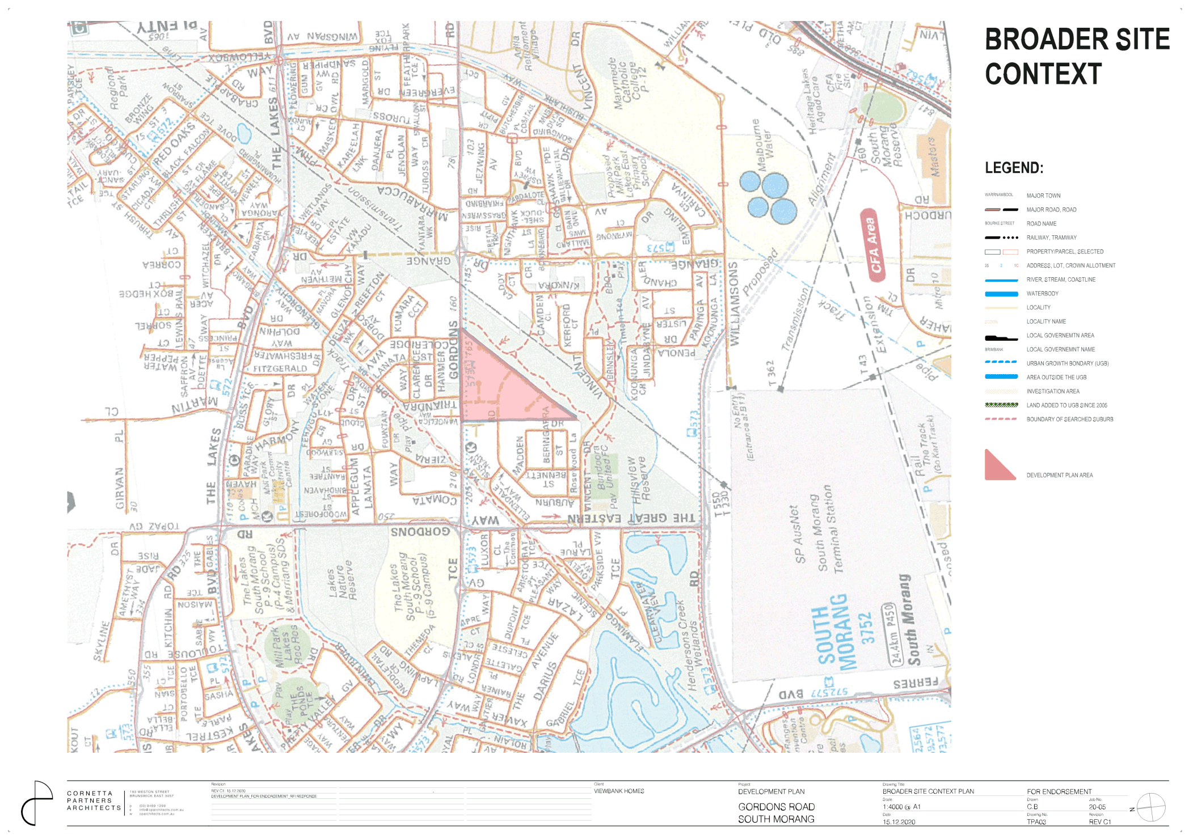
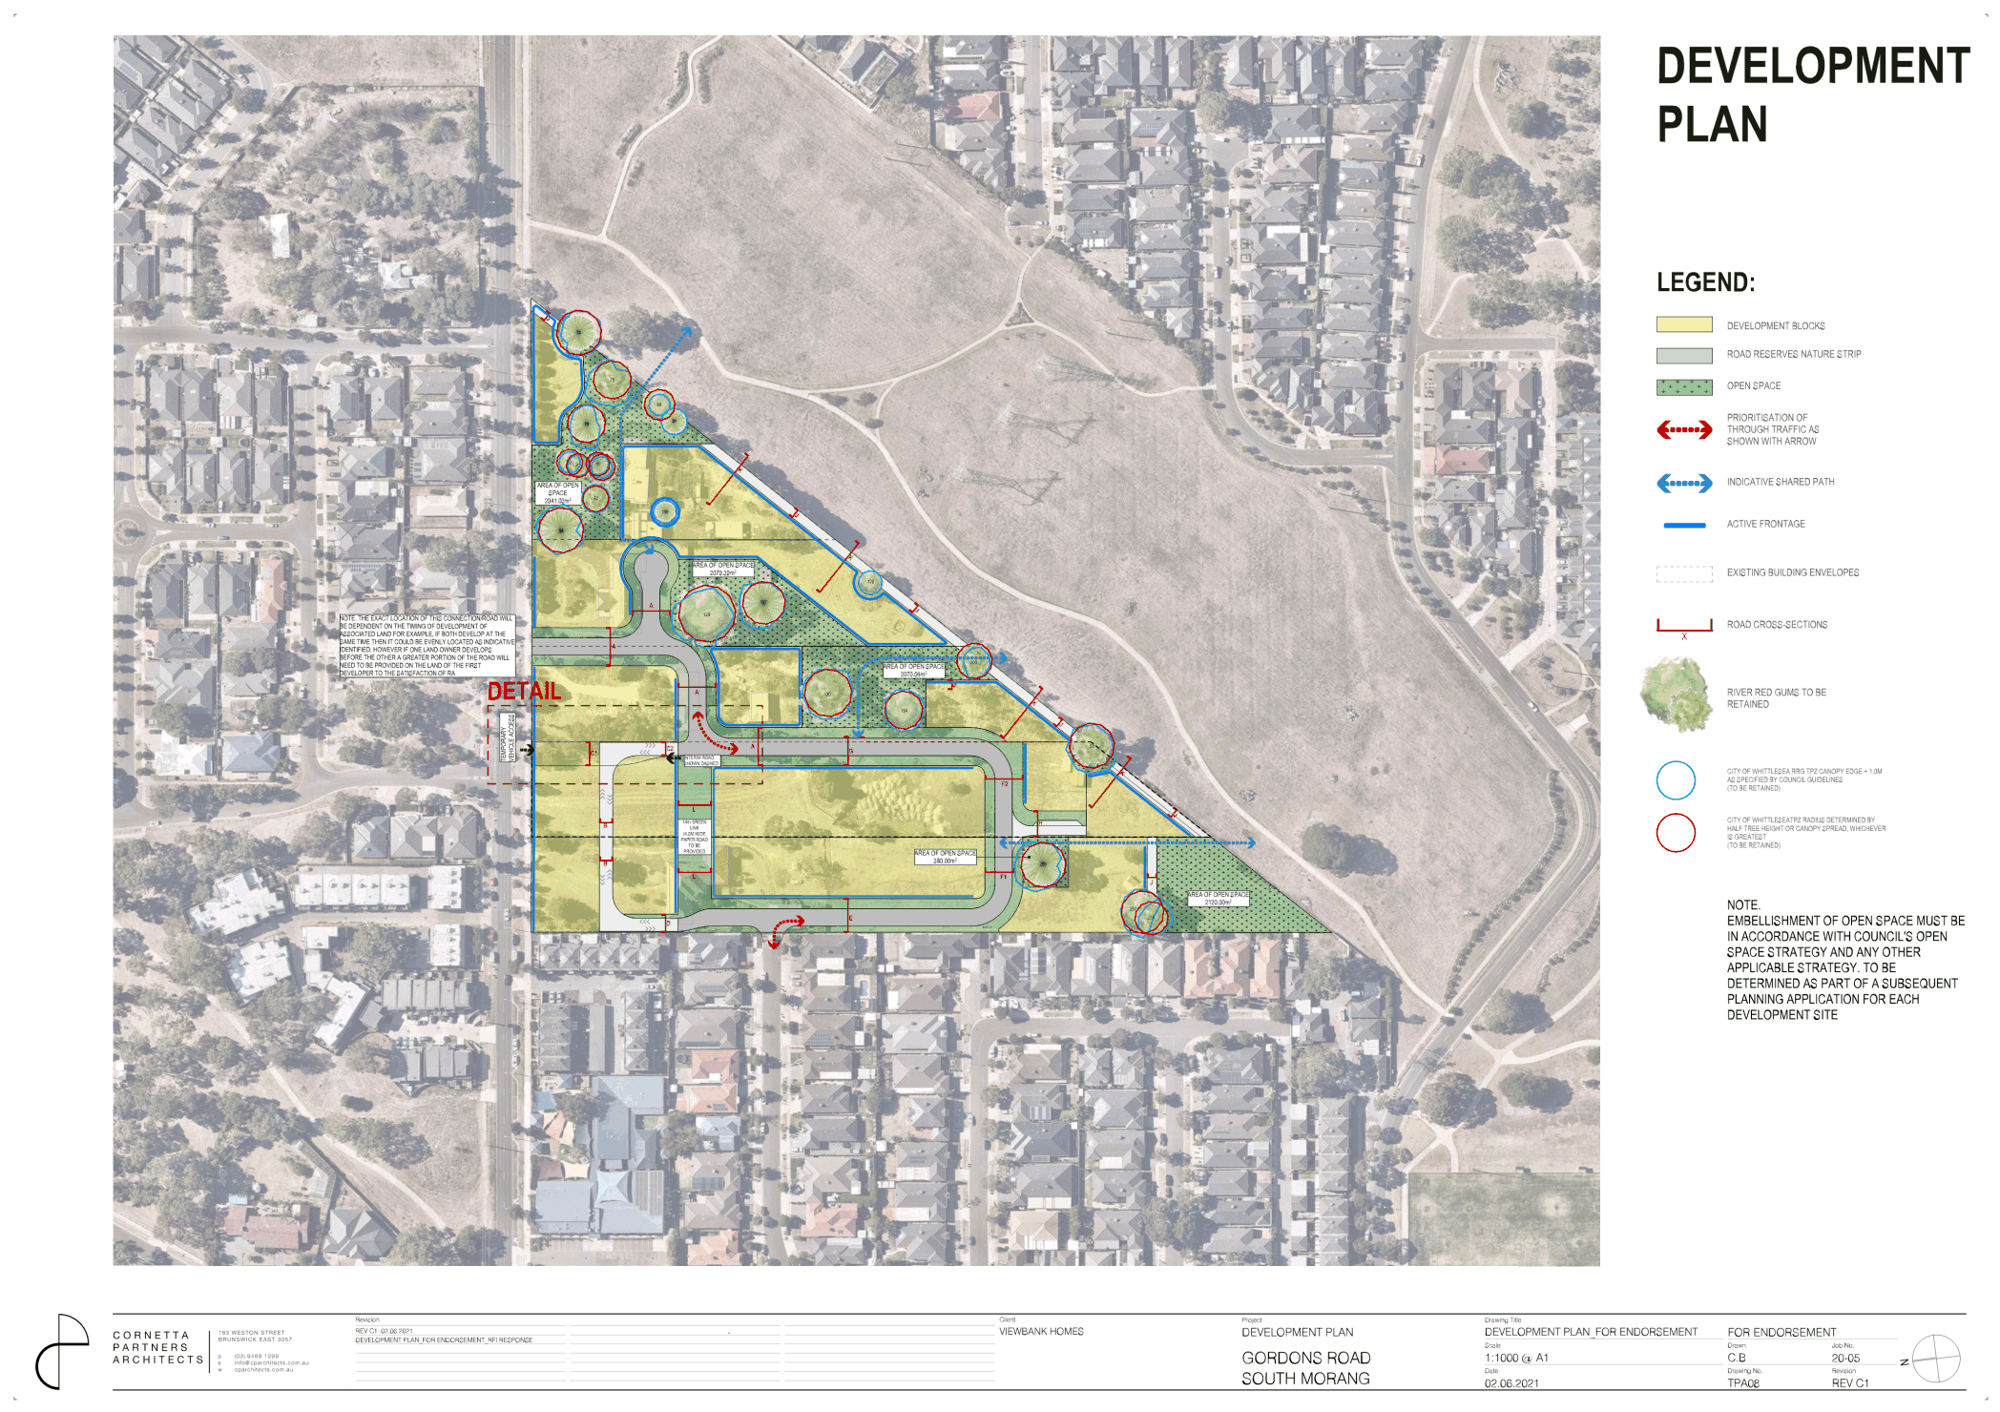
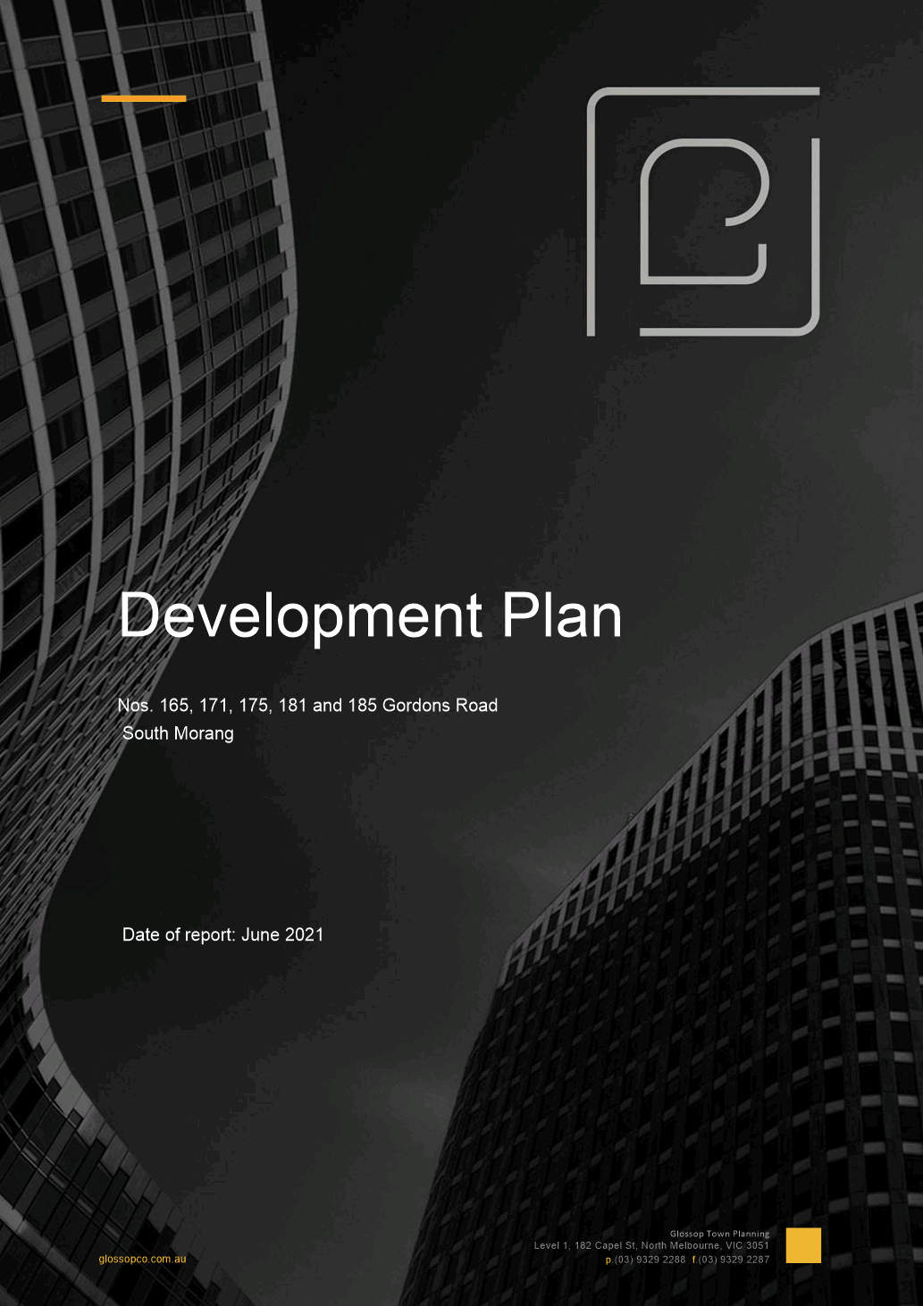

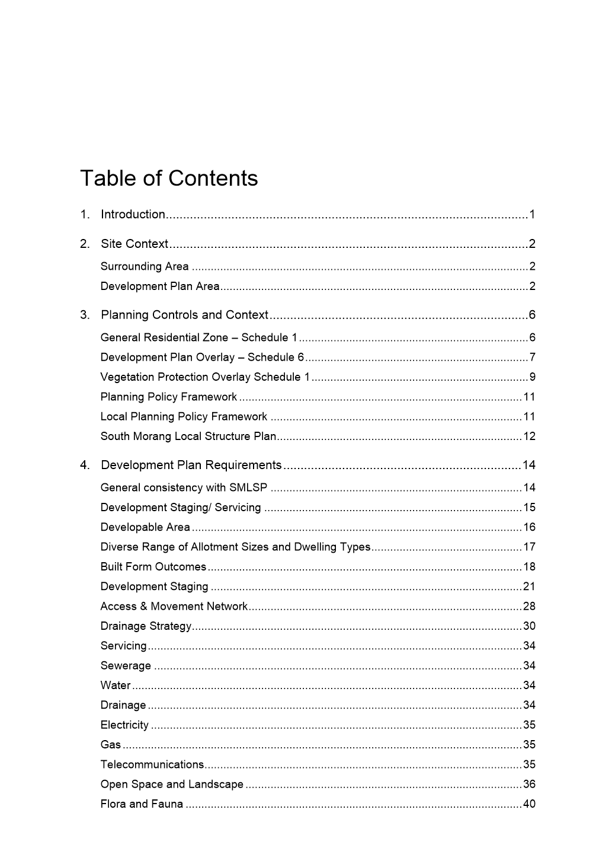

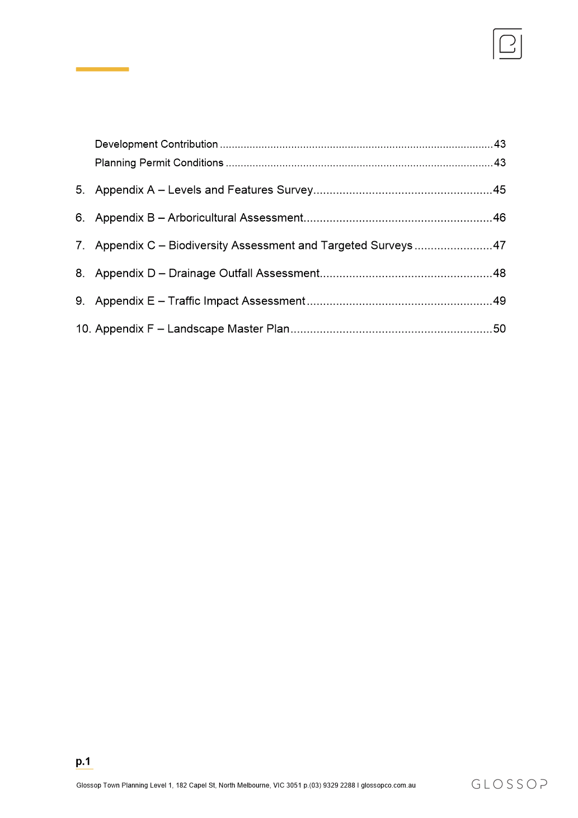

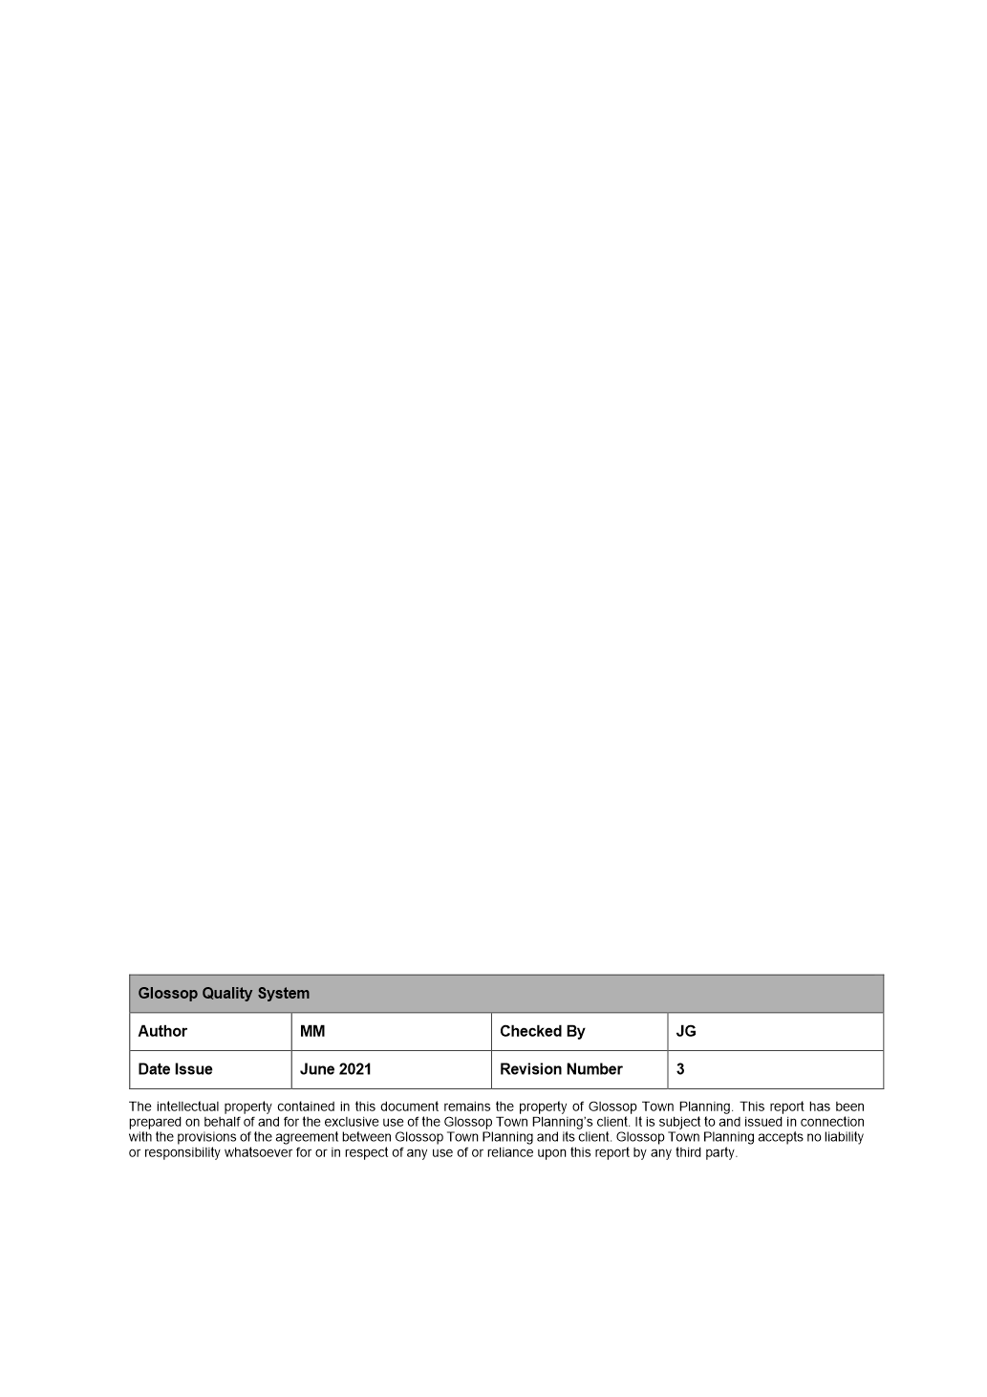

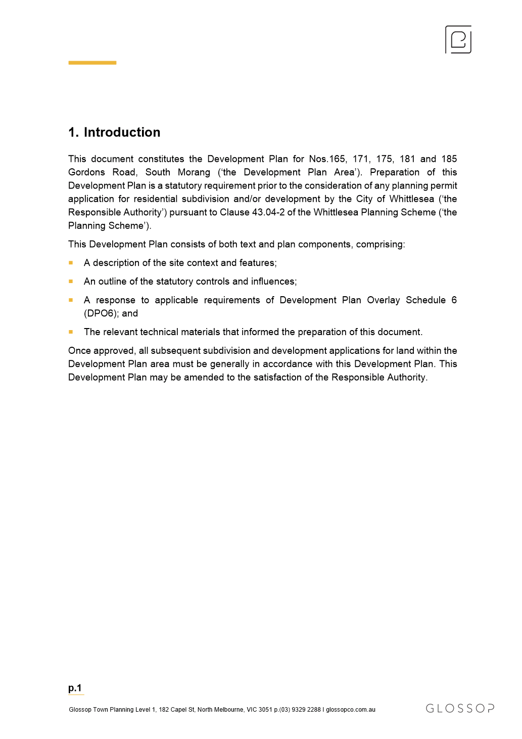

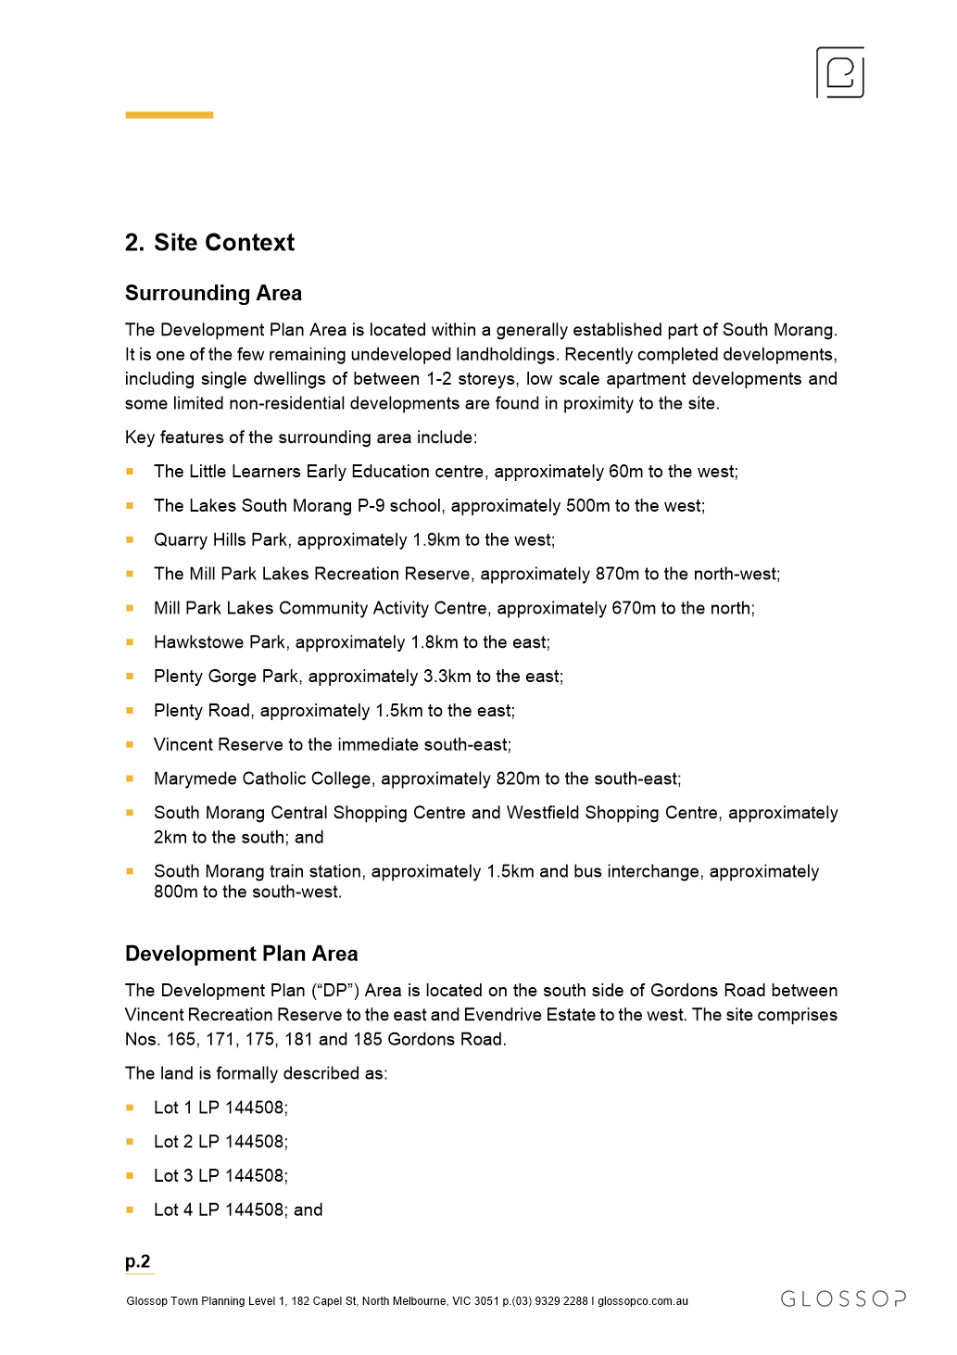

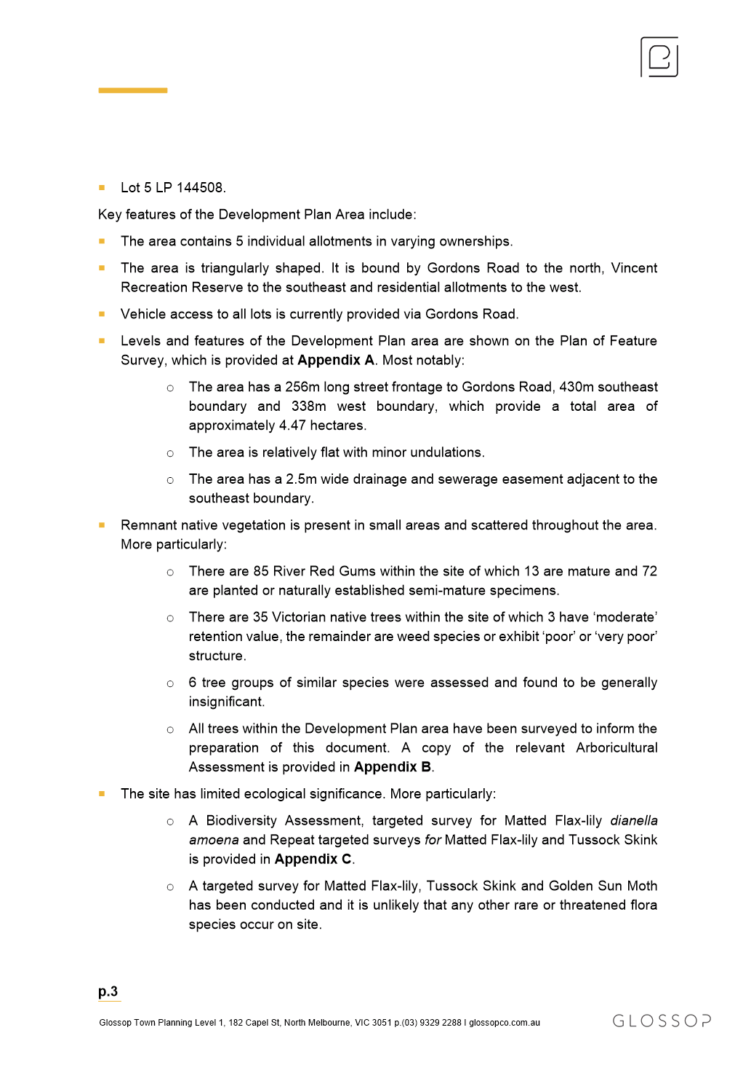

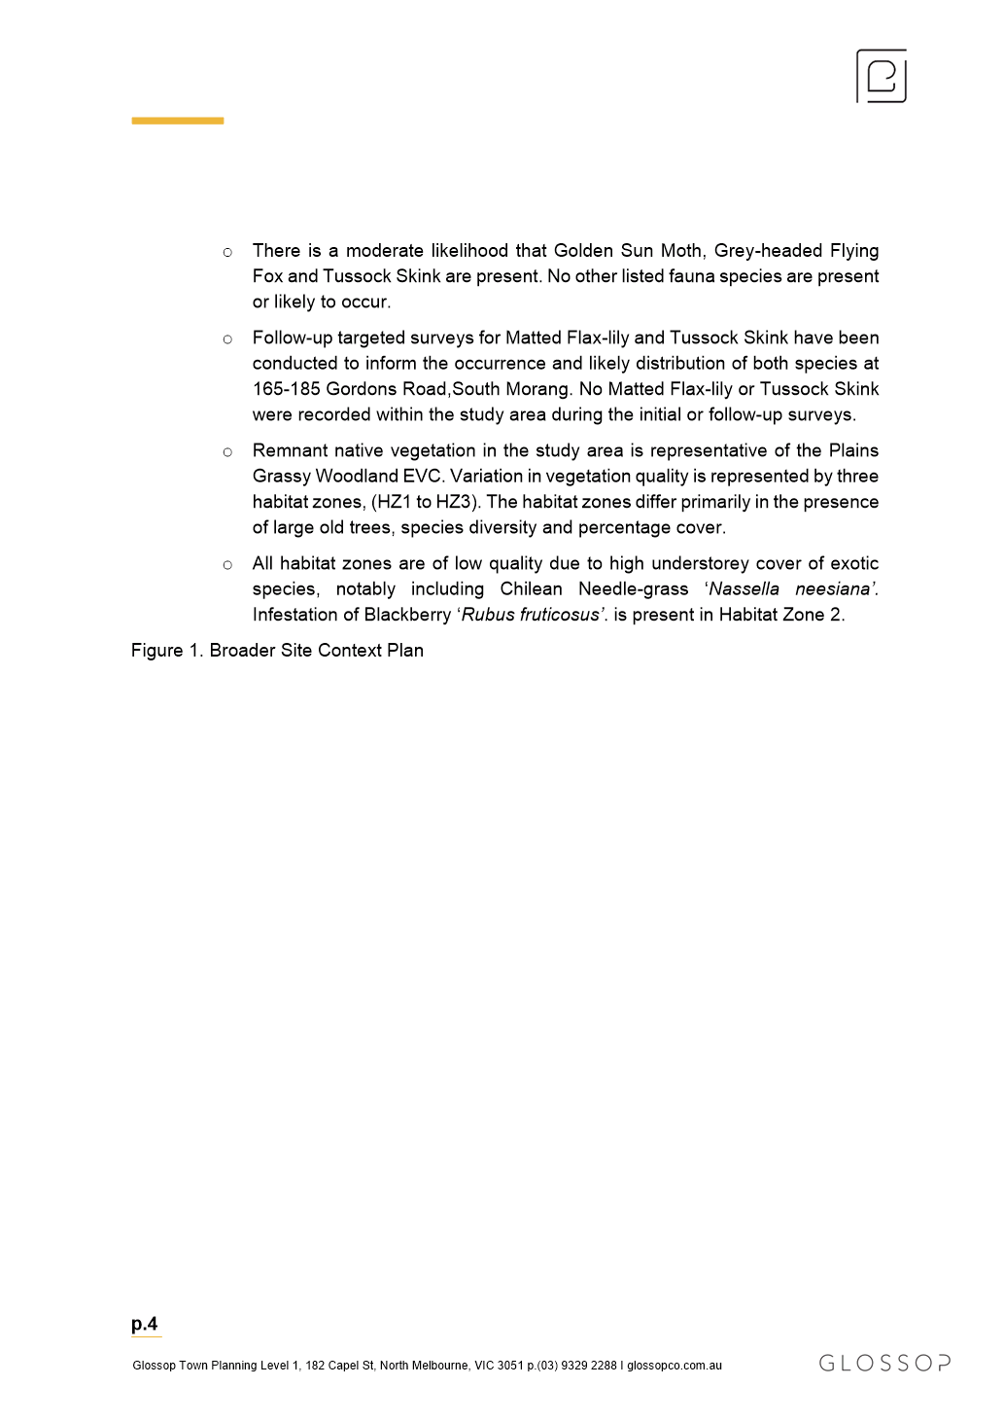
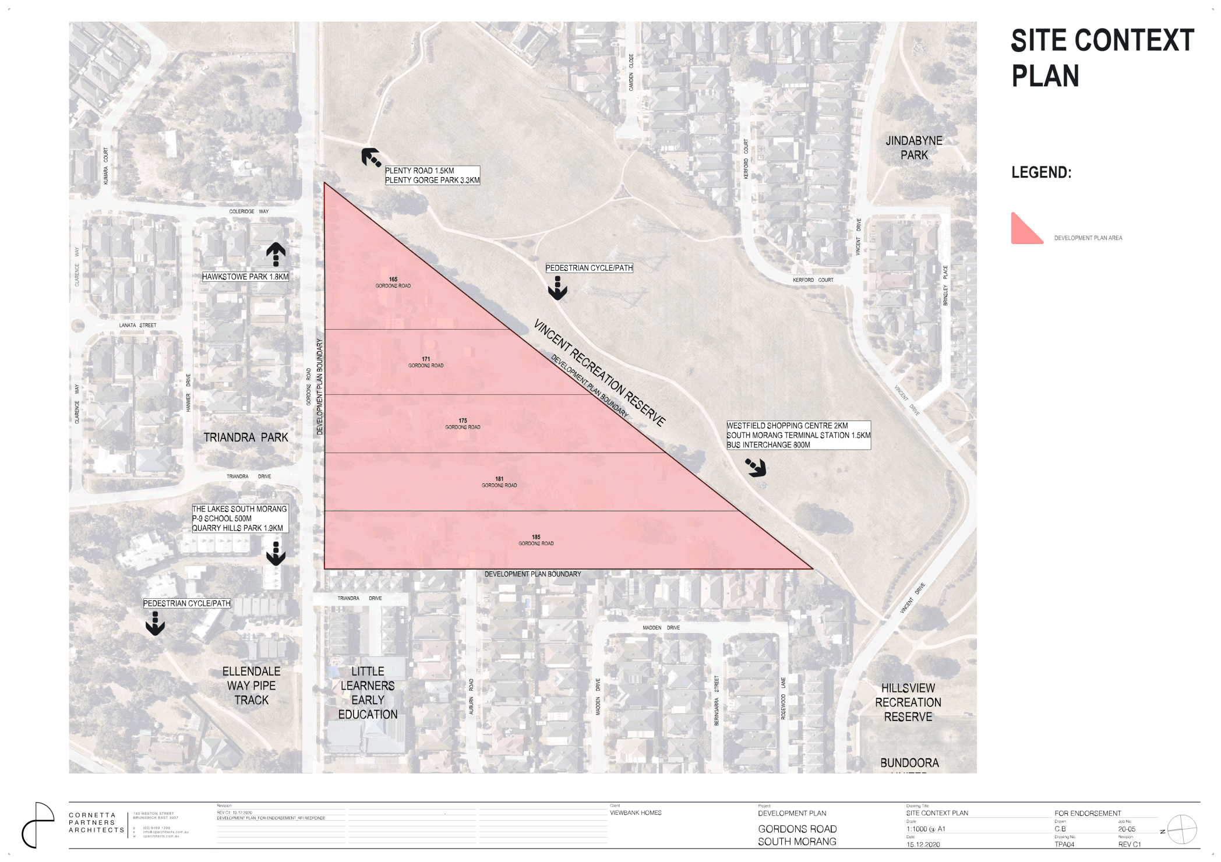
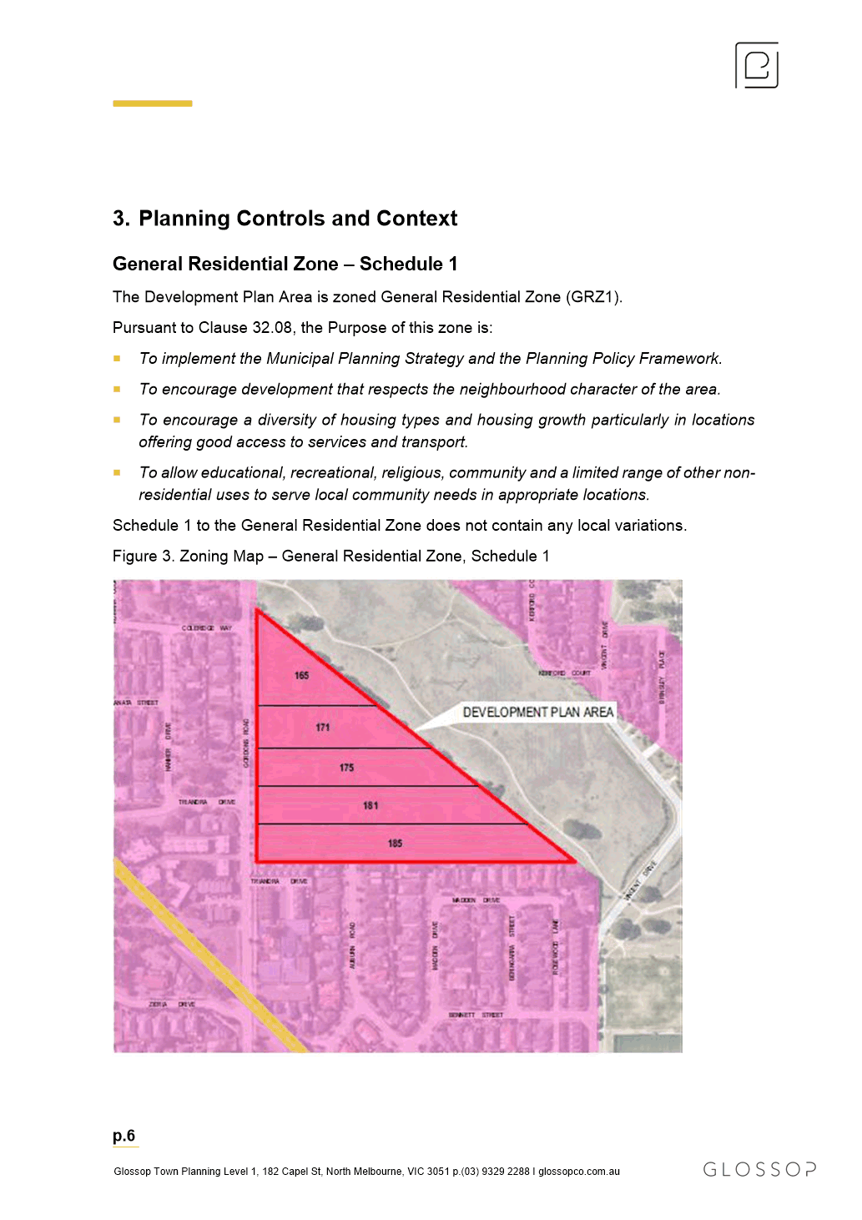

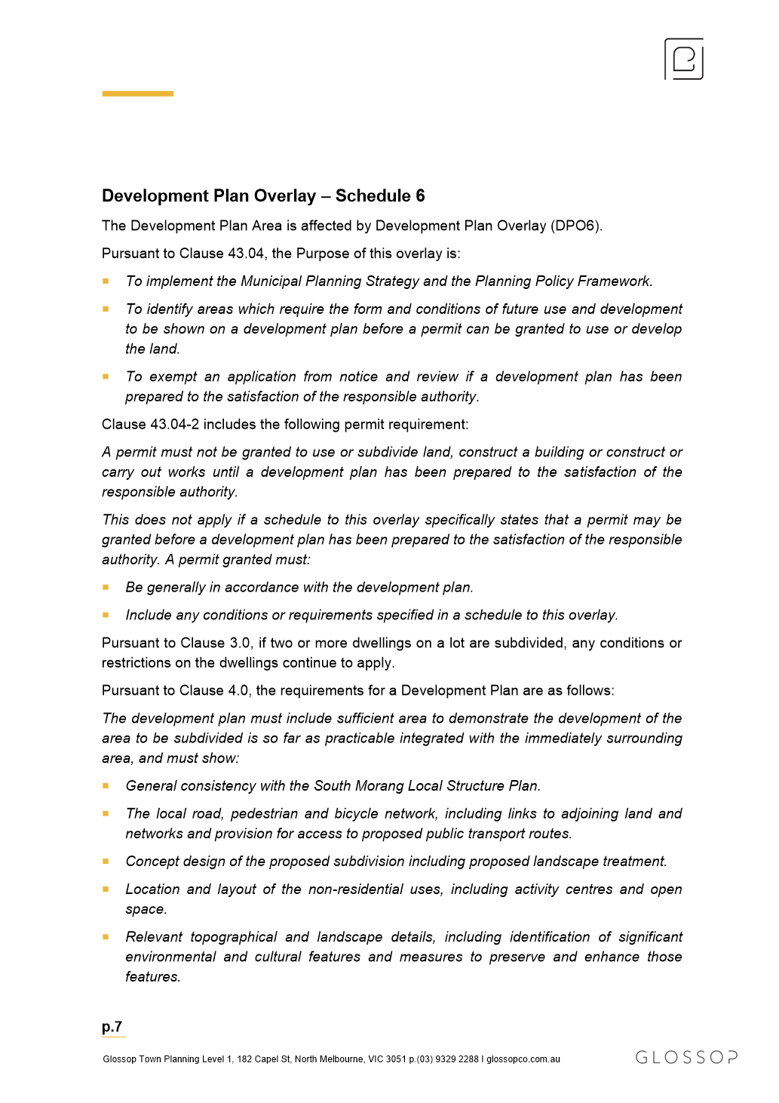

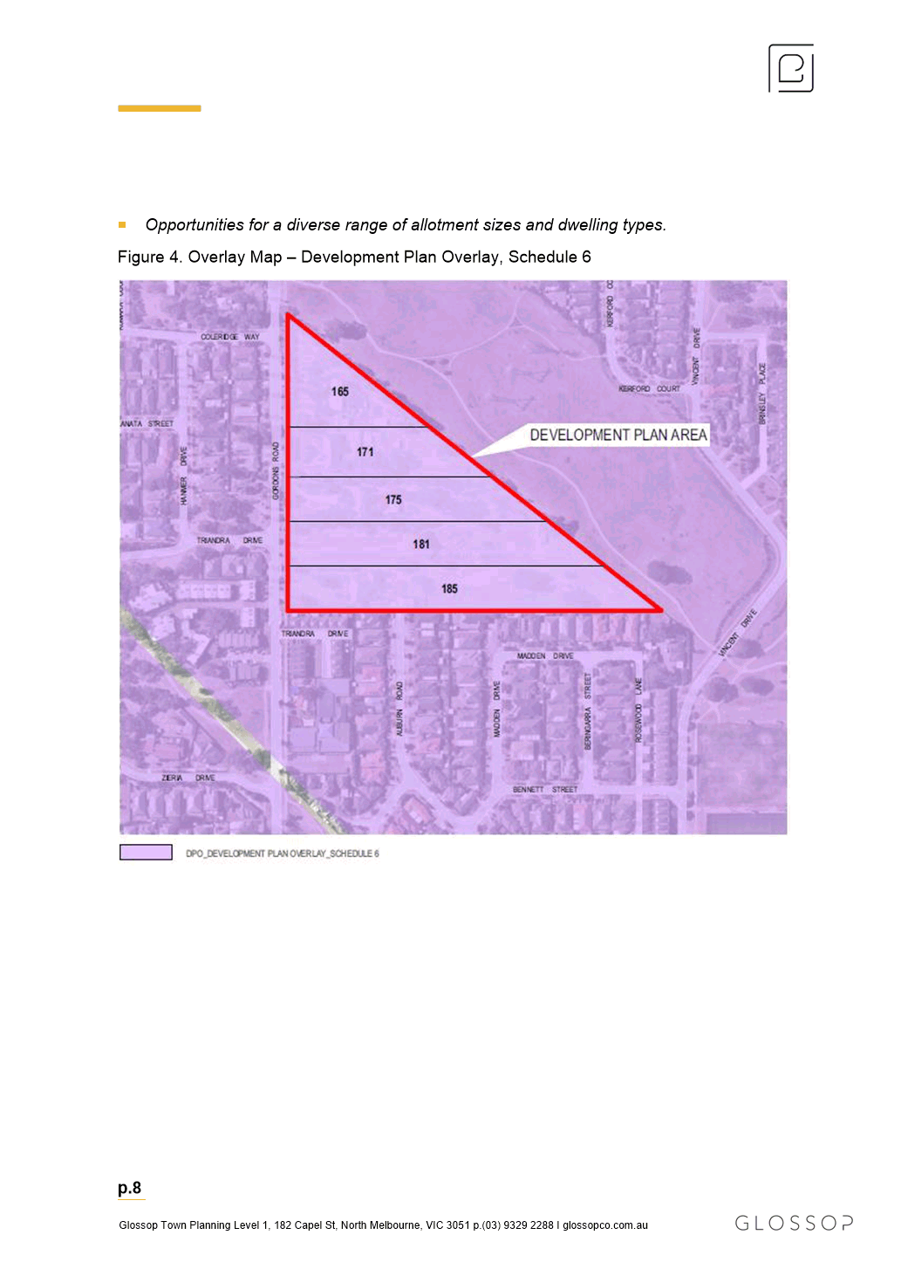

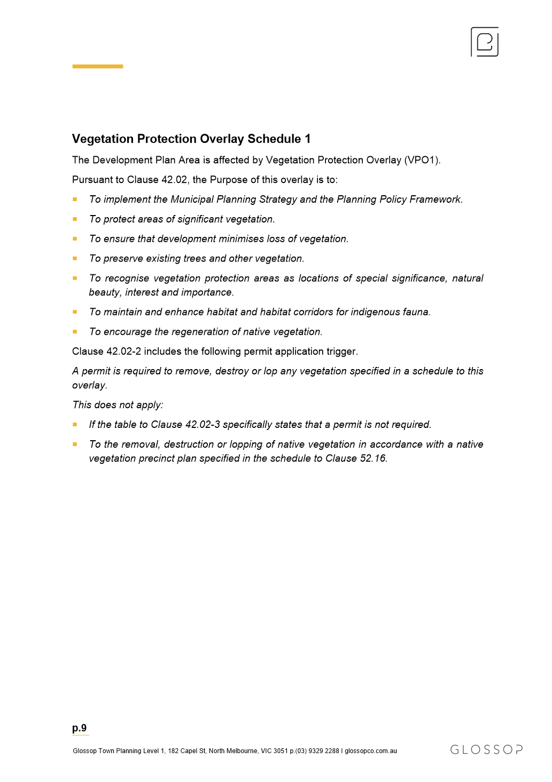

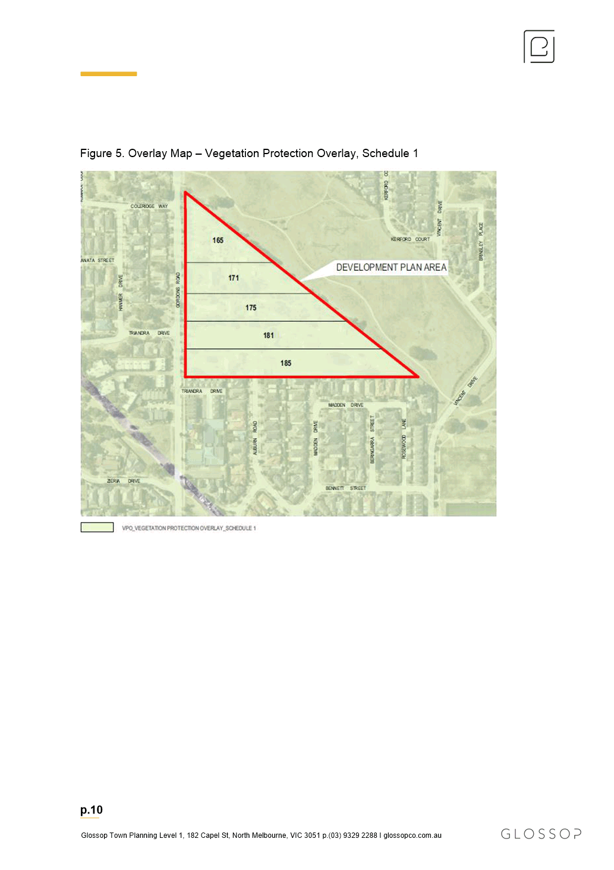

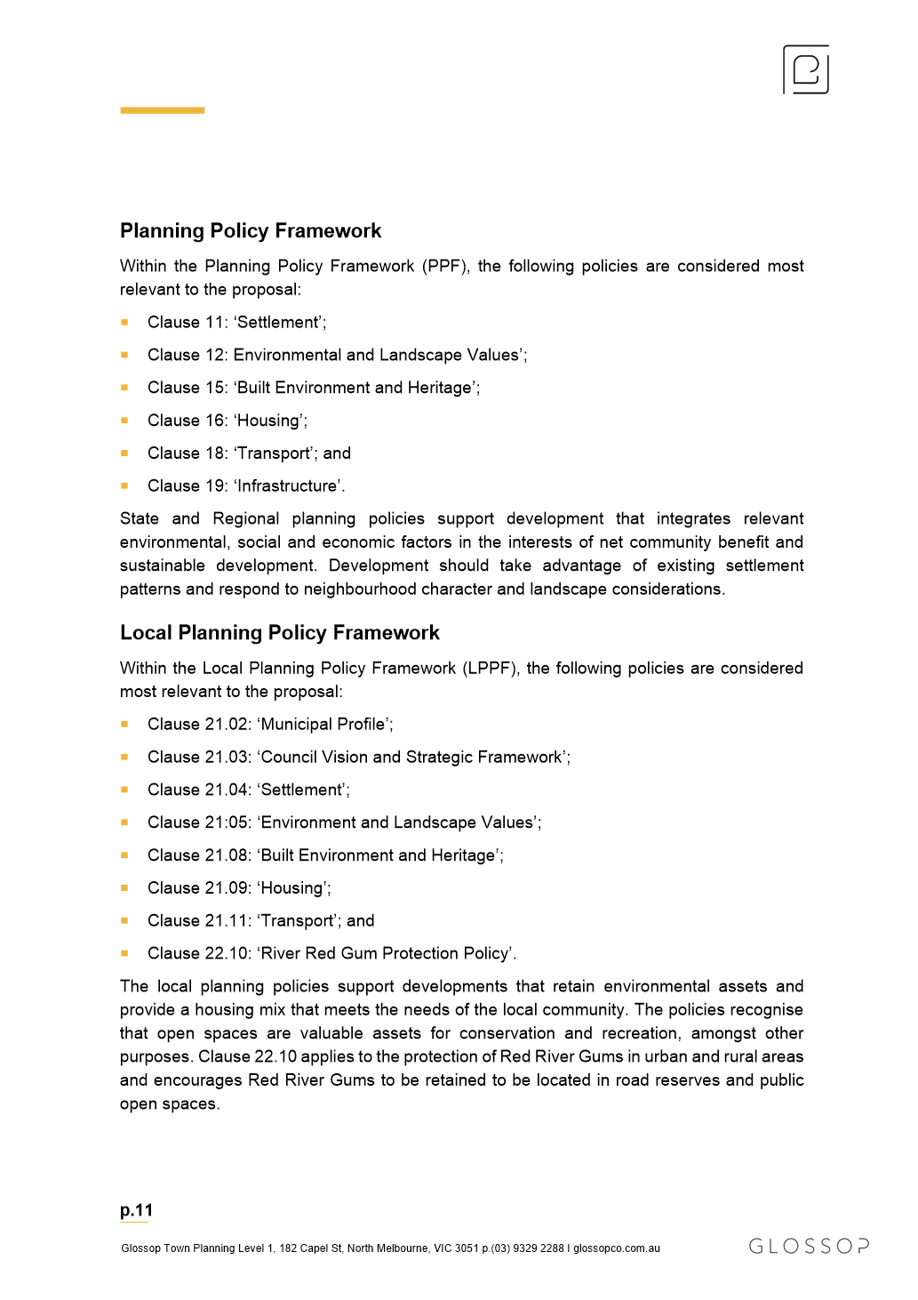

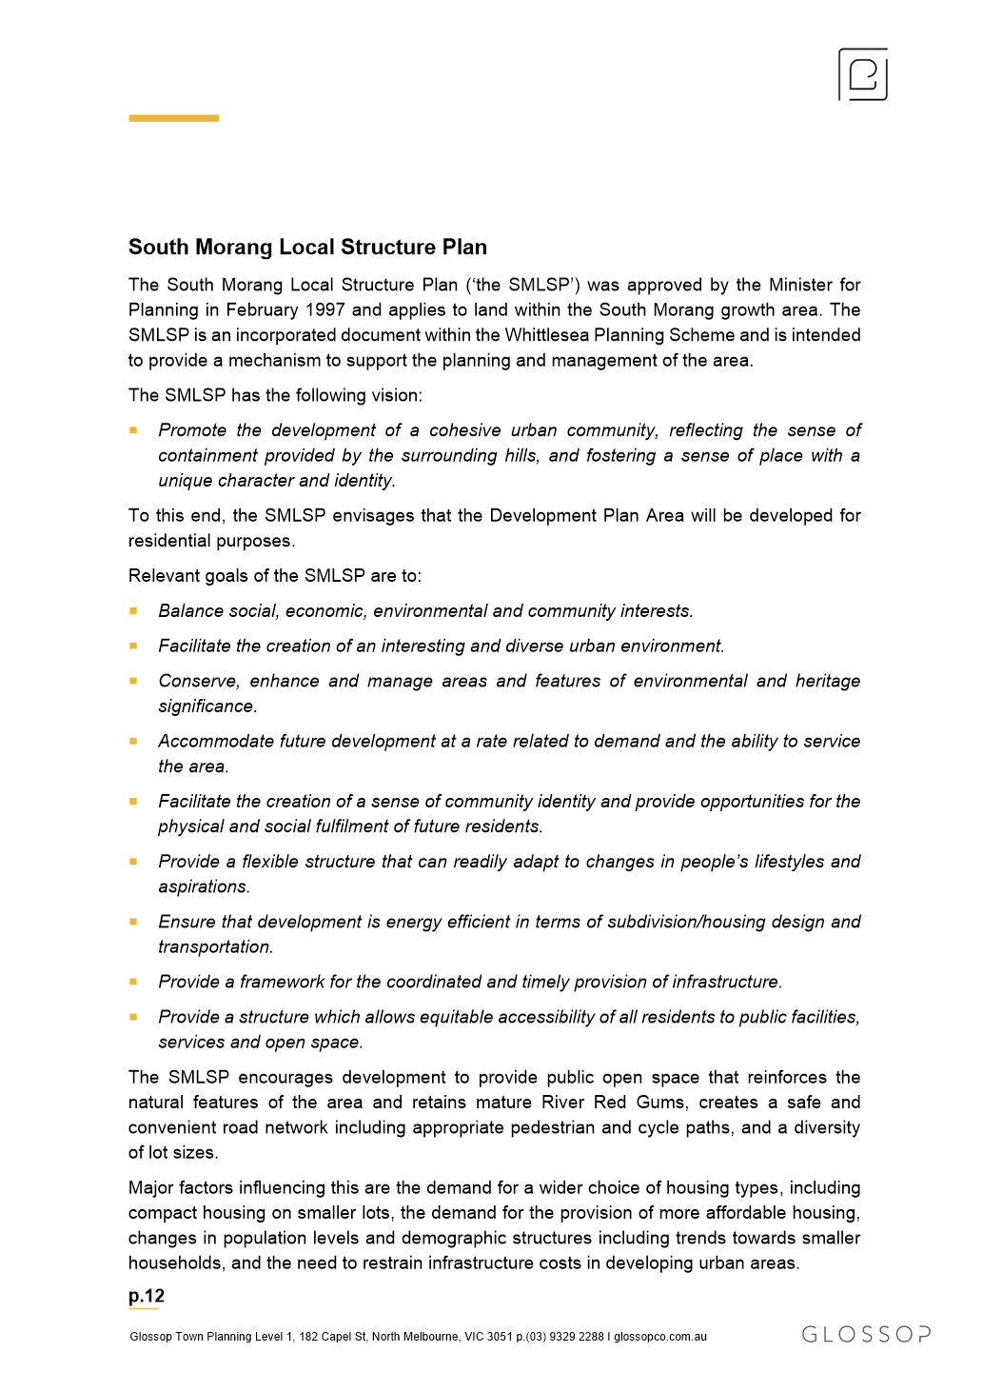

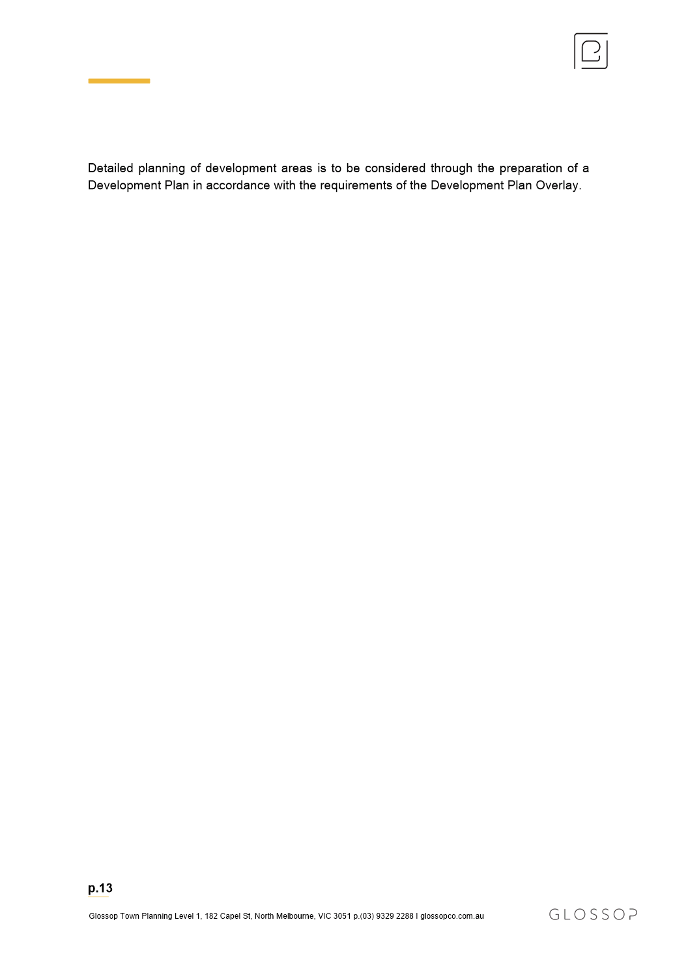

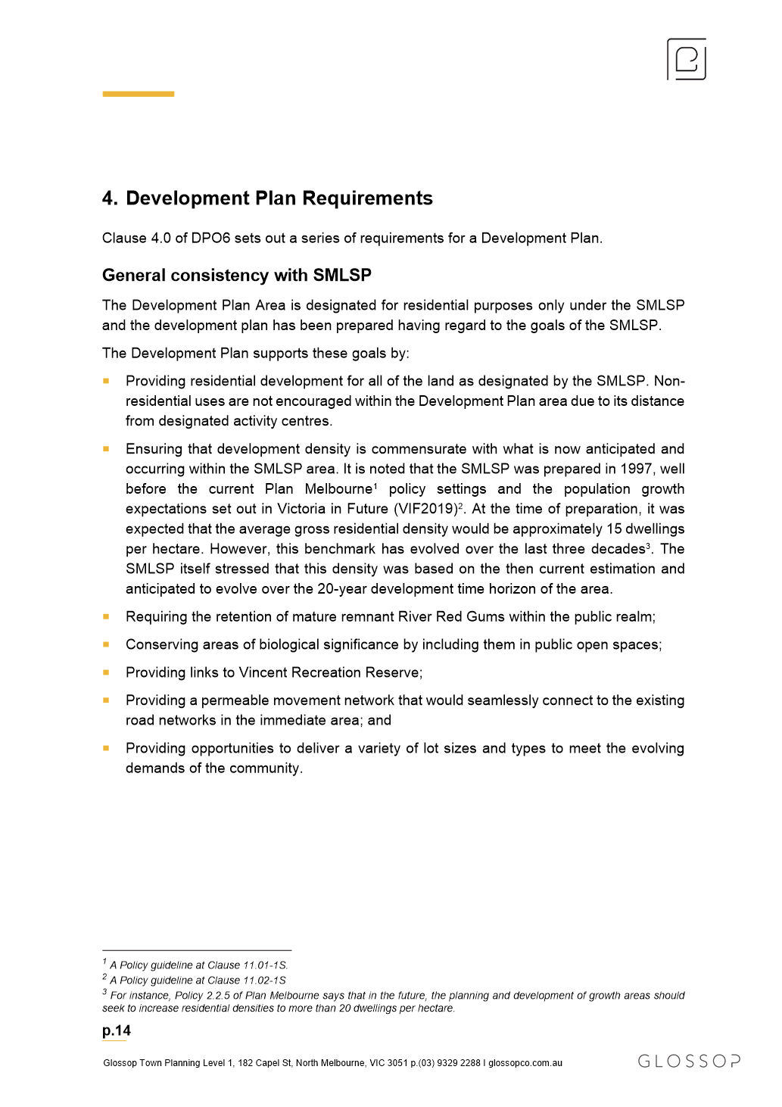

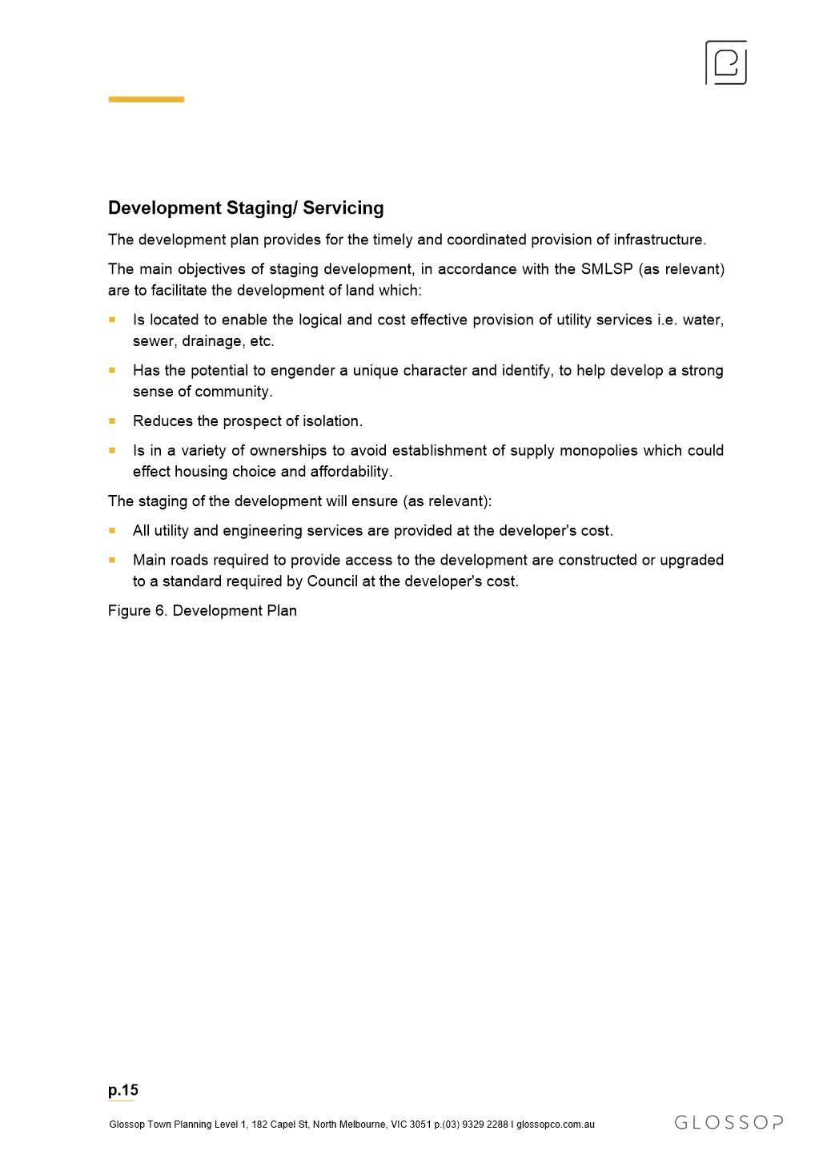
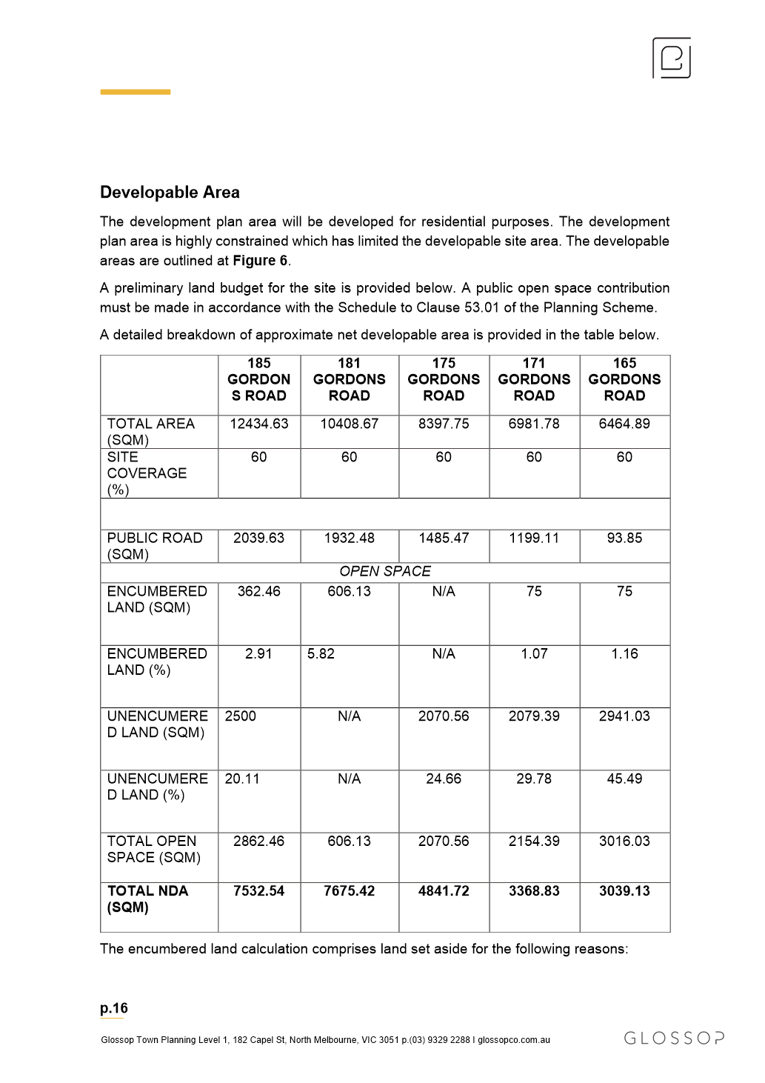

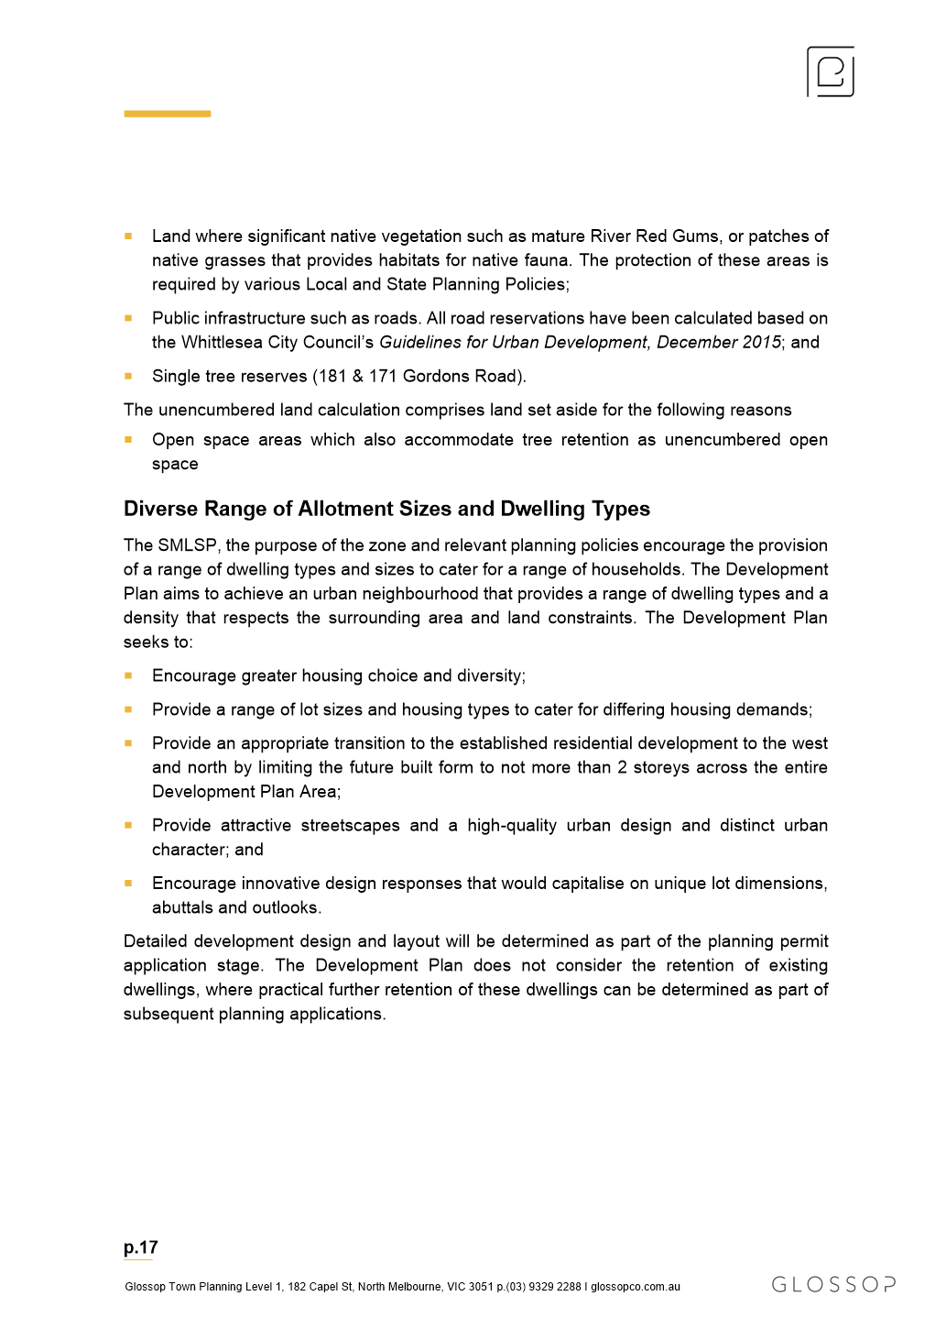

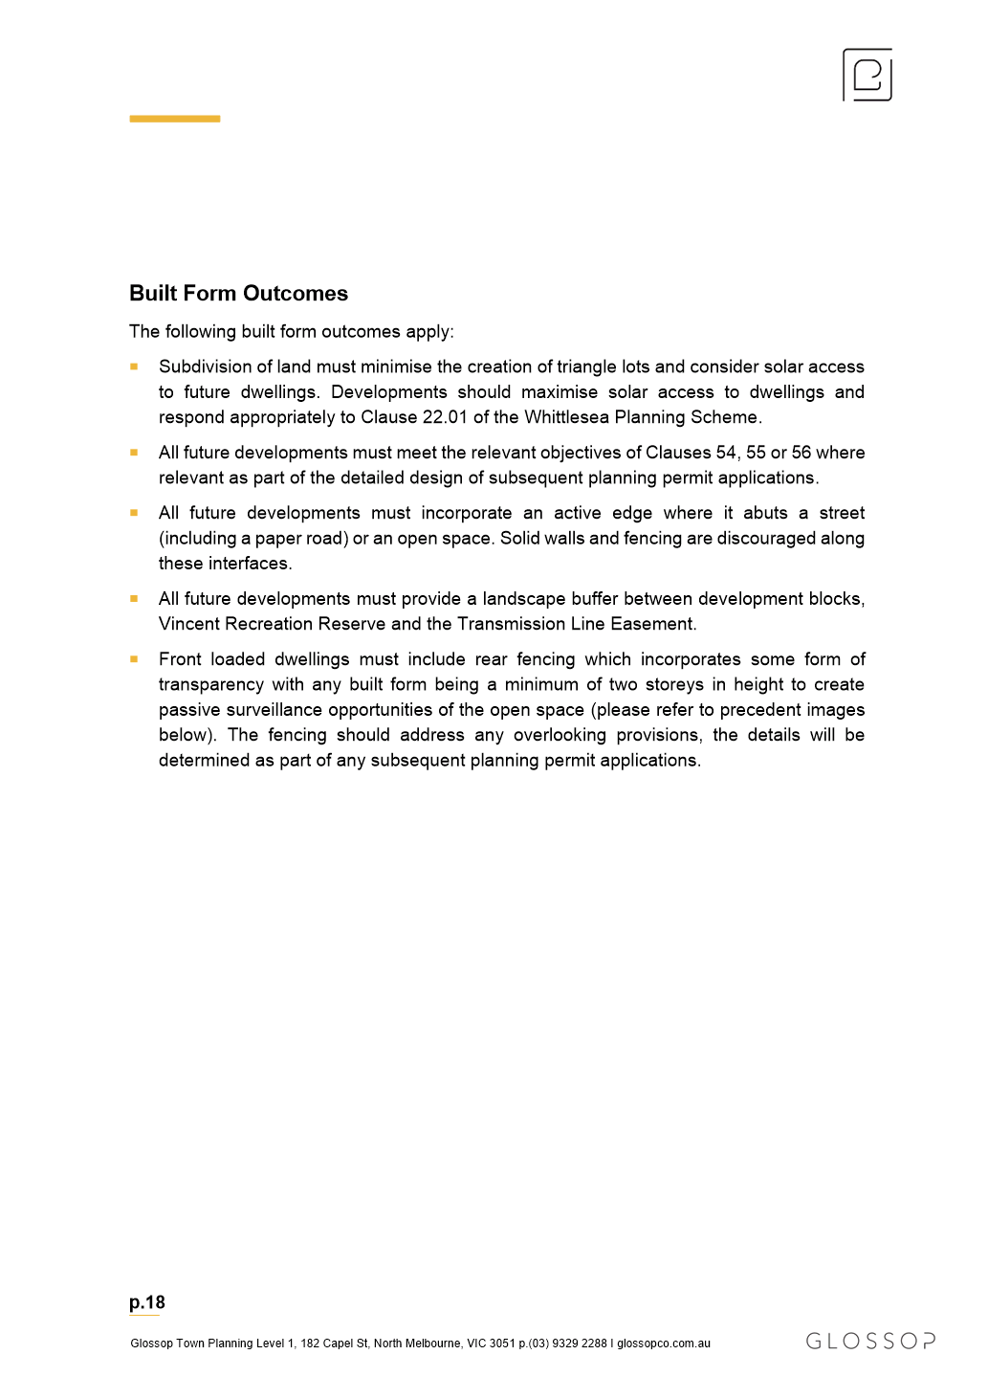

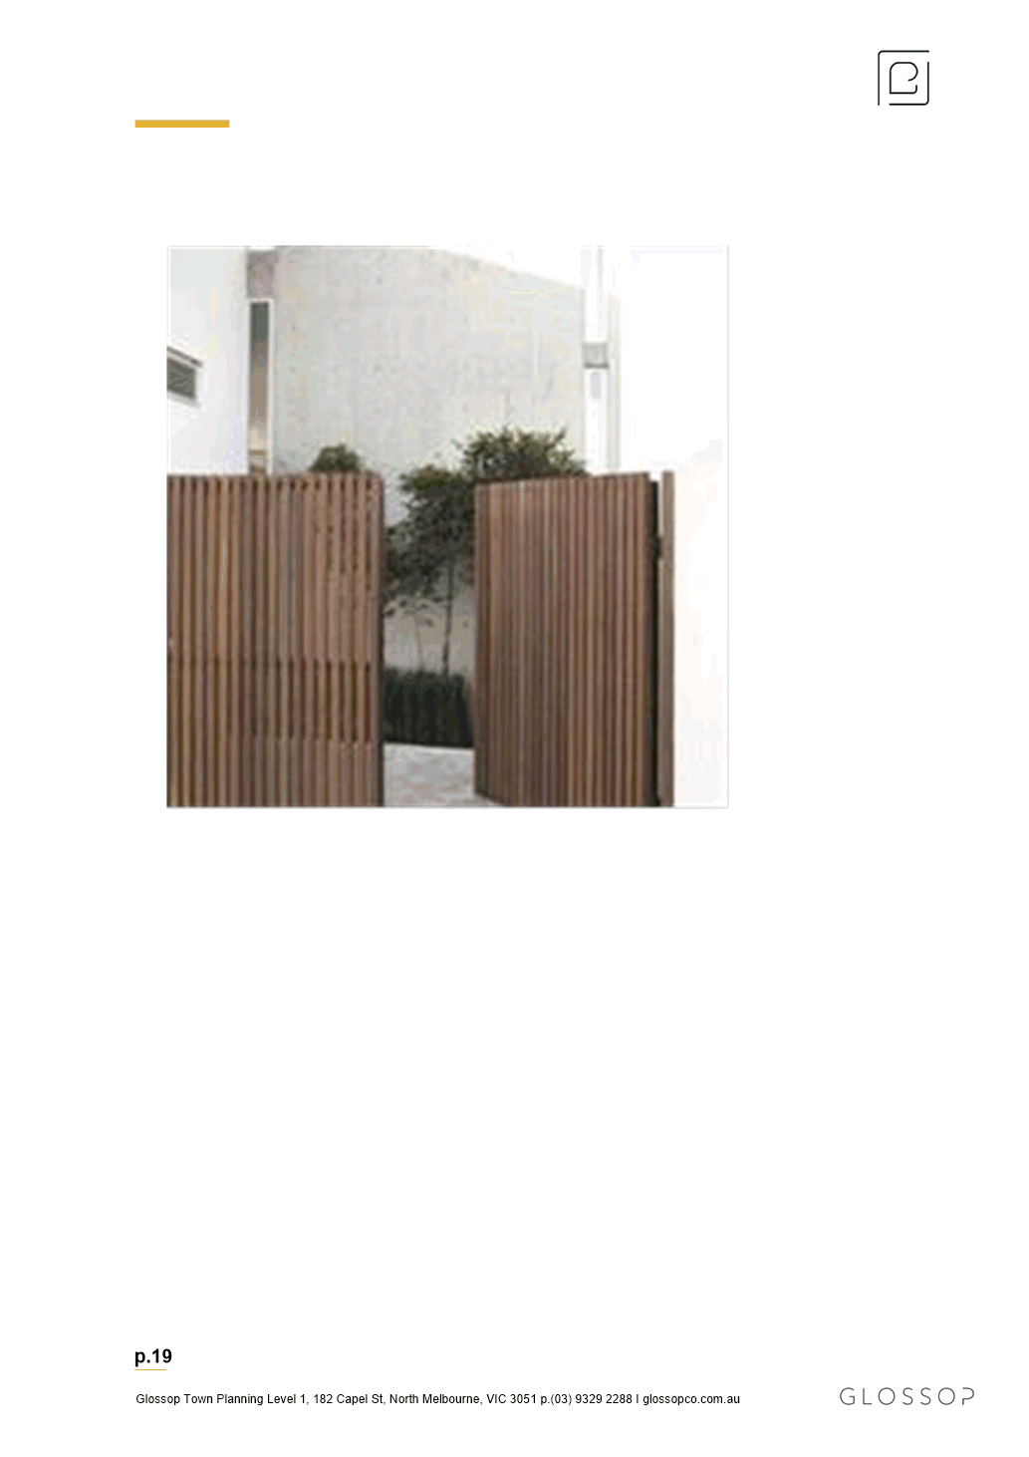

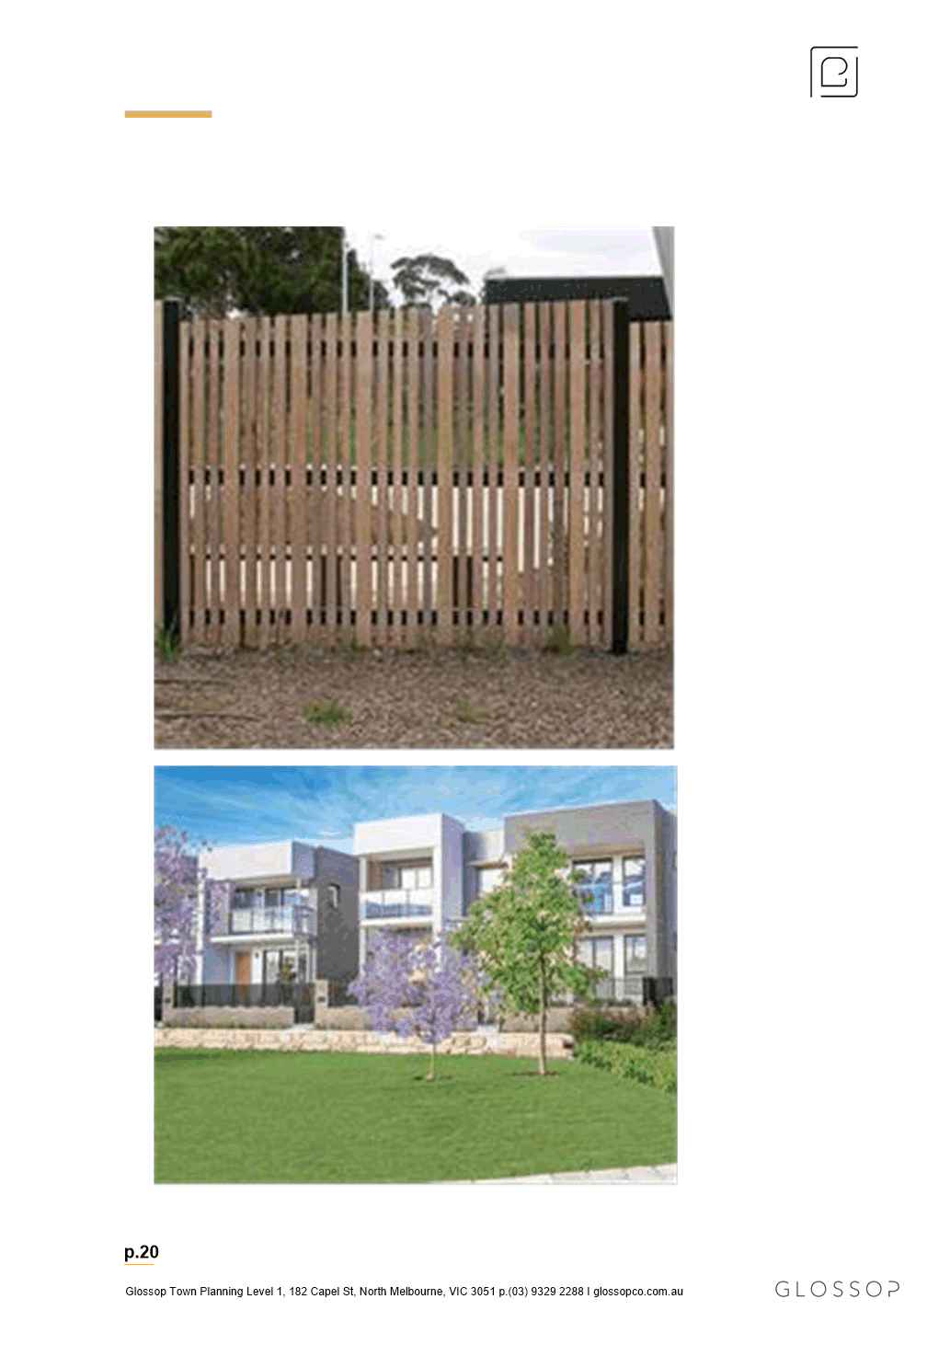

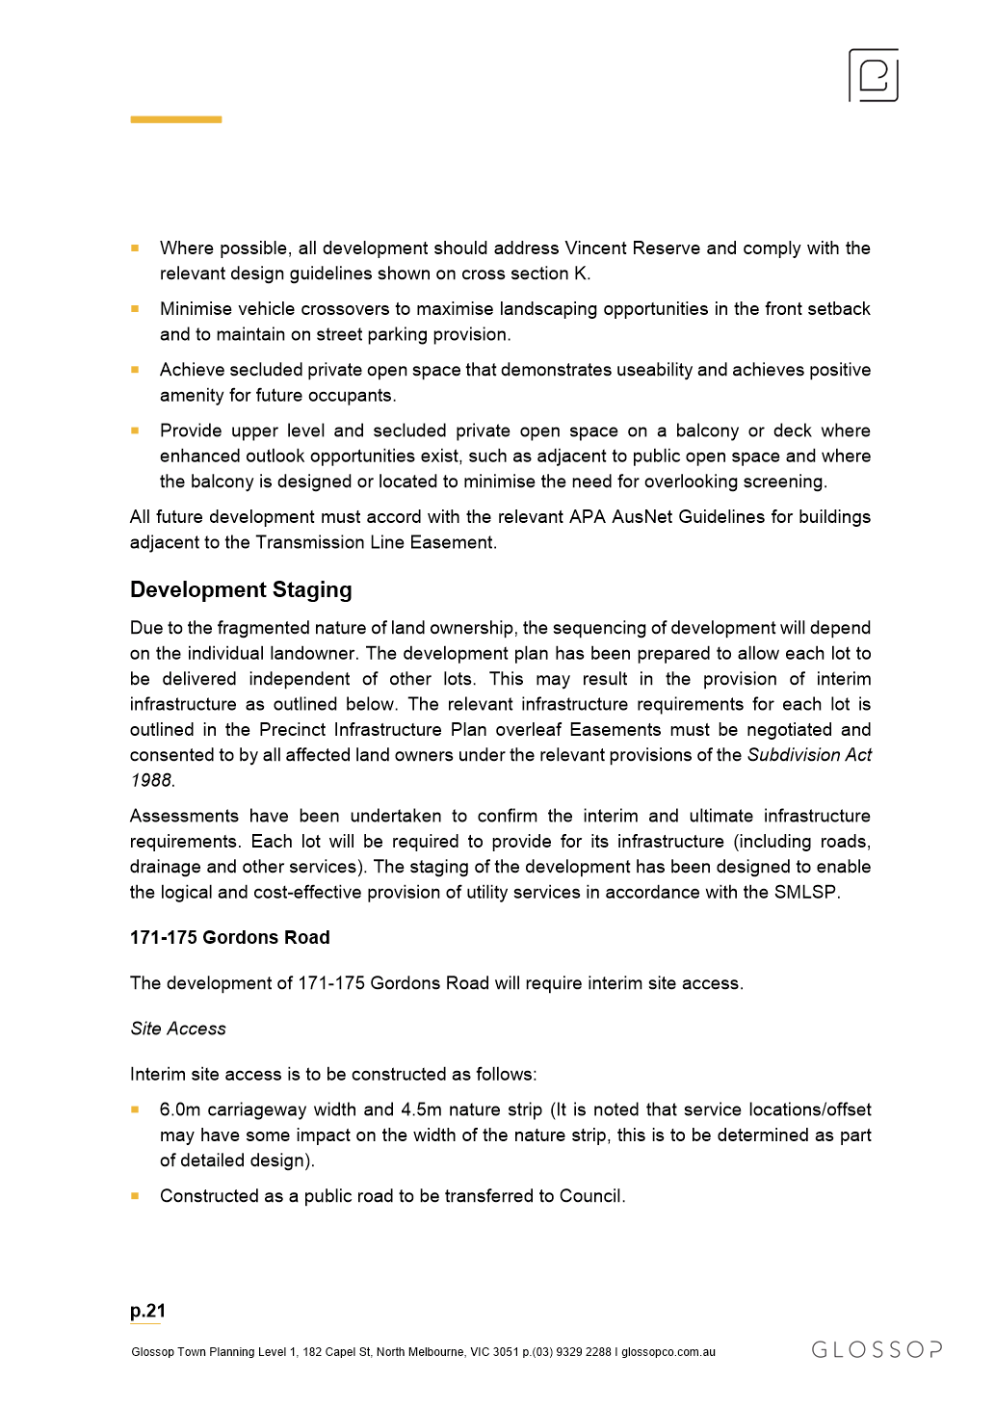

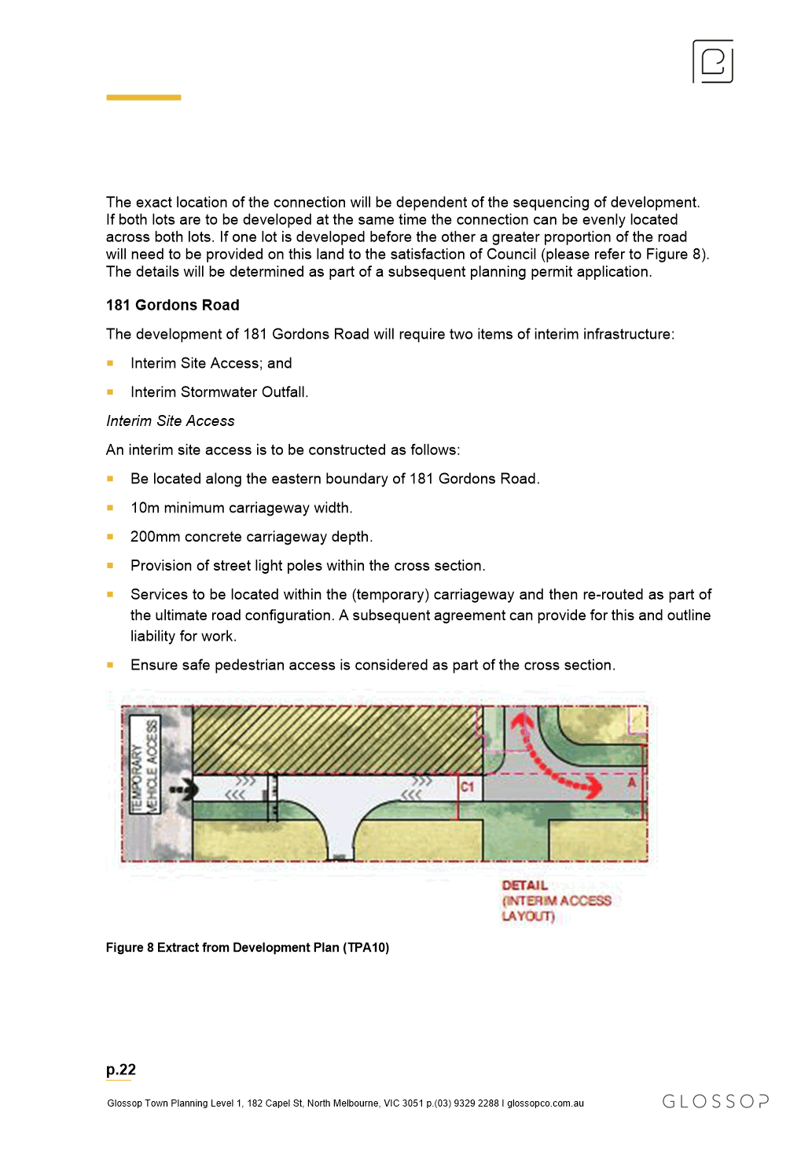

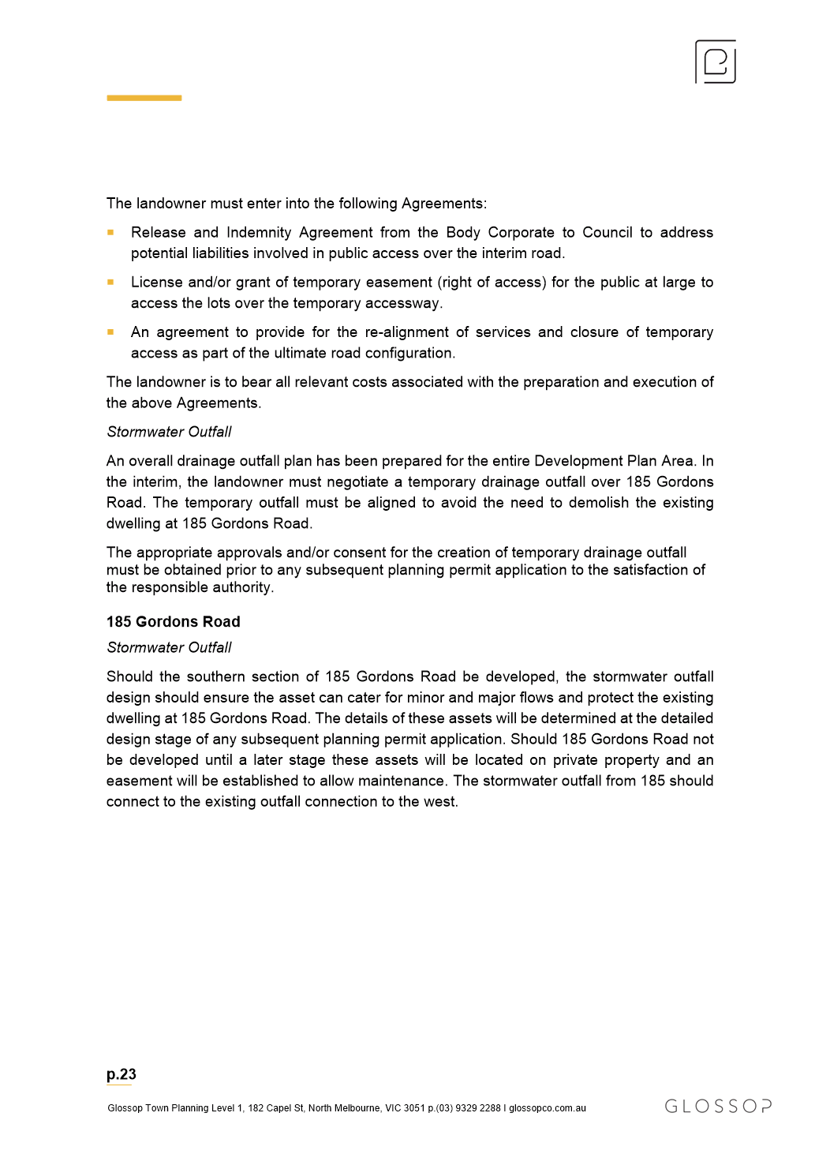
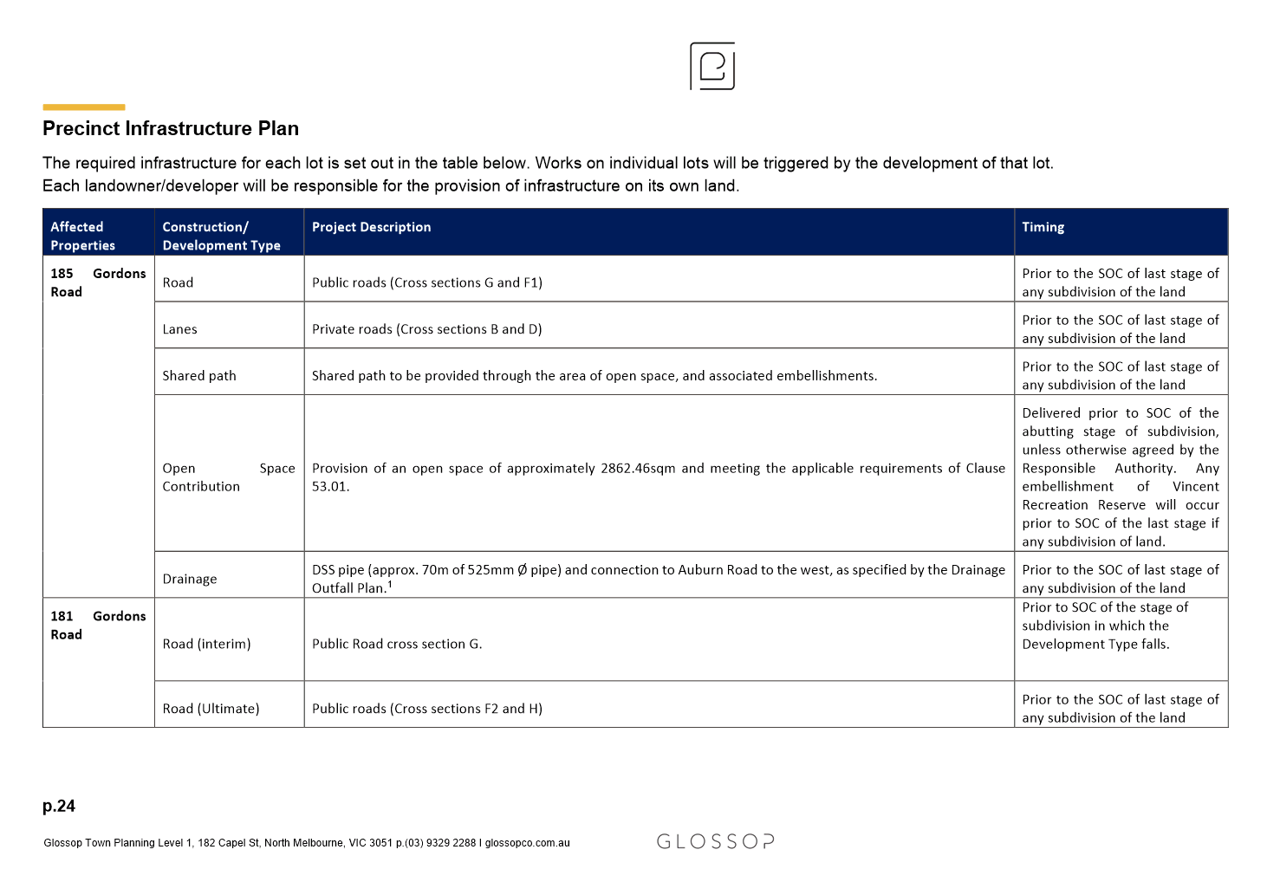
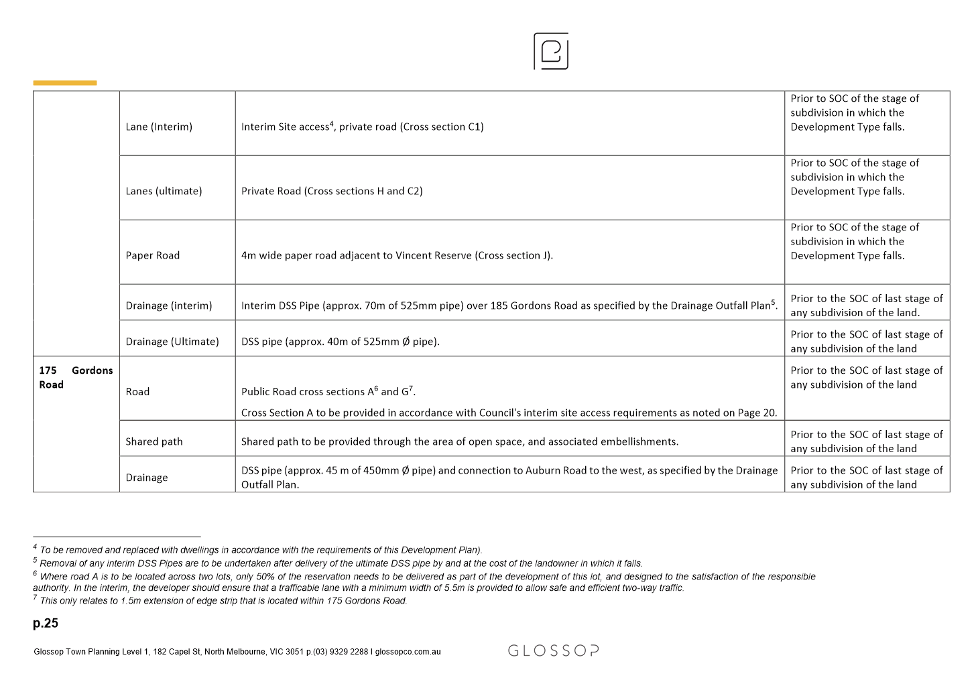

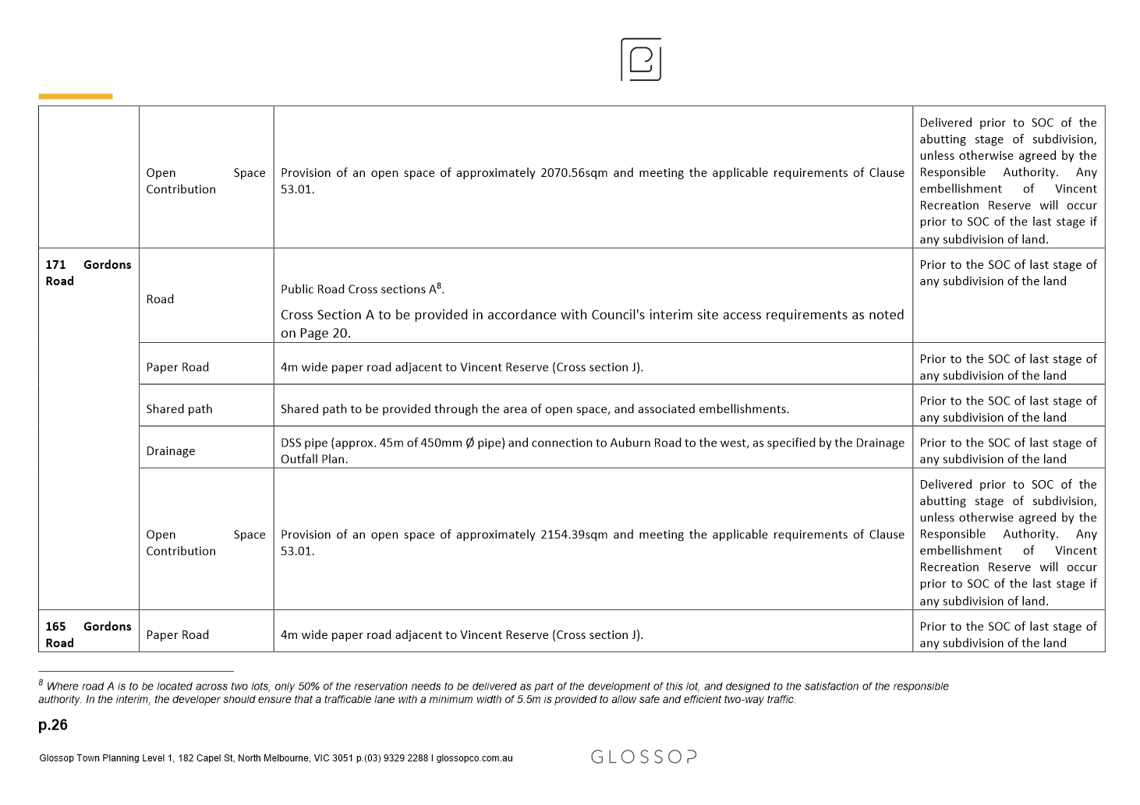

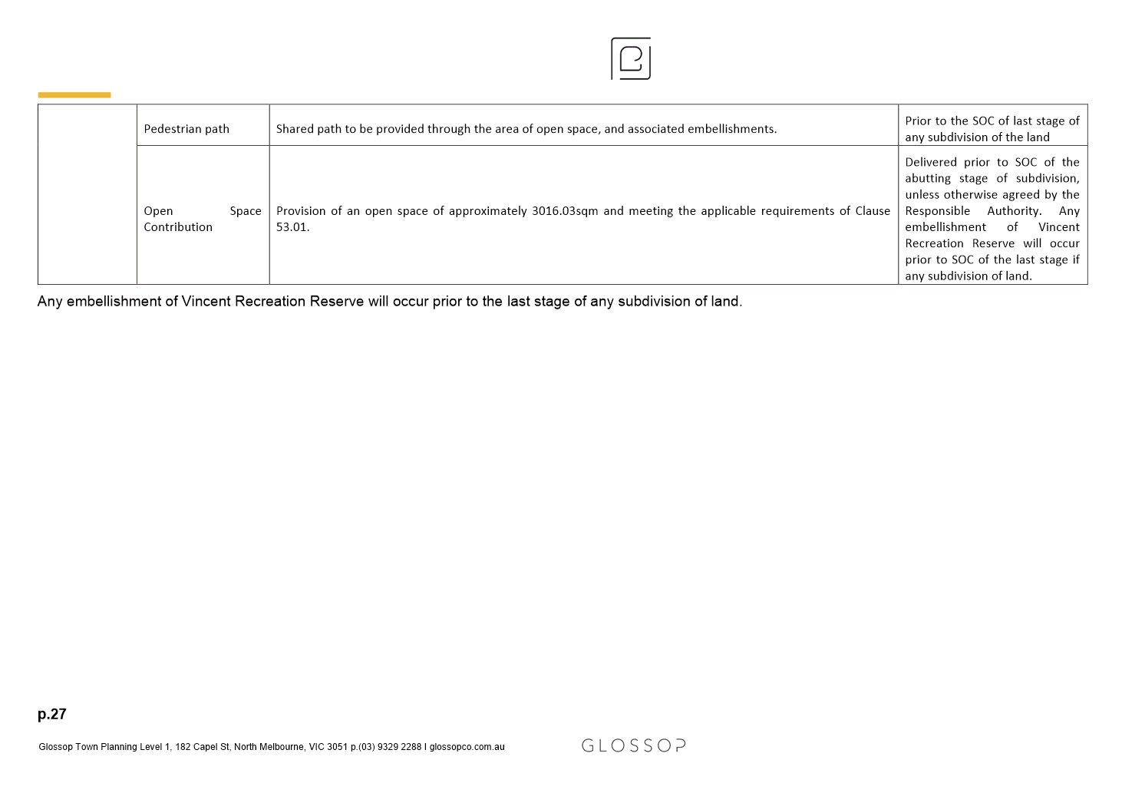
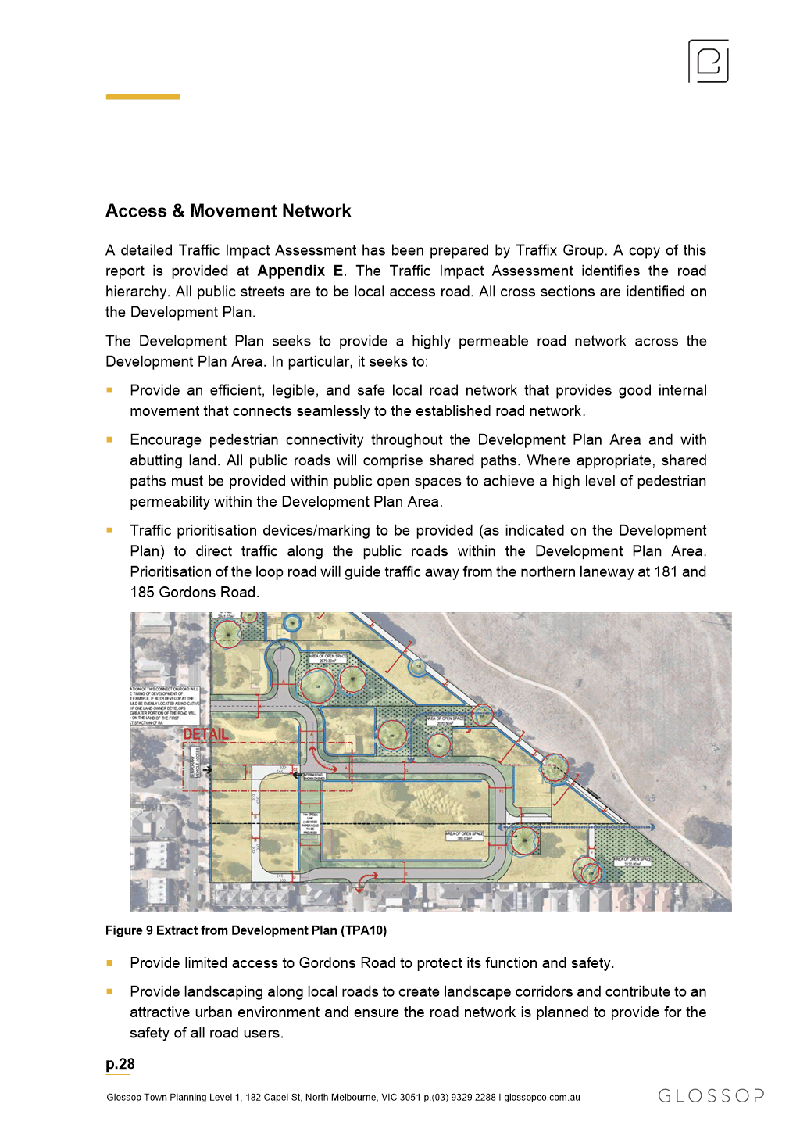

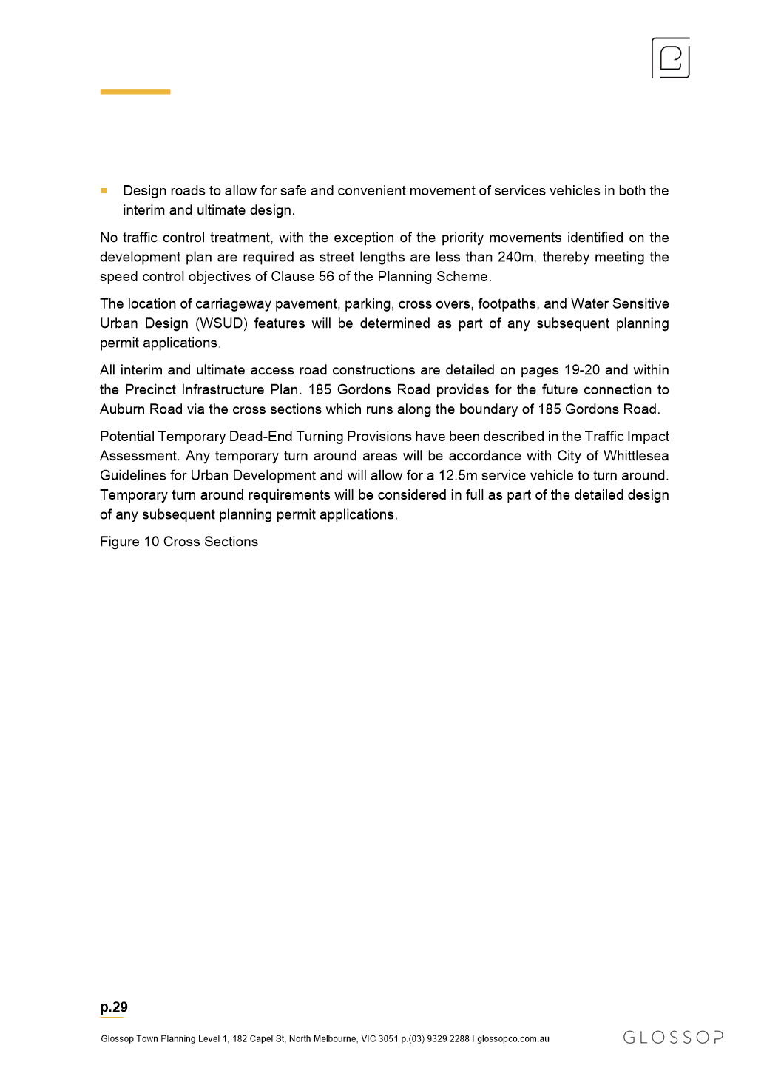
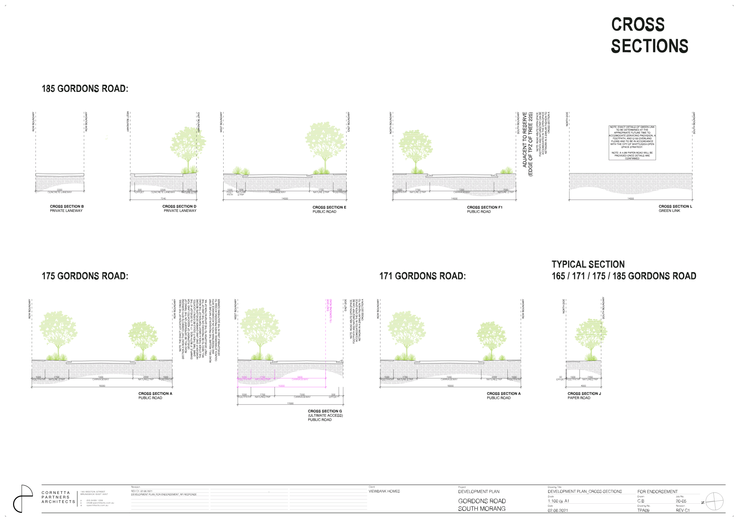
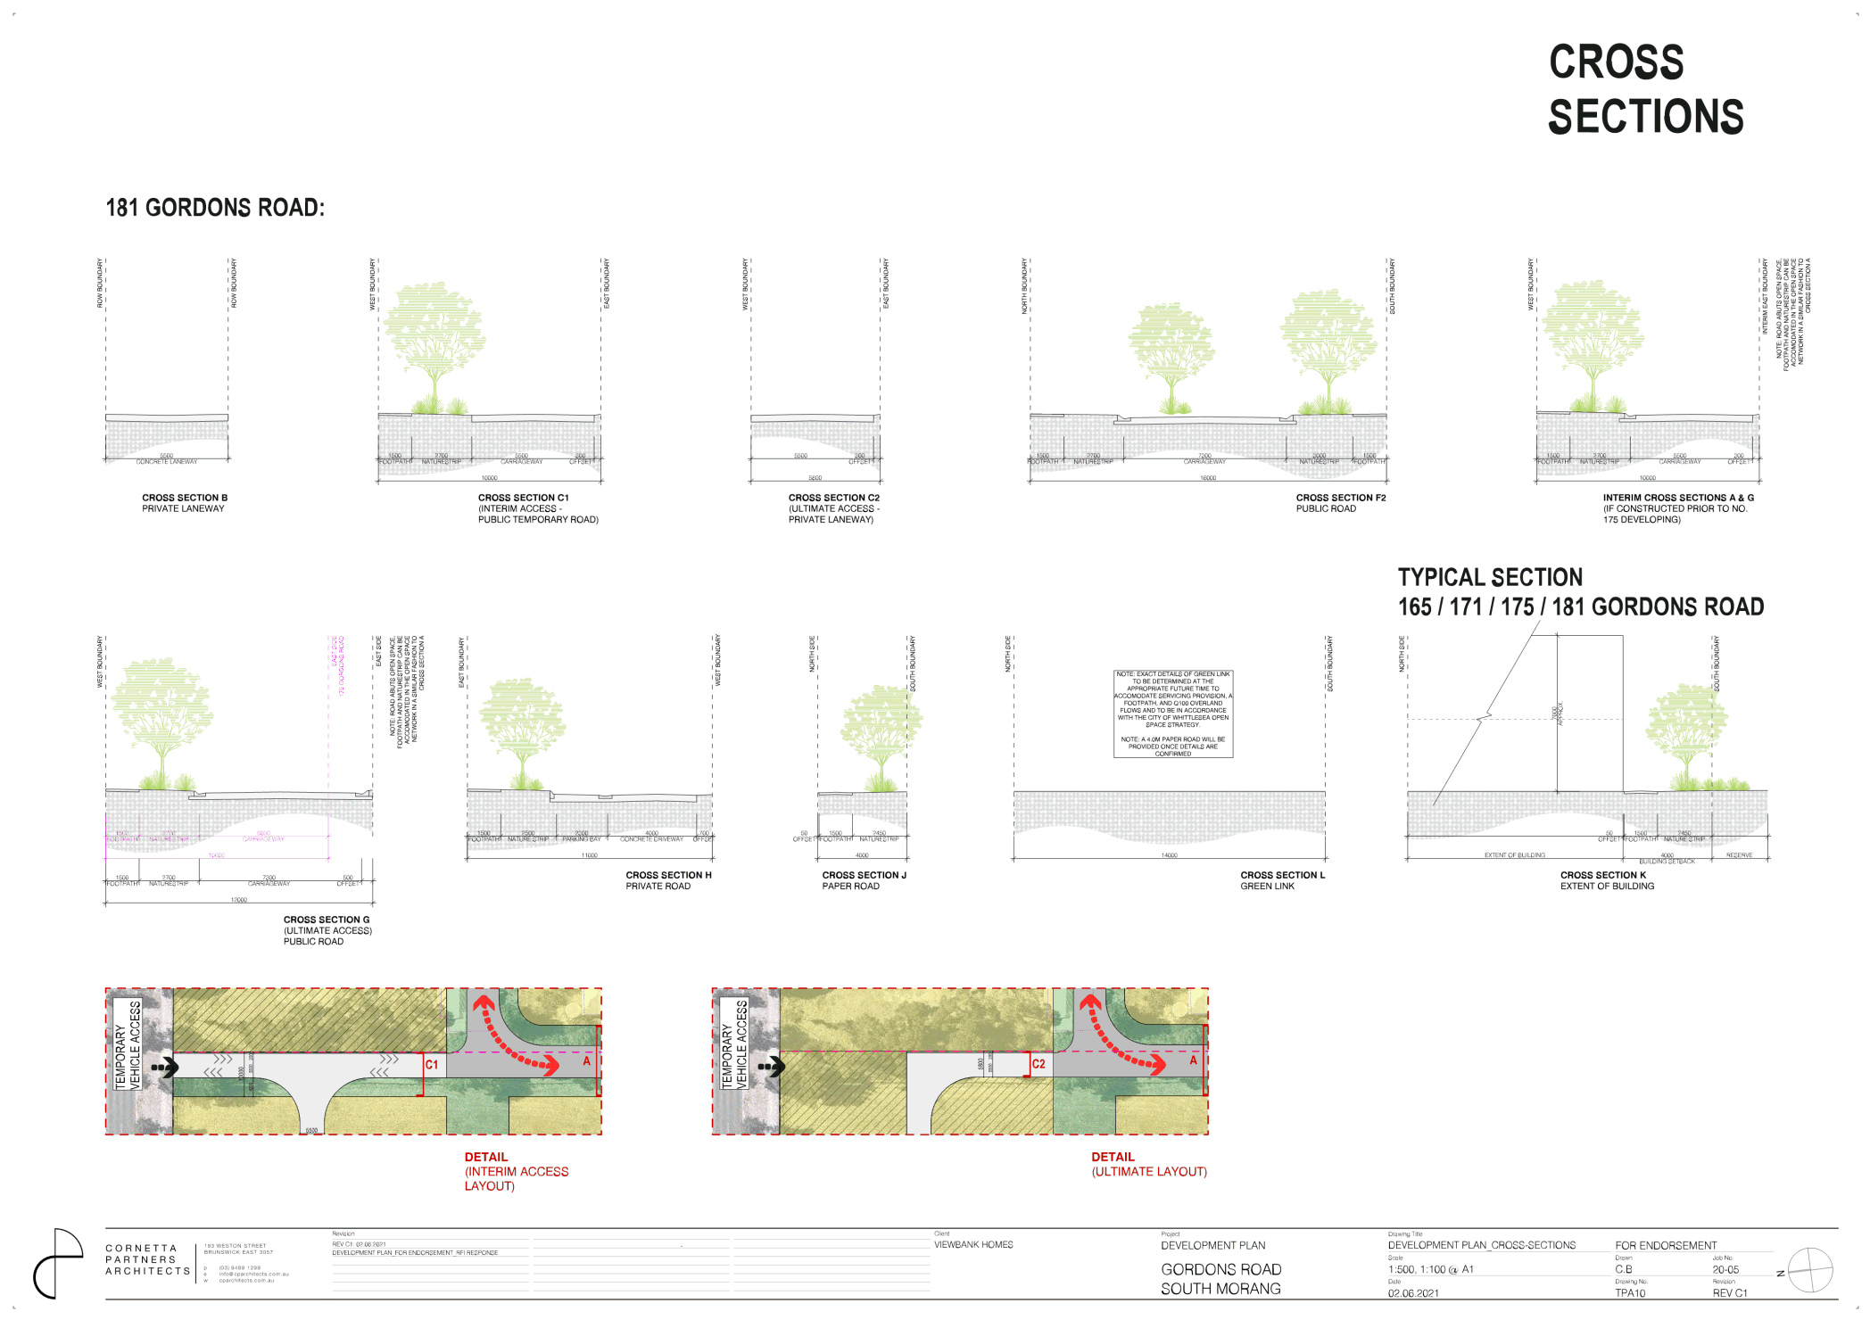
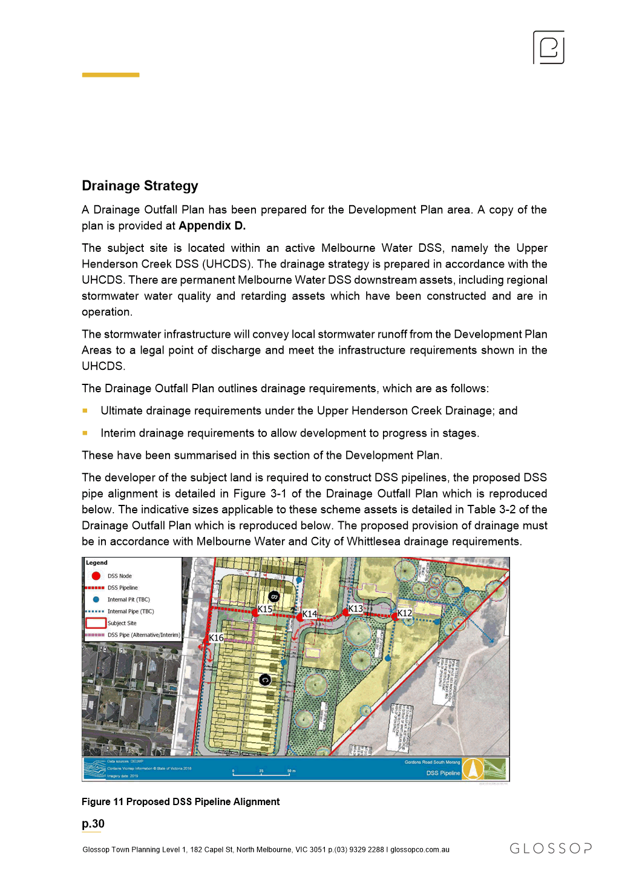

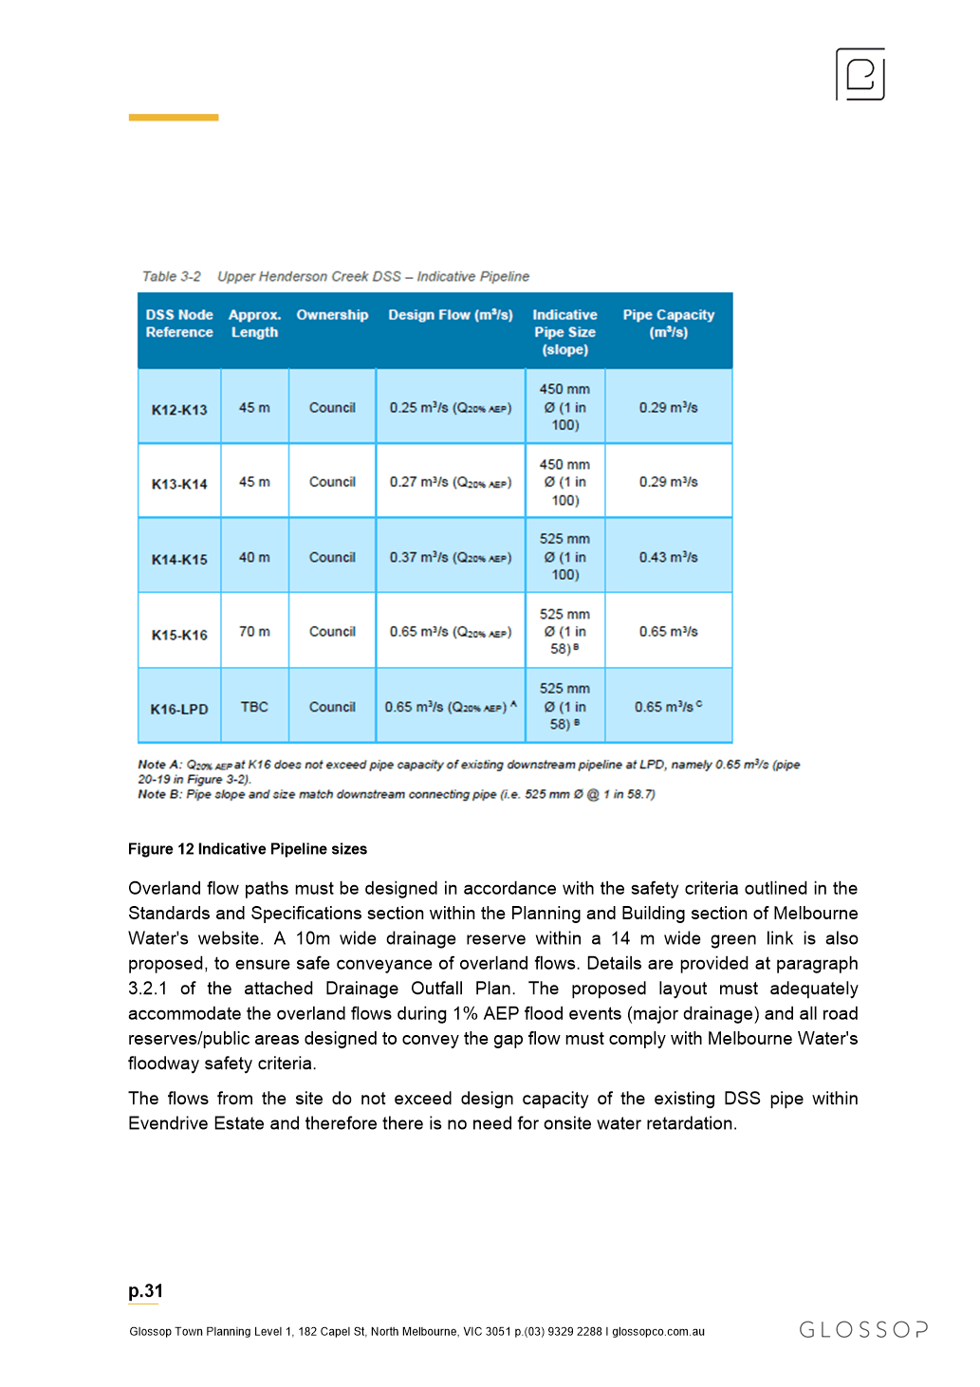

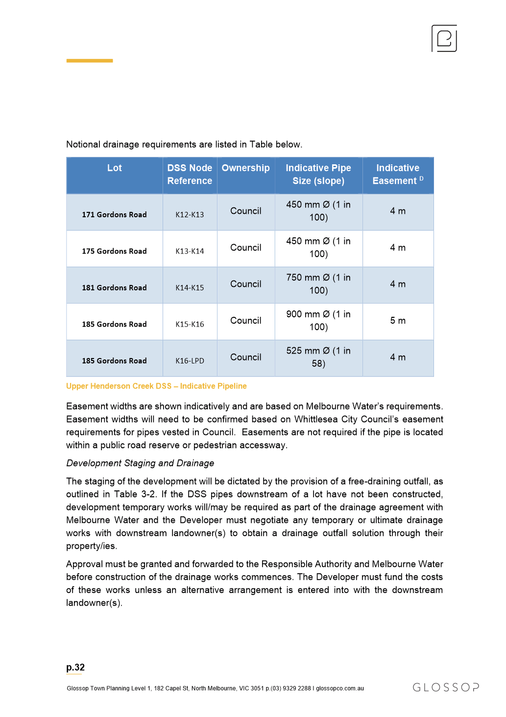

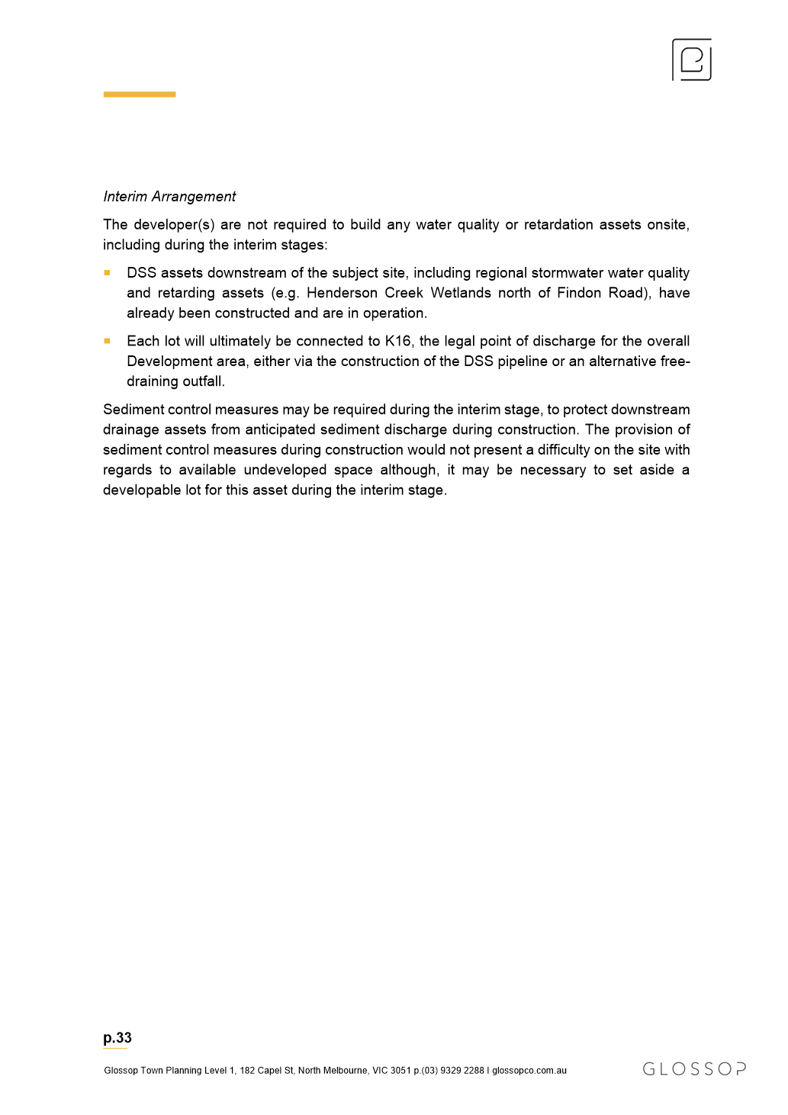

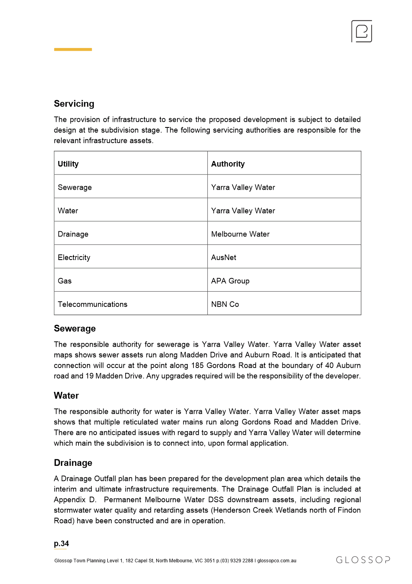

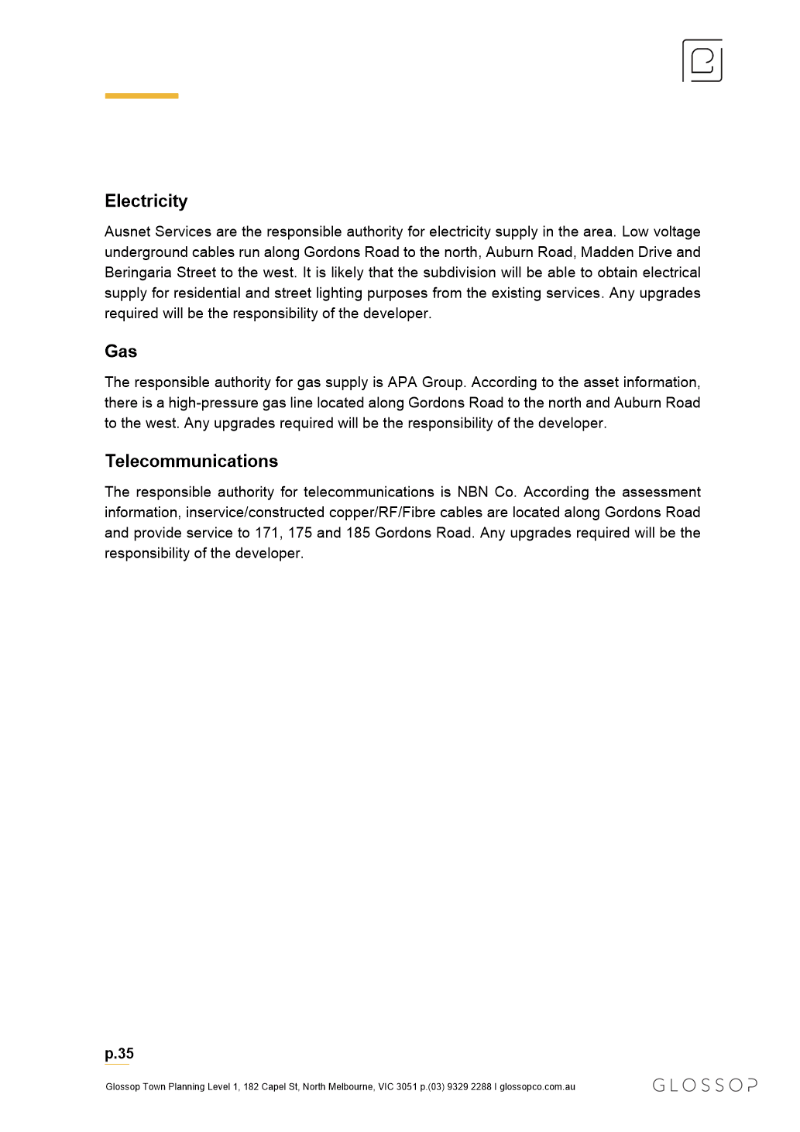

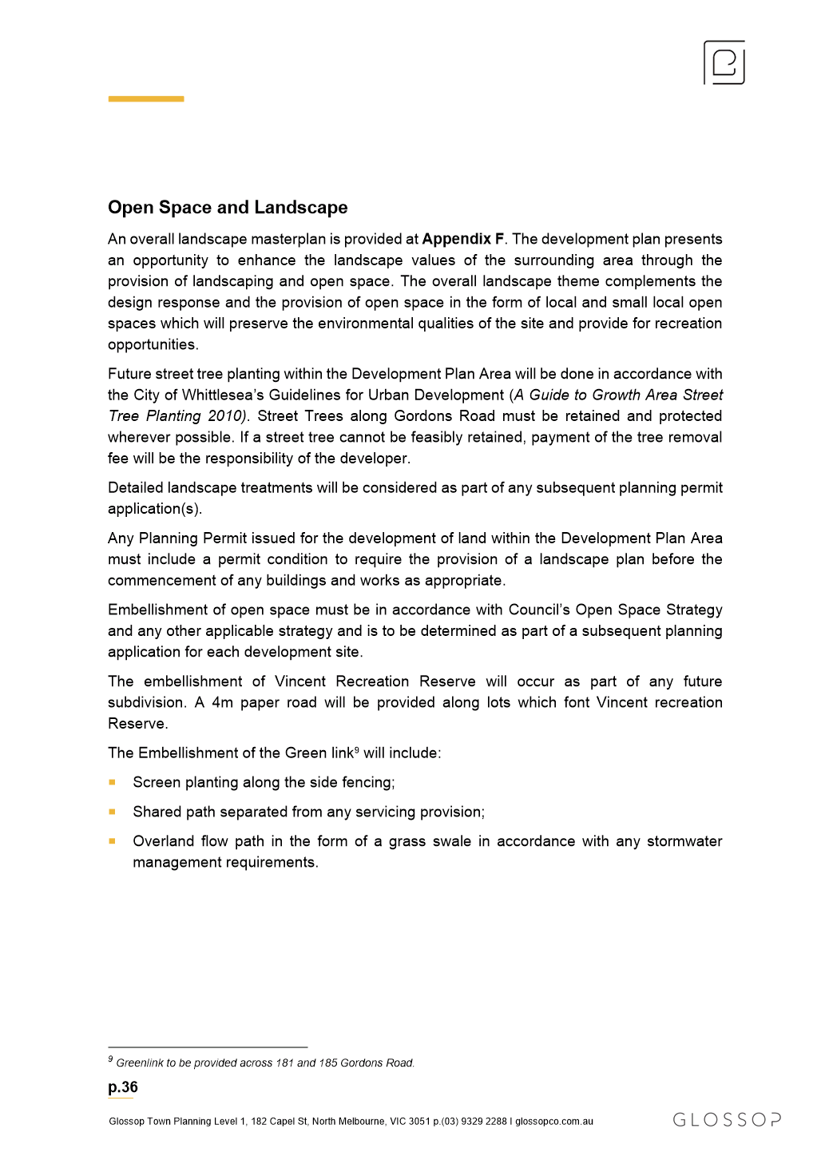

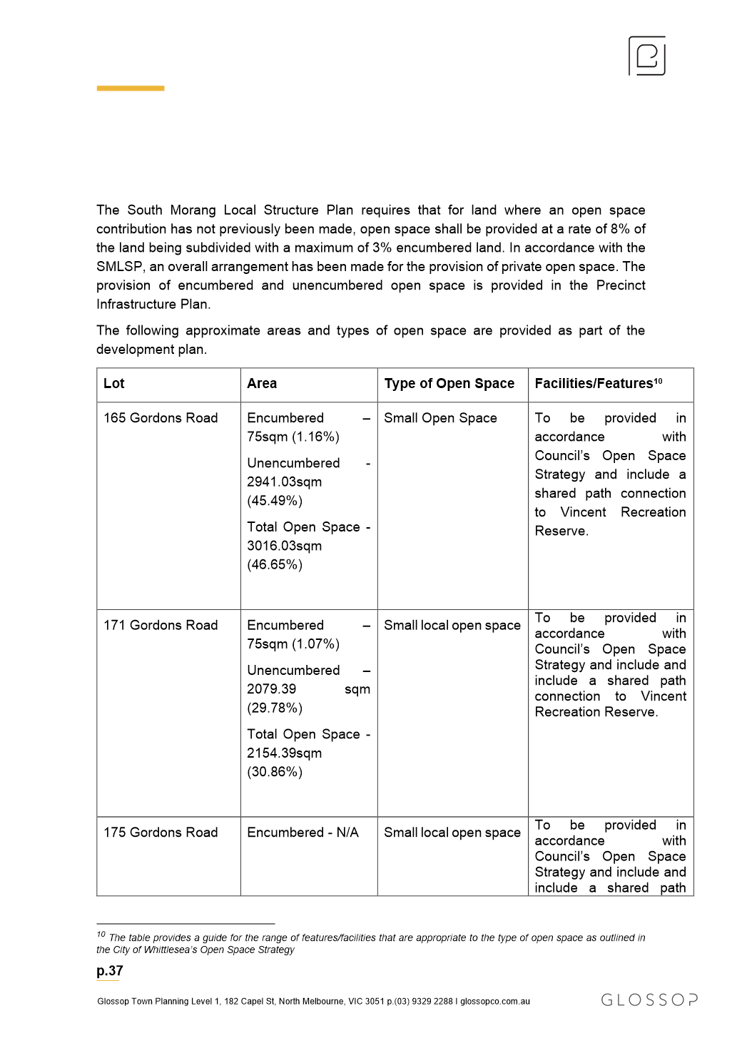

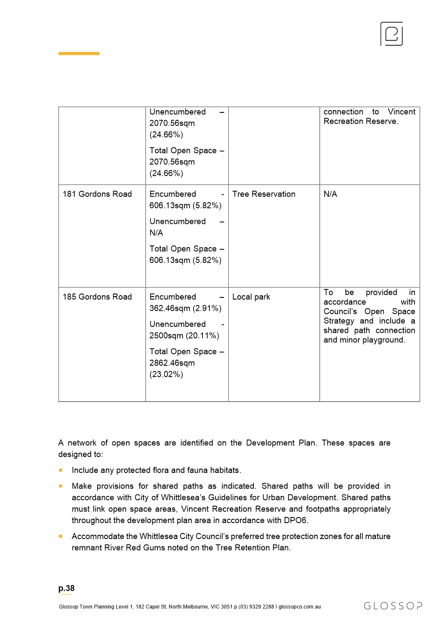

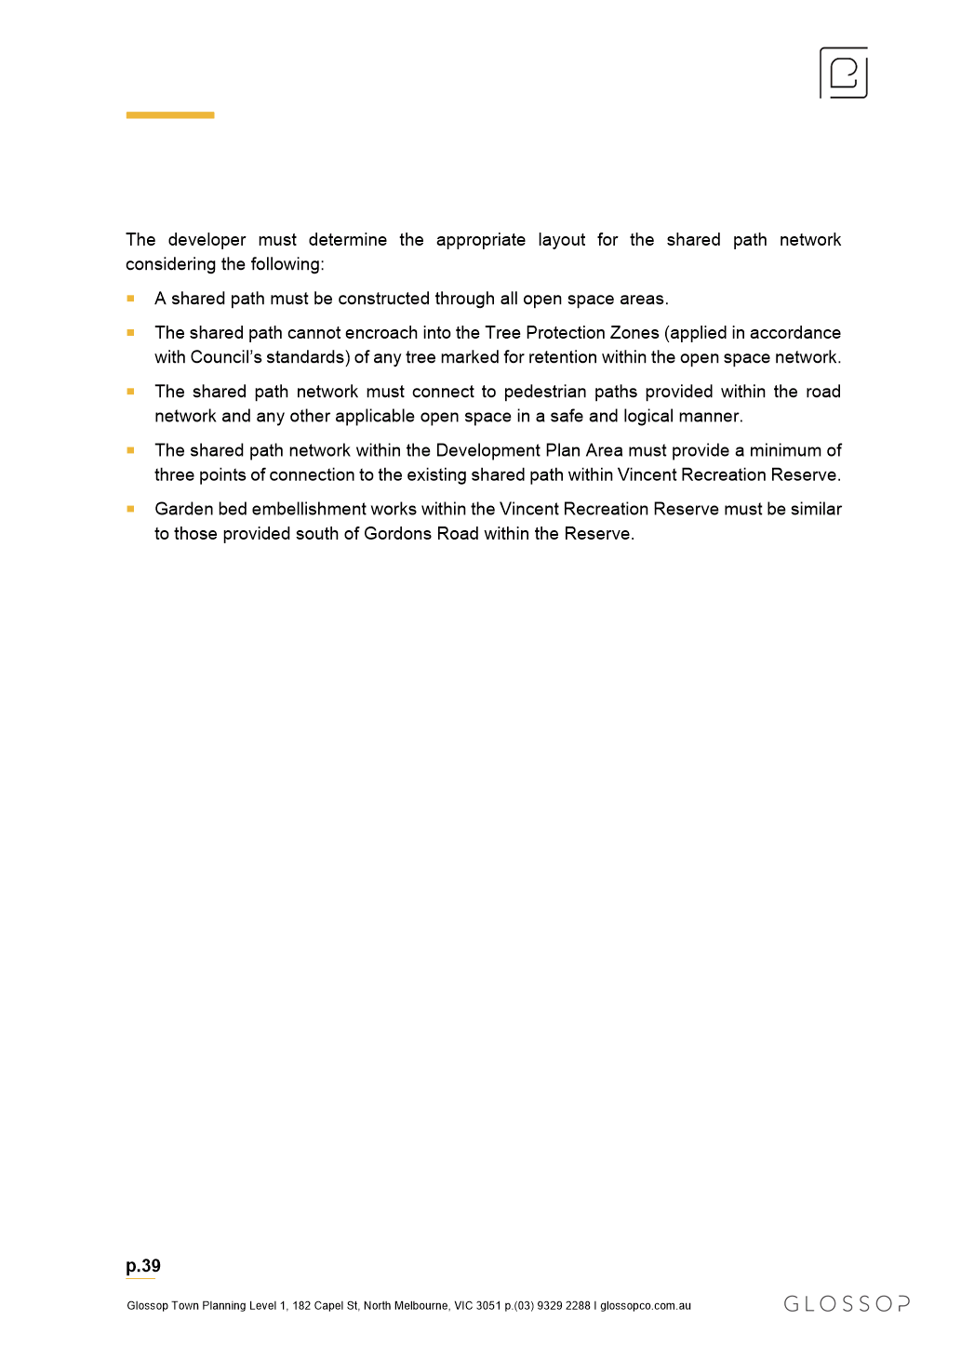

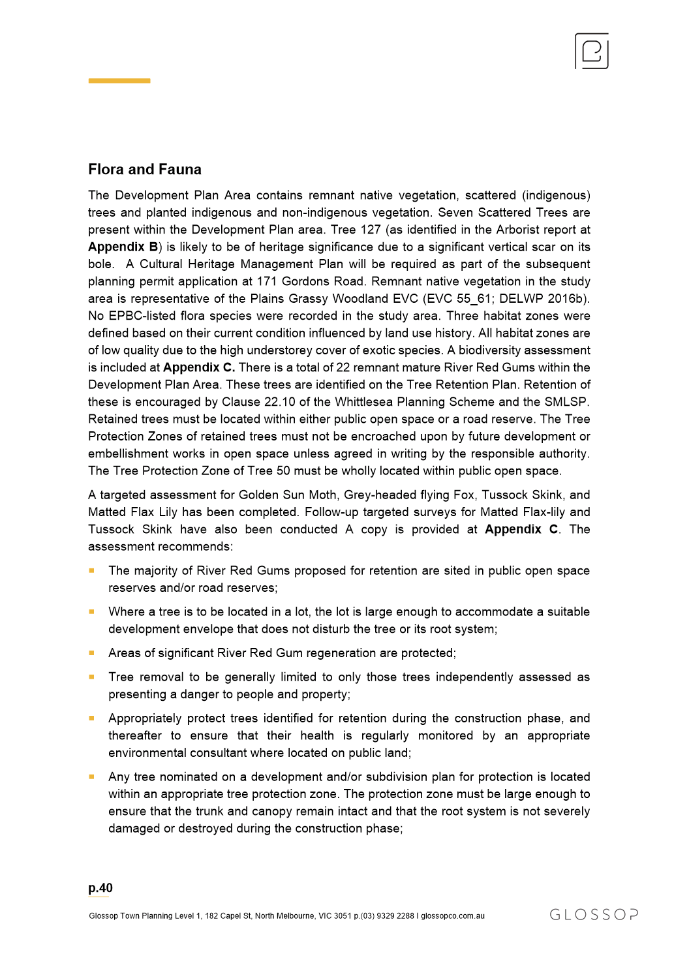

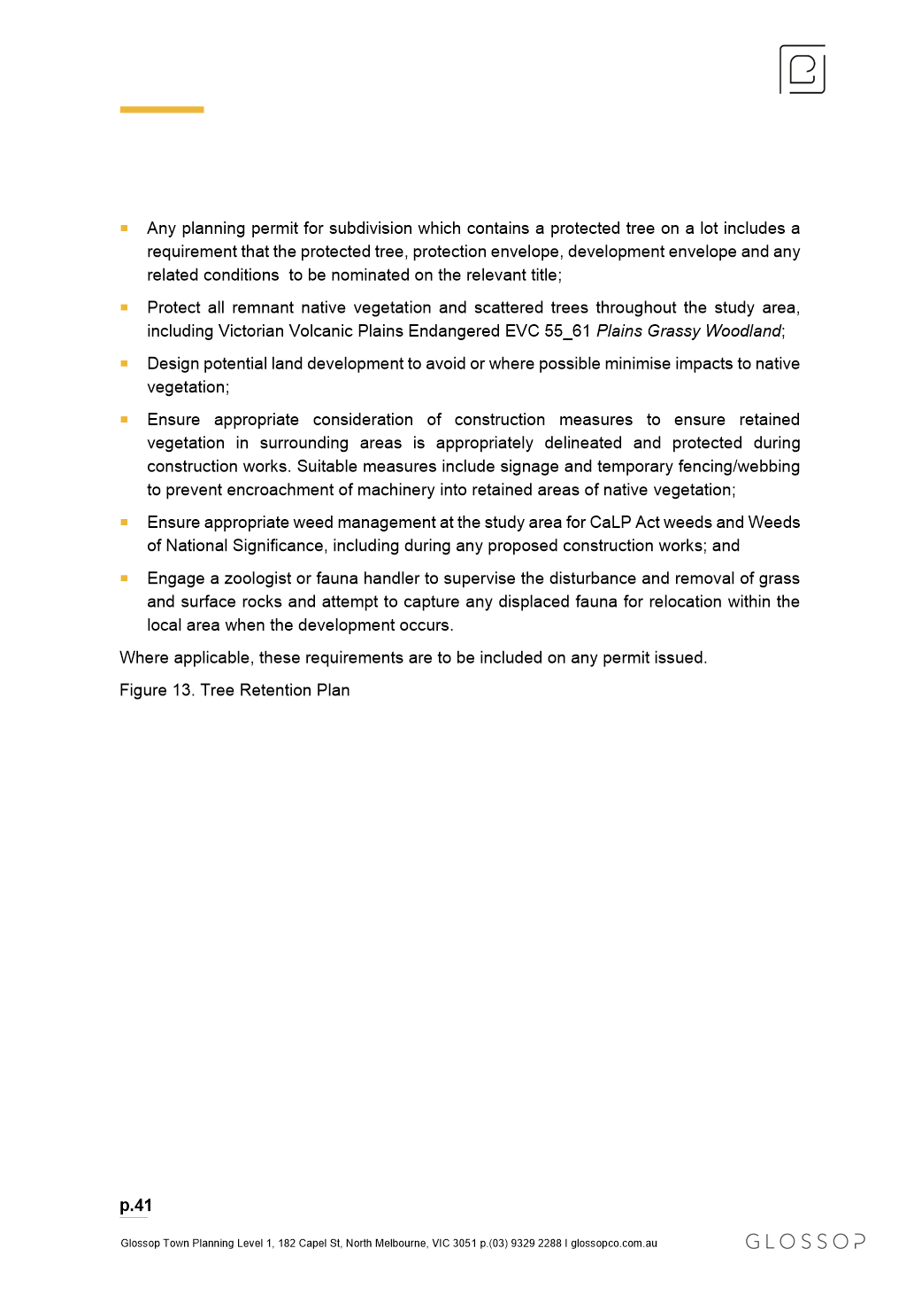
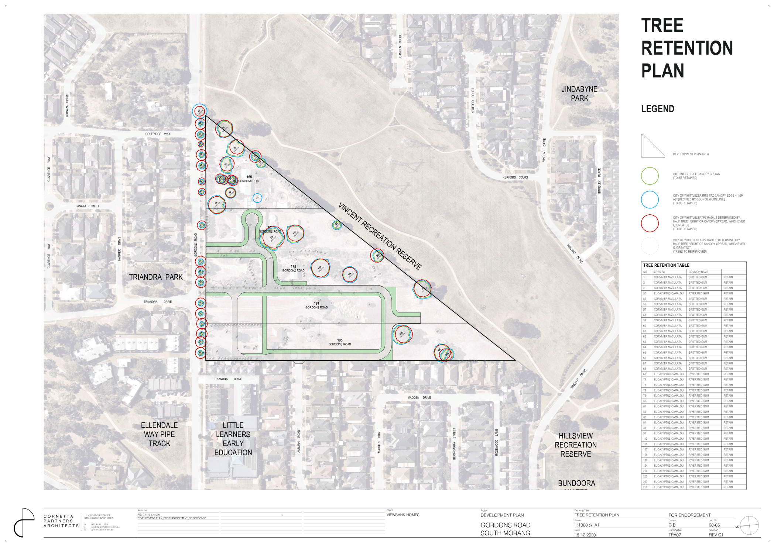
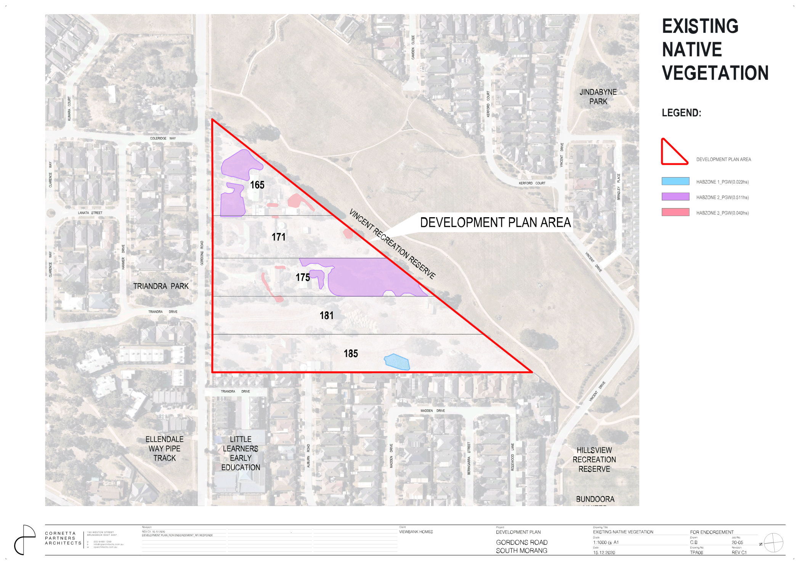
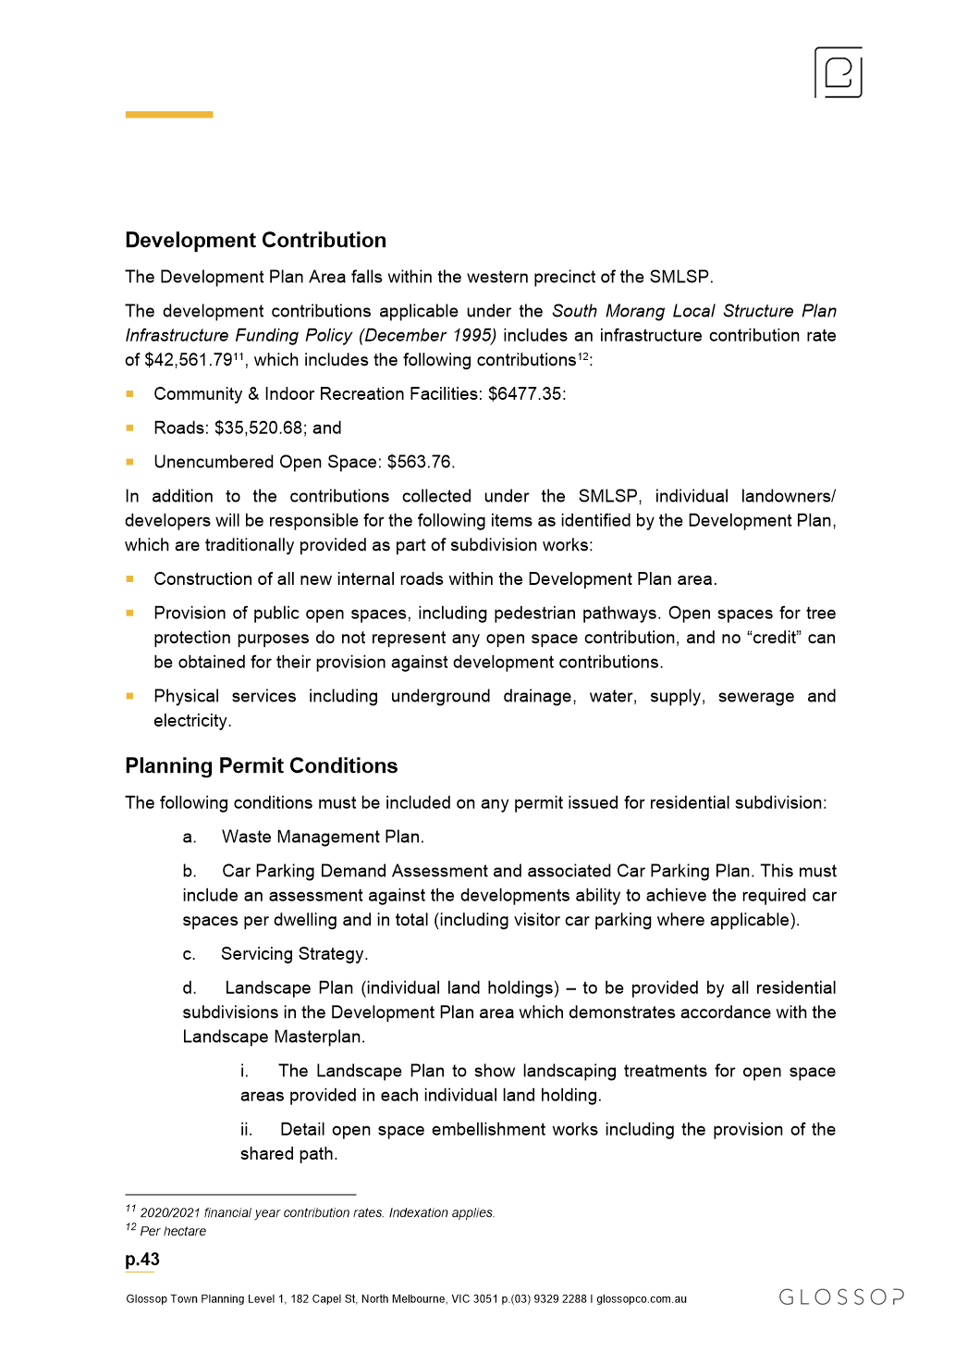

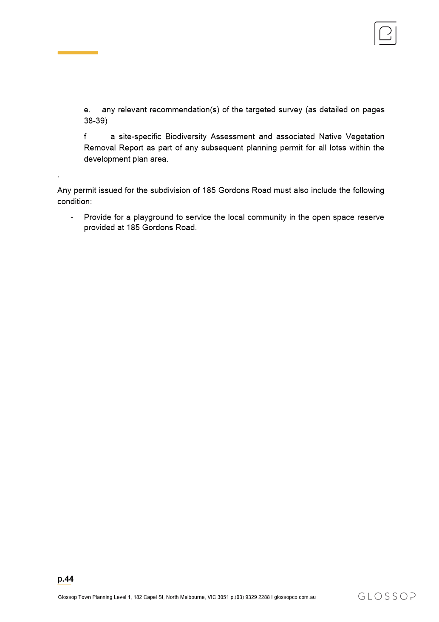

ITEM 6.2.4 FOR DECISION - PLANNING APPLICATION 719837 - USE OF THE LAND FOR INDUSTRY (ASPHALT BATCHING PLANT) AND BUILDINGS AND WORKS, INCLUDING BUILDINGS AND WORKS WITHIN THE LAND SUBJECT TO INUNDATION OVERLAY AT 29 GRAYSTONE COURT EPPING
Attachments: 1 Architectual Plans
2 Locality Map
3 Bund Screen Plan
Responsible Officer: Director Planning & Development
Author: Statutory Planner

APPLICANT: Alex Fraser Asphalt Pty Ltd
COUNCIL POLICY: 15.02-1L Environmentally Sustainable Development
17.01-1L Diversified Economy
19.03-3L Water Sensitive Urban Design
ZONING: Industrial 1 Zone
OVERLAY: Design & Development Overlay – Schedule 2 (part)
Development Plan Overlay – Schedule 33
Land Subject to Inundation Overlay (part)
REFERRAL: Melbourne Water – Section 55,
Environment Protection Authority (EPA) – Section 52
OBJECTIONS: Five objections
RECOMMENDATION SUMMARY
That Council resolve to approve Planning Application No. 719837 and issue a Notice of Decision to Grant a Planning Permit, subject to conditions, for the use of the land for industry (asphalt batching plant) and associated buildings and works, including buildings and works within the Land Subject to Inundation Overlay.
Brief overview
The application seeks approval for the use of the land for an asphalt batching plant and associated buildings and works within the site. The site is currently being used as a materials recycling facility as approved by Planning Permit No. 711082 (issued 30 September 2009, as amended).
The site has a total area of 35.85 hectares and both uses are to run on site concurrently, with the uses being interrelated.
Notification of the application was undertaken and a total of seven objections were received, two objections have subsequently been withdrawn following successful mediation between all parties.
rationale for recommendation
The proposal has demonstrated a satisfactory level of compliance with the applicable industrial zoning and overlays, as well as relevant Council policy.
Council officers have engaged with all objectors, two of which agreed to meet with Council officers and the applicant and visited existing similar facilities operated by the applicant. Following this, both objectors were satisfied that all issues raised in their objections were adequately addressed or could be managed via a Planning Permit and subsequently withdrew their objections.
impacts of recommendation
The approval of this application will allow for the re-use of materials currently recycled on site in asphalt which supports a more sustainable use; reduces the impacts of transport to and from the site and further supports the ongoing development of the City of Whittlesea’s growth areas and major road projects.
Any objectors unhappy with the decision retain rights to seek a review of the decision at the Victorian Civil and Administrative Tribunal.
what measures will be put in place to manage impacts
Appropriate conditions will be included to manage any offsite amenity impacts. A Site Environmental Management Plan will also manage how any environmental or amenity impacts of the use will meet EPA, Melbourne Water and Council requirements.
Ongoing dust management measures are to be increased on site, including through requiring the paving of the entry/exit and circulation areas associated with the proposed uses within the site.

Report
SITE AND SURROUNDING AREA
The subject site is located to the south of Cooper Street and access to the site is via the southern end of Graystone Court (see Attachment 1). The parcel is irregular in shape, with an approximate width of 558.45 metres and depth of 548.79 metres and a total area of 35.86 hectares.
The site is bound by Central Creek to the west and partially along the southern boundary, and the Hume Freeway to the east. The land to the north and west (beyond the waterway) forms part of an industrial subdivision known as Biodiversity Park. Land directly north-east of the site is within the 415 Cooper Street, Epping Development Plan (approved January 2018). The subdivision of the surrounding area created lots suitable for industrial use and development, most of which has been or is in the process of being constructed.
The wider area is characterised by the Cooper Street Employment Area to the north/east of the Hume Freeway and the Melbourne Wholesale Market. Land to the north is also developing for industrial uses and development at 410 Cooper Street Epping, while land to the north west is currently utilised as a materials recycling facility. To the west is the transition across the Merri Creek into Hume City Council and the suburb of Campbellfield, which is a state significant industrial precinct. The closest residential land is the Carlingford Estate (Lalor), approximately 210 metres from the south-eastern corner of the subject site boundary and 900 metres from the proposed buildings and works/use.
The subject site is currently being used as a materials recycling facility and was previously used for extractive industry (quarry), until approximately 2019. The materials recycling component is primarily carried out in the southern parts of the site, with a water storage reservoir in the north-east corner and landscape buffers, fencing and bunds to all boundaries. The works area is proposed in the north-western corner of the site.
restrictions and easements
The subject land is formally known as Lot 100 on Plan of Subdivision 712702W. Covenants as to part AD931057E, AD931058C and AD933850Y apply to the land, restricting certain industrial waste or contaminates being brought to the land.
Section 173 Agreement AH652106N applies to the land and relates to the provision of open space for the creation of the open space adjacent to the Merri Creek and Council’s requirements on the transfer of the land. It is noted that this Agreement has been satisfied.
Section 173 Agreement AL469580T applies to the land and relates to the maintenance requirements of the water assets and management of stormwater flows within the land and the provision of Council access.
None of the restrictions on Title preclude Council from determining the application or are contravened by the proposal.
An 18 metre wide easement in favour of Council is located along the northern site boundary for the purposes of drainage.
Proposal
The proposal is for the use and development of an asphalt batching plant within the subject site (see Attachment 2). The asphalt is to be produced utilising materials which are recycled on site in conjunction with the existing use of the land. The proposal results in buildings and works within the Land Subject to Inundation Overlay which is associated with the former alignment of Central Creek.
The asphalt plant is to include buildings and works for raw material bins, bitumen storage tanks, batching facilities and associated plant and equipment. In addition, an office/amenities building, workshop, drivers crib room, truck and car parking areas, as well as the access lanes within the works area are all proposed to be constructed. The maximum height of the plant is 21.5 metres above natural ground level.
The proposed buildings are to be setback from the northern title boundary a distance of 33 metres (minimum) to 59.02 metres (maximum). Raw material bins are proposed on the western side boundary for a length of 86 metres and the existing bund wall is to be cut back to construct the bins. From the north, an approximately 9 metre high bund screens views into the works area from Cooper Street, while an approximately 15 metre high bund will screen views from the Hume Freeway to the east (see Attachment 3).
The application is proposed to operate 24 hours a day, seven days a week. Normal hours of operation are nominated as 5.00am to 6.00pm Monday to Friday and 5.00am to 5.00pm Saturday, Sunday and public holidays, excluding Christmas Day, Good Friday and ANZAC Day. By requesting provision for the use to operate 24 hours a day allowance is made for occasional night shifts due to the nature of major road projects and the roadworks for these occurring during evenings.
Vehicle access to the asphalt plant is proposed to be fully sealed to minimise dust emissions as a result of the traffic to the site.
Public Notification
Public notice of the application was required as the proposed facility exceeds a fire protection quantity under the Dangerous Goods (Storage and Handling) Regulations 20212 and will require a notification under the Occupational Health and Safety Regulations 2017.
Public notice of the application resulted in a total of seven objections being received. The grounds of objection can be summarised as follows:
1. Dust emissions
2. Health risks associated with chemicals used in production of asphalt and odour and fume emissions
3. Heavy vehicle (truck) traffic increases
4. Loss of property values
5. Noise emissions and compliance with set levels
6. Environmental impacts
7. Views from the street
As previously noted, Council officers engaged with all objectors and as a result, two objectors agreed to meet with Council officers and representatives for the applicant to further discuss their concerns. Objectors then met with the applicant on site of one of the applicants existing asphalt batching plants in Laverton to tour and view the operation. Subsequently, both objections were withdrawn.
One withdrawal stipulates a condition for any Permit to issue to require as follows:
The permit holder must ensure:
• If the dust extraction or augers fail, the plant must be shut down until such time as the dust extraction or augers are repaired and fully operational; and
• If the dust extraction or augers fail, a vacuum system must be employed to extract the dust and ensure it is not emitted to air.
Council officers and the applicant have no objections to the inclusion of the above condition on any permit to issue. The purpose of the condition seeks to ensure that any potential for dust emission from the proposed use is mitigated. During mediation it was demonstrated that the plant would automatically shut down should the augers fail and a dust extraction (vacuum) system would be employed, therefore this condition reinforces that process.
ASSESSMENT AGAINST THE WHITTLESEA PLANNING SCHEME
Victorian Planning Provisions (VPP)
The following sections of the Victorian Planning Provisions (VPP) are relevant to the application:
Clause 13.05-1S of the VPP is a State policy for noise abatement which sets out an objective ‘to assist the control of noise effects on sensitive land uses.’
Relevant strategies seek to:
• Ensure that development is not prejudiced, and community amenity is not reduced by noise emissions, using a range of building design, urban design and land use separation techniques as appropriate to the land use functions and character of the area.
Planning decisions are required to consider the State Environment Protection Policy (SEPP) Control of noise from Commerce, Industry and Trade No. N-1.
Clause 13.06-1S of the VPP is a State policy for air quality management which sets out an objective ‘to assist the protection and improvement in air quality’.
Relevant strategies seek to:
• Ensure, wherever possible, that there is suitable separation between land uses that reduce amenity and sensitive land use.
Planning decisions are required to consider State Environment Protection Policy (Air Quality Management) and Recommended separation distances for industrial residual air emissions (Environment Protection Authority, 2013).
Clause 14.02-1S and 14.02-2S of the VPP are State policies for catchment planning and management and water quality, which set out an objective ‘to assist the protection and restoration of catchments, water bodies, groundwater, and the marine environment’ and ‘to protect water quality’.
Relevant strategies include:
• Retaining drainage corridors with vegetated buffer zones at least 30 metres wide along each side of a waterway to maintain natural drainage functions, stream habitat, wildlife corridors and landscape values.
• Requiring development at or near waterways provide for the protection and enhancement of the environmental qualities of waterways and their instream uses.
• Protect reservoirs, water mains and local storage facilities from potential contamination.
• Ensure that land use activities potentially discharging contaminated runoff or wastes to waterways are site and managed to minimise such discharges and to protect the quality of surface water and groundwater resources, rivers, streams, wetlands, estuaries and marine environments.
Planning decisions are required to consider (as relevant) State Environment Protection Policy (Waters of Victoria) and Urban Stormwater – Best Practice Environmental Management Guidelines (Victorian Stormwater Committee 1999).
Clause 15.02-1L of the VPP sets out an objective ‘to achieve best practice in environmentally sustainable development from the design stage through to construction and operation’.
The policy includes general strategies, energy performance strategies, integrated water management strategies, indoor environment quality strategies, transport strategies, waste management strategies and urban ecology strategies.
Clause 17.01-1L of the VPP relates to diversified economy and includes relevant strategies as follows:
• Support the allocation of employment growth in Thomastown, Epping, Bundoora, and South Morang.
• Encourage a more equal distribution of employment opportunities and types throughout the municipality with particular emphasis on Epping and South Morang.
• Facilitate a greater diversity in economic investment in the municipality by supporting the following:
o Employment generating industries within the Cooper Street Employment Area (including the Melbourne Wholesale Markets, Cooper Street South-West and Cooper Street West) with an emphasis on the food industry, freight, logistics, office, research and development, high technology, manufacturing and industrial uses.
Clause 17.03-2S of the VPP sets out an objective ‘to facilitate the sustainable operation of industry’.
Relevant strategies seek to:
• Ensure that industrial activities requiring substantial threshold distances are located in the core of industrial areas.
• Minimise inter-industry conflict and encourage like industries to locate within the same area.
• Provide adequate separation and buffer areas between sensitive uses and offensive or dangerous industries…to ensure that residents are not affected by adverse environmental effects, nuisance or exposure to hazards.
Clause 18.01-2 of the VPP sets out an objective ‘to coordinate development of all transport modes to provide a comprehensive transport system’.
Relevant strategies seek to:
• Planning or regulating new uses or development of land near an existing or proposed transport route to avoid detriment to, and where possible enhance the service, safety and amenity desirable for that transport route in the short and long term.
Clause 19.03-3L of the VPP requires applications for new buildings and works within the Urban Growth Boundary to comply with Objectives and Strategies as nominated within the Clause.
Relevant objectives include:
• To reduce pressure on the potable water supply, mitigate flooding and improve downstream river health.
Strategies to achieve this require improving the quality of stormwater and reducing the flow of water discharged to waterways and using measures to prevent litter being carried off-site in stormwater flows.
Industrial 1 Zone
The subject site is located within the Industrial 1 Zone, the purpose of which is:
• To implement the Municipal Planning Strategy and the Planning Policy Framework.
• To provide for manufacturing industry, the storage and distribution of goods and associated uses in a manner which does not affect the safety and amenity of local communities.
The use of the land for an asphalt batching plant (a form of industry and manufacture) requires a planning permit as it cannot meet the Section 1 (permit not required) conditions due to exceeding a fire protection quantity under the Dangerous Goods (Storage and Handling) Regulations 2012 and as it requires a notification under the Occupational Health and Safety Regulations 2017.
It is noted that the site is more than 900 metres from a residential property, which exceeds the 500 metre recommended separation distance per the Industrial Residual Air Emissions Guidelines (EPA, 2013). It is therefore considered that the safety and amenity of any residential property in the surrounding area will not be adversely affected by the proposed use.
The proposed use is consistent with the purpose of the Zone and the applicable Victorian Planning Provisions. The use contributes to the provision of jobs and facilitates urban development in Council’s growth areas. The development allows for the expansion of an existing industrial use in a designated industrial area and demonstrates a high standard of environmentally sustainable practices and design.
Design and Development Overlay – Schedule 2
The overlay relates to the Hume Freeway – Metropolitan Ring Road to North of Craigieburn.
The proposed buildings and works are located outside of the part of the land which is affected by this overlay and therefore an assessment under the overlay is not triggered.
Development Plan Overlay – Schedule 33
The subject site is located within the Cooper Street South-West Employment Area, which requires any planning application for use of the land, and/or the construction of buildings and works to ensure that the orderly and integrated use and development of the land as intended for the precinct and identified in the concept plan is not prejudiced.
The use of the land on the concept plan is nominated as ‘existing Materials Recycling site’. No changes to this are proposed and the proposed use seeks to compliment the use identified by the plan. It is therefore considered that the proposal is generally in accordance with the concept plan and does not prejudice its outcomes.
Land Subject to Inundation Overlay
Part of the subject site is located within the Land Subject to Inundation Overlay, the purpose of which is:
• To implement the Municipal Planning Strategy and the Planning Policy Framework.
• To identify land in a flood storage or flood fringe area affected by the 1 in 100 year flood or any other area determined by the floodplain management authority.
• To ensure that development maintains the free passage and temporary storage of floodwaters, minimises flood damage, is compatible with the flood hazard and local drainage conditions and will not cause any significant rise in flood level or flow velocity.
• To reflect any declaration under Division 4 of Part 10 of the Water Act, 1989 where a declaration has been made.
• To protect water quality in accordance with the provisions of relevant State Environment Protection Policies, particularly in accordance with Clauses 33 and 35 of the State Environment Protection Policy (Waters of Victoria).
• To ensure that development maintains or improves river and wetland health, waterway protection and flood plain health.
The overlay applies to land within the site which previously included Central Creek. The creek has been re-routed as part of the wider subdivision of the area. As part of the assessment, this application was referred to Melbourne Water who did not object, subject to the inclusion of conditions on any permit to issue.
It is noted that the storage bins of materials used in the process is currently nominated directly on the western site boundary, which abuts the creek. Melbourne Water have conditionally required management to avoid pollutant/sediment laden runoff entering the waterway from the bins to be detailed for approval. It is therefore considered that the proposed use can be appropriately managed to mitigate any potential impacts on the health of the waterway.
Car Parking
Clause 52.06 of the Whittlesea Planning Scheme prescribes the rate and design standards for car parking spaces required on site. The onsite provision of 13 car parking spaces exceeds the requirements of Scheme and is satisfactory.
Design requirements of access lanes and vehicle crossings nominated at Clause 52.06 have also been assessed and are satisfactory.
Comments on Grounds of Objection
Dust emissions
The applicant has demonstrated that dust mitigation on site has been thoroughly considered as a result of the existing use of the land for materials recycling. Dust monitors at the boundaries specifically record dust emissions to ensure that compliance with EPA requirements are continually met.
Additional dust control measures are proposed through sealing of vehicle accessways that contain the highest traffic movements.
Components of the asphalt mix are stored under cover to reduce any potential emissions and the plant is entirely closed, resulting in only steam emissions. To further counteract any potential emissions, the applicant has agreed to the implementation of conditions on the permit at the request of a neighbouring property owner to ensure that should the machines fail, the operation will cease immediately and any fine particles are vacuumed to ensure they are not emitted into the air.
It is noted that any Site and Environmental Management Plan (SEMP) will further require that in the event that the dust generated by the site operation cannot be controlled than the offending site activities are to cease until dust minimisation is re-established.
Health risks associated with chemicals used in production of asphalt & odour and fume emissions
The applicant has advised that asphalt manufacturing does not produce any chemicals and the plant used only emits clean steam. Approximately 200 litres of turpentine is to be stored on site for the purpose of testing the asphalt and the EPA prescribes methods for the disposal of any turpentine which is to be wasted as a result of the use.
It is noted that the EPA granted an ‘exemption from works approval’ for the proposed use, subject to odour emission monitoring results demonstrating compliance with State Environment Protection Policy (Air Quality Management).
The proposal includes mechanisms to control odour, through a ‘closed’ system design which results in any bitumen particles transferred to be via a water bath. In addition, fume extraction at the loading point of the asphalt into trucks mitigates potential emissions at this point.
Noting these factors, it is considered that the proposal implements best practice measures to mitigate any potential impacts and ensure compliance with State policy requirements.
Heavy vehicle (truck) traffic increases
The subject site is contained within a significant industrial precinct and a purpose built industrial and business park. Consideration has been given to the ultimate development of the area, ensuring that the road network and intersections with Cooper Street would be sufficient to cater for the expected traffic volumes when the area is completely developed.
The applicant has submitted that a maximum of 19 trucks and 16 passenger vehicles would be attending the site as a result of the use per day, with the proposed use resulting in an additional 38 truck movements (inbound/outbound) per day. Traffic modelling prepared on behalf of the applicant suggests that this is a relatively low amount in traffic engineering terms, which can be easily accommodated by the surrounding road network. This has been reviewed by Council Engineers who considered this assessment satisfactory.
Loss of property values
No evidence was submitted to establish this claim. In accordance with Clause 65.01 of the Whittlesea Planning Scheme, property values are not a decision guideline that can be given consideration in determining a planning application. Further, VCAT have consistently upheld this view that the perceived loss of property value as a result of a planning application is not a matter which can be considered.
Noise emissions and compliance with set levels
Some of the objectors expressed concerns with ensuring that plant operations will comply with set noise levels that are required under any Permit to issue. Compliance with SEPP levels are enforceable by the EPA and are reinforced by conditions on industrial use permits, which are in turn enforceable under the Planning and Environment Act 1987 by Council enforcement officers. It is considered that these measures are enough to ensure compliance can be achieved.
Environmental impacts
As detailed previously, the proposed use will operate within an entirely ‘closed’ system, this results in ensuring that any emissions from the manufacturing of the asphalt is converted into steam, which is the only material which is released.
In addition, the materials used in the manufacturing when stored on site will be completely contained within the bins nominated along the western boundary and are transferred via entirely enclosed conveyor systems to the plant. These measures ensure that any potential for emissions are minimised.
These factors can be reinforced via a SEMP which will be enforceable under the conditions of any Permit to issue and which details the overall risk of each environmental component of the site. A SEMP determines this by detailing any potential issues (without preventative measures) and the likelihood of them occurring (without preventative measures), which ultimately determines the level of risk. The level of risk subsequently determines the type and amount of environmental protection measures to prevent the risks from occurring or reduce them to an acceptable level.
Views from the street
As noted above and demonstrated in Attachment 3, existing bunds within the site ensure that views to the plant from Hume Freeway and Cooper Street will be obscured.
As Graystone Court forms part of an industrial precinct, it is not considered that it is necessary to screen views of industrial plant equipment within the site from the street or the surrounding industrial buildings.
Declarations of Conflicts of Interest
Under Section 130 of the Local Government Act 2020 and Rule 47 of the Governance Rules 2021, officers providing advice to Council are required to disclose any conflict of interest they have in a matter and explain the nature of the conflict.
The Responsible Officer reviewing this report, having made enquiries with relevant members of staff, reports that no disclosable interests have been raised in relation to this report.
Conclusion
The application has been assessed against the relevant provisions of the Whittlesea Planning Scheme. The proposal demonstrates a satisfactory level of compliance, subject to the inclusion of permit conditions detailed in the recommendation section of this report (including those recommended by referral authorities).
The concerns of objectors have been taken into consideration in assessing the proposal and it is considered the proposed use is consistent with an industrial area and will not have a detrimental impact on the ongoing use of the area for industrial purposes. Any impacts, including noise, dust and odour emissions can be effectively managed via the permit and accordingly approval of the application is recommended.

Recommendation
THAT Council resolve to approve Planning Application No. 719837 and issue a Notice of Decision to Grant a Permit for Use of the Land for Industry (Asphalt Batching Plant) and Buildings and Works, including Buildings and Works in the Land Subject to Inundation Overlay in accordance with the endorsed plans and subject to the following conditions:
Amended Plans
1. Before the development and use permitted starts, amended plans to the satisfaction of the Responsible Authority must be submitted to and approved by the Responsible Authority. When approved, the plans will be endorsed and will then form part of this permit. The plans must be generally in accordance with the plans dated December 2020, Revision C and prepared by Davis, Naismith & McGovern, but modified to show:
a. The existing vehicle crossover and any (made or unmade) internal path.
b. The type of material to be stored in each bin to be notated, in accordance with Condition 26.
c. A schedule of external materials, finishes and colours.
d. A Site Environmental Management Plan in accordance with Conditions 2 and 27.
e. A Waste Management Plan in accordance with Condition 3.
f. A Stormwater Management Plan in accordance with Condition 4.
g. The following sustainability initiatives to be notated on the plans:
- The development must meet the NCC 2019 requirements for lighting, insulation and glazing.
- Rainwater tanks connected to toilets for flushing must be provided for the office.
- Office area must achieve at minimum 30% of each office floor area is achieving 2% daylight factor. Skylights are encouraged. Warehouse/workshop roof must incorporate skylights/ transparent roof sheeting for at least 10% of roof area.
- Install light-coloured roofing to reduce the Urban Heat Island impact. Light-coloured roofing must have a minimum initial solar reflective index of 82. (Colourbond ‘Surfmist’ colour or similar.)
- Secure staff bike parking must be provided. Shared visitors bike parking to be provided in the car park area. Provide end of trip facilities including a shower and a minimum 2 lockers conveniently located in the change rooms next to the shower.
- Provision for electric vehicle charging infrastructure must be provided in the carpark.
- At least 80% of all construction and demolition waste must be recycled.
- It is recommended that at least 20% supplementary cement materials like slag and/or flyash should be incorporated in all the concrete mixes used on site.
- It is recommended that a solar PV system is installed for each warehouse/workshop.
Site Environmental Management Plan
2. Before works commence, a Site Environmental Management Plan (SEMP), must be submitted to and approved by the responsible authority and Melbourne Water. When approved, the plan will be endorsed and form part of this planning permit.
The SEMP must clearly nominate the dust mitigation requirements in accordance with Condition 21.
The approved SEMP must be implemented to the satisfaction of the Responsible Authority.
Waste Management Plan
3. Before the use and / or development starts, a Waste Management Plan must be submitted to and approved by the Responsible Authority. When approved, the plan will be endorsed and form part of this planning permit. The approved waste management plan must be implemented to the satisfaction of the Responsible Authority.
The Plan must be in accordance with Council’s Waste Management and Resource Recovery Strategy, and provide the following details of a regular private waste (including recyclables) collection service for the subject land including:
• The type/s and number of waste bins.
• Screening of bins.
• Type / size of trucks.
• Frequency of waste collection.
• The provision and use of a bin-tug. The bin-tug must be maintained in an operational state at all times.
• Hours of collection (to comply with EPA Regulations).
to the satisfaction of the Responsible Authority. The endorsed Waste Management Plan must not be amended without prior written consent of the Responsible Authority.
Stormwater Management Plan
4. Prior to the commencement of works, a stormwater management plan as required by Clause 53.18 (Stormwater Management in Urban Development) based on amended plans must be submitted to and approved by the Responsible Authority. The site should meet the Urban Stormwater - Best Practice Environmental Management Guidelines (Victorian Stormwater Committee, 1999) objectives, with plans modified to show:
a. Deemed to Comply report, STORM rating and calculations, or MUSIC calculations or equivalent.
b. Details of water sensitive urban design devices including type and constructed dimensions, and the location, use and dimensions of the area(s) draining to each device. Water sensitive urban design devices may include raingardens, rainwater tanks, permeable gross pollutant (litter) traps and landscape elements.
Site Management Plan
5. Prior to the commencement of works, including demolition and excavation, a Site Management Plan must be submitted to and endorsed by the Responsible Authority. No works are permitted to occur until the Plan has been endorsed by the Responsible Authority. Once endorsed, the Site Management Plan will form part of the permit and must be implemented to the satisfaction of the Responsible Authority. The plan must:
a. Be in accordance with the Responsible Authority’s Site Management Plan template.
b. Address occupational health and safety, traffic management, environmental controls and cultural heritage and/or dry stone wall protection measures to the satisfaction of the Responsible Authority.
c. Be submitted to the Responsible Authority a minimum of 21 days before a required pre-commencement meeting (attended by authorised representatives of the construction contractor and project superintendent as appointed by the developer) on the site of the works.
d. Identify any site offices, workspaces, personnel rest and amenity areas, hardstands, material laydown areas, and stockpiles.
e. Include the proposed route for construction vehicle, equipment and machinery access to the site including a program for the upgrade and maintenance works required along this route while works are in progress.
f. Address the location of parking areas for construction and sub-contractors’ vehicles, equipment and machinery on and surrounding the site, to ensure that they cause minimum disruption to surrounding properties.
g. Include measures to reduce the impact of noise, dust and other emissions created during the construction process.
h. Demonstrate all environmental and cultural heritage and/or dry stone wall protection measures identified on a drawing(s) drawn to scale.
i. Provide measures to ensure that no mud, dirt, sand, soil, clay or stones are washed into or allowed to enter the storm water drainage system.
j. Include means by which foreign material will be restricted from being deposited on public roads by vehicles, equipment and machinery associated with the building and works on the land to the satisfaction of the Responsible Authority.
k. Address any recommendations of any approved Cultural Heritage, Dry Stone Wall and Conservation Management Plans applying to the land.
l. Identify the location and method of any Tree Protection Zones inclusive of trees within nature strips adjacent to the site boundaries in accordance with Appendix 2 of Council’s ‘Street Tree Management Plan’.
m. Ensure that all contractors working on the site must be inducted into an environmental management program for construction works.
All works must be carried out generally in accordance with the measures set out in the Site Management Plan approved by the Responsible Authority. Any changes to the Site Management Plan must be submitted to and approved by the Responsible Authority prior to implementation unless otherwise agreed to in writing by the Responsible Authority.
For further information, including submission, please contact Council’s Infrastructure Protection Unit on 9217 2170 or info@whittlesea.vic.gov.au.
Drainage Management
6. Before starting any buildings or works, engineering plans showing a properly prepared design (with computations) for the internal drainage and method of disposal of stormwater from all roofed and sealed areas, including the use of an on-site detention system (if required), must be submitted to Council for approval. These internal drainage works must be completed to Council’s satisfaction prior to using or occupying any building on the site.
7. Prior to using or occupying any building on the site, the permit holder is required to construct at no cost to Council, drainage works between the subject site and the Council nominated point of discharge. Such drainage works must be designed by a qualified engineer and submitted to and approved by Council. Computations will also be required to demonstrate that the drainage system will not be overloaded by the new development. Construction of the drainage system must be carried out in accordance with Council specifications and under Council supervision
Layout Not Altered
8. The development allowed by this permit and shown on the plans and/or schedules endorsed to accompany this permit shall not be amended for any reason without the consent of the Responsible Authority.
9. Once the development has started it must be continued and completed to the satisfaction of the Responsible Authority.
Construction Works
10. Any litter generated by building activities on the site shall be collected and stored in an appropriate enclosure which complies with Council’s Code of Practice for building/development sites. The enclosures shall be regularly emptied and maintained such that no litter overspills onto adjoining land. Prior to occupation and/or use of the building, all litter shall be completely removed from the site.
11. During the construction phase, vehicles leaving the site must not deposit mud or other materials on roadways. Any mud or other materials deposited on roadways as a result of construction works on the site must be cleaned to the satisfaction of the Responsible Authority within two hours of it being deposited.

12. The permit holder shall be responsible to meet all costs associated with reinstatement and/or alterations to Council or other Public Authority assets deemed necessary by such Authorities as a result of the development. The permit holder shall be responsible for obtaining prior specific written approval for any works involving the alteration of Council or other Public Authority assets.
13. At all times during the construction phase of the development, the permit holder shall take measures to ensure that pedestrians are able to use with safety any footpath along the boundaries of the site.
Materials on Roadway
14. During the construction phase, any mud or other materials deposited on roadways as a result of construction works on the site must be cleaned to the satisfaction of the Responsible Authority within two hours of it being deposited.
Vehicle Washing
15. A concrete paved washing bay must be constructed so that all waste water drains to an oil and silt interceptor trap then discharges to an approved outlet to the satisfaction of the Responsible Authority.
Stormwater Management
16. Before the use of the development allowed by this permit starts, stormwater management works shown on the endorsed plan must be completed and then maintained to the satisfaction of the Responsible Authority.
Car Park Construction
17. Before the use commences and / or occupation of the development hereby permitted, the area(s) set aside for the parking of vehicles and access lanes as shown on the endorsed plans must be:
a. Constructed.
b. Properly formed to such levels that they can be used in accordance with the plans.
c. Surfaced with an all-weather sealcoat or treated to the satisfaction of the Responsible Authority to prevent dust and gravel being emitted from the site.
d. Drained and maintained.
e. Line marked to indicate each car space and all access lanes.
f. Clearly marked to show the direction of traffic along access lanes and driveways.
to the satisfaction of the Responsible Authority.
Car spaces, access lanes and driveways must be kept available for these purposes at all times, to the satisfaction of the Responsible Authority.
18. In areas set aside for car parking, measures must be taken to the satisfaction of the Responsible Authority to prevent damage to fences or landscaped areas.
Sustainability Compliance Inspection & Report
19. Prior to the occupation of any building approved under this permit, a compliance inspection and report prepared by a suitably qualified person or company, must be submitted to the Responsible Authority.

The compliance report must be to the satisfaction of the Responsible Authority and must confirm that all sustainability measures notated on the plans as required under Condition 1.f. and Condition 4 have been implemented in accordance with the approved documentation.
Completion of Development
20. Upon completion of all buildings and works authorised by this permit the permit holder must notify the Responsible Authority of the satisfactory completion of the development and compliance with all relevant conditions.
Dust Mitigation Requirements
21. The permit holder must ensure:
• If the dust extraction or augers fail, the plant must be shut down until such time as the dust extraction or augers are repaired and fully operational; and
• If the dust extraction or augers fail, a vacuum system must be employed to extract the dust and ensure it is not emitted to air.
Car Parking
22. A minimum of 13 car spaces must be provided on the land for the use and development permitted, to the satisfaction of the Responsible Authority.
Loading / Unloading
23. The loading and unloading of goods from vehicles must only be carried out on the land and must not disrupt the circulation and parking of vehicles on the land, to the satisfaction of the Responsible Authority.
Noise Levels
24. Noise levels emitted from the site must not exceed the permissible levels determined under State Environment Protection Policy No. N-1 (Control of Noise from Commerce, Industry & Trade).
Hours of Operation
25. The use hereby permitted may operate 24 hours a day excluding Christmas Day, Good Friday and ANZAC Day.
General Amenity
26. The development and / or use permitted must be managed so that the amenity of the area is not detrimentally affected, through the:
a. Transport of materials, good or commodities to or from the land;
b. Appearance of any building, works or materials;
c. Emissions of noise, artificial light, vibration, smell, fumes, smoke, vapour, steam, soot, ash, dust, waste water, waste products, grit or oil.
EPA Victoria Conditions
27. The permit holder must ensure that nuisance dust and/or nuisance airborne particles must not be discharged or emitted beyond the boundaries of the premises.

28. There must be no emissions of noise and/or vibrations from the premises which are detrimental to either of the following:
a. The environment in the area around the premises; and/or
b. The wellbeing of persons and/or their property in the area around the premises.
Melbourne Water Conditions
29. Prior to the endorsement of plans, additional information must be submitted to Melbourne Water outlining what type of materials will be stored in the proposed 'bins' adjacent to the Melbourne Water waterway along the western boundary and how these will be managed to avoid pollutant/sediment laden runoff entering the waterway.

30. Prior to the commencement of works, a Site Environmental Management Plan must be submitted to Melbourne Water for review and approval.

31. Prior to the commencement of works, a drainage plan must be submitted to Melbourne Water for review and approval.

32. Prior to the commencement of works, a separate application direct to Melbourne Water must be made for the approval of any new or modified stormwater connection to Melbourne Water's drains or watercourses.
Permit Expiry
33. This permit will expire if:
a. The approved development does not start within 2 years of the date of this permit; or
b. The approved development is not completed within 4 years of the date of this permit and / or
c. The approved use is not commenced within two years of the completion of the development.
The responsible authority may extend the periods referred to above if a request is made in writing. This request must be made before or within 6 months after the permit expiry date where the development has not yet started and within 12 months after the permit expiry date where the development allowed by the permit has lawfully started before the permit expires.
NOTES:
Building Over Easements
Any building or works to occur within an easement must be carried out to the satisfaction of the Responsible Authority. In addition, the following will apply:
a. Access to any drainage pit in the easement is to be maintained.
b. Council reserves the right to excavate, lay, repair or replace pipes within the easement.
c. Council is not liable for any damage from such works and that reinstatement shall be the owner's responsibility and at the owner's expense.
d. Prior to a building approval being issued, any drain(s) existing in the easement are required to be shown on the plans, with a detailed sketch indicating any pier and beam footings required to span these public assets.
e. Building approval must be obtained prior to the commencement of the works.
Melbourne Water Advice
Please note, Melbourne Water may not grant access to our land for construction purposes, therefore it is advised that the applicant consider how any construction activities can be conducted via existing access to the site. To access more information regarding other services or online applications that Melbourne Water offers please visit our website. For general development enquiries contact our Customer Service Centre on 131 722.
Environment Protection Act 2017 Note
The amended Environment Protection Act 2017 will impose new duties on individuals and/or businesses undertaking the activity permitted by this permit. If your business engages in activities that may give rise to a risk to human health or the environment from pollution or waste, you may understand those risks and take action to minimise them as far as reasonably practicable.

Council Resolution
Moved: Chairperson Wilson
Seconded: Administrator Eddy

THAT Council resolve to adopt the Recommendation.
Carried

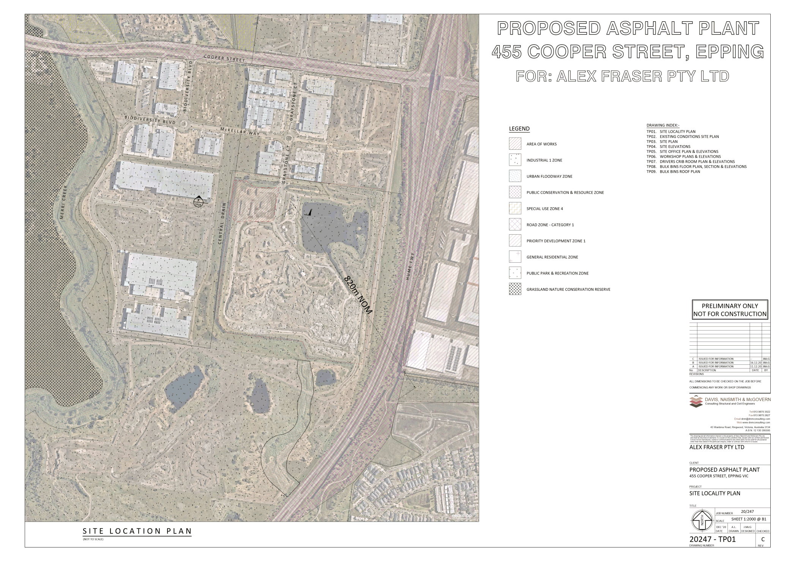
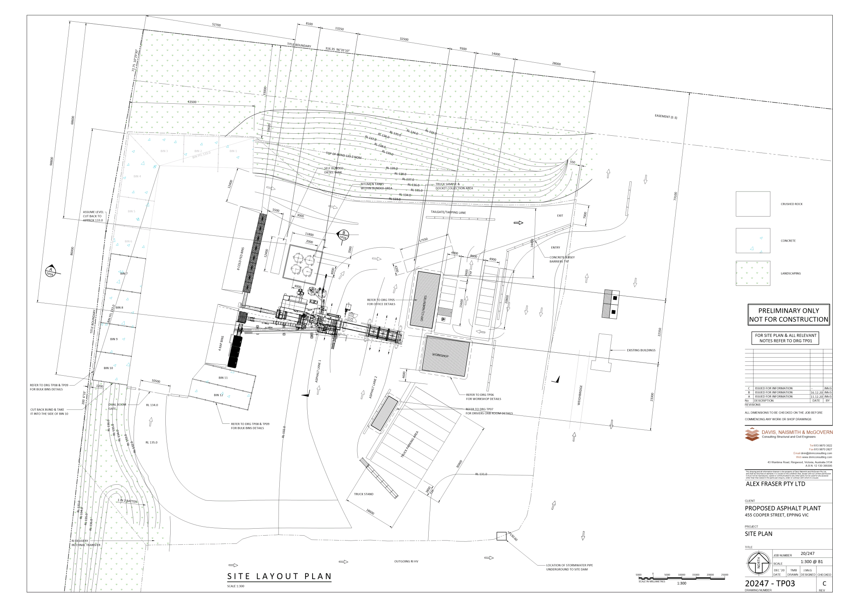

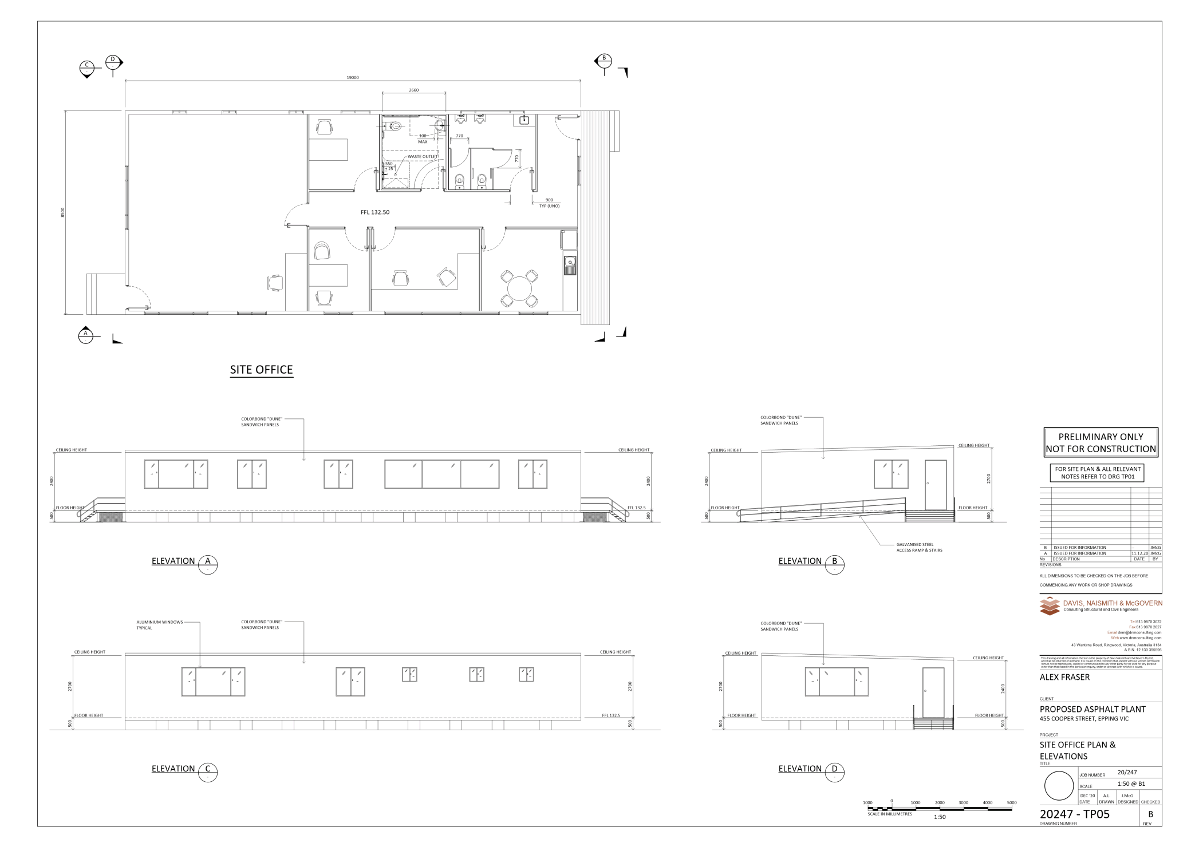

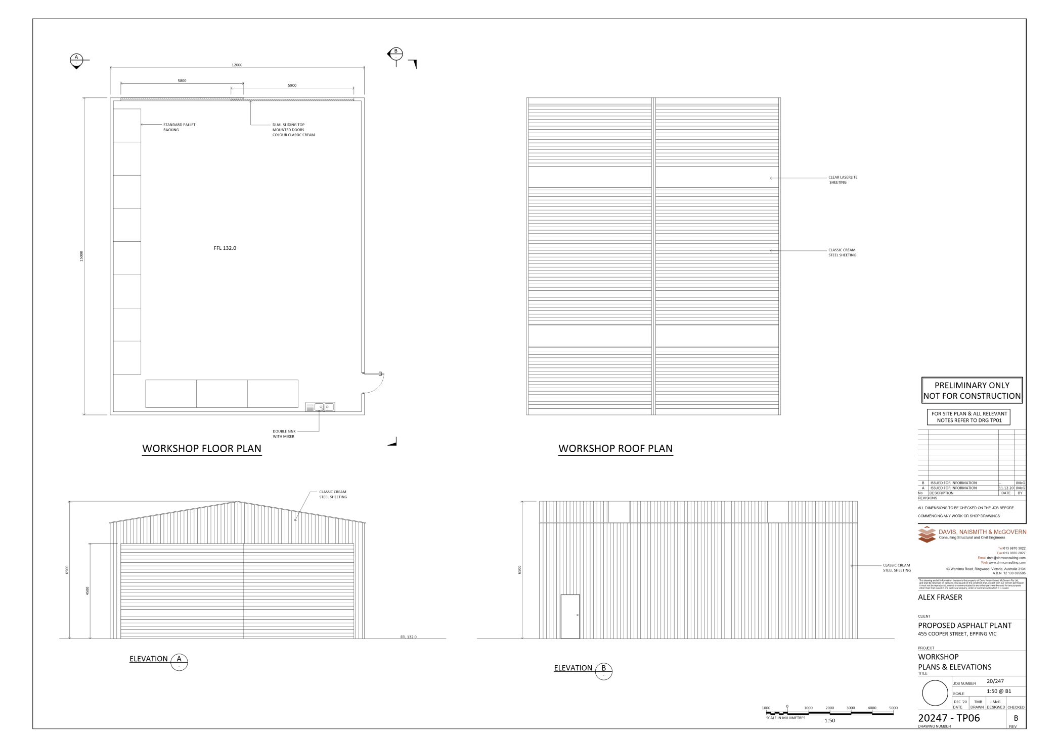

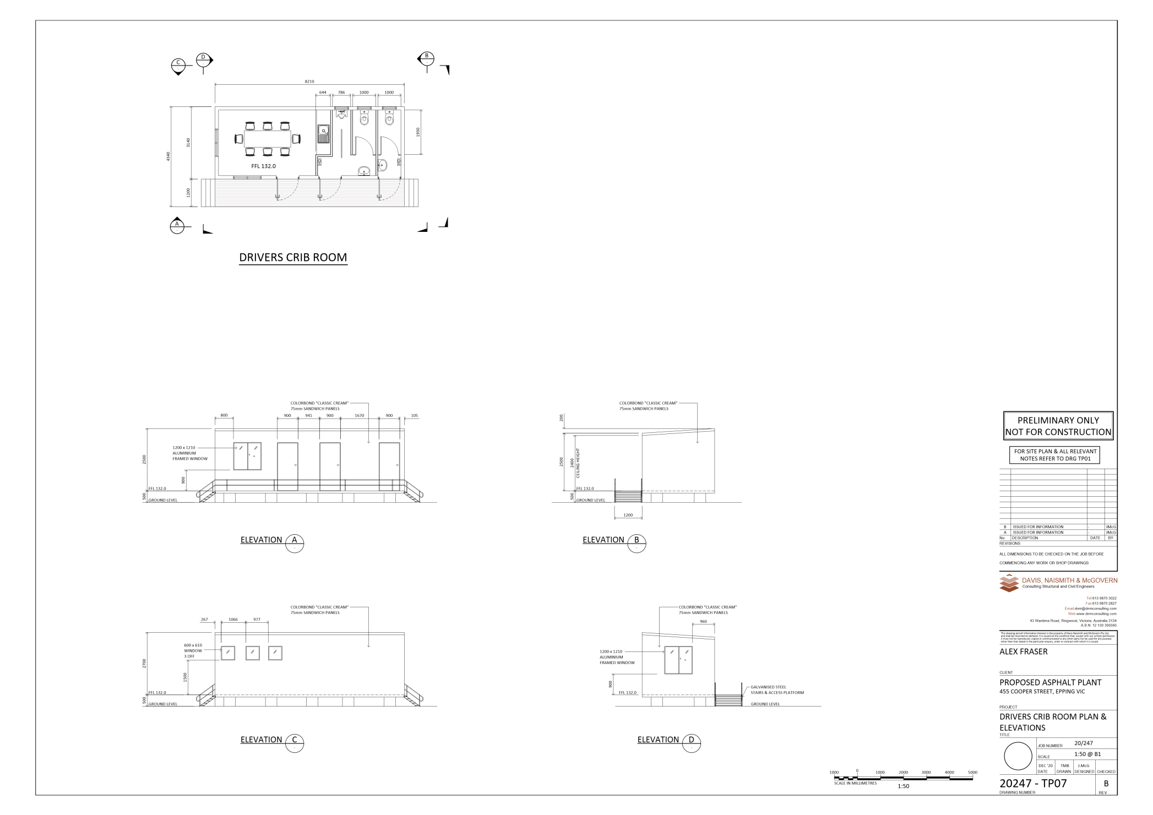

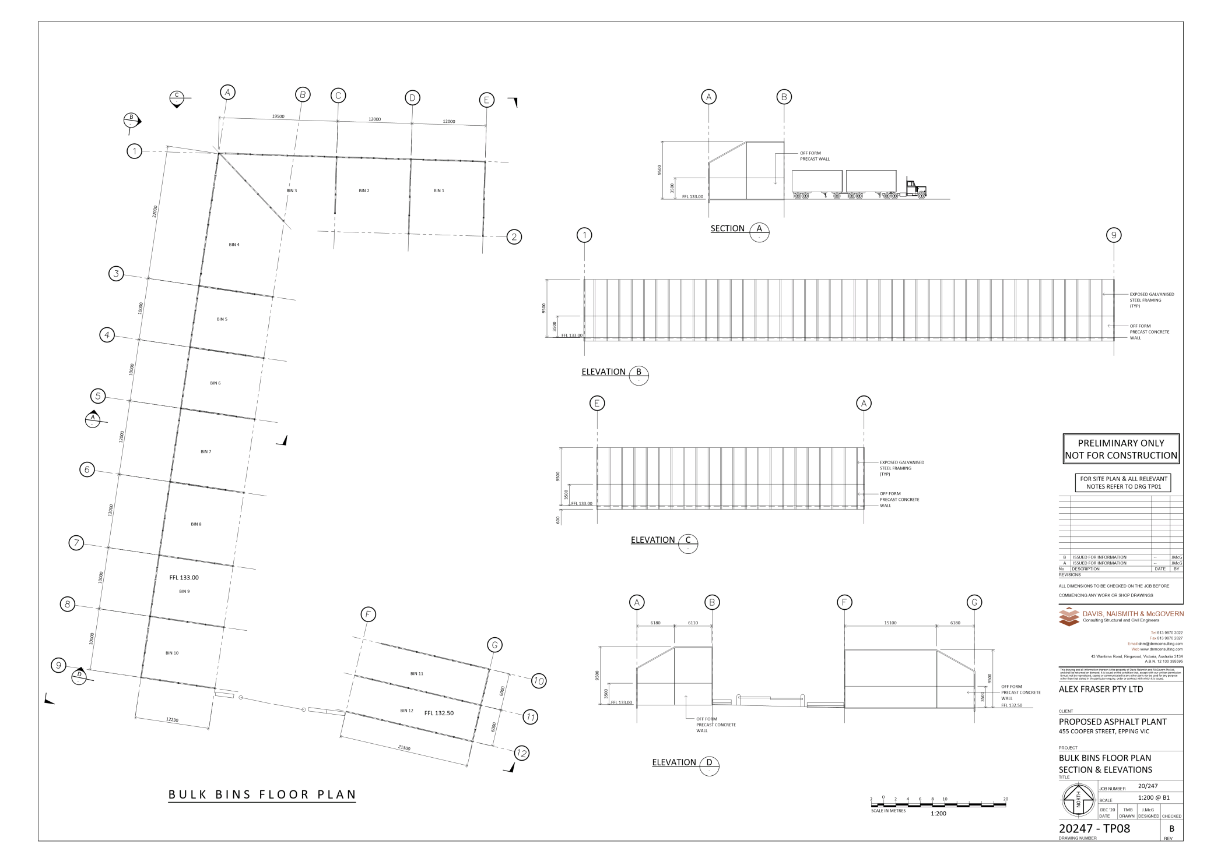

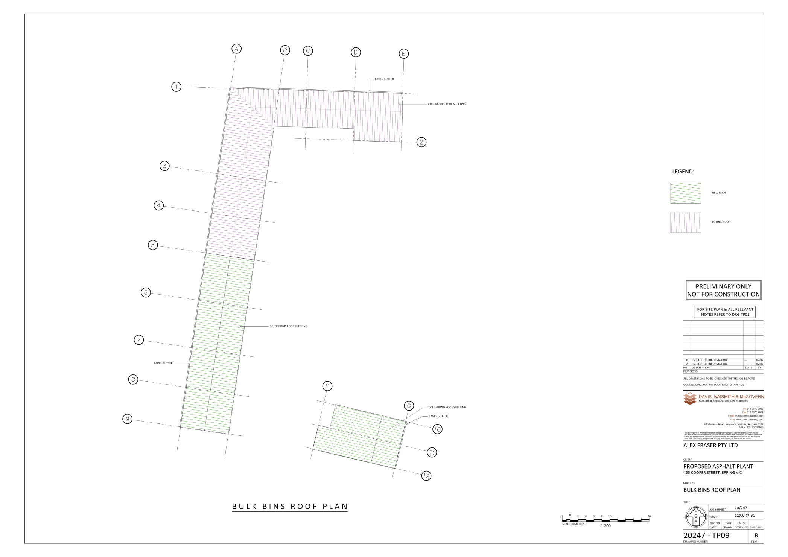

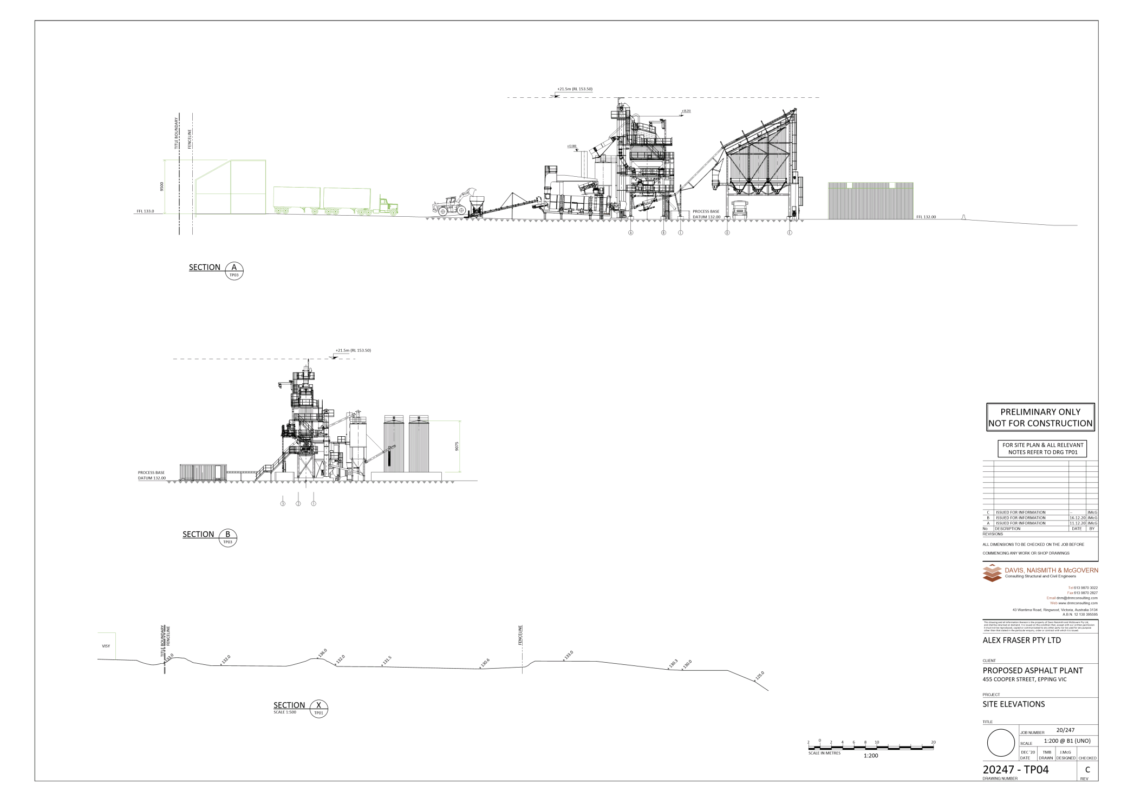

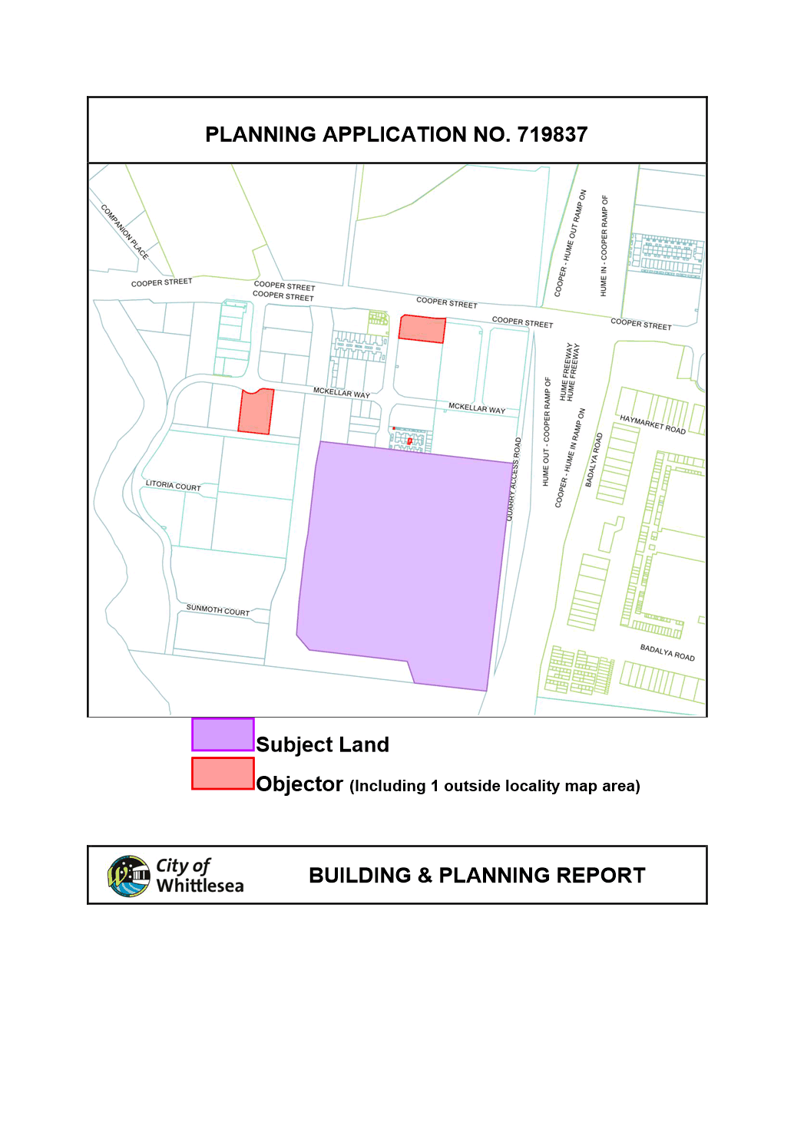

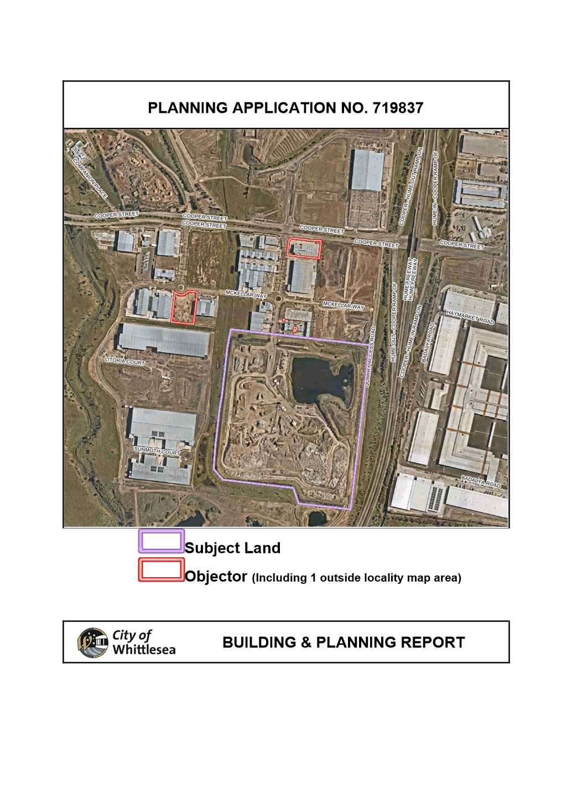

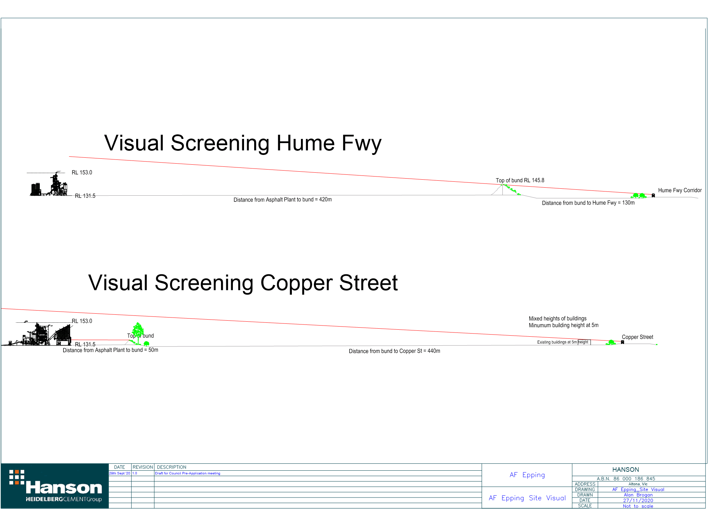

6.3 Strong Local Economy
ITEM 6.3.1 FOR DECISION - Adoption of City of Whittlesea Investment Attraction Plan and 2021-2022 Actions
Attachments: 1 City of Whittlesea IAP 2021-26
Responsible Officer: Director Planning & Development
Author: Project Manager - Investment Attraction

RECOMMENDATION SUMMARY
That Council resolve to:
1. Adopt the Investment Attraction Plan 2021-2026,
2. Support the implementation of Year 1 priority actions for 2021/2022 as identified in the Investment Attraction Plan 2021-2026.
3. Write to participating stakeholders and invite them to a roundtable breakfast event scheduled for mid-July to thank them for their contribution to the project and demonstrate Council’s commitment to supporting investment activity.
Brief overview
The Investment Attraction Plan 2021-2026 (the Plan, Attachment 1) responds to Council’s commitment to support businesses to start, grow and prosper, giving the community access to a range of local jobs in a strong local economy.
The Plan sets out a suite of actions mapped along five stages of an Investor Journey. These actions will inform Council service provision activities and guide how Council communicates and engages with strategic partners to attract public and private investment to the City to create new local employment opportunities.
rationale for recommendation
The importance of economic development, and investment attraction activities is recognised in Goal 3 – Strong Local Economy in Whittlesea 2040: a place for all.
The Plan and its actions are designed to build on the strengths and opportunities for the city, informed by an analysis of key economic drivers and impacts from COVID-19, a competitor review, and stakeholder engagement with business, State Government, Industry and advocacy groups, and health, tertiary and training institutions.
impacts of recommendation
By capitalising on the City’s strengths and responding to key opportunities, the Plan and its resulting actions will help to ensure that Council’s investment attraction efforts are targeted and effective in attracting public and private investment.
what measures will be put in place to manage impacts
The action plan will guide service delivery activities. Progress against key actions will be reported to Council and the community annually. A final report will be prepared at the end of the Plan in 2026 to report overall progress to Council and the community.

Report
Introduction
The Investment Attraction Plan 2021-2026 (the Plan) will guide the City of Whittlesea’s efforts to retain and grow existing investment, and attract new investment in the city, supporting an increase in employment opportunities for local residents.
Background
Council’s Economic Development Strategy 2017-2021 sets out Council’s commitment to support businesses to start, grow and prosper, giving the community access to a range of local jobs in a strong local economy.
The City of Whittlesea is one of the fastest growing municipalities in Australia. The city welcomes more than 8,000 new residents every year and over the past 5 years an average of 1,800 jobs p.a. This rapid population growth is expected to continue and by 2040 our population is estimated to grow from 236,539 (June 2020) to 382,896.
Census data from 2016 shows that around 32 per cent of residents work within the municipality and 19 per cent work in inner Melbourne. Some 80 per cent of residents drive to work with many experiencing long commute times of more than two hours. Traffic congestion and long commutes significantly impact on the wellbeing of our community.
With nation leading population growth and development combined with an existing lag in road and public transport infrastructure, the City of Whittlesea has a major focus on attracting more local jobs in a diverse range of industries, supporting the diverse nature of our resident and business community.
A range of investment attraction initiatives have been completed by Council in line with the Economic Development Strategy since 2017, however economic impacts arising from the COVID-19 pandemic in 2020 and 2021 have highlighted the need to increase these efforts. Accordingly, the preparation of an Investment Attraction Plan is one of the actions set out in the Municipal Pandemic Recovery and Response Action Plan, endorsed by Council in February 2021.
Proposal
The Investment Attraction Plan outlines the greatest ever commitment by Council on how Council together with key stakeholders and partners can create an attractive business and investment environment that will influence public and private investment decision making and in turn create additional employment opportunities for local residents.
Current status
Guided by the Economic Development Strategy 2017-2021, Council has progressed a number of investment attraction initiatives, complementing business support service activities. These include:
• Business-focussed communications, including the development of an Investment Attraction Prospectus, regular eNewsletter for business subscribers, and social media promotions,
• Development and implementation of Council’s Priority Development Application Process and completion of the State Government’s Better Approvals Process review, and
• Council’s Advocacy program, as well as support for regional investment attraction and advocacy activities facilitated through partnerships with NORTHLink, the Northern Councils Alliance and National Growth Areas Alliance.
Economic impacts from the COVID-19 pandemic has highlighted the importance of the role of local business in supporting local economic participation, placing greater emphasis on Council’s Economic Development functions. By identifying the city’s key strengths and opportunities for economic growth sectors, the Investment Attraction Plan will focus Council efforts to attract public and private investment, targeting new medium and large businesses and supporting all business to thrive and grow for the benefit of the local community.
Developing the Plan
Urbis was appointed in late 2020 to work with Council to prepare the Investment Attraction Plan.
The Plan has been prepared considering the following:
• Existing Council and State Government and regional investment policy and objectives;
• Macro-economic growth trajectory for Australia following COVID-19 and implications for Whittlesea
• COVID-19 impacted population projections and impact upon growth assumptions for in Whittlesea
• COVID-19 impacted employment growth and business growth projections by sector
• Key investment infrastructure, institutions, economic anchors and drivers
• Skills review of residents matched against existing jobs
• Investment attraction activities, materials and resourcing at other Councils
• Feedback from targeted stakeholders examining:
o Perceptions of Whittlesea from their investment or business experience
o Reasons for locating in Whittlesea and future plans
o Suggested opportunities for improvements to Council services for business retention and growth.
Goals and Targets
The Plan seeks to position the City of Whittlesea as:
• Supportive, providing businesses with support networks that empower them to rise above post COVID-19 pandemic challenges, innovate and grow
• Proactive, going the extra mile to make things happen, so businesses can pursue their growth plans with confidence and optimism and
• Forward thinking, supporting job growth now and into the future.
In doing this, the Plan sets out a number of actions focussed around five different stages of the investment journey.
• Outcome 1: More businesses are aware of the City of Whittlesea’s strengths and seek information or advice from the City of Whittlesea when they are defining their business growth needs.
• Outcome 2: More businesses shortlist the City of Whittlesea as one of their location options.
• Outcome 3: The City of Whittlesea offers prospective businesses competitive packages.
• Outcome 4: More businesses are highly satisfied with their experience of relocating to the City of Whittlesea.
• Outcome 5: More existing businesses are highly satisfied with their experience in the City of Whittlesea.
Actions under each outcome are focussed on how Council coordinates messaging and activities, communicates with key stakeholders and our business community, and champions successes. These actions have been thematically grouped and prioritised in the Implementation Plan.
The Plan sets out measures of success such as customer satisfaction ratings from business impact surveys and number of enquiries from potential investors and/or businesses.
Measurable targets and further economic indicators such as number of new businesses and local jobs created, number of targeted communications to business and business engagement efforts and events will be developed as part of the Strong Local Economy Strategy being developed in 2021-2022.
Consultation
Community input on the role of Council in supporting a Strong Local Economy and business support activities has been sought and confirmed through recent community engagement for the Council Action Plan 2021 and recent Business Impact Surveys.
Stakeholder interviews were undertaken with representatives of the following sectors:
• State Government
• Industry and advocacy groups
• Businesses in the Food and beverage, Health, Education, Retail, Manufacturing, Logistics, freight and warehousing, and renewable energy and waste recycling sectors;
• Landowners and developers
Input has also been included from local members of Parliament.
Themes arising from the targeted interviews and resulting opportunities are set out in detail in the Plan.
Critical Dates
The Municipal Pandemic Readiness & Recovery Plan identified the development of an Investment Attraction Plan in the list of actions to be implemented by Council up to June 2021.
Financial Implications
The approved 2021-2022 Council Budget provides Council’s greatest ever level of funding to economic development and investment attraction activities. This includes a dedicated Investment Attraction budget of $235,000, further supported by taking a ‘whole of council’ approach to implementation including increased resourcing for economic development, communications and advocacy, grants and planning functions.
This budget allocation will support Year 1, 2021-2022 actions focused on the development and implementation of strategic frameworks for the following essential investment attraction approaches:
• Communications
• Partner Engagement & Advocacy
• Business Engagement & Support
• Council grants and incentives package
• Priority Development Approvals Process and
• Evaluation and monitoring.
The approved 2021/2022 Council Budget contains the greatest ever level of funding towards investment attraction activities enabling delivery of Year 1 priority actions. The balance of actions for future years will be referred to Council for consideration as part of subsequent budget approval processes.
Policy strategy and legislation
The Investment Attraction Plan is informed by
• Whittlesea 2040: A Place for All. Goal 3, Strong Local Economy
• Economic Development Strategy 2017-2021
• Municipal Pandemic Recovery & Response Plan
• Community Building Strategy – Building better together

Links to whittlesea 2040 and the CoUNCIL Plan
Goal Strong local economy
Key Direction Increased local employment

The Investment Attraction Plan seeks to deliver on the outcomes of Whittlesea 2040: A place for all by strengthening the investment environment within the city in order to increase the number and diversity of local jobs. The proposed actions will direct how Council will work with government, business and industry partners to promote the city’s strengths, and to guide new Council-led initiatives and internal processes relevant to business activity.
At its meeting on 1 March 2021, Council resolved to adopt a new integrated planning framework. The aim is to consolidate all of Council’s community-facing policies, strategies and plans within five major strategies aligned to the key theses of Whittlesea 2040: A place for all. It is proposed that this Plan will fall under the proposed new Strong Local Economy Strategy to be developed in the second half of this year. To be consistent with the new integrated planning framework the document title has been amended to Investment Attraction Plan (previously Investment Attraction Strategy).
Declarations of Conflicts of Interest
Under Section 130 of the Local Government Act 2020 and Rule 47 of the Governance Rules 2021, officers providing advice to Council are required to disclose any conflict of interest they have in a matter and explain the nature of the conflict.
The Responsible Officer reviewing this report, having made enquiries with relevant members of staff, reports that no disclosable interests have been raised in relation to this report.
Conclusion
The Investment Attraction Plan 2021-2026 will guide Council’s approach and actions to attract and retain investment in the City, giving the community access to a range of local jobs in a strong local economy in line with the directions set in Whittlesea 2040: a place for all.
The Plan and its actions aim to position Council as supportive, proactive and forward thinking in creating a positive investment environment, and recognises the importance of working with key partners and building on Council’s strengths to achieve this goal.
The approved 2021/2022 Council Budget contains the greatest ever level of funding towards investment attraction activities, and will enable delivery of Year 1 priority actions. The balance of actions for future years will be subject of annual prioritisation and budget approval processes.

RECOMMENDATION
THAT Council resolve to:
1. Adopt the Investment Attraction Plan 2021-2026;
2. Support the implementation of Year 1 priority actions for 2021/2022 as identified in the Investment Attraction Plan 2021-2026;
3. Write to participating stakeholders and invite them to a roundtable breakfast event scheduled for mid-July to thank them for their contribution to the project and demonstrate Council’s commitment to supporting investment activity.
Council Resolution
Moved: Administrator Eddy
Seconded: Chairperson Wilson

THAT Council resolve to adopt the Recommendation.
Carried

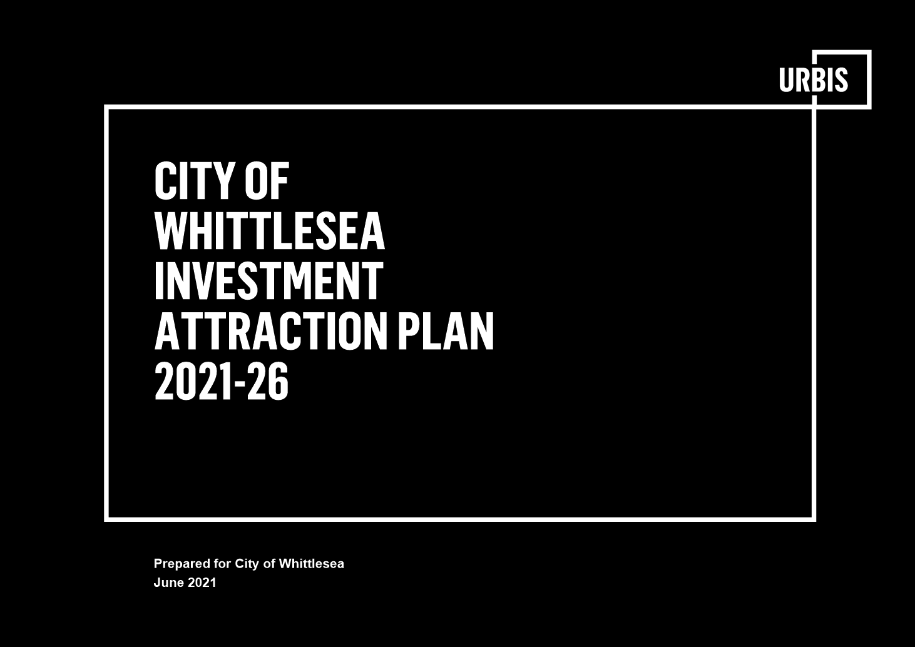

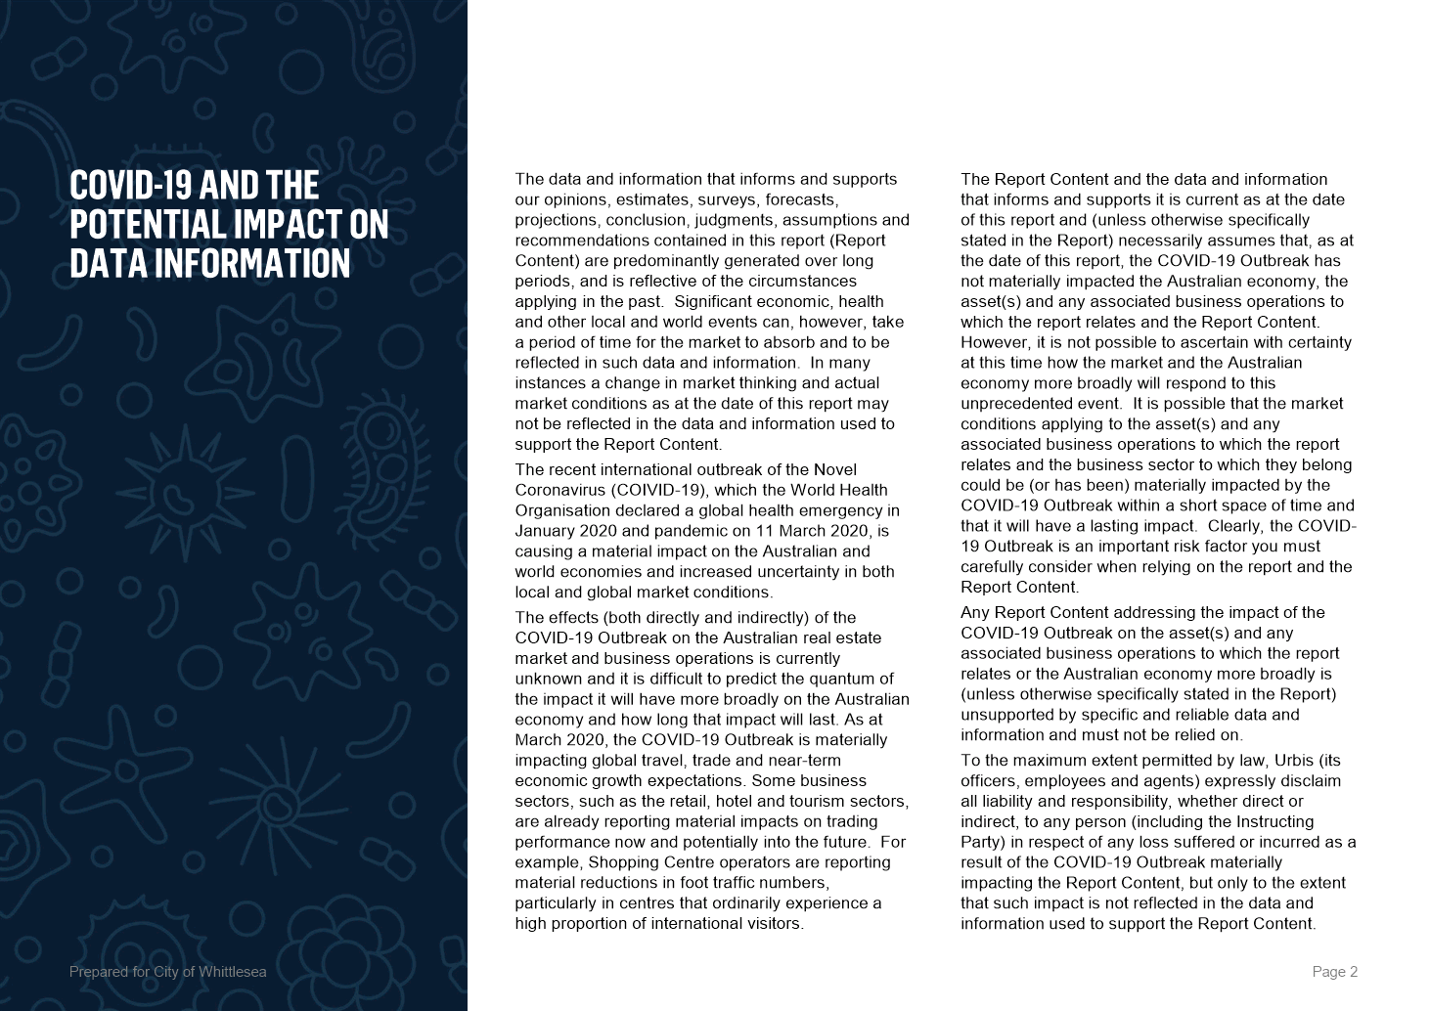

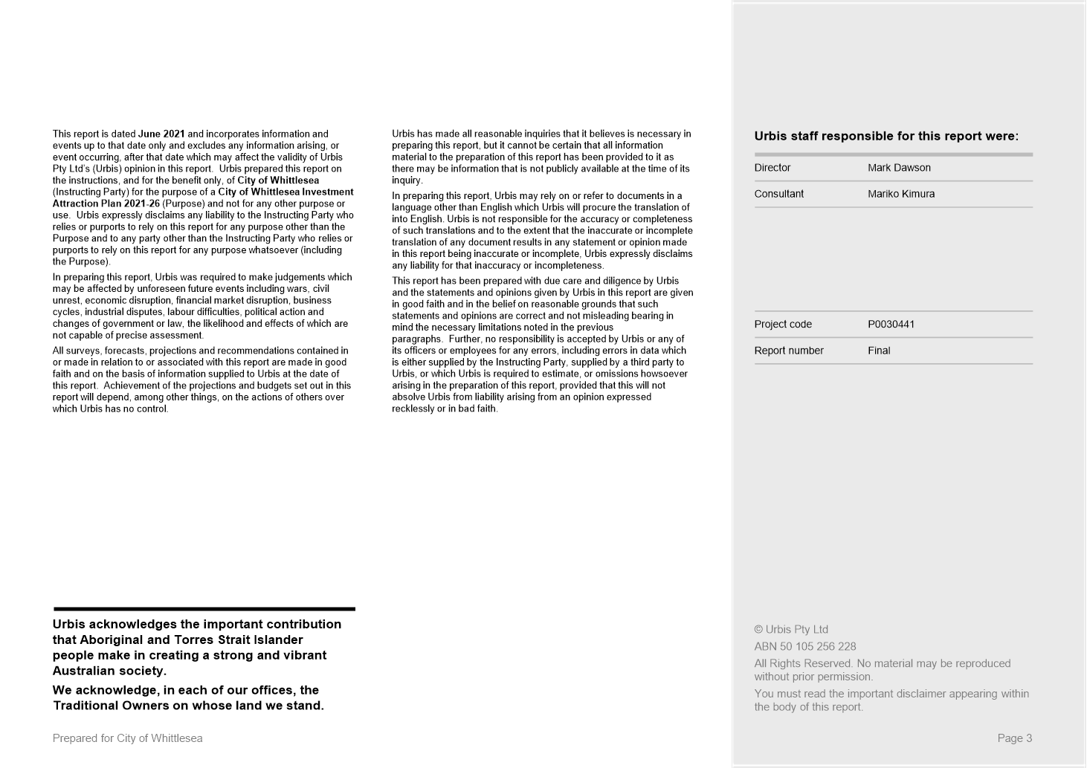

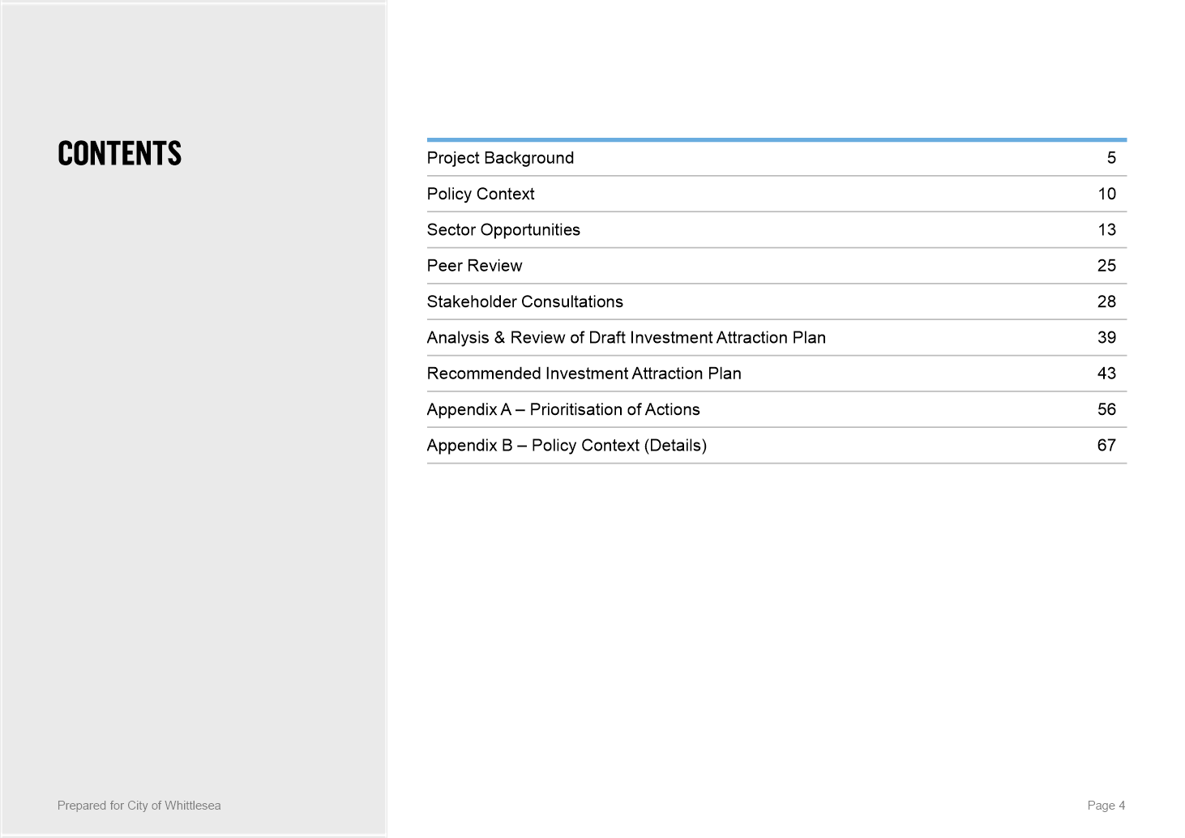

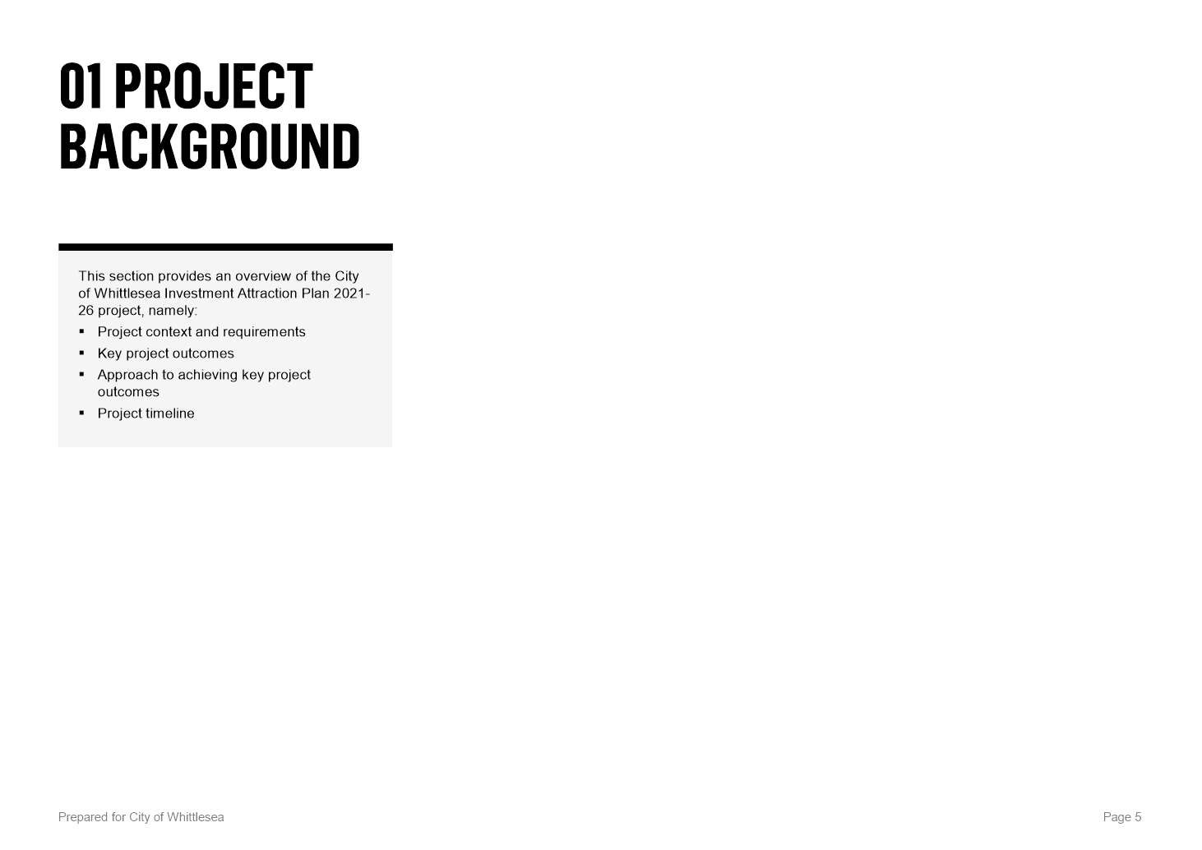

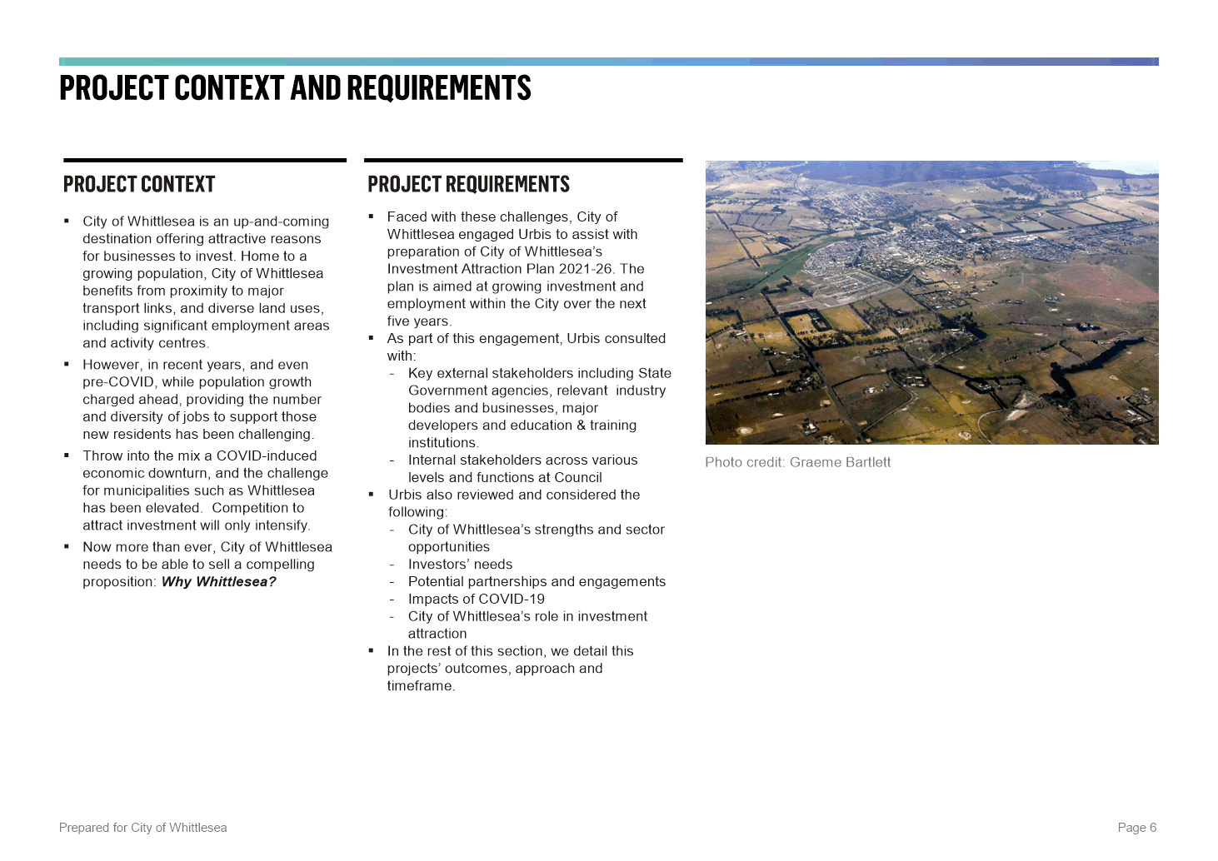

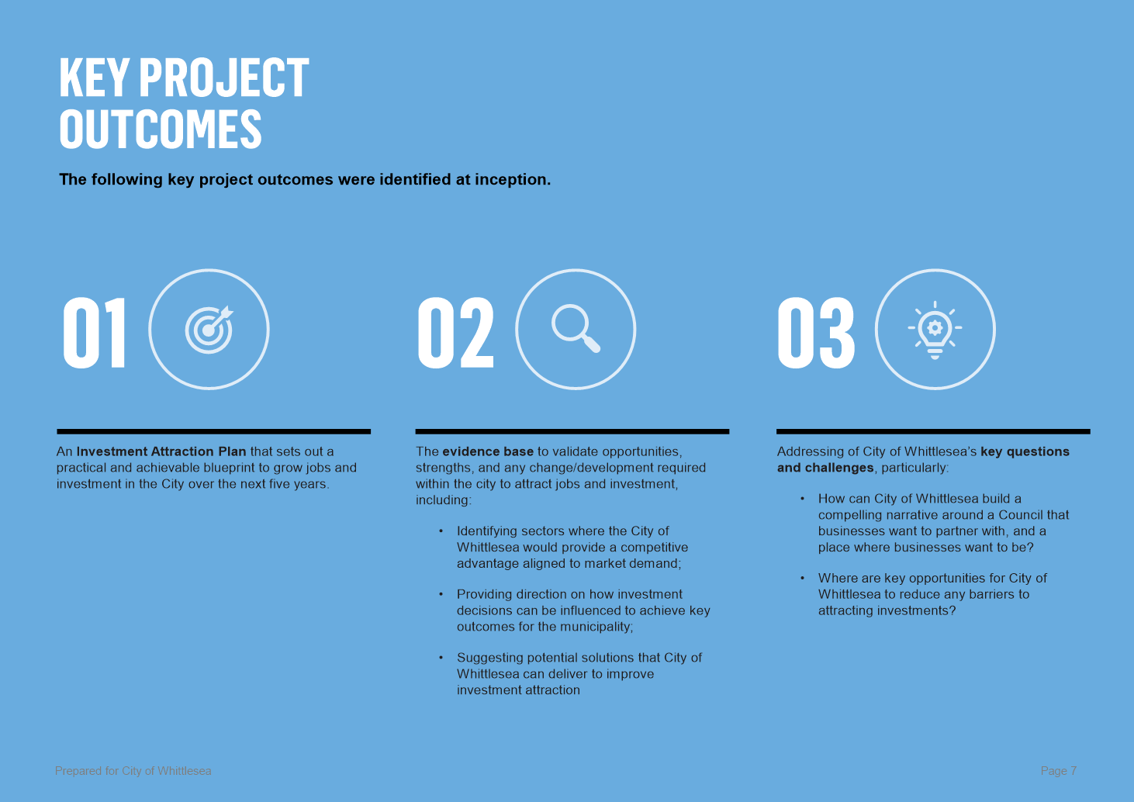

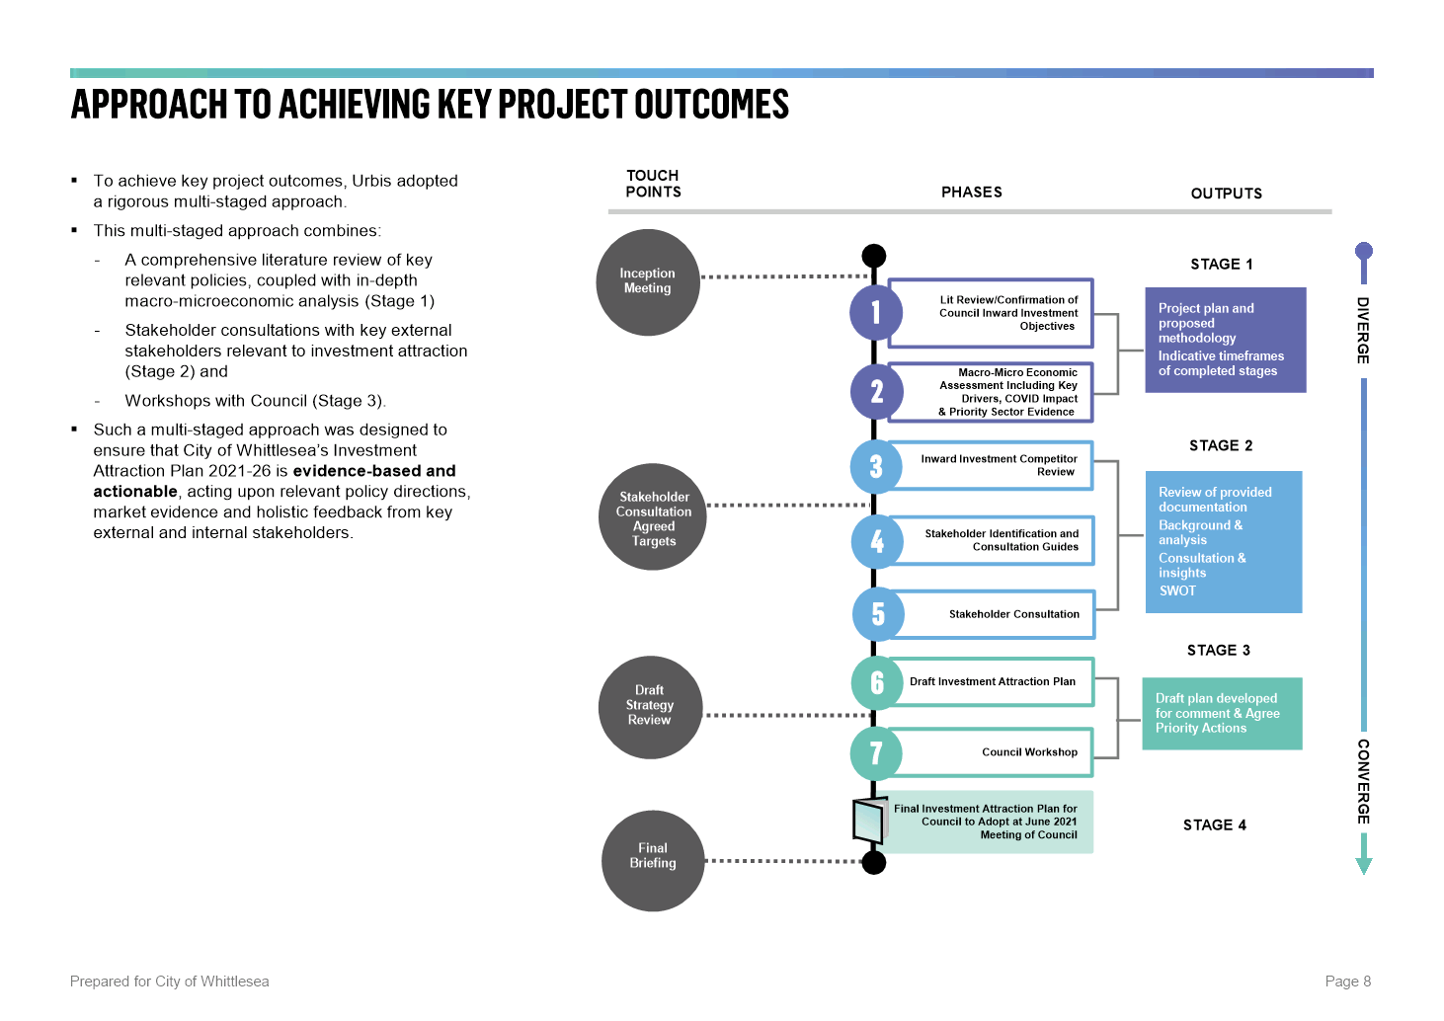

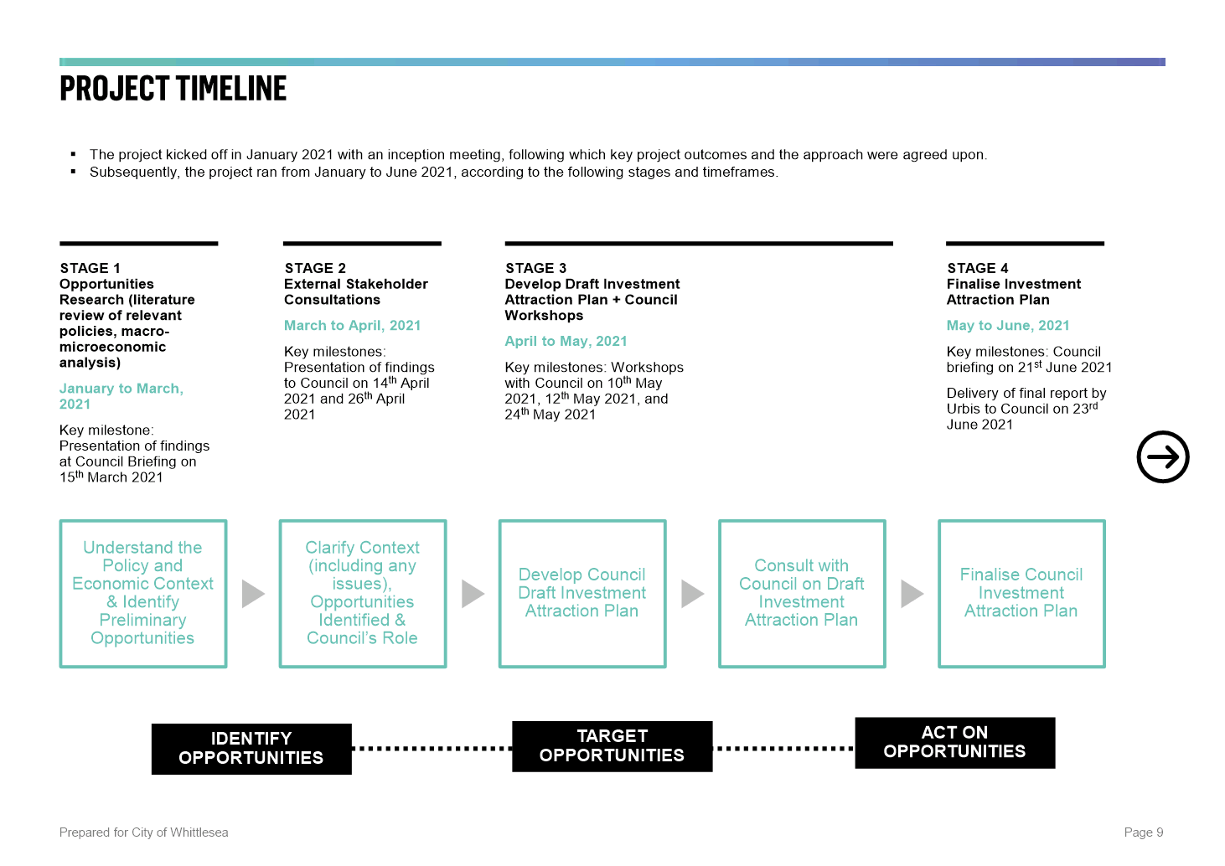

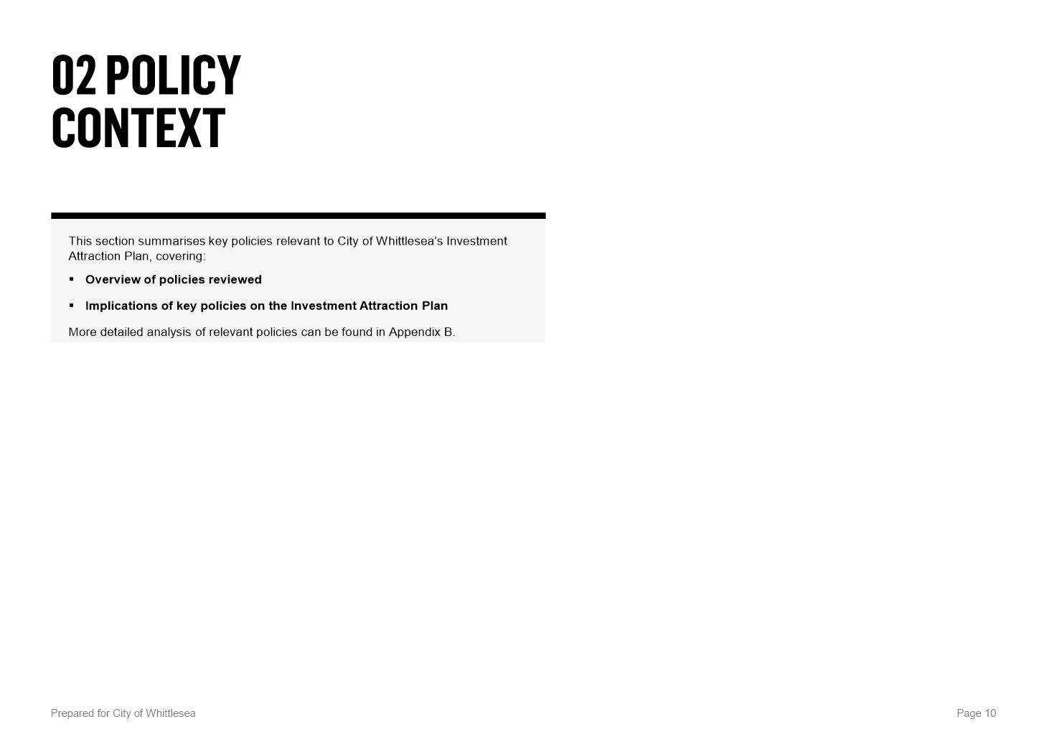

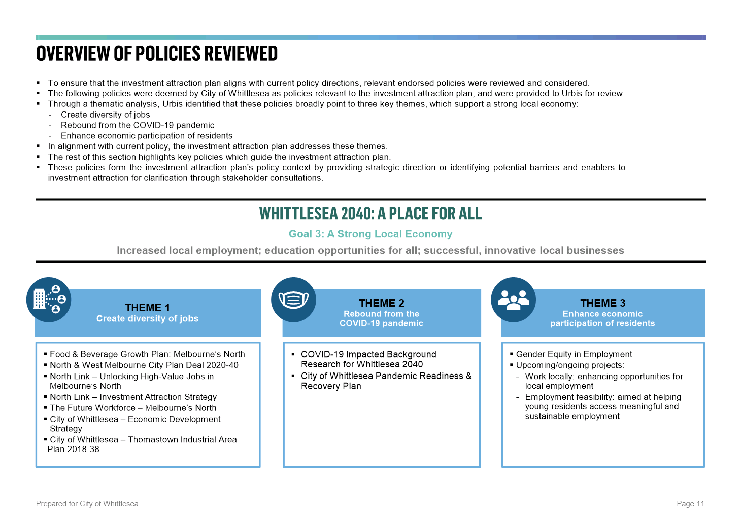

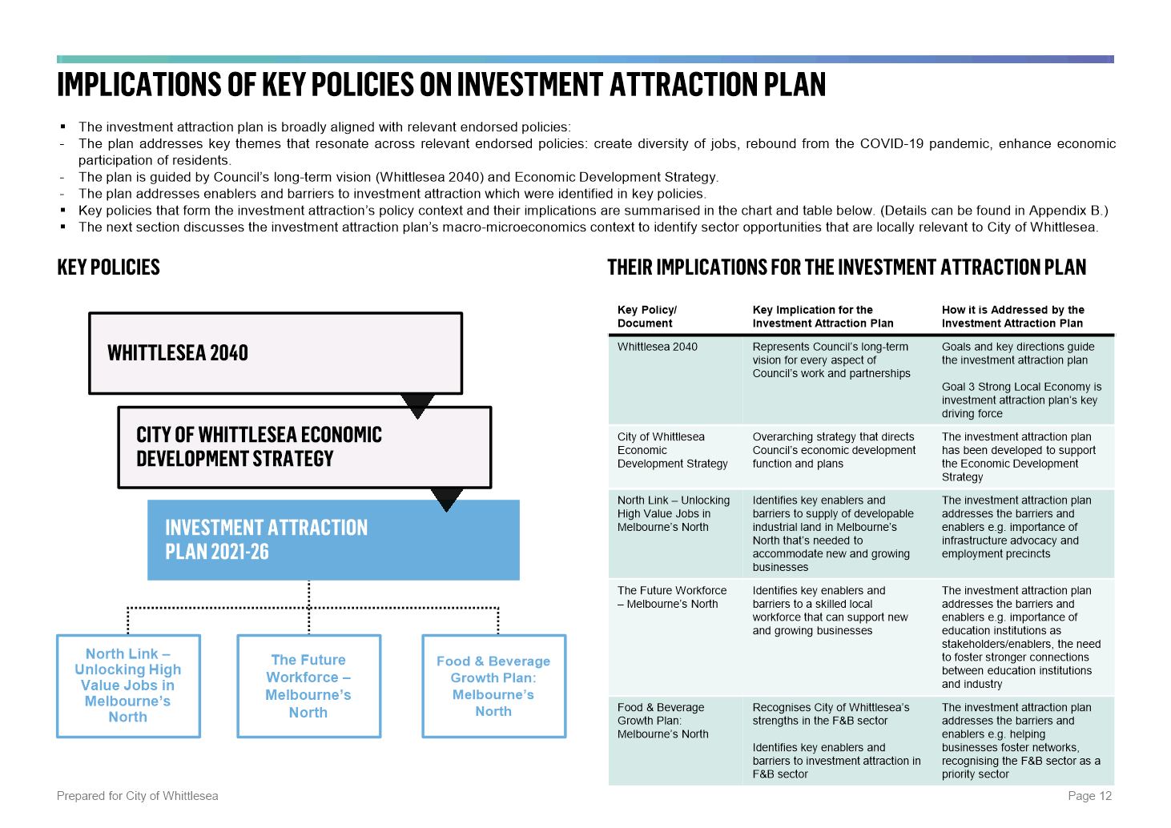

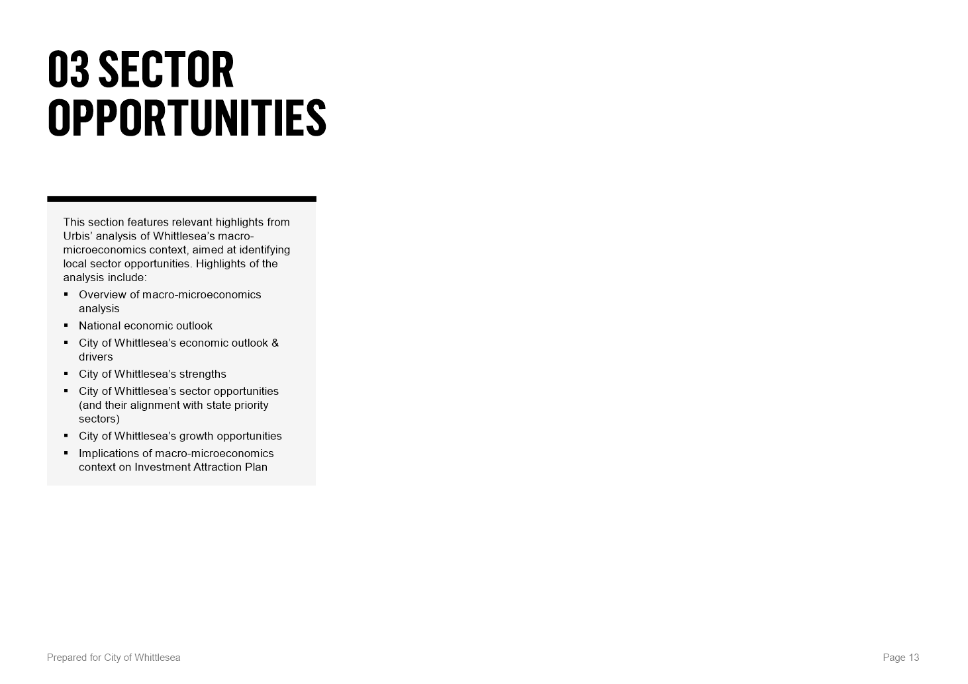

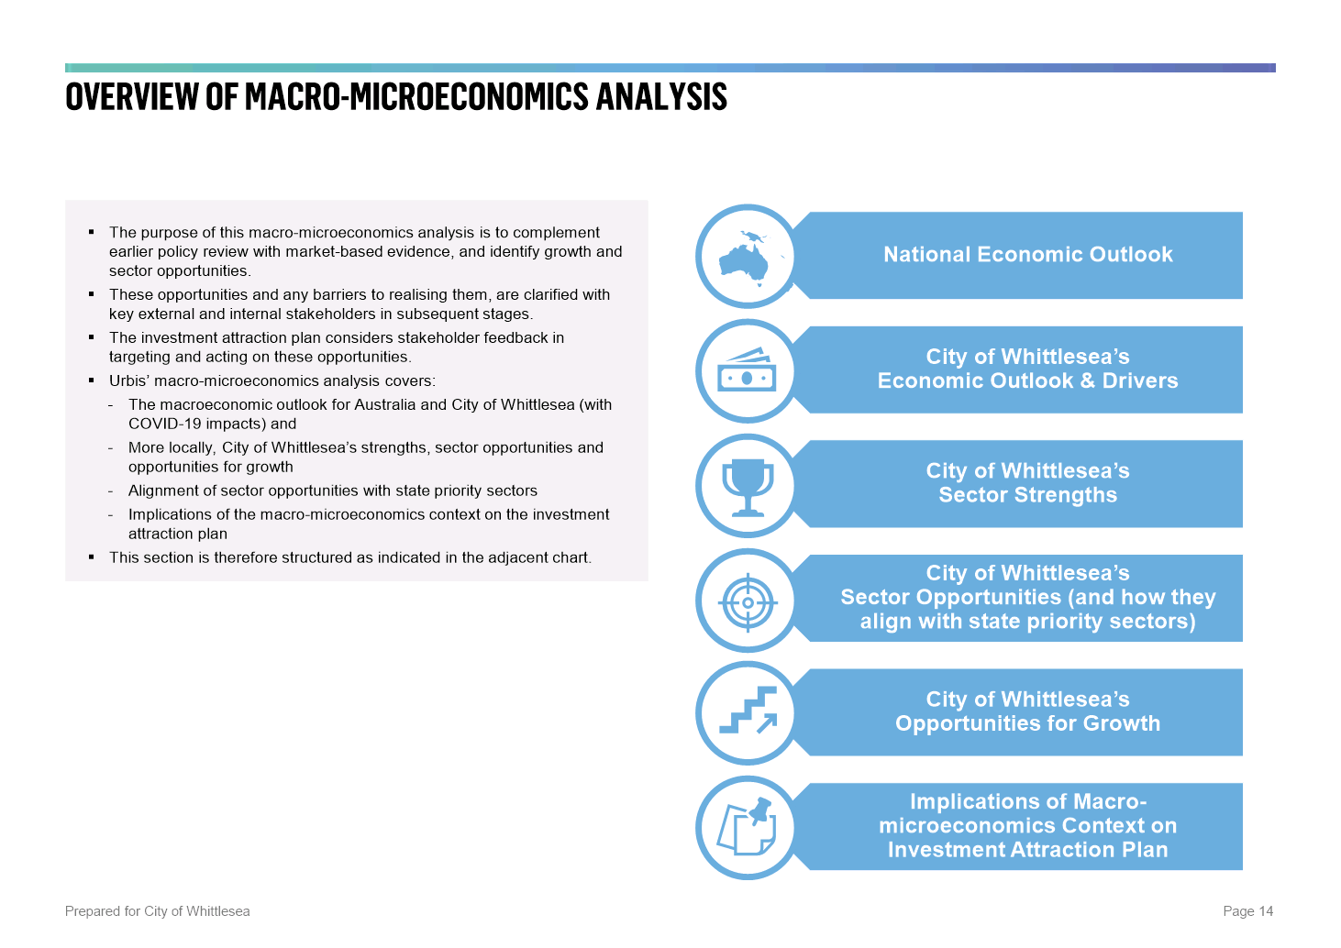

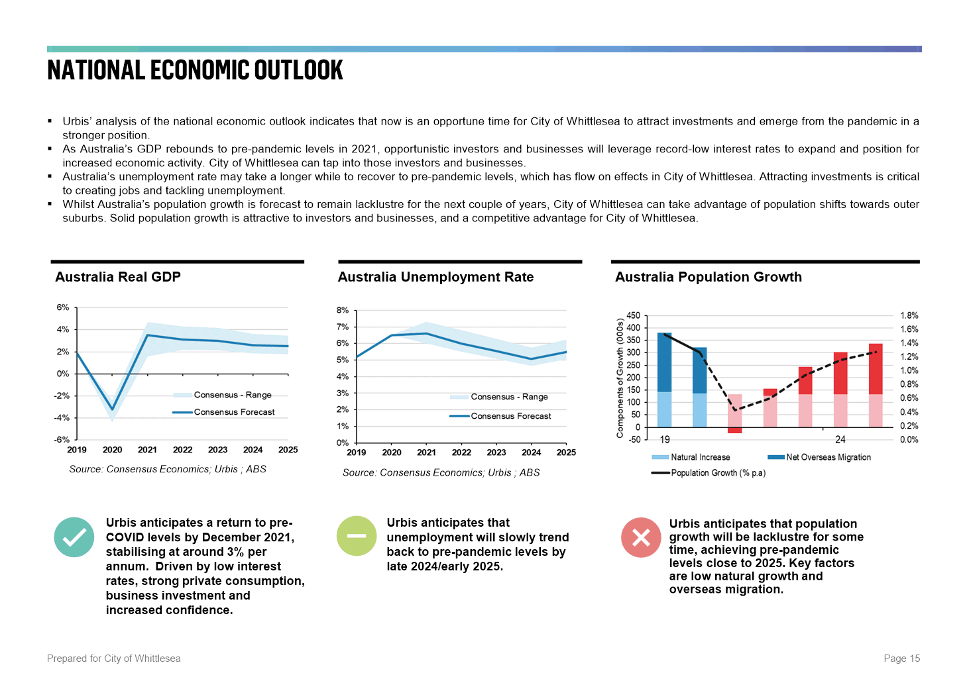

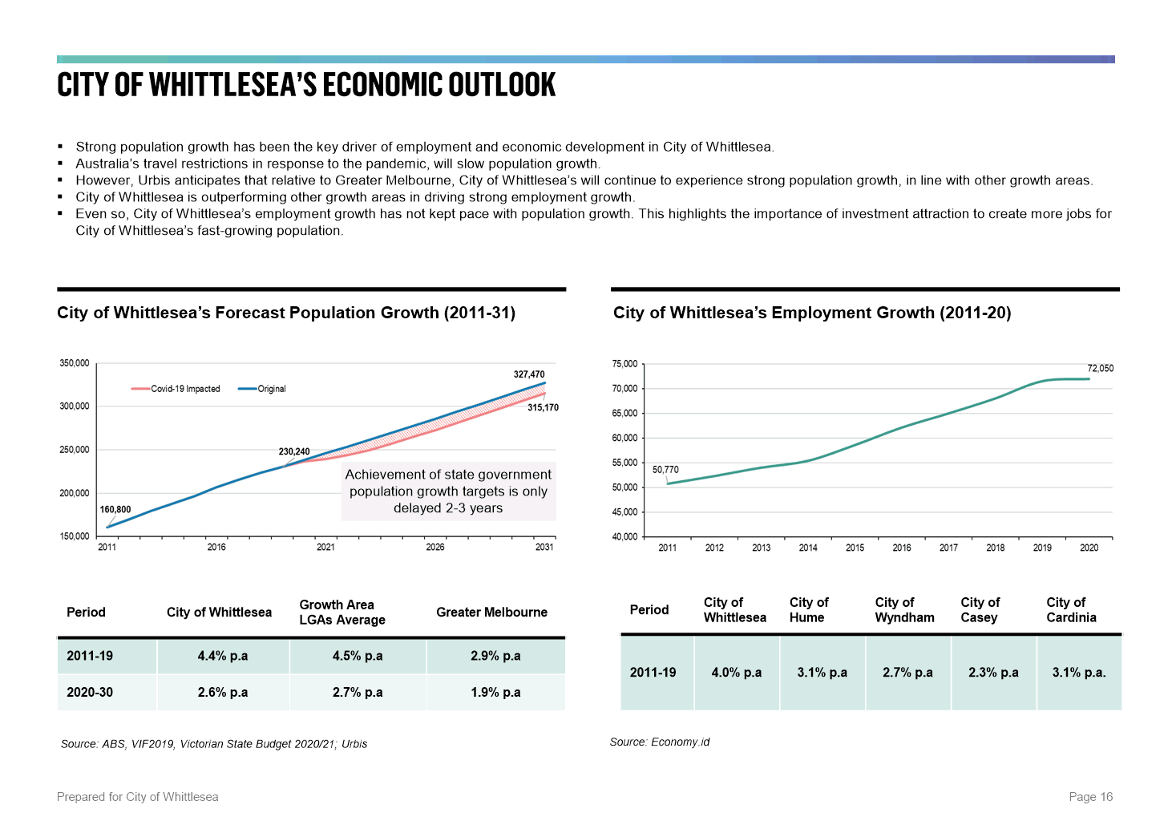

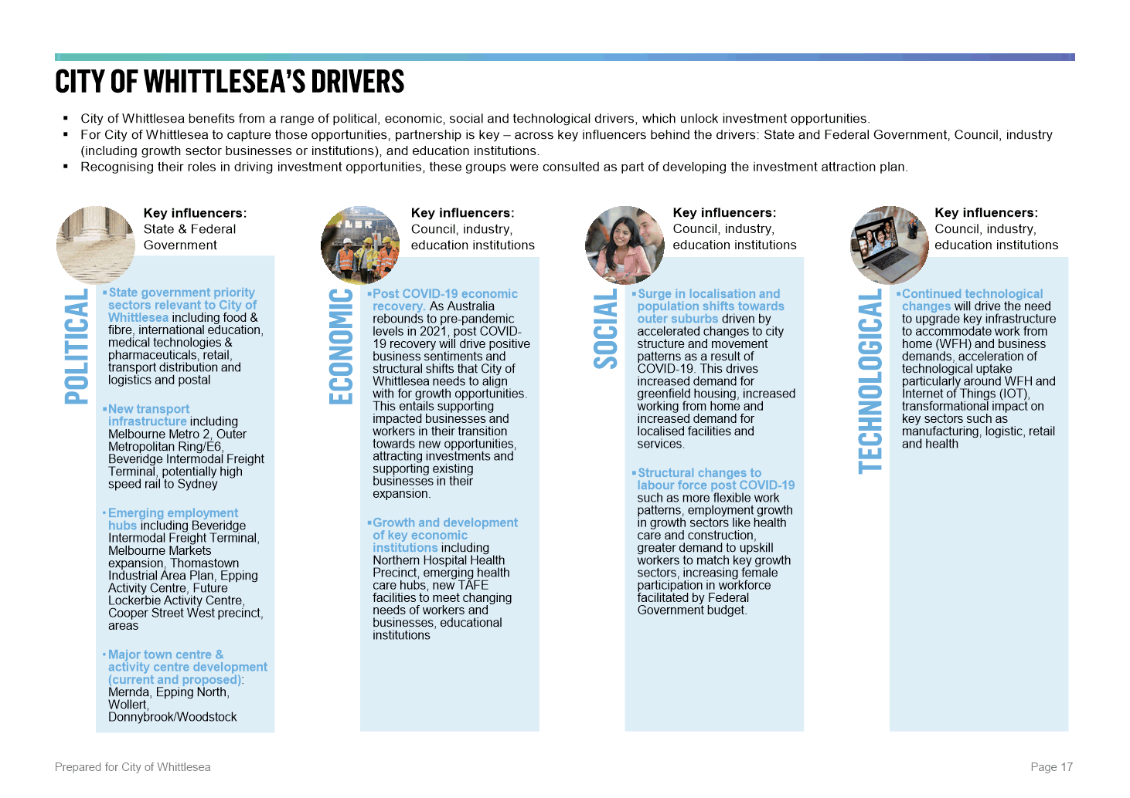

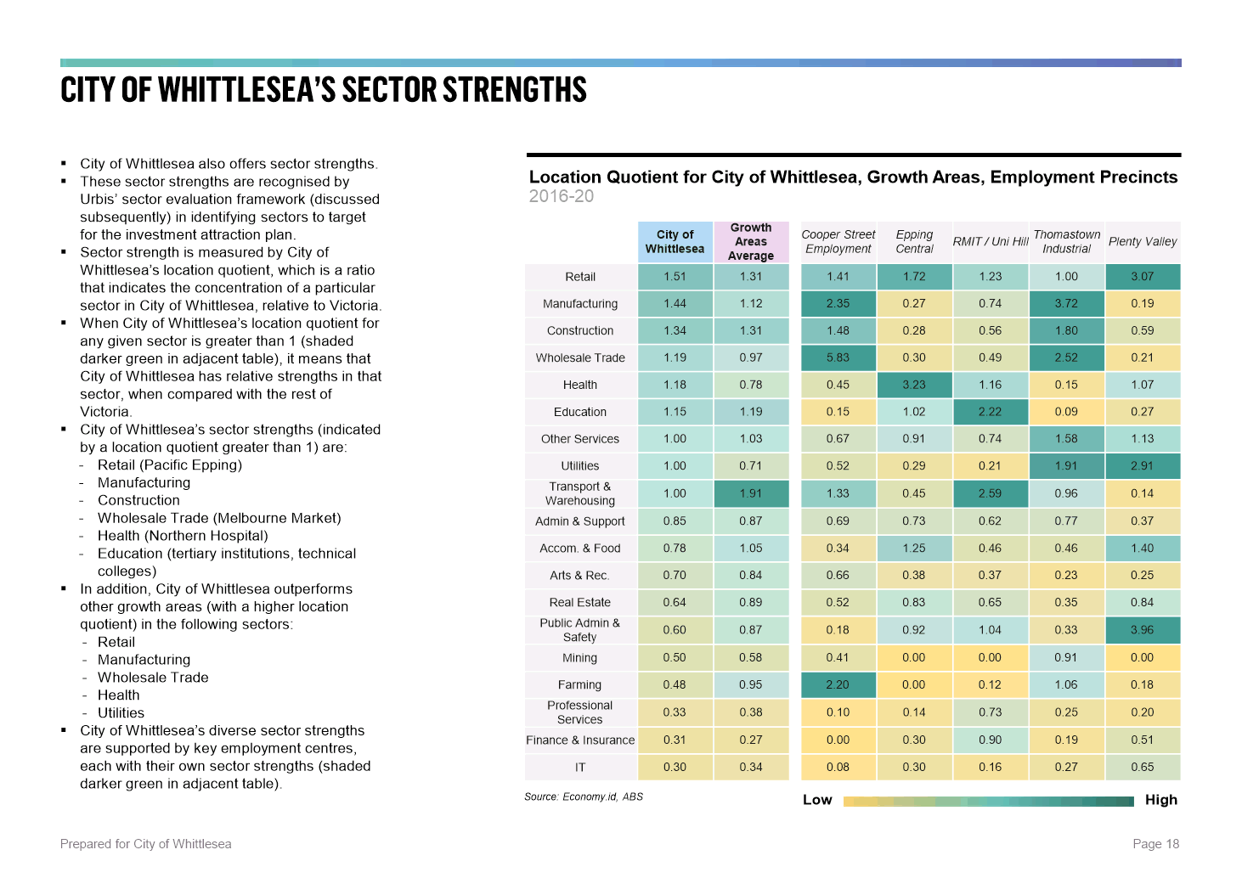

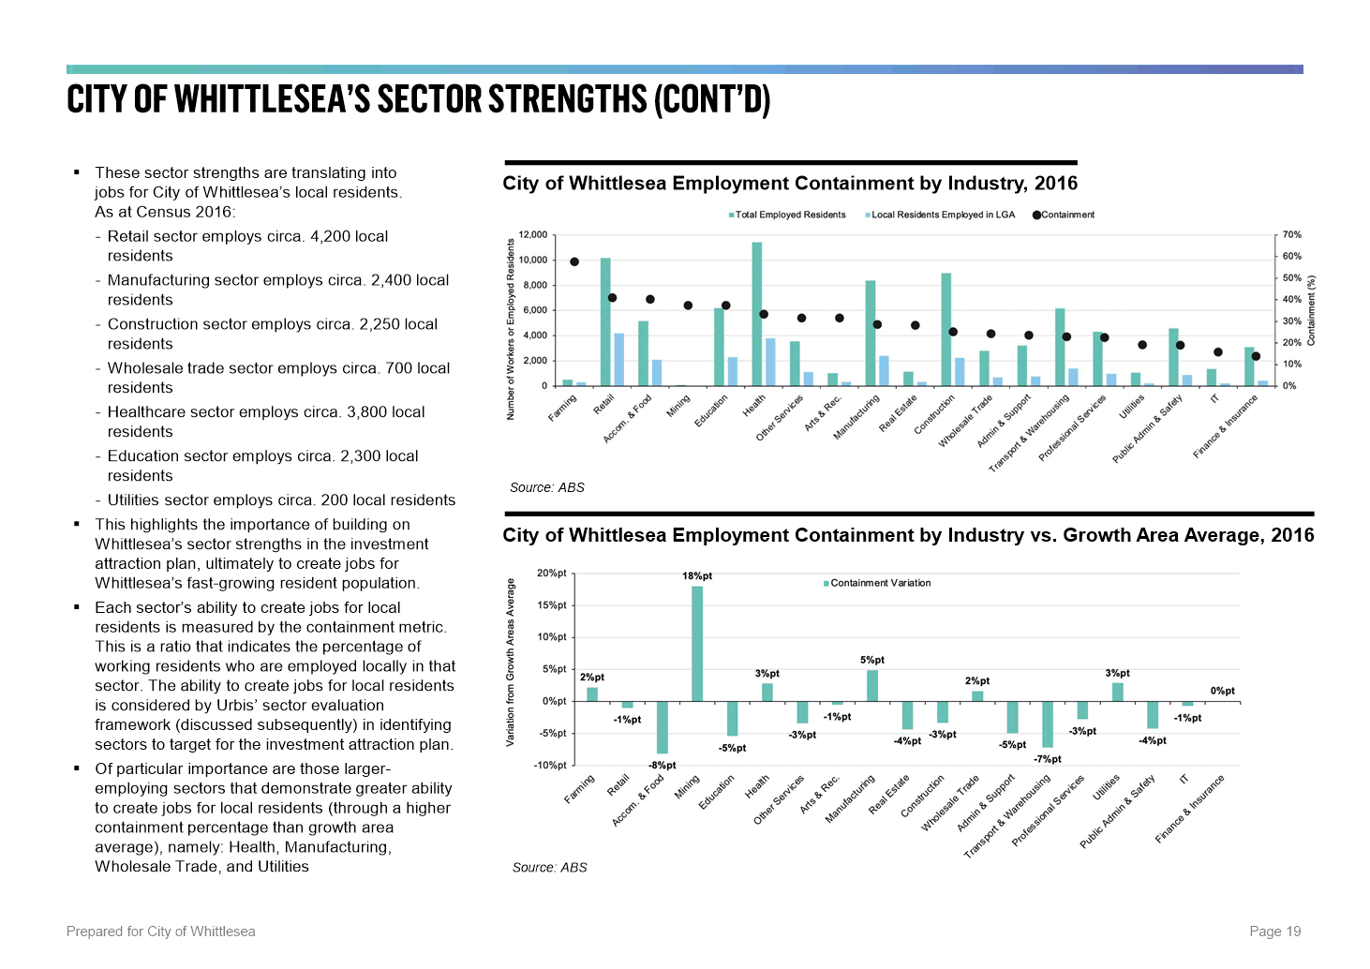

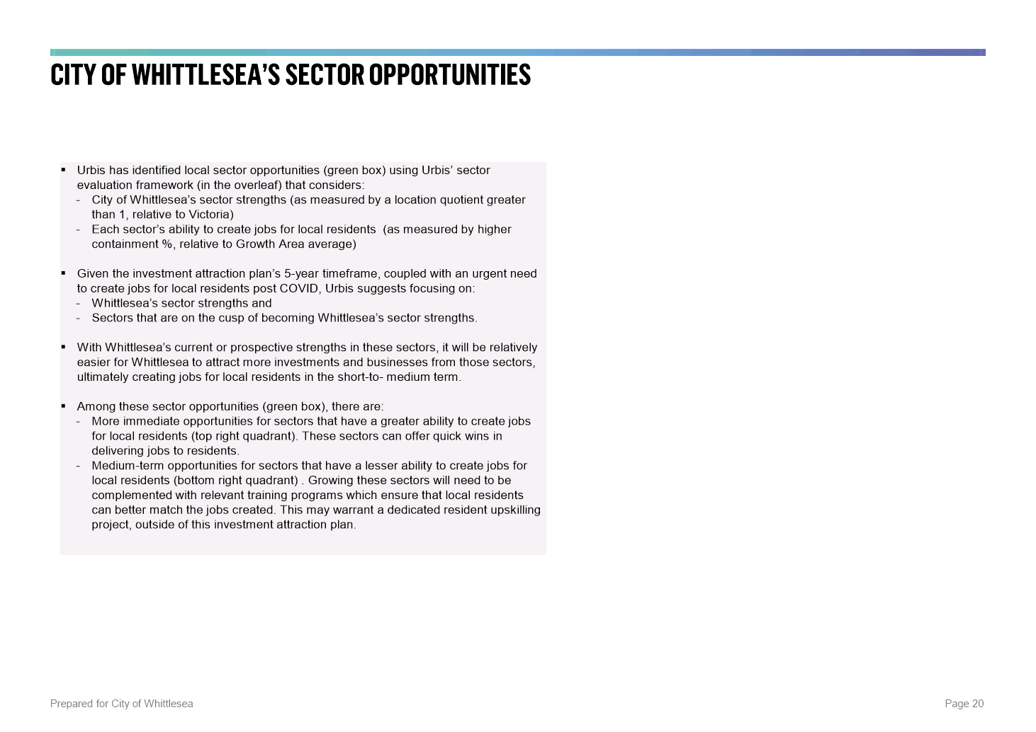

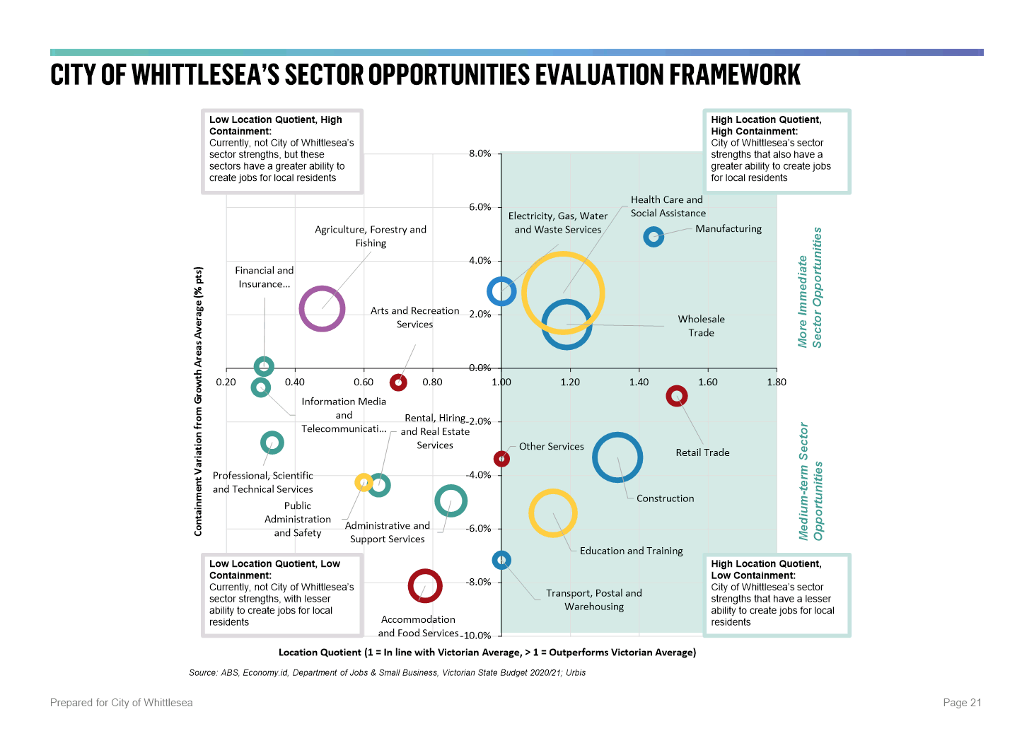

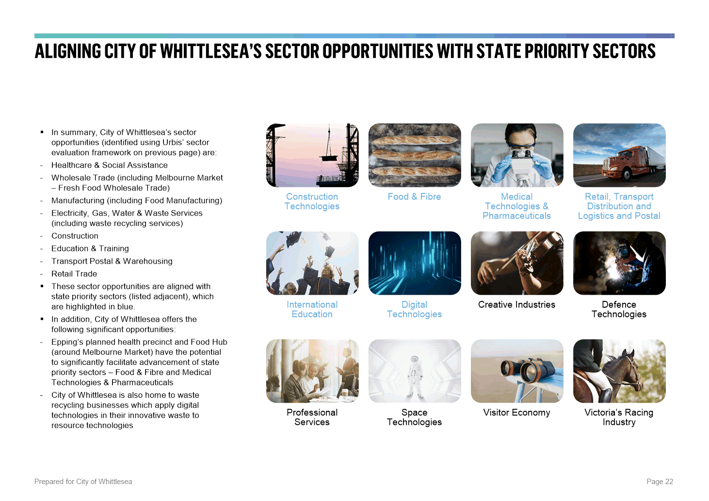

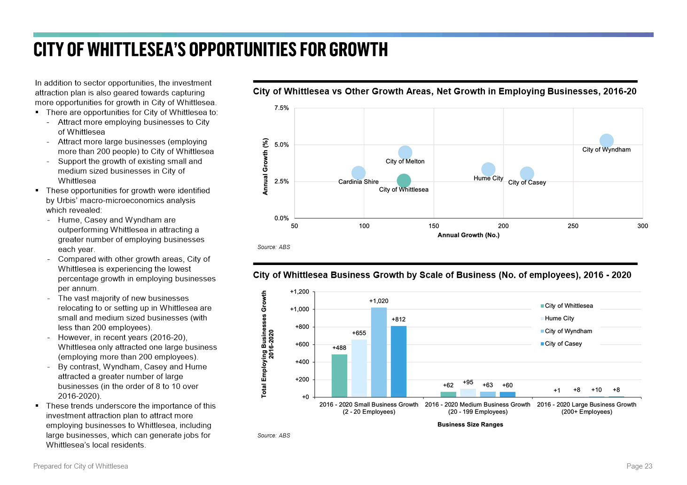

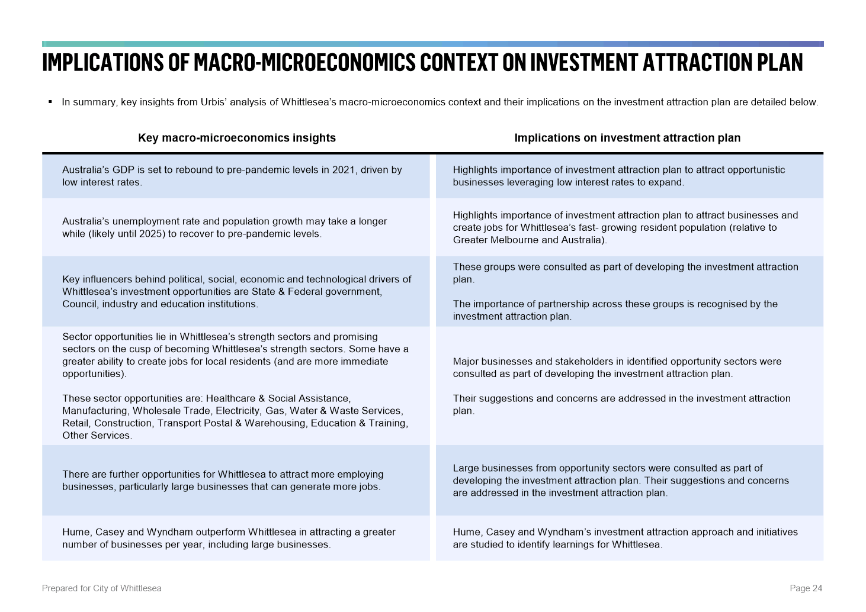

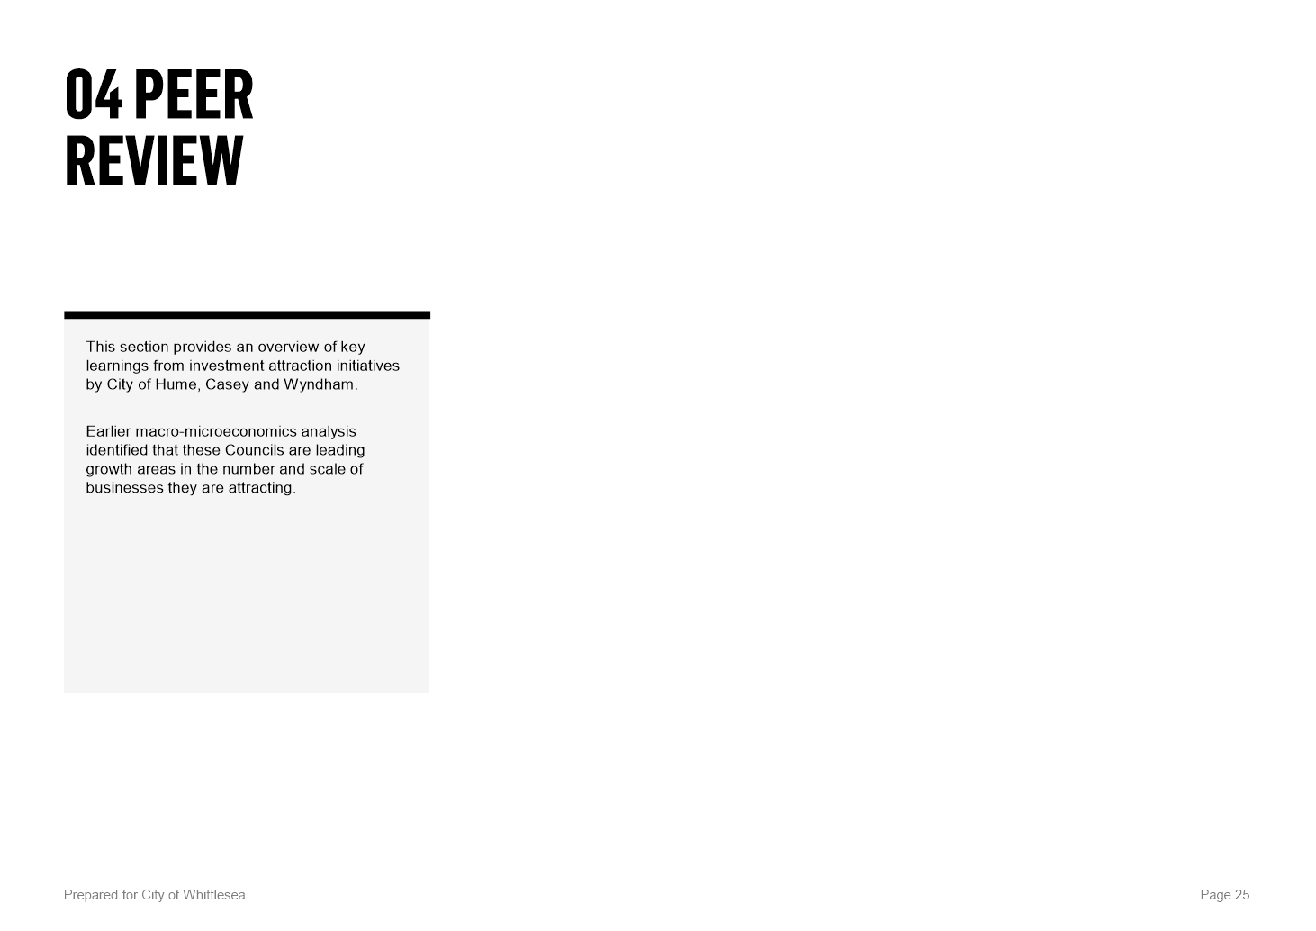

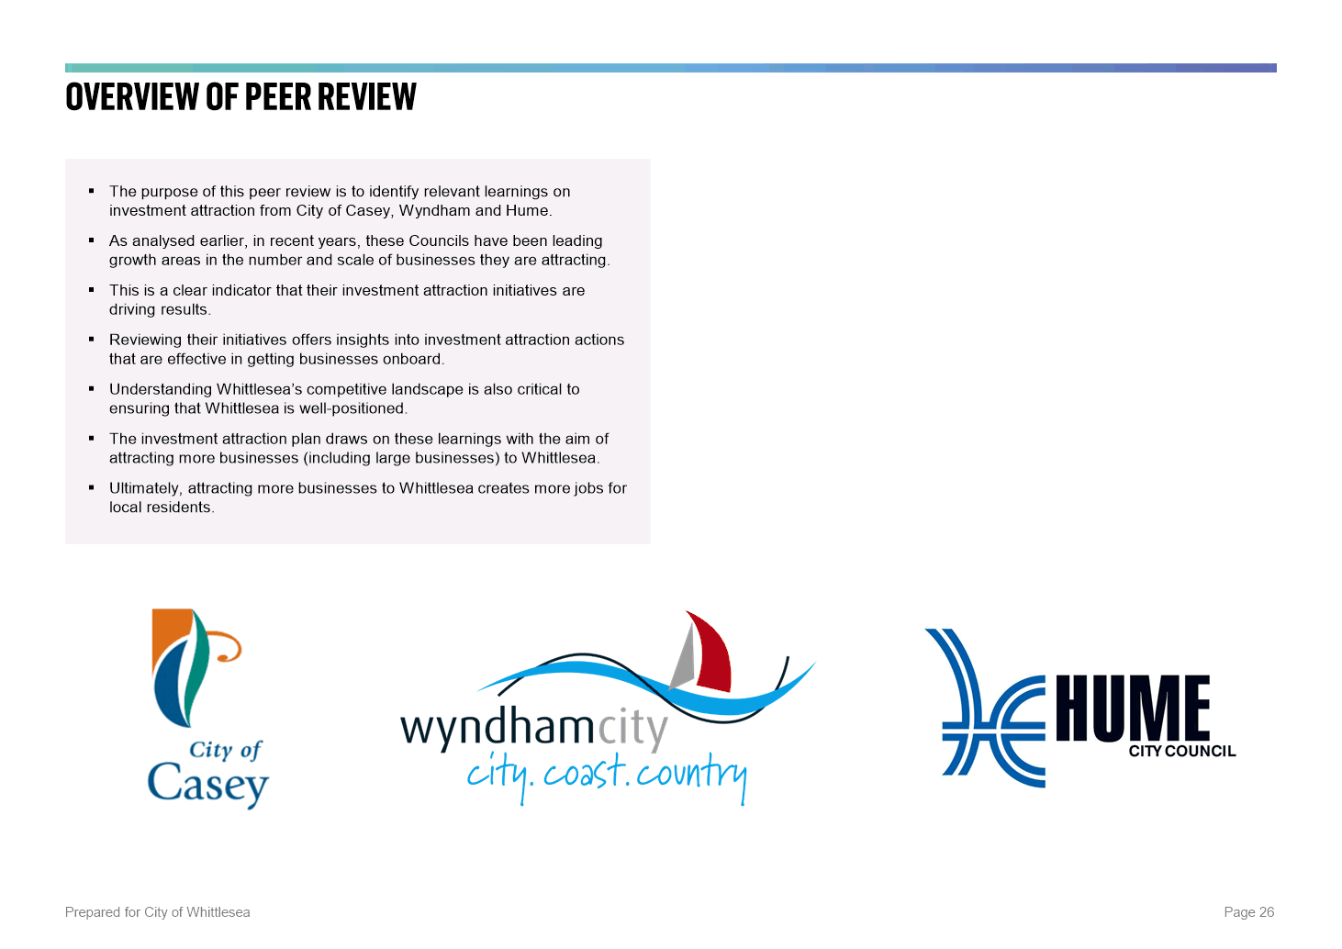

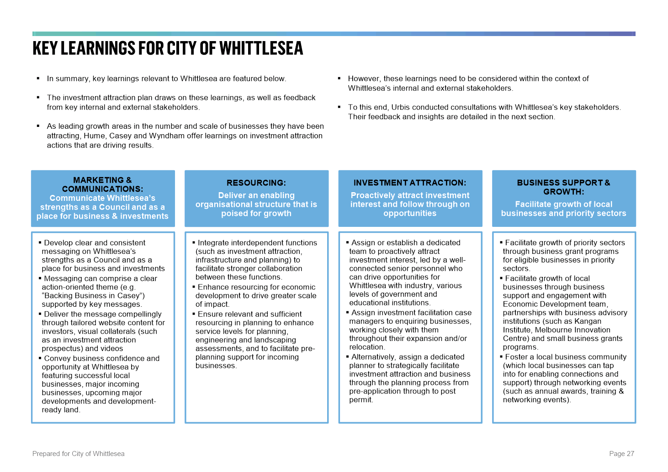

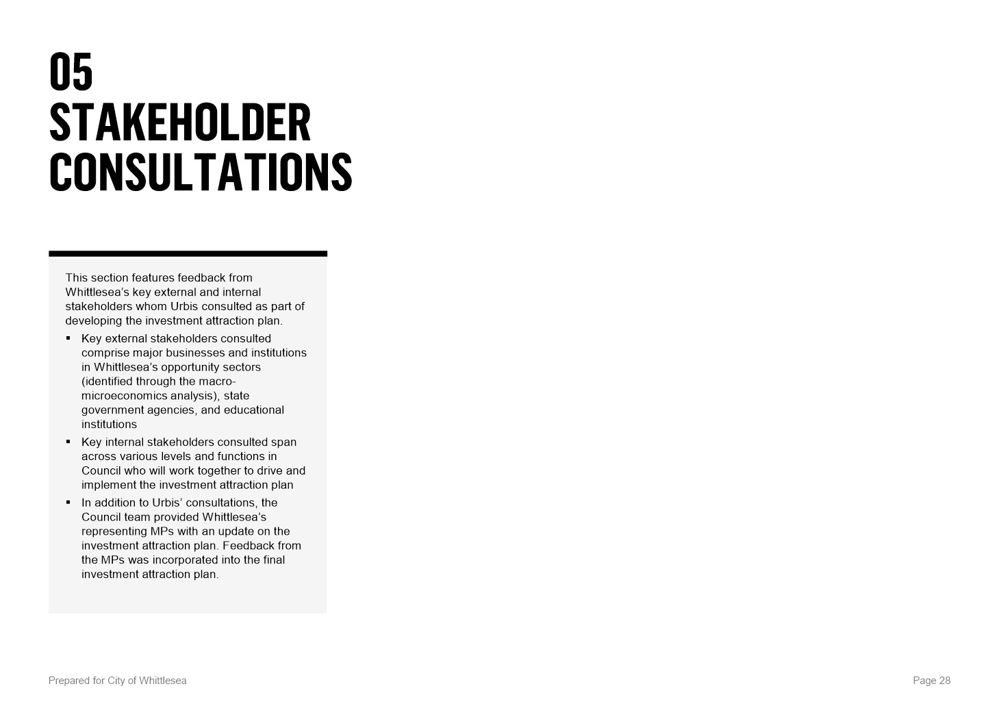

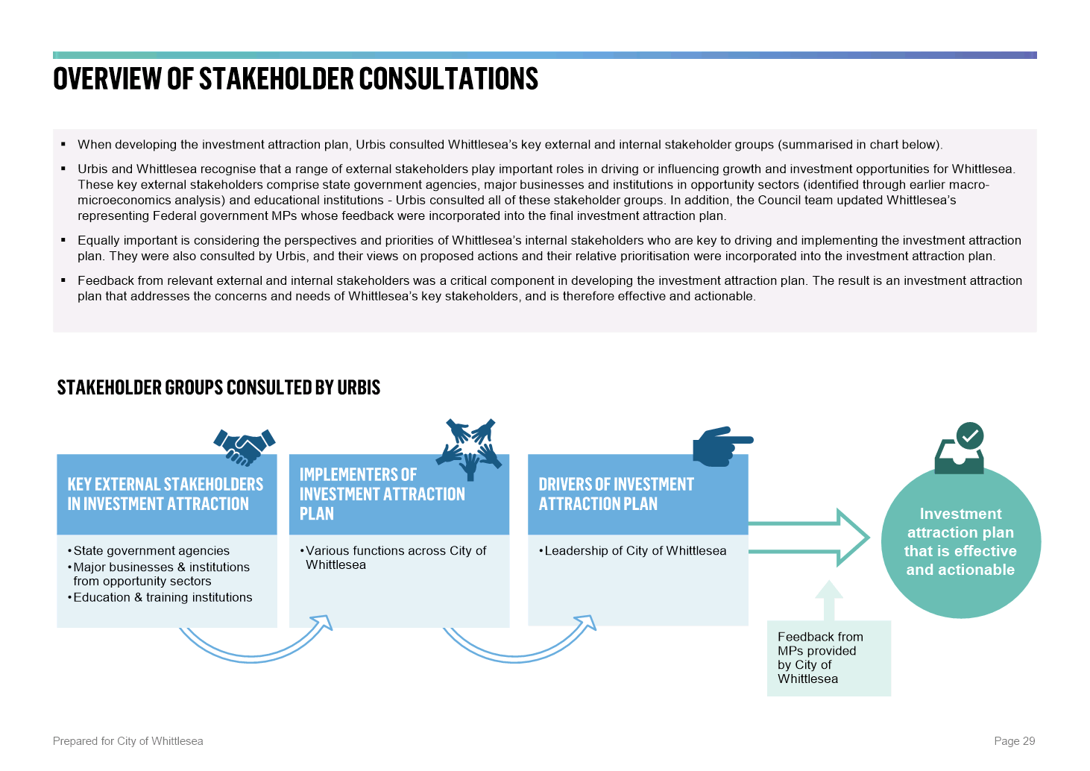

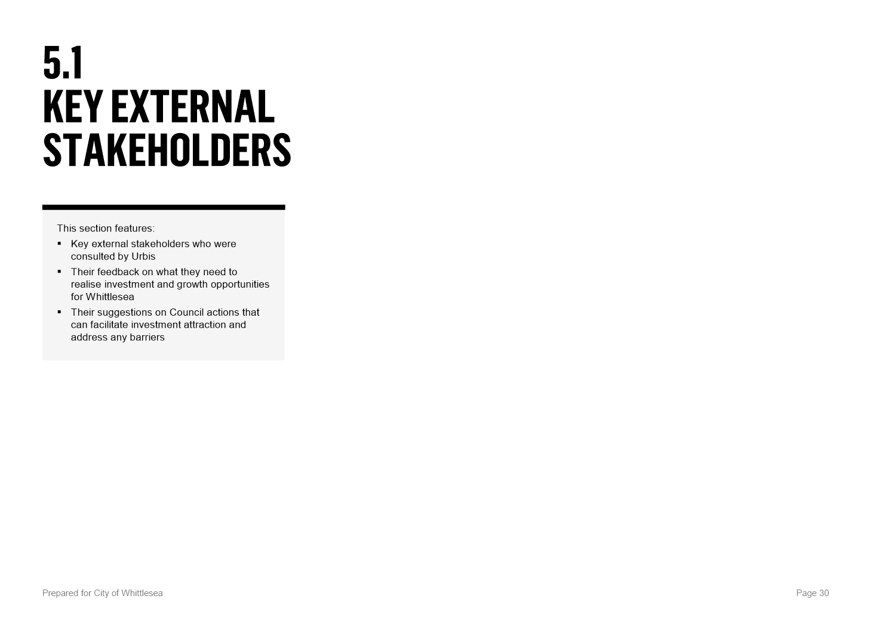

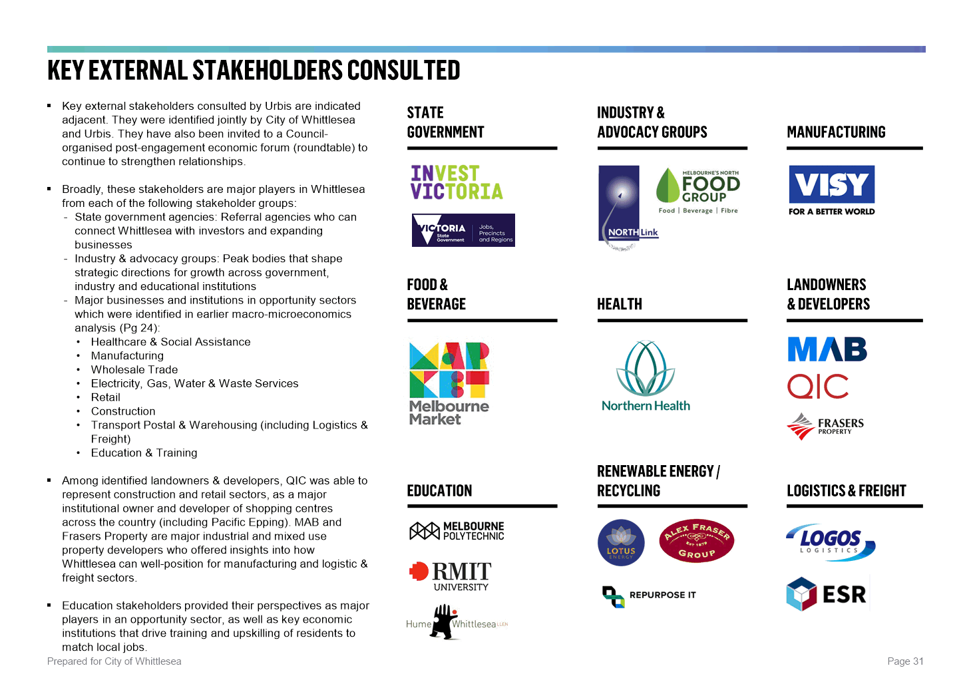

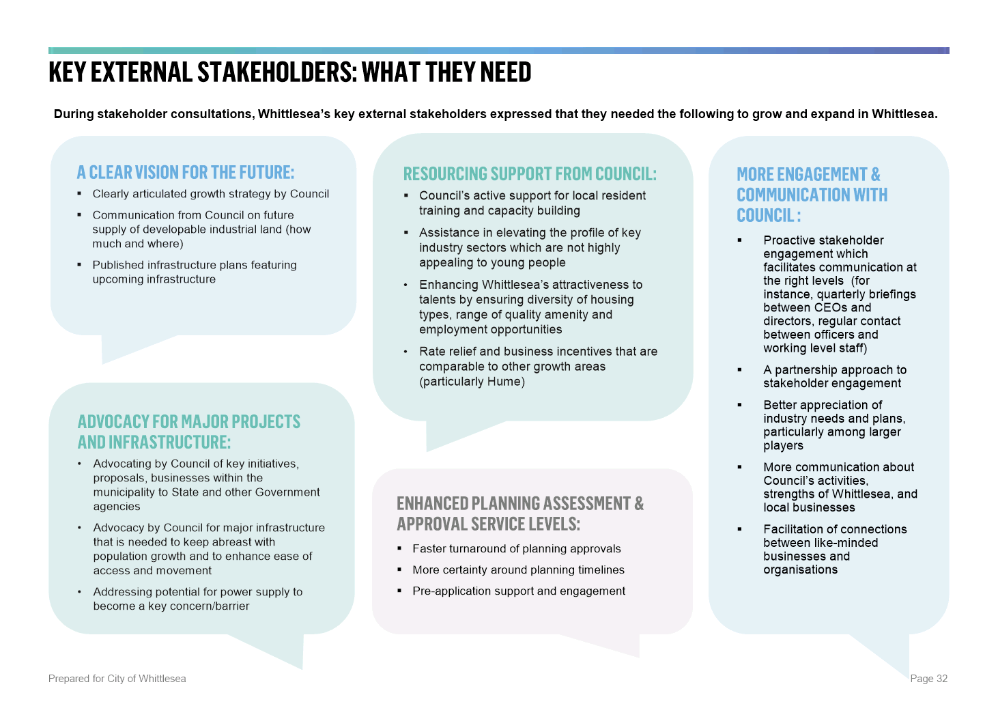

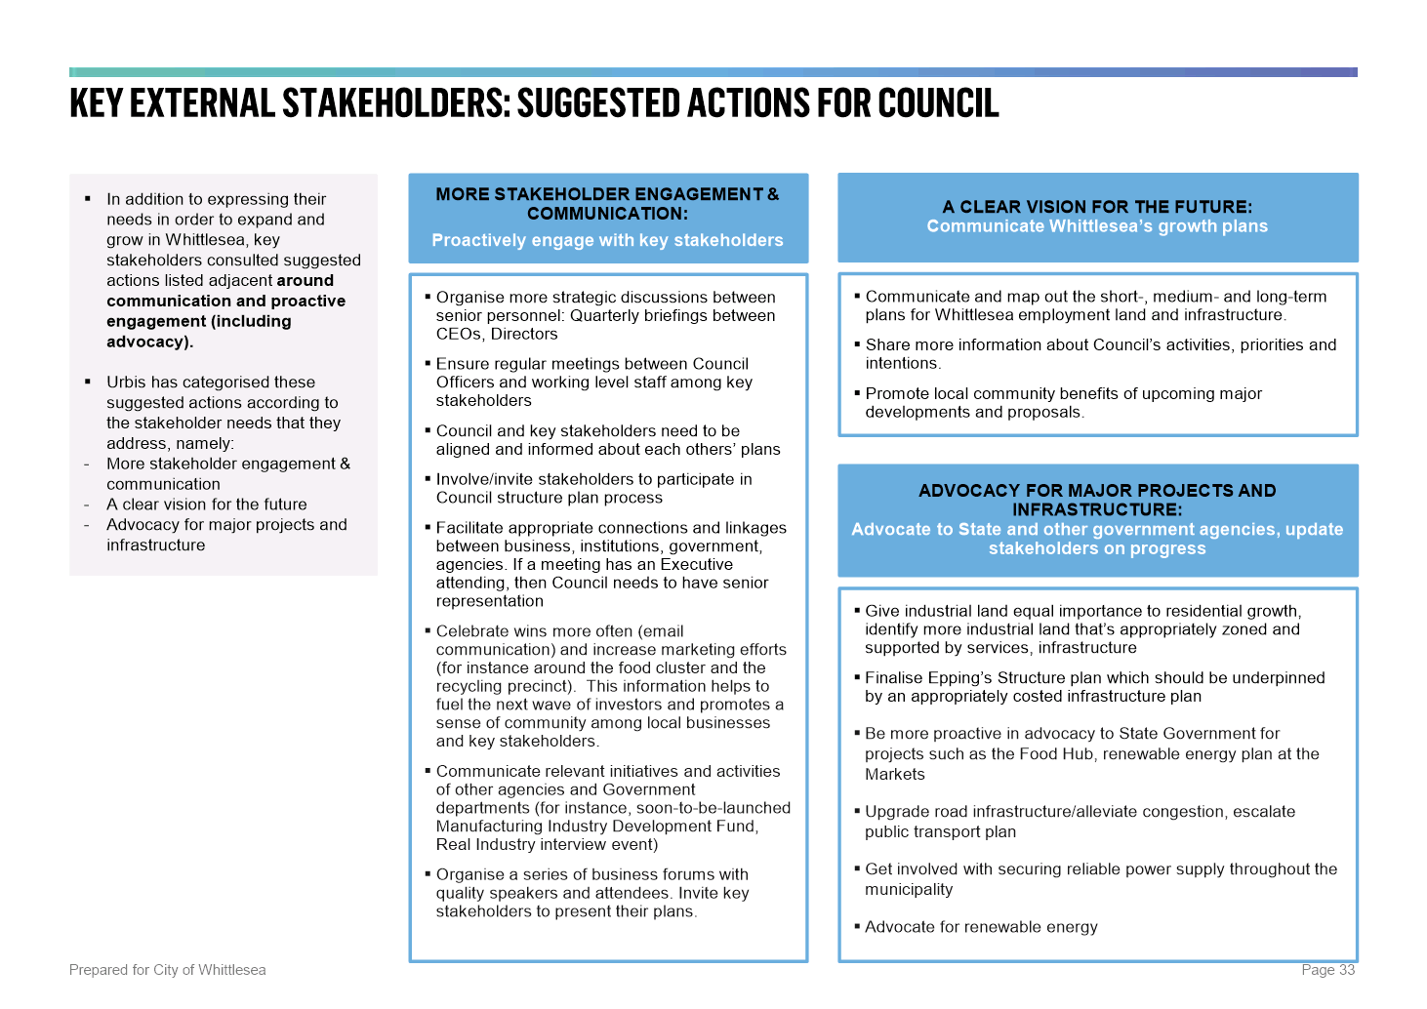

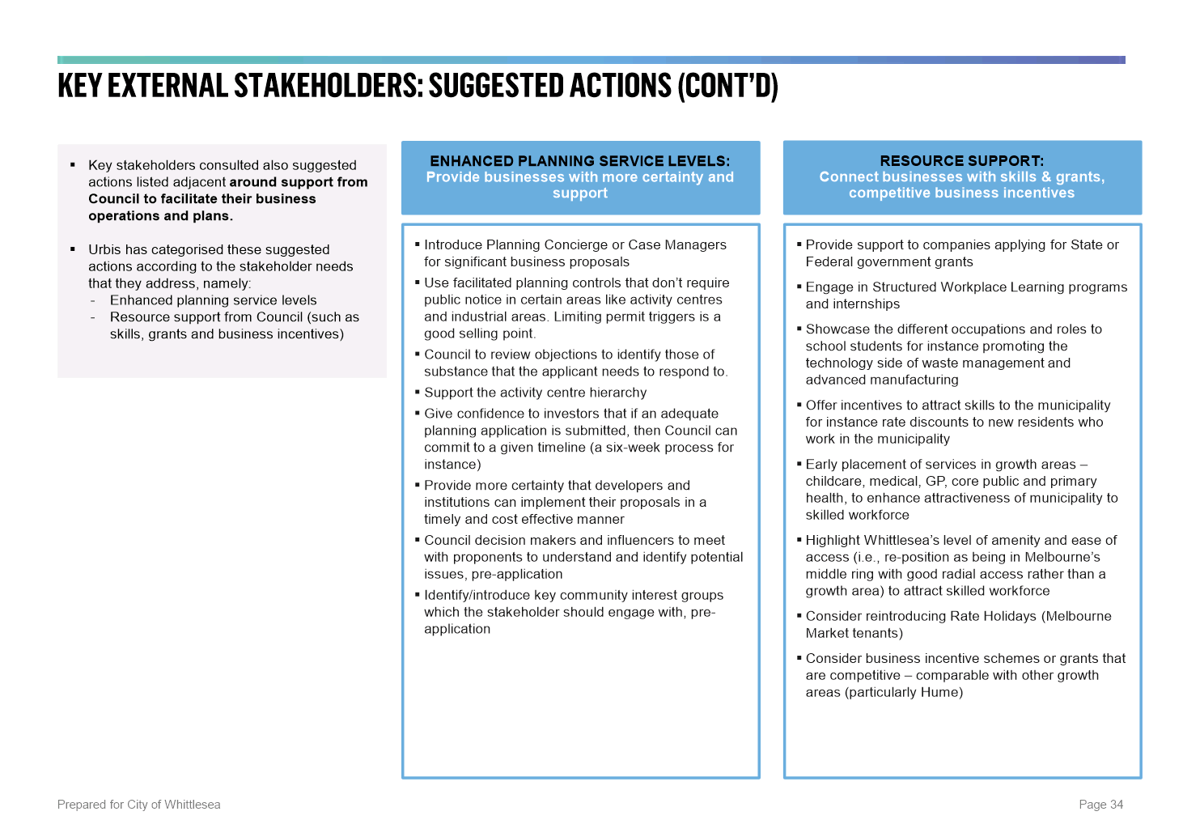

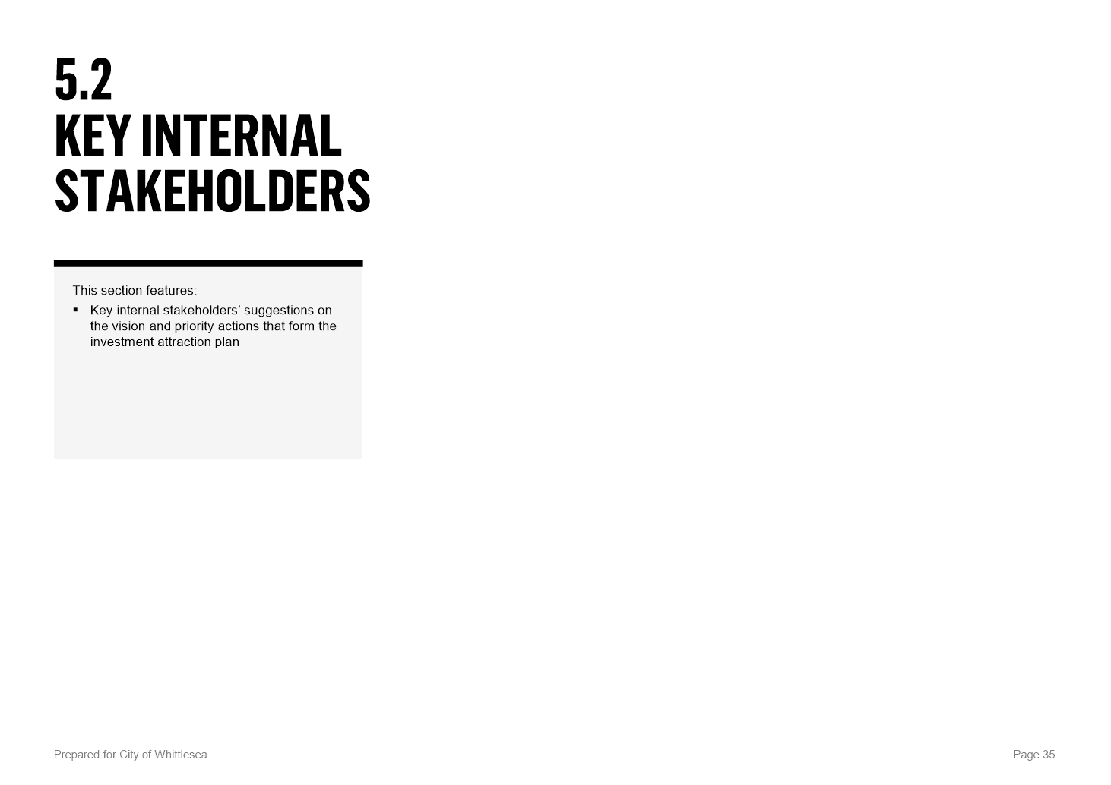

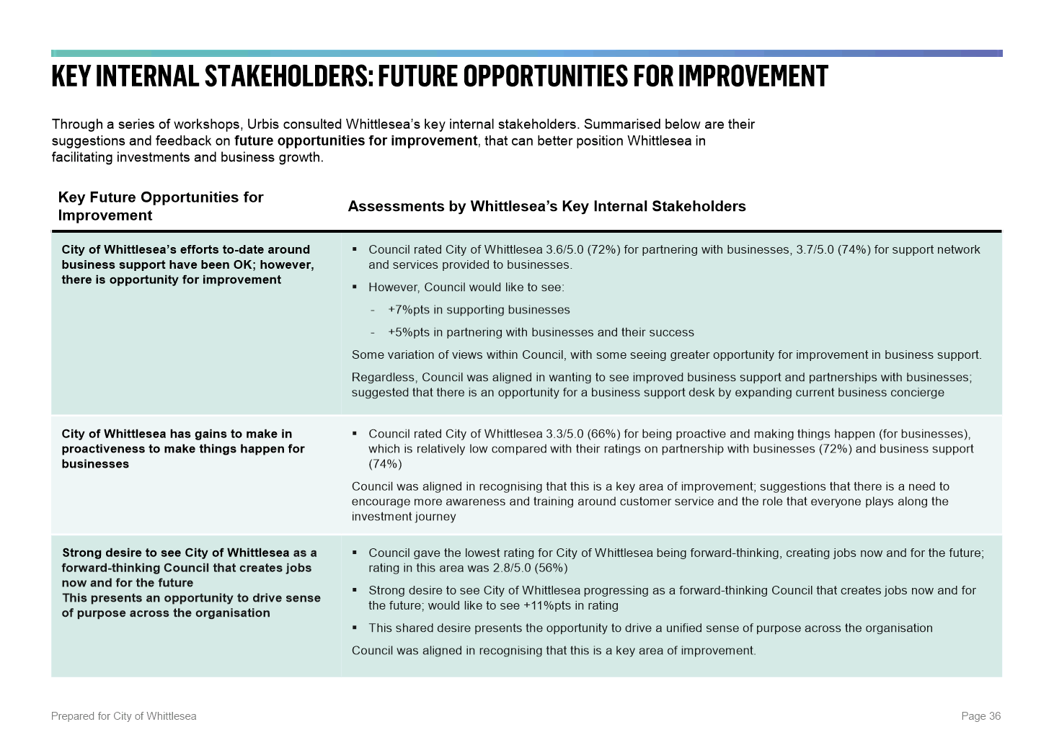

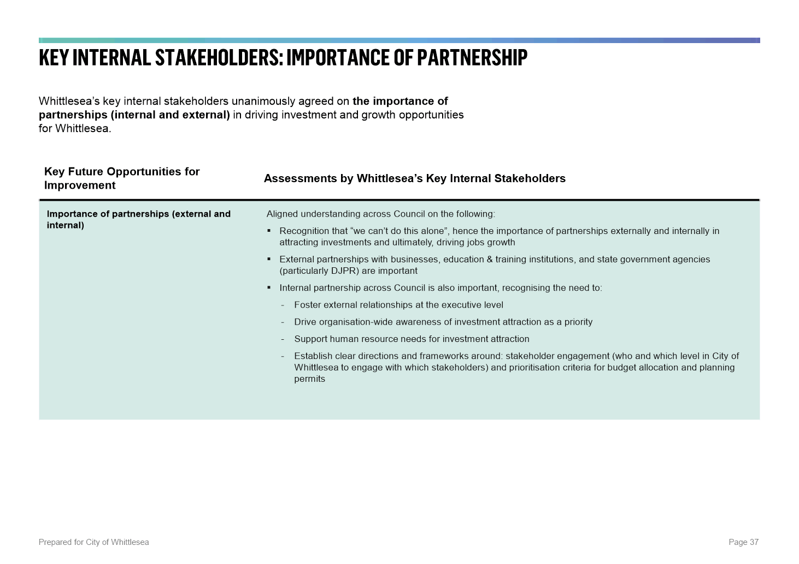

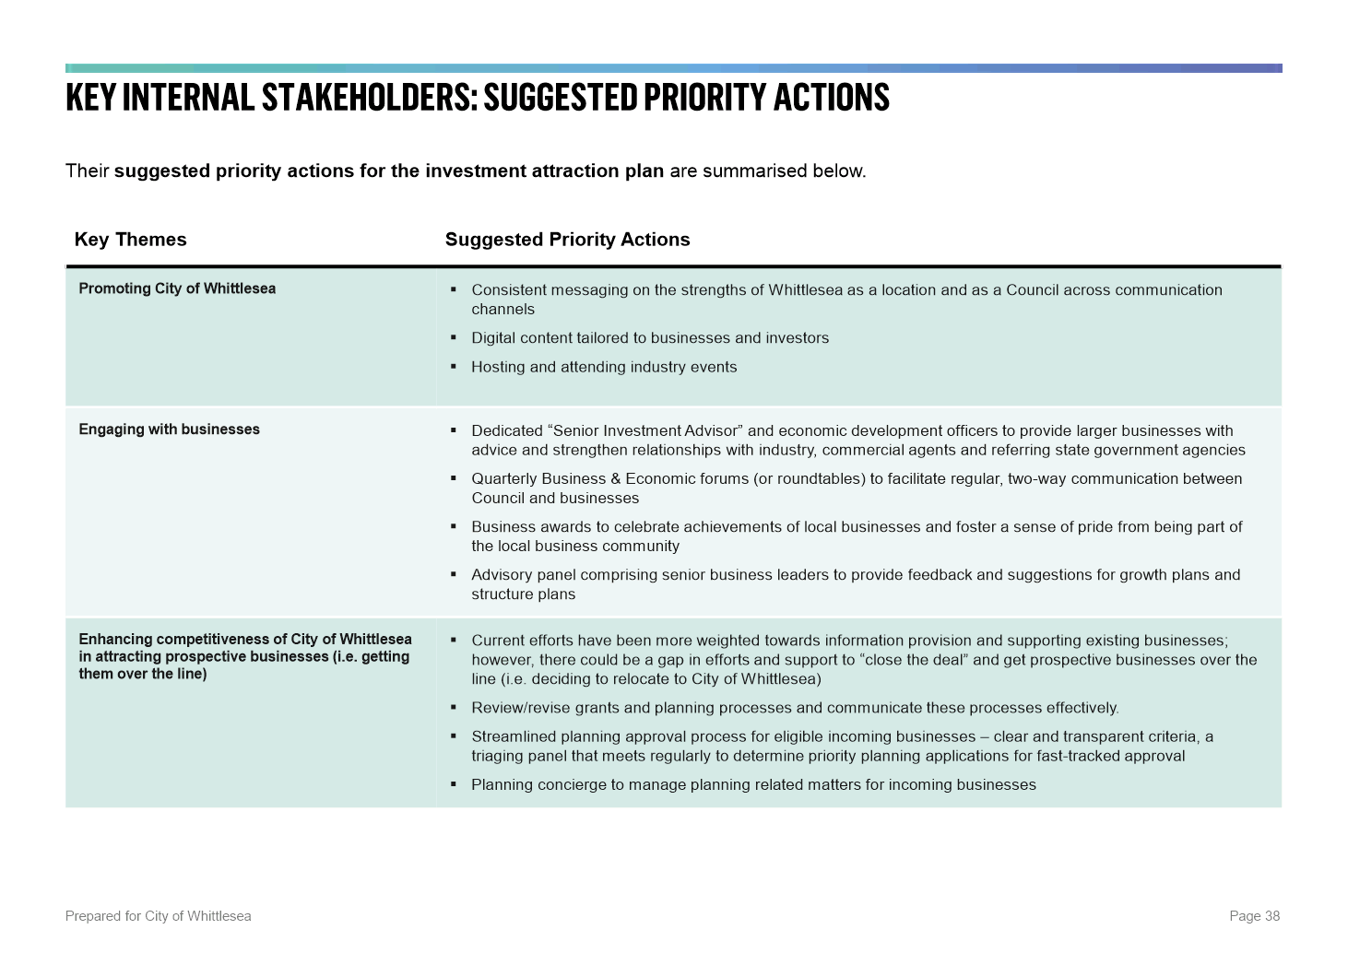

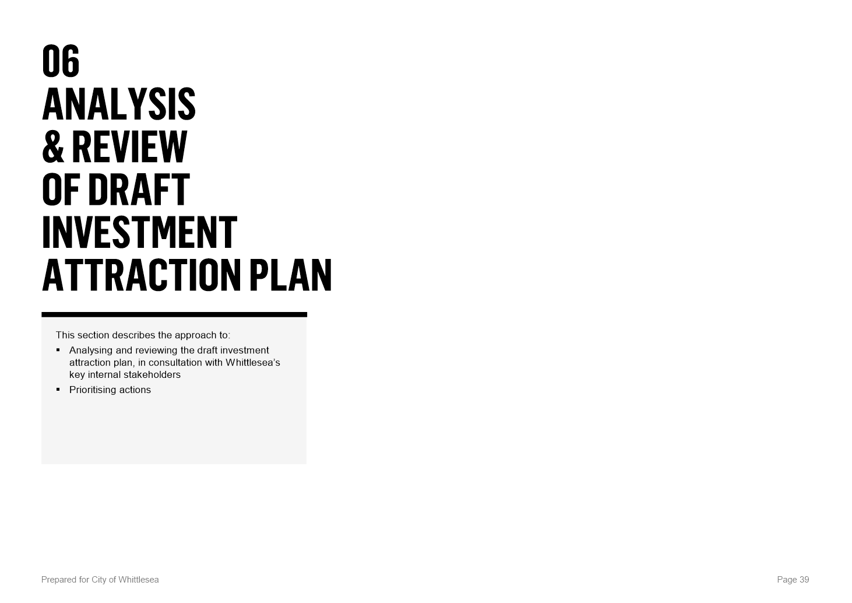

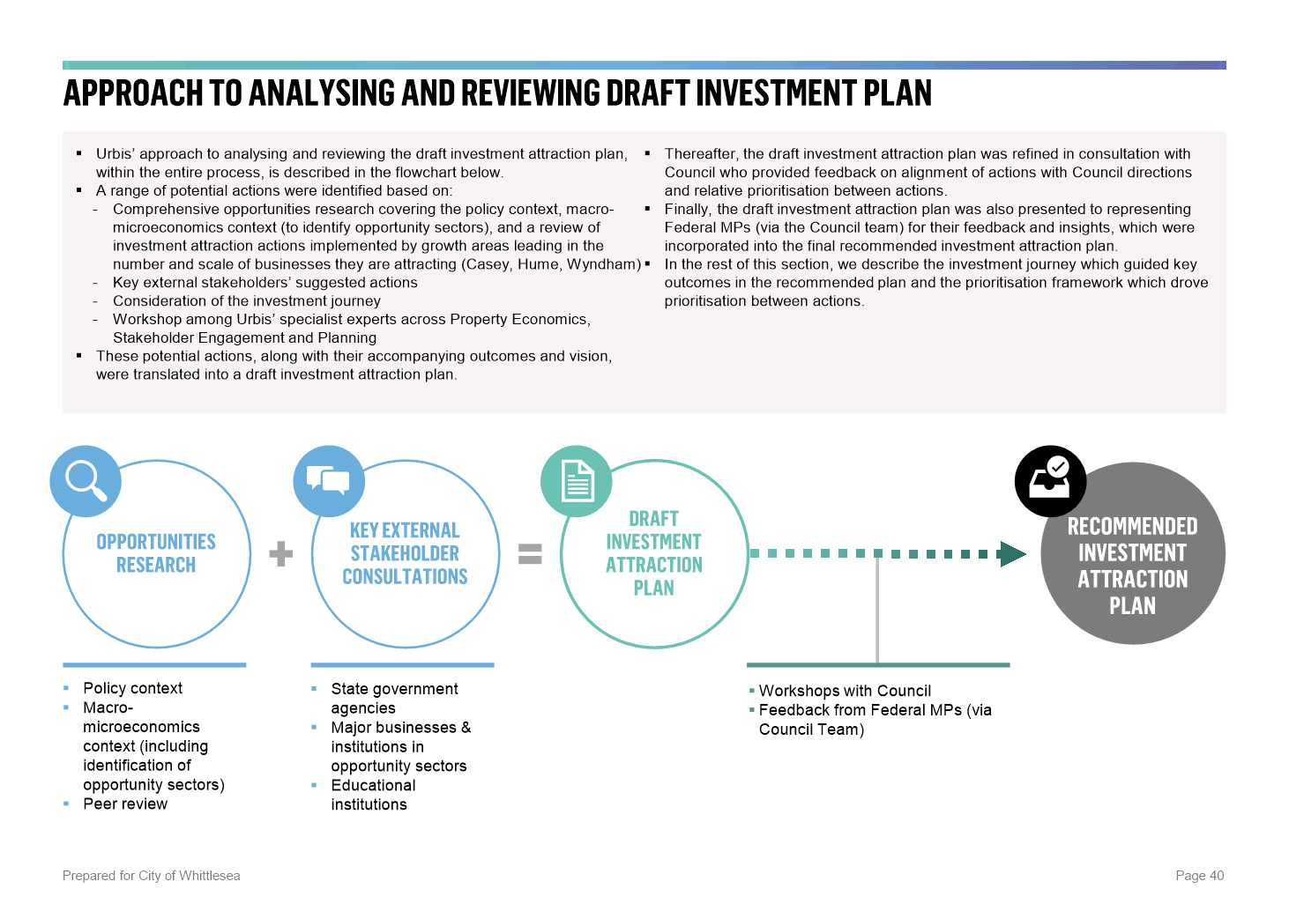

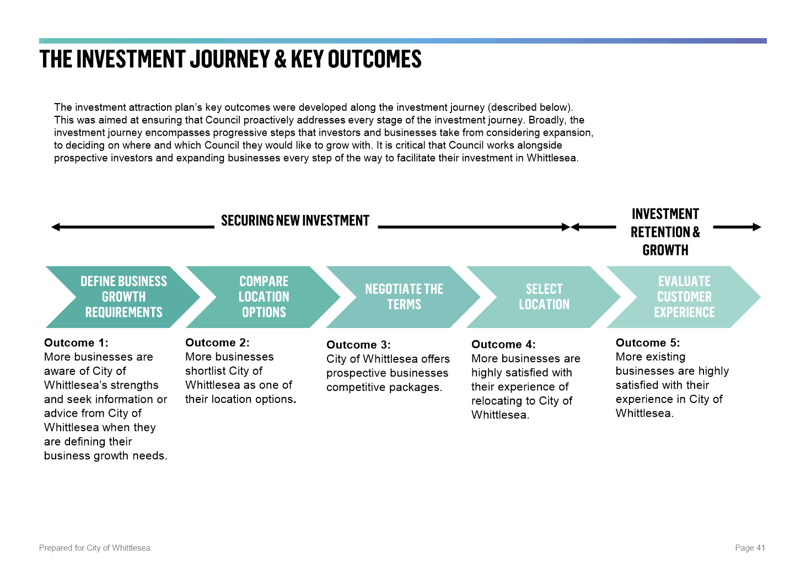

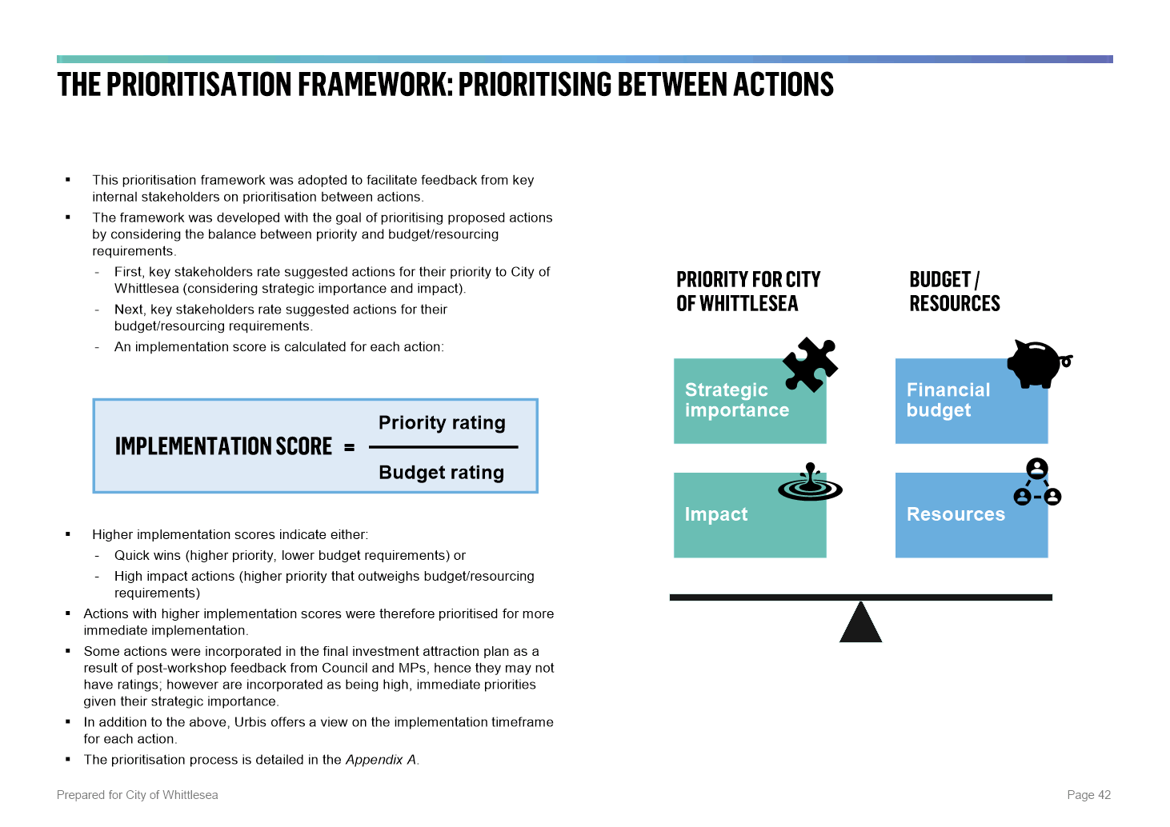

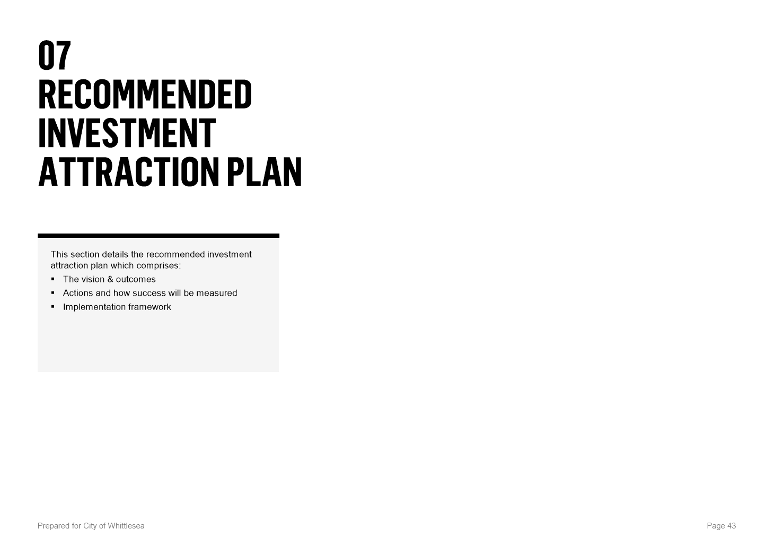

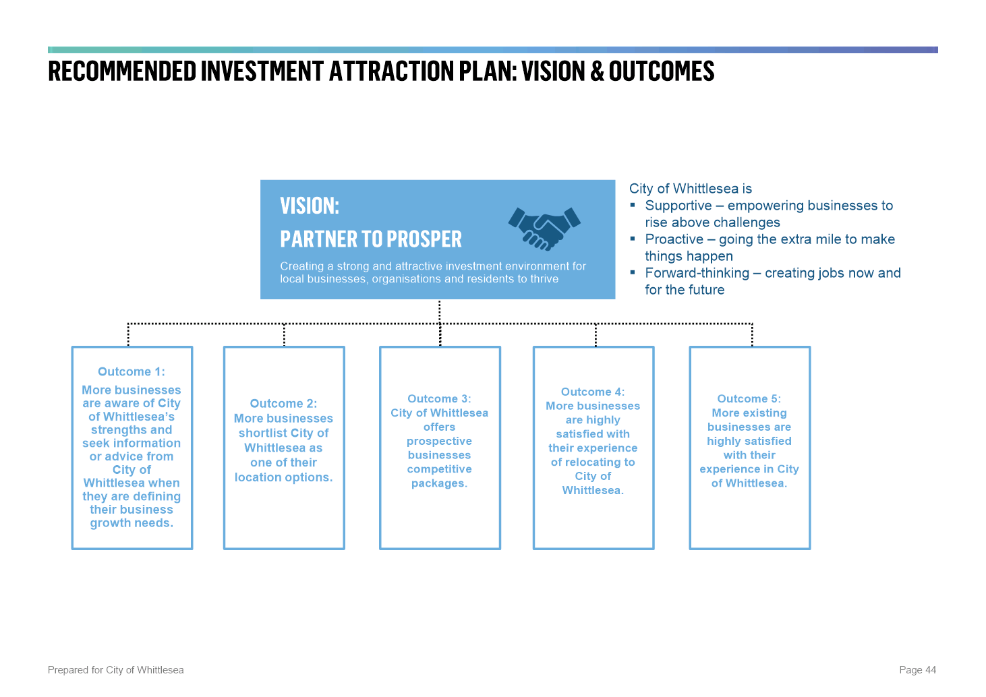

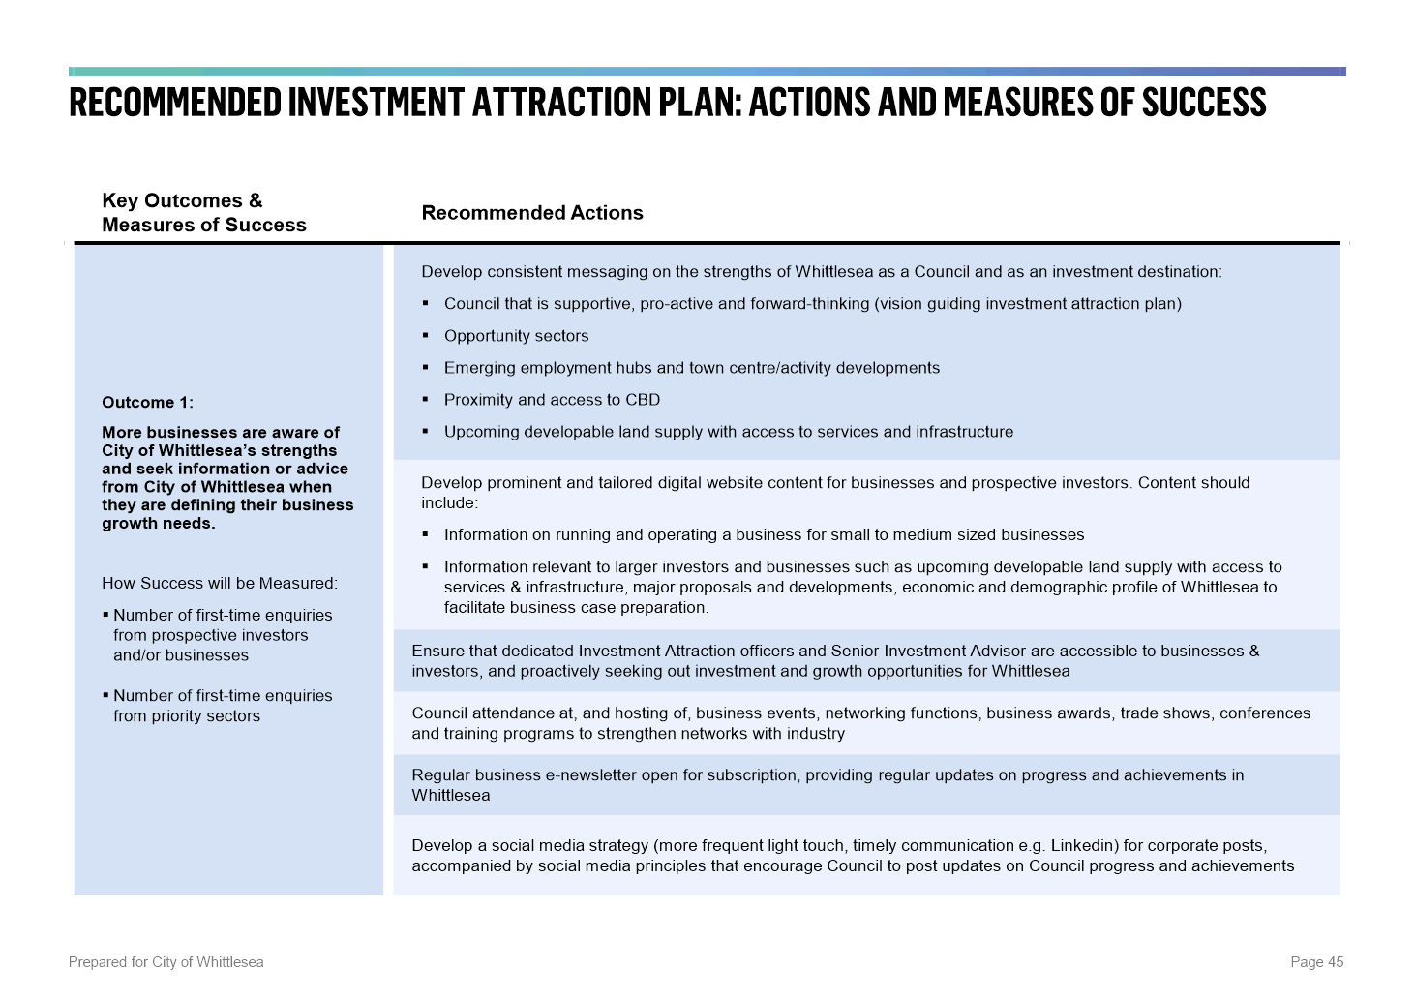

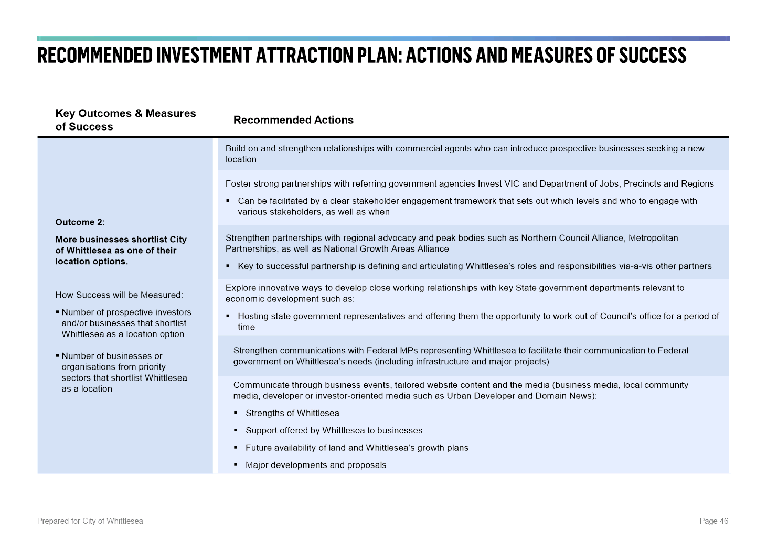

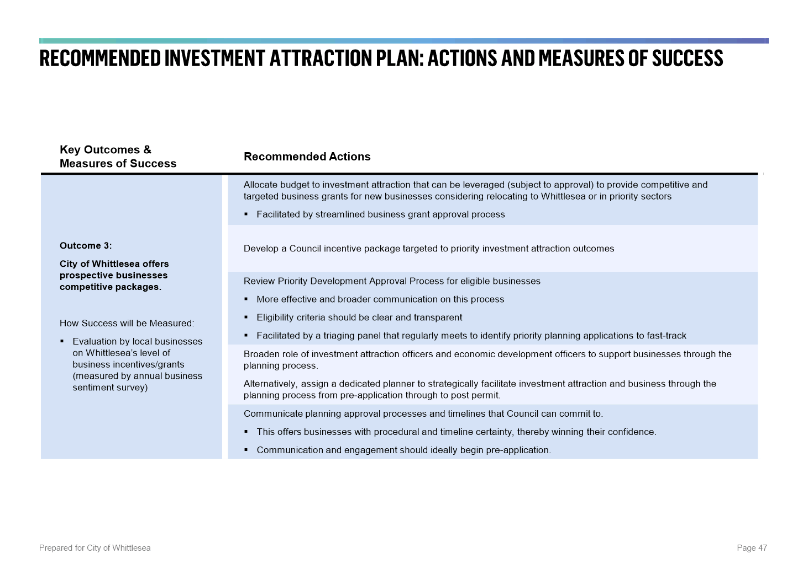

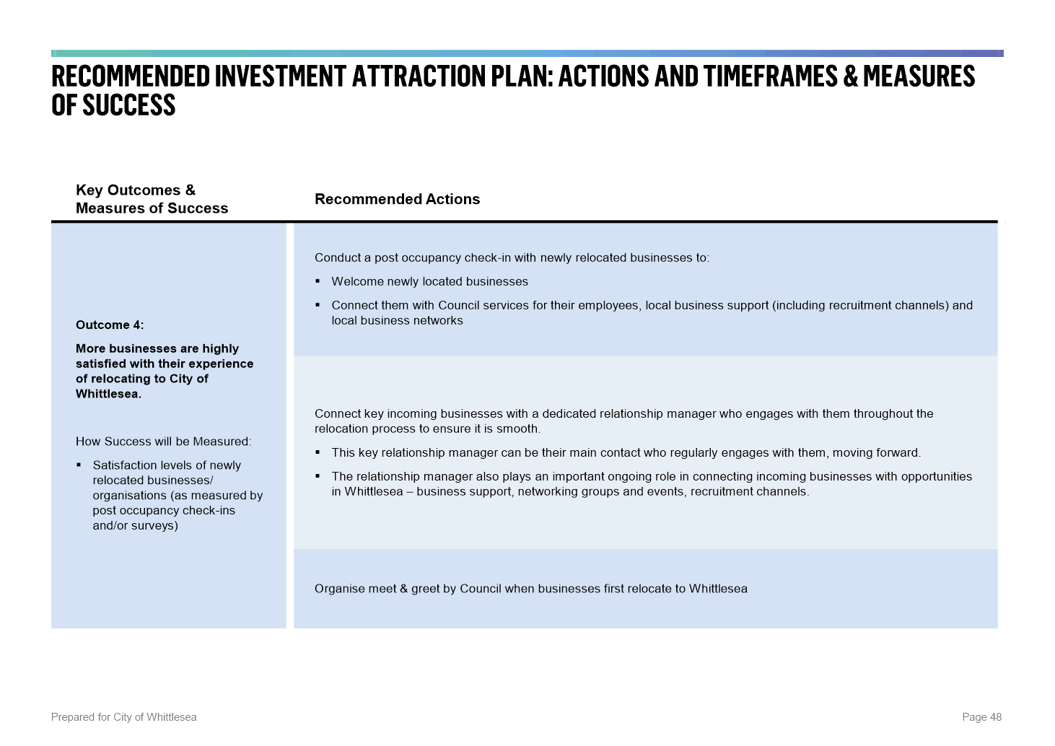

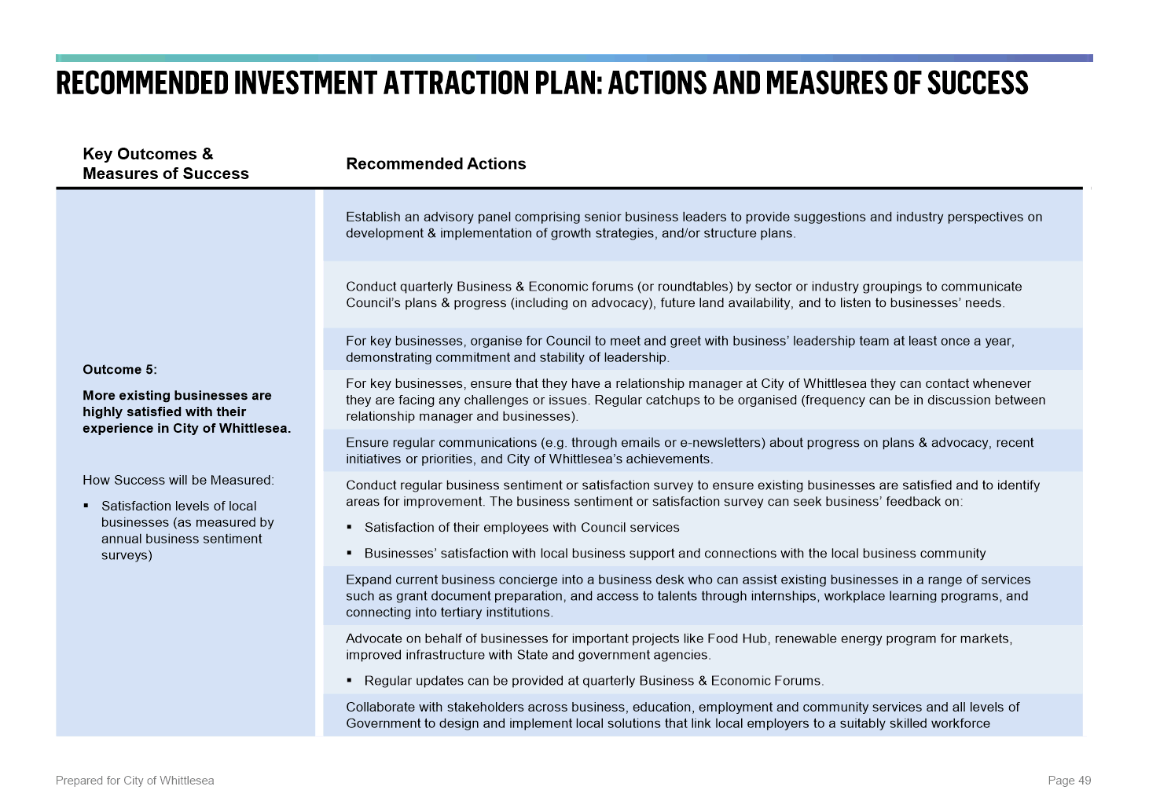

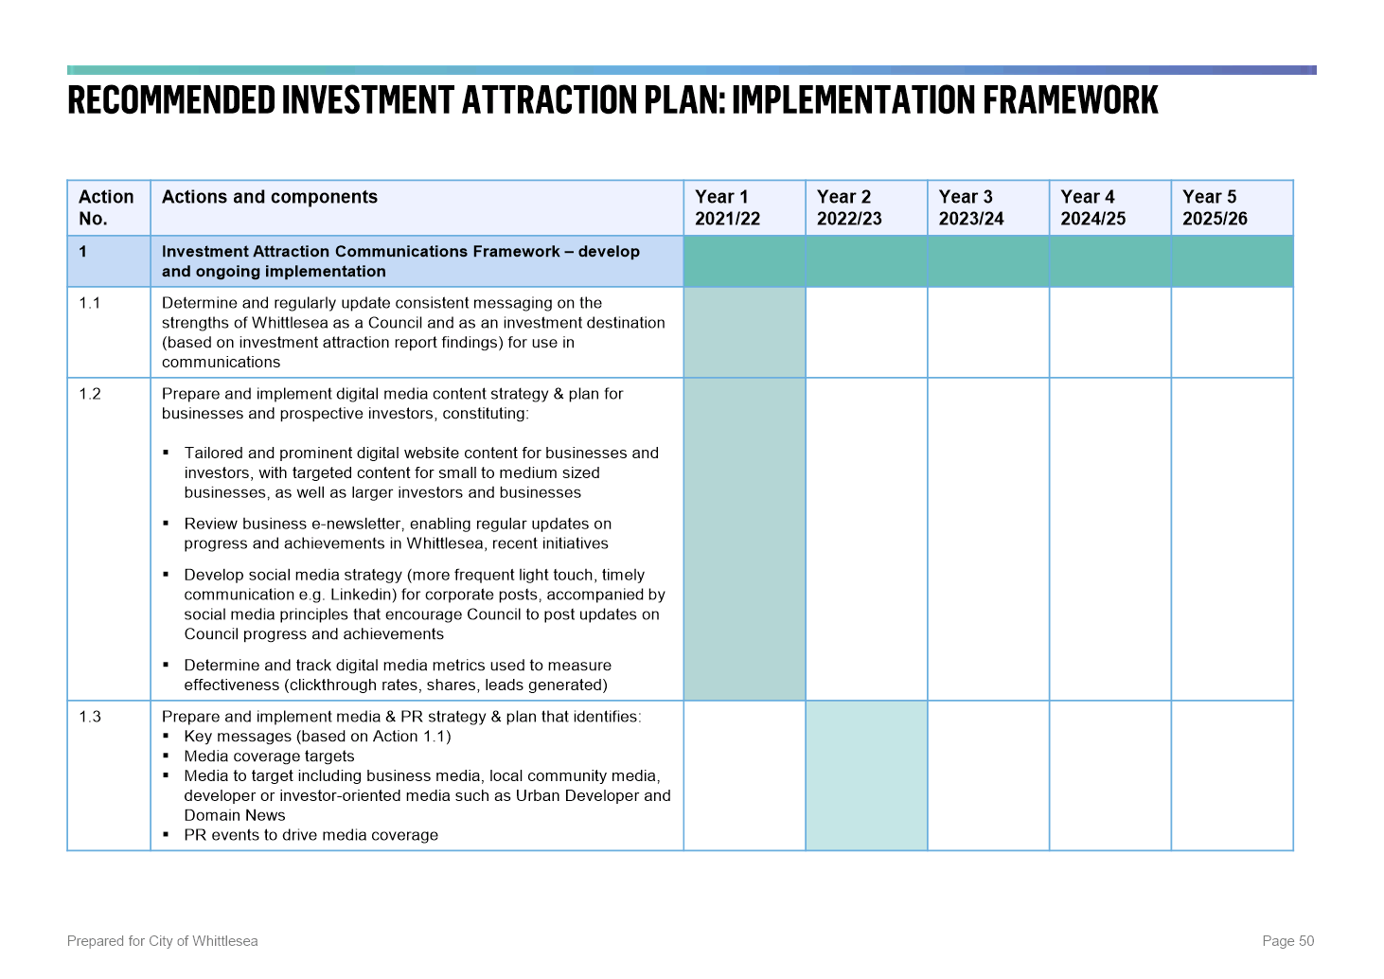

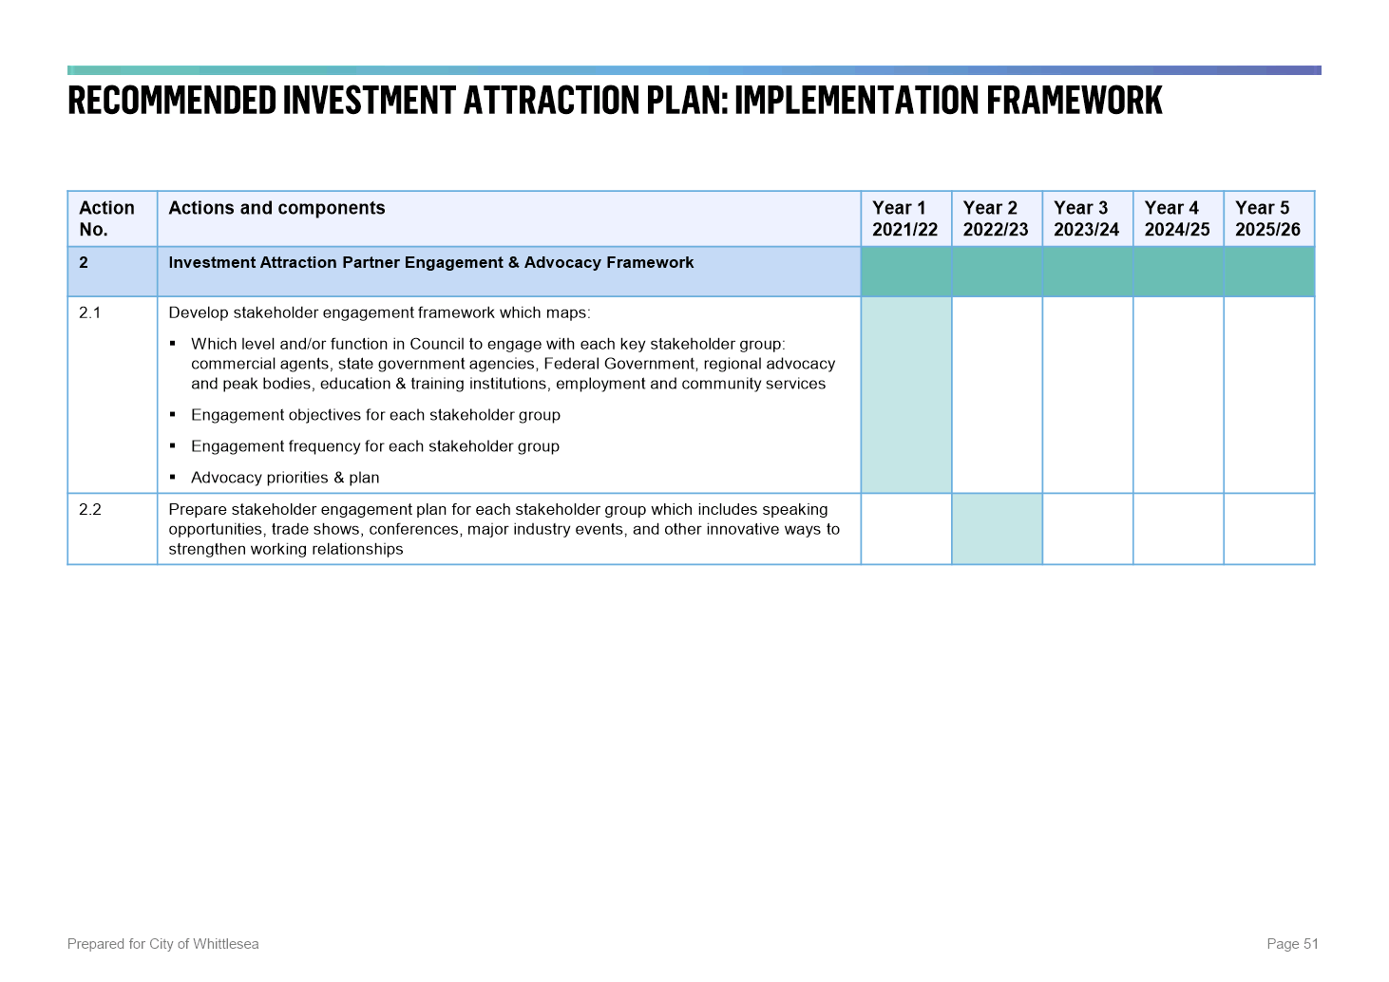

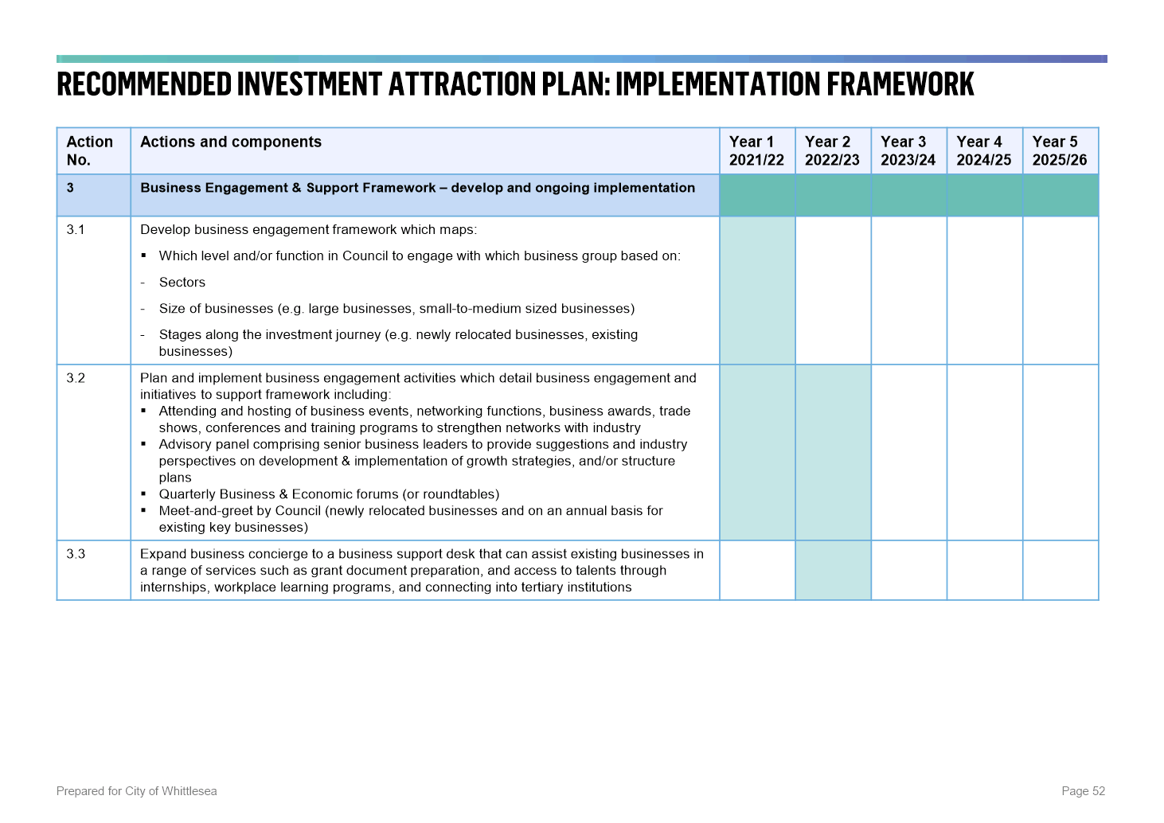

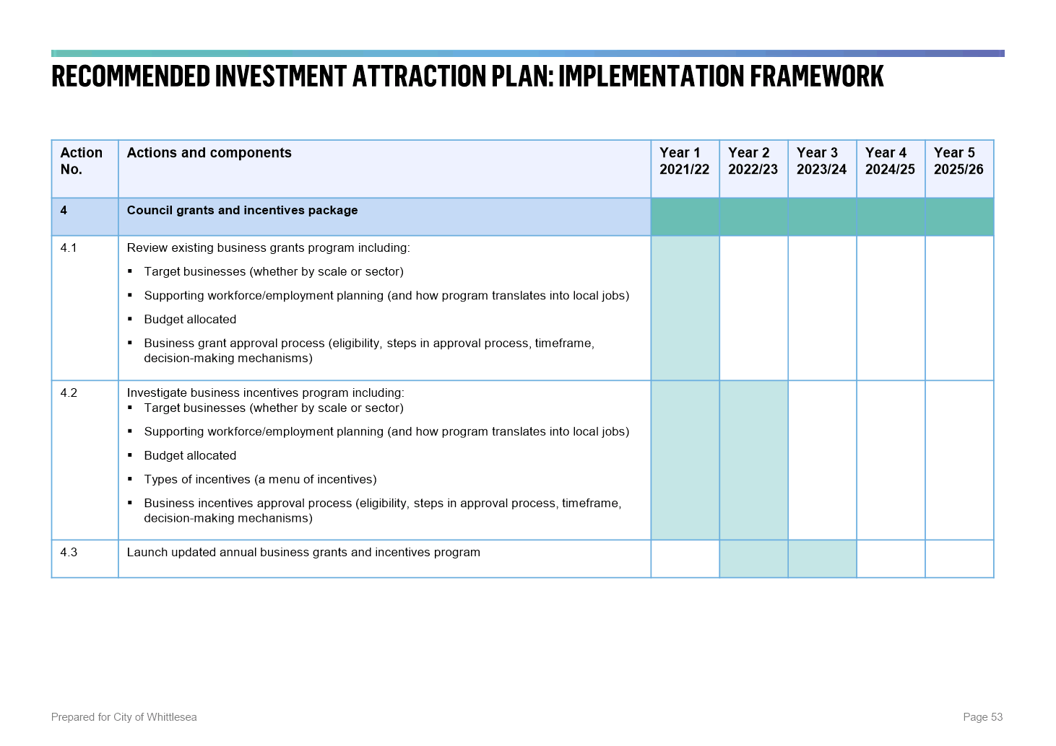

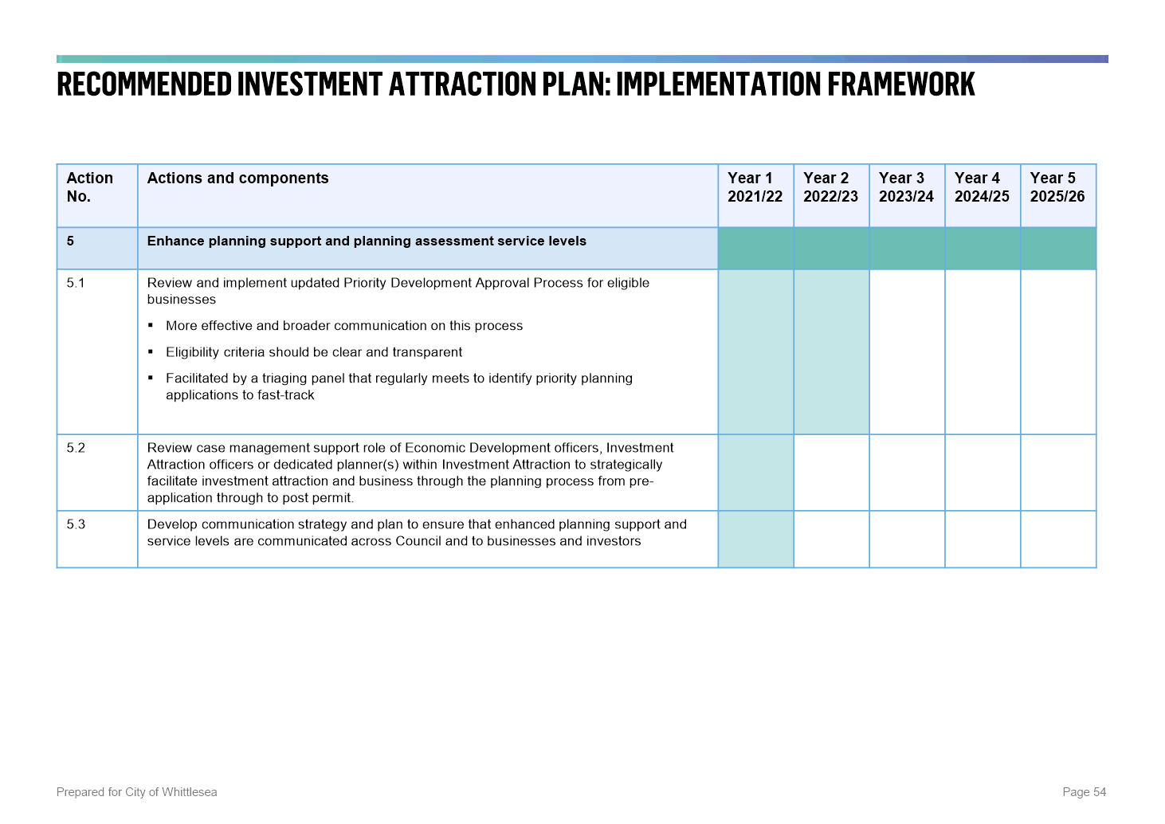

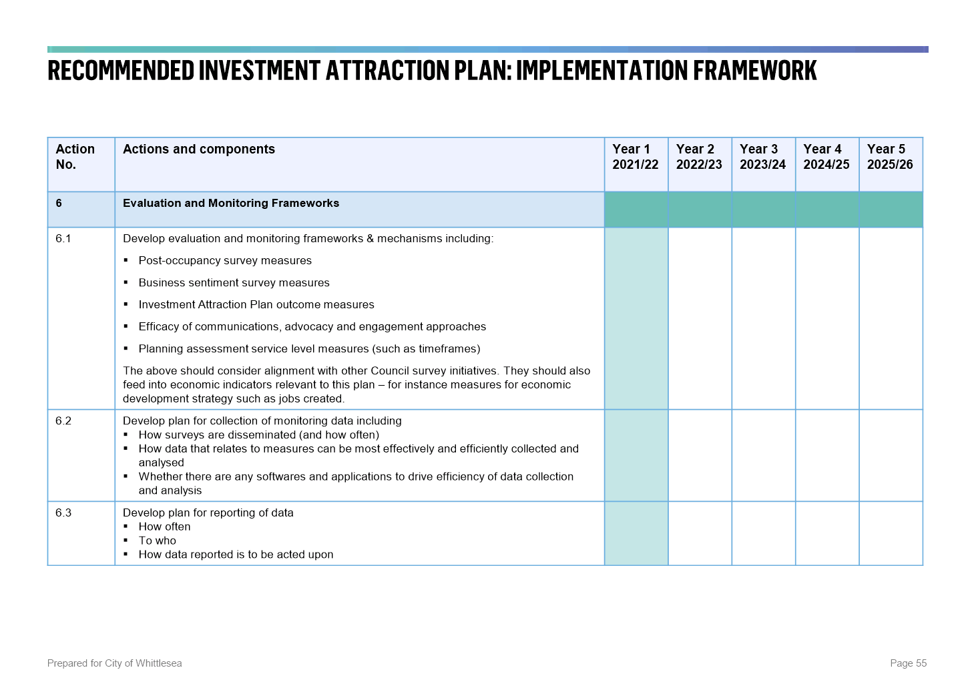

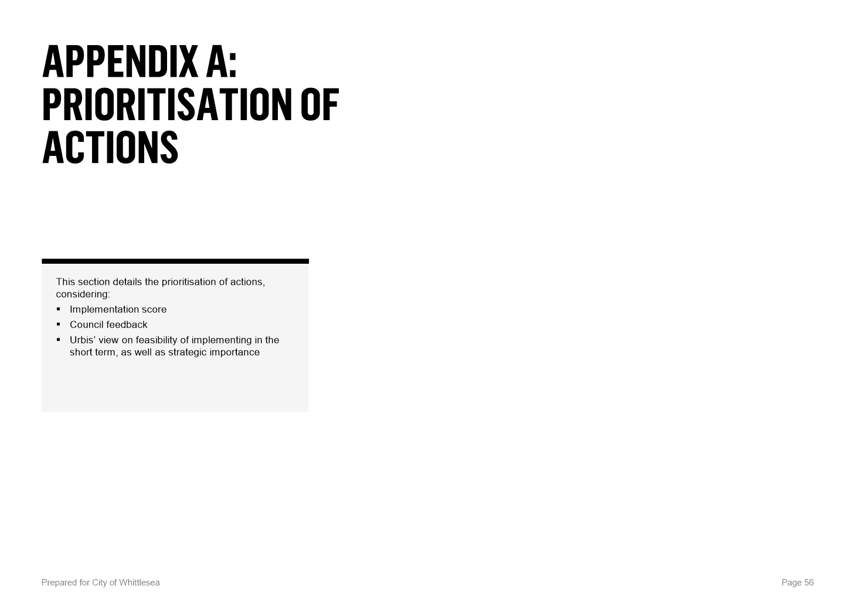

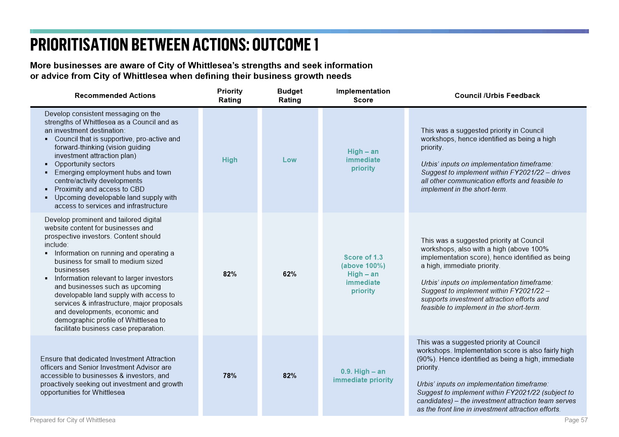

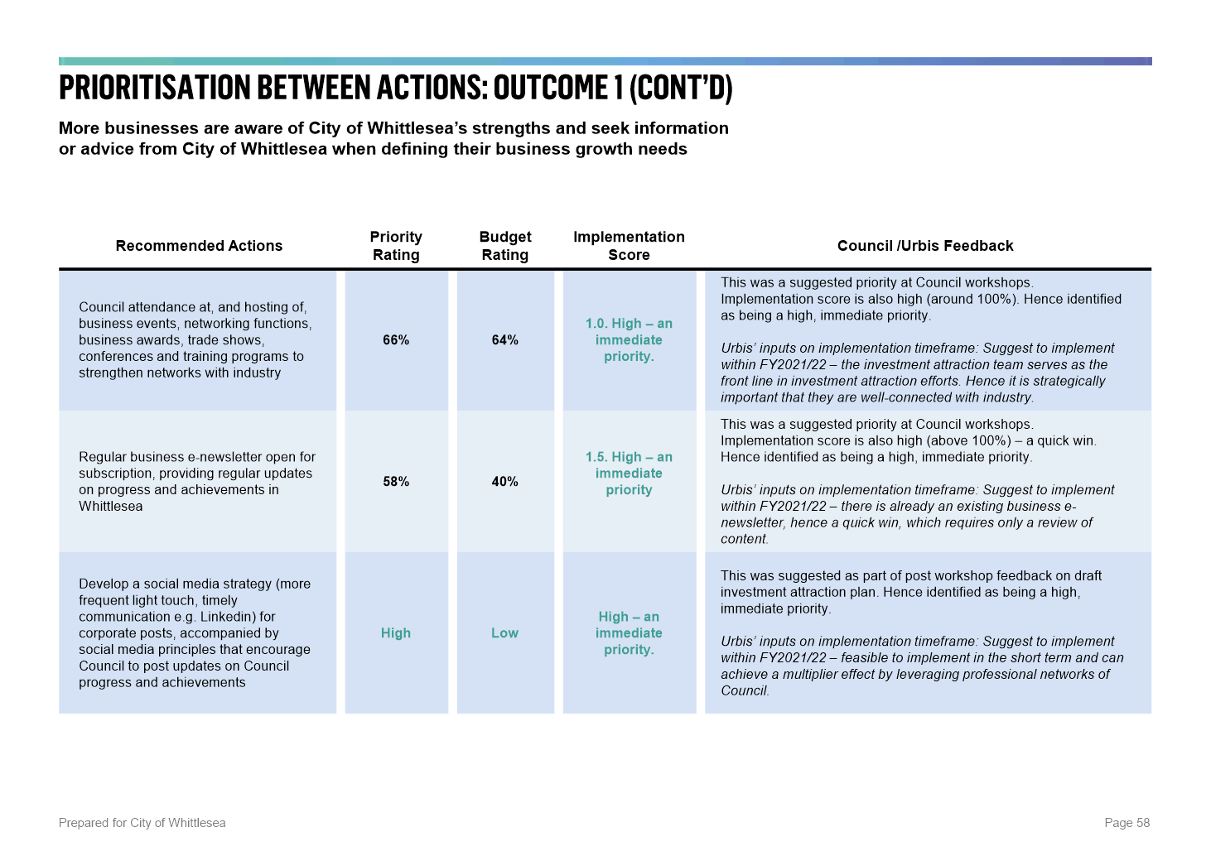

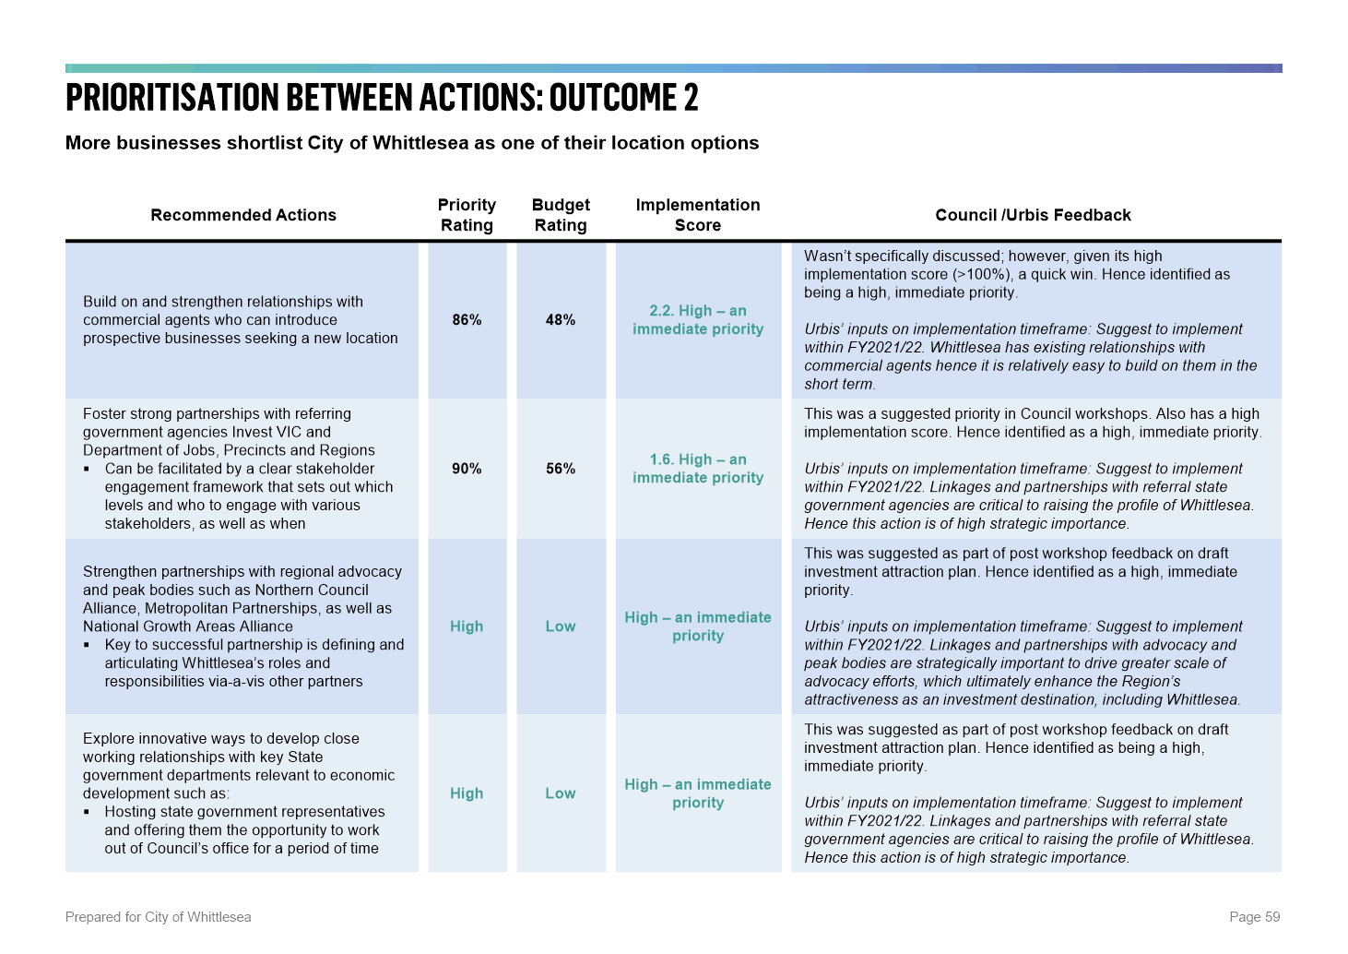

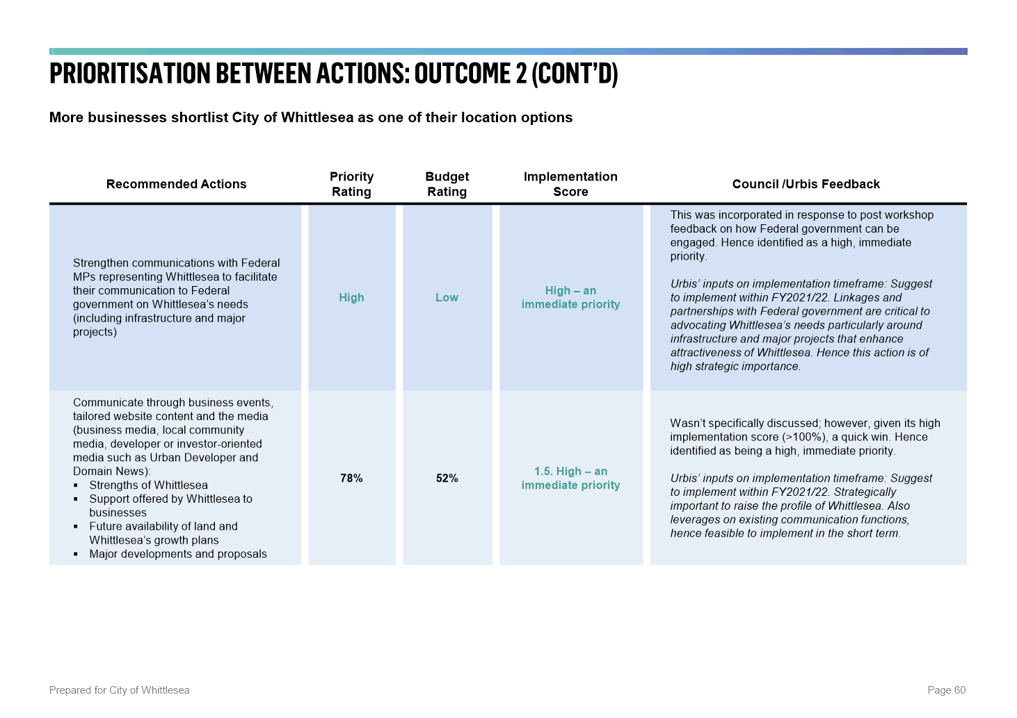

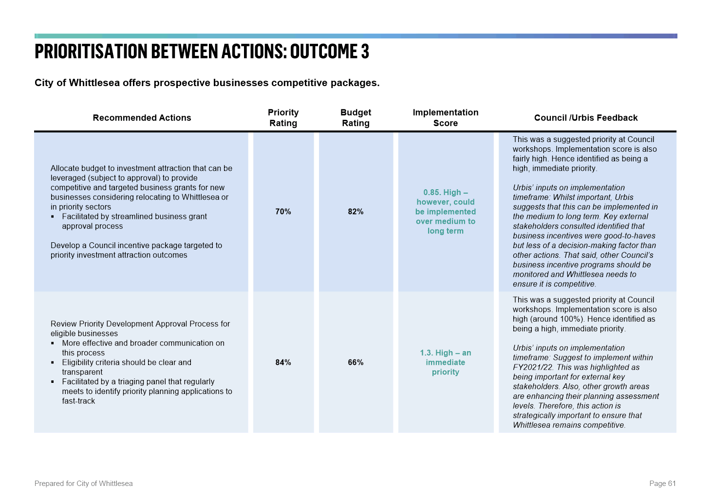

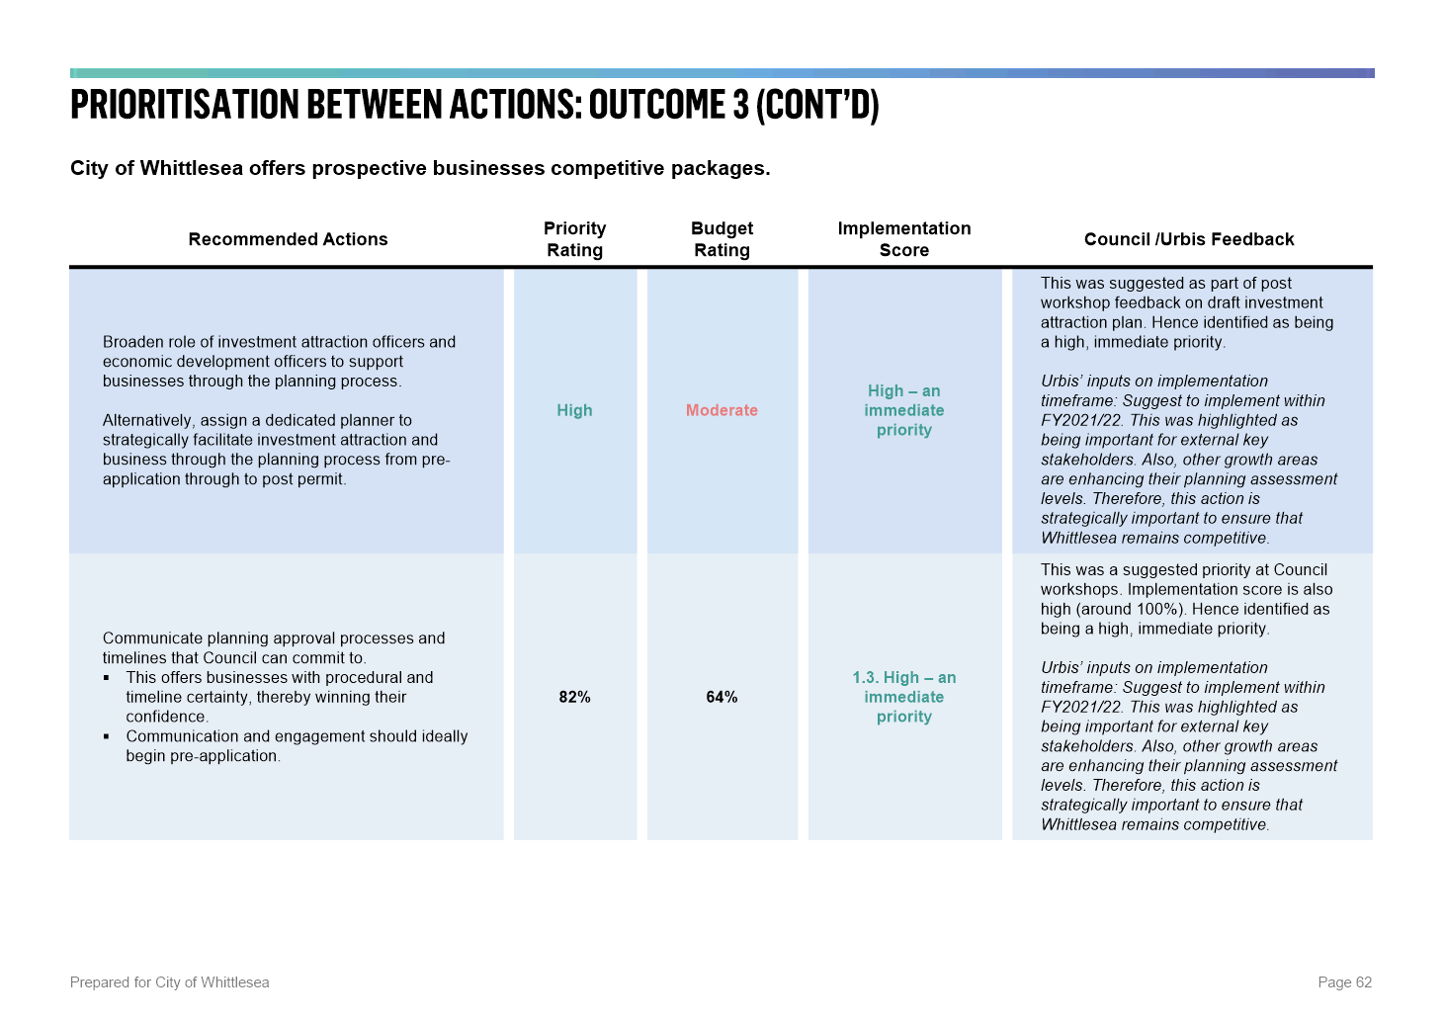

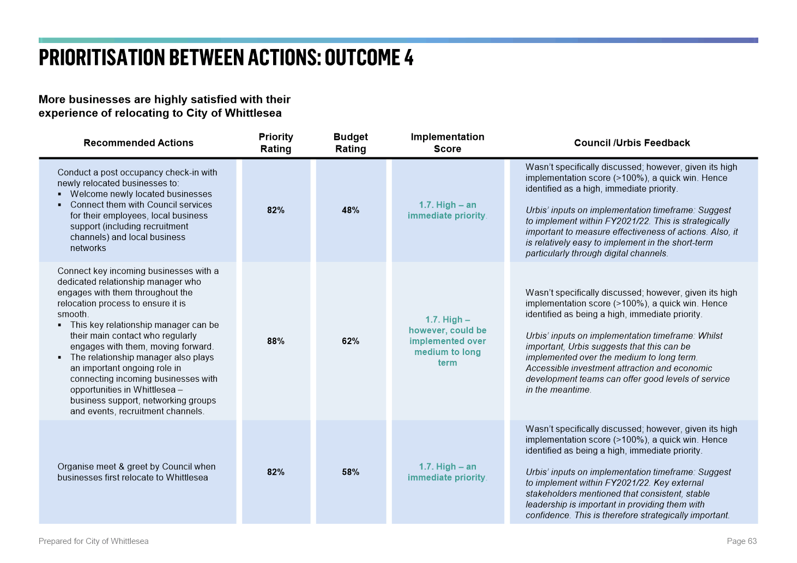

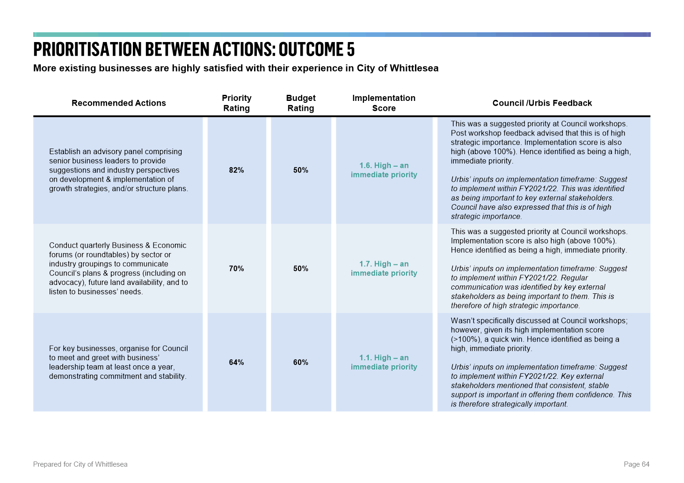

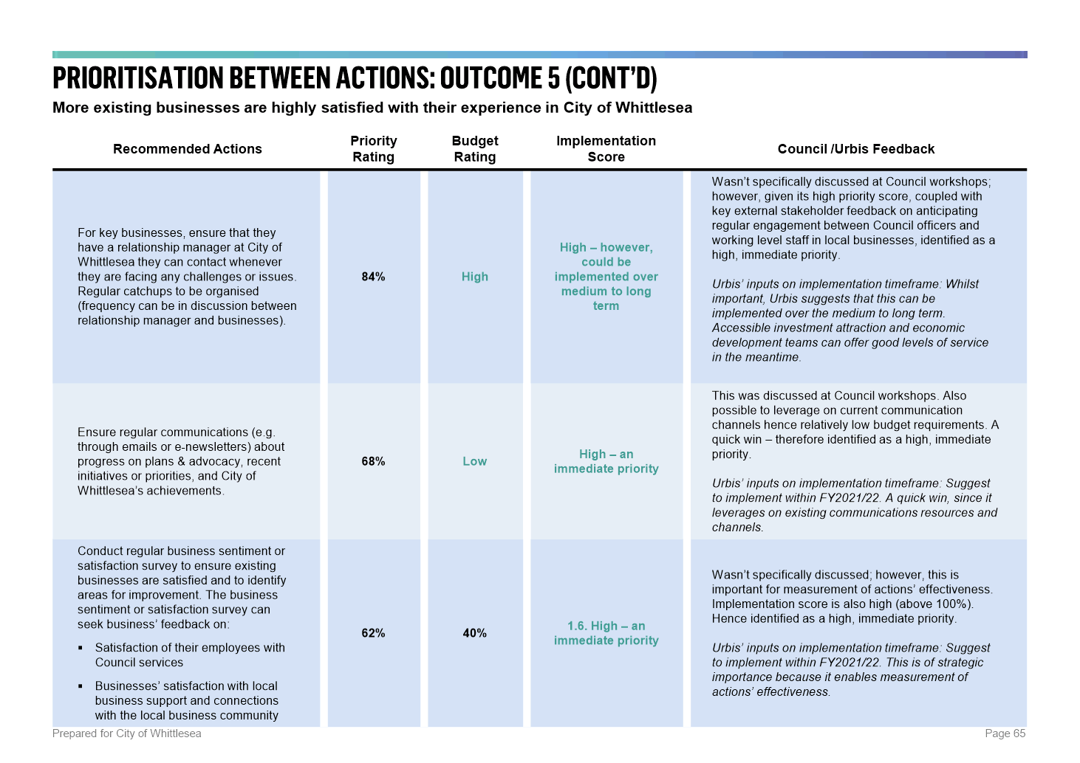

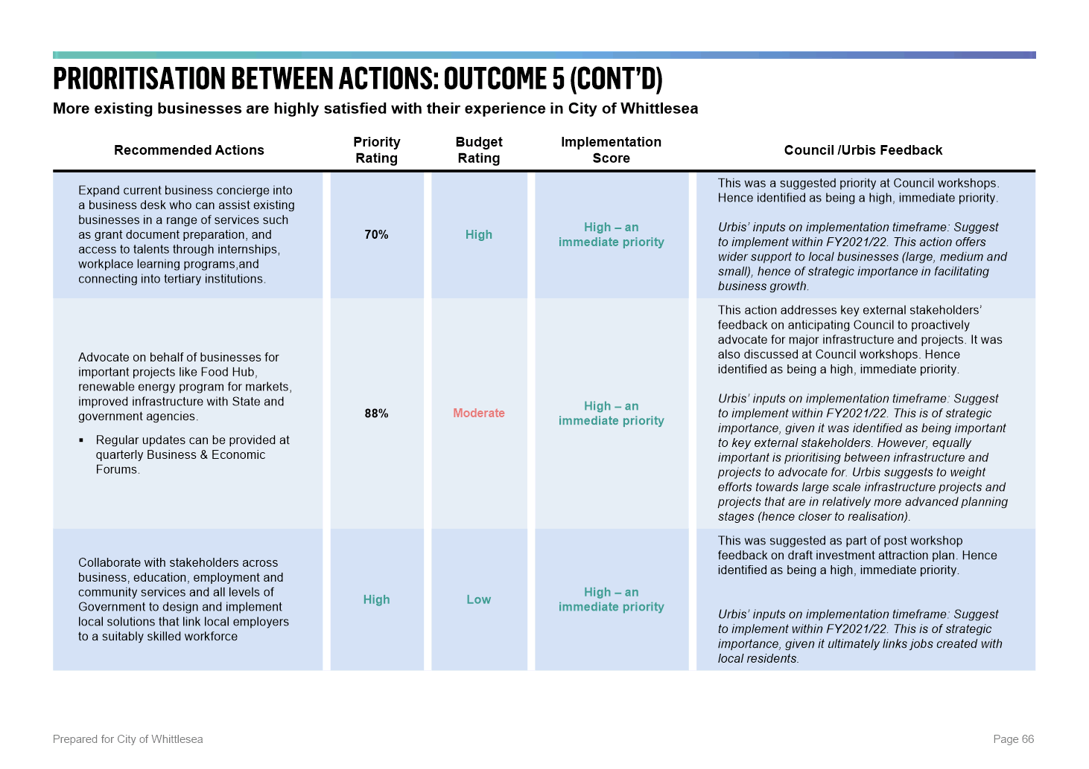

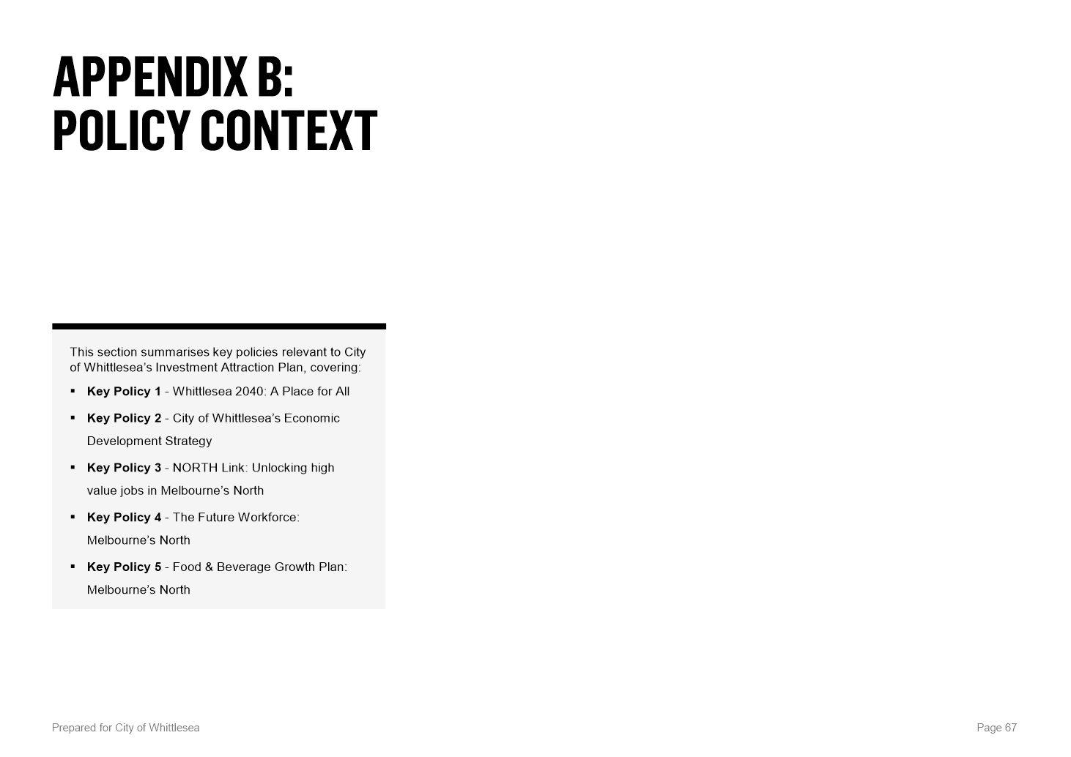

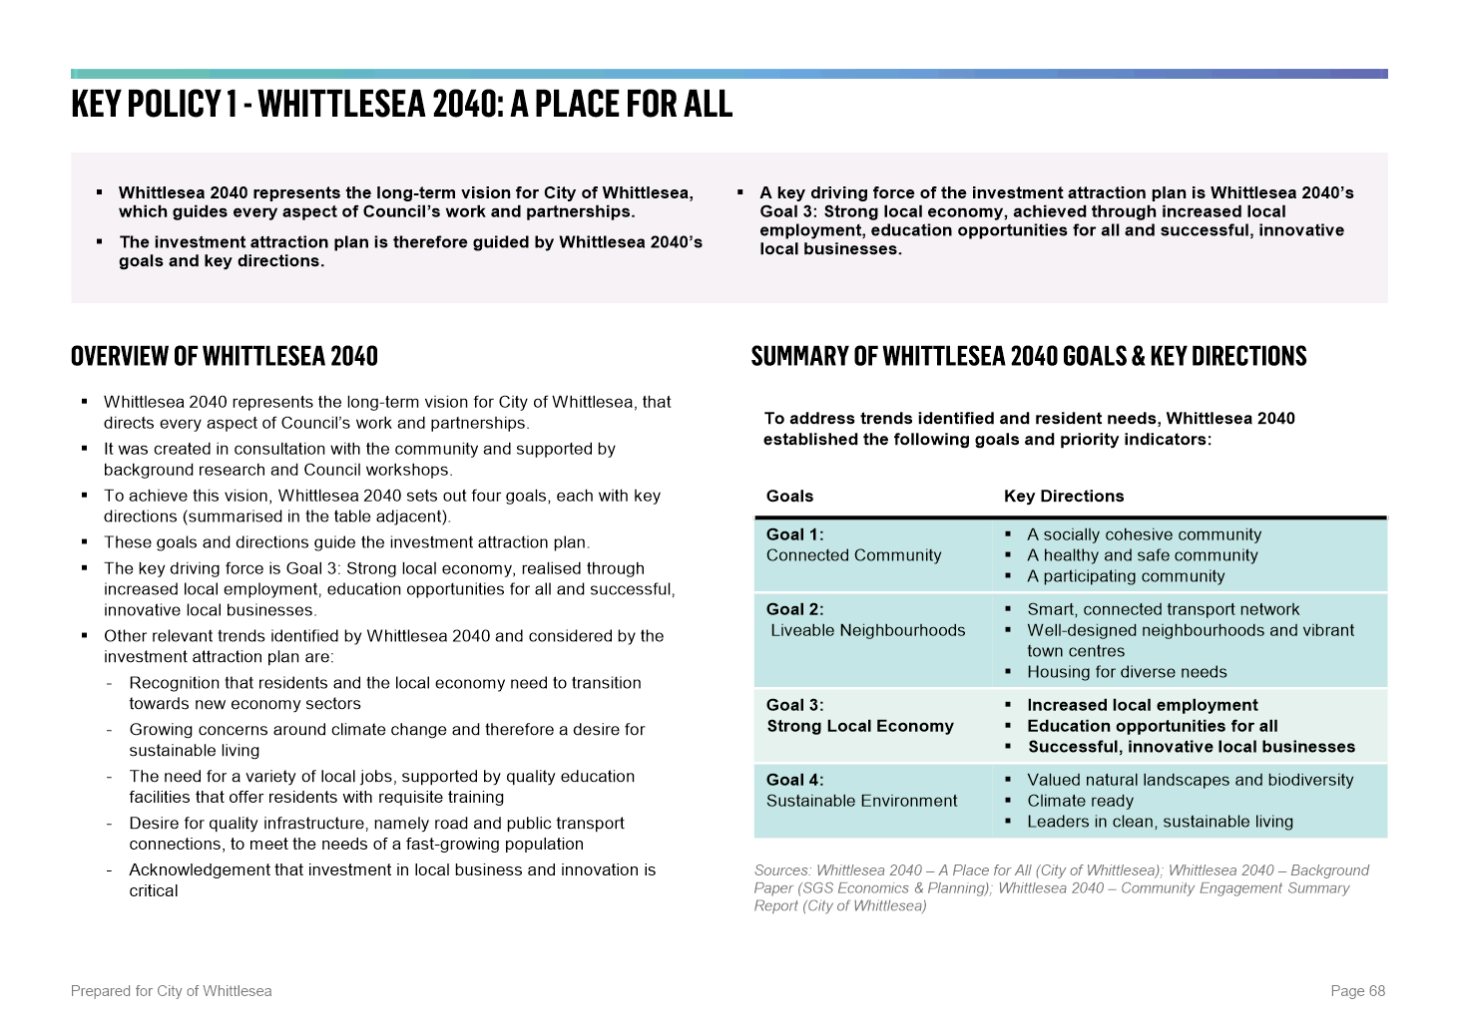

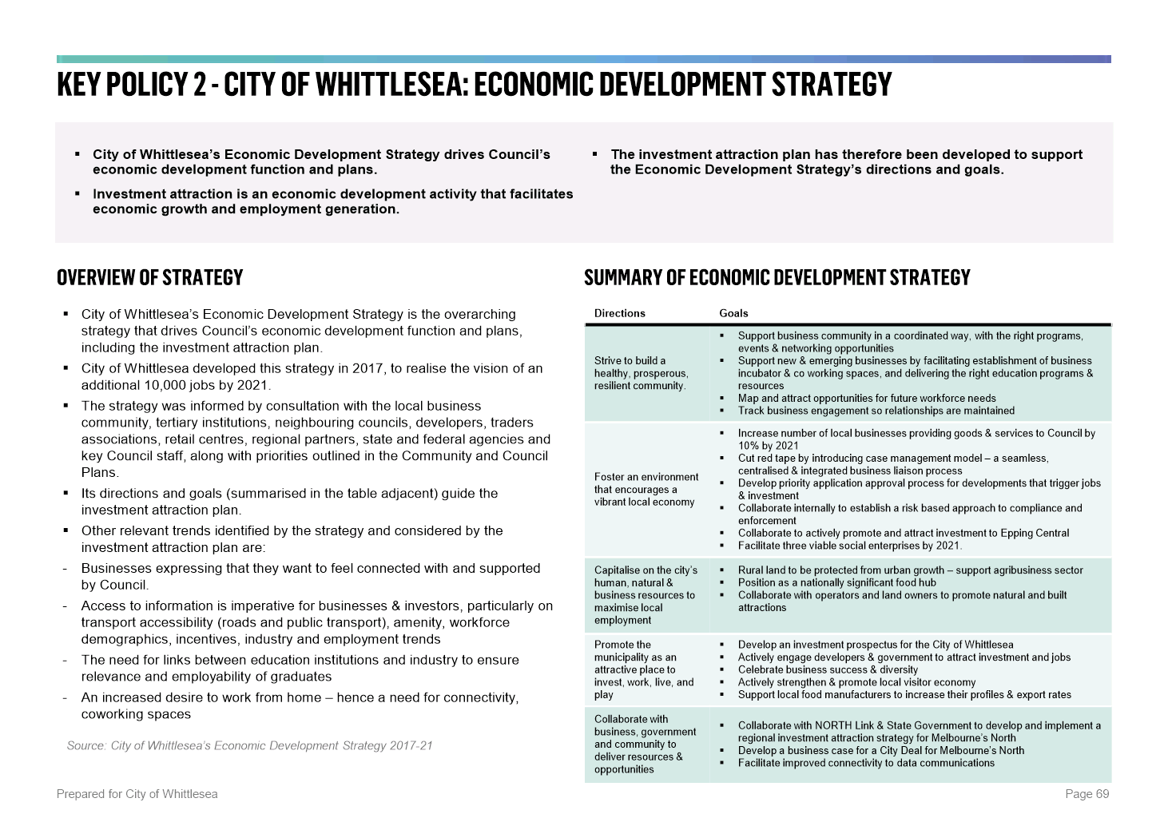

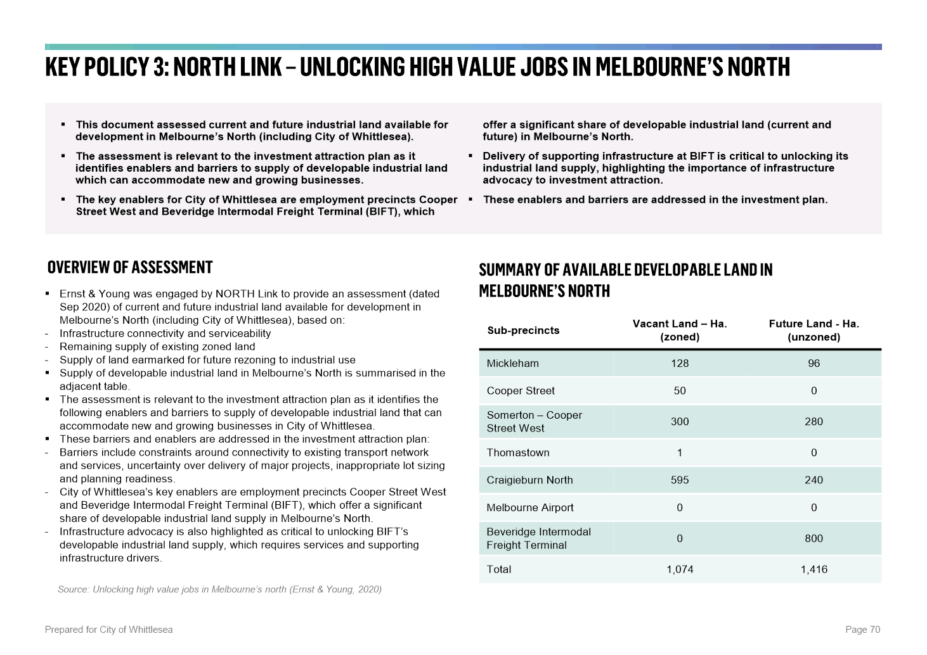

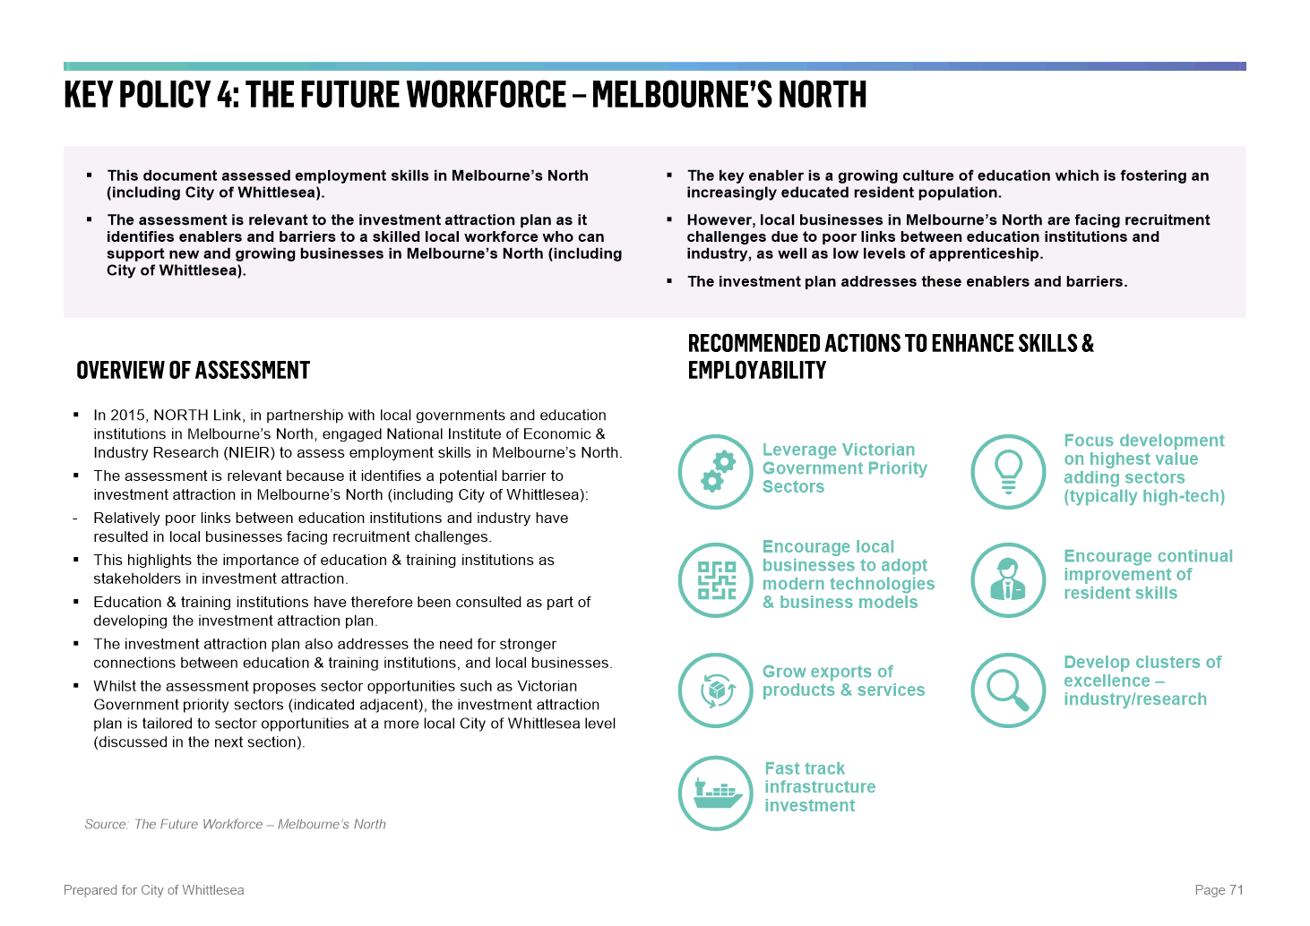

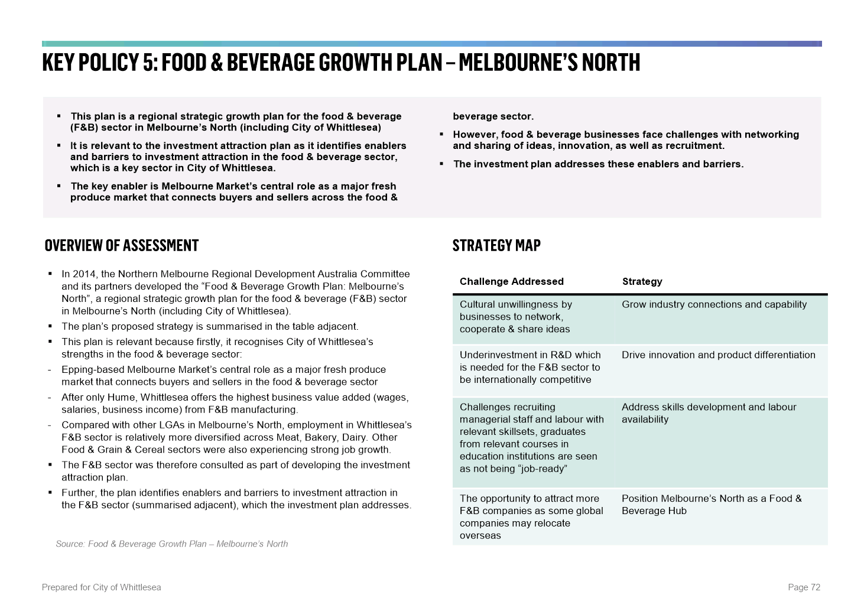

6.4 Sustainable Environment
ITEM 6.4.1 For Decision - Cooper Street West Resource Recovery Hub - Proposals to Lease Community Engagement Outcome
Attachments: 1 Site Plan
2 Proposed Occupancies Site Plan
Responsible Officer: Director Corporate Services
Author: Consultant

RECOMMENDATION SUMMARY
Council resolve following the completion of the community engagement process in accordance with Section 115 of the Local Government Act 2020 and Council’s Community Engagement Policy, to enter into leases on its properties at 480 Cooper Street and at 335-355 O’Herns Road, Epping.
Brief overview
• Council presently holds two lease agreements within the Cooper Street Hub that are approaching expiry in 2021 (at 480 Cooper Street) and 2022 (at 335-355 O’Herns Road).
• Prior to entering new lease agreements, it was decided to take the opportunity to ensure Council’s significant land holdings within the Cooper Street Hub are contributing to positive environmental outcomes. An industry wide Expression of Interest (EOI) has been undertaken.
• The EOI process related solely to the occupation and leasing of Council owned property within the Cooper Street Hub, negotiation of waste disposal contracts has been managed by a separate procurement activity.
• Three viable submissions were received in response to the EOI process.
rationale for recommendation
The intention to lease Council properties was presented to Council at its meeting on 4 May 2021 and was followed by a community engagement process.
A lengthy process was undertaken to source the best combination of occupiers at the Council owned property known as the Cooper Street Waste & Resource Recovery Hub (CSRRH). The proposed leases will be subject to appropriate terms and conditions including the specification and formalisation of in-kind benefits.
impacts of recommendation
The proposed agreements will not only deliver financial benefit to Council but will continue current and expand on future recycling programs benefitting the Whittlesea community.
what measures will be put in place to manage impacts
Council officers will continually monitor terms and conditions to ensure best practices and services to the community are maintained during the lease period.

Report
Background
Council owns the properties known as 480 Cooper Street, Epping, and 335-355 O’Herns Road, Epping (totalling 77Ha) (Attachment 1 – Site Plan). The two sites are predominantly vacant land with part of the property being a landfill site with gas extraction facilities still in place, whilst the balance is made up of internal roads and hardstand areas.
An integral part of delivering a cohesive and integrated waste and resource recovery system is the concept of waste and resource recovery hubs. A hub is a facility, or group of facilities, that manage or recover waste or material streams. Hubs are described across three levels, state, regional and local. A hub of state significance can be part of a broader industrial or employment precinct. The Metropolitan Waste and Resource Recovery Implementation Plan 2016 (Metro Implementation Plan) and Statewide Waste and Resource Recovery Infrastructure Plan (SWRRIP) identifies 14 Hubs of State Importance within metropolitan Melbourne. These plans identify the Cooper Street Precinct in Epping as a Hub of State and Metropolitan importance.
Council presently holds two lease agreements within the CSRRH with operators that provide, amongst other services, organic and construction & demolition (C & D) materials processing. These leases are approaching expiry in 2021 (at 480 Cooper Street) and 2022 (at 335-355 O’Herns Road). The expiry of these leases presented Council with an opportunity to reflect on the contribution its significant land holdings within the Cooper Street Hub could make to our local and regional environmental outcomes. To this end it was decided that an Expression of Interest (EOI) process would be used to identify the most suitable lessee(s).
Expression of Interest - Initial Assessment
Seven formal submissions received in response to the EOI were assessed using the matrix below. Four were shortlisted for further consideration.
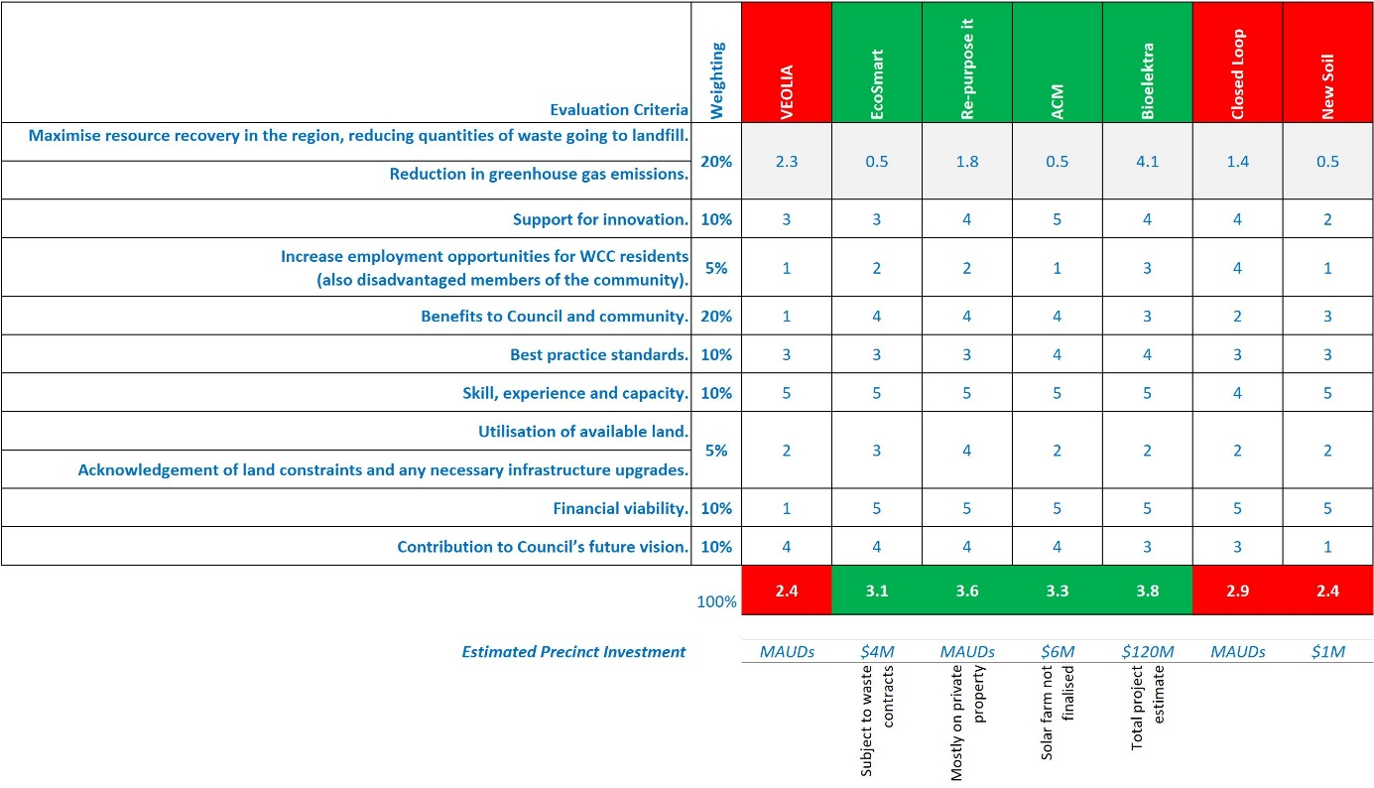
The four shortlisted applicants were asked to present to the working group in order to further clarify details of their submission. At that stage Bioelektra withdrew their interest when officers restated that Council’s waste service contracts were subject to separate tender processes and therefore feedstock from Council’s waste operations would not be guaranteed. Presentations were provided by the three remaining applicants in late March 2020.
In-Kind Benefits
The remaining three applicants became the focus of further consideration, predominantly to determine, in addition to a site rental to be paid to Council, what in-kind benefits they might provide to Council and the community (e.g. landfill diversion, resident vouchers for drop-off of green waste and other materials, processing of contractor materials such as parks maintenance green waste, etc.).
• Suez, Ecodynamics, Smart Recycling, Salvos Stores Consortium (SESS)
- Expressing interest in Cooper Street
• Repurpose It (RPI)
- Expressing interest in Cooper Street and O’Herns B
• Aurora Construction Materials (ACM).
- Expressing interest in O’Herns B
The table below shows which applicant’s proposed uses are likely to provide in-kind benefits. Only proposed uses on Cooper Street and/or O’Herns A, B, and C were considered.
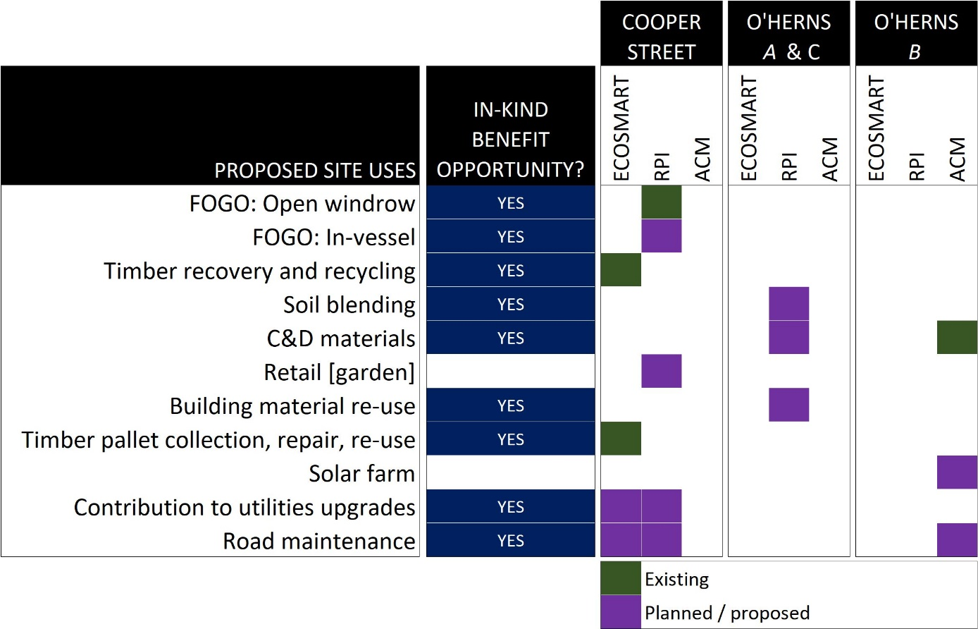
It is worth noting that RPI have pre-existing plans to construct in-vessel FOGO facilities on their property at 460 Cooper Street.
Applicant Lease Proposal
The table below shows the general lease terms being sought by the remaining three applicants.
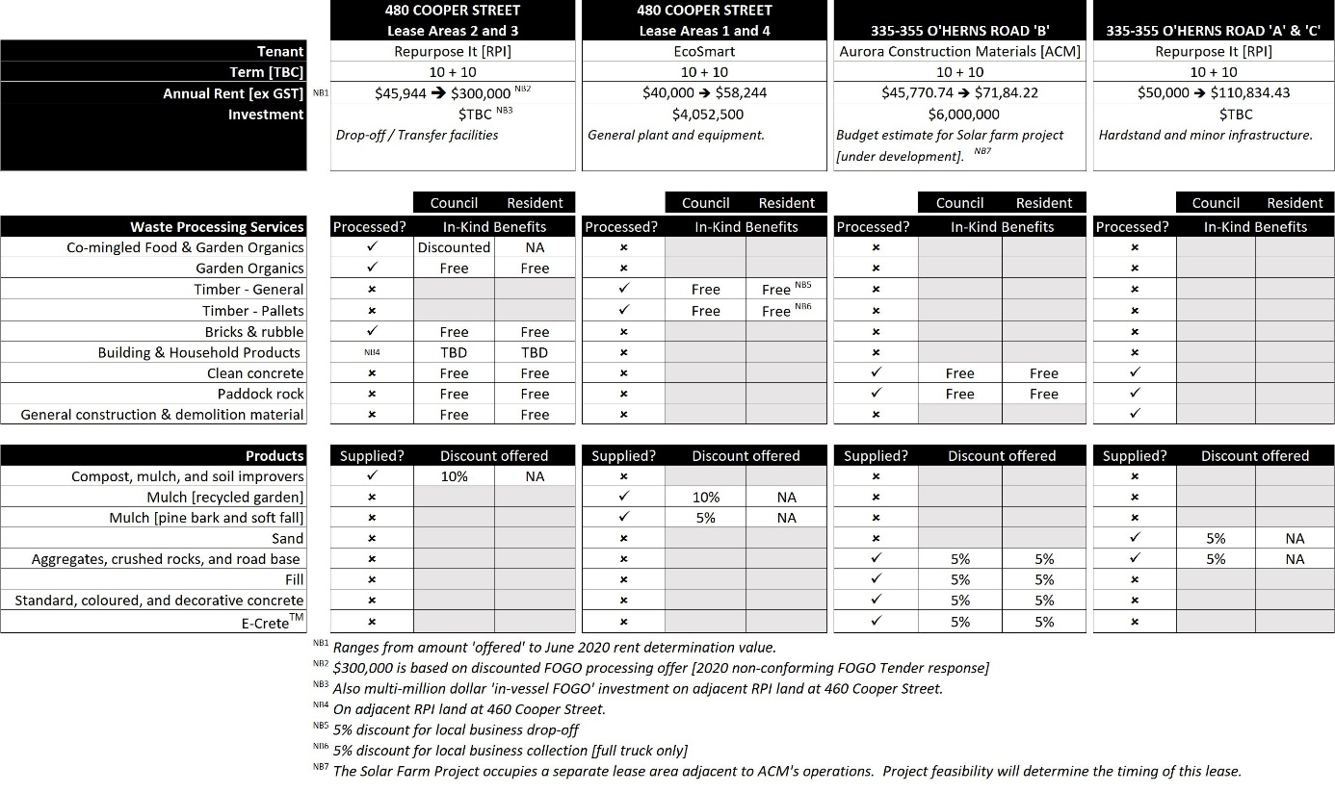
Proposed Lease Allocations
(see Attachment 2 – Proposed Occupancies Site Plan)
Following a detailed review of the submissions received as part of the EOI process and subsequent discussions and negotiations with preferred firms (potential tenants/partners), the following lease allocations (and partnerships) are proposed:
1. Repurpose It (RPI)
As RPI have been the successful tenderer for Council’s recently awarded FOGO contract, have invested heavily in their own site adjoining Council’s Cooper Street Waste & Resource Recovery Hub (CSRRH) and their EOI offer was the most attractive (financially and also with in-kind benefits), we propose a lease of two parcels of land within the CSRRH.
RPI purchased adjoining land at 460 Cooper Street, Epping, in March 2017 and specialise in construction material recycling (500,000 tonnes pa). They have 50 full time staff and 50 part time, currently have a 24/7 operation with full compliance to Council and EPA regulations. They are an innovative firm (Westpac business awards - top 20/2400) and have a high sustainability reputation. They have established a partnership with Downer who is seeking large scale investment in resource recovery technology (including establishment of education facility and research testing lab) and are open to partnerships with other proposed tenants on CSRRH. They also have proposals for waste transfer, timber recycling and R&D.
Part 480 Cooper Street, Epping
Situated at the rear of the site with a land area of approximately 11.524 hectares, this parcel will be utilised by RPI specifically for Council’s FOGO contract. It is proposed that the occupancy of this parcel mirror the term of the FOGO contract which is an initial term of ten years with an option of ten years (at Council’s discretion). RPI have offered an annual rental of $300,000 for each year in the first ten year term as well as the second ten year term should Council exercise its option to continue both the FOGO contract and the lease. The FOGO contract gives Council the flexibility to exercise the second term from between 1 to 10 years and it is intended that the proposed lease will mirror this flexibility. One of numerous conditions that will be part of the proposed lease agreement is for RPI to meet all fire requirements on Council’s land made by Fire Rescue Victoria.
Part 335-355 O’Herns Road, Epping
This parcel can be described as the “dog-leg” portion of the site with an area of approximately 14.3 hectares and the centre portion of the site of 13.5 hectares, which will both be utilised by RPI to assist with the many waste and resource recovery activities that the they are involved. It is also proposed that the occupancy of this parcel mirror the term of the FOGO contract which is an initial term of ten years with an option of ten years (at Council’s discretion). RPI have offered an annual rental of $50,000 for each year in the first ten year term.
2. Ecodynamics
The SESS Consortium (SESS) submission to Council’s EOI process dissolved following Suez’s unsuccessful FOGO tender bid. (EcoSmart) provided an acceptable revised offer with Ecodynamics operating as the head lessee. Ecodynamics is an existing tenant at the CSRRH and have an established and successful relationship with Council. Established in 1988, Ecodynamics Group is a vertically integrated landscaping construction, materials supply, nursery and services company, employing more than 150 people across three states. As the only business of its kind in the Australian landscaping industry, Ecodynamics Group consists of four distinct yet complementary businesses which have been assembled to provide a seamless, risk free service to our client base, primarily encompassing the civil infrastructure industry. Ecodynamics are experienced at bringing new people to the construction environment and training them to have long, safe and fulfilling careers. They recognise and celebrate their ability to create lasting good through their work: providing rewarding careers, building strong communities, and creating healthy environments as lasting legacies for local asset holders. It is with this vision in mind that Ecodynamics intend to further develop the Cooper Street Waste Precinct into a world class facility by demonstrating the positive impact of the circular economy to Council and its community members.
Part 480 Cooper Street, Epping
Situated at the front of the site with a land area totalling approximately 14.609 hectares, this parcel will be utilised by Ecodynamics in the same way as it is currently utilised. Ecodynamics will occupy 7.962 hectares themselves and sub-lease 6.647 hectares to Smart Pallets (a timber pallet recycling firm). This will ensure that the full drop-off recycling range of services continues to be offered to the Whittlesea community. This voucher based drop-off service will continue to be provided to the community, which currently consists of green waste drop-off (approximately 10,432 collections annually) timber drop-off (approximately 2,200 collections annually) and rubble drop-off (approximately 874 collections annually). These in-kind services save the community approximately $1.23 million per annum.
Ecodynamics have offered an annual rental of $40,000 to occupy the 14.609 hectares plus continuing the in-kind benefits of recycling drop-off at Cooper Street for all Whittlesea residents. It is proposed that Ecodynamics be offered a lease term of ten years, an option of ten years with annual CPI rental increases.
One of numerous conditions that will be part of the proposed lease agreement is for RPI to meet all fire requirements on Council’s land made by Fire Rescue Victoria.
3. Aurora Construction Materials (ACM)
ACM has been the existing tenant at 335 O’Herns Road since 2007 (through a 15 year lease/permit recycled concrete and quarry operations and has invested $20 million on Council’s land to date). ACM is 100% Australian owned and operated and employs over 100 staff with 60 located at Epping (four sites overall) with a further 124 jobs to be created if awarded a new lease. They contribute a direct and indirect income of approximately $7 million annually in the local economy (200 suppliers), reprocesses 400,000 tonnes of waste rock and producing over 120,000 cubic metres of concrete product containing recycled material. ACM has also stated that they will partner with a solar panel provider to offset electricity costs, similar to the trial run at Wollert landfill, and have invested $2 million in E-crete as a more sustainable alternative to concrete. It is proposed that a new lease be given to ACM essentially continuing to operate under similar terms of their existing lease with Council.
Part 335-355 O’Herns Road, Epping
This is the parcel of the site slightly set back from the front boundary with an area of approximately 10.2 hectares. ACM have offered an annual rental of $42,000 to occupy the 10.2 hectares plus in-kind benefits consisting of:
• The establishment of free of charge community drop-off facilities for relevant construction and demolition products.
• Products to be discounted for Council, Council’s agents, and City of Whittlesea residents.
It is proposed that ACM be offered a lease term of ten years, with an option of ten years with annual CPI rental increases.
ACM have also stated that when the solar project is finalised, they would also propose a lease of approximately 7.73 hectares of land at the front of 335-355 O’Herns Road, Epping, for an annual rental of $32,000.
Proposal
To seek Council approval to enter into lease negotiations, including appropriate terms and conditions and the specification and formalisation of in-kind benefits, with the three remaining short-listed applicants, at the Council owned property known at the Cooper Street Waste & Resource Recovery Hub (CSRRH).
Consultation
Initial consultation was undertaken by Council via an information session open to the wider waste industry, which received 75 registrations. A subsequent Expression of Interest (EOI) campaign was then communicated to the wider waste industry. This consultation and EOI resulted in seven formal submissions.
Subsequent to short-listed applicants being identified, an IAP2 ‘Inform’ level of community consultation has been undertaken in accordance with Council’s Community Engagement Policy. A community engagement process in accordance with Section 115 of the Local Government Act 2020, and in accordance with Council’s Community Engagement Policy, has been undertaken and no feedback on the proposed leases was received by Council. Community consultation included placing all the information on the lease proposals on Council’s website (Hive) via an engagement page. The engagement page also includes contact details of one of Council’s Officers involved in this project as an opportunity to obtain additional information.
Critical Dates
Council presently hold two existing leases within the CSW Resource Recovery Hub which expire in 2021 (480 Cooper Street) and 2022 (335-355 O’Herns B) respectively.
By completing community consultation on the proposed leases, Council has met its obligations under Section 115 of the Local Government Act 2020 and Council’s Community Engagement Policy. No submissions or comments were received from the community.
Financial Implications
The financial implications related to awarding the above leases fall into two categories, annual rent and in-kind benefits.
Policy strategy and legislation
Under Section 115 of the Local Government Act 2020, Council must undertake a community engagement process in accordance with its community engagement policy, which has now been achieved.
link to strategic risks
Strategic Risk Contaminated Land - Failure to prevent significant negative impact of Council’s decisions and management relating to contaminated sites
The expression of interest campaign has enabled current and prospective Tenants to develop and implement new and sustainable practices within Council’s existing former landfill sites and gas extraction areas.

Links to whittlesea 2040 and the CoUNCIL Plan
Goal Sustainable environment
Key Direction Leaders in clean, sustainable living

To ensure Council’s significant land holdings within the Cooper Street Hub are contributing to positive environmental outcomes, whilst maximising in-kind benefits and long-term capital investment for the community.
Declarations of Conflicts of Interest
Under Section 130 of the Local Government Act 2020 and Rule 47 of the Governance Rules 2021, officers providing advice to Council are required to disclose any conflict of interest they have in a matter and explain the nature of the conflict.
The Responsible Officer reviewing this report, having made enquiries with relevant members of staff, reports that no disclosable interests have been raised in relation to this report.
Conclusion
The Expression of Interest Campaign resulted in three viable submissions. No community feedback has been received in response to the community consultation undertaken. The proposed leases for use of Council owned property within Cooper Street Waste and Resource Recovery Hub (being specifically 480 Cooper Street and 335-355 O’Herns Road parcels A, B, and C), will contribute to positive environmental outcomes as well as maximising in kind benefits and longer-term capital investment for the community.

RECOMMENDATION
THAT Council resolve to:
1. Note that a community engagement process in accordance with Section 115 of the Local Government Act 2020 and in accordance with Council’s Community Engagement Policy has been undertaken and no feedback on the proposed leases was received by Council
2. Enter into the following leases:
a) Part 480 Cooper Street, Epping (approximately 11.524 hectares) to Repurpose It (RPI) for an initial term of ten years with an option of ten years, at an annual rental of $300,000 for each year of both terms plus “in-kind” benefits.
b) Part 335-355 O’Herns Road, Epping (an area of approximately 14.3 hectares and the centre portion of the site of 13.5 hectares) to Repurpose It (RPI) for an initial term of ten years with an option of ten years at an annual rental of $50,000 for each year plus “in-kind” benefits.
c) Part 480 Cooper Street, Epping (situated at the front of the site with a land area totalling approximately 14.609 hectares) to Ecodynamics at an annual rental of $40,000 plus in-kind benefits for a term of ten years with an option of ten years with annual CPI rental increases.
d) Part 335-355 O’Herns Road, Epping (with a land area of approximately 10.2 hectares) to Aurora Construction Materials (ACM) at an annual rental of $42,000 plus in-kind benefits for a term of ten years with an option of ten years.
3. Authorise the Chief Executive Officer to finalise all terms and conditions and sign the leases on behalf of Council.

Council Resolution
Moved: Chairperson Wilson
Seconded: Administrator Eddy

THAT Council resolve to adopt the Recommendation.
Carried

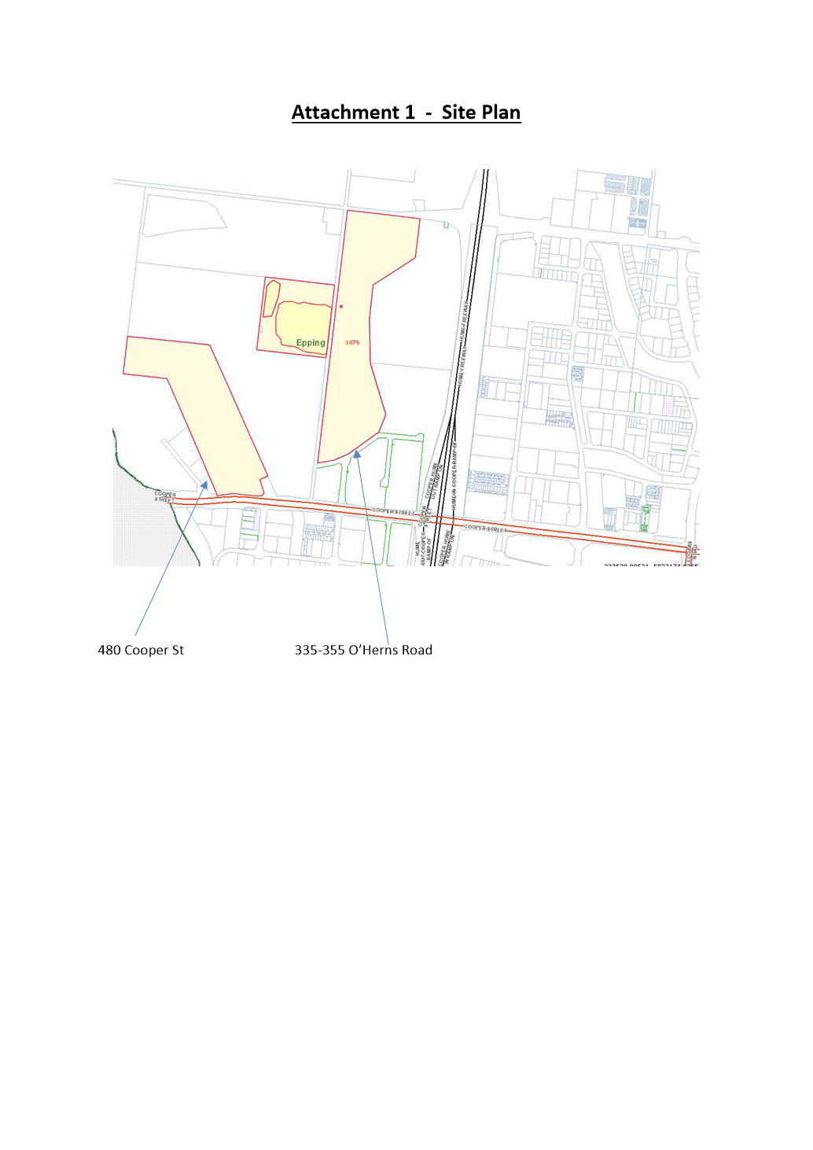
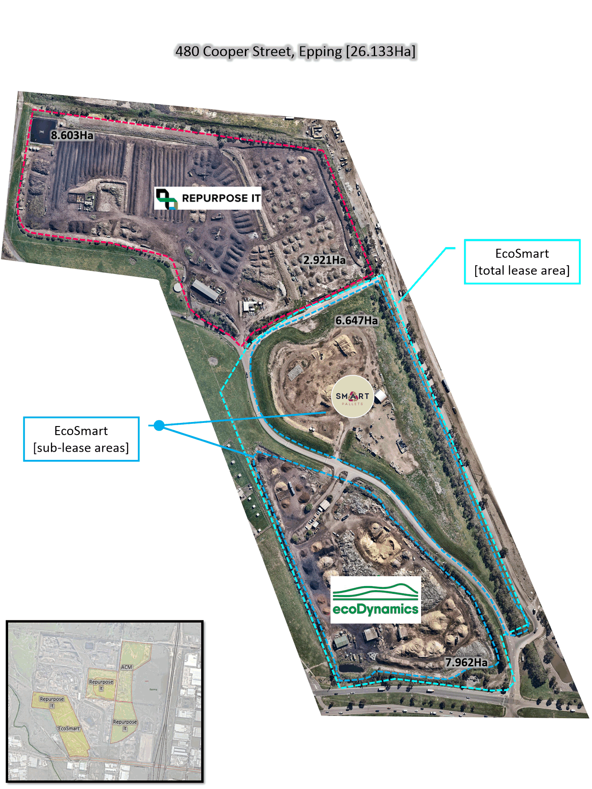

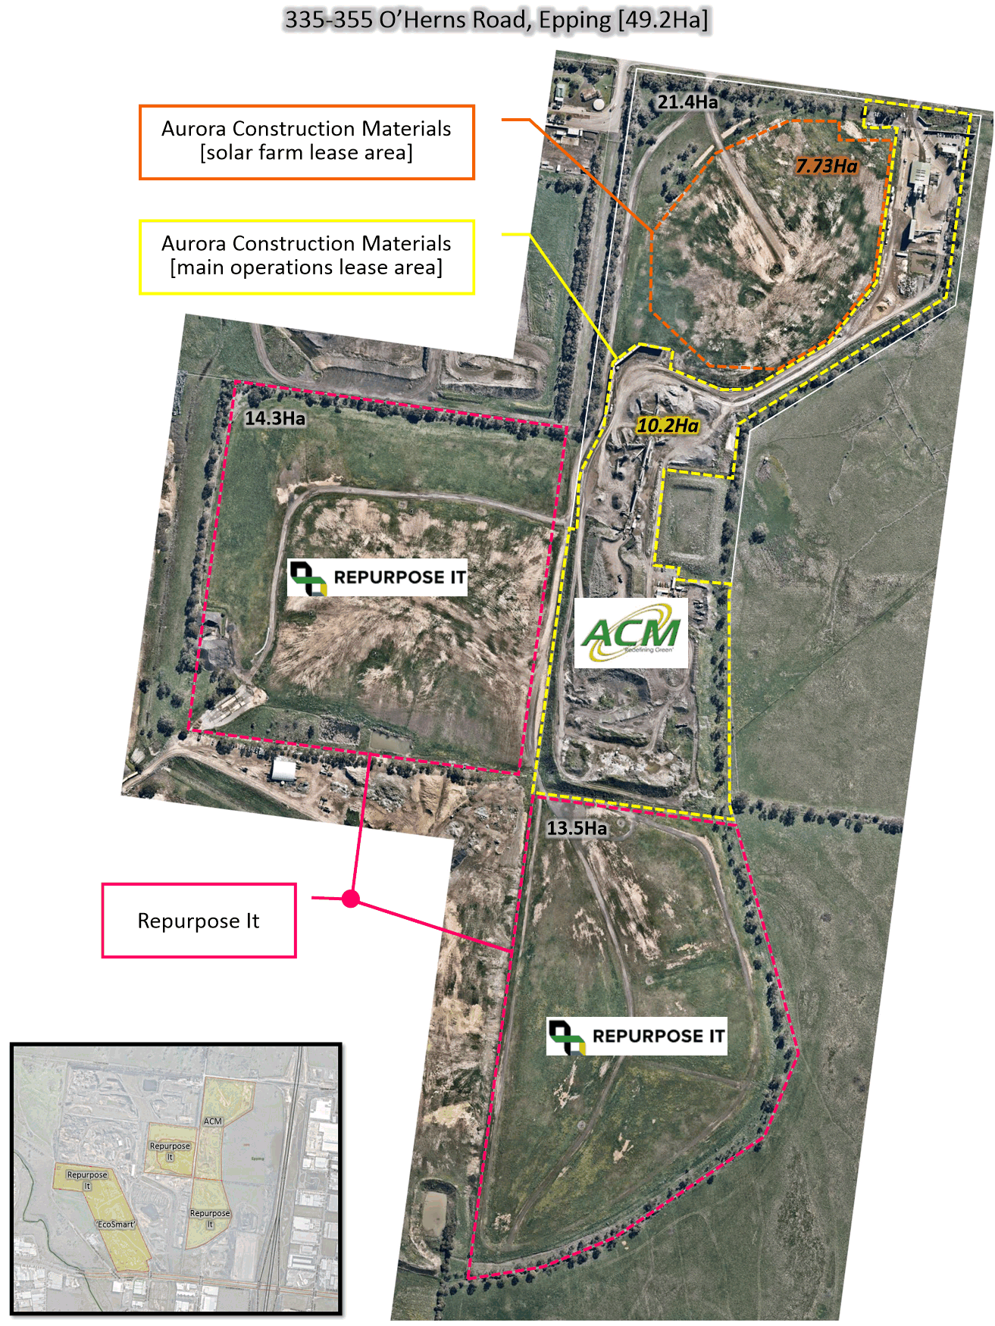

ITEM 6.4.2 For Decision - Response to Petition for Replacement of Trees along Fielding Drive, Mernda
Responsible Officer: Director Infrastructure & Environment
Author: Senior Arborist Planning & Risk

RECOMMENDATION SUMMARY
THAT Council resolve to:
1. Note the progress report and actions undertaken to date.
2. Consult with all residents along Fielding Drive, Mernda (including the head petitioner and signatories) regarding the final investigation outcomes.
3. Prepare a subsequent report to the Scheduled Council Meeting dated 2 August 2021 to finalise the matter.
Brief overview
• Council has received a petition from 15 residents requesting the removal of nature street trees from Fielding Drive, Mernda. The petition was signed by 13 residents of Fielding Drive, one resident of Harriers Street, and one resident of Dorobolo Street.
• Council Officers met with the head petitioner and other interested residents on site at a meeting dated 19 May 2021 to discuss their respective concerns and the items raised within the petition.
• Council commissioned two independent assessments: an arobticultural assessment and an engineering report which outlined the likely impacts of the existing trees on the abutting properties. The recommendations within these reports remain under review.
• Following the detailed consideration of the two independent assessments, additional consultation is required with all residents along Fielding Drive, Mernda (including the head petitioner and signatories) to ensure the final investigation outcomes appreciate and resolve the concerns raised.
• It is proposed to present a subsequent report to the Scheduled Council Meeting dated 2 August 2021.
rationale for recommendation
The recommendations above are proposed in line with the Council’s endorsed Greening Whittlesea Strategy and Street Tree Management Plan for the management of mature trees within a streetscape.
impacts of recommendation
Council’s existing tree assets continue to be managed in a sustainable way consistent with the Council-adopted Street Tree Management Plan (2019), whilst ensuring key concerns of residents are addressed where possible.
what measures will be put in place to manage impacts
A range of available proposals are being explored to address the overarching concerns of residents. Regardless of the final investigation outcome, the site will be monitored regularly to assess the success of the desired outcomes.

Report
Introduction
At its meeting dated 2 February 2021, Council tabled a petition from residents requesting the removal and replacement of the existing nature street trees from Fielding Drive, Mernda. The petition was signed by 13 residents of Fielding Drive, one resident of Harriers Street, and one resident of Dorobolo Street.
Council investigated the request looking at core issues and commissioned independent arboricultural and engineering assessments to evaluate the status of current tree assets. Issues raised in the petition were concerned mainly on the size of the trees and the mess created from excessive leaf shed.
Background
Fielding Drive, Mernda is a streetscape dominated by a combination of mature Eucalyptus trees including Brittle Gum, Wallangarra Gum and Red Ironbark. Eucalyptus trees are an evergreen tree listed on Council’s approved street tree species list and classified as a medium to large tree. The two main species planted in Fielding Drive in Wallangarra and Brittle Gum, are in the top 10 most common street trees in the City of Whittlesea. Together they combine for a total 8.7 per cent of our street trees. These trees are all currently managed and maintained proactively by Council on a biannual program.
A petition was received on 2 February 2021 signed by 15 residents requesting that Council remove the existing nature strip trees and replant with new trees as part of the Street Tree Renewal Plan. The grounds on which the signatories believe that the current trees are unsuitable include:
• Trees dropping debris including leaves
• Frequency of street sweeping (messy street)
• Leaf shedding become unsafe for foot traffic
• Canopy spread and size
• Branches cracking under wind and weather
• Darkness created from canopy cover.
Council has commissioned two independent reports: an arboricultural assessment to assess the current health status, and an engineering assessment to review the likely impacts of the trees on the abutting houses. The recommendations made within these reports are currently under review.
Council is also investigated the Fielding Drive trees to assess property clearances in line with the guidelines set out in the Street Tree Management Plan (STMP). The STMP defines the levels of service provided for Council’s street trees and the criteria by which Council does (and does not) remove trees. In many instances’ property clearances were insufficient, and there is significant inconsistency to property setbacks on the street.
Furthermore, there are currently two claims against Council for tree related damage in Fielding Drive, Mernda. These are being dealt with through Council’s claim process and the individual claimants.
A range of available proposals are being explored to address the overarching concerns of residents. These proposals were presented to Council at its meeting dated 4 May 2021, where it resolved to:
…defer consideration of Item 6.4.1 – Petition to Replace Trees Along Fielding Drive, Mernda to the 1 June 2021 Council Meeting and, in the interim the Director Infrastructure and Environment and other relevant Council Officers meet with the head petitioner and other interested residents on site to discuss their concerns.
A further progress report was presented to Council at its meeting dated 1 June 2021 where it resolved to:
…defer consideration of Item 6.4.3 – Petition to Replace Trees Along Fielding Drive, Mernda to the July 2021 meeting and, in the interim the Director Infrastructure and Environment and other relevant Council Officers meet with the head petitioner and other interested residents on site to discuss their concerns.
This updated progress report now provides an update to Council on the actions of Officers regarding the investigation and outlines the next steps.
Proposal
Council is currently reviewing the recommendations made within the independent arboricultural and engineering assessments, and how they impact the issues identified by the signatories in the petition.
As such, a range of available proposals are being considered including increased proactive inspections and tree pruning, amendments to maintenance service programs and even removal / replacement of the existing nature strip trees. Regardless of the final response and investigation outcomes, the site will be monitored regularly to assess the success of the desired benefits.
Critical dates
It is proposed to present the final investigation outcomes to the Scheduled Council Meeting dated 2 August 2021.
Consultation
Initial consultation for this petition was delivered via the head petitioner, in accordance with Council’s guidance on petitions management. This has included both verbal updates and written correspondence to the head petitioner. Officers have also responded to further representations for updates by individual signatories.
Council Officers met with the head petitioner and other interested residents on site at a meeting dated 19 May 2021 to discuss their respective concerns and the items raised within the petition.
Following the detailed consideration of the two independent assessments, further consultation is required with all residents along Fielding Drive, Mernda (including the head petitioner and signatories) to ensure the final investigation outcomes appreciate and resolve the concerns raised.
Financial Implications
The investigation remains ongoing. However, Council has two options to resolve the items raised by the petitioners, as follows:
• Remove and replace the existing nature strip trees. This cost is estimated at $27,900.
• Amend and increase the maintenance regime. This cost is estimated at $2,425 per annum (calculated at $1,425 per annum for tree pruning services and $1,000 per annum for additional street sweeping services).
Policy strategy and legislation
Review of the Fielding Drive, Mernda petition request has been completed in accordance with the following Council policies:
• Whittlesea 2040 – A Place for All Community Plan (2018)
• Greening Whittlesea City Forest Strategy 2020
• Greening Our Streets Street Tree Management Plan (2019).
link to strategic risks
Strategic Risk Community and Stakeholder Engagement - Ineffective stakeholder engagement resulting in compromised community outcomes and/or non-achievement of Council's strategic direction
The City of Whittlesea Street Tree Management Plan (2019) outlines how Council will respond to requests for tree removal from the community and communicates the evaluation criteria whereby Council will support tree removals.

Links to whittlesea 2040 and the CoUNCIL Plan
Goal Sustainable environment
Key Direction Valued natural landscapes and biodiversity

The proposal acknowledges the value of streetscapes in our local community and the contribution of these trees to local amenity, biodiversity and urban shading/cooling.
Declarations of Conflicts of Interest
Under Section 130 of the Local Government Act 2020 and Rule 47 of the Governance Rules 2021, officers providing advice to Council are required to disclose any conflict of interest they have in a matter and explain the nature of the conflict.
The Responsible Officer reviewing this report, having made enquiries with relevant members of staff, reports that no disclosable interests have been raised in relation to this report.
Conclusion
The petition from 15 residents requesting removal and replacement of the existing street trees remains under review.
A range of potential service measures are being explored to address the concerns of petitioners which mitigate the impacts on amenity of the street, including increased proactive inspections and tree pruning, amendments to maintenance service programs and even removal / replacement of the existing nature strip trees.
Council Officers have previously met with the head petitioner and other interested residents on site. However, additional consultation is required with all residents along the street following appreciation of the recommendations within the two independent arboricultural and engineering assessments.
A subsequent report will be presented at the Scheduled Council Meeting dated 2 August 2021 to finalise the matter.

RECOMMENDATION
THAT Council resolve to:
1. Note the progress report and actions undertaken to date.
2. Consult with all residents along Fielding Drive, Mernda (including the head petitioner and signatories) regarding the final investigation outcomes.
3. Prepare a subsequent report to the Scheduled Council Meeting dated 2 August 2021 to finalise the matter.
Council Resolution
Moved: Chairperson Wilson
Seconded: Administrator Duncan

THAT Council resolve to adopt the Recommendation.
Carried

6.5 High Performing Organisation
ITEM 6.5.1 For Noting - Unconfirmed Minutes of Audit & Risk Committee Meeting
Attachments: 1 Unconfirmed Minutes of Audit & Risk Committee Meeting - 27 May 2021
Responsible Officer: Executive Manager Governance
Author: Internal Compliance Officer

RECOMMENDATION SUMMARY
That Council resolve to note the Unconfirmed Minutes of the Audit & Risk Committee meeting held on 27 May 2021.
Brief overview
As required under Council’s Audit & Risk Committee Charter, this report presents the Unconfirmed Minutes of the Audit & Risk Committee meeting held on 27 May 2021.
rationale for recommendation
Council is required to comply with the requirements of the Audit & Risk Committee Charter and the Local Government Act 2020.
impacts of recommendation
Council will comply with its Audit & Risk Committee Charter and meet its legislative requirements.
what measures will be put in place to manage impacts
Provision of Audit & Risk Committee meeting minutes, ensures that the Council is regularly informed of the operations of the Audit & Risk Committee.

Report
Background
The Audit & Risk Committee is an independent advisory committee of Council and its role is to report to Council and provide appropriate advice and recommendations on matters presented to it. It acts in this capacity by monitoring, reviewing and advising on issues within its scope of responsibility and assisting Council’s governance obligations to its community.
The Audit & Risk Committee meets at least four times a year and its Charter requires that minutes from Committee meetings are presented to Council.
The Audit & Risk Committee considered a number of reports at the meeting held on 27 May 2021, as well as confirming minutes from the previous meeting held on 25 February 2021.
Main agenda items included:
• In-camera discussion with the CEO
• Audit & Risk Committee Work Plan
• CEO’s Update
• Financial Report:
- Corporate Performance Report for the Quarter Ended 31 March 2021
- Summary of Changes to Model Financial Report for the year ending 30 June 2021
- System Implementation Matters
• Risk Management Update
• Internal Audit:
- Internal Audit Status Report
- Internal Audit Reviews
- Outstanding Action Items Report from Previous Internal Audits
- Strategic Internal Audit Plan
• Draft Interim Management Letter – Year Ending 30 June 2021
• Internal Control Environment Update
• Panel Contract Expenditure Distribution Report and Adopted Procurement Policy 2021
• Asset Management Strategy Implementation Update
• Internal Compliance Reviews
• Quarterly Compliance Update – Monitoring Compliance with the Governance Principles
• External Agency Examinations
A copy of the minutes from the 27 May 2021 Audit & Risk Committee meeting is attached (Attachment 1).
Policy strategy and legislation
The Audit & Risk Committee is established in accordance with Division 8, Section 53 and 54 of the Local Government Act 2020.
The Committee’s responsibilities and requirements are outlined in the Audit & Risk Committee Charter.
link to strategic risks
Strategic Risk Governance - Ineffective governance of Council’s operations and activities resulting in either a legislative or policy breach
The Audit & Risk Committee assists Council in monitoring its governance requirements and provides advice to Council to assist with fulfilling its oversight responsibilities.
Links to whittlesea 2040 and the CoUNCIL Plan
Goal High-performing organisation
Key Direction More informed Council decisions based on strong advice and community consultation and engagement

The establishment of the Audit & Risk Committee and the reports it receives are reflective of Council’s commitment to the implementation of good governance principles. The Committee provides advice to Council to assist with fulfilling its oversight responsibilities for the financial and non-financial reporting process; internal controls; the audit process; risk management; and Council’s process for monitoring compliance with legislation, regulations and the Code of Conduct.
Declarations of Conflicts of Interest
Under Section 130 of the Local Government Act 2020 and Rule 47 of the Governance Rules 2021, officers providing advice to Council are required to disclose any conflict of interest they have in a matter and explain the nature of the conflict.
The Responsible Officer reviewing this report, having made enquiries with relevant members of staff, reports that no disclosable interests have been raised in relation to this report.
Conclusion
The Audit & Risk Committee met on 27 May 2021. The minutes of that meeting are attached to this report for noting by Council.
RECOMMENDATION
THAT Council resolve to note the Unconfirmed Minutes of the Audit & Risk Committee meeting held on 27 May 2021.
Council Resolution
Moved: Administrator Eddy
Seconded: Chairperson Wilson

THAT Council resolve to adopt the Recommendation.
Carried

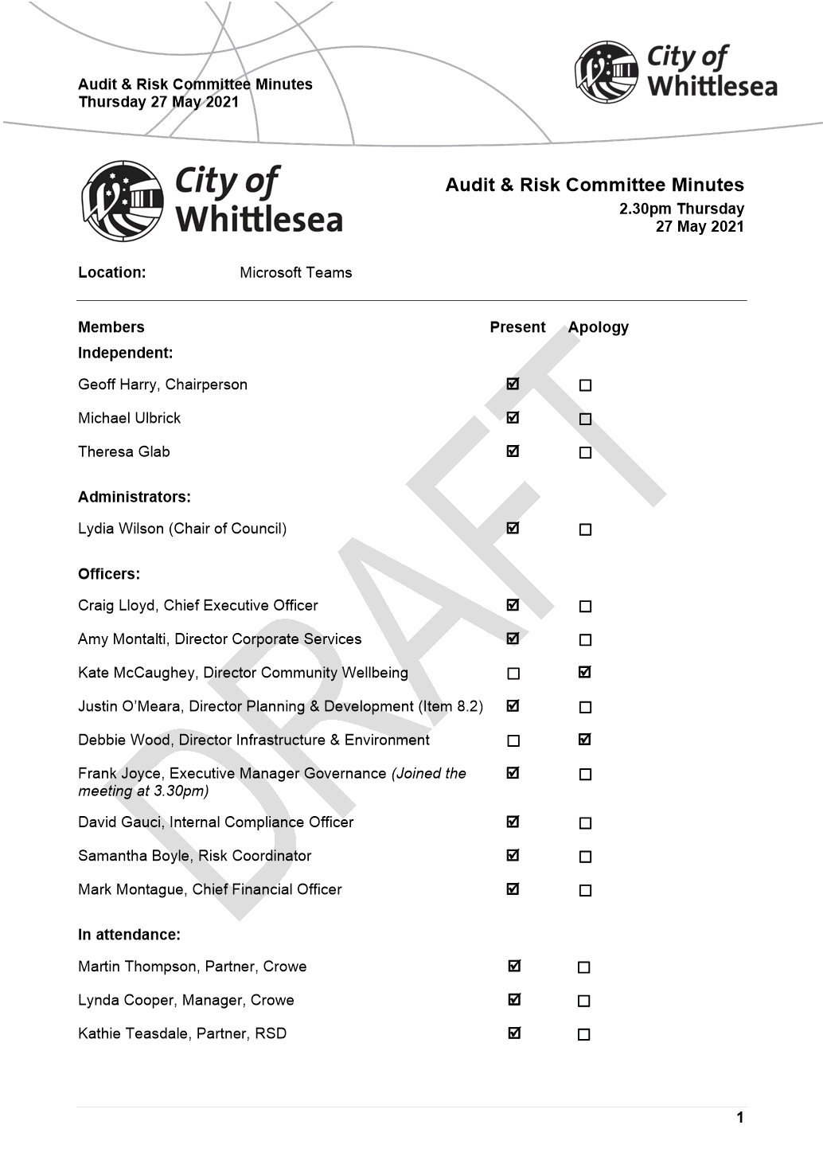

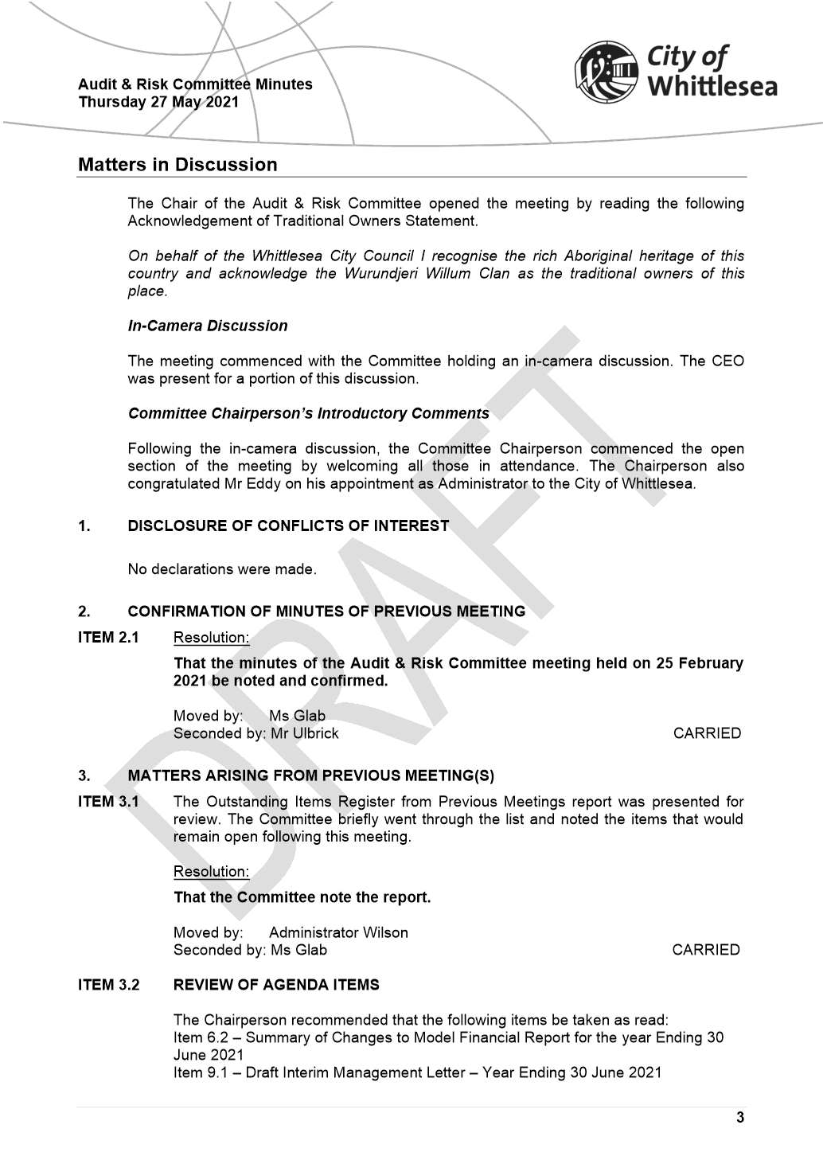

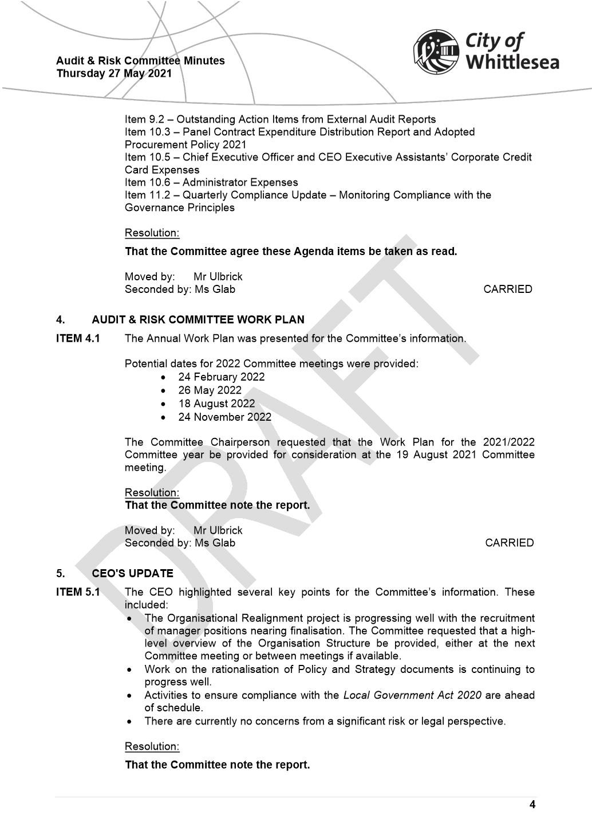

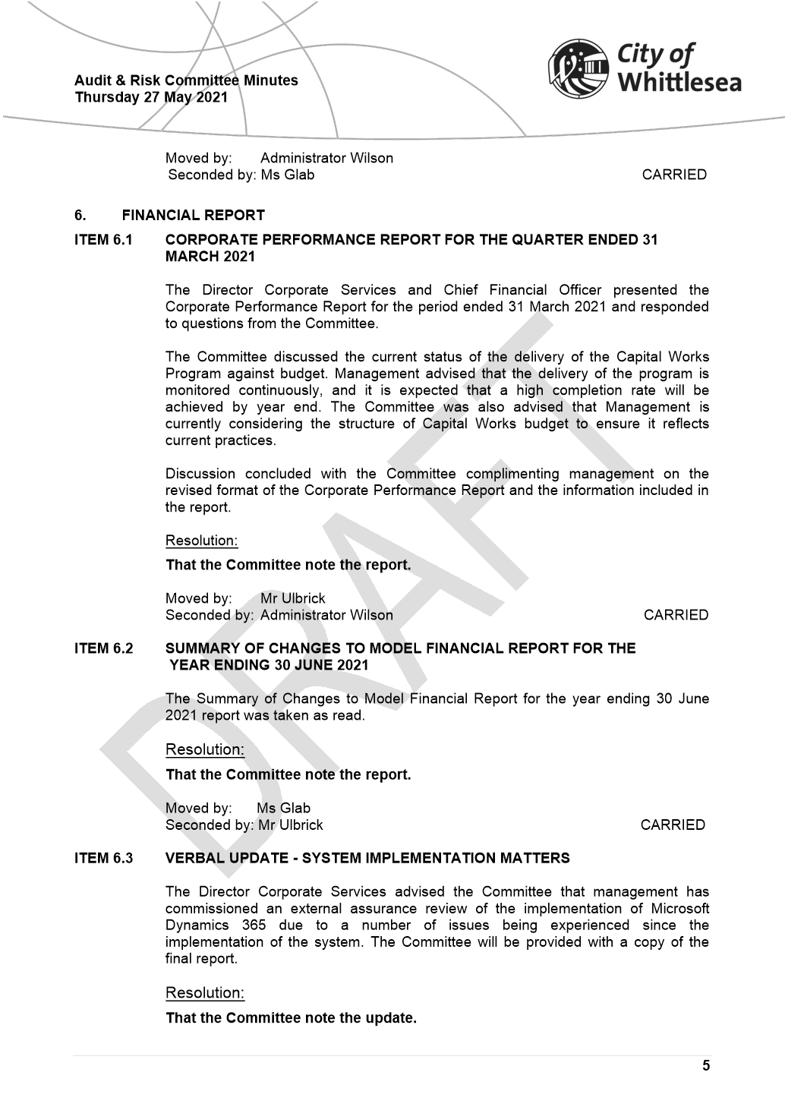

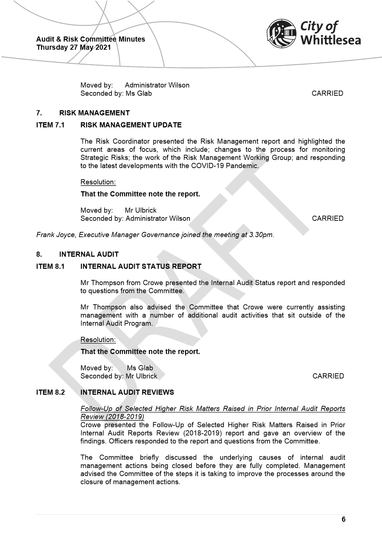

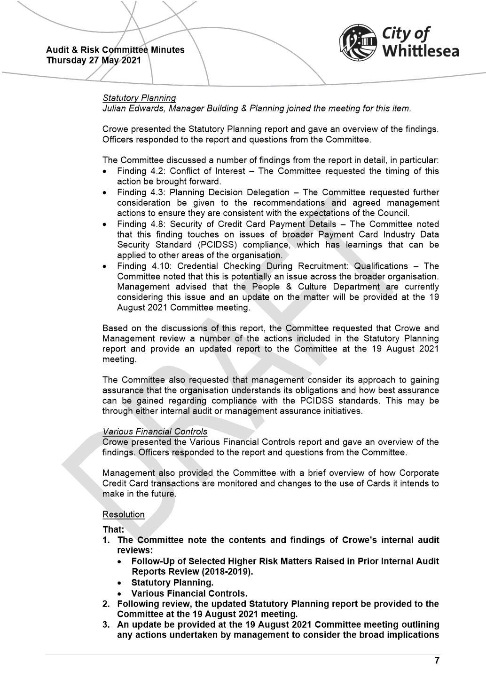

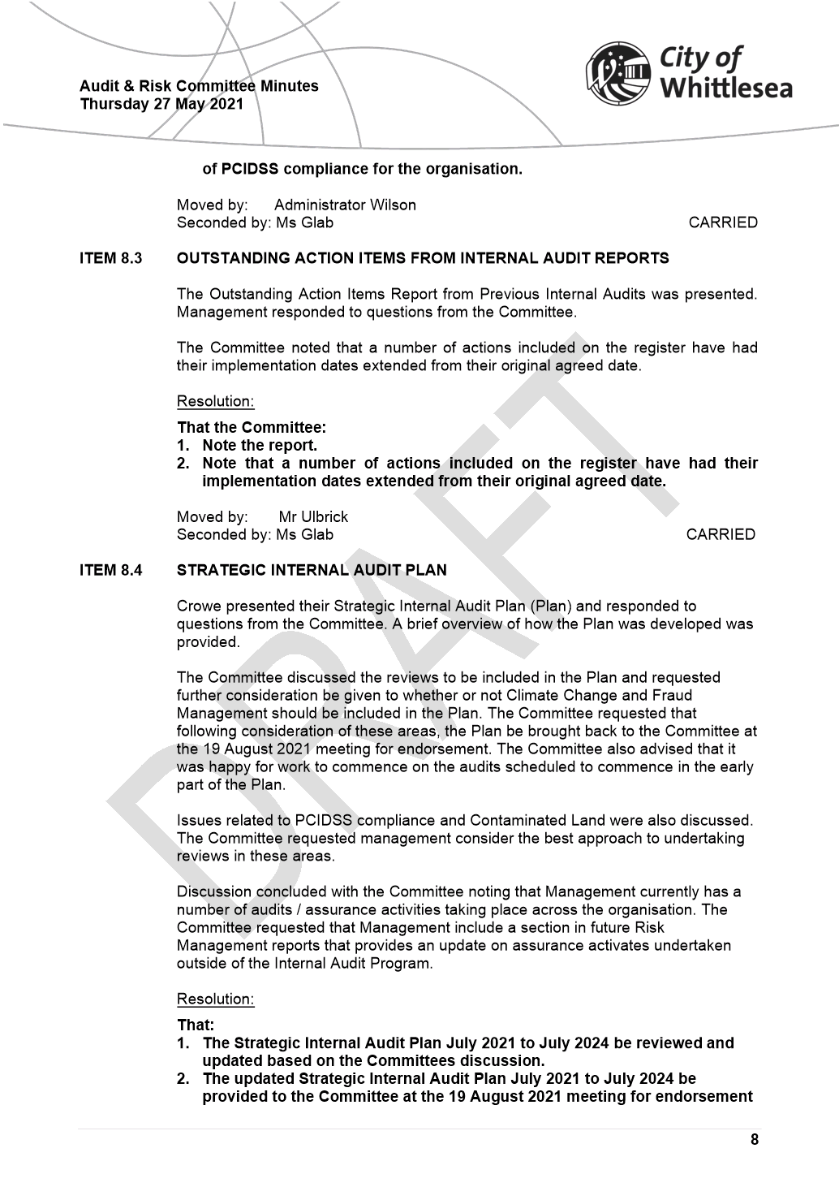

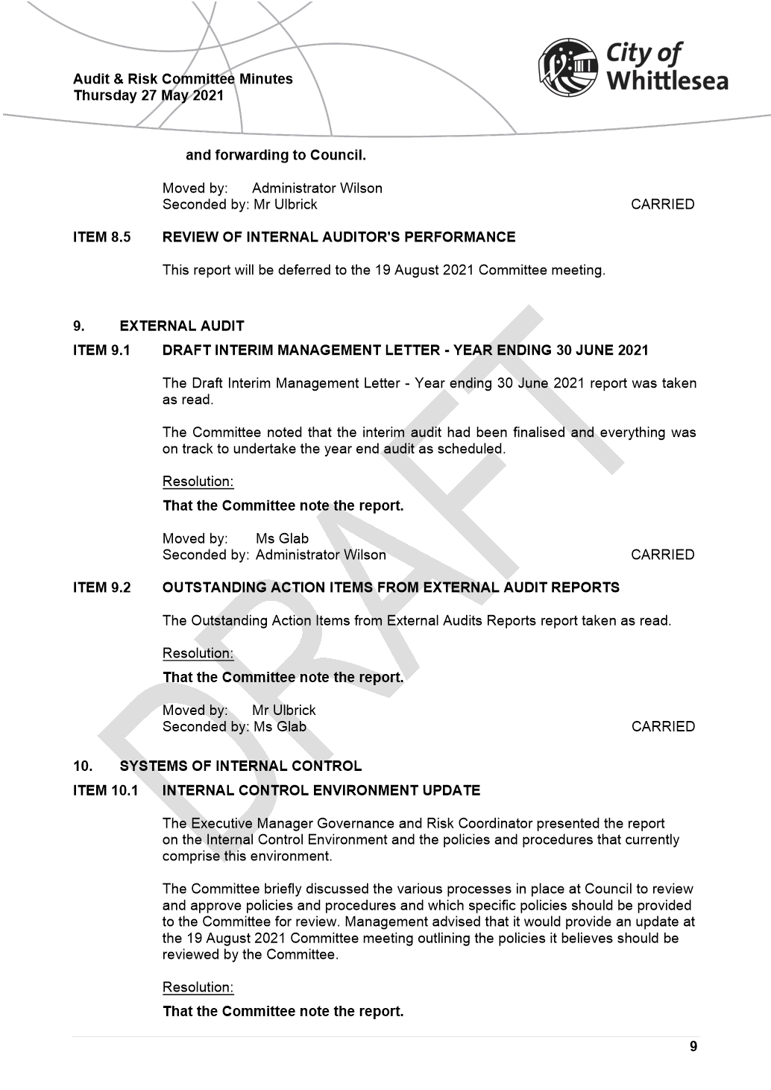

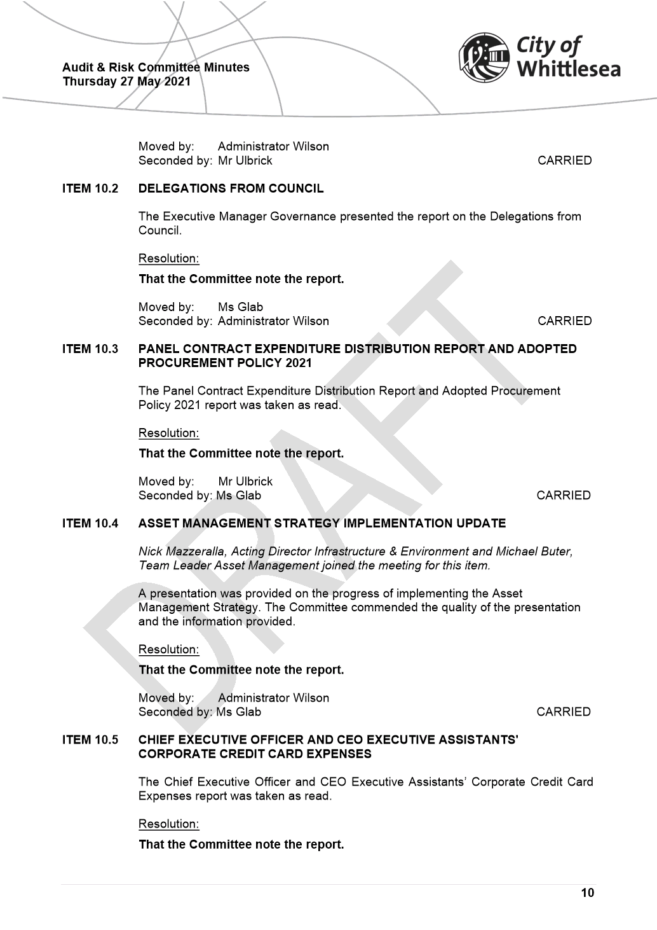

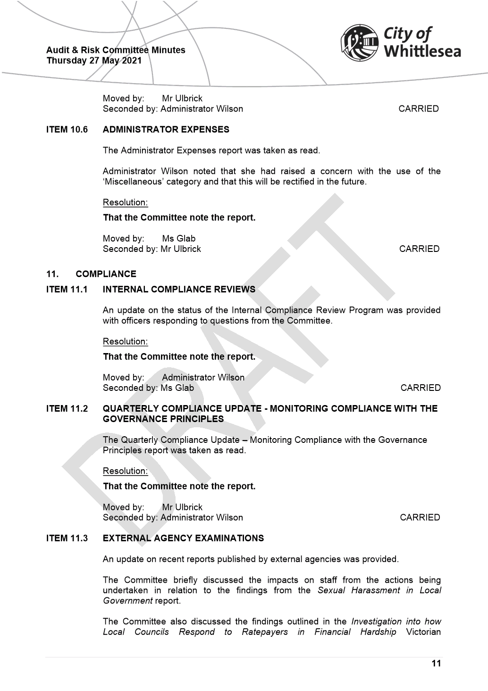

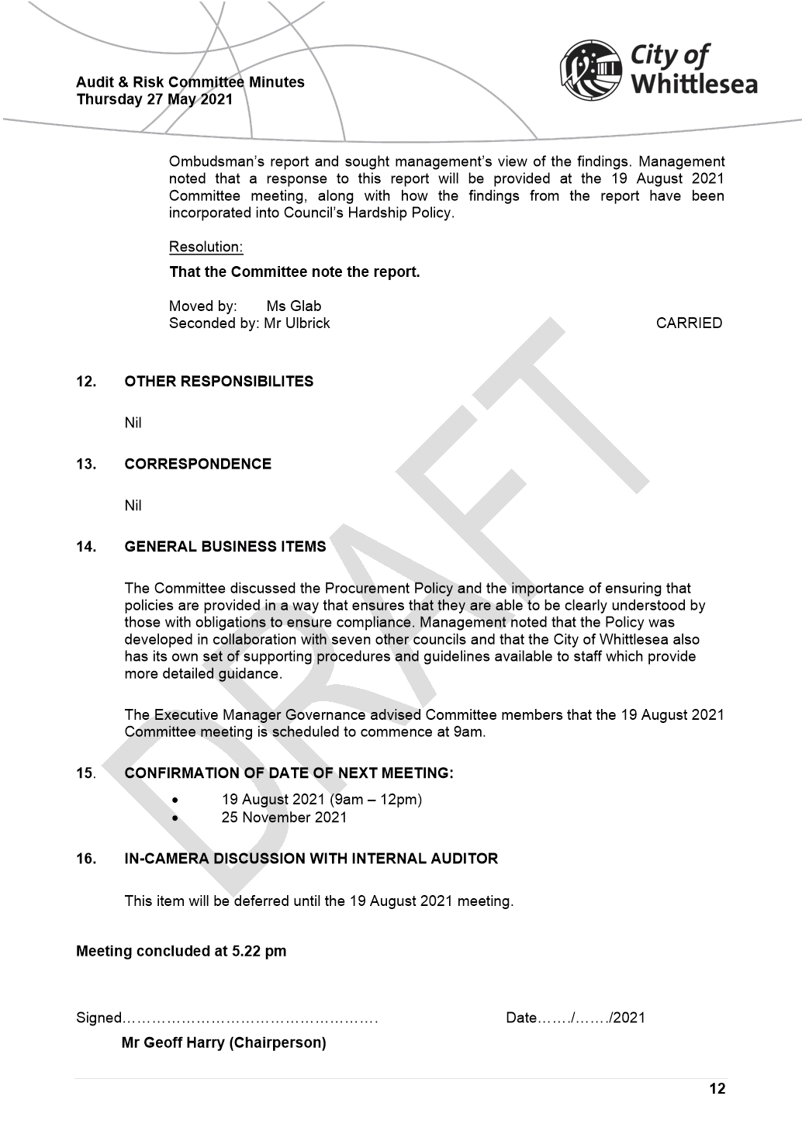

ITEM 6.5.2 For Decision: Financial Hardship Policy
Attachments: 1 Draft Financial Hardship Policy
2 Covid 19 Financial Hardship Policy
Responsible Officer: Director Corporate Services
Author: Director Corporate Services

RECOMMENDATION SUMMARY
1. Adopt the updated Financial Hardship Policy with application from 1 October 2021 (Attachment 1).
2. Extend the current COVID-19 Hardship Policy, including the suspension of interest charges, to 30 September 2021 (Attachment 2).
Brief overview
The existing COVID-19 Hardship Policy is due to expire 30 June 2021. An updated Hardship Policy has been drafted with the intent of responding to those experiencing hardship in an empathetic manner while also making the process less cumbersome for our customers.
rationale for recommendation
The City of Whittlesea is committed to providing assistance to those in our community that are experiencing financial hardship and are having difficulty meeting their financial obligations to Council. This policy ensures that regardless of their circumstances our community will face no judgement, and will be treated with understanding, dignity and respect. Financial hardship assistance will help reduce additional penalties and costs that are being incurred by those in the community that can least afford them. Council is committed to continual improvement through our learning, working with our partners and experts in the field of financial vulnerability.
impacts of recommendation
The new Hardship Policy will provide assistance to those in our community that are experiencing financial hardship and are having difficulty meeting their financial obligations to Council. This policy ensures that regardless of their circumstances our community will face no judgement, and will be treated with understanding, dignity and respect.
what measures will be put in place to manage impacts
Council will recruit a Hardship Support Officer to support the implementation of the policy and to provide the community with a dedicated trained professional to support them through the hardship application process. Supporting procedures and appropriate delegations will be developed prior to the 1 October 2021 implementation date of the new Financial Hardship policy.

Report
Background
The City of Whittlesea is committed to providing assistance to those in our community that are experiencing financial hardship and are having difficulty meeting their financial obligations to Council. This policy ensures that regardless of their circumstances our community will face no judgement, and will be treated with understanding, dignity and respect. Financial hardship assistance will help reduce additional penalties and costs that are being incurred by those in the community that can least afford them. Council is committed to continual improvement through our learning, working with our partners and experts in the field of financial vulnerability.
Council has an existing Rates Hardship Policy which only applies to our community members who are experiencing difficulty in paying their council rates. In April 2020, as a response to the COVID-19 pandemic (pandemic), Council adopted a COVID-19 Hardship Policy. This policy simplified the hardship application process along with expanding the financial support to all financial obligations to Council rather than just rates debts. This policy expires on 30 June 2021.
Financial hardship is a key focus area in the Health and Wellbeing Partnership Plan as limited income and access to economic resources are one of the fundamental causes of negative health and wellbeing outcomes. These factors determine access to material goods and services, ability to pay for health-related expenses, housing, education and capacity to choose healthy lifestyle behaviours and participate in the community. Prior to the pandemic Whittlesea already had high levels of disadvantage:
• City of Whittlesea ranked as the 36th most disadvantaged municipality out of the 79 Victorian local government areas in Victoria. Thomastown (ranked as 68/2,672 Victorian suburbs) and Lalor (ranked as 93/2,672 Victorian suburbs), are among the most socioeconomically disadvantaged suburbs in Victoria.
• A greater number of City of Whittlesea residents live in poverty compared to Greater Melbourne (17% compared to 12.6%). Women, children and young people are more likely to experience poverty and in Thomastown, 40% of children are living in poverty.
This has been further exacerbated by increasing unemployment and under-employment from the pandemic. Impacts of the pandemic included;
• Whittlesea recorded a higher number of job losses than for Victoria (-5.8% compared to -5.2%)
• Prior to COVID 19, households in Whittlesea reported experiencing high rates of mortgage (20.3%) and rental stress (33.8%) compared to Greater Melbourne (15.6% and 30% respectively)
• New postcode modelling indicates where the financial impact of the pandemic was categorised as ‘medium’, the impact is now categorised as ‘high’ to ‘extreme’ range
• Residents also report low levels of savings prior to COVID 19, and 1 in 4 residents identify that they would be unable to access $2000 in an emergency (Community Attitudes and Liveability Survey, 2018)
Council developed a Financial Vulnerability Advocacy and Action Plan which involved consultation with key local community health and welfare agencies including Whittlesea Community Futures Partnership, Whittlesea Community Connections and Uniting Kildonan.
Key themes and feedback received regarding financial hardship included;
• Maintain dignity and privacy – it is difficult to identify yourself as a person facing financial hardship and unable to cover daily living expenses etc. Council policy, procedures and staff interactions need to reflect this
• Ideally, reduce the number of staff the resident needs to interact and limit (where possible) the need to explain the situation multiple times
• Assistance should be made available to all Council payments, proportionate to the level of need and outstanding costs
• Policy and procedures need to be clear, easy to understand and easily accessible
• All information regarding financial hardship support should be made available across Council media avenues and included on rates information and notices
• Actively support referrals to other local welfare and community organisations where appropriate
• Explore training opportunities for staff to undertake sensitivity training related to financial hardship.
The recently released Victorian Ombudsman report ‘Investigation into how local councils respond to ratepayers in financial hardship’ (the report) highlighted the lack of support that local councils provided customers who are facing financial hardship. In the report the Ombudsman stated ‘The public sector is expected to act in the public interest more than the private sector – but in dealing with hardship, local councils lag behind utility and other companies, including banks. We would be rightly concerned if our bank was doing more to meet its social obligations than our council’. The report further provided recommendations as to what a good approach to hardship looked like.
A recent Local Government Inspectorate report into the Yarriambiack Shire Council stated ‘Council rates are a necessary impost on the community to help fund services and asset purchase and renewal. It is important that councils apply an equitable imposition of rates and charges across the municipality. Failure to recover outstanding rates means it fails this objective and provides a disadvantage to ratepayers’.
As a result of the emerging evidence on the impacts of COVID-19, consultation with community organisations, and the Victorian Ombudsmen report, Council recognises that it needs a hardship policy which supports all our community, is responsive to their personal needs, tailors the application process commensurate with the assistance being requested and ensures that the support provided provides for equitable collection of rates across the municipality. All the aforementioned evidence and information was considered in the drafting of the updated Financial Hardship Policy.
Proposal
It is proposed that council adopt the updated Financial Hardship Policy and support the recruitment of a Hardship Support Officer to support the implementation of the policy and to provide our community with a dedicated trained professional to support them through the hardship application process.
Consultation
Council developed a Financial Vulnerability Advocacy and Action Plan which involved consultation with key local community health and welfare agencies including Whittlesea Community Futures Partnership, Whittlesea Community Connections and Uniting Kildonan. All recommendations identified through this consultation have been included in the updated Financial Hardship Policy.
Consultation, subsequent to the drafting of this policy, has been undertaken with officers from the Rates, Health Planning and Equity and Inclusion teams.
Critical Dates
Council’s COVID-19 Hardship Policy ends on 30 June 2021, at which time Council’s Rates Harship Policy will apply. The Rates Harship Policy only applies to our community members who are experiencing difficulty in paying their council rates which means that any community members requiring support with any other amounts owing to council will not have a current avenue for support. The COVID-19 Hardship Policy allows our community to request assistance with all amounts owing to Council and by extending this policy, whilst preparing for the application of the updated Financial Hardship Policy, we will ensure that our community has this continued broader support.
Financial Implications
$104,000 of resourcing is required to recruit a Hardship Support Officer to implement the updated Hardship Policy and support customers through the application process by providing a much improved personalised service. Currently Council outsources it’s debt collection, with these costs being oncharged to the ratepayer. The Harship Support Officer will also undertake debt collection processes with the aim of collecting Council’s outstanding debt while reducing penalties and costs being incurred by the community.
Policy strategy and legislation
A number of sources were considered in the drafting of this policy including;
• Local Government Act 2020
• Council Revenue and Rating Plan
• Municipal Association of Victoria, Hardship Policy Guidelines (November 2013)
• Whittlesea 2040 A place for all
• Financial Vulnerability Advocacy and Action Plan 2020-22
• Health and Wellbeing Partnership Plan 2017-21
• Equal and Safe Strategy Action Plan 2020-2021
link to strategic risks
Strategic Risk Not linked to the risks within the Strategic Risk Register.

Links to whittlesea 2040 and the CoUNCIL Plan
Goal Connected community
Key Direction A healthy and safe community

Declarations of Conflicts of Interest
Under Section 130 of the Local Government Act 2020 and Rule 47 of the Governance Rules 2021, officers providing advice to Council are required to disclose any conflict of interest they have in a matter and explain the nature of the conflict.
The Responsible Officer reviewing this report, having made enquiries with relevant members of staff, reports that no disclosable interests have been raised in relation to this report.
Conclusion
This policy will support those most vulnerable in our community and ensure that they are treated with understanding, dignity and respect when facing financial hardship. Their circumstances will be kept confidential and they will be provided tailored support commensurate with their individual needs.

RECOMMENDATION
THAT Council resolve to:
1. Adopt the updated Financial Hardship Policy with application from 1 October 2021.
2. Extend the current COVID-19 Hardship Policy, including the suspension of interest charges, to 30 September 2021.
UnCouncil Resolution
Moved: Chairperson Wilson
Seconded: Administrator Duncan

THAT Council resolve to adopt the Recommendation.
Carried UNANIMOUSLY

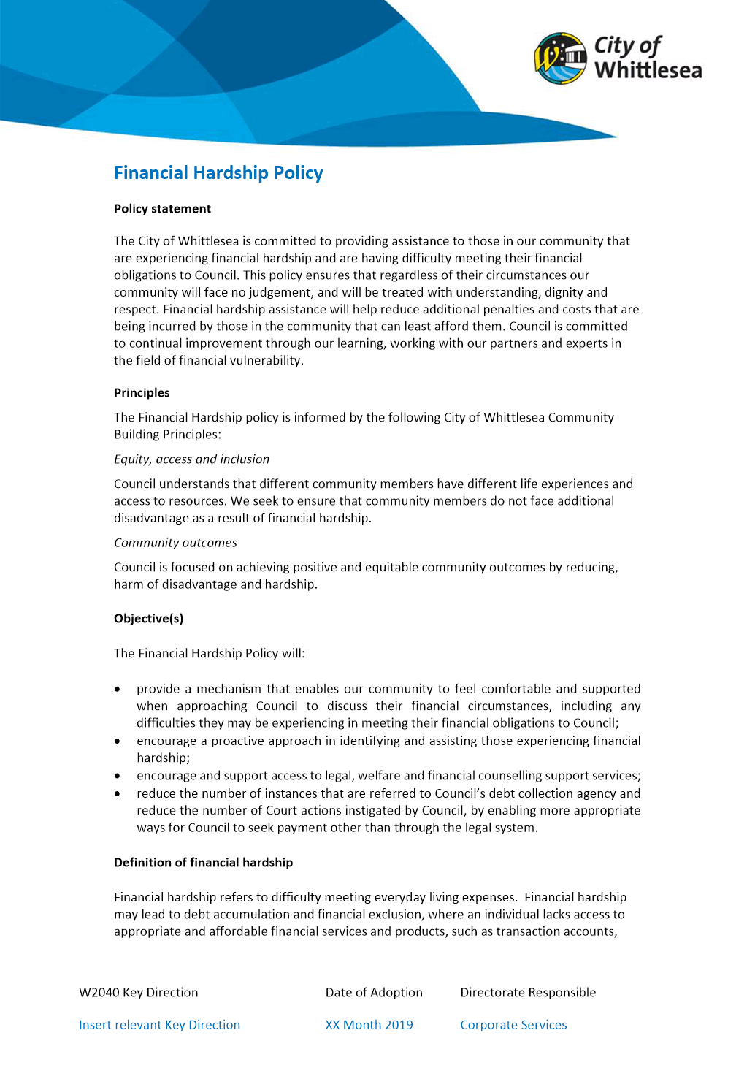

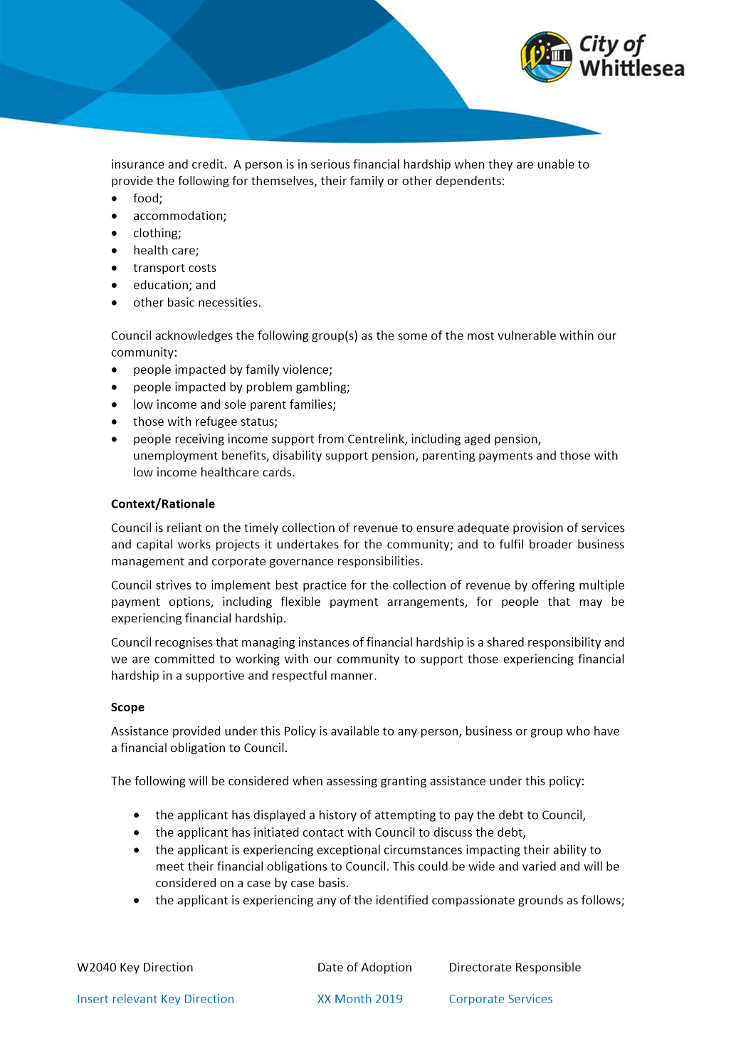

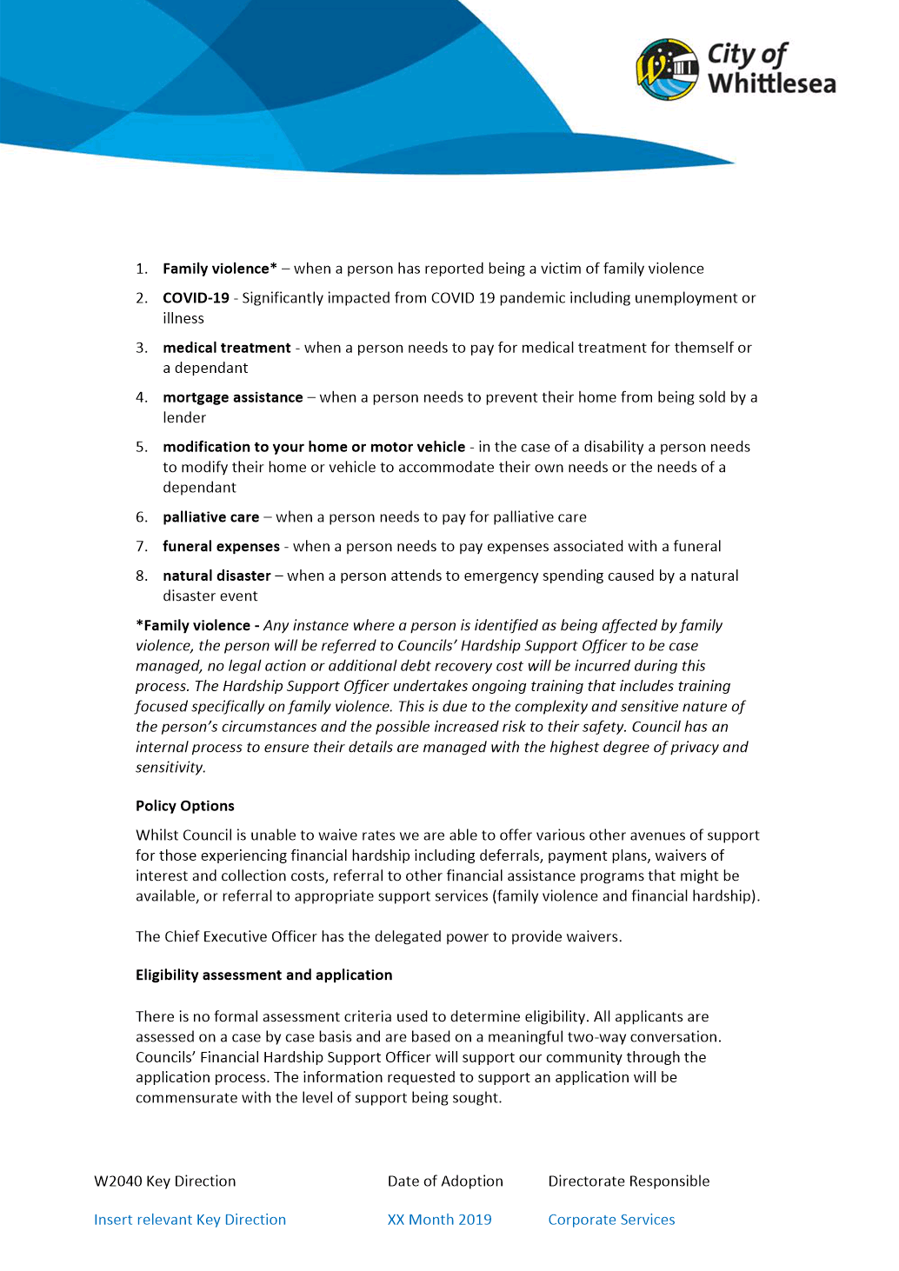

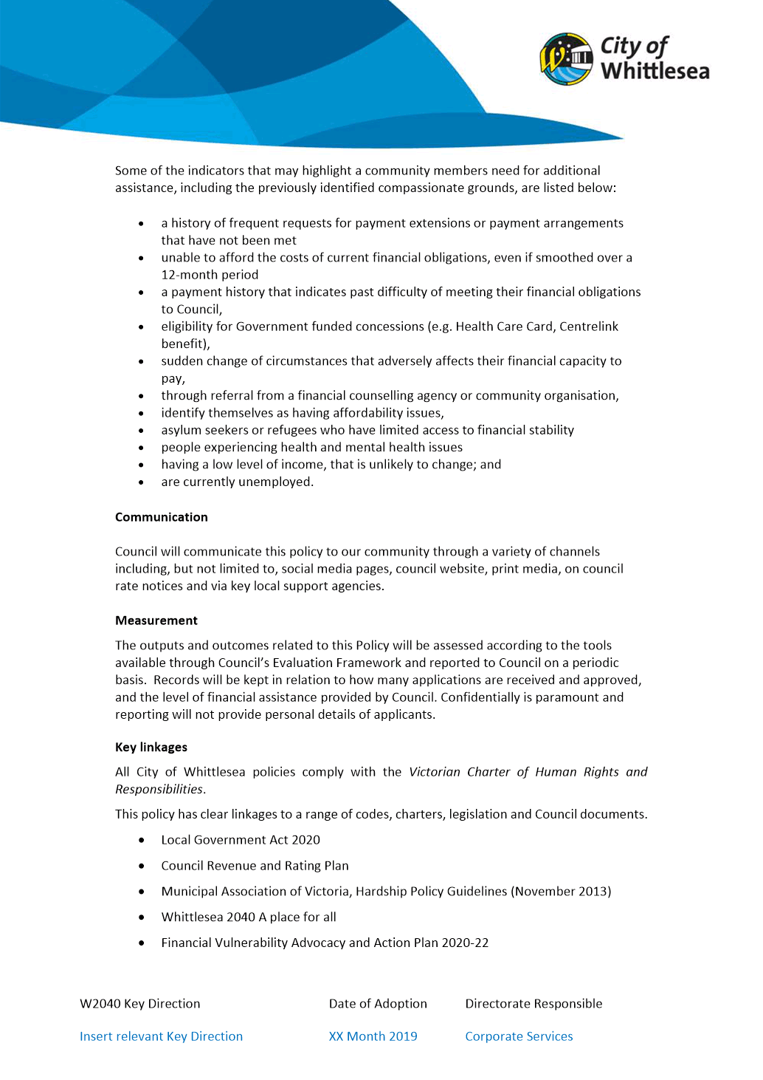

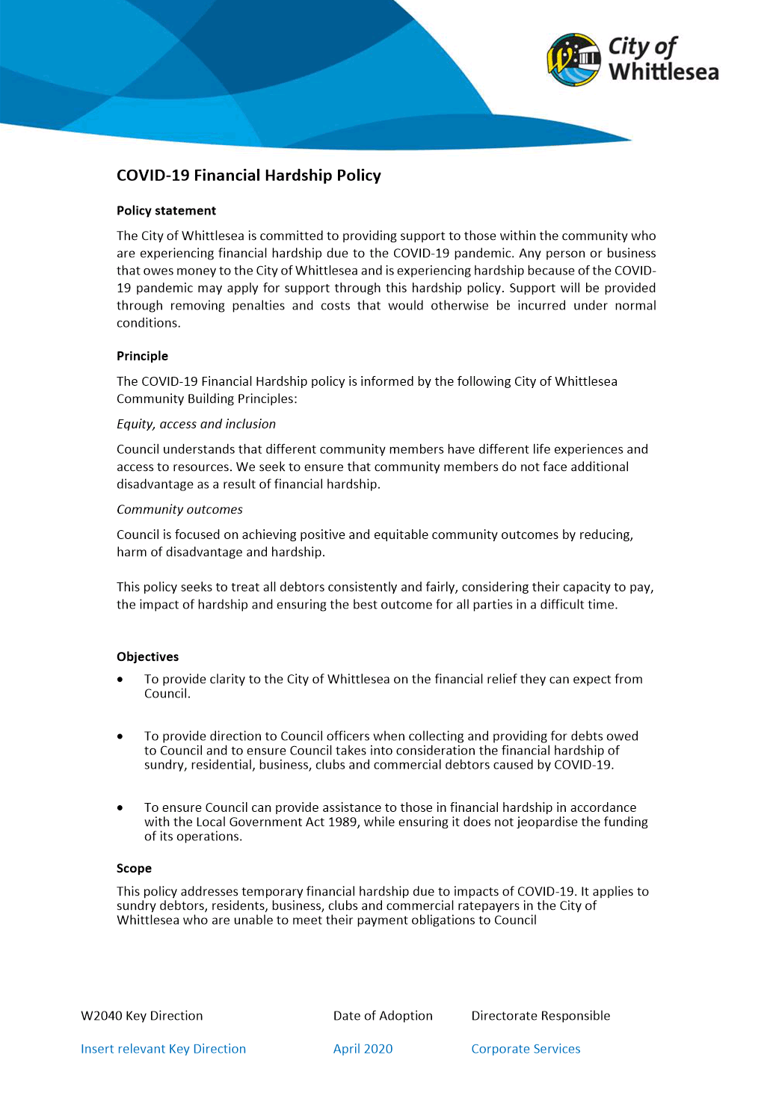

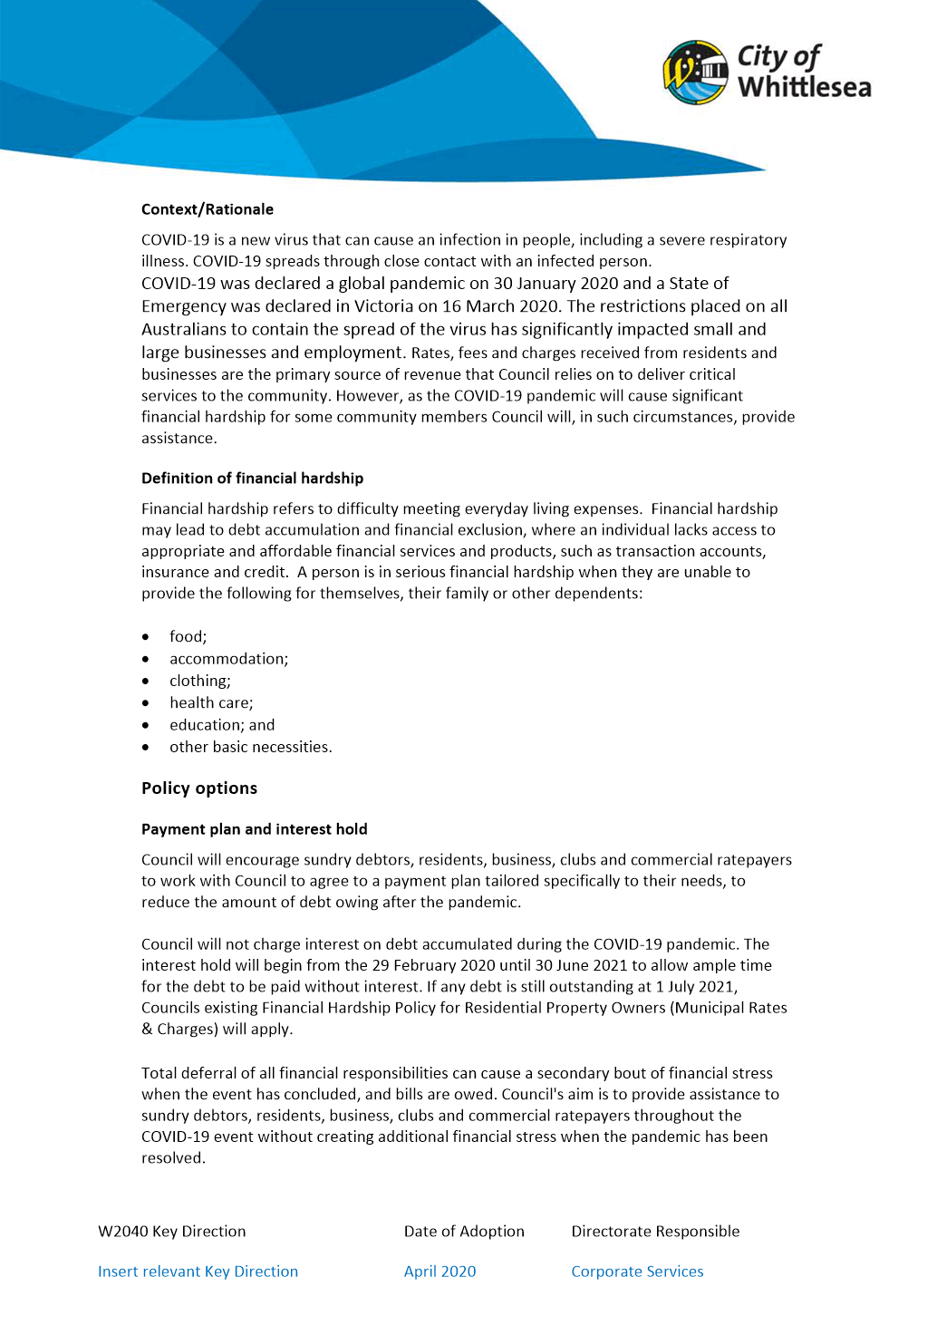

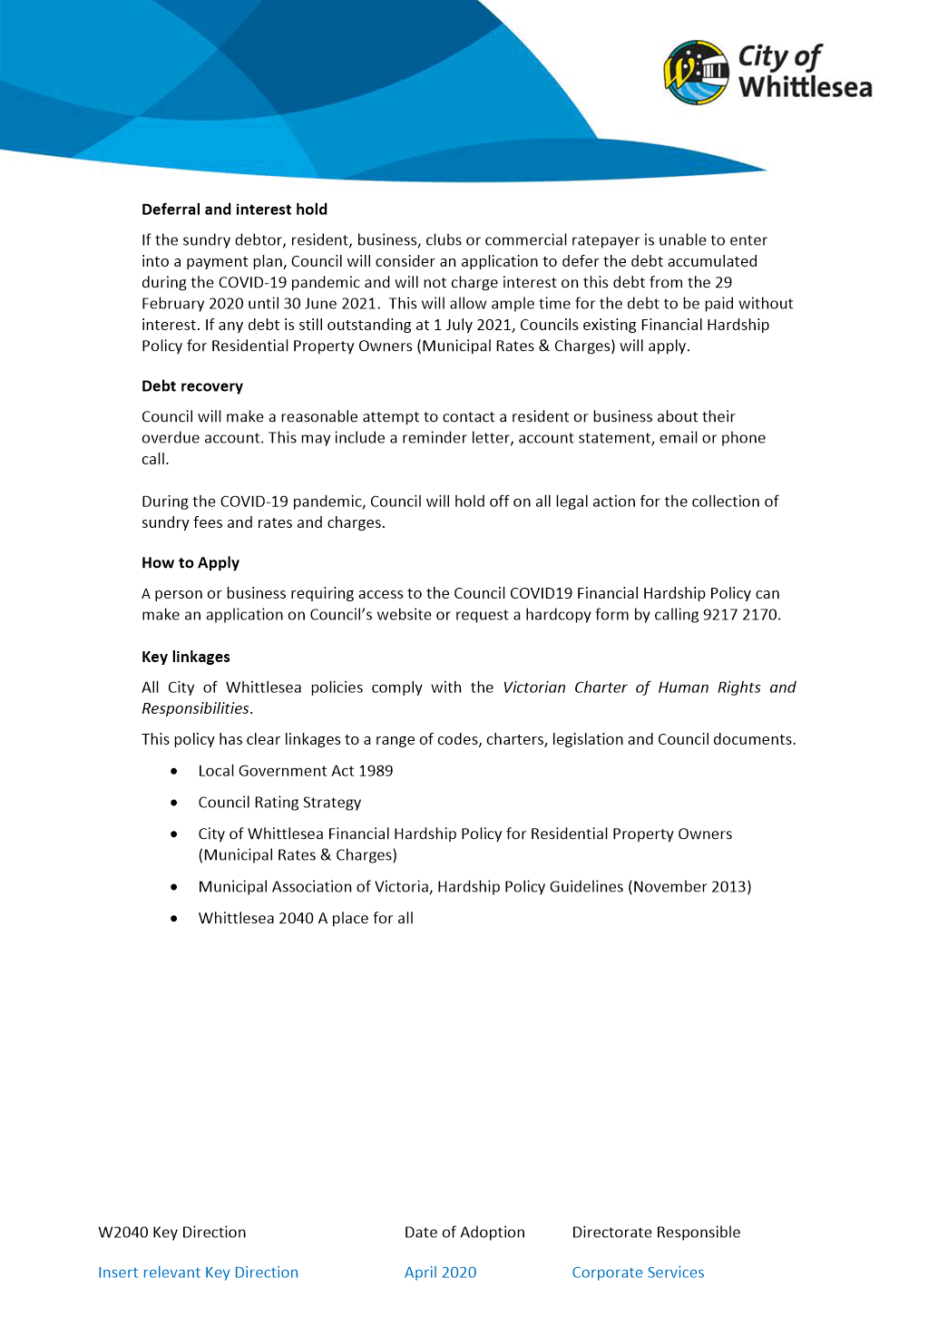

7. Notices of Motion
NIL

8. Questions to Officers
NIL

9. Urgent Business
NIL

10. Reports Council REPRESENTATIVES AND CEO UPDATE
10.1 ADMINISTRATOR PEITA DUNCAN REPORT
Administrator Duncan’s report was provided verbally at the 5 July 2021 Council meeting, the report is as follows:
“Just two items I really wanted to note, I attended the community grants online celebration, which was fantastic, so well done to council officers and everybody involved in putting that event together. It was quite good fun. And also, the reconciliation group meeting, Whittlesea Reconciliation Group meeting was held again. So I attended that and it was very productive and well worthwhile, as it always is, I must say, and I think we're really starting to get some traction there, and mutual understanding and outcomes.”

10.2 ADMINISTRATOR CHRIS EDDY REPORT
Administrator Eddy’s report was provided verbally at the 5 July 2021 Council meeting, the report is as follows:
“Since the last meeting, we obviously had a period of time where there were not many events. We have started to return to a more normal way of operating, and one of the highlights for me was representing the council last week at the turning of the sod for the new Mernda town centre, along with the local member, Danielle Green, who spoke very eloquently about the development in the area that is planned. That was a highlight. Really looking forward to seeing that project take shape. I have to mention the Audit and Risk Committee that I have attended as an observer. Other than that, looking forward to getting back into the thick of things as we return to something that looks a little bit like normal in the weeks ahead.”
10.3 CHAIR OF COUNCIL LYDIA WILSON REPORT
Chairperson Wilson’s report was provided verbally at the 5 July 2021 Council meeting, the report is as follows:
“I would like to make a brief report. I also attended the Audit and Risk Committee over the last months, I have participated with the Interface Council Group, also had a board meeting of Whittlesea Community Connections, participated with the Northern Councils Alliance and also as chair of the Yarra Plenty regional library board, we had a board meeting during the last month. But also, we have been very busy, mostly alongside the Chief Executive Officer, with a number of meetings with local members of Parliament. We had a joint meeting with Colin Brooks MP, Bronwyn Halfpenny MP and Danielle Green MP, in relation to the Investment Attraction Strategy. We had a meeting with Tania Maxwell MP regarding the inquiry into homelessness in Victoria, and then we had a meeting with Cindy McLeish MP in relation to a regional tourism arrangements. I also participated in the COVID-19 Community Recovery Fund Budgeting Group, which we resolved on that particular item earlier this evening, which was most informative. We had a meeting with Hope Street Youth in relation to the first response youth service. A meeting with Danielle Green MP alongside representatives from the City of Nillumbik. All Administrators participated with the community yarn, alongside the CEO and other council officers and as I indicated earlier, I participated in the launch of the financial wellbeing booklet with Whittlesea Community Connections last Friday.”

10.4 For Noting - CEO Update - 5 July 2021
Responsible Officer: Chief Executive Officer
Author: Chief Executive Officer

The CEO Update was provided verbally by the Chief Executive Officer at the 5 July 2021 Council meeting, the report is as follows:
“June was another big month for our community, and council, as we both supported each other through the period of COVID disruption. I would like to thank our staff who undertook 75,00 face-to-face meetings with businesses throughout our shopping precincts and thank you to our partners at the Department of Health, Victoria Police and WorkSafe in supporting that. It is a significant effort on top of people's normal work holds. Also thank you to the officers who were redeployed into COVID cleansing throughout that time too.
Council made an important decision to support the public health of our community by hosting a mass vaccination hub at PRACC next door here. It is now operated by Northern Health and is currently operating seven days a week and we thank them for the work that they are doing and have reached their 50 thousand vaccine last week at that centre which is quite an effort on behalf of our community.
Our highly anticipated $25 million redevelopment of the Mill Park leisure centre is complete, with the aquatics area opening last Friday. It is pleasing to see that memberships have now passed 2,500 and more than 1,800 learn-to-swim enrolments have already been achieved. We are planning a community opening day next month and that will be advertised quite widely very soon.
In addition to NAIDOC Week, which the Chair has already touched on.
This week is also Youth Week so a number of activities are under way as part of that week:
- Our youth team is holding a tree planting tomorrow,
- On Wednesday, there is a screening of the movie Cruella at the Village Cinema. There is still a couple of seats left for that if people are interested.
It's good to see community events coming back to life. This coming Saturday, the Church Street Whittlesea will be the focus of our winter weekend series there are activities, crafts, face painting and live music from 10am and the farmers market is also back again on the 17th of July at the council offices here.
Finally, I touched on this briefly earlier on, I would like to thank three of our staff, Neville Kurth, who has been deployed off to the Yarra Ranges to assist the council there in a crisis team capacity; also to Rochelle Maile and Spiros Kynigopoulos. They have spent two weeks assisting Latrobe City Council in the really affected area of Traralgon. They are both environmental health officers and they have been out in the field working with local emergency services and staff to help them with this recoveries.”

11. Confidential Business
11.1 Connected Communities
Nil Reports
11.2 Liveable Neighbourhoods
Nil Reports
11.3 Strong Local Economy
Nil Reports
11.4 Sustainable Environment
Nil Reports
11.5 High Performing Organisation
11.5.1 For Decision - Financial Reserves Review & Policy Development
11.6 Notices of Motion
Nil Reports

Council Resolution
Moved: Administrator Eddy
Seconded: Administrator Duncan

THAT Council resolve that the meeting be closed to the public for the purpose of considering details relating to the following confidential matters in accordance with Section 66(2)(a) of the Local Government Act 2020 on the grounds that the report contains as follows:
11.5.1 For Decision - Financial Reserves Review & Policy Development
This report is presented to Council as a confidential document on the grounds that it contains:

● Council business information, being information that would prejudice the Council's position in commercial negotiations if prematurely released.
In particular the report/attachment contains information regarding Council's strategies for future investment which if publicly disclosed may bring unreasonable prejudice against Council.
Carried

12. Closure

ACCORDINGLY, THE MEETING WAS CLOSED TO THE PUBLIC AT 8.45PM.
CONFIRMED THIS 2ND DAY OF AUGUST 2021.

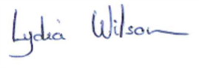
___________________________
LYDIA WILSON
CHAIR OF COUNCIL

Emergency Management Victoria (2019) Resilient Recovery Strategy
Emergency Management Victoria (2019) Resilient Recovery Strategy
Emergency Management Victoria (2019) Resilient Recovery Strategy

