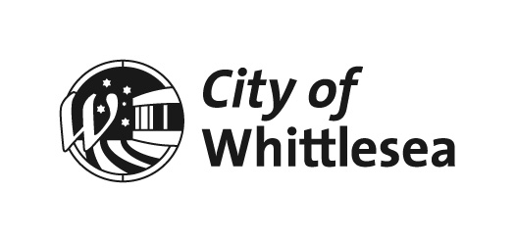
Minutes

OF Scheduled
COUNCIL MEETING
HELD ON
Monday 4 October 2021
AT 6.30pm
meeting held remotely
via zoom

ADMINISTRATORS

LYDIA WILSON CHAIR OF COUNCIL
PEITA DUNCAN ADMINISTRATOR
CHRIS EDDY ADMINISTRATOR
On 19 June 2020 the Acting Minister for Local Government appointed the Panel of Administrators for the City of Whittlesea and appointed Lydia Wilson as Chair of the Panel. The Panel of Administrators comprises of Ms Lydia Wilson, the Honourable Bruce Billson and Ms Peita Duncan. On 3 March 2021, the Hon. Bruce Billson resigned from his position as Administrator with the City of Whittlesea. Effective from 12 May 2021, the Minister for Local Government appointed Mr Chris Eddy as the third Panel Member. Ms Lydia Wilson, Ms Peita Duncan and Mr Chris Eddy will undertake the duties of the Council of the City of Whittlesea until the October 2024 Local Government Election.

SENIOR OFFICERS

CRAIG LLOYD CHIEF EXECUTIVE OFFICER
FRANK JOYCE EXECUTIVE MANAGER GOVERNANCE & STRATEGY
KATE MCCAUGHEY DIRECTOR COMMUNITY WELLBEING
AMY MONTALTI DIRECTOR CORPORATE SERVICES
JANINE MORGAN EXECUTIVE MANAGER PUBLIC AFFAIRS
JUSTIN O’MEARA DIRECTOR PLANNING & DEVELOPMENT
DEBBIE WOOD DIRECTOR INFRASTRUCTURE & ENVIRONMENT

ORDER OF BUSINESS

The Chief Executive Officer submitted the following business:

1. Opening 9
1.1 MEETING OPENING & INTRODUCTIONS 9
1.2 PRAYER BY THE CHIEF EXECUTIVE OFFICER 9
1.3 ACKNOWLEDGMENT OF TRADITIONAL OWNERS STATEMENT 9
1.4 Present 9
1.5 PANDEMIC UPDATE 10
1.6 Whittlesea team participates in Victorian Youth Parliament 11
1.7 International Day of Older Persons 11
2. Apologies 12
3. Declarations of Interest 12
4. Confirmation of Minutes of Previous Meeting 12
5. Questions, Petitions and Joint Letters 13
5.1 public Question Time 13
5.2 Petitions 13
5.2.1 Petition – Removal of Eucalyptus Trees in Woodstock Drive and Shetland Way Doreen 13
5.3 Joint Letters 13
6. Officers’ Reports 15
6.1 Connected Communities 15
6.1.1 Annual Report 2020-2021 15
6.1.2 Update on Council's Disability Action Plan 2017-21:Outstanding actions 195
6.1.3 Instrument of Appointment and Authorisation for Planning Enforcement Officer 203
6.2 Liveable Neighbourhoods 209
6.2.1 Reconstruction of Arthurs Creek Road from Plenty Road to Recreation Road, Contract 2021-42 Tender Evaluation Report 209
6.2.2 PROPOSED PLANNING SCHEME AMENDMENT: 2000 DONNYBROOK RD, YAN YEAN ROAD 215
6.2.3 PLANNING SCHEME AMENDMENT C226 – SIGNS LOCAL POLICY - EXHIBITION OUTCOMES AND ADOPTION 231
6.3 Strong Local Economy 247
6.3.1 Business Advisory Panel membership 247
6.4 Sustainable Environment 253
6.4.1 Joint Letter - Gum Tree Removal Request - Flaxen Hills Road, Doreen 253
6.5 High Performing Organisation 259
6.5.1 17-19 Johnsons Road, Mernda - Sale of Council Land 259
6.5.2 Administrator Action Plan - 6 month update 297
6.5.3 Audit & Risk Committee Matters 337
6.5.4 2021/22 Growing Suburbs Fund - Project Applications 351
6.5.5 Contract 2019-71 Extension - Temporary Agency Staff Management 369
7. Notices of Motion 375
Nil Reports 375
8. Questions to Officers 375
9. Urgent Business 375
10. Reports from Council representatives and ceo update 377
10.1 Administrator Peita Duncan Report 377
10.2 Administrator Chris Eddy Report 377
10.3 Chair of Council Lydia Wilson Report 377
10.4 CEO Update - 4 October 2021 378
11. Confidential Business 381
11.1 Connected Communities 381
Nil Reports 381
11.2 Liveable Neighbourhoods 381
11.2.1 Compulsory Land Acquisition 381
11.3 Strong Local Economy 381
Nil Reports 381
11.4 Sustainable Environment 381
Nil Reports 381
11.5 High Performing Organisation 381
Nil Reports 381
11.6 Notices of Motion 381
Nil Reports 381
12. Closure 382

Note:
In these Minutes, Resolutions adopted by Council are indicated in bold text.

1. Opening
1.1 MEETING OPENING & INTRODUCTIONS
The Chair of Council, Lydia Wilson opened the meeting at 6:30PM.
“Welcome to this Council Meeting of 4 October 2021 which is being livestreamed.
I am Lydia Wilson, Chair of the Panel of Administrators and I would also like to introduce my Panel colleagues, Administrators Ms Peita Duncan and Mr Chris Eddy.
I would also like to introduce our Chief Executive Officer, Mr Craig Lloyd and ask that he in turn introduce the members of the Executive Leadership Team in attendance today.”
“Good evening everyone, we also have with us:
Executive Manager Governance, Mr Frank Joyce;
Director Community Wellbeing, Ms Kate McCaughey;
Director Corporate Services, Ms Amy Montalti;
Director Planning & Development, Mr Justin O’Meara;
Executive Manager Public Affairs, Ms Janine Morgan; and
Director Infrastructure & Environment, Ms Debbie Wood.
These members of the Executive Leadership Team will join us during the meeting.”
1.2 PRAYER BY THE CHIEF EXECUTIVE OFFICER
Following the Introductions, the Chief Executive Officer read the following prayer:
Almighty God, we ask for your blessing upon this council to make informed and good decisions to benefit the people of the City of Whittlesea.
Our father who art in heaven, hallowed be thy name, Thy kingdom come, Thy will be done on earth as it is in heaven. Give us this day our daily bread and forgive us our trespasses as we forgive them that trespass against us; and lead us not into temptation but deliver us from evil, For thine is the kingdom, the power and the glory, for ever and ever.
Amen
1.3 ACKNOWLEDGMENT OF TRADITIONAL OWNERS STATEMENT
The Chair of Council, Lydia Wilson read the following statement:
“On behalf of the City of Whittlesea I recognise the rich Aboriginal heritage of this country and acknowledge the Wurundjeri Willum Clan as the Traditional Owners of this place.
I would also like to personally acknowledge Elders past, present and emerging.”
1.4 Present
Members:
Ms Lydia Wilson Chair of Council
Ms Peita Duncan Administrator
Mr Chris Eddy Administrator
Officers:
Mr Craig Lloyd Chief Executive Officer
Mr Frank Joyce Executive Manager Governance & Strategy
Ms Kate McCaughey Director Community Wellbeing
Ms Amy Montalti Director Corporate Services
Ms Janine Morgan Executive Manager Public Affairs
Mr Justin O’Meara Director Planning & Development
Ms Debbie Wood Director Infrastructure & Environment
Ms Samantha Boyle Unit Manager Governance & Risk
Ms Jane Maynard Strategic Planner
Mr Nick Robinson Strategic Planner
Ms Sarah Rowe Manager Economic Development
Mr Nick Mazzarella Manager Capital Delivery
Ms Caroline Lintott Manager Maintenance and Operations

1.5 PANDEMIC UPDATE
The Chair of Council, Lydia Wilson provided an update on the current pandemic before the commencement of formal business.
“If I could perhaps start off by just making a few comments in relation to the pandemic and particularly of relevance to the City of Whittlesea. As everyone would be only too well aware, COVID numbers in our local community continue to rise, but thankfully so to do the vaccination rates. We are really pleased about that.
As we move towards the Victorian government's roadmap to reopening, it has never been more important than ever to ensure that we are all vaccinated. Too many people in our community are in hospital and sadly a number of them have died and that includes a number of residents of the City of Whittlesea. So we want to urge you to make sure that you get your booking for your vaccination if you are eligible and have not done so through the Victorian Government State Vaccine Hub, which is that Plenty Ranges Arts and Convention Centre at the rear of the council officers. Or it is through your GP or through local pharmacies. Obviously there are details available on our own website and at Coronavirus.vic.gov.au.
Council is partnering with the Government, local health providers and community agencies to help our residents to find and book vaccine appointments, and we recently launched several booking booths to further support our community to ensure that they get vaccinated. And look out for those booths, which are at some of our local shopping precincts. We will be able to help you to book your vaccine, provide you with information and also transport support, if that is required. Our booths will also have multilingual staff on hand to help those who may need information and support in their own language. I would also like to thank all those in our community who have already received the vaccine and to be hundreds of people who have been in isolation and are staying home to play their part in supporting the local community. Each one of us as a really important job to play right now.
Finally I just wanted to send out a particular acknowledgement and recognition of Northern Health, and DPV health. To the many health professionals that operate across those organisations and are at the front line, whether it is doctors, nurses, allied health staff, paramedics and other support personnel, we have got a really huge debt of gratitude for those staff for helping us to keep safe and their huge amount of endeavour during the vaccination period. It is interesting to note that since the role out began in March Northern Health has provided over 200,000 vaccinations to our community, which is a really major milestone that we should all be so proud of. And the clinic is currently vaccinating approximately 1500 people per day. Again, just concluding on this, we must all do our bit and stay safe and healthy and look out for one another. Thank you.”
1.6 Whittlesea team participates in Victorian Youth Parliament
Administrator Peita Duncan acknowledged five participates from Whittlesea who participated the in Victorian Youth Parliament.
“I would like to acknowledge five of our young people from the City of Whittlesea that recently participated in the Victorian Youth Parliament. This happened during the recent school holidays, where our Youth Services team at council supported a group of local young people to participate in the annual Youth Parliament Program. The Youth Parliament is run by Victoria YMCA and it is an opportunity for young people aged 16 to 25 to have their voices heard at the highest levels of Government and in the State Government. These sorts of initiatives are part of Council’s broader support for community leadership and we were extremely proud of last week's youth participants who included and I think it is absolutely necessary that we name them: Monika Boceska, Jasmine Bullock, Victoria Warda, Anna Scott and Nina Fitzsimmons.
This team participated on behalf of the Council and sponsored the Improved Accessibility and Public Transport Bill which was overwhelmingly supported by the Youth Parliament in the Legislative Assembly and passed following the same procedures that the Victorian Government use to adopt Bills in Victoria. Improved Accessibility and Public Transport Bill is an act to improve access to trains, stations and services with particular attention to the barriers faced by people with disability. It is critically important, the work they have done here. The Bill also ensures regular maintenance of all train stations to facilitate safe and easy transport use across metro and rural train stations. Another really critical issue is to be safe when you are travelling around the state, whether it’s our own municipality or broader than that across Metropolitan Melbourne. Once again on behalf of the Administrators, congratulations to all of you for representing our community so well.”
1.7 International Day of Older Persons
The Chair of Council, Lydia Wilson made an acknowledgement regarding the International Day of Older Persons.
“Thank you Ms Duncan, and I would echo your congratulations to our Whittlesea team. Well done.
And just a further acknowledgement if I could and that is to recognise that Friday 1 October 2021 was the international Day of Older Persons. And obviously it is a day to celebrate older people and their contributions to the community and also to raise awareness of issues around ageing in today's world. And this year's theme is very topical. It is digital equity for all ages, and is obviously a focus on access and participation in the digital world by older persons. And obviously now, with the key theme during the pandemic, when so many of our services and social interactions are online. Just to reflect for a minute on our statistics, in 2021 and estimated 29,300 people aged 65 and over called the City of Whittlesea home, and that is 12% of our population. And by 2041 this is forecast to almost double to be 54,660 people. And that will be making up 14% of the population.
In Victoria the month of October is celebrated as the Victorian Seniors Festival and Council has organised an unbelievable suite of online programs, including a virtual high tea, which will be held on October 13. And we are really proud that in excess of 200 residents have already booked in for this event and further information is available via the council website. Ms Duncan and I will also be participating. And I note that it is not too late to book. You can book before October 6. And you would be receiving a high tea package that have been catered by local businesses. And they will be delivered to your door. So it is a wonderful initiative of our Whittlesea Positive Ageing team and congratulations to our staff and Peita and I really look forward to sharing and celebrating along some of our older residents.”

2. Apologies
Nil

3. Declarations of Interest
NIL

4. Confirmation of Minutes of Previous Meeting
Council Resolution
Moved: Administrator Eddy
Seconded: Administrator Duncan

THAT the following Minutes of the preceding meeting as circulated, be confirmed:
Scheduled Meeting of Council held 6 September 2021.
Carried

5. Questions, Petitions and Joint Letters
5.1 public Question Time
NIL

5.2 Petitions
5.2.1 Petition – Removal of Eucalyptus Trees in Woodstock Drive and Shetland Way Doreen
Chairperson Wilson tabled a petition from 12 residents requesting:
“We the residents of Woodstock Drive and Shetland Way, Doreen, wish to raise with the City of Whittlesea our serious concerns about the state of the trees lining both streets. We refer to Woodstock Drive east of Brookwood Avenue.
These now fully grown Ghost gum trees have been planted close together, with at least 2 or 3 outside each residence. The roots of these trees have caused significant damage and previous requests for Council action have proved fruitless. Over the past 12 months all Ghost gum trees in Woodstock Drive west of Brookwood have been removed by the Council. The only trees remaining (about 10% in total) in Woodstock Drive are east of Brookwood Avenue.
We respectfully request that the remaining trees in Woodstock Drive and Shetland Way be removed as a matter of urgency to prevent further damage to our homes. It is evident that residents in both streets take pride in their homes and they are a well maintained.
It would be appreciated if our concerns are considered as a matter of urgency to prevent further damage and costs to residents.”

Council Resolution
Moved: Chairperson Wilson
Seconded: Administrator Duncan

THAT Council note the petition and that a final report will be presented to Council at its meeting of the 8 November 2021.

Carried

5.3 Joint Letters
NIL

6. Officers’ Reports
6.1 Connected Communities
ITEM 6.1.1 Annual Report 2020-2021
Attachments: 1 Annual Report 2020-21
Responsible Officer: Chair of Council
Author: Executive Manager Public Affairs

RECOMMENDATION SUMMARY
That Council resolve to receive and note the 2020-2021 Annual Report in accordance with section 100(1) of the of the Local Government Act 2020.
Brief overview
The 2020-21 Annual Report has been developed to provide an overview of Council’s performance in the 2020-21 financial year including the implementation of the Council Plan.
rationale for recommendation
The 2020-21 Annual Report has been developed to meet legislative requirement of the Local Government Act 2020.
impacts of recommendation
Council’s acceptance of the 2020-21 Annual Report will ensure we meet our legislative reporting requirements under the Local Government Act 2020.
what measures will be put in place to manage impacts
Finalisation of the report in accordance with legislative requirements ensures no measures are required as Council will be compliant.

Report
Introduction
The 2020-21 Annual Report has been developed to provide an overview of Council’s performance for the 2020-2021 financial year.
Background
Council’s performance for the 2020-2021 Annual Report has been reported against each Council goal to demonstrate how Council is performing in achieving the 2017-2021 Council Plan. Performance has been measured as follows:
• results achieved in relation to the strategic indicators in the Council Plan
• progress in relation to the major initiatives identified in the 2020-2021 Annual Budget
• services funded in the Budget and the persons or sections of the community who provided those services
• results against the prescribed service performance indicators and measures.
Highlights include:
• our organisation’s response to the COVID-19 pandemic which included support and relief for our community, staff redeployment and the transition to working from home for the majority of our workforce
• $54 million on our New Works Program, which included more than 133 projects to build and upgrade community centres, sporting fields, tennis courts, playgrounds, roads, bike paths and footpaths across our municipality
• completion of the $25 million redevelopment of Mill Park Leisure, which includes a state-of-the-art gym, four pools, a spa and sauna, accessible change facilities and a new café
• introduction of an opt-in food and garden organics waste recycling service, resulting in a 16 per cent increase in the diversion of food and garden waste from landfill
• implemented a new online planning portal, allowing people to manage their planning applications from start to finish in the one location, as well as receive real-time application status updates, making it a quicker and easier process.
Proposal
It is recommended that Council receive and note the 2020-2021 Annual Report.
Consultation
The 2020-21 Annual Report will be available on Council’s website and hard copies will be made available at Council Offices and at the Yarra Plenty Regional Library branches of Lalor, Thomastown, Mill Park and Whittlesea once these facilities are open to the public.
Critical Dates
The Chair of Administrators must report on the implementation of the Council Plan by presenting the Annual Report to a Council Meeting open to the public within four months of the end of the financial year (S18d and S100 of the Local Government Act 2020). On 14 September 2021 the Acting Minister for Local Government provided a two-month extension to submit the Annual Report, however it has been determined that this extension is not required.
Financial Implications
The Annual Report was produced within approved budget allocations.
Policy strategy and legislation
Council is required to prepare the Annual Report including the Audited Performance Statement and Financial Statements in accordance with Section 98 of the Local Government Act 2020. A copy of the Annual Report will be forwarded to the Minister for Local Government in accordance with the Local Government (Planning and Reporting) Regulations 2014.
link to strategic risks
Strategic Risk Governance - Ineffective governance of Council’s operations and activities resulting in either a legislative or policy breach
The Annual Report is required under the Local Government Act 2020 and provides transparency and reporting to community on Council’s performance over 2020-21 including implementation of the Council Plan.
Links to whittlesea 2040 and the CoUNCIL Plan
Goal High-performing organisation
Key Direction Driving better community outcomes through improved service access, satisfaction and advocacy

The 2020-21 Annual Report has been developed to provide an overview of Council’s performance for the 2020-2021 financial year.
Declarations of Conflicts of Interest
Under Section 130 of the Local Government Act 2020 and Rule 47 of the Governance Rules 2021, officers providing advice to Council are required to disclose any conflict of interest they have in a matter and explain the nature of the conflict.
The Responsible Officer reviewing this report, having made enquiries with relevant members of staff, reports that no disclosable interests have been raised in relation to this report.
Conclusion
The City of Whittlesea 2020-2021 Annual Report is an integral part of Council’s commitment to open and accountable governance. It provides the community with an overview of Council’s performance and achievements during the 2020-2021 financial year in delivering against Council’s priorities set out in the 2017-2021 Council Plan and 2020-2021 Annual Budget. It also provides detailed financial statements relating to Council’s financial position.

RECOMMENDATION
THAT Council resolve to receive and note the 2020-21 Annual Report in accordance with Section 100(1) of the Local Government Act 2020.
Council Resolution
Moved: Chairperson Wilson
Seconded: Administrator Eddy

THAT Council resolve to adopt the Recommendation.
CarrieD unanimously

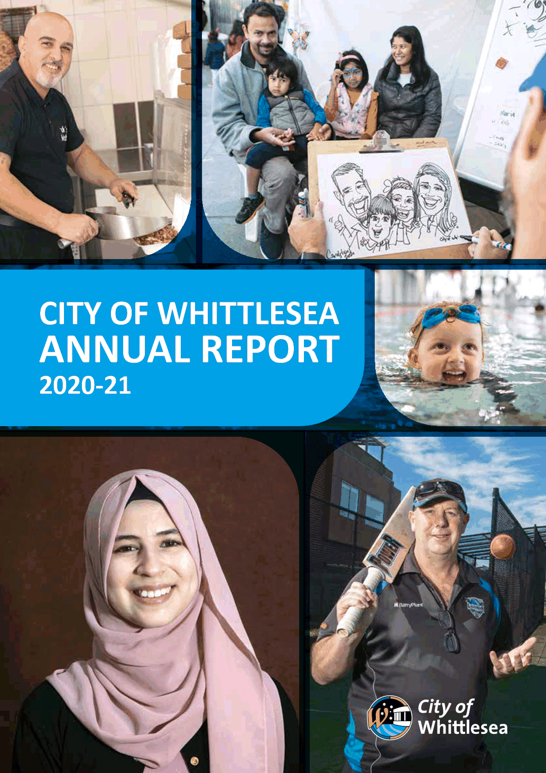

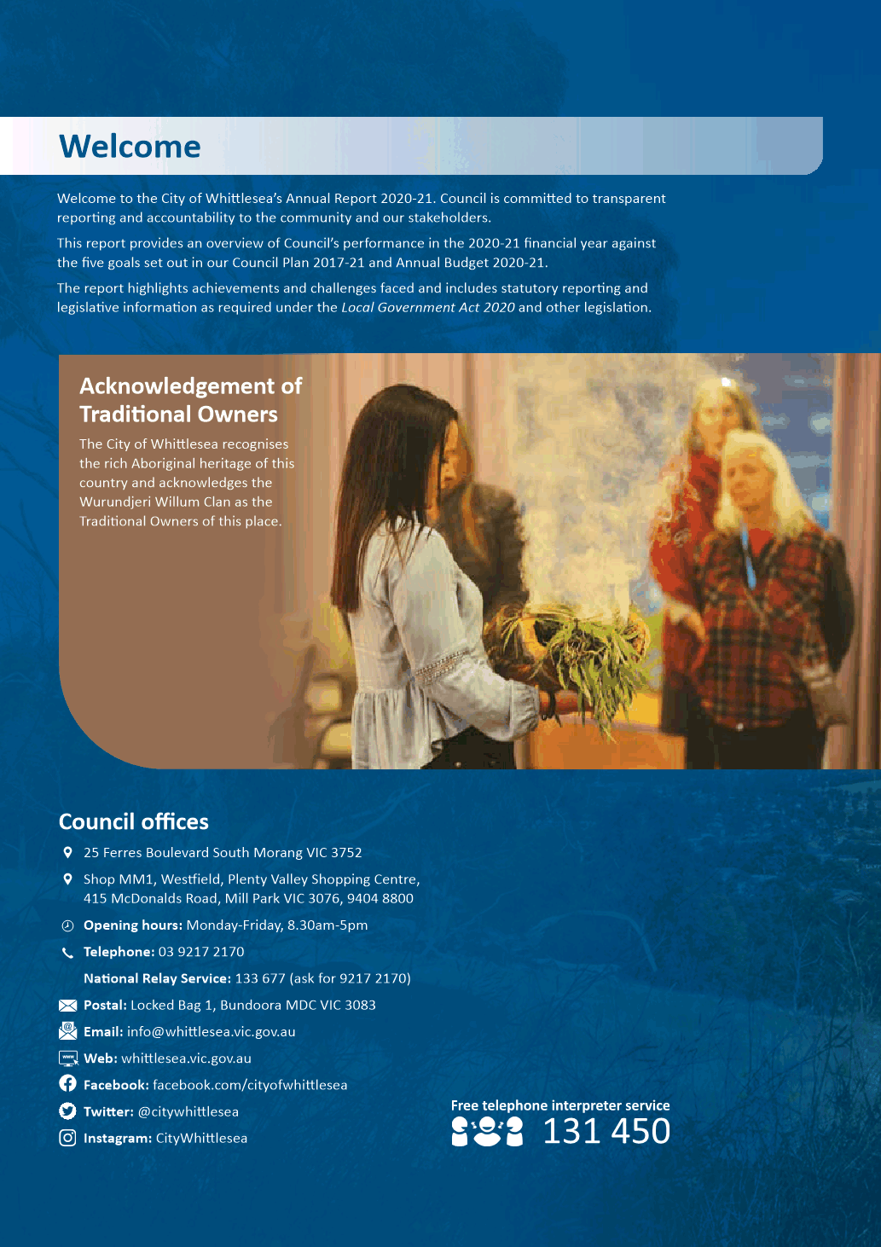

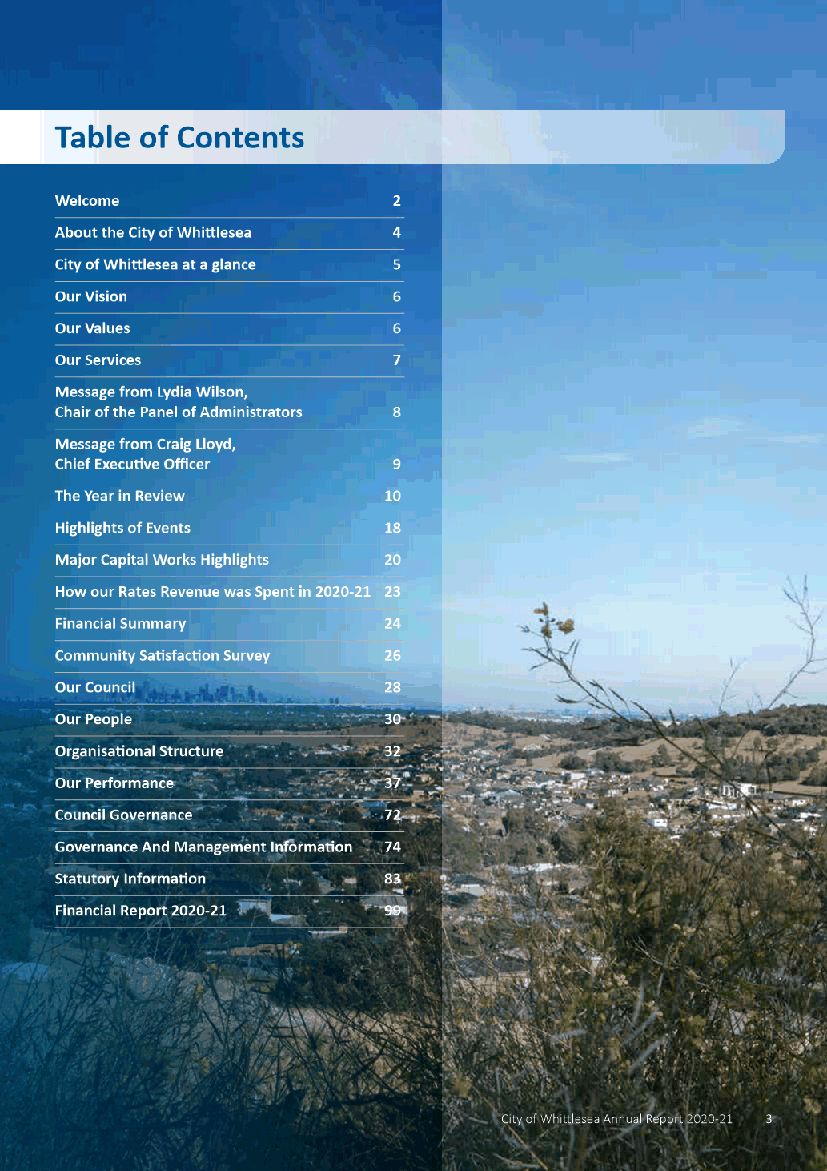

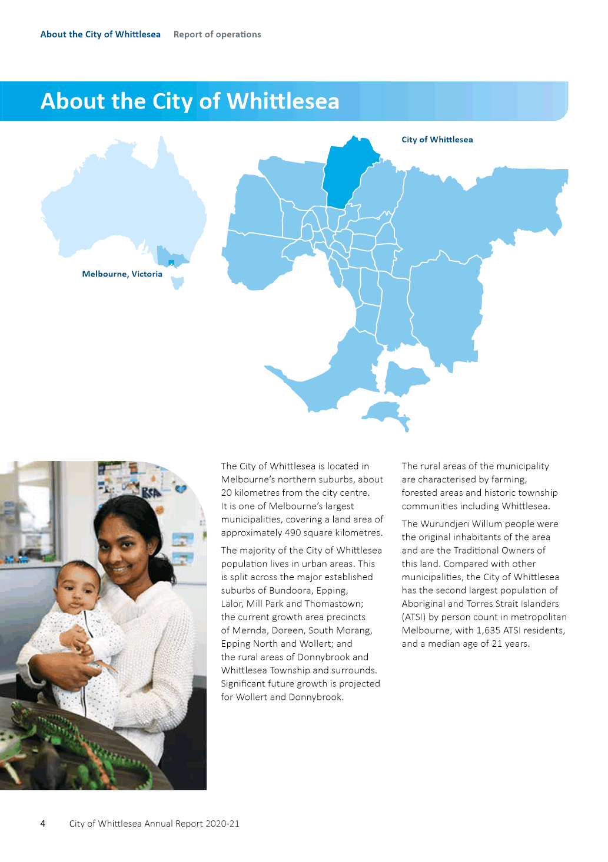

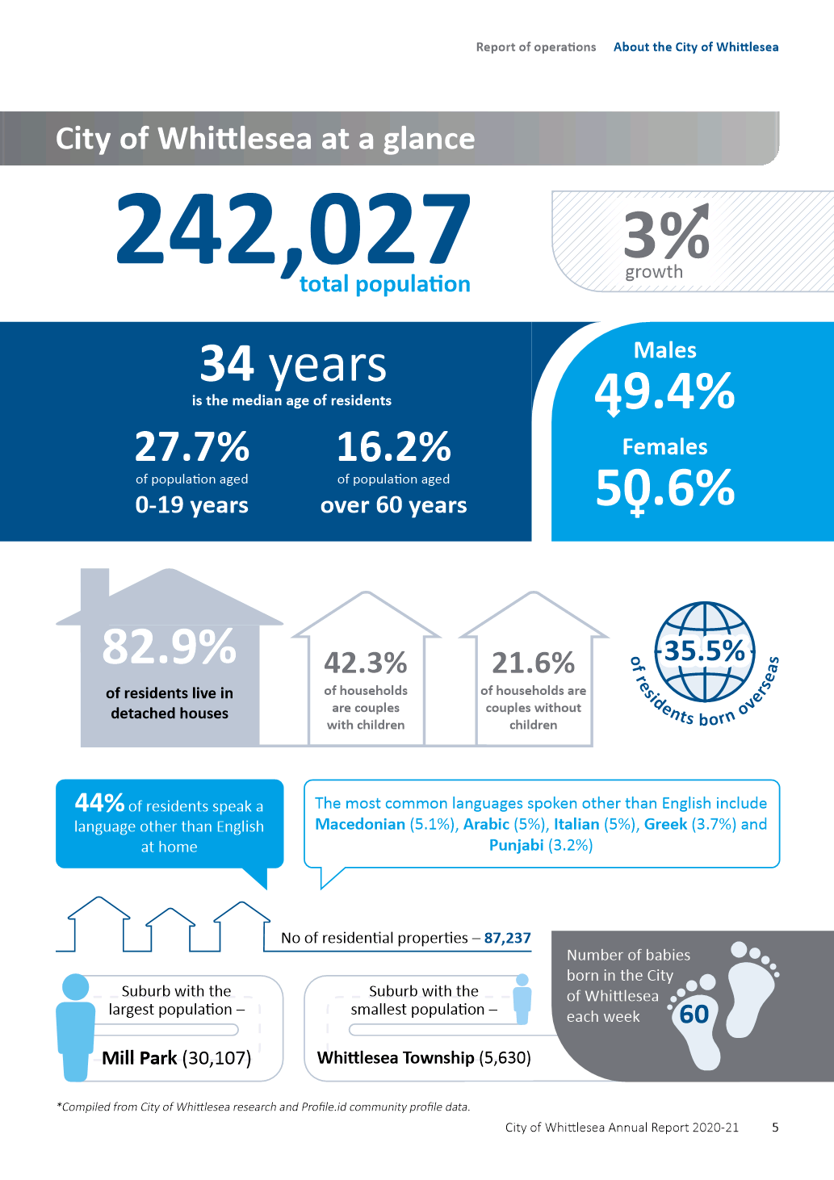

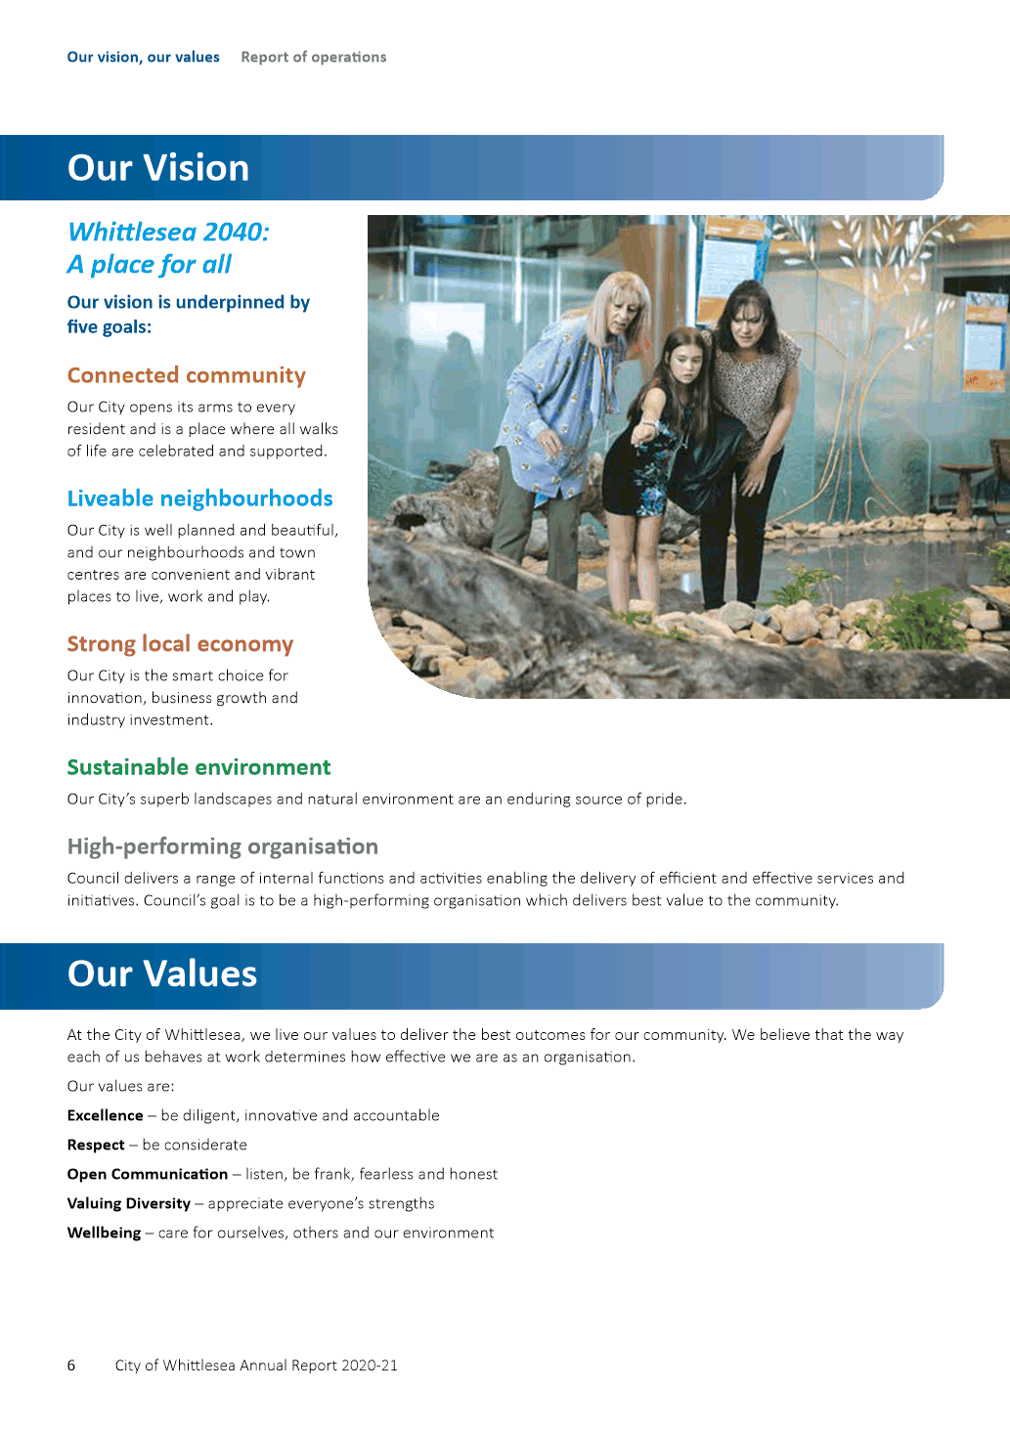

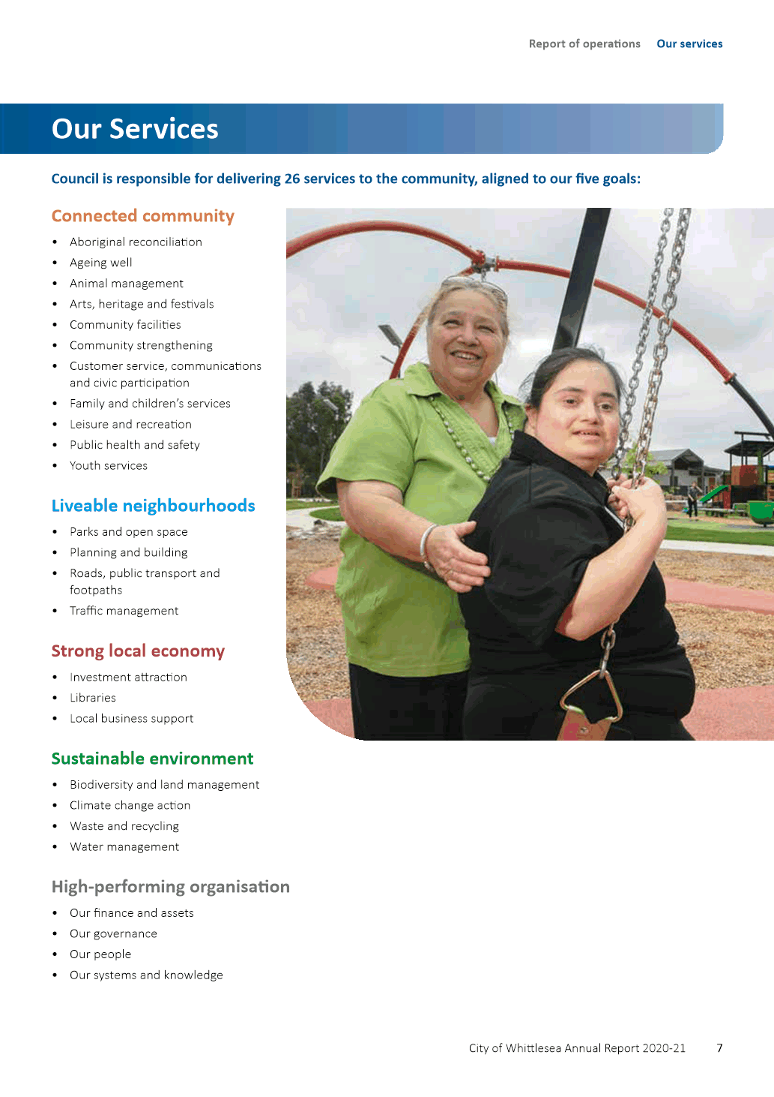

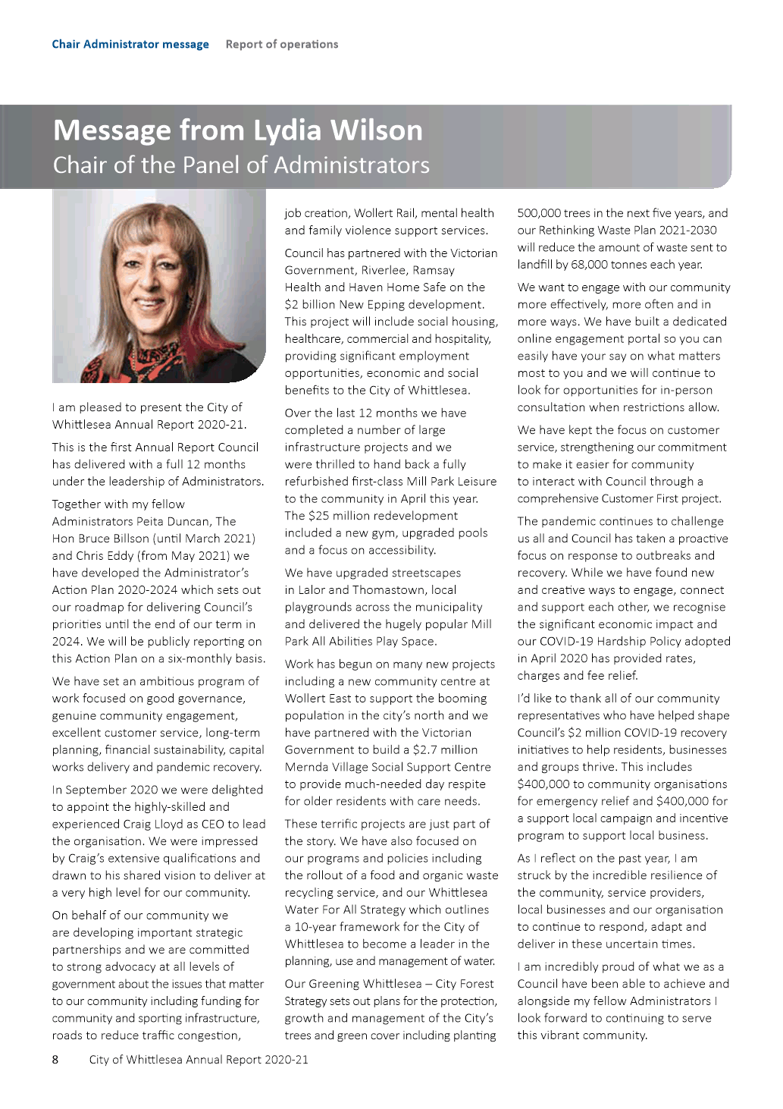

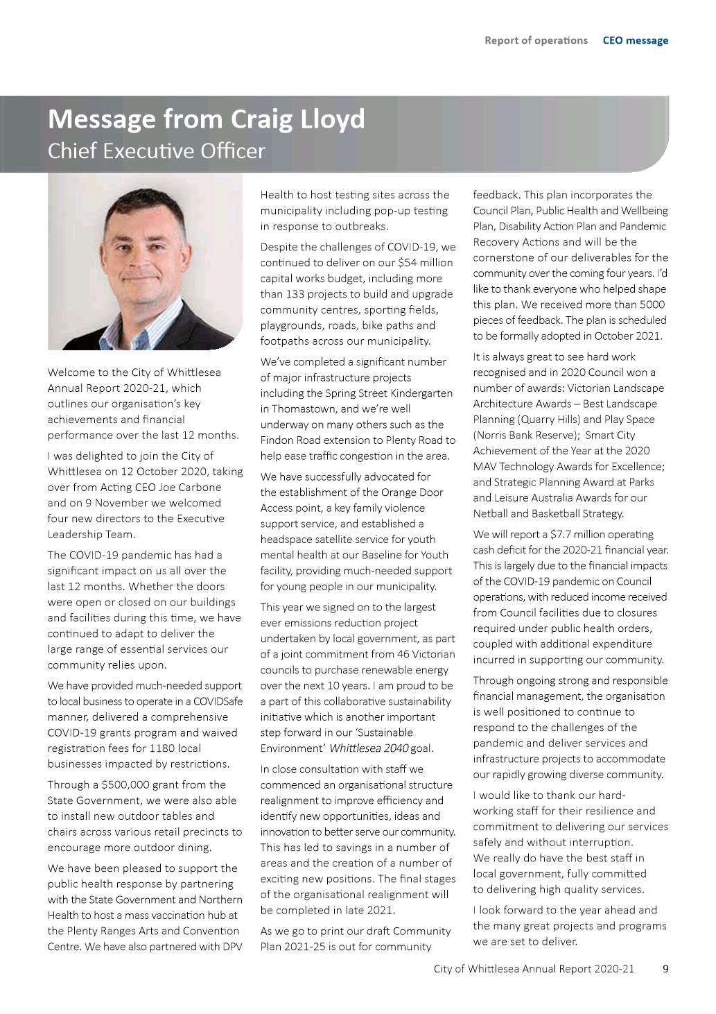

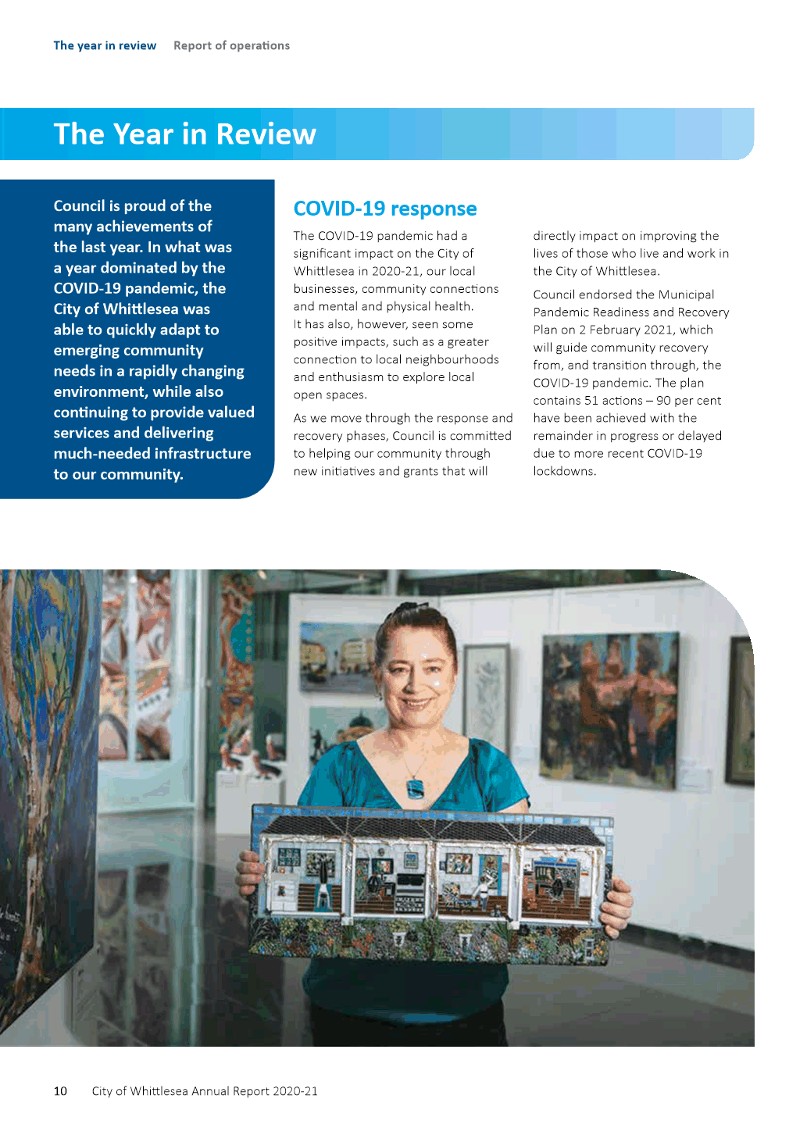

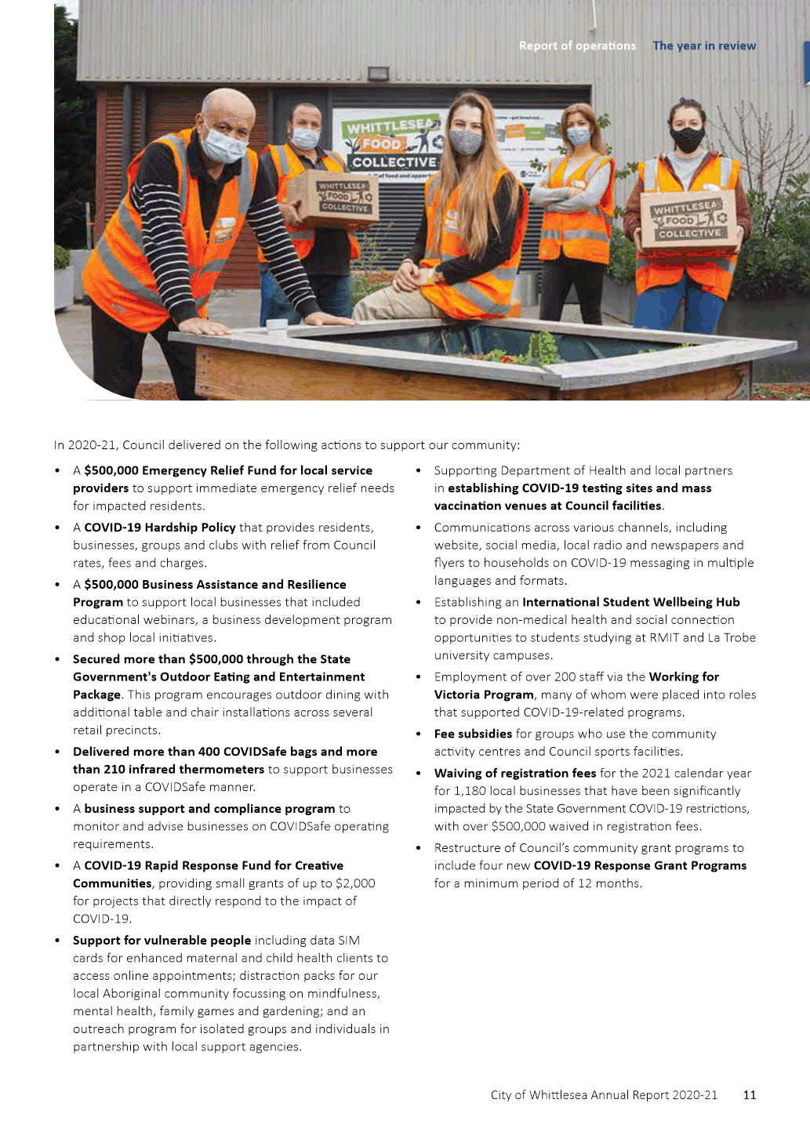

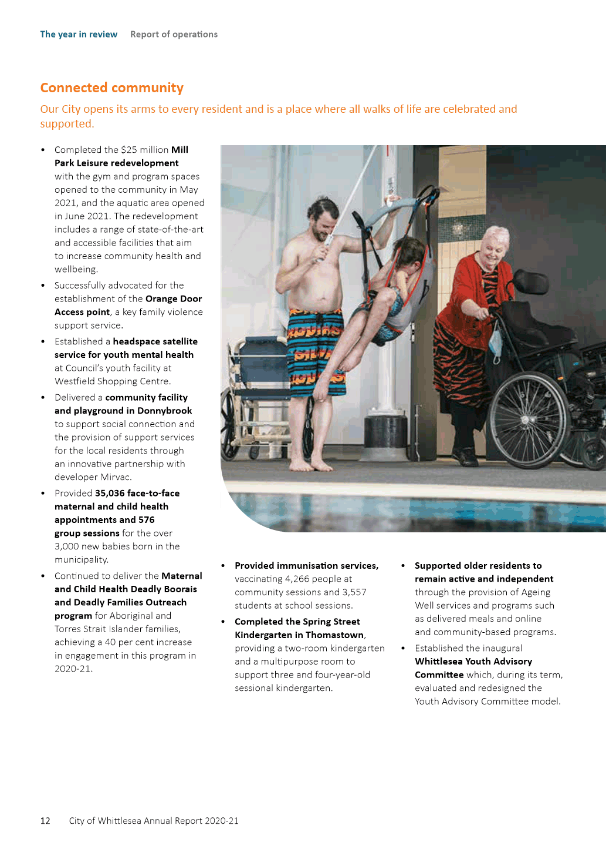

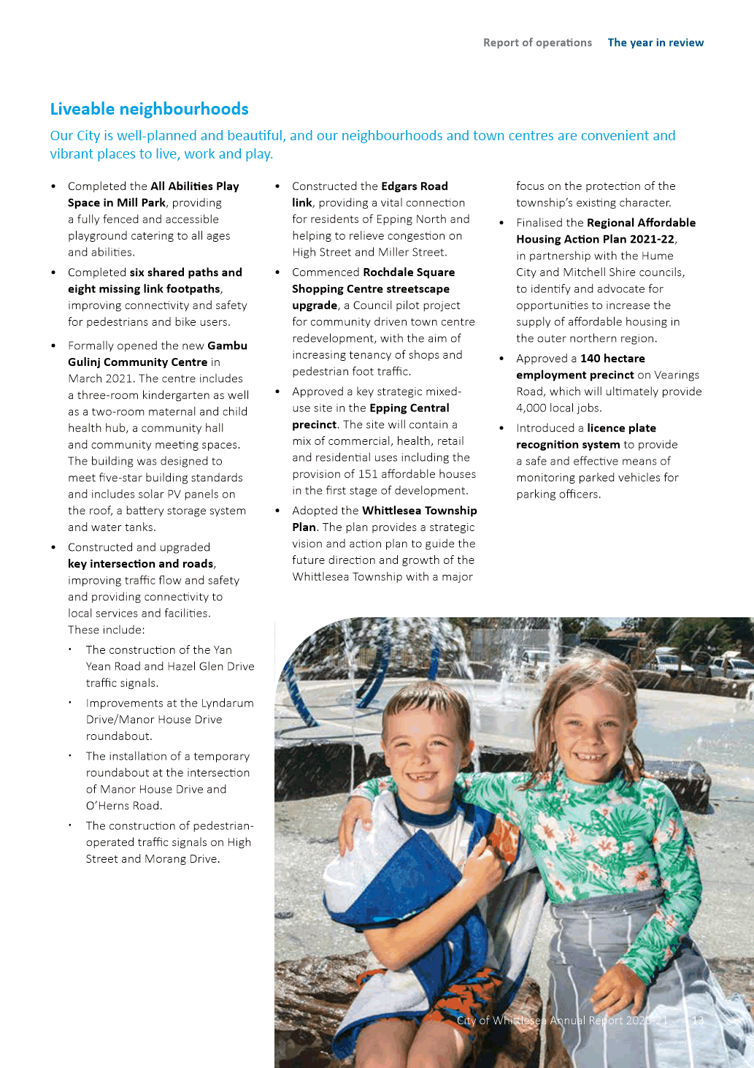

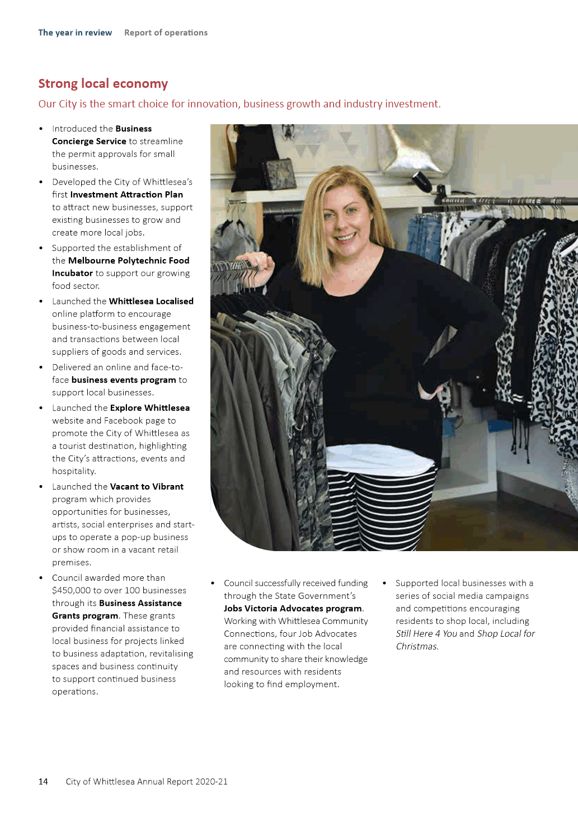

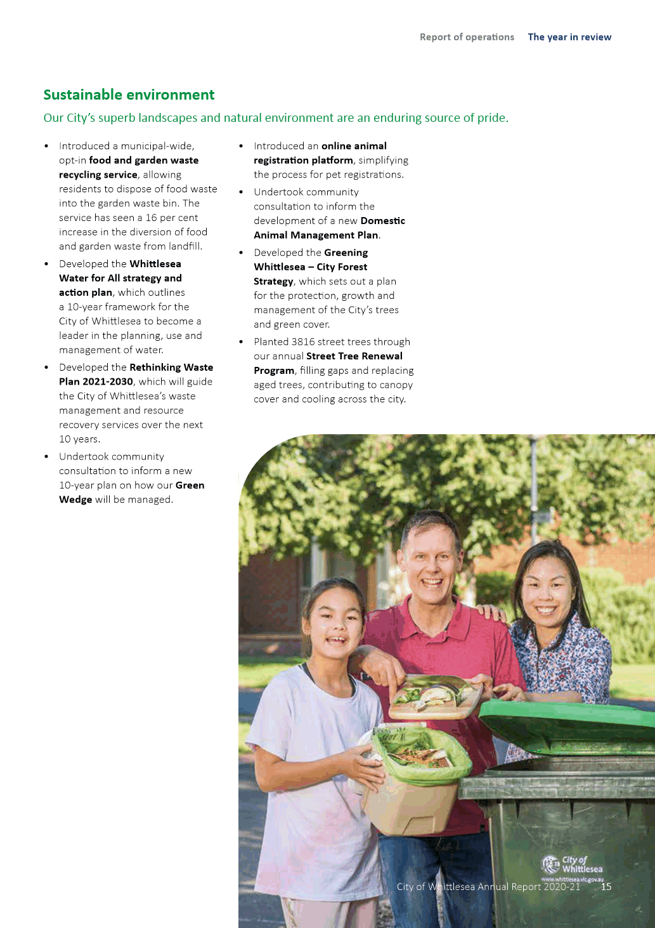

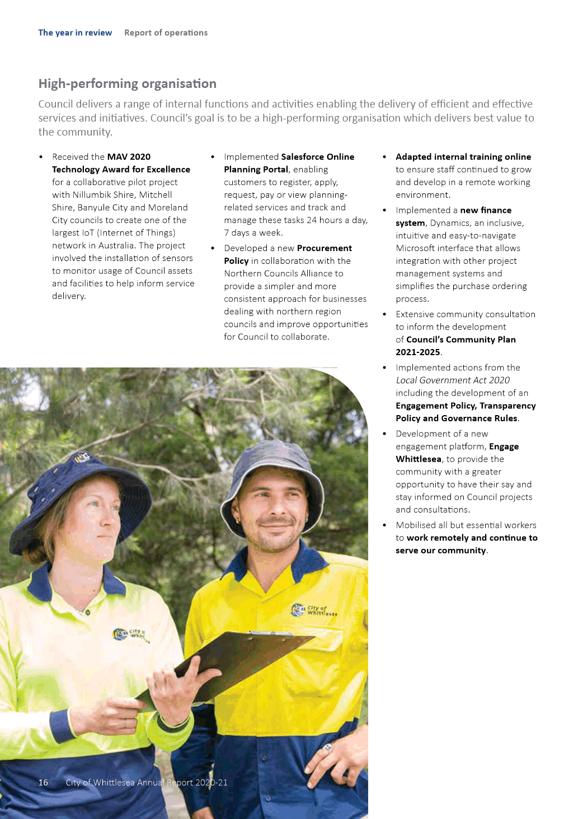

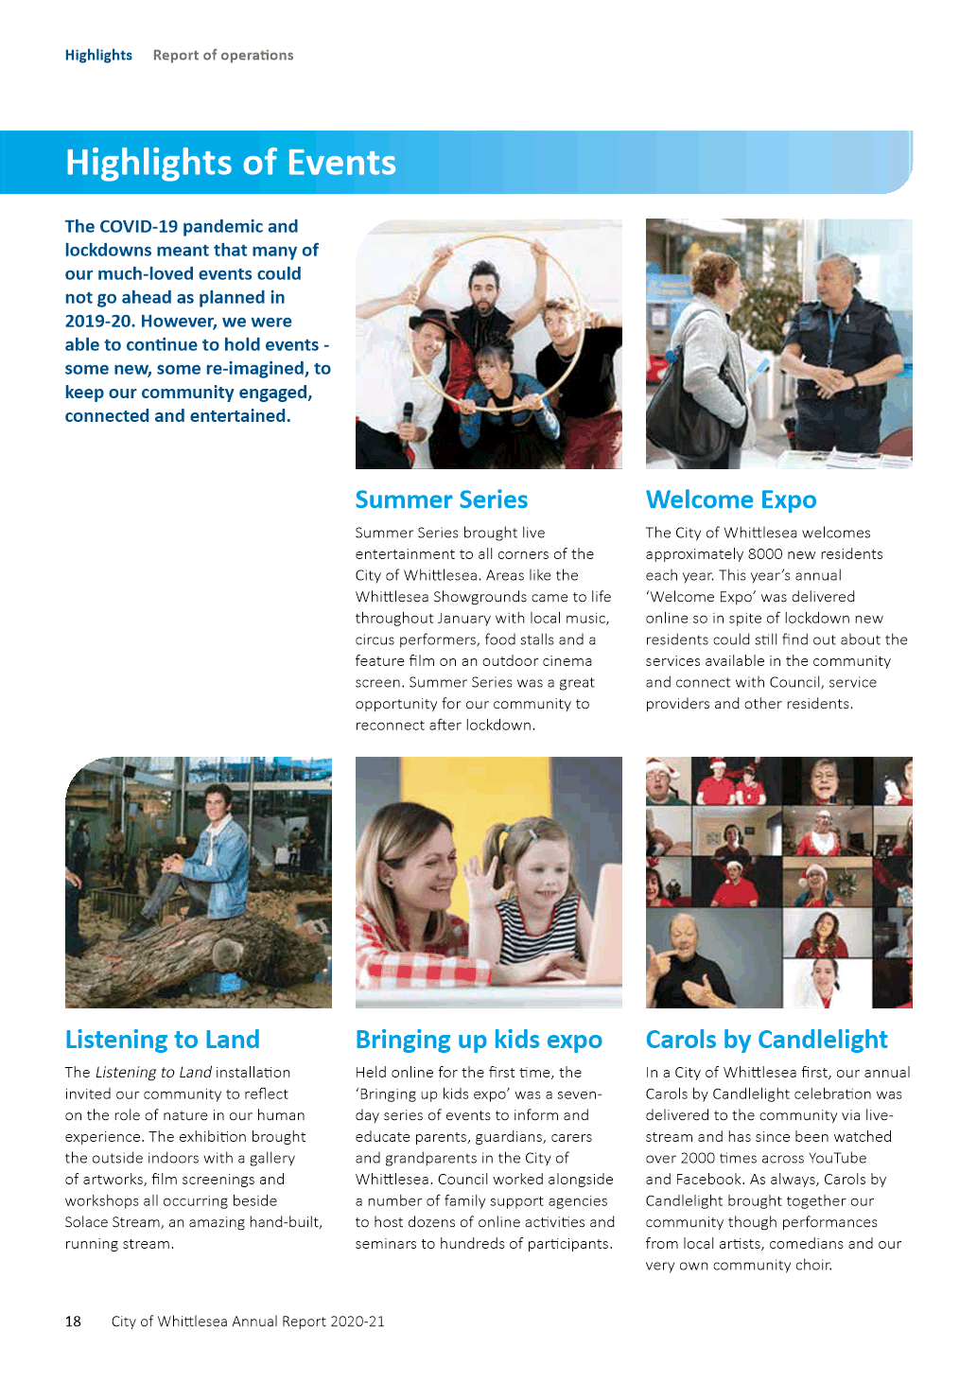

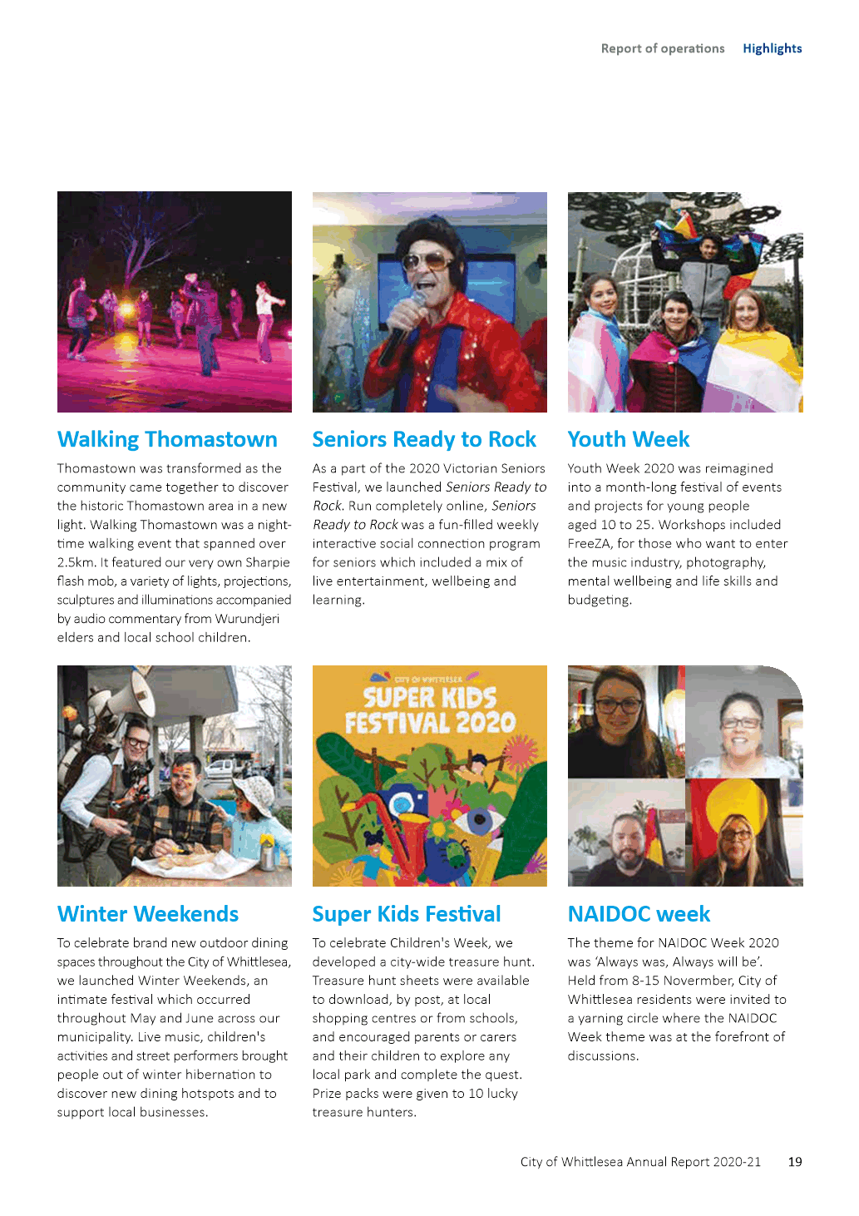

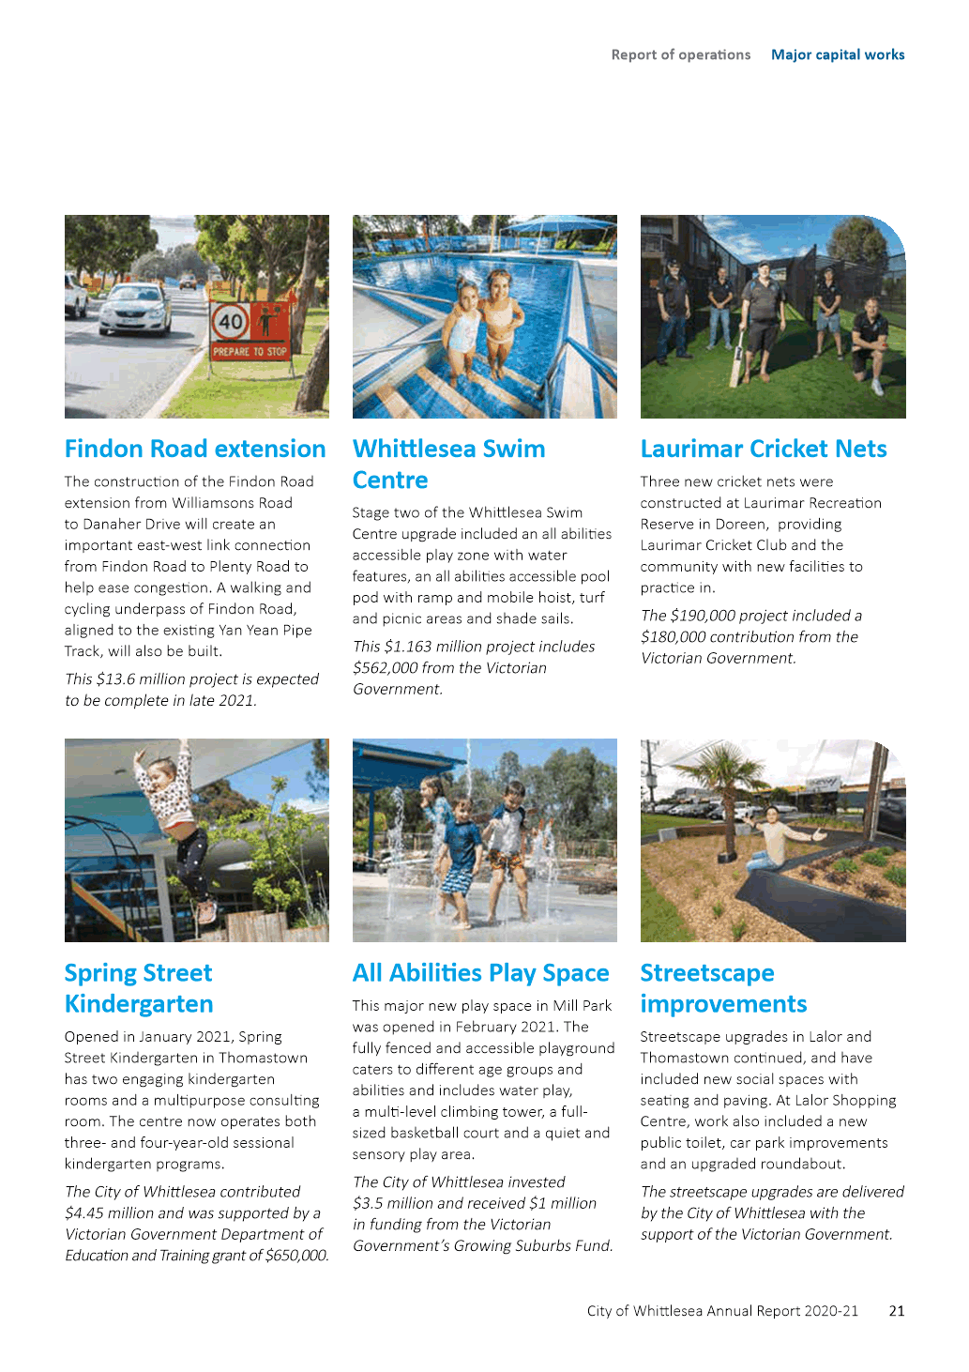

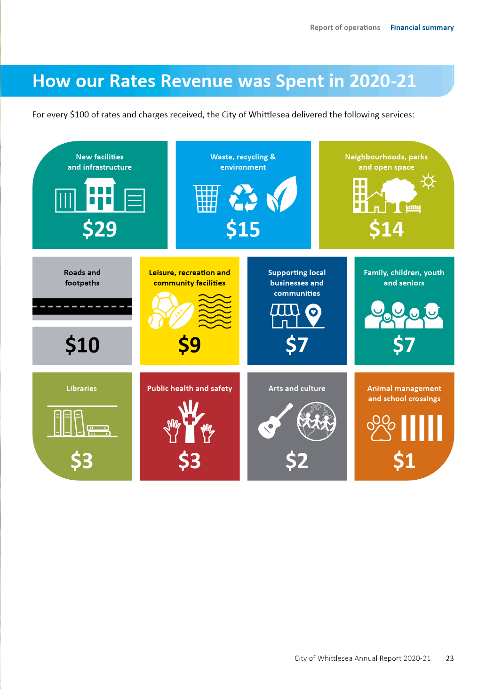

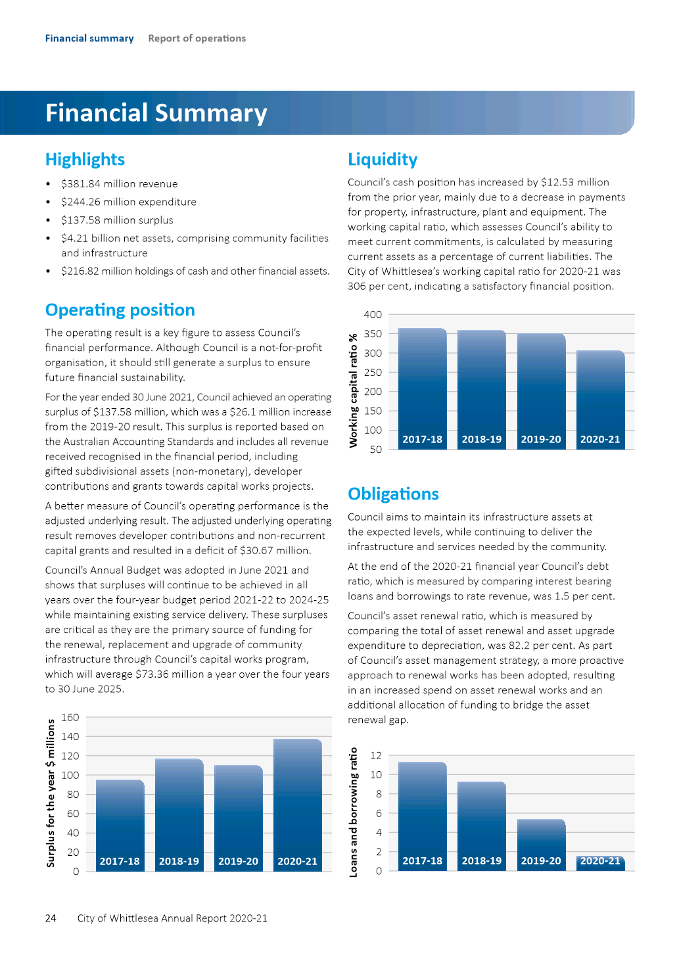

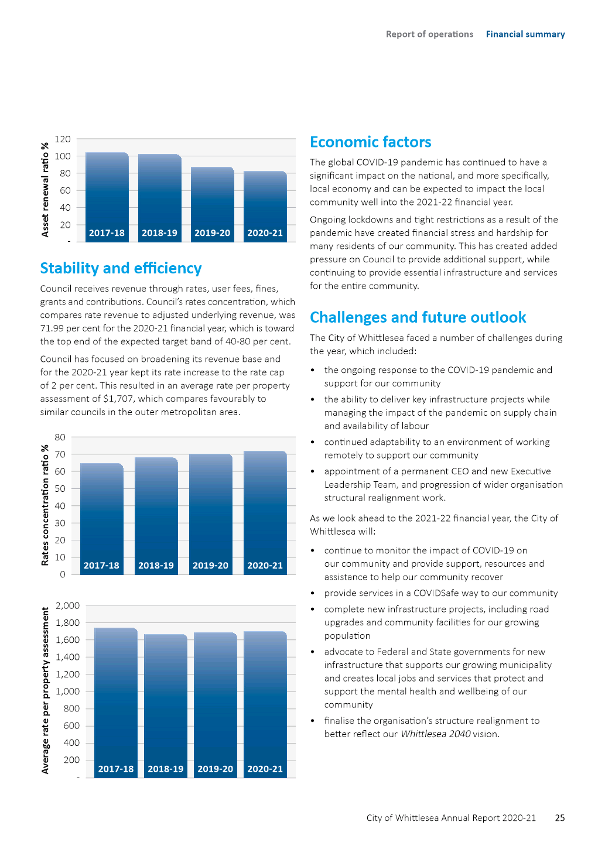

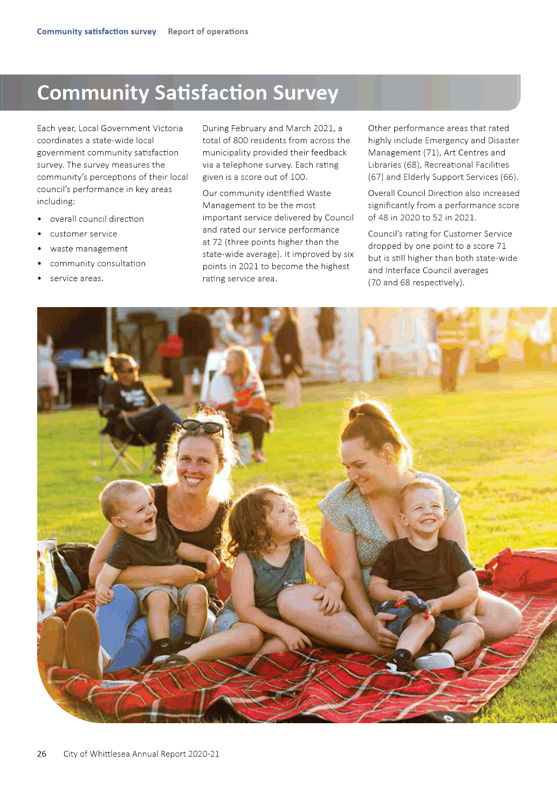

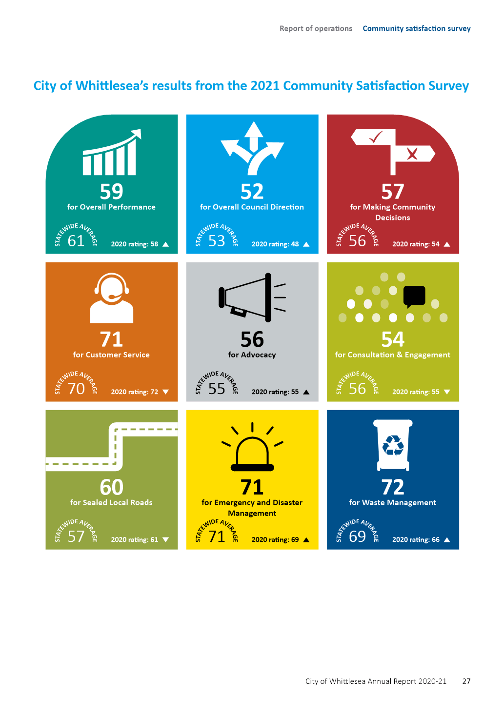

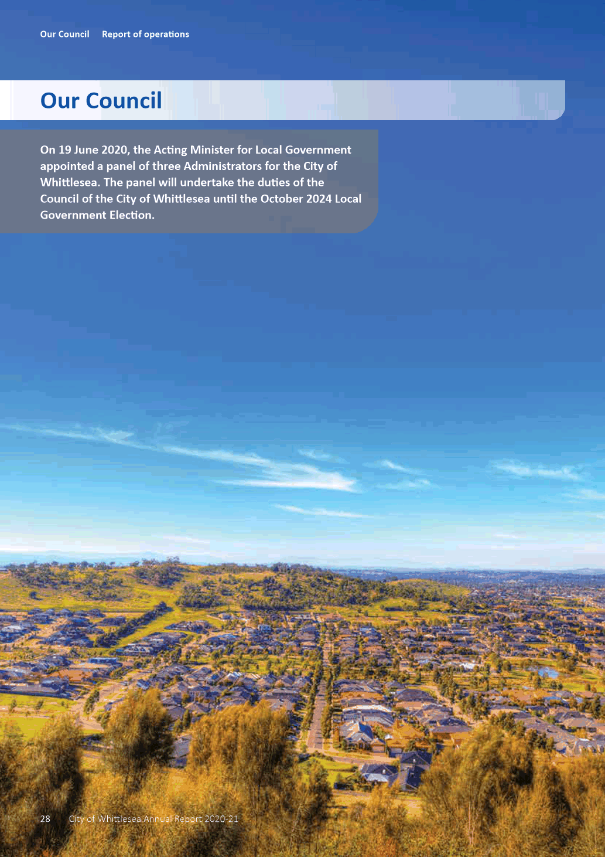

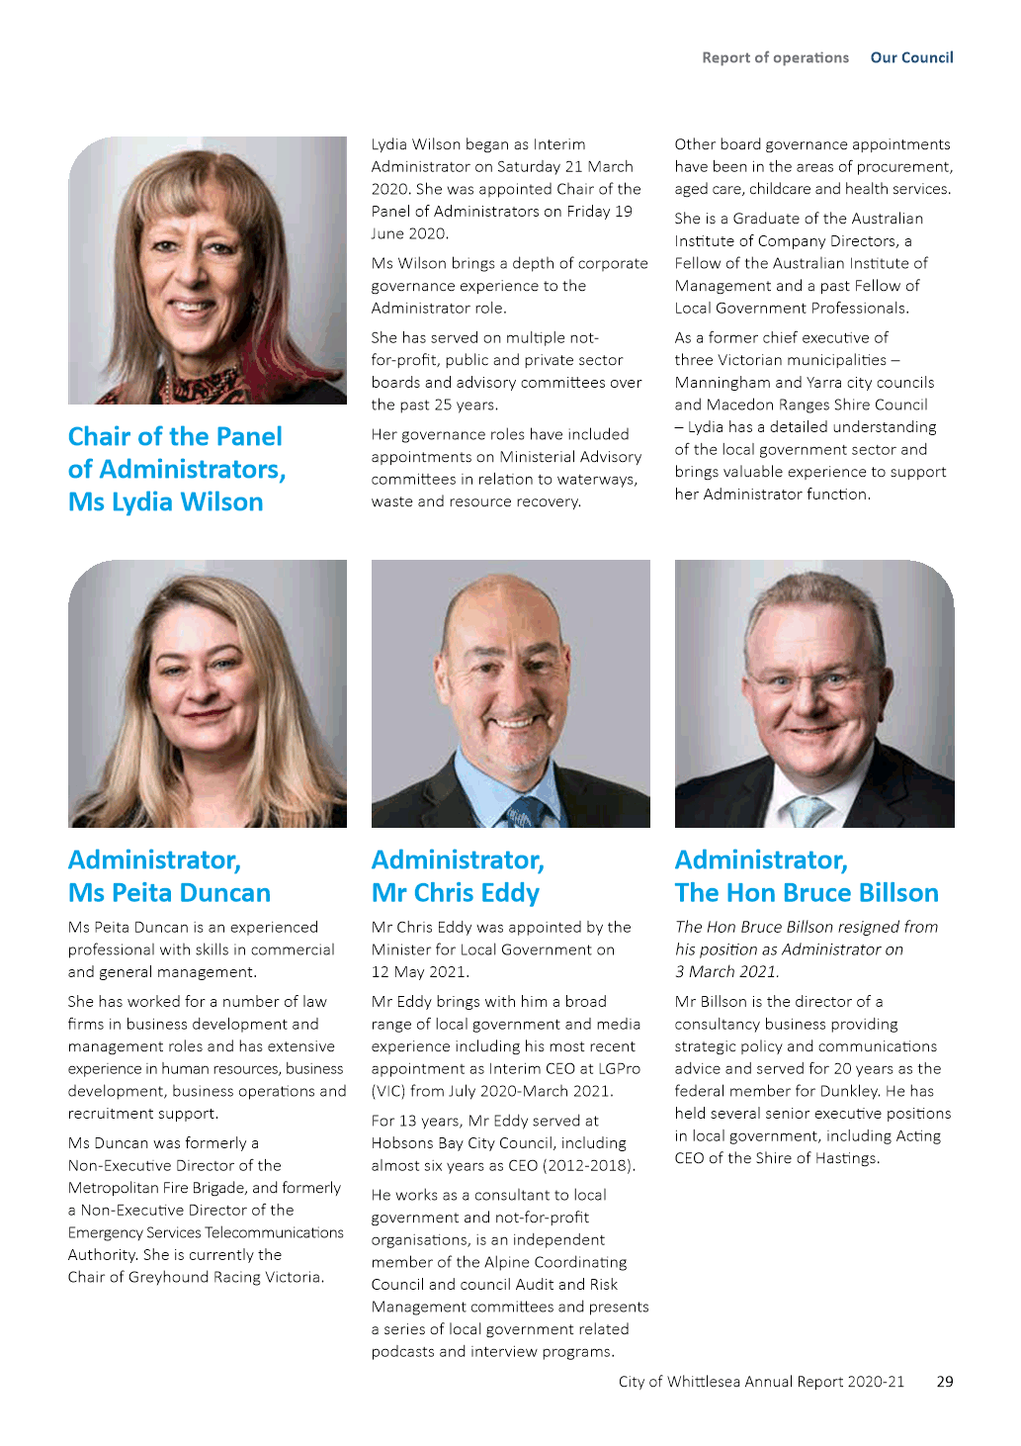

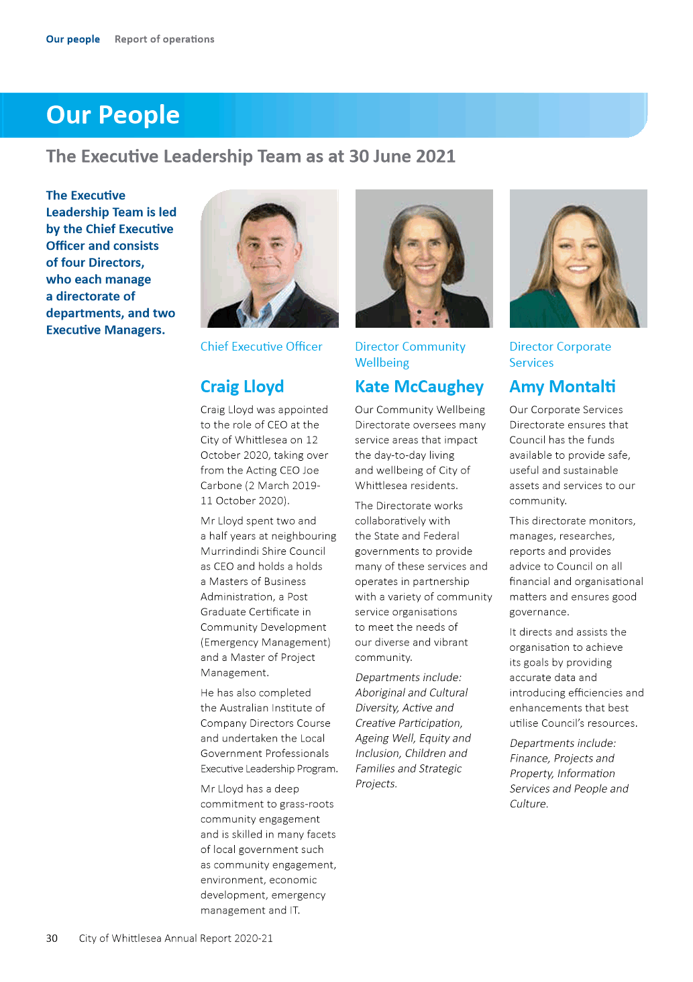

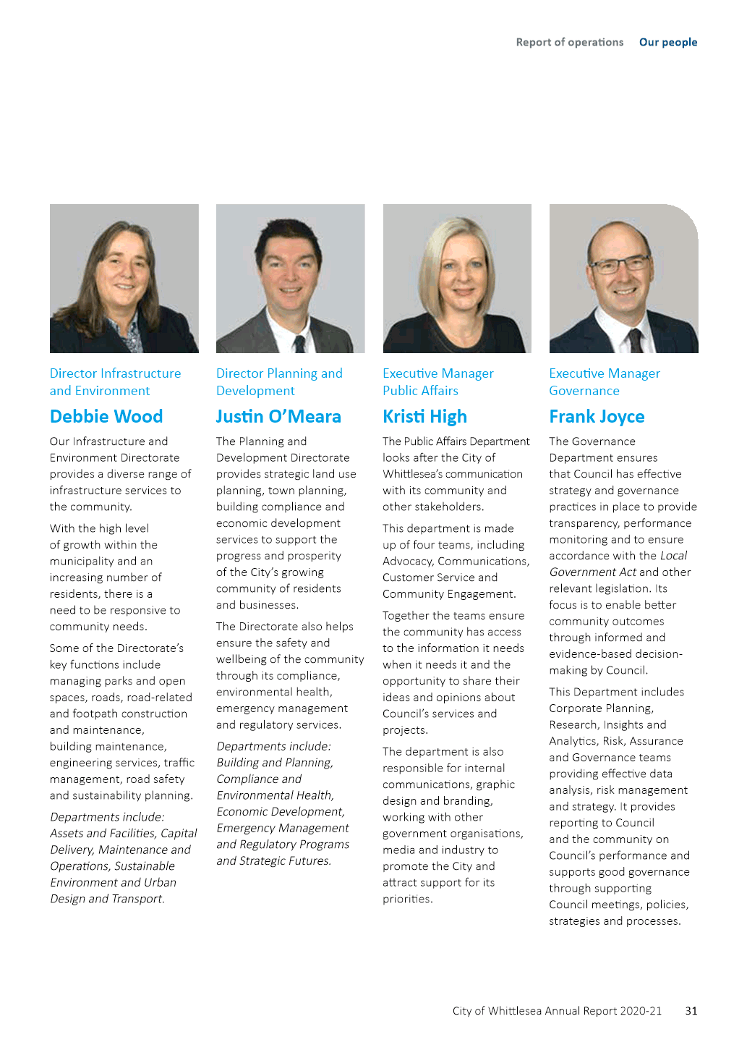

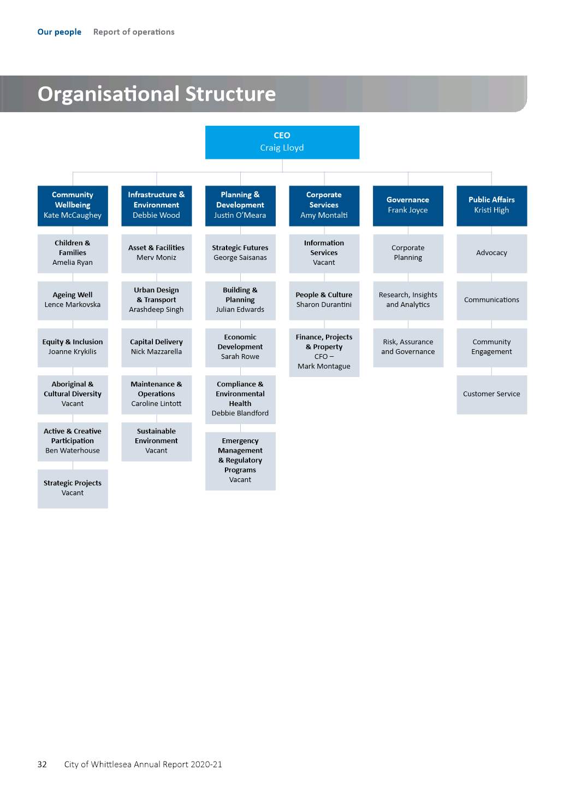

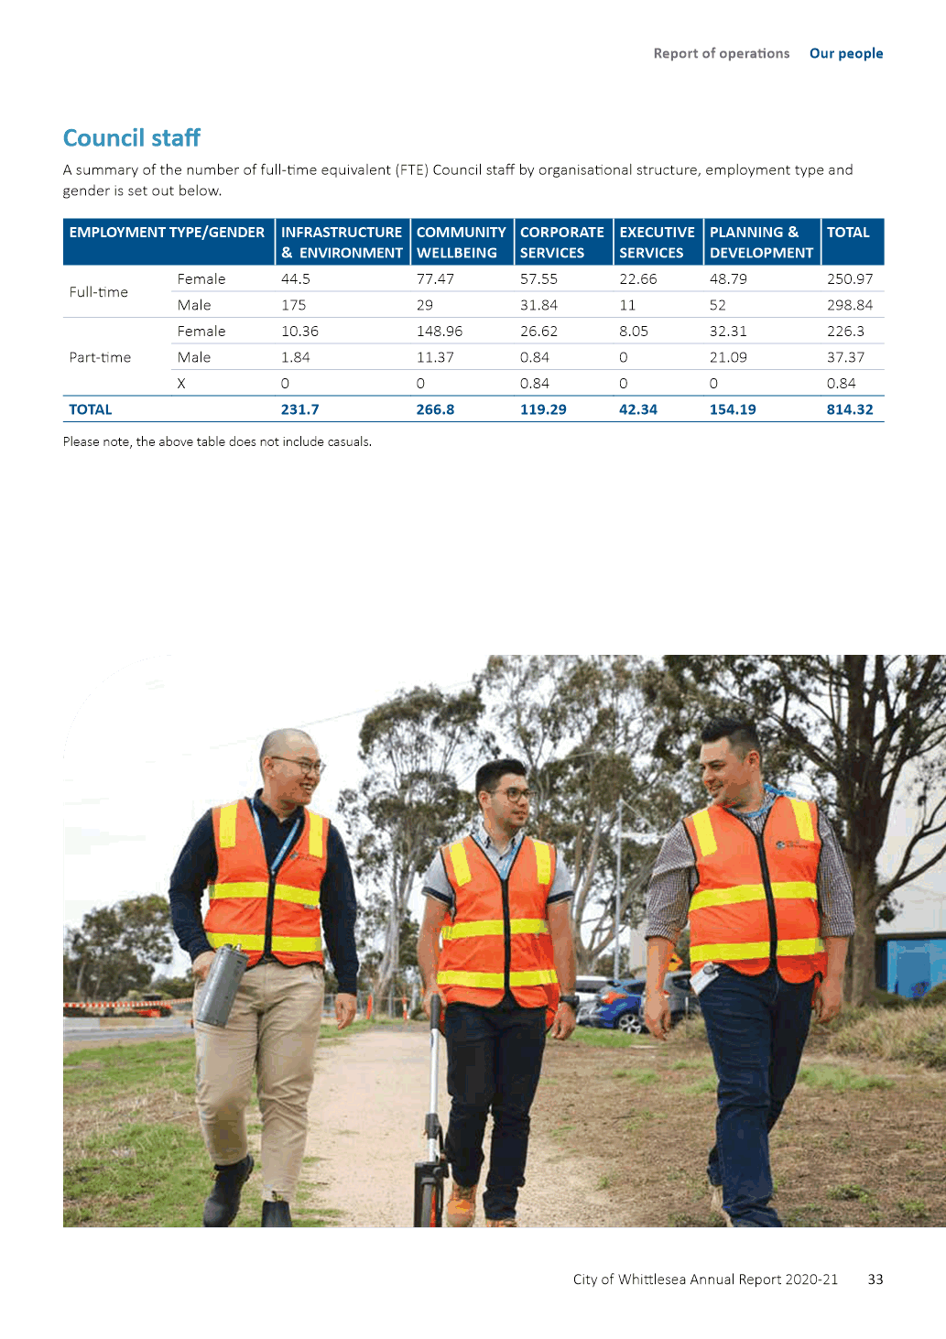

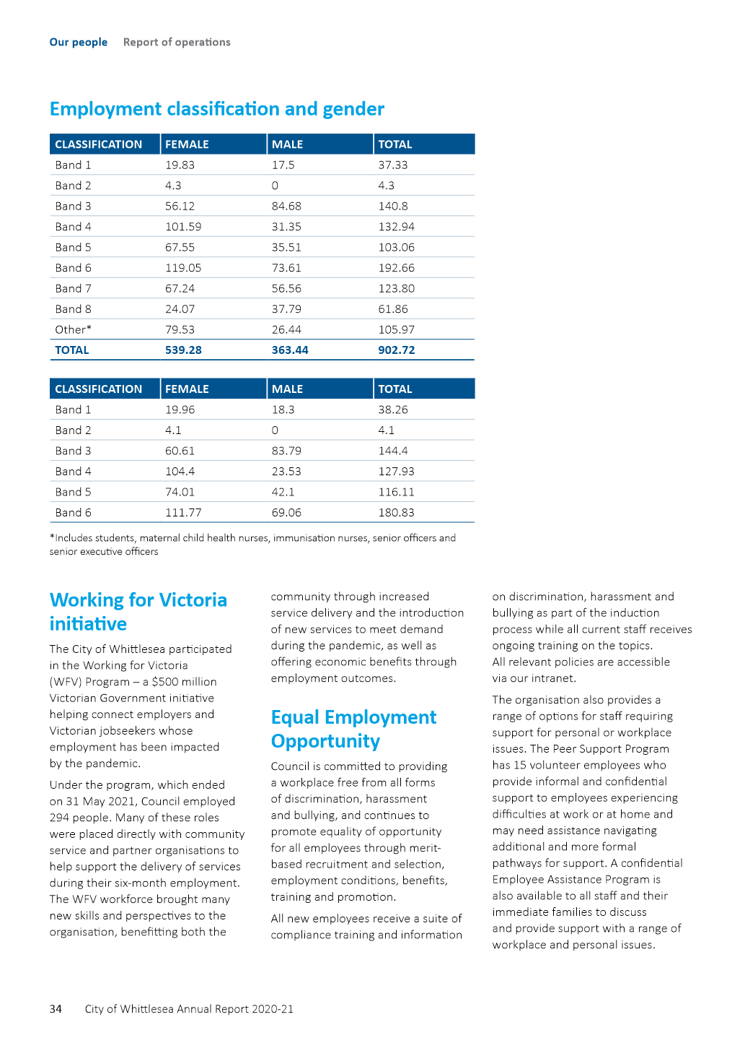

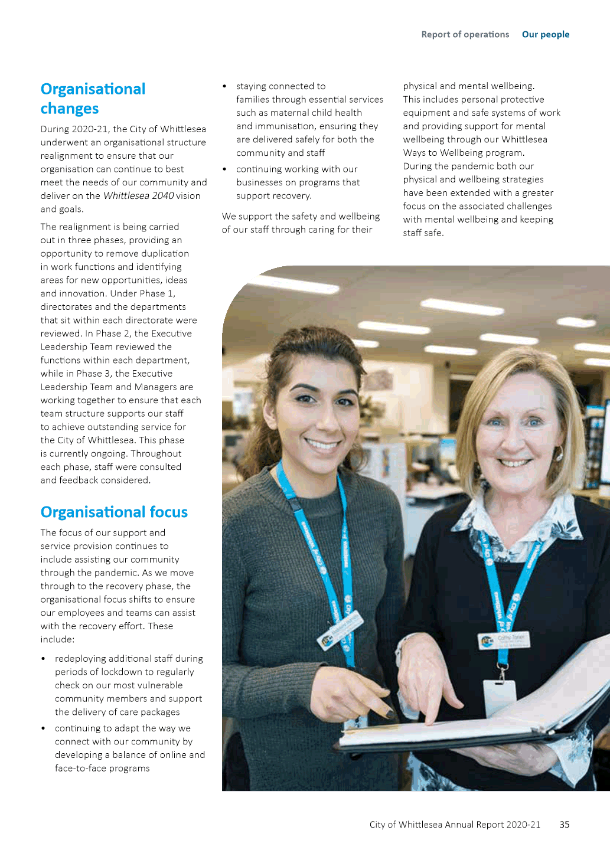

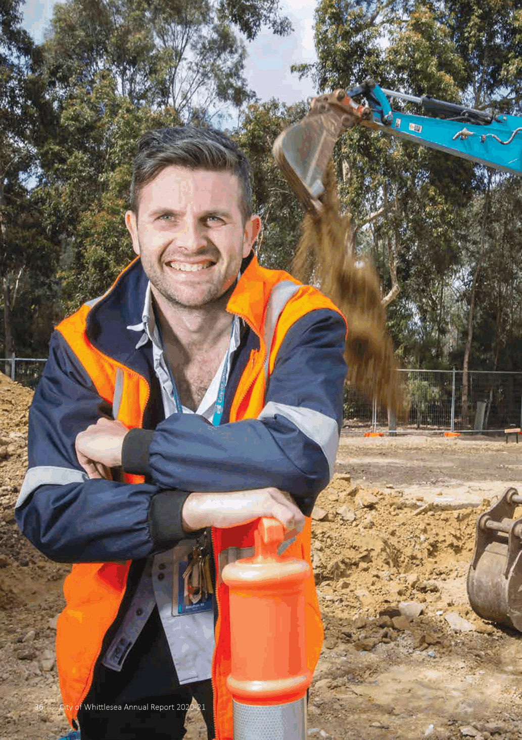

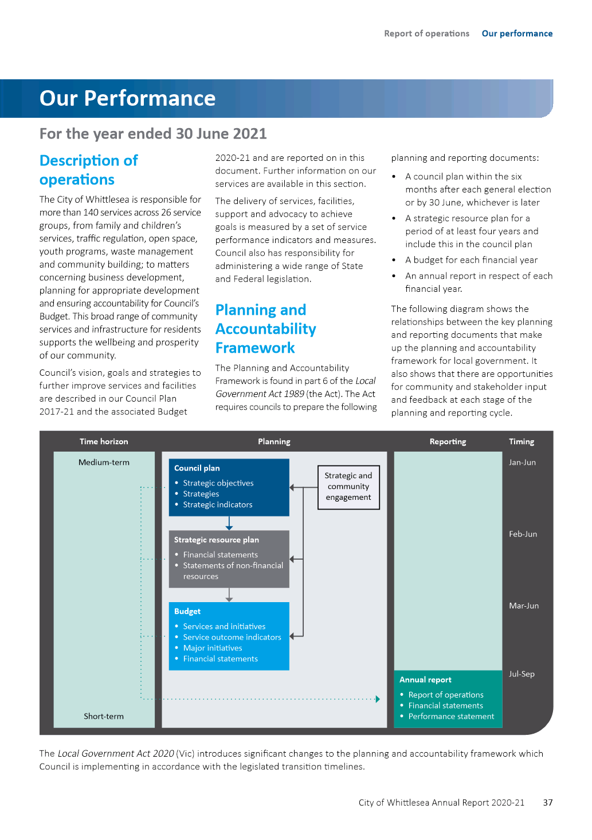

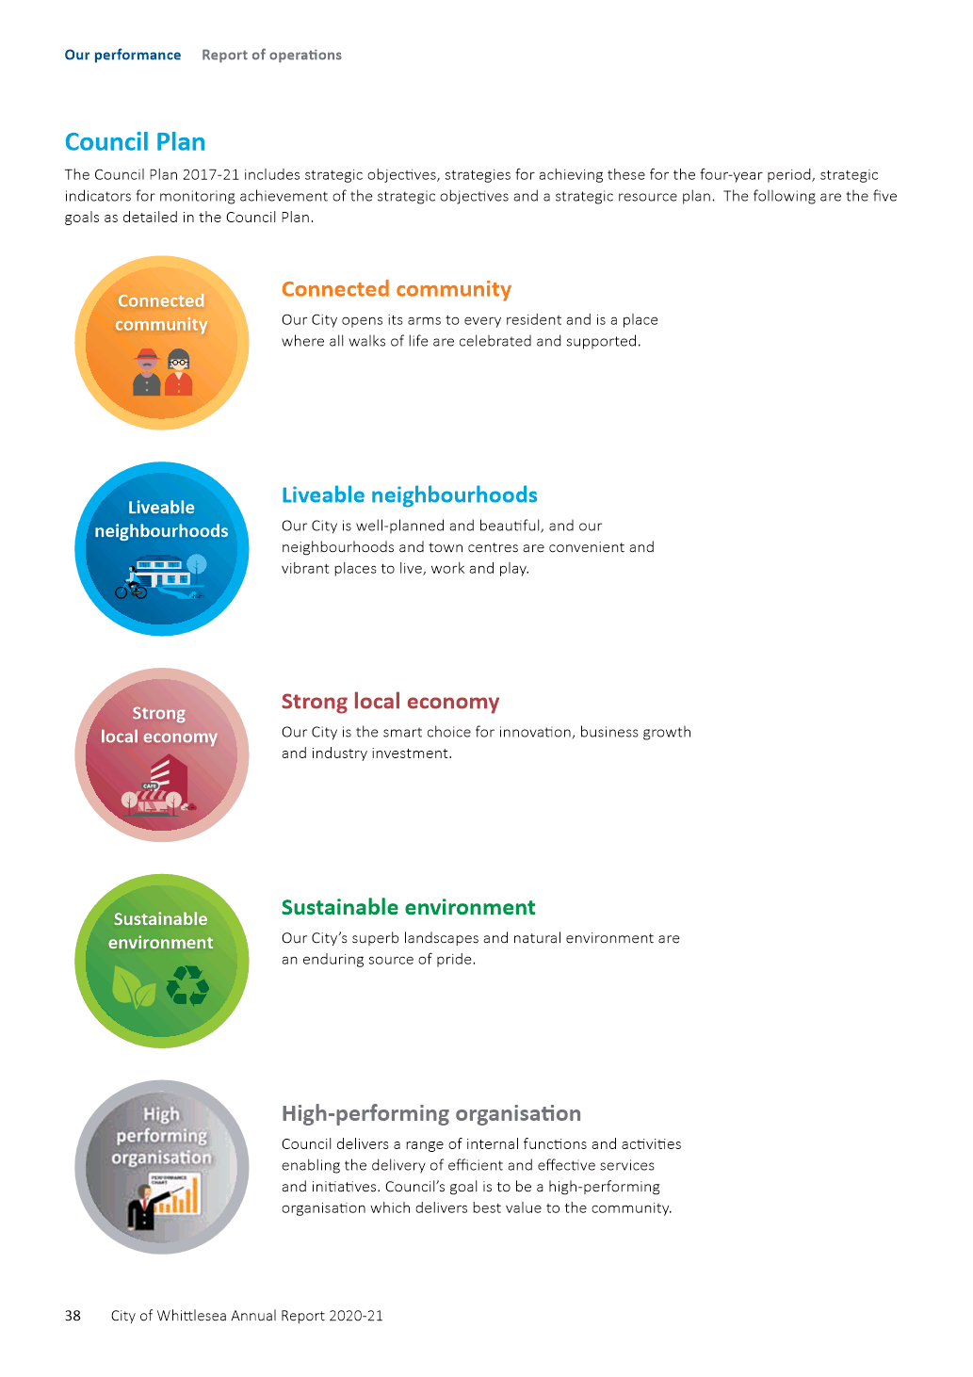

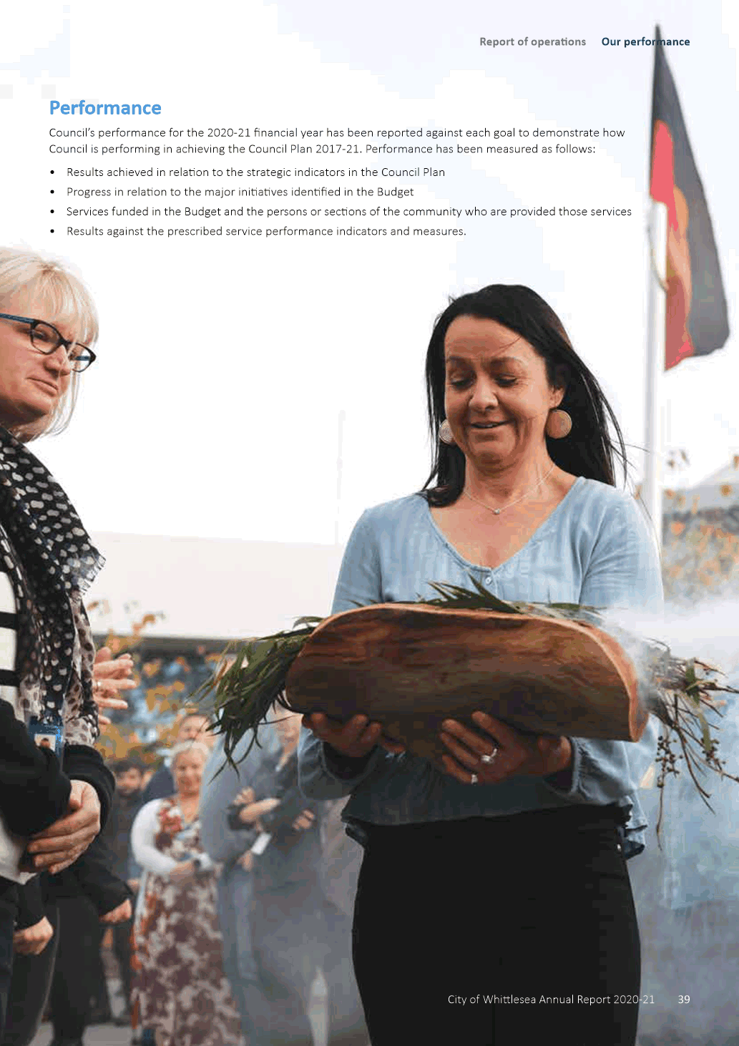

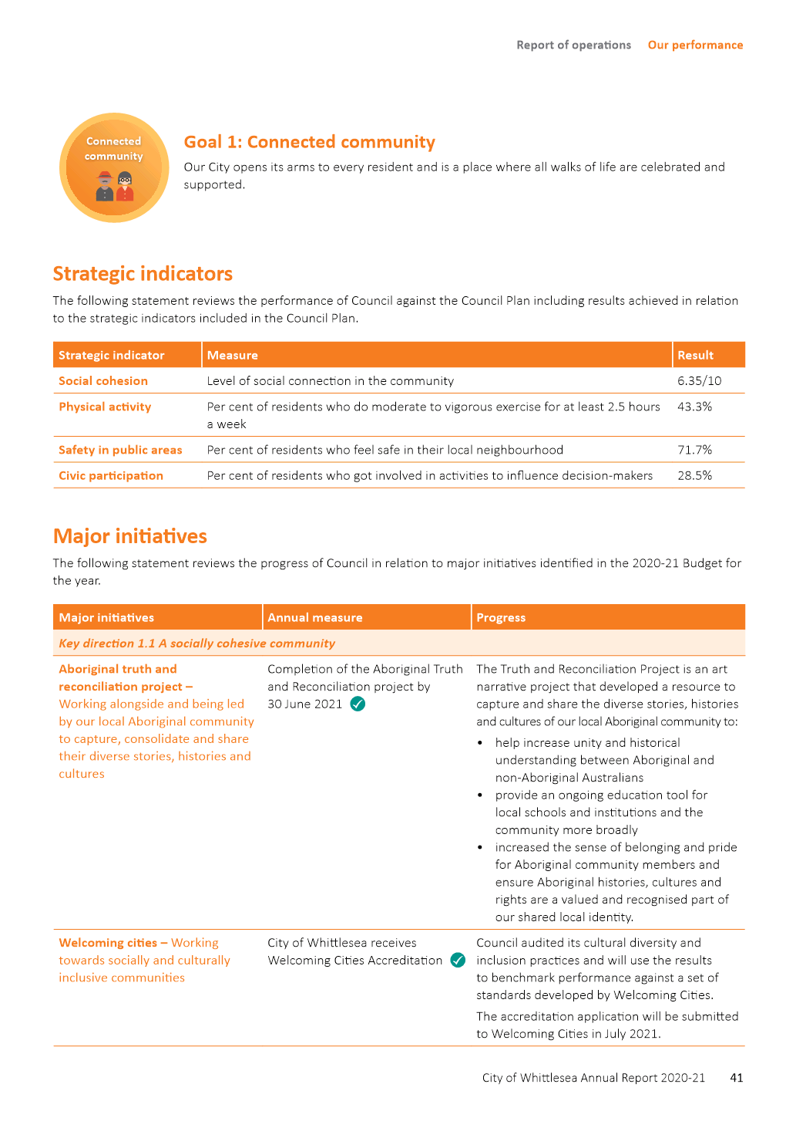

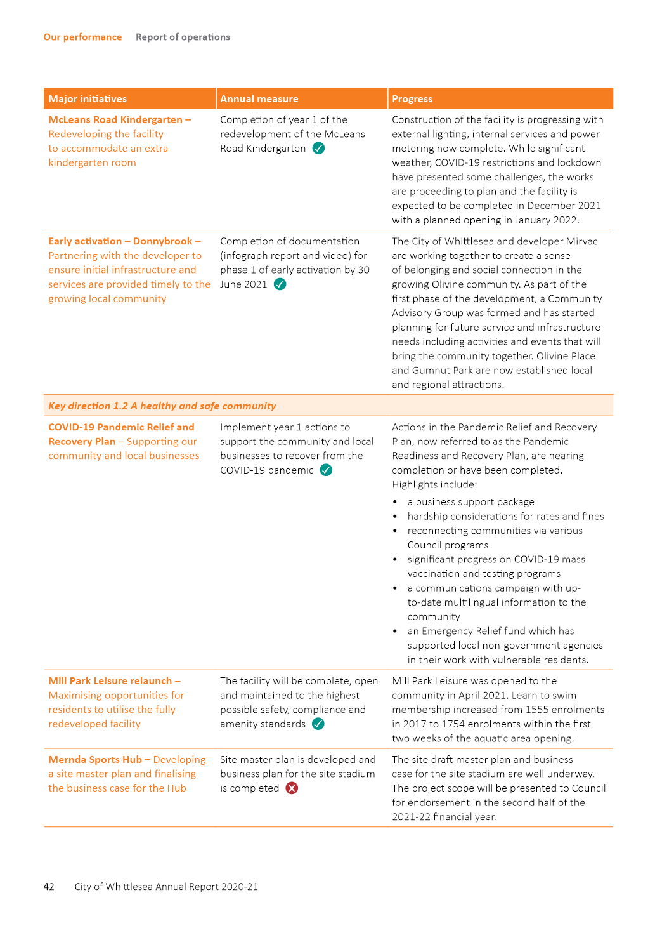

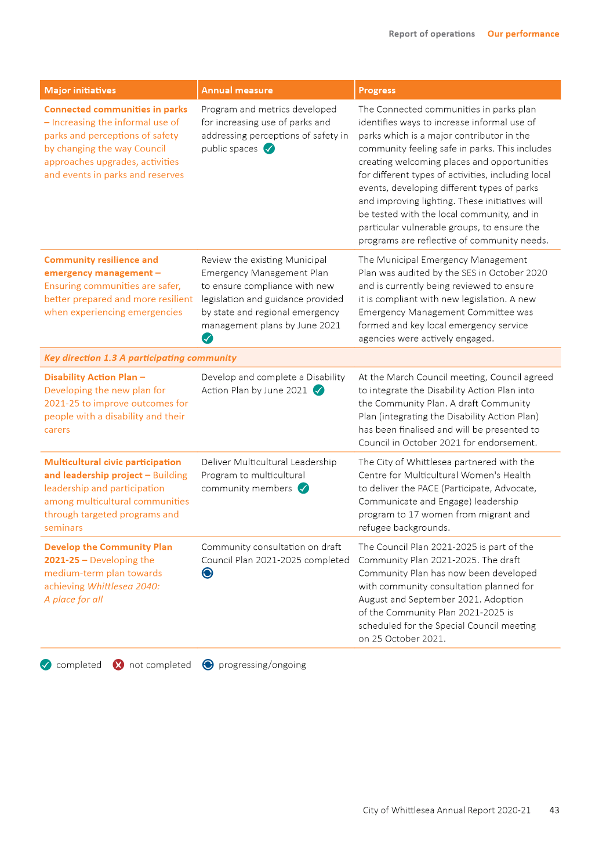

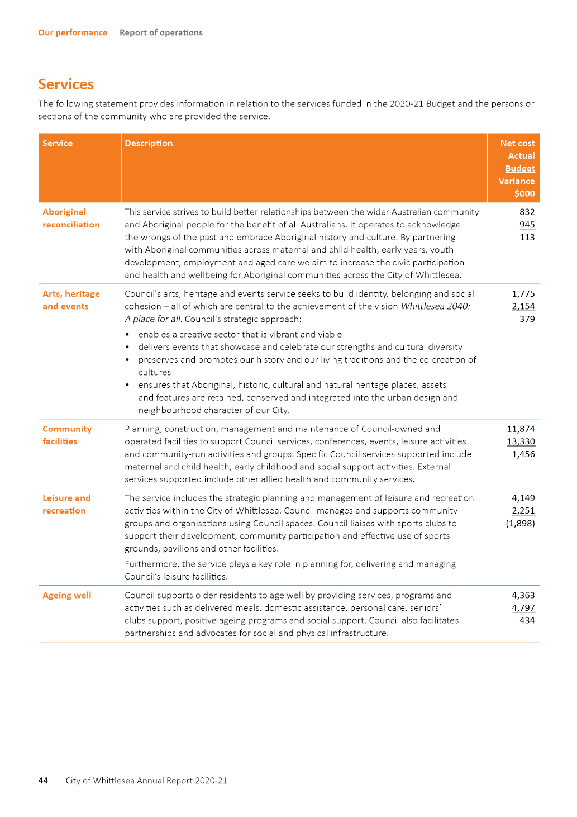

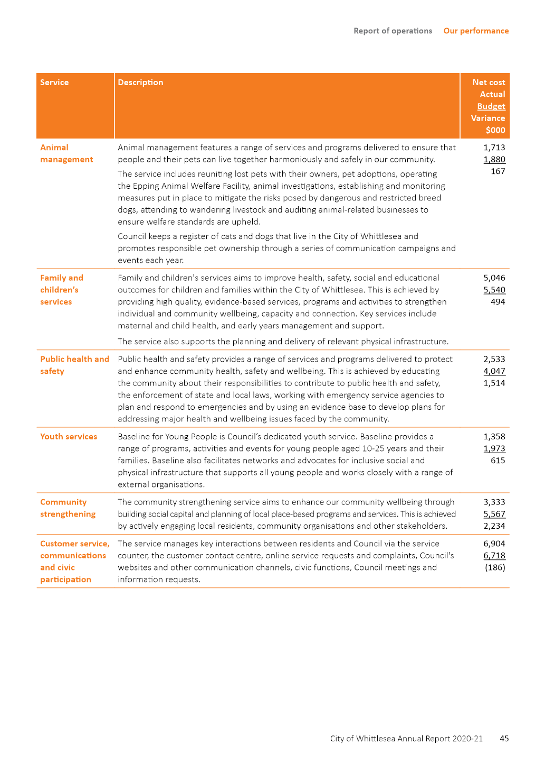

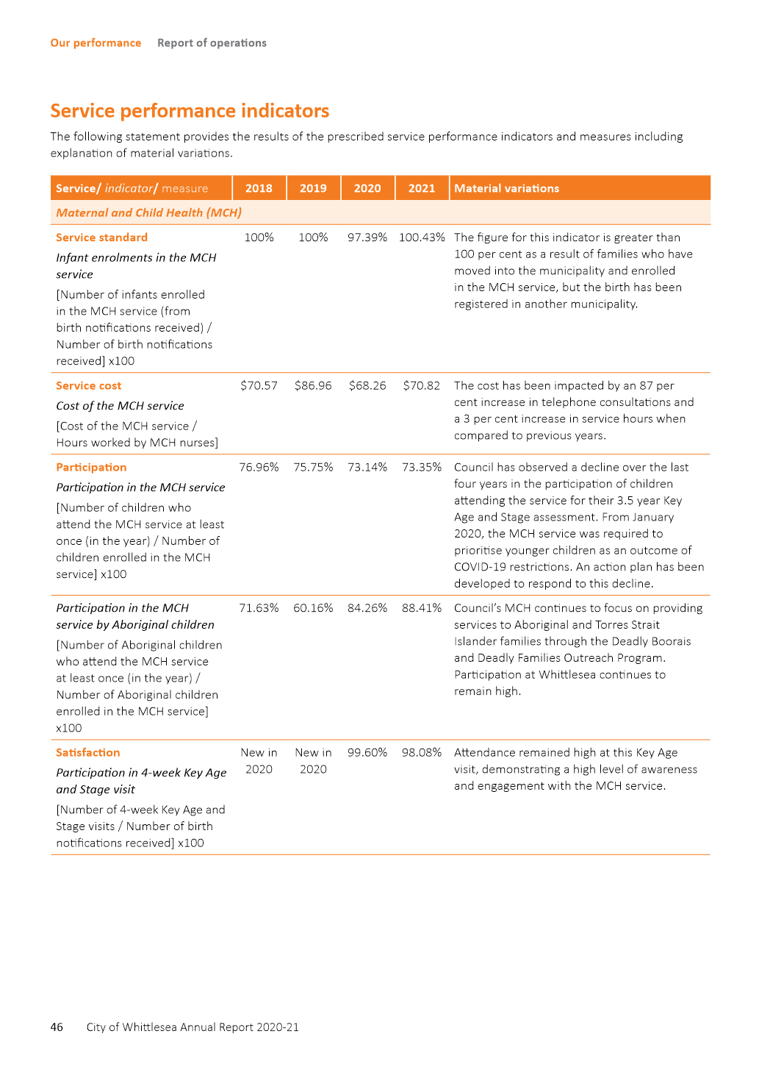

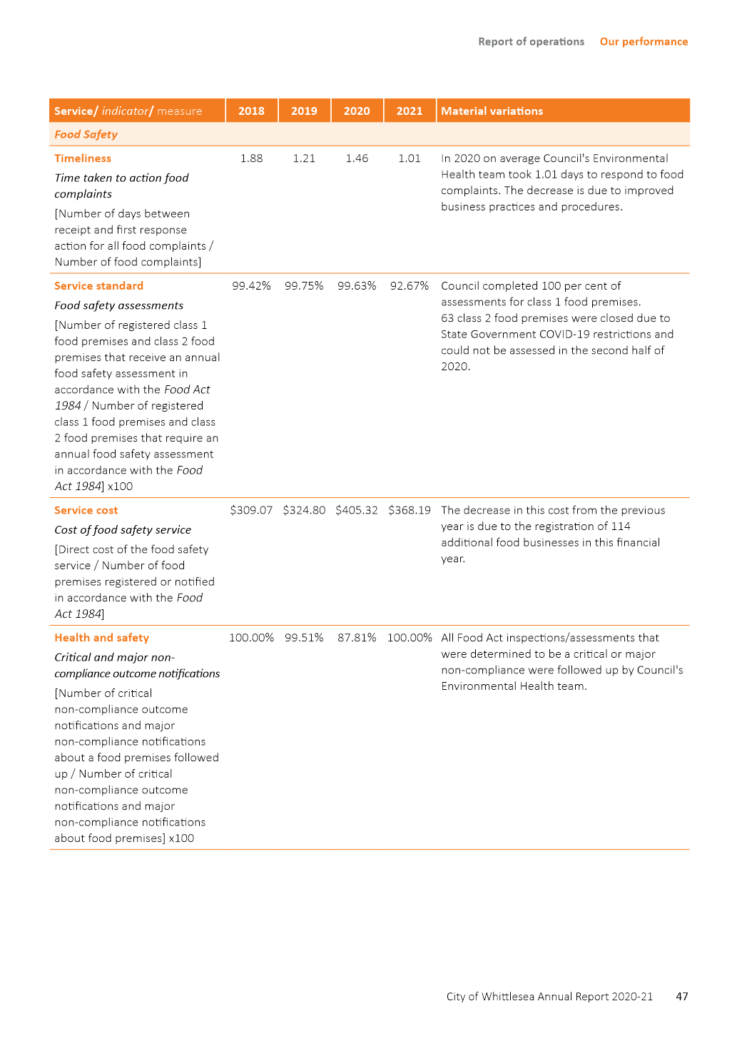

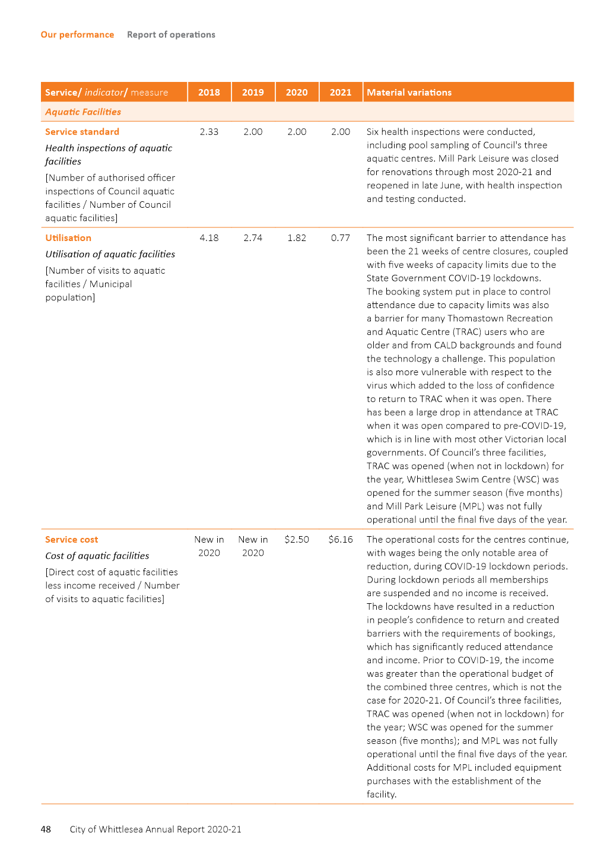

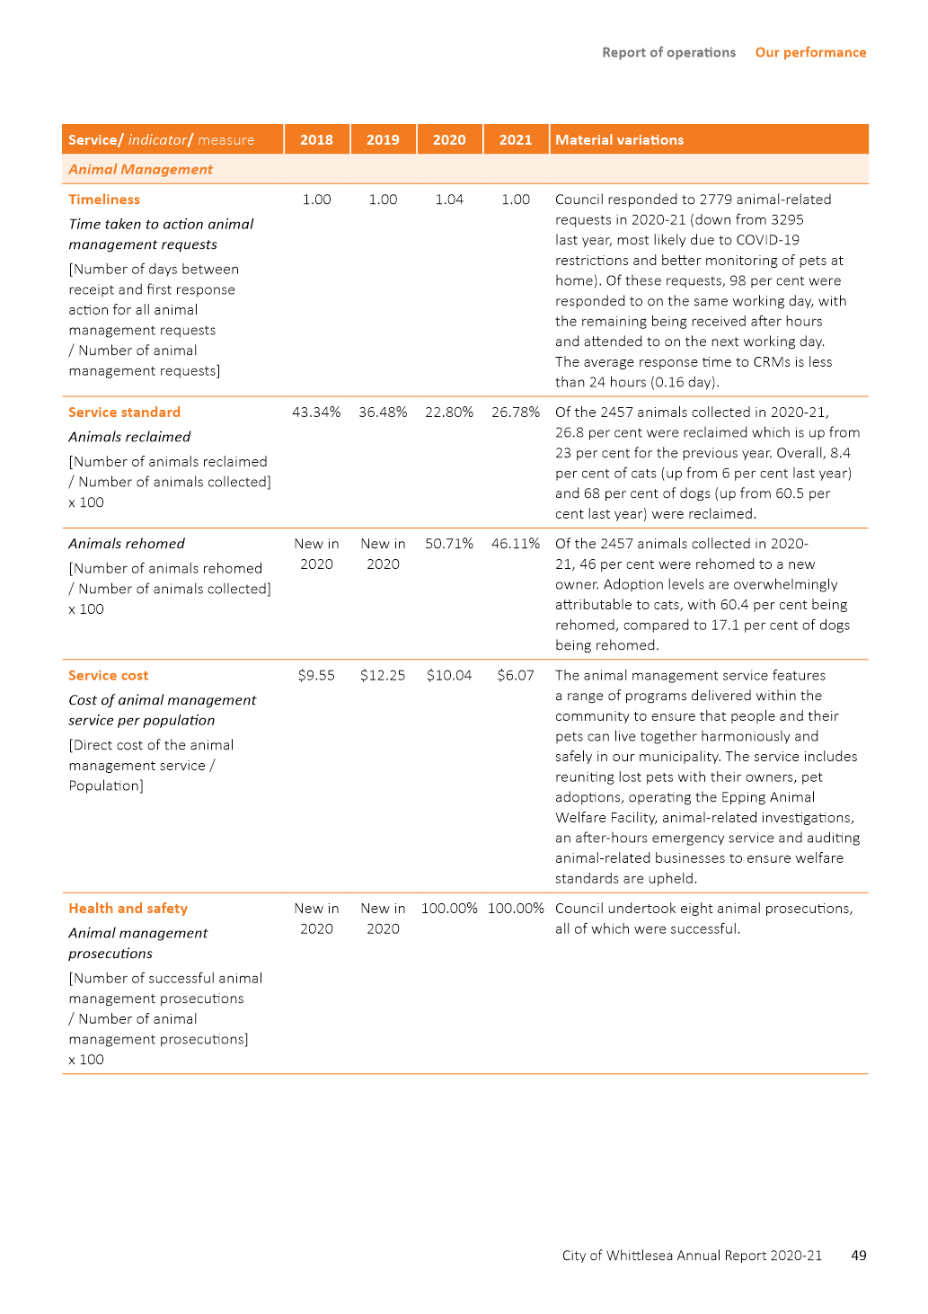

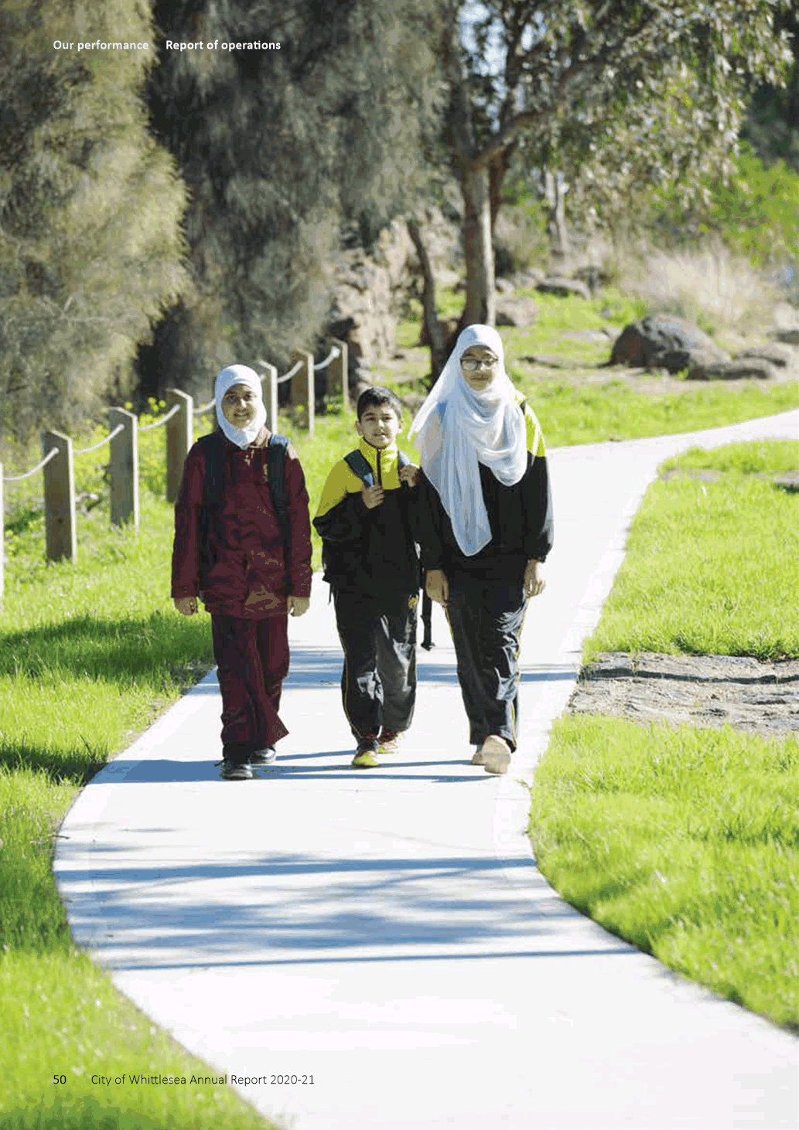

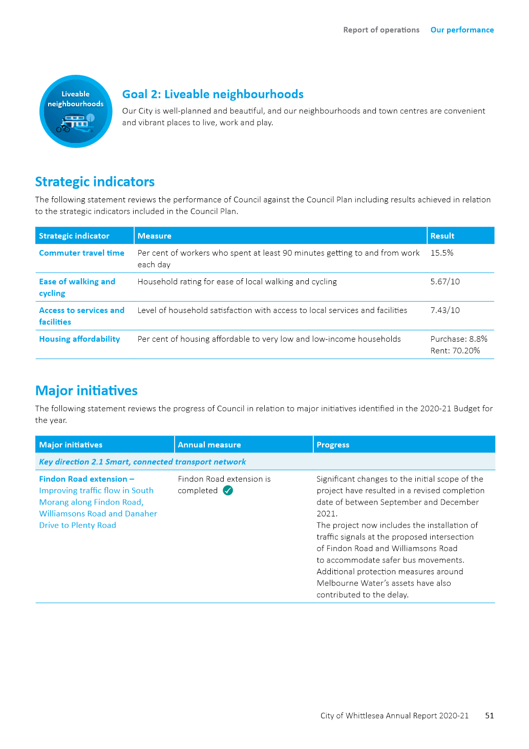

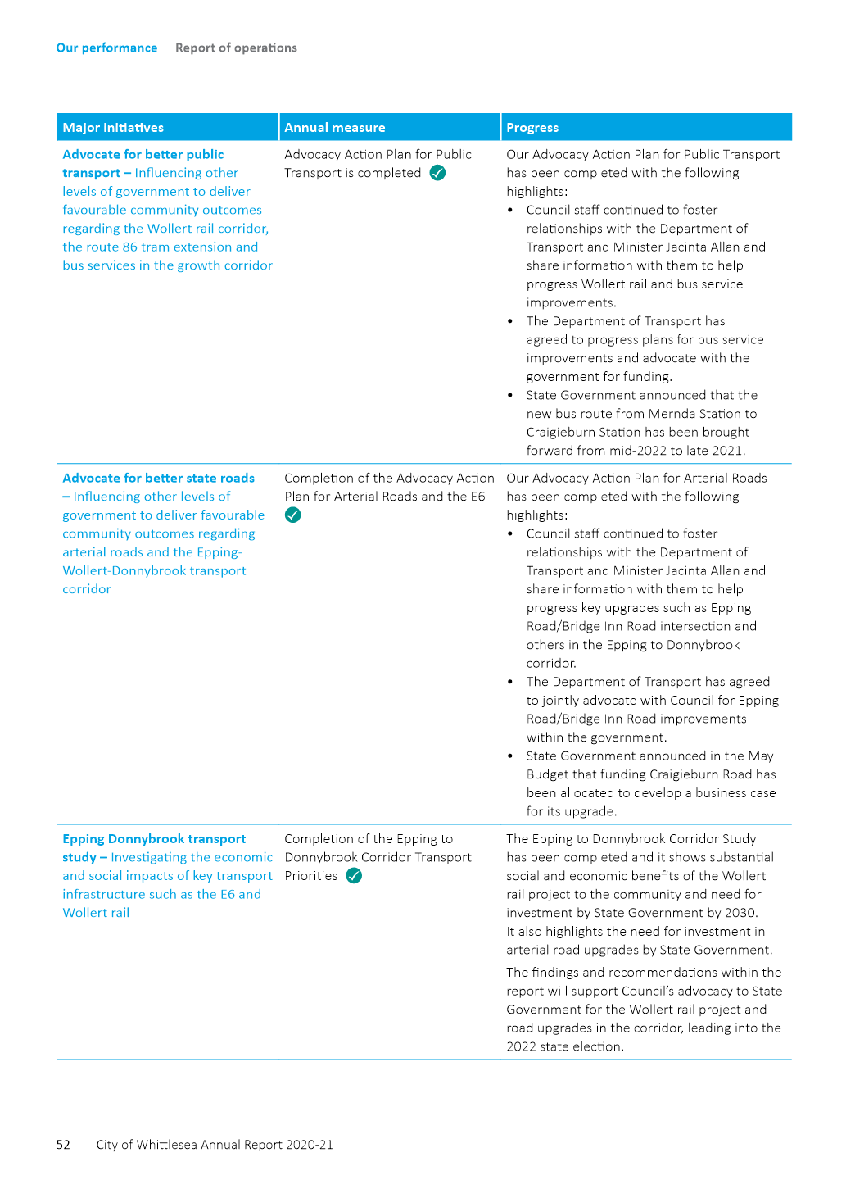

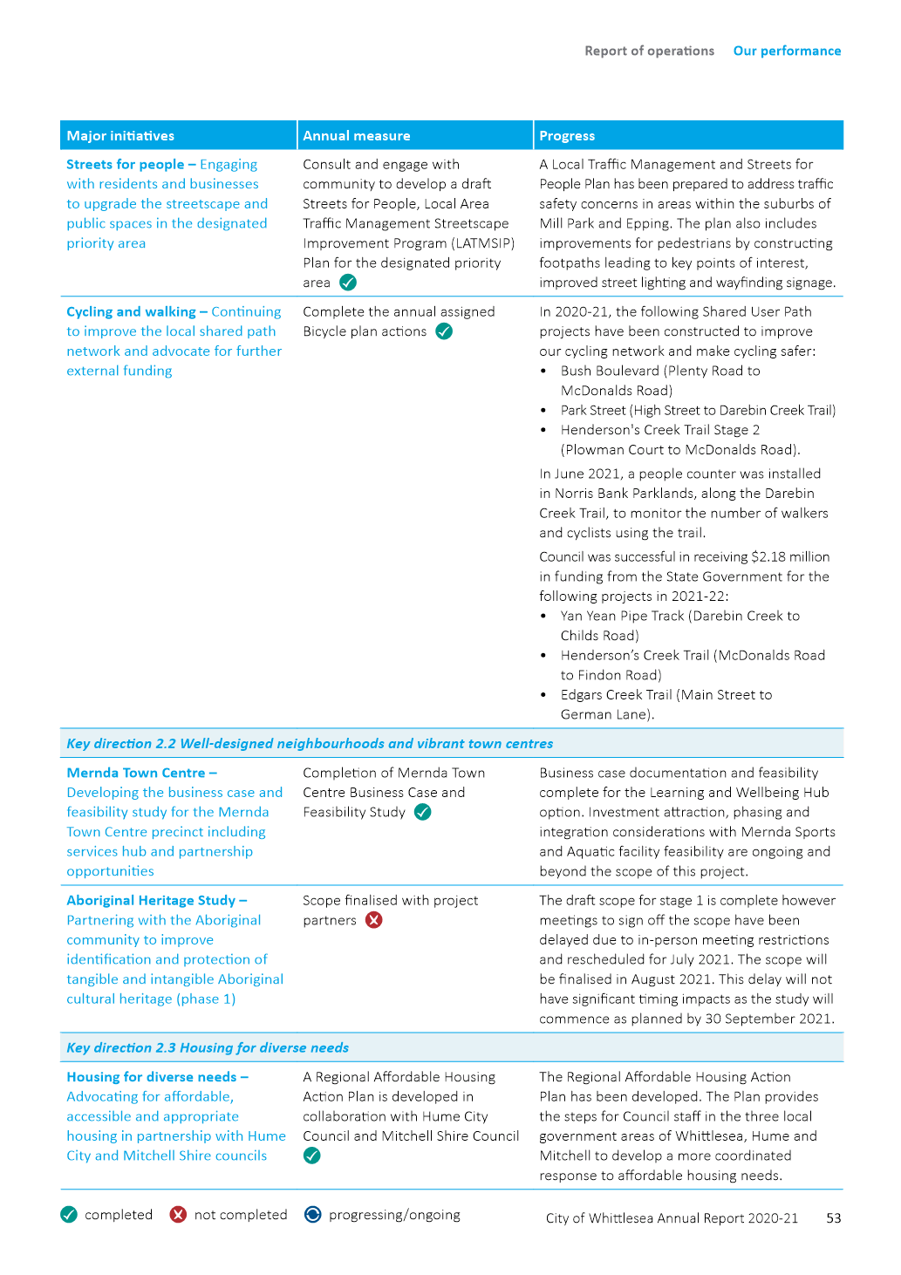

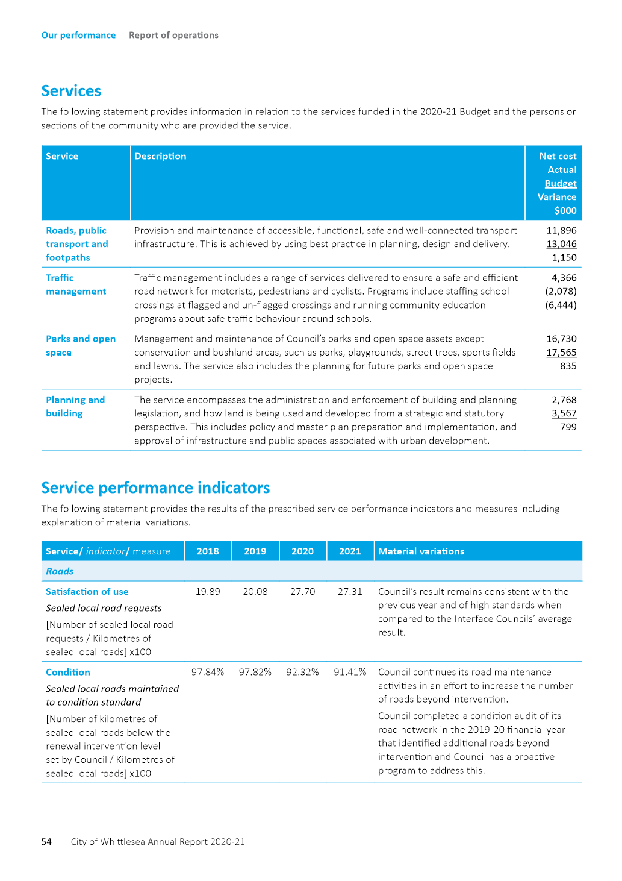

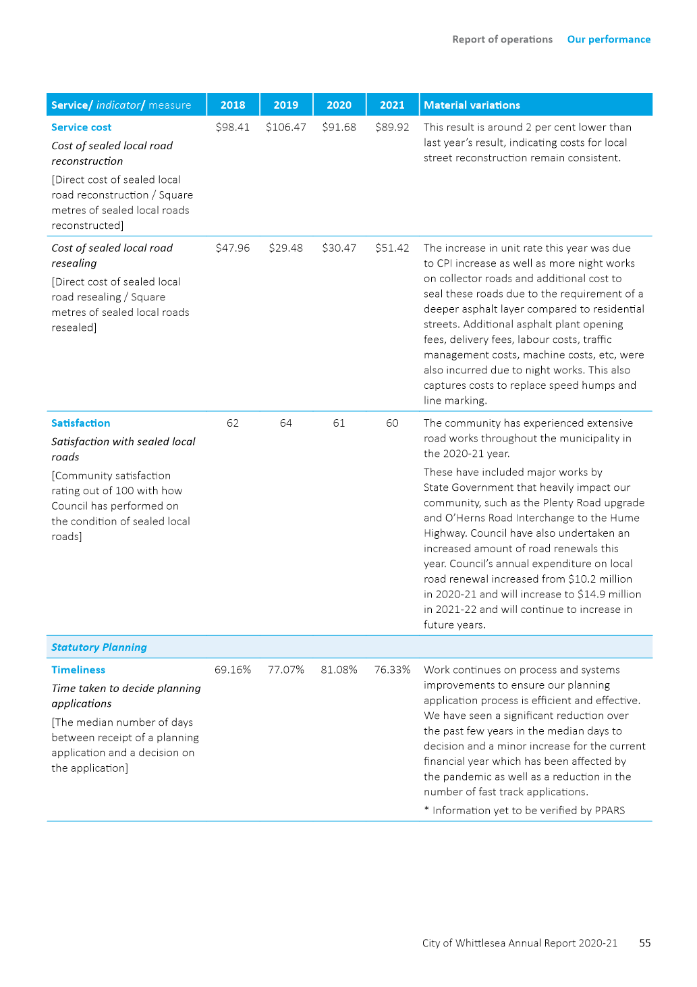

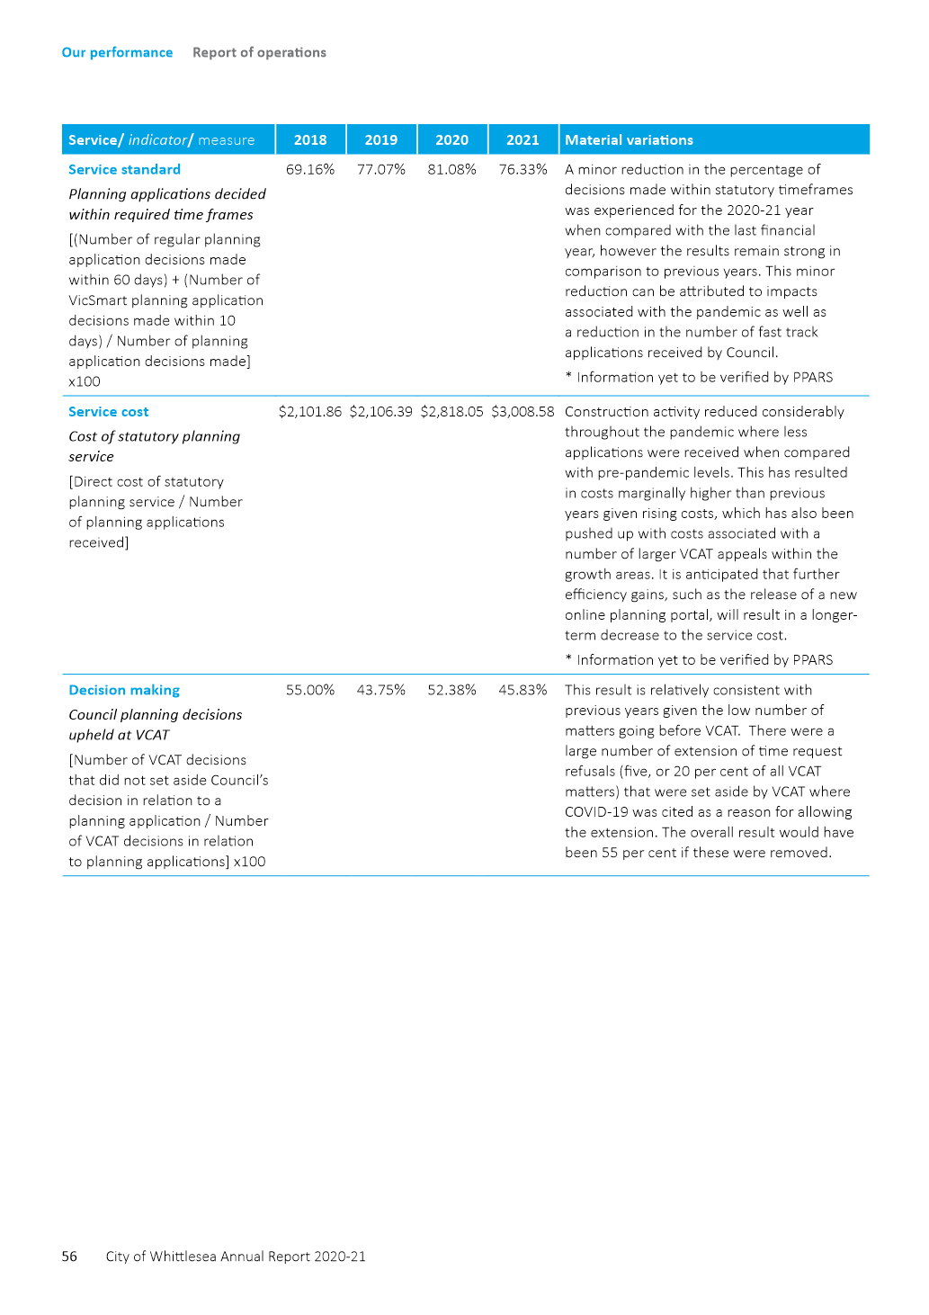

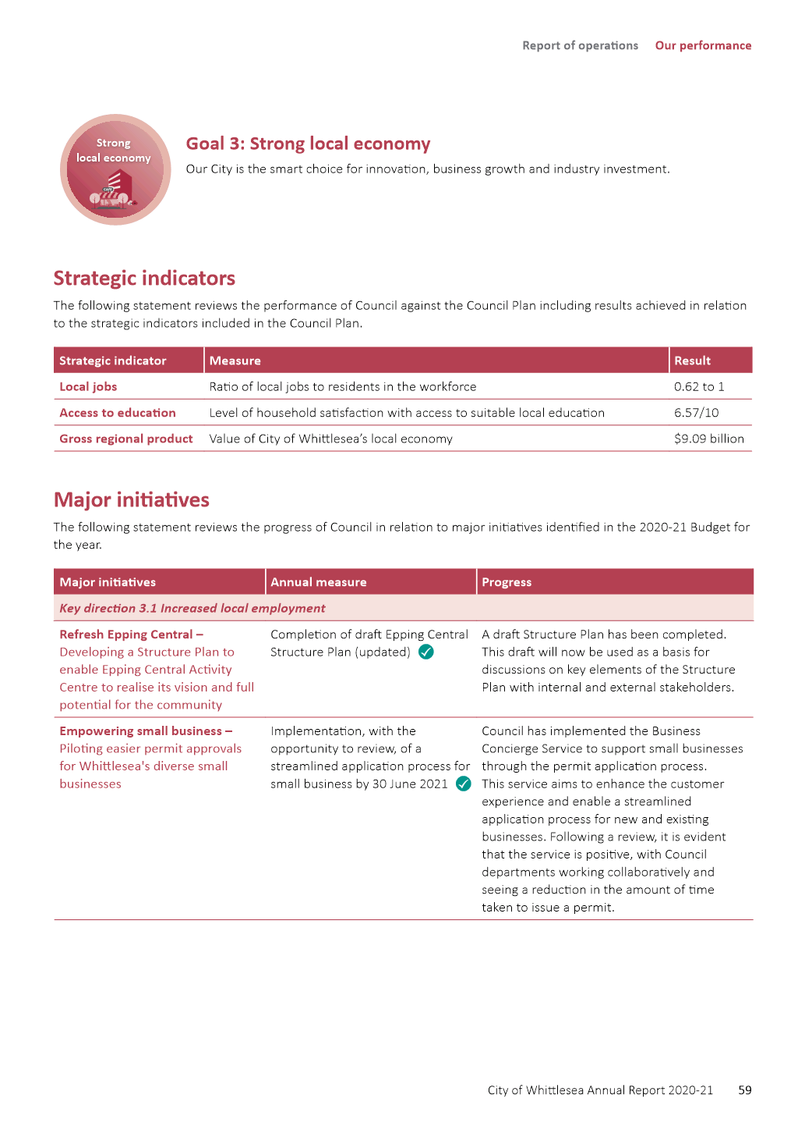

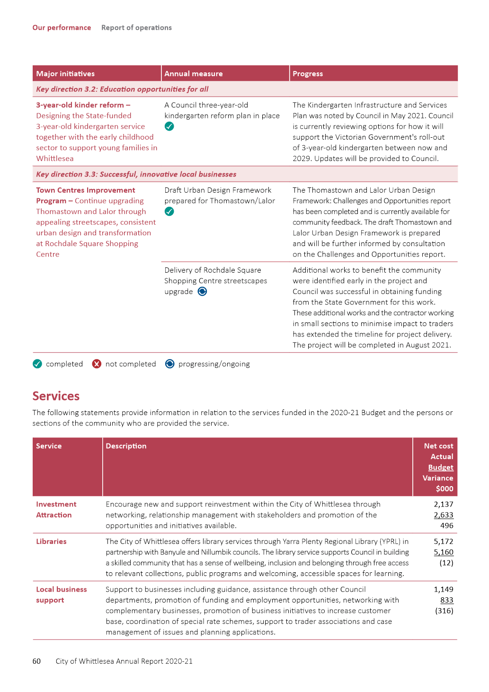

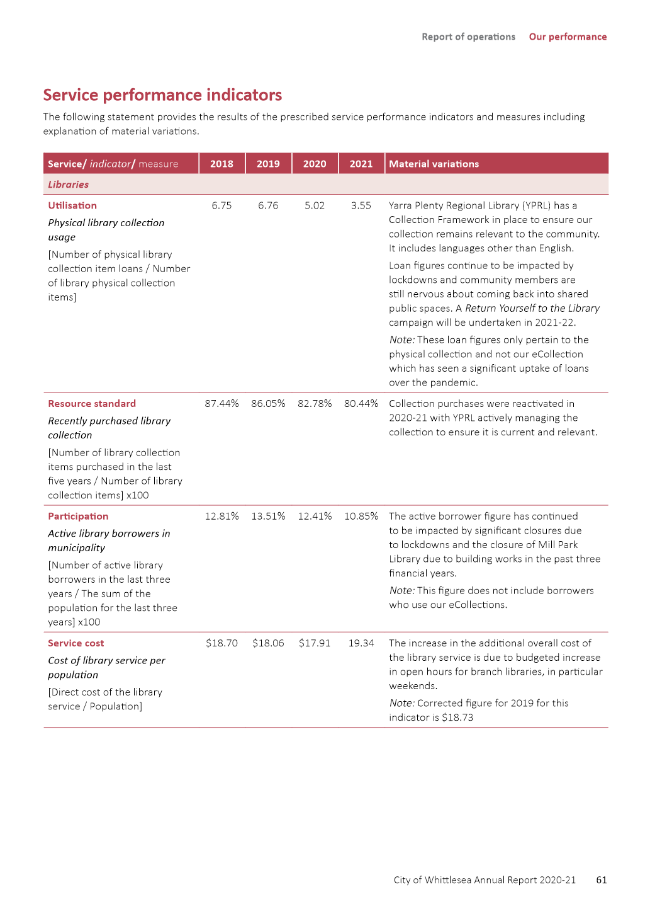

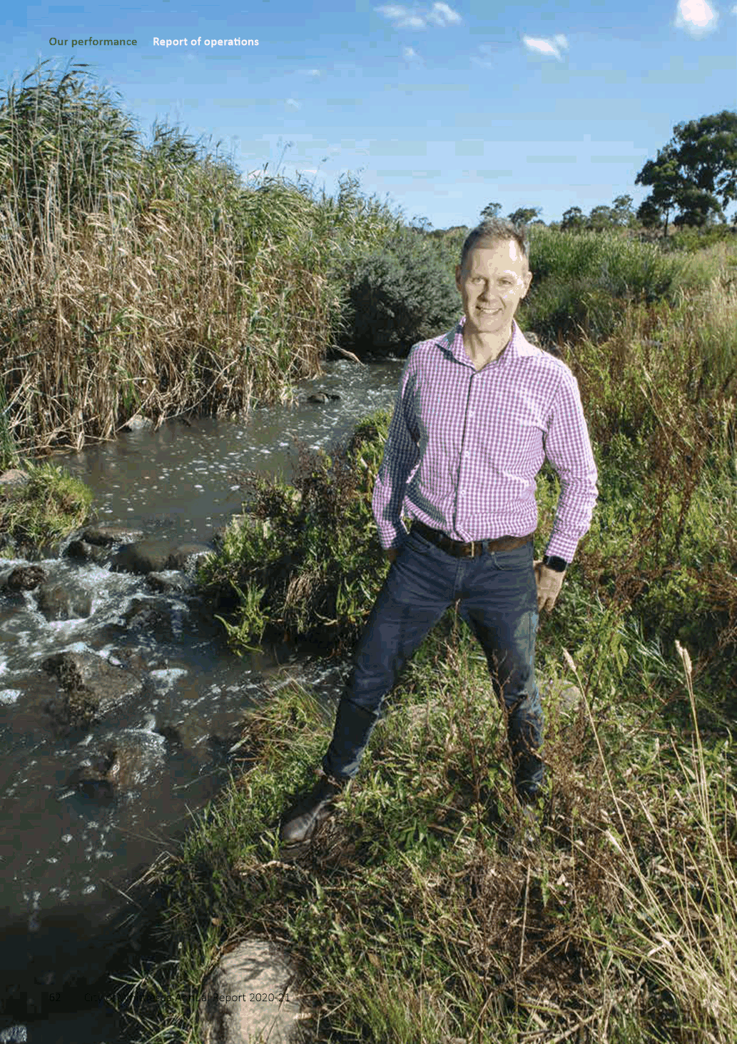

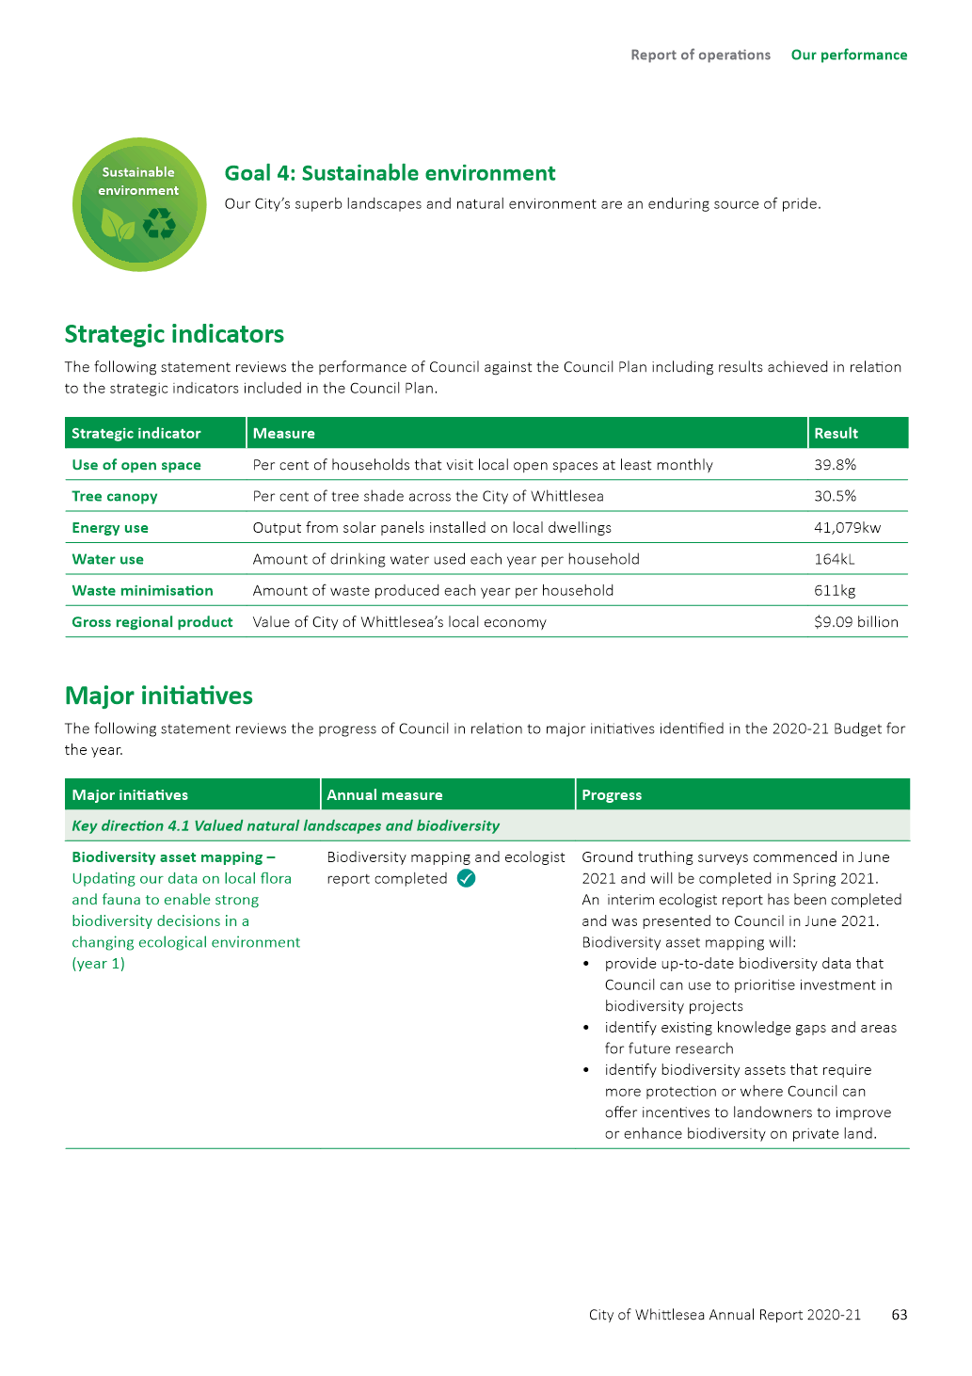

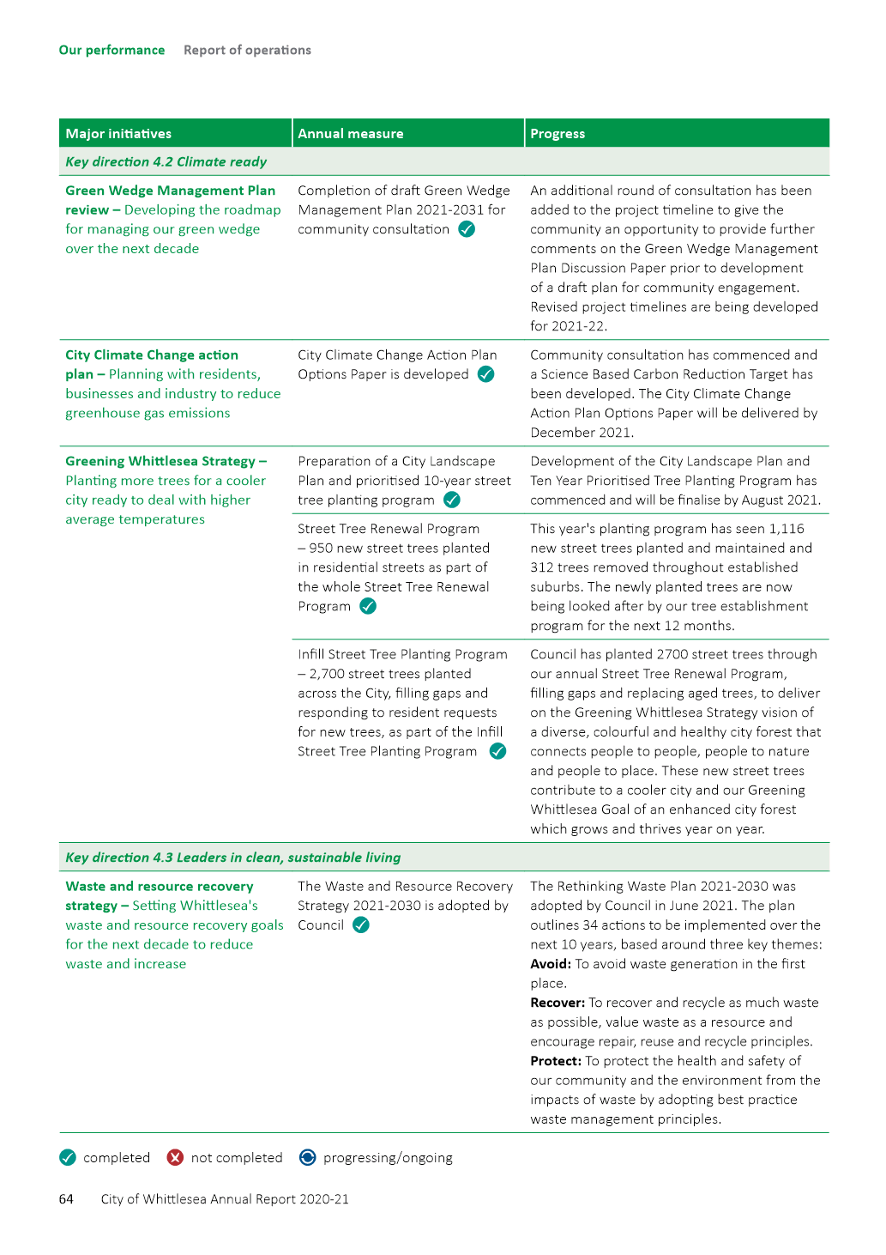

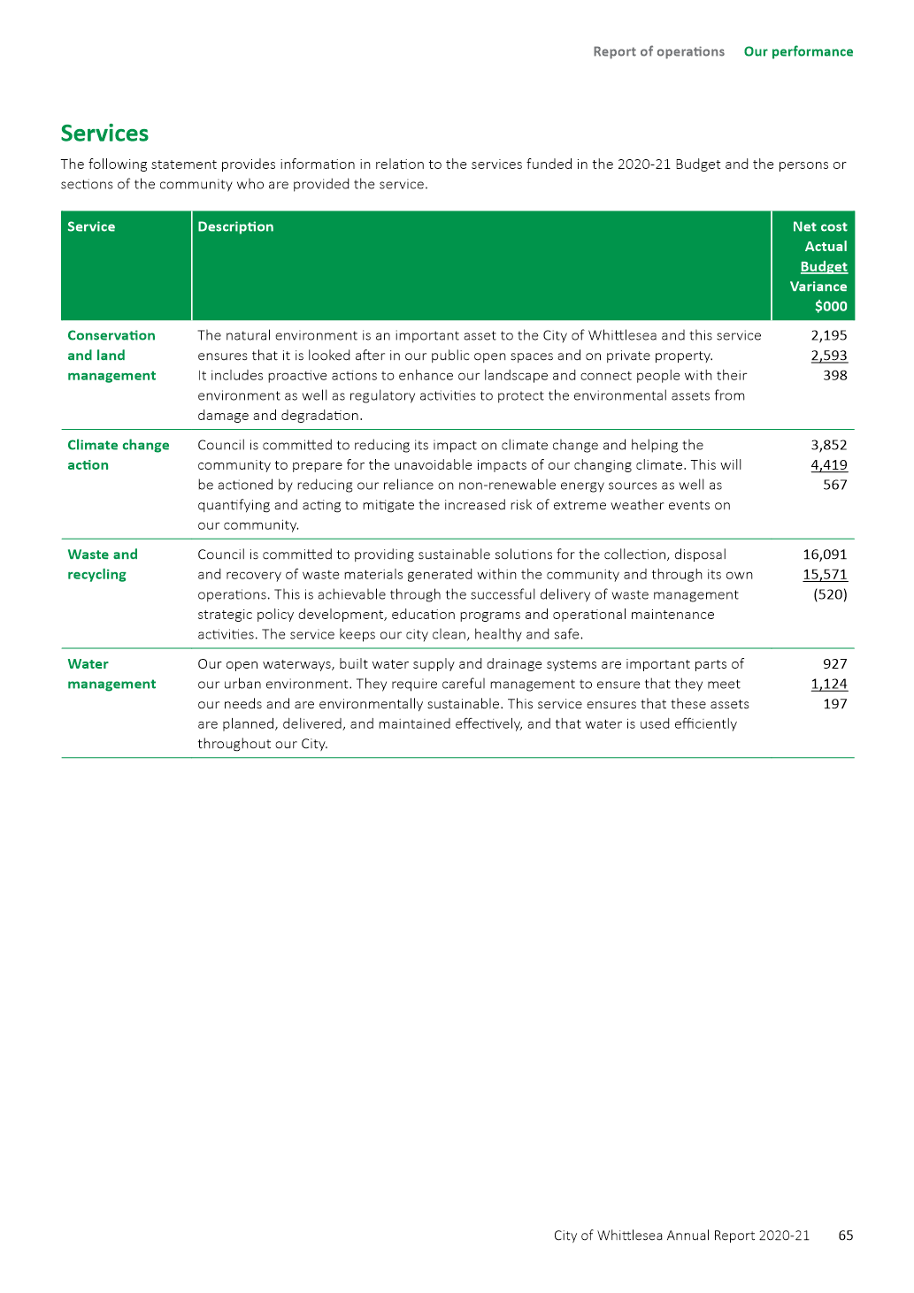

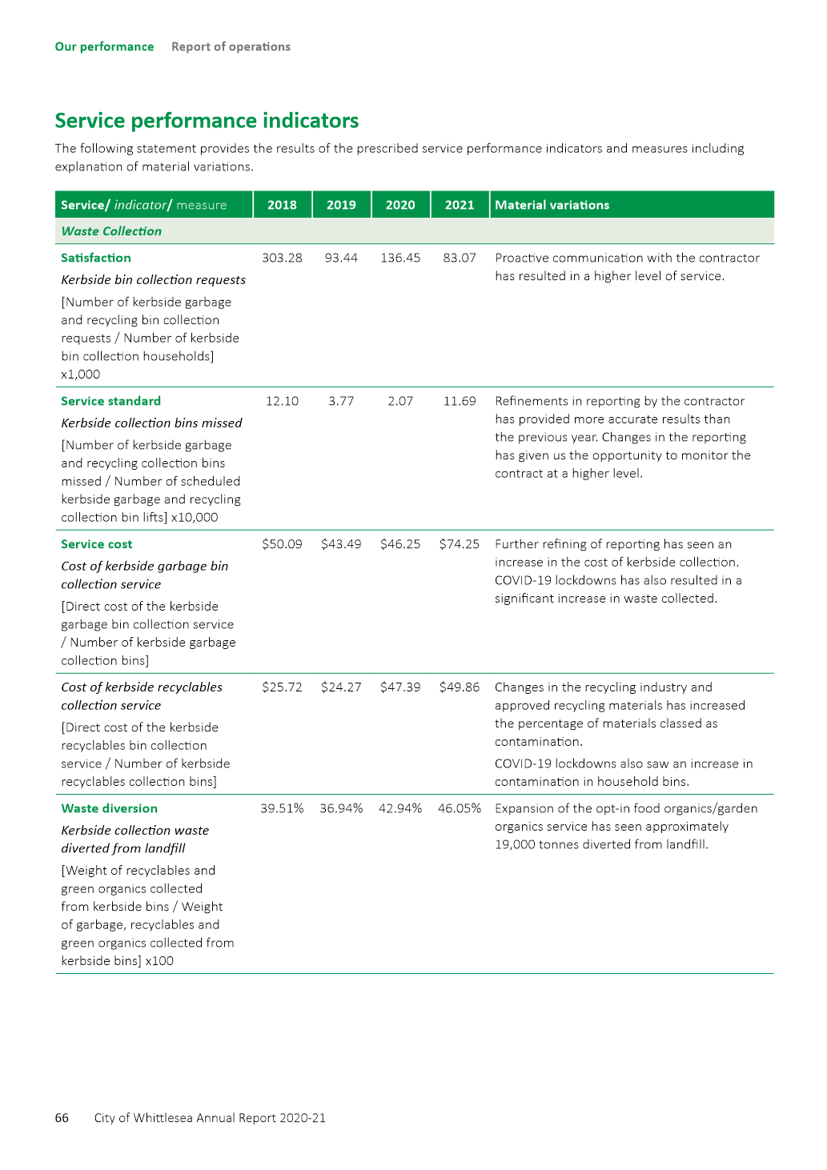

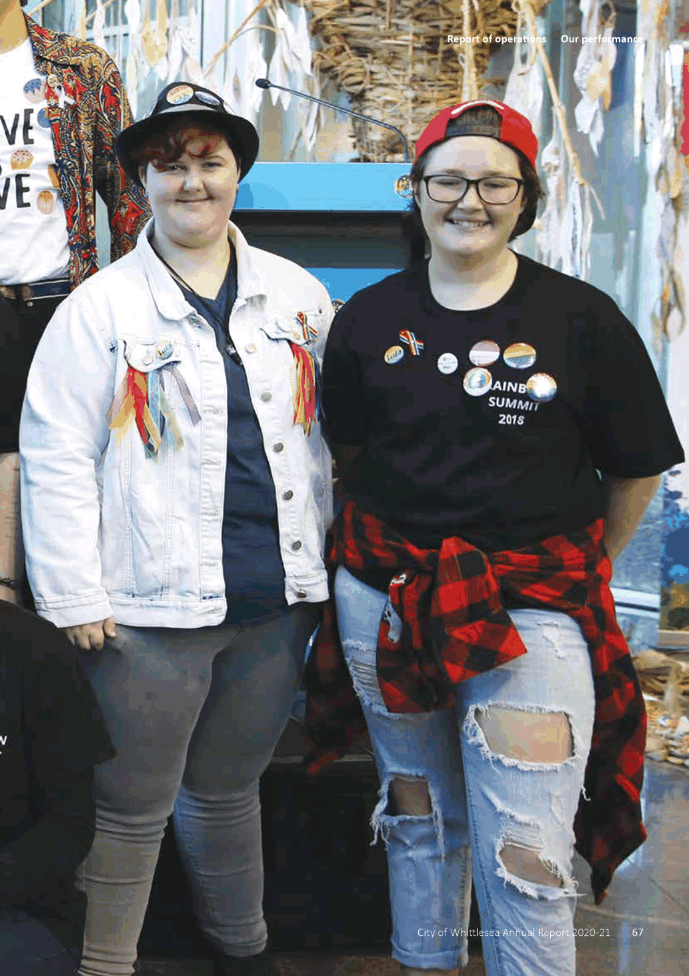

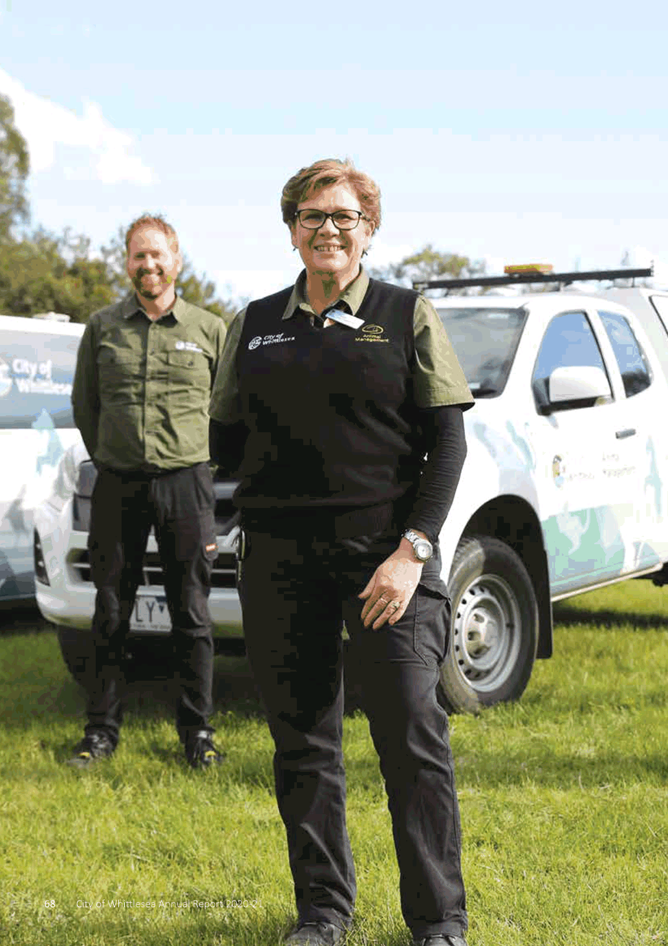

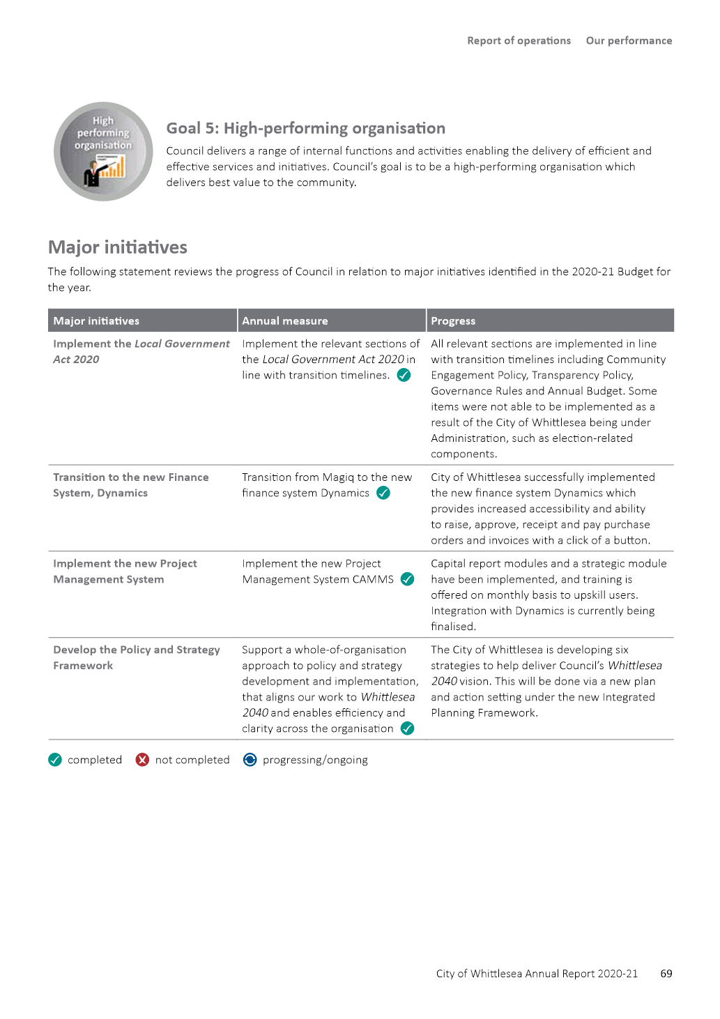

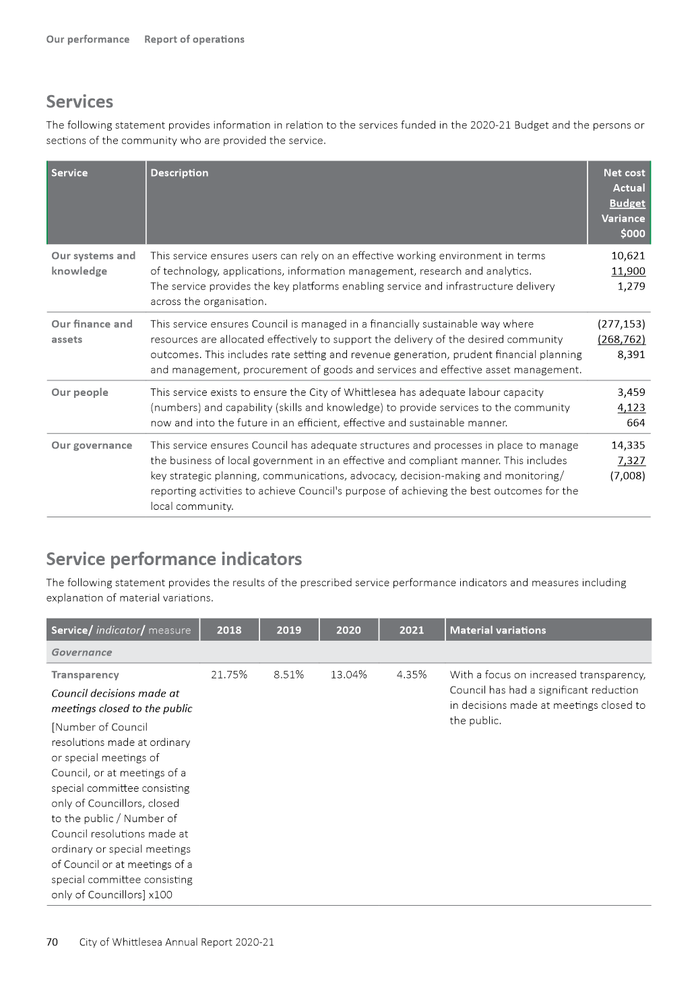

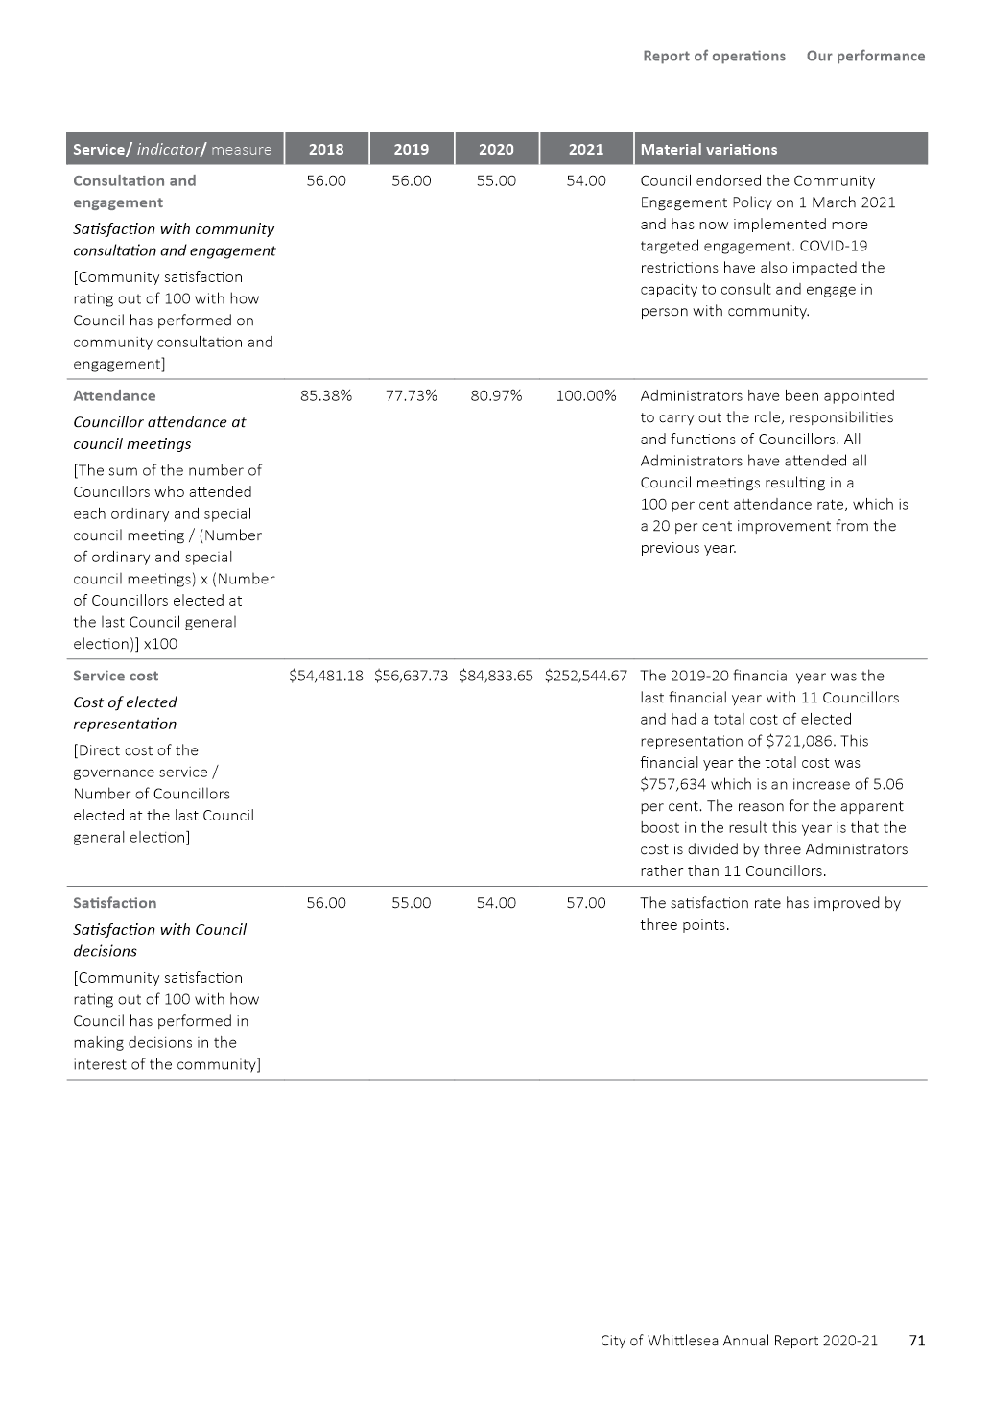

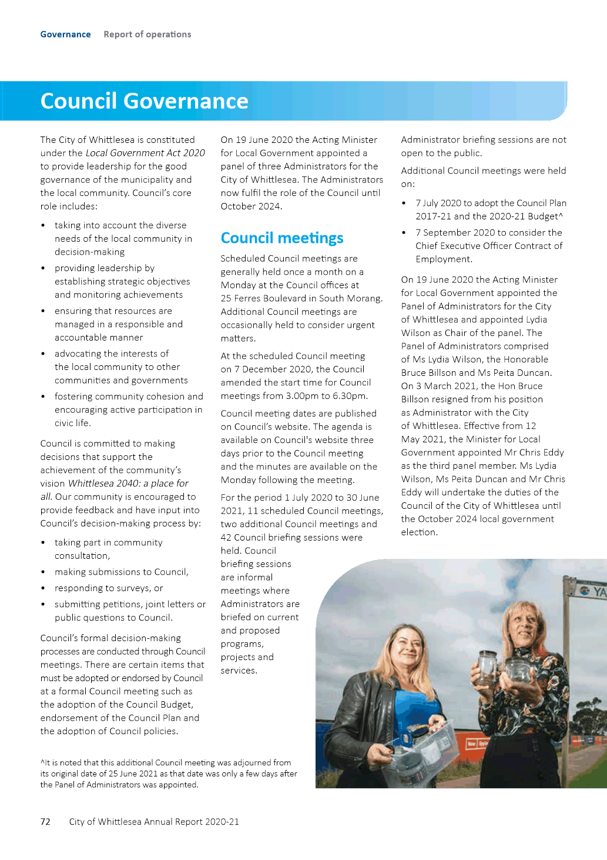

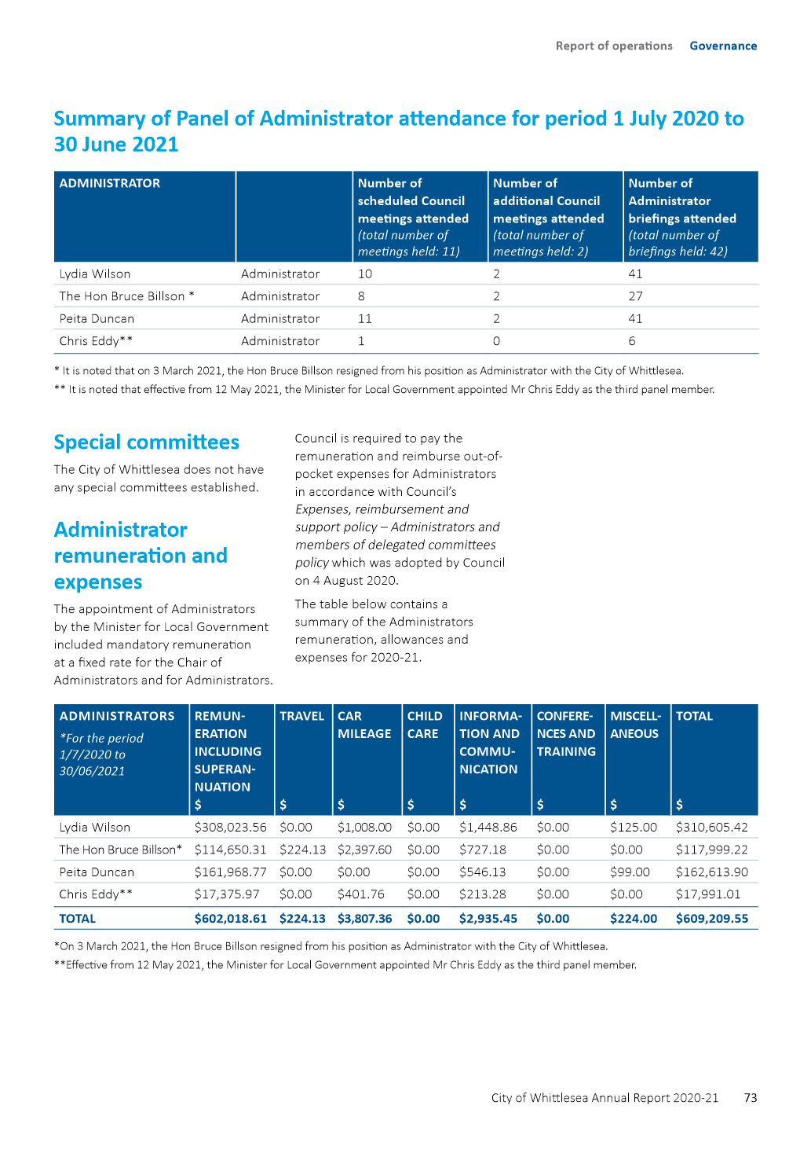

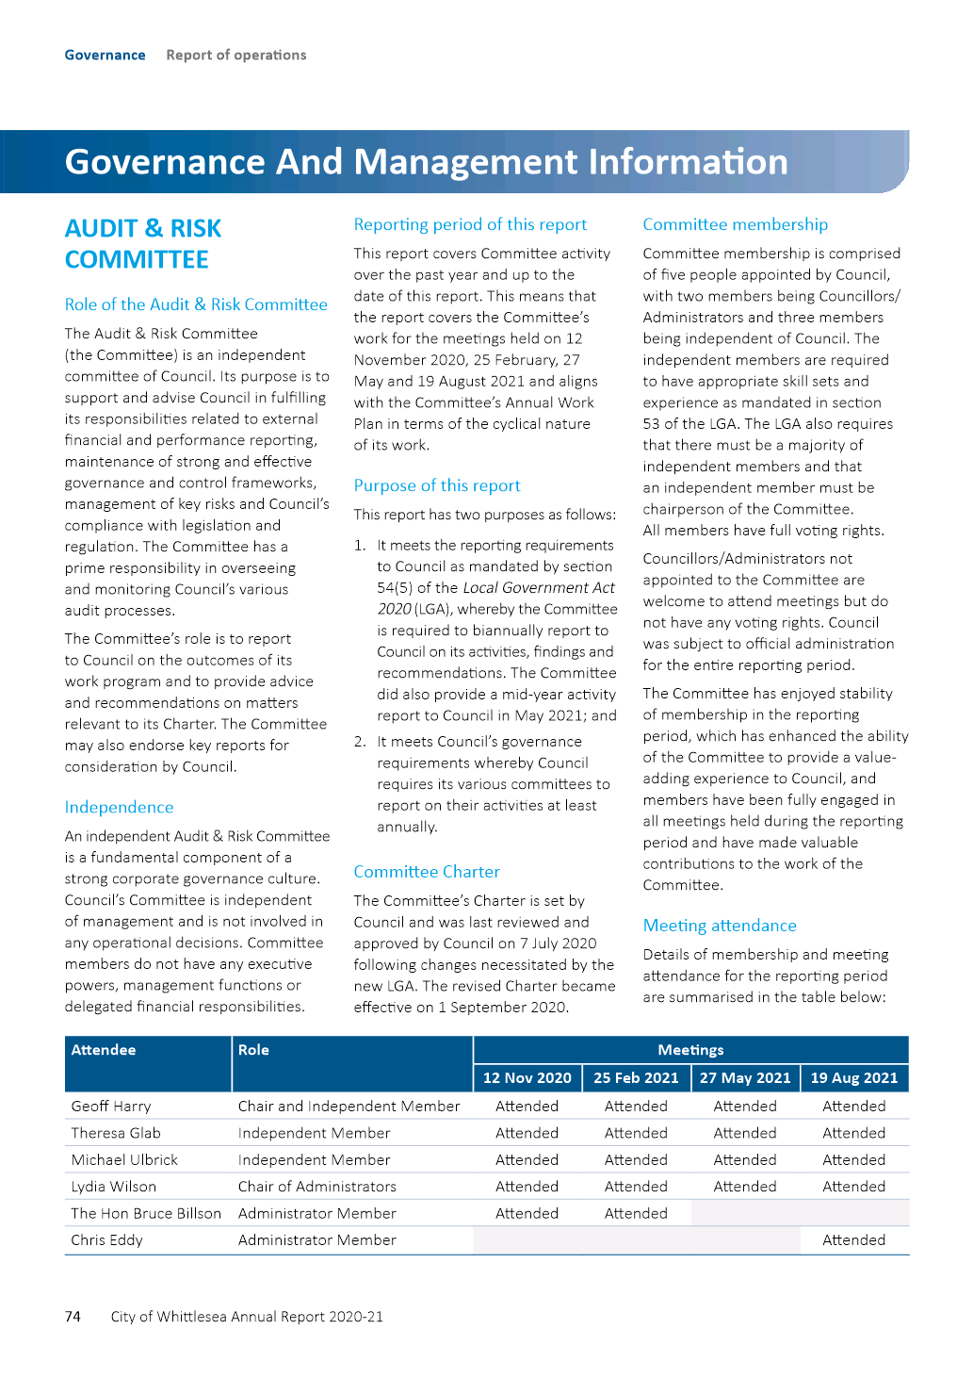

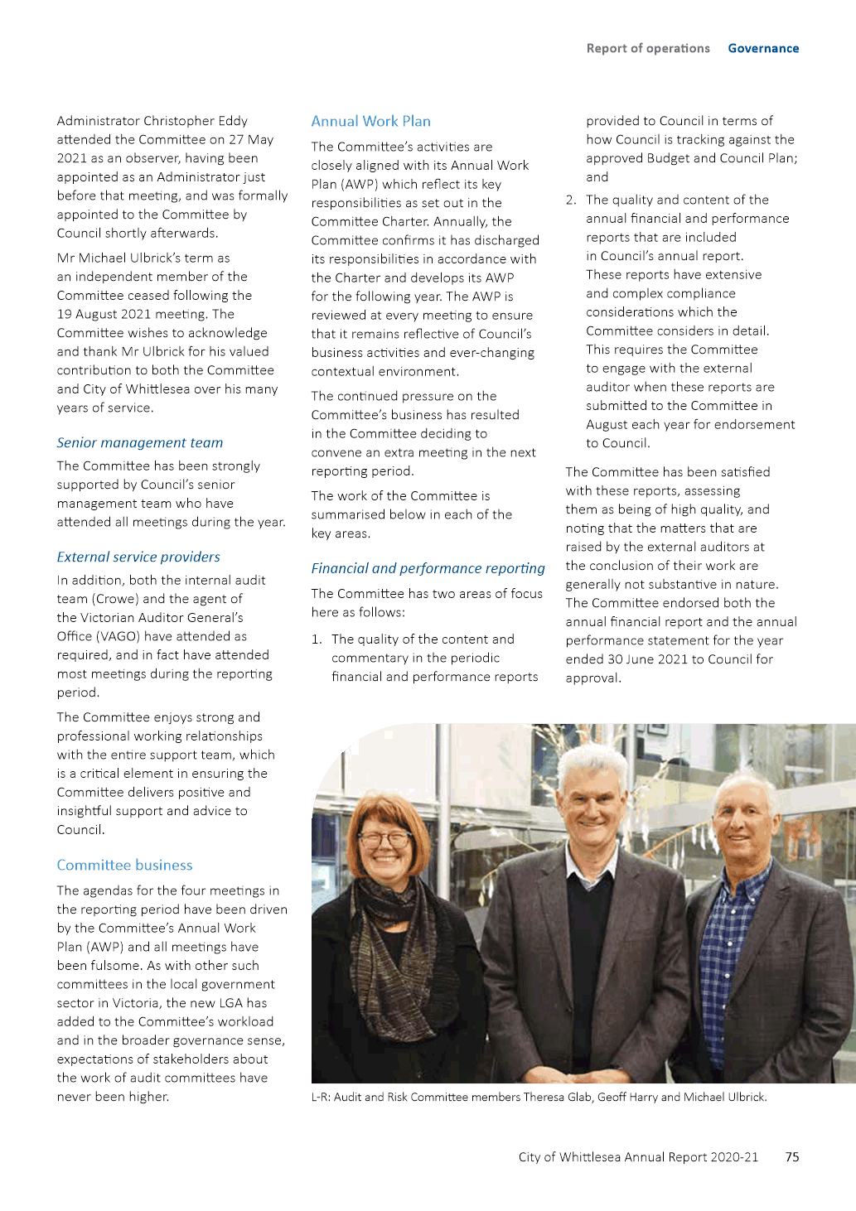

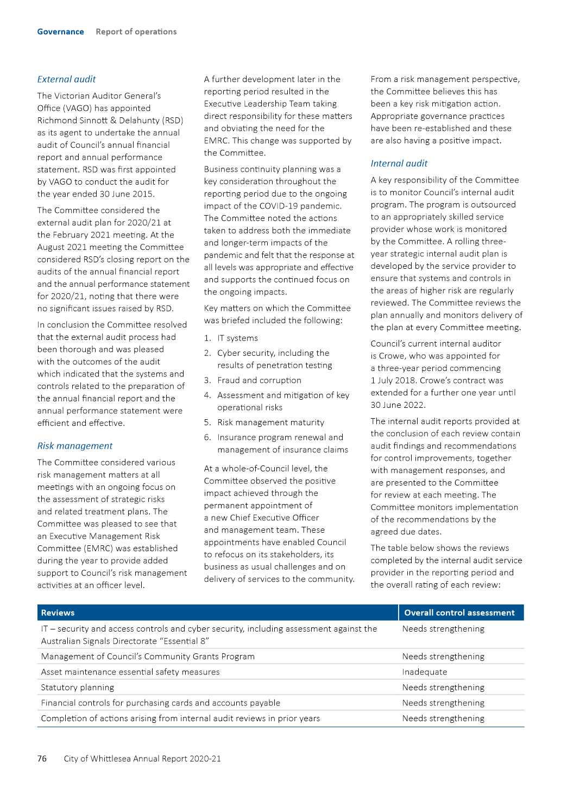

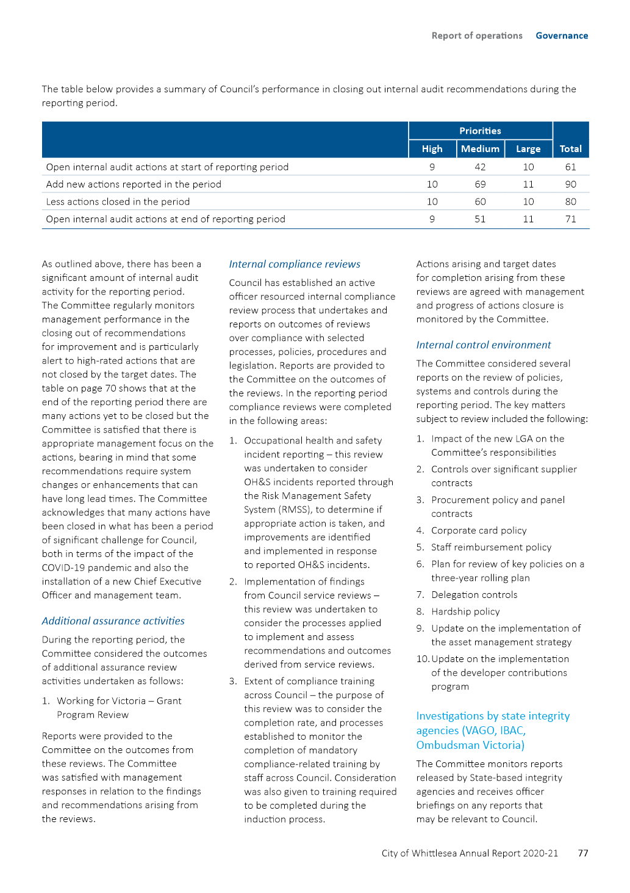

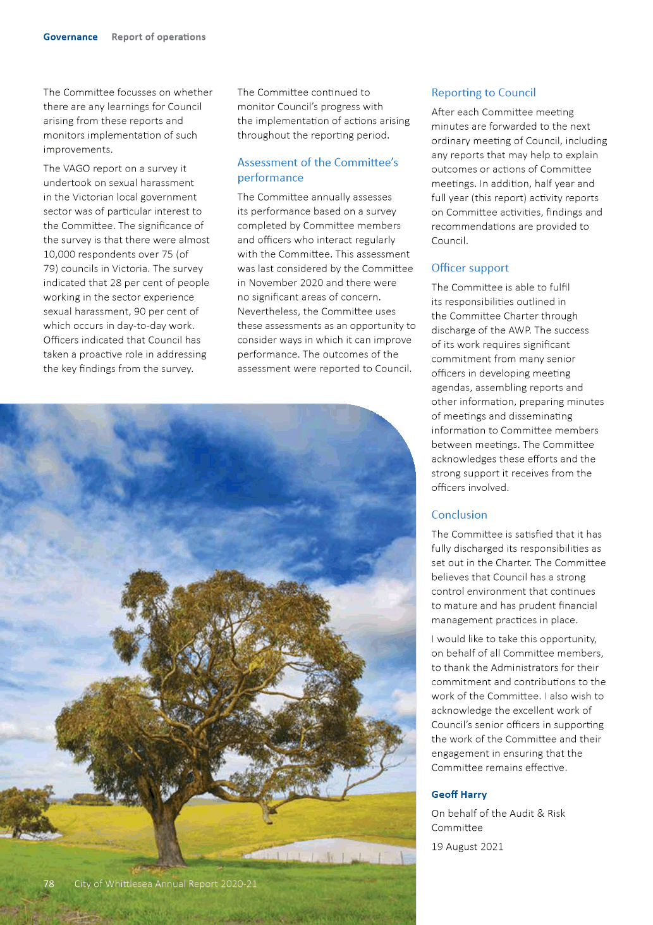

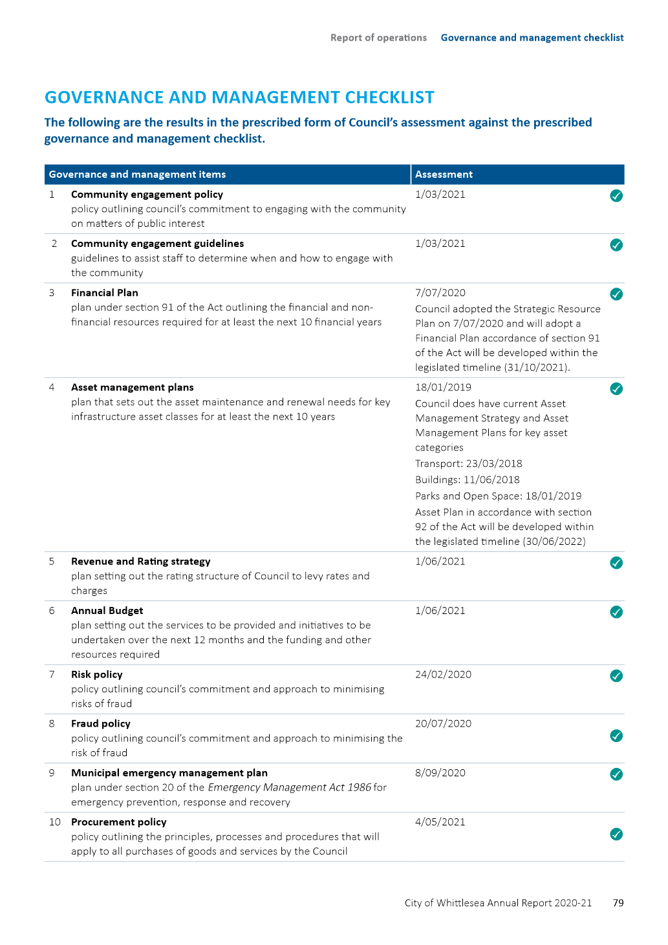

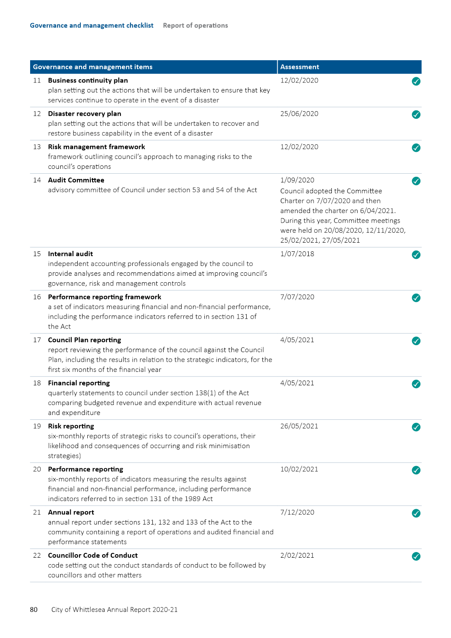

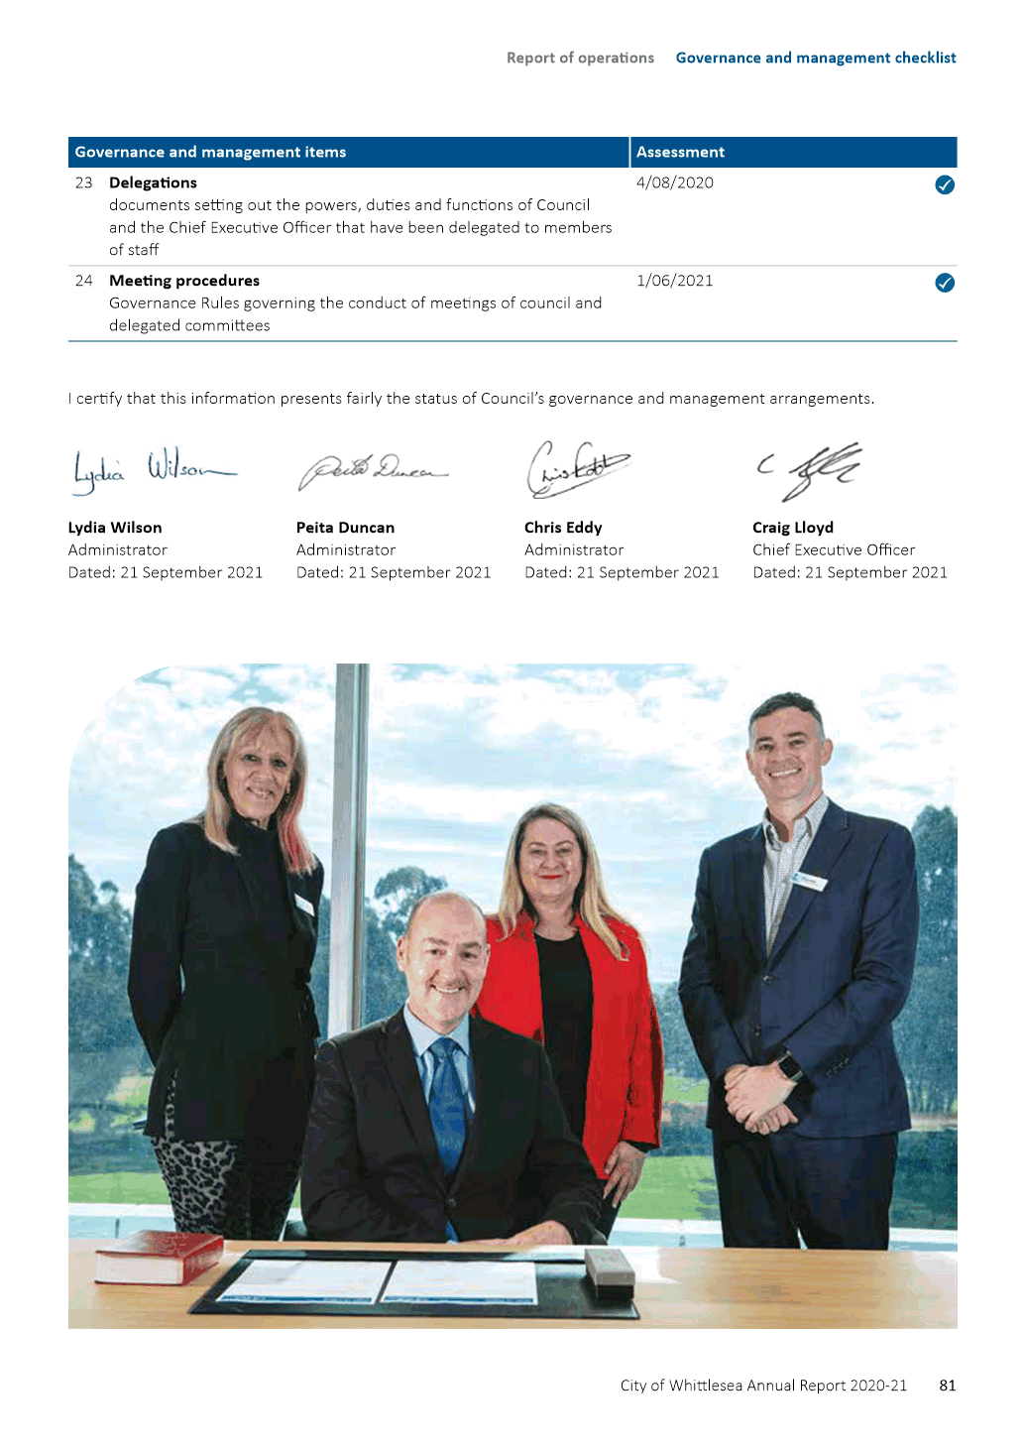

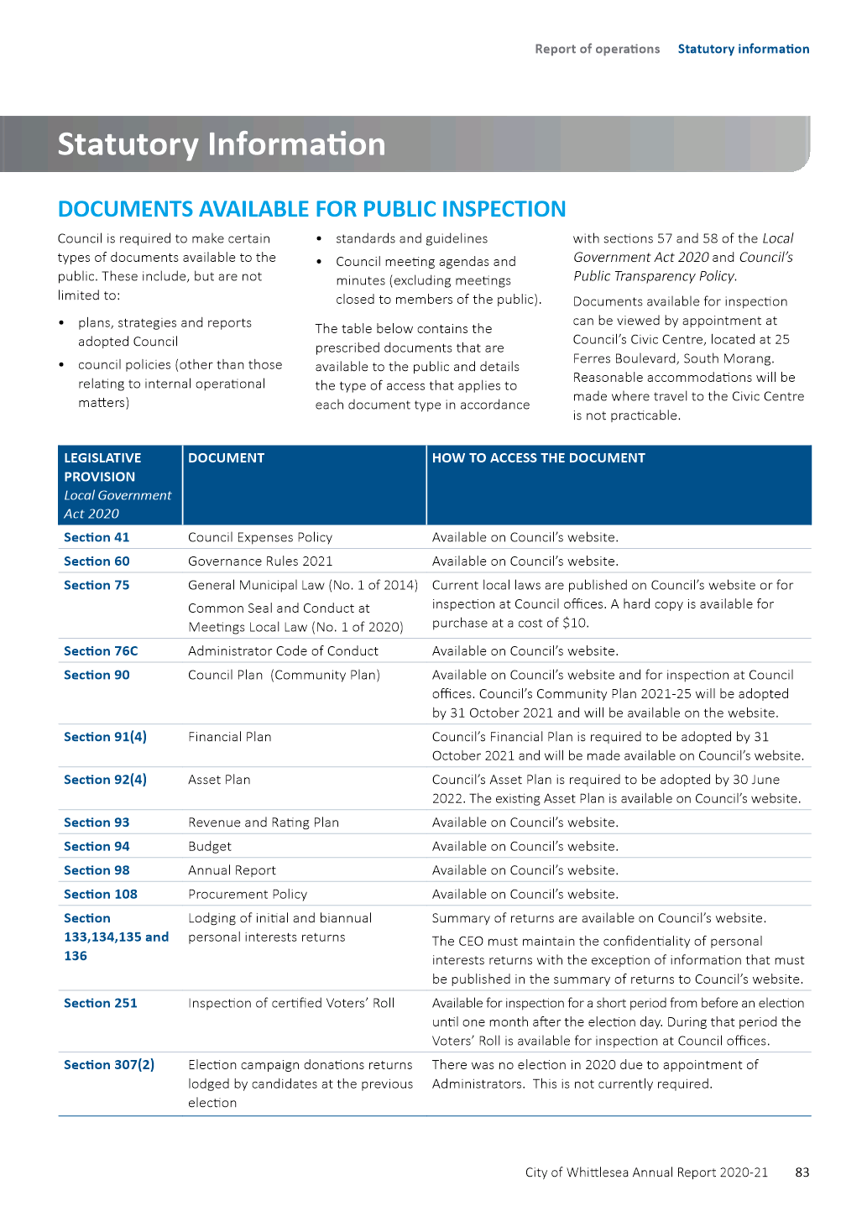

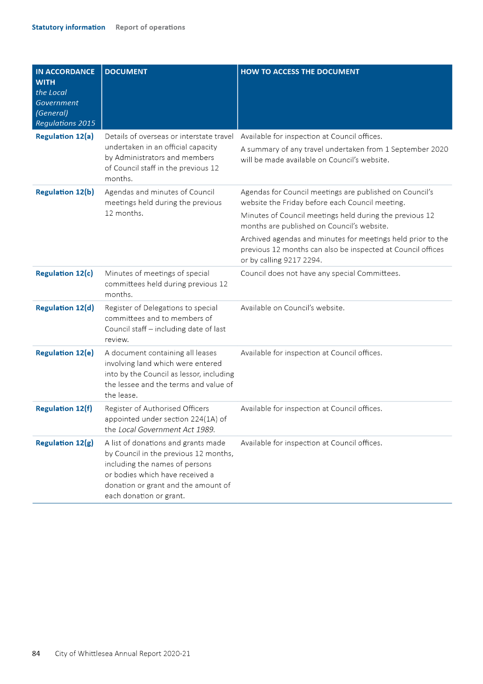

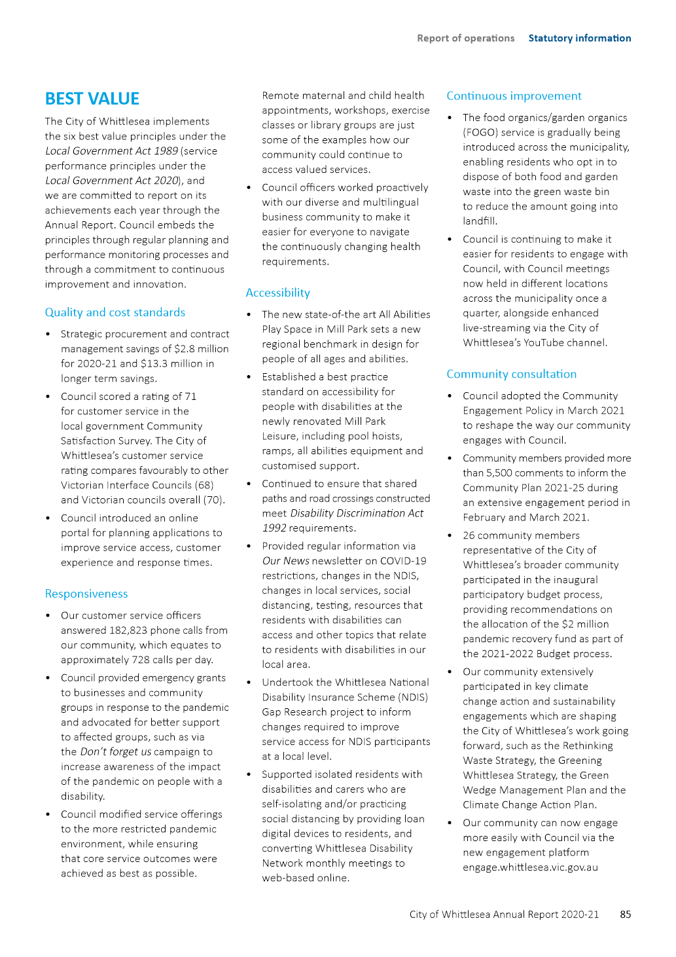

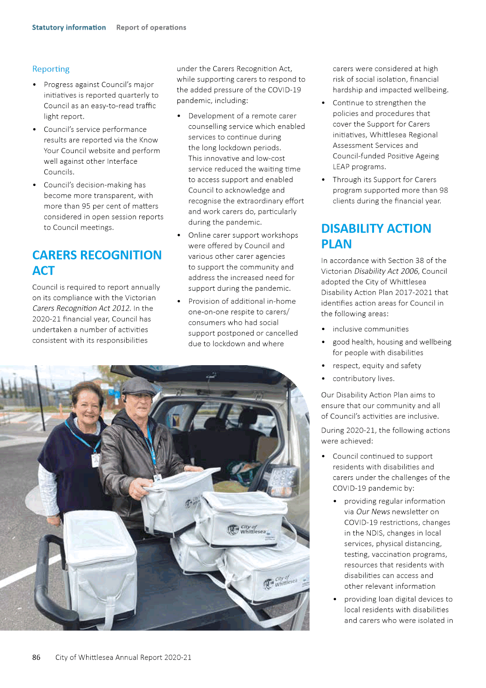

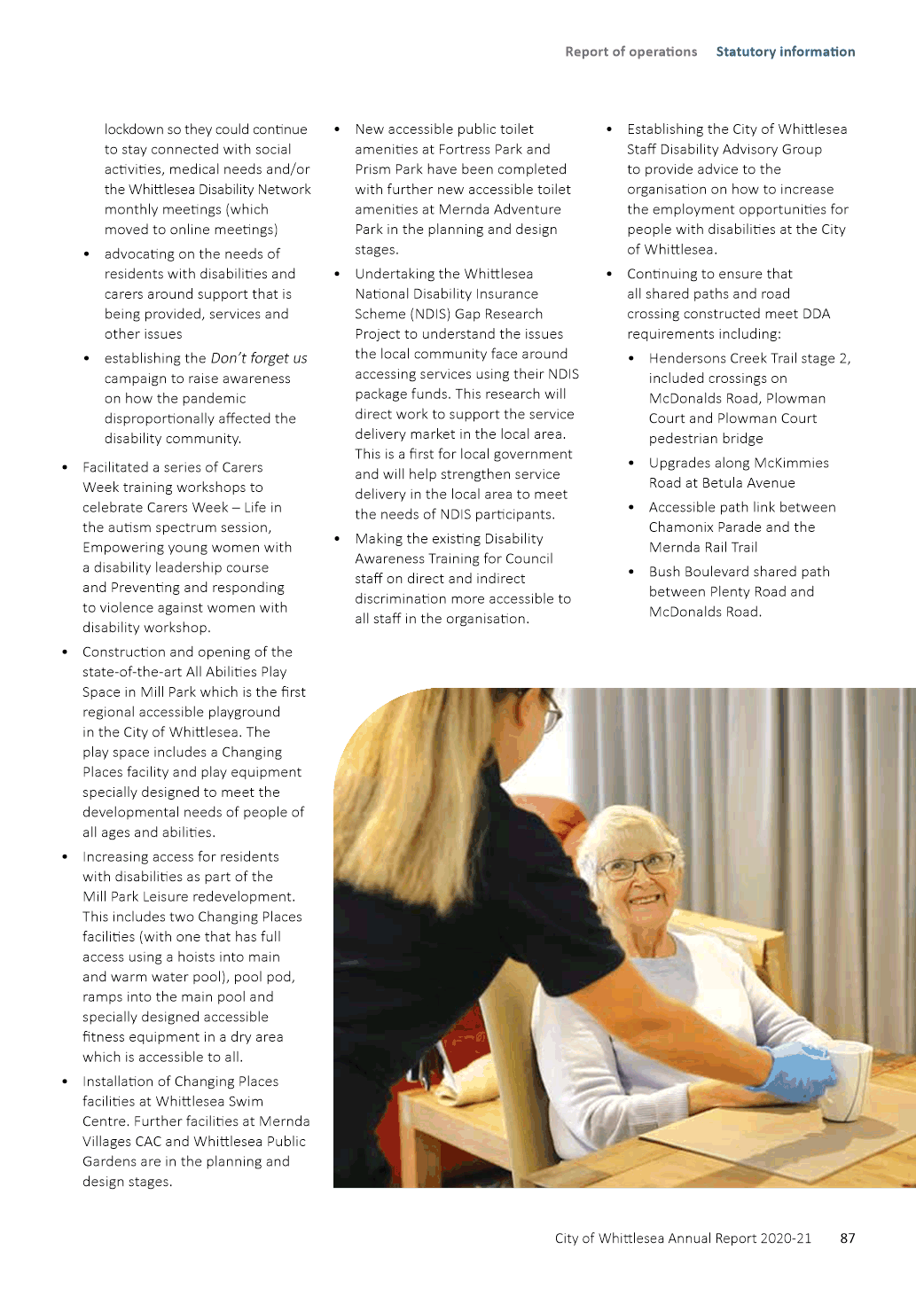

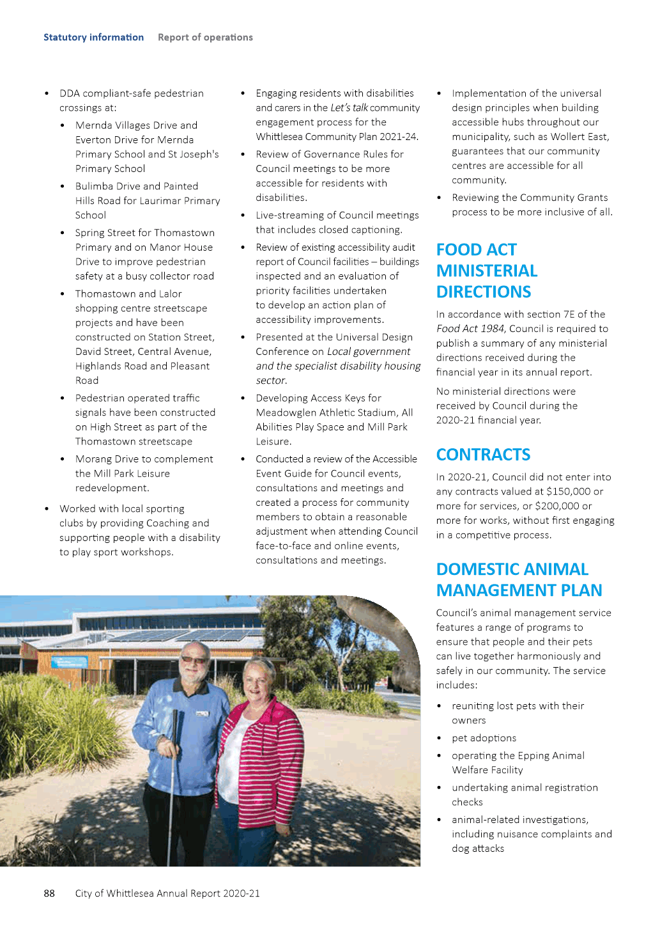

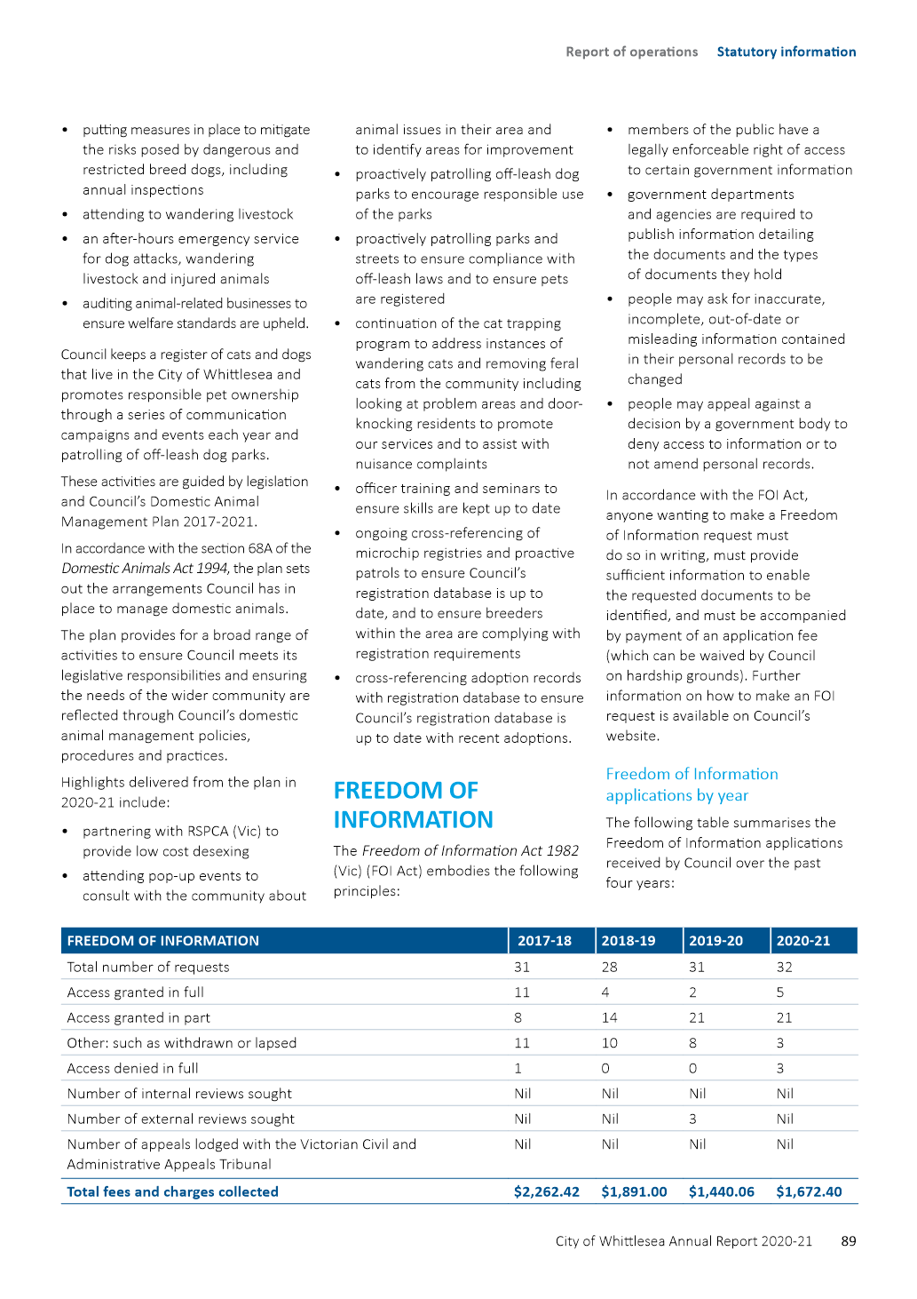

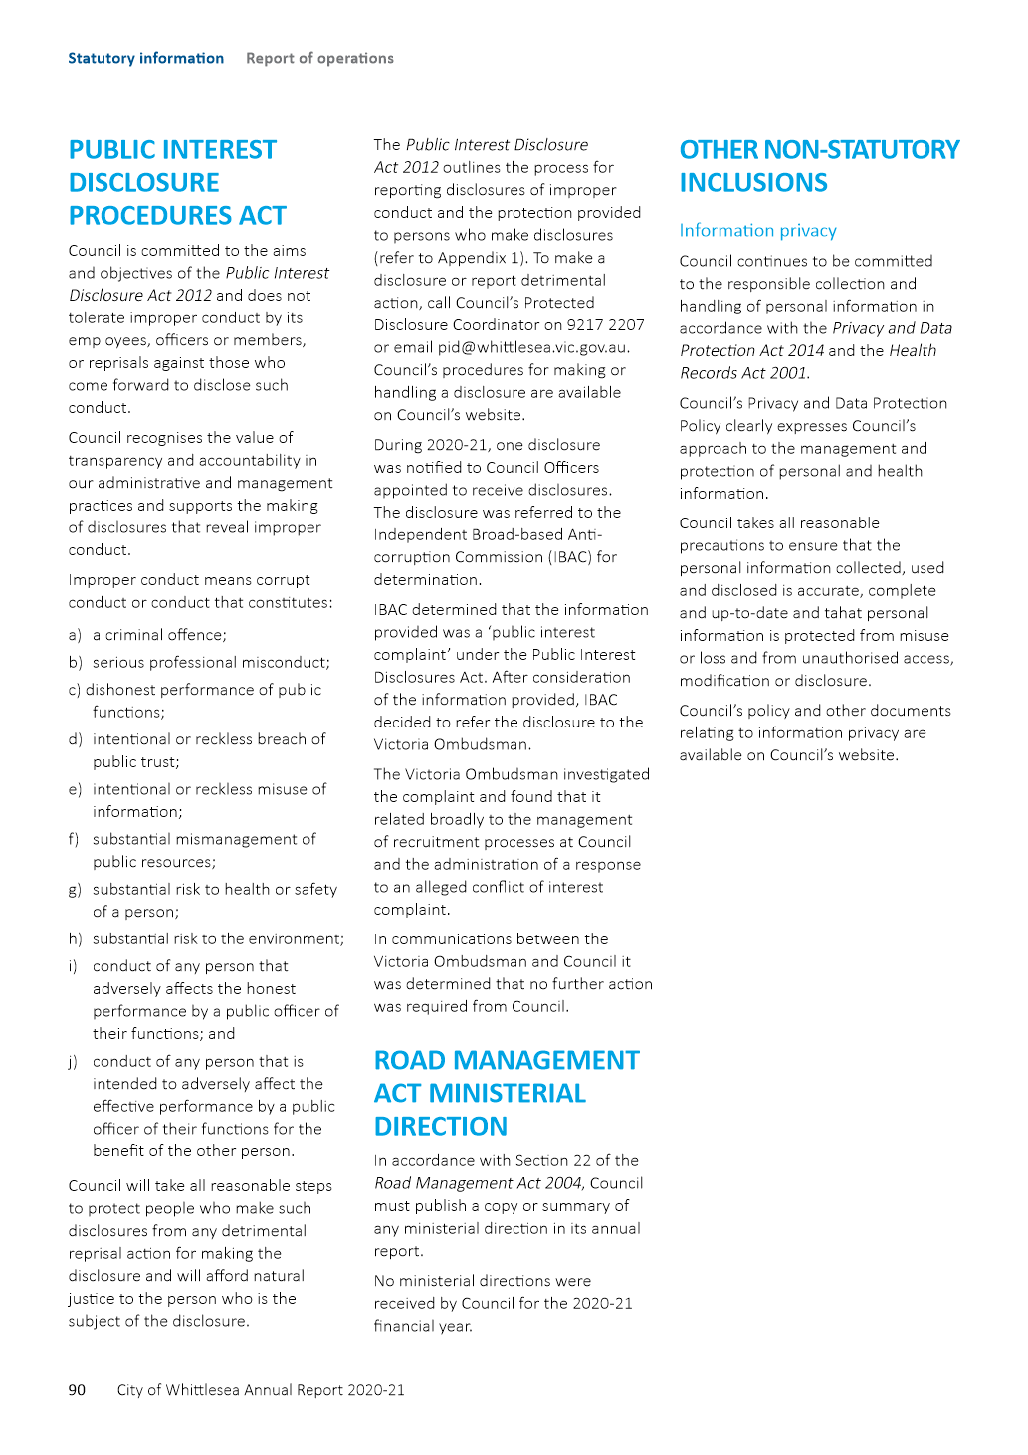

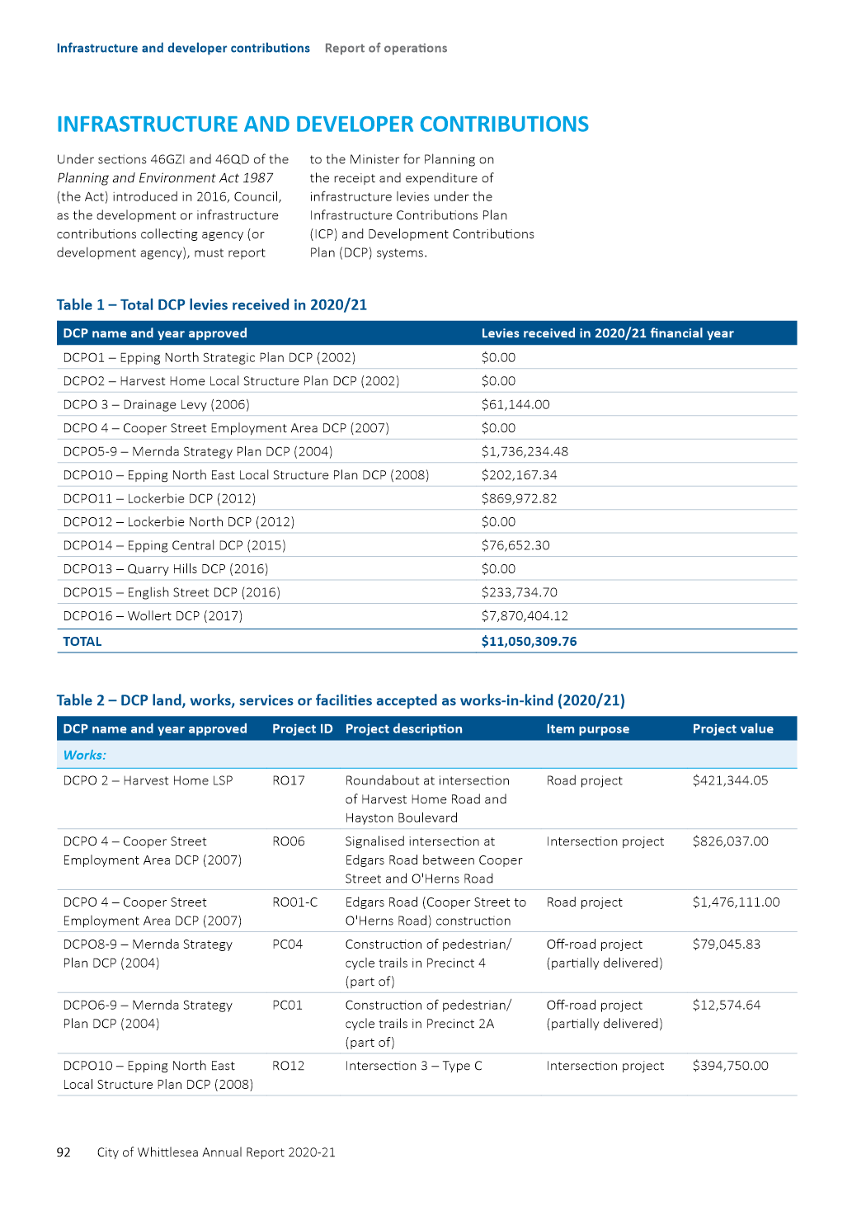

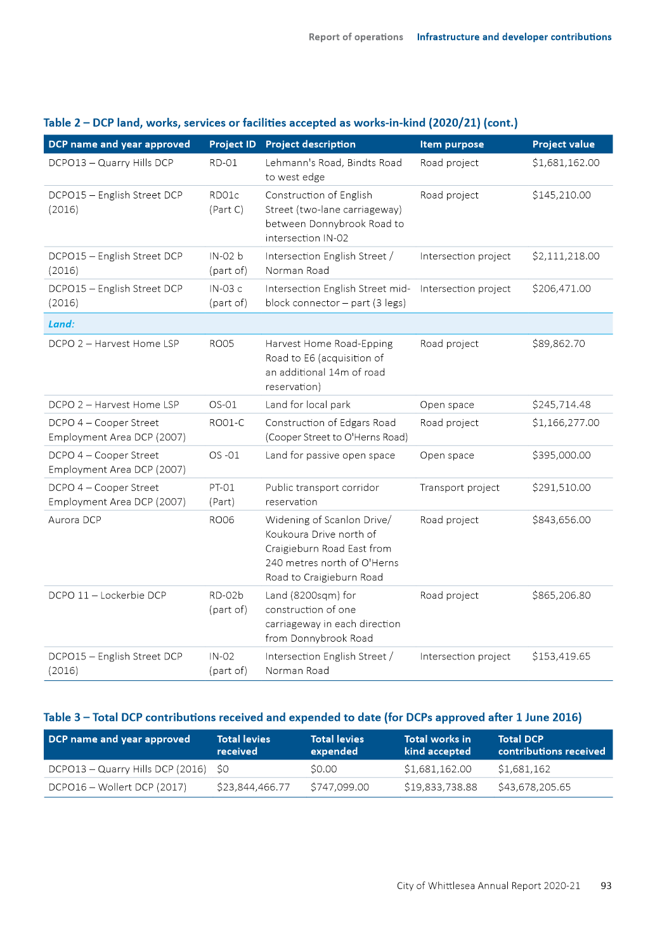

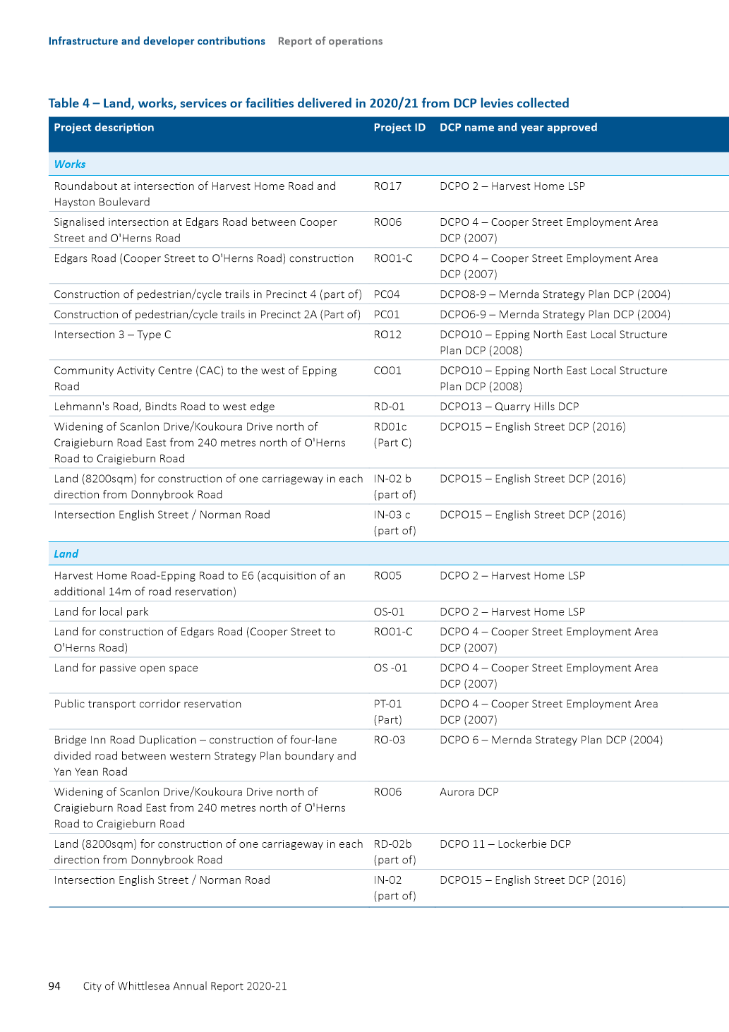

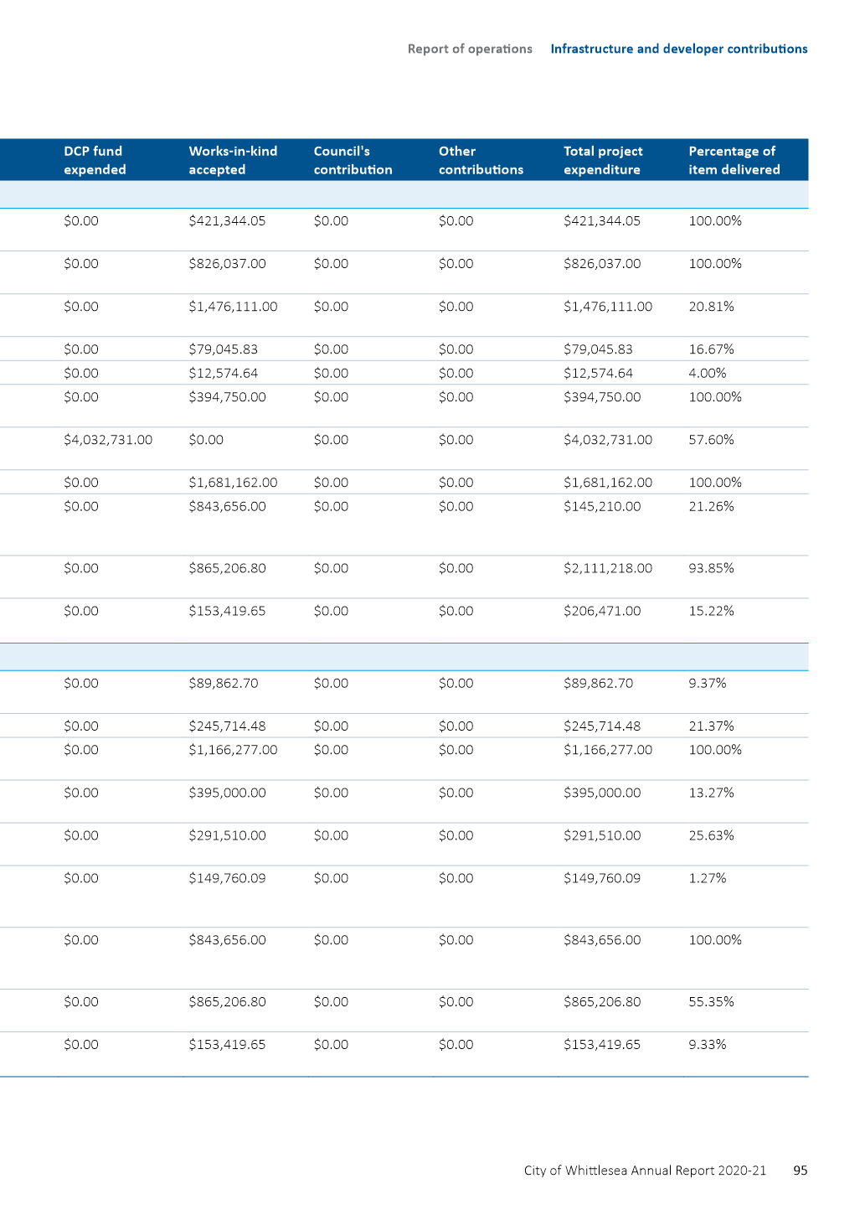

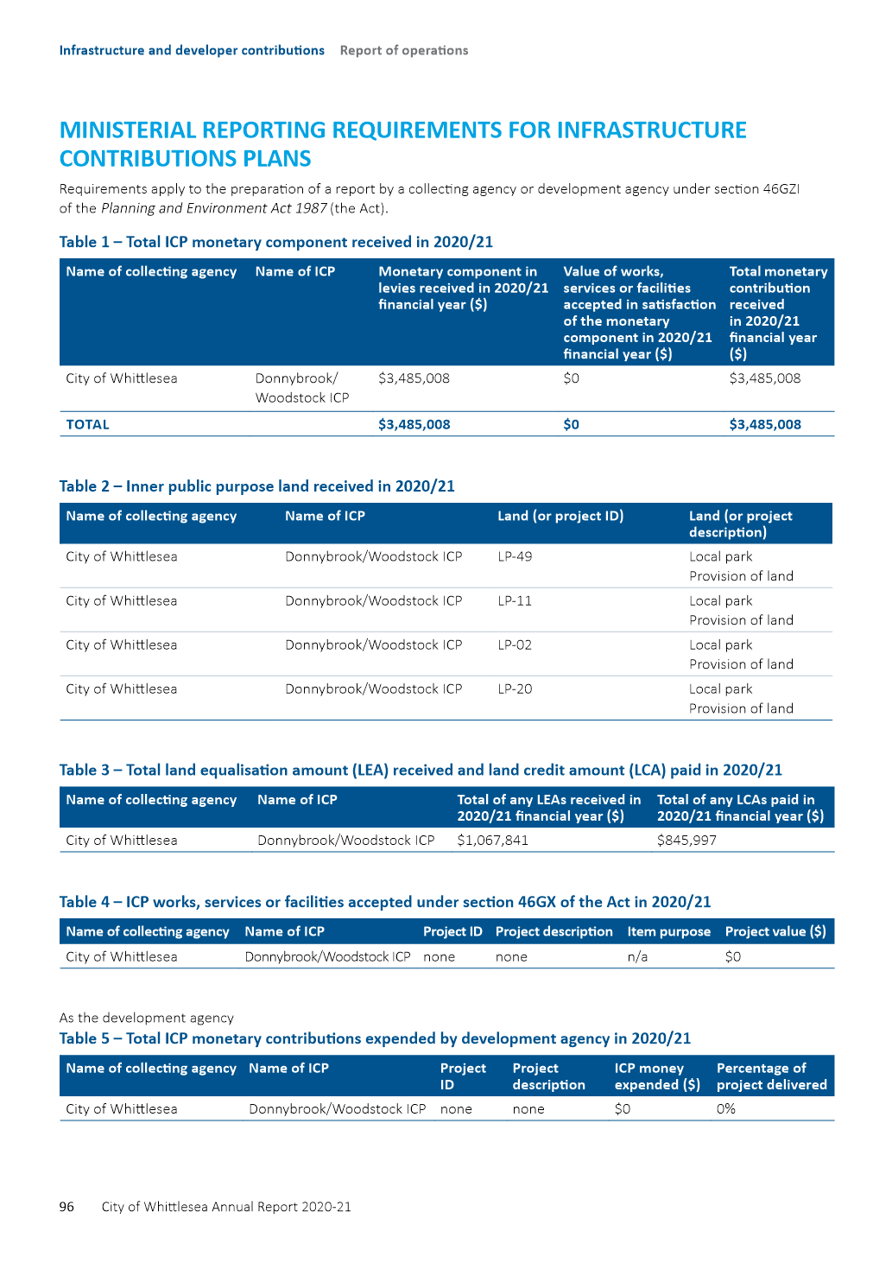

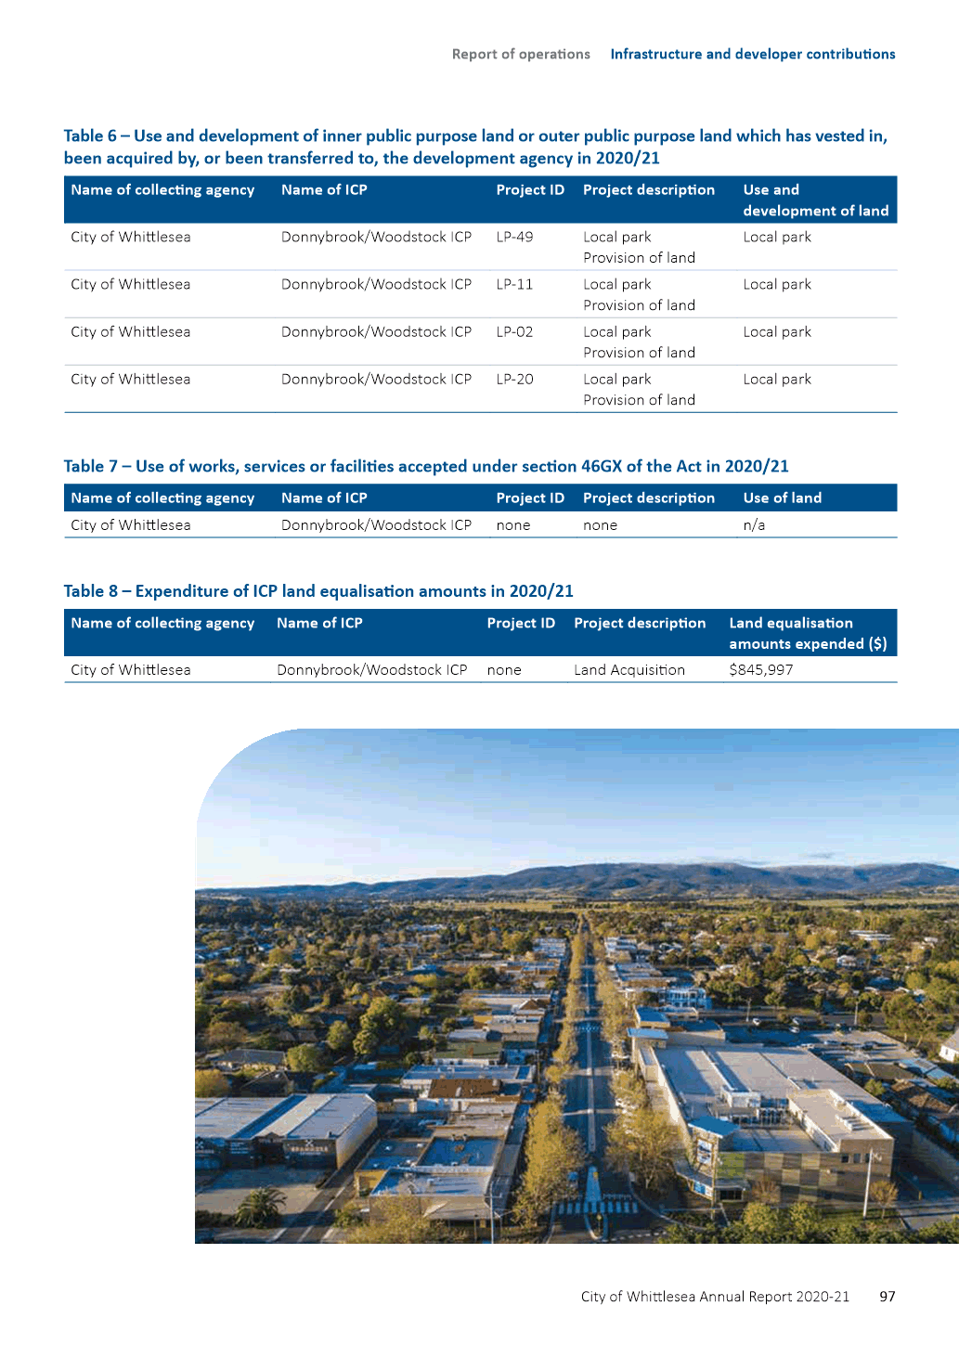

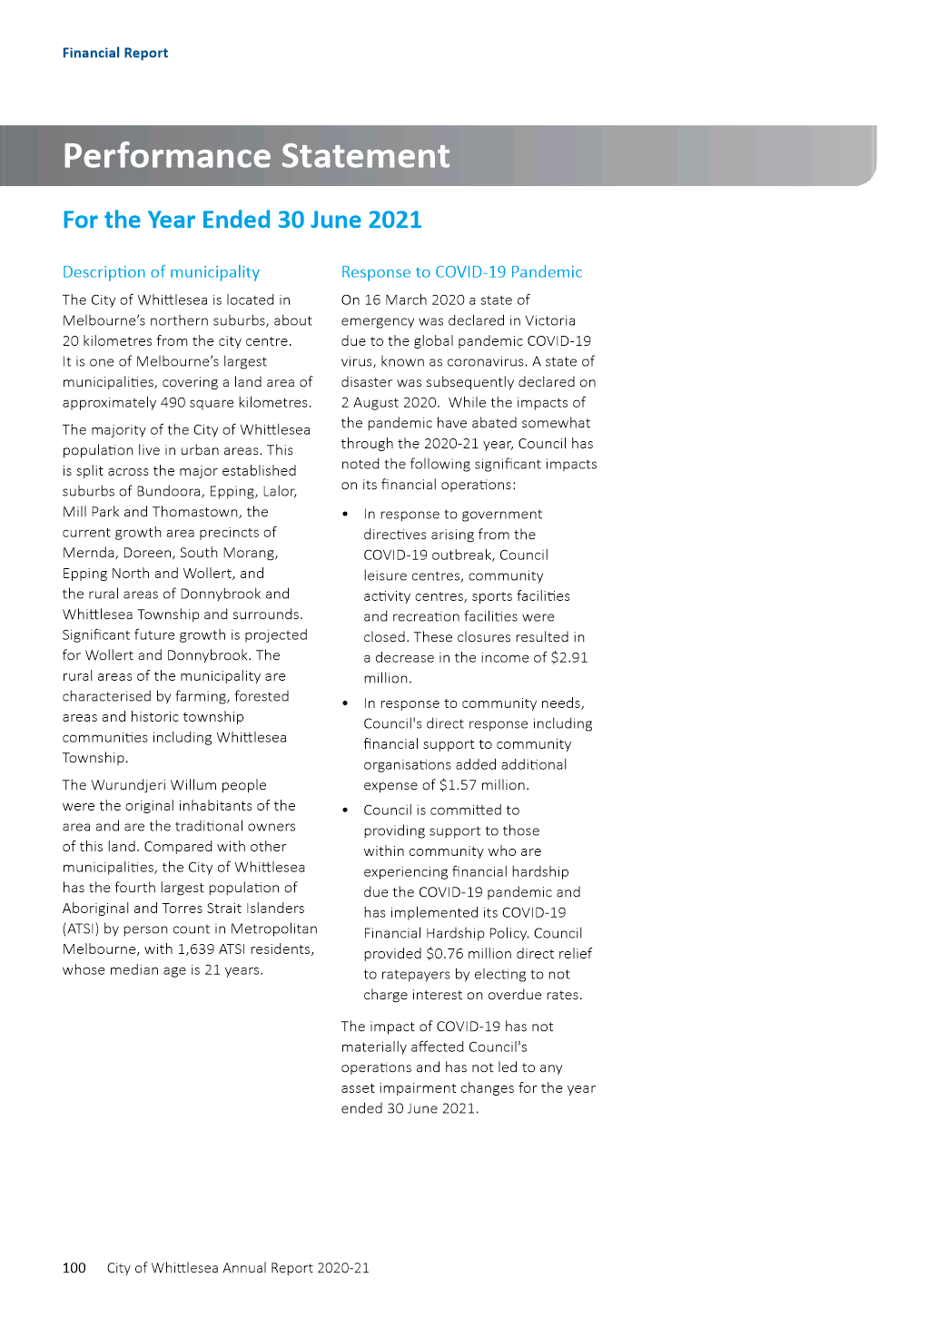

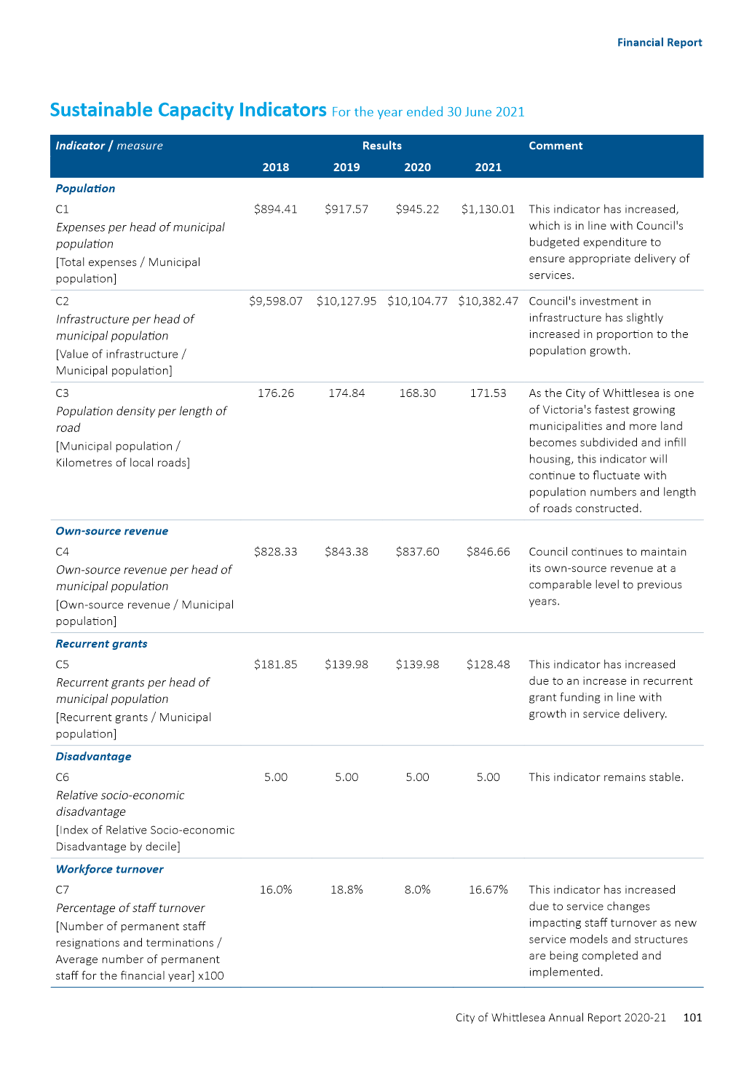

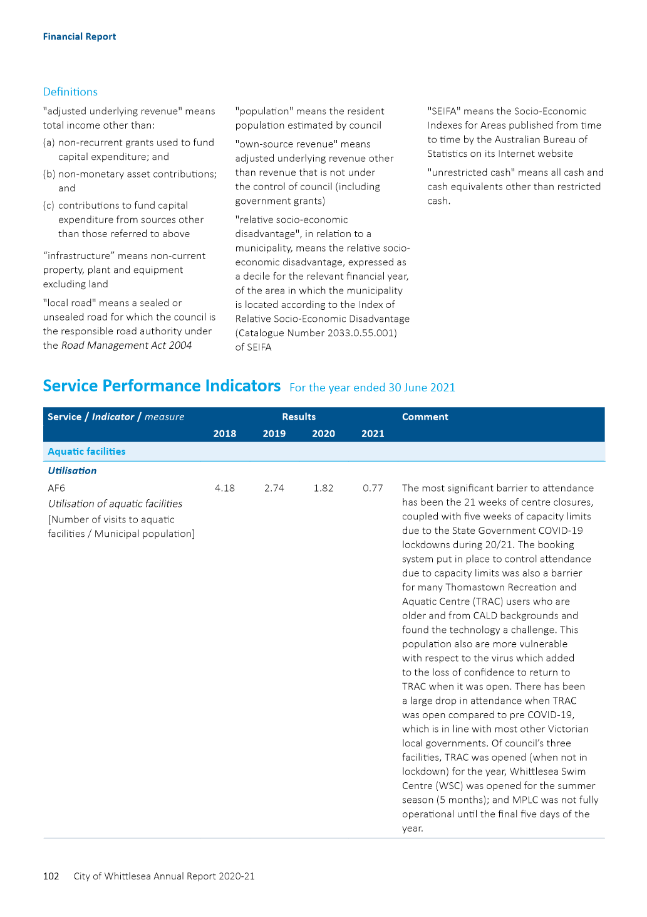

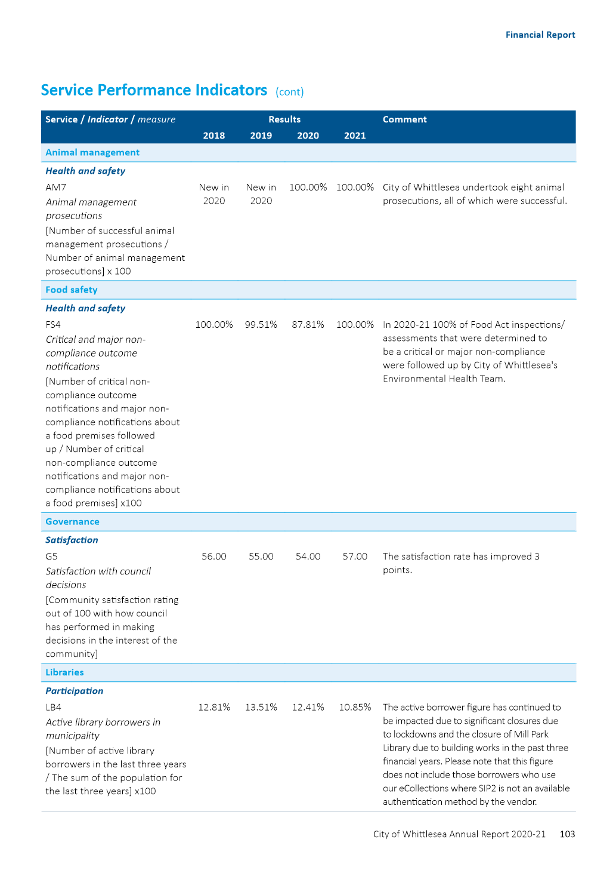

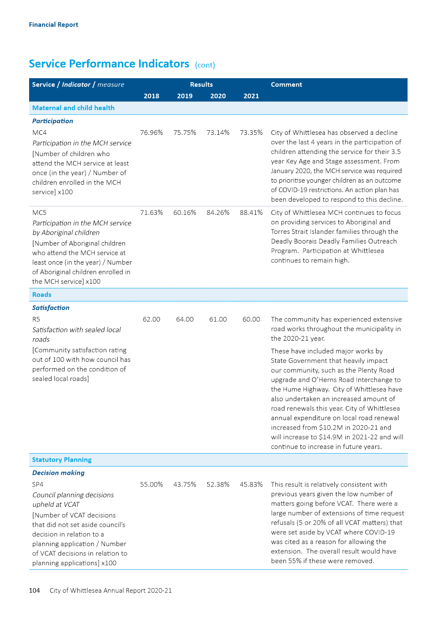

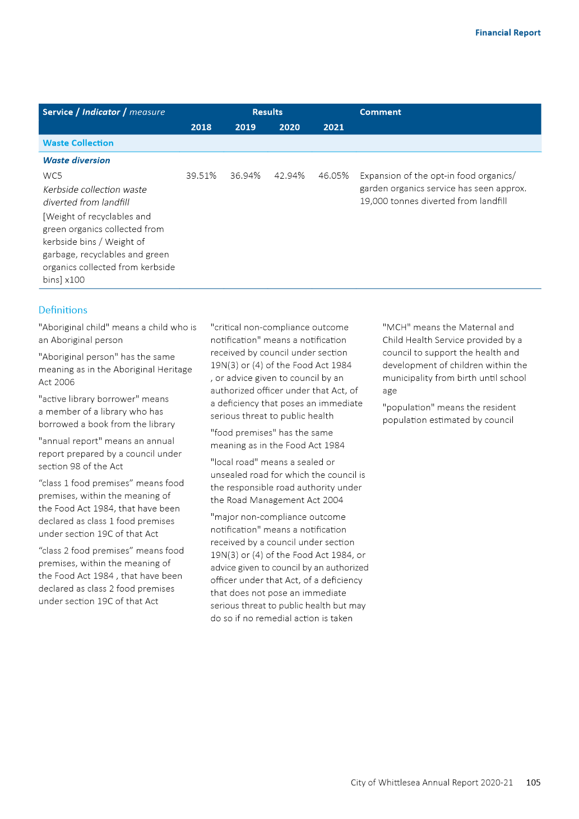

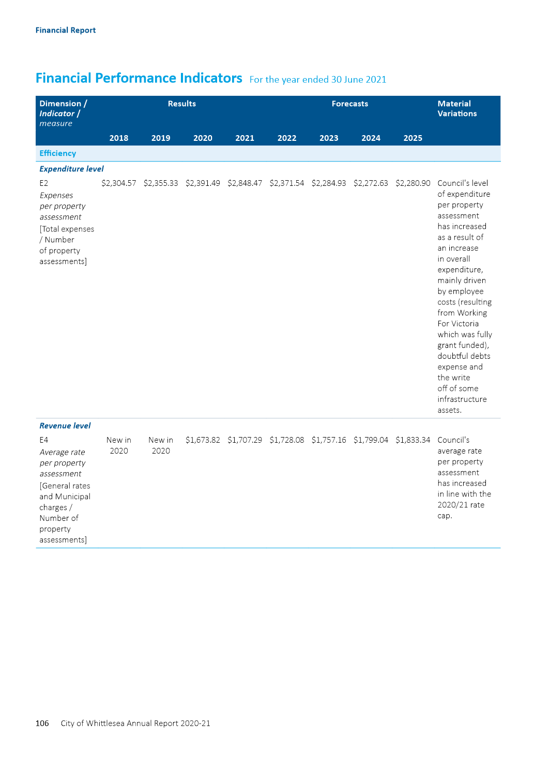

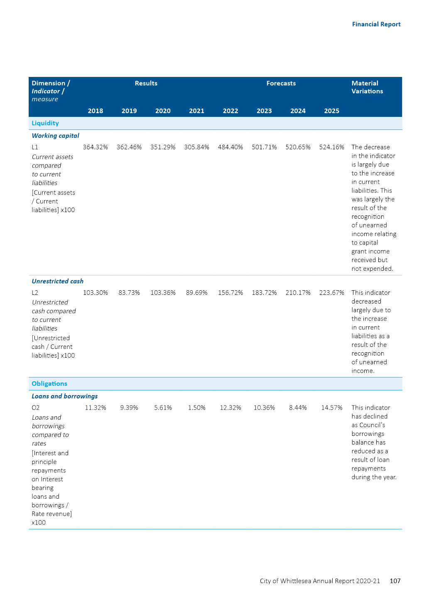

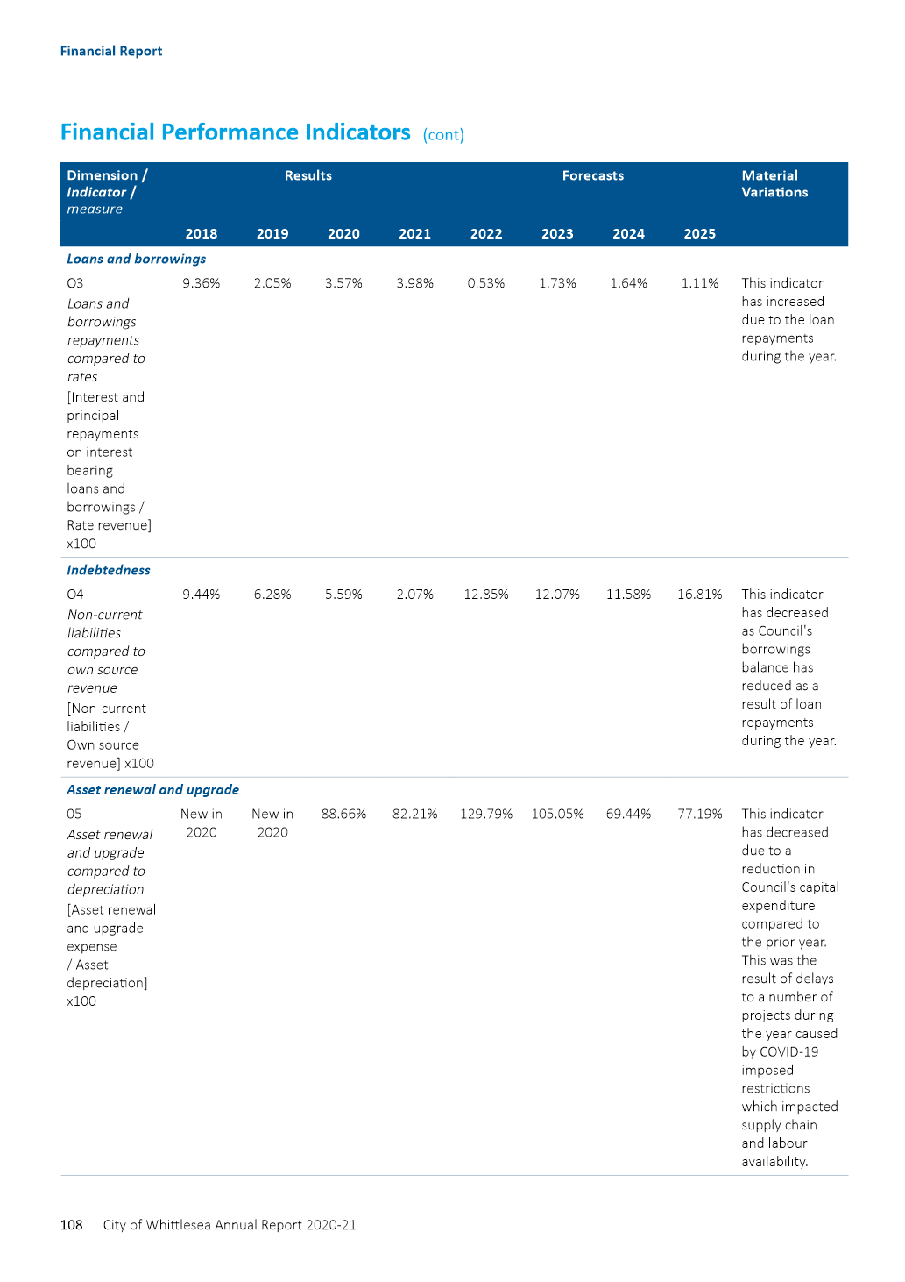

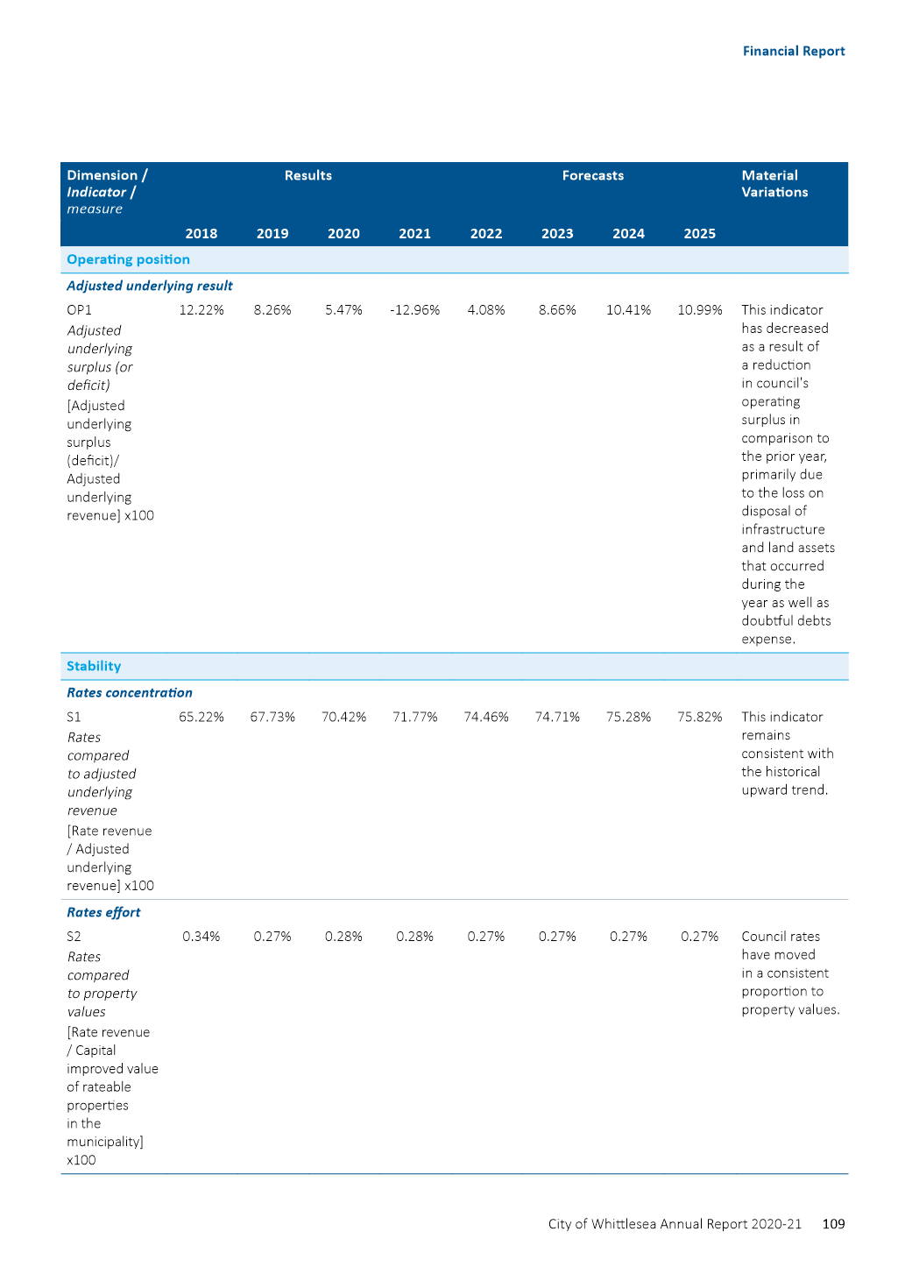

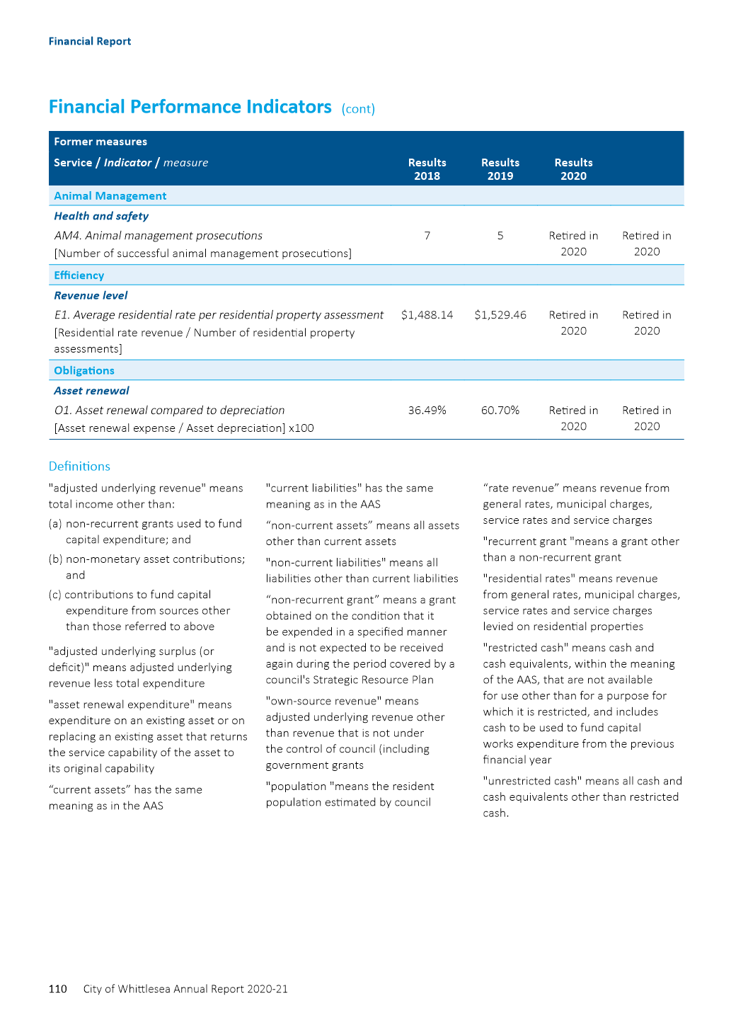

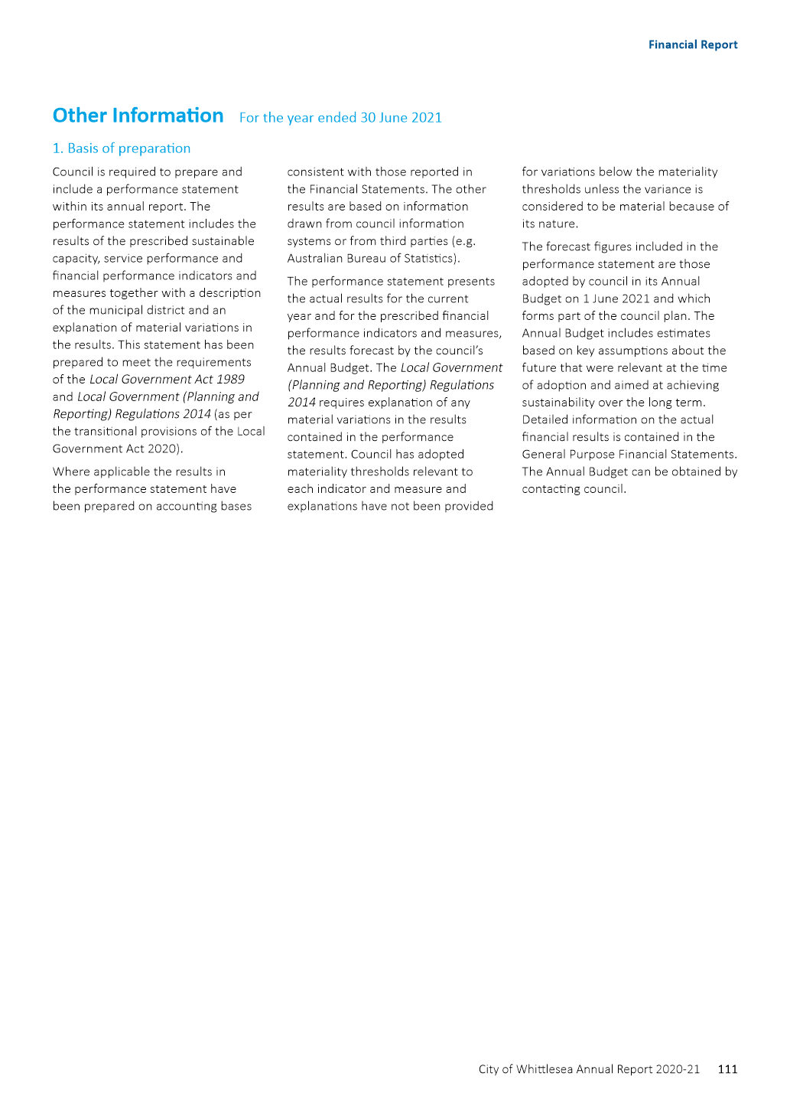

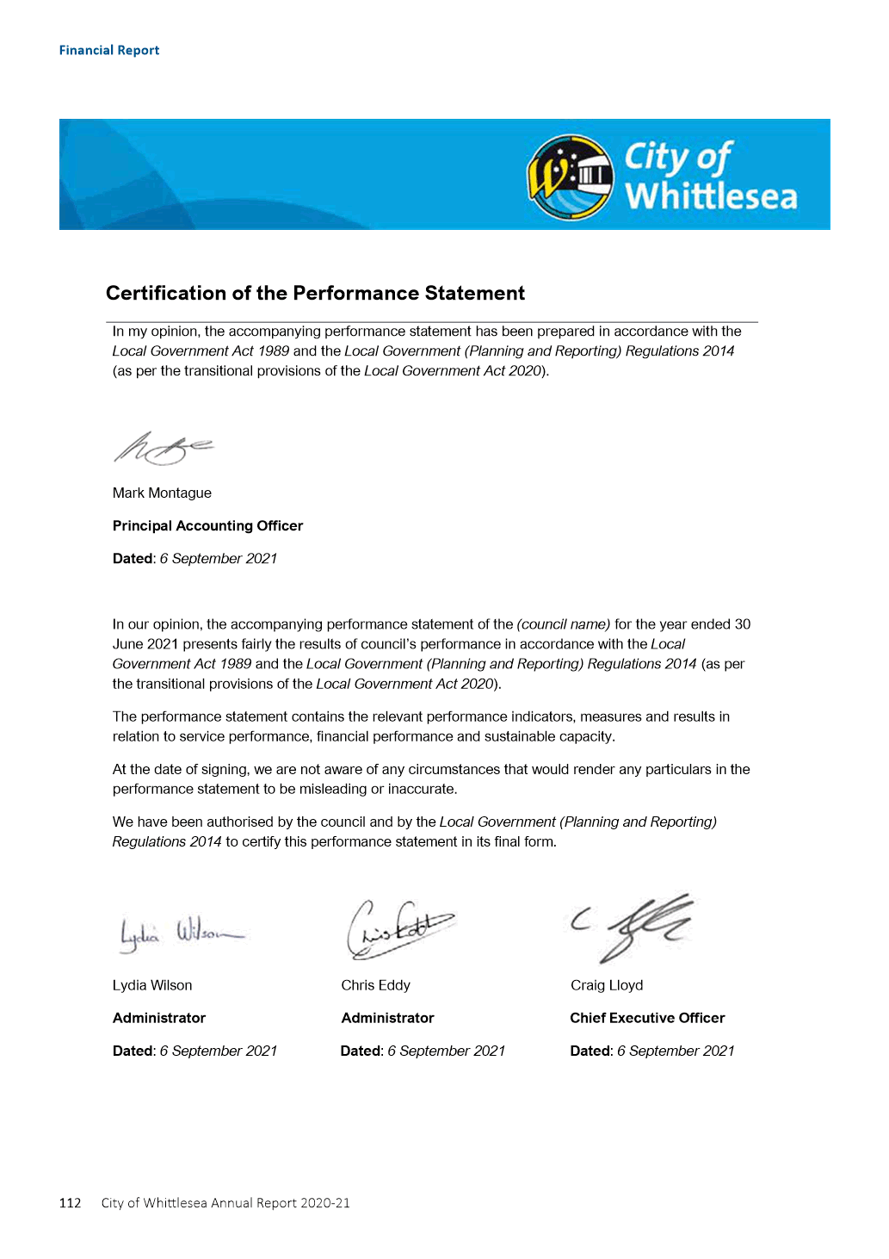

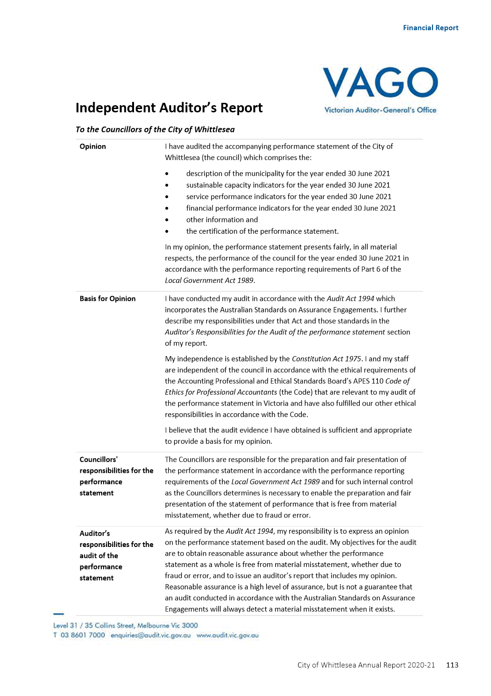

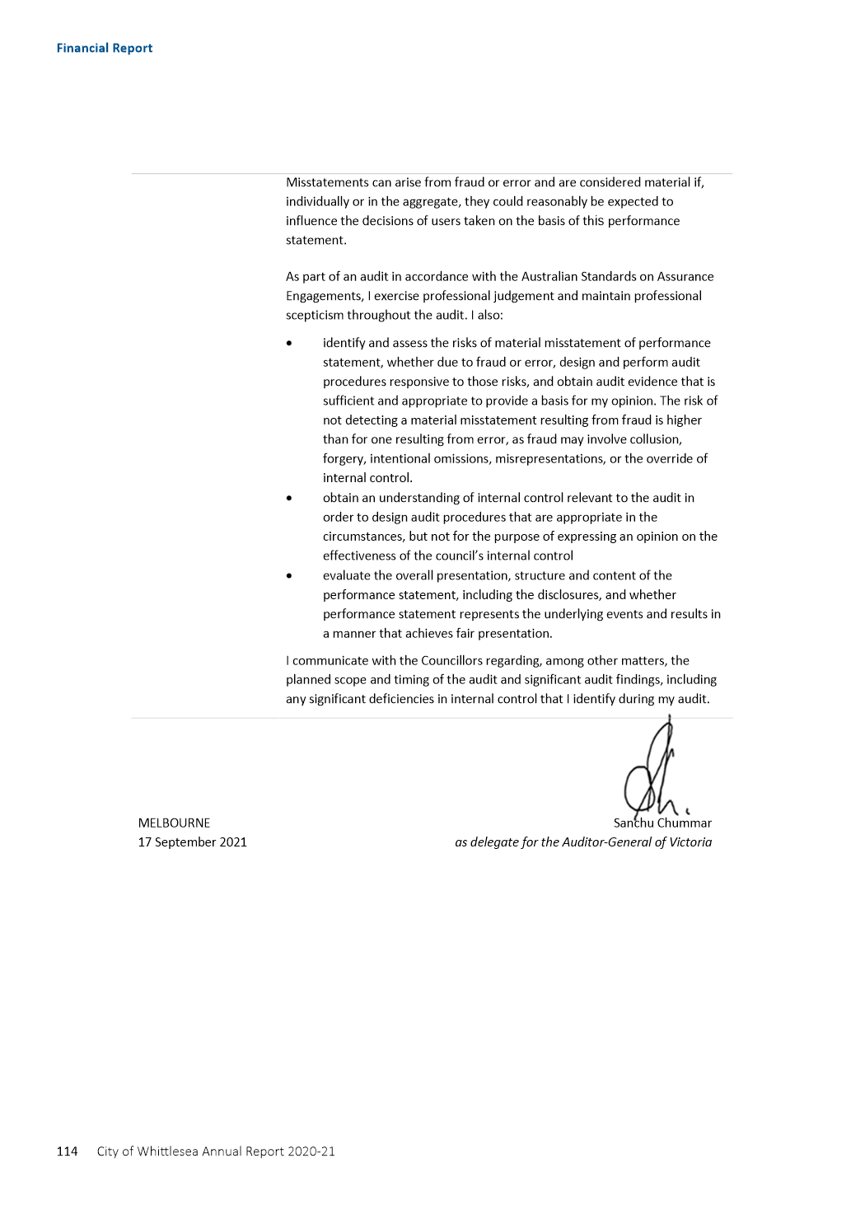

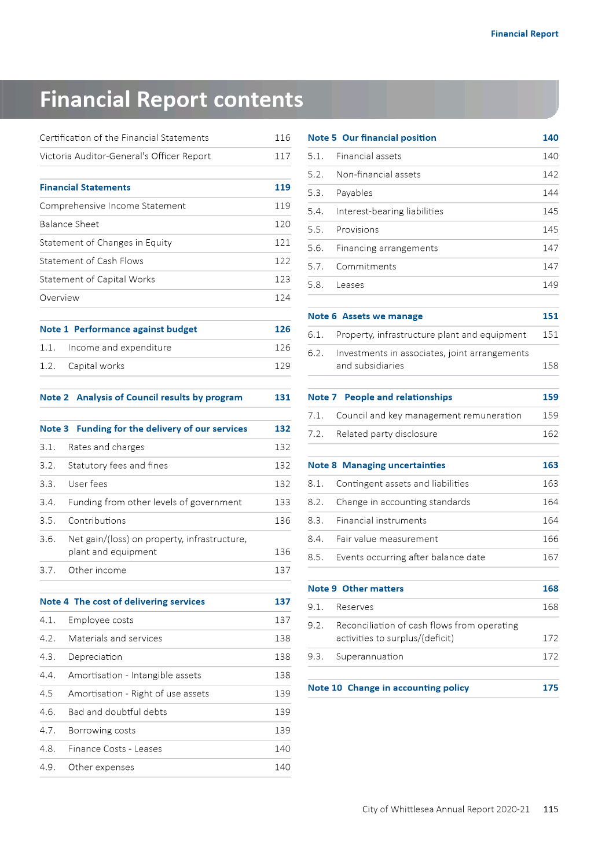

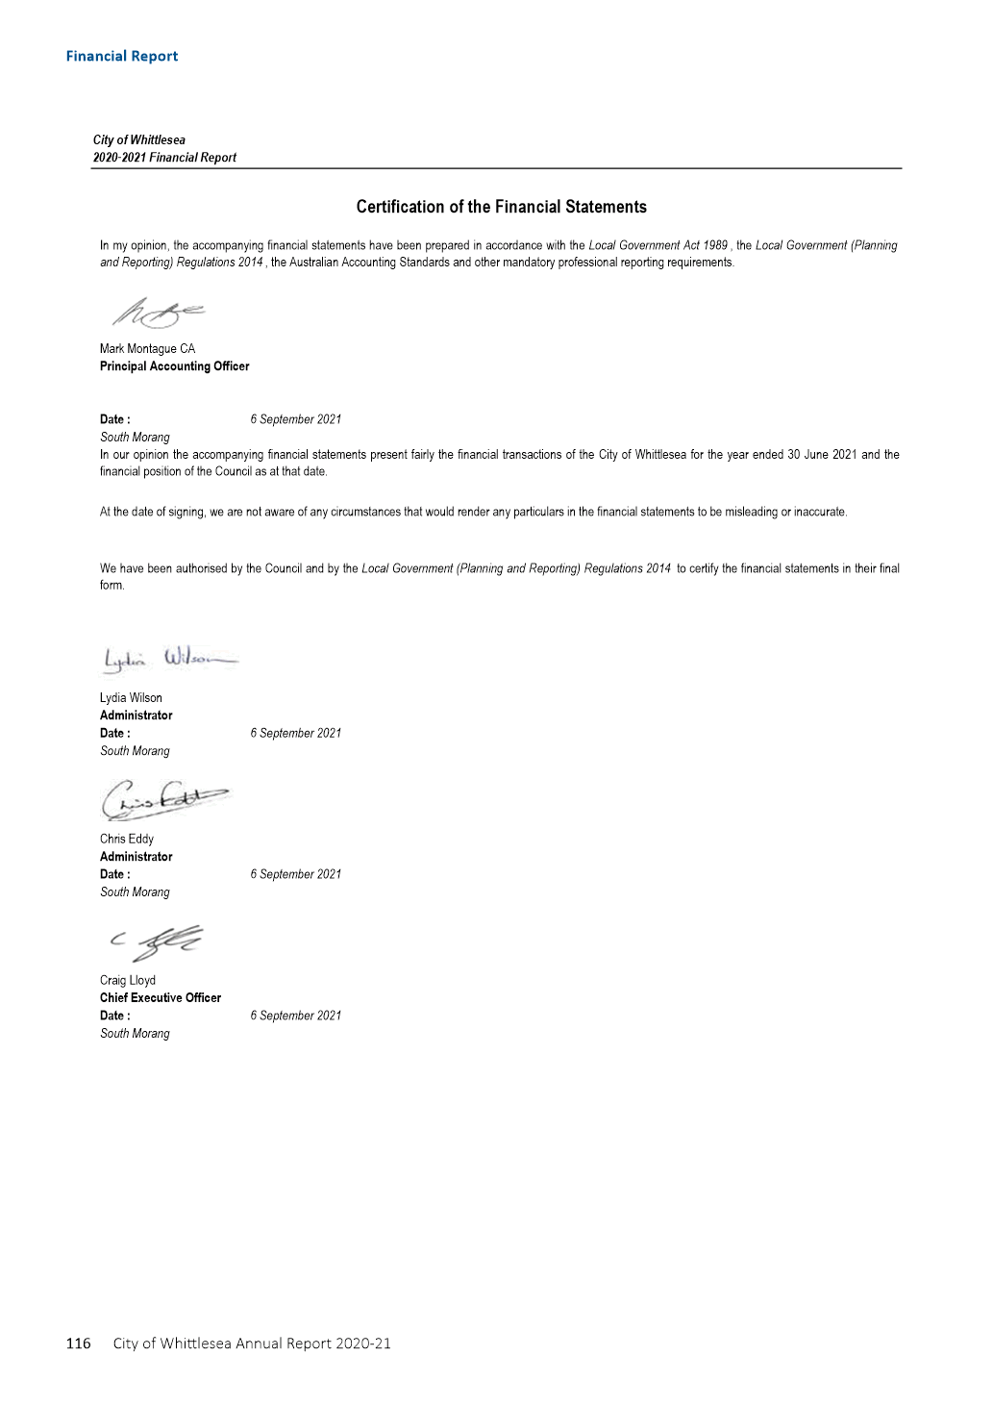

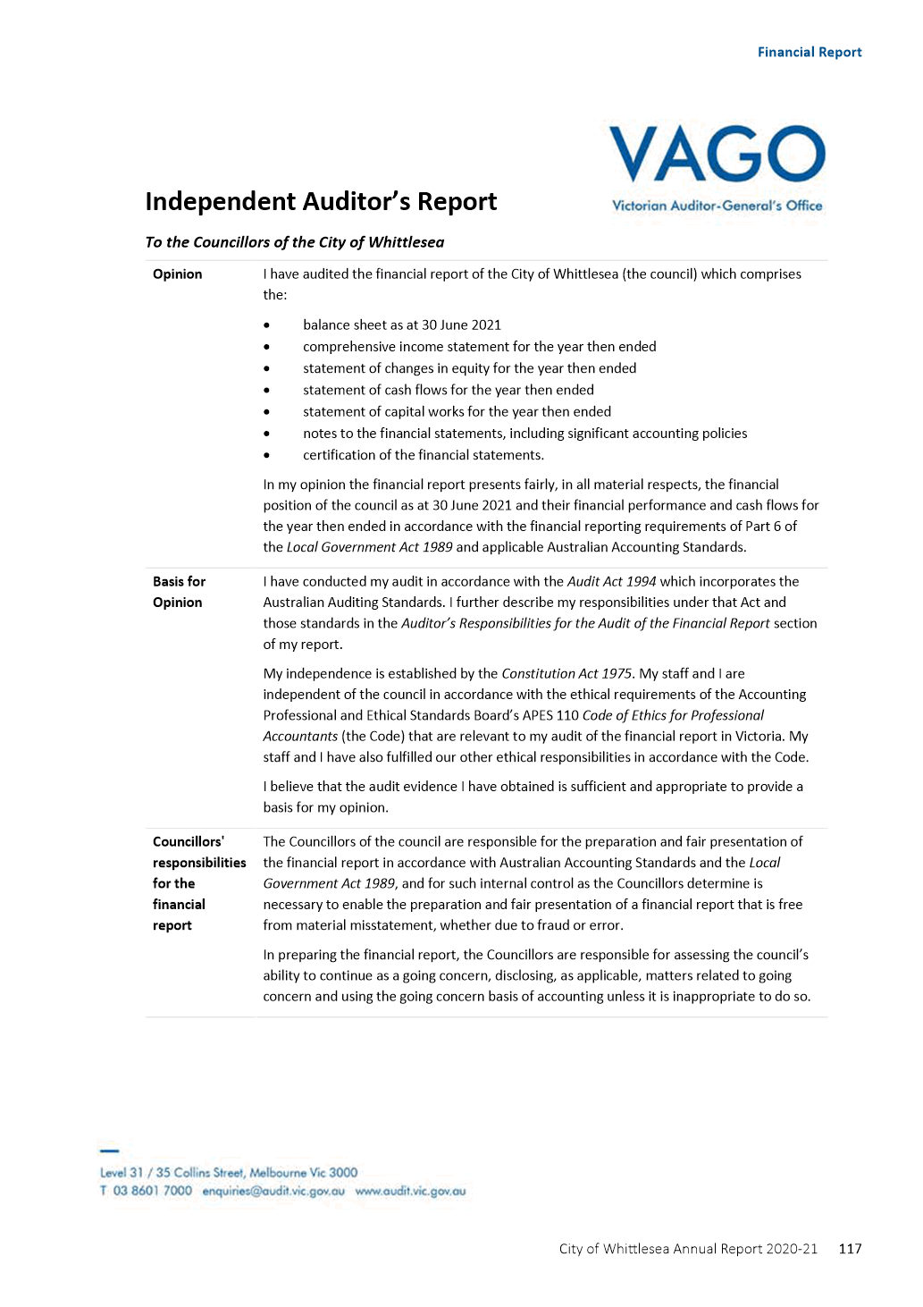

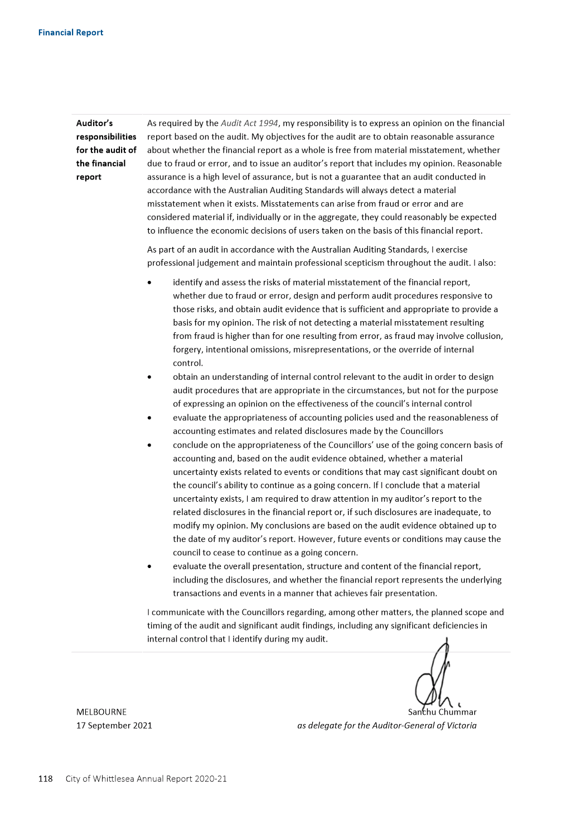

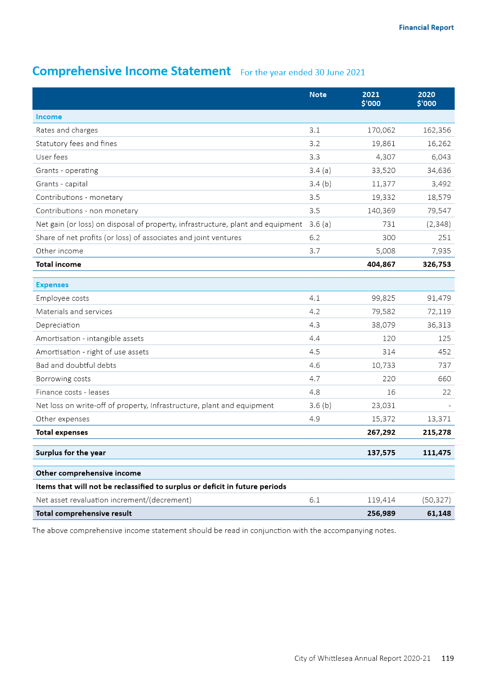

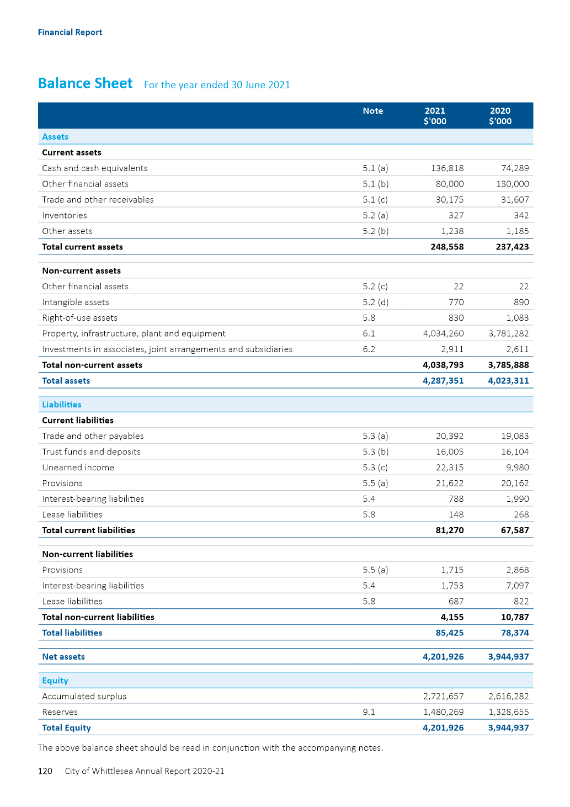

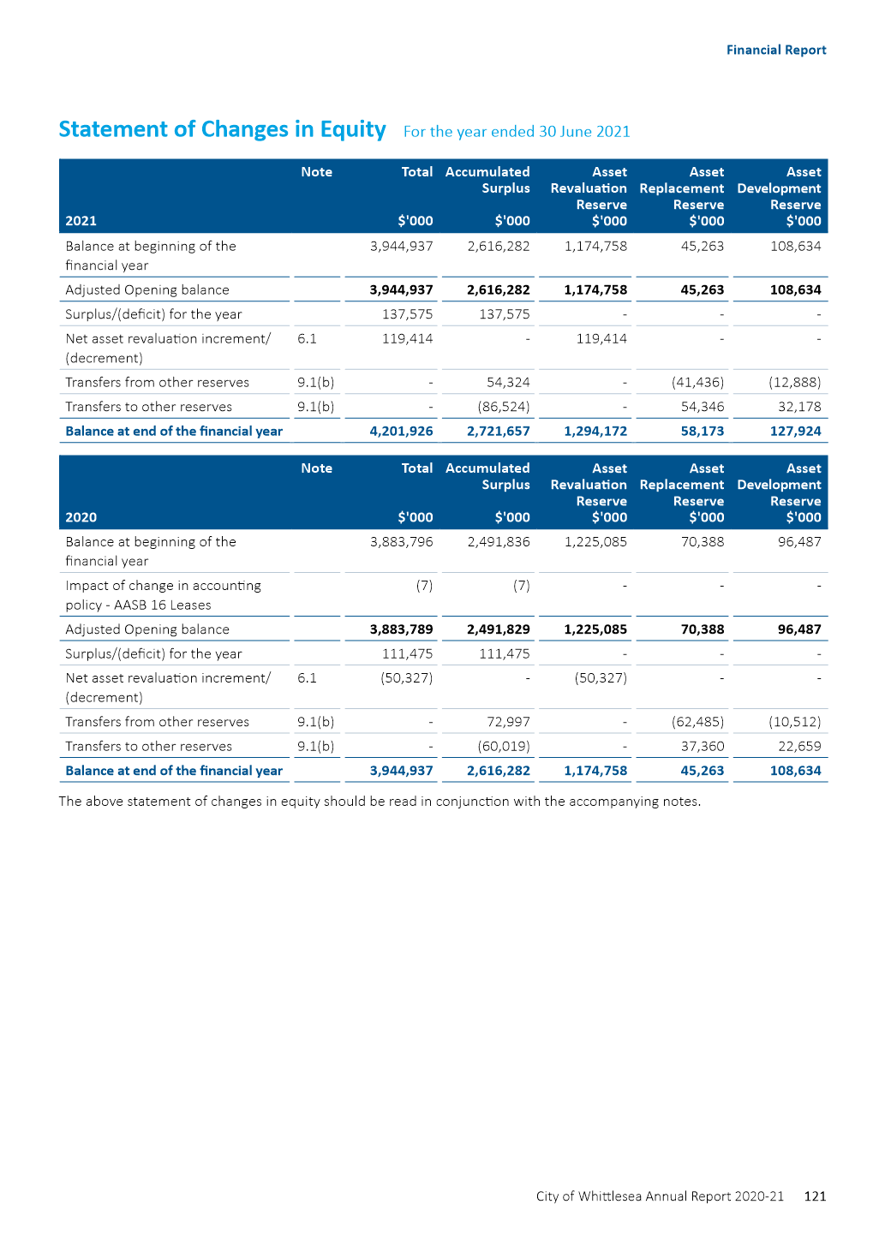

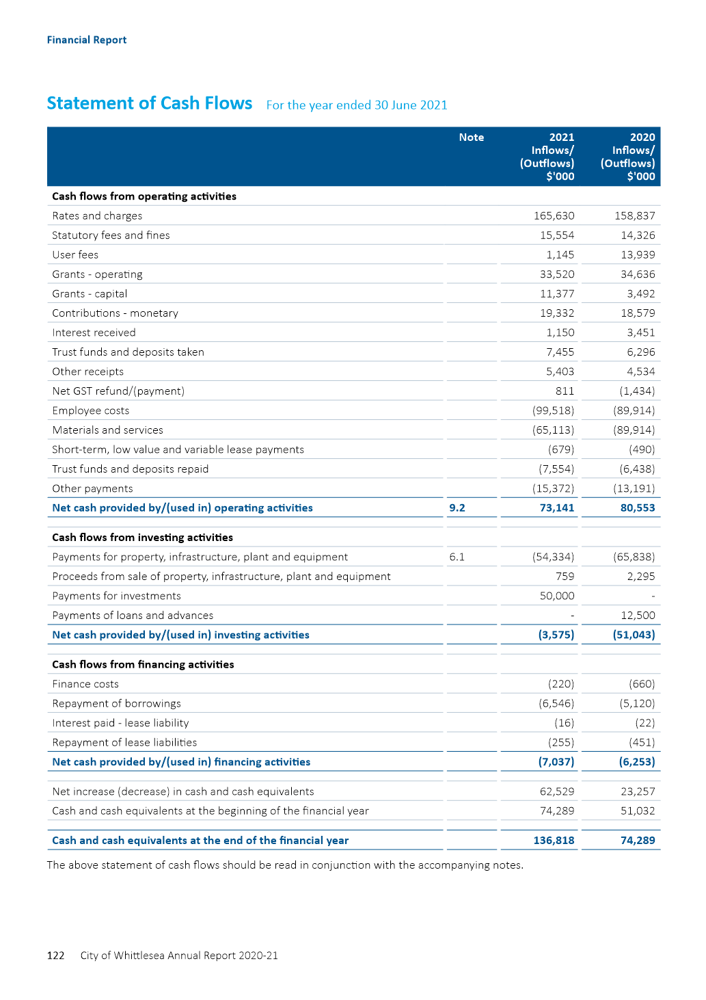

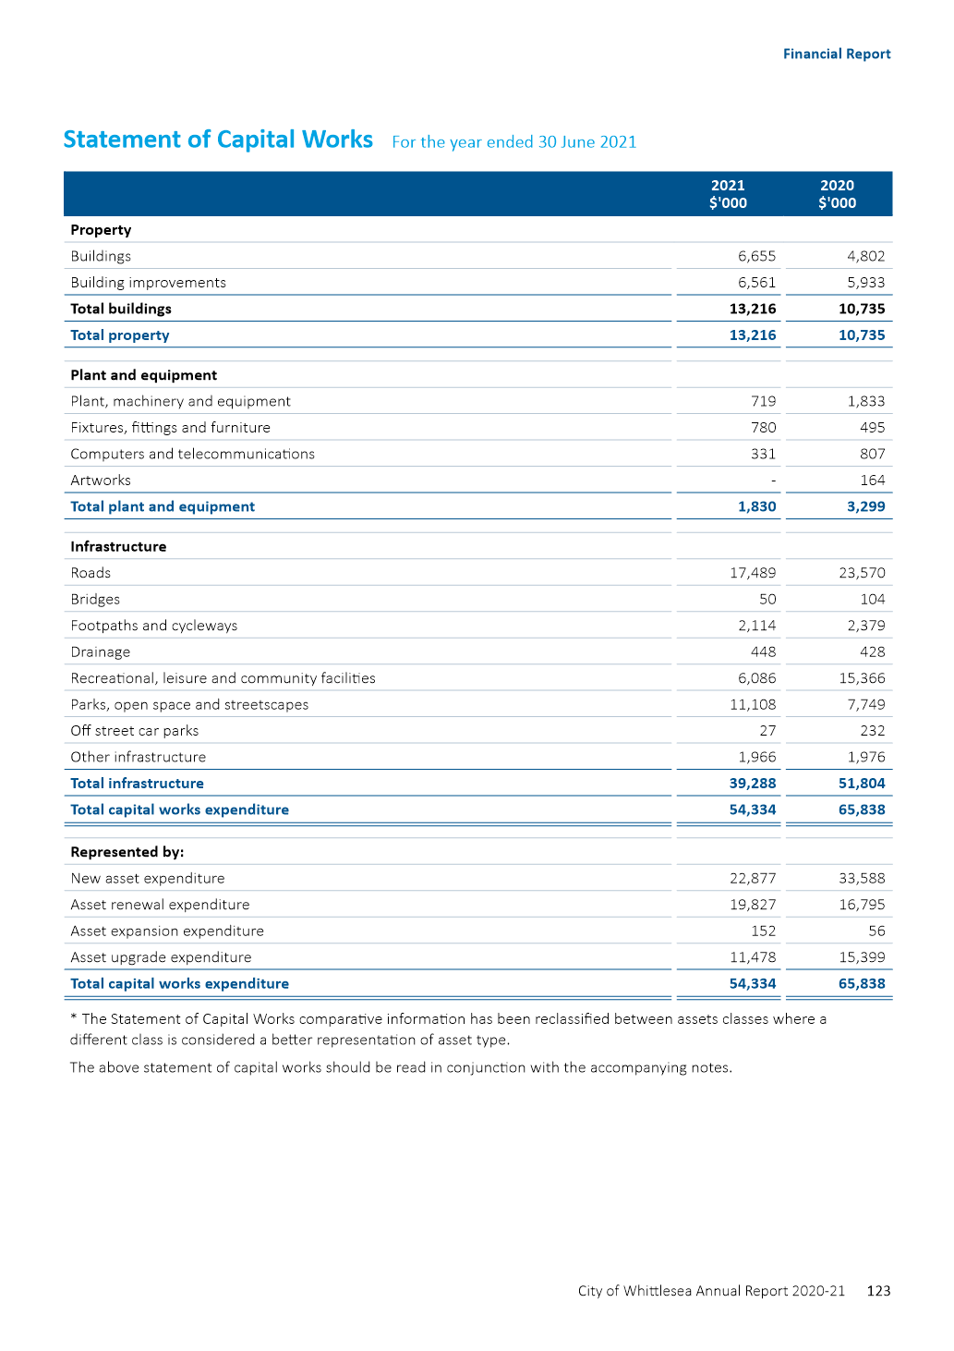

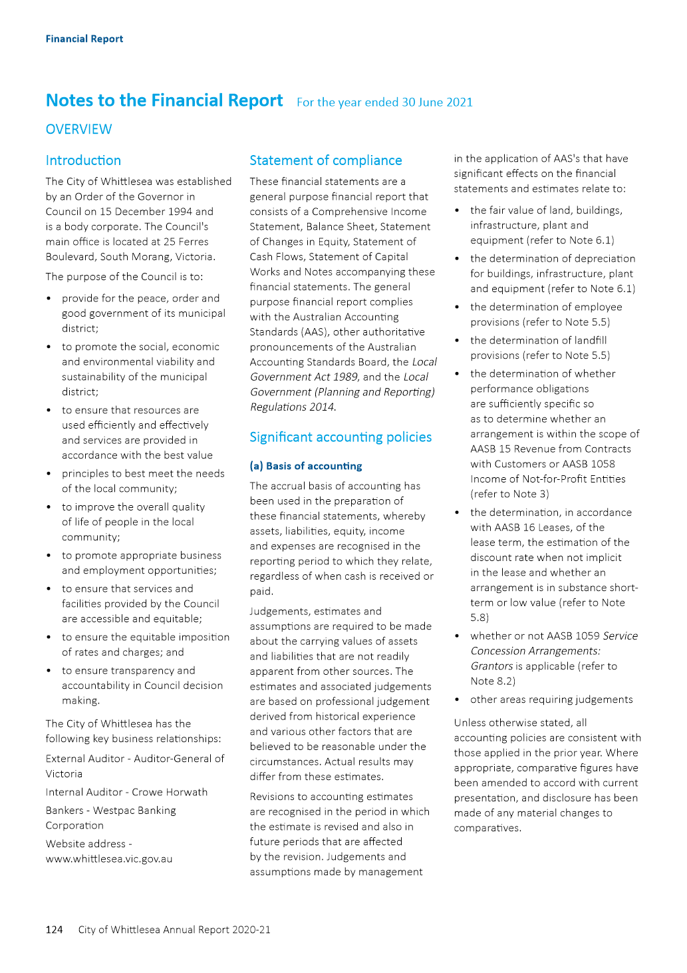

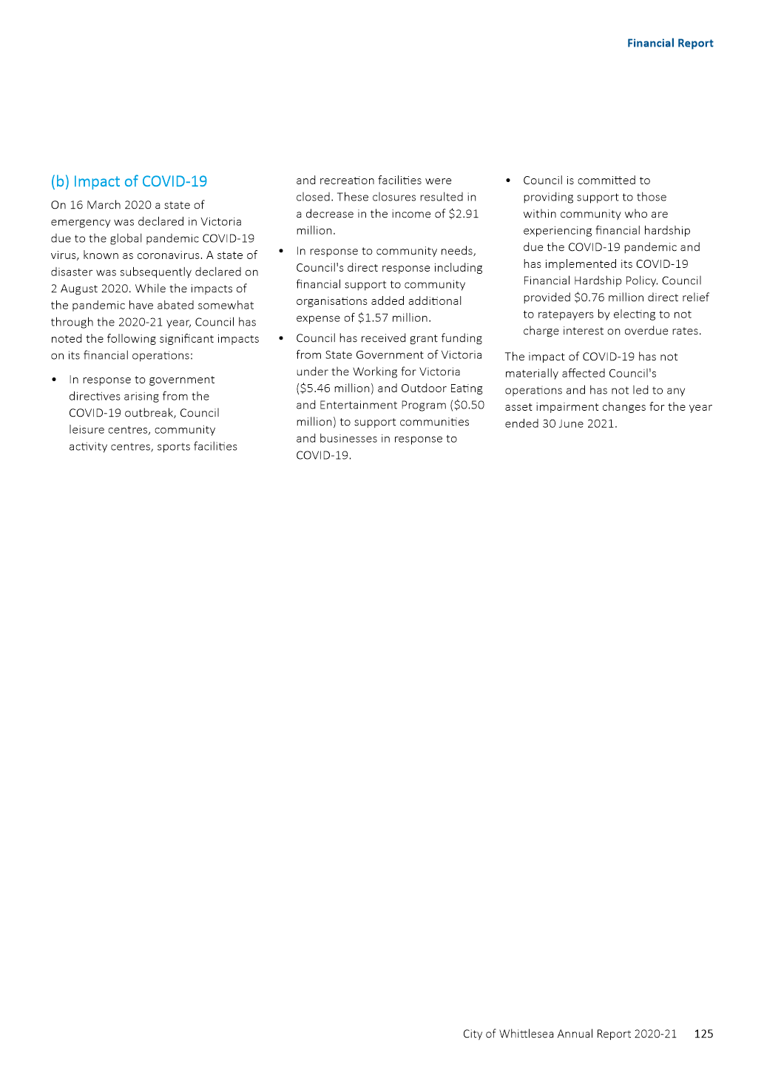

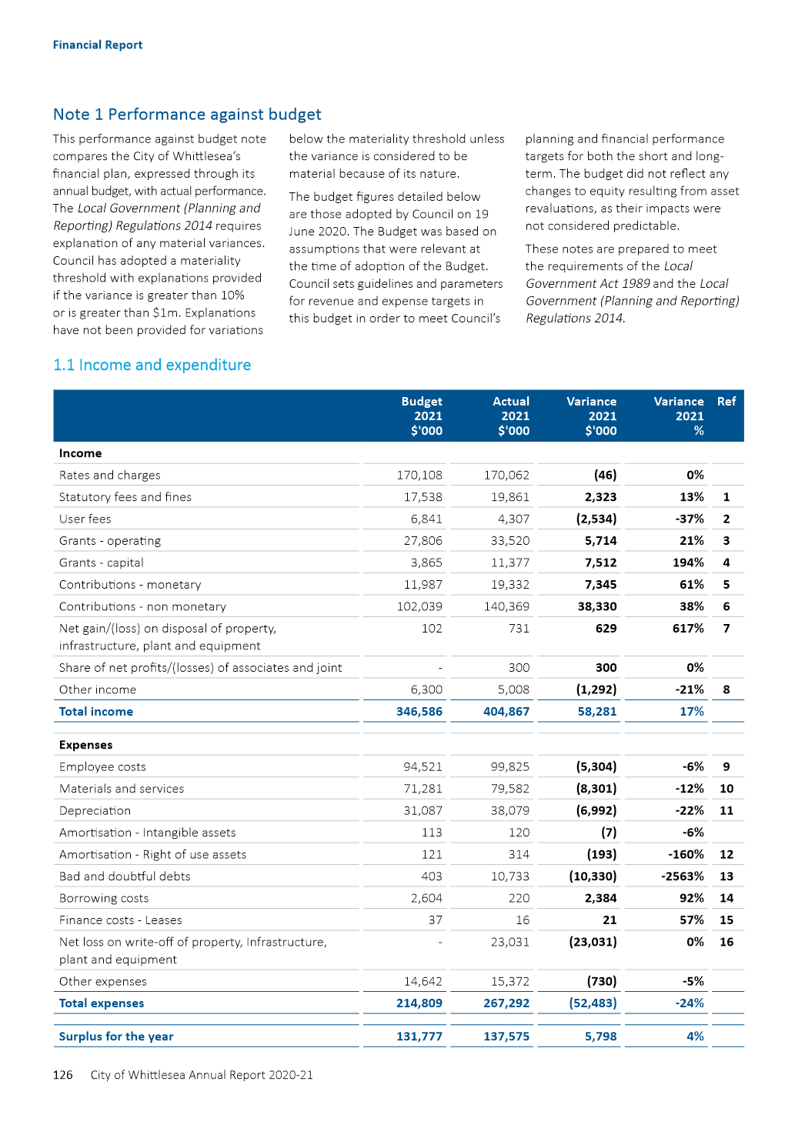

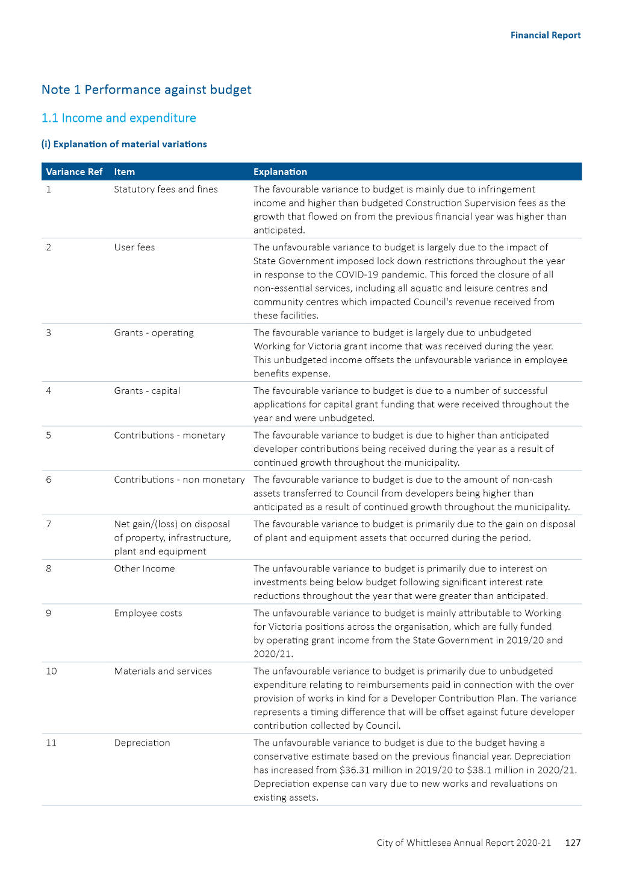

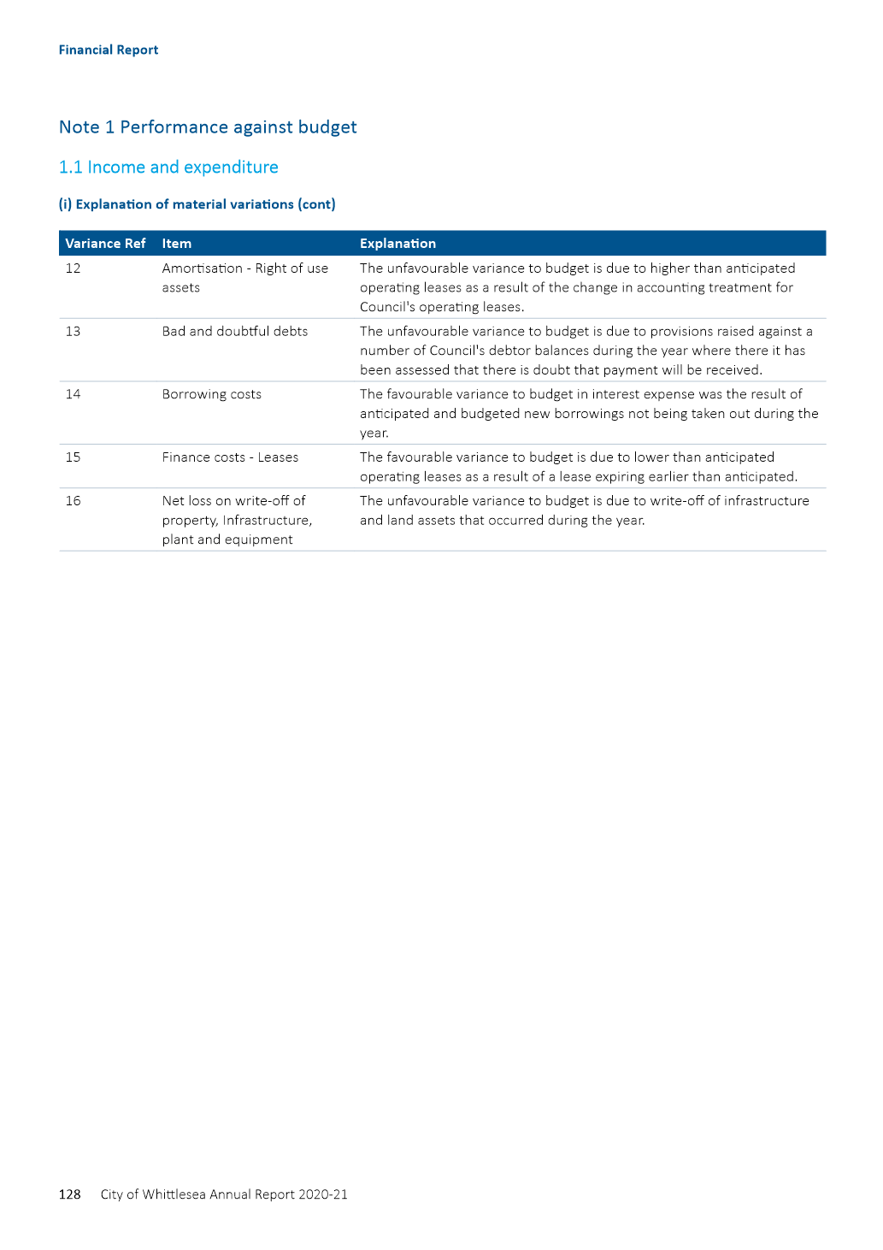

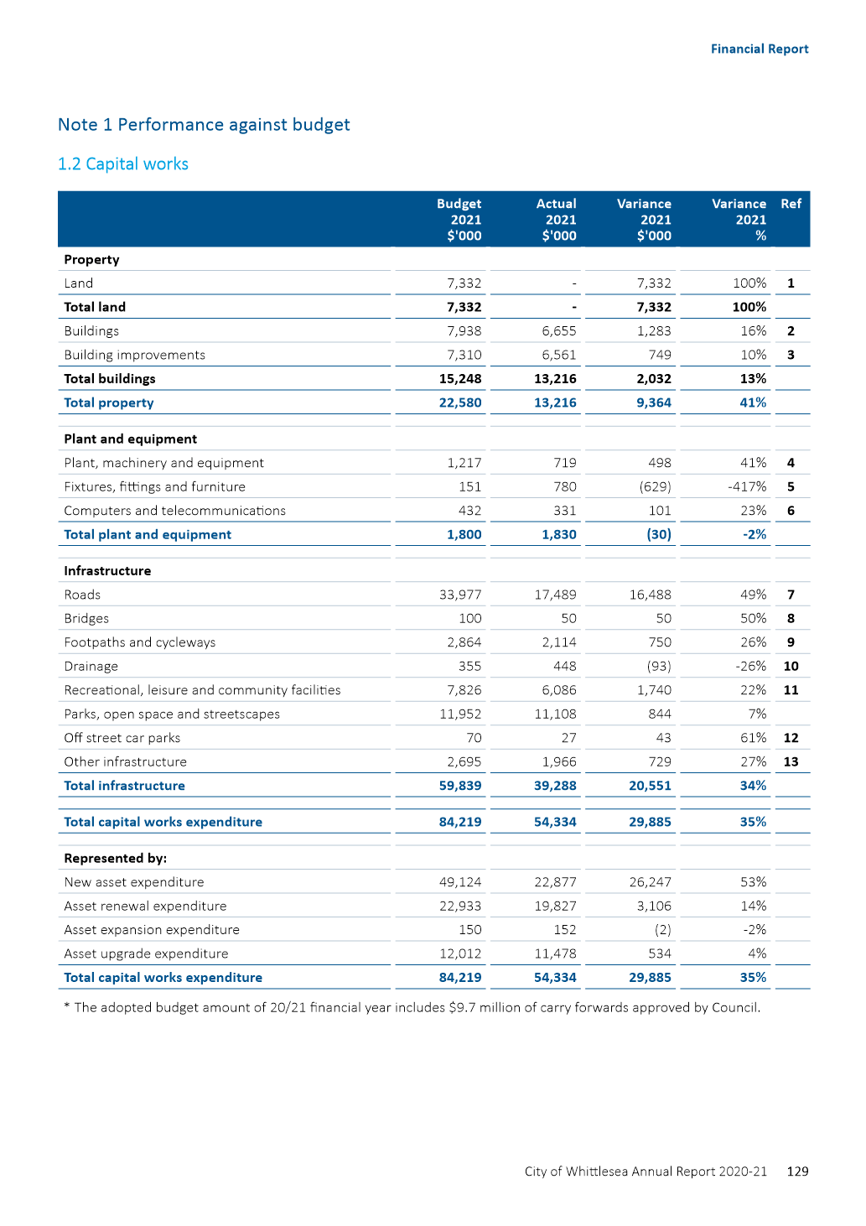

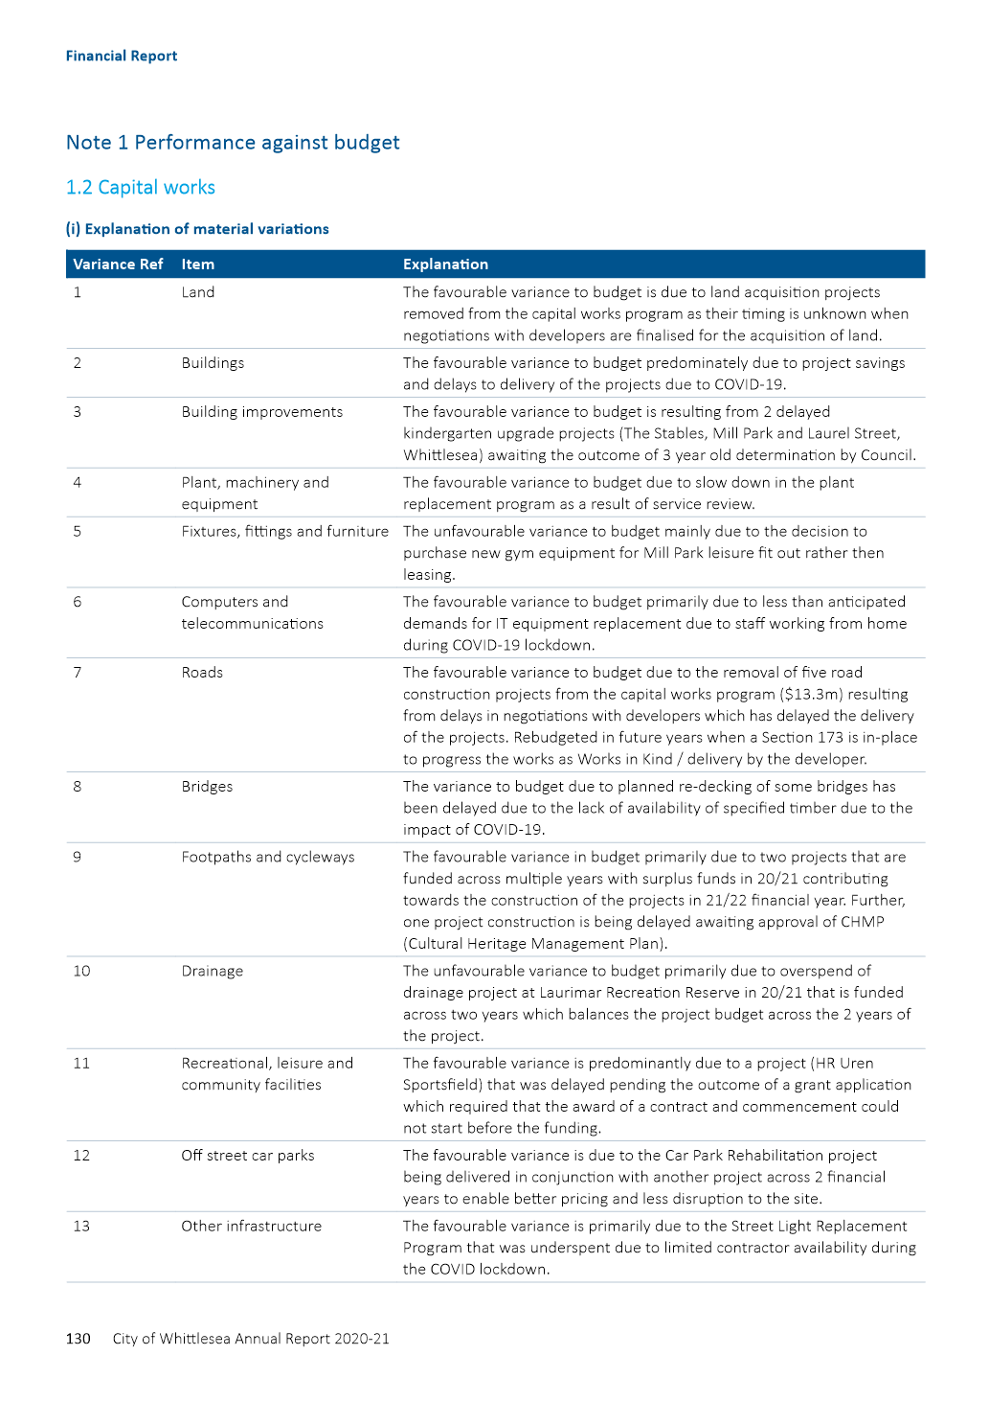

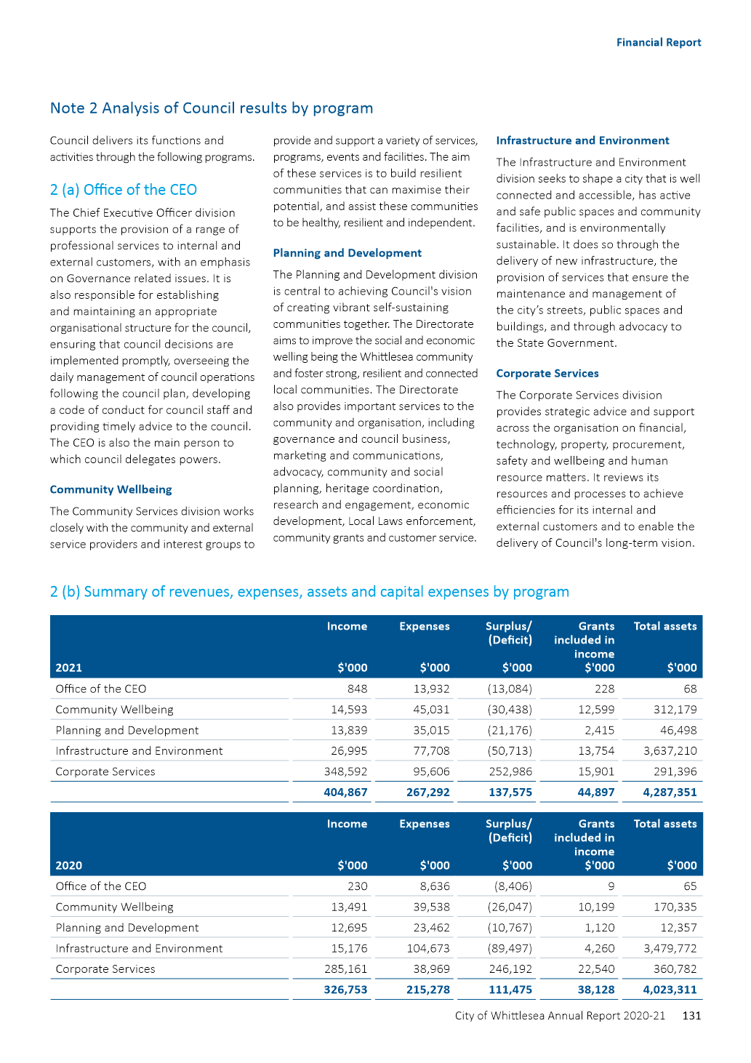

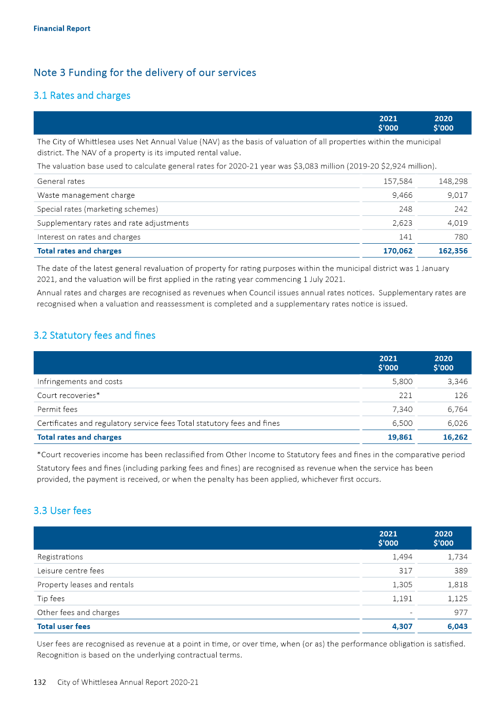

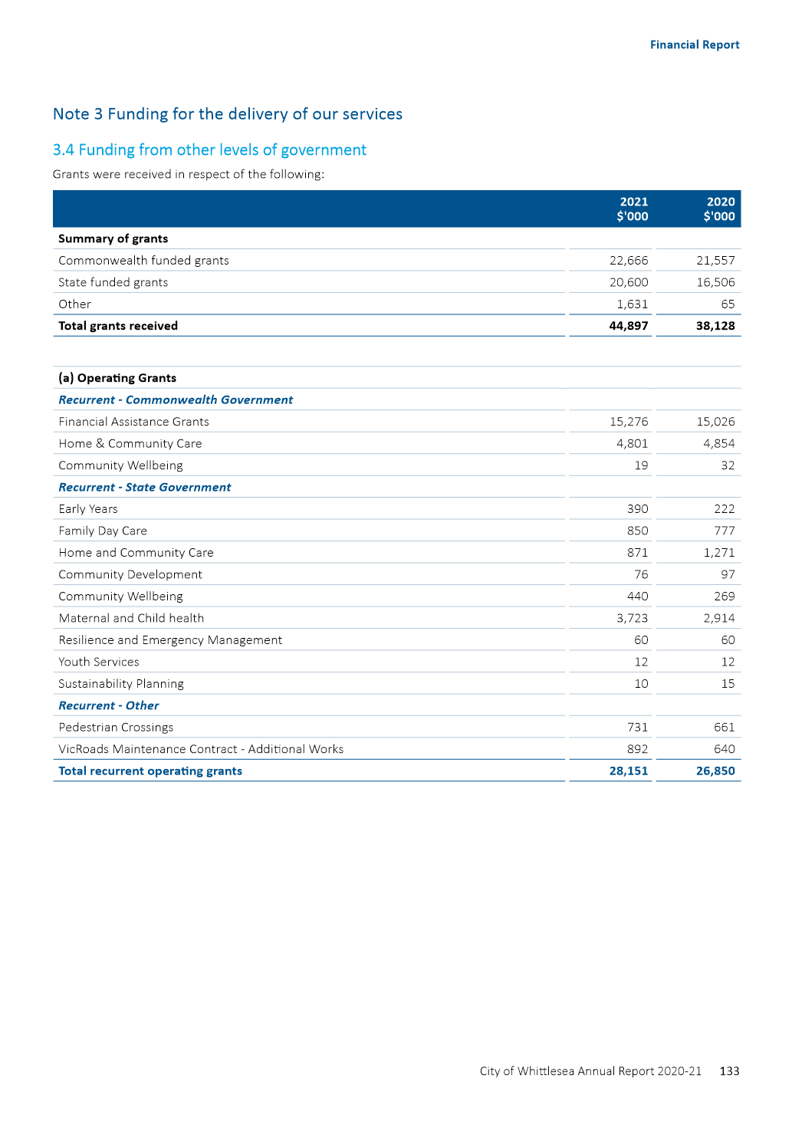

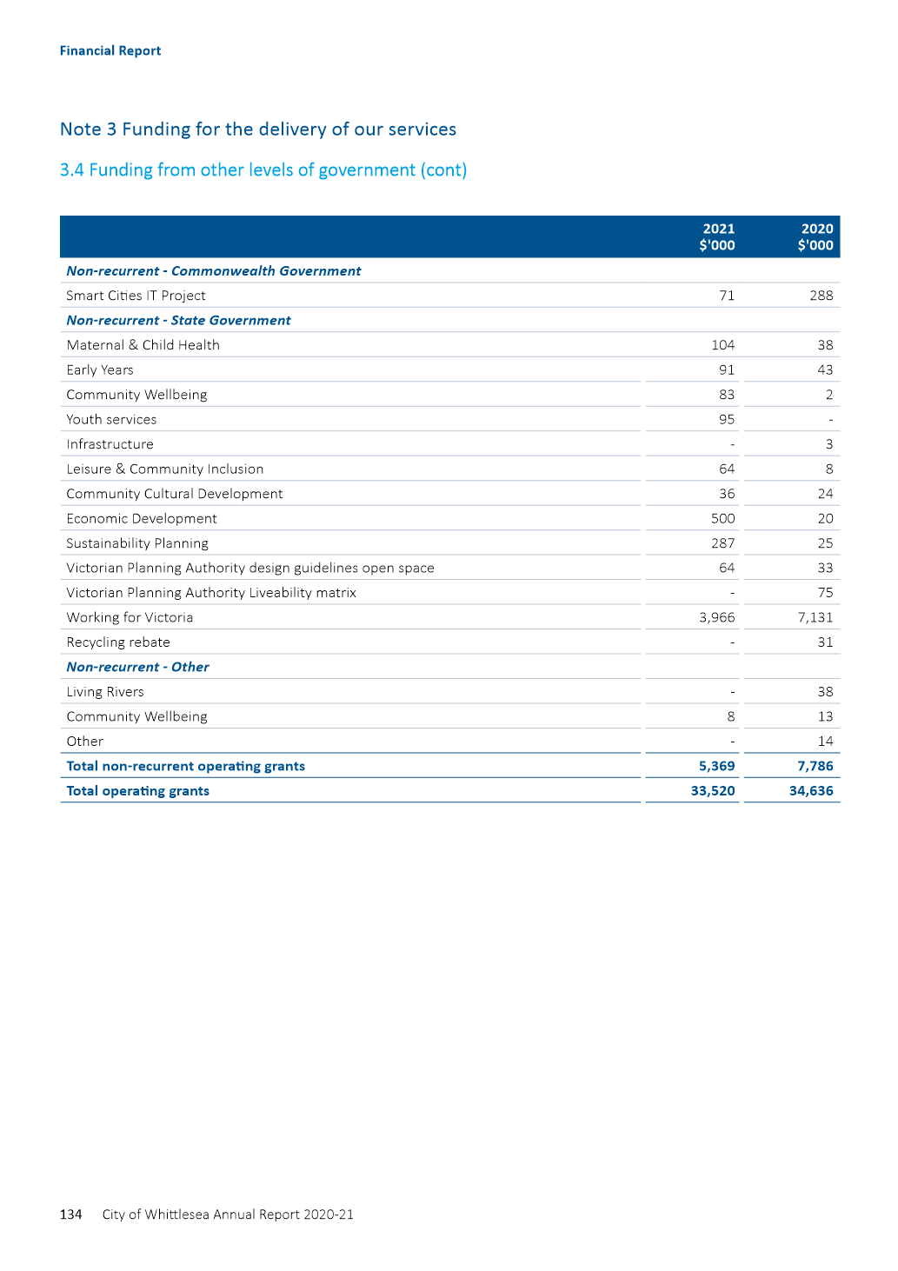

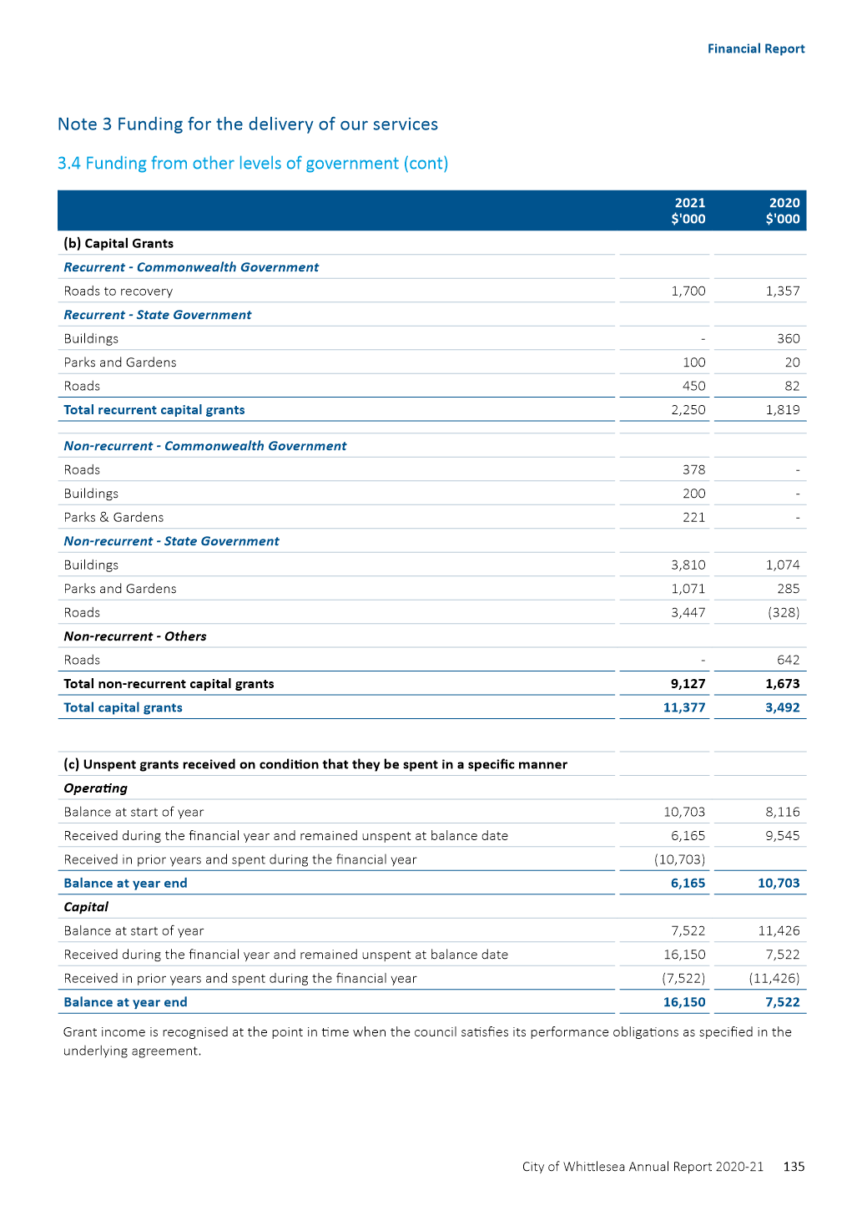

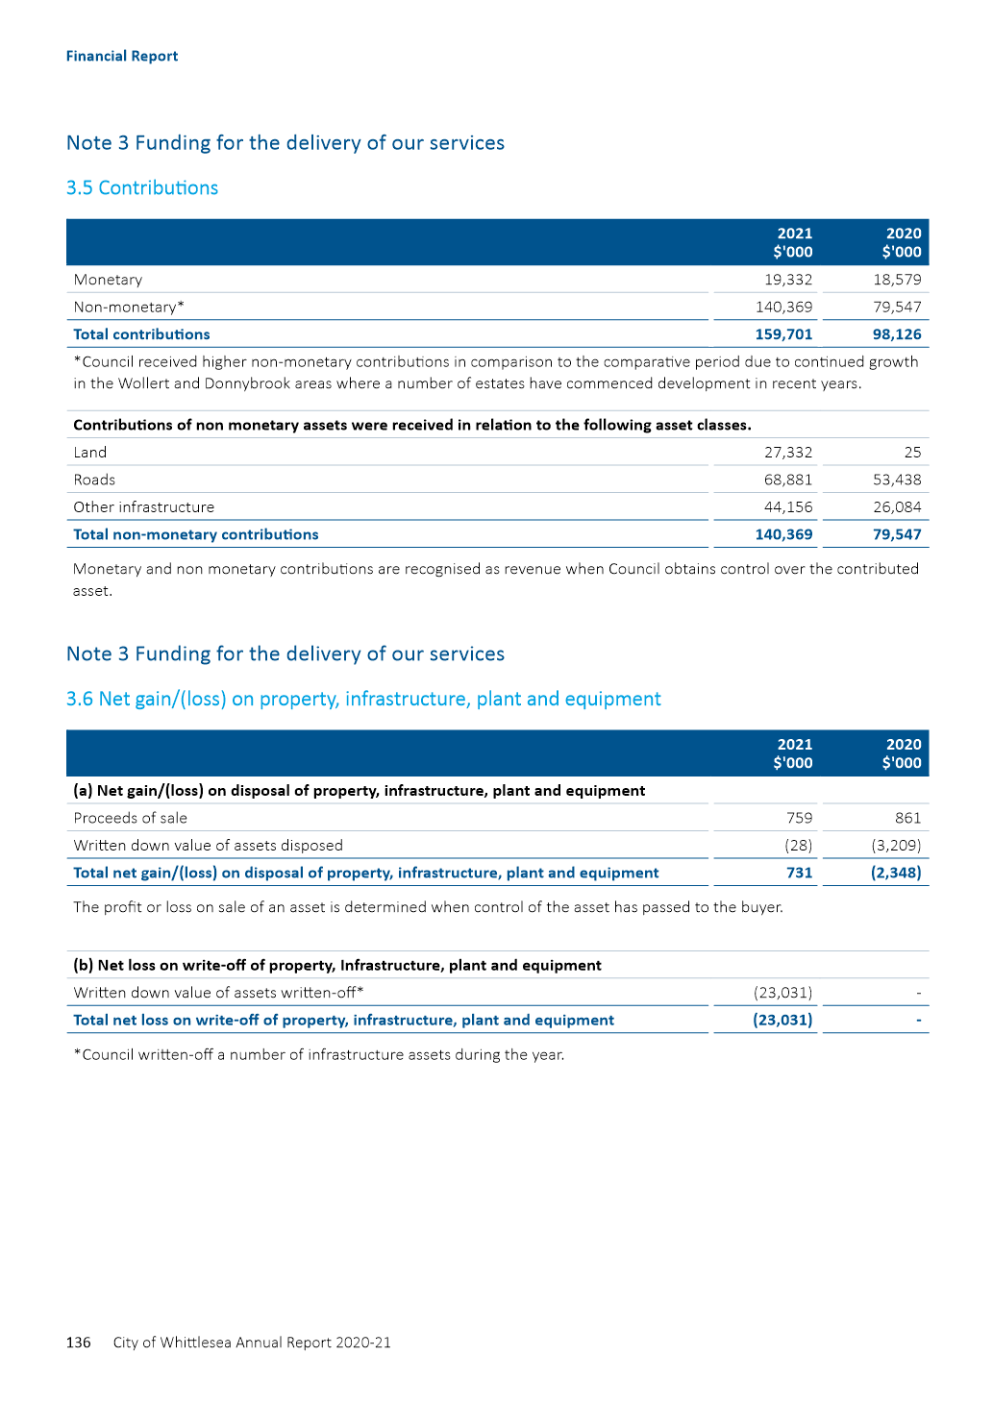

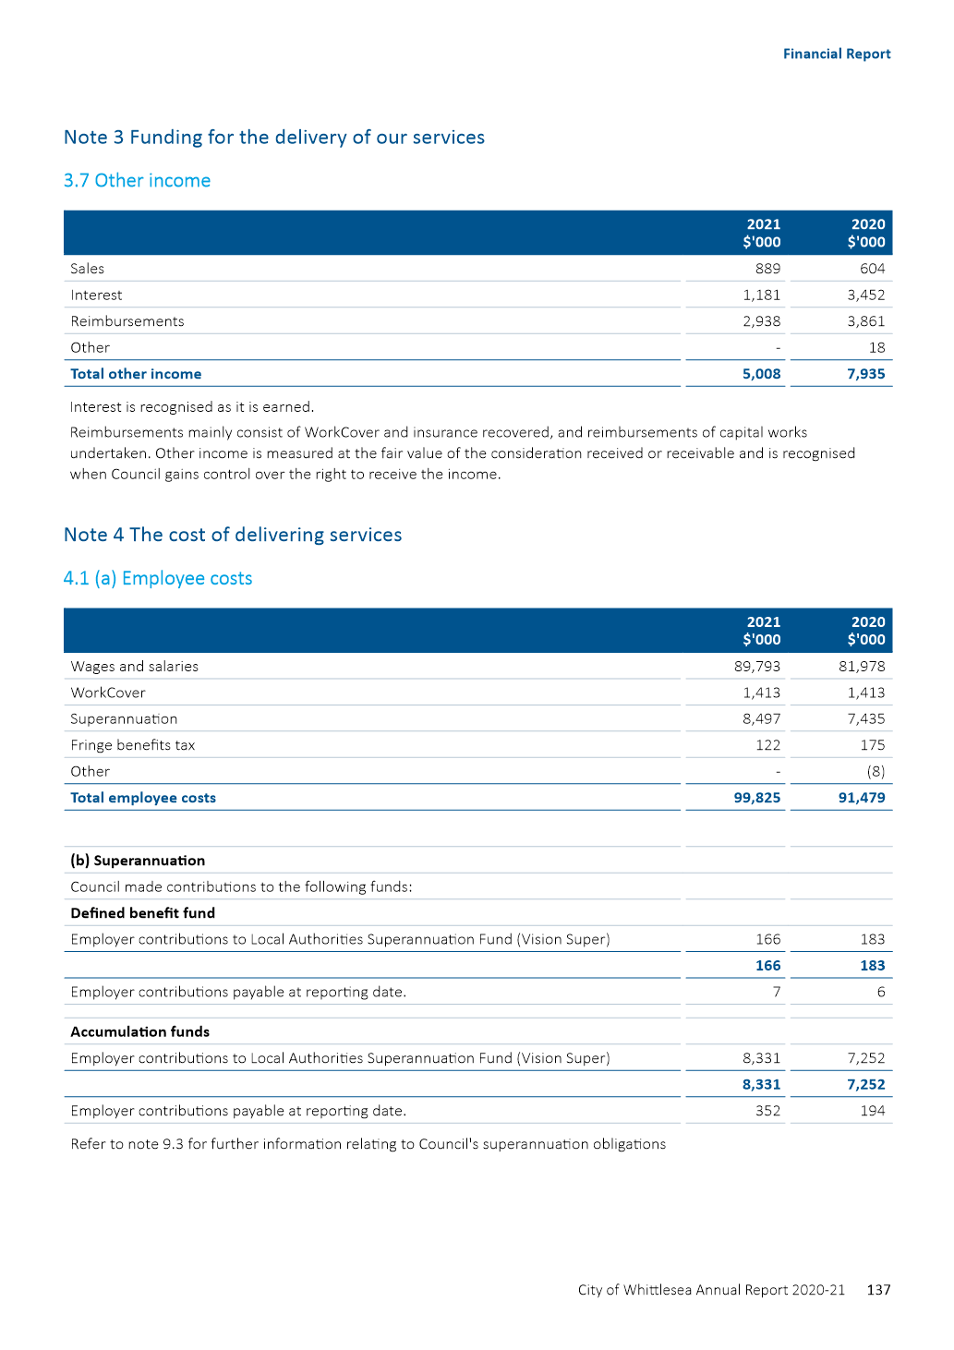

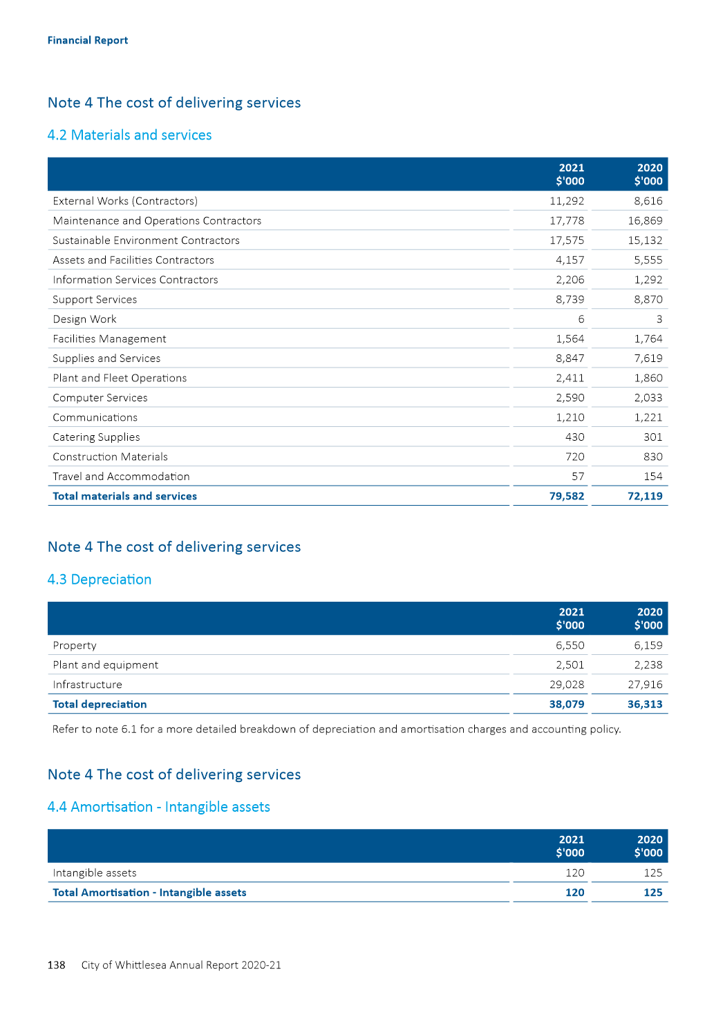

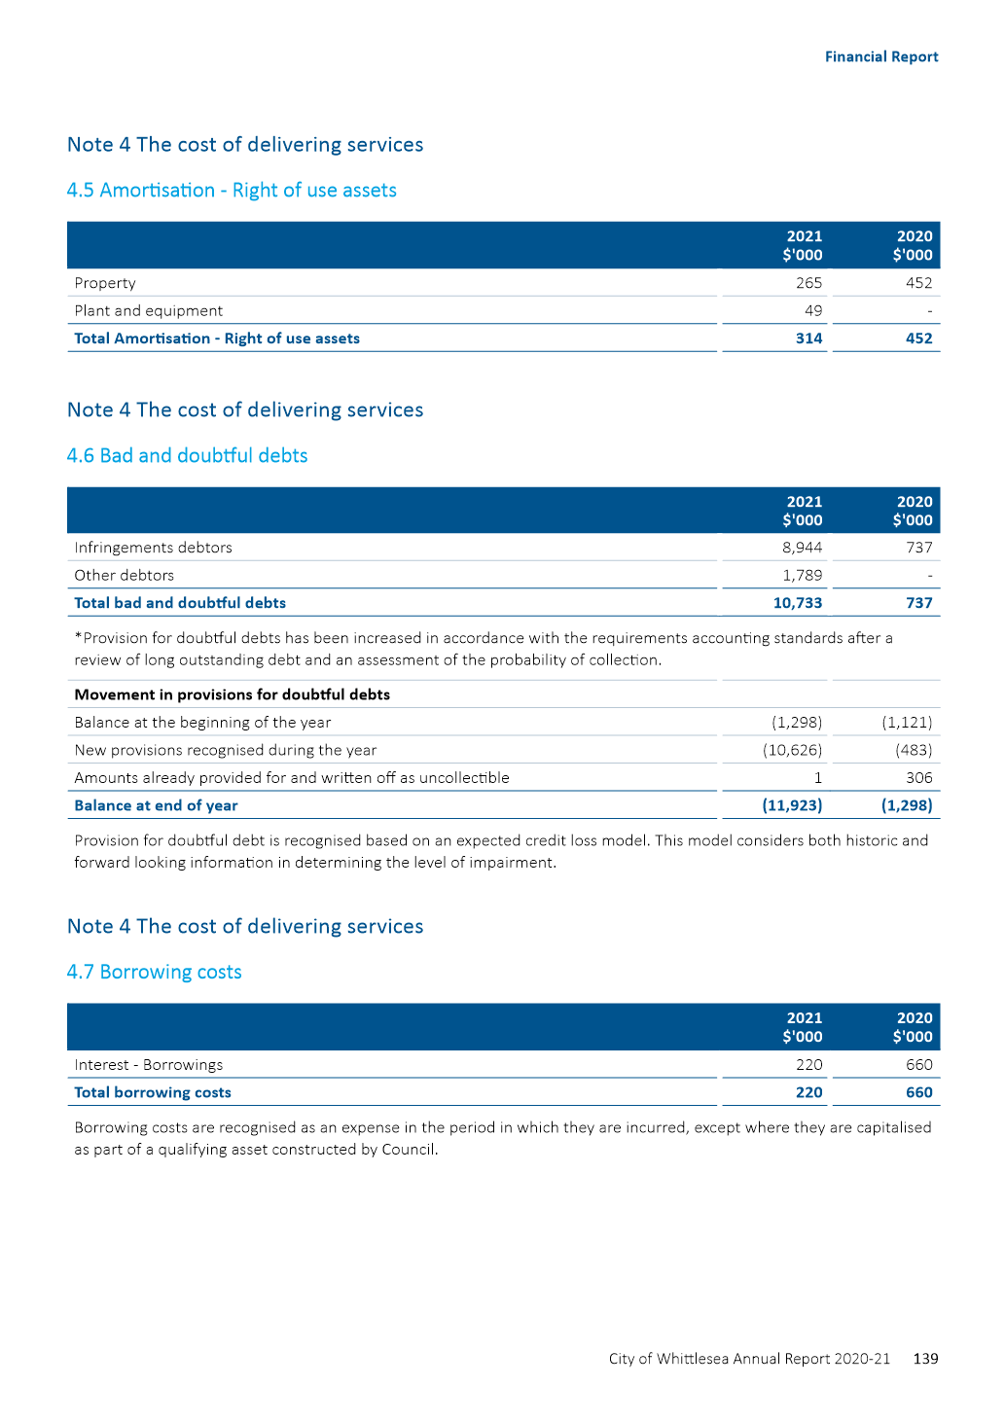

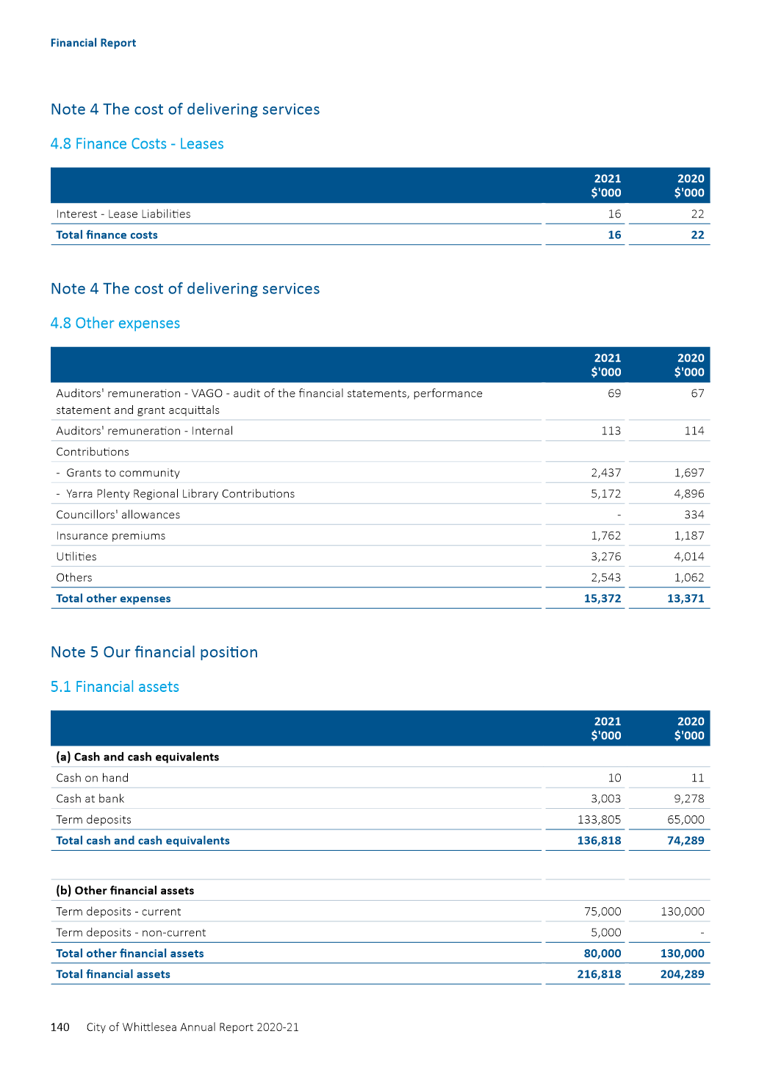

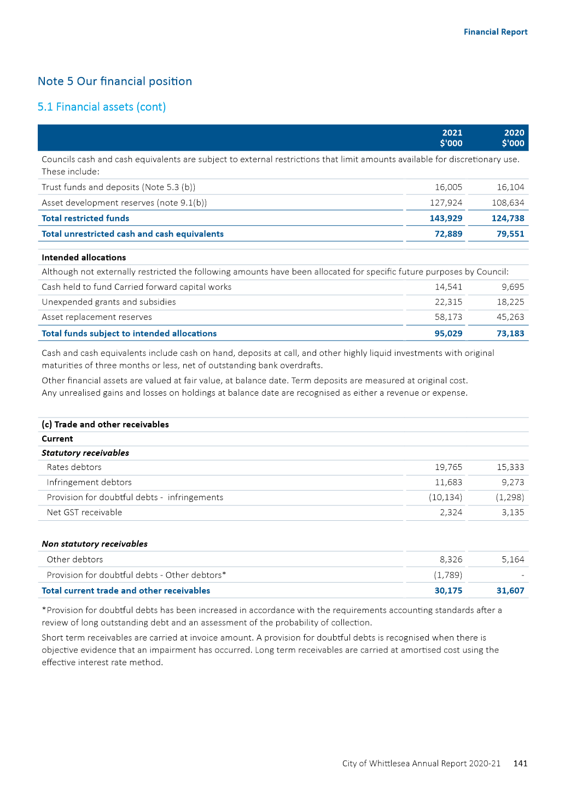

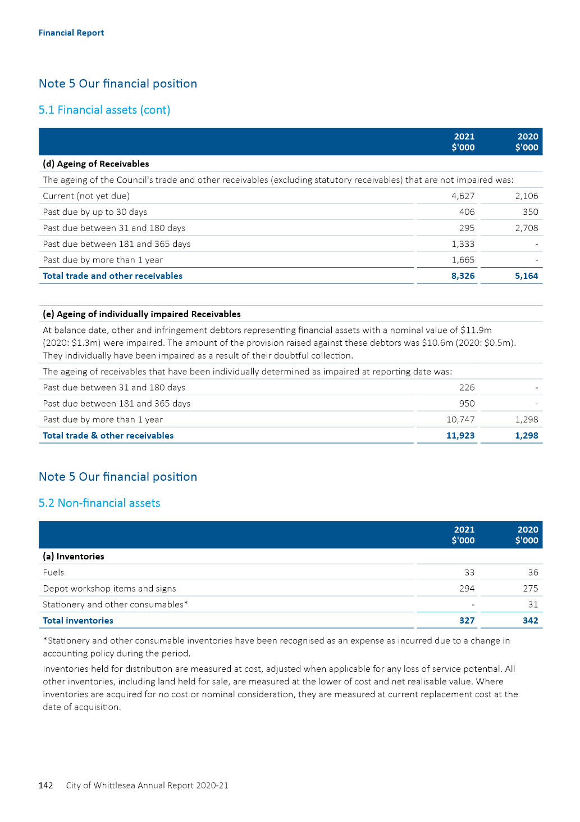

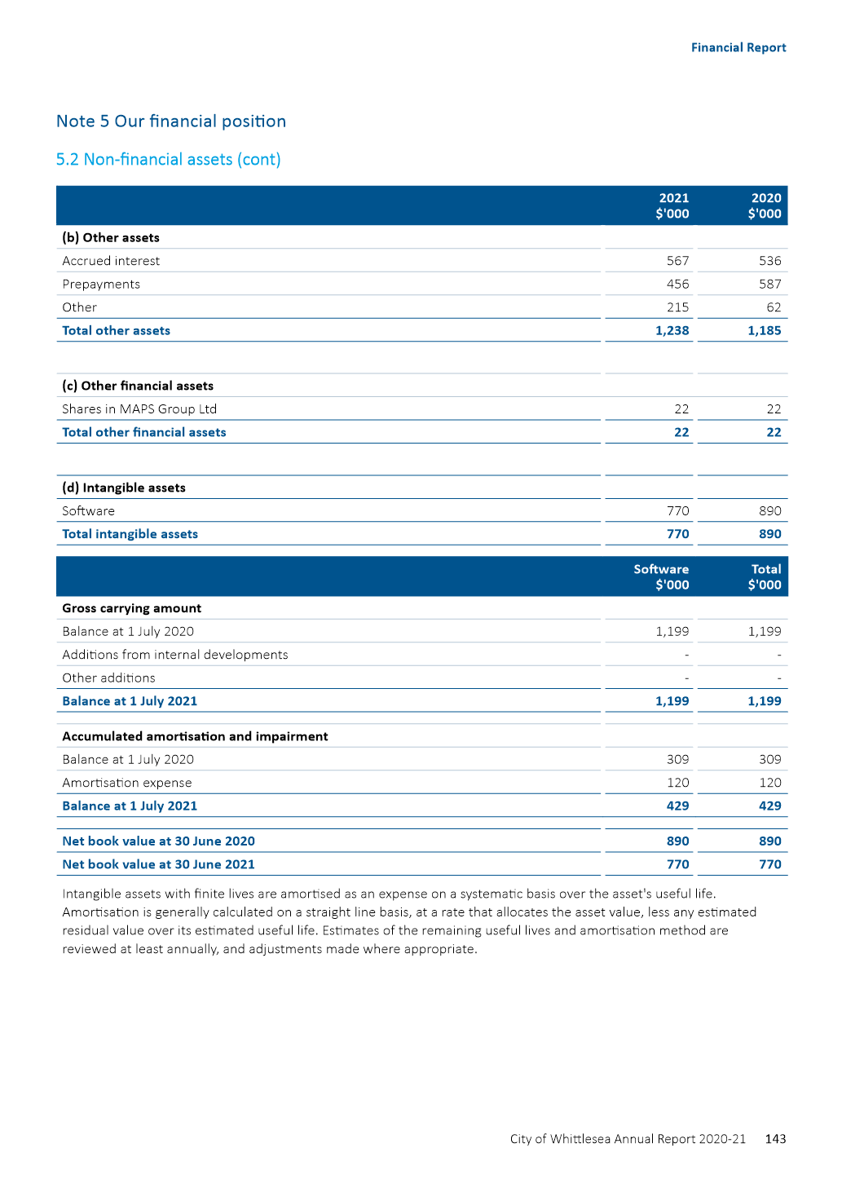

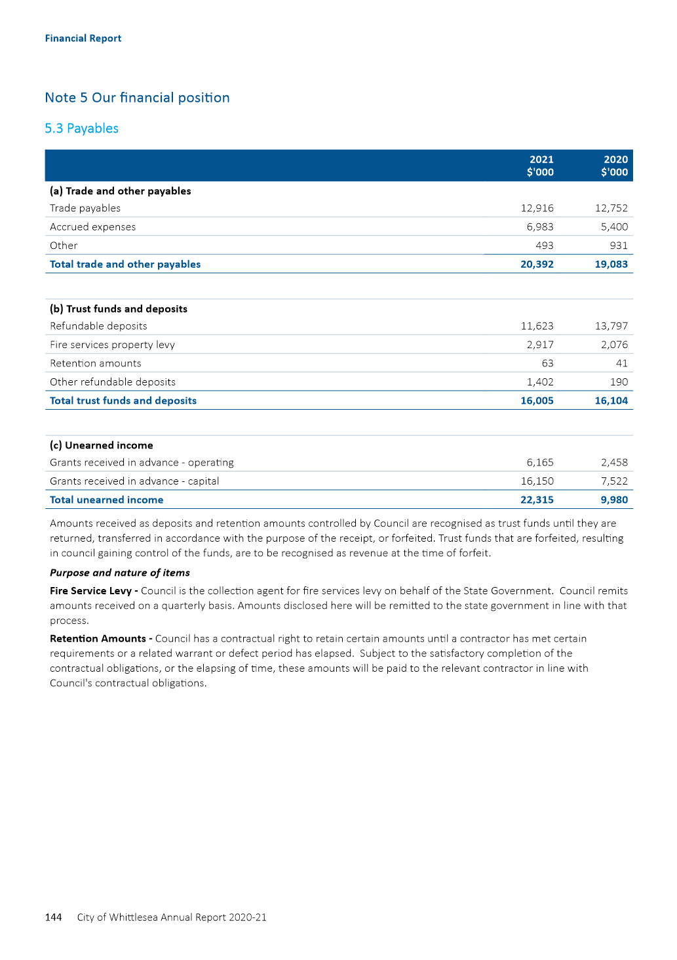

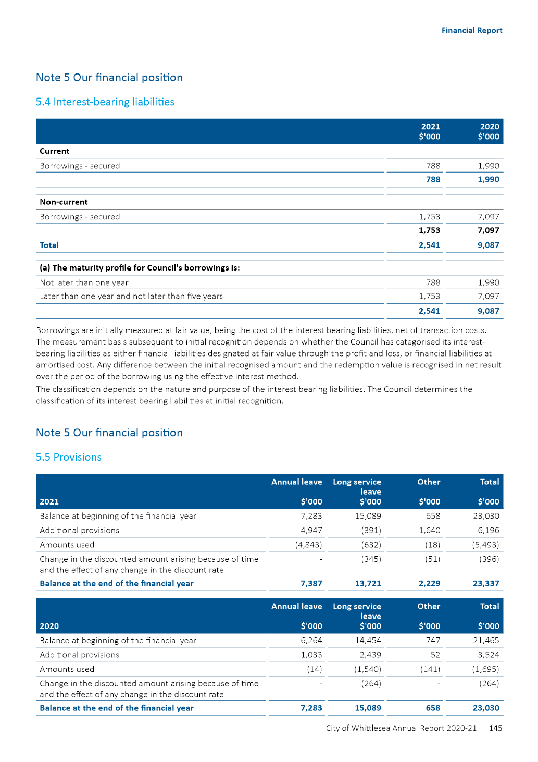

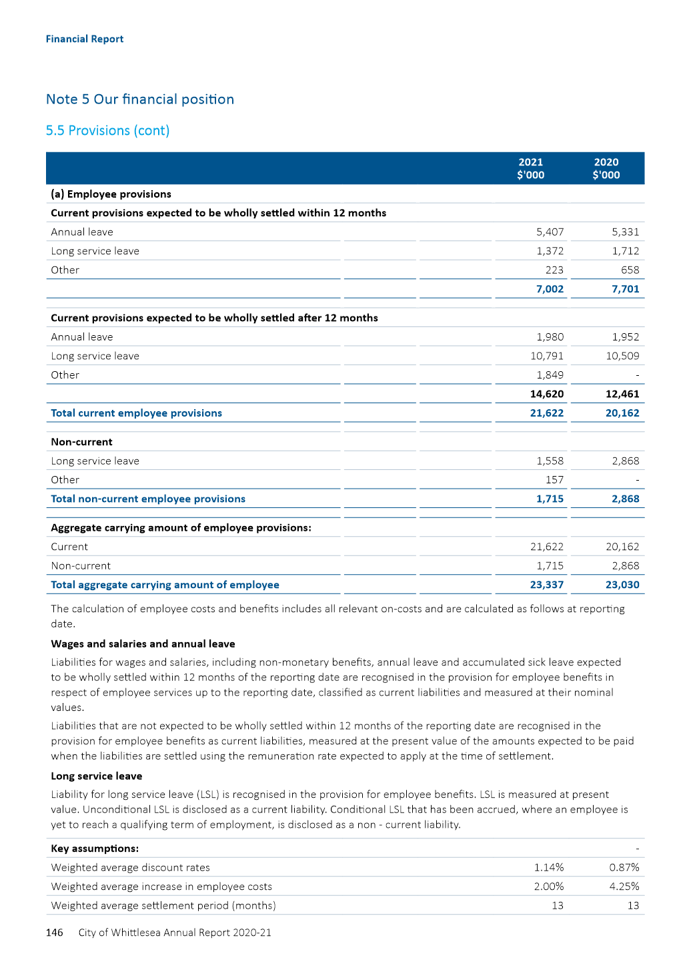

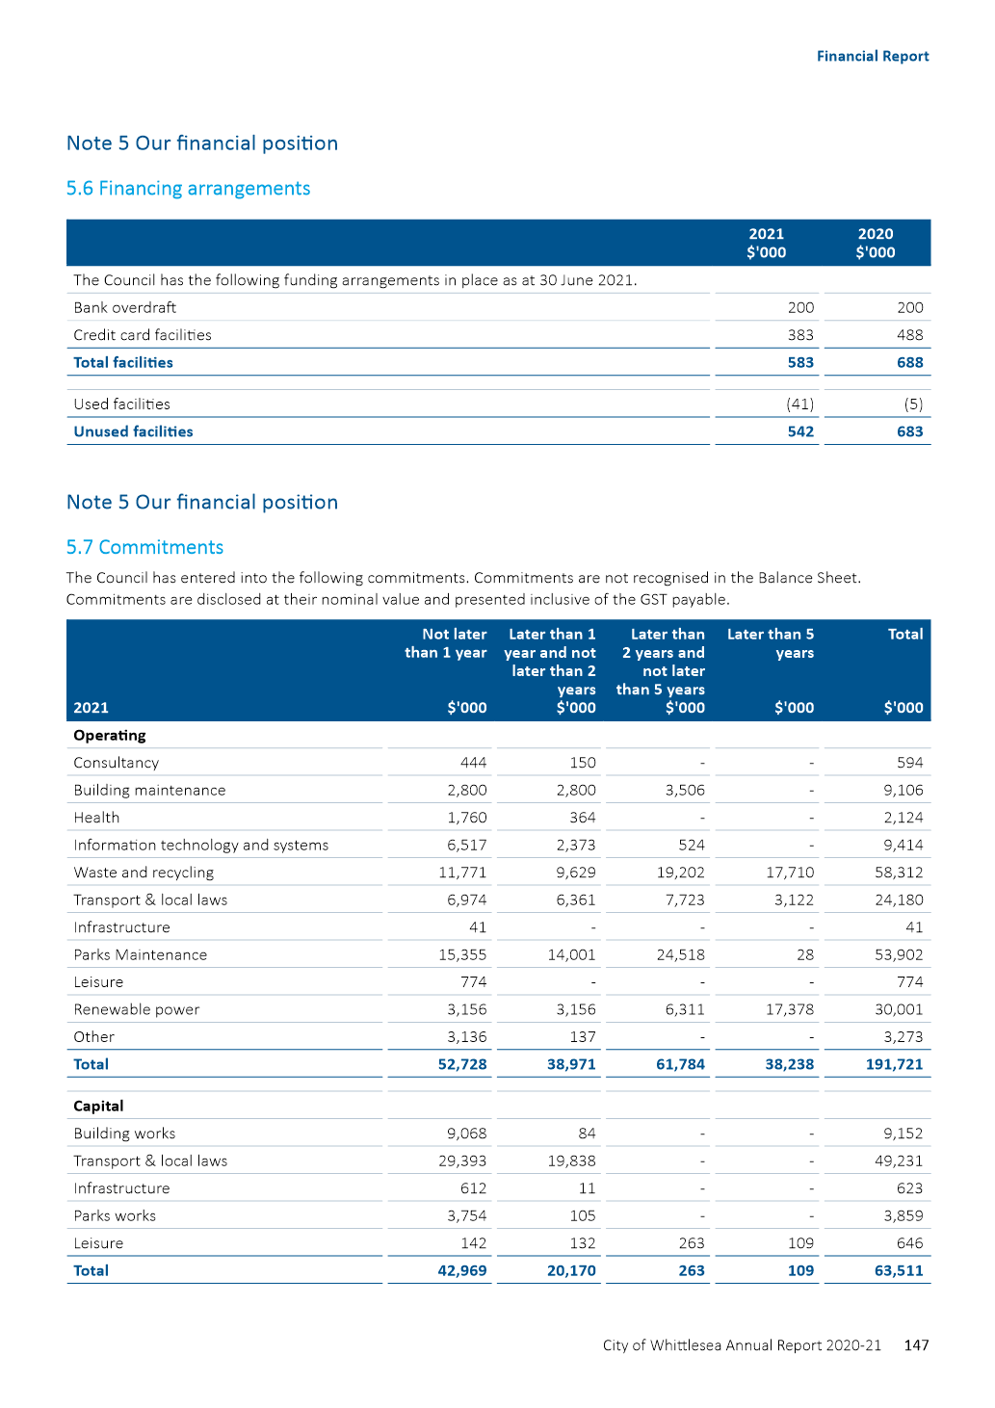

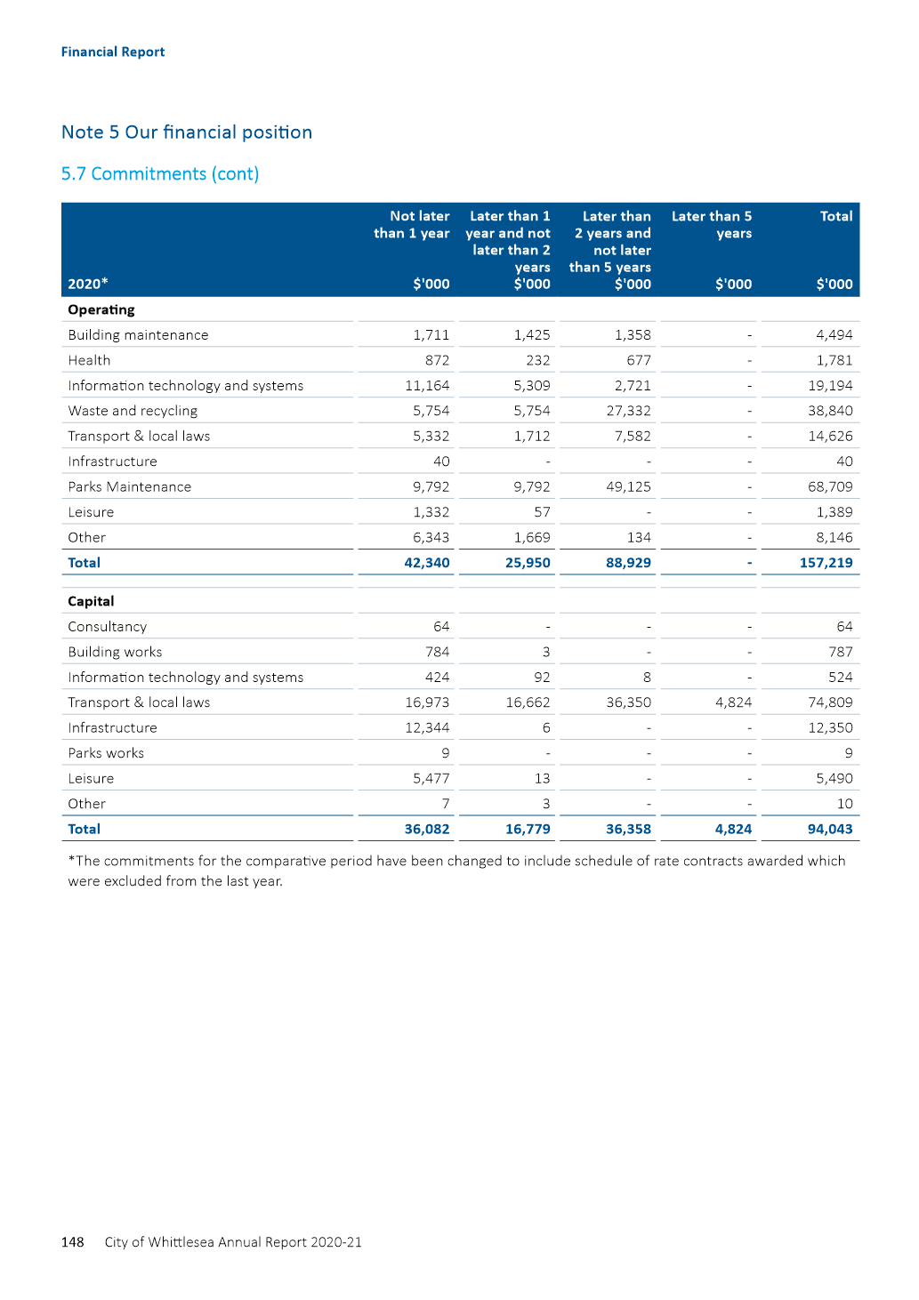

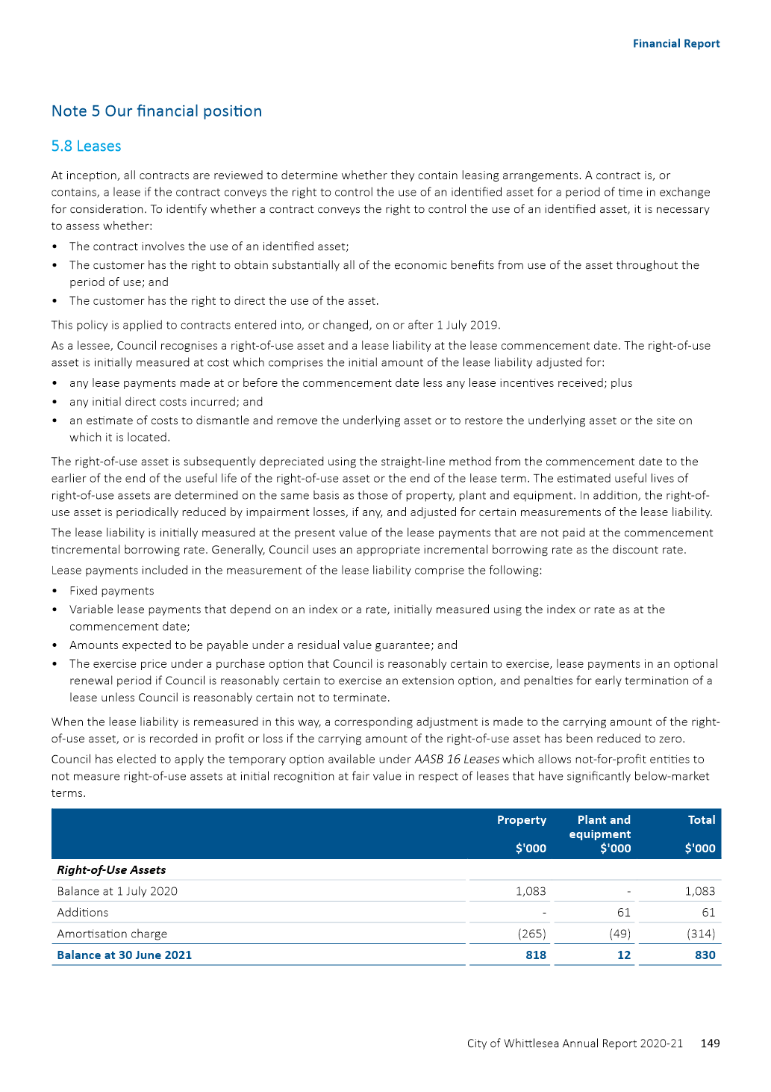

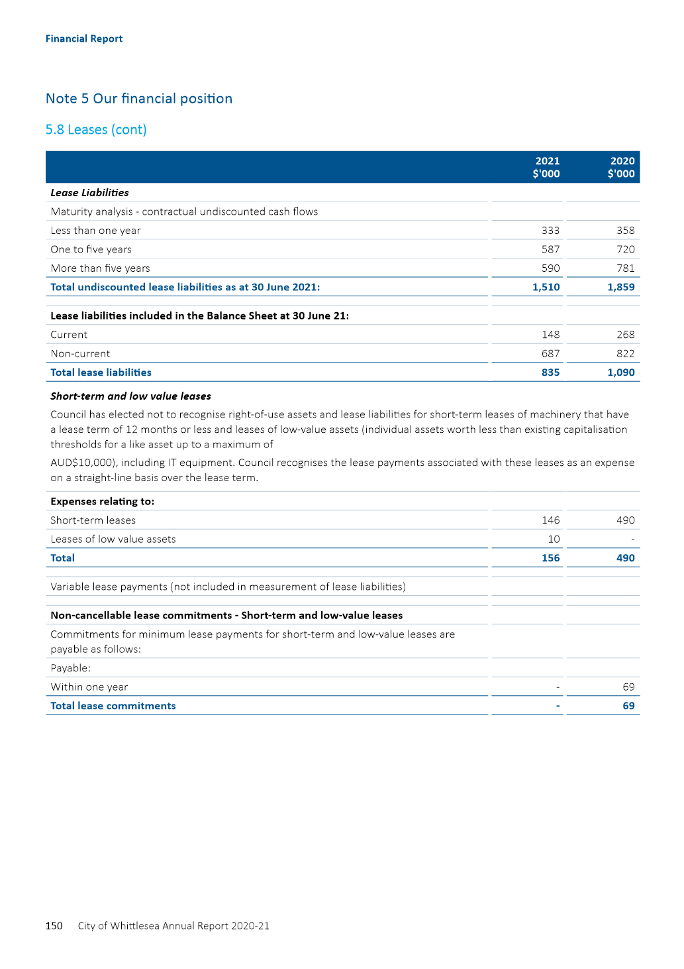

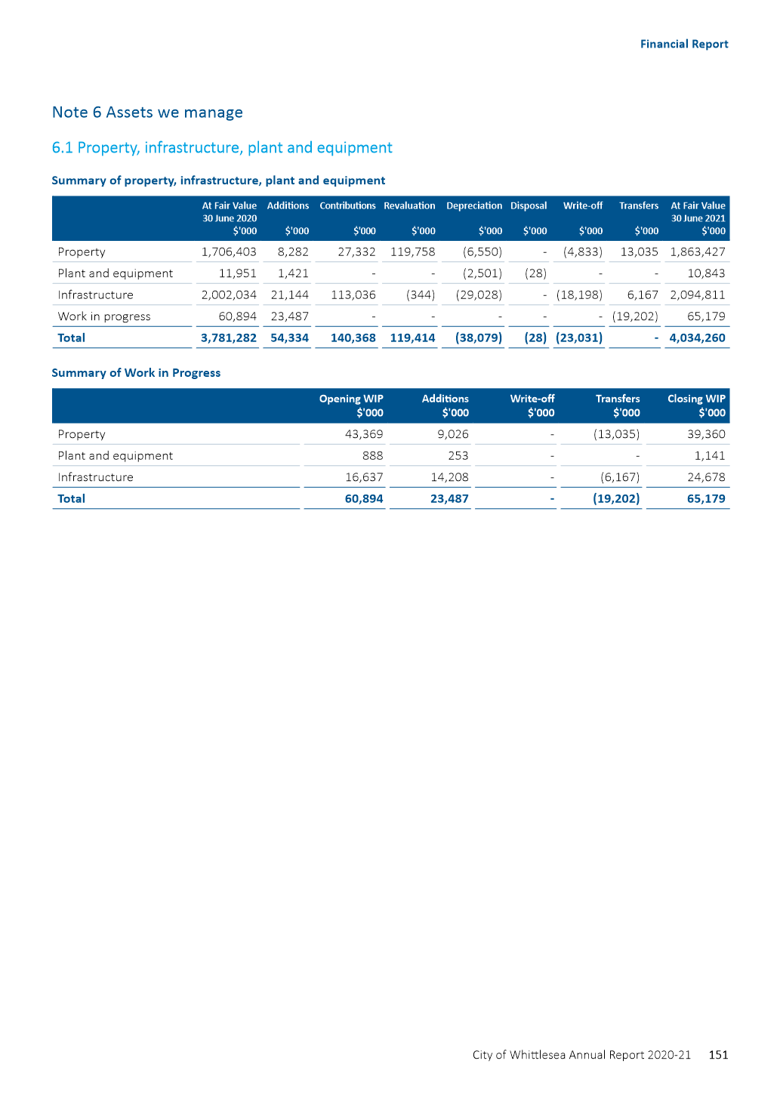

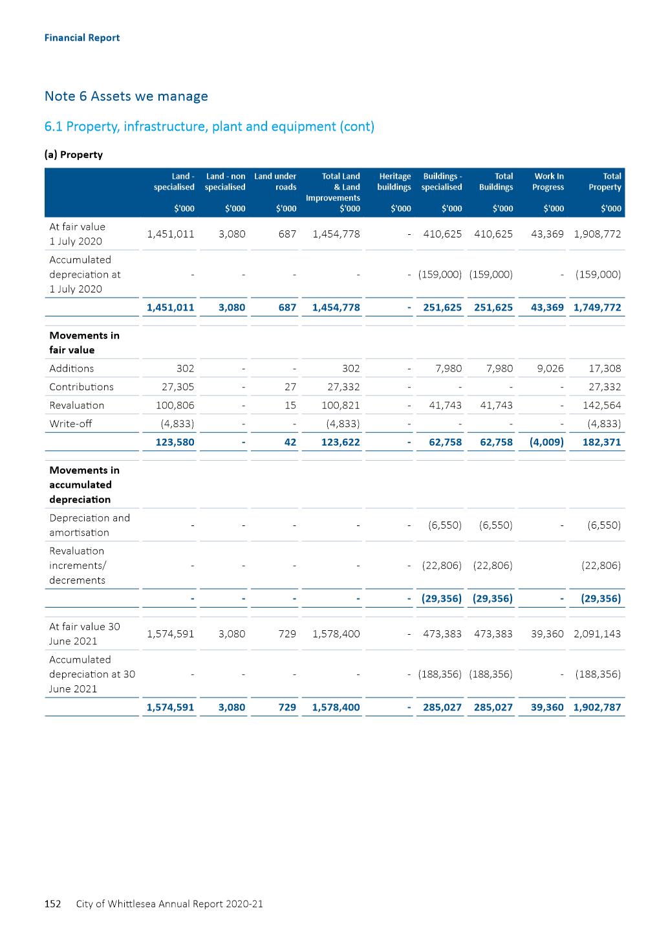

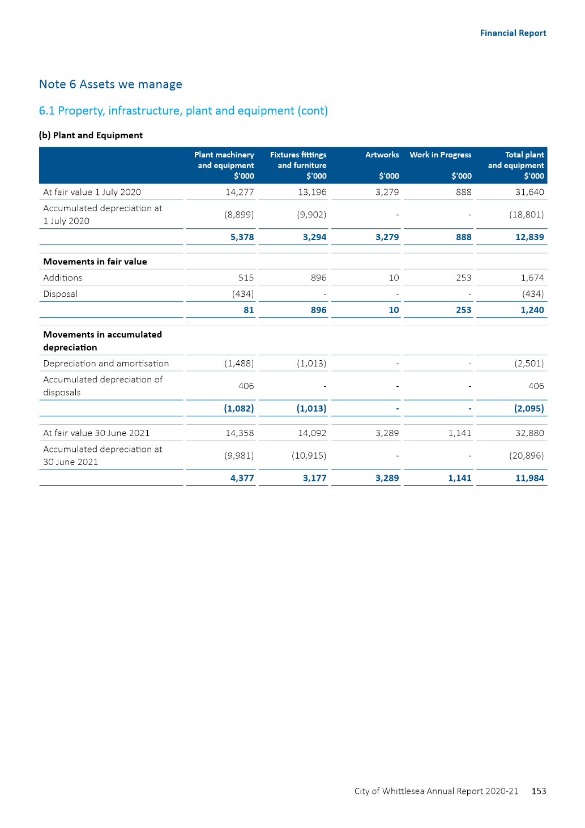

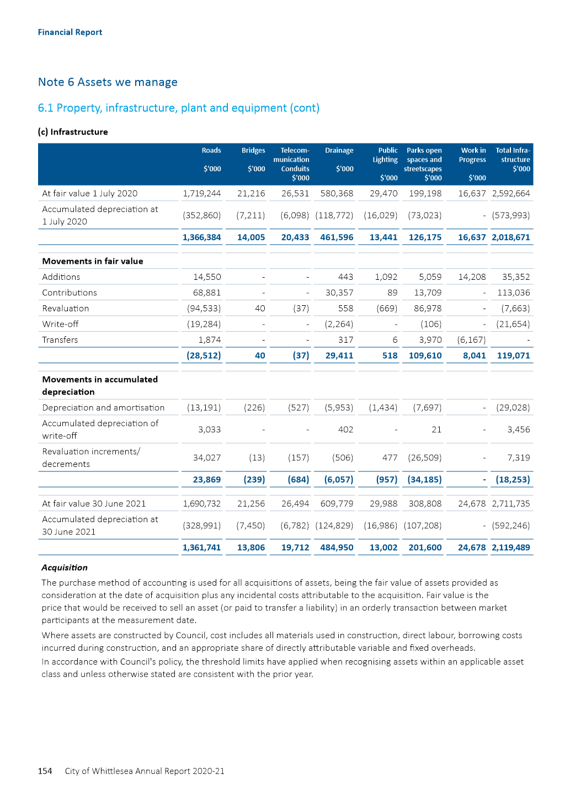

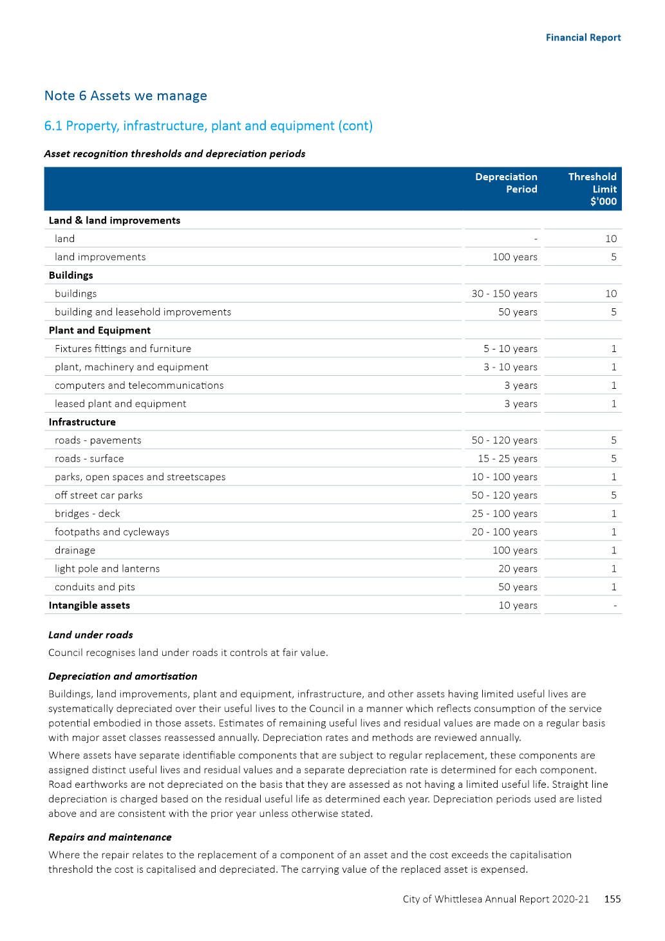

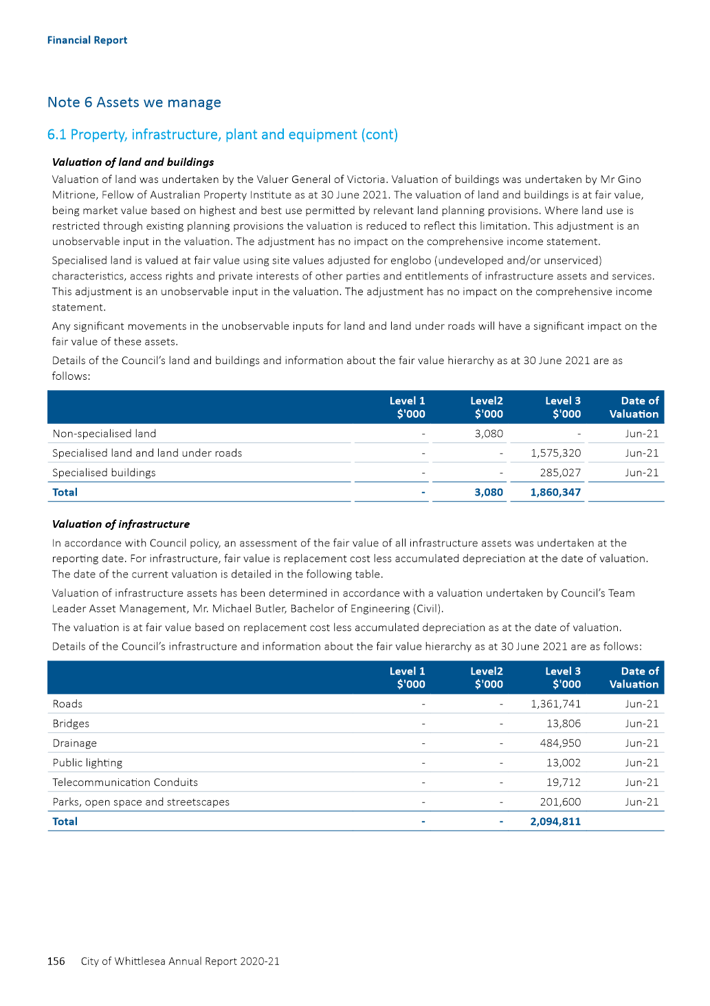

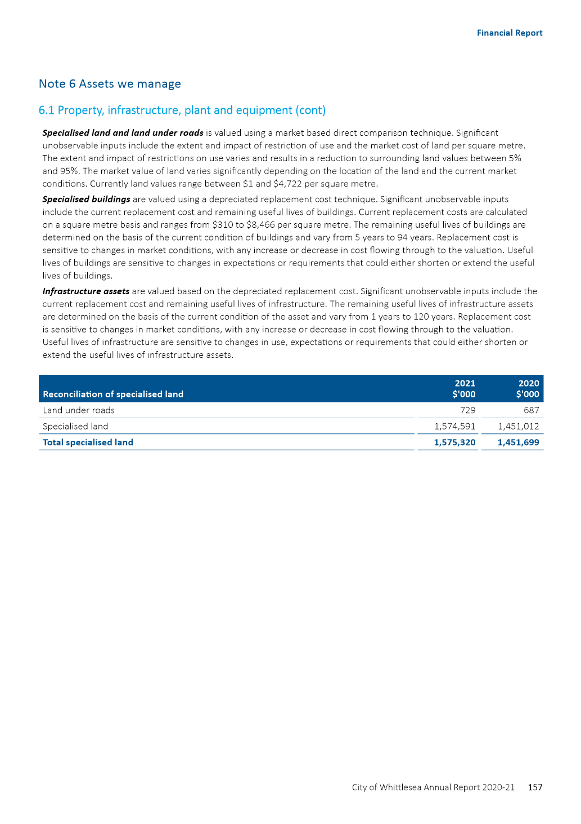

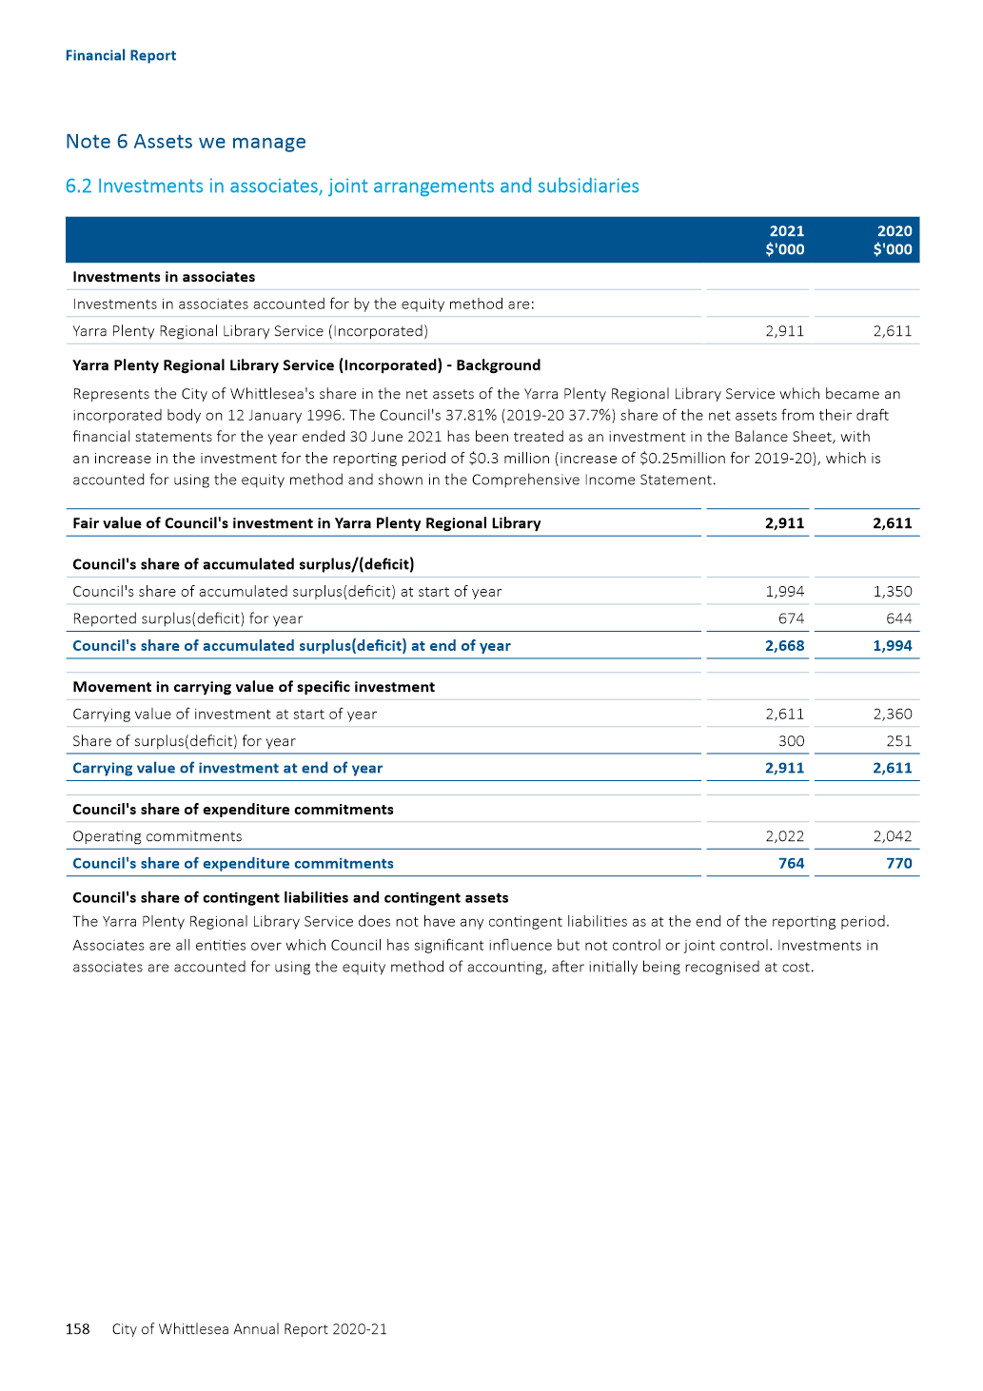

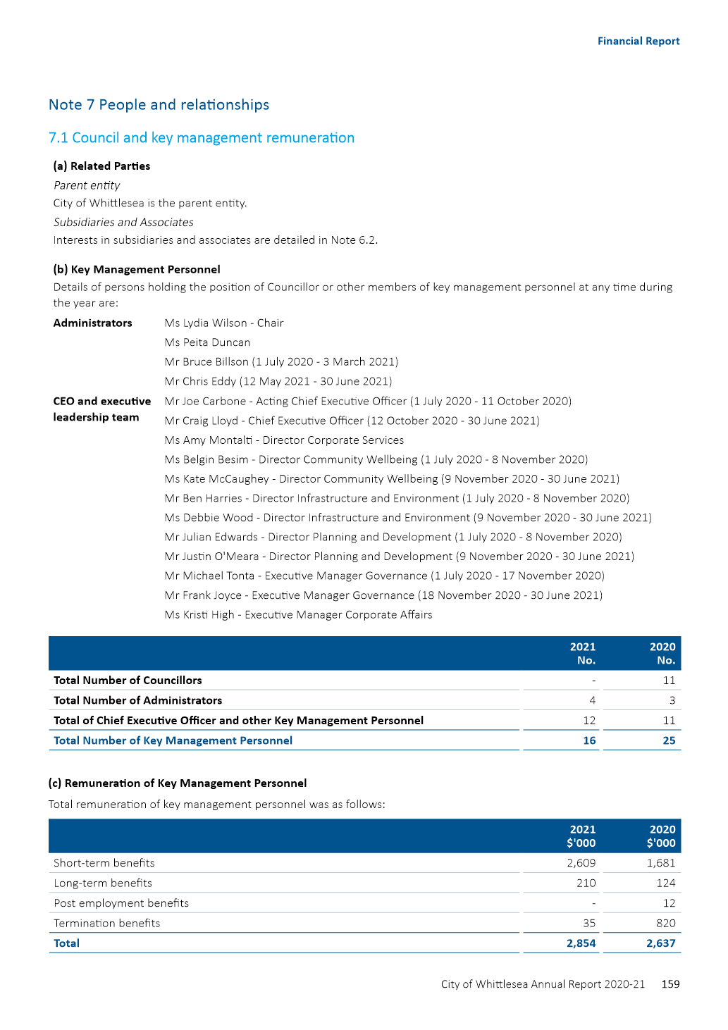

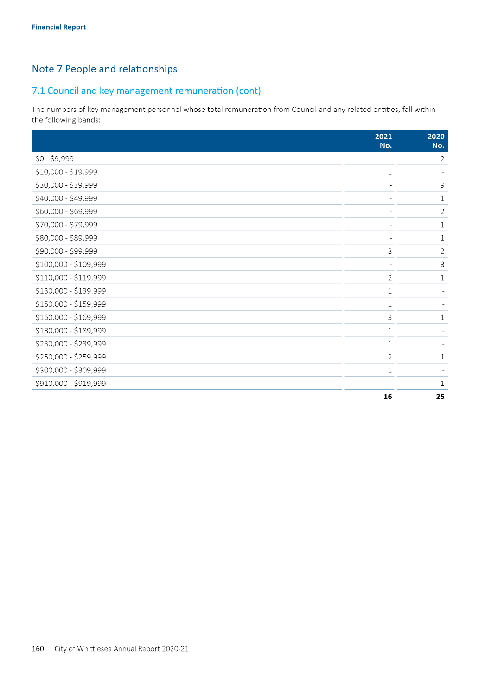

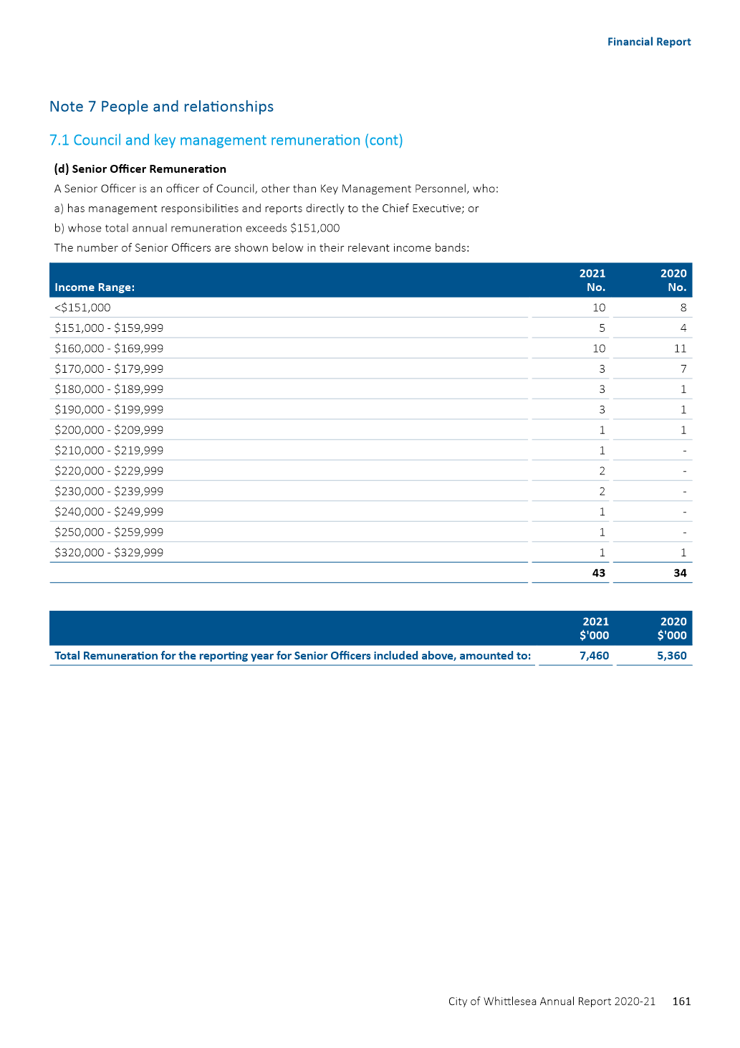

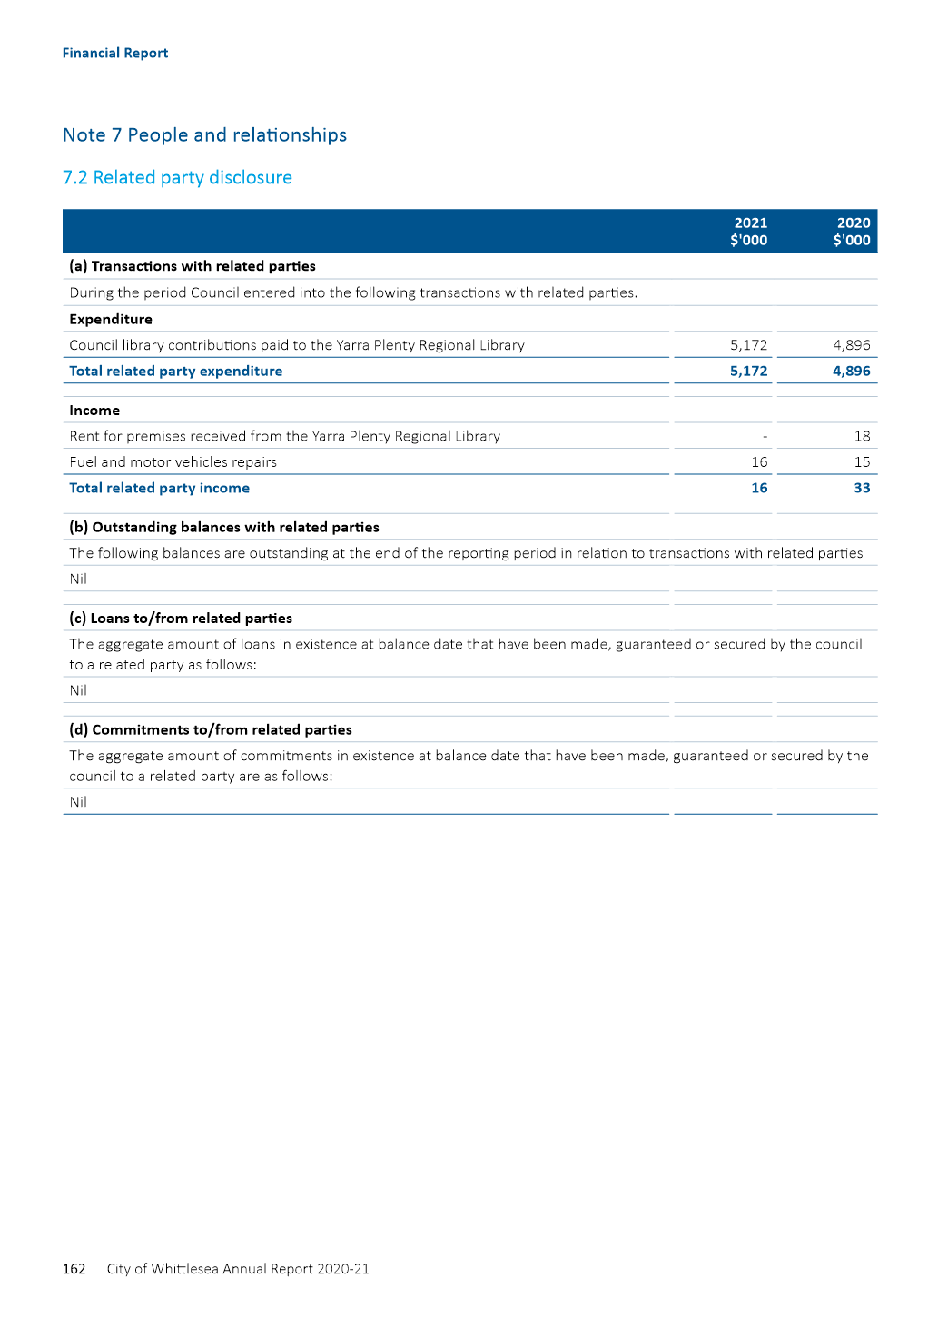

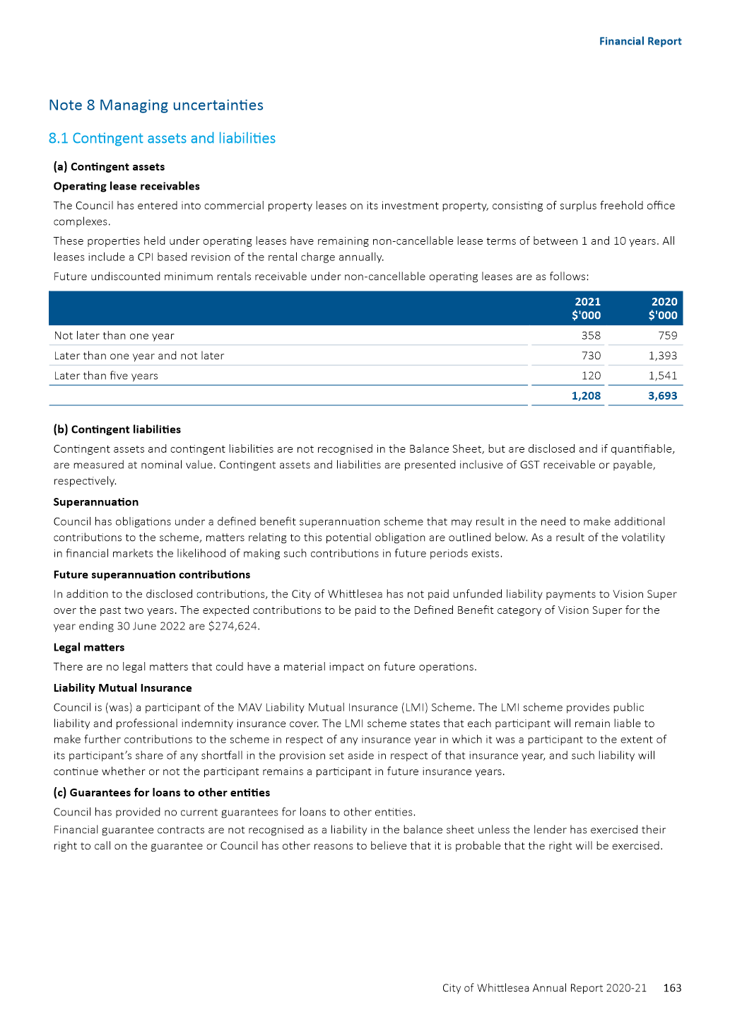

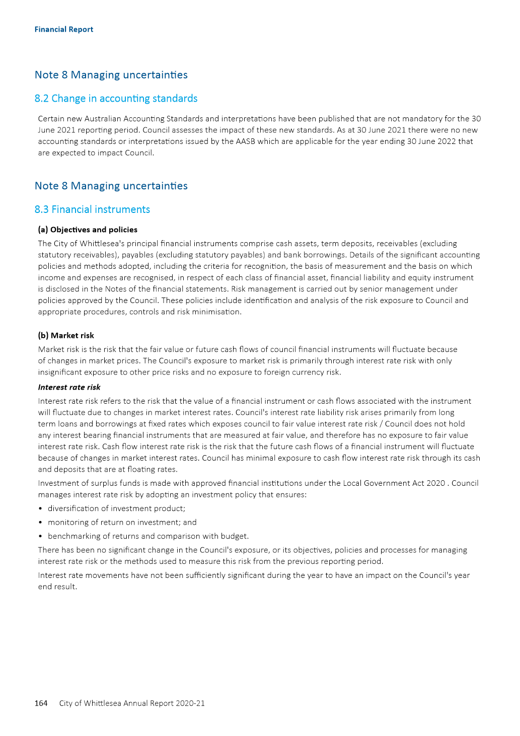

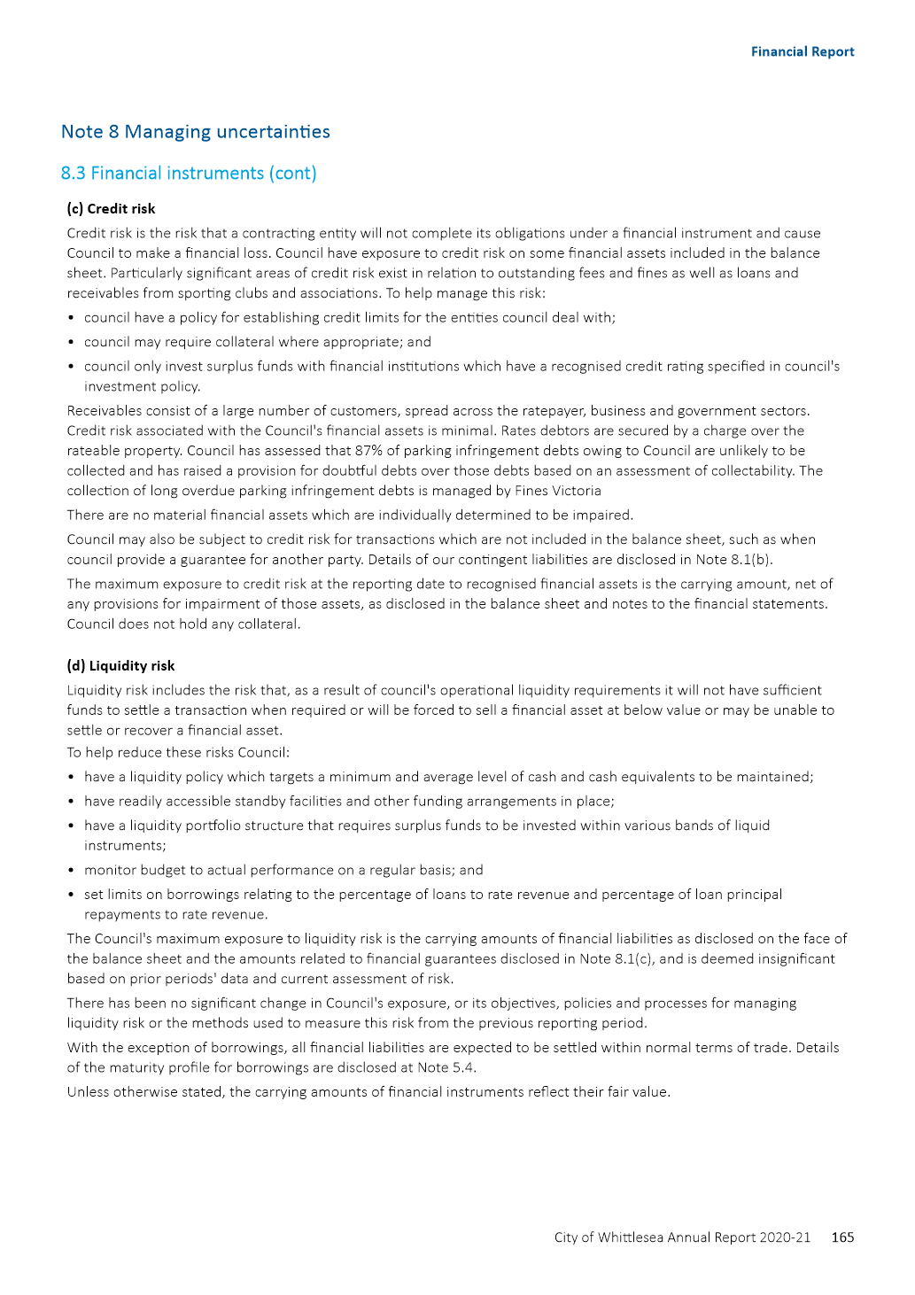

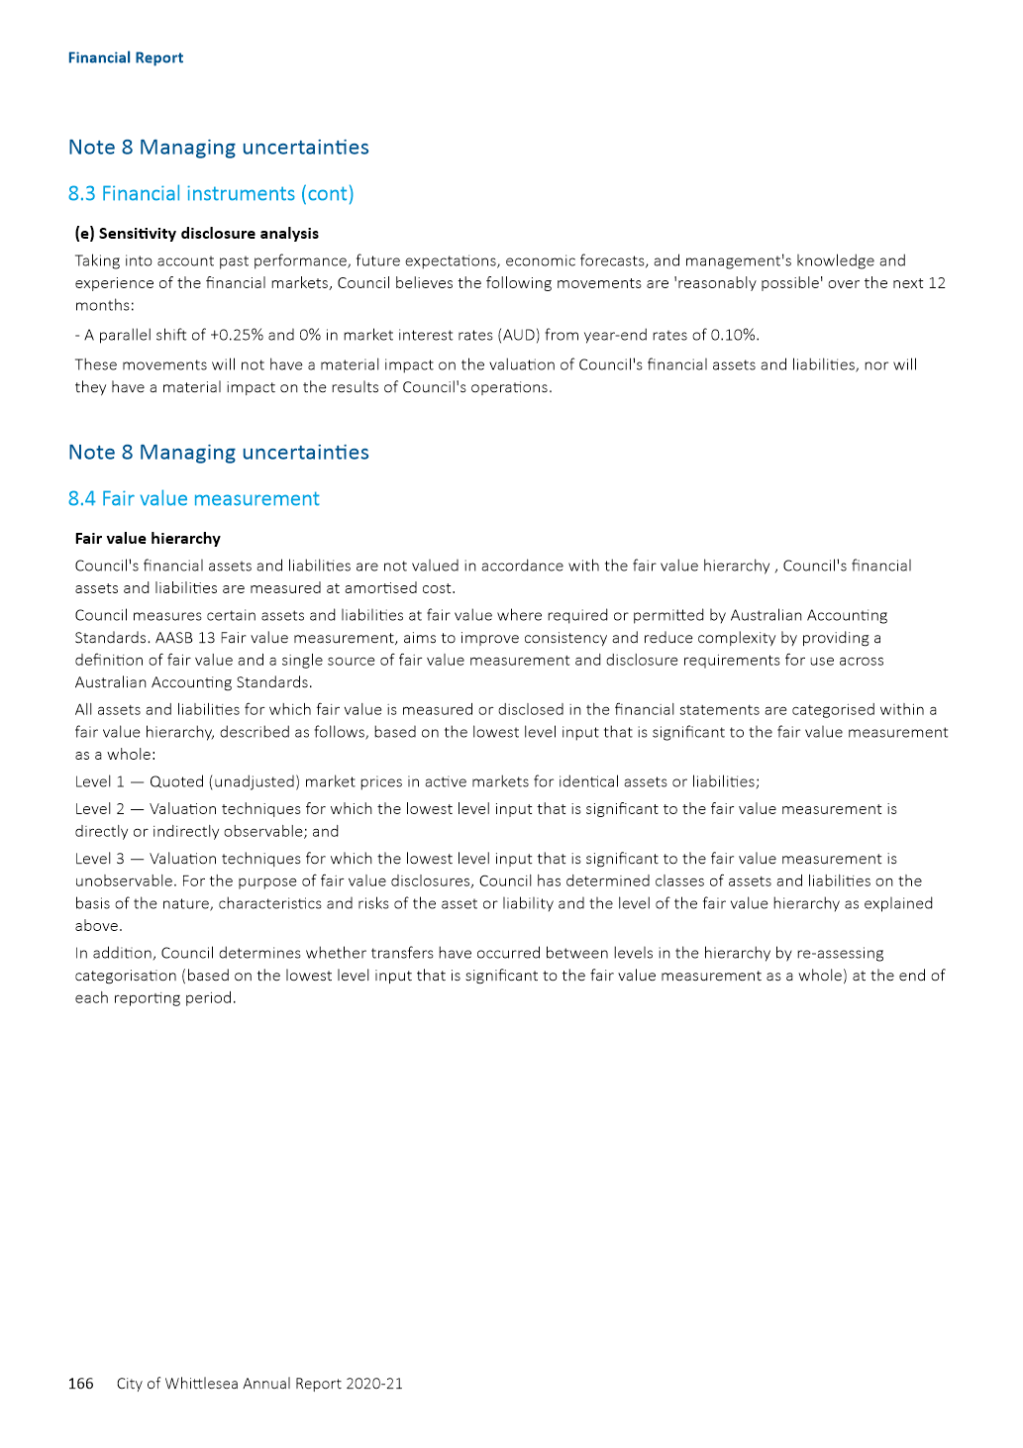

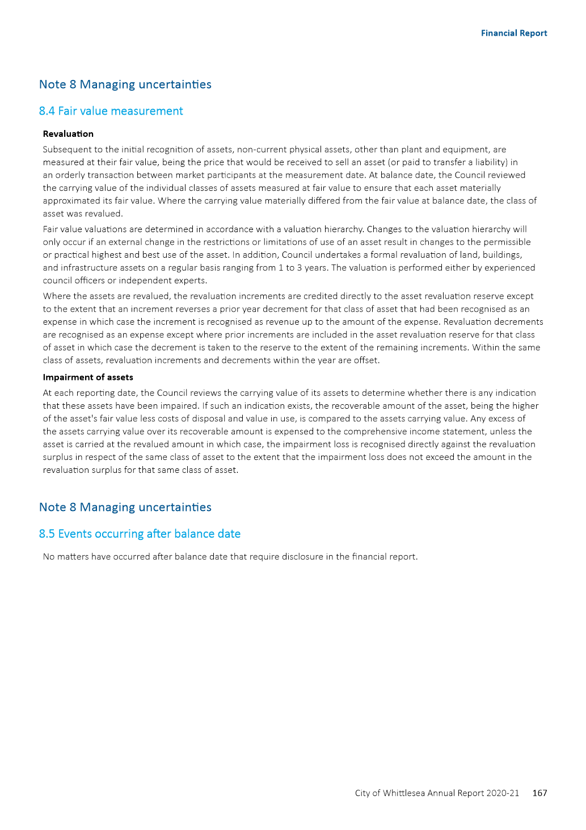

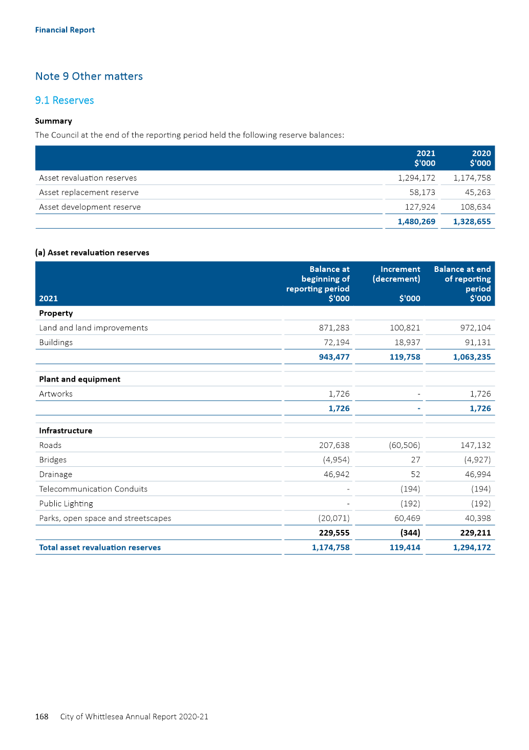

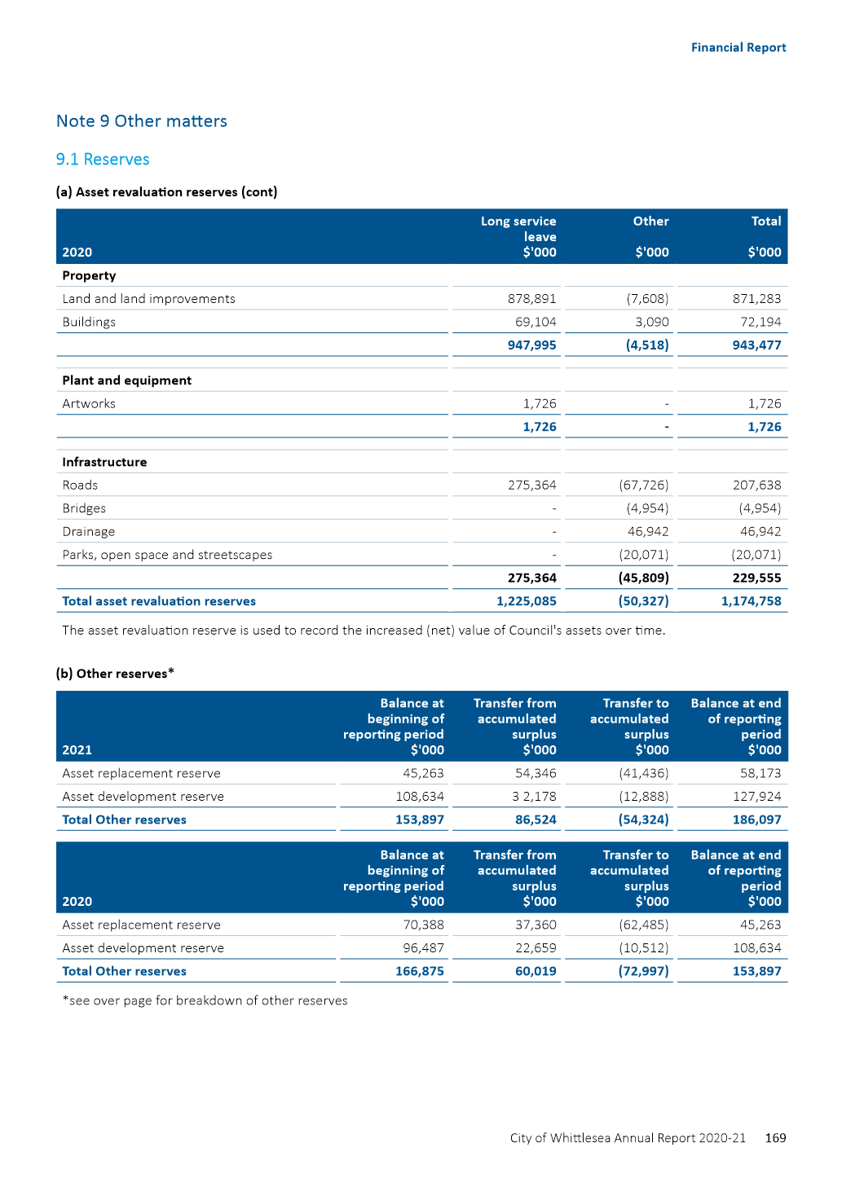

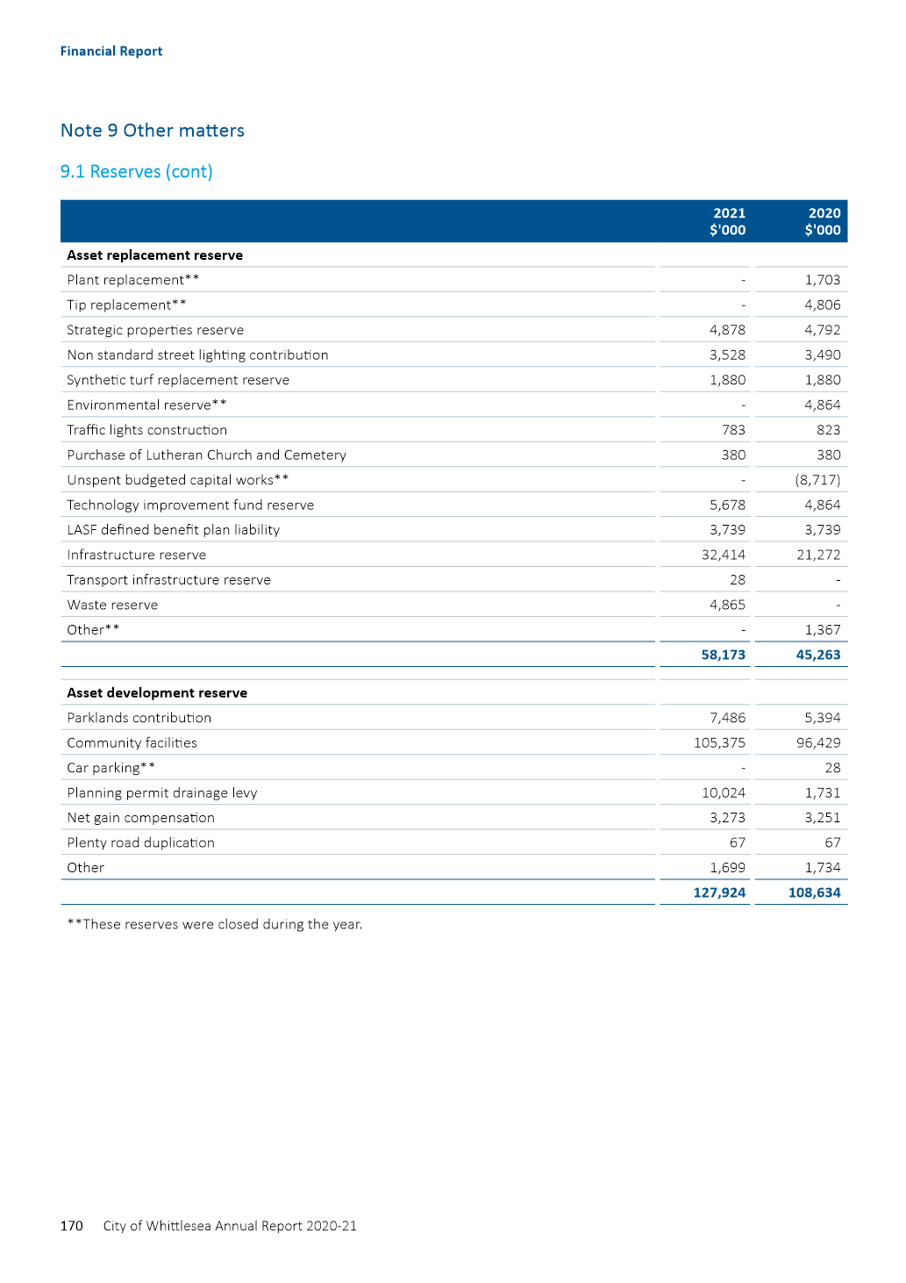

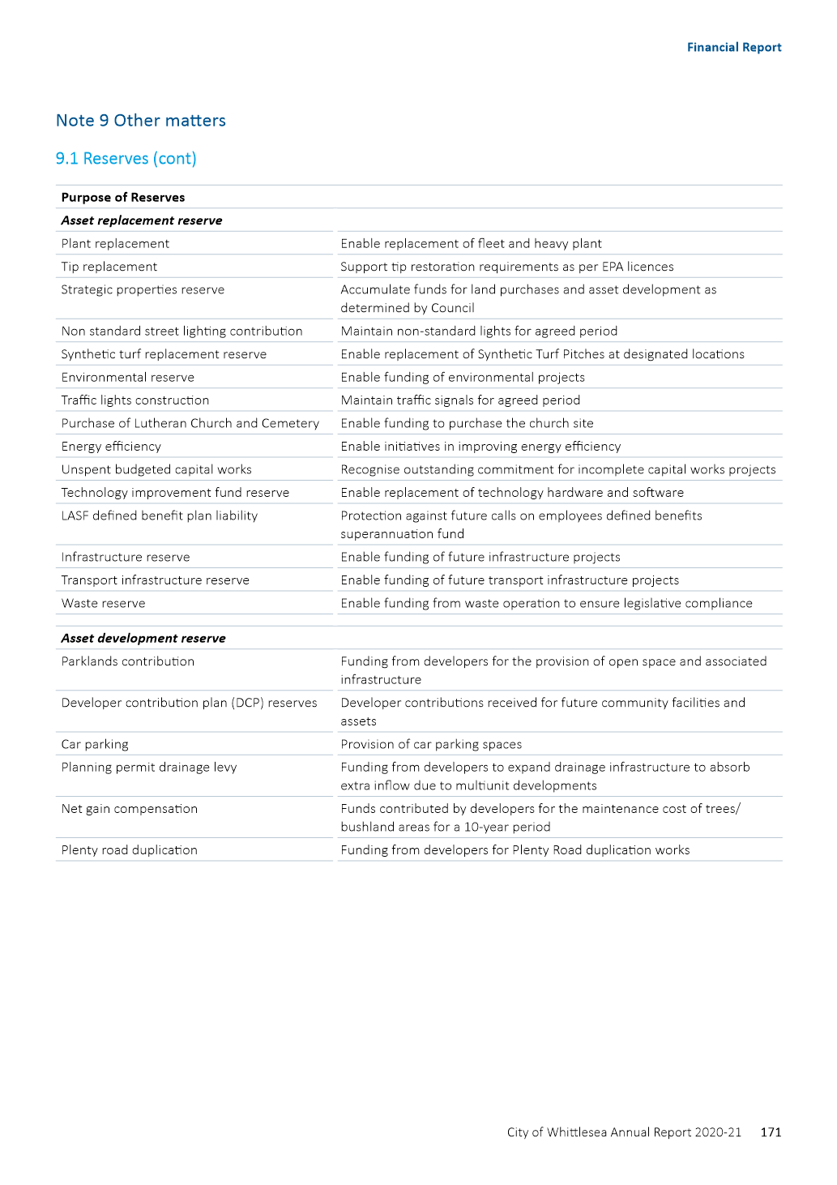

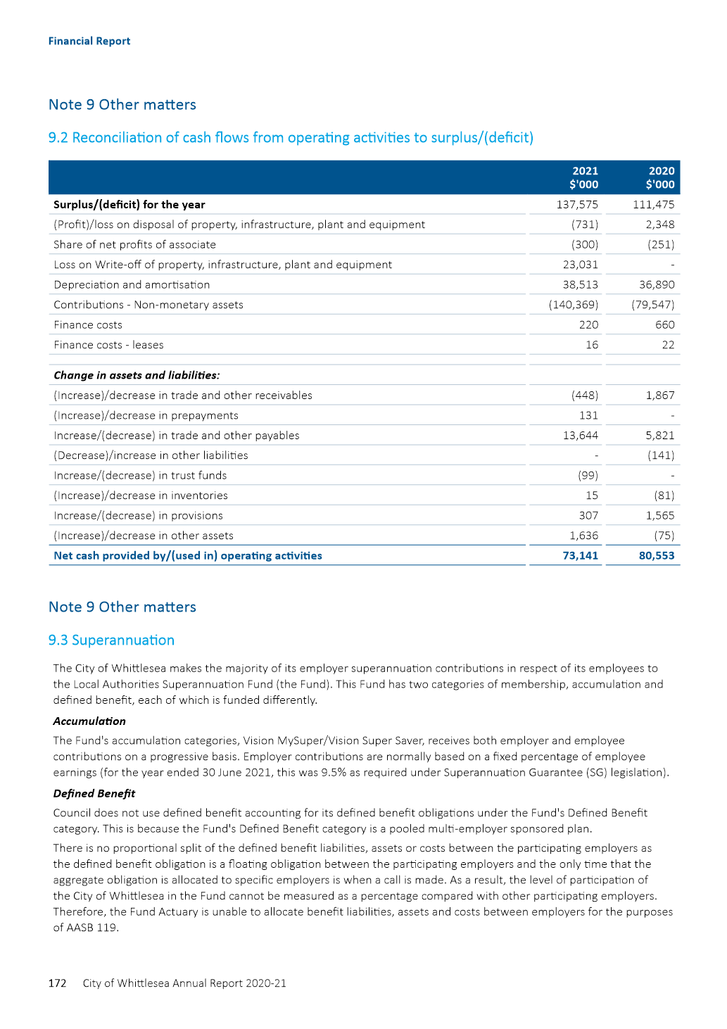

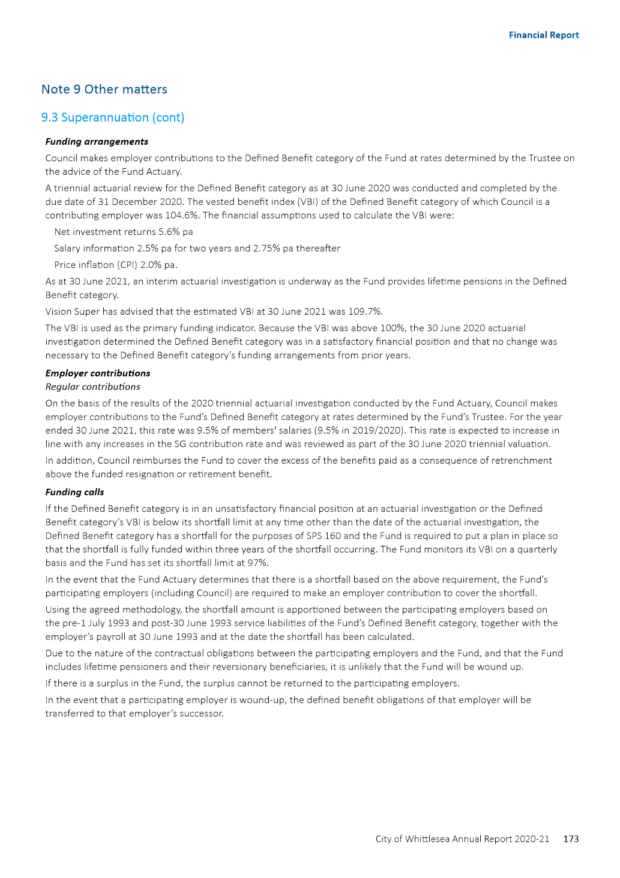

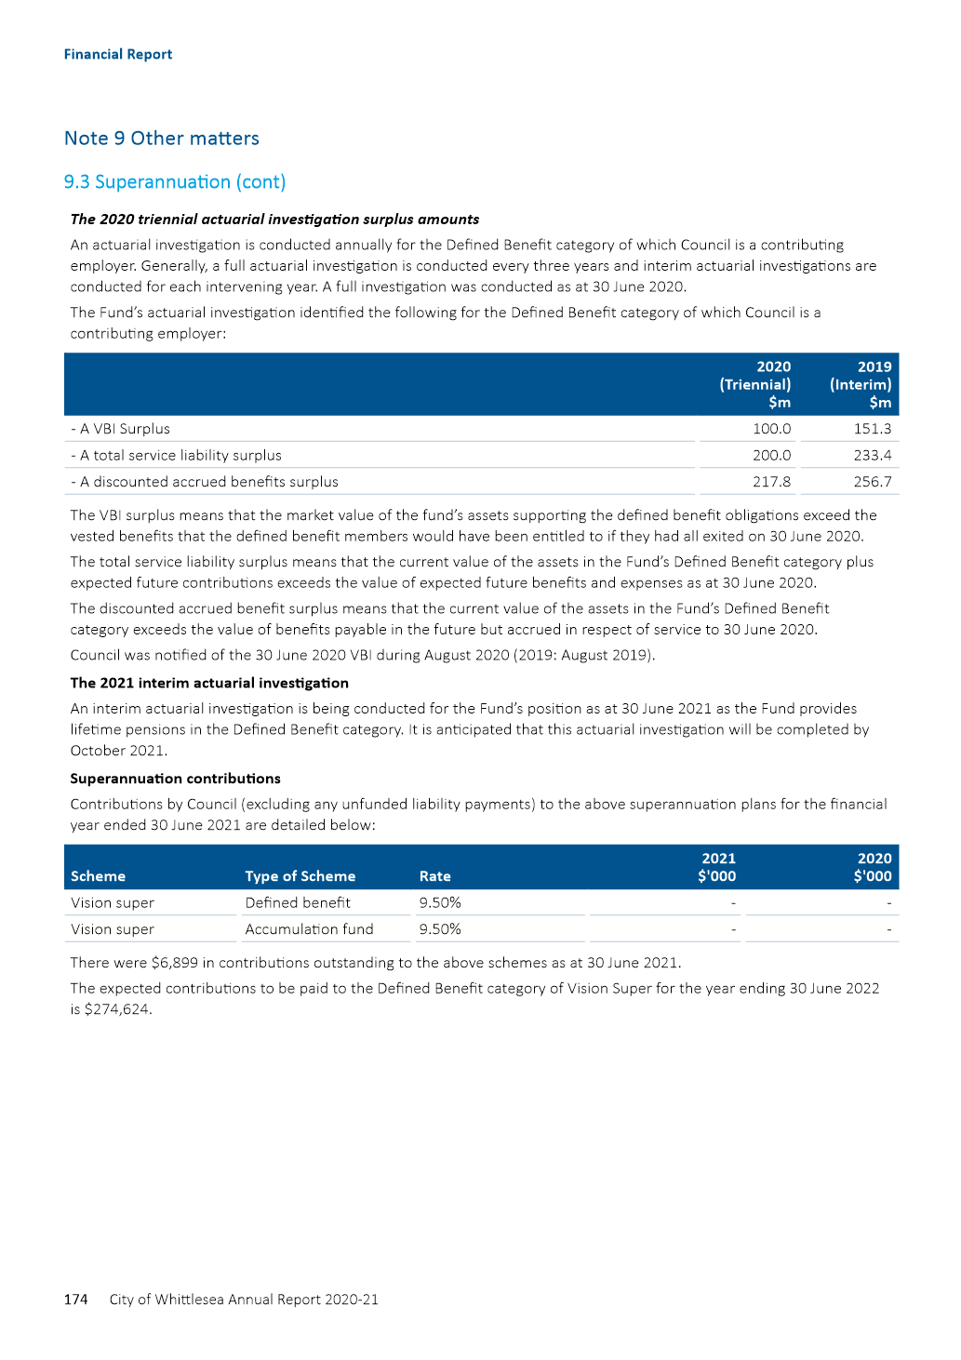

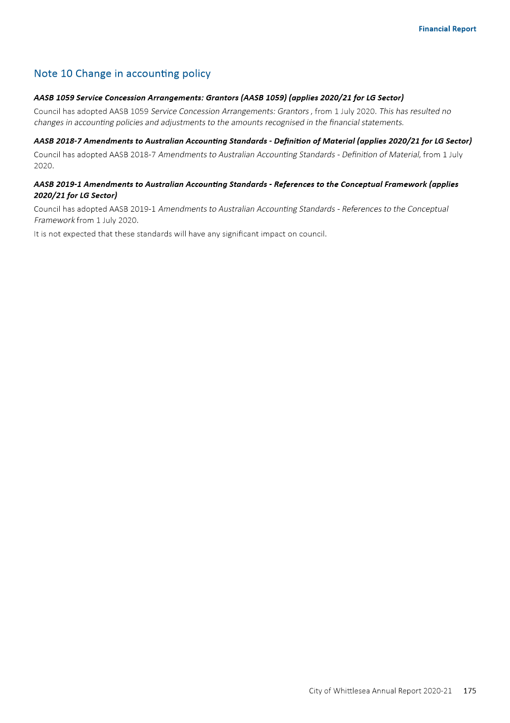

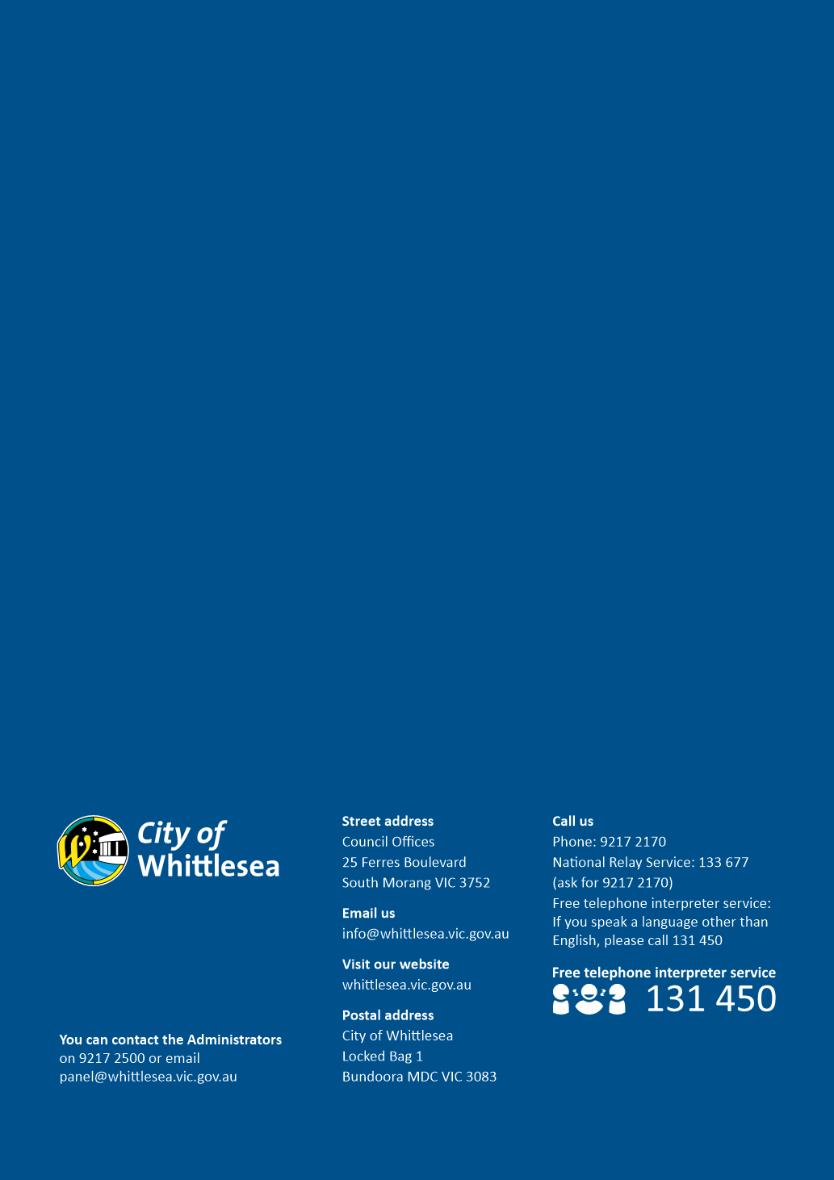

ITEM 6.1.2 Update on Council's Disability Action Plan 2017-21:Outstanding actions
Responsible Officer: Director Community Wellbeing
Author: Team Leader Access

RECOMMENDATION SUMMARY
THAT Council note the five (5) outstanding actions of the Disability Action Plan 2017-21 have been integrated into actions in the draft Community Plan 2021-25.
Brief overview
• The Final Progress Report on Council’s Disability Action Plan 2017-2021 (the DAP) was presented to Council on 5 July 2021.
• The DAP consisted of 105 actions over four years and 100 actions of those were completed.
• Five actions remain outstanding due to external factors (resource shortfall; COVID19).
• Council sought a further report on the five outstanding actions.
• The five outstanding actions have now been integrated into the Community Plan 2021-2025 as outlined in this report.
rationale for recommendation
Integrating future Disability Plan actions into the Community Plan and W2040 Strategies will ensure a whole of organisation approach and ability to generate greater community outcomes. This will maximise health outcomes for residents with disabilities and carers while also meeting Council’s requirements under the Disability Act Victoria 2006.
impacts of recommendation
Benefits
• A whole of Council and community approach to disability inclusion leading to improved outcomes for meeting the human rights of inclusion for people with disabilities in our community.
• Stronger reporting structures with links to the Community Plan 2021-25 and W2040 Strategies.
• Developing a holistic and proactive approach that will champion inclusion of people with disabilities across a larger number of initiatives throughout the organisation, which will have broader reach for all in our community
• Integrating the DAP with the Community Plan and the Municipal Public Health & Wellbeing Plan, gives Council the opportunity to achieve a strong health and wellbeing outcomes for the whole community.
Potential negative impact
• A possible negative impact is that the integration of Disability Plan actions may result in diminished visibility of those actions leading to stakeholders, including community members, feeling that Council has less of a commitment to disability inclusion.
what measures will be put in place to manage impacts
Council briefed the Whittlesea Disability Network (WDN) on the new process that is being undertaken and improved outcomes expected by integrating DAP actions into the Community Plan 2021-25 at the September meeting.
For the life of the two previous DAPs, project managers have provided quarterly progress reports using Council reporting systems. This process will now be enhanced with monthly reporting for all actions in the Community Plan and quarterly reporting for all actions in the W2040 Strategies. An annual progress report, specifically on the DAP actions will be provided to Council and to the Whittlesea Disability Network.

Report
Background
In 2017, Council endorsed the DAP 2017-21 as a stand-alone cross-Council plan with actions under four key commitment areas:
• Inclusive communities;
• Good health, housing and wellbeing for people with disabilities;
• Respect, equity and safety for all; and
• Contributory community living as a right for all regardless of ability.
The 2017-21 DAP consisted of 105 actions over four years, with 100 of these achieved and five actions not achieved due to external factors (resource shortfall; COVID19; avoidance of duplication).
The significant outcomes achieved in the 2017 – 2021 DAP include:
• Development of the All-Abilities Playground at Mill Park.
• Increasing access for residents with disabilities as a part of the Mill Park Leisure redevelopment.
• Delivery of the Marveloo portable change facility for events.
• Increase (from three to eight) in Changing Places facilities within the municipality, enhancing community participation for people with disability.
• Working with the Victorian Government on Accessible Parking Scheme reform.
• Undertaking the NDIS Gap Research Project that will support the service delivery market in the local area. This is a first for local government and will help strengthen service delivery in the local area to meet the needs of NDIS participants.
• Participation in the Australian Network on Disabilities Access and Inclusion Index Assessment which analyses Council’s confidence and capacity to employ and support people with disabilities. Council’s ranking increased from 29% to 51%, which puts Council in the top 20% of organisations that undertake the assessment.
• Provision of regular information to residents with disabilities and carers via direct newsletter and regular updates to the Whittlesea Disability Network (WDN). The WDN’s membership has evolved over the past four years and further work is required to ensure the forum continues to meet residents’ needs.
• Support for residents with disabilities and carers during COVID lockdowns who are self-isolating and/or practicing physical distancing requirements.
• Council’s Street Activities Policy and Guidelines were reviewed in 2019 and aim to balance activating vibrant business precincts with ensuring footpaths provide clear and unobstructed access for pedestrians of all abilities. Council will continue to monitor outside trading with the use of permits, ensuring spaces are accessible for all.
The five actions that were not achieved in the previous plan are:
• Develop a Business Support Program that works with local business owners to encourage the inclusion of customers with disabilities (2018-19).
• Establish Disability Work Experience/Employment Pilot Program with Council Departments for people with disabilities (including people with disabilities from Aboriginal, CALD backgrounds and women with disabilities) (2018-19).
• Develop a Community Disability survey to get baseline data on community attitudes around inclusion in our community (2017-18).
• Establish the Access and Inclusion Coordinating Group which oversees the work to increase the employment opportunities for people with disabilities at Council (2019-20).
• Develop a training program for staff that have community communication responsibility on the Accessible Communication Policy and Inclusive Communication Protocol (including Communication toolkit).
The Final Progress Report on Council’s Disability Action 2017-21 went to Council on 5 July 2021. Council resolved to:
Seek a further report by October 21 in relation to those action not achieved within the current Disability Action Plan, namely the Business Support Program; Disability Work Experience Employment Pilot; Establishment of ac Access and Inclusion Co-ordinating Group; and a training program for staff.
PROPOSAL
Integration of the new Disability Action Plan 2021-2025 into the draft Community Plan 2021-25 has been designed to ensure services and programs are inclusive for people with disabilities, and that we adopt a whole of organisation approach to this issue (rather than it sitting within a small number of teams or officers).
In the spirit of this approach, the five actions of the DAP 2017-2021 that were not achieved (listed above) have been integrated into relevant actions in the draft Community Plan 2021-2025 as presented in Table 1.
DAP 2017-21 Action | Outcome | Progress | The relevant draft Community Plan 2021-25 action/s
Develop a Business Support Program that works with local business owners to encourage the inclusion of customers with disabilities (2018-19) | Increase opportunity for residents with disability to access local businesses | Council submitted two applications under the NDIS Information Linkages and Capacity Building (ILC) program in two funding rounds and was unsuccessful in each round. Information on how businesses can support the needs of customers with disabilities has been included in Economic Development’s “Business Resources Guide”. | Goal 3- Strong local economy  As part of COVID recovery, deliver a “support local” campaign and incentive program to support the community and local businesses.  Implement the Investment Attractions Plan to attract investment, strengthen the local economy and increase the number and diversity of local jobs.
Establish Disability Work Experience/ Employment Pilot Program with Council Departments for people with disabilities (including people with disabilities from Aboriginal, CALD backgrounds and women with disabilities) (2018-19). | Increase employment opportunities for residents with disability. | This action was also included in the ILC applications mentioned above that were unsuccessful. There has been a huge amount of work in the last 4 years looking at employment of people with disabilities across the organisation. This has including the development of the Workplace adjustment policy and the establish of Staff Disability Advisory Group. | Goal 3- Strong Local economy  As part of COVID recovery, deliver a “support local” campaign and incentive program to support the community and local businesses.  Work with partners to increase opportunities for local work, training, apprenticeships and programs with a focus on young people and groups who experience significant barriers to employment.  Goal 5- High-performing organisation  Continue to be an employer of choice through developing and implementing a new Workforce Plan to attract and retain the high quality and skilled staff to support our community.
Develop a Community Disability survey to get baseline data on community attitudes around inclusion in our community. (2017-18) | Increase the engagement of residents with a disability to influence the design of programs and decision-making. | In 2017 it was decided to take a more systemic approach to our engagement of people with disabilities. This was supported by consultation with 171 residents with a disability who provided feedback that they preferred the disability ‘lens’ to be incorporated across Council’s engagement program rather than having a standalone ‘disability’ survey. (Community Engagement Report, 2021). | Goal 1- Connected Community  Strengthen engagement with community through supporting or developing advisory groups and networks across our diverse community including young people, business, sustainability, people with a disability and Aboriginal people  Goal 5- High-performing organisation  Continue to strengthen local community engagement in line with Council’s Community Engagement Policy to inform Council programs and decision-making.
Establish the Access and Inclusion Coordinating Group which oversees the work to increase the employment opportunities for people with disabilities at Council (2019-20). | Increase employment opportunities for residents with disability. | This action was put on hold last year due to COVID19 and organisational changes. The first meeting of this group has been planned for later this year. | Goal 5- High-performing organisation  Continue to be an employer of choice thorough developing and implementing a new Workforce Plan to attract and retain the high quality and skilled staff to support our community.
Develop training program for staff that have community communication responsibility on the Accessible Communication Policy and Inclusive Communication Protocol (including Communication toolkit). | Increase the capacity of all staff across the organisation to provide accessible communication materials for all in our community. | The development of the Accessible Communication Policy and Inclusive Communication Protocols is underway and will be incorporated into the diverse mix of communication and engagement with community. Staff training on these Protocols will be developed. | Goal 5- High-performing organisation  Improve customer service through investing in technology, systems and Council staff and make it easier for our community to interact with Council.  Maintain strong communications with our community to promote access to services, including multilingual, accessible for all and mobile friendly communications and website.
Table 1: Integrating outstanding DAP actions into draft Community Plan 2021-2025Consultation
Council has resolved to take a whole of Council and community approach to disability inclusion leading to improved outcomes for meeting the human rights for people with disabilities in our community, by integrating the new Disability Action Plan 2021-2025 with the draft Community Plan 2021-25. This holistic and proactive approach championed the inclusion of people with disabilities across a larger number of initiatives throughout the organisation This will have broader reach for all in our community.
Financial Implications
Actions from the DAP that appear in the draft Community Plan 2021-25 will be funded via Council’s recurrent department budgets or as draft Community Plan 2021-25 initiatives.
Policy strategy and legislation
The alignment to the National Disability Strategy (NDS) (updated version expected late 2021), Victorian Disability Act 2006, and the current State Disability Plan (2017-20) (new plan expected in late 2021) is outlined in Table 2 below.

W2040 Goal area | Disability Act 2006 Requirements | NDS Proposed Outcome areas | State Disability Plan Pillar (2017/20)
Connected Communities | Reducing barriers to persons with a disability accessing goods, services and facilities  Achieving tangible changes in attitudes and practices which discriminate against persons with a disability | Health and wellbeing  Rights, protection, justice and legislation  Personal and community support | Health, housing and wellbeing
Liveable Neighbourhoods | Promoting inclusion and participation in the community | Inclusive and accessible communities | Inclusive communities  Health, housing and wellbeing
Strong Local economy | Reducing barriers to obtaining employment | Economic security  Learning and skills | Contributing lives
Table 2: alignment to key frameworks
Note: The DAP will also include actions around W2040 Goal area Sustainable Environment but there is less of a link around this goal area with the Disability Act, NDS and the State Disability Plan.
link to strategic risks
Strategic Risk Governance - Ineffective governance of Council’s operations and activities resulting in either a legislative or policy breach
The new DAP has links to all Goal areas of the Whittlesea 2040. It has strong links to Goal areas 1) Connected communities, 2) Liveable neighbourhoods, 3) Strong Local Economy and 5) High Performing Organisation. It also links to 4) Sustainable Environment but not as strongly.
Links to whittlesea 2040 and the CoUNCIL Plan
Goal Connected community
Key Direction A participating community

The new DAP has links to all Goal areas of the Whittlesea 2040. It has strong links to Goal areas 1) Connected communities, 2) Liveable neighbourhoods, 3) Strong Local Economy and 5) High Performing Organisation. It also links to 4) Sustainable Environment but not as strongly.

Declarations of Conflicts of Interest
Under Section 130 of the Local Government Act 2020 and Rule 47 of the Governance Rules 2021, officers providing advice to Council are required to disclose any conflict of interest they have in a matter and explain the nature of the conflict.
The Responsible Officer reviewing this report, having made enquiries with relevant members of staff, reports that no disclosable interests have been raised in relation to this report.
Conclusion
The integration of these actions into the draft Community Plan 2021-2025 ensures Council continues to work towards reducing barriers to persons with a disability accessing goods, services, facilities and employment opportunities; as well as promoting inclusion and participation in the community.

RECOMMENDATION
THAT Council note the Disability Action Plan’s (2017-2021) five outstanding actions have been integrated into the draft Community Plan 2021-2025.

Council Resolution
Moved: Administrator Duncan
Seconded: Chairperson Wilson

THAT Council resolve to adopt the Recommendation.
Carried

6.1.3 Instrument of Appointment and Authorisation for Planning Enforcement Officer
Attachments: 1 Instrument of Appointment and Authorisation - Planning Enforcement Officer
Responsible Officer: Executive Manager Governance & Strategy
Author: Governance Officer

RECOMMENDATION SUMMARY
THAT Council resolve to appoint and authorise the member of Council’s planning enforcement staff referred to in the attached Instrument as an authorised officer pursuant to the powers conferred on Council by s 224 of the Local Government Act 1989, s 147(4) of the Planning and Environment Act 1987 and other legislation referred to the Instrument.
Brief overview
Revised Instrument of Appointment and Authorisation has been prepared for Council’s planning enforcement officer particularly in relation to the administration of Planning and Environment Act 1987.
rationale for recommendation
Under the Planning and Environment Act 1987, authorised officers can only be appointed by Council resolution. This Planning and Environment Act 1987 makes no provision for Council to delegate this power to the CEO.
impacts of recommendation
The Instrument of Appointment and Authorisation authorises the relevant member of staff to exercise the powers conferred under the specified legislation and under Council’s local laws. Authorised officers require this authorisation to properly exercise their role and to institute legal proceeding on behalf of Council.
what measures will be put in place to manage impacts
A register of Authorised Officers must be kept and is publicly available.

Report
proposal
The Instrument of Appointment and Authorisation has been updated based on advice from Council’s solicitors and is submitted to Council for approval.
Instrument of Appointment and Authorisation allows the authorised officer to exercise the powers granted to them by legislation or under a Council local law.
The revised Instrument makes specific reference to s 313 of the Local Government Act 2020 to allow the authorised officer to institute proceedings for offences against the Planning and Environment Act 1987.
Consultation
Council’s Team Leader Planning Enforcement has been consulted on the revised Instrument.
Critical Dates
It is important that Instruments of Appointment and Authorisation are executed as soon as possible to ensure Planning Enforcement Officers have the proper authorisation to continue carrying out their duties.
Financial Implications
There are no financial costs in preparing the Instrument.
Policy strategy and legislation
Section 224 of the Local Government Act 1989 provides for the appointment of authorised officers for the purposes of the administration and enforcement of any Act, Regulation or local laws which relate to the functions and powers of Council.
link to strategic risks
Strategic Risk
Governance - Ineffective governance of Council’s operations and activities resulting in either a legislative or policy breach
The officer will be unable to fulfil their duties as an authorised officer if the updated Instrument of Appointment and Authorisation is not put in place.

Links to whittlesea 2040 and the CoUNCIL Plan
Goal High-performing organisation
Key Direction Driving better community outcomes through improved service access, satisfaction and advocacy

Declarations of Conflicts of Interest
Under Section 130 of the Local Government Act 2020 and Rule 47 of the Governance Rules 2021, officers providing advice to Council are required to disclose any conflict of interest they have in a matter and explain the nature of the conflict.
The Responsible Officer reviewing this report, having made enquiries with relevant members of staff, reports that no disclosable interests have been raised in relation to this report.
Conclusion
It is recommended that the member of Council staff referred to in the attached Instrument be appointed as an authorised officer to allow them to effectively perform their duties.

RECOMMENDATION
THAT Council resolve to:
1. Appoint and authorise the member of Council staff referred to in the attached Instrument as an authorised officer pursuant to powers conferred on Council by s224 of the Local Government Act 1989, s147(4) of the Planning and Environment Act 1987 and the other legislation referred to in the Instrument; and
2. Have the Instrument come into effect when it is executed and remain in force until Council decides to vary or revoke them.

Council Resolution
Moved: Chairperson Wilson
Seconded: Administrator Eddy

THAT Council resolve to adopt the Recommendation.
Carried

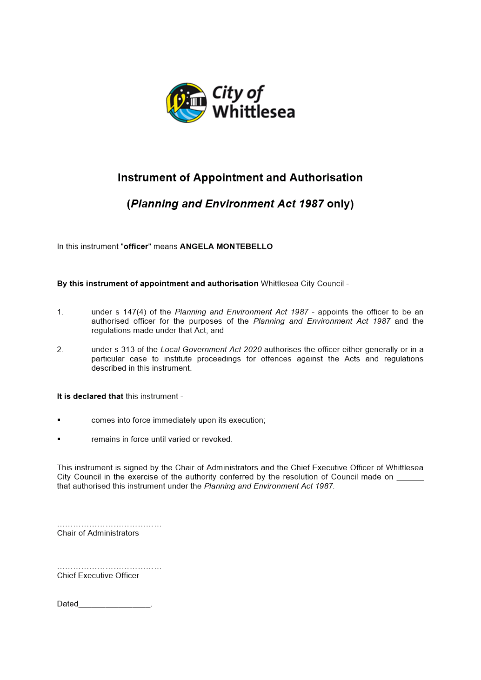

6.2 Liveable Neighbourhoods
ITEM 6.2.1 Reconstruction of Arthurs Creek Road from Plenty Road to Recreation Road, Contract 2021-42 Tender Evaluation Report
Attachments: 1 Detailed Tender Evaluation - Confidential
This attachment has been designated as confidential by the Director Infrastructure & Environment, under delegation from the Chief Executive Officer, in accordance with Rule 53 of the Governance Rules 2021 and sections 66(5) and 3(1) of the Local Government Act 2020 on the grounds that it contains private commercial information, being information provided by a business, commercial or financial undertaking that— (i) relates to trade secrets; or (ii) if released, would unreasonably expose the business, commercial or financial undertaking to disadvantage and confidential meeting information, being the records of meetings closed to the public under section 66(2)(a). In particular the attachment contains information regarding the detailed tender evaluation.
Responsible Officer: Director Infrastructure & Environment
Author: Project Manager

RECOMMENDATION SUMMARY
It is recommended that contract number 2021-42 for Reconstruction of Arthurs Creek Road from Plenty Road to Recreation Road:
• is awarded to BILD Infrastructure Pty Ltd
• for the lump sum price of $ 2,110,481.39 (excl. GST)
Brief overview
The tender evaluation panel advises that:
• Nine tenders were received
The recommended tender was the highest ranked and is considered best value because it has demonstrated that it has the highest ability to deliver this project in accordance with Council’s specified requirements.
rationale for recommendation
The recommended tenderer demonstrated the highest capability and capacity to deliver this project, and with minimal impact on Council and the community.
impacts of recommendation
Award of the contract to BILD Infrastructure Pty Ltd will enable delivery of the works within Council’s timelines. There are no negative impacts foreseen with the recommendation, other than some minor impact to the local traffic during the course of the works.

what measures will be put in place to manage impacts
During the construction process, the management of works including quality control, methodology and site management will be closely monitored with efficiencies maximised where possible to ensure the project is completed within the time allocated. In addition, a traffic management plan will be prepared and implemented to reduce the impact to the local traffic during the works.

Report
Background
Arthurs Creek Road is a ‘local’ road connecting Plenty Road with Yan Yean Road. It provides for local access however this road will have a more strategic transport role in the future as a result of the unprecedented development occurring in the Donnybrook and surrounding areas. This road is also strategically linked to the Plenty Valley growth corridor, encompassing the South Morang and Mernda/Doreen growth centres as well as the Whittlesea Township.
The road pavement is in poor condition with sections of road continuously failing during the wet season as the road is in a flood basin.
The purpose of this contract is to reconstruct 1,270 lineal metres of Arthurs Creek Road from Plenty Road to Recreation Road, to reinforce the road pavement and upgrade the open drain along the road.
Tenders for the contract closed on 26 May 2021. The tendered prices and a summary of the evaluation are detailed in the confidential attachment.
Consultation
Consultation with the local community regarding this road occurred in September 2020 with feedback supportive for the upgrade of this section of Arthurs Creek Road.
As part of the traffic management plan for the works, variable message sign (VMS) trailers will be installed a week prior to the works to inform road users of the impending works. In addition, updates will be provided through Council’s social media channels and Council’s Customer Service team will be provided with a brief project update.
EVALUATION
No member of the Tender Evaluation Panel declared any conflict of interest in relation to this tender evaluation.
A Tender Probity & Evaluation Plan was designed specifically for this tender process and it was authorised prior to this tender being advertised. All tenders received were evaluated in accordance with that plan. The evaluation involved scoring of conforming and competitive tenders according to these pre-determined criteria and weightings:
Criteria | Weighting
Price | 60%
Capability | 15%
Capacity | 12.5%
Impact | 12.5%
The weightings reflect the relative importance of each element to this particular contract. They were determined as being most appropriate after considering numerous factors including (but not restricted to) the time, quality, risk and contract management requirements which were likely to have the most impact on the achievement of best value.
Only tenders that were conforming and competitive were fully scored. Tender submissions that were evaluated as non-conforming or not sufficiently competitive were set aside from further evaluation. In cases where this occurred the reasons for that outcome are detailed in the confidential attachment.
The evaluation outcome was as follows:
TENDERER | CONFORMING | COMPETITIVE | SCORE | RANK
Tenderer A: BILD Infrastructure Pty Ltd | Yes | Yes | 86 | 1
Tenderer B | Yes | Yes | 73 | 2
Tenderer C | No | Yes | NA | NA
Tenderer D | No | Yes | NA | NA
Tenderer E | Yes | No | NA | NA
Tenderer F | Yes | No | NA | NA
Tenderer G | No | No | NA | NA
Tenderer H | No | No | NA | NA
Tenderer I | No | No | NA | NA
Refer to the confidential attachment for further details of the evaluation of all tenders.
FINANCIAL IMPLICATIONS
This contract will be funded through Council’s New Works Program and a grant from the Local Road and Community Infrastructure Funding Program as part of the Federal Government Economic Stimulus Program.
link to strategic risks
Strategic Risk Service Delivery - Inability to plan for and provide critical community services and infrastructure impacting on community wellbeing
It is Council’s responsibility to provide and maintain critical infrastructure for the community to enable it to travel on safe and effective road networks within the municipality. Arthurs Creek Road also services the local agricultural community and upgrading this road will enable the community to conduct business with enhanced efficiency and safety, as well as enhancing any tourism opportunities.
Links to WHITTLESEA 2040 AND the CoUNCIL Plan
Goal Liveable neighbourhoods
Key Direction Smart, connected transport network
The road upgrade will enhance Council’s ability to provide a safe and effective road network meeting community expectations.

Declarations of Conflicts of Interest
Under Section 130 of the Local Government Act 2020 and Rule 47 of the Governance Rules 2021, officers providing advice to Council are required to disclose any conflict of interest they have in a matter and explain the nature of the conflict.
The Responsible Officer reviewing this report, having made enquiries with relevant members of staff, reports that no disclosable interests have been raised in relation to this report.
CONCLUSION
The tender from BILD Infrastructure Pty Ltd was determined to be best value and it is considered that this company can perform the contract to the required standards.

Recommendation
THAT Council resolve to:
1. Accept the tender submitted by BILD Infrastructure Pty Ltd for the sum of $2,110,481.39 (excluding GST) for the following contract:
Number: 2021-42
Title: Reconstruction of Arthurs Creek Road from Plenty Road to Recreation Road
subject to the following conditions:
a) Tenderer to provide proof of currency of insurance cover as required in the tender documents.
b) Price variations to be in accordance with the provisions as set out in the tender documents.
c) Tenderer to provide contract security as required in the tender documents.
2. Approve the funding arrangements detailed in the confidential attachment.

Council Resolution
Moved: Administrator Duncan
Seconded: Administrator Eddy

THAT Council resolve to adopt the Recommendation.
Carried

ITEM 6.2.2 PROPOSED PLANNING SCHEME AMENDMENT: 2000 DONNYBROOK RD, YAN YEAN ROAD
Attachments: 1 Site map
2 Existing Zoning map
3 Existing Environmental Significance Overlay
4 Existing Significant Landscape Overlay
Responsible Officer: Director Planning & Development
Author: Strategic Planner

RECOMMENDATION SUMMARY
That Council resolve to write to the Minister for Planning expressing support for the rezoning of land at 2000 Donnybrook Rd, Yan Yean under s20(4) of the Planning and Environment Act 1987 from part Green Wedge Zone (GWZ) and part Rural Conservation Zone 1 (RCZ1) to Public Use Zone 5 (PUZ5) to facilitate the use and development of the subject site for a cemetery.
Brief overview
The Greater Melbourne Cemeteries Trust (GMCT) is seeking consent from the Minister Planning to undertake a rezoning amendment under s20(4) of the Planning and Environment Act 1987 to rezone the site at 2000 Donnybrook Road, Yan Yean from part GWZ and part RCZ1 to PUZ5. The proposed rezoning will allow the land to be used for the purpose of cemetery / crematorium. This is consistent with the longstanding reservation of the land for the purposes of a cemetery.
As this is Amendment is proposed to be processed under s20(4), the Minister for Planning will be the Planning Authority. The proponent has requested that Council provide its views on the proposed Planning Scheme Amendment prior to it being submitted to the Minister for Planning. It is recommended that Council write to the Minister for Planning to note its support for the proposed Amendment and expedited planning process.
rationale for recommendation
The land has a permanent reservation under the Crown Land (Reserves) Act 1978 for cemetery and crematoria purposes, dating back to 1931 when it was reserved as the Plenty Valley Cemetery.
The s20(4) process is an appropriate Amendment process to expedite the rezone the site due to the largely administrative nature of the amendment, and will ensure that the Crown land, which has long been reserved for cemetery purposes, is located within the appropriate zone in the Whittlesea Planning Scheme.
impacts of recommendation
The recommendation provides support for an important State significant asset that will benefit to the residents of the City of Whittlesea and surrounding areas.
The PUZ5 explicitly identifies ‘cemetery / crematorium’ as the primary use of the land. It will allow the site to be used for these purposes without the requirement for a planning permit which will reduce the administrative burden for the GMCT. It is noted that some development (such as buildings, tree removal) in areas of environmental significance may still trigger a planning permit.
what measures will be put in place to manage impacts
The significant environmental values of the site will continue to be protected from any inappropriate land use by the presence of the Environmental Significance Overlay (ESO1) and Significant Landscape Overlay (SLO1) which may trigger planning permit requirements for some buildings and works.
The Planning Scheme Amendment documents will also be reviewed by officers at the Department of Environment, Land, Water and Planning to ensure it satisfies relevant policy and Ministerial Directions.

Report
Introduction
The Greater Melbourne Cemeteries Trust (GMCT) is requesting that the Minister Planning undertake a Planning Scheme Amendment under s20(4) of the Planning and Environment Act 1987 to rezone the site at 2000 Donnybrook Rd, Yan Yean from part GWZ and part RCZ1 to PUZ5. The rezoning will to facilitate the use of the land for the purpose of cemetery / crematorium consistent with its longstanding reservation as a future cemetery.
As the land is publicly owned, the Department of Environment Land Water and Planning (DELWP) have confirmed that the amendment is eligible to be processed through the Government Land Planning Service (GLPS).
This would see the amendment processed under s20(4) of the Planning and Environment Act 1987 (the Act) with the Minister acting as the Planning Authority and no public exhibition. This is due to the highly administrative nature of the amendment. Prior to the lodgement of the Amendment with the Minister for Planning, the GMCT have sought the views of Council on the proposal.
subject site
The site at 2000 Donnybrook Rd, Yan Yean is approximately 83.2 hectares in size and is Crown land. The site is immediately adjacent to the Growling Grass Frog Golf Course which is located to its west.
The site is undeveloped and is currently being used for grazing. It is mostly cleared of vegetation, except for a number of patches of vegetation, most significantly within the southwest and the north east corners, as shown in Attachment 1.
The site is zoned Green Wedge Zone (GWZ), with the exception of a small area within the south west corner where Barbers Creek runs through the site that is zoned Rural Conservation (RCZ1), as shown in Attachment 2. The south west corner has also been identified as an area of Aboriginal cultural heritage sensitivity.
This area is also affected by the Environmental Significance Overlay (ESO) Schedules 1 (River Red-Gum grassy woodland native habitat area), and Schedule 2 (River Red-Gum and Grassy Woodlands), as shown in Attachment 3. The eastern portion of the site is affected by the Significant Landscape Overlay Schedule 1 (Whittlesea Hills), as shown in Attachment 4. This reflects the topography of the site which rises from the flatter western part of the site to the steeper eastern part forming part of the “Whittlesea Hills”.
The site abuts Donnybrook Road along the northern boundary which is a main road (zoned Category 1 Road - RDZ1). The She Oak Hill Cutting on Donnybrook Road is of heritage significance and affected by Heritage Overlay HO176. Another heritage property ‘Burnside Dairies Manager’s House’ (HO45) is also located in proximity to the site.
Proposal
The GMCT is seeking consent from the Minister for Planning to undertake an Amendment under s20(4) of the Act to rezone the land from Green Wedge Zone / Rural Conservation Zone (GWZ/RCZ) to Public Use Zone 5 (PUZ5).
The Amendment process under s20(4) Act is an expedited process where the Minister for Planning is the planning authority. Under this process the Minister for Planning prepares (as opposed to Council) and approves the Amendment without the need for a statutory exhibition process. Prior to preparing the Amendment, the Minister may seek the views of relevant stakeholders such as the Council. The GMCT are therefore seeking these views in advance of lodging the Amendment request with the Minister.
The proposal will rezone the land to PUZ5. No further changes are proposed to the planning controls. The PUZ5 enables land to be used for the purpose of a cemetery / crematorium without the need for a planning permit, so long as it is carried out by or on behalf of the public land manager. A permit is generally required for other uses.
As such, no changes are proposed to the current ESO1 and SLO1 overlays which apply to the site. Therefore, any buildings and works or vegetation removal within these overlay areas will still require a planning permit from Council. A permit will also be triggered for access given the site adjoins a Category 1 Road.
DISCUSSION
The GMCT are a community-focused organisation operating 19 cemeteries and memorial parks in Melbourne’s metropolitan region. In addition to the 19 existing cemeteries two new greenfield cemeteries have been identified for establishment in the GMCT’s Strategic Plan. One of these is Plenty Valley which is to be established on the subject site and will cater to Melbourne’s northern region.
The proposed rezoning of the site will facilitate the use of the land for a cemetery / crematorium by the GMCT consistent with its longstanding reservation. The application of the PUZ5 will provide greater certainty in respect to its land use designation and reduce the administrative burden for the GMCT in establishing and using the site for its intended purpose.
The design of the proposed cemetery has not yet been finalised but will be informed through a detailed master planning process. This will also investigate whether a crematorium is needed on the site to supplement the Fawkner facility. The GMCT have indicated that community engagement on the master plans for the site will commence between 2024 – 2025, with construction and operations commencing between 2028 and 2030.
The subject site is located Whittlesea’s Green Wedge area. Cemeteries are a permissible use in the current GWZ subject to a permit. It is noted that as the rezoning will result in the removal of the minimum lot size requirement of the GWZ, the rezoning will likely require ratification by Parliament under Section 46AF of the Act. The Public Use Zone does not contain minimum lot controls. However, given the proposed use of the land will be for a cemetery this change will not have a detrimental impact on the green wedge through land fragmentation.
The proposed amendment will retain the environmental overlays which currently apply to part of the subject site, namely the ESO1 and SLO1. A planning permit will be triggered if buildings and works are proposed in these areas. This will ensure that any buildings or works on the part of the site which contain landscape or environmental values will need to be sensitively designed and not detrimentally impact these values.
It is noted that there are two heritage places (HO45 and HO176) in proximity to the site. The She Oak Hill Cutting (HO176) is on Donnybrook Road immediately adjoining the northern boundary road of the site. Across Donnybrook Road to the north west of the site is ‘Burnside Dairies Manager’s House’ (HO45). The heritage controls include the house, stable and outbuilding. The application of the PUZ5 and use of the subject site as a cemetery is not expected to impact on the significance of these places. The access to the cemetery should avoid the area covered by HO176.
Given, the sites locational context it will be important to provide for the retention of existing trees where possible and that revegetation is to be carried out around the edges to the surrounding land, noting that consideration be given to ensuring appropriate fire breaks. This feedback has been provided to the proponent.
Consultation
Prior to lodgement of the Amendment with the Minister for Planning, the proponent has requested Council to outline its support or otherwise for the proposed Amendment. This is normal practice for Amendments which are submitted to the Minister for Planning under the expedited process. Council officers have been provided with details of the proposed Amendment and supporting background reports. These have been reviewed internally by Council officers from relevant teams.
In addition to consulting with Council, the GMCT are consulting with relevant agencies including the Department of Transport and surrounding landowners.
Consultation with the surrounding landowners is taking place in the form of letter drops containing information about the proposed rezoning, an online questionnaire, and opportunity to discuss the amendment with the project team.
The feedback received will be presented as part of the submission of the proposed Amendment to the Minister.
There are further consultations proposed in respect to this Amendment. As noted above under s20(4) of the Planning and Environment Act, 1987 the Minister for Planning is exempt from undertaking statutory exhibition of the Amendment.
The GMCT have indicated that community engagement on the master plans for the site will commence between 2024 – 2025.
NEXT STEPS
Following the completion of this consultation, the Amendment documents will be lodged with the DELWP and submitted to the Minister for Planning for their review and consideration.
As the land is Crown land, the Department of Environment Land Water and Planning (DELWP) have confirmed that the amendment is eligible to be processed through the Government Land Planning Service (GLPS).
The Government Land Planning Service (GLPS) is established to process Amendments related to government land. Its main purpose is to ensure that appropriate planning provisions are in place on government land.
This process will make the Minister for Planning the Planning Authority for the amendment and a decision made under Section 20(4) of the Planning and Environment Act (1987). If required, the Amendment will need to be ratified by the Parliament under Section 46AF of the Act.
The design of the proposed cemetery will be informed by a future master planning process with construction and operations commencing between 2028 and 2030.
Financial Implications
There are no financial implications for Council as a result of this proposed Amendment. The planning authority for the Amendment will be the Minister for Planning.
Policy strategy and legislation
Planning Policy
• The proposed Amendment is consistent with the document A Practitioner's Guide to Victorian Planning Schemes, January 2020 and is appropriate use of the Victorian Planning provisions include the Public Use Zone.
• The proposed Amendment implements State Planning Policy 19.02-4S to Identify and protect land for cemeteries and crematoria
Green Wedge Management Plan
The proposed Amendment and use of the land for a cemetery/crematorium is consistent with Councils Green Wedge Management Plan and compatible with the Whittlesea Green Wedge noting the longstanding reservation.
It is noted that since the proposed rezoning will remove the Green Wedge Zone minimum lot controls it is likely that the Amendment will require the ratification of Parliament under Section 46AF of the Act. Given the proposed use of the land will be for a cemetery the removal of the subdivision controls will not have a detrimental impact on green wedge values through additional land fragmentation.
Crown Land (Reserves Act) 1978
The site has been reserved as the Plenty Valley Cemetery since 1931. It is formally identified as Crown Allotment 11A Parish of Yan Yean.
The Crown land has a permanent reservation under the Crown Land (Reserves) Act 1978 for cemetery and crematoria purposes, under the administration of the Secretary to the Department of Health and Human Services and managed by the GMCT.
It is administered by the Department of Health and Human Services (DHHS) and managed by the GMCT, as the committee of management.
In accordance with the Crown Land (Reserves) Act 1978 and Cemeteries and Crematoria Act 2003, the site is restricted for use and development for cemetery and crematoria purposes.
link to strategic risks
Strategic Risk Not linked to the risks within the Strategic Risk Register.
There are no strategic risk implications for Council as a result of this Amendment. The Amendment documents are being prepared by a consultant on behalf of the GMCT. The planning authority for the Amendment will be the Minister for Planning.
Links to whittlesea 2040 and the CoUNCIL Plan
Goal Liveable neighbourhoods
Key Direction Well-designed neighbourhoods and vibrant town centres

Cemeteries and crematoria are vital community infrastructure. The use of this land for a cemetery / crematoria is appropriate and will not impede on the delivery of the goals under Whittlesea 2040.
Declarations of Conflicts of Interest
Under Section 130 of the Local Government Act 2020 and Rule 47 of the Governance Rules 2021, officers providing advice to Council are required to disclose any conflict of interest they have in a matter and explain the nature of the conflict.
The Responsible Officer reviewing this report, having made enquiries with relevant members of staff, reports that no disclosable interests have been raised in relation to this report.
Conclusion
The Greater Melbourne Cemeteries Trust (GMCT) is proposing to request that the Minister for Planning prepare a Planning Scheme Amendment to rezone the land at 2000 Donnybrook Road, Yan Yeah from GWZ and RCZ1 to PUZ5. The rezoning will facilitate the use of the land for the purpose of a cemetery / crematorium.
In this circumstance, the Minister for Planning will be the Planning Authority for the amendment and a decision will be made under s20(4) of the Act. This process will expedite the Amendment and result in it being exempt from statutory public exhibition. Prior to lodgement of the Amendment with the Minister for Planning, key stakeholders including Council and landowners have been consulted and invited to outline its support or otherwise for the proposed Amendment.
It is considered that the proposed Amendment is appropriate and therefore it is recommended that Council write to the Minister for Planning expressing support for the proposed Amendment.

RECOMMENDATION
THAT Council resolve to write to the Minister for Planning expressing support for a Planning Scheme Amendment under s20(4) of the Planning and Environment Act 1987 to rezone land at 2000 Donnybrook Rd Yan Yean from Green Wedge Zone / Rural Conservation Zone (GWZ/RCZ1) to Public Use Zone 5 (PUZ5) to facilitate the use and development of the subject site for the purpose of a cemetery.
Council Resolution
Moved: Chairperson Wilson
Seconded: Administrator Eddy

THAT Council resolve to adopt the Recommendation.
Carried unanimously

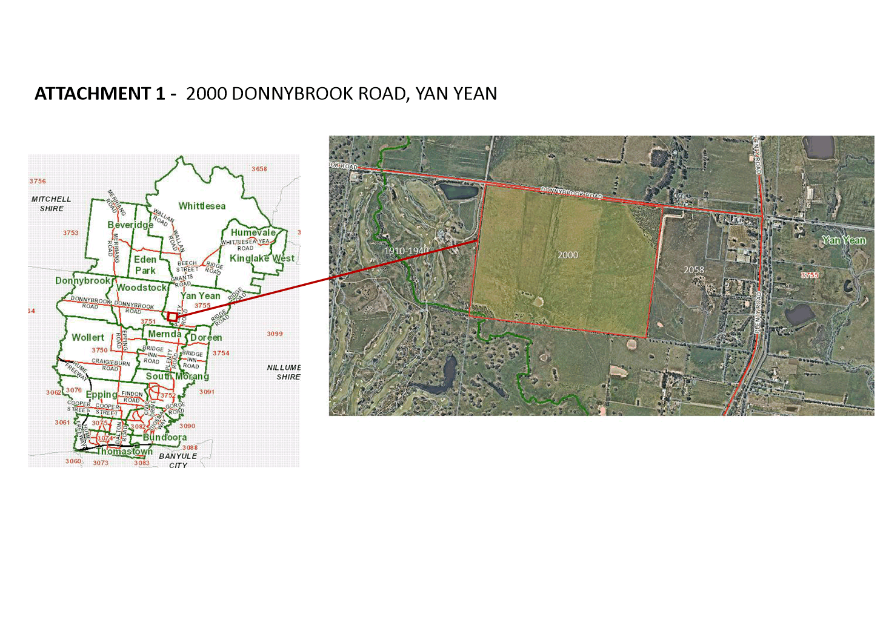
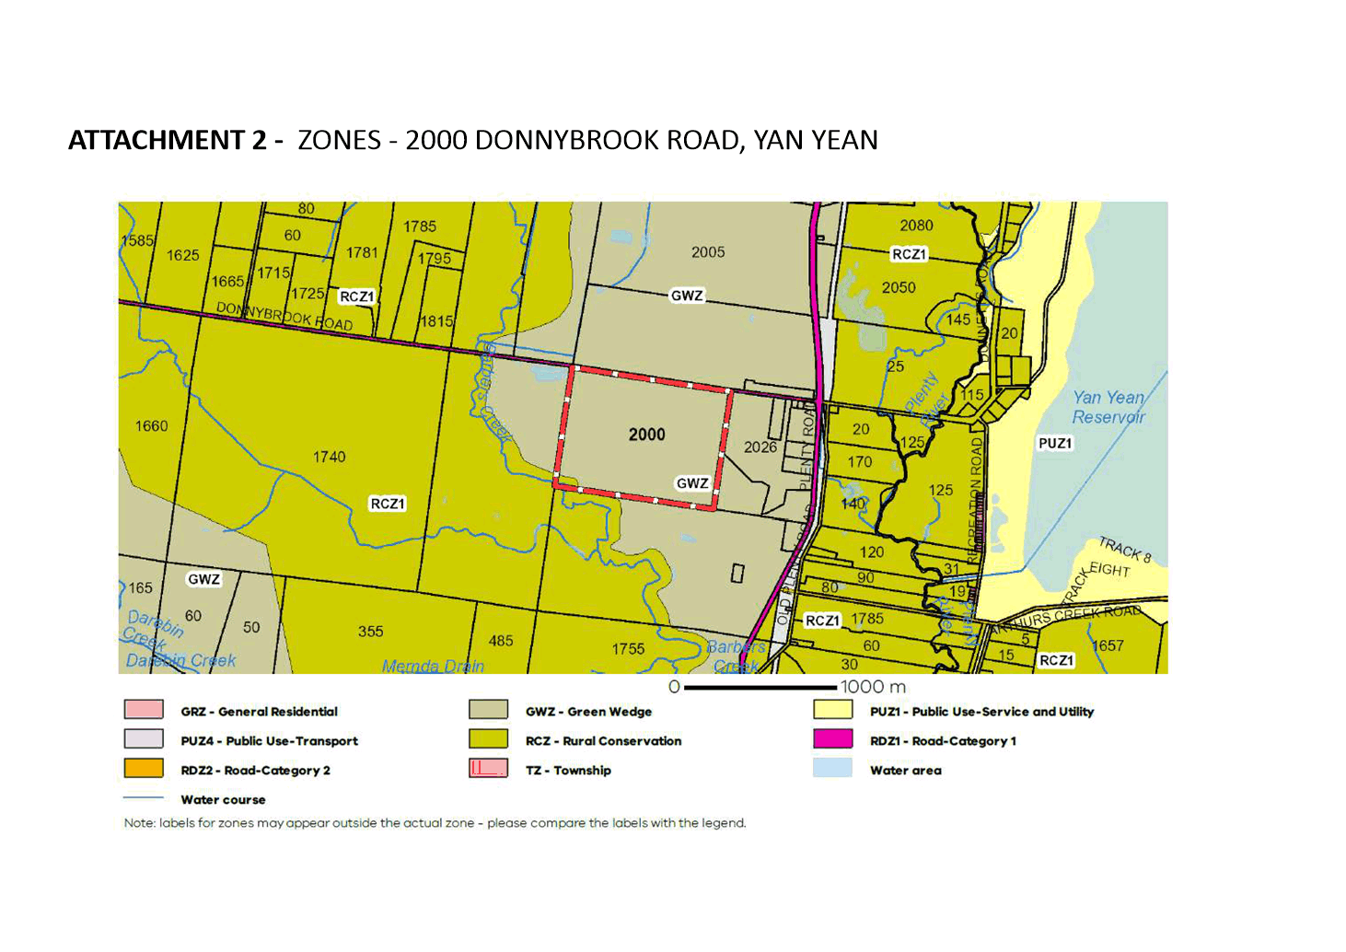
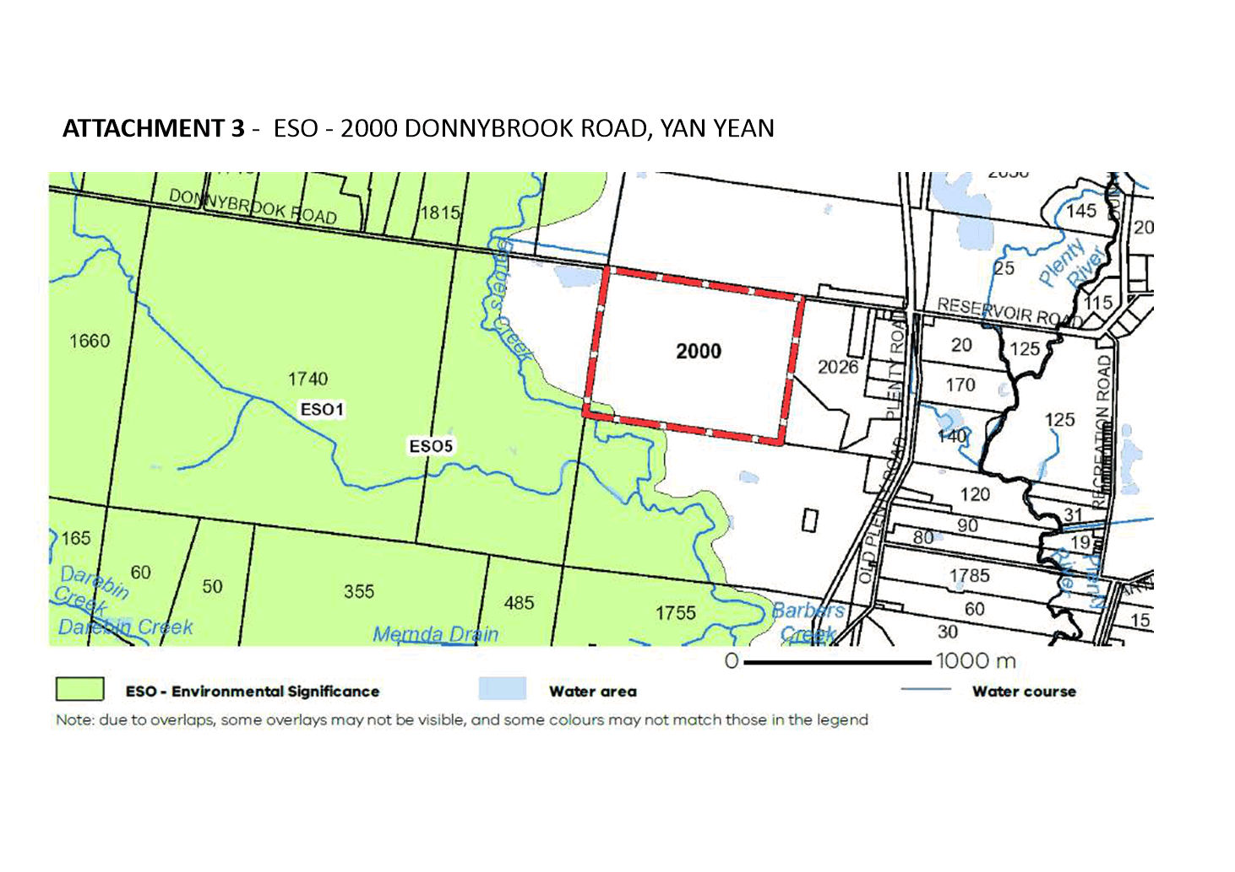
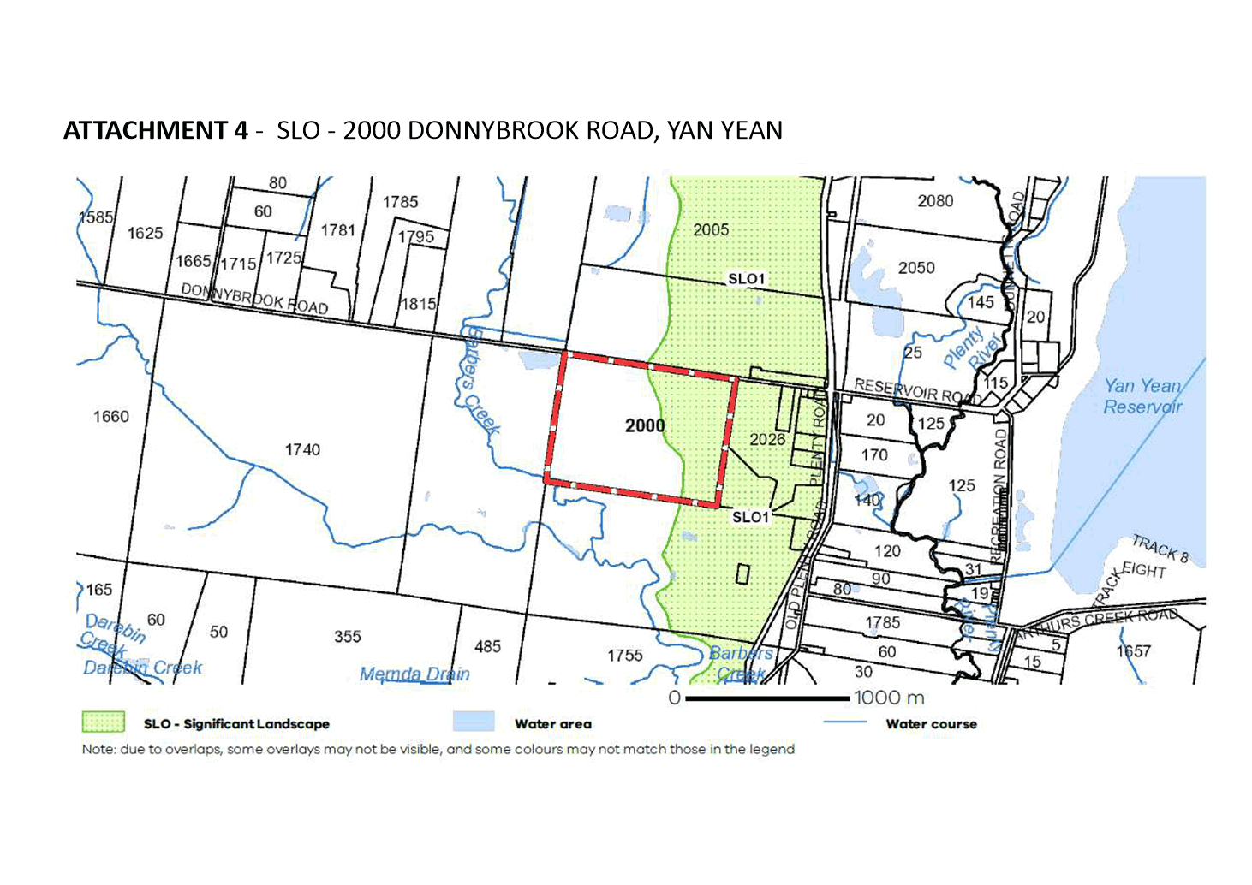

ITEM 6.2.3 PLANNING SCHEME AMENDMENT C226 – SIGNS LOCAL POLICY - EXHIBITION OUTCOMES AND ADOPTION
Attachments: 1 Whittlesea C226wsea Clause 15.01-1L Post Exhibition changes
2 Whittlesea C226wsea 02.03-5 Exhibition Gazetted
3 Whittlesea C226wsea 18.02-3L Exhibition Gazetted
Responsible Officer: Director Planning & Development
Author: Strategic Planner

RECOMMENDATION SUMMARY
That Council resolve to:
1. Adopt Amendment C226wsea to the Whittlesea Planning Scheme as detailed in Attachments 1-3 of this report, comprising the post exhibition version of Clause 15.01-1L and the exhibited version of Clauses 02.03-5 and 18.02-3L;
2. Submit Amendment C226wsea as detailed in Recommendation 1. above to the Minister for Planning for approval; and
3. Advise the submitter of the resolutions above.
Brief Overview
- Amendment C226 seeks to implement a municipality wide local planning policy on signage which will bring the City of Whittlesea into line with other municipalities. It amends existing Clauses 02.03-5 and 18.02-3L and introduces a new Clause 15.01-1L to the Whittlesea Planning Scheme.
- Council resolved on 7 August 2018 to seek Authorisation of Amendment C216 (now C226) to update and introduce a new signs local policy.
- The Minister of Planning granted Conditional Authorisation on 21 March 2019, which essentially required exhibition of the Amendment to wait until the policy neutral translation of the Whittlesea Planning Scheme into the new Planning Policy Framework was complete via Amendment C250. Amendment C250 was Gazetted on 18 December 2020 which allowed Council Officers to complete the policy neutral translation of the signs policy into the new format, in consultation with the Department of Environment Land Water & Planning, to satisfy the condition of Authorisation.
- The policy responds to contemporary sign designs, technologies and practices. A variety of sign typologies are included in the policy along with performance objectives that seek to increase legibility, reduce clutter, and ensure that advertising signs do not unreasonably impact the visual amenity of the municipality.
- Amendment C226 was placed on exhibition between 23 March 2021 and 30 April 2021. One submission was received.
- Discussions with the submitter have resulted in minor changes being proposed to Clause 15.01-1L of the exhibited local policy to resolve the submission. The proposed changes are generally consistent with the intent of the exhibited policy. The submitter has subsequently agreed to withdraw their submission, avoiding the need for a Planning Hearing. It is recommended that these changes be adopted by Council and subsequently submitted to the Minister for Planning for approval.
Rational for recommendation
• The Amendment implements a municipality wide local planning policy on signage. It responds to contemporary sign designs, technologies and practices to reduce clutter and ensure that signs do not unreasonably impact the visual amenity of the municipality. It targets areas that consistently cause problems or delay processing of planning applications. It also provides transparency to businesses and the community about how Council will apply its discretion under the Whittlesea Planning Scheme, when considering planning applications for signs.
• Council resolved on 7 August 2018 to seek Authorisation of Amendment C216 (now C226) to update and introduce a new signs local policy.
• The Minister of Planning granted Conditional Authorisation on 21 March 2019, which essentially required exhibition of the Amendment to wait until the policy neutral translation of the Whittlesea Planning Scheme into the new Planning Policy Framework was complete via Amendment C250. Amendment C250 was Gazetted on 18 December 2020 which allowed Council Officers to complete the policy neutral translation of the signs policy into the new format, in consultation with the Department of Environment Land Water & Planning, to satisfy the condition of Authorisation.
• The policy responds to contemporary sign designs, technologies and practices. A variety of sign typologies are included in the policy along with performance objectives that seek to increase legibility, reduce clutter, and ensure that advertising signs enhance the visual amenity of the municipality.
• Amendment C226 was placed on exhibition between 23 March 2021 and 30 April 2021. One submission was received.
• Discussions with the submitter have resulted in minor changes being proposed to Clause 15.01-1L of the exhibited local policy to resolve the submission. The proposed changes are generally consistent with the intent of the exhibited policy. The submitter has subsequently agreed to withdraw their submission, avoiding the need for a Planning Hearing. It is recommended that these changes be adopted by Council and subsequently submitted to the Minister for Planning for approval.
Impacts of the recommendation
Should the recommendations be adopted, the Amendment will be submitted to the Minister for Planning for approval. The decision of whether or not to approve and gazette the Amendment, will be at the discretion of the Minister.
Once adopted and approved by the Minister, the policy can be considered by Council’s statutory planners and given weight in relevant planning permit applications. The weight given will be determined on a case-by-case basis and will be at Council’s discretion.
What measures will be put in place to manage impacts?
If the Amendment is approved by the Minister for Planning, it must be considered for all relevant planning permit applications for signs. No transitional arrangements are proposed. The policy will guide the discretion currently exercised by Council officers. The policy does not change what does and does not trigger a planning permit application.
The implementation of the policy will be overseen by Council’s statutory planning team. No additional resources are required for the implementation of this local planning policy.

Report
INTRODUCTION
This report seeks to inform Council of the outcome of the statutory exhibition of Amendment C226 and recommends adoption of the Amendment subject to the changes discussed in this report. The Amendment itself proposes to introduce a new municipality wide local planning policy on signage.
One submission was received which sought specific policy changes to the exhibited documents in relation to signs within greenfield residential estates. Whilst significant changes were initially sought, many of these could not be accommodated. Following discussions between Council officers and the submitter, agreement has been reached on more modest changes. The submitter has withdrawn their submission based on the proposed post exhibition changes to Clause 15.01-1L, which will avoid the need for a Planning Panel. These proposed changes are highlighted in Attachment 1. It is recommended that the Amendment be adopted by Council subject to the changes noted above and forwarded to the Minister for Planning for approval.
BACKGROUND
• The Amendment obtained conditional Authorisation from the Minister for Planning on 21 March 2019. Compliance with these conditions required Council to delay exhibition of the Amendment until the Whittlesea Planning Scheme, and the proposed new signs policy were updated to reflect the new Planning Policy Framework (PPF) introduced by State Government.
• Consequently, Amendment C226 was placed on hold pending the completion of Amendment C250wsea which was implementing the new PPF format. Amendment C250 was Gazetted on 18 December 2020.
• Following Gazettal of Amendment C250, Amendment C226 was able to be translated into the new PPF format. This translation was policy neutral and involved a process of reorganisation and rationalisation to meet the new PPF rules in consultation with DELWP.
• Amendment C226 was subsequently placed on statutory exhibition between the 23 March 2021 and the 30 April 2021. One submission was received.
• Council received an extension from DELWP on processing timeframes to allow technical discussions to occur between Council, DELWP and the submitter to resolve the submission and avoid a Panel Hearing.
AMENDMENT
The City of Whittlesea does not have a municipality-wide policy that provides guidance on signs when a planning permit is triggered. The existing signs policy in the Whittlesea Planning Scheme only relates to signs abutting the metropolitan ring road and is therefore very limited in its application. The new policy will provide for that municipal wide coverage and enable Council to more effectively address the following consistent concerns that arise with signs:
• Encourage the use of clear, well designed signs that complement the development upon which they are displayed;
• Discourage visual clutter by taking existing signs into account when assessing new proposals, and encouraging business identification signs to be located on properties rather than promotion signs that relate to businesses or events elsewhere;
• Encourage a precinct-based approach to signs in residential, commercial and industrial estates;
• Encourage a design-led approach to the temporary construction hoardings and scaffolding mesh screen signs that are used to shroud construction works;
• Restrict the use of bunting, banners, trailers, balloons and streamers as permanent signs, to motor vehicle sales premises only;
• Ensure portable signs are well secured and limited in number and size to avoid visual clutter;
• Ensure that sponsorship signs proposed for community open space are compatible with the natural and built environment; and,
• Provide additional guidance to manage the changes and advances in signs technology.
To support development of the new policy, officers undertook a gap analysis and policy case studies from other local governments in metropolitan Melbourne. Relevant internal departments were also consulted to identify the issues and inform the development of the policy. The new policy will provide updated and clear guidance with respect to a range of sign typologies while also addressing emerging changes in technology and advertising practices.
As urbanisation continues to increase across City of Whittlesea, a clear, all-encompassing signs policy is required to provide guidance to members of the community, business owners and Council staff.
The policy provides guidance on general signs, business identification signs, promotion and major promotion signs, precinct and estate signs, signs in residential areas, signs attached to shop fronts and signs adjacent to freeways. It will ensure that wayfinding signs are appropriately sited and displayed, and that signs are secured and do not present a safety risk.
It should be noted that policy does not change what does or does not require a planning permit. The policy only applies in instances where a planning permit is triggered. Further, existing lawfully displayed signs will not be impacted.
The policy exempts the commercial precincts within Epping Central (identified as 4A, 6 and 7) as defined in the Epping Central Framework Plan, to avoid duplication with existing Development Plans that regulate the development of signs in those areas.
Specifically, the Amendment seeks to:
• Introduce a new Clause 15.01-1L (Signs) with a new local planning policy that provides a municipal wide application and responds to contemporary sign designs, technologies and practices (Refer to Attachment 1 – post exhibition version). This clause has been edited after exhibition as a result of discussions to resolve the submission received. This will be discussed in the next section of this report;
• Make minor amendments to existing Clause 02.03-5 (Built Environment and Heritage) of the Municipal Planning Strategy (MPS) to include a new strategy on signs (Refer to Attachment 2); and,
• Amend existing Clause 18.02-3L – (Signs adjacent the Metropolitan Ring Road) broadening its scope to include freeways and reflecting other policy updates such as moving some content into the new Clause 15.01-1L (Refer to Attachment 3).

STATUTORY EXHIBTION
The Amendment was exhibited between 23 March 2021 and the 30 April 2021, in accordance with Section 19 of Planning and Environment Act 1987 as follows:
• Written notices to Prescribed Ministers;
• Written notice to Department of Transport;
• An advertisement in the Age Newspaper;
• A notice in the Government Gazette; and,
• The Amendment documentation was placed on the City of Whittlesea website.
In addition to the above statutory requirements, an article was placed in Council’s monthly Economic Development Business News and promoted on Council’s Facebook page. Local sporting clubs registered with the City of Whittlesea were also contacted via email.
One submission was received during the exhibition period. This submission raised concerns that the drafting of the Amendment was ambiguous and sought the inclusion of specific, prescriptive outcomes. The submission provided examples from the City of Melton and City of Wyndham signs policies, which contained specific performance measures for new residential estates, display home centres and land sales office signs regarding the number of signs per width of road frontage, size requirements and setbacks.
The submission suggests the policy should be redrafted for the following reasons:
• The policy comprises “open ended” statements that are subjective in nature;
• The policy is difficult to interpret and needs clearer performance standards, in comparison to City of Melton and City of Wyndham signs policies;
• Concern that the policy does not provide clarity or certainty for applicants which could lead to differing interpretations and potential for matters to go to Victorian and Civil Administrative Tribunal (VCAT); and,
• Preference for a “tick-box” approach to reduce conflict between decision makers and applicants.
The submission sought greater certainty for new residential estates, particularly in relation to the following strategies in Clause 15.01-1L:
• Avoid visual saturation of display village and land sales office signs within an estate.
• Encourage promotion signs that are visually distinct from business identification signs.
• Support promotion signs in Council reserves only where the size, height, and design are compatible with the natural and built environment of the reserve and surrounding area.
• Ensure major promotion signs that advertise real estate:
o Avoid a proliferation of competing signs.
These matters are discussed in the section below.
DISCUSSION
The submission received to Amendment C226 has raised concerns that the drafting of the Amendment is ambiguous and that clearer outcomes and more prescriptive measures should be considered. Specifically, the submission identified four strategies (identified above) from the exhibited Clause 15.01-1L that they felt required performance measures for new residential estates, display home centres and land sales office signs. The issues raised in the submission are discussed here:

Reflecting the example policies
The submission provided examples from the City of Melton and the City of Wyndham of a policy model for Whittlesea to follow. Specifically, performance standards within the City of Wyndham providing detailed information on number of signs per frontage, setbacks, size of signs and location of signs were advocated as a more user friendly and “frictionless” approach to regulating signage.
However, the State Governments introduction of the new PPF format mean this approach cannot be applied. In July 2018, Amendment VC 148 introduced a new PPF framework into all Victorian planning schemes as part of the State Government’s Smart Planning Reforms. VC148 requires all Councils to translate their local planning framework into the new PPF structure. This process is called a PPF Translation. To date, neither the Melton Planning Scheme nor Wyndham Planning Scheme have undergone a PPF translation of their schemes, so these policies are not consistent with the new PPF requirements.
The new PPF format has essentially relocated where local policy content sits in the Planning Scheme. Clause 02 now contains the Municipal Planning Strategy (MPS) which contains Council’s high-level context and directions for land use and development in the municipality. Clauses 11 – 19 of the PPF used to contain just state & regional policy, but now local policy has been integrated into these clauses under the various themes (ie. Settlement, Built Environment) to better align and integrate state and local planning policy. A local policy cannot include prescriptive detail, it should provide guidance on how Council will apply its discretion in making a planning decision.
It is also noted that, an advanced draft of Whittlesea’s proposed policy had initially reflected some of the Wyndham and Melton approach. However, this draft version was not supported by DELWP officers due to the inclusion of the prescriptive requirements. The drafting and prescriptive nature of the draft policy did not meet the proposed new PPF format which was about to be released by the State Government.
Further to this, the extent of the changes being sought would be considered ‘transformative’ to the Amendment, given the exhibited version of the Amendment included mostly broad statements and no specific prescription. On this basis, following discussion with DELWP, officers were not able to recommend their inclusion.
Some of the requirements identified in the Melton and Wyndham policies are already included as permit exemptions in Clause 37.07 – Urban Growth Zone, Schedule 1 – 6 - Clause 7.0 Signs, under the existing Precinct Structure Plans. This clause provides generous exemptions for promotion signs associated with land and home sales signs, associated with greenfield housing estates. The PPF translation rules do not allow a local policy to duplicate another part of the scheme, so some of these requirements cannot be included in the policy.
For these reasons, the approach advocated by the submission could not be applied. Notwithstanding, some more modest modifications to Clause 15.01-1L have been identified and agreed with the submitter to seek to resolve the submission and avoid a Panel Hearing. These are discussed later in the report below.
Changes sought to specific strategies
The submission sought changes to Clause 15.01-1L, to provide greater certainty for new residential estates, particularly in relation to the following strategies:
• Avoid visual saturation of display village and land sales office signs within an estate.
• Encourage promotion signs that are visually distinct from business identification signs.
• Support promotion signs in Council reserves only where the size, height, and design are compatible with the natural and built environment of the reserve and surrounding area.
• Ensure major promotion signs that advertise real estate:
o Avoid a proliferation of competing signs.
In relation to dot points 1 and 4 (above), the submitter specifically identified these strategies as examples of open-ended drafting and sought more performance-based standards. As discussed above, such changes did not meet the new PPF format and would be transformative to the Amendment. On this basis Council officers were unable to support the extent of changes being sought, and the submitter subsequently agreed that no changes would be made to these two strategies.
The strategy at dot point 2 was identified by the submitter as being somewhat confusing. Minor changes have been proposed by Council officers, using more direct language to convey the strategy’s intention in a clearer manner in order to improve its meaning and avoid confusion. The submitter has subsequently agreed to the proposed minor changes.
In relation to dot point 3, the submission supported the inclusion of the strategy but described this as a ‘change of policy’ relating to promotion signs being encouraged on Council reserves and sought further clarification regarding the size, setbacks and design of such signs. However, the intent of this strategy was not to allow more promotion signs in Council reserves, but to more effectively manage sponsorship related promotion signs often associated with community-based sporting clubs on Council land. The submission has highlighted that this strategy is misleading, and needs to be amended to make it clearer, by explicitly discouraging promotion signs in Council reserves unless they are in association with community-based sporting clubs. It is recommended that this strategy be amended to clarify the intent of the policy, to avoid confusion. The submitter supports the proposed changes which make the intention of the strategy clear.
In addition to the above, negotiations with the submitter identified an opportunity to include two new strategies which would provide further guidance for signs at display home centres to address some of the submitters concerns. These strategies provide support for:
• Signs at key entry points to display home centres that assist in creating a sense of place.
• Fixed pole signs with banner flags for display home centres.
The inclusion of these two strategies is considered reasonable and consistent with the intent of the exhibited amendment.
Further, to ensure consistency with the land use terms in Clause 73.03 of the Whittlesea Planning Scheme, all references to ‘display villages’ in the exhibited Amendment have been amended to ‘display home centre’.
The above changes recommended to the exhibited version of Clause 15.01-1L are shown as tracked changes in a post exhibition version of the clause (Refer to Attachment 1). No changes are proposed to the exhibited versions of Clauses 02.03-5 and 18.02-3L (Attachments 2 and 3). The changes are modest and clarify the intent of the policy in keeping with the exhibited Amendment. The submitter has agreed to withdraw their submission on the basis of these changes which will avoid the need for a Planning Panel.
CONSULTATION
In addition to the statutory exhibition, internal consultation on the initial drafting of the Amendment was undertaken with a range of internal departments including: Planning & Building, Economic Development, Compliance and Environment, Arts Culture & Events, Parks & City Forest.

No further consultation on the Amendment is planned at this time, except to advise the submitter of the outcome of the Council meeting.
CRITICAL DATES
Action | Date
Authorisation of C216 (now C226) obtained from Council | 7 August 2018
Authorisation granted from the Minister of Planning | 21 March 2019
Approval of Amendment C250 (PPF Translation) | 18 December 2020
Exhibition of Amendment C226 commenced | 23 March 2021
Exhibition of Amendment concluded | 30 April 2021
Council Meeting | 4 October 2021
In accordance with Ministerial Direction No. 15: The Planning Scheme Amendment Process, Council must decide within 60 days of the closing date of submissions, being 26 July 2021. A request for an extension of time was sought and granted from DELWP to enable Council to seek to resolve the submission before reporting the matter to Council.
Financial implications
A fee will be payable to DELWP if the Amendment is submitted to the Minister of Planning for approval.
The policy will be implemented by Council’s statutory planning teams.
No unusual fees are required to implement this Amendment.
POLICY STRATEGY AND LEGISLATION
Victorian Planning Framework
A new PPF framework was introduced into all Victorian planning schemes as part of the State Government’s Smart Planning Reforms. A PPF translation of the Whittlesea Planning Scheme was undertaken via Amendment C250, which was Gazetted on 18 December 2020. This Gazettal allowed the progression of Amendment C226wsea.
Furthermore, the Amendment has been processed in accordance with the requirements of the Planning and Environment Act, 1987. Two Ministerial Direction 15: The Planning Scheme Amendment Process have been granted by DELWP. These extensions enabled council officers to negotiate an outcome acceptable to the submitter.
Whittlesea Planning Scheme
The following sections of the Whittlesea Planning Scheme are relevant to this Amendment:
Clause 02.03-5 - Built Environment and Heritage:
• Council aims to: Upgrade the image and appearance of Whittlesea including its:
▪ Major gateways and transport corridors (including signs)
Clause 18.02-3L - Signs adjacent the Metropolitan Ring Road:
• provides guidance for pole mounted signs, sky signs and panel signs on building facades exposed to the alignment of the Metropolitan Ring Road. The policy also addresses associated issues such as visual clutter, intrusiveness to nearby residential areas as well as the degradation of the existing built form.
Clause 37.07 Urban Growth Zone: Schedules 1 – 6 Clause 7.0 Signs:
• sets out various permit exemptions to Clause 52.05 of the Planning Scheme for land and home sales signs.
Clause 52.05 Particular Provisions - Signs:
o sets out state-wide application requirements, advertising categories, referral, expiry, decision guidelines, exempted signs, existing signs and specific provisions affecting major promotion signs.
Clause 73: Sign Terms:
o lists terms which may be used in the Planning Scheme in relation to outdoor advertising and their definitions.
link to strategic risks
Strategic Risk Service Delivery - Inability to plan for and provide critical community services and infrastructure impacting on community wellbeing
The implementation of this policy will provide additional guidance to the discretion currently exercised by Council officers.
Links to whittlesea 2040 and the CoUNCIL Plan
Goal Liveable neighbourhoods
Key Direction Well-designed neighbourhoods and vibrant town centres

The Amendment will result in a clearer approach to decisions on signs applications. The implementation of the policy will provide additional certainty to applicants as well as the Responsible Authority.
Additionally, the current ‘gaps’ in policy have the capacity to negatively impact applications of this type.
Declarations of Conflicts of Interest
Under Section 130 of the Local Government Act 2020 and Rule 47 of the Governance Rules 2021, officers providing advice to Council are required to disclose any conflict of interest they have in a matter and explain the nature of the conflict.
The Responsible Officer reviewing this report, having made enquiries with relevant members of staff, reports that no disclosable interests have been raised in relation to this report.
Conclusion
Amendment C226wsea seeks to implement a municipality wide local planning policy on signs, which will bring the City of Whittlesea into line with other municipalities. It amends existing Clause 02.03-5 and 18.02-3L and introduces a new Clause 15.01-1L. Development of the policy has undergone an extensive process of consultation with internal stakeholders, Council, the sole submitter to the Amendment and the State Government. The policy has also been on statutory exhibition in accordance with the requirements of the Planning and Environment Act 1987.
The Amendment was exhibited, and one submission was received. The submission sought the inclusion of specific performance measures for new residential estates, display home centres and land sales office signs. As noted above the prescriptive performance measures approach is no longer available to Councils, due to new Planning Scheme framework and drafting requirements.
Discussions with the submitter have resulted in minor changes to the exhibited Clause 15.01-1L as outlined in Attachment 1, to resolve the submission. The changes are consistent with the intent of the exhibited policy. The submission has been withdrawn which has avoided the need for a Planning Panel.
It is therefore recommended that Council adopt the Amendment as outlined in this report and be submit to the Minister for Planning for approval.

RECOMMENDATION
THAT Council:
1. Adopt Amendment C226wsea to the Whittlesea Planning Scheme as detailed in Attachments 1-3 of this report, comprising the post exhibition version of Clause 15.01-1L and the exhibited version of Clauses 02.03-5 and 18.02-3L.
2. Submit Amendment C226wsea detailed in Recommendation 1. above to the Minister for Planning for approval; and
3. Advise the submitter of the resolutions above.
Council Resolution
Moved: Administrator Duncan
Seconded: Administrator Eddy

THAT Council resolve to adopt the Recommendation.
Carried

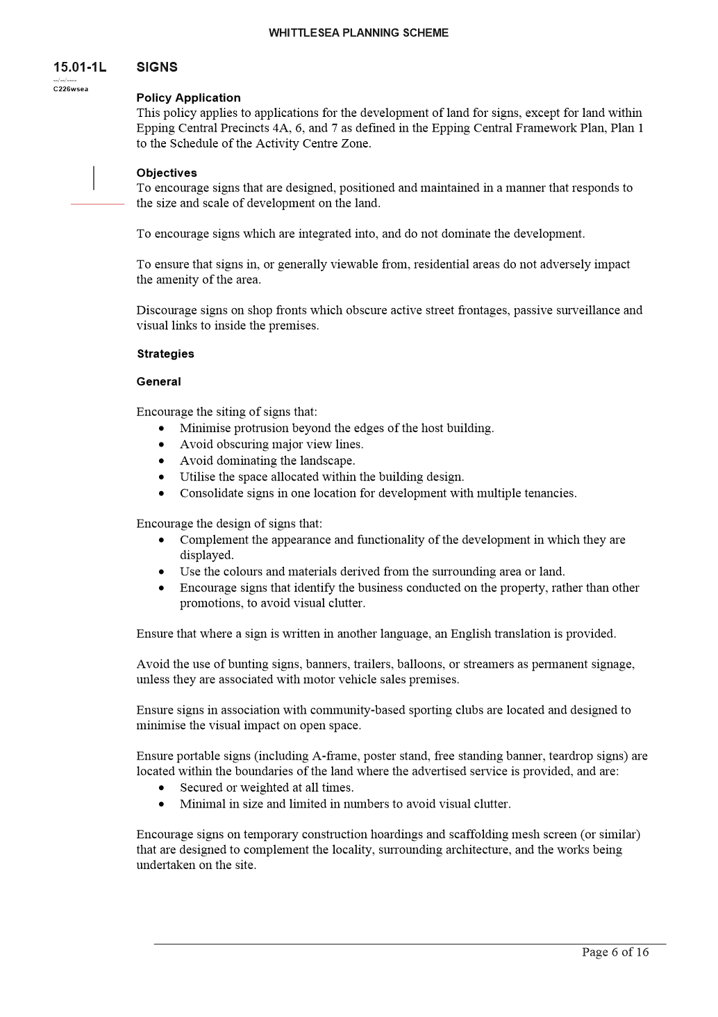

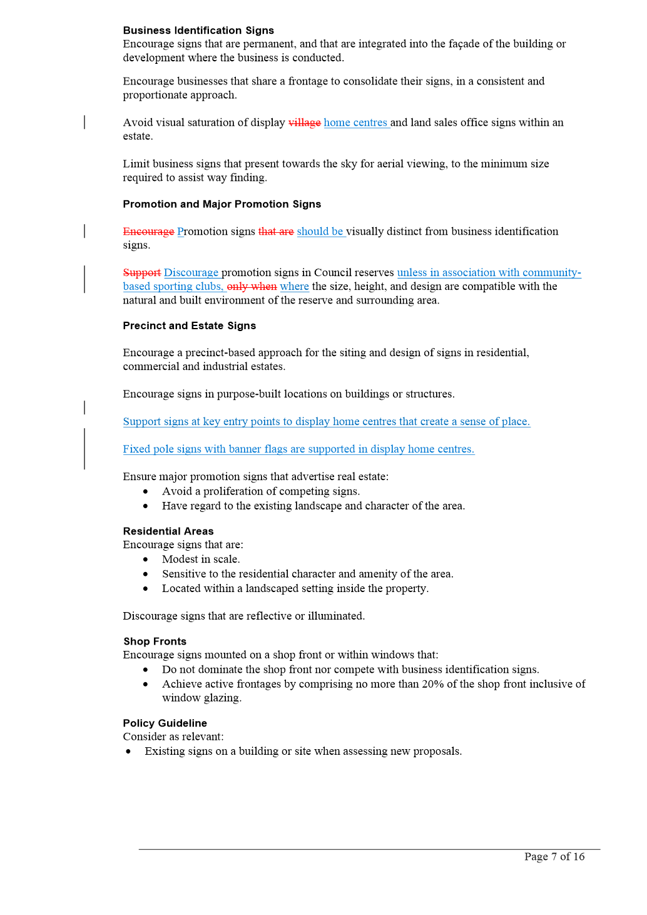

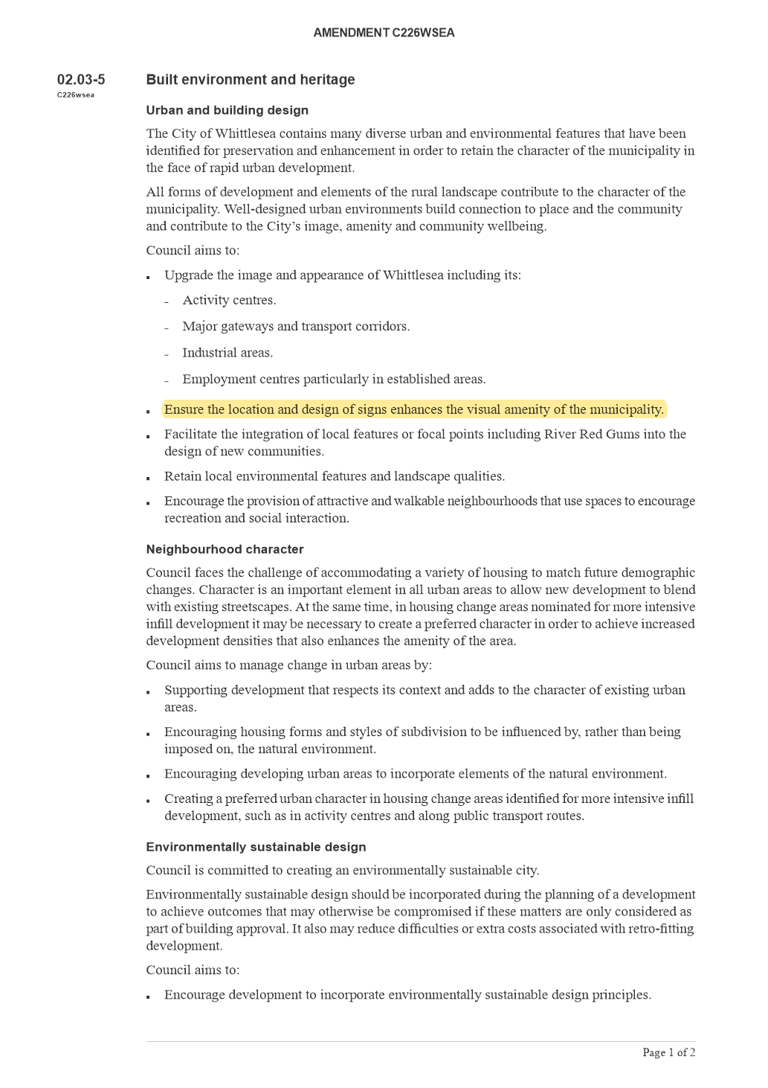

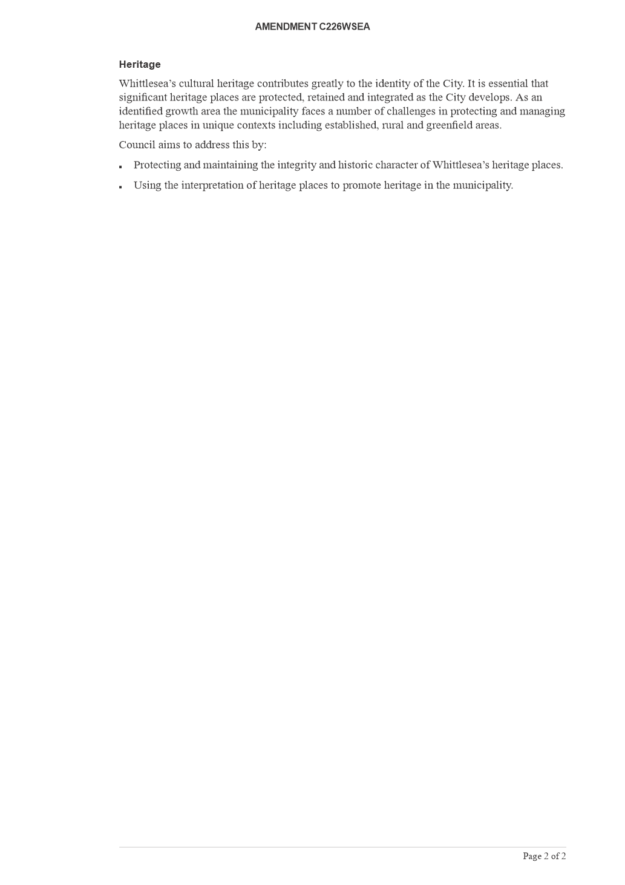

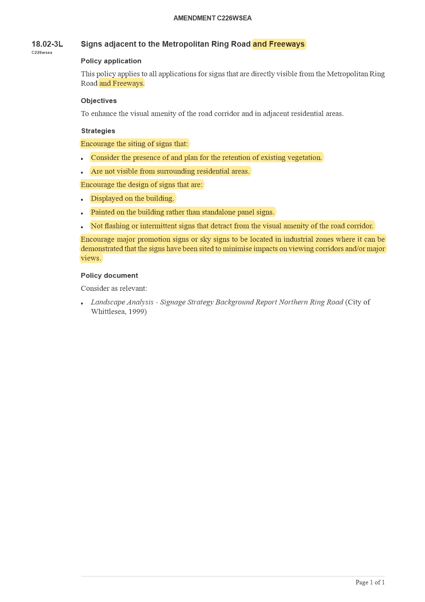

6.3 Strong Local Economy
ITEM 6.3.1 Business Advisory Panel membership
Responsible Officer: Director Planning & Development
Also in attendance: Manager Economic Development

RECOMMENDATION SUMMARY
That Council resolve to:
1. Appoint the following people listed below, as members of Council’s Business Advisory Panel:
• Peter Vu/Jose Cambon, Costa Group (noting Jose Cambon as proxy)
• Daniel Wilson, Quest Apartments Epping
• David Power, Melbourne Market Authority
• Kerryn Lester-Smith, Melbourne Polytechnic
• Catherine Cervasio, Aromababy
• Joshua Robinson, Lotus Energy
• Aristos Karavias, Repurpose It
• Giorgio Linguanti, That’s Amore
• Michelle Andrews-Sims, Wine in a Glass
• Paul Hearne, Limelight
2. Appoint the position of Chair to David Power, Melbourne Market Authority;
3. Committee members be notified in writing that their nominations have been approved by Council;
4. Council to write to unsuccessful submitters;
5. The list of Committee members be published on Council’s website; and
6. Amend the Terms of Reference to increase the number of local business representatives from 10 to 11 to enable a representative of the small and micro business cohort to be invited to join the Panel in the future.
KEY FACTS AND / OR ISSUES
• The Business Advisory Panel Terms of Reference and Expression of Interest process was endorsed at 1 June Council Meeting.
• The Business Advisory Panel will work together with Council in delivering the key objectives and advocate for a Strong Local Economy.
• The membership of the Panel will include Administrator / Councillor, Council Officers and up to 10 local business representatives.

Report
Introduction
The purpose of the Business Advisory Panel (Panel) will enable business leaders’ work with Council in delivering key objectives and advocacy for a Strong Local Economy. Following endorsement at the 1 June 2021 Council meeting, an Expression of Interest process was open, inviting the business community to submit an application for consideration.
Background
The Business Advisory Panel has clear linkages with Whittlesea 2040 Goal: Strong Local Economy and the Economic Development Strategy key direction 5 Collaborate with community, business and government to deliver resources and opportunities. The Panel aims to further enhance the partnerships between Council and the business community.
Following the endorsement of the Terms of Reference and Expression of Interest (EOI) at 1 June Council Meeting, the EOI process was made available to the business community.
Proposal
Thirteen business community members submitted an Expression of Interest to join the Business Advisory Group. It is proposed that nine of the submission be accepted and invited to join the Business Advisory Panel.
summary of recommended BUSINESS ADVISORY PANEL members
The proposed Panel members will join Chair of Administrators Lydia Wilson, Administrator Chris Eddy and nominated Council members.
The proposed membership represents the diversity of the local Whittlesea Business Community in relation to industry sector, broad coverage of additional affiliations, cultural background and location within the municipality. They have all been engaged with Council in other matters through program and/or event support, partnership opportunities or strong engaged relationships with Council.
Additionally, submissions were considered based on the responses to the following factors:
• Knowledge level of local business and its contribution to the Panel
• Applicants current role within the business
• Overview of current role responsibility and how the role would benefit the Panel
• Additional affiliations and memberships held within their respected industry
The proposed committee members are listed below with reference to the affiliated industry sector:
Peter Vu/Jose Cambon Costa Group (Agriculture). It is intended that Peter Vu be the primary contact, with Jose Cambon to step in as proxy if required.
Daniel Wilson Quest Apartments Epping (Visitor Economy)
David Power Melbourne Market Authority (Government Administration and Wholesale Trade – Food and Flowers)
Kerryn Lester-Smith Melbourne Polytechnic (Education)
Catherine Cervasio Aromababy (Wholesale Trade – Mother and Baby products)
Joshua Robinson Lotus Energy (Resource Recovery)
Aristos Karavias Repurpose It (Resource Recovery)
Giorgio Linguanti That’s Amore (Food manufacturing and Wholesale)
Michelle Andrews-Sims Wine in a Glass (Beverage manufacturing)
Paul Hearne Limelight (Advanced Manufacturing)
ADDITIONAL MEMBERSHIP PROPOSAL
The Terms of Reference currently states membership of the Panel will include Administrator / Councillor, Council Officers and up to 10 local business representatives. However an opportunity presents itself for the Panel to include a representative of the small and micro business cohort. It is proposed that in early 2022, Council establish a chamber of commerce-style group representing the small and micro business cohort. Once the Group has been established, a representative from the Group would be invited to join the Panel.
It would be proposed to amend the current Terms of Reference to allow an additional panel member to increase to 11 local business representatives to ensure the Panel has a full representation of the business community.
Position of chair
Submitters were invited to nominate themselves for the position of Chair as part of the Expression of Interest. As per the Terms of Reference, the position of Chair is selected by Council and will reviewed on an annual basis.
Three submitters self-nominated for the position of Chair. Upon consideration it is recommended that David Power, Commercial and Business Development Manager, Melbourne Market Authority be Chair. David holds experience in previous committee membership and currently holds the position of Chair of the National Retailer Program Marketing Committee.
Consultation
The EOI was officially launched on 30 June 2021. Various methods of communication were carried out to promote and encourage businesses to submit an EOI. Activities included a media release which resulted in stories being published in local newspaper publications, online posts on Council’s Linked In, Council’s website and Council’s Business eNewsletter.
A total of 13 EOI’s were received for consideration.
Critical Dates
The first meeting of the Business Advisory Panel is scheduled to take place on Thursday 28 October 2021.
Financial Implications
No financial commitment is required. The establishment of the Panel and its activities will be delivered within existing resources and budget.
Policy strategy and legislation
The Business Advisory Panel has clear linkages with Whittlesea 2040 Goal: Strong Local Economy and the Economic Development Strategy key direction 5 Collaborate with community, business and government to deliver resources and opportunities. The Panel aims to further enhance the partnerships between Council and the business community.
link to strategic risks
Strategic Risk Not linked to the risks within the Strategic Risk Register.
Links to whittlesea 2040 and the CoUNCIL Plan
Goal Strong local economy
Key Direction Successful, innovative local businesses

The Panel will enhance the collaboration between Council and the business community. Through collaboration, the Panel will support successful, innovative local businesses who offer employment and education opportunities for our community.
Declarations of Conflicts of Interest
Under Section 130 of the Local Government Act 2020 and Rule 47 of the Governance Rules 2021, officers providing advice to Council are required to disclose any conflict of interest they have in a matter and explain the nature of the conflict.
The Responsible Officer reviewing this report, having made enquiries with relevant members of staff, reports that no disclosable interests have been raised in relation to this report.
Conclusion
The proposed Panel members represent the diversity of the local Whittlesea Business Community in relation to industry sector, broad coverage of additional affiliations, cultural background, and location within the municipality. They have all been engaged with Council in other matters through program and event support, partnership opportunities or strong engaged relationships with Council.
The Panel will enhance the collaboration between Council and the business community.

RECOMMENDATION
THAT Council resolve to:
1. Appoint the following people listed below, as members of Council’s Business Advisory Panel:
• Peter Vu/Jose Cambon, Costa Group (noting Jose Cambon as proxy)
• Daniel Wilson, Quest Apartments Epping
• David Power, Melbourne Market Authority
• Kerryn Lester-Smith, Melbourne Polytechnic
• Catherine Cervasio, Aromababy
• Joshua Robinson, Lotus Energy
• Aristos Karavias, Repurpose It
• Giorgio Linguanti, That’s Amore
• Michelle Andrews-Sims, Wine in a Glass
• Paul Hearne, Limelight
2. Appoint the position of Chair to David Power, Melbourne Market Authority;
3. Notify successful applicants in writing that their nominations have been approved by Council;
4. Write to unsuccessful applicants;
5. Publish the list of Committee members on Council’s website; and
6. Amend the Terms of Reference to increase the number of local business representatives from 10 to 11 to enable a representative of the small and micro business cohort to be invited to join the Panel in the future.
Council Resolution
Moved: Administrator Eddy
Seconded: Chairperson Wilson

THAT Council resolve to adopt the Recommendation.
CarrieD UNANIMOUSLY

6.4 Sustainable Environment
ITEM 6.4.1 Joint Letter - Gum Tree Removal Request - Flaxen Hills Road, Doreen
Responsible Officer: Director Infrastructure & Environment
Also in attendance: Team Leader Parks & City Forest Business Improvement

RECOMMENDATION SUMMARY
That Council:
1. Note the report and actions taken to resolve the written request for work on the street trees located along Flaxen Hills Road, Doreen.
2. Implement the recommendations of the independent arborist assessment
3. Advise the head petitioner of the proposed works.
KEY FACTS AND / OR ISSUES
• Council received a petition containing approximately 60 names requesting the removal of street trees in Flaxen Hills Road, Doreen. The petition was not signed and did not have any addresses, although contact phone numbers were provided. An examination of Council records shows that names listed on the petition originate from 22 households on Flaxen Hills Road and 2 households on Overland Drive. A further six names were not located during the record search.
• A letter has been sent to the head petitioners, Mr and Mrs Urquhart advising of the Council meeting date for the presentation of this report.
• Council commissioned an independent arboricultural assessment for the entire street, from Hazel Glen Drive to Yan Yean Road, totalling 337 trees. The report recommends one removal and routine work for 18 trees.
• Two trees have since been poisoned in the street and have died. These trees will be removed whilst undertaking the recommended works.
• An examination of Council’s CRM record shows 35 tree related requests since 2011, which have all been responded to and resolved. This is considered an acceptable rate of requests for the number of trees under consideration.
• Following the detailed consideration of the independent assessments and CRM record for Flaxen Hills Road, Doreen, it is recommended that the above recommendations be added to the Zone Maintenance Program under contract with Citywide for 2021/2022.

Report
Introduction
On 21 July 2020, Council received a petition from residents requesting the removal and replacement of the existing street trees from Flaxen Hills Road, Doreen. The petition was in the form of a list of 60 names with phone numbers. An examination of Council records shows that names listed on the petition originate from 22 households on Flaxen Hills Road and 2 households on Overland Drive. A further six names were not located during the record search.
Issues raised in the petition were concerned mainly with the size of the trees and the mess created from excessive leaf shed.
Council places a significant value on established street trees for the multitude of environmental, social and economic benefits that they bring to the local Community. This philosophy was recently reinforced by Council through the adoption of the Greening Whittlesea – City Forest Strategy which aims to increase tree canopy cover across the municipality by 20 per cent by the year 2040. For these reasons, Council only removes established trees in the most extreme circumstances.
As a result of the petition, an investigation was undertaken looking at the core issues, and by examining past CRM records of tree requests in Flaxen Hills Road, Doreen. In addition, an independent arborist was commissioned to undertake an assessment of the 337 trees to evaluate the status of current tree assets.
Background
Flaxen Hills Road, Doreen is a streetscape dominated by a combination of mature Gum Tree species including Corymbia citriodora (Lemon Scented Gum) and Corymbia maculata (Spotted Gum). Corymbia trees are an evergreen tree listed on Council’s approved street tree species list and classified as a medium to large tree.

The two main species planted in Flaxen Hills Road, C. citriodora and C. maculata, are in the top 10 most common street trees in the City of Whittlesea. Together they combine for a total 6.2 per cent of our street trees.

These trees are all currently managed and maintained proactively by Council on a bi-annual program.

A petition was received on 21 July 2020 listing 60 names requesting that Council remove the existing nature strip trees and replant with new trees as part of the Street Tree Renewal Program. An examination of Council records shows that names listed on the petition originate from 22 households on Flaxen Hills Road and 2 households on Overland Drive. A further six names were not located during the record search.

The grounds on which the signatories believe that the current trees are unsuitable include:
• Trees dropping debris including leaves
• Leaf shedding become unsafe for foot traffic
• Canopy spread and size
• Branches cracking under wind and weather

Council’s CRM records were examined to determine the number of complaints received over a ten-year period. This showed that 35 tree related requests were received since 2011, which have all been responded to and resolved. This is considered an acceptable rate of requests for the number of trees under consideration.
Furthermore, there were four claims against Council for tree related damage in Flaxen Hills Road, Doreen. Three claims resulted in the removal of the tree based on the findings of an independent engineering report.
Council officers have also investigated the Flaxen Hills Road trees to assess property clearances in line with the guidelines set out in the Street Tree Management Plan (STMP). The STMP defines the levels of service provided for Council’s street trees and the criteria by which Council does (and does not) remove trees.
An independent arborist was commissioned to assess the current health status of the trees. The investigation included the further assessment of 337 trees along Flaxen Hills Road. The average ULE (Useful Life Expectancy) of the trees is 50 years. The average value of the trees, using the modified Burnley method, is $56,561.19. The overall condition of the trees is of good form and vigour. Based on this assessment, the arborist has recommended that most of the trees are retained, with the removal of one tree and routine maintenance work for a further 18 trees. Since the report was completed, two trees have been poisoned in the street and have died.
The two trees that have been poisoned were noticed to be in a state of rapid decline by Council’s arborist whilst on a routine inspection in May 2021. Upon investigation, some small drill holes were noted in one tree. In addition, a green crust like residue was also observed in the soil adjacent to both trees, which indicates the use of pool chemicals. However, without testing, this cannot be confirmed. At the time, signage was installed to publicise the poisoning of the trees, however this was removed within two weeks by persons unknown.
Parks and City Forest will review the poisoned tree process particularly to formalise guidelines for the use of surveillance measures to act as a preventative measure and the size and location of signage should poisoning occur in the future.
The poisoned trees will be removed whilst undertaking the recommended works.
Proposal
Council officers have reviewed the recommendations made within the independent arboricultural report. Most trees were compliant with the Street Tree Management Plan Guidelines. One tree was recommended for removal and 18 have recommendations for routine maintenance. Two trees have since been poisoned in the street and have died. These trees will be removed whilst undertaking the recommended works. The remaining trees are to be retained and will be assessed as part of the bi-annual zone maintenance program. A separate request to assess the footpaths for compliance has been made to the maintenance and operations department.
Consultation
Council officers have notified the head petitioner of the Council meeting on 4 October 2021 for the presentation of this report and have provided communications and updates to enquiries from individuals. Most of this communication has been through the management of complaints relating to structural damage to houses.
A mail out will be arranged to advise of the proposed works to the 22 households on Flaxen Hills Road and 2 households on Overland Drive. A further six names were not located during the record search. Any response to the mail out will be managed individually.
Financial Implications
To resolve the items raised in the petition for Flaxen Hills Road, Doreen the costs are as follows:
• Removal of three trees as recommended by arboricultural investigation estimated $6,000
• Routine maintenance as recommended by arboricultural investigation – costs included in Citywide contract
All works can be funded within existing programs as part of the operational budget or under the Citywide contract. No new funding is required for the proposed works.
Policy strategy and legislation
Review of the Flaxen Hills Road, Doreen petition request has been completed in accordance with the following Council policies:
• Whittlesea 2040 – A Place for All Community Plan (2018)
• Greening Whittlesea City Forest Strategy 2020
• Greening Our Streets Street Tree Management Plan (2019).
link to strategic risks
Strategic Risk Community and Stakeholder Engagement - Ineffective stakeholder engagement resulting in compromised community outcomes and/or non-achievement of Council's strategic direction
The City of Whittlesea Street Tree Management Plan (2019) outlines how Council will respond to requests for tree removal from the community and communicates the evaluation criteria whereby Council will support tree removals.

Links to whittlesea 2040 and the CoUNCIL Plan
Goal High-performing organisation
Key Direction Driving better community outcomes through improved service access, satisfaction and advocacy

Goal Sustainable environment
Key Direction Valued natural landscapes and biodiversity

The proposal acknowledges the value of streetscapes in our local community and the contribution of these trees to local amenity, biodiversity and urban shading/cooling.
Declarations of Conflicts of Interest
Under Section 130 of the Local Government Act 2020 and Rule 47 of the Governance Rules 2021, officers providing advice to Council are required to disclose any conflict of interest they have in a matter and explain the nature of the conflict.
The Responsible Officer reviewing this report, having made enquiries with relevant members of staff, reports that no disclosable interests have been raised in relation to this report.
Conclusion
The petition listing 60 names requesting the removal and replacement of the existing street trees has been reviewed and the arborist recommendation for minor works is being presented.
The investigation involved an examination of 337 trees along Flaxen Hills Road. The average ULE (Useful Life Expectancy) of the trees is 50 years. The average value of the trees, using the modified Burnley method, is $56,561.19. The overall condition of the trees is of good form and vigour. Based on this assessment, the arborist recommendations conclude to retain most of the trees, with the removal of one tree and routine maintenance work for a further 18 trees. The two trees subsequently poisoned will also be removed as part of the recommended works. A request has been made to inspect the footpaths by the Operations and Maintenance department to assess for compliance.
Communication via mail out to the identified households will be factored into the timing of works and routine zone maintenance under the Citywide contract.

RECOMMENDATION
THAT Council resolve to:
1. Note the report and actions taken to resolve the written request for work on the street trees located along Flaxen Hills Road, Doreen.
2. Implement the recommendations of the independent arborist assessment
3. Advise the head petitioner of the proposed works.

council resolution
Moved: Administrator Duncan
Seconded: Administrator Eddy

THAT Council resolve to:
1. Note the report and actions taken to resolve the written request for work on the street trees located along Flaxen Hills Road, Doreen.
2. Implement the recommendations of the independent arborist assessment namely removal of one tree; routine maintenance of 18 trees; removal of 2 trees that have died; and retention of remaining trees with their assessment as part of the bi-annual zone maintenance program.
3. Advise the head petitioner of the proposed works.
Carried

6.5 High Performing Organisation
ITEM 6.5.1 17-19 Johnsons Road, Mernda - Sale of Council Land
Attachments: 1 Confidential Attachment - Confidential
This attachment has been designated as confidential by the Director Corporate Services, under delegation from the Chief Executive Officer, in accordance with Rule 53 of the Governance Rules 2021 and sections 66(5) and 3(1) of the Local Government Act 2020 on the grounds that it contains Council business information, being information that would prejudice the Council's position in commercial negotiations if prematurely released. In particular the attachment contains sensitive financial information which would diminish Council's position in these negotiations.
2 Location Plan
3 Aerial Photo
4 Council Report 2 August 2021
Responsible Officer: Director Corporate Services
Author: Consultant

RECOMMENDATION SUMMARY
That Council resolve to:
1. Acting under section 114 of the Local Government Act 2020 and all other powers enabling Council, to undertake a community engagement process in accordance with Council’s ‘Community Engagement Policy’ in relation to the intention of Council to sell (by either public sale, public auction or via an expressions of interest process) the Council-owned property known as 17-19 Johnsons Road, Mernda (subject property) under and subject to the following terms and conditions (proposed sale) –
a) To develop, construct, subdivide and sell the subject property in accordance with the approved 35 lot plan of subdivision;
b) To confine the proposed sale to the sale on the open market (by public sale, public auction or via an expression of interest process) of 32 of the 35 lots that will be developed;
c) To reserve the remaining 3 of the 35 for sale and/or lease to a suitable housing provider as determined by Council and otherwise in accordance with Council’s Social Affordable Housing Policy (affordable housing allocation); and
d) To establish such other terms and conditions in relation to the proposed sale as may be required by Council.
2. To receive a further report on the proposed sale following the close of the community engagement process.
Brief overview
The property located at 17-19 Johnsons Road, Mernda, was purchased by Council from the State Government for $1.8 million. The purchase was made with the strategic intent of selling the property at a future point in time for a return to be reinvested back into community infrastructure.
It is proposed that Council develop and subdivide the site into 35 lots, with 32 of these to be sold on the open market and the remaining 3 lots to be reserved for sale and/or lease, via an expression of interest, to a registered housing organisation to undertake an Affordable Housing development in accordance with Council’s Social Affordable Housing (SAH) Policy.
rationale for recommendation
Council is presented with two options for consideration (outlined in Attachment 1).
Option one is to on-sell the property undeveloped on the open market to a purchaser/developer who will be required to develop the site in accordance with the approved plan of subdivision.
Option two is for Council to develop the site in accordance with the approved plan of subdivision and sell-off each individual lot on the open market. This is the recommended option as it presents the best return on investment for Council.
impacts of recommendation
The recommendation ensures Council will meet the requirements of Section 114 of the Local Government Act 2020 and Council’s community engagement policy. Further, the recommendation of the disposal method outlined in Option 2 (outlined in Attachment 1) represents the best return on investment for Council.
what measures will be put in place to manage impacts
A further report will be presented to Council outlining community feedback from the consultation process, and any impacts on the final recommendation to Council on the preferred disposal method of the site, including the reservation of lots for affordable housing.

Report
Introduction
The report seeks Council’s endorsement for the proposed development and sale of Council owned property at 17-19 Johnsons Road, Mernda. Following the purchase of the property in 2014 for the purpose of future resale, Council is presented with two options for the disposal of the site. The first option is to sell the property to a developer on the open market with the approved plan of subdivision. The second option is for Council to develop the land and sell off each lot individually on the open market.
Background
The property located at 17-19 Johnsons Road, Mernda, is located on the southern side of Johnsons Road some 140m to the east of Schotters Road. The site was previously used for the Mernda Primary School, with the school relocating to a larger site (25 Everton Drive, Mernda) in 2011. The site was purchased from the State Government in 2014 for $1.8 million, with the intention of future resale profits to be reinvested into community infrastructure.
The land is rectangular in shape with a frontage of 120.3m to Johnsons Road and measures approximately 2.02 hectares and is largely flat. The site does not contain any buildings and features significant numbers of mature trees, particularly along the boundaries, and in the southern quarter of the site, with others located in the centre of the site, refer Attachment 2 - Location Plan and Attachment 3 - Aerial Photograph.
The land was valued and purchased by Council on the basis of the land being rezoned and developed for residential purposes with the sole intent being to provide a future financial return to council. The land was zoned as ‘Public Use’ at the time of the purchase and was intended to be rezoned (by Whittlesea Planning Scheme Amendment C175) for future residential subdivision purposes in accordance with the proposed Mernda Township Strategy Plan. Amendment C175 was gazetted and came into operation on 4 May 2017 rezoning this site and the area to the south and west, most of which is on the eastern side of Plenty Road to General Residential Zone and introduced Development Pan Overlay Schedule 34.
Following the re-zoning of the land to “General Residential”, Council engaged the consultancy firm “Urbis” to undertake an independent and autonomous application to subdivide the site. This application went through normal scrutiny by Council Planning Officers and public consultation processes and was approved by Council (with various conditions) at its meeting on 2 August 2021, refer to Attachment 4 - Council Report.
Officers have taken the opportunity to assess the development and its ability to support the outcomes of Council’s SAH policy. An allocation of three lots is proposed to be reserved for affordable housing. An expression of interest process is proposed to be undertaken to offer the three lots for sale and/or lease to a suitable housing provider as determined by Council.
Consultation
A four-week consultation period is proposed to occur between October and November 2021 and be promoted through Council’s communication channels, local media and direct correspondence with surrounding residents and property owners.
Consultation will be undertaken in accordance with Council’s Community Engagement Policy to comply with the requirements of Section 114 of the Local Government Act 2020. All details on the preferred sale option will be advertised on Council’s website (Hive) via an engagement page. The engagement page will include contact details for a Council Officer who can respond to community enquiries on this project.
Critical Dates
No critical dates exist in relation to this proposal or project, other than ensuring a financial gain be returned to Council for proposed reinvestment back into community infrastructure, and to support the objectives of Council’s SAH Policy.
Policy strategy and legislation
Under Section 114 of the Local Government Act 2020, Council must undertake a community engagement process in accordance with its community engagement policy prior to the selling or exchanging of land.
The recommendations in the report also take into account Council’s adopted SAH Policy and Whittlesea Planning Scheme.
link to strategic risks
Strategic Risk Financial Sustainability - Inability to meet current and future expenditure
Strategic property purchases and development are an alternative source of cashflow that Council has identified to meet the financial constraints associated with rate capping. Council’s return on investment from this project is intended to be reinvested back into community infrastructure.
Links to whittlesea 2040 and the CoUNCIL Plan
Goal High-performing organisation
Key Direction More cost-effective investment through better return on investment, efficiency and an engaged workforce
This project will result in additional funding available to Council, outside the usual revenue sources, to assist in funding priority programs and projects that will benefit the community.
Declarations of Conflicts of Interest
Under Section 130 of the Local Government Act 2020 and Rule 47 of the Governance Rules 2021, officers providing advice to Council are required to disclose any conflict of interest they have in a matter and explain the nature of the conflict.
The Responsible Officer reviewing this report, having made enquiries with relevant members of staff, reports that no disclosable interests have been raised in relation to this report.
Conclusion
The property located at 17-19 Johnsons Road Mernda was purchased by Council from the State Government for the purpose of generating a future return on investment to be reinvested into community infrastructure. Following the consideration of various sales options, the preferred option is for Council to develop, construct and subdivide the site in accordance with the approved 35 lot plan of subdivision (Option 2 from Attachment 1). Further, it is proposed that Council will sell 32 of the 35 lots that will be developed on the open market and reserve three lots for “Affordable Housing” in accordance with Council’s SAH Policy.
RECOMMENDATION
THAT Council resolve to:
1. Acting under section 114 of the Local Government Act 2020 and all other powers enabling Council, to undertake a community engagement process in accordance with Council’s ‘Community Engagement Policy’ in relation to the intention of Council to sell (by either public sale, public auction or via an expressions of interest process) the Council-owned property known as No 17-19 Johnsons Road, Mernda (subject property) under and subject to the following terms and conditions (proposed sale) –
a) To develop, construct, subdivide and sell the subject property in accordance with the approved 35 lot plan of subdivision;
b) To confine the proposed sale to the sale on the open market (by public sale, public auction or via an expression of interest process) of 32 of the 35 lots that will be developed;
c) To reserve the remaining 3 of the 35 lots for sale and/or lease to a suitable housing provider as determined by Council and otherwise in accordance with Council’s Social Affordable Housing Policy (affordable housing allocation); and
d) To establish such other terms and conditions in relation to the proposed sale as may be required by Council.
2. To receive a further report on the proposed sale following the close of the community engagement process.

council resolution
Moved: Administrator Duncan
Seconded: Administrator Eddy

THAT Council resolve to:
1. Acting under section 114 of the Local Government Act 2020 and all other powers enabling Council, to undertake a community engagement process in accordance with Council’s ‘Community Engagement Policy’ in relation to the intention of Council to sell (by either public sale, public auction or via an expressions of interest process) the Council-owned property known as No 17-19 Johnsons Road, Mernda (subject property) under and subject to the following terms and conditions (proposed sale) –
a) To develop, construct, subdivide and sell the subject property in accordance with the approved 35 lot plan of subdivision;
b) To confine the proposed sale to the sale on the open market (by public sale, public auction or via an expression of interest process) of 32 of the 35 lots that will be developed;
c) To reserve the remaining 3 of the 35 lots for sale and/or lease to a suitable housing provider as determined by Council and otherwise in accordance with Council’s Social Affordable Housing Policy (affordable housing allocation); and
d) To establish such other terms and conditions in relation to the proposed sale as may be required by Council.
2. To receive a further report on the proposed sale following the close of the community engagement process in December 2021.

Carried

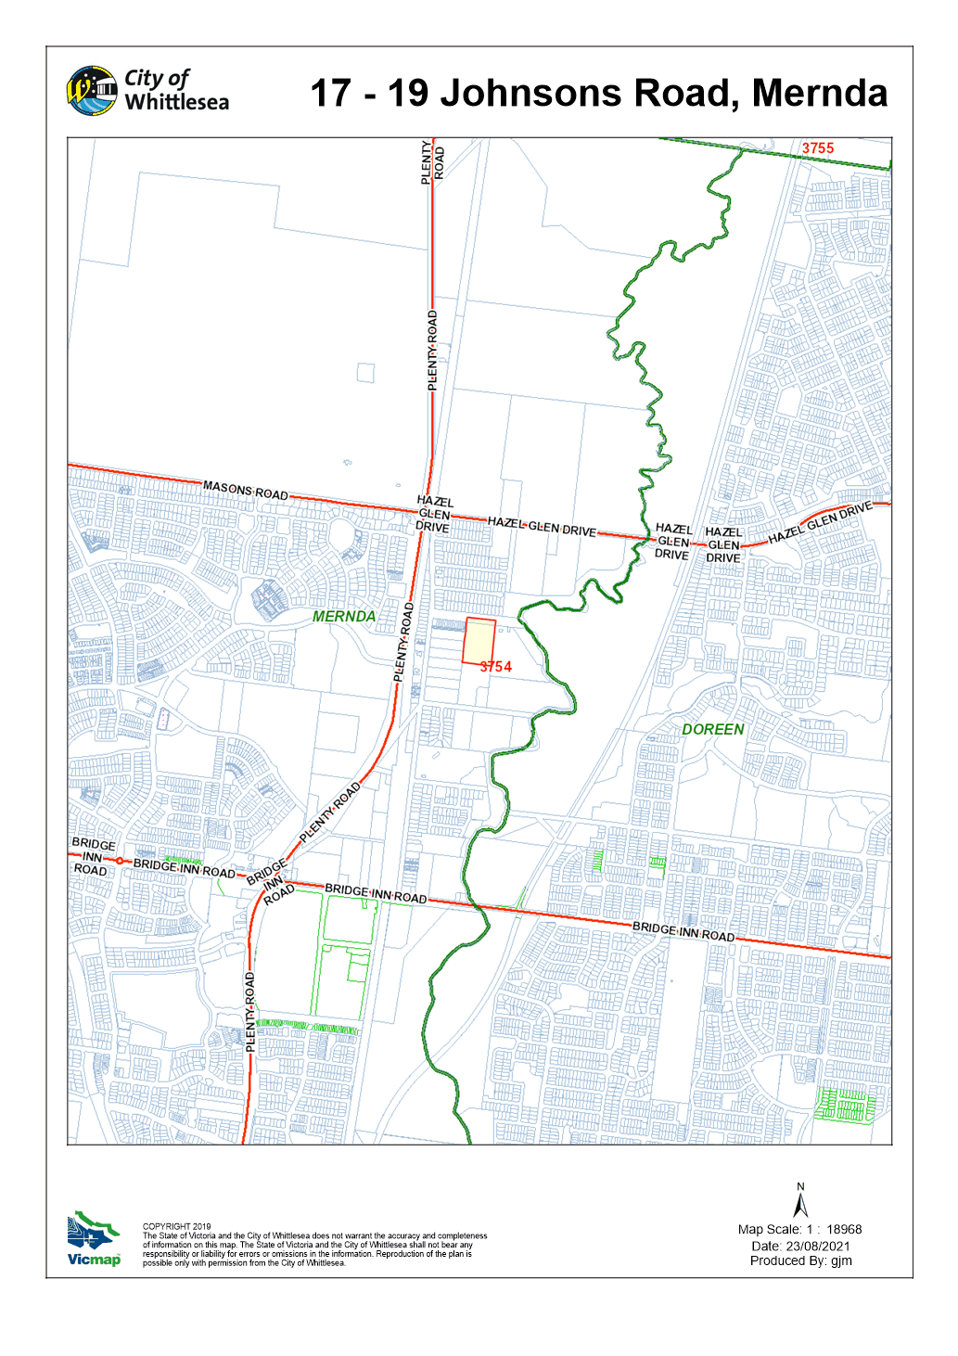
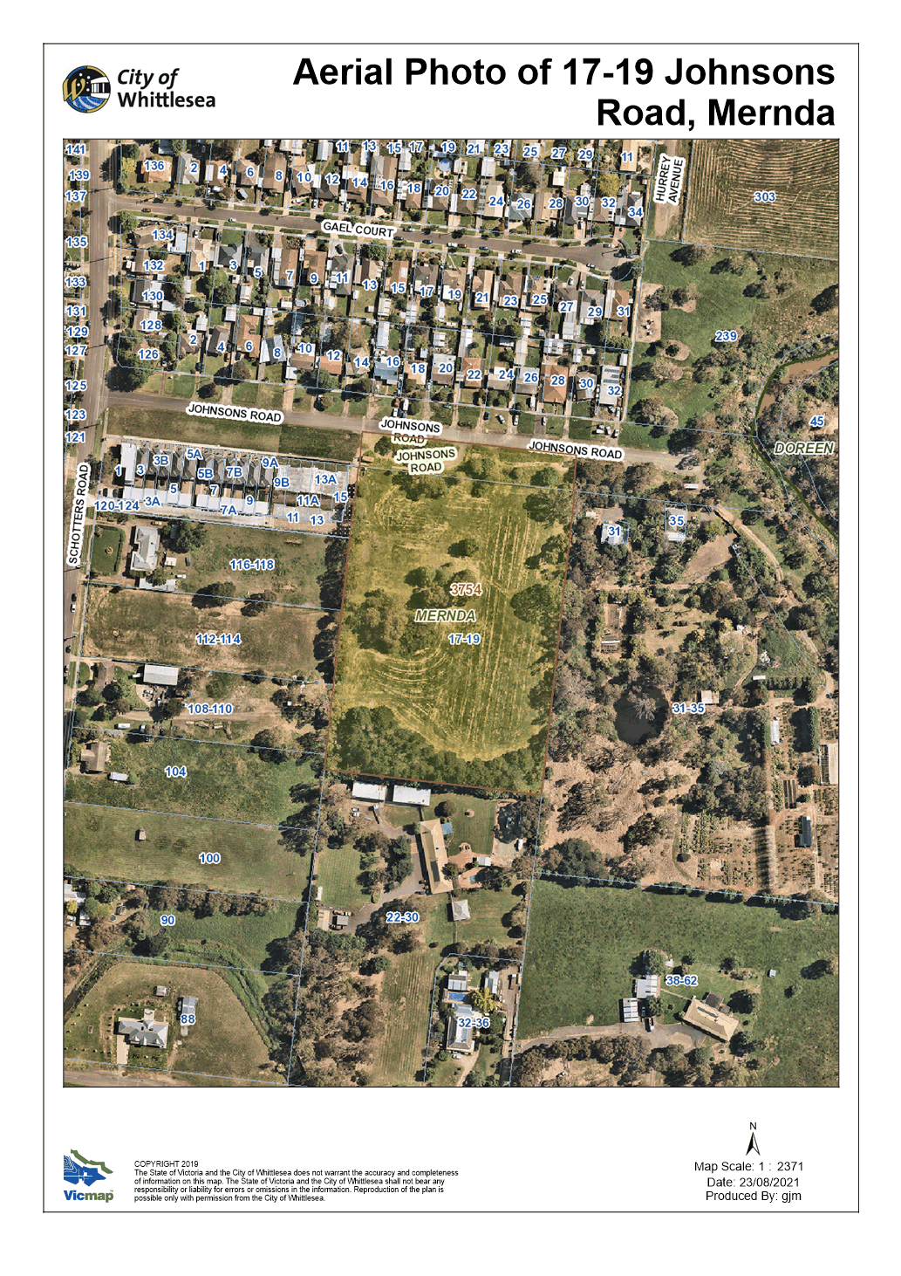
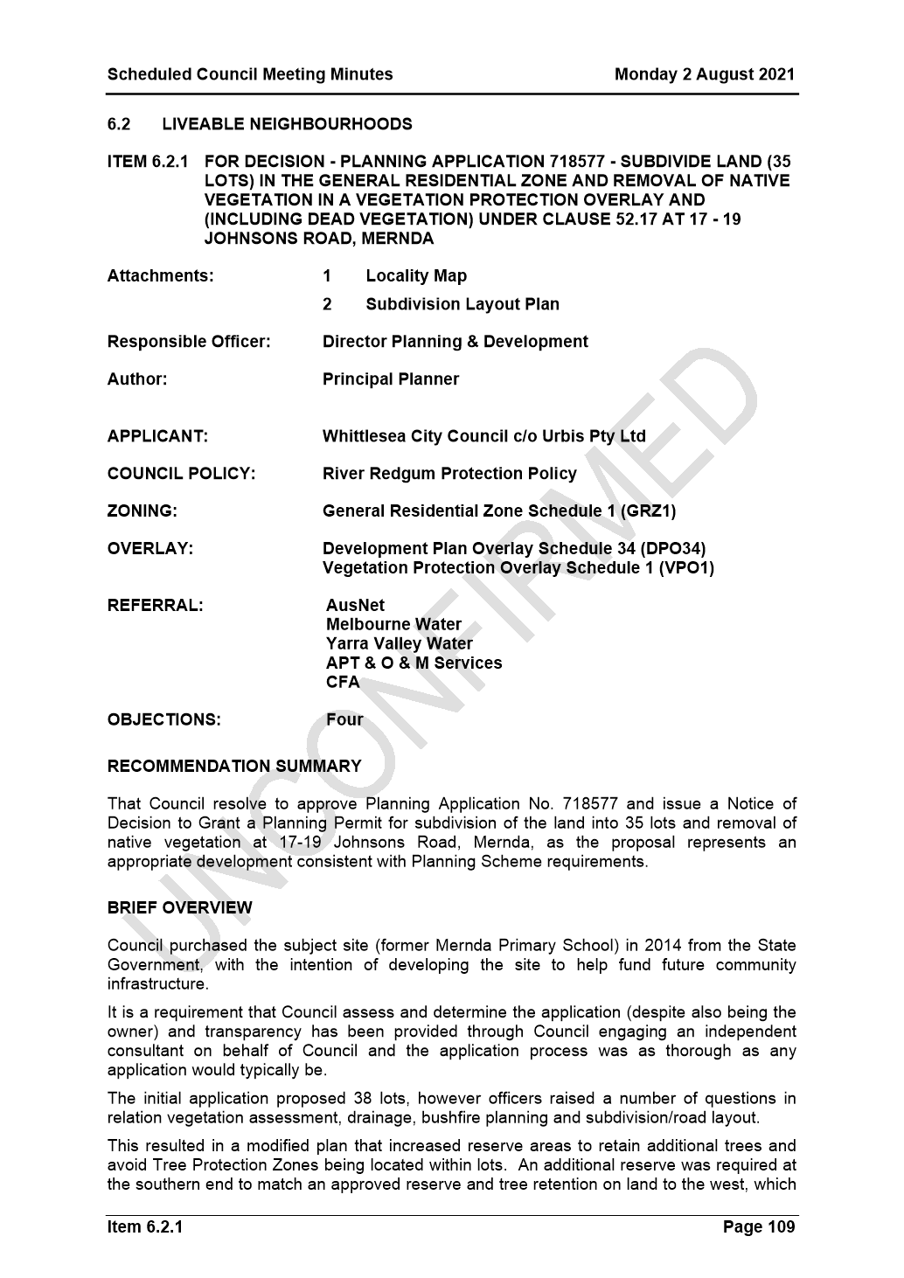

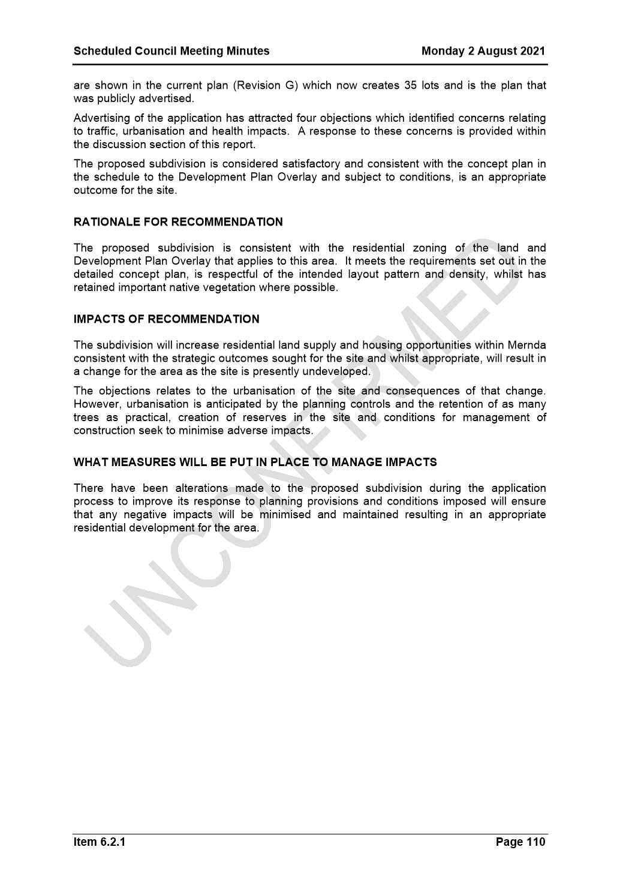

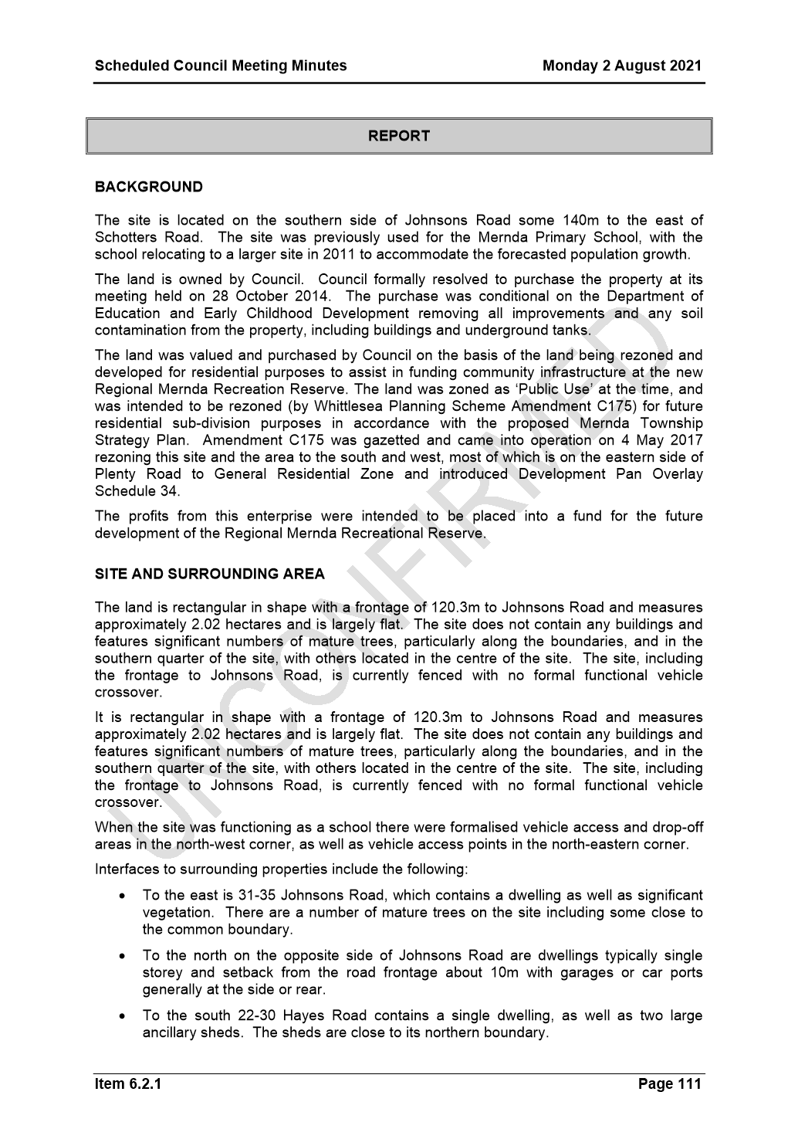

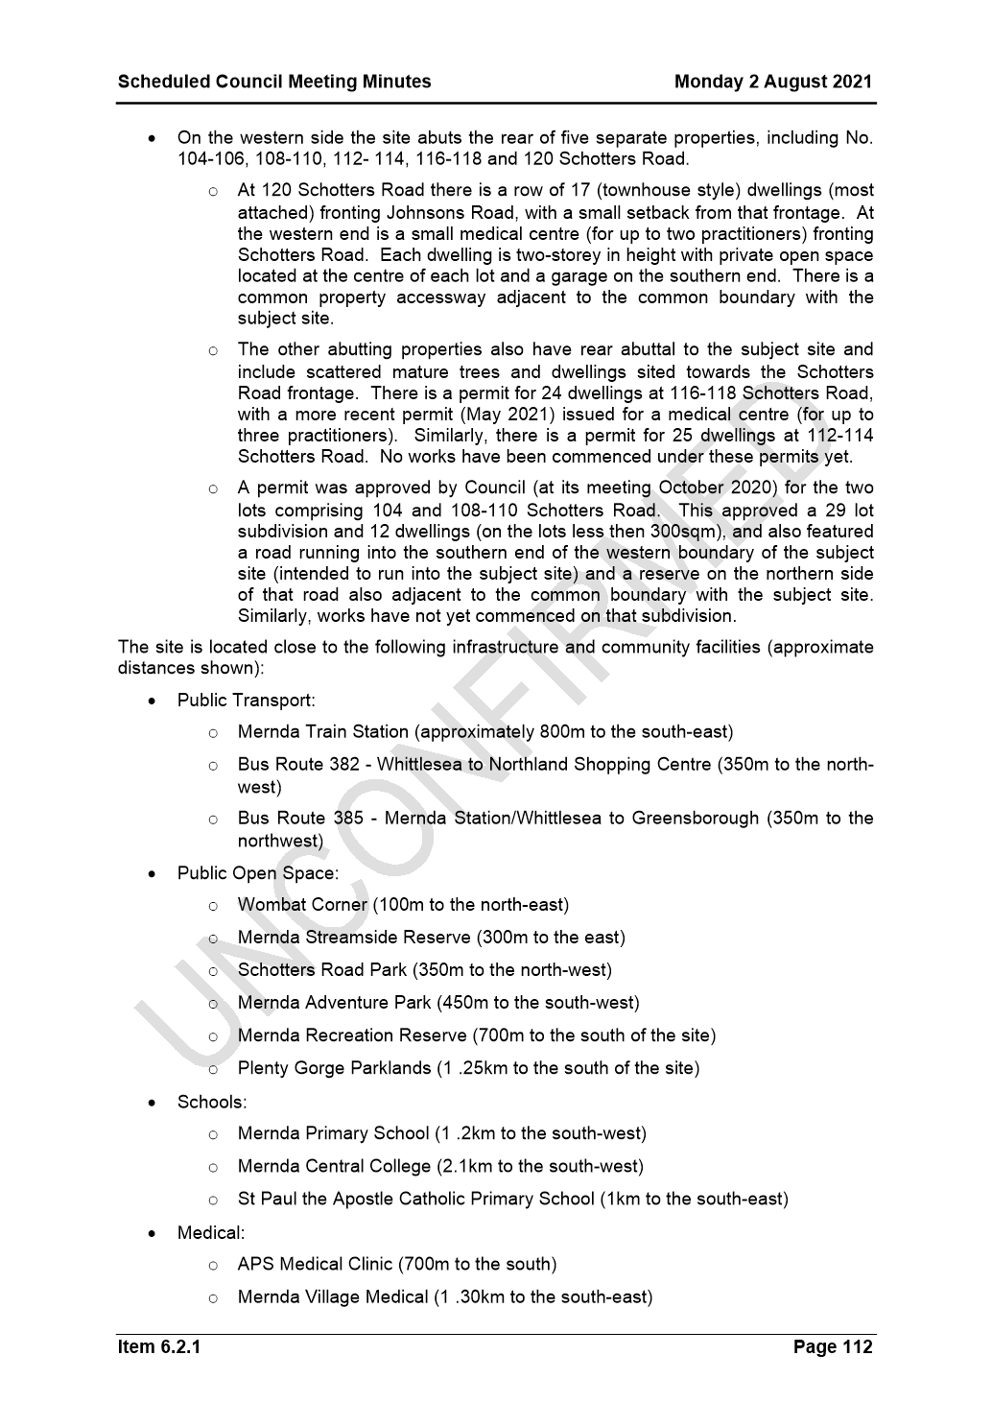

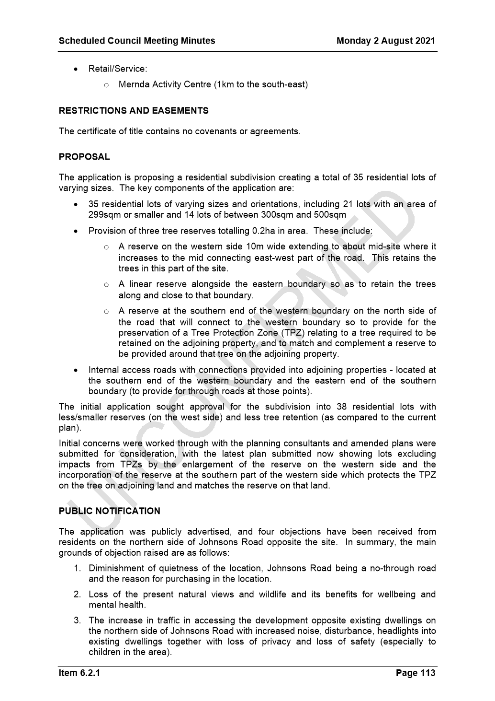

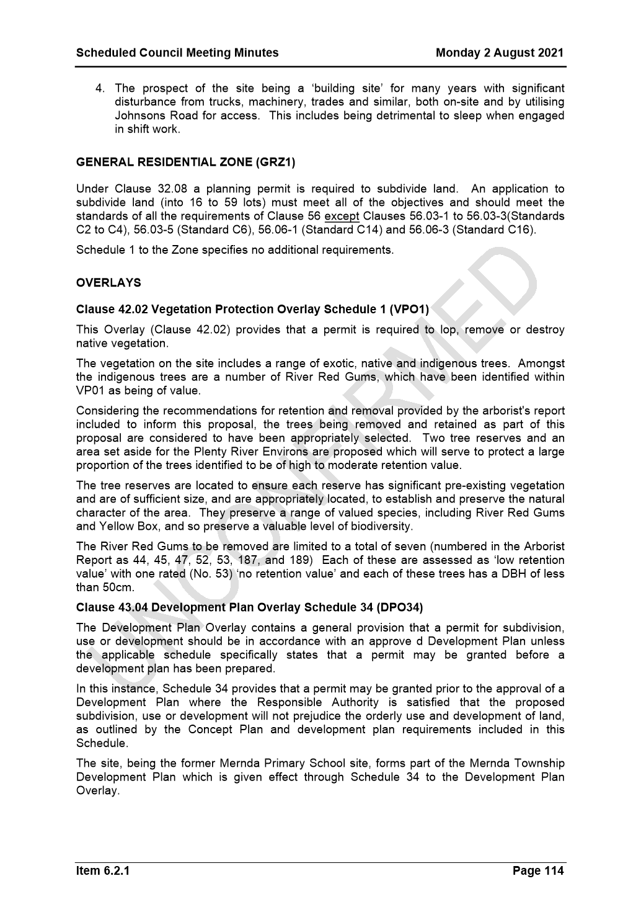

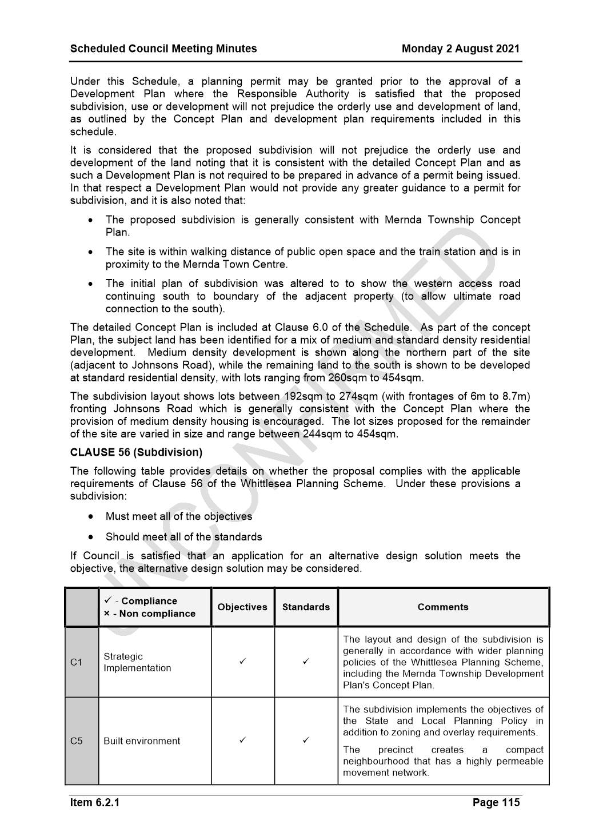

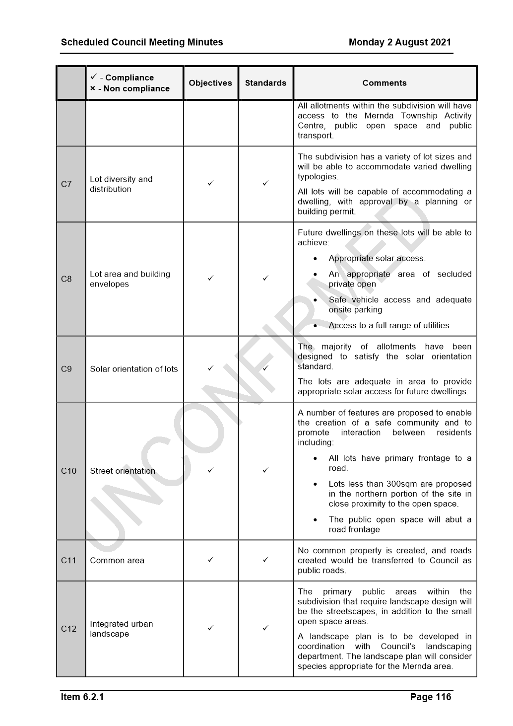

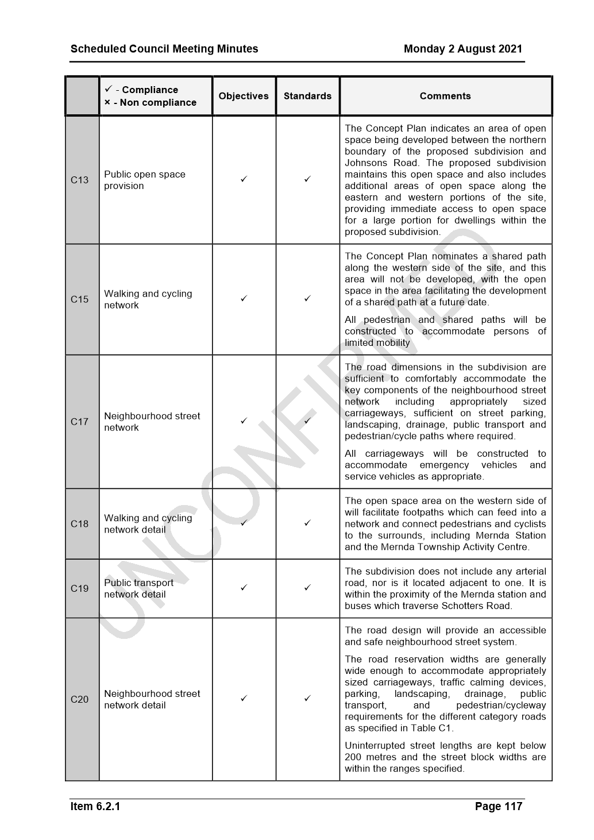

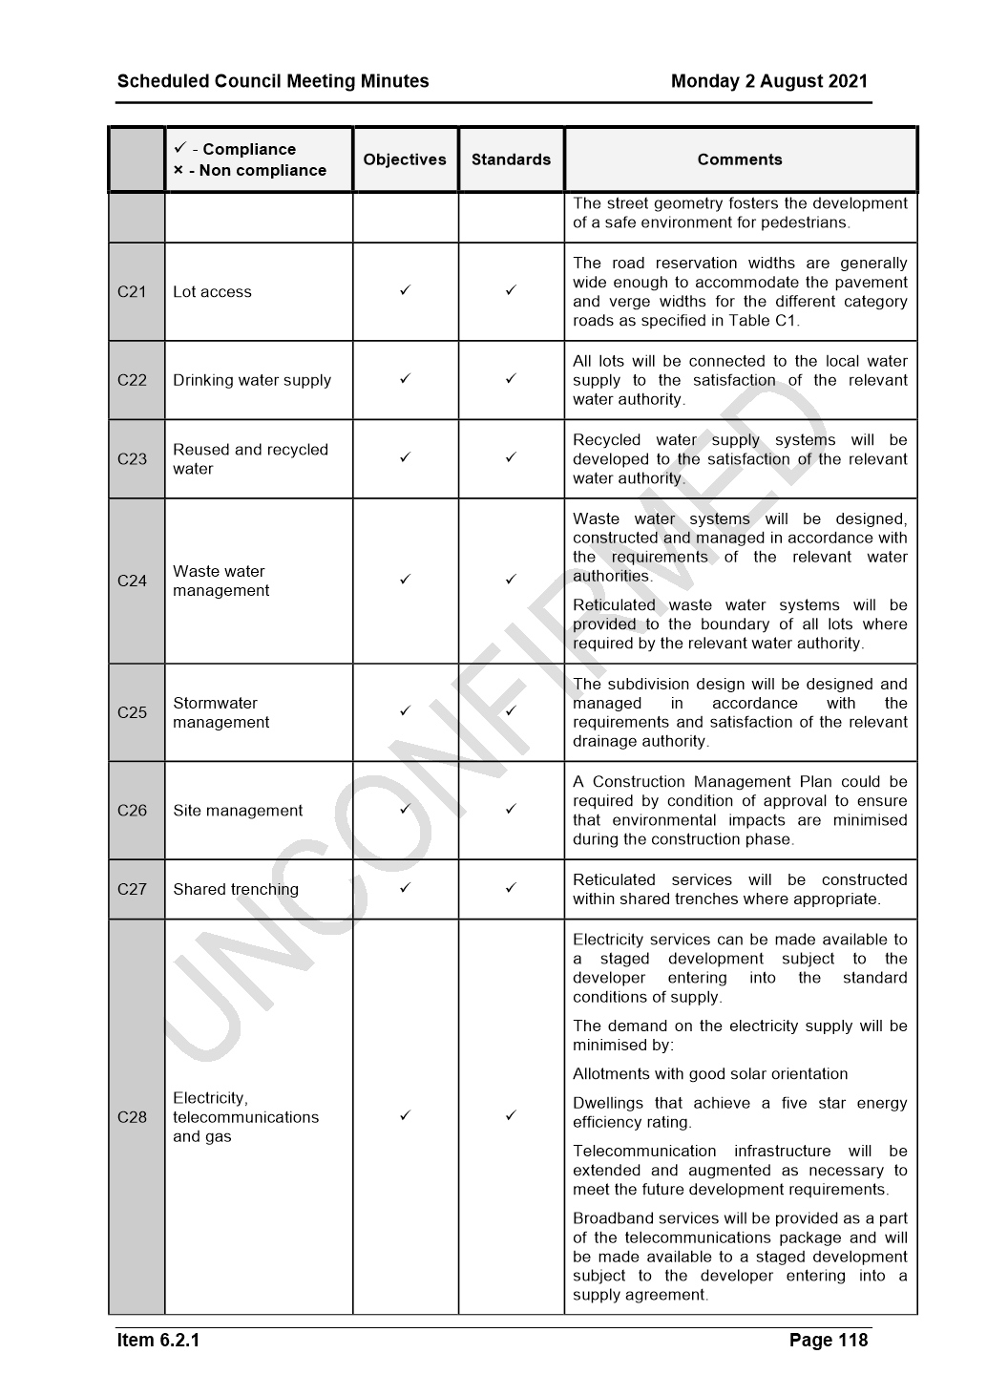

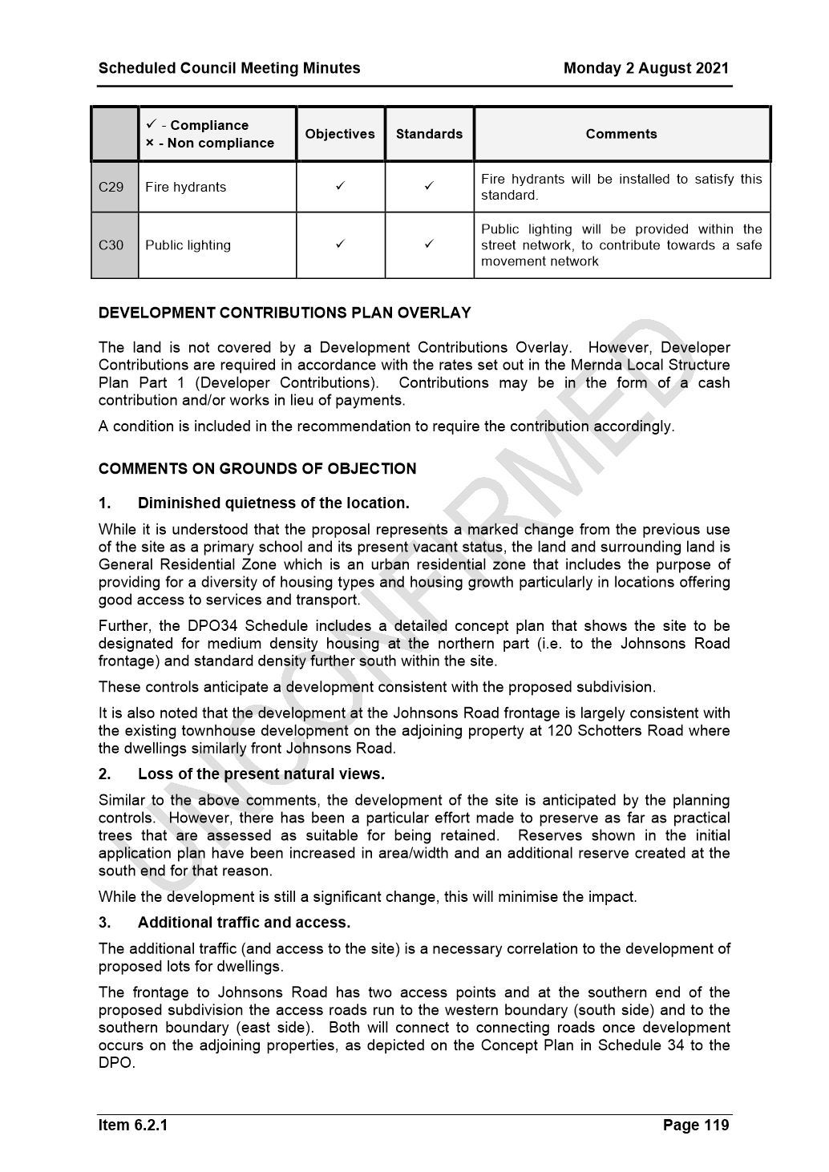

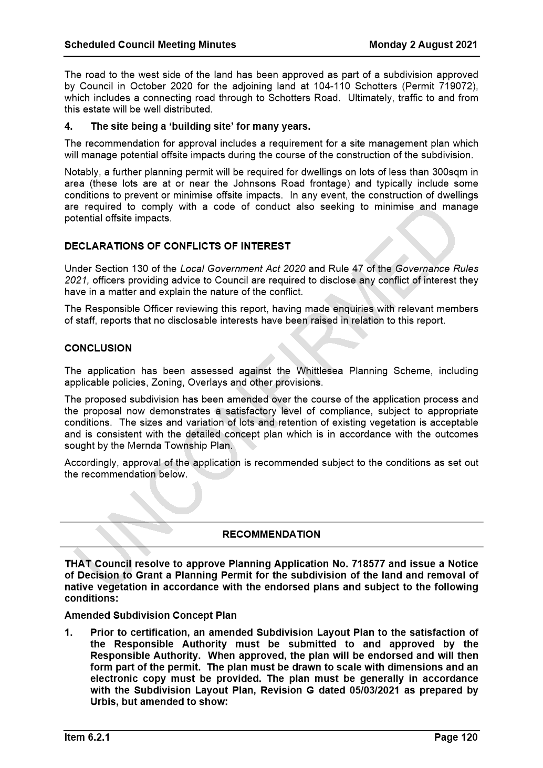

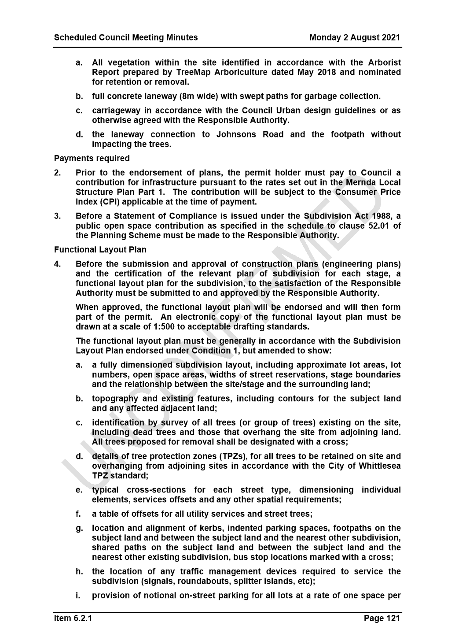

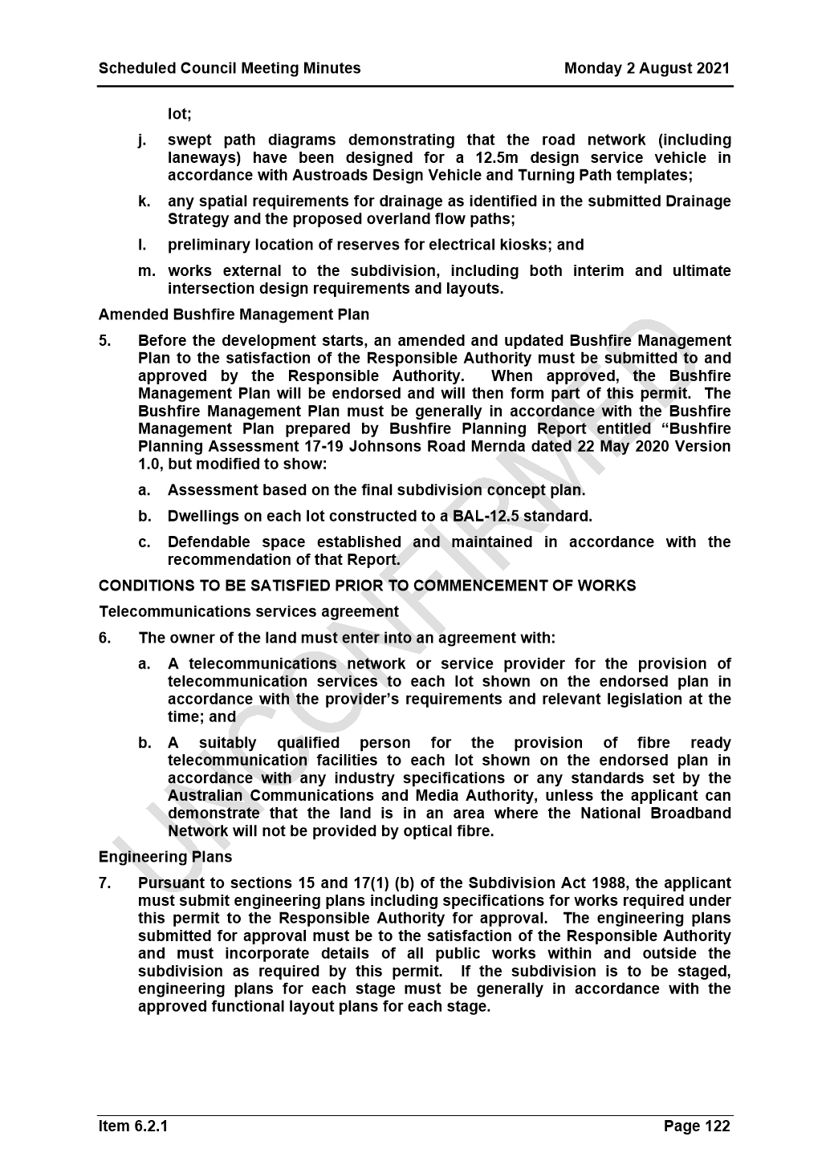

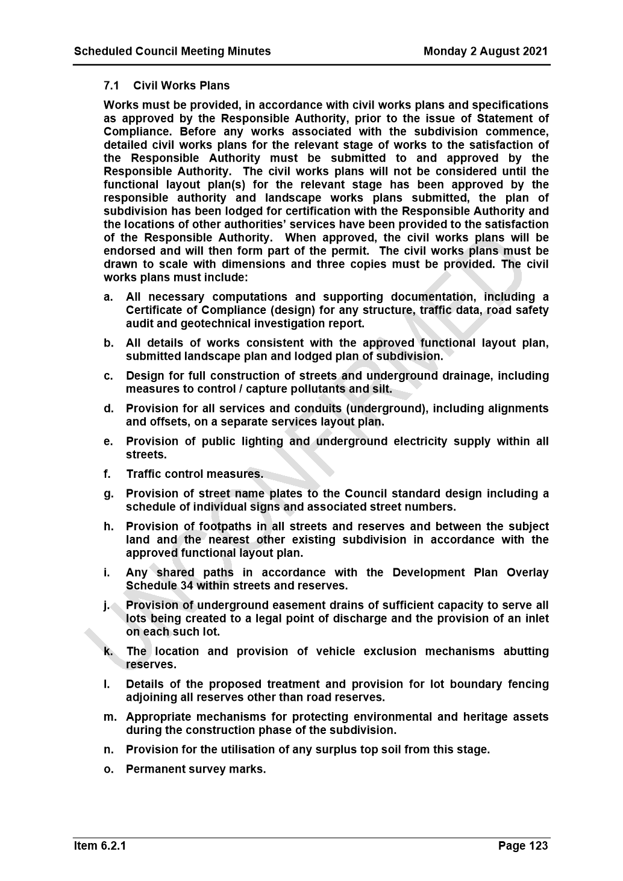

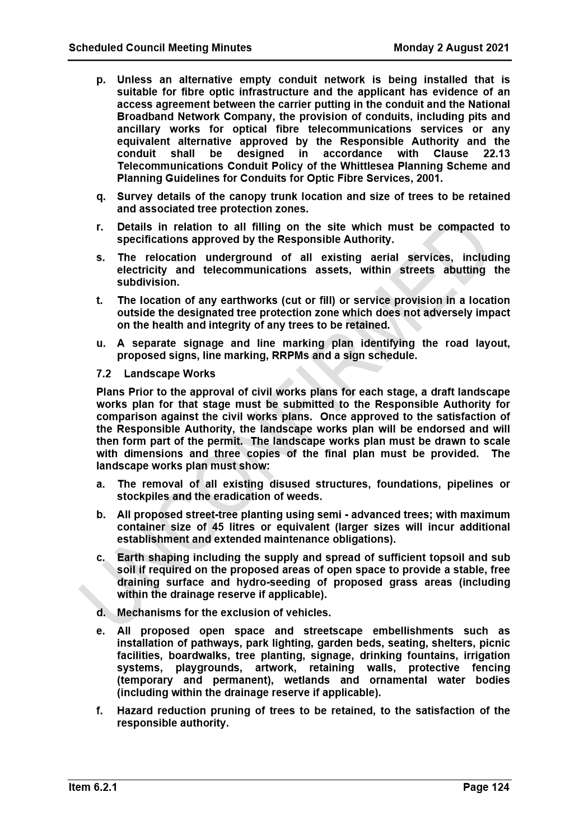

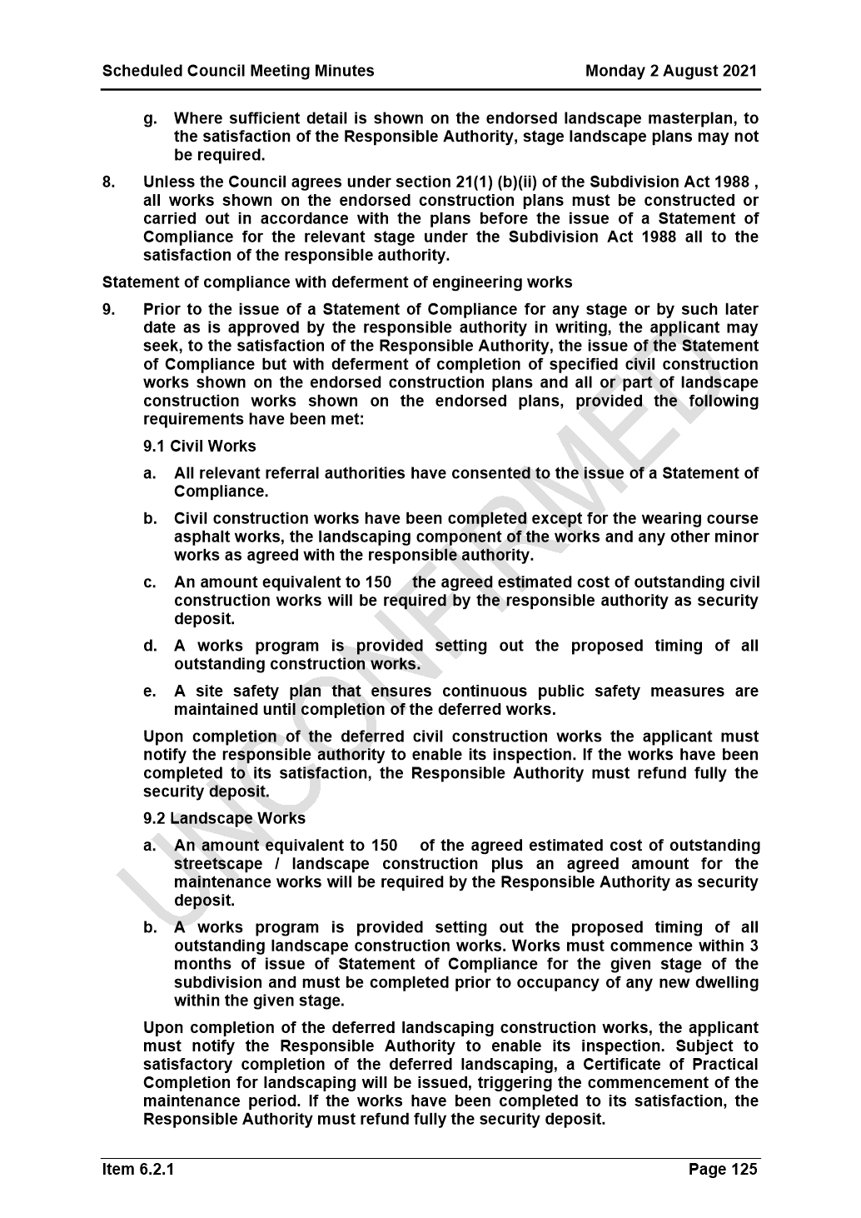

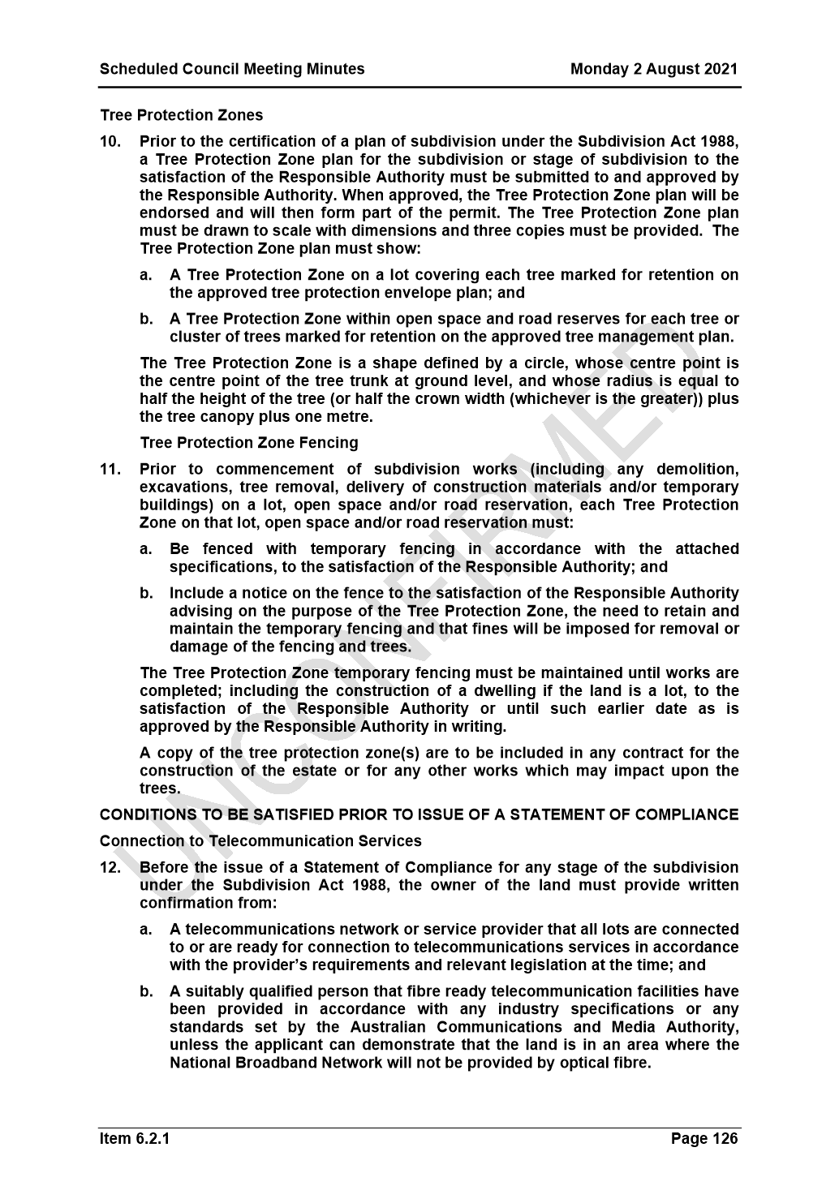

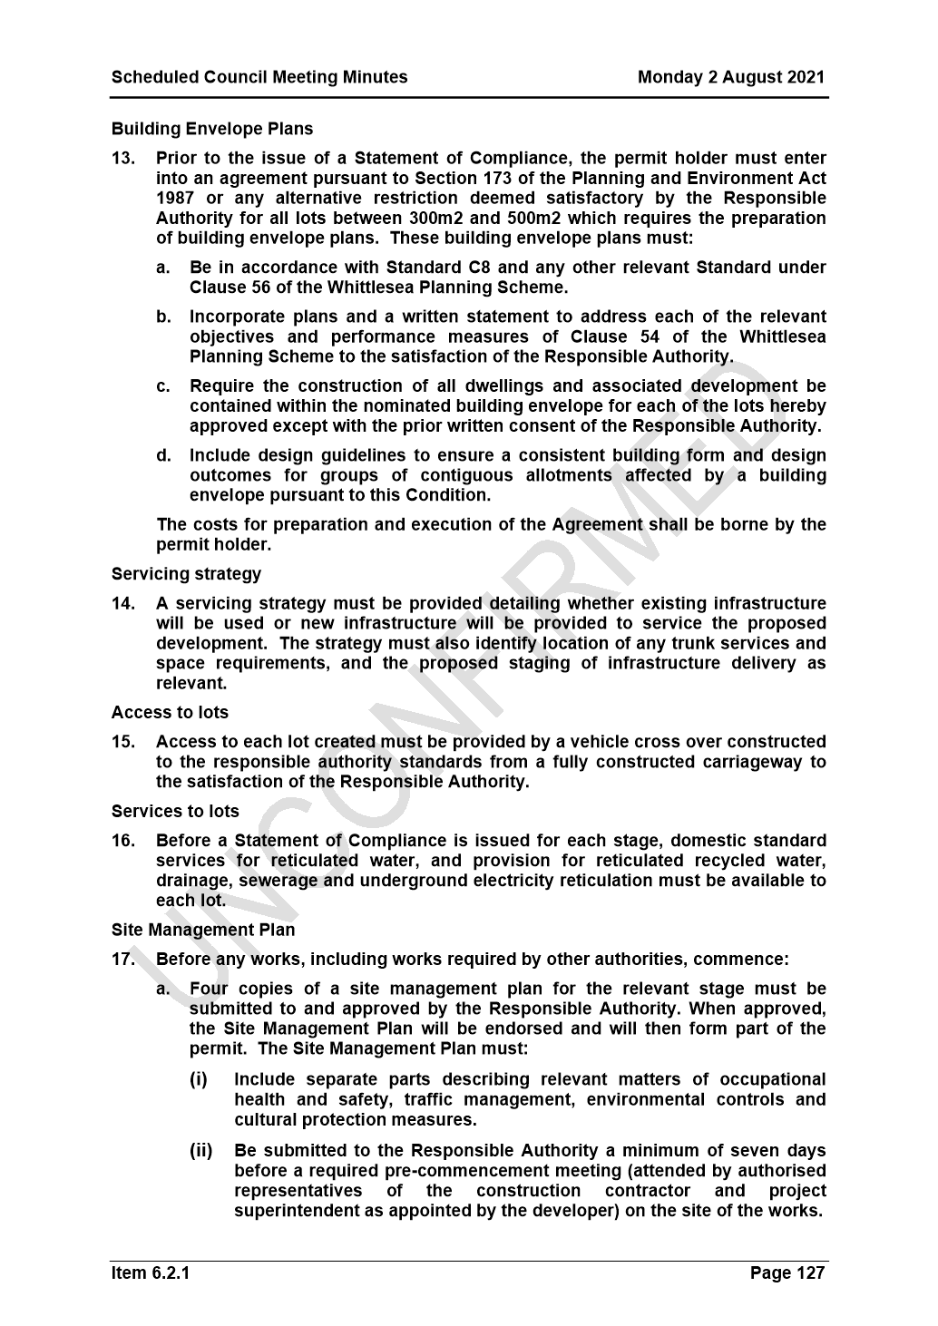

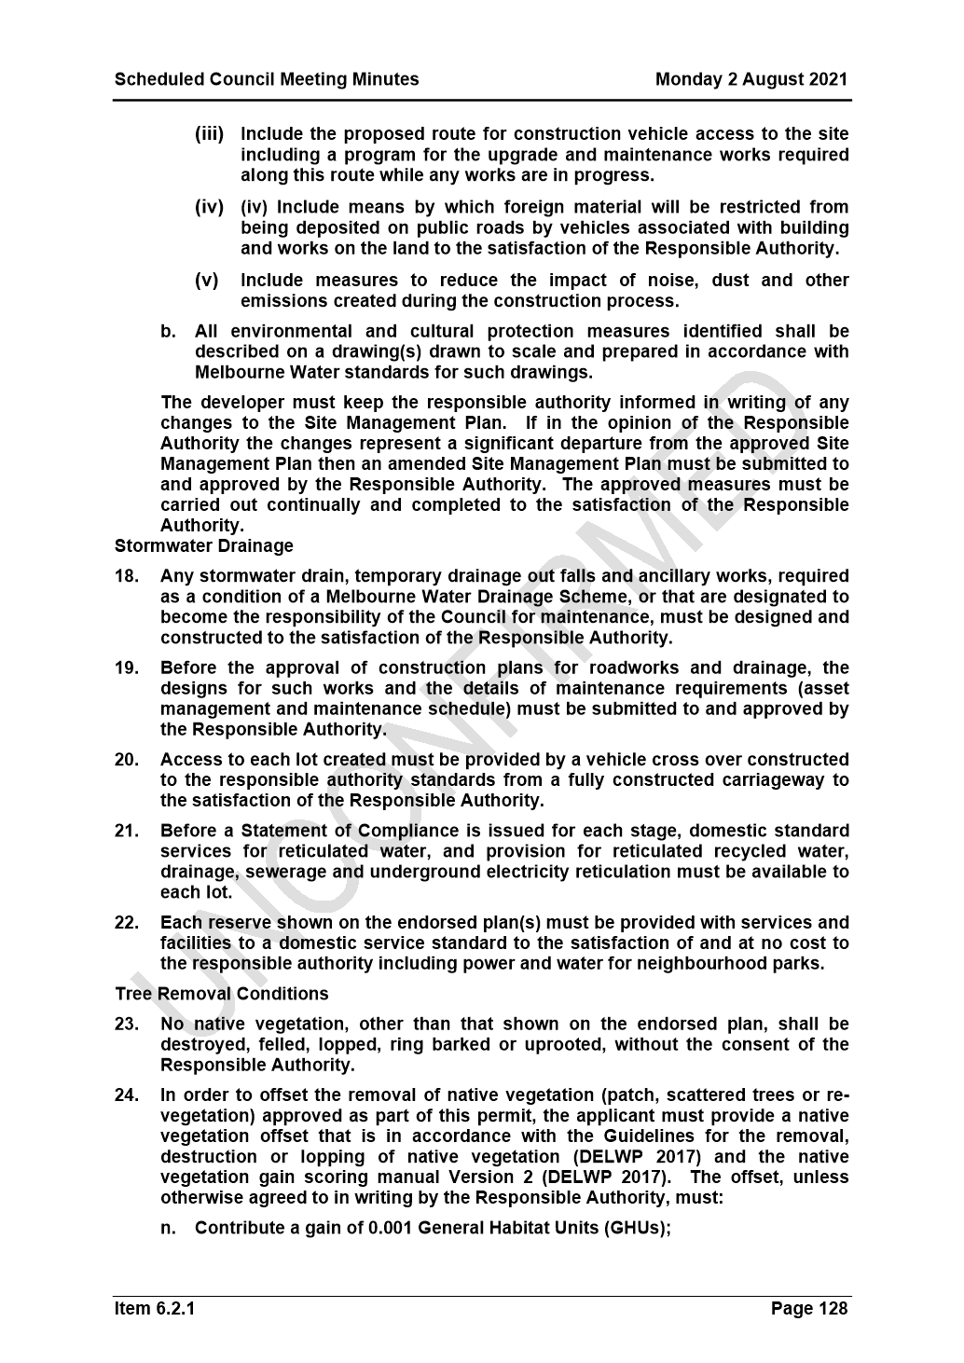

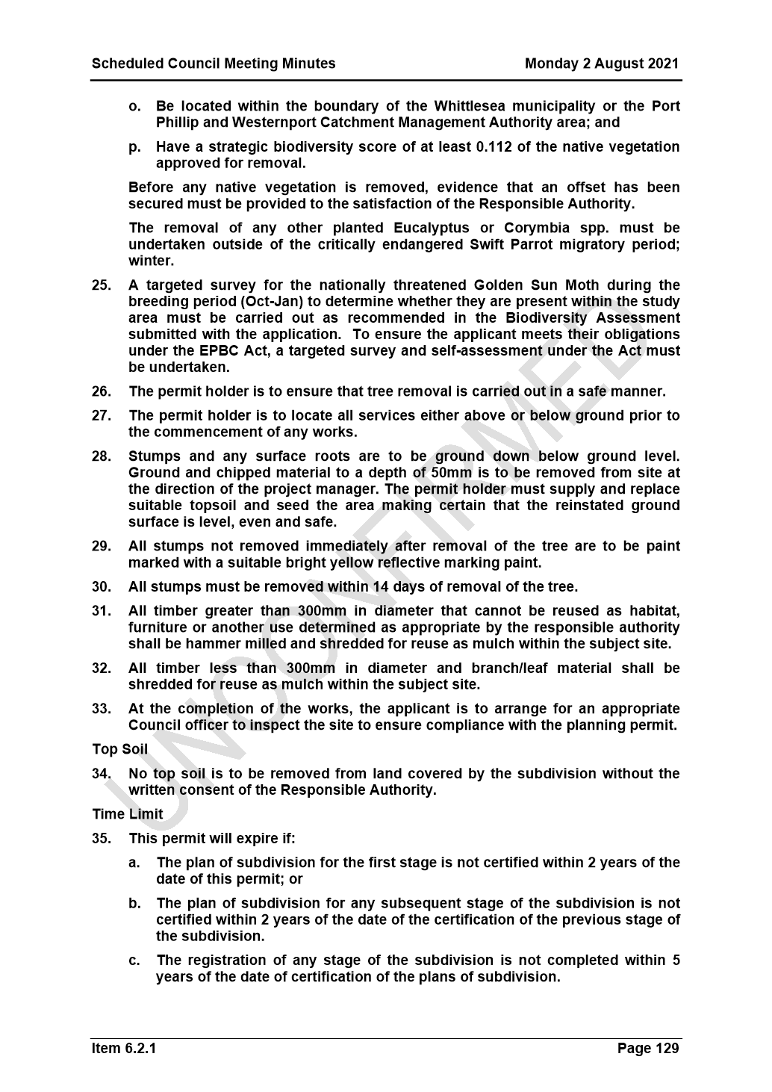

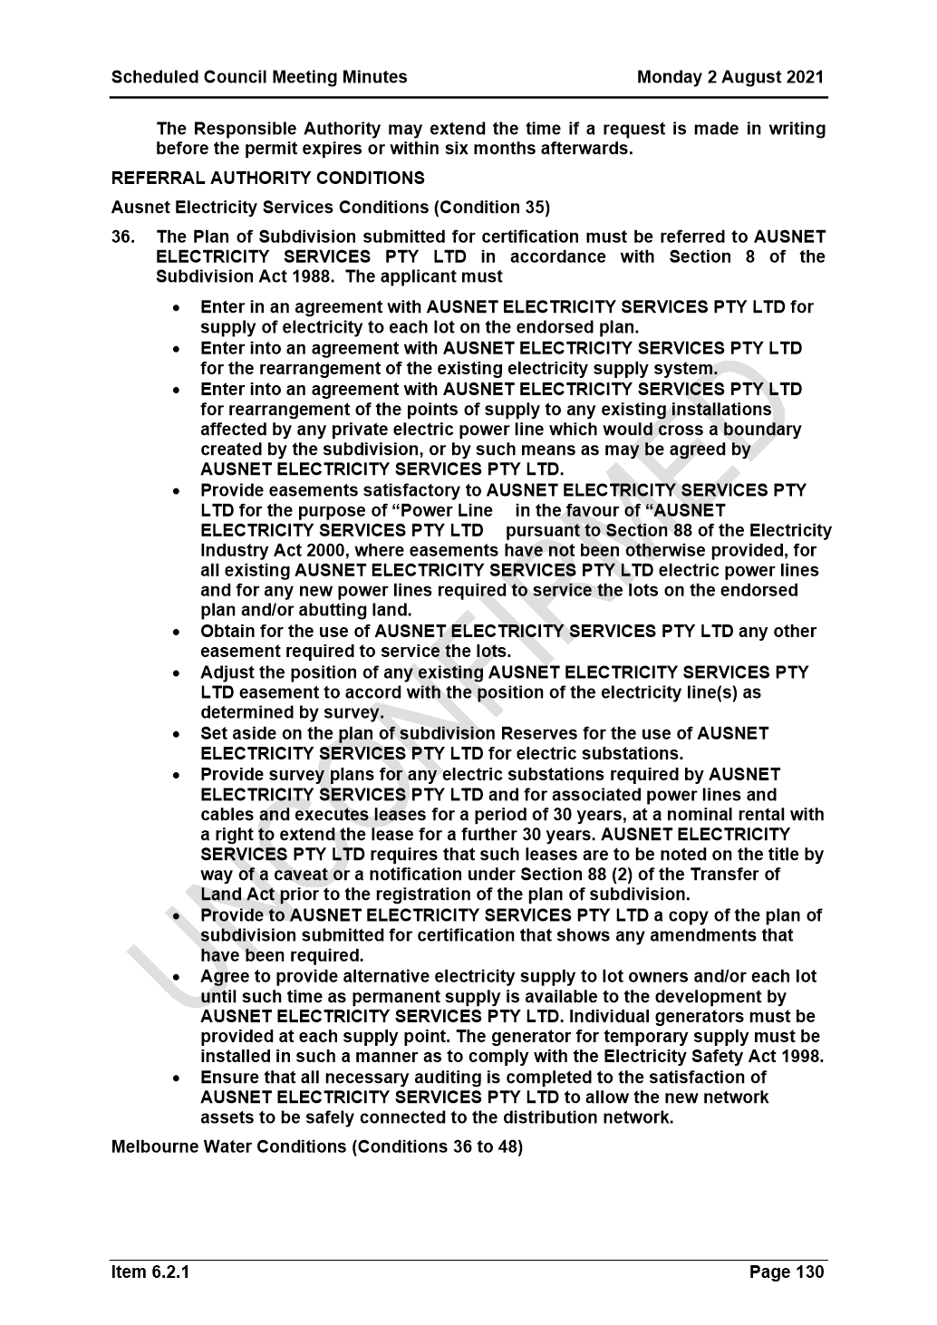

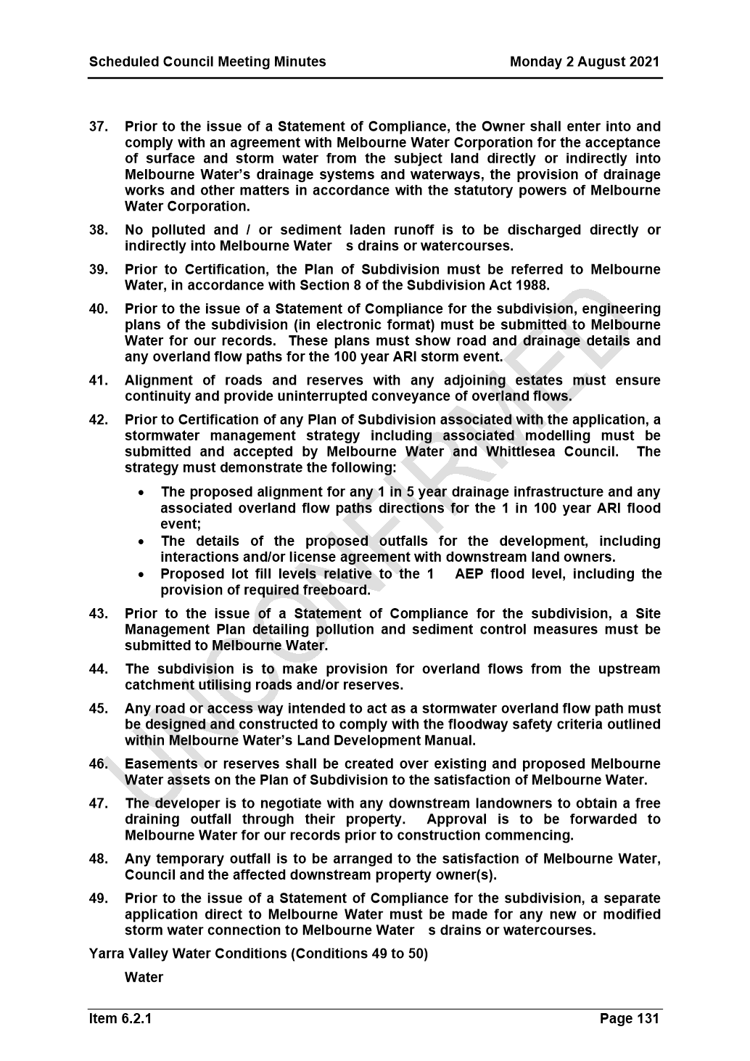

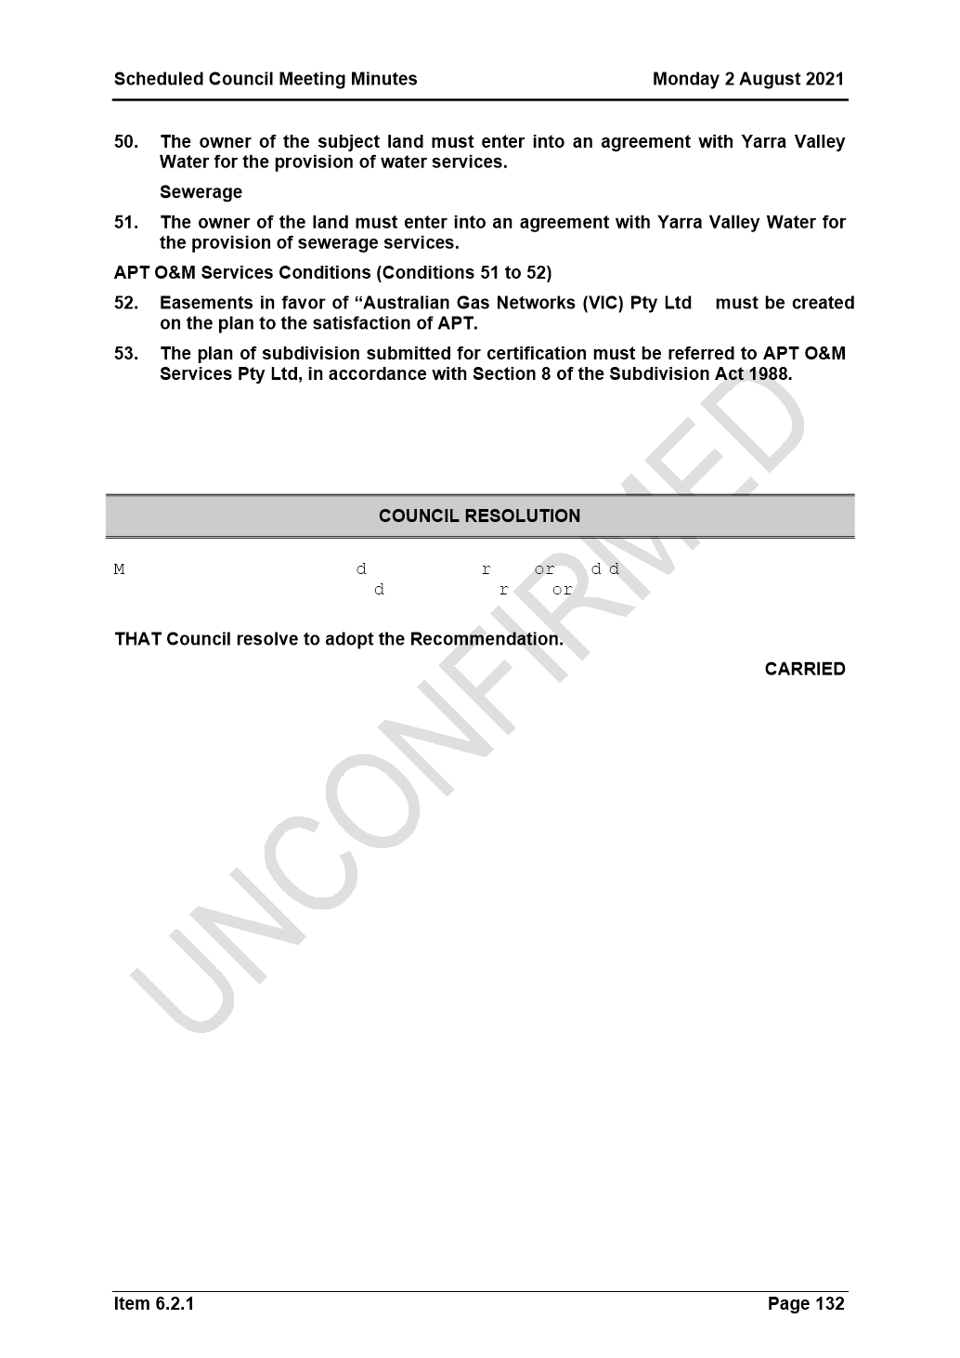

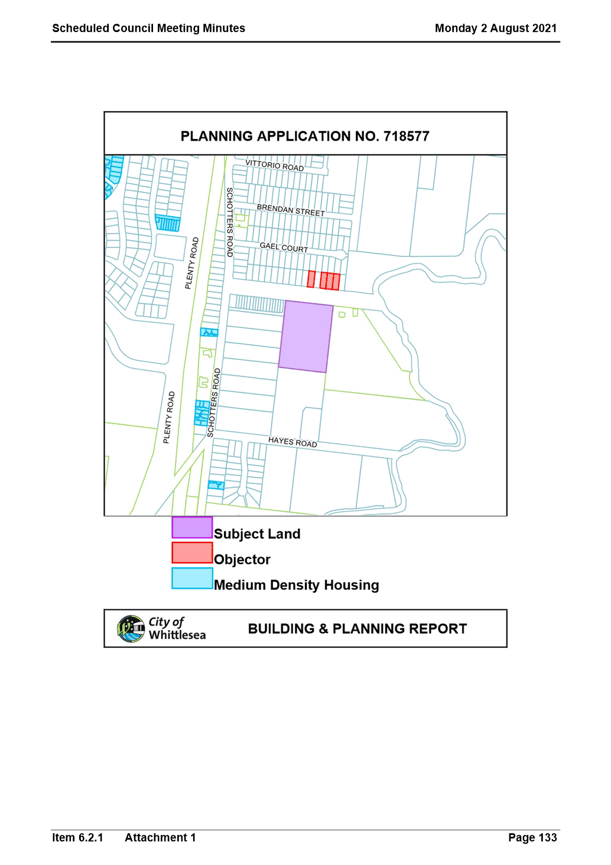

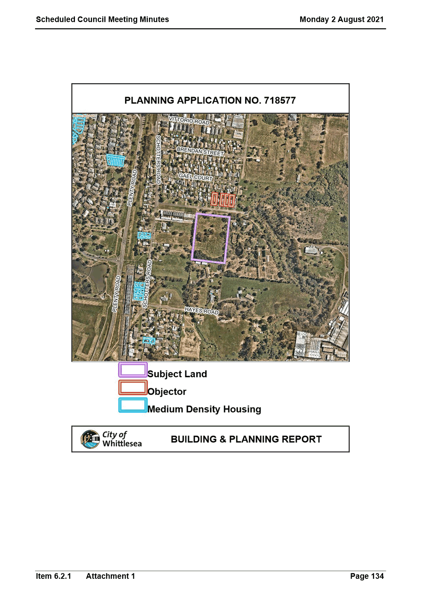
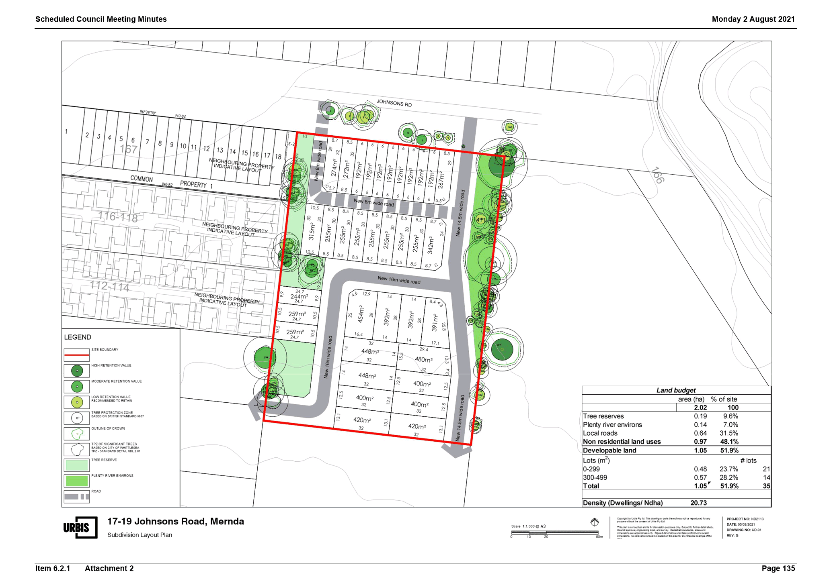

ITEM 6.5.2 Administrator Action Plan - 6 month update
Attachments: 1 Administrator Action Plan 2020-2021 - September 2021 Update
2 Activities of Administrators
Responsible Officer: Chair of Council
Author: Executive Manager Governance & Strategy

recommendation summary
THAT Council resolve to note the report and Action Plan and provide a copy of it to the Minister for Local Government, Local Government Victoria and to all local Members of Parliament.
Brief overview
Council developed and endorsed the Administrator Action Plan 2020-2024 (the Action Plan) on 6 April 2021 to confirm actions and commitments to ensure continued good governance during Council’s four-year term. The Action Plan outlines priorities in line with the Community Vision, Whittlesea 2040: A place for all, and considers the Local Government Act and needs of the community in responding and recovering from the COVID 19 pandemic.
rationale for recommendation
Transparency via regular reporting to the community plays a critical role in demonstrating good governance. This report is also in line with recommendations made in the Municipal Monitor’s report tabled in Parliament on 17 March 2020.
This six-monthly update (Attachment 1) is in line with Council’s commitment to publicly report on the Action Plan twice annually and provide transparency on key strategic decisions and work undertaken by Council over the past six months to ensure good governance in the best interest of the community.
impacts of recommendation
The Action Plan will evolve and adapt according to community feedback, including reflecting priorities as outlined in the Community Plan 2021-2025 once it is finalised.
what measures will be put in place to manage impacts
Monitoring and reviewing the Administrator Action Plan will occur every six months.

Report
Background
Ms Lydia Wilson was appointed by the Minister for Local Government to the role of Interim Administrator on 21 March 2020.
On 19 June 2020, the Panel of Administrators was appointed, with Ms Wilson appointed Chair being joined by the Hon Bruce Billson and Ms Peita Duncan. Mr Chris Eddy was appointed Administrator effective 12 May 2021 following the resignation of the Hon Bruce Billson on 5 March 2021. Ms Lydia Wilson, Ms Peita Duncan and Mr Chris Eddy will undertake the duties of the Council of the City of Whittlesea until the October 2024 Local Government Election.
An initial six-month report on the governance arrangements under Administrators was tabled at the Council Meeting held on 6 October 2020. On 6 April 2021 a 12-month report was tabled which included the Administrator Action Plan. (Attachment 1).
A key emphasis throughout this period has been embedding good governance at the City of Whittlesea as recommended in the Municipal Monitor’s report tabled in Parliament on 17 March 2020 which recommended: “Administrators develop, implement and publicly report on an action plan to embed good governance at the Council taking into account the reform opportunities in the Local Government Bill 2019.”
The focus on good governance has included progressive implementation of the provisions of the Local Government Act 2020 and restoring stability to the organisation following a significant period of turmoil and disruption.
In addition to re-established good governance and effective decision-making, the Council has been diligent in re-building the reputation of the City of Whittlesea through community engagement, developing clear strategic directions including the draft Community Plan 2021-2025, responding to challenges associated with COVID-19 and developing and implementing the Administrator action plan, which serves as a roadmap for a successful future.
Administrator Action Plan
The Administrator Action Plan outlines the strategies and actions that have been identified to ensure good governance at the City of Whittlesea through to October 2024.
The actions are outlined under the five priority areas of the Council Plan and Community Vision, Whittlesea2040: A place for all together with the additional priorities of Good Governance/Effective Implementation of the Local Government Act 2020 and Covid Response and Recovery as outlined below:
1. Good Governance/Effective implementation of LG Act 2020
2. COVID19 Response and Recovery
3. Connected Communities
4. Liveable Neighbourhoods
5. Strong Local Economy
6. Sustainable Environment.
7. High Performing Organisation
The Plan provides a status update of the key actions over the past six months including a few highlights as outlined below:
- Development of the Draft Whittlesea Community Plan 2021-2025 (integrating the Public Health and Wellbeing Plan, Disability Action Plan and Pandemic Recovery Plan) for Community consultation.
- Adoption of the 2021/22 budget and a new best practice Financial Hardship policy.
- Adoption of revised Governance Rules 2021 enabling increased community participation at Council meetings.
- Community Council meetings quarterly preceded by Community Forum (pending Government restrictions).
- Supported the establishment of a purpose-built Aboriginal Gathering Place at Quarry Hills Park
- A range of initiatives to improve customer service and responsiveness including a new Customer First Program.
- Endorsement of a co-designed $2 million Pandemic Recovery Fund to support our community to respond and recover from COVID-19.
- Significant funding and support to assist businesses in response to COVID-19.
- Inaugural Community Awards Committee endorsed and nominations opened.
- Inaugural Business Advisory Panel endorsed.
- Online and in person citizenship ceremonies held resulting in approximately 450 conferees in total new citizens.
- Key strategies and plans adopted including: Whittlesea township strategy, Road Management Plan, Investment Attraction Plan, Greening Whittlesea Strategy, draft Domestic Animal Management Plan and the Rethinking Waste Plan.
- Significant community engagement activities as captured in Attachment 2.
- Participation in the Audit and Risk Committee with oversight of major internal and external audits, policy review and annual financial and performance statements.
- Completion of multiple major infrastructure projects including Mill Park All Abilities Play Space, upgrading of Mill Park Leisure Centre, Spring Street Kindergarten, signalisation of Findon Road/Ferres Boulevard. Design completed and construction commenced for Wollert East Community Centre.
Financial Implications
Administrators, appointed as the Council, are responsible for the financial health and wellbeing of the Council and the adoption of the annual budget. The 2021/22 Annual Budget was adopted at the 1 June 2021 Council Meeting. Highlights included $76.4 million for capital works programs, $1.5 million for Community Plan initiatives (to be determined following Community Consultation on the Community Plan) in addition to the $2 million COVID-19 Community Recovery Fund.
Consultation
Administrators have undertaken significant consultation over the past six months, through face to face and virtual means. Attachment 2: Activities of Administrators details the significant engagement with Community. The Administrators consulted together and with Council’s Executive Leadership Team to prepare this report and update the Action Plan.
Policy strategy and legislation
The Panel of Administrators were appointed under the provisions of the Local Government (Whittlesea City Council) Act 2020 by the Minister for Local Government.
The Chair of the Panel of Administrators takes on the role functions and duties of the Mayor and the Administrators take on the roles, duties and functions of a Councillor. Together the Panel of Administrators form the Council of the City of Whittlesea.
The laws regulations, policies and procedures that apply to the Council and to Councillors also apply to Administrators.
link to strategic risks
Strategic Risk Governance - Ineffective governance of Council’s operations and activities resulting in either a legislative or policy breach
The Panel of Administrators have been put in place to ensure good governance a the City of Whittlesea as Council under the Local Government Act.
Links to whittlesea 2040 and the CoUNCIL Plan
Goal High-performing organisation
Key Direction More informed Council decisions based on strong advice and community consultation and engagement
Declarations of Conflicts of Interest
Under Section 130 of the Local Government Act 2020 and Rule 47 of the Governance Rules 2021, officers providing advice to Council are required to disclose any conflict of interest they have in a matter and explain the nature of the conflict.
The Responsible Officer reviewing this report, having made enquiries with relevant members of staff, reports that no disclosable interests have been raised in relation to this report.
Conclusion
The past 18 months has been an exceptionally busy period for the Panel of Administrators, working as Council, with considerable demonstrated achievements. In addition to the re-establishment of good governance and effective decision-making, considerable efforts have been made to re-build the reputation of the City of Whittlesea, to engage with the community and to improve staff morale. A clear action plan and priorities for the future has been developed and is being progressively implemented in partnership with the CEO and Executive Leadership Team. Progress against this plan will continue to be publicly reported on a six-monthly basis.
Administrators will continue to be vigilant in relation to the current COVID-19 challenges and supporting COVID-19 recovery whilst enhancing their visibility in the community.

RECOMMENDATION
THAT Council resolve to note the report, and to provide a copy of the report, to the Minister for Local Government The Hon. Shaun Leane, Local Government Victoria and all local Members of Parliament as a formal record of the activities of the Panel of Administrators over the past 6 months and its Action Plan going forward.

Council Resolution
Moved: Chairperson Wilson
Seconded: Administrator Duncan

THAT Council resolve to adopt the Recommendation.
Carried

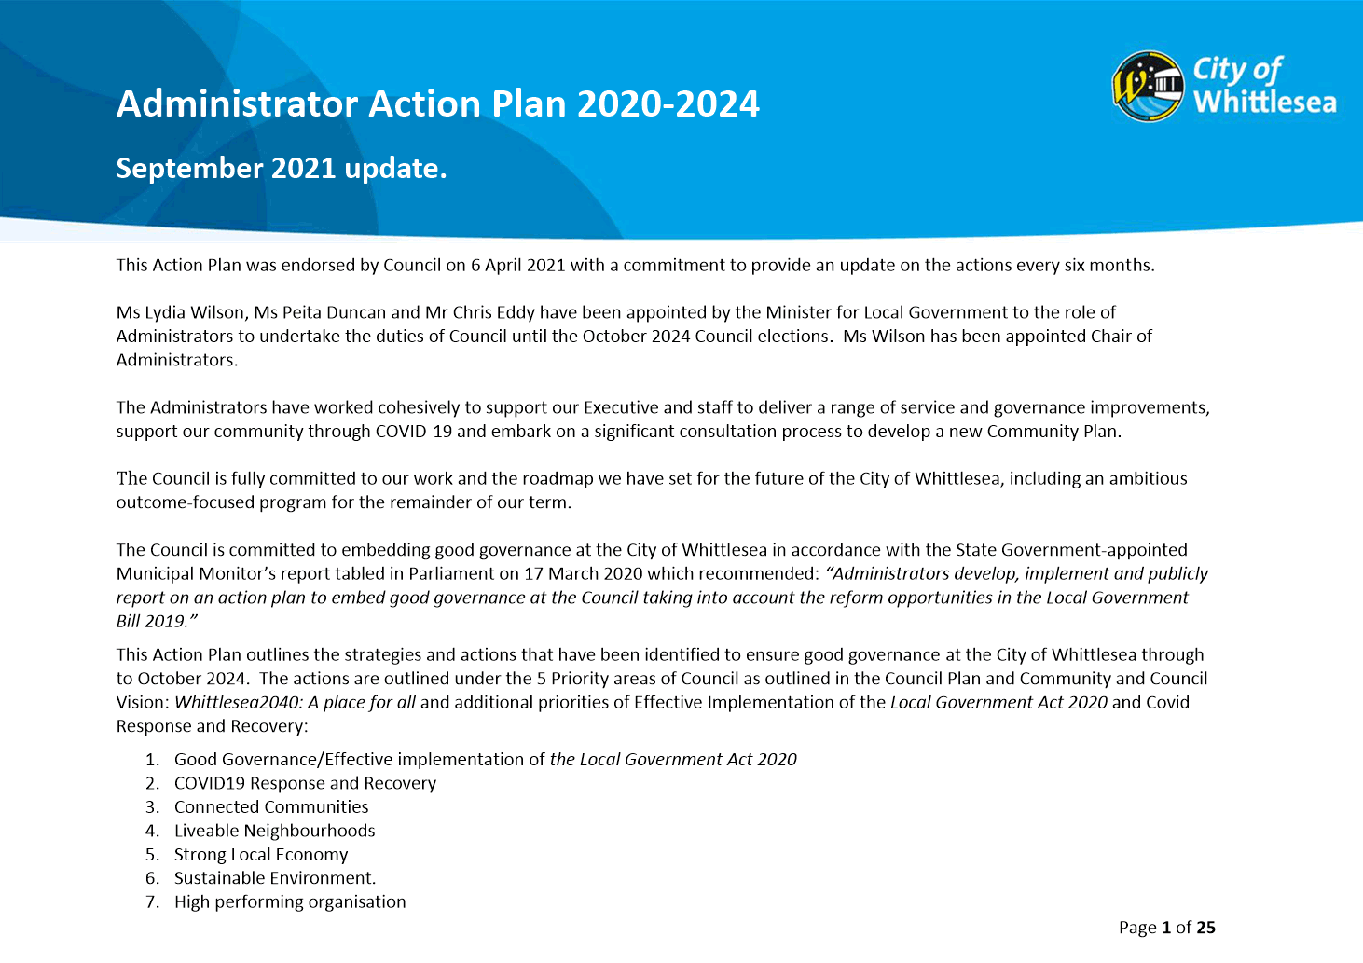
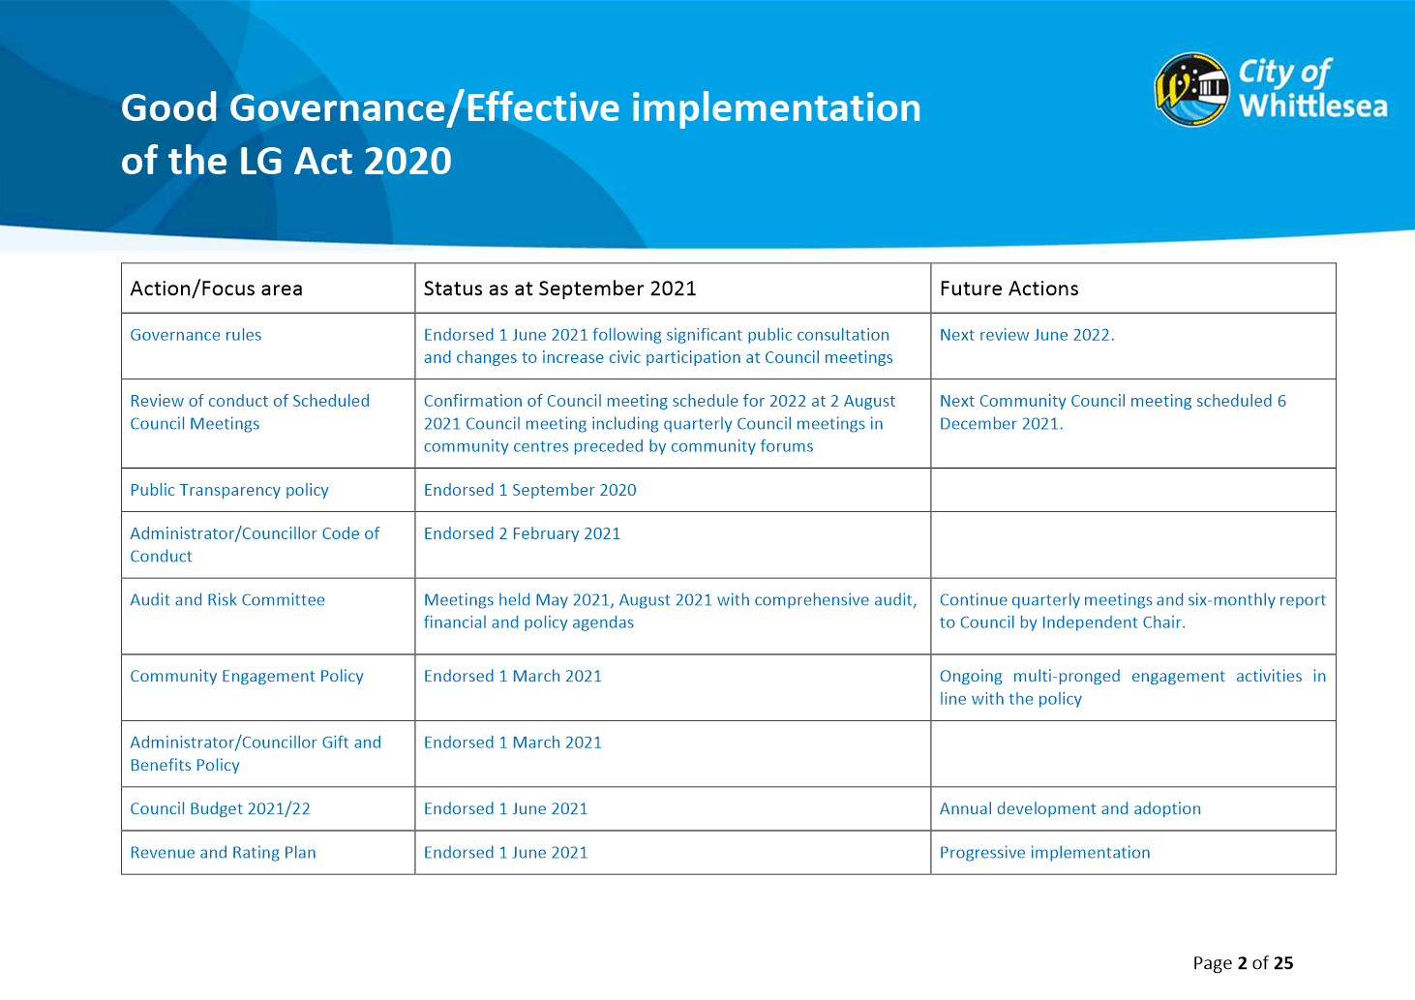

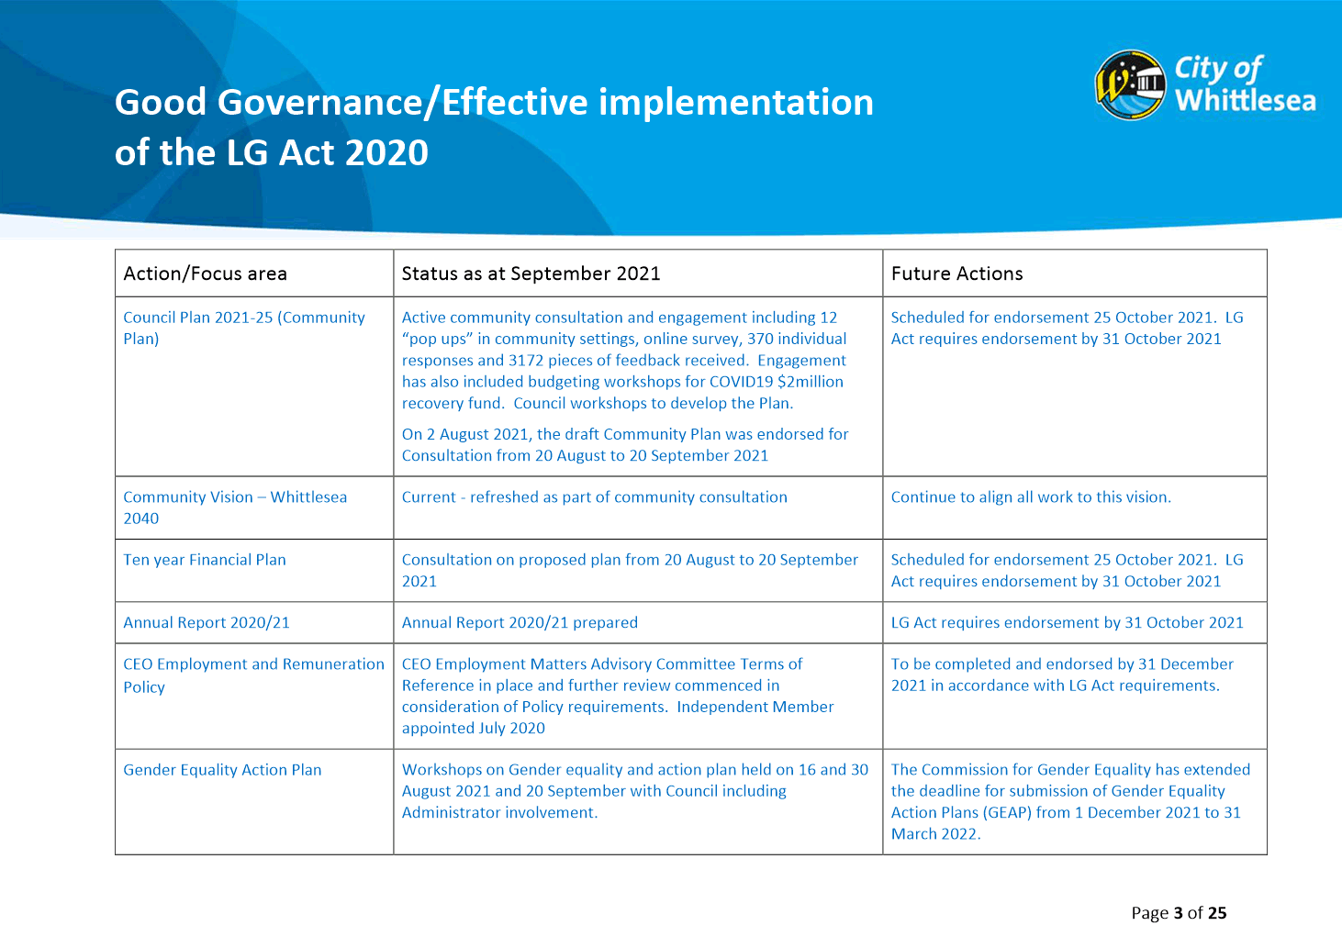

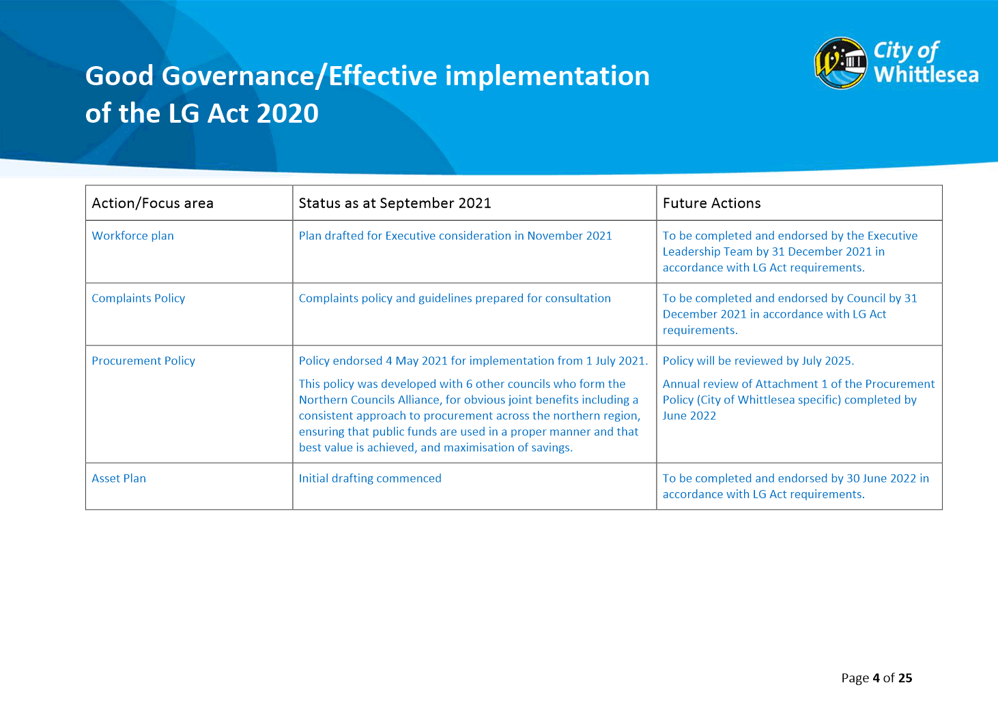

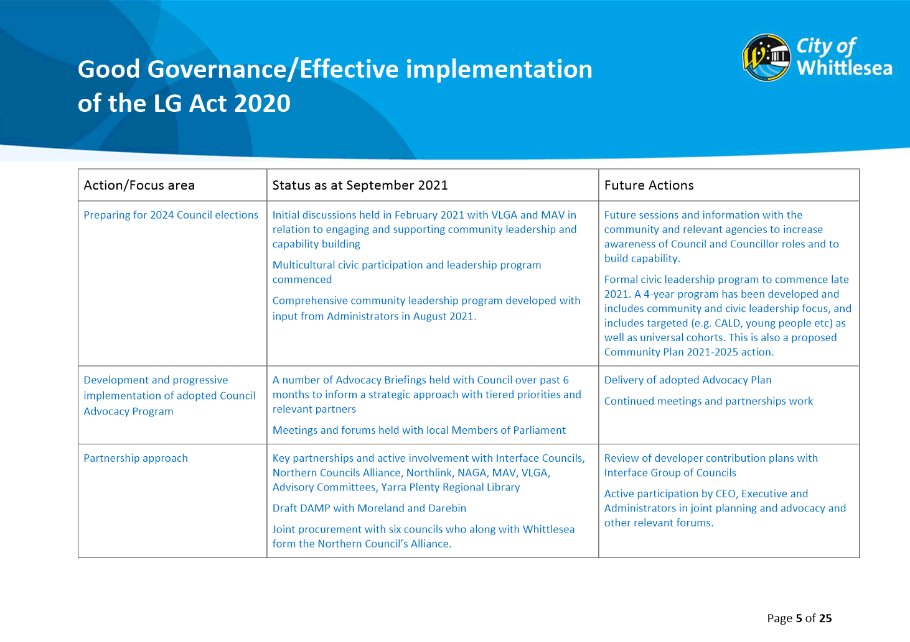

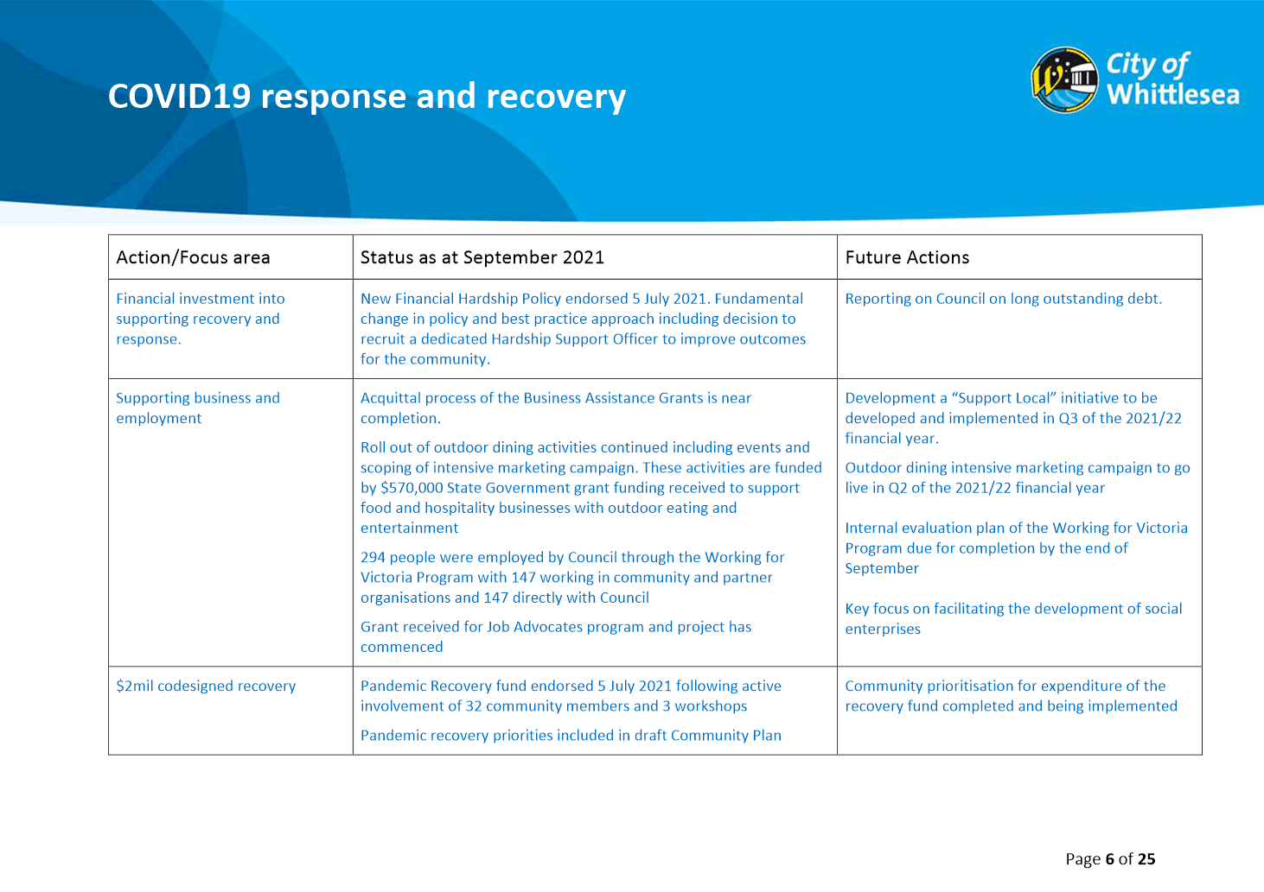

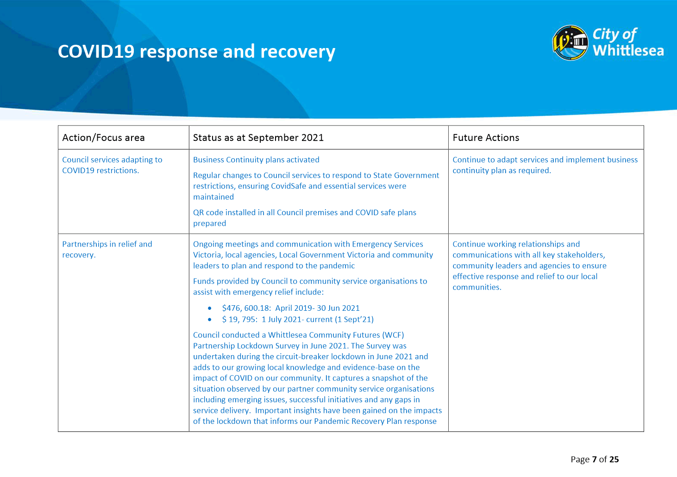

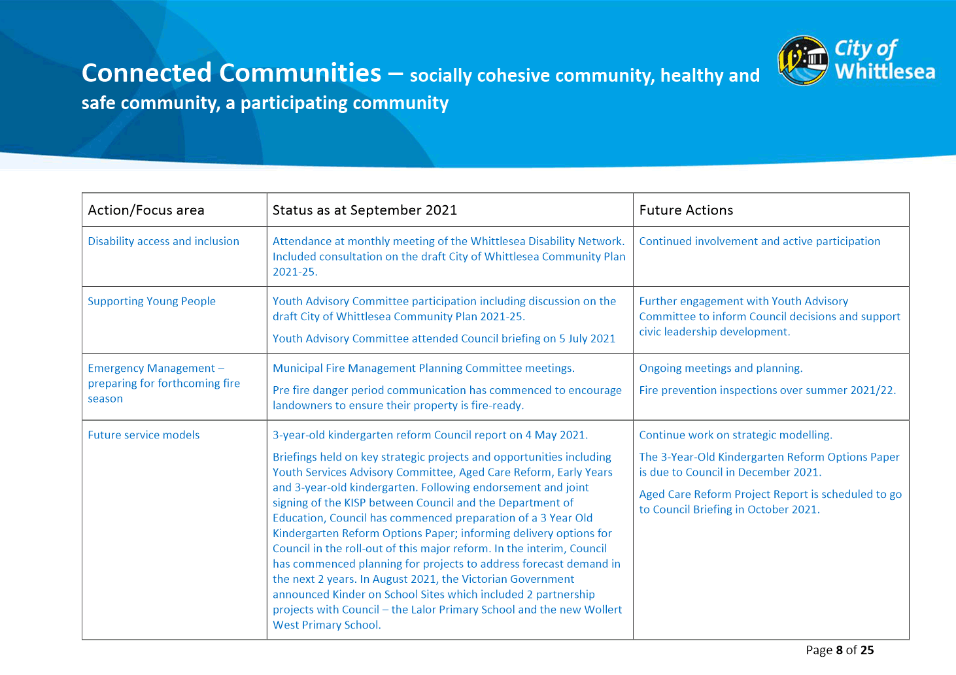

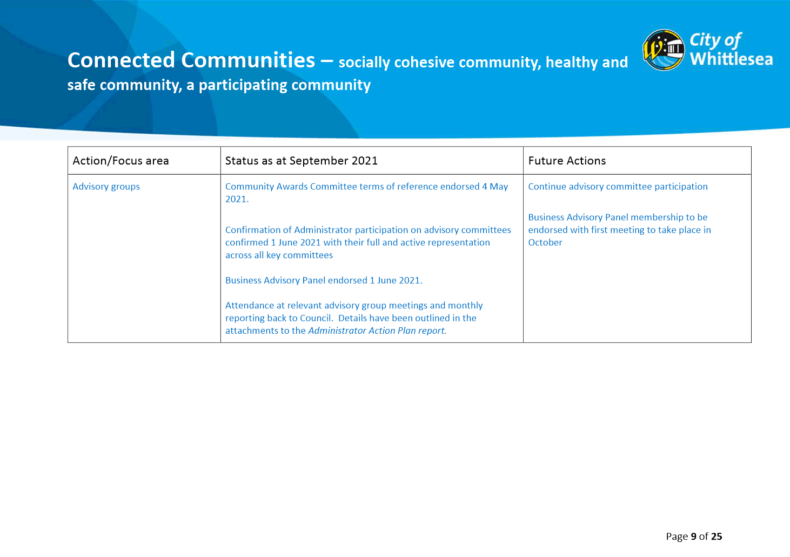

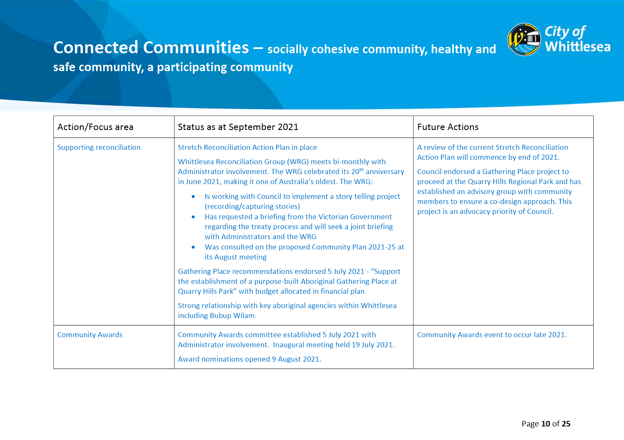

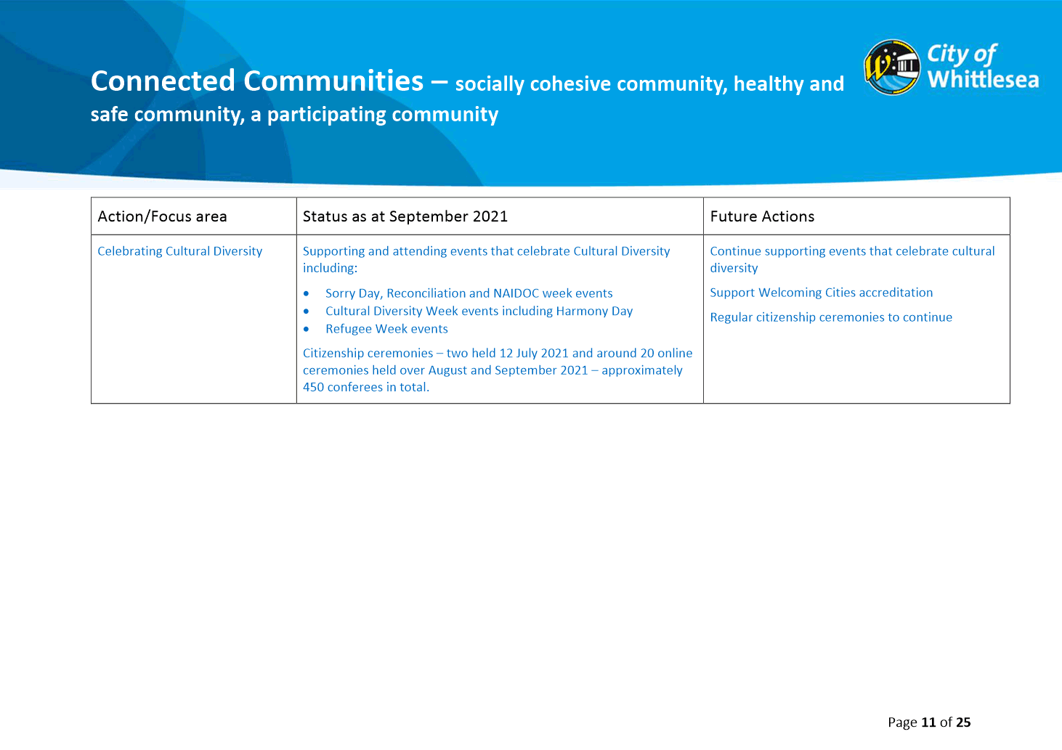

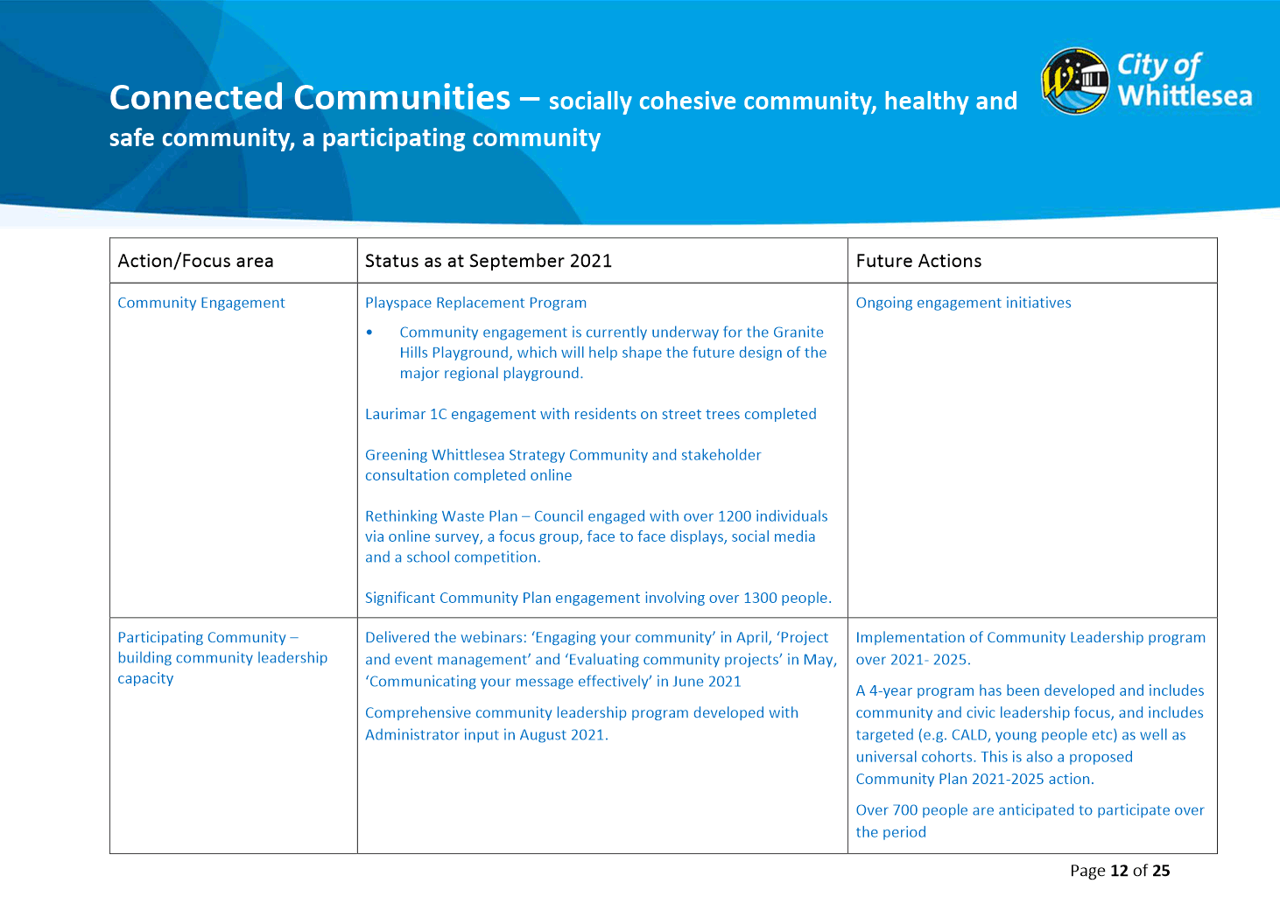

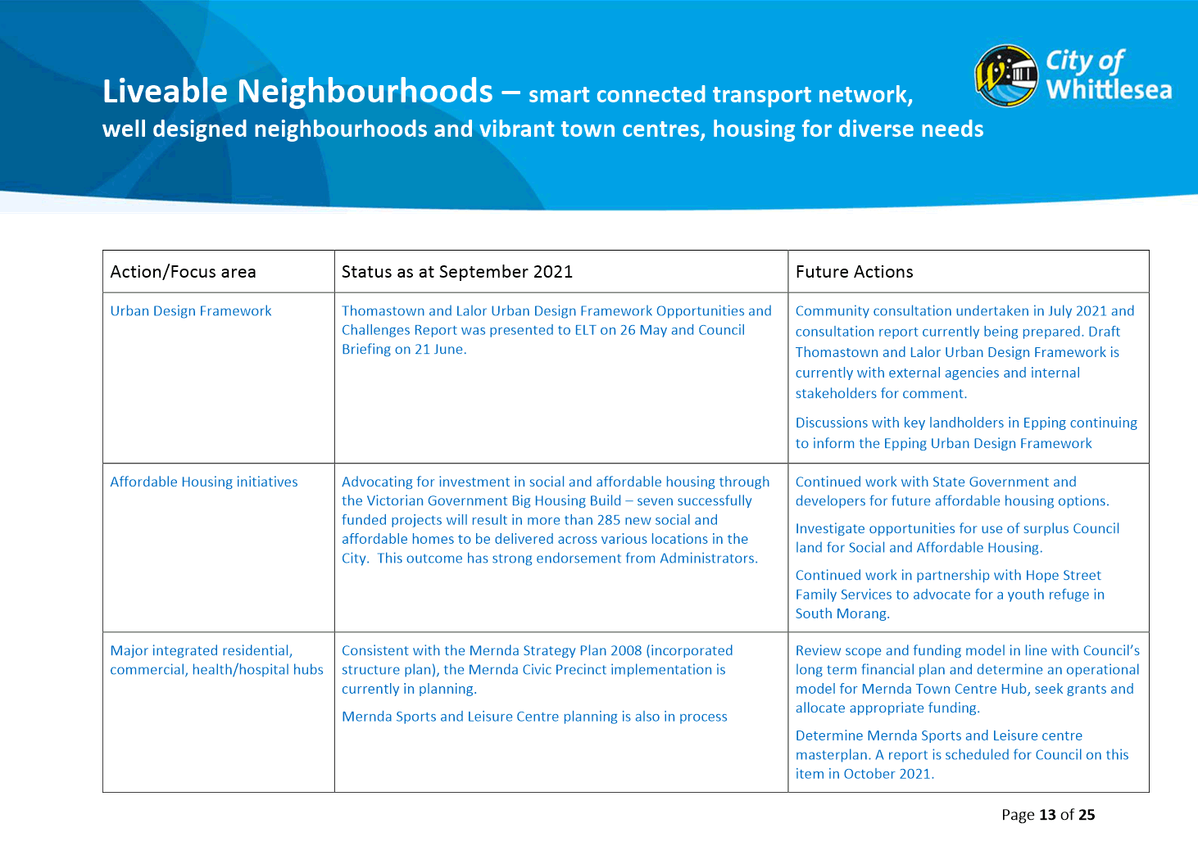

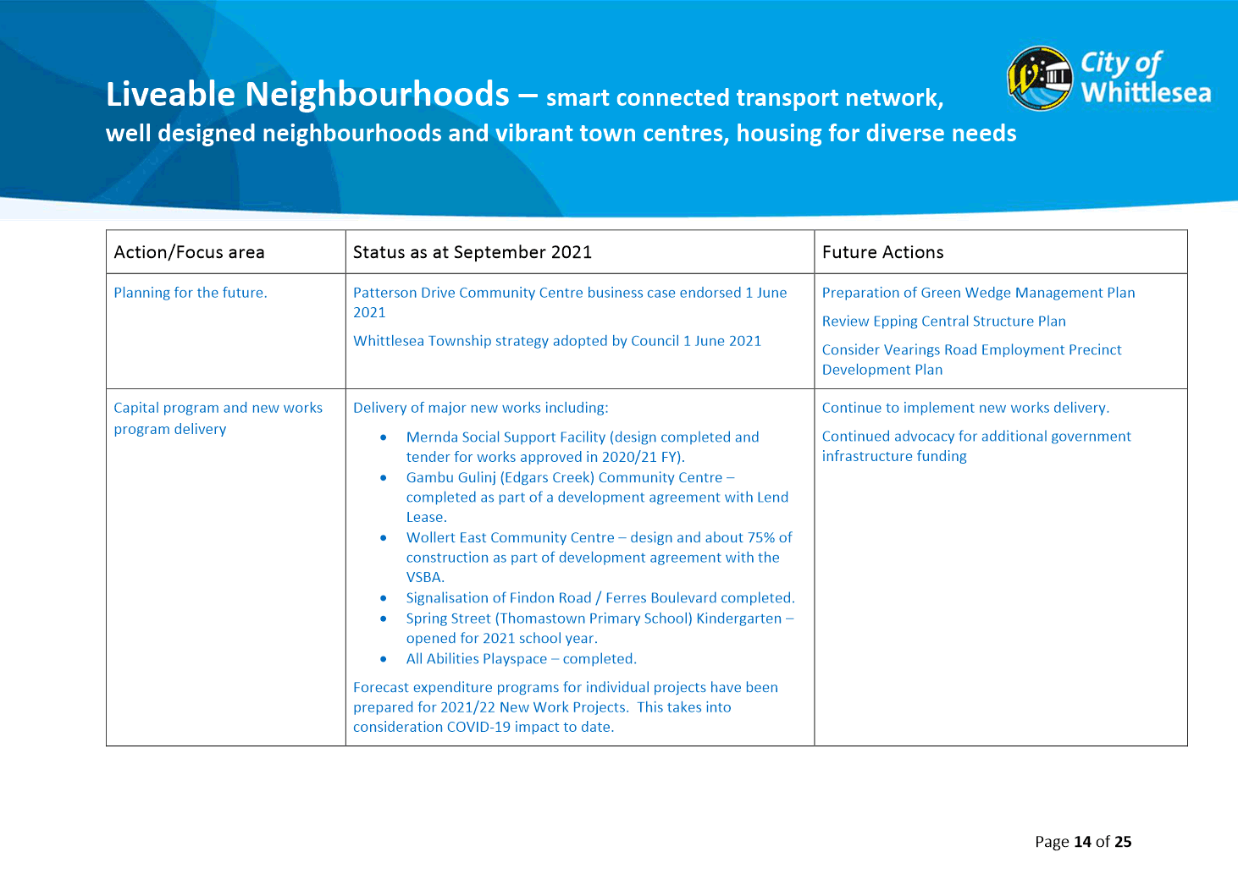

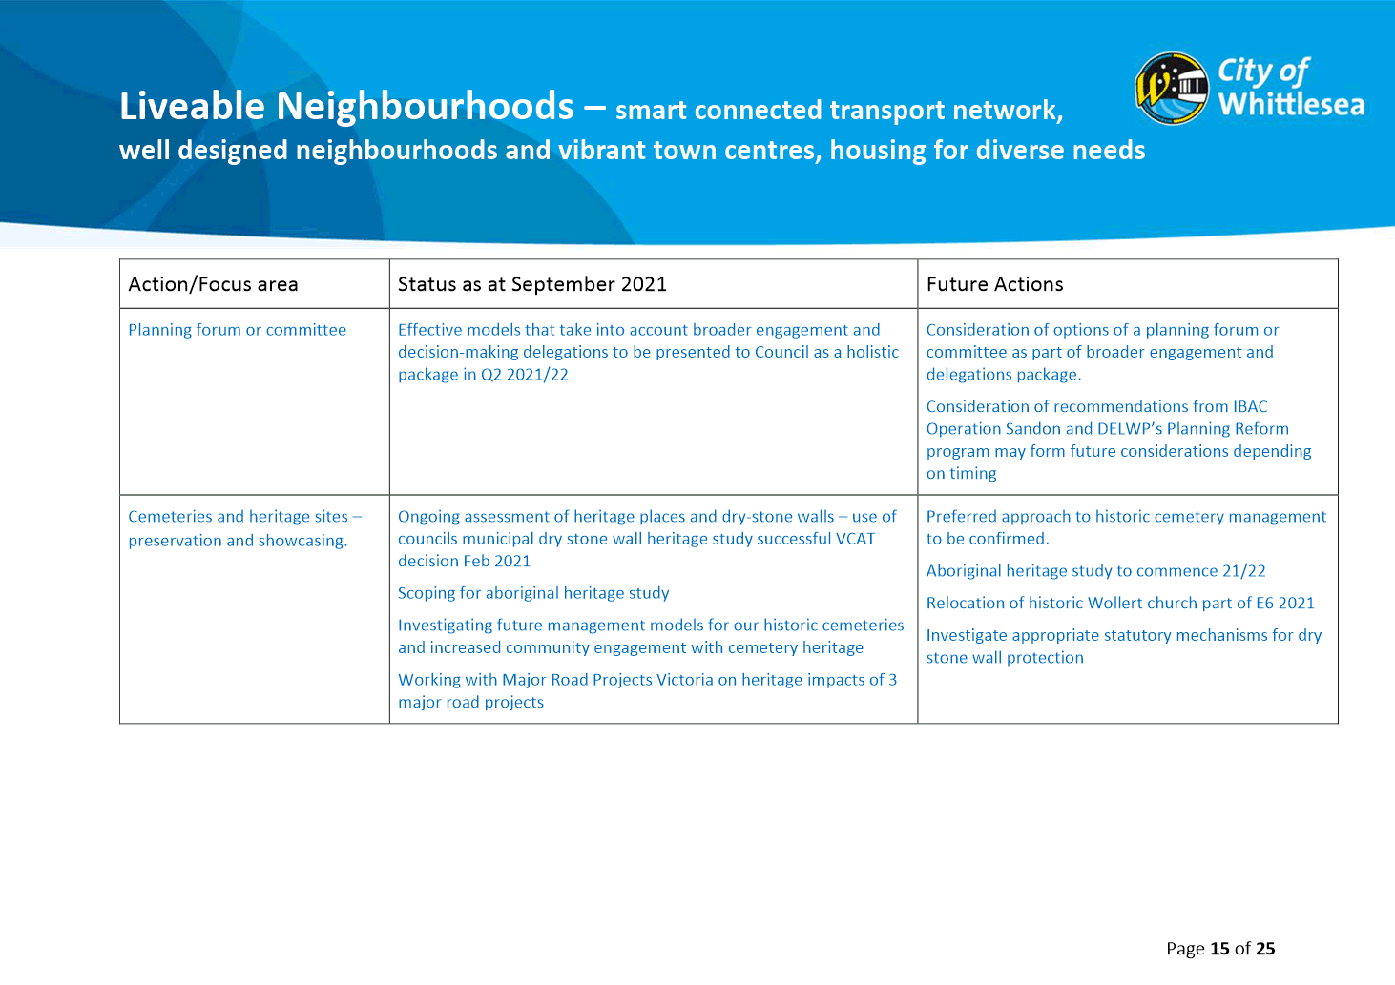

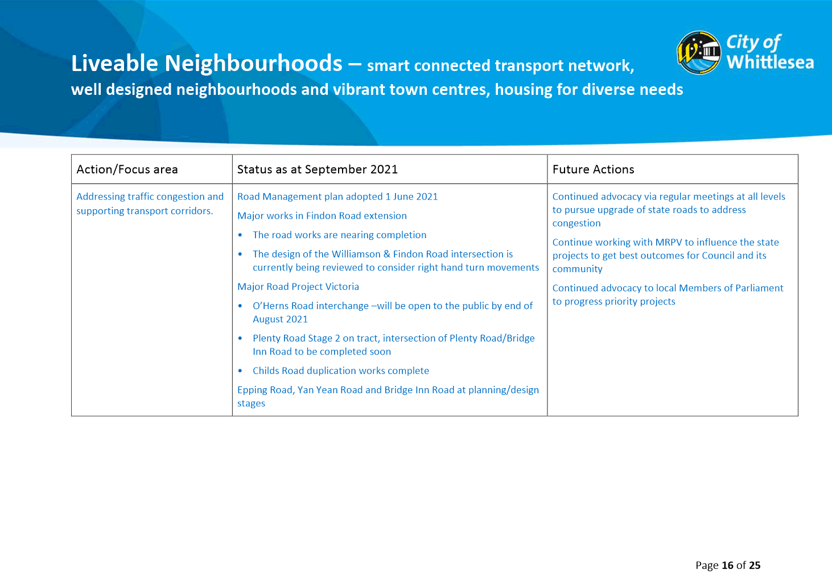

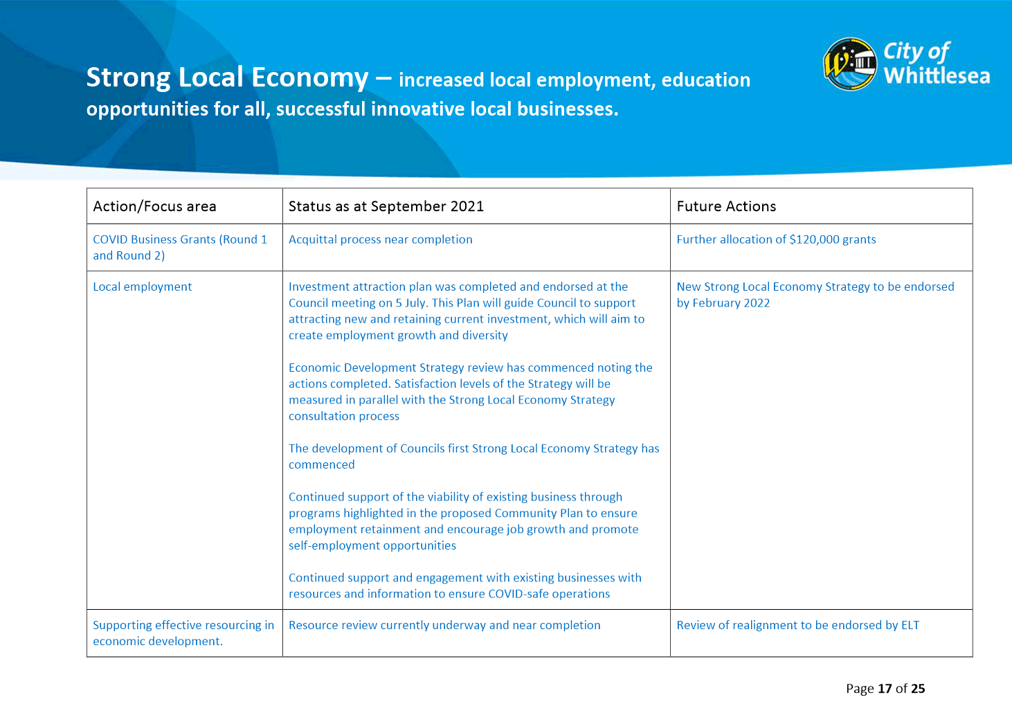

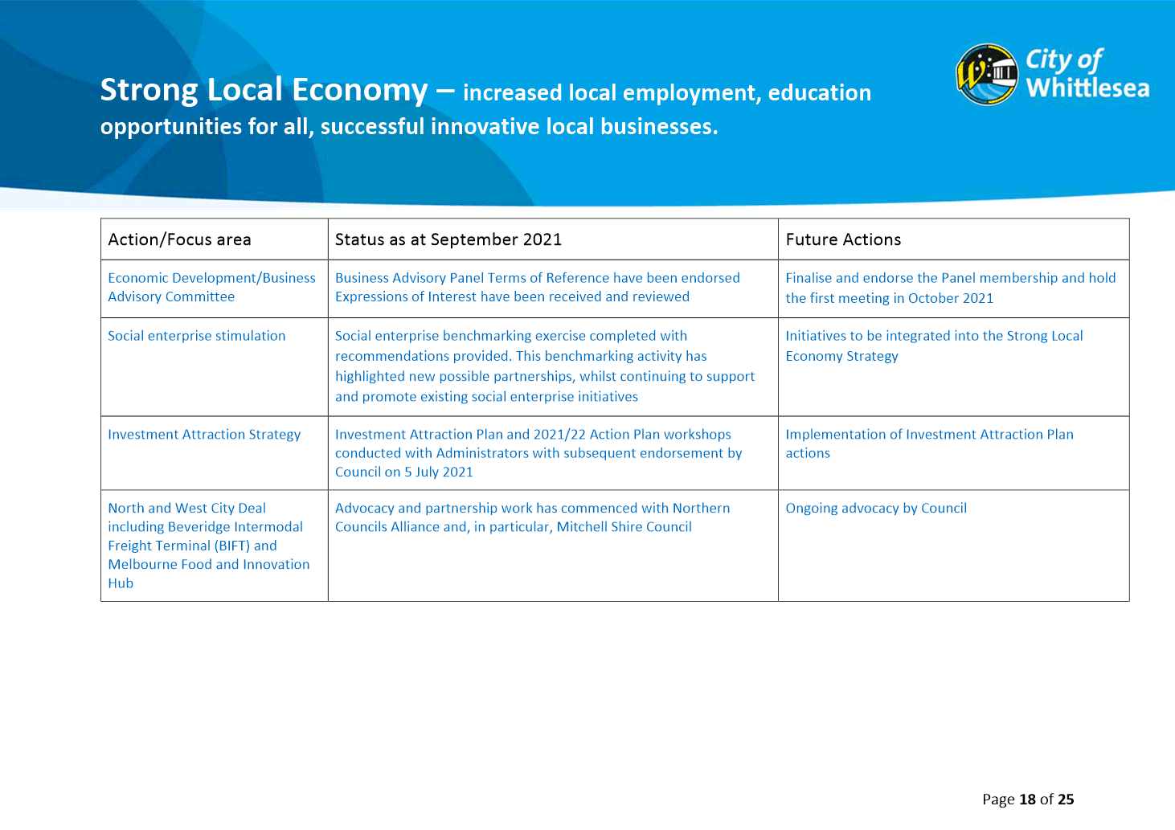

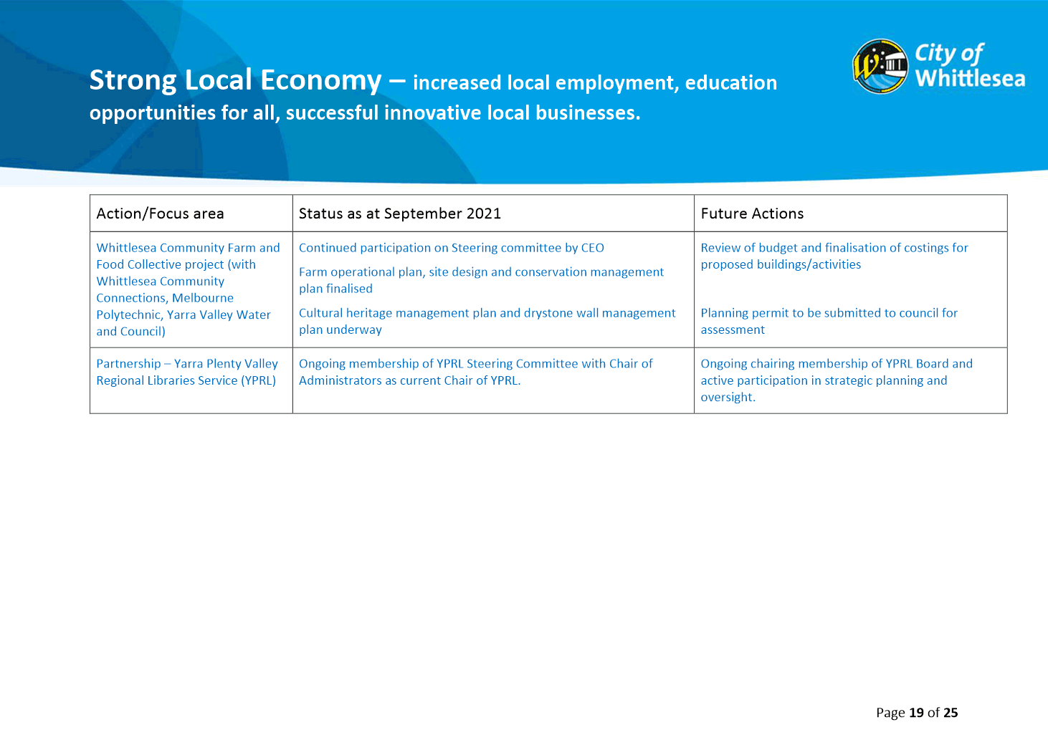

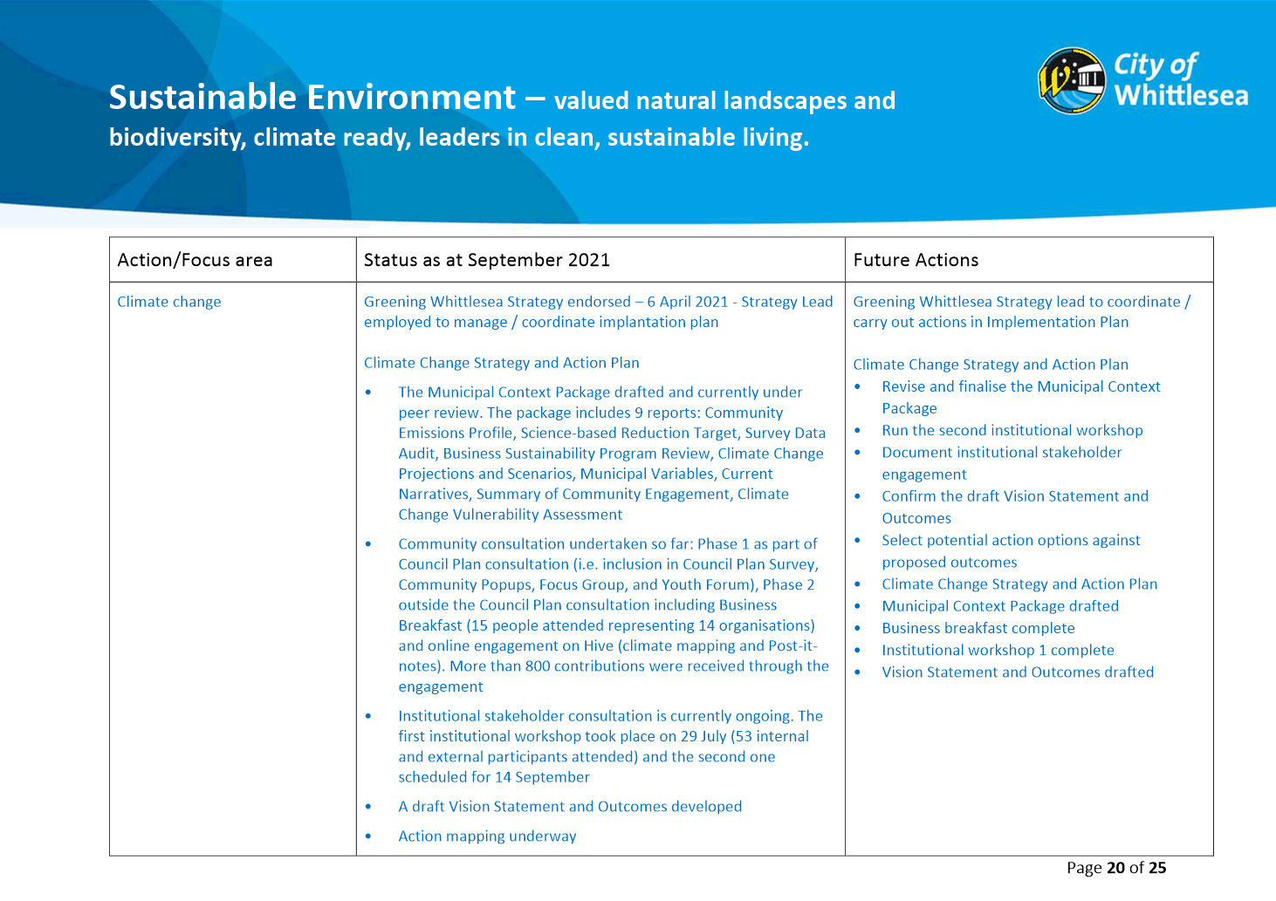

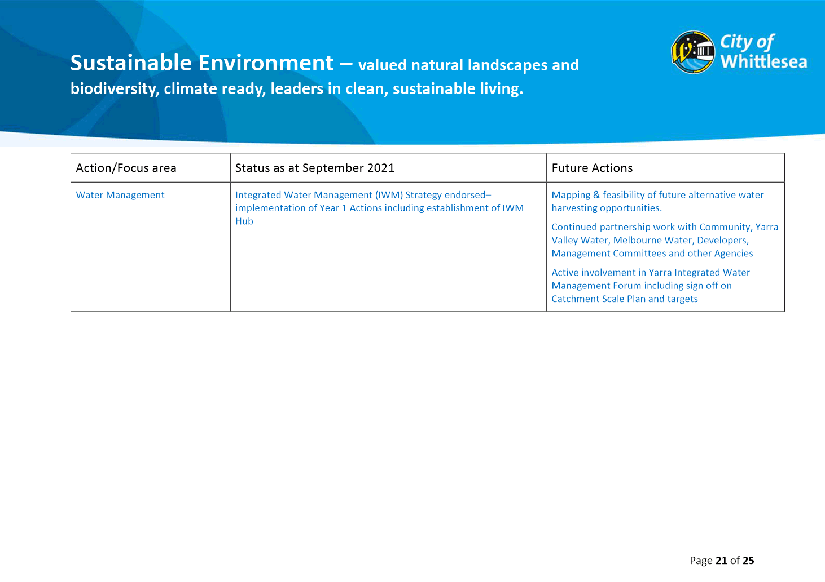

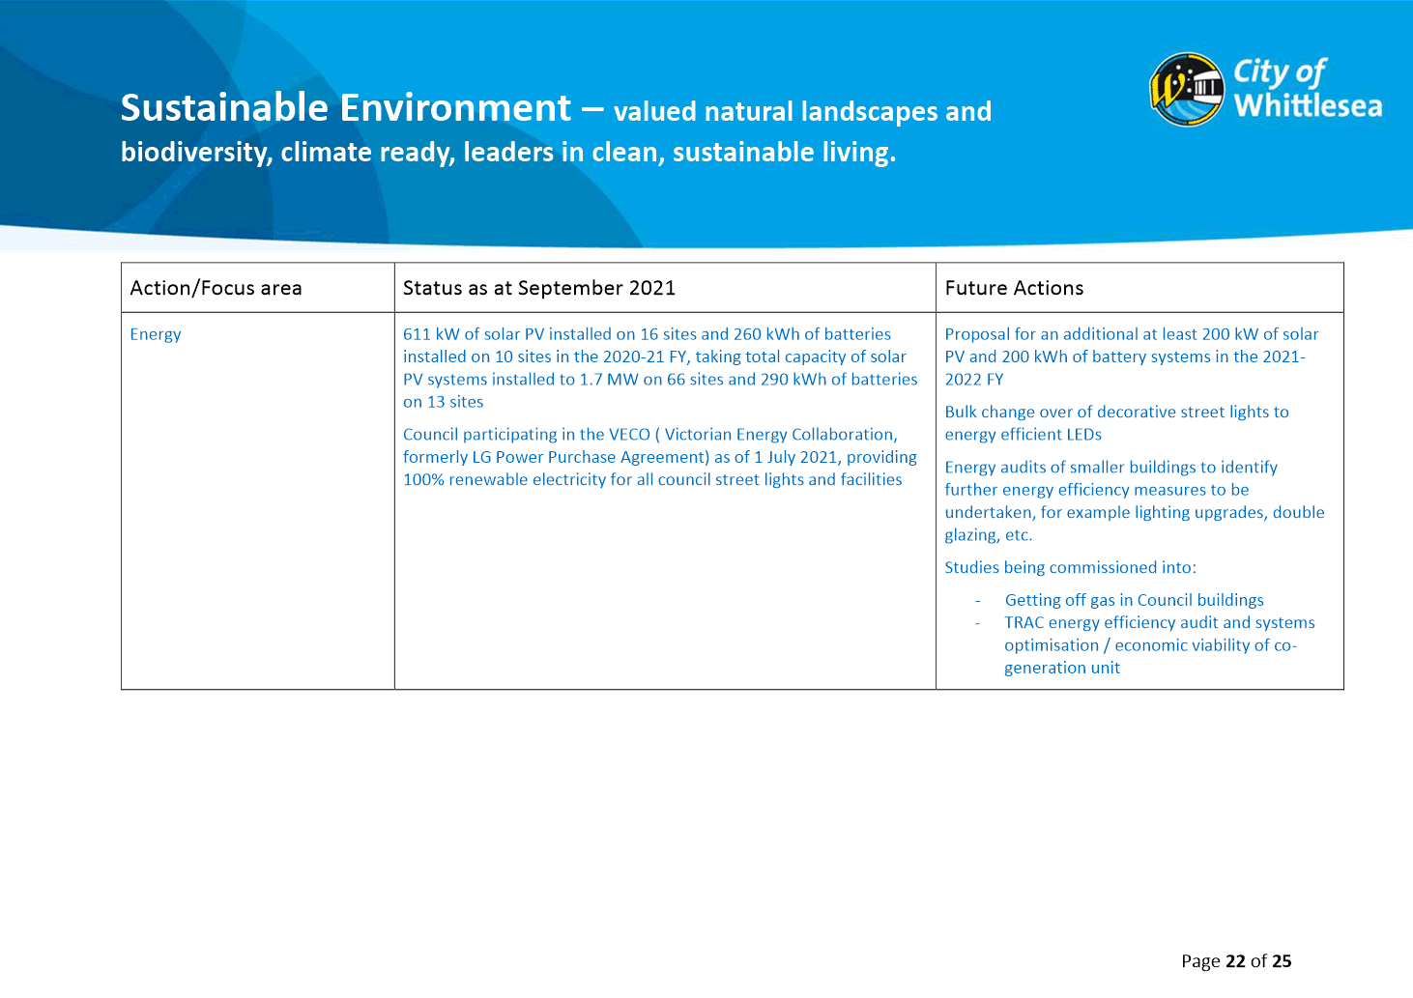

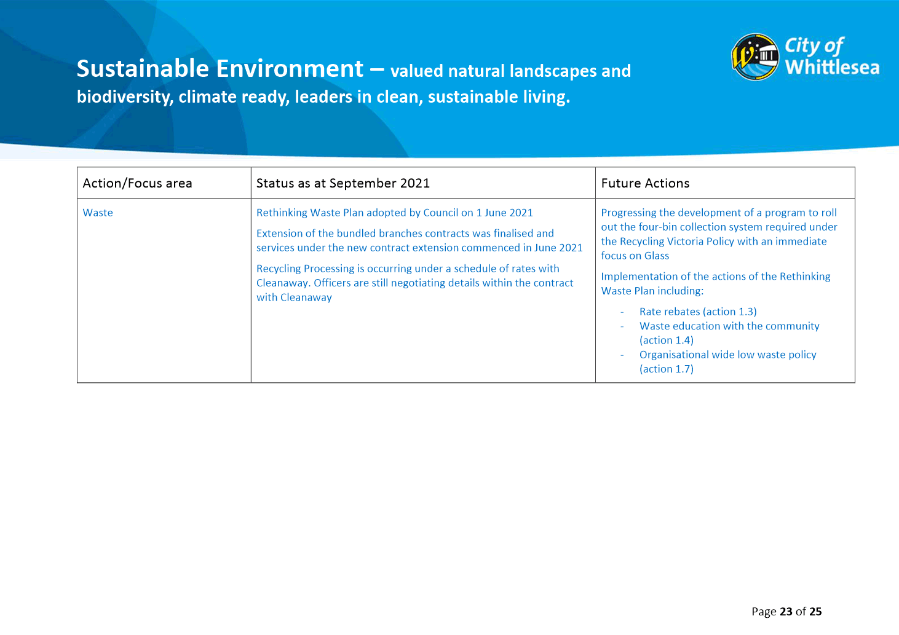

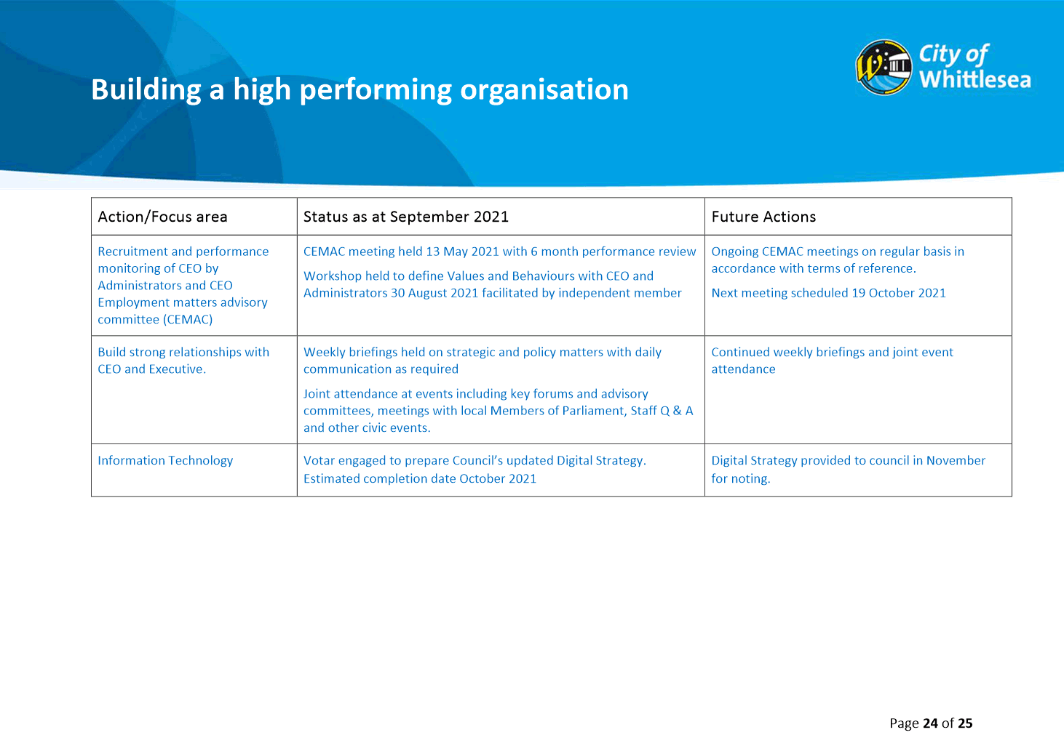

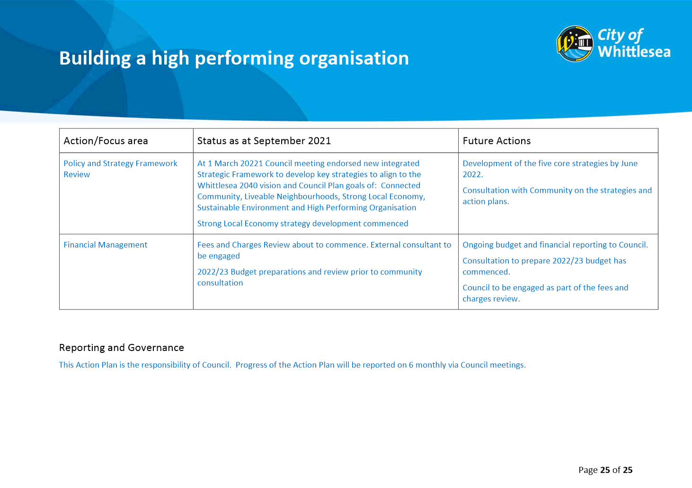

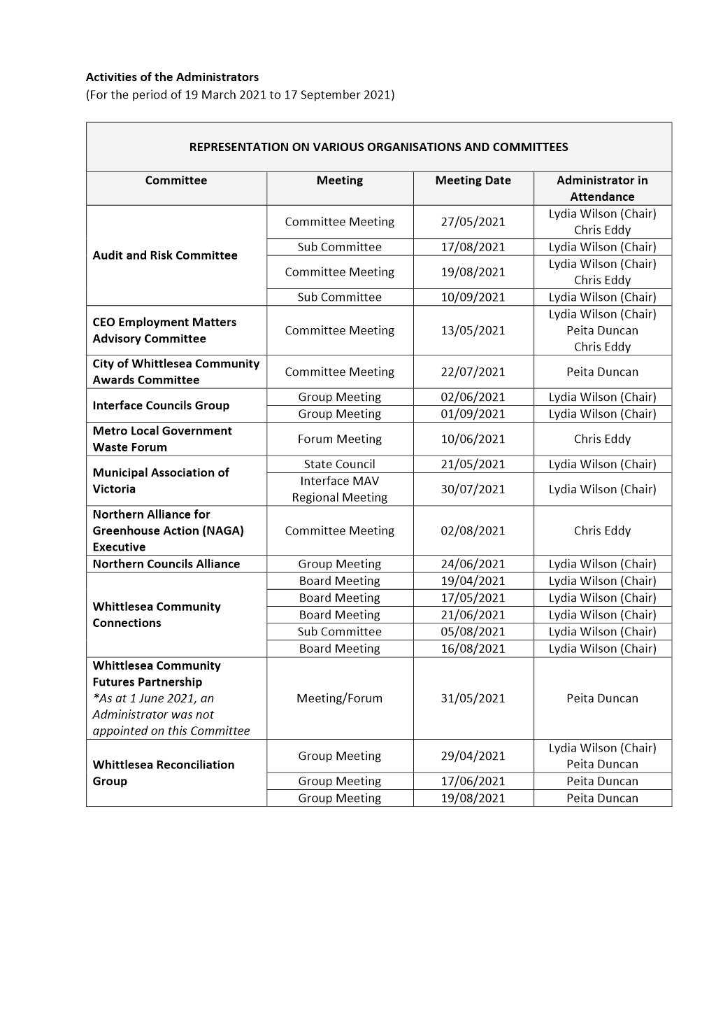

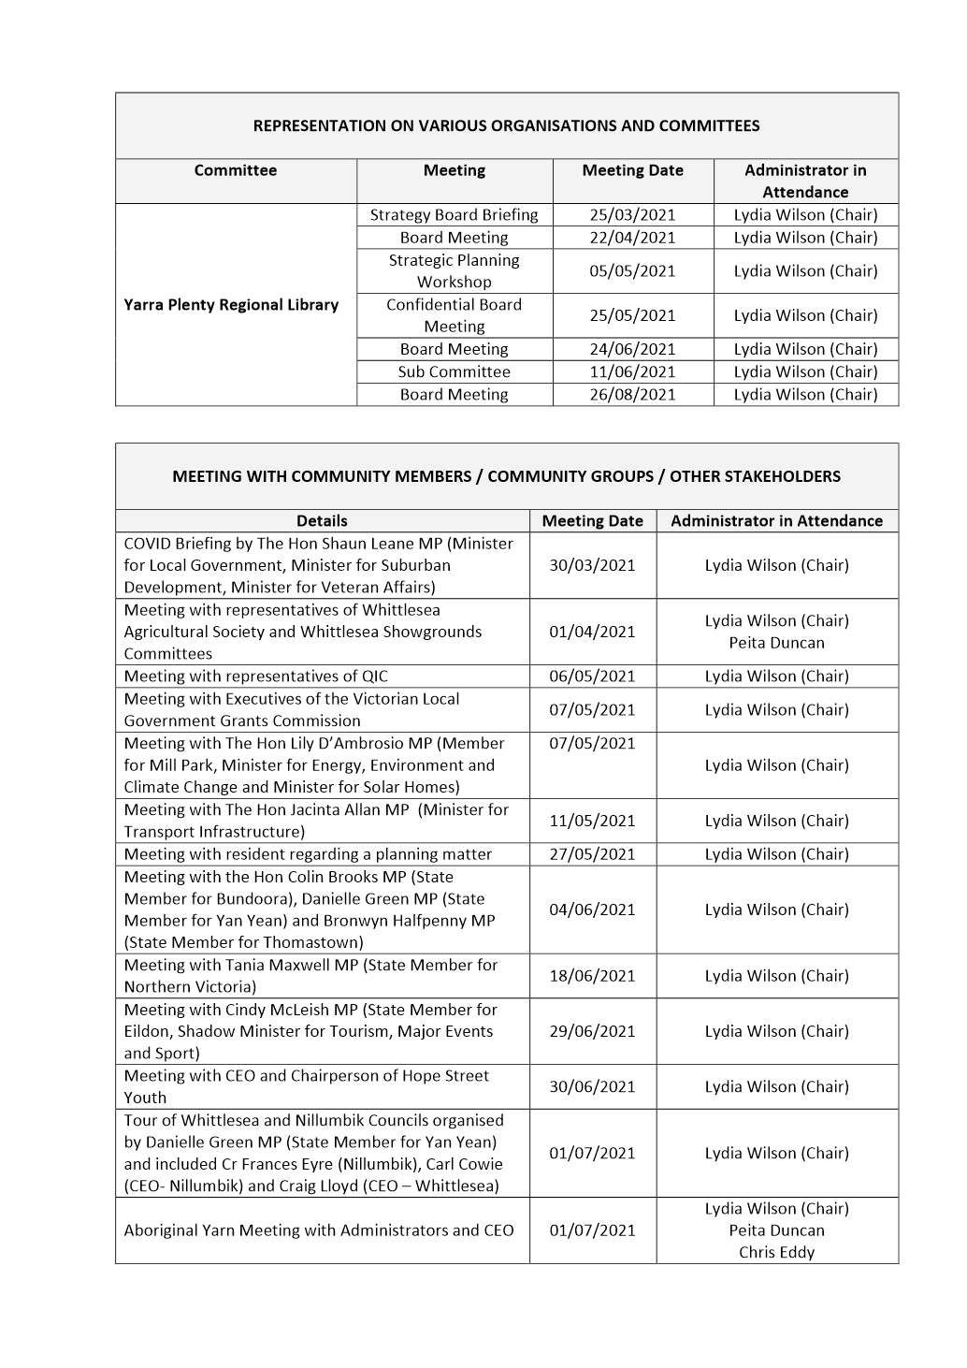

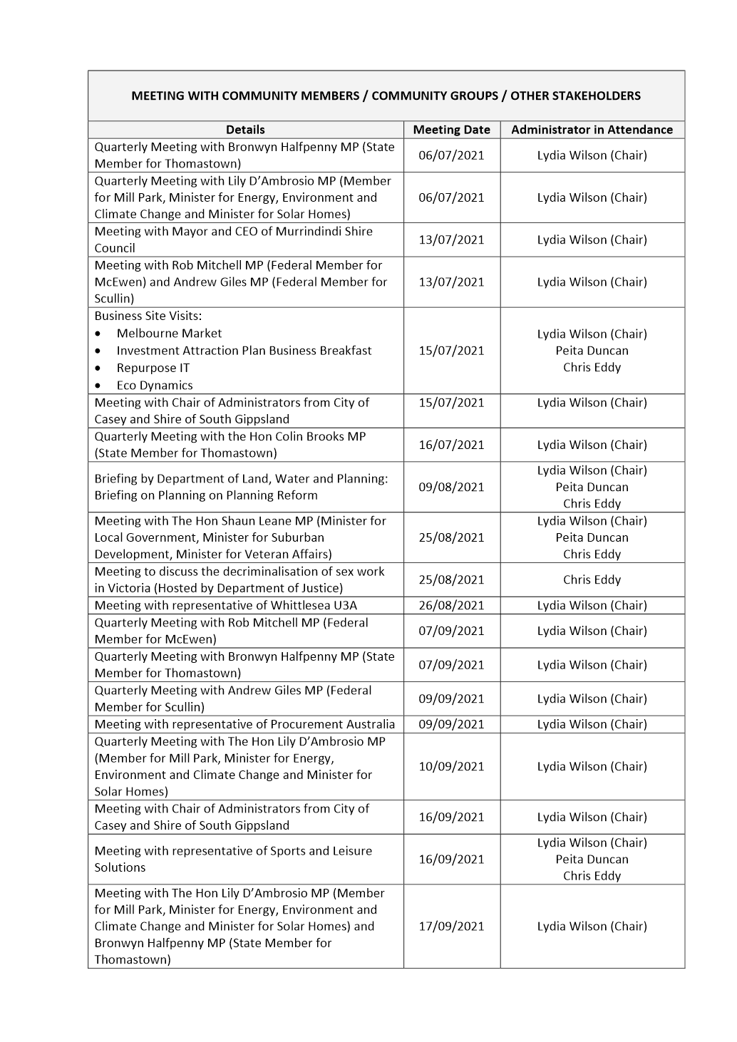

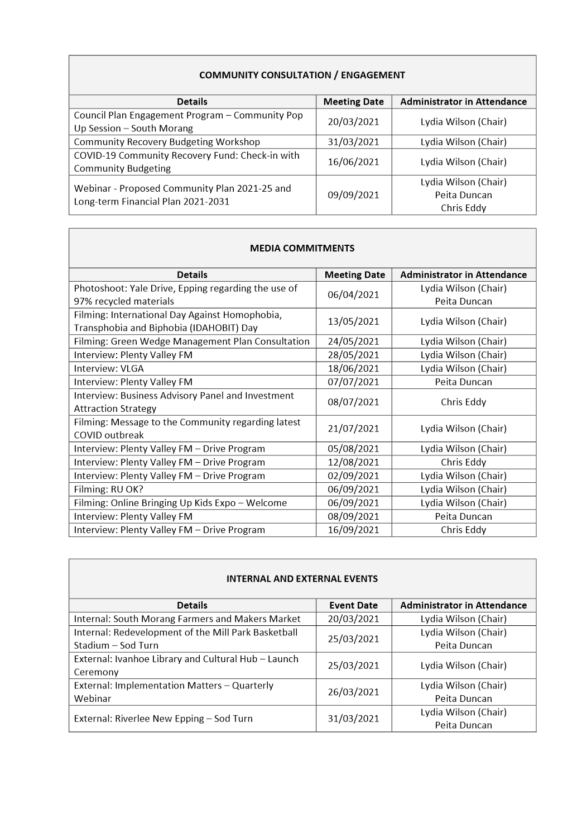

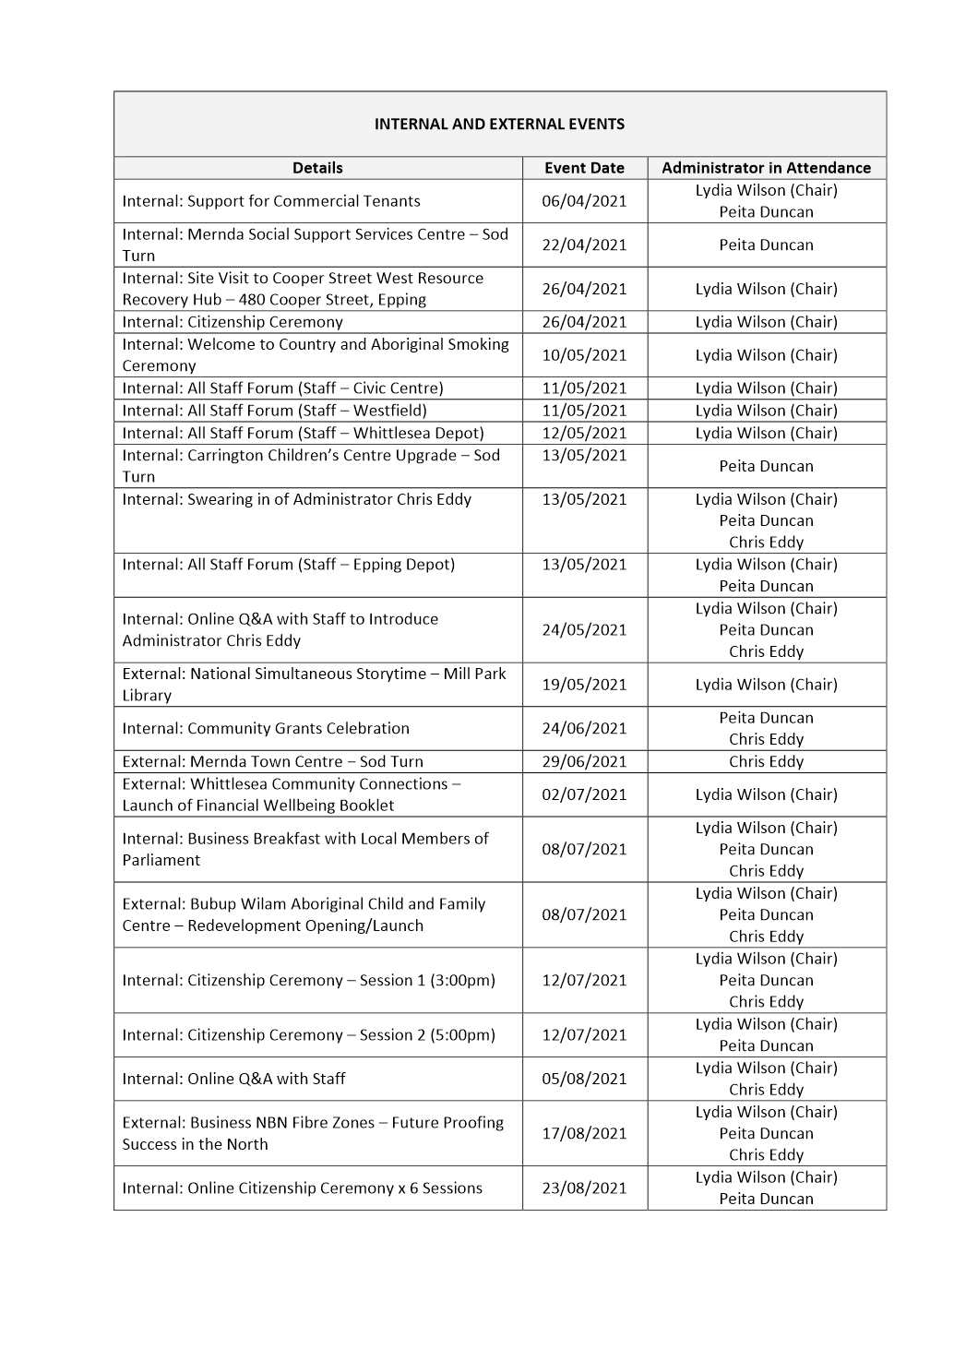

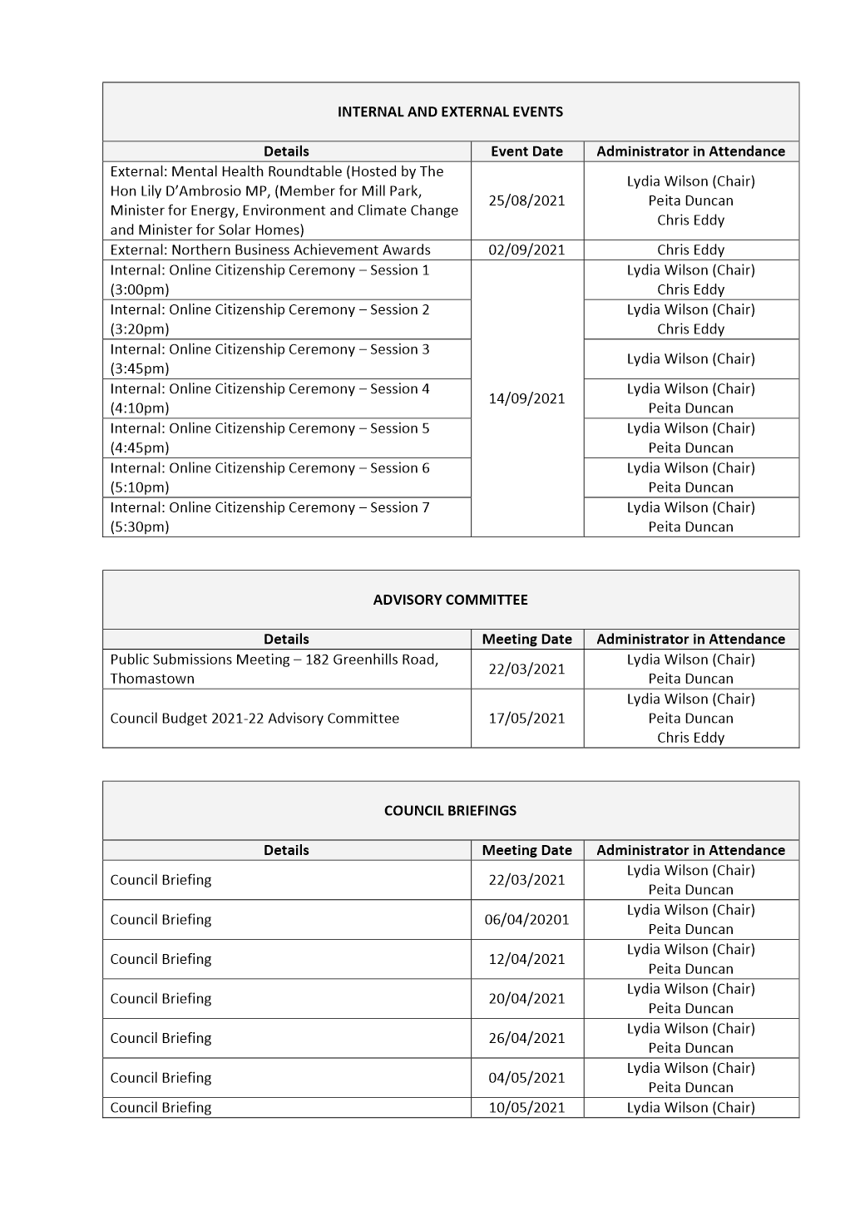

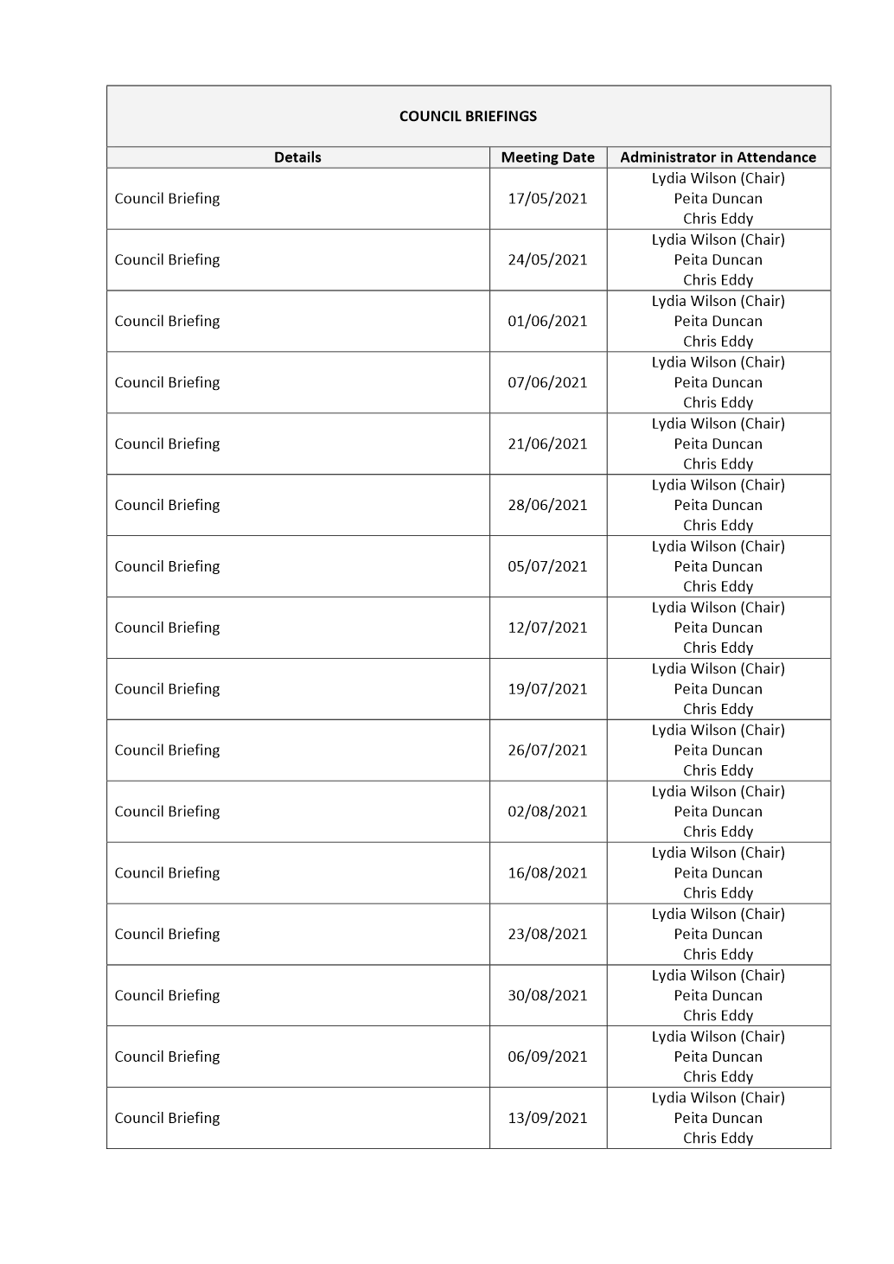

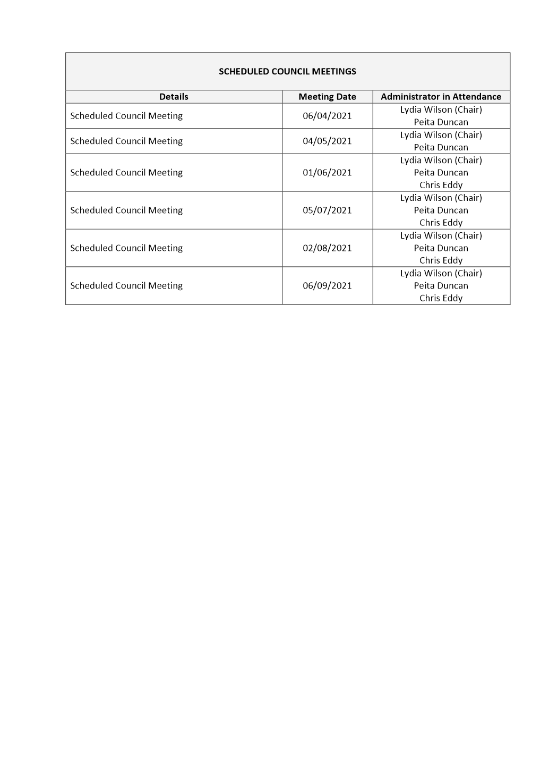

ITEM 6.5.3 Audit & Risk Committee Matters
Attachments: 1 Audit & Risk Committee Charter
2 Review of Fees Paid to Independent Members of Council Audit & Risk Committees - Confidential
This attachment has been designated as confidential by the Executive Manager Governance & Strategy, in accordance with Rule 53 of the Governance Rules 2021 and sections 66(5) and 3(1) of the Local Government Act 2020 on the grounds that it contains private commercial information, being information provided by a business, commercial or financial undertaking that— (i) relates to trade secrets; or (ii) if released, would unreasonably expose the business, commercial or financial undertaking to disadvantage. In particular the attachment contains information regarding fees paid by other Councils to Audit & Risk Committee members that was provided in confidence.
Responsible Officer: Executive Manager Governance & Strategy
Author: Internal Assurance Coordinator

RECOMMENDATION SUMMARY
THAT Council:
1. Adopt the updated City of Whittlesea Audit & Risk Committee Charter, with key changes including:
a) Increasing the membership of the Committee from five members to six, which includes four independent members.
b) Adjusting the quorum requirements from two to three independent members.
c) Introducing a clause that requires a formal review of an independent member’s performance and independence be undertaken before they are eligible for extension or re-appointment.
d) Amending independent member term limits to allow independent members to serve a maximum of six years on the Committee.
e) Adjusting remuneration fees for independent members from a per meeting to an annual amount.
f) Increasing the expected number of meetings per year from four to five.
2. Appoint Ms Jen Johanson as independent member to the City of Whittlesea’s Audit & Risk Committee commencing 4 October 2021 for a three-year term ending 30 September 2024, in accordance with the terms of reference contained in the Audit & Risk Committee Charter.
3. Appoint Mr Bruce Potgieter as independent member to the City of Whittlesea’s Audit & Risk Committee commencing 4 October 2021 for a three-year term ending 30 September 2024, in accordance with the terms of reference contained in the Audit & Risk Committee Charter.
4. Effective from 4 October 2021, set the fee for the Audit & Risk Committee Chair to $10,000 per annum, paid quarterly.
5. Effective from 4 October 2021, set the fee for Audit & Risk Committee independent members to $8,000 per annum, paid quarterly.
Brief overview
Following the Audit & Risk Committee meeting held on 19 August 2021, the term of the Committee’s longest serving member Mr Michael Ulbrick concluded, creating a vacancy on the Committee. In accordance with the City of Whittlesea Audit & Risk Committee Charter (Charter), Council is required to fill this vacancy.
In looking to fill the vacancy, an opportunity also exists to review the current Charter and the remuneration paid to independent members of the Committee.
This report seeks Council’s approval of proposed amendments to the Audit & Risk Committee Charter, appointment of two new independent members to the Audit & Risk Committee and consideration of an increase in fees paid to independent members of the Committee.
rationale for recommendation
Council is required to comply with the requirements of the Audit & Risk Committee Charter and the Local Government Act 2020.
Any amendments to the Audit & Risk Committee Charter, appointment of independent Committee members and changes to Committee member remuneration require the approval of Council.
impacts of recommendation
Council will comply with its Audit & Risk Committee Charter and meet its legislative requirements.
what measures will be put in place to manage impacts
Appointment of independent members to the Audit & Risk Committee and an up to date Charter ensures Council maintains best practice governance processes and structure and is well placed to meet the requirements of the Local Government Act 2020 and the expectations of the community.

Report
Background
Following the Audit & Risk Committee meeting held on 19 August 2021, the term of the Committee’s longest serving member Mr Michael Ulbrick concluded, creating a vacancy on the Committee. In accordance with the City of Whittlesea Audit & Risk Committee Charter, Council is required to fill this vacancy.
In looking to fill the vacancy, an opportunity also exists to review the current Charter and the remuneration paid to independent members of the Committee.
This report seeks Council’s approval of proposed amendments to the Audit & Risk Committee Charter, appointment of two new independent members to the Audit & Risk Committee and consideration of an increase in fees paid to independent members of the Committee.
Proposal
Amendments to the Audit & Risk Committee Charter
Council is required to review the Audit & Risk Committee Charter on a regular basis, and it is timely to do so now as there is a vacancy on the Committee which must be filled. The Committee and its activities should reflect the needs of a contemporary Council such as the City of Whittlesea. The workload of the Committee, its succession plan and the membership’s independence should meet the expectations of a modern Audit & Risk Committee and be addressed by its Charter.
To ensure that the City of Whittlesea and its Audit & Risk Committee remain at the forefront of Local Government, the following key changes are recommended to the Audit & Risk Committee Charter:
• Increase the membership of the Committee from five members to six, which includes four independent members;
• Adjust the quorum requirements from two to three independent members;
• Introduce a clause that requires a formal review of an independent member’s performance and independence be undertaken before they are eligible for extension or re-appointment. This review process is to be determined by the Chief Executive Officer or their delegate;
• Amend independent member term limits to allow independent members to serve a maximum of six years on the Committee;
• Adjust remuneration fees for independent members from a per meeting to an annual amount, payable quarterly;
• Increase the expected number of meetings per year from four to five, with the intent of the fifth meeting to focus on annual financial and performance reporting requirements; and
• Add a clause to invite the Chair of the Committee to attend Council meetings to present the Committee’s biannual report.
A copy of the updated Charter is attached to this report (all changes are included as tracked changes).

Appointment of Independent Committee Representatives
With the term of independent Audit & Risk Committee member, Mr Michael Ulbrick concluding following the 19 August 2021 Committee meeting, a vacancy has become available on Council’s Audit & Risk Committee. To fill this vacancy; and in accordance with the amendments proposed to the Audit & Risk Committee Charter outlined above, it is recommended that Council appoint two new independent members to the Committee.
An advertising process was undertaken, including placing advertisements on Seek, LinkedIn and Council’s careers webpage from 19 July 2021 to 1 August 2021, inviting expressions of interest for independent members to join the Audit & Risk Committee. Twenty-six applicants submitted written applications.
A selection panel comprising the Chair of Council, CEO and Chairman of the Audit & Risk Committee reviewed the 26 applications received for shortlisting. Five applicants were shortlisted, and all attended for an interview with the selection panel.
All candidates interviewed had strong financial, business, compliance and risk management experience, along with a sound knowledge of local government issues and extensive experience with Audit & Risk Committees.
At the completion of the interview process the panel determined that Ms Jen Johanson and Mr Bruce Potgieter best met the requirements of the role and could be recommended to Council for appointment to the Audit & Risk Committee. Reference checks of the two shortlisted candidates confirmed the value they add to Audit and Risk Committees and the skills and experience they would bring to the role.
Ms Johanson has extensive experience in finance, governance, risk management and information technology in both the private and public sectors. Ms Johanson currently holds the role of Senior Advisor, Risk and Advisory Services, Cyber Security & Privacy with RSM Australia. She also holds current appointments with local government Audit & Risk Committees at Bayside City Council, Hume City Council and South Gippsland Shire Council. Ms Johanson is also a member of the Audit & Risk Committee at the University of Melbourne and the
Independent Broad-based Anti-Corruption Commission.
Mr Potgieter has extensive experience in audit and risk management in the public sector, particularly within local government through his many years of experience as an audit partner with various organisations. Mr Potgieter has extensive experience with local government Audit & Risk Committees and is currently the Audit & Risk Committee Chair at Mitchell Shire Council and Mansfield Shire Council, as well as a member of the Audit & Risk Committees at Kingston City Council and Maroondah City Council. Mr Potgieter was previously Chair of the Audit & Risk Committee at Monee Valley City Council and Stonnington City Council.
It is recommended that both Ms Johanson and Mr Potgieter be appointed to the Committee from 4 October 2021 for a three-year term ending 30 September 2024, in accordance with the terms of reference contained in the revised Audit & Risk Committee Charter.

Proposed Fee Increase for Independent Committee Representatives
The current Audit & Risk Committee Charter states that the remuneration paid to independent Committee members for attendance fees is to be reviewed by Council periodically (previously annually). Council’s current fee of $2,000 per meeting ($8,000 annual fee) for the Chair and $1,400 per meeting ($5,600 annual fee) for the other independent members was last reviewed by Council at the 1 October 2019 Council meeting.
The above fees were set based on the outcomes of a benchmarking review undertaken in 2019 of fees paid to independent members of the Audit & Risk Committees of other councils. Prior to undertaking this benchmarking exercise, previous fee increases were linked to the annual increase in the Mayoral and Councillor allowance as outlined in the Victorian Government Gazette. A review of fees was not undertaken in 2020 due to the COVID-19 Pandemic.
Given that fees have not been reviewed for two years and with the ever-changing external environment, a further benchmarking exercise has been undertaken of fees paid to independent members of other councils’ Audit & Risk Committees to assess how the current fees paid by the City of Whittlesea compared. Fees paid by fourteen other Councils were considered. This information was gathered via requests and through information publicly available. The results indicated that the councils generally pay annual fees to independent members of between $5,200 and $8,190, with the Chair generally receiving between $5,400 and $11,875. The average annual fees for the Chair were $9,157, with independent members generally receiving an average of $7,056 per annum. Councils reviewed held an average of four meetings per year. The councils reviewed, and fees paid, are included as a confidential attachment.
Results of this review indicate that the City of Whittlesea’s independent members’ fees are below the average paid by the other councils reviewed.
Recommend Increase
The role and responsibilities of Audit & Risk Committee members are ever growing. In addition to the increased responsibilities placed on Audit & Risk Committees by the introduction of the Local Government Act 2020, there is greater focus and scrutiny over matters of compliance, audit, risk management and prudent financial management. Council currently has in place a Committee that includes highly qualified and respected independent members. As a guide, independent Committee members perform the following tasks:
Regular Tasks | Time Estimate  (Hours) | Chair | Member
Review of draft meeting agendas, including comparison to the Committee’s annual work plan | 1.0 | x
Review of papers prior to meeting (including preparation of meeting plan and discussion with Council officers as required) | 3.5 | x
Review of papers prior to meeting | 3.0 |  | x
Attendance at meeting (travel time excluded) | 2.5 | x | x
Review of draft minutes prior to circulation | 0.5 | x
Review of minutes | 0.5 |  | x

In addition to the tasks outlined in the above table, Committee members may also be required to perform tasks between meetings, such as the review of internal audit scopes and other documents and reports. The Committee Chairperson also performs additional tasks, including regular contact with Officers, discussions with auditors, and involvement on the panel to review internal audit tenders.
From 4 October 2021, it is proposed to increase remuneration to independent members to $8,000 per annum and the Chair to $10,000 per annum. This increase will better align the remuneration structure with payments made to independent members of other councils’ Audit & Risk Committees and recognise the time, commitment, responsibilities and level of knowledge and skill required by Council’s Audit & Risk Committee members. It is also noted that a change to a per annum fee is in line with changes recommended to be made to the Audit & Risk Committee Charter referenced earlier in this report.
Consultation
Fees paid to independent members of Audit & Risk Committees of fourteen other councils were reviewed.
Recruitment of independent members was undertaken by a panel in accordance with Council’s Recruitment Policy.
Financial Implications
Fees paid to independent members of the Audit & Risk Committee are included in Council’s budget.
Policy strategy and legislation
The Audit & Risk Committee is established in accordance with Division 8, Sections 53 and 54 of the Local Government Act 2020.
The Committee’s responsibilities and requirements are outlined in the Audit & Risk Committee Charter.

link to strategic risks
Strategic Risk Governance - Ineffective governance of Council’s operations and activities resulting in either a legislative or policy breach
The Audit & Risk Committee assists Council in monitoring its governance requirements and provides advice to Council to assist with fulfilling its oversight responsibilities.

Links to whittlesea 2040 and the CoUNCIL Plan
Goal High-performing organisation
Key Direction More informed Council decisions based on strong advice and community consultation and engagement

The establishment of the Audit & Risk Committee and the reports it receives are reflective of Council’s commitment to the implementation of good governance principles. The Committee provides advice to Council to assist with fulfilling its oversight responsibilities for the financial and non-financial reporting process; internal controls; the audit process; risk management; and Council’s process for monitoring compliance with legislation, regulations and the Code of Conduct.
Declarations of Conflicts of Interest
Under Section 130 of the Local Government Act 2020 and Rule 47 of the Governance Rules 2021, officers providing advice to Council are required to disclose any conflict of interest they have in a matter and explain the nature of the conflict.
The Responsible Officer reviewing this report, having made enquiries with relevant members of staff, reports that no disclosable interests have been raised in relation to this report.
Conclusion
The amendments proposed to the Audit & Risk Committee Charter will ensure the Committee’s membership and workload reflects best practice. The revised Charter will facilitate the appointment of an independent member, in addition to filling the vacancy that exists.
In accordance with Council’s Audit & Risk Committee Charter, two independent positions on the Audit & Risk Committee have been advertised, with interviews conducted of shortlisted candidates. The selected applicants Ms Jen Johanson and Mr Bruce Potgieter have extensive experience and appropriate skills to offer Council’s Audit & Risk Committee and are worthy of appointment.
Additionally, the proposed fee increase is reflective of the independent Committee members’ responsibilities and duties and is also enabled by the amendment of the Charter.

RECOMMENDATION
THAT Council:
1. Adopt the updated City of Whittlesea Audit & Risk Committee Charter, with key changes including:
a) Increasing the membership of the Committee from five members to six, which includes four independent members.
b) Adjusting the quorum requirements from two to three independent members.
c) Introducing a clause that requires a formal review of an independent member’s performance and independence be undertaken before they are eligible for extension or re-appointment.
d) Amending independent member term limits to allow independent members to serve a maximum of six years on the Committee.
e) Adjusting remuneration fees for independent members from a per meeting to an annual amount.
f) Increasing the expected number of meetings per year from four to five.
2. Appoint Ms Jen Johanson as independent member to the City of Whittlesea’s Audit & Risk Committee commencing 4 October 2021 for a three-year term ending 30 September 2024, in accordance with the terms of reference contained in the Audit & Risk Committee Charter.
3. Appoint Mr Bruce Potgieter as independent member to the City of Whittlesea’s Audit & Risk Committee commencing 4 October 2021 for a three-year term ending 30 September 2024, in accordance with the terms of reference contained in the Audit & Risk Committee Charter.
4. Effective from 4 October 2021, set the fee for the Audit & Risk Committee Chair to $10,000 per annum, paid quarterly.
5. Effective from 4 October 2021, set the fee for the Audit & Risk Committee independent members to $8,000 per annum, paid quarterly.

Council Resolution
Moved: Administrator Eddy
Seconded: Chairperson Wilson

THAT Council resolve to adopt the Recommendation.
Carried

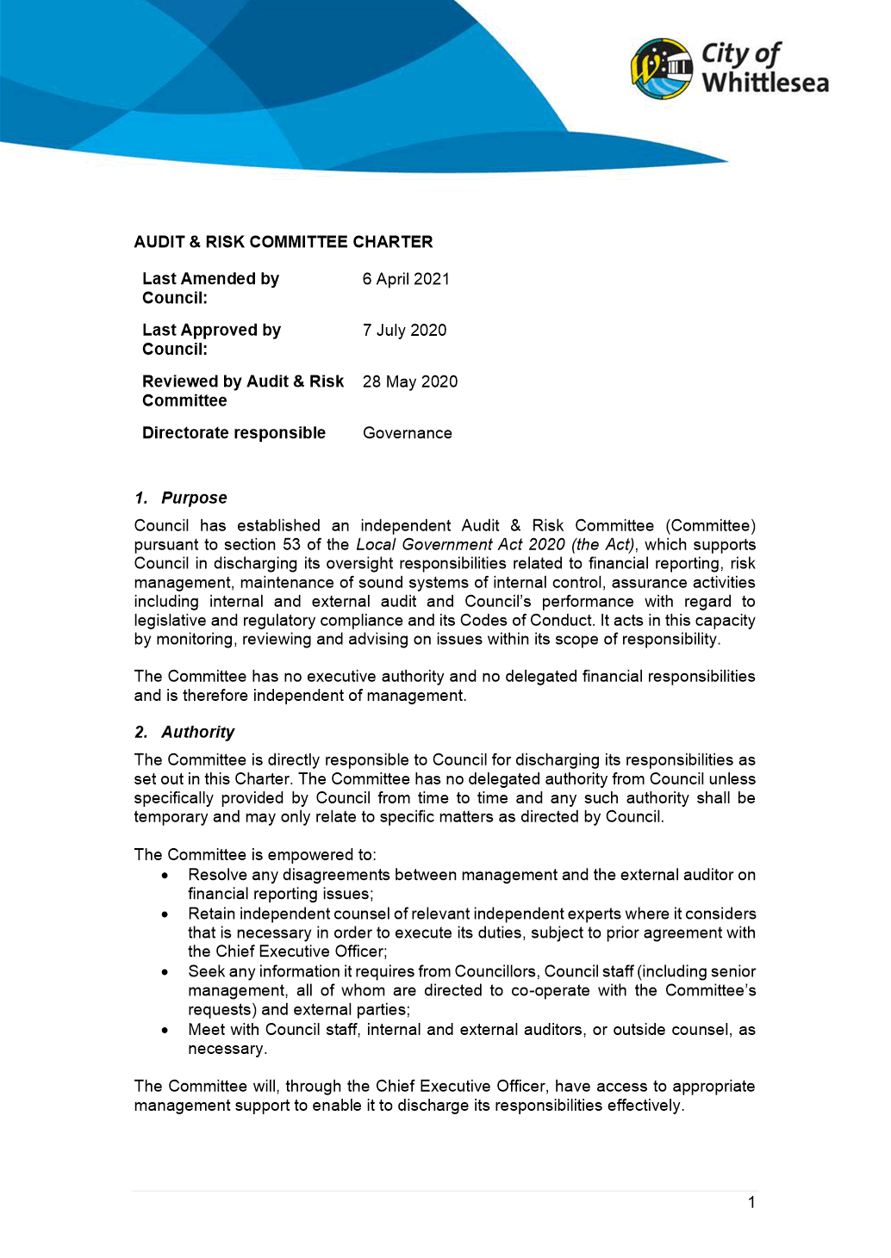

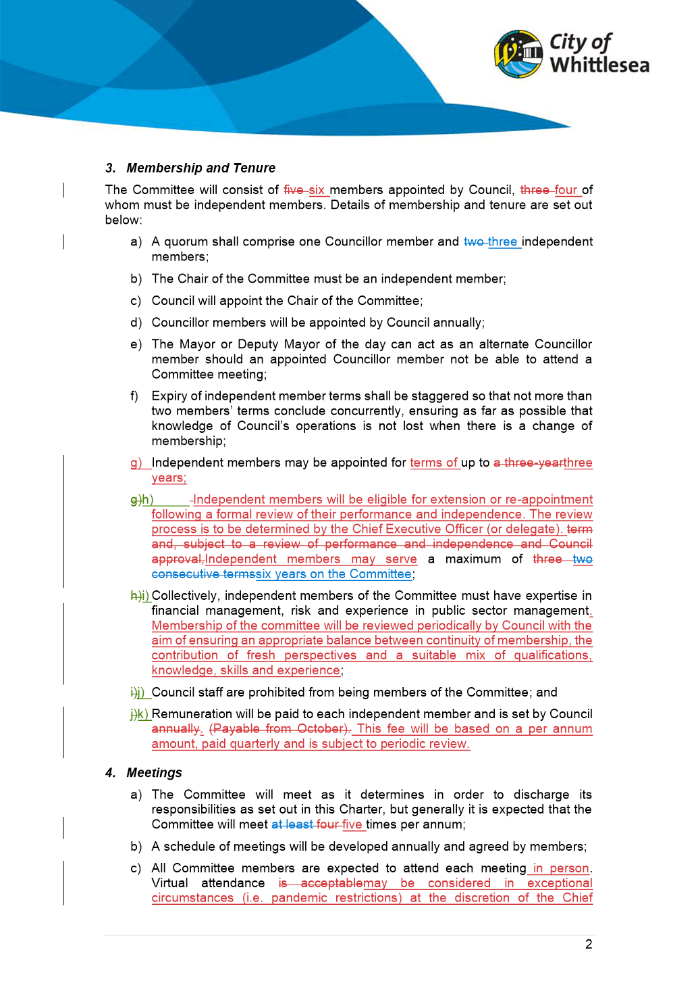

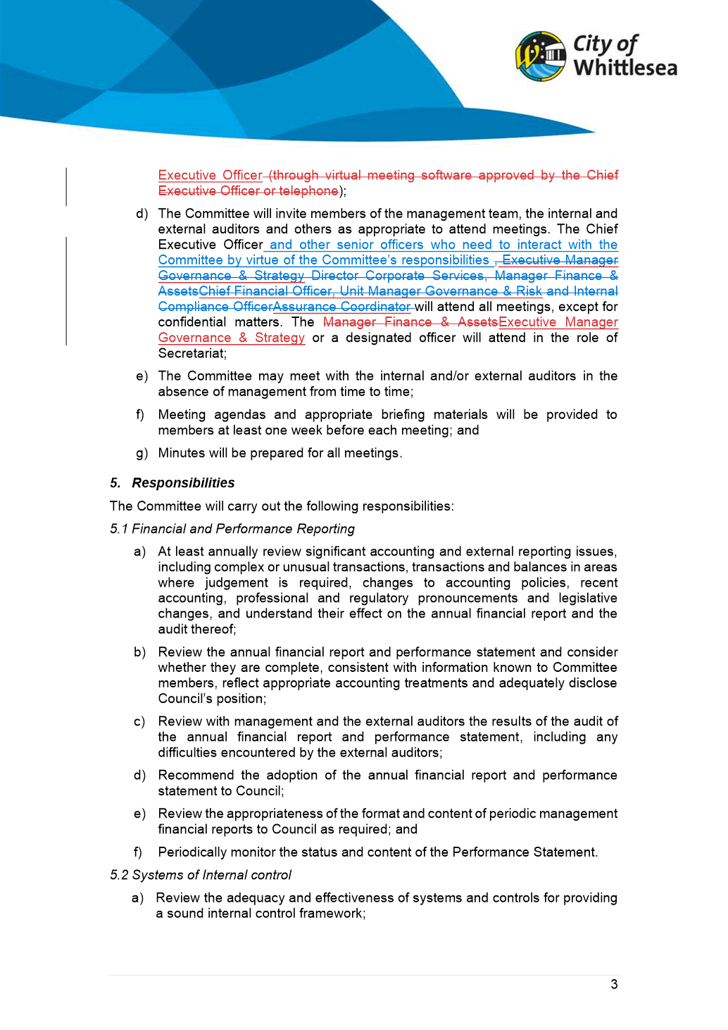

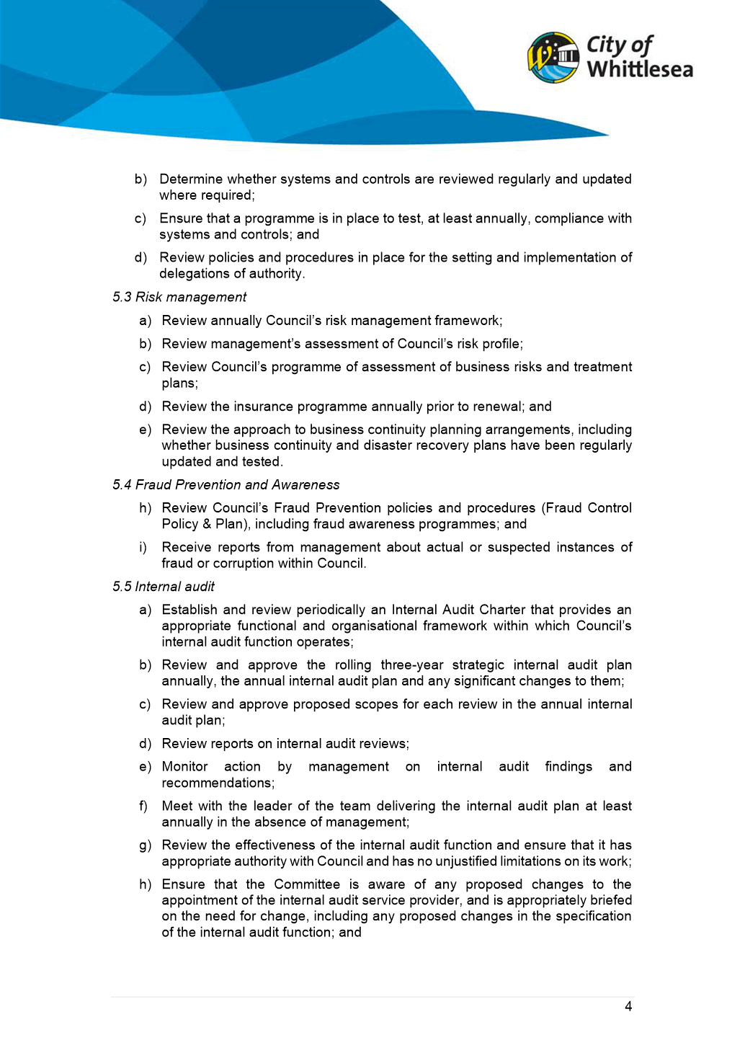

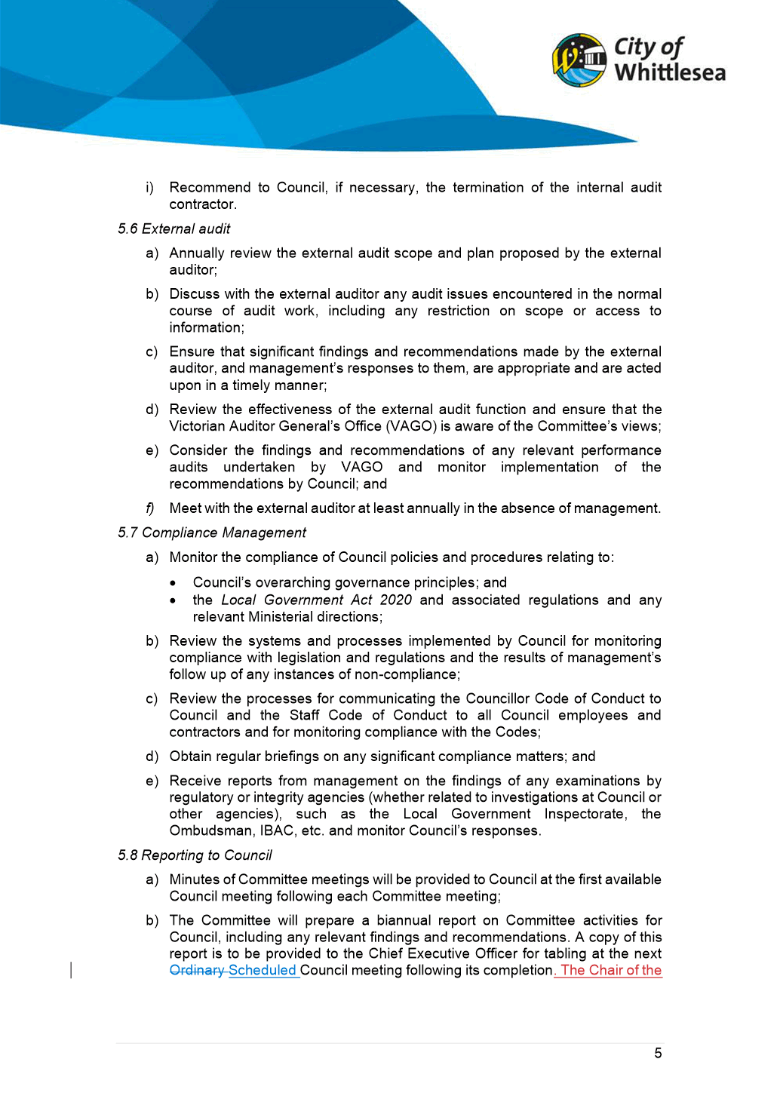

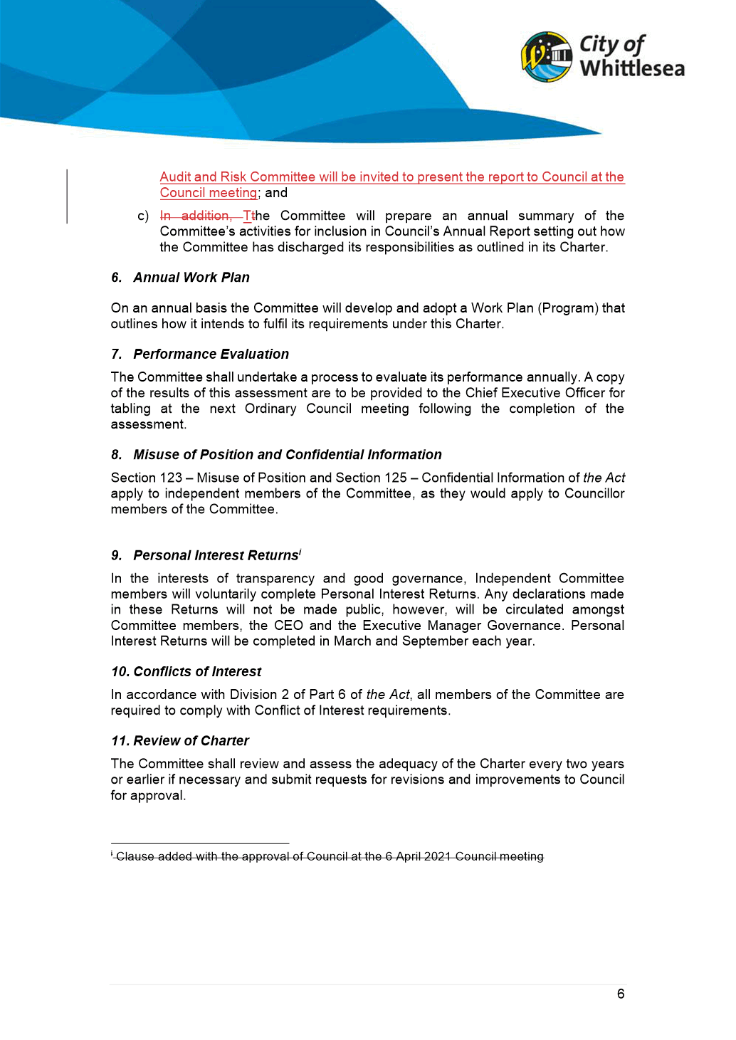

ITEM 6.5.4 2021/22 Growing Suburbs Fund - Project Applications
Attachments: 1 GSF Priority Projects
Responsible Officer: Director Corporate Services
Author: Team Leader Business Support

RECOMMENDATION SUMMARY
That Council resolve to approve the submission of the following seven projects listed in priority order to the 2021/22 round of the Growing Suburbs Fund:
1. Aboriginal Gathering Place, Mernda for $4,000,000
2. Patterson Drive Community Activity Centre, Donnybrook for $2,000,000
3. Streetscape Improvements on Gorge Road, South Morang for $425,000
4. Community Energy Efficiency Program for $250,000.
5. Huskisson Reserve Pedestrian and Cycling Access, Lalor for $325,000
6. Worchester Park Bushfire Regeneration, Bundoora for $275,000
7. Plenty Ranges Arts and Convention Centre Infrastructure Improvements for $225,000
Brief overview
Applications for the 2021/22 round of the Growing Suburbs Fund (GSF) opened on 1 September 2021. It is proposed that Council submit applications for seven projects, totalling $7,500,000 which will need to be matched by Council funding. This report seeks Council’s approval to proceed with the GSF applications and a priority order for the funding submissions. The GSF guidelines require that a council resolution be made to support the project applications in priority order.
rationale for recommendation
A working group containing a cross section of Council officers identified seven priority projects from the 4 Year New Works Program that best aligned with the GSF Guidelines. Other projects were identified and presented to the officers from the Department of Jobs Precincts and Regions (DJPR), however they were not supported and didn’t meet the necessary criteria in the guidelines.
All project proposals have been discussed with the funding agency as required in the grant guidelines. Applications for projects that have not been discussed with DJPR will not be considered by them.
The guidelines place a strong emphasis on projects that are ready to commence work within 18 months of the funding announcement (expected in December 2021) and for construction to be completed within 24 months of commencement of works.
impacts of recommendation
The proposed seven projects listed above amount to a total application amount of $7,500,000 and Council must contribute a matching funding amount to that of the Growing Suburbs Fund application. All projects must commence no later than within 18 months of the funding announcement (expected in December 2021) and for construction to be completed within 24 months of commencement of works.
The nominated projects are currently listed with forecast budgets in the 4 Year New Works Program. If the grant applications are successful, this will result in offsets to Council’s future New Works Program budget of up to $7,500,000 to bring forward future infrastructure requirements.
what measures will be put in place to manage impacts
All project proposals have been discussed with the funding agency as required in the grant guidelines. Applications for projects that have not been discussed with DJPR will not be considered by them.
It is a condition of the funding criteria that a council resolution providing support for each application in priority order of projects is mandatory to support the applications. The next available Council meeting is 4 October 2021 which is prior to the applications closing date of 13 October 2021. Confirmation of the recommended project applications in priority order from the Council minutes will be submitted with the respective applications after the Council meeting.

Report
Introduction
Applications for the 2021/22 round of the Growing Suburbs Fund (GSF) opened on 1 September 2021. It is proposed that Council submit an application for seven projects, totalling $7,500,000. This report seeks ELT’s approval to proceed with the GSF application based on the proposed priority and seek Council approval at its meeting on 4 October 2021. The listed order of priority is a requirement for DJPR to understand Council’s relative priority of the projects.
Background
The GSF program is aimed towards funding critical local infrastructure needs to promptly respond to the pressures experienced by interface communities by bringing forward local infrastructure projects. It will support interface councils to better meet the needs of their diverse communities and improve amenity, liveability and resilience of these communities.
The GSF is open to six peri-urban and ten interface councils including the City of Whittlesea and will fund a mix of projects that have a direct benefit to communities across the following broad infrastructure categories:
• Community health and well-being
• Early education, learning and training
• Sport, recreation and leisure facilities that have dedicated community space and
support multi use purposes
• Environmental and climate change resilience
• Place-making, civic amenity and community connecting.
The maximum allocation to any of the 16 eligible councils is 15% of the $50 million fund (i.e. $7.5 million). The City of Whittlesea has been very successful in past GSF Rounds and on average has successfully received $5-$6 million per round from this funding program.
It is important to note that the funding agency, the Department of Jobs, Precincts and Regions (DJPR), will award the entire $50 million fund from December 2021. Eligible councils must be prepared to enter into funding agreements with DJPR by February 2022 and all successful projects must commence construction within 18 months of the funding announcement. The emphasis is on projects ready to proceed and construction must be completed within 24 months of commencement of works.
The key difference from previous rounds of this funding program is the requirement to discuss all eligible project applications with DJPR before submission of the applications. The proposed list of projects has been discussed with DJPR and seven have been supported for application to the GSF.
The GSF will generally not fund:
• Projects that have already commenced construction
• Land acquisition
• Projects that are sporting pavilions without a dedicated community use space
• Infrastructure that is fully scoped and funded through a developer contributions plan
• Maintenance works
• Recurrent operating costs
• Drainage, waste, roads and associated footpaths, as well as public transport infrastructure
• Infrastructure that does not have direct community benefit or address an identified community need
• Service connections
• Bundling of small projects into a larger project for submission.
Applications for infrastructure funding will be assessed against the following five criteria:
Criterion 1 - Why is the project required? – (25% weighting)
• Extent to which the project addresses an identified need in the community.
Criterion 2 - Who will benefit and how? – (25% weighting)
• Extent to which the project will deliver benefits to the locality.
Criterion 3 - What will be delivered? – (20% weighting)
• Relationship between what the project will deliver, the need for the project, and the
expected benefits.
Criterion 4 - How will the project be delivered? – (20% weighting)
• Realistic timeframes for delivery and demonstration that projects are financially viable
and value for money.
Criterion 5 - Extent of council and community support for the project – (10% weighting)
• Recognised council priority and supported by the community.
Each project must be supported by the evidence of a council resolution providing support for each application and priority order of projects, site/floor plans for the project, confirmation of other funding sources and a project plan. These are currently being prepared for the proposed projects. Applications close on 13 October 2021.
A cross-organisation working group was established to identify opportunities in the 4 Year New Works Program and shortlist projects that best met Grant guidelines.
Council officers then met with the funding agency, the DJPR to discuss the shortlisted projects as identified by the working group (refer to Attachment 1 for summary of project opportunities). DJPR provided feedback on the likely strength of the shortlisted projects against the Grant fund objectives and criteria, which further helped prioritise the list of proposed projects.

Proposal
The projects listed below were identified as best meeting the Grant funding objectives and criteria and are listed in priority order (as Per Attachment 1).
Project | PID | Proposed Funding
 |  | Growing Suburbs Fund  $ | Proposed Council Matching Funds/Year  $
Aboriginal Gathering Place  • Implementation of the Whittlesea Aboriginal Gathering Place to create a welcoming, inclusive and culturally safe space where the local Aboriginal community can access a comprehensive range of community supported program and activities that are responsive to their needs. | CW-10471 | 4,000,000 | 4,000,000 (2022/23+)
Patterson Drive Community Activity Centre, Donnybrook  • Design and construction of 4 x consult suites housing MCH and other services, separate program/waiting rooms, community hall, 3 room kindergarten, multi-purpose program spaces for services such as youth and social support | CW-10343 | 2,000,000 | 2,000,000 (2022/23+)
Streetscape Improvements on Gorge Road, South Morang  • The Gorge Road shopping precinct in South Morang has been identified in Councils Town Centre Improvement Plan as a high priority for renewal due to strong transport connectivity and opportunity to drive economic benefit to the local area. | CW-10458 | 425,000 | 425,000 (2022/23)
Community Energy Efficiency Program  • Ongoing program to ensure community facilities continue to minimise energy consumption, reduce our corporate greenhouse gas emissions and our impact on the environment | CW-10137 | 250,000 | 250,000 (2022/23)
Huskisson Reserve Pedestrian and Cycling Access  • Pedestrian access into Huskisson Reserve from Edgars Road is restricted due to the Edgars Creek being a physical barrier – this has an impact on the usability, accessibility and connectivity of Huskisson Reserve for the Lalor community. The Council endorsed Huskisson Reserve Master Plan recommends the construction of a pedestrian bridge over Edgars Creek and upgrade to the park on Edgars Road | CW-TBA | 325,000 | 325,000 (2022/23+)
Worchester Park Bushfire Regeneration  • Upgrade to the infrastructure at Worchester Park in Bundoora following a bushfire that destroyed the infrastructure, conservation and habitat. | CW-TBA | 275,000 | 275,000 (2022/23)
Plenty Ranges Arts and Convention Centre Infrastructure Improvements  • Upgrade to infrastructure to support disability access, HVAC and acoustic improvements to assist users and participants of PRACC | CW-10775 | 225,000 | 225,000 (2022/23+)
Total |  | $7,500,000 | $7,500,000
In summary, the proposed seven project applications listed above best meet the GSF grant criteria for a total application of $7,500,000. An equivalent funding contribution is required from Council, which is included in the draft 2022/23 New Works Program and beyond.
Consultation
A series of meetings were undertaken with DJPR to discuss potential project applications and feedback was received regarding their suitability.
Community consultation will be undertaken on a project by project basis.
Critical Dates
All project proposals must be discussed with DJPR prior to applications being made. This has occurred.
• Applications close on 13 October 2021.
• Funding announcements are expected from December 2021.
• Funding Agreements are to be executed in February 2021.
• Successful projects must commence within 18 months of the funding announcement.
• Projects must be completed within 24 months of commencement.
Financial Implications
The proposed seven projects listed above amount to a total application amount of $7,500,000 and Council must contribute a matching funding amount to that of the Growing Suburbs Fund application. All projects must commence within 18 months of the funding announcement (expected in December 2021) and construction must be completed within 24 months of commencement of works.
The nominated projects are currently listed with forecast budgets in the 4 Year New Works Program. If the grant applications are successful, this will result in offsets to Council’s future New Works Program budget of $7,500,000.
Policy strategy and legislation
Council has benefited from previous rounds of the Growing Suburbs Fund to deliver significant community infrastructure identified in the Council Plan. The projects identified in this current round have been selected based on their strength of meeting the grant guidelines and their strategic importance to Council as identified in the 4 Year New Works Program.
link to strategic risks
Strategic Risk Financial Sustainability - Inability to meet current and future expenditure
Links to whittlesea 2040 and the CoUNCIL Plan
Goal High-performing organisation
Key Direction More cost-effective investment through better return on investment, efficiency and an engaged workforce
Declarations of Conflicts of Interest
Under Section 130 of the Local Government Act 2020 and Rule 47 of the Governance Rules 2021, officers providing advice to Council are required to disclose any conflict of interest they have in a matter and explain the nature of the conflict.
The Responsible Officer reviewing this report, having made enquiries with relevant members of staff, reports that one disclosable interest has been raised in relation to this report. The relevant officer has provided written notice to the Chief Executive Officer disclosing the nature of the conflict of interest and how it will be managed and resolved in the public interest.
Conclusion
Applications to 2021/22 round of the Growing Suburbs Fund will close on 13 October 2021. After extensive consideration of the projects currently listed in Council’s 4 Year New Works Program. Seven projects were found to best meet the criteria and are recommended for Council approval in priority order for submission to the Grant program.

RECOMMENDATION
THAT Council resolve to approve the submission of the following seven projects listed in priority order to the 2021/22 round of the Growing Suburbs Fund:
1. Aboriginal Gathering Place, Mernda for $4,000,000
2. Patterson Drive Community Activity Centre, Donnybrook for $2,000,000
3. Streetscape Improvements on Gorge Road, South Morang for $425,000
4. Community Energy Efficiency Program for $250,000
5. Huskisson Reserve Pedestrian and Cycling Access, Lalor for $325,000
6. Worchester Park Bushfire Regeneration, Bundoora for $275,000
7. Plenty Ranges Arts and Convention Centre Infrastructure Improvements for $225,000.
Council Resolution
Moved: Chairperson Wilson
Seconded: Administrator Duncan

THAT Council resolve to adopt the Recommendation.
Carried

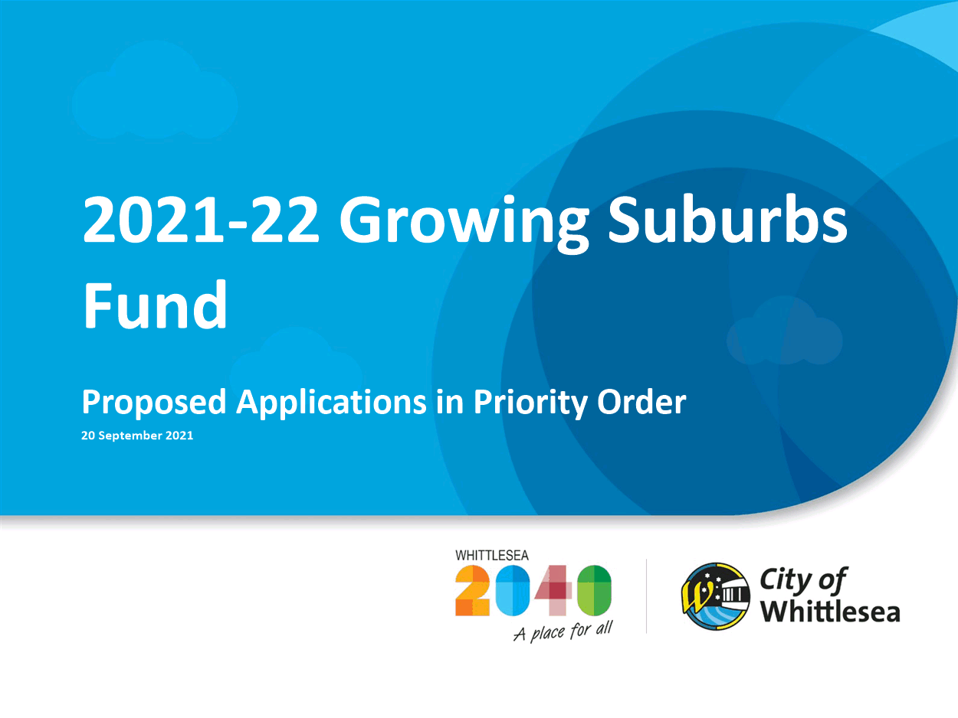
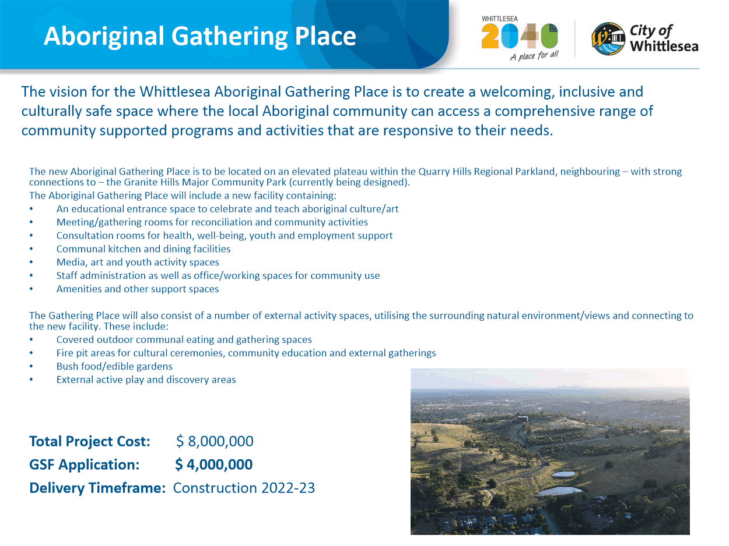

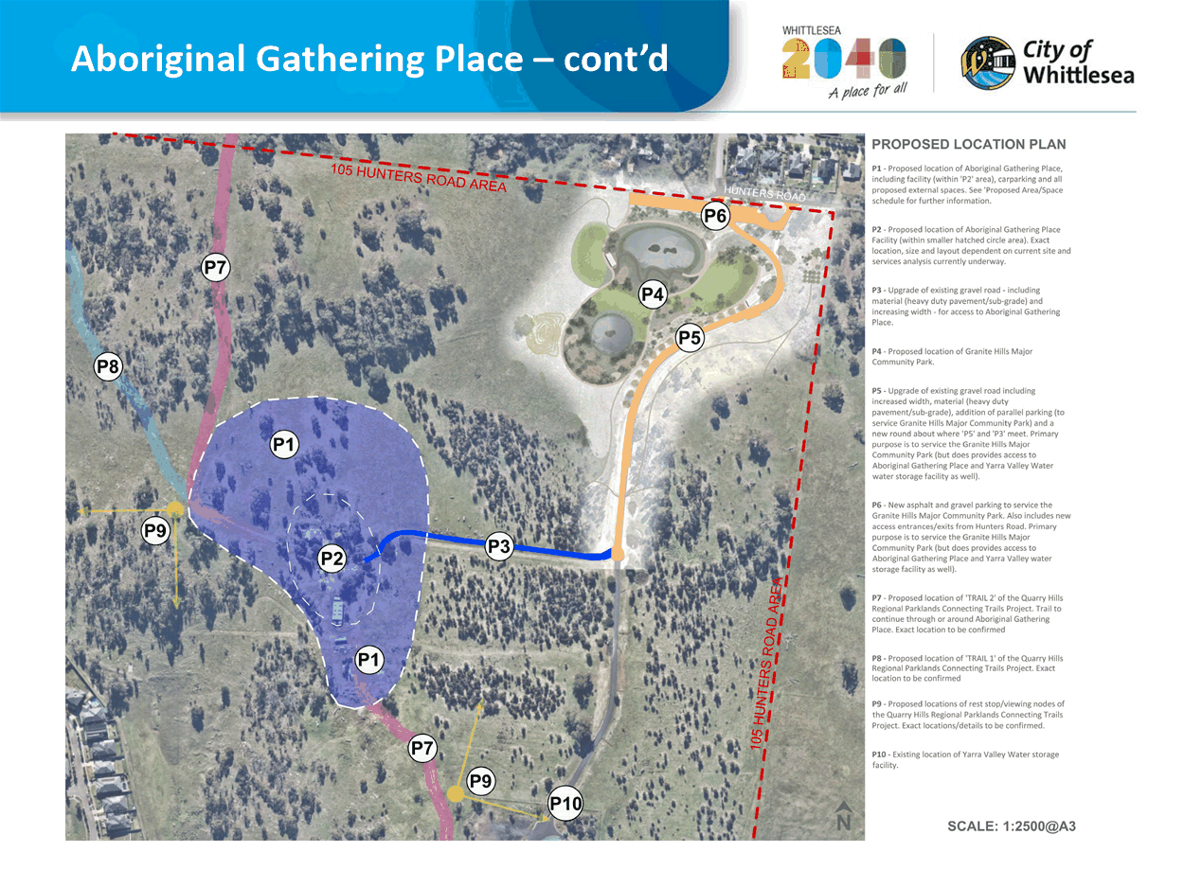

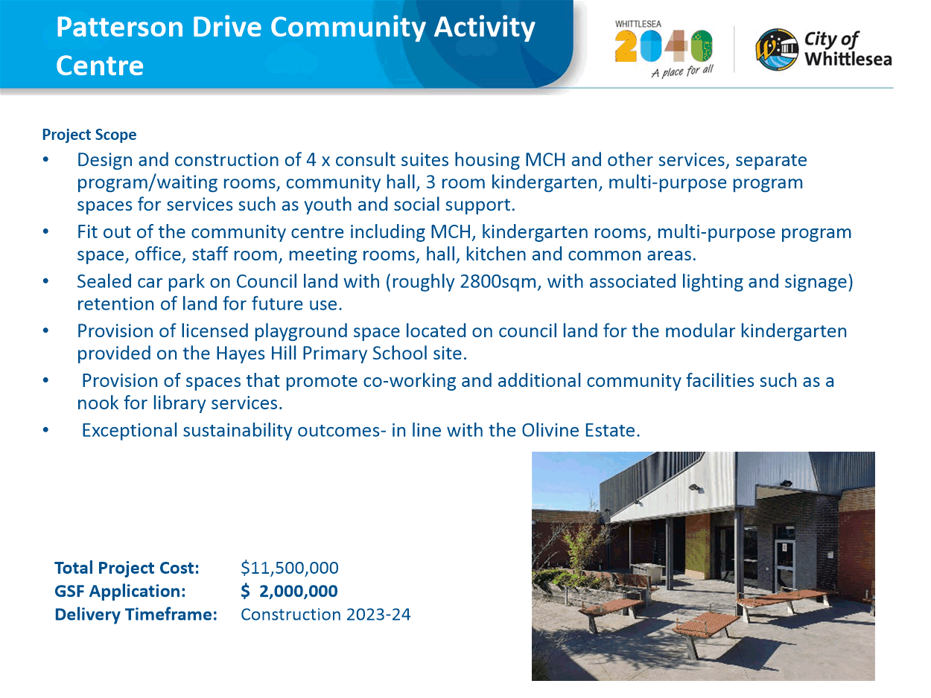

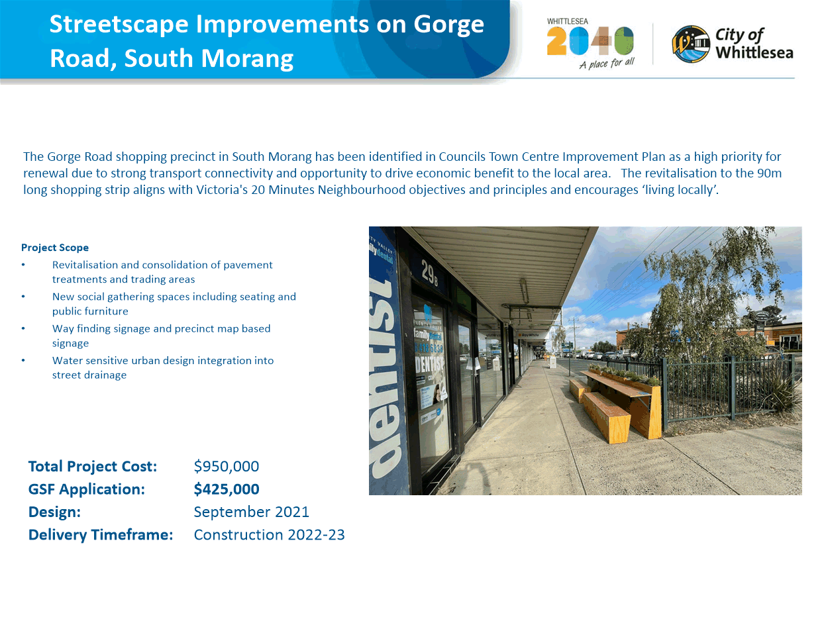

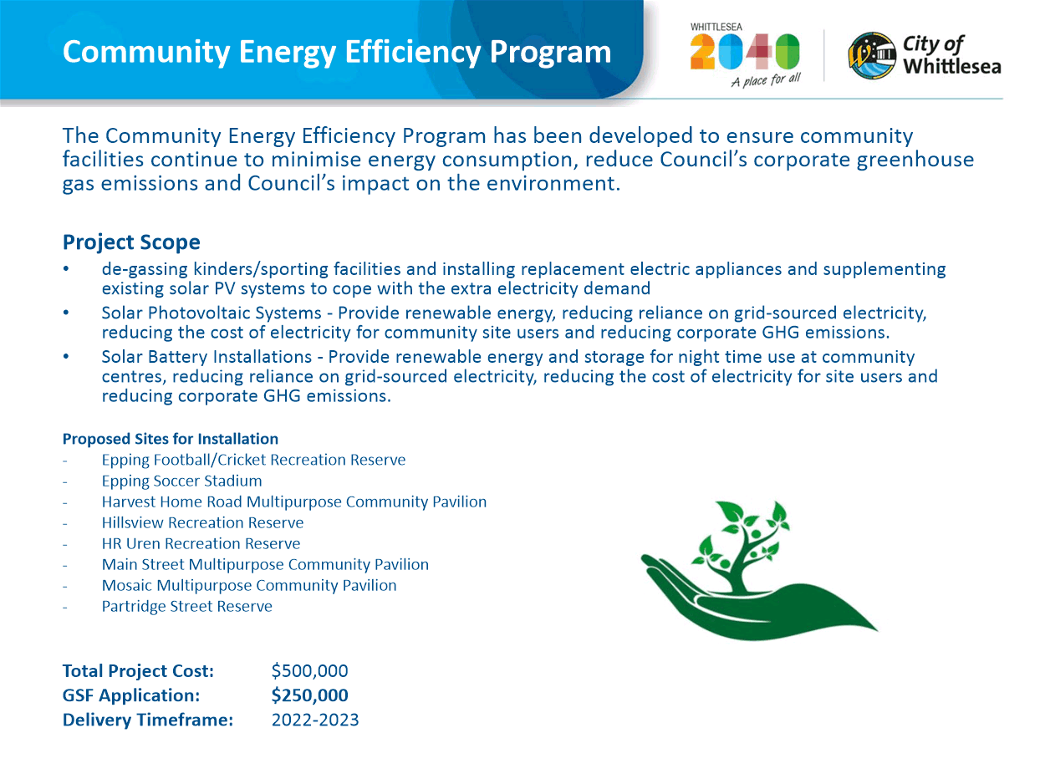

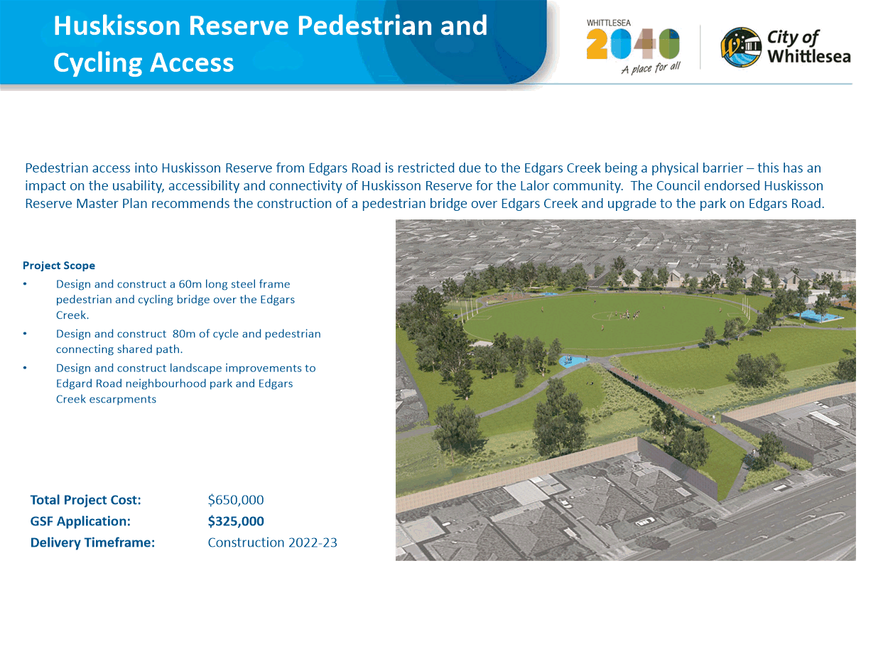

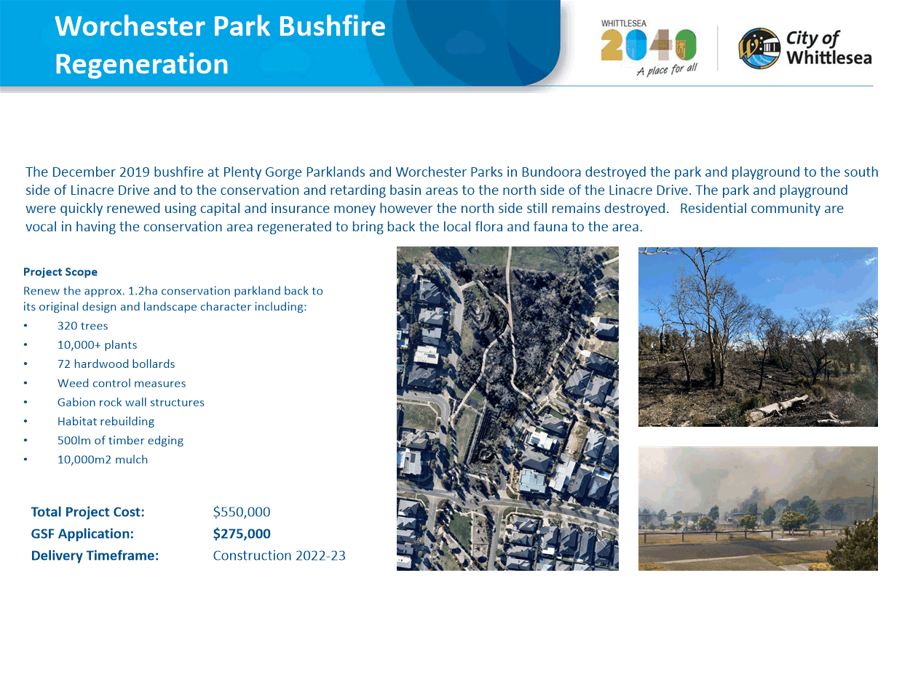

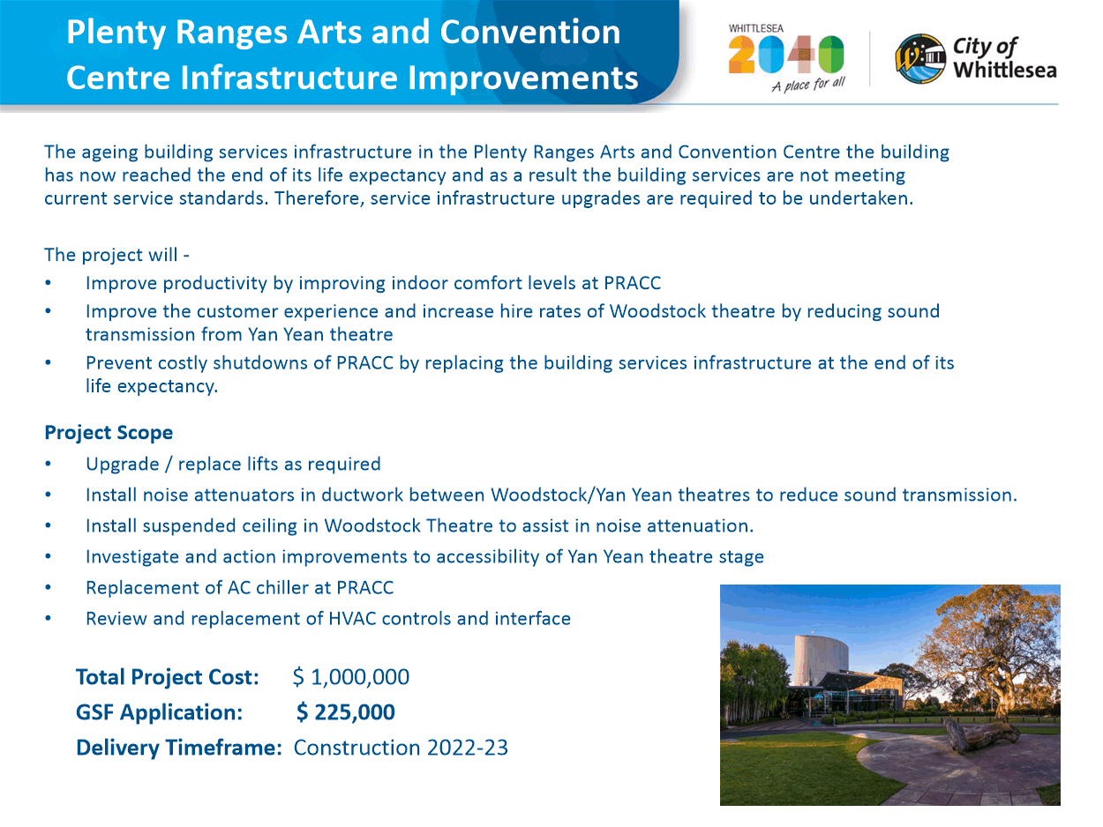

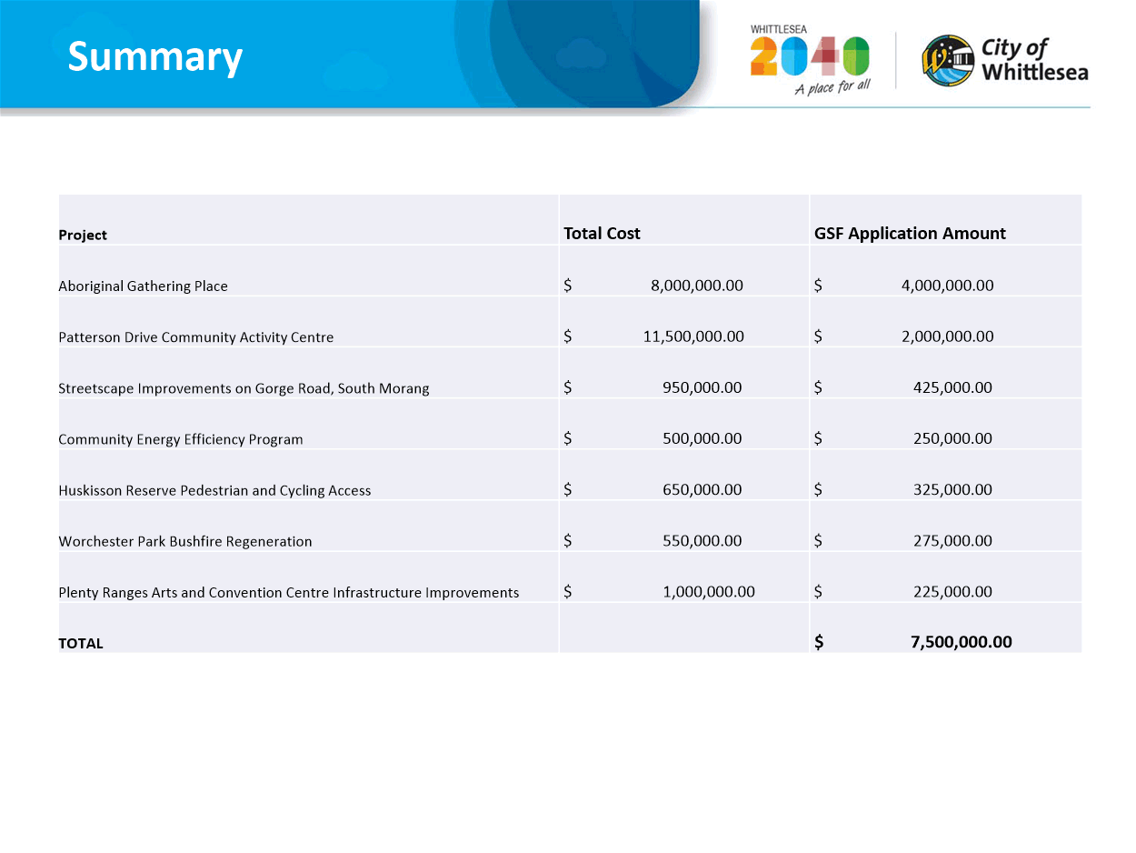

ITEM 6.5.5 Contract 2019-71 Extension - Temporary Agency Staff Management
Attachments: 1 Details of Variation - Confidential
This attachment has been designated as confidential by the Director Corporate Services, under delegation from the Chief Executive Officer, in accordance with Rule 53 of the Governance Rules 2021 and sections 66(5) and 3(1) of the Local Government Act 2020 on the grounds that it contains private commercial information, being information provided by a business, commercial or financial undertaking that— (i) relates to trade secrets; or (ii) if released, would unreasonably expose the business, commercial or financial undertaking to disadvantage. In particular the attachment contains information regarding commercial or financial undertaking that relates to trade secrets or, if released, would unreasonably expose the business, commercial or financial undertaking to disadvantage.
The attachment contains variation amounts submitted by the Contractor and provided to Council in confidence. The release of this information could reasonably be expected to prejudice the commercial position of the persons who supplied the information or to confer a commercial advantage on a third party.
Responsible Officer: Director Corporate Services
Author: Unit Manager Human Resources

RECOMMENDATION SUMMARY
That Council resolve, in relation to Contract No. 2019-71, for Temporary Agency Staff Management to:
1. Approve a variation of $2,381,595 (excluding GST) to contract number 2019-71 for Temporary Agency Staff Management, making a new contract sum of $5,131,595 (excluding GST) and to extend the contract to 31 October 2022.
2. Note the funding arrangements detailed in the confidential attachment.
3. Delegate authority to the CEO to approve a further extension of contract number 2019-71 for Temporary Agency Staff Management for the period 1 November 2022 to 31 October 2023, following a review of expenditure by the CEO.
Brief overview
The contract manager advises that:
• This was a collaborative contract with the Northern Region Councils which include Hume City Council, Moreland City Council, City of Whittlesea, Nillumbik Shire Council and Darebin City Council.
• This contract was awarded to Comensura Pty Ltd.
• The contract has been performed satisfactorily and extension options are available to 31 October 2023.
• Variation and extension of this contract is required for the hire of temporary agency staff throughout key areas of the organisation to assist in the delivery of key services to the community.
rationale for recommendation
The contractor’s prices were benchmarked against the current market rates for these services. Additionally, economies of scale were achieved through the initial collaborative process, and therefore the prices are considered competitive.
impacts of recommendation
This contract enables Council to continue the timely delivery of a range of key services to the community.
what measures will be put in place to manage impacts
Council will continue its regular consultation and engagement with the relevant stakeholders throughout the extension period of the contract. Any change in the delivery of services will be communicated to affected parties in a timely manner to manage any impact to services.

Report
Background
This contract was awarded to Comensura Pty Ltd. A summary of the financial performance of the contract is provided in the confidential attachment.
The contract commenced on 1 November 2019 and the current approved end date is 31 October 2021. Options exist to extend the contract up to 31 October 2023.
Agency staff are used predominantly to cover unplanned staff absence or to meet short term needs, often for critical service delivery areas. Agency staff may be engaged:
• For ad hoc requirements (eg. catering, functions, events)
• To address unexpected absences (eg. sick leave) for critical service areas such as Ageing Well Services, City Safety and Litter Collection
• For short term requirements (eg. backfilling a key position whilst recruitment action is undertaken)
• To assist with short term project work.
Council has recently been reviewing its resourcing requirements and as such a number of vacancies have been filled by short term contract staff to ensure the continuation of service delivery to the community while this review is undertaken. The increase in agency staffing costs have been fully offset by salary savings. The use of agency staff will be reduced in the new calendar year and this has been factored into the contract variation cost estimates. Future expenditure will be subject to enhanced internal scrutiny by the Executive.
Exercising of the optional extension period will enable Council to continue to source temporary labour hire services via a single online sourcing portal which reduces repetitive administrative processes, tracks the approval process and ensures achieving competitive industry rates.
It should be noted that the use of agency staff is not the preferred option for the engagement of staff, with the focus on Council employing staff directly, however short term assignments are occasionally required.
VARIATION AND EXTENSION
The contract has been performed satisfactorily and a variation of $2,381,595 is now being requested. This variation is made up of $1,653,300 for a 12 month contract extension and $728,295 for increased agency staff costs for the current term of the contract to 31 October 2021. Further details of the requested variation are provided in the confidential attachment.
The contractor’s prices have been checked and are considered competitive and it is therefore proposed to extend the contract term to 31 October 2022.
FINANCIAL IMPLICATIONS
Sufficient funding for this contract is available within the recurrent budgets for each Council department, with underspend of the approved salary budget being used to offset the costs of short term labour hire.
link to strategic risks
Strategic Risk Service Delivery - Inability to plan for and provide critical community services and infrastructure impacting on community wellbeing
The provision of temporary staff is vital to ensuring Council can continue to deliver key services to the community.
Links to WHITTLESEA 2040 AND the CoUNCIL Plan
Goal High-performing organisation
Key Direction More cost-effective investment through better return on investment, efficiency and an engaged workforce
The provision of temporary staff is vital to ensuring Council can continue as a high performing organisation by delivering key services to the community during periods of unplanned absence, short term project work and/or particular ad hoc requirements.
Declarations of Conflicts of Interest
Under Section 130 of the Local Government Act 2020 and Rule 47 of the Governance Rules 2021, officers providing advice to Council are required to disclose any conflict of interest they have in a matter and explain the nature of the conflict.
The Responsible Officer reviewing this report, having made enquiries with relevant members of staff, reports that no disclosable interests have been raised in relation to this report.
CONCLUSION
Variation and extension of the contract is sought in accordance with the contract’s terms and conditions and Council’s applicable policy and procedures.

Recommendation
THAT Council resolve, in relation to Contract No. 2019-71, for Temporary Agency Staff Management to:
1. Approve a variation of $2,381,595 (excluding GST) to contract number 2019-71 for Temporary Agency Staff Management, making a new contract sum of $5,131,595 (excluding GST) and to extend the contract to 31 October 2022.
2. Note the funding arrangements detailed in the confidential attachment.
3. Delegate authority to the CEO to approve a further extension of contract number 2019-71 for Temporary Agency Staff Management for the period 1 November 2022 to 31 October 2023, following a review of expenditure by the CEO.

Council Resolution
Moved: Administrator Eddy
Seconded: Chairperson Wilson

THAT Council resolve, in relation to Contract No. 2019-71, for Temporary Agency Staff Management to:
1. Approve a variation of $2,381,595 (excluding GST) to contract number 2019-71 for Temporary Agency Staff Management, making a new contract sum of $5,131,595 (excluding GST) and to extend the contract to 31 October 2022.
2. Note the funding arrangements detailed in the confidential attachment.
3. Any further extension of contract no 2019-71 for temporary agency staff management beyond 31 October 2022 to be the subject of a further review and report to Council.
Carried

7. Notices of Motion
Nil Reports

8. Questions to Officers
NIL

9. Urgent Business
NIL

10. Reports from Council representatives and ceo update
10.1 Administrator Peita Duncan Report
Administrator Duncan’s report was provided verbally at the 4 October 2021 Council meeting, the report is as follows:
“I attended with yourself Chair, and Administrator Eddy, many, many citizenship ceremonies held online. Again, congratulations to all of those people. It was fantastic to be able to hold those ceremonies online with everybody and otherwise they would be waiting for quite some time I think to be doing it in person. I hope they enjoyed their time.
I had the Whittlesea Reconciliation Group Meeting as well, which was very good and we are progressing well with moving one of their major festivals to be an online festival this year, that will be later in the year because of the restrictions of the crowd numbers and the pandemic at the moment. There is uncertainty as to whether that will land.
I also attended a Vax Chat and Q&A session that was held by one of the senior doctors at Northern Health about vaccination and it was a great opportunity for the community to be online and actually to hear from this vaccine specialist about the myth busting I think and it broke a few myths for myself but also for the community to be able to ask whatever questions they had. There was some excellent questions that were answered. Hopefully that has helped allay any fears with anybody in the community about vaccination.
And then I have just done a Plenty Valley FM radio interview probably two weeks ago just promoting some of the activities that we had on the kids during school holidays and other matters. That is it from me. Thank you Chair.”

10.2 Administrator Chris Eddy Report
Administrator Eddy’s report was provided verbally at the 4 October 2021 Council meeting, the report is as follows:
“Obviously the entire period since the last meeting we have all been under some form of lockdown and restrictions but the business of council has gone on in virtual environment so we have had multiple briefings on issues that are very important including today having received the Greater Metropolitan Cemeteries Trust Senior team, which was enlightening.
On your behalf Madam Chair, it was my pleasure to step in as the presiding officer for five citizens are ceremonies last week and welcome 121, formerly welcome, 121 new citizens to the City of Whittlesea. They are such joyous, happy occasions. I wish every community meeting could be as happy and joyous as they are. We are making the best of less than ideal circumstances by having those in an online environment.
Other than that, I think it was since the last meeting in the online session with a number of very interested community members in relation to the Community Plan and the Financial Plan, the CEO fielding questions on a broad range of topics that evening and that was very well done if I may say, Mr CEO. There has been a bit happening despite the fact I have not moved very far from the chair I'm sitting on in my study.”

10.3 Chair of Council Lydia Wilson Report
Chairperson Wilson’s report was provided verbally at the 4 October 2021 Council meeting, the report is as follows:
“If I could also make a few brief comments, with my colleagues, obviously, there was a session already discussed on the proposed Community Plan and Financial Plan and Mr Eddy reflected on the comments and questions that came in and alongside Ms Duncan, the online session which was a vaccine chat with the Q&A. I had actually reflected on the night that I thought I was really quite well-informed, but it went to show in a way how much more learning I got out of that session.
I attended the Annual General Meeting of the Lalor Living and Learning Centre last week. I had a full day of Audit Committee interviews and we have already talked about the appointment of our new independent members of the Audit Committee.
I had a meeting with the Executive Director of Local Government Victoria, Julie Reid, two weeks ago and then, importantly, alongside Mr Lloyd, we had a whole series of individual quarterly meetings with Local Members of Parliament and that included Mr Rob Mitchell, Ms Bronwyn Halfpenny, Mr Andrew Giles, Mr Colin Brooks, Mr Craig Ondarchie, Ms Samantha Ratnam and Minister Lily D’Ambrosio which is really important in relation to local issues and also the pandemic as well.”

10.4 CEO Update - 4 October 2021
The CEO Update was provided verbally by the Chief Executive Officer at the 4 October 2021 Council meeting, the report is as follows:
The past few months have seen us dealing with a new COVID outbreak which has had significant impacts on our local community including a number of local community members sadly dying from the effects of the virus.
Since early September the COVID situation in the north has continued to increase to a critical point where we are seeing up to half of all Victoria’s cases in the City of Whittlesea and Hume Council areas. The Hume outbreak is shifting across into Whittlesea and we are now seeing over 100 COVID positive cases a day.
In response to the increasing number of local community cases of COVID and the modelling predictions of what’s to come for our community, Council has formally activated our Emergency Management Team.
I have also joined a high-level daily COVID working group with the North Eastern Public Health Unit and Department of Health to ensure a consistent flow of information and data, and to advocate for the City of Whittlesea and our community’s needs during the pandemic. We also continue to work closely with our colleagues in other Councils, particularly Hume, Darebin and Moreland.
Our advocacy has directly led to a number of additional vaccine pop-up sites being established, which I will speak more about shortly.
This Emergency Management Team is coordinating our COVID response including providing material support to those isolating. During September Council received referrals from 136 households.
Council is also supporting other community agencies, including Whittlesea Community Connections, who are providing support to families who are struggling with hardship due to the current COVID situation or who are COVID positive and need material aid.
While vaccination numbers started slowly, they have grown significantly in the past few weeks with significant growth in first doses. I was informed today that we have reached as of yesterday 78.4% first dose of those 16 and over (a 6.7% increase in the past week), and 42.3% second dose (a 4.4% increase in the past week). While the increase is encouraging, the numbers are still lagging behind the Victorian averages, and the State first dose number of 82.3%. We have however moved from having the 5th lowest vaccination rate, to the ninth lowest in the course of the past week which is fantastic progress – and thank you to everyone that has been vaccinated in the past few weeks.
Council has been working with the Victorian Government and other providers to ensure enough vaccine supply and opportunities are provided in our local community.
We have been able to secure two Victorian Government school pop ups, one at Hazel Glen College during September and another at Epping Secondary College just last weekend where some 300-400 people a day have received their first dose vaccine.
This coming weekend there will be a pop-up vaccine clinic at our French St Hall in Lalor from Thursday 7 October to Sunday 10 October from 9.30am until 5pm and we hope to see more of our Lalor community turning out for vaccination. Lalor, Epping, Wollert and Thomastown have lower vaccination rates compared to the rest of the Municipality, and some of the lowest rates in the State, whilst at the same time having a significant number of active cases. Of the 1,224 actives cases in our Municipality, approximately 56% are in those suburbs.
Plenty Ranges Arts and Convention Centre continues to operate as a successful vaccine hub run by Northern Health with some 1,500 doses delivered each day.
And more stock of Moderna, Pfizer and AstraZeneca are being diverted into pharmacies, to GPs and state hubs in the City of Whittlesea to respond to need.
As a Council we have been working to prioritise the sharing of COVID and vaccination information but more importantly a drive towards vaccination which we know is the way forward in this pandemic that will see our community and our businesses reopen.
In September we hosted an online vaccination information session with Northern Health’s Dr Aboltins, Head of Infectious Disease which was well attended and has had close to 500 views on YouTube.
We are also working with our multi-cultural community to provide information sessions in languages other than English with an Arabic session planned for later this week.
A business information session has also been organised for 7 October to help connect local businesses with supports available as well as address any questions about their COVIDSafe obligations.
Council is working on various projects to support vaccination, including creating mobile booking booths which will be located at various shopping strips and key locations to assist our community to book their first and second vaccinations. These are due to swing into action later this week and with the support of Whittlesea Community Connections, we will have bi-cultural health navigators supporting the community in their own languages, as required.
Council will continue to prioritise vaccination opportunities and amplify state government messaging around the importance of double-dose vaccination as we move forward in the roadmap to reopening.
We will continue to use our resourcing to support our community and local businesses with material support, advice and information as required and we look forward to reopening in the next few months.
Please, if you have not yet received a vaccine, and are able to do so, please book in as soon as possible and play your part in keeping yourself, your family and your community safe.
Finally, I would like to thank all of our staff that have been working so hard for our community, whether that be from home, or on our frontline. Thank you to each and every one of you for everything you are doing.”

11. Confidential Business
11.1 Connected Communities
Nil Reports

11.2 Liveable Neighbourhoods
11.2.1 Compulsory Land Acquisition

11.3 Strong Local Economy
Nil Reports

11.4 Sustainable Environment
Nil Reports

11.5 High Performing Organisation
Nil Reports

11.6 Notices of Motion
Nil Reports
Council Resolution
Moved: Administrator Duncan
Seconded: Administrator Eddy

THAT Council resolve that the meeting be closed to the public for the purpose of considering details relating to the following confidential matters in accordance with Section 66(2)(a) of the Local Government Act 2020 on the grounds that the report contains as follows:
11.2.1 Compulsory Land Acquisition
This report is presented to Council as a confidential document on the grounds that it contains:

● Council business information, being information that would prejudice the Council's position in commercial negotiations if prematurely released.
In particular the report contains information that prematurely discloses Council's intentions and diminishes the strength of Council's position in these negotiations.
Carried

12. Closure

ACCORDINGLY, THE MEETING WAS CLOSED TO THE PUBLIC AT 8.27PM.
CONFIRMED THIS 8th DAY OF NOVEMBER 2021.

___________________________
LYDIA WILSON
CHAIR OF COUNCIL

