Strong Local Economy Strategy 2022 2026

Acknowledgement of Traditional Owners

The City of Whittlesea recognises the rich Aboriginal heritage of this country and acknowledges the Wurundjeri Willum Clan as the Traditional Owners of this place.
About 50,000 years before colonisation, a diversity of Wurundjeri people, families and communities managed the land that the City of Whittlesea now occupies.
Throughout this time the Plenty River and other local natural features provided an abundance of flora and fauna as both a source of food and shelter.

The pre-colonial legacy of the Wurundjeri people can still be seen today as the Whittlesea area is home to a number of protected and sacred ‘scarred’ trees. These trees were used for making bark canoes or as boundary markers for distinct tribal groups. Today the scarred river-red gum trees serve as a reminder that Aboriginal people have always been, and will always be, central to the social, economic and cultural prosperity of the City of Whittlesea.

Contents
Acknowledgement of Traditional Owners 1
About this document 3
How we engaged 4
How we plan – an integrated people focused approach 4
A Community Wealth Building Approach 4
Economic links in other strategies 5
The economy we want 6
Community benefits of a Strong Local Economy 7
Introducing the City of Whittlesea 7
Overview of the City of Whittlesea community 8
Overview of the City of Whittlesea economy 8
Place overview 9
Challenges facing our economy 11
Increased local employment 11
Why is this important? 11
Achievements to date and current activities 14
Priorities for action 14
Education opportunities for all 15
Why is this important? 15
Achievements to date and current activities 17
Priorities for action 17
Successful, innovative local businesses 18
Why is this important? 18
Achievements to date and current activities 20
Priorities for action 21
Making it happen 22
Monitoring our economy 22
Glossary 24
References 25

About this document

The Strong Local Economy Strategy (the Strategy) outlines the City of Whittlesea’s contribution toward building a prosperous and inclusive economy for all.
Informed by the analysis of trends impacting our economy and engagement with local businesses, institutional stakeholders, partner organisations, and the wider community, the Strategy:
- Sets out the economy we want and outlines how this will positively impact our community
- Provides an overview of the City of Whittlesea’s existing economy
- Identifies the challenges and opportunities facing our local economy – including the recent impact and ongoing effects of COVID-19
- Defines Council’s priority areas for action and what we will do to contribute to strengthening our local economy between 2022–2026
- Outlines how we will monitor our economy to ensure our actions respond to what our community needs.
The Strategy also presents a summary of current Council services and priorities for action under the following Whittlesea 2040 ‘key directions’:
- Increased local employment,
- Education opportunities for all, and
- Successful, innovative local businesses.
It builds on and has been prepared to support the national, state and regional priorities for job creation, workforce education and training and business support and incentives, as set out in the Federal Economic Recovery Plan for Australia 20/21, Australia’s 2022-23 Migration Program, Victorian Government Jobs Plan 2020/21, Victorian Department of Education Strategic Plan 2021-25, North & West Melbourne City Deal Plan 2020 – 2040 and The Future Workforce: Melbourne’s North (2015).
This Strategy is provided in three parts:
- The Strong Local Economy Strategy 2022–2026 (this document) – outlines Council’s strategic direction toward strengthening our local economy.
- The Strong Local Economy Action Plan 2022–2023 - A Year One Action Plan which sets out Council’s commitments to deliver on the Strategy. The Action Plan will be reviewed annually.
- The Strong Local Economy Discussion Paper (October 2021) – detailed supporting evidence including consultation outcomes and an in-depth analysis on each of the trends, challenges and opportunities explored in the Strategy.

How we engaged
In early 2021 Council launched the Let’s Talk: Shaping the Community Plan 2021-25 consultation program. This process engaged more than 1,300 people across 40 online and face-to-face events, 786 completed surveys, 26 community service providers, 12 pop-up stalls and 17 targeted focus groups sessions. Feedback from this process was used to develop the Strong Local Economy Strategy Discussion Paper.
Consultation on the Strong Local Economy Discussion Paper was undertaken throughout October 2021. This included an online engagement page and community survey, direct phone calls with businesses, community members, and partners. Further feedback was obtained during a targeted focus group session with local businesses and institutional stakeholders and the inaugural meeting of the Business Advisory Panel.

How we plan – an integrated people focused approach

The Strong Local Economy Strategy is the first of seven strategies that outlines Council’s commitments, the outcomes we strive for and the actions we will deliver for our community.
The seven strategies are known as Council’s Integrated Planning Framework. Each strategy expands on our long- term 20-year community vision, Whittlesea 2040: A place for all and our Community Plan 2021–2025, to provide our community with more information on Council’s priorities and our overall strategic direction.
The Integrated Planning Framework adopts the State Outcomes and Benefits Framework as well as a Community Wealth Building Approach.

A Community Wealth Building Approach

Community Wealth Building aims to create a fairer and more sustainable economy by empowering local people and redirecting wealth back into local economies.
The City of Whittlesea has considered this approach in the preparation of the Strong Local Economy Strategy.
The Centre for Local Economic Strategies identifies five Pillars for Community Wealth Building that large institutions, such as Council, can apply for positive impact at scale.

Five Pillars for Community Wealth Building
Pillar | Council applies this by
- Socially progressive procurement of goods and services | Social Procurement Policy
- Positive and fair employment practices to provide opportunities for disadvantaged groups | Inclusive Employment Policy
- Using land and property to support positive community outcomes | Social and Affordable Housing Policy, Parks and Open Space program
- Harnessing wealth and savings for local community and economic benefit | Encouraging community to strengthen business-to-business transactions and networks, and promote behaviours of locally conscious, community-led investment
- Encourage a diversity in business ownership, building wealth that stays in local communities. | Supporting local business, encouraging new small business development and business growth.

Council can also encourage large businesses and partner institutions to adopt similar practices for the benefit of the local community.

Economic links in other strategies

Connected community
- Supporting early childhood learning outcomes
- Support the arts and culture and sports and recreation sectors
- Building employment pathways

Liveable neighbourhoods
- Develop amenity to generate competitive outcomes
- Supporting business activity through efficient planning and development assessment processes
- Improve streetscapes and access to commercial centres
- Advocacy for improvements to city shaping infrastructure and employment precincts

Sustainable environment
- Support efforts towards a climate resilient economy
- Support the resource recovery sector
- Support sustainable land management and agricultural production ’international students

High performing organisation
- Procurement practices that support local businesses and social outcomes
- Equitable and inclusive recruitment policies
- Adoption of smart technology devices

Reconciliation
- Recognition of Traditional Owners
- Cultural awareness programs
- Create effective Aboriginal employment pathways

Community infrastructure
- Planning for necessary community infrastructure

The economy we want
“In 2040 the City of Whittlesea is the smart choice for innovation, business growth and industry investment. People of all ages have opportunities to learn and develop skills locally. There are many opportunities to gain employment and build careers not too far from home. Residents support local business, and we are renowned for our successful local economy.” Whittlesea 2040: A place for all

Key direction 1: Increased local employment
- Our municipality attracts investment to provide more local jobs to match population growth
- Our economy is inclusive and accessible for all
- Our community has access to employment support and career advisory services.

Key direction 2: Education opportunities for all
- Our community use libraries to learn and develop
- Our workforce has skills matched to industry needs both now and into the future
- Businesses and education providers collaborate to develop locally required skills.

Key direction 3: Successful and innovative local businesses
- Our businesses innovate and thrive by adapting to technology and the circular economy
- Our economy has a diverse base that fosters small business development
- Our community has vibrant and competitive business precincts.

Community benefits of a Strong Local Economy

Key Direction 1: Increased local employment
- More businesses to employ local talent
- Improved and equitable economic opportunities for all
- Less commuting time and cost
- Employment and career advisory services for job seekers
- Extra hours with family and friends

Key Direction 2: Education opportunities for all
- Libraries facilitate education programs
- Increased ability for all residents to be productive
- Education providers support local skills needs
- Bridge the skills gap
- Access to tertiary qualification programs

Key Direction 3: Successful and innovative local businesses
- Business innovation and technology
- Business networks/ mentorship program
- Support small businesses
- Workers spending locally
- Sustainability and health benefits

Introducing the City of Whittlesea

The City of Whittlesea is located in Melbourne’s northern suburbs, about 20 kilometres from the Melbourne Central Business District.
It is one of Melbourne’s largest and fastest growing municipalities, covering a land area of 489 square kilometres. It has established urban areas across Bundoora, Epping, Lalor, Mill Park and Thomastown, growth precincts in Mernda, Doreen, South Morang, Epping North, Wollert and Donnybrook and rural areas which are characterised by farming and historic township communities including Whittlesea Township.
Comparative housing affordability and good transport links to inner Melbourne will continue to act as significant drivers for population growth in future years.
The City of Whittlesea population is projected to grow by more than 150,000 new residents between 2020 and 2040, making it the third most populous local government area in Victoria.
Jobs are projected to grow by around 60,000 over the same period (based on Department of Planning job projections (2016-2031), extrapolated to 2040).
Note: Employment projections are based on Department of Planning estimates published prior to COVID-19.

Overview of the City of Whittlesea community
- 236,539 population
- 54% qualifications among ages 15+
- 71,014 houses
- 7.3% unemployment (September 2021 quarter)
- 2.93 household size
- $1,441 median weekly income
- 35.5% born overseas
- 34 median age

Overview of the City of Whittlesea economy
Whittlesea Economic Profile 2019/20
- 17,297 businesses
- 72,045 local jobs
- 116,486 employed residents
- 44,441 jobs deficit
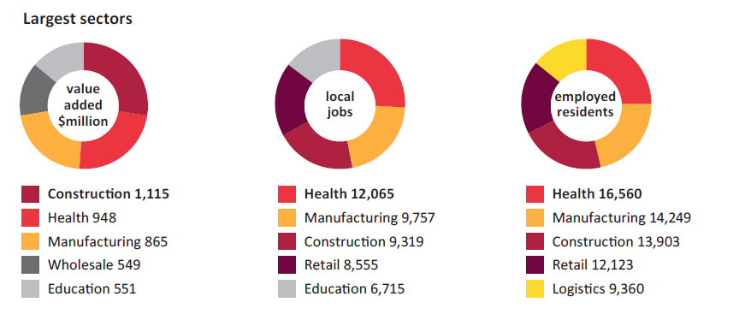

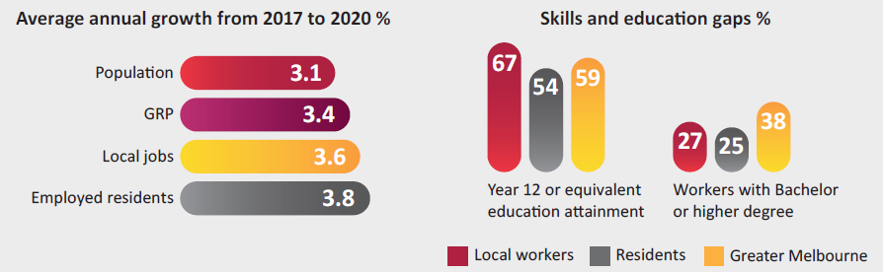
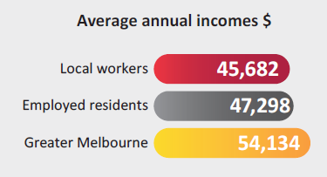

Place overview

Bundoora
- 6,702 local jobs
- Unemployment 9.3%
- Highest rate of tertiary education completion at 24.8% of population

Donnybrook
- Unemployment 4.0%
- Population expected to grow to 37,380 (1,565% increase) by 2035

Doreen
- 3,056 local jobs
- Unemployment 5.1%
- Highest median household income at $1,801 p/w
- Highest labour force participation (74.5% of residents 15+)

Epping
- 16,681 local jobs
- Unemployment 8.8%
- Population expected to grow to 21,249 (32.8% increase) by 2035

Epping North – Wollert
- 792 local jobs
- Unemployment 7.2%
- Development tipped to increase by 49% by 2035, population expected to grow to 81,542 (214% increase) by 2035

Lalor
- 3,324 local jobs
- Unemployment 9.5%
- 65.5% of residents 15+ speak a language other than English at home
- Median household income $1,102 p/w

Mernda
- 1,635 local jobs
- Unemployment 6.0%
- No. of residential dwellings to increase by 78% by 2041

Mill Park
- 6,395 local jobs
- Unemployment 7.0%

South Morang
- 4,134 local jobs
- Unemployment 6.3%

Thomastown
- 17,306 local jobs
- Unemployment 10.1%
- 68.3% of residents 15+ speak a language other than English at home
- Lowest median household income at $1,020 p/w

Whittlesea Township
- 2,154 local jobs
- Unemployment 3.8%
- Highest median age at 40yo

Challenges facing our economy
COVID-19 The pandemic has caused job losses and accelerated other changes in the local economy.
Jobs deficit There are 44,500 more locals participating in the workforce than there are local jobs.
Gender inequality There is a gender pay gap of -30 per cent across the municipality. This compares to a gap of only -1 per cent across City of Whittlesea staff.
Economic inequality There is a large discrepancy in incomes and skills between established areas and new growth areas.
Barriers to participation There are several vulnerable groups who face barriers to higher participation rates.
Diversifying the industry base 41 per cent of all local employment is generated in the health, construction and manufacturing sectors.
Climate change and waste Continuing changes to weather patterns will have impacts on business productivity, production costs and equipment damage.

Unequal outcomes
There are large spatial differences in terms of the socio-economic profile of residents in the City of Whittlesea. This means that the economic challenges vary from location to location.
Established areas like Thomastown, Lalor and Epping, are older, have lower incomes and are less skilled. These areas have a relatively high share of non-English speaking households and have a higher proportion of single parents which are more likely to be exposed to economic hardship.
In contrast, growth areas like Doreen and Mernda, are attracting a different demographic, with higher incomes and higher skill levels. These areas are located further away from highly skilled jobs. They also have a relatively large share of people who provided unpaid childcare.

Increased local employment

Why is this important?
The City of Whittlesea must increase local jobs to satisfy the needs of a rapidly growing residential population from a diverse range of backgrounds and skill levels.
What the community told us
32 per cent of people want a greater number and diversity of job opportunities closer to home.

“More job opportunities so people can stay within their municipality, creating ownership and connection within the area they reside.”

Jobs deficit
There are more resident workers than local jobs and this gap is increasing. In 2020, there were 72,045 jobs in the City of Whittlesea. Each year the community welcomes 8,300 new residents, but only creates 2,300 more jobs.
Jobs and skills mismatch
In 2016, 70 per cent of local residents worked outside the City of Whittlesea. Some workers are clearly trading off proximity for affordability or lifestyle, while others have no choice but to commute to access jobs that suit their qualifications.
In 2016, around 50 per cent of local jobs were performed by workers from outside the area.
Underemployment also appears to be a concern given the increase in the City of Whittlesea’s part-time resident workforce between 2011 and 2016.
Commuter impacts
The shortfall in jobs and mismatch has added to the commuter population with around 1 in 5 resident workers travelling into inner Melbourne every day for work. Some residents may be attracted by higher paying jobs outside the municipality. Of those residents working within the municipality, only 20% are earning more than $65,000 per year, compared to 33% of those working elsewhere.
Gender inequality1

Women trade their careers and financial independence for lower skilled / paid jobs close to home, to be available for caring responsibilities. In contrast, men trade their caring responsibilities and time with their families for long days with long commutes to maintain their careers. (Gender Equity in Employment Report)
There is a persistent pay gap between men and women which continues to limit the economic potential of the City of Whittlesea. In 2017/18, women living in the City of Whittlesea earn only 70 per cent of what men do (30 per cent pay gap), a greater discrepancy than the Australian national figure of 86 per cent (14 per cent gap).
The gender equality issues also vary across locations. For women living in Doreen, childcare responsibility is a contributing factor behind unemployment. While in
Thomastown, issues such as language difficulties and car ownership are contributing factors. 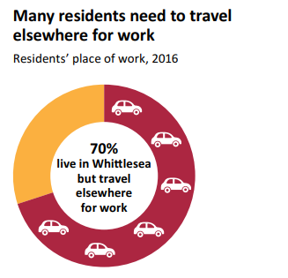
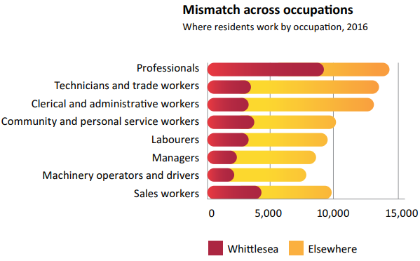

COVID-19 impact on employment
Some of the acute impacts COVID-19 is having on employment include:
Job losses
The number of jobs fell by 3,000 in the June Quarter 2020.
Increased barriers to participation
The pandemic has exacerbated insecure employment, financial insecurity, heightened occupational risks for essential workers and increased isolation and domestic violence.
Remote working
An increase in remote working may benefit the City of Whittlesea’s large female workforce who are highly educated and unable to find equivalent work close to home.

Online shopping
5.2 million households shopping online in January 2021, a 44 per cent increase compared to the year before. This is particularly relevant given retail is our fourth largest employer.
1 The City of Whittlesea recognises that the LGBTIQA community are not adequately represented in the Australian Government Census or other economic data sources, and, as a result, in this strategy. The City of Whittlesea is incorporating questions related to sexual orientation, gender identity and intersex variations in its direct data collection through the annual household survey, and commits to utilising more representative data when it becomes available.

Achievements to date and current activities
- Developed the Investment Prospectus and the first Investment Attraction Plan to attract businesses and create more local jobs
- Launched the Explore Whittlesea website and social media channels to promote the City of Whittlesea as a tourist destination, highlighting the City’s attractions, events and hospitality
- Delivered an advocacy campaign for a North and West City Deal with partners
- Contributed to the Economic Development Strategy vision of 10,000 new jobs
- Established our Social Procurement Policy and Council’s Local Supplier Database
- Prepared planning scheme amendments and master planning for major employment areas and activity centres
- Establishment and review of the Priority Development Assessment planning application process
- Establishing Council’s Inclusive Employment Program
- Developing an economic participation plan
- Participating in the Jobs Victoria Jobs Advocates program.

Priorities for action
Investment attraction
In 2021, Council endorsed the Investment Attraction Plan 2021-2026. Council is focused on attracting new investment to the city and supporting further investment by existing businesses to create more local job opportunities for local residents.
Agriculture
Today, Agriculture generates $51 million in economic activity (value added). A range of agribusiness related opportunities have been identified to take advantage of the region’s productive and viable farming land, proximity to major regional transport and infrastructure and access to recycled water.

Diverse natural, cultural and landscape values
The City of Whittlesea has several nature-based, heritage and recreational assets. There are already a range of tourism offers including cellar doors, cafes and restaurants, wildlife, tourism destinations (e.g. Funfields), and events such as the Whittlesea Country Music Festival and Whittlesea Agricultural Show.
Future opportunities have also been identified to harness our diverse natural and cultural assets, and promote representation of these assets in our visitor economy.
These include the Regional Sports and Aquatic Facility at Mernda, and the Quarry Hills Regional Parkland and proposed Aboriginal Gathering Place.
Community Wealth Building – celebrating benefits of local employment
As part of a Community Wealth Building approach, opportunities exist for large institutions such as Council to promote positive employment and enterprise practices.
Council directly supports more inclusive economic participation outcomes through our social procurement practices and our Inclusive Employment Program. By encouraging other large employers and businesses in the municipality to adopt the same approach, developing an economic participation plan and supporting the Victorian Government’s Job Advocates program, we can also help to enrich opportunities for disadvantaged groups identified within our municipality.

Education opportunities for all

Why is this important?
Residents of the City of Whittlesea must have the skills to adapt to the changing future needs of business to ensure a prosperous future for all.
What the community told us
Our community wants diverse employment pathways and opportunities for skills development and training, especially for young people and people who are long- term unemployed.
Lower education and skills
The City of Whittlesea overall has a lower proportion of residents with qualifications than the average for Greater Melbourne.
Most future jobs are expected to require post-school qualifications. The City of Whittlesea currently has a large skills gap compared to Greater Melbourne.
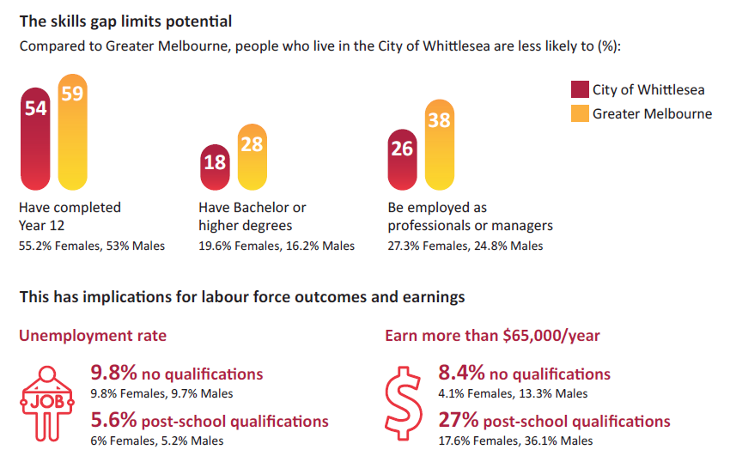

Barriers to participation
Five key population groups do not have equal access to employment or pathways to employment.
Aboriginal and Torres Strait Islander people
Unemployment rate (11.7 per cent) in 2016 was higher than the City of Whittlesea average (7.2 per cent)
Culturally and linguistically diverse people
44 per cent of people spoke a language other than English at home in 2016, well above the Greater Melbourne average (32 per cent)
People with a disability
Working-age people with a disability were 2.4 times more likely to be unemployed (17 per cent) than people without a disability (7.2 per cent)
Young people
Youth disengagement (not earning or learning) in Whittlesea was 1.3 times greater than in Greater Melbourne in 2016
Women
Women were more likely to be unemployed, work part-time, earn less with a tertiary education, undertake unpaid childcare and rely on jobs closer to home

COVID-19 impact on education
Some of the acute impacts COVID-19 is having on education include:
International education
Australia’s education industry is the largest service-based export.
Border closures reduce the inflows of international students and spending.
Online education
From pre-school to university, education providers have been forced to adapt to increased teaching online.
Increased digitisation and automation
To remain competitive, businesses and education providers in the City of Whittlesea will need to reskill and upskill workers for the digital transformation.

Achievements to date and current activities
- Supported the establishment of the Melbourne Polytechnic Food Incubator to support our growing food sector
- Established an ongoing partnership with Whittlesea Youth Commitment and other service providers to support young people
- Partnership with Melbourne Polytechnic, Whittlesea Community Connections and Yarra Valley Water to investigate local food and farming opportunities at the Whittlesea Community Farm and Food Collective
- Continue to support the Whittlesea Tech School, hosted by Melbourne Polytechnic, a high-tech learning centre and community hub to engage with science, technology, engineering, arts and mathematics
- Partnership with Deakin University to define regenerative agricultural practices and produce best practice regenerative agriculture case studies
- Facilitating employment training and support services.

Priorities for action
Growing population and skill base
Population growth has been a major driver of the City of Whittlesea’s economy over the past decade with an average of 4.5 per cent per year. This growth has increased local expenditure, driving demand for local services and increasing the skills profile in the City of Whittlesea.
Highly skilled multicultural community
The City of Whittlesea has a strong multicultural resident base. In 2016, 35.5 per cent of residents stated they were born overseas, and 44 per cent spoke a language other than English at home. These residents are also highly skilled. In 2016, 46 per cent of recent overseas arrivals in the City of Whittlesea had a tertiary education, well above the City of Whittlesea’s general population average of 28 per cent.

The rise of knowledge workers
Knowledge-based jobs require more cognitive skills and rely on non-routine work. These jobs are difficult to automate, often requiring creativity, problem solving and/or human presence e.g. child care.
Improving the education and qualification levels is key for lifting participation and employment levels, as well as increasing the attractiveness of the municipality to new businesses.

Successful, innovative local businesses

Why is this important?
The City of Whittlesea must have a competitive business environment to retain and attract investment and create the jobs we need to support the rapidly growing community.
What the community told us
47 per cent of community survey respondents want us to help local businesses grow through initiatives such as grants, incentives and marketing support.
Diversifying the industry base
The City of Whittlesea has 17,297 businesses in 2020. The three largest industries by employment are Health care and social assistance, manufacturing and construction.
City of Whittlesea’s local jobs market is primarily focused on the provision of household services such as health, construction and retail. In 2019/20, nearly 41 per cent of local employment was in these three fast-growing industries.
However, business services, such as architects, engineers, tax professionals, accountants, lawyers and computer programmers, are under-represented. 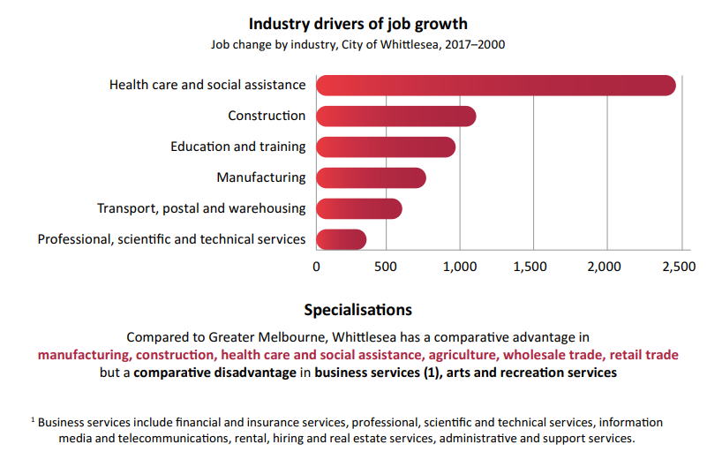
Supporting sectors undergoing transition
Technological and consumer-based change places some industries at risk of further job losses, especially manufacturing, retail trade and agriculture.
Enhancing local entrepreneurship
In the City of Whittlesea, around half of workers are employed by small businesses (i.e. less than 20 employees).
The City of Whittlesea has experienced much slower growth in micro businesses with 1-4 employees and larger businesses with more than 200 employees.
Climate change

The municipality will continue to be affected by climate change impacts of rising temperatures, more frequent, intense and longer heatwaves, decline in rainfall and longer, more extreme fire seasons. (City of Whittlesea, 2021b)
These changes will impact health outcomes, natural assets, built infrastructure and essential services.
Economic productivity will be impacted, with supply chain disruption, asset and equipment damage and increased production costs. The industries of health and social services, manufacturing, construction and agriculture are expected to be most affected.

COVID-19 impact on business
Some of the acute impacts COVID-19 is likely to have on business include:
Slower economic growth
Economic growth is likely to be slower than forecast due to a range of factors, including slower population growth.
Supply chain disruption
Major global supply chain disruption has impacted manufacturing and delivery times. However, this leads to emerging local manufacturing opportunities to address supply chain weakness.
Business resilience and adaptability
41 per cent of Australian businesses surveyed by the ABS in April 2021 had changed the way they provide products and services, 39 per cent changed suppliers and 31 per cent changed the type and range of products or services.
Nature based / outdoor tourism
The COVID-19 pandemic has seen people seeking travel and outdoor experiences closer to home due to the uncertainty of border restrictions and requirements.

Achievements to date and current activities
- Established the Business Advisory Panel to enable our business community to provide advice, insight and feedback to Council on key initiatives
- Introduced the Business Concierge Service to streamline the permit approvals for small businesses
- Launched the Whittlesea Localised online platform to encourage business-to-business engagement and transactions
- Delivery of the Ignite start up program and series of events supporting start-ups and entrepreneurs
- Delivery of the Business Pandemic and Recovery Support Programs including a $450,000 Business Assistance Grants Program for more than 100 businesses
- Development and implementation of the Visitor Economy Marketing Plan and campaigns
- Worked with the local business community to provide promotional support through shop local campaigns
- Supported local businesses in response to the pandemic through educational webinars, business development programs and networking events
- Designed and constructed streetscape improvements to Lalor Shops and Rochdale Square
- Established the Vacant to Vibrant program, matching vacant shops with prospective business owners
- Commencement of the Shopfront Improvement Program
- Support food and hospitality businesses through the State Government’s Outdoor Eating and Entertainment, Outdoor Activation and Local Government Business Concierge and Hospitality Support programs
- Supported businesses financially through the Economic Development Community Grants Programs
- Established partnership with Deakin University to investigate agricultural opportunities in the municipality through the production of a Land Capability Assessment
- Developing a Circular Economy Action Plan
- Advocacy for the development of key activity centres and employment precincts
- Refreshing the Epping Central Structure Plan
- Advocating for the improved NBN and mobile infrastructure
- Establishing a Whittlesea Business Network.

Priorities for action
Circular and green economy
The transition to a circular economy will see governments dedicate significant investment towards innovative solutions that reduce emissions and waste. The City of Whittlesea can support this transition and harness funding opportunities through:
- Activities and investment at the Cooper Street West Waste and Resource Recovery Hub;
- Existing strengths in advanced manufacturing, education and training, food production and processing;
- The City of Whittlesea’s commitment to zero net emissions.
These strengths will provide opportunities for local job creation and drive local investment in technology, resource efficiency and adoption of low emission approaches to doing business.
Industry specialisations as a comparative advantage
Specialisations make the City of Whittlesea’s economy unique, and will drive where investment can work with future growth. The following opportunity sectors have been identified:
- Health Care and Social Assistance
- Wholesale Trade (including Melbourne Market – Fresh Food Wholesale Trade)
- Manufacturing (including Food Manufacturing)
- Electricity, Gas, Water and Waste Services (including waste recycling services)
- Construction
- Education and Training (including Tertiary Education)
- Transport, Postal and Warehousing
- Retail Trade.
Other proposed projects and partnerships which will have a direct impact on jobs in the City of Whittlesea including the Melbourne Food Innovation and Export Hub (MFIX) in Epping.
Leveraging infrastructure investment
Major infrastructure projects identified for Melbourne’s north and west would deliver unprecedented investment in the region. Major projects committed to or identified include Melbourne Airport Rail Link, North East Link, Suburban Rail Loop, Melbourne Metro 2, the Beveridge Intermodal Freight Terminal, Wollert Rail, Wallan Rail Electrification and the Outer Metropolitan Ring Road / E6.
These are expected to significantly improve the economic performance of Melbourne’s North and West, providing multiple opportunities for the City.

Importance of competitive precincts
The shift to knowledge jobs has also led to a substantial shift in the geography of jobs, with a concentration of a disproportionate share of economic activity in a handful of economic regions with strong job density. The development of successful employment precincts will be critical to the success of the City of Whittlesea.
Innovation and start-ups
In the past decade, there has been strong growth in tech-based start-up businesses. They grow quickly and through applying digital applications, decreased barriers to entry, abundance of skilled labour, and where available, supply of low-rent office space (e.g. co-working spaces). Further support for start-ups can assist this important source of innovation and jobs creation.
Community wealth building
Encouraging re-investment in the local community improves local spending power, local ownership of economic decision-making, and social enterprise outcomes. Council can demonstrate these practices and encourage local businesses to do the same.

Making it happen

The Action Plan clearly outlines the actions Council is committed to delivering and how we will track our performance over time.
It is also hoped the Action Plan can help to facilitate and strengthen our productive relationships with key stakeholders.

Action Plan
The Strong Local Economy Strategy will be delivered through implementation of:
- The Strong Local Economy Action Plan: An Action Plan that sets out a series of tasks for each key direction outlined in this strategy.
- Investment Attraction Plan 2021-26: A plan which outlines Council’s existing commitments to grow investment and employment over the next five years.
An Action Plan for each year of the strategy will be released annually in line with Council’s Community Plan and annual budget processes.

Monitoring our economy

Council has prepared an evaluation framework to monitor the trends and performance of the local economy.
The indicators below will help us to track the health of our economy and progress towards the outcomes identified in this Strategy. They have been nominated with consideration of access to regular, accurate data.
Council will continue to monitor these indicators and will work with other levels of government as well as partners in the private and not-for-profit sectors and our broader community to influence these indicators for the better.
All indicators will be monitored looking at differences across age, sex and key population groups, focusing on Aboriginal and Torres Strait Islander people, Culturally and Linguistically Diverse Communities, people with
a disability and young people, and will be compared against State and other local government area averages.

Key direction 1: Increased local employment
- Increase in the number of medium and large businesses
- Increase in number of local jobs
- Decreased unemployment rate
- Increased investment in key commercial and industrial areas
- Increase in value of building approvals, residential and non- residential.

Key direction 2: Education opportunities for all
- Increased enrolment across higher educational programs
- Increased access to library facilities and services
- Increased number of local qualified workers in local jobs
- Increase in education and training programs reflective of local industry needs.
- Increase in small employing businesses
- Decrease vacancy rates in key commercial industrial areas
- Increased availability of land for investment
- Increased adoption of circular economy principles and practices
- Increased NBN and mobile phone coverage and network capacity
- Increase local and international export as a share of Gross Regional Product (GRP).

Sources
p. 10, Sources: NIEIR, ABS Census of Population and Housing 2016, ABS Regional Population, Department of Education Unemployment rate: ABS September 2021 Labour force survey
p. 11, Sources: NIEIR, ABS Census of Population and Housing 2016, ABS Business Counts and Exits, ABS Regional Population
p. 12, Source: ABS Census of Population and Housing 2016 pp. 14–15, 22, Source: NIEIR, 2020
p. 18, Source: ABS, 2016
p. 19, Source: ABS Census of Population and Housing, 2016

Glossary
Aboriginal – Throughout this document, the term ‘Aboriginal’ is taken to include people of Aboriginal and Torres Strait Islander descent. ‘Aboriginal’ is used in preference to ‘Indigenous’, ‘First Nations’, and ‘Koori’.
Circular economy – a model of production and consumption, which involves sharing, leasing, reusing, repairing, refurbishing and recycling existing materials and products as long as possible.
Climate change – a change in global or regional climate patterns attributed largely to the increased levels of atmospheric carbon dioxide produced by the use of fossil fuels.
Deficit – A deficit is synonymous with a shortfall or loss and is the opposite of a surplus.
Economic inequality – refers to the disparities in income and wealth among individuals in a society.
Economic participation – an individual’s engagement in work and/or education, and their access to economic resources that results from such participation.
Entrepreneur – a person who sets up a business or businesses, taking on financial risks in the hope of profit.
Gender inequality – social process by which people are treated differently and disadvantageously, under similar circumstances, on the basis of gender.
Green economy – defined as low carbon, resource efficient and socially inclusive. Growth in employment and income are driven by public and private investment into such economic activities, infrastructure and assets that allow reduced carbon emissions and pollution, enhanced energy and resource efficiency, and prevention of the loss of biodiversity and ecosystem services.
Inclusive employment – efforts that promote fair and equitable access to decent employment, ensuring satisfactory pay and conditions, career prospects and opportunities for social integration.
Innovation – a new idea, method, or process applied in a research or business setting.
Remote working – the practice of an employee working at their home, or in some other place that is not an organization’s usual place of business.
Skills gap – a mismatch between the skills that employers need and the skills that job seekers possess.
Start-up – a company or project undertaken by an entrepreneur to seek, develop, and validate a scalable business model.

References

General
Australian Federal Government 2020, Economic Recovery Plan for Australia 2020/21
Australian Federal Government 2021, Planning Australia’s 2022-23 Migration Program Discussion Paper
Victoria State Government 2021, Department of Education and Training Strategic Plan 2021 – 2025 Victoria State Government 2020, Jobs Plan 2020 – 2021

Increased local employment
City of Whittlesea 2015, Aboriginal Reconciliation Policy
City of Whittlesea 2016, Road and Public Transport Plan: Responding to the challenges of travel and transport in the City of Whittlesea
City of Whittlesea 2018, Gender Equity in Employment Project Report 2018-2020
City of Whittlesea 2020, Financial Vulnerability Advocacy and Action Plan 2020-2022
City of Whittlesea 2021, Investment Attraction Plan 2021-2026
City of Whittlesea 2021, Investment Prospectus: The right place for business 2021
City of Whittlesea, Investment Attraction Plan 2021-2026 City of Whittlesea 2017, Disability Action Plan 2017-2021
City of Whittlesea 2017, Economic Development Strategy 2017-2021: Growing our economy together
City of Whittlesea 2017, Stretch Reconciliation Action Plan July 2017-September 2020
City of Whittlesea 2020, Whittlesea 2040: COVID 19 Impacts
City of Whittlesea 2020, Whittlesea 2040: What our Community Wants for the Future
City of Whittlesea 2021, Community Engagement Report June 2021
City of Whittlesea 2021, Economic Development Strategy Review May 2021
SGS Economics and Planning 2018, Whittlesea 2040: Background Paper
SGS Economics and Planning 2020, Community Wealth Building in Australia: A New Focus for Regional Economic Development
Victoria State Government 2020, Gender Equality Act 2020 (No.5 of 2020)

Education for all
City of Whittlesea 2017, Lifelong Learning Policy 2017
City of Whittlesea 2018, What our community wants for the future City of Whittlesea 2018, Whittlesea 2040: A Place for All
City of Whittlesea 2021, Community Plan 2021-2025
City of Whittlesea 2021, Strengthening the Local Economy by Expanding Economic Participation 2021
NORTH Link 2015, The Future Workforce: Melbourne’s North
City of Whittlesea 2014, Multicultural Policy Statement and Principles

Successful and innovative local businesses
City of Whittlesea 2012, Environmental Sustainability Strategy 2012-2022
City of Whittlesea 2020, COVID-19 Business Impact Survey Final Report Nov 2020
City of Whittlesea 2021, Municipal Pandemic Readiness and Recovery Plan City of Whittlesea 2021, Rethinking Waste Plan 2021-2030
City of Whittlesea 2021, Thrive Social Enterprise Benchmarking Project City of Whittlesea Planning Scheme
NORTH Link 2020, North & West Melbourne City Deal Plan 2020-2040 Victoria State Government 2019, Cooper Street Waste and Recovery Hub Plan
Victoria State Government 2020, Melbourne Industrial and Commercial Land Use Plan
Victoria State Government, Draft Northern Metro Land Use Framework Plan City of Whittlesea 2011, Green Wedge Management Plan 2011-2021
City of Whittlesea 2014, Tourism Strategy 2014-2019
City of Whittlesea 2015, Arts Policy 2015
City of Whittlesea 2016, Arts Development Strategy 2016-2020
City of Whittlesea 2018, Thomastown Industrial Area Plan 2018-2038
Victoria State Government 2017, Renewable Energy Action Plan
Victoria State Government 2017, Victorian Renewable Hydrogen Industry Development Plan
Victoria State Government 2020, Recycling Victoria: A new economy

Contact us
Council Offices
25 Ferres Boulevard South Morang VIC 3752
Email: info@whittlesea.vic.gov.au
Website whittlesea.vic.gov.au
Postal address
City of Whittlesea Locked Bag Bundoora MDC VIC 3083
Phone: 9217 2170
National Relay Service: 133 677
(ask for 9217 2170)
Connect with us in your preferred language 131 450

