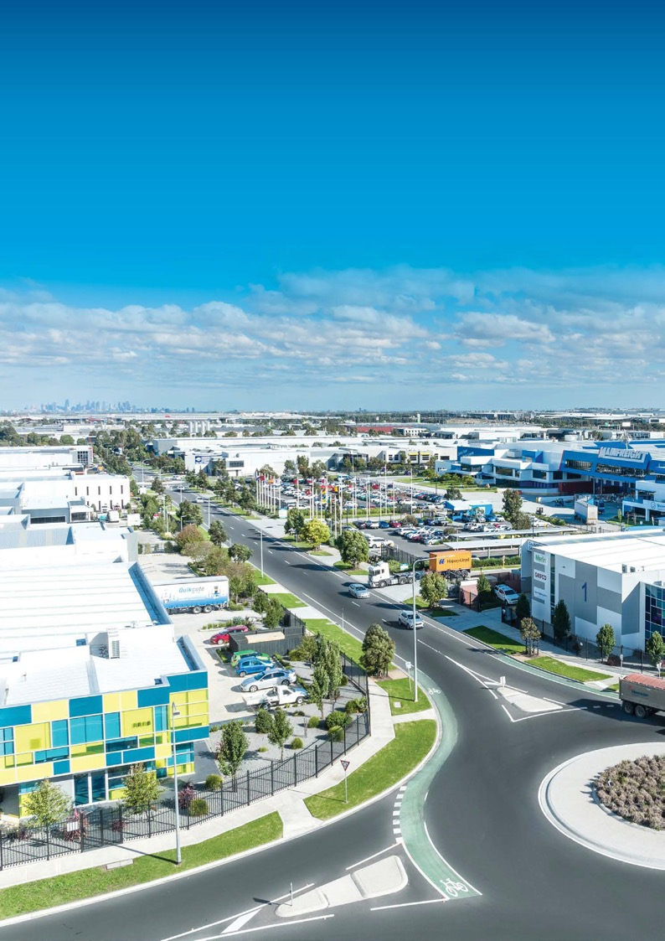

Investment Prospectus
Partner to Prosper

Cooper Street Employment Area, Epping

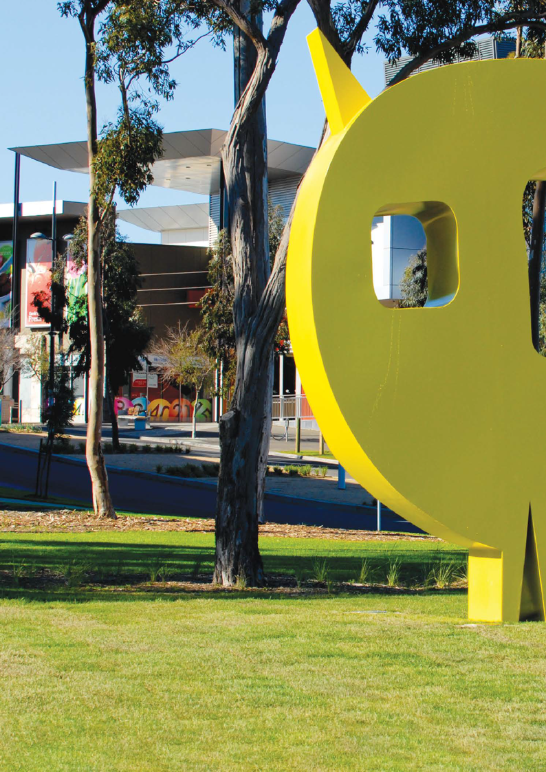

University Hill, Bundoora

Welcome
The City of Whittlesea is committed to building a robust and economically valuable investment environment where our local businesses, partnering organisations and residents will thrive.
We achieve this by being:
A Supportive City
Empowering our local businesses to rise above challenges and innovate
1
A Proactive City
Going one step further to make things happen without unnecessary barriers
2
A Forward-Thinking City
Creating jobs and valuable opportunities now and into the future
3

Located in Melbourne’s North, the City of Whittlesea is one of Melbourne’s largest and fastest growing municipalities. Covering a land area of 489 square kilometres, the City of Whittlesea population is projected to grow by more than 124,000 new residents between 2022 and 2040, in the Top 10 fastest growing Local Government Areas in
Australia *.
Proximity and access to Melbourne’s Central Business District (CBD), strong population growth, key sector strengths and availability of developable land act as secure and significant drivers for economic growth now and into
the future.

Developing a strong local economy is a key goal of our ‘Whittlesea 2040’ vision. Our ‘Investment Attraction Plan 2021-2026’ and ‘Strong Local
Economy Strategy 2022-2026’ outline the initiatives and actions we are co-ordinating across Council to ensure that our local economy will continue to grow and prosper. We are excited about our work with our Business Advisory Panel which gives us valuable insight from local Business leaders to enhance our decision making. Our ‘Business Network’ initiative offers local businesses the opportunity to cultivate important business-to-business relationships and our annual Business Network Awards which recognise outstanding local businesses.

*based on 10 years average growth

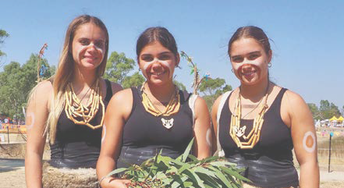
Djirri Djirri Dance group

The Wurundjeri Willum people were the original inhabitants of the area and are the traditional owners of this land. The City of Whittlesea is home to the second highest population of Aboriginal and Torres Strait Islander people in Melbourne. Many street and location names across the City of Whittlesea were inspired by Wurundjeri culture and traditions including Bundoora, Mernda and Wollert.

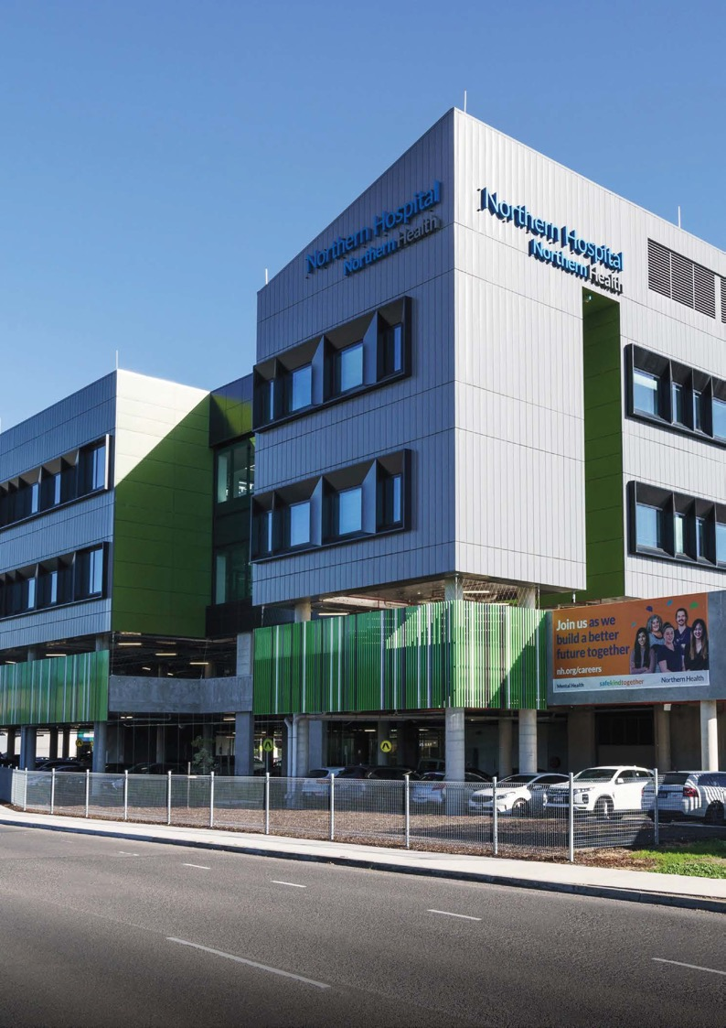

Northern Hospital, Epping

Connectivity

Positioned in Melbourne’s North, the City of Whittlesea offers a
strategic and central location to trade locally, nationally and internationally.
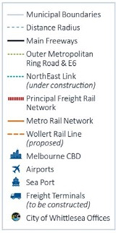
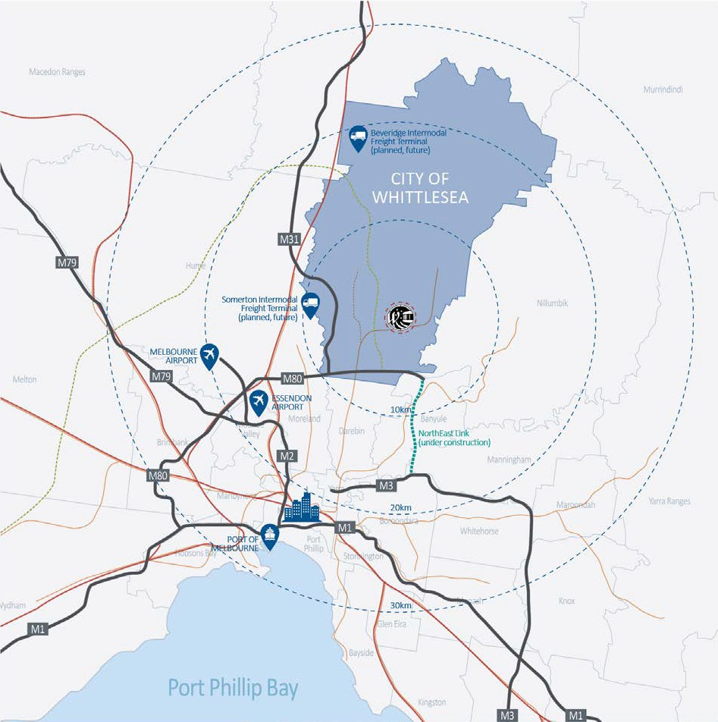
Easy access to:
- Melbourne Central Business District – 25 mins
- Melbourne International Airport – 20 mins
- Essendon Airport – 25 mins
- Port of Melbourne – 35 mins
- National Road Network – direct access to eastern seaboard via Hume Freeway (M31), Metropolitan Ring Road (M80), and west via Calder Freeway (M79)
- Metro Trains to CBD – running from 8 stations every 20 mins on weekdays
- National Rail Network
- Beverage Intermodal Freight Terminal (planned, future)
- Somerton Intermodal Freight Terminal (planned, future)
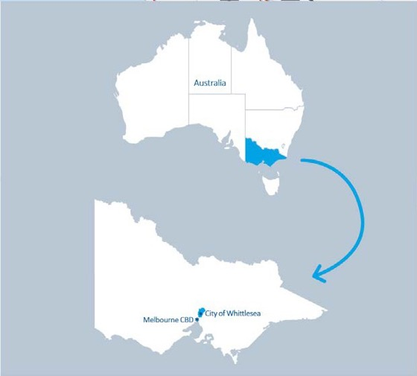

Competitive advantage

Connectivity

Local

CBD
40 MINS by train
Metro Trains to CBD from 8 stations
25 MINS by road

National
  - Travel/travel routes – Hume Freeway (M31), Metropolitan Ring Road (M80),
west via Calder Freeway (M79)
  - Direct access to:
Beveridge Intermodal Freight Terminal (planned, future)
Outer M80 Metropolitan Ring Road/E6 (proposed), North East Link (under construction)

International
  - Melbourne International Airport – 20 mins
  - Port of Melbourne – 35 mins

Detailed information available at: https://economy.id.com.au/whittlesea

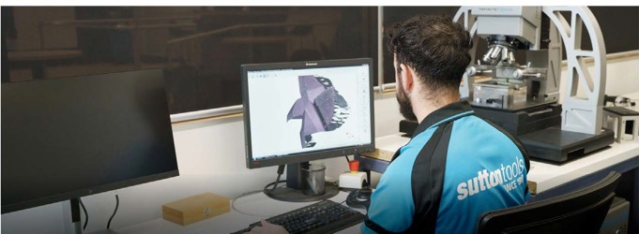
Sutton Tools, Thomastown

Strong population and economic growth

238,004

residents in 2022
- 355,144 predicted by 2040
- Born overseas – 37.5%
- Median age – 35 years
- Own/purchasing home – 69.7%

Population Growth Forecast

Our Economy
(2022)

21,617
Businesses

77,893
Local jobs
$10.39 billion
GRP
(4.95% increase on previous year)

2022/2023
Greater Melbourne – 1.97%
City of Whittlesea – 2.59%

Key opportunity sectors

Health Care and Social Assistance
- Home to the Northern Hospital, Northpark Private Hospital and the new Northern Private Hospital (under construction), Mernda Community Hospital (under construction).
- Home to RMIT University Bundoora Campus and Northern Centre for Health Education Epping Campus.
- Proximity to Austin Biomedical Alliance Precinct and La Trobe University Bundoora campus.

Food and Beverage (including manufacturing and wholesale trade)
- Melbourne Wholesale Fruit, Vegetable and Flower Market (estimated $2 bn produce sold annually).
- Proposed Melbourne Food Innovation and Export Hub (MFIX) at Epping.
- RMIT University’s Food Research and Innovation Centre.
- Melbourne Polytechnic’s School of Food, Plant and Animal Industries.
- Proximity to La Trobe AgriBio Centre.

Electricity, Gas, Water and Waste
- State significant waste and resource recovery facilities at Wollert and Cooper Street West.

Transport and Logistics
- Direct access to major transport routes to Australian eastern Seaboard via the Hume Freeway ideal for logistics hubs.
- Future Beveridge Intermodal Freight Terminal (BIFT) (planned).

Advanced Manufacturing
- Supported by strong established manufacturing base, education institutions and Melbourne’s North Advanced Manufacturing Group.
- Growing and skilled local workforce.

Employment centres and employment land supply

State Significant Metropolitan Activity Centre
Epping, Lockerbie (future).

Major Activity Centres at South Morang | Plenty Valley, Mernda, Wollert (future).

Northern State Significant Industrial Areas
Epping and Thomastown offer industrial and commercial opportunities – established, developing and in renewal.
Small, Medium and Large Commercial and Industrial Offerings Turnkey, design and construct or clear lots available in a range of sizes for lease and sale.

Industrial Land Supply
Zoned vacant and future land supply available in Epping, Wollert, Donnybrook, and Beveridge.
328.1 hectares – zoned, vacant
(26% of North Region)
1,642.3 hectares – future supply
(57% of North Region)
(reference: MICLUP part b, table 18)

The City of Whittlesea has proven itself as a robust municipality by achieving a 4.95% increase in Gross Regional Product in FY21/22. With rapid population growth and a pipeline of opportunities that will come over time, along with critical infrastructure available and planned to activate and facilitate growth, the City of Whittlesea offers excellent commercial and industrial growth potential.
From our Priority Development Assessment Process to our Business Concierge Service, Business Advisory Panel and commitment to buy local policy, we are motivated and working hard to support our partners to capitalise on the municipality’s strengths.

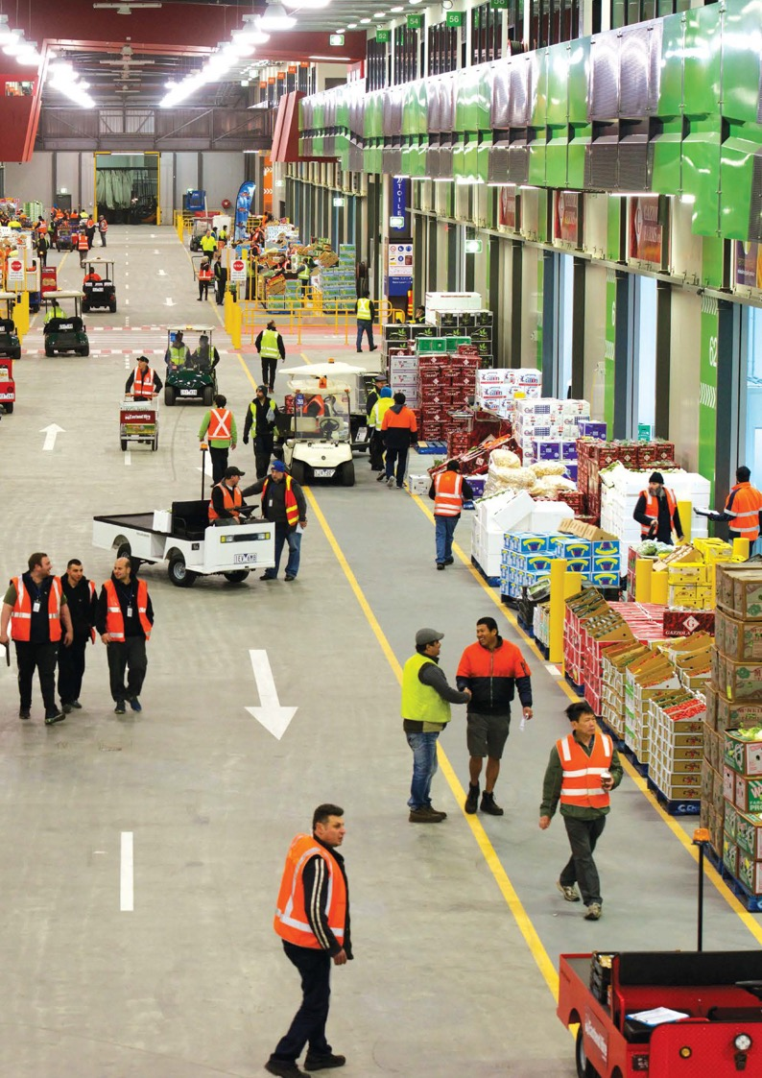

Melbourne Wholesale Fruit, Vegetable and Flower Market, Epping

Industry focus
The City of Whittlesea is home to a number of established, leading and
emerging sectors anchored by industry clusters and state government prioritisation. Leverage the established infrastructure and supply chains to grow your business.

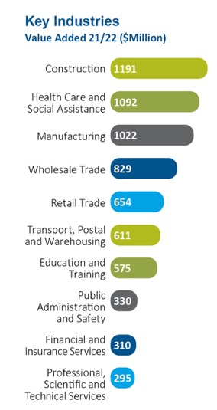
Total value add:
$8.21B

21/22

Top 5 employers by sector 21/22

Healthcare and Social 16.7%
Construction 13.5%
Retail Trade 11.6%
Manufacturing 10.7%
Education and Training 9.3%

International Exports in 21/22 Total International exports $804.3m
36.40% Food Product Manufacturing
27.79% Wholesale Trade
10.58% Transport, Postal and Warehousing
7.39% Textile, Leather, Clothing and Footwear Manufacturing
7.16% Machinery and Equipment Manufacturing

Detailed information available at: https://economy.id.com.au/whittlesea

Industry Opportunities
Significant potential to facilitate advancement of state priority sectors:
- Healthcare and Social Assistance
- Tertiary Education
- Food and Beverage
- Professional Services
- Manufacturing
- Waste Recovery and Reuse Advanced Manufacturing
- Financial and Insurance
- Logistics, Wholesale Trade Services and Distribution
- Professional, Scientific and Medical Technologies
- Technical Services and Pharmaceuticals

Key activity centres
The City of Whittlesea offers business a strategic location that unlocks potential now and into the future.

Commercial and Retail
Industrial

State Significant Industrial Areas
Epping – established, developing and renewal Thomastown Industrial Area – established
Beveridge Intermodal Freight Terminal (BIFT) – planned, future

Regionally Significant Industrial Areas
Wollert – vacant, zoned
Shenstone Park, Donnybrook – vacant, zoned

State Significant Commercial Areas
Epping Metropolitan Activity Centre – established and renewal Lockerbie – planned, future

Major Activity Centres
Plenty Valley Town Centre, South Morang – established and developing University Hill, Bundoora– established and developing
Wollert – future, zoned Mernda – developing, zoned

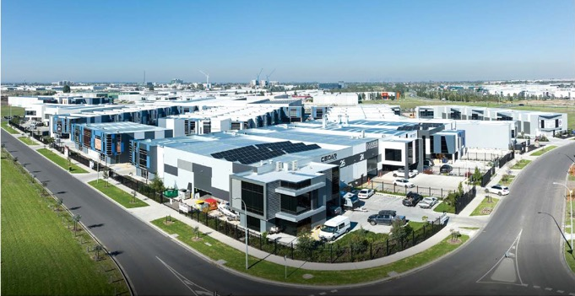

ConnectNorth Business Park, Cooper Street and O’Herns Road Employment Precinct

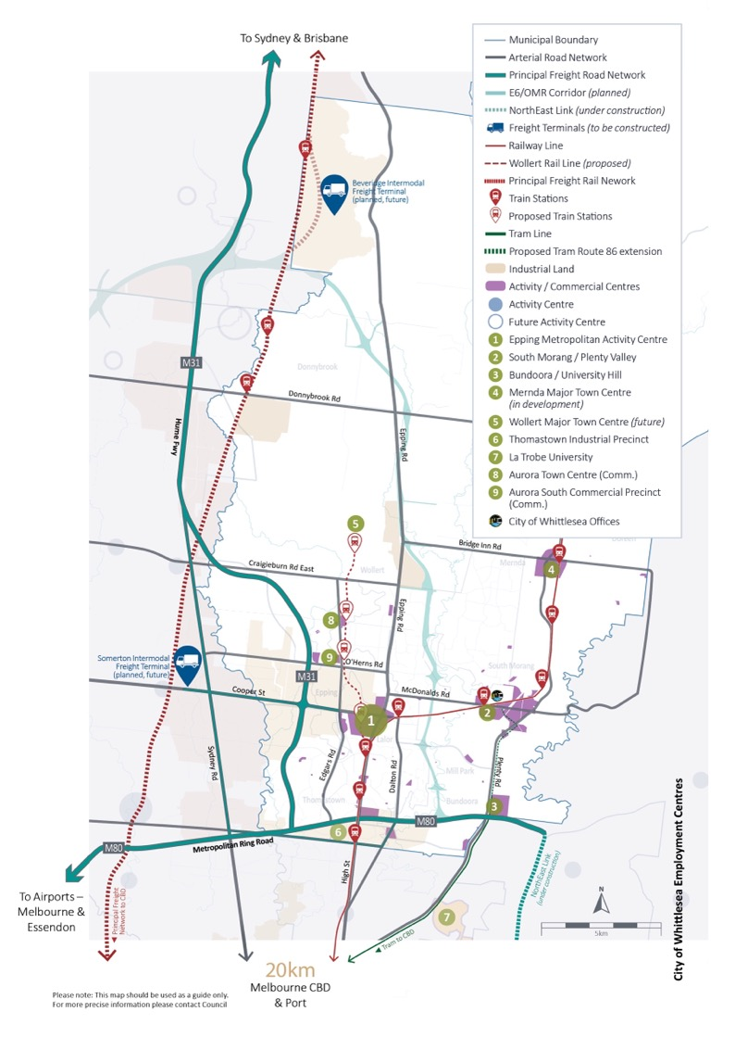
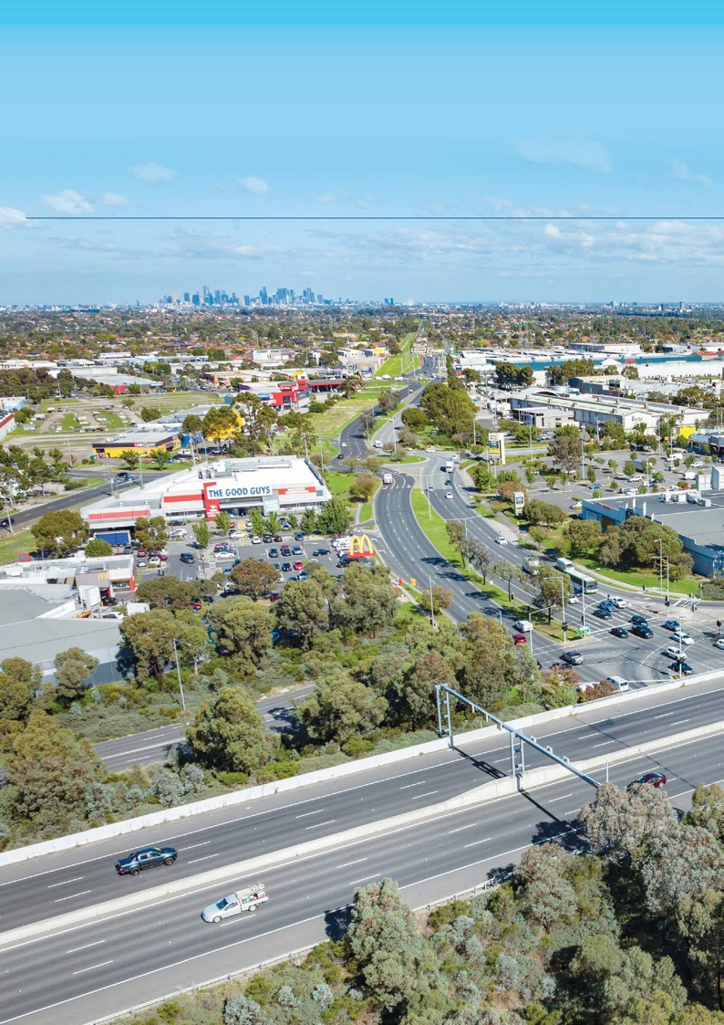

Investment opportunities
Industrial | Commercial

Thomastown Industrial Area M80 Metropolitan Ring Road and Dalton Road Interchange

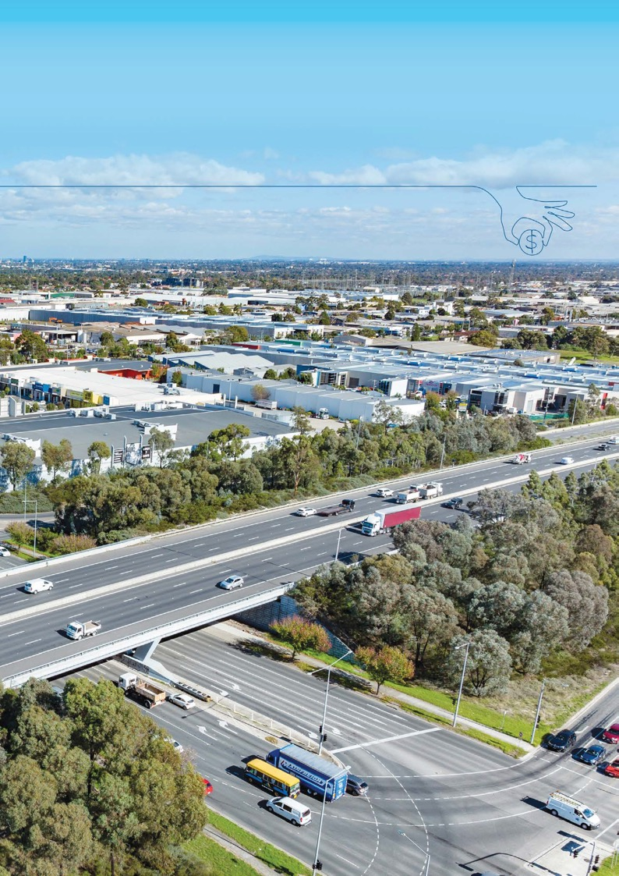

Epping | | | Metropolitan Activity Centre
 | | | State Significant Commercial and Industrial Area
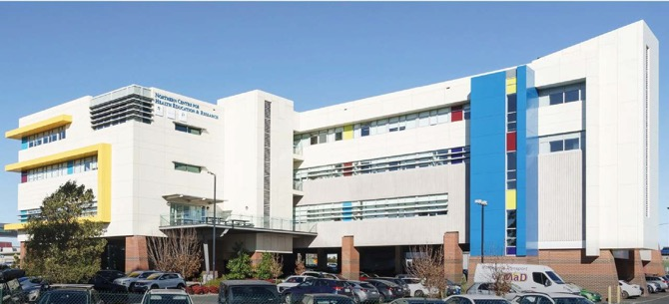

Northern Centre for Health Education & Research, Epping

Epping is one of nine Metropolitan Activity Centres in Victoria, and part of the Northern State Significant Industrial Precinct (SSIP). With a strong core of established commercial, industrial and retail offerings, a major critical health cluster and home to the Melbourne Market, as well as strong logistics offerings, Epping provides prime investment opportunities for business.
    - Epping is recognised by State Government as an area of significant growth for employment, new housing, services and entertainment.
    - Strategically located 20kms from Melbourne CBD, with direct access to major freight and travel routes, Melbourne Airport, the Port of Melbourne and the agricultural producing regions of Victoria and the northern states.
- Proximity to Northern Hospital and the thriving Epping Health Precinct, retail and entertainment precinct (including Pacific Epping), Northern Centre for Health Education & Research and Melbourne Polytechnic.
- Home to a number of market leading operators, the rapid growth and development of this area will continue to gather momentum and provide optimal opportunities for priority sectors.

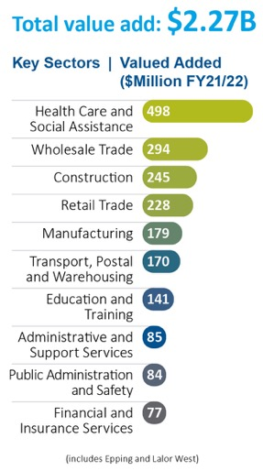
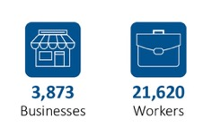

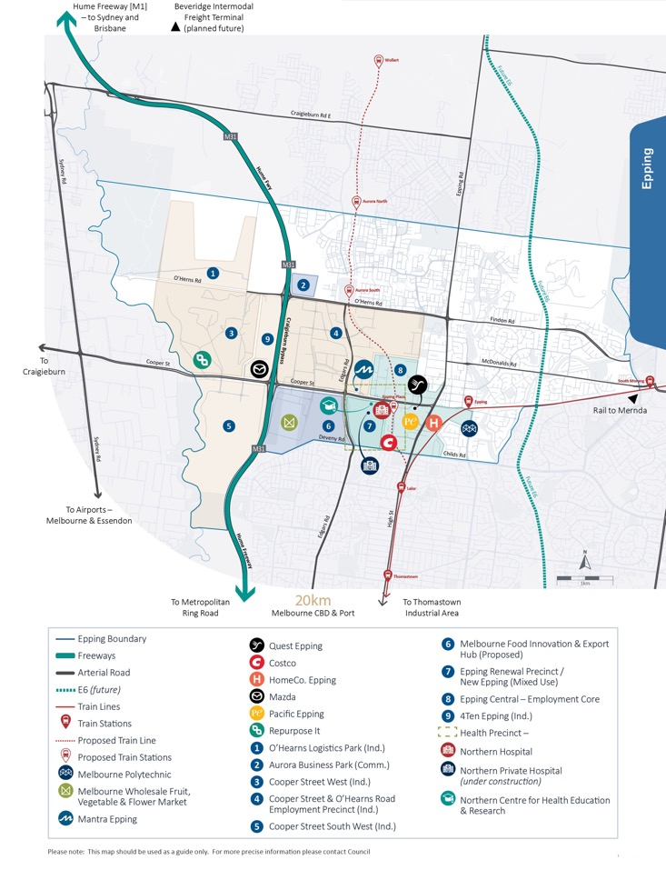
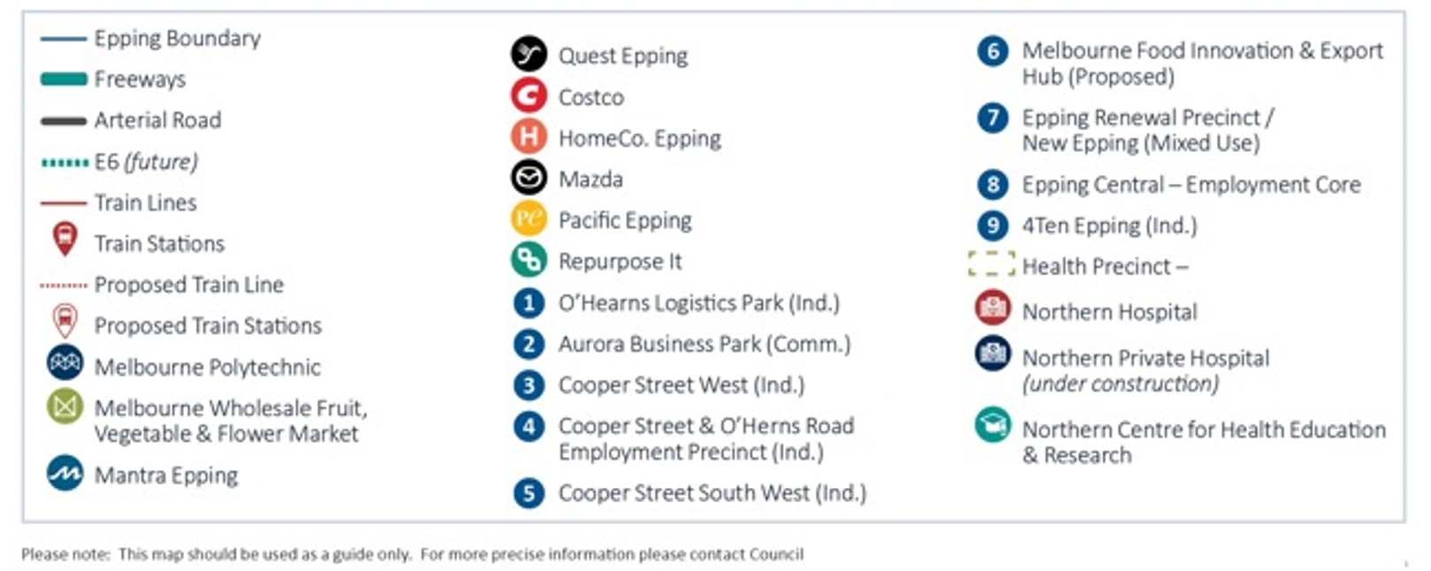
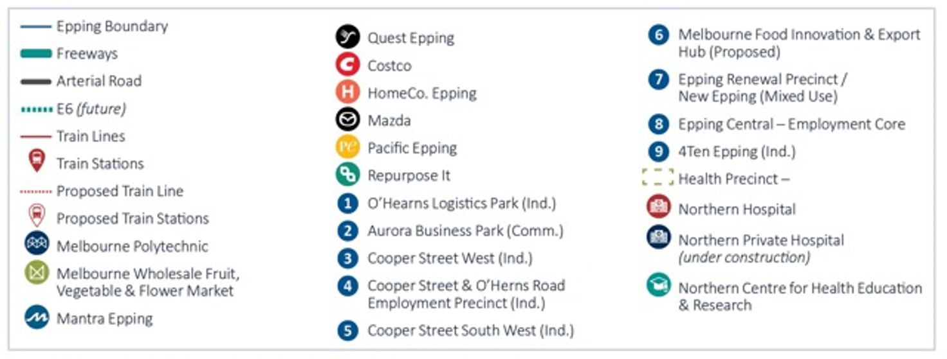Total Area 33, 746km² To CBD 20.01km

Epping | Cooper Street and O’Herns Road Employment Precinct

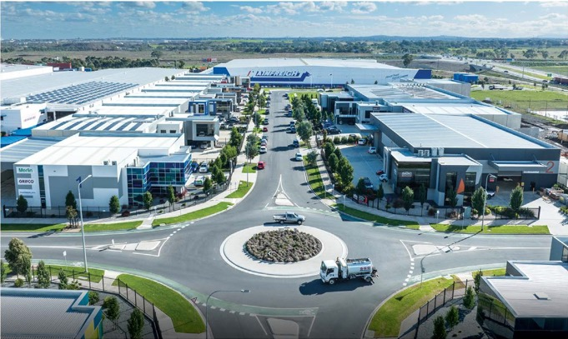
Alliance Business Park, Cooper Street Employment Area

  - Significant employment area expected to generate over 25,000 jobs at completion.
  - Serviced by excellent transport links including the Hume Freeway, Cooper Street, Edgars Road and O’Herns Road diamond interchange.
  - Location of The Northern Hospital, Melbourne Wholesale Fruit, Vegetable and Flower Market
and Mainfreight.
  - Major industry clusters of food and beverage and advanced manufacturing, medical, transport and logistics.
- Business parks include Alliance Park, Connect North, Northpoint Enterprise Park.
- Located close to current and future residential growth areas providing access to local employment opportunities.
- High amenity location providing both industrial and commercial options. Both turnkey facilities and a range of lot sizes to design and build are available.

Located here:

Total Area 4,201km² To CBD 19.15km

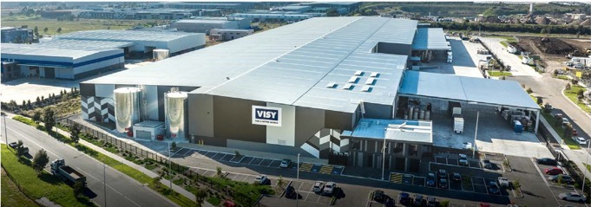

Biodiversity Business Park, Cooper Street South West Employment Precinct

Epping | Cooper Street West and South West Employment Precinct
The Cooper Street West and Cooper Street South West precincts present significant opportunities for future investment.
Cooper Street’s role as a state significant waste and resource recovery hub has been identified in the State-wide Waste and Resource Recovery Infrastructure Plan. This precinct will continue to provide
a service to the local community and support initiatives to increase
recovery and improved management of waste. Industrial opportunities are also available.
Council is currently looking to attract effective, innovative and forward thinking Initiatives that will encourage this hub to be world leading.
  - Cooper Street South West offers a range of state of the art warehousing and logistics facilities, with design and construct opportunities remaining.
  - Proximity to Melbourne Wholesale Fruit, Vegetable and Flower market presents opportunities for related businesses.
  - Serviced by excellent transport routes including Hume Freeway diamond interchange at Cooper Street and O’Herns Road.
  - Providing optimal opportunity for further growth and industry diversity with more than 200 hectares of large greenfield employment land industrially zoned.
  - Home to the Biodiversity Business Park.

Epping

Located here:

We are quite passionate about being located here in the Cooper St West Precinct in the City Of Whittlesea, we’ve got a grand vision of setting up the City of Whittlesea and our business Repurpose It as a reference site, not just for the rest of Victoria, but for Australia.
GEORGE HATZIMANOLIS, CEO AND DIRECTOR, REPURPOSE IT

Total Area 3,677km² To CBD 18.76km

Epping | Epping Central

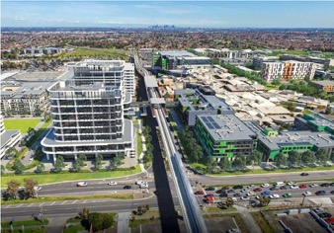

Artist impression of the future of Epping Central

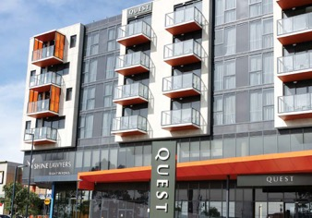
Quest Apartments, Epping

Located close to the major arterial road network linking to Melbourne Airport, the Port of Melbourne and agricultural producing regions of Victoria.
The heart of the Epping Metropolitan Activity Centre, Epping Central is strategically placed between the City of Whittlesea's southern established suburbs of Thomastown, Lalor, Bundoora, South Morang and Mill Park, and the growth areas corridor to the north, particularly Epping North, Wollert and Donnybrook, with easy access to industrial land to the west.
    - A designated Metropolitan Activity Centre and recognised as an area of significant growth for employment, new housing, services and entertainment.
    - Proximity to Northern Hospital and thriving Epping Health Precinct.
    - Established retail, dining and entertainment precinct including Pacific Epping.
    - Home to Melbourne Polytechnic (Epping campus).
    - Access to major regional road infrastructure and public transport including Epping train station,
with plans for future road and rail expansion to Wollert.
    - The new Epping Central Structure Plan endorsed June 2023 will guide and support further growth, and enhance opportunities for jobs, and business across retail, commercial and light industry for the next
20 years.

Located here:
Total Area 15,417km² To CBD 21.01km
Epping

Epping | Epping Renewal Precinct
New Epping
- New Epping will regenerate and
transform 51 hectares of land by creating a $2 billion mixed-use community spanning residential, commercial, healthcare and convenience retail, all centred around a central green spine.
- It shares a boundary with the established Northern Hospital and is adjacent to the proposed Melbourne Food Innovation and Export Hub.

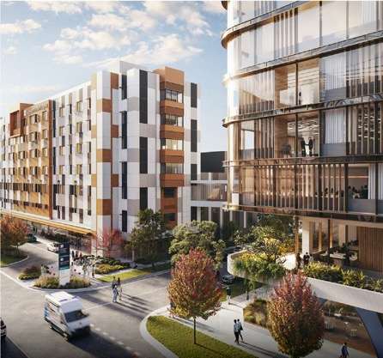

Artist impression of the Northern Private Hospital (under construction)

- New Epping’s new Northern Private Hospital, operated by Ramsay Healthcare, is scheduled to open early 2024, and will anchor the community’s 7 hectare health, wellness and knowledge precinct.

Located here:
Epping | Vearings Road Employment Precinct

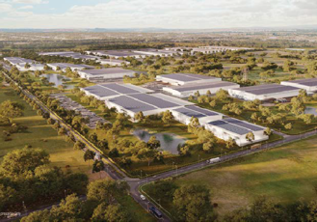
O’Herns Logistics Park

Artist impression of O’Herns Logistics Park

  - Set on 140 hectares of industrial zoned land and located near O’Herns Road diamond interchange, O’Herns Logistics Park has immediate access to the Hume Freeway, is located only 20 kms from Melbourne’s CBD and 13km from Melbourne’s International Airport.
  - Flexible land and building options are now available, with purpose-built buildings designed and delivered
to your specifications with a focus on sustainable design.
  - Stage 1 includes land and construct packages with pre-leases and turnkey buildings, all positioned in the heart of the estate. The site has been planned for heavy vehicle access for all, including B-doubles and gas is available.
Thomastown | Thomastown Industrial

Precinct

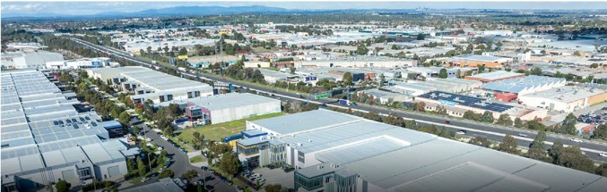

Meridian Business Park, Thomastown

The Thomastown Industrial Precinct is part of the Northern State Significant Industrial Precinct (SSIP). It emerged as a major industrial location during the 1970s and has progressively developed since in response to market demands.
New businesses continue to relocate here to expand and capitalise on the developments and rejuvenation that is occurring.
- Majority of land is Industrial 1 Zone (IN1Z).
- Some Commercial 2 Zoning (C2Z) within the Dalton Road and Settlement Road precincts.
- Offers redevelopment and expansion opportunities for a variety of businesses.
- Excellent access to the regional, metropolitan and national freeways, rail and bus services.
- Only 15kms to Melbourne’s CBD.

Located here:

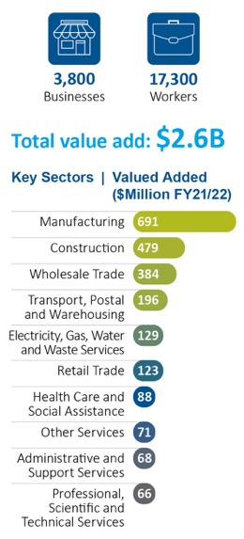
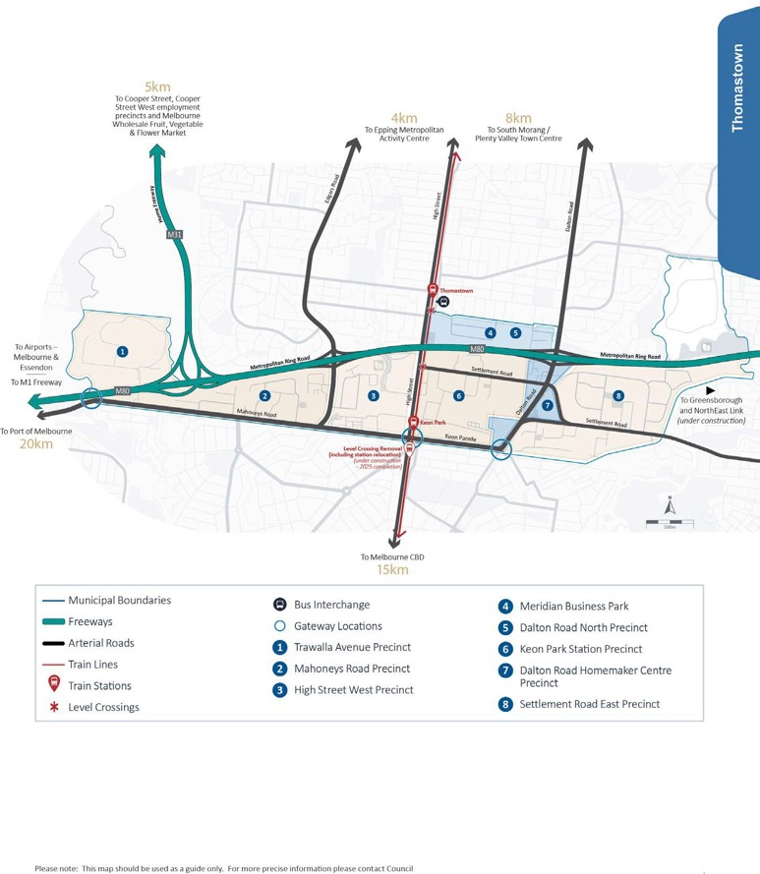
Total Area 14,723km² To CBD 14.97km
Thomastown

South Morang | Plenty Valley Town Centre

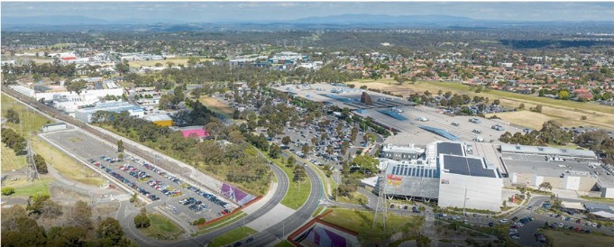
View of Plenty Valley Town Centre

- Identified by the Victorian Government as a major activity centre supporting a vibrant mix of uses and activities including the Civic Precinct, which is home to City of Whittlesea municipal offices.
- Activity Centre Zone 2 with opportunities for greenfield development and constructed turnkey commercial facilities.
- Guided by the Plenty Valley Structure Plan, which seeks to unlock the mixed-use development opportunities of the precinct.
- Opportunity for further development of community and civic uses with complementary commercial and employment forming uses within and adjacent to the civic precinct.
- Development opportunities lend further support for a transport hub to create an integrated and efficient multi-modal transport interchange.
- More than $150 million investment expected.

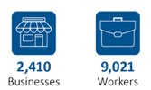

Located here:

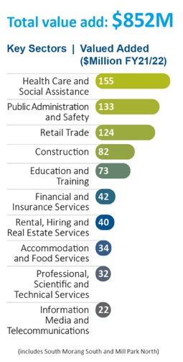
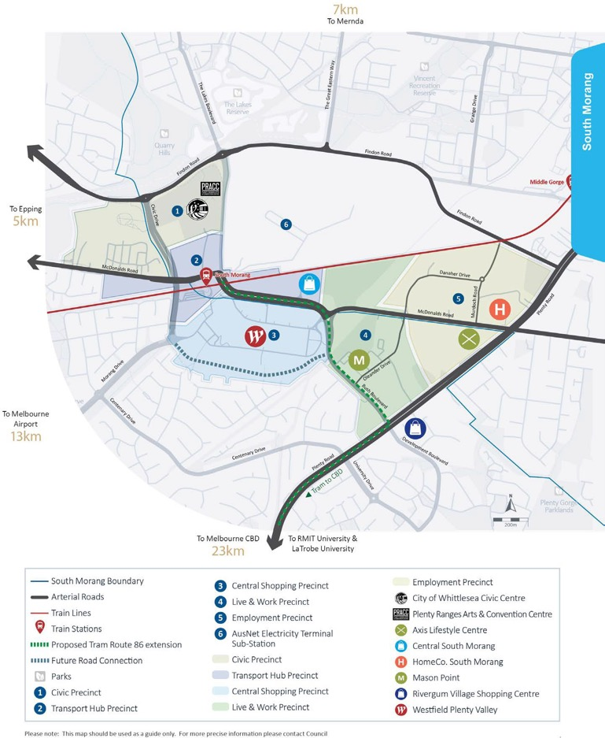
South Morang Total Area 21,060km² To CBD 23.44km Plenty Valley Total Area 1,999km² To CBD 21.46km

Bundoora

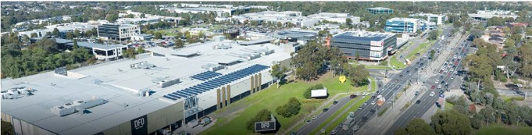

View of University Hill, Bundoora

Bundoora is a thriving suburb with an established reputation for being a great place to work, live and study, and a strategic location for business.

    - Home to RMIT University, Northpark Private Hospital, State Government departments and other market leading organisations.
    - A key hub for Healthcare and Social Assistance for medical practioners providing services to the population of the northern region and nearby hospitals including Northpark Private Hospital, Northern Hospital, and La Trobe Private Hospital.
    - Connected internally by Plenty Road, Bundoora providing direct access to the M80 Ring Road and North East Link (under construction).
    - 86 tram line starts at RMIT University, providing direct access to the CBD.
    - Close proximity to La Trobe University and the La Trobe National Employment and Innovation Cluster.
    - RMIT’s Bundoora campus offers education, health and Biomedical, Bioscience, early childhood intervention services, Biotech, Nursing, Food Science, Engineering and features a Fifa approved soccer pitch.
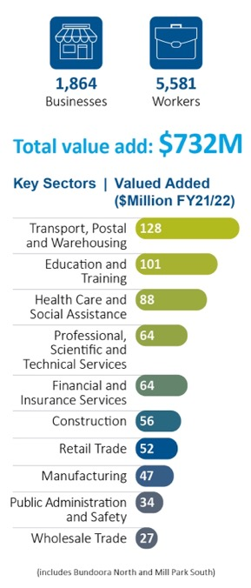
University Hill
University Hill is an award winning master planned development set on 104 hectares of land. This $1 billion investment, combines mixed use, retail, office, commercial, light industrial and residential uses among 18 hectares of landscaped parkland and public space.
With 40,000m² of commercial space and 27,000m² of retail, this contemporary business park environment includes office development as well as large format retail, commercial and light industrial offering.
University Hill is designated as ‘Special Use Zone 3’ for integrated mixed-use high technology, retail, office, commercial, light industrial and residential, in particular to encourage the further development of uses related to tertiary training, education, technology, research and development.
Co-working and serviced office space is at Waterman Bundoora, with conference facilities and accommodation at Uni Hill Conference Centre and Quest Uni Hill.

Total Area 7,318km² To CBD 17km

Located here:

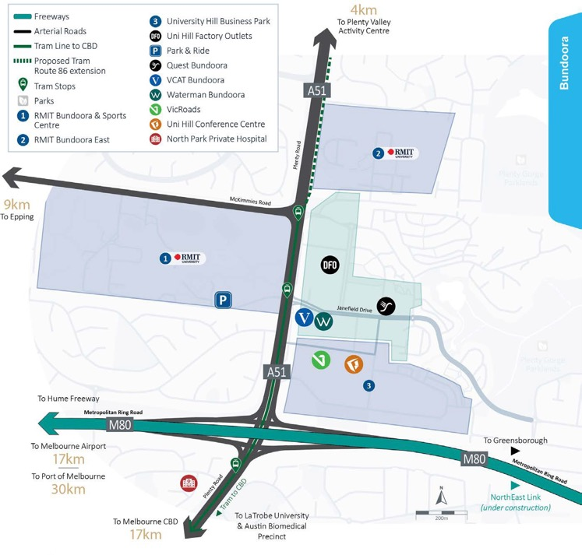
Please note: This map should be used as a guide only. For more precise information please contact Council

Mernda | Mernda Town Centre

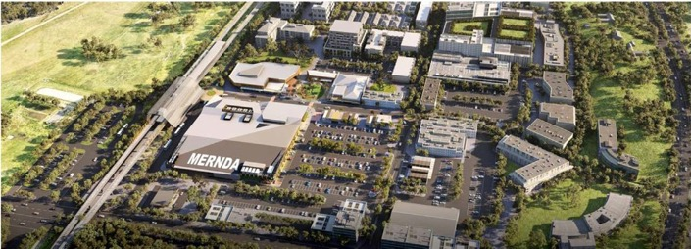

Artist impression of Mernda Town Centre

Mernda Town Centre is well connected and equipped for rapid growth. With a number of infrastructure and major projects underway, valuable investment opportunities are available now.

- Recognised by State Government as as a Major activity centre, to service the rapid growth suburbs of Mernda and Doreen.
- Located adjacent to the Mernda Train Station with metro trains running to CBD and a bus exchange connecting the area to Epping, South Morang, Whittlesea and Greensborough.
- More than $100 million investment expected across 80,000m² of commercial space and 30,000m² retail floor space upon completion.
- Anchored by Woolworths, staged development of other retail to include: multiple supermarkets, discount department stores, speciality retail, dining options (cafes and restaurants).
- Office/commercial floorspace: later stages of development to incorporate a range of opportunities for local businesses
- Mernda Police Station and Ambulance Victoria located in the area.
- Construction soon to commence on committed Whittlesea Community Hospital in the town centre core, to be operated by Northern Health.
- Mernda Health and Wellbeing Centre partner opportunities available.
    - Land has been set aside for a mix of retail, commercial, residential uses and civic facilities.
    - Creation of up to 5,000 jobs across more than 100 businesses.

    - Bridge Inn road upgrade currently under construction due for completion 2025.

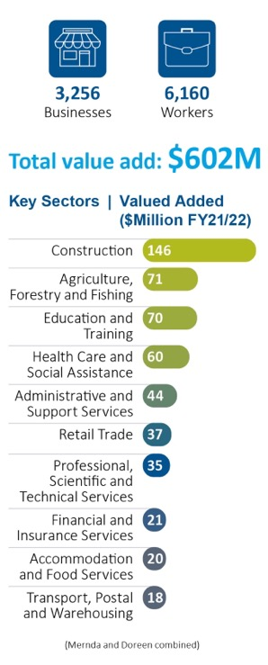

Total Area 22,466km² To CBD 27.58km

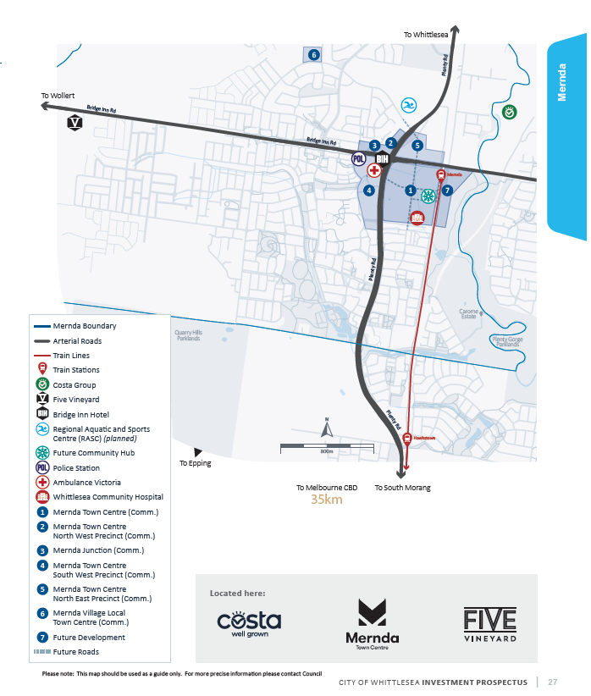

Please note: This map should be used as a guide only. For more precise information please contact Council

Wollert

Wollert is a rapidly developing suburb, expected to accommodate more than 40,000 people and create approximately 8,000 jobs at completion.
      - An employment hub is located along Epping Road and the future Outer Metropolitan Ring Road/ E6 corridor. The area is zoned for
development and within proximity to utility services.
      - Wollert Major Town Centre will accommodate retail and community needs as well as
opportunities for entertainment, employment and accommodation.
- Council is currently advocating for the Wollert train line to connect Epping North to the Wollert
town centre.
- Cafés and small offices will be encouraged with scope for apartments and commercial office development on the upper floors.
- Multiple community centres, sports reserves and facilities.
- Multiple primary and secondary schools.
- Local parks and a strong conservation are network.

Donnybrook | Woodstock | Lockerbie

The broader Donnybrook area is projected to be home to more than 70,000 people at full build out, across the Donnybrook/Woodstock, English Street Precinct Structure Plan areas and the recently approved Shenstone Park Precinct Structure Plan. Significant development has occurred to date in the area, which adjoins the Lockerbie Precinct Structure Plan area to the west at Kalkallo.

- Commercial and industrial employment precincts are nominated as part of the English Street Precinct Structure Plan (PSP) and within the Shenstone Park PSP.
- Five future town centres with retail and office employment space.
- Multiple primary and secondary schools and community centre sites, including a library.
- Sporting reserves, local parks and a strong conservation area network.

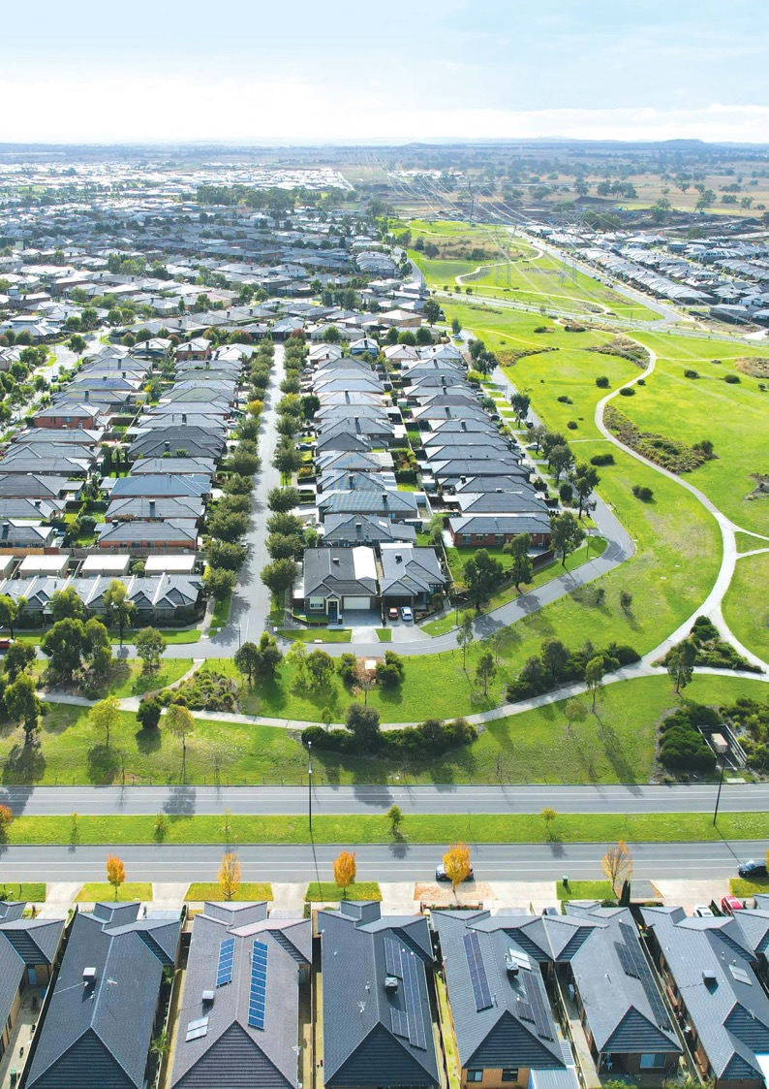

Aerial view of Wollert

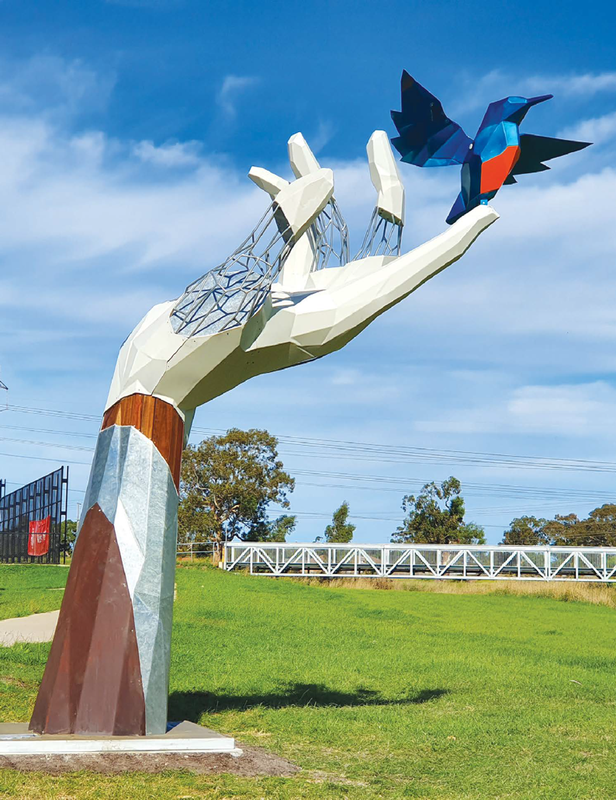

‘The Guardian’ by Damian Vick, Hillsview Recreation
Reserve, South Morang

Future focus – looking 10 years ahead and beyond
Recognised by Victorian and Federal Government as a region of economic significance, investment in major infrastructure projects directly impacts and facilitates growth now and into the future.

Key Advocacy Priorities
Partner with us to advocate for key priorities relevant to your business.

Melbourne Food Innovation and Export Hub (MFIX) at Epping
Advance MFIX as a transformational project for Melbourne’s north to position the City of Whittlesea and Victoria as a food hub of national significance, and incentivise relocation of a major anchor tenant to attract innovative food manufacturing and export businesses.

Beveridge Intermodal Freight Terminal (BIFT)
A transformational project for Victoria, recognising its significance as both a long term freight terminal and a major future employment precinct in the coming years. Partner with us to advocate for improved infrastructure connections to harness the potential of this precinct, such as the E6, to benefit business and community.
- Strategically located to maximise links to the Inland Rail, Hume Freeway and proposed E6/Outer Metropolitan Ring Road.
- Over 1,000 hectares of land is identified for the BIFT and associated freight and logistics.

Major suburban roads
Deliver major upgrades to State owned arterial roads for increased capacity and decreased congestion.

Better public transport
The delivery of a train line to Wollert, extension to Tram Route 86 from University Hill to the Plenty Valley Town Centre and improved and extended bus services and frequencies.
Go to www.whittlesea.vic.gov.au/advocacy for more information on these and other advocacy priorities.

Major Road Advocacy Priorities
- Craigieburn Road duplication between Epping Road and Hume Freeway.
- Donnybrook Road duplication between Epping Road and the Merri Creek.
- Epping Road duplication between Craigieburn Road East and Bridge Inn Road.
- Findon Road declare and duplicate between Plenty Road and
Epping Road.
- Bridge Inn Road declare and duplicate between Plenty Road and Wellington Street Mernda.

Major Road Upgrades Under Construction
- Epping Road duplication -Memorial Avenue to Craigieburn Road, Epping/Wollert (due for competition 2025).
- Edgars Road – O’Herns Road to Rockfield Street, Epping North (due for competition 2023).
- Bridge Inn Road urbanisation and duplication - Plenty Road to Yan Yean Road, Mernda/Doreen (due for completion 2025).

Growing the Agri-Food Sector
Anchored by the Melbourne Wholesale Fruit, Vegetable and Flower Market, with access to recycled water, a skilled local workforce and local farmers’ markets, agriculture and food businesses have the potential to thrive in the City of Whittlesea.
Council plans to maximise local agricultural and food production capabilities with the ‘Agri-Food Plan 2022-2026’. As well as optimizing industry growth, the primary objective of the plan is to attract investment from new and innovative businesses to encourage sustainable practices now and into the future. The municipality offers viable agricultural and industrial land that is located within close proximity of major local, national and international transport routes including sea, air and road.
The City of Whittlesea will grow the agri-food sector by:
- developing and implementing the ‘Agri-Food Plan 2023-2026’
- delivery of networking and capacity building events
- partnerships and collaborations such as the Wollert Community Farm and FoodInc, to develop pathways to starting and growing an agriculture or food business.

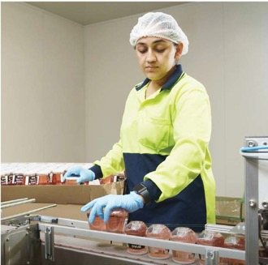
Wine In A Glass, Epping

Activating a Circular Economy
With a commitment to encouraging a more viable and sustainable use of resources, council partners with local operators to explore opportunities to be active participants in a localised Circular Economy including:
- development of the ‘Circular Economy Plan’
- product and process innovation – advocating for businesses to be mindful of their underutilized resources and support them in finding ways to innovate and create new streams of income from these resources
- industrial collaborations – advocating for businesses to maximise their use of resources through sharing, innovating, and collaborating
- cross-industry collaborations – advocating for the education sector to work with the community and businesses across different industries to help them make their operations more circular
- sustainable procurement – Council commitment to support local operators and those who use circular products
- forge connections – with local, state and federal Government agencies and other operators
- support advocacy and other initiatives.

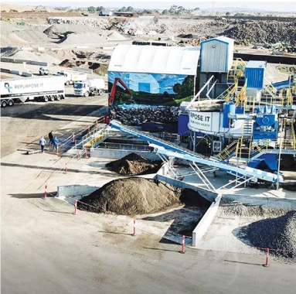

Repurpose it, Cooper Street West and South West Employment Precinct, Epping

Capturing the Visitor Economy
Tourism presents significant growth opportunities for the local economy.
Major attractions in the
area include:
- Five Vineyard Winery
- Funfields Theme Park
- Growling Frog Golf Course
- Plenty Gorge Parklands Quarry Hills Regional Park
- 850 kms cycling routes (on road, off road and informal)

Future opportunities
include:
- Events and functions
- Tourist accommodation
- Nature and Historical Tours
- Nightlife
In 2021/22 visitors spent an estimated $756 million, contributing $348 million to the local economy.
In the five years prior to 2020, City of Whittlesea welcomed an average of 673,000 visitors annually. Forecasts indicate that visitation is likely to increase to at least 1 million domestic visitors per year by 2032.
Aiming to increase tourist numbers to the area over the next three years, the new City of Whittlesea Destination Plan 2023-2026 focuses on four priority areas: Heritage, Arts and Culture; Tourism Infrastructure; Nature Based; Food and Drink.

Whittlesea
Country Music Festival
Darebin Creek Trail
Growling Frog Golf Course, Yan Yean

How we can help

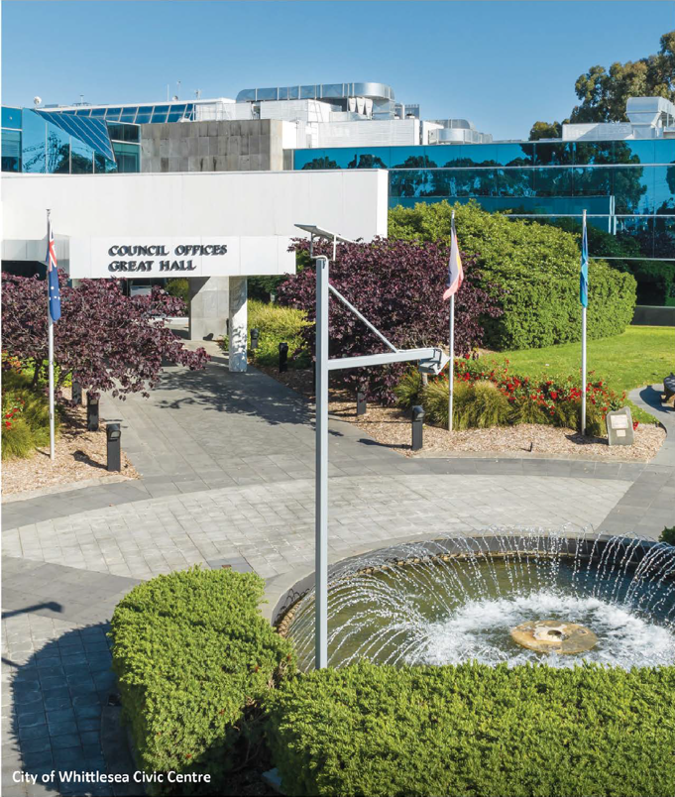

The City of Whittlesea partners with operators to create a beneficial outcome for them and the local community in the following ways:

Priority Development Assessment Process
Fast-tracking with a case manager for projects that meet agreed criteria
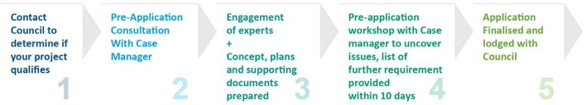

Business Concierge
Seamless and centralised business assistance, provision of news and information, greater access to other government agencies

Grants and funding support
Information about support available from all levels of government and other organisations to businesses of all sizes

Business Advisory Panel
Commercial leaders provide Insight to inform council for investment, advocacy and initiative prioritisation decision making

City of Whittlesea Business Network
Encouraging increased business to business collaboration at events and through online portal

Government Partner Advocating and Relationship Management
Facilitating important linkages for initiatives and support for businesses to grow

Economic Development Department
Motivated and actively focused on supporting businesses to grow within the local economy

Business Education and Training
Support local businesses to increase productivity of their human capital

Commitment to Buy Local
Council priority of procurement of local products and services

Linkages to Local Workforce
Programs and initiatives to support businesses to establish an inclusive and diverse local workforce

Knowledge
Access to localised data sets, economic modelling, e-news and other info to assist with decision making

Contact

To have a confidential discussion about the potential of your business locating within the City of Whittlesea, contact our Investment Attraction and Business Growth Team in our Economic Development Department today!

03 9217 2170
25 Ferres Boulevard, South Morang VIC 3752
invest@whittlesea.vic.gov.au
whittlesea.vic.gov.au/invest
linkedin.com/company/city-of-whittlesea
facebook.com/CityOfWhittlesea
instagram.com/citywhittlesea

This prospectus is dynamic and updated regularly. Scan the QR code for the latest version

This version published October 2023

