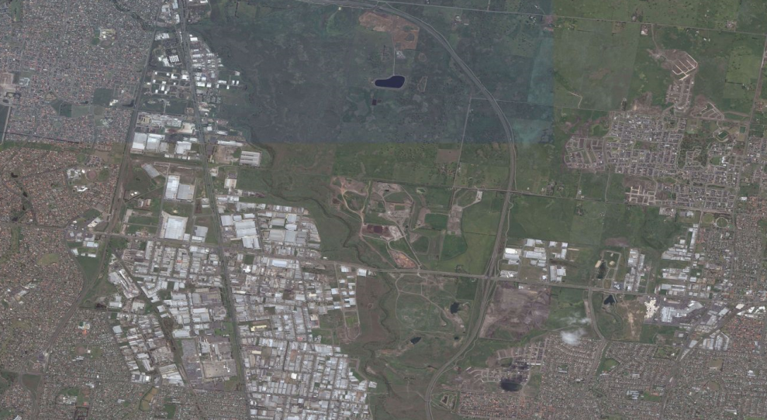

Amended Cooper Street West Position Paper
Adopted October 2017

Table of contents
1. Introduction 6
2. Land use opportunities 9
Land use opportunities 9
Economic opportunities 9
Transport linkages 9
Environmental and heritage values 11
3. Land use constraints 11
Former landfills and closed landfill buffers 11
Development on former landfill sites 12
Other landfill factors 13
Active quarry buffers 13
Environmental and heritage values 14
Road network 14
O’Herns Road access 15
Cooper Street access 16
Gas pipeline 16
Stormwater 17
Climate change 18
Pedestrian and cycling links 20
Melbourne Airport 20
4. Cooper Street West sub-precincts 20
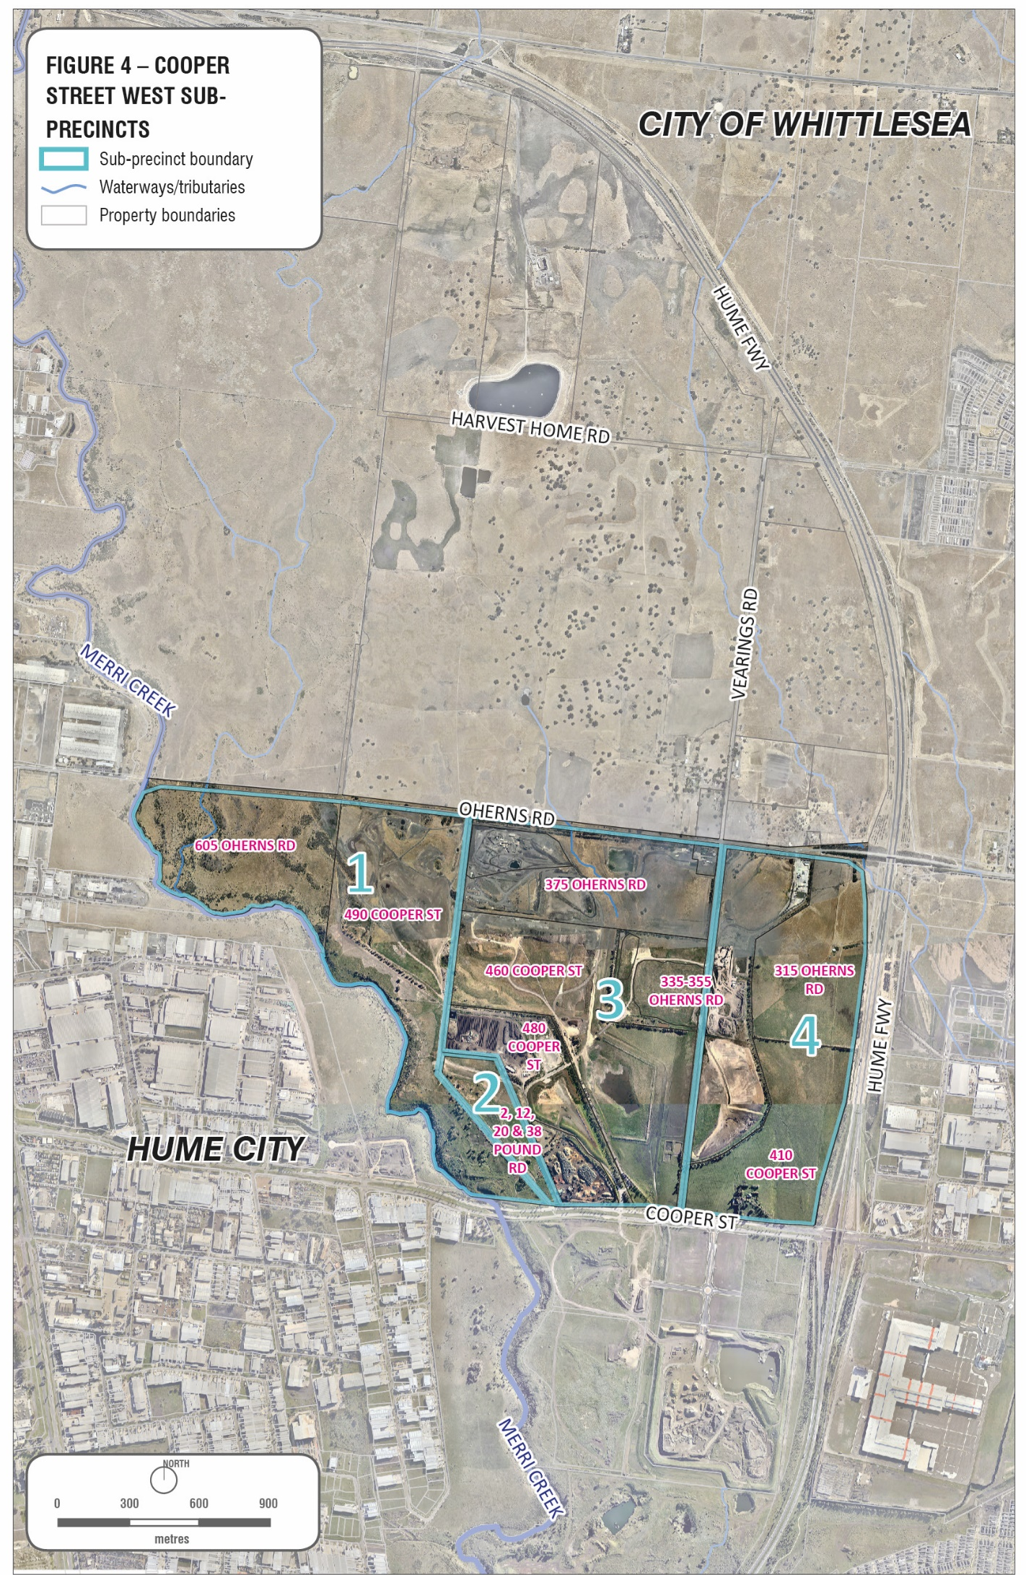5. Sub-Precinct 1 – Parklands and conservation land 21
Creeks and waterways 22
Open space 22
Biodiversity Conservation Strategy 25
Closed landfill and buffers 25
Summary of land use constraints 25
Precinct 1 – Site Summaries: Merri Creek Marran Baba parklands and conservation land 25
Key recommendations 26
Key planning considerations 27
6. Sub-Precinct 2 – Animal welfare 30
Summary of land use constraints 30
Precinct 2 – Site Summaries: Animal welfare 30
Closed landfill 32
7.0 Sub-Precinct 3 – Earth resources and waste recovery 35
Active quarries 35
Closed landfill 35
Waste and resource recovery 35
Extractive industry 36
Gas pipeline 36
Summary of land use constraints 38
Precinct 3 – Site summaries: Earth resources and waste recovery 38
Closed landfill, quarry buffers and gas pipeline buffers 39
Closed landfills 40
Extractive industry and waste and resource recovery 40
Design and development 41
Environmental and heritage values 41
8. Sub-precinct 4 – Gateway – Emerging industry 44
Summary of land use constraints 44
Precinct 4 – Site Summaries: Gateway and emerging industry 44
Closed landfills 47
Landfill and quarry buffers and gas pipeline 48
Design and development 48
Road network 49
9. Northern Quarries Investigation Area (NQIA) 51
10. Conclusion 51
Precinct 1 52
Precinct 2 52
Precinct 3 52
Precinct 4 53
11. Glossary 54
12. References 55

1. Introduction
The purpose of this Position Paper is to establish City of Whittlesea’s position with respect to the future use and development of land in the Cooper Street West Precinct. The precinct forms part of the State Significant Northern Industrial Precinct in Plan Melbourne 2017-2050 and part of the broader Cooper Street Employment Area. The designation of Cooper Street as a gateway to the municipality, developing as a higher order employment area was initiated over 20 years ago, with the City of Whittlesea General Plan (1994). The Plan identified Cooper Street as an opportunity to promote well-designed employment land, which would enhance the image of the industrial areas in the municipality.
In 1996, the City of Whittlesea and the City of Hume prepared a precinct strategy for Cooper Street, titled Cooper Street Precinct Strategy (October 1996). The strategy was prepared to guide future development to an area which was largely rural to developing into an urban area. The shared vision for Cooper Street was: To create a vibrant living and working community, which integrates good urban design, effective use of physical services and the significant natural environment of the Merri Creek and nearby Grasslands, to promote the precinct as a gateway to the Northern Metropolitan growth areas (Cooper Street Precinct Strategy, 1996: 5).
In 2006, a Development Plan was prepared for the Cooper Street Employment Area. The Development Plan specifically excluded the Cooper Street West precinct on the basis of the previous and active quarrying and landfill operations. The precinct was also subject to investigations relating to the future Merri Creek Regional Park at that stage.
Cooper Street West is the remaining land in the broader Cooper Street Employment Area yet to be planned since the original inception for Cooper Street as an employment area. It forms part of the Northern State Significant Industrial Precinct. The precinct is important as nearby planning and development is creating more interest and demand for the precinct. North of the precinct is the Northern Quarries Investigation Area (NQIA) currently under investigation by the Victorian Planning Authority; east of the Precinct lies the Cooper Street Development Plan Area, Epping Metropolitan Activity Centre and Melbourne Wholesale Markets and south of the precinct is Cooper Street South-West Employment Area (Alex Fraser Group and Biodiversity Business Park).
The Cooper Street West Precinct is bound by O’Herns Road to the north, Hume Freeway to the east, Cooper Street to the south and the Merri Creek to the west (Figure 1). Cooper Street is an important east-west arterial road which links the City of Whittlesea with the Hume Freeway industrial corridor. The industrial activities located adjacent to Cooper Street include large scale warehousing, manufacturing and distribution activity. Its proximity to national road, rail, air and port transport linkages, makes the Cooper Street West precinct an ideal location for industrial development, reliant on good transport networks and freight movement. Plan Melbourne 2017-2050 has identified that in the past 5 years, demand for new industrial land has been driven by freight, logistics and manufacturing (Plan Melbourne, 2017:35).
The Local Planning Policy Framework in the Whittlesea Planning Scheme, Clause 21.10 (Economic Development) identifies that the Cooper Street Employment Area (including the Melbourne Wholesale Market) contributes to greater economic diversity by supporting employment generating industries and is identified as one of Whittlesea’s four major employment areas.
The precinct also contains a number of environmental values and risks which need to be considered when planning for future development in the precinct. Portions of the precinct contain high ecological values and are protected by State and Federal legislation; sections of land have been identified as environmental offsets, with the presence of Growling Grass Frog habitat. The precinct also includes a number of creek systems including Merri Creek, Curly Sedge Creek and Central Creek.
The Precinct also supports land identified as future conservation areas under the Biodiversity Conservation Strategy – an overarching strategy for the protection of biodiversity in the growth corridors and setting out the obligations under Part 10 of the Commonwealth EPBC Act 1999.
Council has developed a Masterplan for the former Northern Landfill Site in Cooper Street, Epping. The Strategic Intent is that the Masterplan reflects the wider environmental significance of the corridor including the Merri Creek environment, neighbouring Craigieburn Grasslands and Growling Grass Frog habitat.
The Statewide Waste and Resource Recovery Infrastructure Plan Victoria 2015-2044 has identified Cooper Street, Epping as a State significant waste and recovery hub that is well located to service Melbourne as it is located close to major transport routes. The Plan identifies the significance of the hub in accepting organic material, garden organics, mainly from the metropolitan area and being the only construction and demolition hub for northern metropolitan Melbourne. The Plan states that pressure from residential encroachment and incompatible industrial and commercial activities could impact on the functionality of the precinct in the future. It recommends preserving adequate buffer distances and ensuring that activities within the precinct are compatible and conducted in a manner that does not detrimentally impact on the surrounding land users. The Plan also recognises that some of the existing hubs identified will transition out of waste and resource recovery activities over time.
Parts of the Precinct have a long history of quarrying and extractive industry which has significantly altered the physical landscape and facilitated the establishment of significant areas of filled land. While quarrying activities continue, in recent years, the number of extractive and landfill industries operating within the study area has reduced considerably.
The quarrying and landfill operations have constrained the extent of future developable land for employment purposes within Cooper Street West Precinct. A high-pressure gas pipeline easement also runs along the eastern portion of the precinct and a portion of the northern section, which carries a level of risk and may limit the type of uses and development that may be appropriate. The precinct also contains protected environmental values along the Merri Creek Corridor which further restrains development for a number of properties.
Ongoing take up of employment land within the broader Cooper Street Precinct, reduction in land supply in the immediate area and recent development interest are key factors in reviewing the planning for this precinct.
The underlying basis for future economic growth in the Precinct includes:
- its attraction for manufacturing, warehousing storage and distribution activities;
- the opportunity for broad acre development projects;
- its accessibility to local, metropolitan and regional routes.
The purpose of the paper is to identify Council’s position in relation to this complex and constrained precinct and identify at the outset, the key planning considerations for development and land use planning.
The Position Paper has identified 4 sub-precincts to the overall area, reflecting the distinctive uses in the precinct. The Position Paper aims to support the intended employment purposes for the precinct and identify the constraints to provide greater certainty for land owners and future development interests.

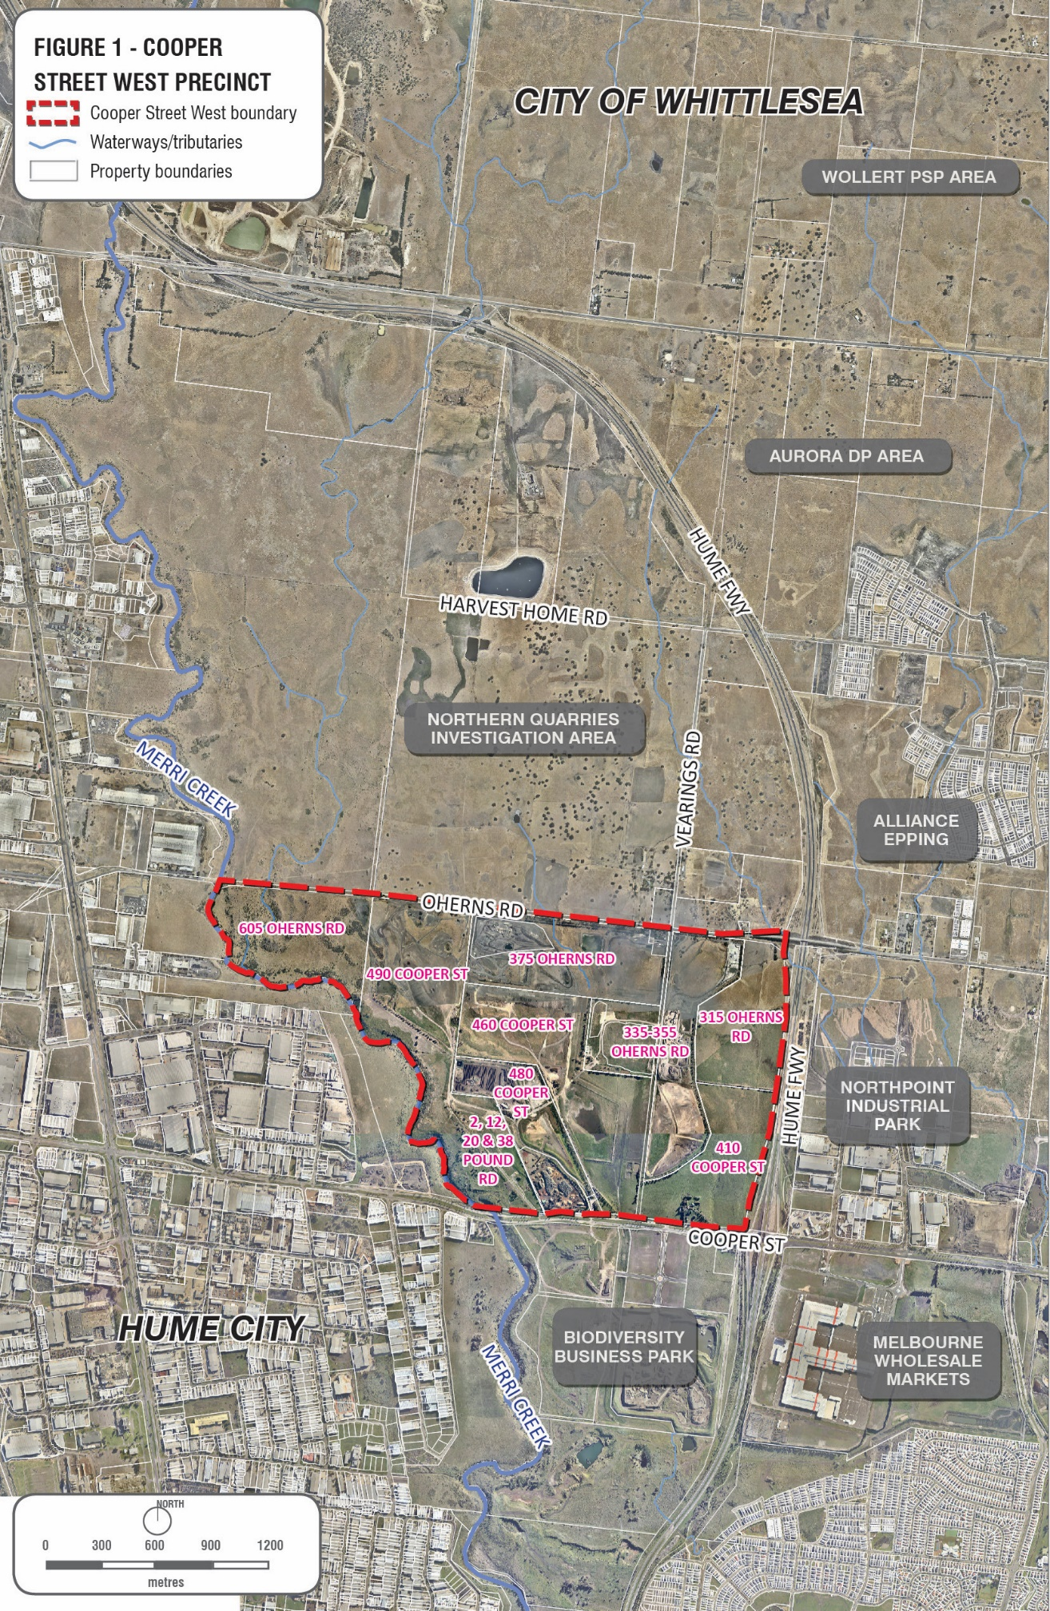

2. Land use opportunities

Land use opportunities
The Cooper Street West Precinct has been designated for employment uses however due to some of its constraints; this may be more limited than the other areas of Cooper Street Employment Area.
The proximity of the study area to future growth areas, transport infrastructure and regionally significant employment precincts present significant opportunities for future investment (Figure 2).
Key opportunities include:

Economic opportunities
- Proximity to the Melbourne Wholesale Fruit and Vegetable Market which is a state significant project which presents opportunities for related businesses.
- Proximity to the broader Cooper Street Employment Area, State significant Northern Industrial Area (as identified in Plan Melbourne) and Epping Metropolitan Activity Centre.
- The precincts gradual transitioning away from extractive and landfill activities with a reduction in the number of active sites and others at various stages of rehabilitation.
- Cooper Street’s (Epping) role as a State significant waste and resource recovery hub as identified in the Statewide Waste and Resource Recovery Infrastructure Plan.
- Proximity to the Northern Quarries Investigation Area (NQIA) and the potential for additional employment land north of the precinct.
- The emerging development south of the precinct at Biodiversity Business Park.

Transport linkages
- Access to major transport infrastructure including the Melbourne-Brisbane Rail Line, the Hume Freeway (M31), the Metropolitan Ring Road and Sydney Road (Route 55) and proposed construction of the O’Herns interchange to the Hume Freeway.
- Proximity to Melbourne Airport, Melbourne Wholesale Market and surrounding industrial precincts including Northpoint Industrial Park, Northern Quarries Investigation Area and Biodiversity Business Park provide an incentive for investment.
- An opportunity to improve road connectivity and services (i.e. drainage) throughout the site.
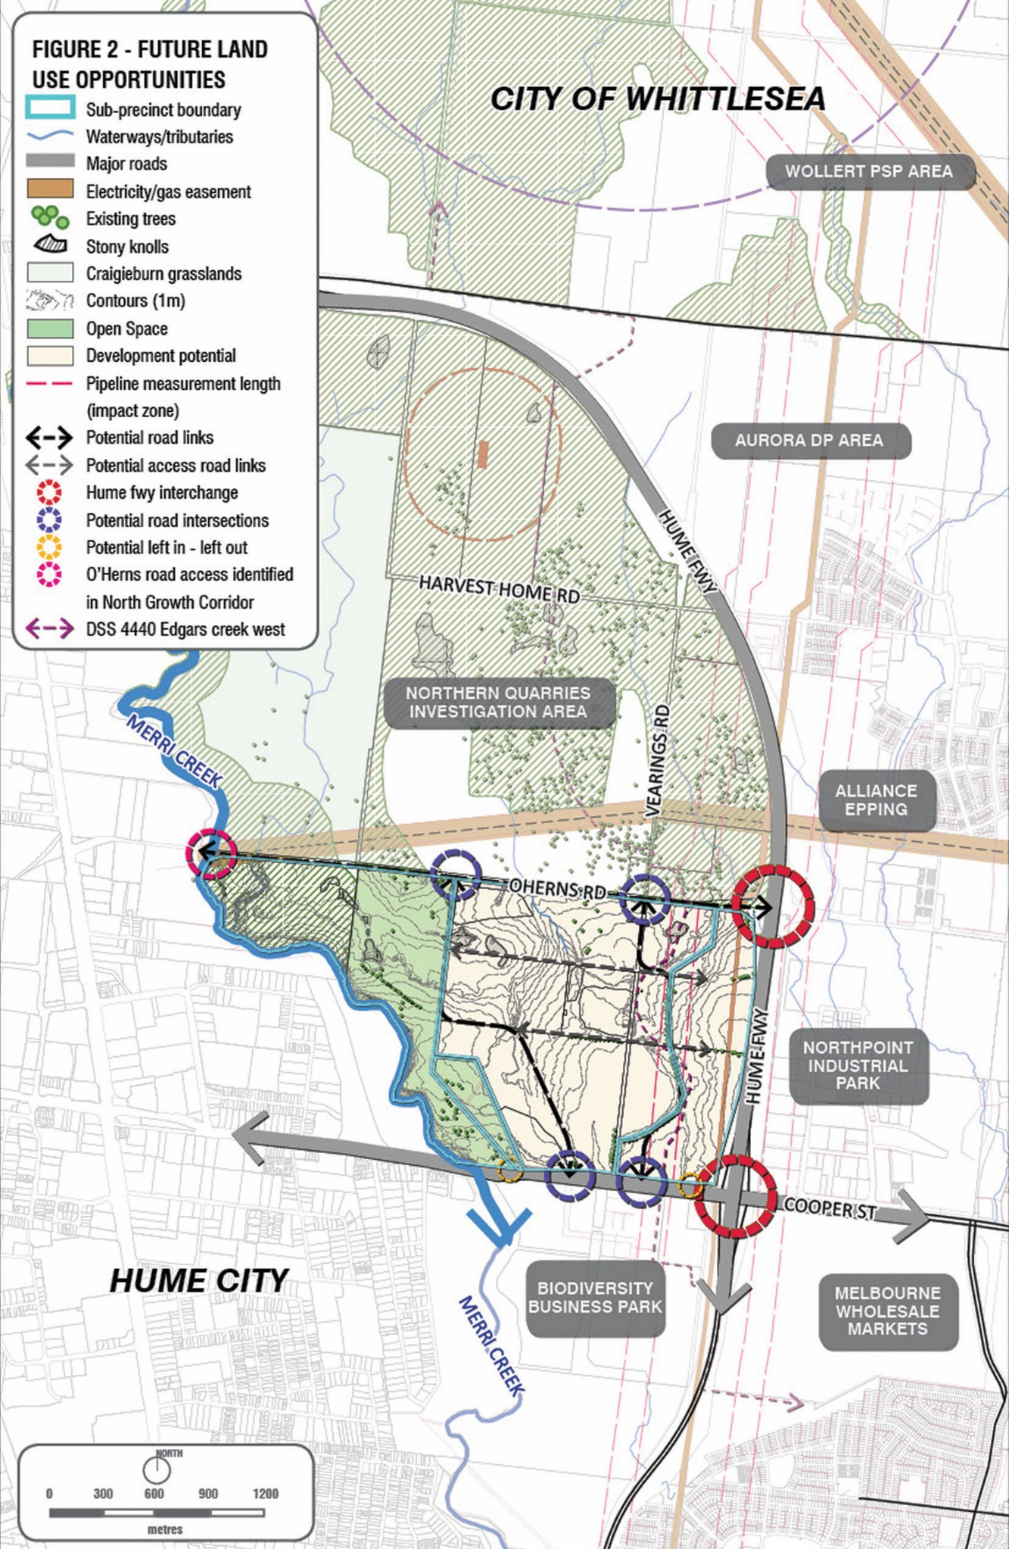

Environmental and heritage values
- Opportunities to improve the environmental and conservation conditions of the Merri Creek and surrounding area.
- Opportunities to provide lineal conservation areas along the Merri Creek, providing habitat for endangered fauna and flora.
- Opportunities to link the Cooper Street Grasslands through to the Merri Creek Parklands and further north to the Craigieburn Grasslands.
- The land that forms part of the Northern Landfill Masterplan has unique physical and environmental features, including vantage points and city views. Opportunities exist to optimise on the scenic views and environmental values.
- Opportunities to restore and rehabilitate native grassland vegetation and Redgum woodland habitat for protected native fauna.
- Opportunities to protect and restore highly valued Growling Grass Frog habitat.
- Opportunities to provide additional high quality open space in Epping.
- Opportunities to protect and integrate identified heritage values into the precinct.

3. Land use constraints
The precinct is encumbered by a number of significant constraints. The precinct contains former quarries and former putrescible waste and solid inert landfills which require time for the land to remediate and stabilise. Former landfill sites can impact on the land adjoining the properties. In addition to the former land uses impacting on the development potential of the precinct, the land also contains identified environmental values which are required to be protected. A portion of the precinct along the eastern boundary is also affected by a gas pipe line easement. It is noted that development within the broader precinct must not prejudice the ability for Council as the landowner to meet environmental compliance requirements of its landfill monitoring program (Figure 3).

Key land use constraints are discussed below.

Former landfills and closed landfill buffers
One of the key land use constraints for developing within the precinct is the former landfills and their buffers which affect adjoining land.
- The EPA’s “Closed Landfill Guidelines” (December 2012) identifies that it can take approximately 30 years for landfills to decompose and therefore potential risks from landfill gas can remain for at least 30 years post-closure. Environmental risks include leachate, site contamination, land instability, subsidence and landfill gas migration.
- The EPA guidelines, Landfill BPEM - Best practice environmental management – Siting, design, operation and rehabilitation of landfills (EPA Publication 788.3, August 2015) recommends a 500m buffer distance for Type 2 (Putrescible) landfill from buildings or structures and a 200m buffer distance for Type 3 (Solid Inert) landfill from buildings or structures.
- Buffer distances are measured from the edge of the landfill cells, however, if the location of the cell is unknown; the buffer distance is measured from the boundary of the landfill. For the purposes of this paper, the buffers are measured from the property boundaries.
- Land within buffer areas may be used for non-sensitive uses provided the uses do not prejudice the ability for environmental compliance and monitoring requirements to be met.
- The closed landfill buffer distance applies to any building or structure located near a closed landfill including industrial development and subsurface structures such as stormwater drains or service trenches that may allow landfill gas to migrate / accumulate. The buffer provides a protection zone for subsurface landfill gas migration.
- Where a proposed development or planning scheme amendment is proposed within the recommended EPA landfill buffer, a Section 53V audit under the Environment Protection Act 1970 may be required to assess the “risk of harm” to the proposed development, by the potential offsite impacts. A 53V (risk of harm) audit could be avoided if “other relevant and sufficient information” from previous assessments or audits is available, which may be relied on in making a decision. EPA advises that this may include a landfill gas risk assessment.
- The Statewide Waste and Resource Recovery Infrastructure Plan Victoria 2015-2044 encourage the use of closed landfills, where appropriate, for resource recovery activities given the existing provision of a buffer. It also recommends the use of planning controls to prevent encroachment of sensitive uses near waste and recovery facilities which could impact the functionality of the site.
- Monitoring was conducted and a report prepared by Cardno Pty Ltd (Landfill Gas Buffer Assessment 15 and 25 Vearings Rd, 315 O’Herns Rd and 410 Cooper St Epping (V160682GR Report 01.3 Cardno 2017) on behalf of the City of Whittlesea. The monitoring found low concentrations of landfill gas on the eastern boundary of Cooper No.1, eastern and northern boundaries of Cooper No 2 and the Northern boundary of the Northern landfill. This report can be utilised for background information, although it is noted that the report makes a number of assumptions about development that may be constructed on site.
- Notwithstanding the Cardno Landfill Gas Buffer Assessment report (2017), any proposed development within the recommended EPA Closed landfill buffer, must engage a suitably qualified expert to undertake a landfill gas risk assessment to assess the risk of harm to any proposed development by offsite impacts.

Development on former landfill sites
- Former landfills present a high potential for contamination and as such are likely to require a Section 53X contaminated land audit under the Environment Protection Act 1970, as they can pose an environmental risk.
- Development potential of former landfill sites is significantly constrained and generally limits the construction of significant buildings or structures.
- The EPA’s “Closed Landfill Guidelines” (December 2012) suggest that practical post closure uses for landfills can include sports grounds, public open space and golf courses. In limited circumstances, landfills can also potentially be developed subject to resolving issues of site contamination land stability, leachate and landfill gas.
- Significant site investigations and rehabilitation is required before former landfills can be developed to ensure latent risks are appropriately managed. Development of a former landfill will generally require: hydrogeological investigation, risk assessment, ensuring sub-base stability for any foundations/building construction/works and consultation with Council.
- Gas extraction and monitoring facilities on former putrescible landfill sites will impact on any proposed works and the location of any future road connections within the precinct. The location of a road, works, services or development will be restricted by:
- The location of any active gas extraction pipes, including the header line or bulk line or main;
- The location of leachate sumps, including any connecting pipework to/from the leachate ponds;
- Any pipework or lines may need to be protected from the impact of development / works (i.e. culverts) which needs to be determined in consultation with the ‘gas contractor’ engaged by the landfill owner to manage the gas extraction.
- For any proposed development on Closed landfills, a Site Remediation Strategy must be prepared by a suitably qualified professional to describe the risks and opportunities associated with developing the site to a higher land use. The strategy is to demonstrate that:
- A 53X contaminated audit has or will be completed and how the audit conditions will be implemented;
- The site is capable of being remediated so that it is suitable for the proposed use and development;
- The process for the clean-up of the site is sound; and
- Provide a framework for the on-going management of the site conditions, including adequate consideration of geo-technical matters.

Other landfill factors
EPA Publication 1625 identifies that closed landfill sites such as the Cooper Street Landfills should consider the risk from landfill gas impacts. If the caps of the Cooper Street Landfills are disturbed, dust, noise and odour should be appropriately managed to mitigate against potential impacts to offsite receptors including those on the 3 sites.

Active quarry buffers
- There are two active quarries in the Precinct (Works Authority 149 and 445 respectively).
- Separation buffers of 250 metres (where no blasting occurs) or 500 metres (where there is blasting) from sensitive uses are required from active quarries (where no blasting occurs) to minimise off-site impacts arising from unintended fly rock, odour and dust emissions.
- The existing active quarries cannot be used for landfill purposes as these sites are not listed on the Landfill Schedule by the Regional Waste Management Group. EPA has indicated that on this basis, new landfills within this precinct would not be supported.
- Following the depletion of the extractive resources it is likely that the land will be remediated with Clean fill. A period of time will be required to allow the land to stabilise prior to development.

Environmental and heritage values
- A significant portion of land (605 O’Herns Road) within the precinct is covered by the State Government’s Biodiversity Conservation Strategy (BCS). The BCS is the overarching strategy for the protection of biodiversity in the growth corridors and protects sites of state and national significance. 605 O’Herns Rd is almost entirely covered by Conservation Area 34 which protects the habitat for the Growling Grass Frog (Litoria raniformis) which is listed as vulnerable under the Environment Protection and Biodiversity Conservation Act 1999 (the EPBC Act) and threatened under the Victorian Flora and Fauna Guarantee Act 1988.
- A portion of the precinct on 490 Cooper St includes Growling Grass Frog habitat which is protected as an environmental offset for the lost habitat at the Melbourne Wholesale Market site under the EPBC Act.
- Native grassland vegetation, recovering Redgum woodlands and large River Redgum trees exist within the study area. The study area also includes areas of Council land with active remediation and restoration of native grassland and grassy woodland habitat which provides for protected native fauna, including the Matted Flax-lily, Golden Sun Moth populations and remnant kangaroo populations.
- The Golden Sun Moth Synemon plana is listed as Critically Endangered and the Matted Flax-lily Dianella amoena as endangered under the EPBC Act and is also listed as threatened under the Flora and Fauna Guarantee Act 1988 and classified as Critically Endangered in Victoria.
- North of the Precinct includes the Craigieburn Grassland Native Conservation Reserve (protected under the EPBC Act) and south of the precinct exists the Cooper Street Grassland Native Conservation Reserve.
- Protected Aboriginal Cultural Heritage sites have been identified in the Victorian Heritage Inventory for 490 Cooper St.
- To protect and enhance the natural and visual character and environmental values of the Merri Creek. The western portion of land in the precinct is covered by the Environmental Significance Overlay 3 (Merri Creek Environs) which recognizes the environmental significance of the Merri Creek.
- Protected heritage values of State significance are identified for 3 sites within the precinct.

Road network
- Whilst the precinct is in a strategically advantageous location with respect to roads infrastructure it currently suffers from a delay in investment in the surrounding network. The redevelopment of an area at this scale will require internal road networks which will be made more challenging by the issues of land instability for former landfill sites.
- The precinct currently lacks a functional local road network. As a result, more detailed planning for the Precinct is required to identify future north-south, east-west road alignments. Given the potential land instability from a history of extensive quarrying and landfilling in the area, geotechnical investigations will be required to determine the appropriate siting of future east- west, north-south road connections within the precinct. Such investigations will ensure roads are located in areas that are able to support the construction of roads that complements the adjacent land uses.
- There is limited north-south road access from O’Herns Road to Cooper Street, and a portion of Vearings Road south of O’Herns Road is not in Council ownership. East-west connections across closed land fill sites will need to be assessed having regard to appropriate geo-technical assessments to ensure the ground movement associated with a landfill is minimised. Any movement could cause road and associated infrastructure to fail, therefore the location of collector roads may not provide for the more typical direct links normally expected due to these constraints.
- The precinct contains a number of unsealed roads and single carriageways. The western section of O’Herns Road is an unsealed Council road which terminates at the Merri Creek.
- The eastern boundary of the study area is the Craigieburn Bypass (Hume Freeway). VicRoads is currently preparing a business case for the upgrade to the Hume Freeway and O’Herns Road interchange. This will vastly improve areas into the study area and provide a major catalyst for development opportunities.
- The identified O’Herns Road extension over the Merri Creek contained in the Northern Growth Corridor Plan will have implications for the environmental values of Merri Creek.

O’Herns Road access
- O’Herns Road is one of the few main arterial roads connecting the northern suburbs of Epping, Epping North and Wollert.
- The North Growth Corridor Plan illustrates O’Herns Road as extending over the Merri Creek to allow a future connection to Sydney Road. This is a long-term plan and further discussion and investigation will be required with VicRoads. Notwithstanding, O’Herns Road is not fully constructed and is not capable of taking additional traffic. Further development of the precinct will require duplication and full reconstruction of O’Herns Road. Land reservations may be required to allow for a future 4-lane divided road with median and service roads.
- The extension of O’Herns Road over the Merri Creek may be problematic due to environmental values within the area of O’Herns Rd and the Merri Creek.
- VicRoads has advised that a minimum 34 metre road reserve would be required for a 4 lane road reservation or 41 metres for a 6 lane reservation including path and services.
- Cooper Street Employment Area Development Plan – identifies Cooper Street and O’Herns Road as arterial roads with service roads along the O’Herns Road, Cooper Street frontages. Local access to land frontages on the arterial roads is generally proposed via service roads, which will minimise safety concerns and reduce delays on the arterials.
- The preferred arrangement for a north-south access onto O’Herns Road would be from Vearings Road. Vearings Road is intended to be the main north-south access road through the precinct.
- VicRoads has advised that safety and the operation of the O’Herns Rd interchange is a concern. Access to O’Herns Road may need to be via collector intersections (for example Vearings Road) and service road access to O’Herns Road west of Vearings Road can be considered. However due to the limited permeability in the local road network and proximity to the O’Herns Interchange a fully signalized intersection at Vearings Road should be encouraged.
- VicRoads have advised that an updated VITRIM modelling will inform any potential long term strategic need to reserve land for an east/west road connection across the Merri Creek and potential duplication of the western section of O’Herns Road.
- There is limited road access to Cooper Street West Precinct from O’Herns Road.

Cooper Street access
- Cooper Street is identified as a gateway to the City of Whittlesea in the Cooper Street Employment Area Development Plan. Cooper Street is identified as the most important east-west arterial in the middle region of the municipality in the Cooper St Development Plan. Landscaped median and landscaped verges will significantly increase the amenity of this road. A high standard of design is expected from development fronting Cooper St to reflect the gateway location and the high level of exposure.
- The Cooper Street West Precinct is adjacent to a major freeway and important freeway access interchange (Cooper Street and future O’Herns Road interchange). Safety issues can arise for service road access in close proximity to the interchanges.
- VicRoads have advised that service roads access would not be acceptable east of “Graystone Court (Alex Fraser Drive)”.
- Access arrangements for Cooper Street have been largely determined by the approved subdivision for the Cooper Street South-West Precinct. Signalised intersections along Cooper Street have been identified for Graystone Court and Biodiversity Drive. Direct vehicular access to Cooper Street as an arterial road may not be permitted and sites with Cooper Street and O’Herns Road frontages may require service road access, or to be accessed from future roads internal to the Precinct.
- Signalised intersections are proposed for Cooper Street and Alex Fraser Drive and Cooper Street and Biodiversity Drive. The possible future connection of an extension to Vearings Road to the south to Cooper Street will need careful consideration to the satisfaction of VicRoads and connect to one of the aforementioned roads and not from a third intersection with Cooper Street.
- A DCP arrangement with land owners is likely to be required to upgrade the local roads within the precinct.
- VicRoads has advised that whilst service roads along arterial roads are generally discouraged due to the additional conflict points created, development of the Cooper Street West precinct for industrial purposes may require a service road to be built along the sites of Cooper Street

Gas pipeline
- A high-pressure gas transmission pipeline (known as Keon Park to Wollert T47.1) exists along the eastern boundary within the precinct in an easement of approximately 35 metres in width (running north-south). A measurement length of approximately 370 metres is applicable for development in the vicinity of the high-pressure gas infrastructure which may present some constraints on the use and development for 410 Cooper St and 315 O’Herns Rd.
- A gas pipeline (known as Somerton Pipeline T102) exists along the northern boundary of the precinct (running east-west). Some sections of the pipeline are within the precinct, while some sections run along the north side of O’Herns Road. The pipeline has an easement of 7 metres and measurement length of approximately 135 metres that is within the precinct.
- High pressure gas pipelines carry a level of risk which must be assessed to ensure that risk to people, property and the environment is within acceptable levels, in accordance with the Guideline for the Planning and Development of Land in the Vicinity of High Pressure Natural Gas Pipelines in Victoria, 2014 (APA Group) and Australian Standard 2885 Pipelines: Gas and Liquid Petroleum.
- The City Gate facility, which is a pressure reducing facility, also exists within the diamond interchange of O’Herns Road and Hume Freeway.
- The Whittlesea Planning Scheme (Clause 19.03-6) requires existing high-pressure pipelines to be protected from further encroachment by incompatible residential, commercial, industrial and other sensitive land uses, unless suitable additional protection of pipelines is provided. Land use and zone compatibility with the existing pipeline design needs to be assessed to manage the risk.
- The relevant gas pipeline authority (APA Group) needs to be consulted early in the process to determine the potential safety impacts. A Safety Management Study may be required where an impact on pipeline safety and associated risk is identified.
- Development restrictions apply on pipeline easements. Easements are required to be kept clear to allow access to the pipeline for maintenance and operations. The Guideline states that permanent structures including; buildings, storm water compensating basins, inflammables and corrosives are not permitted on a pipeline easement.
- Land use must also be compatible with the conditions of pipeline easements. The Guideline recommends that pipeline easements be used as open space, such as parks, gardens and reserves, designed and developed in line with AS 2885. Landscaping is typically restricted to grasses, groundcovers and low shrubs to maintain line of sight along the pipeline.

Stormwater
- The Edgars Creek Drainage Scheme runs north south through the eastern portion of the precinct. If and when this area is to be developed, Melbourne Water would require the owners to enter into an agreement that implements the Drainage Services Scheme (DSS). The Agreement will facilitate and require provision of Works and payment of contributions for both hydraulic and water quality.
- The precinct will incorporate design which utilises the natural attributes of the precinct in a manner which enhances the development and the stormwater drainage.
- There may be potential impact of Central Creek to the stormwater on waterways.
- The subdivision layout of the precinct will reflect the overall drainage scheme and will incorporate best practice stormwater management.
- One of the key objectives in the management of stormwater run-off is the need to minimise the increases associated with changes to the permeability of the landscape or topography as well as protecting the quality of the receiving waters. It is intended that development within the precinct will be required to minimise any increase in stormwater run-off.
- Best practice urban stormwater requirements would be required to minimise stormwater impacts to the nearby Merri Creek and other creek systems.

Climate change
- Predictions for local climate change is that we will see less rainfall but more intense rainfall events meaning that to properly address the risks related to stormwater management, provisions should be made to cope with the predicted changes.
- Increased temperatures and development will enhance the Urban Heat Island Effect and as such mitigating techniques such as green infrastructure will be encouraged.

Pedestrian and cycling links
- A shared pathway currently exists along Cooper Street. The Galada Tamboore Trail also provides a link between the Merri Creek Trail and the eastern side of the Craigieburn bypass via a pedestrian footbridge into the Whittlesea Public Gardens.
- Currently, no formalised pedestrian and cycling access exists within the study area, the Parks Victoria Merri Creek Marran Baba Parklands Strategic Management Plan (2013) provides for the future establishment of shared trails through the precinct. This includes the establishment of a pedestrian/cycling link between the ‘Galada Tamboore’ trail and the ‘Cooper Street Grasslands’ south of Cooper St. The Plan recommends the future Merri Creek shared use trail along the western side of the Merri Creek north of Cooper St.
- Council’s proposed Northern Landfill Masterplan also identifies additional shared pedestrian and bike paths for the precinct.

Melbourne Airport
- Proximity to Melbourne Airport requires consideration of various safeguarding considerations including uses that may attract birdlife, pilot lighting distribution and structures within prescribed airspace.

4. Cooper Street West sub-precincts
The Position Paper identifies 4 sub-precincts for Cooper Street West, recognising the current and intended future land uses for the precinct can be categorised as follows:
- Merri Creek parklands and conservation land
- Animal welfare
- Earth resources and waste recovery
- Gateway and emerging industry.
The purpose is to identify the opportunities and constraints for each sub-precinct, the key issues and make recommendations to inform future planning (Figure 4).

5. Sub-Precinct 1 – Parklands and conservation land
The former landfill at 490 Cooper Street is currently undergoing remediation and revegetation to form part of the Merri Creek Marran Baba Parklands. It also includes Growling Grass Frog habitat that forms part of an environmental offset for lost habitat on the Melbourne Wholesale Market site. The revegetated open space uses along the Merri Creek provide passive recreation, including the future Merri Creek trail, and visitor entry points. The Land at 605 O’Herns Rd has been identified as Conservation Area 34 (Growling Graas Frog corridor) under the Biodiversity Conservation Strategy (Figure 5 & 6).

Creeks and waterways
The Merri Creek is an iconic and valued Melbourne waterway that flows into the Yarra River. Council recognises its importance and the need to protect and preserve the Creek’s natural beauty, its flora and fauna and its cultural and historic significance. The creek extends along the western boundary of the study area, forming the spine of current and future open space provision within Cooper Street West. Land adjoining the Merri Creek is identified as having Aboriginal Cultural Heritage Sensitivity and some sites within the precinct have been identified in the Heritage Inventory.
The Environmental Significance Overlay Schedule 3 (ESO3) covers the land adjacent to the Creek throughout the study area. This overlay recognises the Creek’s environmental significance and the role its preservation has in protecting threatened flora and fauna species. The overlay also includes in its objectives the protection of the landscape character, the waterways, the natural systems and the views amongst other things.
Both State and Local planning policy directions for the Merri Creek seek to ensure:
- The environmental and recreational values associated with the Merri Creek and its surrounds are protected and enhanced; and
- The creation of continuous links and trails extending to Craigieburn.

Open space
The Merri Creek Marran Baba Parklands Strategic Management Plan (2013) was released by Parks Victoria in May 2013. The plan builds upon previous strategic planning exercises undertaken for the parklands including the Merri Creek Parklands Draft Concept Plan (2006) and Merri Creek Strategic Statement (2008).
It outlines the key directions for the future use and management of the Merri Creek Parklands over the next 15 years. The plan is primarily a management tool which provides high level strategic objectives for the future use and development of land parcels within and surrounding the Cooper Street West area. This includes Council owned land at 490 Cooper Street and the Craigieburn Grasslands Nature Conservation Reserve. It also provides some direction around the integration and complementary management of land owned by local government, with specific references to 490 Cooper Street, Epping.
The plan is primarily a management tool to administer the state-owned areas of land within the parklands. However, it does also provide some direction around the integration and complementary management of land owned by local government, with specific references to 490 Cooper Street, Epping.
Council has prepared a draft master plan for 490 Cooper St, which aims to link the designated open space area to the Merri Creek Marran Baba Parklands Strategic Management Plan.
Stage 1 of the Northern Landfill Masterplan aims to protect and manage the Growling Grass Frog habitat and focus on education and research with only limited public access aimed at schools, institutions, research and interest groups. The focus will be on land rehabilitation and re-establishment of local indigenous habitat ecology and landscapes. Stage 2 of the project will allow for more public access and be designed to link with the employment precinct.
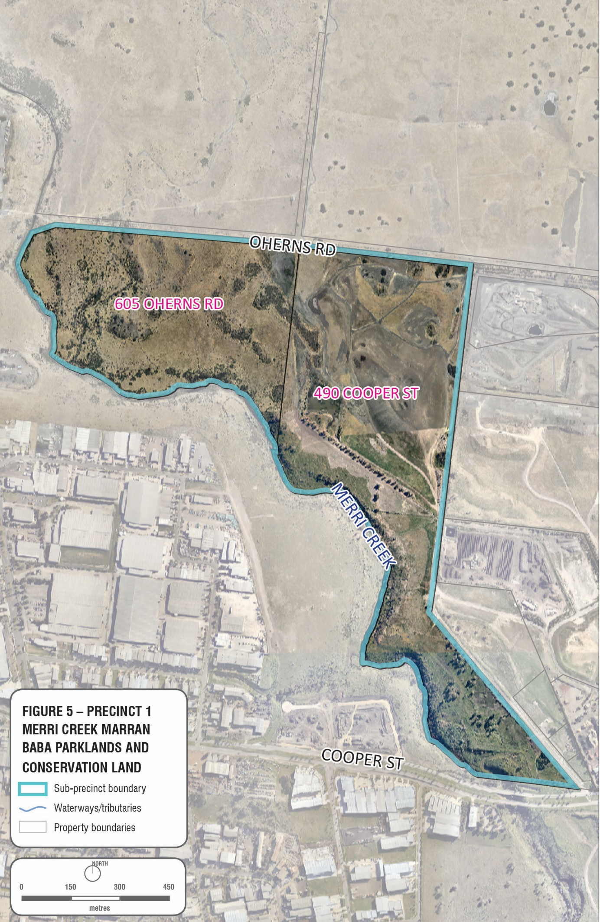

Biodiversity Conservation Strategy
The land at 605 O’Herns Road is protected by the State’s Biodiversity Conservation Strategy; this strategy protects nationally significant fauna and flora in the Northern Growth Corridor.
A significant portion of 605 O’Herns Rd is mapped as forming the southernmost portion of Conservation 34 Growling Grass Frogs (Litoria raniformis). The site supports native vegetation, including threatened flora species such as, Curley Sedge (Carex tasmanica), River Swamp Wallaby Grass (Amphibromus fluitans), Rosemary Grevillea (Grevilla rosmarinifolia), Small Milkwart (Comesperma polygaloides). The land is identified as being part of Merri Creek Reach 1 in the Growling Grass Frog Masterplan Melbourne Growth Corridor (March 2017).
The strategy identifies the following actions in protecting the conservation areas:
- Apply appropriate planning provisions to the land depending on the circumstances (may include a Rural Conservation Zone, and Environmental Significance Overlay or another statutory mechanism) to be determined by the State Minister for Planning.
- Prepare conservation management plan(s) and ensure planning provisions for implementation and funding are in place.
- Establish management agreements with landowners under section 69 of the Conservation Forests and Lands Act 1987 and/or transfer land to Crown to be managed by Melbourne Water.
Normally land covered by the Biodiversity Conservation Strategy have some potential for development as part of a Precinct Structure Planning or Development Plan process whereby land identified as a Growling Grass Frog Corridor would be zoned to Rural Conservation Zone with an appropriate Environmental Significance Overlay. A Land Management Cooperative Agreement would normally be sought as part of a planning permit that sets out an agreement between DELWP and the land owner. However, 605 O’Herns Rd is an anomaly in this process as it is an isolated site not part of any broader development proposal. DELWP have advised that they will work with the land owner and Council to implement the BCS for this site, opportunities exist for this site to form part of the broader Merri Creek Marran Baba Parklands.

Closed landfill and buffers
- To recognise and manage environmental risks associated with being a former landfill site and within a closed landfill buffer and an active quarry buffer.
- To ensure adequate buffers and measures are made to allow continuing gas extraction and maintenance of gas extraction equipment.

Summary of land use constraints
Land Use Constraints | Former Landfill  Sites | Closed Landfill  Buffers | Active Quarry Buffer | Pipeline Easement | Biodiversity Conservation Strategy | Environmental Offsets | Protected habitat | Protected heritage values

Precinct 1 – Site Summaries: Merri Creek Marran Baba parklands and conservation land
Address | Owner | Land Area | Planning Controls | Summary of land
490 Cooper St, Epping | City of Whittlesea | 26.08ha | ES03  SUZ4  RFO  VHR H7822-0064 | Council owned land.  Former landfill (solid inert) site subject to ongoing remediation works (known as Northern).  Site contains a Growling Grass Frog offset area for the Melbourne Wholesale Markets and pockets of significant native vegetation declared under the EPBC Act.  Earmarked for inclusion in the Merri Creek Marran Baba Parklands Strategic Management Plan. A draft master plan has been prepared to facilitate this. A report on native vegetation has been prepared by Applied Botany, Zoology and Ecological Consultants.  A desktop audit prepared by consultants Biosis found artefacts found and recorded for Aboriginal Cultural Heritage.  Victorian Heritage Inventory has found stone wall and sheep wash (see below)  Victoria Heritage Register listing – Sheep Wash  Affected by the Somerton Gas Pipeline (T102) measurement length
605 O’Herns Road Epping | Private | 37.64 ha | SUZ  UFZ  ES03  PAO4  VHR H7822-0065 | Vacant land in private ownership.  Protected under the Biodiversity Conservation Strategy - highly valued conservation land  Identified as part of Merri Creek Reach 1 in the Growling Grass Frog Masterplan Melbourne Growth Corridor (March 2017)  A Public Acquisition Overlay (schedule 4) applies to a portion of land; this overlay was originally applied for the Craigieburn Bypass but is now considered potentially redundant.  Aboriginal Cultural Heritage considerations  Victoria Heritage Register listing – Sheep Pens  Contains the Somerton Gas Pipeline (T102)

Key recommendations
- Support the implementation of the Merri Creek Marran Baba Parklands Strategic Management Plan and Biodiversity Conservation Strategy.
- Support the implementation of the Northern Landfill Master Plan.
- Review the application of Special Use Zones (Schedule 4 – Extractive Uses) for land at 490 Cooper Street intended to be protected for conservation purposes and open space.
- Investigate the potential removal of the Public Acquisition Overlay on 605 O’Herns Road.
- To work with the Department of Environment, Land, Water and Planning (DELWP) to implement the Biodiversity Conservation Strategy and support the long-term protection of land at 605 O’Herns Rd.
- Support the rezoning of land at 605 O’Herns Road to protect the environmental values of the site, in line with the Biodiversity Conservation Strategy.
- Liaise with the Department of Environment, Land, Water and Planning to investigate opportunities for the potential inclusion of 605 O’Herns Rd into the Merri Creek Marran Baba Parklands Plan.
- To work with Department Water Environment Land Planning to implement the Biodiversity Conservation Strategy and protect conservation areas through appropriate planning provisions, conservation management plans and agreements.
- Minimise off-site impacts of the former landfills and land remediation.
- Ensure that any proposed development on the Closed Landfill portion of the sub-precinct is required to undertake the necessary technical studies and, where appropriate an environmental audit to ensure suitability for development. There are a number of environmental and geotechnical risks associated with the development of Closed landfills which require careful management.
- Any proposed development within the Closed Landfill buffer is required to undertake the necessary technical studies to ensure suitability for development.

Key planning considerations
- To recognise and manage environmental risks associated with being a former landfill site and within a closed landfill buffer and an active quarry buffer.
- To support the key principles of the Northern Landfill Master Plan.
- To enhance and preserve protected habitat for the endangered Growling Grass frog.
- To meet the requirements of the Environment Protection and Biodiversity Conservation Act 1999 for land protected under the Biodiversity Conservation Strategy for Melbourne’s Growth Corridors (2013).
- To meet the approvals made under s146B of the Environment Protection and Biodiversity Conservation Act 1999 for urban development in Melbourne’s growth corridors, and the conditions of these approvals.
- To maintain the habitat corridor along Merri Creek.
- To ensure rehabilitation and enhancement of the Merri Creek environs and extension of the Merri Trail link along the Merri Creek Corridor.
- To ensure protection and conservation of threatened species.
- To avoid the removal of native vegetation.
- To protect identified heritage values.
- To protect Aboriginal Cultural Heritage and consult with Aboriginal representatives and develop cultural heritage management plans as appropriate.
- To provide vistas to and from the Merri Creek, there are various opportunities to capitalise on views of the Melbourne CBD to the south and the Quarry Hills to the east.
- To provide landscaping and architectural features which define the entry point into the Merri Creek Parklands as appropriate.
- To ensure the interface and boundaries between sub-precincts respect the conservation and amenity values of the Merri Creek Parklands.
- To plan for pedestrian and bicycle access and linkages which do not detrimentally impact the environmental values of the precinct, and link with the main Merri Creek Shared Trail.
- To ensure safe access for fire management and emergency vehicles is available in the precinct.
- To manage stormwater runoff and drainage.
- To recognise and respond to the constraints on land use and development within the vicinity of the gas pipeline easement and consult with the relevant authority.
- To reconsider the application of the Public Acquisition Overlay Schedule 4 (PAO4) that applies to a portion of 605 O’Herns Rd. This overlay and schedule was incorrectly applied, the PAO was originally applied for the Craigieburn Bypass (Road Reservation), but when this was no longer required, the PAO was retained and an incorrect schedule applied. Removal of this as part of any future “clean up” or “anomalies” planning scheme amendment may be appropriate.
- Support new development in accordance with Recommended Separation Distances for Industrial Residual Air Emissions EPA Publication 1518.
- Refer to The Designing, constructing and operating composting facilities EPA Publication 1588 when considering potential changes to land use near existing composting facility/facilities.
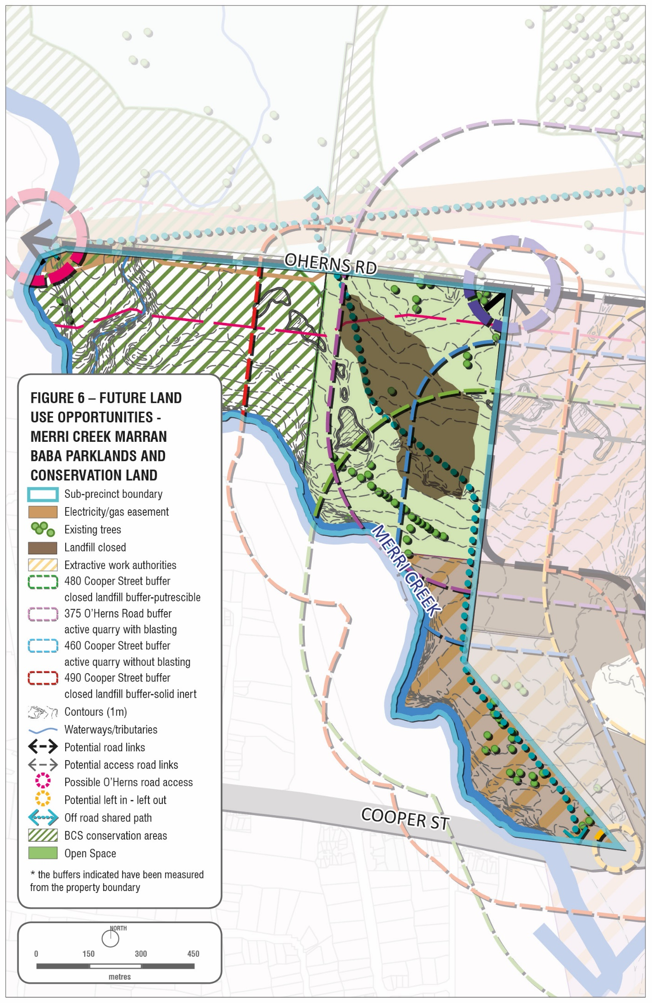

6. Sub-Precinct 2 – Animal welfare
This sub-precinct consists of three (3) allotments which are accessed from Pound Road.
The Animal Welfare Precinct will contain Council’s facility for lost pets and impounded livestock. The facility is a partnership between the Cities of Whittlesea, Darebin and Moreland and will cater for the holding, accommodation and treatment of domestic animals and livestock from these 3 municipalities and expected to house over 3000 dogs and 3000 cats. The new facility will be constructed on Lot 3 with options for other appropriate uses for Lot 1 and 2. The land is zoned Public Use Zone (schedule 6) for Lot 3 and Industrial 1 zone for Lots 1 and 2, with an overall area of 2.91 ha.
The land potentially contains some portion of the closed putrescible landfill and is within a closed landfill buffer and as such any proposed development and any works within the recommended landfill buffer can pose a safety risk. Council must be satisfied that it is appropriate to reduce or develop/undertake any works on a Closed landfill or within a landfill buffer. This will require the appropriate technical assessments.
A portion of the precinct contains native grassland vegetation, recovering Redgum woodlands and large old Redgum trees and is of significant value due to its proximity to Golden Sun Moth populations, which is listed as threatened under the Flora and Fauna Guarantee Act 1988 (Vic). The rehabilitated portion of the precinct also provides native grassland and Redgum woodland habitat for protected native fauna, including remnant kangaroo populations. These areas are to be protected as part of the overall environmental assets of the broader Cooper Street West Precinct (Figure 7 & 8).

Summary of land use constraints

Land Use Constraints | Former Landfill  Sites | Closed Landfill  Buffers | Active Quarry | Active Quarry Buffers | Biodiversity Conservation Strategy | Environmental Offsets | Protected habitat | Protected heritage values
 | - .

Precinct 2 – Site Summaries: Animal welfare
Address | Owner | Area | Planning Controls | Summary of land
2,12,20 and 38 Pound Road, Epping | City of Whittlesea | 2.91 ha | Industrial 1 Zone  PUZ (Schedule 6)  DDO3 | Council owned land that is to develop and operate as a metropolitan animal shelter  Contains remnant grassland and grassy woodland communities as a result of remediation works.

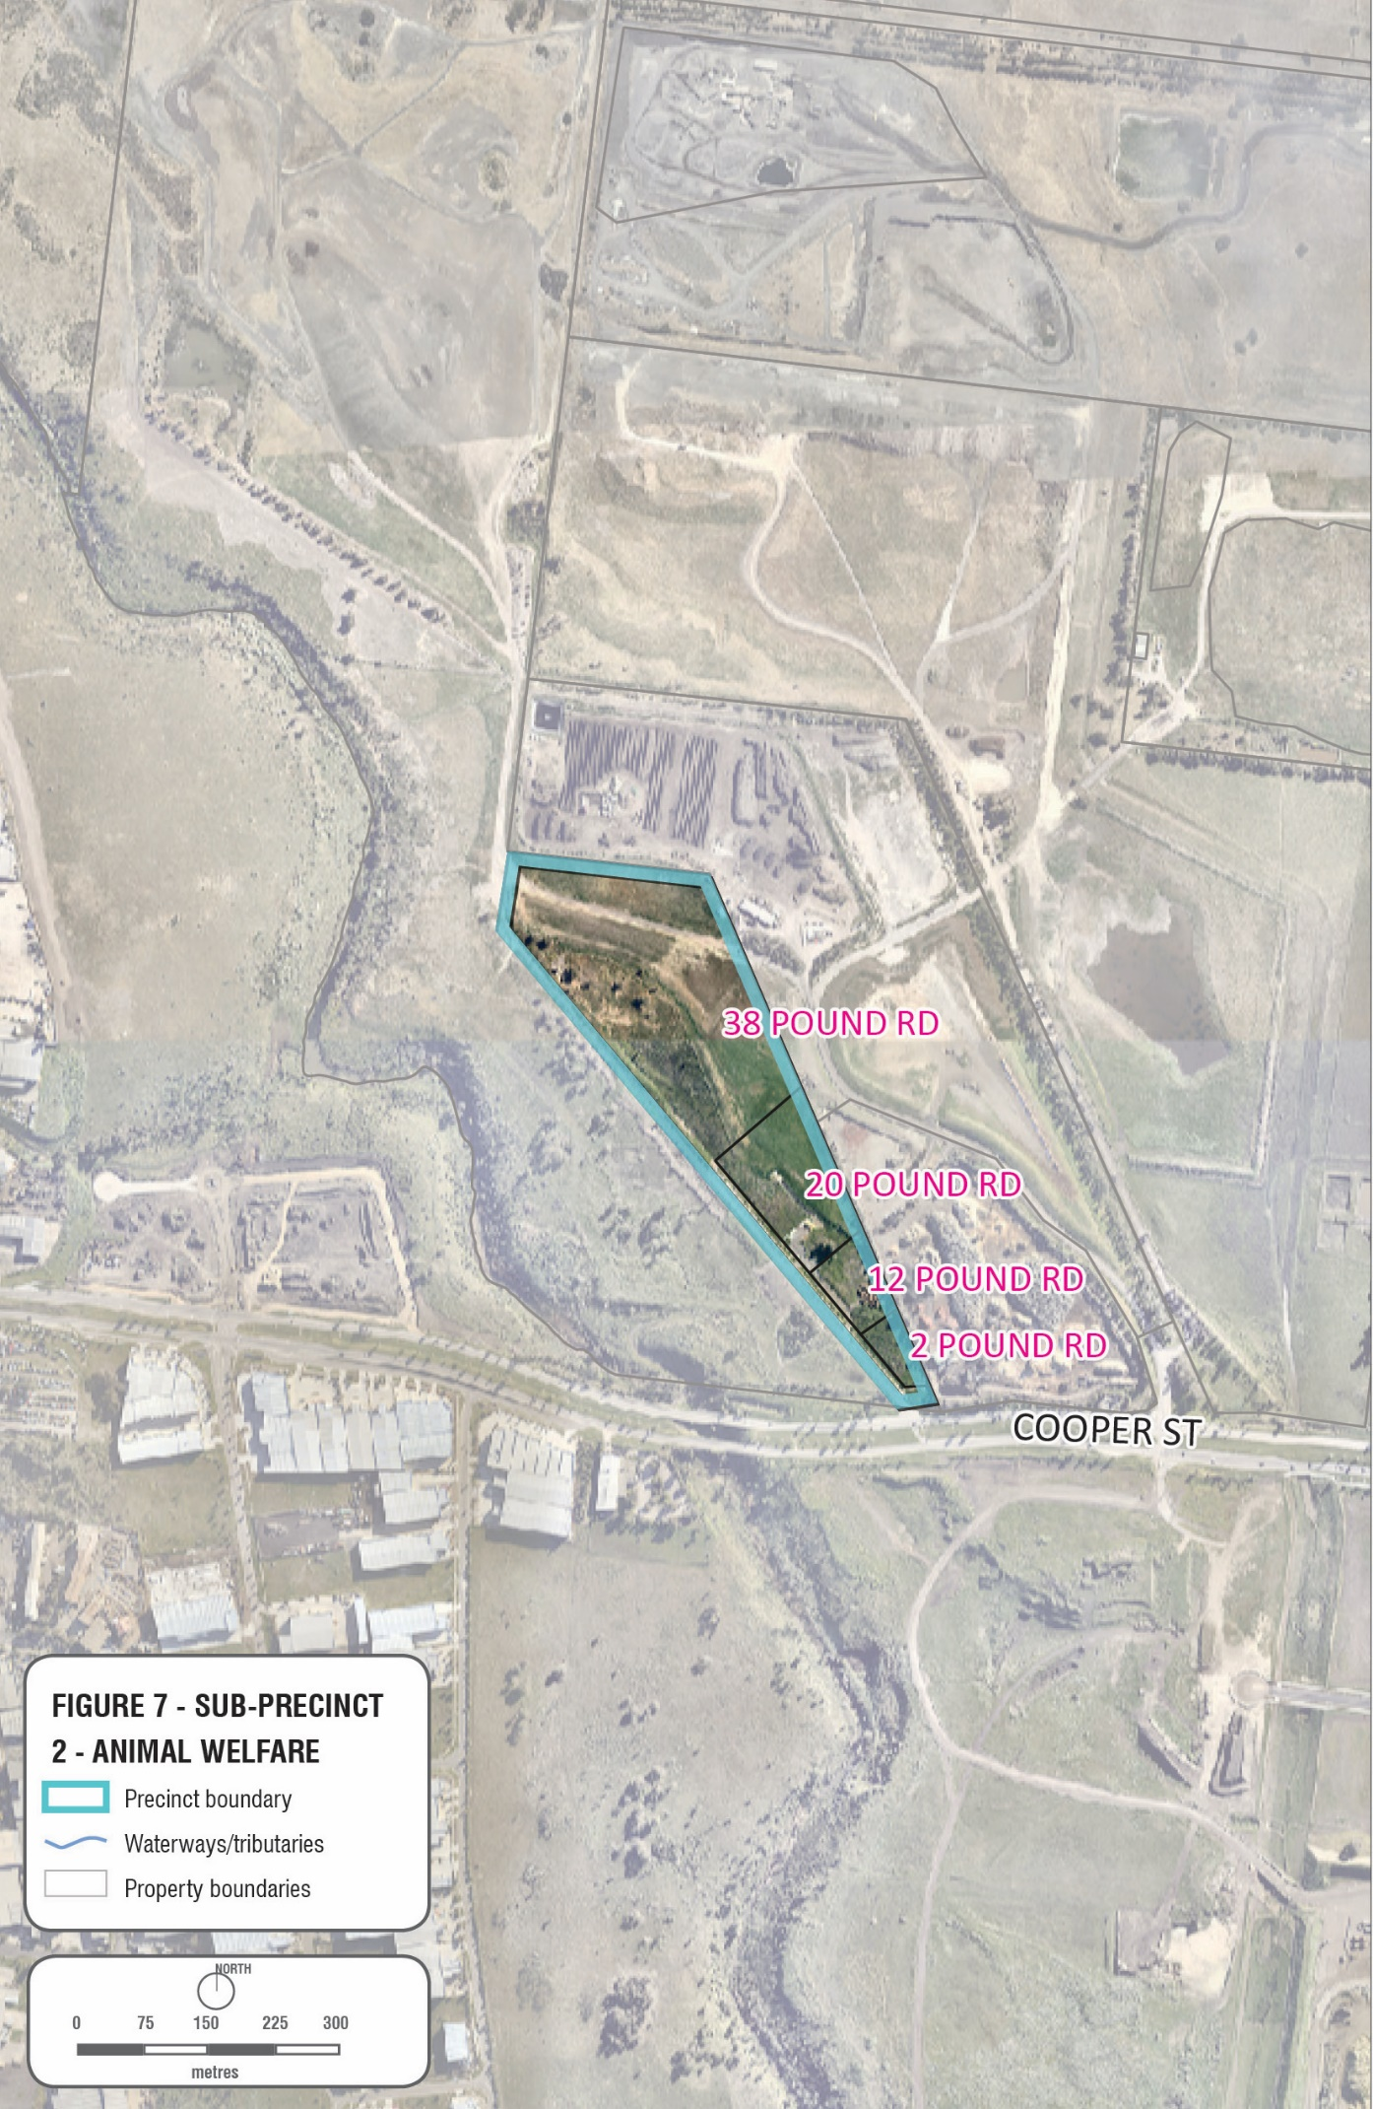

Key recommendations
- Support the operations of the City of Whittlesea’s Animal Welfare Precinct.
- Maintain and protect the native grassland, redgum woodland habitat and large old Redgum trees.
- Ensure that any new development proposal meets the requirements identified in the Best practice environmental management – Siting, design, operation and rehabilitation of landfills (EPA Publication 788.3 August 2015).
- Any proposed development within the Closed Landfill buffer is required to undertake the necessary technical studies to ensure suitability for development.
Key planning considerations
- Provide vehicular access from Pound Road as a left-in and left-out only treatment from Cooper Street.
- Provide a high profile, well designed interface with Cooper Street.
- To ensure the interface and boundaries between sub-precincts respect the conservation and amenity values of the Merri Creek Parklands.
- To protect and maintain the remnant native grassland and redgum woodland for the purposes of providing habitat for native fauna.
- To recognise and manage environmental risks associated with being within a closed landfill buffer and an active quarry buffer.
- Preliminary environmental site assessments are required prior to the development of employment uses. Preliminary environmental site assessments of land near landfills are required to determine whether there is potential contamination. Proposals will be required to propose mitigation of any risks identified and whether an environmental audit is required.
- Support appropriate development and uses, subject to satisfying the environmental risks and buffers associated with a closed landfill.
- To mitigate the potential offsite impacts of waste and resource recovery operations, new development should be considered in accordance with Recommended Separation Distances for Industrial Residual Air Emissions EPA Publication 1518
- Refer to The Designing, constructing and operating composting facilities EPA Publication 1588 when considering potential changes to land use near existing composting facility/facilities.

Closed landfill
- Require a Site Remediation Strategy for any development proposed on the Closed landfill portion of the site, prepared by a suitably qualified professional to describe the risks and opportunities associated with developing the site to a higher land use. The strategy is to demonstrate that:
- A 53X contaminated audit has or will be completed and how the audit conditions will be implemented;
- The site is capable of being remediated so that it is suitable for the proposed use and development;
- The process for the clean-up of the site is sound; and
- Provide a framework for the on-going management of the site conditions, including adequate consideration of geo-technical matters.
- The planning authority needs to be satisfied that the costs of remediating the land are not likely to escalate after the land is rezoned or subdivided, and that this risk is going to be passed onto the subsequent purchasers.

- To the extent that it is appropriate, the remediation costs and obligations need to be borne by the developer of the land, so that those who purchase subdivided land have certainty that they will not be exposed to the costs of environmental regulation that have not been factored into their purchase price.
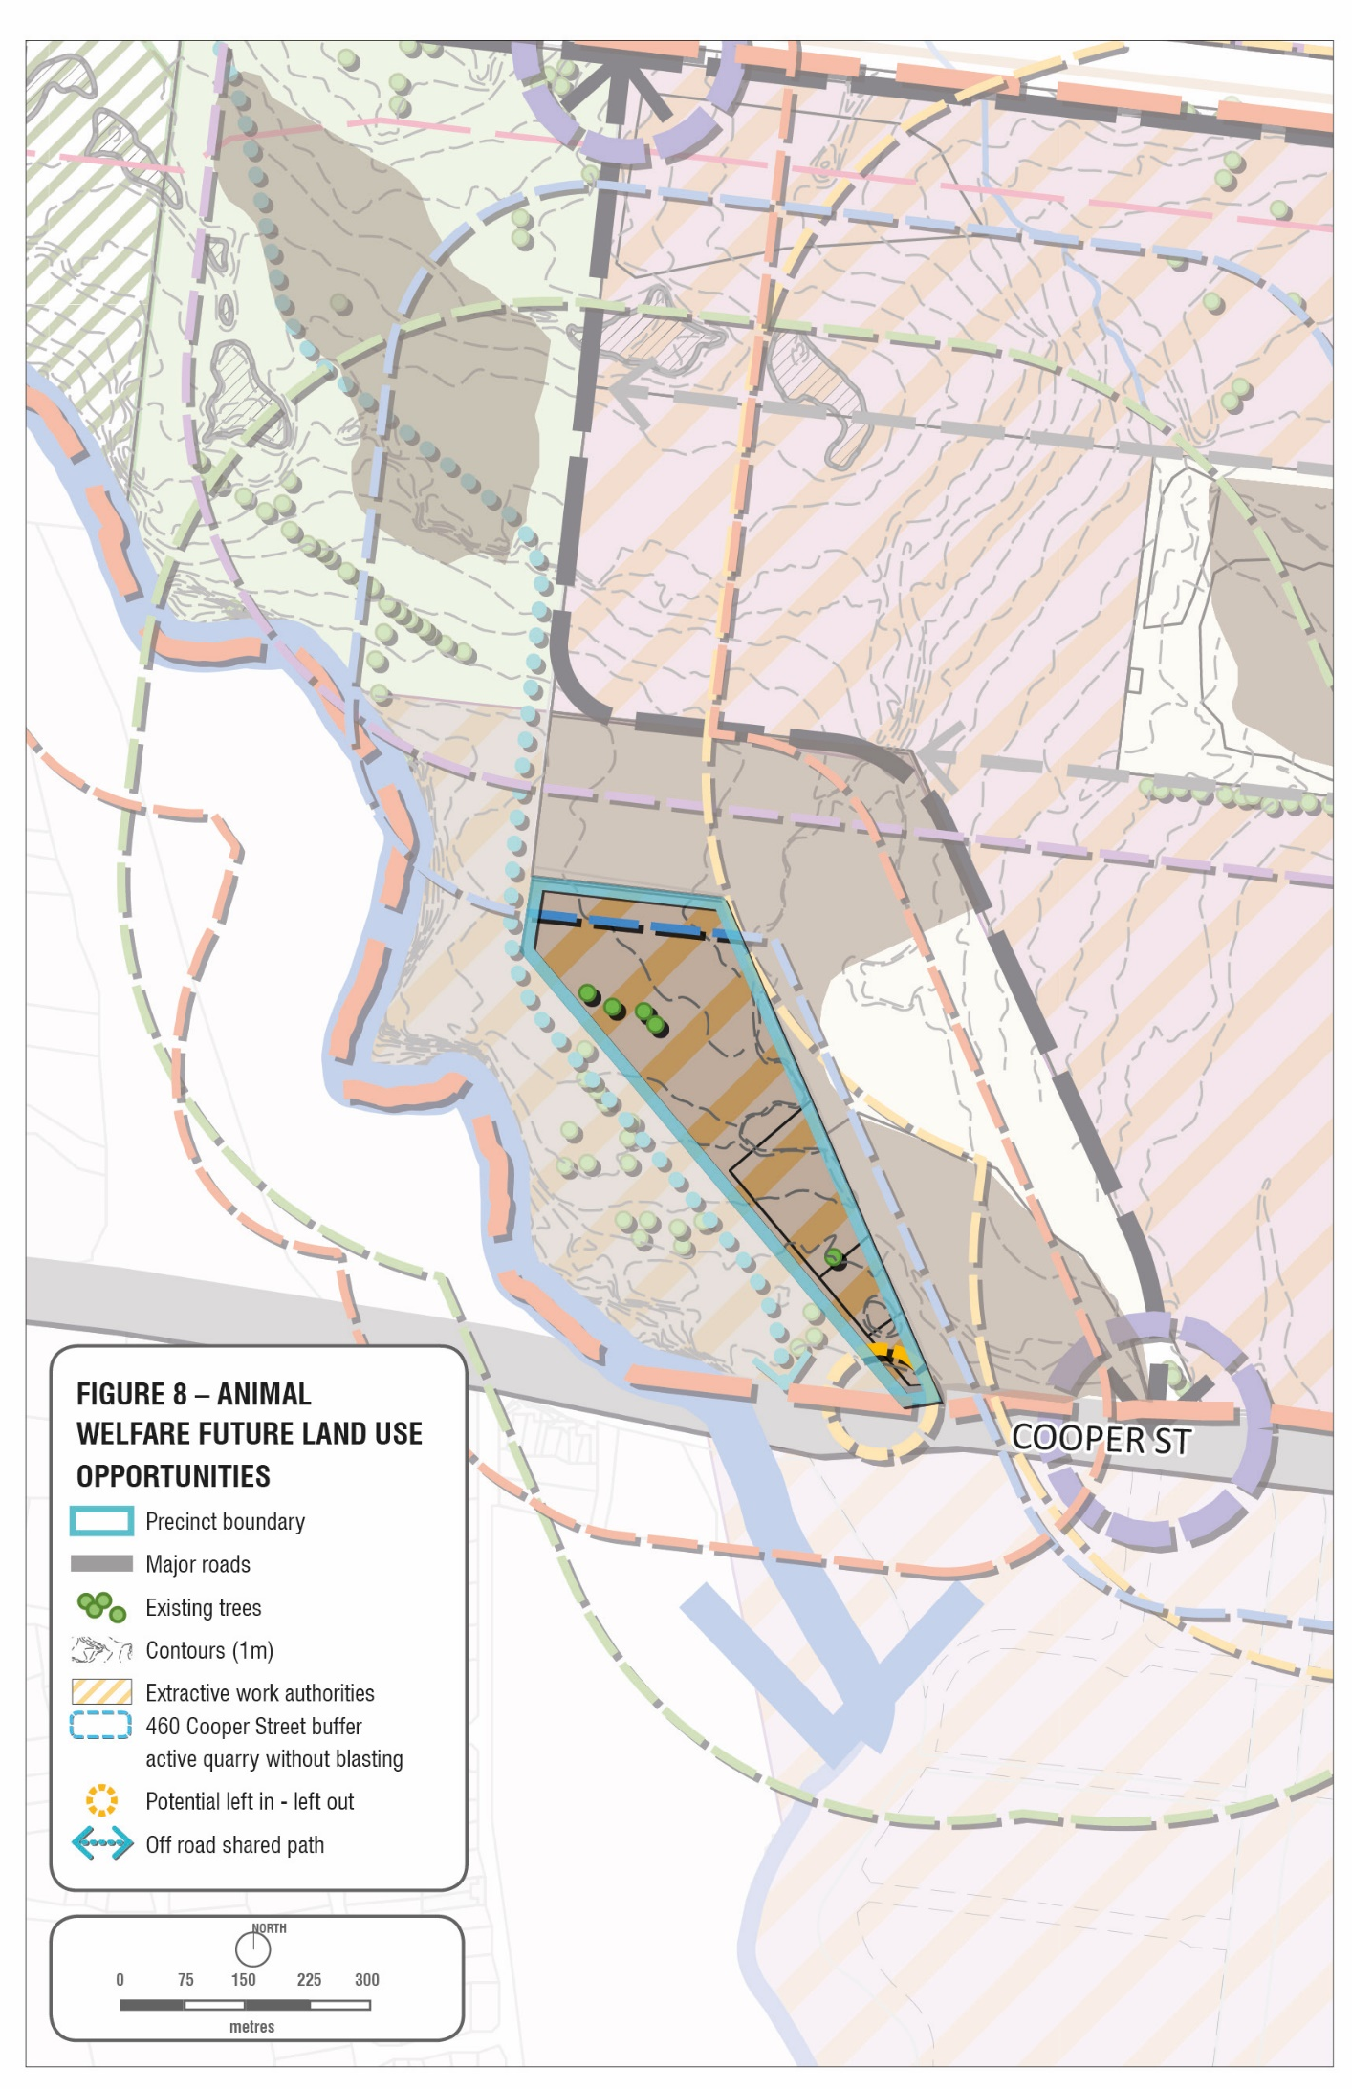

7.0 Sub-Precinct 3 – Earth resources and waste recovery
This sub-precinct is gradually transitioning away from extractive and landfill activities, with most sites in various stages of rehabilitation (Figure 9 & 10).

Active quarries
There are two remaining active quarrying sites (WA 445 and WA149) which provide local employment opportunities.
These active quarries have a separation buffer of 200 metres (WA149) and 500 metres (WA445) (measured from the boundary perimeter) which requires referrals to the relevant authority and restrictions in development including adequate separation distances.

Closed landfill
The sub-precinct contains 2 Closed landfill sites (Cooper No1 and Cooper No 2) which are known to have putrescible waste and solid inert landfill. There are a number of environmental risks associated with former solid inert and putrescible landfills which require careful management and which encumbers future development.
Any proposed development on Closed Landfill is required to undertake the necessary technical studies and where appropriate, an environmental audit to ensure suitability for development.
A site remediation report is required which identifies that:
-the site is capable of being remediated so that it is suitable for the proposed use and development;
-the process for the clean-up of the site is sound; and
-provides a framework for the on-going management of the site conditions.

Waste and resource recovery
Cooper Street Epping has been identified in the Statewide Waste and Resource Recovery Infrastructure Plan as being a hub for waste and resource recycling of State significance, the hub has been identified as being strategically significant for the volume and type of waste recycling, playing an important role in the management of organic, construction and demolition materials. The use of closed landfill sites offer locational advantages given existing buffers and separation from sensitive uses.
The premise of the Statewide Plan is that a waste and resource recovery system provides an essential service. Although it is recognised that some existing hubs will transition out of waste and resource recovery activities over time, however there remains a need for waste resource recovery infrastructure in the long term.
The Metropolitan Waste and Resource Recovery Implementation Plan builds on the work of the Statewide Plan, detailing the opportunities for waste and resource recycling hubs. Waste and resource recovery currently makes a valuable contribution to the local economy by providing in-kind benefits to Council’s green waste recycling and also providing construction and demolition waste recycling facilities.
The precinct has the potential to build on the locational benefits of the area as a waste and resource recovery precinct, including access to feedstocks from Melbourne Wholesale Markets and other various opportunities, including the recycling of waste packaging and/or the consolidation and aggregation of material off-site.
Direction 6.7 of the Melbourne Metropolitan Strategy (Plan Melbourne 2017-2050) identifies the contribution the waste and resource recovery industry makes to the Victorian economy and the need to protect waste and resource recovery infrastructure.
The sub-precinct contains 3 separate recycling facilities on Council owned land which are subject to lease agreements. The timber waste and compost green organic waste recycling facility (480 Cooper St) offers a number of benefits to the local community, including the recycling benefits, and the reduction in cost to transport and dispose of waste to another location. A planning permit (714470 - 5 February 2016) for a materials recycling facility at 460 Cooper Street was more recently granted on private property in the precinct.
Council will continue to support waste recycling industries in the sub-precinct and utilise the opportunities provided under the Statewide Waste and Resource Metropolitan Plan which identifies the area as being a State Significant Hub. There may be opportunities for Council to engage with Sustainability Victoria and the Metropolitan Waste and Resource Recovery Group in supporting and facilitating new waste and resource recovery industries within the sub-precinct. There will be encouragement of technologically advanced processing equipment to mitigate odour and dust emission impacts.
Co-location of other compatible activities that support and enhance waste and resource recovery activities during this time, are also encouraged. The off-site amenity impacts of open window composting operations have been identified as being more difficult to contain and more technologically advanced processing, such as in-vessel composting is preferred for urbanised areas. To minimise potential off-site impacts, earth resources and waste recovery uses will need to employ best practice pollution control, technology and practice. Notwithstanding, new development proposals in the vicinity of these earth resource and waste recovery uses should also ensure adequate design consideration of buildings, to address any potential impacts. In addition, any proposed change of use in proximity to a composting facility should refer to EPA Publication 1588 Designing, constructing and operating composting facilities for recommended separation buffers.

Extractive industry
The existing active Work Authorities (WA 445, WA 149) reflect the long-standing quarrying activity in the area. It is difficult to determine how much longer the extractive industries will continue to operate. Work Authorities are active until the resource is depleted.
These uses provide local employment opportunities and should be protected from encroachment while the extractive operations are active. However, over the next 20-30 years it is anticipated that this hub will transition out of resource extraction activities as the natural resource is depleted, environmental risks are reduced, and demand for other uses occur in the sub-precinct.
The intention is to allow these sites to eventually be rehabilitated such that they can be redeveloped once the resource extraction is complete and the land has stabilised, in accordance with a rehabilitation plan. The sites are not suitable to be used as a future landfill as they are not identified on the Regional Waste Management Group’s Landfill Schedule.

Gas pipeline
A high-pressure gas pipeline easement exists within the precinct which may limit the type of uses and development that are appropriate. These constraints will determine the suitability of future rezoning, land uses and development for this precinct.

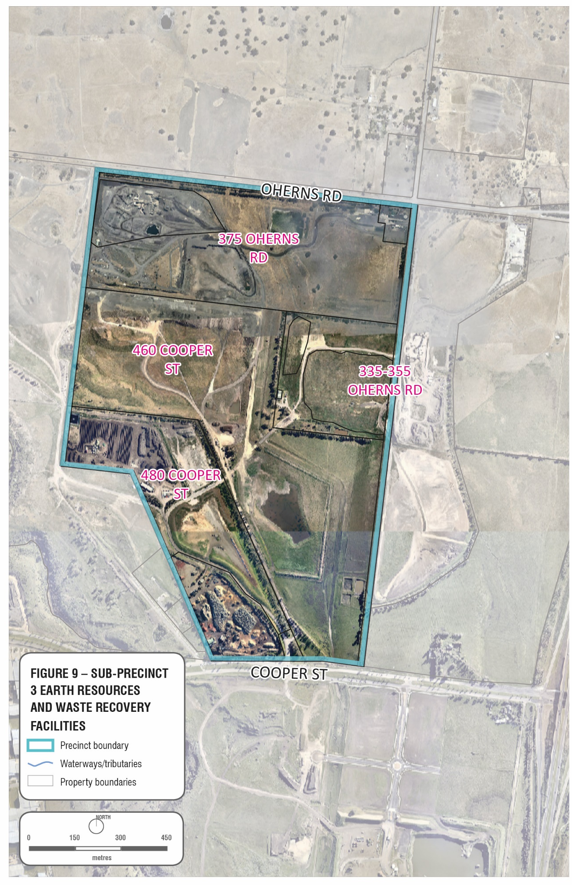

Summary of land use constraints
Land Use Constraints | Former Landfill  Sites | Closed Landfill  Buffers | Active Quarry | Active Quarry Buffers | Biodiversity Conservation Strategy | Pipeline Easement | Central Creek | Protected heritage values

Precinct 3 – Site summaries: Earth resources and waste recovery
Address | Ownership | Land Area | Planning Controls | Summary
Part of 335-355 O’Herns Road, Epping (west of Vearings Rd)  Lot1-TP102498 (14.24ha)  Lot4-TP805492 (34.50ha) | City of Whittlesea | 48.61ha | SUZ (part)  Farming Zone (part)  SIO (part) | Former quarry and landfill (putrescible) site (known Cooper No.2) owned by Council.  Land is currently leased as a concrete batching plant and materials recycling facility (Permit no. 709220). The existing lease will expire in 2021.  Contains the Somerton Gas Pipeline (T102)
375 O’Herns Road, Epping | Private | 42.06ha | SUZ  LSIO  UFZ | Privately owned land.  Active quarry.  Work Approval 445 - Existing operations comprise a residence, offices and associated quarrying infrastructure.  The Northern Quarries Investigation Area Addendum identifies that the operation is expected to continue for the next 20 years.  Victorian Heritage Inventory  Affected by the Somerton Gas Pipeline (T102) measurement length
460 Cooper St, Epping | Private | 55.89ha | SUZ  ESO3 (small portion)  LSIO  UFZ | Privately owned land.  Active quarry. Contains extensive fill areas.  Works Approvals (149) - The site has been significantly disturbed by quarrying activity, is susceptible to inundation and contains large areas of filled ground.  Works Approval for Northern Quarries – 8ha available with quarry life of 7 years WA extended to cover additional 20 ha frontage to Cooper St.  A Permit (No.714470) has been issued ( 5 February 2016) for the use and development of a materials recycling centre.  The site’s redevelopment potential is constrained by the presence of extensive areas of fill and drainage issues associated with Central Creek.
480 Cooper St, Epping | City of Whittlesea | 27.83 ha | Industrial 1 Zone  LSIO  ES03 (part)  DDO3 | Council owned land. Former landfill (putrescible) site (known as Cooper No.1)  Land is currently leased. Two of the leases are currently active including: timber waste recycling facilities and green organic composting facilities.  Activities on Lease Plan Areas 1 and 2 at 480 Cooper Street were authorised under Planning Permit no. 703214 issued on 6 May 1996 for a period of 15 years and amended on 19 October 2010 for a further period of 20 years.  A planning permit (714236) for materials recycling facility adjacent to WA 149 and 445 at 480 Cooper Street, Epping.  Works Approval 381 – Exploration works inactive  Works Authorities on 315 Cooper St to be lifted by Pioneer Quarries.  Victorian Heritage Inventory

Key recommendations
- Support the precincts gradual transition away from extractive industries but support the existing extractive activities already approved in this precinct.
- Support the precincts gradual transition away from extractive uses towards employment uses.
- Support existing and new waste and resource recovery uses in this precinct to support the status of the sub-precinct as being a waste and resource recovery hub of state significance.
- Support the co-location of other compatible uses that support and enhance waste and resource recovery activities.
- Support higher technological processing equipment for waste recycling and resource recovery.
- Ensure that any new development proposal meets the requirements identified in the Best Practice Environmental Management – Siting, design, operation and rehabilitation of landfills (EPA Publication 788.3 August 2015).
- Any proposed development on the Closed Landfill portion of the sub-precinct is required to undertake the necessary technical studies and where appropriate, an environmental audit to ensure suitability for development. There are a number of environmental and geotechnical risks associated with the development of former putrescible landfills which require careful management.
- Prepare a site remediation strategy for any proposed development on a Closed Landfill.
- Identify appropriate locations of new roads within the precinct, informed by geotechnical investigations.
- Minimise off-site impacts of the former landfills and land remediation.
- Minimise off-site impacts of waste and resource recovery industries.
- Refer to The Designing, constructing and operating composting facilities EPA Publication 1588 when considering potential changes to land use near existing composting facility/facilities
- Support new development in accordance with Recommended Separation Distances for Industrial Residual Air Emissions EPA Publication 1518.
- New development should be designed to mitigate the potential offsite impacts of nearby waste and resource recovery operations.
Key planning considerations

Closed landfill, quarry buffers and gas pipeline buffers
- To recognise and manage environmental risks associated with being within a closed landfill buffer and an active quarry buffer.
- To ensure adequate buffers and measures are made to allow continuing gas extraction and maintenance of gas extraction equipment
- To recognise and respond to the constraints on land use and development within the vicinity of the gas pipeline easement and consult with the relevant authority.
- Preliminary environmental site assessments are required prior to the development of employment uses. Preliminary environmental site assessment of land near the quarries and landfills are required to determine whether there is potential contamination and whether an environmental audit is required. Proposals will be required to propose mitigation of any risks identified.

Closed landfills
- Require a Site Remediation Strategy for any proposed development on a Closed landfill site, prepared by a suitably qualified professional to describe the risks and opportunities associated with developing the site to a higher land use. The strategy is to demonstrate that:
- A 53X contaminated audit has or will be completed and how the audit conditions will be implemented;
- The site is capable of being remediated so that it is suitable for the proposed use and development;
- The process for the clean-up of the site is sound; and
- Provide a framework for the on-going management of the site conditions, including adequate consideration of geo-technical matters.
- The planning authority needs to be satisfied that the costs of remediating the land are not likely to escalate after the land is rezoned or subdivided, and that this risk is going to be passed onto the subsequent purchasers.

- To the extent that it is appropriate, the remediation costs and obligations need to be borne by the developer of the land, so that those who purchase subdivided land have certainty that they will not be exposed to the costs of environmental regulation that have not been factored into their purchase price.

Extractive industry and waste and resource recovery
- Recognise the constraints of developing within a separation buffer of an active quarry.
- To mitigate the potential offsite impacts of waste and resource recovery operations, new development should be considered in accordance with Recommended Separation Distances for Industrial Residual Air Emissions EPA Publication 1518
- Recognise the various timelines for existing extractive uses to conclude and the need to remediate closed sites.
- The State significant waste and resource recovery hub within this sub-precinct will continue to provide a service to the local community and support initiatives to increase recovery and improved management of waste.
- Encourage and support the location of waste and resource recovery.
- Council needs to be satisfied that sufficient information has been provided by a proponent that the proposed rezoning of land and/or development will not be adversely impacted by its proximity to a landfill site.
- To consider the separation distances required from the composting facility at 480 Cooper St.
- Ensure new waste and resource recovery proposals do not cause material detriment to surrounding uses.

Design and development
- Provide opportunities for connectivity and integration of the precinct to surrounding land and future development.
- Design to reflect the locational attributes of the precinct.
- To recognise and manage off site impacts by ensuring operators engage in best practice to minimise off-site impacts to support its continuing operations in a metropolitan area.
- Provide high quality urban design response, reflective of the high visibility of this gateway location, in particular from the view lines of Cooper Street, O’Herns Road and Hume Freeway.
- Road network design to minimise impacts on access along Cooper Street and O’Herns Road.
• New development should be designed to mitigate the potential offsite impacts of nearby waste and resource recovery operations,
- To consider the need to undertake air quality and noise assessments for new developments.
- Consider requiring adequate buffer distances to protect existing industries from the encroachment of incompatible sensitive uses.
- The planning authority needs to be satisfied that the costs of remediating the land are not likely to escalate after the land is rezoned or subdivided, and that this risk is going to be passed onto the subsequent purchasers.
- To the extent that it is appropriate, the remediation costs and obligations need to be borne by the developer of the land, so that those who purchase subdivided land have certainty that they will not be exposed to the costs of environmental regulation that have not been factored into their purchase price.

Environmental and heritage values
- To ensure that former Works Authority sites are appropriately remediated and rehabilitated in accordance with the approved rehabilitation plan.
- To recognise and minimise potential impact on waterways and to manage any risks associated with storm events.
- Protect stony knolls, significant trees, River Red Gums and areas of dry stone walls.
- Maintain open waterways to Central Creek.
- Protect cultural heritage significance.
- To ensure the interface and boundaries between sub-precincts respect the conservation and amenity values of the Merri Creek Parklands.

8. Sub-precinct 4 – Gateway – Emerging industry
Precinct 4 has been identified as land which could play a significant gateway role, being on the north-west corner of the Craigieburn Bypass (Hume Hwy) and Cooper Street interchange. High quality built form responses and landscaping are expected to reflect the high visibility of this precinct (Figure 11 & 12).
The precinct includes closed landfills high pressure gas pipeline easements. Development of this precinct should not prejudice the planning and development of the broader precinct, particularly in terms of internal road access arrangements. Development will also require works or services to be provided or paid for including roads, easements and other requirements identified. This would be achieved by a Development Plan Overlay and Section 173 Agreement.
Council owned land at 335 O’Herns Rd is strategically located and may be key to facilitating/unlocking internal access arrangements within the broader precinct. Given a key objective of the Cooper St West Position Paper is to ensure that development of individual parcels and sub-precincts do not prejudice the planning and development of the broader precinct, particularly in terms of internal road access arrangements, it is recommended that Council refrain from making decisions requesting lease until Council is in a position to determine whether the site (or parts of the site) are required to facilitate internal road access arrangements to support the development of key parcels of land in the precinct.
Any proposed development on the Closed Landfill (part of 335 O’Herns Rd) portion of the sub-precinct is required to undertake the necessary technical studies to ensure suitability for development. There are a number of environmental and geotechnical risks associated with the development of former putrescible landfills which require careful management.
Any proposed development must also include an assessment by a suitably qualified Landfill Gas Risk professional. The Cardno Landfill Gas Buffer Assessment 15 and 25 Vearings Rd, 315 O’Herns Rd and 410 Cooper St Epping (V160682G Report 01.3 (Cardno,2017) can be utilised for background information.

Summary of land use constraints
Former Landfill  Sites | Closed Landfill  Buffers | Active Quarry | Active Quarry Buffers | Biodiversity Conservation Strategy | Environmental Offsets | Protected habitat | Pipeline Easement | Protected heritage values

Precinct 4 – Site Summaries: Gateway and emerging industry
Address | Ownership | Area | Planning Controls | Summary
Part of 335-355 O’Herns Road, Epping  (east of Vearings Rd)  Lot1-TP102498 (14.24ha)  Lot4-TP805492 (34.50ha) | City of Whittlesea | X | SUZ (part)  Farming Zone (part)  SIO (part) | Former quarry and landfill (putrescible) site (known Cooper No.2) owned by Council.  Land is currently leased as a concrete batching plant and materials recycling facility (Permit no. 709220). The existing lease will expire in 2021.  Contains the Somerton Gas Pipeline (T102)
410 Cooper St, Epping | Private | 32.09 ha | Farming Zone  DD02  VHR H7822-0269 | Privately owned.  Existing farm dwelling.  A highpressure gas pipeline extends through the site in a north/south alignment (known as Keon Park to Wollert T47.1)  The site has not been quarried to any significant extent and offers scope for redevelopment.  Victoria Heritage Register listing for stonewalls.
315 O’Herns Road, Epping | Private | 29.33 ha | Farming Zone  SUZ  DD02  PAO2 (partial north-east corner) | Privately owned.  Currently used for grazing.  A high-pressure gas pipeline extends through the site in a north/south alignment (known as Keon Park to Wollert T47.1)  The land has not been quarried to any significant extent and offers scope for redevelopment.  Victorian Heritage Inventory.  Contains the Somerton Gas Pipeline (T102)

Key recommendations
- Support the rezoning of the precinct to reflect the intended employment land.
- Recognise the adjoining waste and resource recovery precinct to the west and possible incompatible developments.
- Ensure development of this precinct does not prejudice the planning and development of the broader precinct, particularly in terms of internal road access arrangements.
- Ensure a rezoning is accompanied by a development plan, including a Development Contributions Plan/Infrastructure Contributions Plan or Section 173 Agreement, as required. Technical studies to support the rezoning may be required prior to authorisation to seek a planning scheme amendment
- Ensure integration of the development of this sub-precinct with the broader Cooper Street West Precinct.
- Ensure adequate technical studies are conducted on closed landfills.
- A site remediation strategy is to be prepared for any proposed development on a Closed Landfill.
- Support new development in accordance with Recommended Separation Distances for Industrial Residual Air Emissions EPA Publication 1518.
- New development should be designed to mitigate the potential offsite impacts of nearby waste and resource recovery operations.
- Applicants seeking to develop within this precinct are to engage a suitably qualified expert in Landfill Gas Risk Assessment. The Cardno Landfill Gas Buffer Assessment 15 and 25 Vearings Rd, 315 O’Herns Rd and 410 Cooper St V160682GReport 01.3 (Cardno, 2017) can be utilised for background information.
- Refer to The Designing, constructing and operating composting facilities EPA Publication 1588 when considering potential changes to land use near existing composting facility/facilities.
- Only short-term leases to Council owned land should be considered for the time being, to allow Council the flexibility necessary to facilitate the orderly planning of the broader precinct.
Key planning considerations

Closed landfills
- Require a Site Remediation Strategy for any proposed development on a Closed landfill site to determine whether the site is capable of being remediated and is suitable for the proposed use or development the strategy is to demonstrate that:
- A 53X contaminated audit has or will be completed and how the audit conditions will be implemented;
- The site is capable of being remediated so that it is suitable for the proposed use and development;
- The process for the clean-up of the site is sound; and
- Provide a framework for the on-going management of the site conditions, including adequate consideration of geo-technical matters.
- The planning authority needs to be satisfied that the costs of remediating the land are not likely to escalate after the land is rezoned or subdivided, and that this risk is going to be passed onto the subsequent purchasers.

- To the extent that it is appropriate, the remediation costs and obligations need to be borne by the developer of the land, so that those who purchase subdivided land have certainty that they will not be exposed to the costs of environmental regulation that have not been factored into their purchase price.
- Any development proposal on Closed Landfill must comply with the Ministerial Direction on Potentially Contaminated Land (Ministerial Direction) and State Environment. Protection Policy (Prevention and Management of Contaminated Land) (SEPP(PMCL)).
- Ensure that any new development proposal meets the requirements identified in the Best Practice Environmental Management – Siting, design, operation and rehabilitation of landfills (EPA Publication 788.3 August 2015).

Landfill and quarry buffers and gas pipeline
- To recognise and manage environmental risks associated with being within a closed landfill buffer and an active quarry buffer.
- To ensure adequate buffers and measures are made to allow continuing gas extraction and maintenance of gas extraction equipment.
- To recognise and respond to the constraints on land uses and development within the vicinity of the gas pipeline easements and consult the relevant authority.
- To recognise and respond to the constraints of developing within the separation buffer of an active quarry.
- To recognise the impacts of existing uses on any new developments, including the risk of gas migration, noise, odour and dust emissions.

Design and development
- To seek opportunities for road access and integration of the precinct with future redevelopment potential of the surrounding land.
- To provide high quality built form and landscape amenity at this highly exposed gateway location.
- To enhance the aesthetic appearance and experience along the Hume Freeway, Cooper Street and O’Herns Road.
- If development is to occur on Council owned land:
  - The planning authority needs to be satisfied that the costs of remediating the land are not likely to escalate after the land is rezoned or subdivided, and that this risk is going to be passed onto the subsequent purchasers.
  - To the extent that it is appropriate, the remediation costs and obligations need to be borne by the developer of the land, so that those who purchase subdivided land have certainty that they will not be exposed to the costs of environmental regulation that have not been factored into their purchase price.
- Provide a subdivision layout which allows for vehicles required for industrial areas and within and into/out of the site and with varying allotment sizes, to allow for a variety of industrial/employment uses to establish in the precinct.
- To ensure adequate environmental assessments are made.
- Refer to The Designing, constructing and operating composting facilities EPA Publication 1588 when considering potential changes to land use near existing composting facility/facilities.
- New development should be designed to mitigate the potential offsite impacts of nearby waste and resource recovery operations,
- To identify any development contributions required for the delivery of infrastructure to service the development of the area.
- To protect the identified heritage values.

Road network
- Provide a road hierarchy that is designed to ensure that local collector roads support the major roads and provide a range of access alternatives.
- Require a modified grid-based road network with a high degree of connectivity and accessibility which support ease of movement for larger and heavier industrial vehicles.
- To identify and design the subdivision layout to allow for the earliest delivery of east-west access to adjoining sites, informed by appropriate geotechnical investigations.
- To design and provide for safe access for larger and heavier industrial vehicles to and from O’Herns Road and Cooper Street into the precinct.
- To provide a subdivision layout and local collector road network that is suitable for industrial/employment type uses.
- To conduct geotechnical investigations to inform the siting of connector roads that may be impacted by former quarry/landfill operations.
- To provide access from Cooper Street in alignment with Graystone Court.
- To provide access off O’Herns Road from Vearings Road (south).
- To identify a functional north and south road access, and access to O’Herns Road.

9. Northern Quarries Investigation Area (NQIA)
The Victorian Planning Authority (VPA) released an addendum on the North Growth Corridor Plan in 2015, to investigate the “Northern Quarries Investigation Area” which is a study area north of Cooper Street West. The addendum identifies a potential development area immediately north of Cooper Street West Precinct at 25 Vearings Road. The land is substantially covered by the Biodiversity Conservation Strategy. The remaining identified developable area is covered by non-sensitive use buffers relating to noise and possible fly rock from WA 445 which is located to the south and which is expected to continue operation for the next 20 years.
The land is currently zoned Rural Conservation and the area nominated for future urban development will be managed though a Structure Planning Process. Ministerial direction and resolution of the NQIA has yet to occur.
The land at 25 Vearings Road will share the use of O’Herns Road as the major access road, the upgrade of the O’Herns interchange will increase the demand for these sites and future upgrades to O’Herns Road are required.

10. Conclusion
The Cooper Street West Precinct is well located for future employment/enterprise land. It is anticipated that over time the precinct will evolve to reflect its employment designation.
The Cooper Street West Precinct is proposed to be split into 4 sub-precincts:
- Precinct 1 contains high ecological values and will evolve into an open space and conservation area adjacent to the Merri Creek which will support the transition of this precinct from a waste and extractive resource area.
- Precinct 2 will support Council owned facilities such as the proposed new Animal Welfare Precinct and presents opportunities for new enterprise land.
- Precinct 3 will continue to support extractive industries and materials recycling until the resources are depleted or operations cease. Support emerging new industries and the identified Statewide Waste and Resource Recovery hub status of the sub-precinct.
- Precinct 4 contains some of the most developable land, and is a gateway site for the municipality.
This Position Paper aims to identify the key issues required for any consideration in developing the precinct. It also aims to inform landholders and the surrounding area of Council’s position in relation to future land use and development.
Over time it is intended to integrate the precinct with the original vision of Cooper Street Employment Area. Notwithstanding this, the precinct is constrained by former land uses which require careful investigation, management and remediation before any major development proposals will be appropriate. Due to the high risk associated with closed landfill, additional reports will be required for any proposed new developments.

Key recommendations

Precinct 1
- Support the implementation of the Merri Creek Marran Baba Parklands Strategic Management Plan and Biodiversity Conservation Strategy.
- Support the implementation of the Northern Landfill Master Plan.
- Review the application of Special Use Zones (Schedule 4 – Extractive Uses) for land at 490 Cooper Street intended to be protected for conservation purposes and open space.
- Investigate the potential removal of the Public Acquisition Overlay on 605 O’Herns Road.
- To work with the Department of Environment, Land, Water and Planning (DELWP) to implement the Biodiversity Conservation Strategy and support the long-term protection of land at 605 O’Herns Rd.
- Support the rezoning of land at 605 O’Herns Road to protect the environmental values of the site, in line with the Biodiversity Conservation Strategy;
- Liaise with the Department of Environment, Land, Water and Planning to investigate opportunities for the potential inclusion of 605 O’Herns Rd into the Merri Creek Marran Baba Parklands Plan.
- Minimise off-site impacts of the former landfills and land remediation.
- Ensure that any proposed development on the Closed Landfill portion of the sub-precinct is required to undertake the necessary technical studies and, where appropriate an environmental audit to ensure suitability for development. There are a number of environmental and geotechnical risks associated with the development of Closed landfills which require careful management.
- Any proposed development within the Closed Landfill buffer is required to undertake the necessary technical studies to ensure suitability for development.

Precinct 2
- Support the operations of the City of Whittlesea’s Animal Welfare Precinct.
- Maintain and protect the native grassland, redgum woodland habitat and large old Redgum trees.
- Ensure that any new development proposal meets the requirements identified in the Best practice environmental management – Siting, design, operation and rehabilitation of landfills (EPA Publication 788.3 August 2015).
- Any proposed development within the Closed Landfill buffer area is required to undertake the necessary technical studies to ensure suitability for development.

Precinct 3
- Support the precincts gradual transition away from extractive industries but support the existing extractive activities already approved in this precinct.
- Support the precincts gradual transition away from extractive uses towards employment uses.
- Support existing and new waste and resource recovery uses in this precinct to support the status of the sub-precinct as being a waste and resource recovery hub of state significance.
- Support the co-location of other compatible uses that support and enhance waste and resource recovery activities.
- Support higher technological processing equipment for green waste recycling to minimise off-site amenity impacts.
- Ensure that any new development proposal meets the requirements identified in the Best Practice Environmental Management – Siting, design, operation and rehabilitation of landfills (EPA Publication 788.3 August 2015).
- Any proposed development on the Closed Landfill portion of the sub-precinct is required to undertake the necessary technical studies and where appropriate, an environmental audit to ensure suitability for development. There are a number of environmental and geotechnical risks associated with the development of former putrescible landfills which require careful management.
- Prepare a site remediation strategy for any proposed development on a Closed Landfill.
- Identify appropriate locations of new roads within the precinct, informed by geotechnical investigations.
- Minimise off-site impacts of the former landfills and land remediation.
- Minimise off-site impacts of waste and resource recovery industries.
- Refer to The Designing, constructing and operating composting facilities EPA Publication 1588 when considering potential changes to land use near existing composting facility/facilities.
- Support new development in accordance with Recommended Separation Distances for Industrial Residual Air Emissions EPA Publication 1518.
- New development should be designed to mitigate the potential offsite impacts of nearby waste and resource recovery operations.

Precinct 4
- Support the rezoning of the precinct to reflect the intended employment land.
- Recognise the adjoining waste and resource recovery precinct to the west and possible incompatible developments.
- Ensure development of this precinct does not prejudice the planning and development of the broader precinct, particularly in terms of internal road access arrangements.
- Ensure integration of the development of this sub-precinct with the broader Cooper Street West Precinct.
- Ensure a rezoning is accompanied by a development plan, including a Development Contributions Plan/Infrastructure Contributions Plan or Section 173 Agreement, as required. Technical studies to support the rezoning may be required prior to authorisation to seek a planning scheme amendment.
- Ensure adequate technical studies are conducted on closed landfills.
- A site remediation strategy is to be prepared for any proposed development on a Closed Landfill.
- Support new development in accordance with Recommended Separation Distances for Industrial Residual Air Emissions EPA Publication 1518.
- New development should be designed to mitigate the potential offsite impacts of nearby waste and resource recovery operations.
- Applicants seeking to develop within this precinct are to engage a suitably qualified expert in Landfill Gas Risk Assessment. The Cardno Landfill Gas Buffer Assessment 15 and 25 Vearings Rd, 315 O’Herns Rd and 410 Cooper St V160682GReport 01.3 (Cardno, 2017) can be utilised for background information.
- Refer to The Designing, constructing and operating composting facilities EPA Publication 1588 when considering potential changes to land use near existing composting facility/facilities.
- Only short-term leases to Council owned land should be considered for the time being, to allow Council the flexibility necessary to facilitate the orderly planning of the broader precinct.

11. Glossary
Buffer zone: Buffer zones, or separation distances, aim to minimise the off-site impacts of sensitive land uses arising from unintended, industry generated odour and dust emissions.
A buffer zone is an area of land outside the operating area of a facility that is set aside to maintain an adequate distance between the facility and sensitive land uses (such as residential development) so those uses are not adversely affected by noise, odour or dust. The land may or may not be owned by the facility owner.
Construction and demolition waste: Solid inert waste generated from residential and commercial construction and demolition activities.
In-vessel composting: Composting technology involving the use of a fully enclosed chamber or vessel, in which the composting process is controlled by regulating the rate of mechanical aeration. Aeration assists in heat removal, temperature control and oxygenation of the mass. Aeration is provided to the chamber by a blower fan which can work in a positive (blowing) and/or negative (sucking) mode. Rate of aeration can be controlled with temperature, oxygen or carbon dioxide feedback signals.
Landfill: Discharge or deposit of solid wastes onto land that cannot be practically removed from the waste stream.
Landfill gas: Landfill gas is produced from the degradation of the organic material in the landfill. The hazards associated with gas are:
- physical hazard of explosion (from methane mixing with air and ignited by a spark), or from asphyxiation (by methane build up within enclosed spaces).
- toxic hazard from gases generated in the landfill. For a landfill that has received hazardous gases, there may be potentially harmful significant concentrations of gases other than the traditional landfill gases.
Landfill BEPM (Best practice environmental management: Facility management in line with EPA publication in Best Practice Environmental Management – siting, design, operation and rehabilitation of landfills.
Leachate: Contaminated water that has percolated through or drained from a landfill.
Measurement Length The 4.7W/m2 radiation contour for a full bore rupture, as defined in AS 2885.1 Clause 4.3.2. This radiation intensity is sufficient to cause serious injury after 30 seconds exposure.
Open windrow composting operation: A type of outdoor composting process where organic materials are piled in to windrows and are turned for aeration.
Potentially Contaminated land: Is defined as land used or known to have been used for industry, mining or the storage of chemicals, gas wastes or liquid fuel, land that may have been contaminated by other means such as by ancillary activities, contamination from surrounding land, fill using contaminate soil or agricultural uses.
Prescribed waste and prescribed industrial waste (PIW): These wastes are defined in the Environment Protection (Industrial Waste Resource) Regulations 2009. EPA closely regulates these wastes because of their potential adverse impacts.

12. References
- Assessing Risks Posed by Hazardous Ground Gases to Buildings (CIRIA665), CIRIA (2007)
- Australian Standard 2885 Pipelines: Gas and Liquid Petroleum.
- Biodiversity Conservation Strategy for Melbourne’s Growth Corridors (2013)
- Biodiversity Business Park Cooper Street Epping, Planning and Design Guidelines, City of Whittlesea.
- Council Plan 2013-2017, City of Whittlesea, 2013.
- Cooper Street South West Employment Area Panel Report (Amendment C174), Planning Panels Victoria, August 2014.
- Cooper Street Employment Area Development Plan, City of Whittlesea, October 2007.
- Designing, constructing and operating composting facilities, EPA Publication 1588, EPA Victoria 2015
- Environment Protection and Biodiversity Conservation Act 1999
- Frogs in the Grass – community monitoring of the Growling Grass Frog at the City of Whittlesea Quarry – Seasons 1 and 2, Victorian National Parks, October 2012.
- Growling Grass Frog Master Plan (March 2017)
- Guideline for the Planning and Development of Land in the Vicinity of High Pressure Natural Gas Pipelines in Victoria, APA Group, 2014.
- Land Protection under the Biodiversity Conservation Strategy, Melbourne Strategic Assessment, May 2014.
- Landfill Gas Buffer Assessment 15 and 25 Vearings Road, 315 O’Herns Road and 410 Cooper Street Epping, V160682GReport01.3, Cardno 2017
- Merri Creek and Environs Strategy 2009-2014, Merri Creek Management Committee, May 2009.
- Merri Creek Marran Baba Parklands Strategic Management Plan, Parks Victoria, May 2013.
- Ministerial Direction No. 1 – Potentially Contaminated Land, Minister for Planning, September 2001.
- Northern Quarries Investigation Area Addendum, Metropolitan Planning Authority.
- Plan Melbourne: Metropolitan Planning Strategy, Department of Transport, Planning and Local Infrastructure, 2014.
- Potentially Contaminated Land: General Practice Note, Department of Sustainability and Environment and EPA Victoria, June 2005.
- Recommended separation distance for industrial residual air emissions Publication 1518, EPA Victoria, March 2013.
- Statewide Waste and Resource Recovery Infrastructure Plan Victoria 2015-2044, Sustainability Victoria, 2015.
- Separation distances for large composting facilities Publication 1495, EPA Victoria, August 2012.
- Sub-regional Species Strategy for the Growling Grass Frog (2013)
- Siting, design, operation and rehabilitation of landfills Publication 788.2, EPA Victoria, October 2014.
- The North Growth Corridor Plan, Metropolitan Planning Authority, June 2012.
- Whittlesea Planning Scheme, 2014.

