St John’s wort (Hypericum perforatum)

Pest Plant Local Law

St John’s wort
Note Number: PPLL 09
St John’s wort is a long-lived perennial herb growing to about 80 cm in height. It is an extremely invasive weed of disturbed areas, roadsides, bushland areas and degraded pastures. It competes strongly with indigenous vegetation and pastures and well established infestations can eliminate all other plants, seriously restricting overstorey recruitment.
St John’s wort is known to cause photosensitisation of exposed skin in livestock when consumed and this affects the nervous system of animals and alters heart function, blood vessel and intestinal function. Chronic poisoning can result in death.
It is a prolific seeder, with individual plants capable of producing several hundred thousand seeds per year. Seeds can remain dormant in the soil for up to 20 years.

Local Scene
St John’s wort is not a common weed in the City of Whittlesea but is widely distributed and can be locally common in Eden Park, Beveridge, Donnybrook, Whittlesea and Humevale.

Identification and Description

Flowers
Flowers are bright yellow and up to 2 cm in diameter. They have five petals with black dots on their margins and are contained in numerous clusters at the end of flowering stems. It flowers from October to March.
St John’s wort flowers with black dots along petal margins

Leaves
Leaves are 5-30 mm long, oval to linear in shape, with a prominent mid-vein. The underside is paler than the top and oil glands are visible when held to the light.
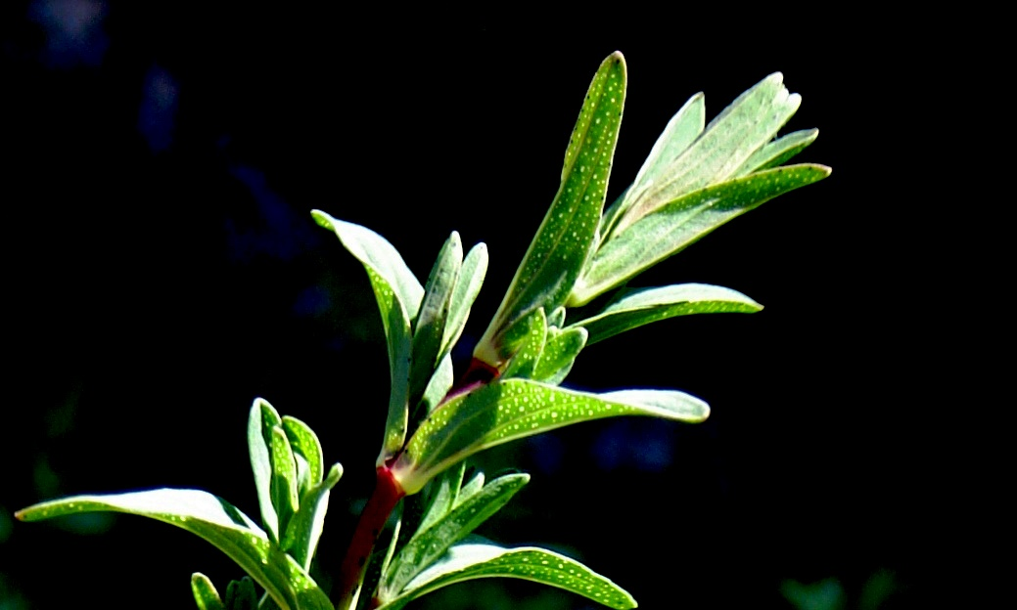
Leaves have visible oil glands when held up to the light

Stems
Several green or reddish-green stems emerge from the underground crown and grow to 30 cm long. Young stems are round and contain two faint longitudinal ridges.

Fruits
The fruits are a sticky brown capsule 5-10 mm long, maturing over autumn and containing up to 70 seeds.

Roots
Grow to a depth of 1 m. Horizontal rhizomes close to the soil surface produce buds that form new stems.

Life Cycle / Reproduction
St John’s wort reproduces by seed and from underground roots called rhizomes. Seeds germinate during autumn, winter and spring and plants generally do not flower in the first year.
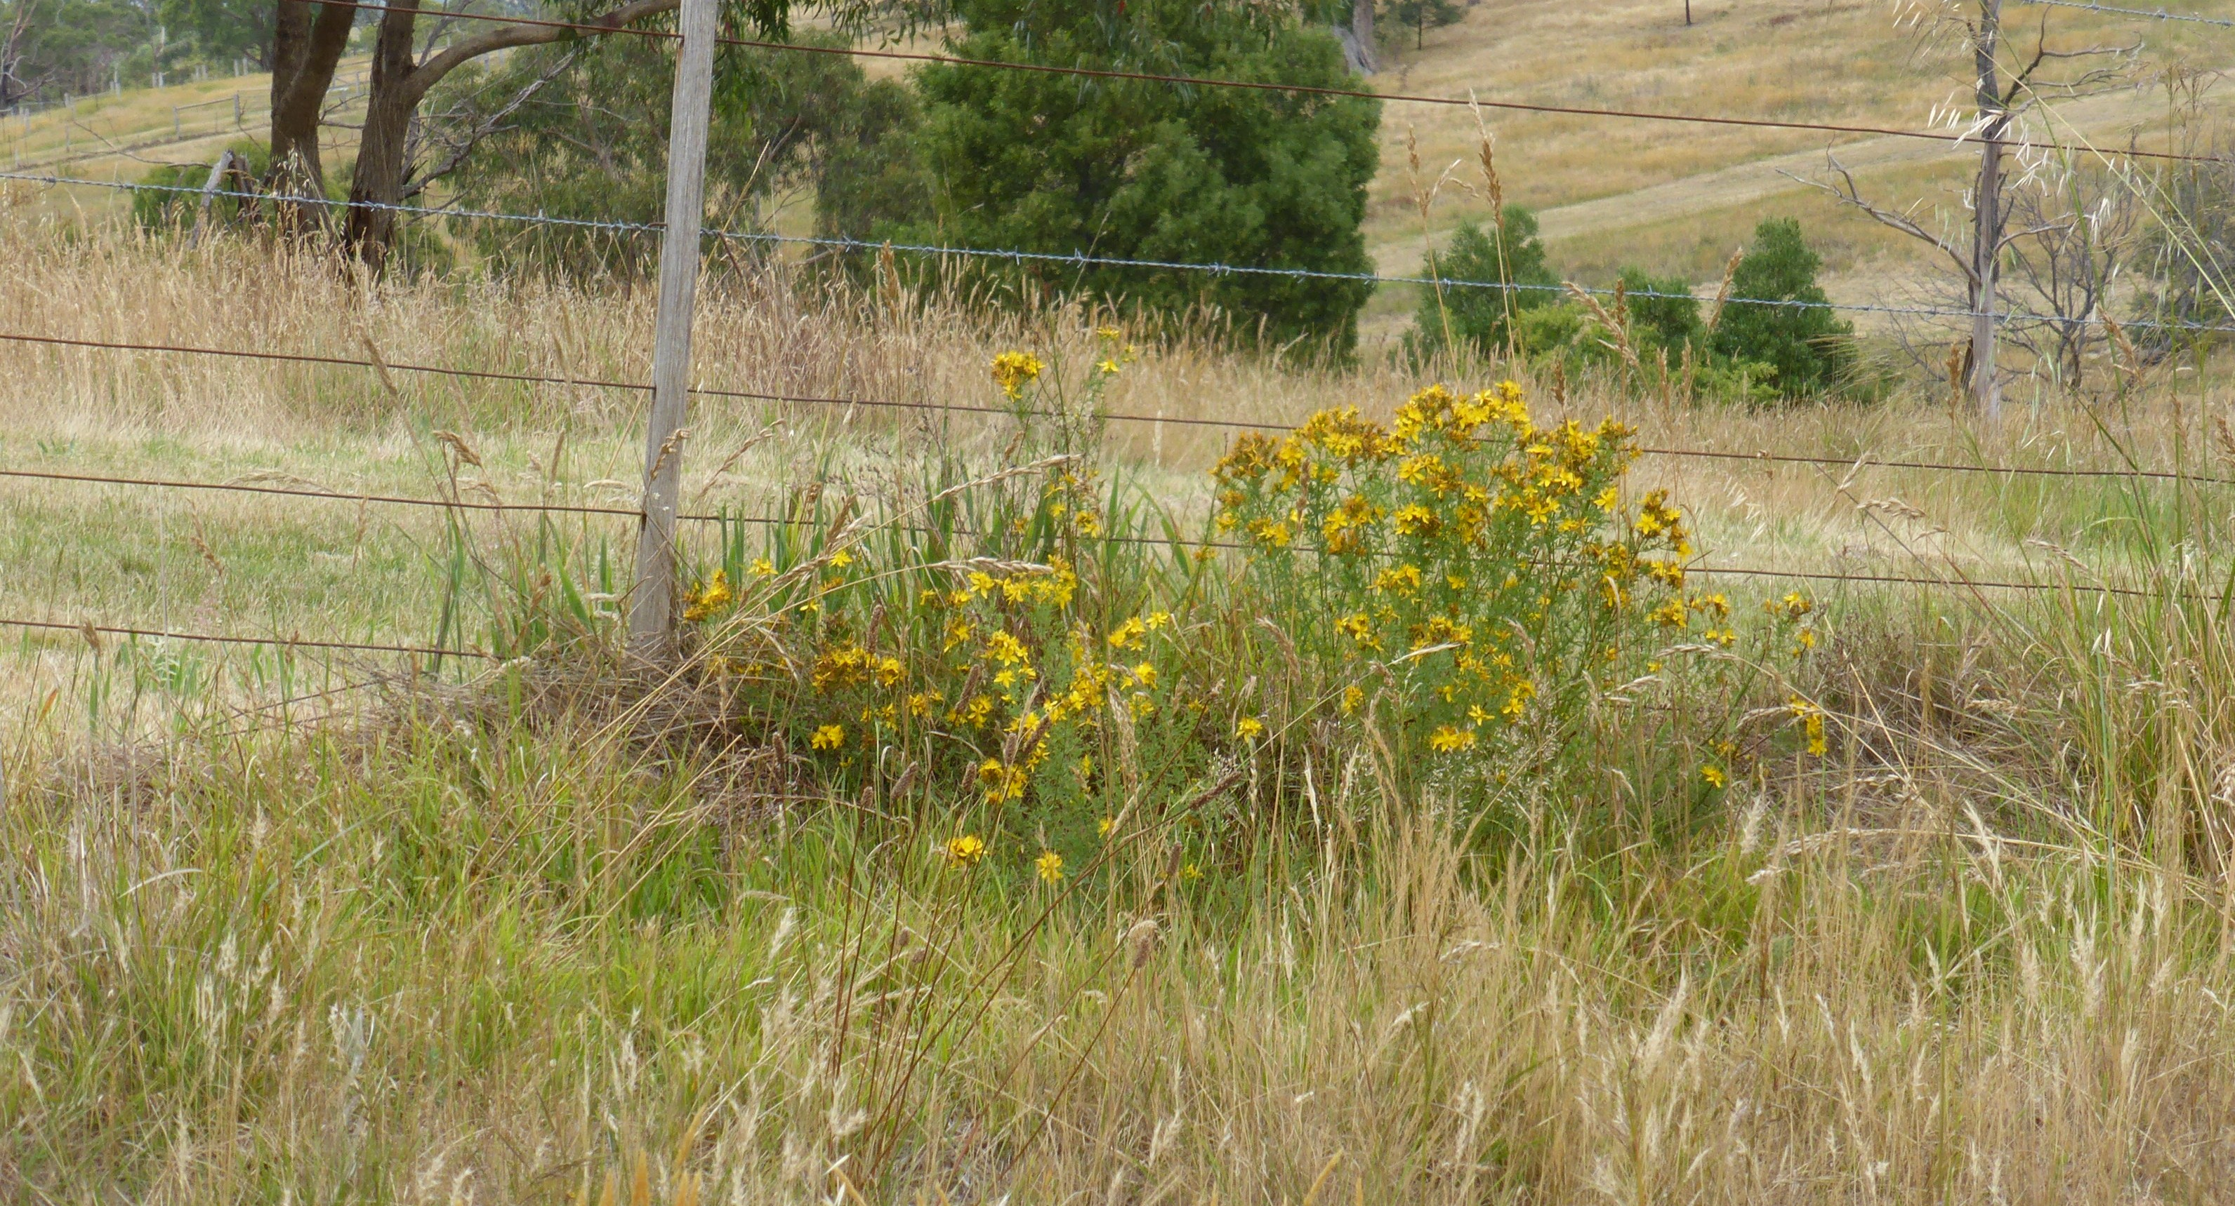
Roadside infestation of St John’s wort
Seed is relatively heavy and only dispersed a short distance by the wind but can be carried large distances by animals (on fur and in digestive tracts), by water, on machinery and in contaminated agricultural produce (fodder). Cultivation can also spread pieces of rhizomes which can produce new plants if the root material comes in contact with moist soil.

Control and Management
Clean areas should be kept free of St John’s wort and managed to prevent infestation. Lightly infested areas should be prioritised to prevent further establishment and prevent spread. Heavily infested areas should be tackled progressively over a number of years.

Prevention
- Seedlings are very susceptible to competition and plants establish best on bare or lightly vegetated ground, so maintain competitive groundcover to prevent establishment.
- Beware of source infestations- new livestock should be quarantined, machinery should be cleaned, ensure fodder is clean.
- Control of rabbits will remove the selective grazing pressure that favours St John’s wort establishment and spread.
- Remove individual plants as soon as identified.

Non-chemical control
- Seedlings and small plants can be hand pulled or dug out as they are slow to develop substantial root systems. Take care to ensure the crown and rhizomes are completely removed.
- Cultivation can be effective, but must be followed up with sowing or planting of pastures and crops.

Chemical Control
- Spot spray infestations using a chemical registered for St John’s Wort control. Using a specific herbicide will avoid off-target damage to desirable plants.
- Treat at the seedling stage.
- Established plants can be treated when flowering (for ease of identification) before fruit browns off in spring-early summer. Repeat applications are generally required on large infestations.

Long-term control
- Ensure you have good coverage of perennial grasses, crops or native vegetation to provide competition.
- Limit soil disturbance and monitor treated areas for re-infestation.
- Remove individual plants as soon as identified.

Similar native species
Small St John’s wort (Hypericum grammineum) and Slender St Johns wort (Hypericum japonicum) are both slender herbs only growing to 30 cm, both have 4 sided stems and only solitary flowers (gold / orange). Slender St John’s wort is indigenous to Whittlesea.

Further Information
This factsheet should be read in conjunction with Note PPLL 12- Weed Control Techniques.
Contact Council’s Land Management and Biodiversity Team for further information and assistance on the control of this weed on 9217 2147

Seasonal Guide to the Management of St John’s Wort
SUMMER |  |  | AUTUMN |  |  | WINTER |  |  | SPRING
Dec | Jan | Feb | Mar | Apr | May | Jun | Jul | Aug | Sep | Oct | Nov
Hand removal |  |  | Spot spraying |  |  | Cultivation

