Variegated Thistle (Silybum marianum)

Pest Plant Local Law

Variegated Thistle
Note Number: PPLL 11
Variegated Thistle is an annual / biennial broadleaf weed growing to one metre and is very competitive in improved pastures where it favours fertile soils with high levels of nutrients. It is also commonly found in cultivated areas, roadsides and disturbed / waste sites especially in moist areas. When established, it crowds out most plants by shading and competition for nutrients and water.
Variegated Thistle is avoided by livestock because of its spines and its spread is therefore encouraged by overgrazing in paddocks due to the selective grazing of other plants. Dense infestations can also provide harbour for rabbits, which will also selectively graze competition plants, further exacerbating problems.
If eaten, the spines can cause damage to stock, particularly around the mouth. Dried leaves and spines can contribute to the contamination of wool fleeces which can incur a price penalty at markets. It can be poisonous to stock under certain conditions due to the high nitrite level in the plant which is converted to toxic nitrites by animals.

Local Scene
The species is predominantly restricted to the basalt soils in the west of the municipality where it commonly grows in association with Artichoke Thistle and to a lesser extent Spear Thistle. It is commonly found in Wollert, Epping, Donnybrook, Woodstock and Mernda.

Identification and Description

Flowers
Purple flowerheads up to 5 cm across are born singularly on flowering stalks. It flowers from spring to summer.
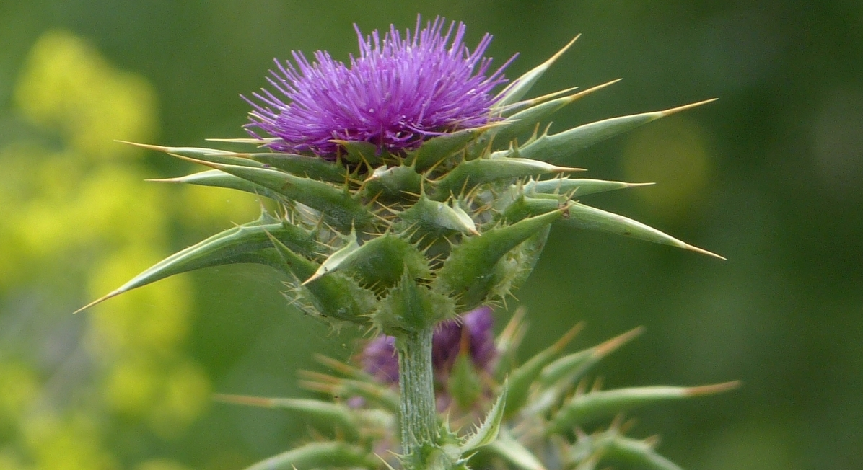
Variegated Thistle flower

Leaves
The leaves are the main identifying feature as they are waxy and variegated with white veins and blotches. They are 25-50 cm long and deeply divided, containing spines on each lobe. Initially develops as a rosette of leaves at ground level.
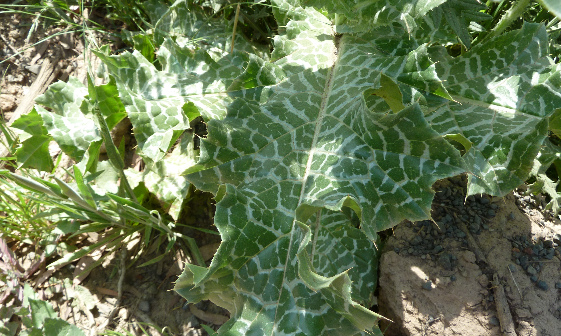
Distinctive variegated leaf

Stems
Stems are stout, erect, and free of spines along their length. Stems are multi-branched from the base.

Seeds
Seeds are black / brown, glossy, with a tuft of bristles attached: up to 2 cm long. Each head can produce 50-200 seeds which can remain viable for at least nine years.

Roots
Plants develop a robust taproot with numerous branches.

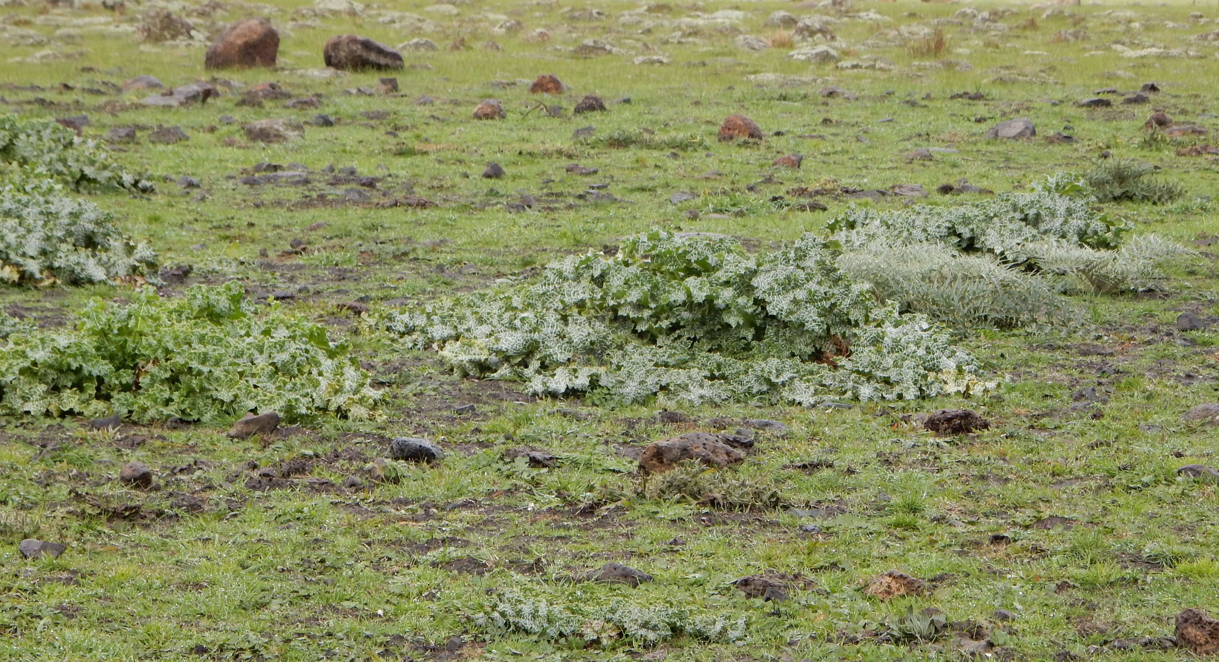
Variegated thistle plants in an overgrazed paddock

Life Cycle / Reproduction
Variegated Thistle grows by either a one-year or two-year lifecycle depending when seeds germinate. Plants only reproduce by seed with main germination occurring after the first autumn rains. Some emergence in late winter to spring and after summer rains can occur.
Seed is relatively large and not dispersed far from the parent plant. However, seed can be dispersed long distances in contaminated soil and hay.

Control and Management
Clean areas should be kept free of Variegated Thistle and managed to prevent infestation. Lightly infested areas should be prioritised to prevent further establishment and spread. Heavily infested areas should be tackled progressively over a number of years.

Prevention
- Beware of source infestations - seed can be transported in contaminated soil, in soil attached to rock and imported in hay.
- Controlling rabbits will remove selective grazing pressure which favours Variegated Thistle establishment and spread.
- Remove individual plants as soon as identified.
- Avoid overgrazing paddocks with livestock as this will remove the competition provided by pasture grasses.

Non-chemical control
- Seedlings and small plants can be chipped out when at the rosette stage. Take care to ensure all root material is removed.
- Cultivation can be effective in killing the plant but should only be undertaken as a preliminary action prior to the establishment of competitive pasture.
- Slashing / mowing can be effective in minimising spread if undertaken before flowering but is not considered a long-term control strategy.

Chemical Control
- Spot spray infestations using a chemical registered for Variegated Thistle.
- Use a broadleaf specific herbicide to avoid off-target damage to surrounding desirable pasture grasses.
- Treat at the rosette stage. Mature plants with flowering stems are difficult to kill due to a well-established tap root.

Long-term control
- Ensure you have good coverage of perennial grasses, crops or native vegetation.
- Limit soil disturbance and monitor treated areas for re-infestation.
- Remove as soon as identified.

Similar native species
There are no similar native species.

Further Information
This factsheet should be read in conjunction with Note PPLL 12- Weed Control Techniques.
Contact Council’s Land Management and Biodiversity Team for further information and weed identification assistance on 9217 2147.

Seasonal Guide to the Management of Variegated Thistle
SUMMER |  |  | AUTUMN |  |  | WINTER |  |  | SPRING
Dec | Jan | Feb | Mar | Apr | May | Jun | Jul | Aug | Sep | Oct | Nov
Hand removal |  |  | Spot spraying |  |  | Cultivation

