Planning and Environment Act 1987
Panel Report
Whittlesea Planning Scheme Amendment C204
Plenty Valley Town Centre Structure Plan

27 July 2018

Planning and Environment Act 1987
Panel Report pursuant to section 25 of the Act
Whittlesea Planning Scheme Amendment C204
Plenty Valley Town Centre Structure Plan
27 July 2018

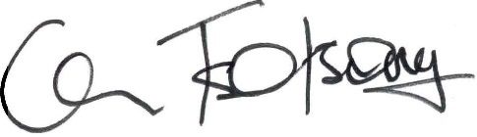
Con Tsotsoros, Chair

Contents
Page
1 Introduction 1
1.1 Plenty Valley Town Centre 1
1.2 The Amendment 1
1.3 Background 2
1.4 Accompanied site inspection 3
1.5 Issues dealt with in this Report 3
2 Planning context 4
2.1 Policy framework 4
2.2 Relevant planning strategies, policies and plans 5
2.3 Planning scheme provisions 6
2.4 Ministerial Directions and Practice Notes 7
2.5 Discussion and conclusion 7
3 The Structure Plan 8
3.1 Background 8
3.2 Vision, themes, principles and objectives 8
4 Proposed Amendment changes since exhibition 12
4.1 Council resolution 12
4.2 Council officer recommendations 12
4.3 Submissions 13
4.4 Discussion and conclusion 15
4.5 Recommendations 15
5 Issues 17
5.1 Commuter car parking 17
5.2 Precinct 5 land uses 19
5.3 Development Contributions Plan Overlay Schedule 18 23
5.4 Railway land permit requirement 25
6 Form and content of the Amendment 26
6.1 Recommendation 26

Appendix A Document list
Appendix B Council’s proposed Amendment changes since exhibition
Appendix C Panel recommended version of Activity Centre Zone Schedule 2

List of Tables
Page
Table 1 Zone and overlay purposes 6
Table 2 Structure Plan themes, principles and centre-wide objectives 9

List of Figures
Page
Figure 1 Plenty Valley Town Centre land 1
Figure 2 Structure Plan precincts 10
Figure 3 Example of wrapping and capping of standard “big box” developments 22

List of Abbreviations

the Act | Planning and Environment Act 1987
ACZ2 | Activity Centre Zone Schedule 2
DCPO18 | Development Contributions Plan Overlay Schedule 18
Structure Plan | Plenty Valley Town Centre Structure Plan

Overview

Amendment summary
The Amendment | Whittlesea Planning Scheme Amendment C204
Common name | Plenty Valley Town Centre Structure Plan
Brief description | The Amendment implements the land use and built form outcomes of the Plenty Valley Town Centre Structure Plan 2017
Subject land | Land shown in Figure 1
The Proponent | Whittlesea City Council
Planning Authority | Whittlesea City Council
Authorisation | 30 May 2018, subject to amending:  - Figures 11 (Built Form Outcomes) and 13 of the Plenty Valley Town Centre Structure Plan 2017 to delete specific height references for interface areas to reflect the amended mandatory height in the General Residential Zone  - Activity Centre Zone Schedule 2 to reflect the mandatory height of 11 metres in the General Residential Zone  - Clause 21.04 to show correct numbering at Objective 1, "Plenty Valley" instead of "South Morang" on Map 1 and associated legend  - Development Contributions Plan Overlay Schedule 18 as per email sent to Council planners on 4 May 2017.
Exhibition | 30 June to 7 August 2017
Submissions | Submissions were received from:  - Country Fire Authority  - AusNet Transmission Group  - Department of Environment, Land, Water and Planning  - Transport for Victoria  - 530 McDonald’s Road Pty Ltd, McMillan Wealthiland Pty Ltd, McMillan Property Group Pty Ltd, McMillan Oleander Pty Ltd and Gary McMillan South Morang Pty Ltd  - Canopi Homes 360 Pty Ltd  - Friends of South Morang  - P Lee & Co Pty Ltd  - Scentre Group  - Brendan Danaher

Panel process
The Panel | Con Tsotsoros (Chair)
Directions Hearing | City of Whittlesea Offices, South Morang, 6 June 2018
Panel Hearing | Planning Panels Victoria, 25 and 27 June 2018
Site inspections | 6 June 2018 (unaccompanied) and 28 June 2018 (accompanied)
Appearances | Whittlesea City Council represented by Terry Montebello of Maddocks  Transport for Victoria represented by Iain Lawrie  Brendan Danaher represented by Mark Bartley and Alex Gelber of HWL Ebsworth Lawyers and calling expert evidence on:  - planning from John Glossop of Glossop Town Planning  - economics from Rhys Quick of Urbis  Canopi Homes 360 Pty Ltd represented by Cameron Alderson  Scentre Group represented by Barnaby Chessell of Counsel, instructed by Samantha Megenis of Minter Ellison
Citation | Whittlesea PSA C204 [2018] PPV
Date of this Report | 27 July 2018

Executive summary

Summary
The Plenty Valley Town Centre (Town Centre) comprises approximately 200 hectares and is about 20 kilometres northeast of Melbourne’s Central City.
The Plenty Valley Town Centre Structure Plan (Structure Plan) was prepared in June 2017 to provide an evidence base and a statutory framework which enable planning and investment decisions in the Plenty Valley Town Centre over the next 20 years. It applies three themes, ten principles and centre-wide objectives. To finalise the Structure Plan, Council invested considerable resources over several years, including consultation with over 500 stakeholders and the preparation of the Plenty Valley Structure Plan Background Report.
In its ultimate form, the Structure Plan envisages a Town Centre comprising five precincts – Civic, Transport Hub, Central Shopping, Live and Work and Employment. The Town Centre will have varying building heights of up to four, six and eight storeys and low, medium and high density resdidential development and mixed use developments.
Whittlesea Planning Scheme Amendment C204 (the Amendment) seeks to implement the land use and built form outcomes of the Structure Plan. This includes amending relevant clauses in the Municipal Strategic Statement, deleting the South Morang Major Activity Centre Policy, introducing and applying Activity Centre Zone Schedule 2 and making associated planning scheme changes.
The Amendment was exhibited from 30 June to 7 August 2017 and received nine submissions. A late submission was subsequently received by Council and referred to the Panel. Key issues raised in submissions related to, among other matters, local street connections with the proposed Civic Drive Extension, commuter car parking at South Morang Train Station, accommodation land uses in Precinct 5, the appropriateness of introducing Development Contributions Plan Overlay Schedule 18 and deleting Development Plan Overlay Schedule 8.
At its 1 May 2018 meeting, Council resolved to make many changes to the proposed provisions and Structure Plan in response to issues raised in submissions. Council contacted submitters about this outcome and some submitters considered their issues resolved. Through further discussions, Council made additional changes which addressed other issues.
Council’s extensive consultation process leading to the Amendment, and its ability to listen and respond to issues, resulted in a well-prepared Structure Plan and relatively small number of unresolved issues at the time of the Hearing.
The Panel has considered written submissions made in response to the exhibition of the Amendment, observations from site visits, and submissions, evidence and other material presented to it during the Hearing.
The Amendment has faithfully translated the Structure Plan’s strategies, objectives and supporting guidance into the proposed provisions. The Amendment is supported by, and implements, the relevant sections of the State and Local Planning Policy Framework and is consistent with the relevant Ministerial Directions and Practice Notes. The Amendment is well founded and strategically justified, and the Amendment should proceed subject to addressing the more specific issues raised in submissions. The Panel supports most of the proposed changes which were considered resolved before the Hearing commenced.
Commuter car parking
Commuter car parking demand at South Morang Train Station may decline when an additional 1,495 car park spaces are available at three other stations along the Mernda rail extension in September 2018.
State planning policy, including Plan Melbourne, encourages sustainable transport such as the strategy for adequate car parking at the South Morang Train Station proposed for Clause 21.13. There is no strategic support to specify 800 car parking spaces in Parking Overlay Schedule 2 or Clause 21.13.
Precinct 5 land uses
Precinct 5 should be an employment precinct without accommodation. There is insufficient strategic planning to understand the effect on existing and future commercial and industrial land uses. Without proper strategic planning, there is likely to be conflict and interface issues between residential and industrial land uses.
Development Contributions Plan Schedule 18
The exhibited Development Contributions Plan Schedule 18 provisions are appropriate and should apply. The Structure Plan would benefit from a note in section 4.3 (Infrastructure) which clarifies that status of infrastructure.
Form and content of the Amendment
The Panel supports Council’s post-exhibition changes to Activity Centre Zone Schedule 2 which seek to improve the schedule’s operation.

Recommendations
Based on the reasons set out in this Report, the Panel recommends that Whittlesea Planning Scheme Amendment C204 be adopted as exhibited subject to the following:
1. Amend Clause 21.23 to add the following Plenty Valley Town Centre strategy:
Support the provision of adequate car parking and infrastructure encouraging sustainable transport, for commuters at the South Morang Train Station.
2. Amend Activity Centre Zone Schedule 2 to, as shown in Appendix C, to:
a) delete Clause 9.0 (Advertising signs) so that Town Centre land is retained in signage Category 1
b) delete Clause 10.0 (Other provisions of the scheme)
c) update maps to incorporate additional elements from the Structure Plan
d) change the last paragraph of Clause 4.4 under the heading “Building Height” to:
“Where a building is less than the preferred minimum building height the structure of the building should be designed so as to be able to accommodate additional building structure and height”
e) change the Precinct Map at Clause 5.3-1 to show other internal pathways and to reference a ‘Public realm focal point’
f) change the Precinct Map at Clause 5.4-1 to relocate the Gateway location on the subject land closer to McDonalds Road
g) change dot point 5 in Clause 5.4-4 to read generally in accordance with: “A landscaping strip is to be provided for development in front-setback areas along McDonalds Road to create an attractive streetscape”
h) make other drafting changes that improve its operation, and align with the Plenty Valley Town Centre Structure Plan and existing development plans.
i) change land use terminology and conditions to reflect what was intended and to improve its operation.
3. Abandon the proposed Parking Overlay requirement in Clause 2.0 for Public Transport Victoria to provide a minimum 800 commuter parking spaces near South Morang Train Station.
4. Abandon changes to the Clause 81.01 Schedule so that the Plenty Valley Town Centre Structure Plan is no longer incorporated into the Whittlesea Planning Scheme.
Based on the reasons set out in this Report, the Panel makes the following further recommendations:
5. Revise the Plenty Valley Town Centre Structure Plan to:
a) add an additional section to provide clarity on how to interpret the document for decision making (Figure 7) Landscape Plan - redraw the map that shows "RRG Retained in Open Space and Integrated with Development" to reflect the 360 McDonalds Road Development Plan 2017 endorsed by the Council on 28 June 2017
b) change Figure 21 (Road Network and Intersection Plan) to redraw the map to reflect the 360 McDonalds Road Development Plan 2017 endorsed by the Council on 28 June 2017
c) change Figure 23 (Residential Development Density) to redraw the map to reflect 360 McDonalds Road Development Plan 2017 endorsed by the Council on 28 June 2017 in terms of both layout and density
d) change Figure 28 (Central Shopping Illustrative Precinct Plan) to:
• provide for loading and service areas along the McDonalds Road frontage to the Centre
• correct anomalies in the application of frontage destinations
• redesignate the parking area in the south-west corner of the site from ‘parking above/underground’ to ‘parking and servicing’.
e) change Figure 29 (Live and Work Illustrative Precinct Plan) to:
• remove the tree shown on Reserve 8 adjacent to the railway reserve
• show only four trees to be retained in Reserve 1
• relocate the key gateways to Plenty Valley to incorporate the three marker sites at the south-east corner of the proposed Lots A, B and D
f) delete the alternative Tram 86 Extension along Civic Drive so that the preferred route is along Bush Boulevard, McDonalds Road and Ferres Boulevard
g) change the proposed connections of Peyton Drive and Stillman Drive with the Civic Drive extension to be restricted to a pedestrian and cycle connection only.
h) add in section 4.3 (Infrastructure):
The list and location of projects are indicative and subject to a further process of assessment as to need, scope, timing, responsibility and cost apportionment (if applicable) when future town planning approvals are sought.

Introduction

Plenty Valley Town Centre
The Plenty Valley Town Centre (Town Centre) comprises approximately 200 hectares shown in Figure 1 and is about 20 kilometres northeast of Melbourne’s Central City.
Figure 1 Plenty Valley Town Centre land
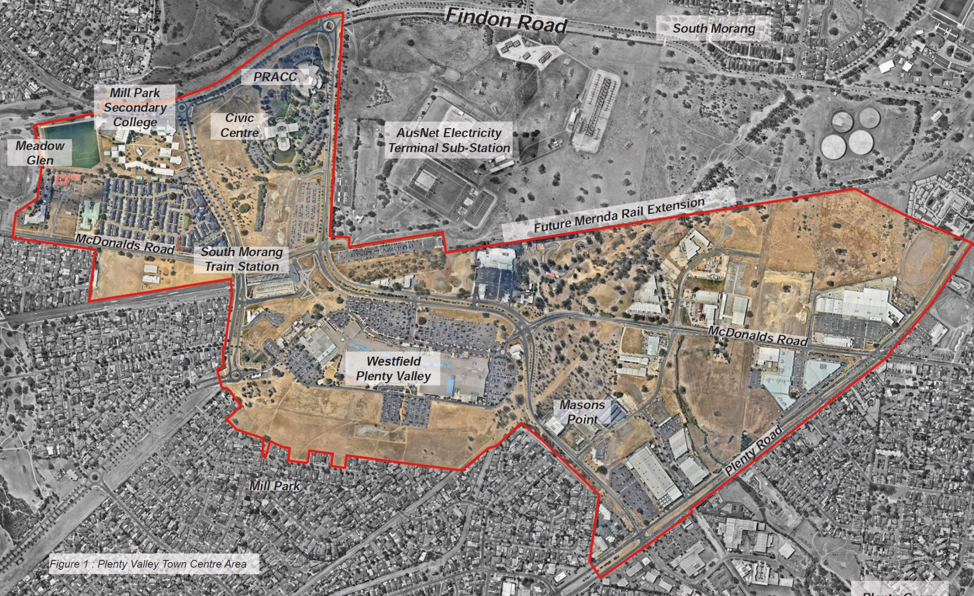
Source: Plenty Valley Structure Plan 2017

The Amendment
The Amendment applies to the Plenty Valley Town Centre land and proposes to implement the land use and built form outcomes of the Plenty Valley Town Centre Structure Plan by:
- amending in the Municipal Strategic Statement, Clauses 21.02 (Municipal Profile), 21.04 (Settlement), 21.08 (Built Environment and Heritage), 21.09 (Housing), 21.11 (Economic Development), 21.11 (Transport), 21.12 (Infrastructure), 21.13 (Local Areas) and 21.14 (Reference Documents)
- deleting Clause 22.15 (South Morang Major Activity Centre Policy)
- introducing Activity Centre Zone Schedule 2
- rezoning all land in Plenty Valley Town Centre Structure Plan area (excluding land currently zoned Public Use Zone 1, Public Use Zone 2, Public Use Zone 4, Road Zone Category 1, some land currently zoned General Residential Zone and land to be rezoned Public Conservation and Resource Zone) to Activity Centre Zone Schedule 2
- rezoning land at 479W and 485W McDonalds Road, Mill Park to Public Conservation and Resource Zone
- introducing Development Contributions Plan Overlay Schedule 18 (DCPO18) and applying it to all land in the Plenty Valley Town Centre Structure Plan area.
- introducing Parking Overlay Schedule 2 and applying it to all land in the Plenty Valley Town Centre Structure Plan area
- deleting Design and Development Overlay Schedule 7
- deleting Development Plan Overlay Schedules 8 and 26
- deleting Development Plan Overlay Schedules 7 and 25 from applying to land in the Plenty Valley Town Centre Structure Plan area
- incorporating the Plenty Valley Town Centre Structure Plan into the Planning Scheme through Clause 81.01
- making associated planning scheme map changes and referencing them in the Clause 61.03 Schedule.

Background
Based on Council’s Part A submission, the following is a chronology of events:
1989 | Plenty Valley Strategic Plan prepared
1998 | South Morang Activity Centre Overall Development Plan prepared
August 2008 | Amendment C106 introduced interim planning provisions to the South Morang Activity Centre while the structure plan project is progressed
September 2010 | Amendment C144 revised and extended the interim planning controls for the South Morang Activity Centre
April 2012 | South Morang Train Station opened
May 2013 | The interim planning provisions extended [Amendment C168]
May - June 2014 | Stage 1 community consultation (issues and opportunities) in relation to the Structure Plan project.
August 2015 | Plenty Valley Town Centre Structure Plan Background Report prepared
January 2016 | The interim planning provisions extended [Amendment C173]
February 2016 | Draft Structure Plan endorsed for consultation
March - April 2016 | Stage 2 community consultation (draft Structure Plan)
December 2016 | The interim planning provisions extended [Amendment C202]
February 2017 | Council resolved to note the updated Structure Plan and commence Amendment C204
30 June - 7 August 2017 | Amendment C204 exhibited
October 2017 | The interim planning provisions expired
January - February 2018 | Further consultation with residents about proposed local road connections with the Civic Drive extension
6 February 2018 | Council resolved to request the appointment of Planning Panel to hear unresolved submissions
1 May 2018 | Council resolved position in respect of the submissions received

Accompanied site inspection
During the Directions Hearing, parties submitted that there would be benefit in an accompanied site inspection. The Panel agreed and all parties were invited to participate in an accompanied site inspection on 28 June 2018 based on an inspection plan prepared by Council.

Issues dealt with in this Report
The Panel considered all written submissions made in response to the exhibition of the Amendment, observations from site visits, and submissions, evidence and other material presented to it during the Hearing.
The Panel has reviewed a large volume of material. The Panel has had to be selective in referring to the more relevant or determinative material in the Report. All submissions and materials have been considered by the Panel in reaching its conclusions, regardless of whether they are specifically mentioned in the Report.
This Report deals with the issues under the following headings:
- Planning context
- The Structure Plan
- Proposed Amendment changes since exhibition
- Issues
- Form and content of the Amendment.

Planning context
Council provided a response to the Strategic Assessment Guidelines as part of the Explanatory Report.
The Panel has reviewed Council’s response and the policy context of the Amendment, and has made a brief appraisal of the relevant zone and overlay controls and other relevant planning strategies.

Policy framework
State
Clauses
11 | Settlement
◆ | The Amendment will:  - provide a planning framework for developing the Town Centre  - specifically support the objective to ‘encourage the concentration of major retail, residential, commercial, administrative, entertainment and cultural developments into activity centres which provide a variety of land uses and are highly accessible to the community’
12 | Environment and landscape values
◆ | The Amendment will protect important biodiversity and landscape values including remnant River Red Gums and the Quarry Hills.
13 | Environmental risk
◆ | The Amendment will protect heritage and including built form controls which support the objective ‘to create urban environments that are safe, functional and provide good quality environments with a sense of place and cultural identity’.
15 | Built environment and heritage
◆ | The Amendment will protect heritage and including built form controls which support the objective ‘to create urban environments that are safe, functional and provide good quality environments with a sense of place and cultural identity’.
16 | Housing
◆ | The Amendment will:  - provide for a diverse range of housing and supporting the objective ‘to locate new housing in or close to activity centres and employment corridors and at other strategic redevelopment sites that offer good access to services and transport.’  - help to ‘deliver more affordable housing closer to jobs, transport and services’ and incentivise the provision of affordable housing.
17 | Economic development
◆ | The Amendment will support new development and commercial facilities in a designated activity centre.
18 | Transport
◆ | The Amendment will offer opportunities for alternative forms of transport through an integrated and unique network of off and on road pedestrian and cycle routes between activity centres/community hubs, regional sports and activity precincts, and within a wide and extensive open space and conservation reserve system.
19 | Infrastructure
◆ | The Amendment will support the integration of transport and land use and encouraging development in close proximity to public transport.
Local
Clauses
21 | Municipal Strategic Statement
◆ | 21.04 Settlement  The Amendment will:  - support the objective ‘to establish the Town Centre as a higher order centre servicing the existing and future population growth in the south-eastern half of the City.’  - support complementary housing, open space and land use objectives.
◆ | 21.05 Environmental and landscape values  The Amendment will support the objective ‘to protect environmental assets and landscape values’ and the objective ‘to protect biodiversity values’, particularly the retention of River Red Gums’.
◆ | 21.08 Built environment and heritage  The Amendment will support urban design objectives including: ‘to ensure new development in Activity Centres achieves high quality urban design outcomes’, through the implementation of built form controls.
 | ◆ | 21.08-3 Environmentally Sustainable Design  The Amendment will implement Environmentally Sustainable Design provisions.
◆ | 21.09 Housing  The Amendment will:  - support greater housing density and diversity in urban renewal areas including activity centres such as Plenty Valley  - support and incentivise the provision of social housing.
◆ | 21.10 Economic development  The Amendment will support greater densities of employment in activity centres such as Plenty Valley.
◆ | 21.11 Transport  The Amendment will support the prioritisation of walking, cycling and public transport over private vehicle use in the activity centre.
◆ | 21.12 Infrastructure  The Amendment will support the provision of infrastructure through the collection of contributions from development.
◆ | 21.13 Local areas  The Amendment will assist in delivering the vision of the Structure Plan by including strategies specific to the Town Centre.
◆ | 21.15 South Morang Activity Centre Policy  The Amendment will replace this expired interim policy.

Relevant planning strategies, policies and plans

Plan Melbourne 2017-2050
Plan Melbourne categories the Town Centre as one of Melbourne’s 121 Major Activity Centres – Suburban centres that provide access to a wide range of goods and services. They have different attributes and provide different functions, with some serving larger subregional catchments.
Council referred to Policy 1.2.1 seeks to “support the development of a network of activity centres linked by transport”.

Planning scheme provisions
Most of the Town Centre is in the Commercial 1 Zone (C1Z) or Commercial 2 Zone (C2Z) and some of it are in the General Residential Zone (Schedules 1 and 3), Road Zone Category 1 (RDZ1) and Public Use Zone.
The Vegetation Protection Overlay Schedule 1 applies to a significant proportion of the Town Centre. Other planning scheme overlays which apply include:
- Design and Development Overlay Schedule 7 (South Morang Activity Centre Key Development Sites), expired October 2017
- Development Plan Overlay:
  - Schedule 7 (South Morang Development Plan Overlay)
  - Schedule 8 (South Morang Activity Centre Development Plan)
  - Schedule 25 (Plenty Road and McDonalds Road Employment Area)
- Development Plan Overlay Schedule 26 (South Morang Activity Major Centre – Eastern Precinct)
- Heritage Overlay.
The Amendment proposes to apply the Activity Centre Zone, Parking Overlay and Development Contribution Plan Overlay. Table 1 shows the purposes of the zone and overlays.
Table 1 Zone and overlay purposes
Zones
Activity Centre | Parking | Development Contributions Plan
Common purpose
To implement the State Planning Policy Framework and the Local Planning Policy Framework, including the Municipal Strategic Statement and local planning policies.
Other purposes
- To encourage a mixture of uses and the intensive development of the activity centre:  - As a focus for business, shopping, working, housing, leisure, transport and community facilities.  - To support sustainable urban outcomes that maximise the use of infrastructure and public transport.  - To deliver a diversity of housing at higher densities to make optimum use of the facilities and services.  - To create through good urban design an attractive, pleasant, walkable, safe and stimulating environment.  - To facilitate use and development of land in accordance with the Development Framework for the activity centre. | - To facilitate an appropriate provision of car parking spaces in an area.  - To identify areas and uses where local car parking rates apply.  - To identify areas where financial contributions are to be made for the provision of shared car parking. | - To identify areas which require the preparation of a development contributions plan for the purpose of levying contributions for the provision of works, services and facilities before development can commence.

Ministerial Directions and Practice Notes
Ministerial Directions
Council submitted that the Amendment meets the relevant requirements of:
- Ministerial Direction 11 (Strategic Assessment of Amendments)
- Ministerial Direction on the Form and Content of Planning Schemes under section 7(5) of the Planning and Environment Act 1987 (the Act).
Planning Practice Notes
Council submitted that the Amendment is consistent with, or guided by:
- Planning Practice Note 1 (PPN1) Applying the Heritage Overlay, January 2018
- Planning Practice Note 46 (PPN46) Strategic Assessment Guidelines, June 2015
- Planning Practice Note 58 (PPN58) Structure Planning for Activity Centres, June 2015.

Discussion and conclusion
No submitter stated that the Amendment did not meet relevant planning policy or that it was not strategically justified. The Panel found considerable State and local planning policy which supported additional dwellings in an activity centre and near public transport, preferably a train station. There was also supporting policy for new employment opportunities in such activity nodes. There was a strong alignment between the strategies and objectives in the Structure Plan and Plan Melbourne. The Amendment has faithfully translated these aspirations and supporting guidance into the proposed provisions.
Council and parties are commended for working collaboratively to resolve issues by changing the proposed provisions and the Structure Plan. The Panel observed these sentiments from parties at the Hearing.
The Panel concludes that the Amendment is:
- supported by, and implements, the relevant sections of the State and Local Planning Policy Framework
- consistent with the relevant Ministerial Directions and Practice Notes
- well founded and strategically justified.
The Amendment should proceed subject to addressing the more specific issues raised in submissions as discussed in the following chapters.

The Structure Plan

Background

Stage One stakeholder consultation
Over 500 people participated in the first stage of community consultation during May and June 2014. Key feedback included:
- More activity: A greater range of shops, dining and entertainment; More recreation and community facilities; Community markets, events, playgrounds; Provision for different user groups.
- Better transport and connections: Improved access by walking and cycling; Improved public transport; An improved approach to parking provision.
- A stronger local identity: A town square for gathering; Quality development; A strong sense of place; Safe spaces.

Background Report
The Plenty Valley Structure Plan Background Report forms the first stage of the structure planning process. It includes findings from background reports and research and identifies key issues and opportunities which inform the Structure Plan. Specifically, it sets out:
- Development parameters: Planning policy context and physical constraints
- Place analysis: Character, land uses and activities, and movement and transport
- Future needs and demands
- Summary of key findings:
  - FND1: The Town Centre has the potential to support a much larger residential population than at present.
  - FND2: The Civic Precinct provides a strong basis for further consolidation of municipal and sub-regional civic uses (such as a Justice Precinct) and opportunities to co-locate services/facilities with a local focus.
  - FND3: Current Development Plans will encourage retail to increase its dominance over other commercial uses.
  - FND4: There is presently no strategy in place to cater for potential future demand for a diversity of office and smaller scale commercial spaces.
  - FND4: The Civic Centre Masterplan could set a mixed-use, high density precedent and establish Plenty Valley’s identity as a place.

Vision, themes, principles and objectives
The Structure Plan seeks to provide an evidence base and a statutory framework which enable planning and investment decisions in the Plenty Valley Town Centre over the next 20 years. It applies the three themes, ten principles and centre-wide objectives shown in Table 2.

Table 2 Structure Plan themes, principles and centre-wide objectives
An attractive town centre | An accessible town centre | A vibrant town centre
1. Maintain and Enhance Plenty Valley’s Unique Landscape Character  LA1: Retain and enhance existing River Red Gums in order to ensure their ongoing contribution towards the identity of the Town Centre  LA2: Protect and Sensitively Incorporate Areas of High Landscape and Biodiversity Value into the Town Centre  LA3: Enhance the Character and Legibility of the Town Centre through the Landscaping of Streets and Reserves | 4. Promote Walking and Cycling Access to Plenty Valley  WC1: Focus the Pedestrian experience along a Central spine  WC2: Complete a Permeable Pedestrian network  WC3: Prioritise Pedestrian Movement Within Public Streets  WC4: Ensure the Town Centre is easily accessed by bicycle within a 2.5km Radius  WC5: Establish new Leisure and Commuter Cycling Routes through the Town Centre and enhance existing routes  WC6: Encourage cycling through the provision of a safe, legible and connected network and dedicated facilities | 7. Provide Additional Housing Close to Shops, Services and Public Transport  HO1: Increase the Residential Population of the Town Centre  HO2: Provide a Variety of Housing
2. Expand and Connect Plenty Valley’s Public Squares and Parks and Promote its Streets as Public Spaces  PS1: Provide Safe and Accessible Parks for Residents, Workers and Visitors  PS2: Introduce New Urban Squares as Gathering Spaces  PS3: Ensure Parks and Open Spaces are Linked to form an overall Network  PS4: Design for Safe and Active Public Spaces  PS5: Ensure Streets are Designed for People | 5. Deliver an Integrated and Accessible Public Transport System  PT1: Capitalise on the activity and investment created by public transport stations and stops  PT2: Interchange public transport modes to provide a flexible, cohesive network  PT3: Ensure public transport is highly accessible to pedestrians and cyclists | 8. Support Local Trade and Employment and Economic Diversity  EMP1: Ensure Opportunities for High Quality Local Work Continue to Expand  EMP2: Help the Local Economy to Diversify and Support a Greater Range of Jobs  EMP3: Accommodate Markets and Smaller Retail Uses
3. Establish Excellence in Design Quality Across the Town Centre Area  DES1: Protect and Enhance Amenity for Existing and Future Residents  DES2: Ensure Building Height and Massing is Appropriate to its Context  DES3: Provide a High Standard of Architectural Design and Minimise Visual Clutter  DES4: Support a Unique Identity for the Centre  DES5: Enhance the Legibility and Quality of Streets and Spaces  DES6: Design for a Sustainable Future | 6. Provide a Permeable Street Network and Encourage a Modal Shift Towards non-Vehicular Forms of Transport  SN1: Complete Missing Road Links  SN2: Adapt Existing Streets to Become Less Car Focussed  SN3: Sensitively Integrate Parking into the Town Centre | 9. Support Plenty Valley’s Emergence as a Major Civic Precinct within the Region by Clustering Key Local and Subregional Services  CIV1: Promote the Centre as a Location for Sub-Regional and Municipal Services  CIV2: Cluster Civic and Community Services  CIV3: Provide for Future Demand in Community Infrastructure
10. Support the Integration of Mixed Uses and Activities Across Plenty Valley Town Centre
MIX1: Mix Housing, Community and Retail Uses
MIX2: Complement Community and Civic Uses
MIX3: Promote the Centre as a Place for Events
MIX4: Programme the Public Realm
The Structure Plan divides the Town Centre into the five precincts in Figure 2 and applies a vision, objectives and directions for each precinct.
Figure 2 Structure Plan precincts
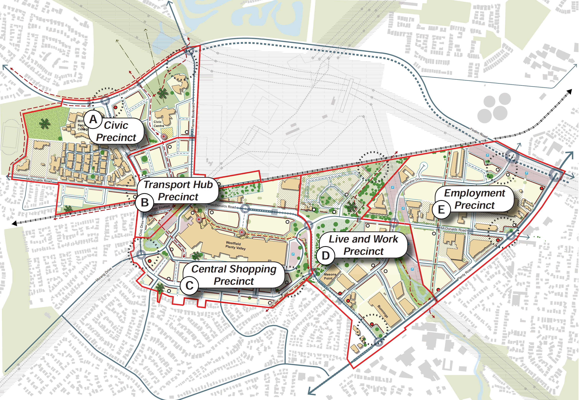
In its ultimate form, the Structure Plan envisages a Town Centre comprising five precincts – Civic, Transport Hub, Central Shopping, Live and Work and Employment. The Town Centre will have varying building heights of up to four, six and eight storeys and low, medium and high density resdidential development and mixed use developments.

Proposed Amendment changes since exhibition

Council resolution
At its 1 May 2018 meeting, Council resolved to:
- update the Structure Plan to identify that the proposed connections of Peyton Drive and Stillman Drive with the extension of Civic Drive should be restricted to a pedestrian and cycle connection only
- update the Council response to the submission from Transport for Victoria (see Appendix B of this report) to: Replace the policy direction in the Parking Overlay with the following strategy in Clause 21.13: “Support the provision of adequate car parking and infrastructure encouraging sustainable transport, for commuters at the South Morang Train Station”
- change the Amendment documentation to reflect the two above resolutions and specific officer recommendations attached to the council report (see Appendix B of this report).

Council officer recommendations
As outlined in Appendix B, Council officers recommended to:
- add the word 'potential' to any reference to the potential Route 86 tram route extension to clarify its status
- replace the policy direction in the Parking Overlay with the following strategy in Clause 21.13: “Support the provision of adequate car parking (minimum 800 parking spaces) and infrastructure encouraging sustainable transport, for commuters at the South Morang Train Station”
- review land use tables with regard to consistency with existing zone provisions and the Structure Plan
- amend ACZ2 to:
  - retain land in the Town Centre in signage Category 1
  - update maps to incorporate additional elements from the Structure Plan
  - change the last paragraph of Clause 4.4 of ACZ2 under the heading “Building Height” to: “Where a building is less than the preferred minimum building height the structure of the building should be designed so as to be able to accommodate additional building structure and height”
  - change the Precinct Map at Clause 5.4-1 to relocate the Gateway location on the subject land closer to McDonalds Road
  - change dot point 5 in Clause 5.4-4 to read generally in accordance with: “A landscaping strip is to be provided for development in front-setback areas along McDonalds Road to create an attractive streetscape”
- realign the boundary between Precinct 4 and Precinct 5 to align with existing property boundaries
- retain a revised Development Plan Overlay Schedule 8 (DPO8) in sub-precincts 1a, 2b, 3b, 3c and 4a
- review and update the drafting of built form controls to ensure they are legible, clearly able to be interpreted and applied and achieve the outcome intended by the Structure Plan
- amend the status of the Plenty Valley Town Centre Structure Plan from an Incorporated Document to a Reference Document
- amend the Structure Plan to:
  - add an additional section to provide clarity on how to interpret the document for decision making (Figure 7) Landscape Plan – redraw the map that shows "RRG Retained in Open Space and Integrated with Development" to reflect the 360 McDonalds Road Development Plan 2017 endorsed by the Council on 28 June 2017
  - Figure 21 (Road Network and Intersection Plan) – redraw the map to reflect the 360 McDonalds Road Development Plan 2017 endorsed by the Council on 28 June 2017
  - Figure 23: Residential Development Density – redraw the map to reflect 360 McDonalds Road Development Plan 2017 endorsed by the Council on 28 June 2017 in terms of both layout and density
  - change Figure 29 (Live and Work Illustrative Precinct Plan) to remove the tree shown on Reserve 8 adjacent to the railway reserve; only show four trees to be retained in Reserve 1; and relocate the “Key gateways to Plenty Valley in accordance with our submission”
  - show the preferred route for the Tram 86 Extension along Bush Boulevard, McDonalds Road and Ferres Boulevard
  - change the proposed connections of Peyton Drive and Stillman Drive with the Civic Drive extension to be restricted to a pedestrian and cycle connection only
- revise Strategy 1.4 in Clause 21.13.3 (Plenty Valley Town Centre) to: “Support Encourage the provision of social and affordable housing in the Town Centre as part of new residential developments”.

Submissions
At the Hearing, Council submitted that it notified parties of the resolved changes and sought confirmation as to whether the changes responded to their submissions. This chapter discusses Submissions for:
- Canopi Homes 360 Pty Ltd (Canopi)
- Scentre Group
- 530 McDonalds Road Pty Ltd, McMillan Wealthiland Pty Ltd, McMillan Property Group Pty Ltd, McMillan Oleander Pty Ltd and Gary McMillan South Morang Pty Ltd (530 McDonalds Road & Ors).

Canopi Homes
Changes requested by Canopi in its submission to the exhibited Amendment, as detailed in Appendix B of this report, were accepted by Council exactly, or generally in accordance with, the changes. The only exception was DPO8 which was still proposed to be deleted. Canopi added that, in response to this proposal, it sought to include a Master Plan requirement in ACZ2 so that detailed requirements and rights established through the endorsed 360 McDonalds Road Development Plan were retained. Council subsequently agreed to retain DPO8 with revised provisions. Canopi explained that retaining DPO8 removed the need to reference a master plan in ACZ2.
Accordingly, Canopi Homes submitted at the Hearing that it supported the Amendment with changes summarised in Council’s Part A Submission (detailed in Appendix B of this report) which include changes sought by Canopi in its original submission.

Scentre Group
Scentre Group owns the Westfield Plenty Valley Shopping Centre in Precinct 3B, and land north of South Morang Train Station in Precinct 2B. At the Hearing, Mr Chessell of Counsel, represented Scentre Group. He submitted that Scentre Group supported the Amendment subject to resolved post-exhibition changes to the Structure Plan and ACZ2 and the following further refinements:
- Revise Figure 28 (Central Shopping Illustrative Precinct Plan of Structure Plan) to:
  - provide for loading and service areas along McDonalds Road frontage to the Centre
  - correct anomalies in the application of frontage designations
  - redesignate the parking area in the south-west corner of the site from ‘parking above/underground’ to ‘parking and servicing’.
- Revise the Precinct Map at 5.3-1 to show other internal pathways and reference the ‘Public realm focal point’.
Mr Chessell submitted that Scentre Group had achieved in-principle agreement with Council to revise the Structure Plan and ACZ2 to reflect its further refinements.

530 McDonalds Road Pty Ltd & Ors
The 530 McDonalds Road & Ors submission related to Precincts 4(b) and 5 and sought to:
- retain existing and approved development opportunities
- retain the existing advertising category
- amend the boundary between the two precincts to align with property boundaries
- rationalise and simplify the level of detail, including height setbacks and building typology
- reference, but no incorporate, the Structure Plan in the Planning Scheme
- delete the proposed road alignments
- delete the proposed DCPO18.
Council tabled written confirmation from Contour Consultants, on behalf of 530 McDonalds Road Pty Ltd and others which stated:
Our client understands that the changes reflected in these documents have been endorsed by Council at its meeting on 1st May 2018 and it is intended that the same be presented to the planning panel hearing. Should Council adopt these changes our client’s submission to AM C204 will be satisfactorily resolved.
Council presented the changes resolved at its 1 May 2018 meeting at the Hearing. These changes did not include deleting DCPO18 and this matter is explained further in Chapter 5.3.

Discussion and conclusion
The Panel has considered submissions to the exhibited Amendment, Council’s response to issues raised in submissions, and its reasons for resolving to propose further changes to the Amendment since it was exhibited.
The Panel supports most of the proposed changes since exhibition which were not raised as issues by other parties at the Hearing. Any such issues are discussed in subsequent chapters.

Recommendations
The Panel recommends:
- Amend Activity Centre Zone Schedule 2 to, as shown in Appendix C, to:
  - delete Clause 9.0 (Advertising signs) so that Town Centre land is retained in signage Category 1
  - delete Clause 10.0 (Other provisions of the scheme)
  - update maps to incorporate additional elements from the Structure Plan
  - change the last paragraph of Clause 4.4 under the heading “Building Height” to:
“Where a building is less than the preferred minimum building height the structure of the building should be designed so as to be able to accommodate additional building structure and height”
  - change the Precinct Map at Clause 5.3-1 to show other internal pathways and to reference a ‘Public realm focal point’
  - change the Precinct Map at Clause 5.4-1 to relocate the Gateway location on the subject land closer to McDonalds Road
  - change dot point 5 in Clause 5.4-4 to read generally in accordance with: “A landscaping strip is to be provided for development in front-setback areas along McDonalds Road to create an attractive streetscape”
  - make other drafting changes that improve its operation, and align with the Plenty Valley Town Centre Structure Plan and existing development plans.
- Abandon changes to the Clause 81.01 Schedule so that the Plenty Valley Town Centre Structure Plan is no longer incorporated into the Whittlesea Planning Scheme.
- Revise the Plenty Valley Town Centre Structure Plan to:
  - add an additional section to provide clarity on how to interpret the document for decision making (Figure 7) Landscape Plan - redraw the map that shows "RRG Retained in Open Space and Integrated with Development" to reflect the 360 McDonalds Road Development Plan 2017 endorsed by the Council on 28 June 2017
  - change Figure 21 (Road Network and Intersection Plan) to redraw the map to reflect the 360 McDonalds Road Development Plan 2017 endorsed by the Council on 28 June 2017
  - change Figure 23 (Residential Development Density) to redraw the map to reflect 360 McDonalds Road Development Plan 2017 endorsed by the Council on 28 June 2017 in terms of both layout and density
  - change Figure 28 (Central Shopping Illustrative Precinct Plan) to:
    - provide for loading and service areas along the McDonalds Road frontage to the Centre
    - correct anomalies in the application of frontage destinations
    - redesignate the parking area in the south-west corner of the site from ‘parking above/underground’ to ‘parking and servicing’.
  - change Figure 29 (Live and Work Illustrative Precinct Plan) to:
    - remove the tree shown on Reserve 8 adjacent to the railway reserve
    - show only four trees to be retained in Reserve 1
    - relocate the key gateways to Plenty Valley to incorporate the three marker sites at the south-east corner of the proposed Lots A, B and D
  - delete the alternative Tram 86 Extension along Civic Drive so that the preferred route is along Bush Boulevard, McDonalds Road and Ferres Boulevard
  - change the proposed connections of Peyton Drive and Stillman Drive with the Civic Drive extension to be restricted to a pedestrian and cycle connection only.

Issues

Commuter car parking

The issue
The issue is whether it is appropriate to include a policy which seeks at least 800 commuter parking spaces near South Morang Train Station.

Submissions
At the Hearing, Mr Lawrie represented Transport for Victoria, which includes Public Transport Victoria. He explained that Public Transport Victoria has two commuter car parks adjacent to South Morang Train Station:
- A sealed 450 capacity car park east of the station on VicTrack owned land
- An unsealed temporary 450 capacity car park north of the station on McDonalds Road on undeveloped land owned by Scentre Group.
In its Part B Submission, Council stated that Scentre Group consented to its land being temporarily used by commuters after they started parking there without permission. The Structure Plan identifies the temporary car park for future development of up to eight storeys.
At its meeting on 21 March 2017, Council resolved to:
Include a policy direction in Schedule 2 to the Parking Overlay for Public Transport Victoria to provide at least 800 car parking spaces to be available to commuters at South Morang Rail Station.
In response to Amendment being exhibited with this requirement in Parking Overlay Schedule 2, Transport for Victoria, which includes Public Transport Victoria, objected to including this requirement. Transport for Victoria submitted that it cannot commit to an additional 800 car parking spaces because it is still investigating potential future car parking in the Structure Plan area. It added that the Structure Plan and Parking Overlay Schedule 2 should therefore not commit Transport for Victoria to providing these additional car parking spaces.
This was reflected in Transport for Victoria’s Hearing submission, where Mr Lawrie said that the prescriptive 800 car space requirement is inconsistent with:
- Parking Overlay Clause 1.0 objective to “encourage a mode shift toward the use of active and sustainable travel modes”
- City of Whittlesea’s Plenty Valley Town Centre Parking Precinct Plan 2017.
Mr Lawrie submitted that demand could be met through parking supply elsewhere or mode shift to active transport or feeder bus services.
Council submitted that it met with Transport for Victoria on 5 December 2017 to seek to resolve its issues. Following this meeting, Council officers recommended that the following policy direction be included in Clause 21.13:
Support the provision of adequate car parking and infrastructure encouraging sustainable transport, for commuters at the South Morang Train Station.
Council resolved to support a revised version:
Support the provision of adequate car parking (minimum 800 parking spaces) and infrastructure encouraging sustainable transport, for commuters at the South Morang Train Station.
At the Hearing, Council submitted that Clause 21.13 is the appropriate location for the strategy and it noted that it does not commit Transport for Victoria to provide the car park spaces.
Mr Lawrie explained that additional commuter car parking spaces will be provided in September 2018 when the Mernda rail extension opens:
- 1,000 spaces at Mernda
- 395 spaces at Hawkstowe
- 550 spaces at Middle Gorge.
Mr Lawrie submitted that an assessment using demand analysis found that commuter car parking demand at South Morang Train Station is expected to decline when the Mernda railway extension opens. He added:
In the event that the licence for the informal 450 space facility on Westfield land is not renewed beyond September 2019, an additional 1,495 spaces will regardless be supplied in the corridor.

Discussion
The Panel agrees with deleting the proposed minimum 800 car park space requirement in Parking Overlay Schedule 2. The exhibited provision was drafted as a requirement for Public Transport Victoria; not a policy direction.
Ideally, train commuters should strive to use bus services to travel to and from South Morang Train Station. However, this may not be a reality for a proportion of these commuters. For those people, available car parking spaces at the South Morang Train Station may be the difference between catching a train or driving many kilometres to get to work. Insufficient information was provided to the Panel to support a specified number of car parking spaces, whether 800 or otherwise.
The Panel considers that commuter car parking demand at South Morang Train Station may decline when an additional 1,495 car park spaces are available at three other stations along the Mernda rail extension in September 2018. Parking at a train station outside a major activity centre and before South Morang Train Station may be more attractive to commuters than continuing to park at South Morang.
Future parking patterns should be monitored and analysed after the Mernda railway extension opens, to better understand how many car parking spaces should be provided around South Morang Train Station. The Panel considers that the officer recommended strategy for Clause 21.13 provides suitable direction.

Conclusions
The Panel concludes:
- Commuter car parking demand at South Morang Train Station may decline when an additional 1,495 car park spaces are available at three other stations along the Mernda rail extension in September 2018.
- State planning policy, including Plan Melbourne, encourages sustainable transport such as the strategy proposed for Clause 21.13.
- There is no strategic support to specify 800 car parking spaces in Parking Overlay Schedule 2 or Clause 21.13.

Recommendations
The Panel recommends:
- Abandon the proposed Parking Overlay requirement in Clause 2.0 for Public Transport Victoria to provide a minimum 800 commuter parking spaces near South Morang Train Station.
- Amend Clause 21.23 to add the following Plenty Valley Town Centre strategy:
Support the provision of adequate car parking and infrastructure encouraging sustainable transport, for commuters at the South Morang Train Station.

Precinct 5 land uses

The issue
ACZ2 prohibits accommodation, including a dwelling, in Precinct 5 (Employment). The issue is whether Precinct 5 should be a mixed-use precinct with accommodation uses.

Submissions
In its Part B Submission, Council referred to the Structure Plan which includes the following strategy:
HO1.2: Encourage high densities (residential) within walking distance of key nodes such as the Civic Centre, South Morang Train Station, Masons Point and Westfield Shopping Centre.
It explained that Precinct 5 is not close to these nodes and that objectives in ACZ2 for that precinct are to:
- develop the Precinct as an attractive employment precinct
- promote the intensification of commercial land uses to provide greater employment opportunities
- support a range of employment generating land uses such as office, small scale manufacturing, services
- encourage development above and adjoining existing buildings or proposed ‘big box’ buildings
- encourage development to respond to the proximity of the Marymede Train Station
- provide a high-quality streetscape along McDonalds Road.
Brendan Danaher submitted that Precinct 5 should be a mixed-use precinct with accommodation land uses because:
- the land is serviced by four existing bus stops and two proposed bus stops
- the land is within walking distance to the future Marymede (now Middle Gorge) Railway Station and less than one kilometre to South Morang Railway Station
- Findon Road, which is being constructed, will connect Danaher Drive to Plenty Road
- the land to the south, if developed for residential and mixed-use purposes, would form a good synergy with Masons Point residential development and would support land being included in a mixed-use development
- the land could readily be included in the ‘Live and Work’ precinct
- land that is zoned for mixed use purposes generally has capacity to provide for higher job density than land zoned for light industry.
Council responded that accommodation has been intentionally excluded from Precinct 5 and that permitting “accommodation in the precinct would undermine and confuse the purpose of the precinct and fundamentally alter its focus from employment to mixed use purposes.”
Council referred to the Plenty Valley Town Centre Residential Capacity Analysis, 2018 which identifies the potential for almost 2800 residential dwellings which can comfortably provide for anticipated residential demand in the short-medium term. It submitted that the proposed planning provisions can also provide considerable residential development opportunities in the longer term.
Council was concerned that enabling accommodation may prevent the ability to achieve State and local planning policy objectives because housing the precinct may:
- reduce the land available for commercial/ industrial uses which are not compatible with sensitive uses
- conflict with the existing commercial/ industrial uses or may discourage future businesses from establishing in the precinct due to the potential land use conflict (i.e. noise, traffic / loading, odour)
- limit local employment and economic diversity as businesses which are not compatible with housing may relocate to other part of the region and be replaced with employment uses that could be provided in other precincts in the Town Centre.
Council considered accommodation to be incompatible with industrial land uses in the precinct. For example, Clause 52.10 of the Planning Scheme identifies the existing panel beater and concrete batching plant with threshold distances to a residential zone of 100 metres and 300 metres respectively. It submitted that incompatible high amenity residential land uses may adversely impact the panel beater or concrete batching plant to be adversely impacted and pressure them to be redeveloped for residential uses.
Council explained that it did not seek to encourage industrial land uses to leave Precinct 5 because it sought to both industrial and commercial employment to offer employment diversity.
Council submitted that Precinct 5 land is outside the 800-metre walking distance to both the future Middle Gorge (formerly Marymede) Train Station and South Morang Train Station. 152. It added that there are residential development opportunities closer to these train stations. Notably, there is significant vacant residential zoned land within 400 metres of the proposed Middle Gorge Train Station.
At the Hearing, Mr Alderson of Canopi Homes submitted that Precinct 5 should be restricted to employment only uses.

Evidence
Brendan Danaher called economic evidence from Mr Quick of Urbis and planning evidence from Mr Glossop of Glossop Town Planning.
Mr Quick disagreed with Council’s reasons for opposing accommodation in Precinct 5. He stated that additional residential development is necessary to maximise the employment outcome from office and commercial development and increase the chances of success for commercial, retail and amenities in that precinct.
Mr Quick considered that employment in the area is shifting away from industrial uses towards the service industries and office-based employment which can be co-located with residential uses. He added that land uses will change in response to economic change, changes to local physical conditions such as the proposed Middle Gorge Train Station and the Findon Road extension.
Through appropriate design and planning in a mixed-use environment, Mr Quick stated that residential uses would not reduce available employment land. For example, residential uses above one to two levels of commercial uses can increase development density and the employment outcome.
Mr Quick stated that the take-up of commercial land in the Plenty Valley Corridor has been modest over the last decade and while this will increase, there is land available for local services in the Plenty Valley Town Centre and Mernda.
He stated that Precinct 5 is well-located for residential development and that the economic benefits of mixed use development are well-established and should be embraced across all the Town Centre. Particularly, areas close to the proposed train station towards the eastern end of the Activity Centre. He considered that including residential uses in Precinct 5 is consistent with the Vision for the Plenty Valley Town Centre Structure Plan (vibrant, accessible, attractive) and its key principles.
Mr Glossop stated that Precinct 5, as exhibited, misses an important opportunity to provide new housing in an appropriate location. He said it more effective and appropriate to achieve a mixed-use precinct, in terms of housing and employment objectives. He addressed historical and current land use pattern, planning policy and the ACZ2 drafting to explain his finding.
Mr Glossop referred to a figure in the Structure Plan showing wrapping and capping of standard “big box” developments, as replicated in Figure 3 of this report. While this example is intended elsewhere in the Town Centre, he said that form of development, combined with precinct guidelines would protect employment land uses to continue in Precinct 5. He suggested such as:
- Provide a minimum 4.0 metres floor to floor height at ground floor.
- Provide a minimum 3.8 metres floor to floor height at first floor of a building.
- Incorporate flexible and adaptable internal layouts that have the potential for a mix of uses, variations in apartment size and type, and for different purposes over time, as the needs of the community and economy change.
Figure 3 Example of wrapping and capping of standard “big box” developments
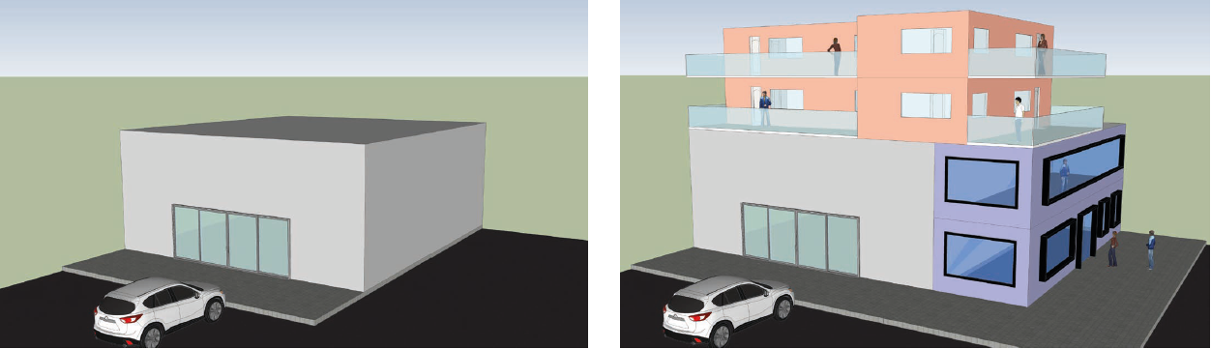
Source: Structure Plan Figure 12

Discussion
The Panel acknowledges that Council seeks to retain industrial and commercial land uses in Precinct 5. It does not seek to transform industrial land uses into commercial uses.
A considerable proportion of Mr Quick’s expert evidence was limited to regional industrial statistics and to 2011 and 2016 figures. While comparing figures between two years can indicate whether something has increased or decreased, it does not provide a longer-term trend. The Panel did not find there was a clear nexus between the regional industrial figures and Mr Quick’s conclusions regarding Precinct 5 in the Town Centre.
The Panel agrees with the general proposition of Mr Glossop and Mr Quick that Precinct 5 could achieve no net loss in employment floorspace if dwellings were restricted from the first two levels. Allowing dwellings conditional to providing employment uses on the first two levels may provide an incentive for future development in this precinct.
However, the Panel agrees with Council there has not been sufficient strategic planning to better understand whether, and to what degree, it is possible to have a mixed-use precinct with existing industrial land uses. This includes understanding whether introducing dwellings may ultimately result in the demise of industrial land uses in this precinct. Industry and dwellings are generally two land uses with challenging interface and co-location issues. The Panel therefore shares Council’s concern that, without sufficient strategic planning, there may be a loss in available commercial and industrial land, conflicting land uses may discourage future businesses from establishing in the precinct, and that employment and economic diversity may be limited.
Irrespective, the Panel is not persuaded that there is a need for additional dwellings in the Town Centre. The Structure Plan identifies extensive land in several precincts for residential and mixed uses. The Panel considers that the planning and economic expert evidence did not provide sufficient strategic basis to include dwellings in Precinct 5.
Mr Glossop’s suggested built form and guidelines may have been appropriate if there was sufficient strategic planning to justify dwellings in the precinct and to address likely residential/industrial interface issues.
The Panel supports Precinct 5 as an employment precinct without accommodation, as envisioned in the Structure Plan. This will provide certainty to existing and prospective industrial and commercial property owners and tenants that their operations will not be adversely impacted in the future.

Conclusions
The Panel concludes:
- There is insufficient strategic planning to understand the effect on existing and future commercial and industrial land uses.
- Without proper strategic planning, there is likely to be conflict and interface issues between residential and industrial land uses.
- The Amendment should not enable accommodation in Precinct 5.

Development Contributions Plan Overlay Schedule 18

The issue
The Amendment proposes to apply DCPO18 to land in the Town Centre. The issue is whether the exhibited DCPO18 provisions are appropriate and should apply.

Submissions
Council submitted that the DCPO enables a schedule to specify that a permit can be granted before a development contributions plan is incorporated. It added that DCPO18 seeks to apply this by specifying that a permit may be granted under certain circumstances such as entering into an agreement under section 173 of the Act. Council explained that DCPO18 includes interim provisions which will be deleted once a development contributions plan is incorporated through a future planning scheme amendment. It submitted that these provisions are common in DCPO schedules and examples include:
- Melbourne Planning Scheme Development Contributions Plan Overlay Schedule 1
- Melbourne Planning Scheme Development Contributions Plan Overlay Schedule 2
- Wyndham Planning Scheme Development Contributions Plan Overlay Schedule 16.
Council submitted that no development will be prohibited if an agreement required by DCPO18 is in place, and it referred to the Structure Plan which states:
Development proponents wishing to develop prior to incorporation of this ICP can enter into agreements with the City of Whittlesea under Section 173 of the Planning and Environment Act 1987 to expedite contributions. Contributions will be required to be made consistent with the likely contributions required in accordance with a future ICP.
In its submission to the exhibited Amendment, 530 McDonalds Road Pty Ltd and others said that DCPO18 was not justified and should be deleted. Council did not support this change and had further discussions with the submitter. In response to these discussions, Council proposed to add a note in section 4.3 (Infrastructure) of the Structure Plan):
The list and location of projects are indicative and subject to a further process of assessment as to need, scope, timing, responsibility and cost apportionment (if applicable) when future town planning approvals are sought.
The written confirmation from Contour Consultants, on behalf of the submitter, states that it considers the matter resolved subject to Council presenting these changes at the Hearing.

Discussion
The Panel notes the resolved position between Council and 530 McDonalds Road Pty Ltd and others, however, due to the nature of the original objection, considered the matter further. The Panel referred to the examples referred to by Council which, as described by Council, apply the same form as proposed by the Amendment. The Panel is cognisant that the existence of similar planning provisions in another planning scheme does not necessarily mean that they are correct. The Panel referred to the second purpose of the Development Contributions Plan Overlay and whether the parent overlay enables a schedule to include the exhibited provisions. The second purpose states:
To identify areas which require the preparation of a development contributions plan for the purpose of levying contributions for the provision of works, services and facilities before development can commence.
The parent overlay specifies that a schedule can enable a permit to be granted in specific circumstances. Therefore, the Panel is satisfied that the exhibited DCPO18 provisions are appropriate and should apply. It also supports the additional note for the Structure Plan which seeks to clarify the status of infrastructure items.

Conclusions
The Panel concludes:
- The exhibited Development Contributions Plan Schedule 18 provisions are appropriate and should apply.
- The Structure Plan would benefit from a note in section 4.3 (Infrastructure) which clarifies that status of infrastructure.

Recommendation
The Panel recommends:
- Revise the Plenty Valley Town Centre Structure Plan to:
  - add in section 4.3 (Infrastructure):
The list and location of projects are indicative and subject to a further process of assessment as to need, scope, timing, responsibility and cost apportionment (if applicable) when future town planning approvals are sought.

Railway land permit requirement
At the Hearing, Mr Lawrie submitted that the State Government owns 323 McDonalds Road, South Morang. It is currently used by the contractor constructing the Mernda railway extension. Mr Lawrie added that ‘Railway station’ is not listed in the ACZ2 table of uses so a planning permit would be needed develop the land. Transport for Victoria requested that a permit not be required for a Railway station.
Council explained that ACZ2 includes the following exemptions:
- In 4.1 (Use of land) – A permit is not required to use land for the purpose and services of Local Government or Transport providing the use is carried out by, or on behalf of, the public land manager.
- In 4.3 (Buildings and works) – A permit is not required to: … Buildings and works for the purpose of Local Government or Transport providing the buildings and works is carried out by, or on behalf of, the public land manager.
Mr Lawrie responded that these permit exemptions achieve the outcome sought by Transport for Victoria.
The Panel notes that the permit exemptions provide more flexibility than what was requested by Transport for Victoria, and it is concludes that there is no issue to resolve.

Form and content of the Amendment
Council submitted a revised ACZ2 with tracked changes which reflected changes that responded to issues raised in submissions. It also included considerable changes to the table of use in Clause 3.0 to:
- correct land use terminology which reflect what was intended for different precincts
- accordingly, change conditions to align with terminology changes.
Council explained that some of the changes proposed in the exhibited ACZ2 were more restrictive than existing planning provisions and, than what was intended.
The Panel supports these changes to ACZ2 and it is satisfied that they will improve the schedule’s operation.
There are precinct guidelines throughout ACZ2 which are expressed as mandatory provisions because they use ‘must’. While the Panel makes no formal recommendation, it strongly encourages Council to consider using ‘should’ to clarify that they are guidelines and to avoid delays over interpretation issues.

Recommendation
The Panel recommends:
- Amend Activity Centre Zone Schedule 2, as shown in Appendix C, to:
  - change land use terminology and conditions to reflect what was intended and to improve its operation.

Appendix A Document list
No. | Description | Presented by
6 June 2018
1 | Map – McDonalds Road Pty Ltd & Ors properties | Mr Gelber
14 June 2018
2a | Part A Submission | Council
25 June 2018
2b | Part B Submission | Council
3 | Letter 7 May 2018 | Council
4 | Proposed DPO8 post exhibition | Council
5 | email – Contour Consultants | Council
6 | ACZ2 exhibited and post exhibition land use matrices | Council
7 | Clue 2015 – Plenty Valley Snapshot | Council
8 | Tract report 2014 extract | Council
9 | Ministerial Direction No 1 | Council
10 | Employment precinct – existing land use | Council
11 | Submission – Transport for Victoria | Mr Lawrie
12 | Aerial map | Mr Lawrie
13 | Plenty Valley Town Centre Residential Capacity Analysis 2018 | Council
14 | Map - Middle Gorge Station and environs | Council
15 | Findon Road cross section | Council
16 | Walkability map | Council
17 | South Morang Train Station Commuter Car Park Count | Council
18 | Whittlesea Leader articles | Council
19a | DCP extracts – Moonee Valley | Council
19b | DCP extracts – Flemington Hill | Council
20 | Table A Summary of Recommended Levies in each Development Setting | Council
21 | Submission – Scentre Group | Mr Chessell
22 | Plenty Valley Structure Plan, Figure 27 – preferred version | Mr Chessell
23 | Plan – Strata subdivision | Council
24 | Aerial map – South Morang, 1989 | Council
25 | Plan and information – Middle Gorge Railway Station Precinct | Council
26 | Proposed Mernda Rail corridor and Findon Road intersection | Council
27 | ACZ2 – Brendan Danaher preferred version | Mr Bartley
27 June 2018
28 | Submission - Canopi Homes | Mr Alderson
29 | Plan – University Hill | Council
30 | Submission – Brendan Danaher | Mr Bartley
31 | Plans and elevations – 855 Plenty Road, South Morang: Stage 1 approved | Mr Bartley
32 | Industrial 3 Zone | Mr Bartley
33 | Photos – Precinct 5: South of McDonalds Road | Mr Bartley
34 | Tract plan | Mr Bartley
35 | Findon Road link | Mr Bartley
36 | Document | Mr Bartley
37 | Aerial plan – 825 Plenty Road, South Morang and surrounding land uses | Mr Bartley
38 | Plans and elevations – 855 Plenty Road, South Morang: Stage 2 | Mr Bartley
39 | Plans – 40C Murdoch Road, South Morang: Two road link options | Mr Bartley
40 | Whittlesea Planning Scheme – Activity Centre Zone Schedule 1 | Mr Bartley
41 | Stonnington Planning Scheme – Activity Centre Zone Schedule 1 | Mr Bartley
42 | Greater Geelong Planning Scheme – Activity Centre Zone Schedule 1 | Mr Bartley
43 | Banyule Planning Scheme – Activity Centre Zone Schedule 1 | Mr Bartley
44 | Wyndham Planning Scheme – Activity Centre Zone Schedule 1 | Mr Bartley
45 | Casey Planning Scheme – Activity Centre Zone Schedule 1 | Mr Bartley
46 | Whittlesea Planning Scheme – Activity Centre Zone Schedule 2  (Scentre Group preferred tracked changes version) | Mr Chessell
47 | Expert Witness Statement – John Glossop (received 18 June 2018) | Mr Bartley
48 | Expert Witness Statement – Rhys Quick (received 18 June 2018) | Mr Bartley

Appendix B Council’s proposed Amendment changes since exhibition
Submissions, issues and Council responses
Transport for Victoria
Issue 1
At this stage there has been no Victorian Government commitment to extending the Route 86 tram route, and any potential future extension would be subject to a future business case assessment and successful funding bid. All references to the potential tram extension should include the wording 'potential' to avoid any confusion as to its status. The image on page 14 should also be updated.
Council response
Support the change to the amendment in the manner requested.
Issue 2
Transport for Victoria and Public Transport Victoria, in conjunction with Council, are currently investigating potential future commuter car parking in the Structure Plan area. At this stage it has not been finalised and is subject of ongoing investigations. Accordingly, no commitment has been made to provide extra parking and the Structure Plan should reflect this. Furthermore, PTV cannot commit to the provision of 800 car parking spaces and this requirement should be deleted from Schedule 2 to the Parking Overlay.
Council response
Council at its meeting on 27 March 2017 provided a policy direction for the provision of 800 car parking spaces at the South Morang Train Station and for it to be stipulated in Schedule 2 to the Parking Overlay. The exhibited documents included the following:
A minimum of 800 parking spaces for commuters is to be provided by Public Transport Victoria in proximity to the South Morang Train Station.
Transport for Victoria (TfV) objected to the inclusion of this policy direction and requested that the requirement be deleted from Schedule 2 to the Parking Overlay. TfV noted that at this stage they cannot commit to the provision of 800 car parking spaces and will continue to monitor the demand for parking at South Morang following with the Mernda Rail project becoming operational and investigate the potential for additional commuter car parking in the future. The provision of infrastructure at the South Morang Train Station is of importance to enable commuters to access the station. There is a clear shortage of car parking spaces. The removal of an existing temporary car park is likely to further exacerbate the issue. Therefore, it is considered that it importance the guidance be provided the planning scheme but that it be provided as a strategy in Clause 21.13 Local Areas rather than a policy direction in the Parking Overlay. It is recommended that the following strategy be inserted into Clause 21.13
'Support the provision of adequate car parking (minimum of 800 parking spaces) and infrastructure encouraging sustainable transport for commuters at the South Morang Train Station.'
The inclusion of the strategy in Clause 21.13 is a better fit than the Parking Overlay as the overlay does not apply to public transport parking. ‘Planning Practice Note 5: The Parking Overlay (PPN5)’ provides guidance in respect to using the Parking Overlay. In accordance with PPN5, it is considered that the Parking Overlay is not the correct tool to use to implement this requirement as the Parking Overlay applies to variations to parking rates outlined in s52.06 of the Victoria Planning Provisions. Commuter parking is not covered by this section. Therefore, the policy direction in the Parking Overlay is not relevant.
Clause 21.13 forms part of Council’s Local Planning Policy Framework and identifies Council’s key strategies in respect to the Plenty Valley Town Centre and can include broader strategies around issues such as transport, housing, jobs and the natural environment.
TfV was generally supportive of the revised wording except requested that the reference to (minimum of 800 parking spaces) be deleted.
Council position
Replace the policy direction in the Parking Overlay with the following strategy in Clause 21.13: “Support the provision of adequate car parking (minimum 800 parking spaces) and infrastructure encouraging sustainable transport, for commuters at the South Morang Train Station.”
530 McDonald's Road Pty Ltd, McMillan Wealthiland Pty Ltd, McMillan Property Group Pty Ltd, McMillan Oleander Pty Ltd and Gary McMillan South Morang Pty Ltd
Issue 1
Not to dilute the development opportunities now available under the Commercial 1 zoning (C1Z) and Development Plan Overlay - Schedule 26 and, as to part, the approved Development Plan to achieve optimising development in the Major Activity Centre.
Council response
The land use table in ACZ2 has been drafted to reflect the purpose of the precincts as identified in the Structure Plan. The land use table has been drafted generally in accordance with the Commercial zones which currently apply to the Town Centre with changes made where necessary. For example, land uses such as Hospital, Dwellings and Exhibition Centres have been promoted whilst other land uses such as Bottle Shops, Gambling Premises, Industry and Warehouses have been more heavily restricted. Upon consideration of this submission a number of anomalies were identified and changes are recommended such as permitting Industry and Warehouses in the Employment Precinct (Precinct 5) generally consistent with the existing zone controls. It is recommended that the land use table be reviewed to optimise appropriate development in the Town Centre generally consistent with existing land use, zones and Structure Plan objectives.
Council position
Review land use tables with regard to consistency with existing zone controls and the Structure Plan.
Issue 2
To retain the lands which are located in proposed Precincts 4(b) and 5 in Category 2 for the purposes of clause 52.05.
Council response
Agree. The submission requests that land in Precincts 4(b) and 5 to be in Category 1 which is the default category for Commercial zones. The other categories apply to more sensitive areas with high amenity. Upon review it is considered that Category 1 is appropriate for the Town Centre given that this is the default provision for the Town Centre and that all precincts will contain a mixture of uses including commercial. The application of other Categories may trigger permit applications for signage which is appropriate for a Town Centre context. It is recommended that ACZ2 be amended to delete any variation to Advertising Sign requirements.
Council position
Amend ACZ2 to retain land in the Town Centre in signage Category 1.
Issue 3
To amend the boundary between proposed Precinct 4(b) and 5 to respect property boundaries and development potential.
Council response
Agree. The boundary between Precincts 4(b) and 5 is currently along the eastern side of the electricity easement and Heaths Court Drain. It is agreed that a better outcome would be to align the precinct boundary with the property boundaries where possible to provide for consistency of planning controls. The boundary realignment will have minimal effect on land use outcomes given the constrained nature of the subject land (electricity easement and drainage). It is recommended that the boundary between Precinct 4(b) and 5 be realigned along the property boundaries on the western side of the electricity easement and Heaths Court Drain.
Council position
Realign the boundary between Precinct 4 and Precinct 5 to align with existing property boundaries.
Issue 4
To rationalise and simplify the level of detail proposed to apply to development in Precincts 4(b) and 5 including height setbacks and building typologies which proposals are not supported by any strategic justification.
Council response
The built form controls in ACZ2 and the Structure Plan have been developed through a comprehensive process as part of preparing the Structure Plan. The Structure Plan has been prepared in accordance with the process outlined in PPN58: Structure Planning for Activity Centres and Built Form Controls developed and implemented in accordance with PPN60: Height and Setback Controls for Activity Centres.
A submission raised concern with the level of detail proposed to apply in respect to built form controls and suggested that the controls have not been strategically justified.
The built form controls have been derived from a built form, character and future land use needs analysis undertaken as part of the Background Report and a detailed built form analysis presented in the draft Structure Plan. The background review considered existing built form and planning controls (such as existing Development Plans). The exhibited Structure Plan and ACZ2 simplify these controls in accordance with the ACZ template provided for in Ministerial Direction No. 1 Form and Content of Planning Schemes. The controls are important for ensuring high quality built form outcomes in the Town Centre including the activation of streets and creation of a high quality public realm. It is considered that the proposed controls are well supported by strategic justification.
Nevertheless, it is considered appropriate to review the manner in which the built form controls have been drafted in the amendment documentation to ensure they are legible, clearly able to be interpreted and applied and achieve the outcome intended by the Structure Plan. In particular, there is an opportunity to simplify the application of concepts such as key corner buildings, key marker buildings, gateways, landscaping buffer and setbacks.
The updated controls have been circulated to the submitter who has deemed the amended controls to resolve the matter.
Council position
Review and update the drafting of built form controls to ensure they are legible, clearly able to be interpreted and applied and achieve the outcome intended by the Structure Plan.
Issue 5
To delete the Plenty Valley Structure Plan 2017 as an Incorporated Document and to delete prescribing its objectives, requirements and guidelines as a development control or consideration.
Amendment C204, exhibited the Structure Plan as an Incorporated Document. Incorporated documents are planning documents which are required for the proper functioning of the planning scheme and decision-making. They carry the same legal weight as other parts of the scheme.
A submission requests the Structure Plan be deleted as an Incorporated Document as:
“it has not been drawn as a piece of subordinate legislation or for use as a regulatory purpose and contains uncertain concepts sought to be applied as mandatory considerations assessing development applications.”
The submission proposes that the Structure Plan be a Reference Document. A Reference Document provides background information to assist in understanding the context in which the planning provision (ie. ACZ2) has been framed. It does not carry the same weight as other parts of the planning scheme.
Through further discussion with the submitter it has been agreed to amend the status of the Structure Plan document to a Reference Document. This was on the basis on the maps in ACZ2 being updated to incorporate additional elements from the Structure Plan such as trees, local road network, parks and focal points.
Council position
Amend the status of the Plenty Valley Town Centre Structure Plan from an Incorporated Document to a Reference Document.
Update maps in ACZ2 to incorporate additional elements from the Structure Plan.
Add an additional section into the Structure Plan to provide clarity as to how the document is to be interpreted for the purpose of decision making.
Canopi Homes 360 Pty Ltd
Issue 1
To amend Strategy 1.4 in Clause 21.13.3- Plenty Valley Town Centre as follows: 'Support Encourage the provision of social and affordable housing in the Town Centre as part of new residential developments.'
Council response
Agree. The purpose of the strategy is to facilitate opportunities for social and affordable housing in the Town Centre particularly on sites where there is an increased density of development permitted or on government land in the right location. Therefore, it is considered that the proposed change to the drafting of the strategy is acceptable.
Council position
Support the change to the amendment in the manner requested.
Issue 2
To amend the last paragraph of Clause 4.4 of Clause 37.08-2 (Schedule 2 to the Activity Centre Zone) under the heading “Building Height” as follows: “Where a building is less than the preferred minimum building height the structure of the building must be designed so as to be able to accommodate additional building structure and height.”
Council response
Agree. The proposed amended wording provides additional clarity to the intent of the clause and therefore is considered acceptable. Further, it is recommended that the word ‘must’ be replaced with ‘should’ in order to provide greater discretion as to when it is appropriate and feasible to implement this guideline.
Council position
Support the change to the amendment generally in accordance with the manner requested.
Issue 3
Amend the Precinct Map at Clause 5.4-1 to relocate the Gateway location on the subject land closer to McDonalds Road.
Council response
The Structure Plan identifies numerous locations as ‘gateway’ sites which seek to provide for special built form outcomes to highlight the significance of these locations. The exhibited location of the ‘gateway’ is along the Yan Yean Pipetrack and is constrained by the electricity easement and rail corridor. The proposed amended ‘gateway’ location is at McDonalds Road and provides an entry point to a more prominent location including the Central Shopping Precinct, the Yan Yean Pipetrack and the residential development on the subject land. It is important that built form in this location provides for this ‘gateway’. Therefore, the amended location is considered more appropriate.
Council position
Support the change to the amendment in the manner requested.
Issue 4
Amend dot point 5 in Clause 5.4-4 of Clause 37.08-2 (Schedule 2 to the Activity Centre Zone) to read: “A 6m wide landscaping strip is to be provided for development in front-setback areas along McDonalds Road to create an attractive streetscape.”
Council response
The amendment to this guideline is supported for Precinct 4 ‘Live and Work’ precinct given the precinct encourages buildings to actively address street frontages for mixed use development. The guideline as exhibited conflicts with this objective in this precinct.
Council position
Support the change to the amendment generally in accordance with the manner requested.
Issue 5
In Clause 4.4 of ACZ2 under the heading “General Built Form guidelines” add the following additional dot point: “Have regard to and be consistent with the guidelines contained in a Master Plan approved by the responsible authority in accordance with Clause 4.4 of this schedule.
Insert the following new section at the end of Clause 4.4 of ACZ2 as follows: “Master Plan A master plan may be approved by the responsible authority for land in precincts 1A, 2B, 3 or 4A or part thereof. The master plan must be consistent with the provisions of this schedule and the Plenty Valley Town Centre Structure Plan. The master plan may provide for further guidance in respect to: - Density. - Built form design. - Public realm design. - Interface treatments to open space reserves and railway line. - Landscaping.
Council response
A key aim of the Structure Plan and the Amendment is to consolidate the existing range of planning controls and documents (such as Development Plans) applying to parts of the Town Centre into an overarching statutory framework to provide for a consistent vision and co-ordinated approach to development in the Town Centre.
The Amendment proposes that the DPO and associated Development Plans will be replaced by the schedule to ACZ and the Structure Plan as an incorporated document.
Two submissions were made in respect to this issue. Scentre Group requested that the DPO and the existing South Morang Development Plan be retained for their land. Environmental Resources Management Australia Pty Ltd submitted that some of the detailed content of the 360 McDonalds Road Development Plan should be retained.
The options of retaining a DPO schedule or incorporating a provision for a master plan in ACZ2 were both further investigated and discussed with the two submitters.
Through further discussions, it has been agreed to retain a DPO over the subject development precincts. This has been on the basis of the DPO Schedule being amended and the Development Plans being updated to ensure that they are consistent with ACZ2 and overall objectives of the Structure Plan.
Further, it is recommended that the control also apply to vacant development land in the immediate vicinity to provide for a consistent and co-ordinated planning approach and outcome across the town centre.
Council position
Support the retention of a revised Development Plan Overlay schedule in sub-precincts 1a, 2b, 3b, 3c and 4a.
Issue 6
That the Master Plan referred to in our submission as proposed to be included in Clause 4.4 of ACZ2 be approved by Council at the same time as it considers adoption of Amendment C204 to the Whittlesea Planning Scheme.
Council response: Noted.
Issue 7
The Plenty Valley Town Centre Structure Plan should be amended as follows:
- Figure 7: Landscape Plan – the map that shows “RRG Retained in Open Space and Integrated with Development” should be redrawn to reflect the 360 McDonalds Road Development Plan 2017 endorsed by the Council on 28 June 2017.
- Figure 21: Road Network and Intersection Plan - the map should be redrawn to reflect the 360 McDonalds Road Development Plan 2017 endorsed by the Council on 28 June 2017.
- Figure 23: Residential Development Density- the map should be redrawn to reflect 360 McDonalds Road Development Plan 2017 endorsed by the Council on 28 June 2017 in terms of both layout and density.
Council response
The 360 McDonalds Road Development Plan 2017 was prepared 'generally in accordance' with the draft Structure Plan however it further refined the 'high level' plan with a number of elements including a revised street network and identified River Red Gum Trees to be retained or removed. It is considered appropriate for the final Structure Plan to reflect the approved Development Plan.
Council position
Support the change to the amendment in the manner requested.
Issue 8
Figure 29: Live and Work Illustrative Precinct Plan in the Plenty Valley Town Centre Structure Plan should be amended as follows:
- Remove the tree shown on Reserve 8 adjacent to the railway reserve.
- Only show 4 trees to be retained in Reserve 1.
- Relocate the key gateways to Plenty Valley to incorporate the three marker sites at the south-east corner of the proposed Lots A, B and D.
Council response
The 360 McDonalds Road Development Plan 2017 was prepared 'generally in accordance' with the draft Structure Plan however it further refined the 'high level' plan with a number of elements including a revised street network and identified River Red Gum Trees to be retained or removed. It is considered appropriate for the final Structure Plan to reflect the approved Development Plan.
Council position
Support the change to the amendment in the manner requested.
Friends of South Morang (FoSM)
Issue 1
The draft Structure Plan shows both a preferred (Ferres Boulevard) and alternate (Civic Drive) Tram Route alignment north of McDonalds Road. The FoSM do not support to the alternate Tram 86 Extension route along McDonalds Road adjacent to the South Morang Rail station then northwards along Civic Drive to Findon Road.
Council response
It is recommended that the Structure Plan be updated to show the preferred route from the community for the Tram 86 Extension being along Bush Blvd, McDonalds Road and Ferres Boulevard. It is noted that the ultimate tram alignment will be subject to future feasibility studies and business case by State Government.
Council position
Support the change to the amendment in the manner requested.
Issue 2
Concerns raised from the residents of Brabham Drive, Peyton Drive, Stillman Drive and Bradley Drive that the extension and connection of local streets to Civic Drive will create additional traffic onto these suburban streets.
Council response
The exhibited Structure Plan provided for the extension of Civic Drive with local street connections with Peyton Drive and Stillman Drive. This reflected the direction of existing plans including the South Morang Activity Centre Overall Development Plan, 1998 and the South Morang Development Plan, 2009.
The Friends of South Morang (FoSM) on behalf of residents raised concern with the proposed connections in their submission citing the impacts of additional traffic on local streets. Council undertook some further consultation with residents on the issue as to the preferred option for the connections.
Analysis of the consultation feedback suggests that residents in the immediate vicinity of the connections were more likely prefer the pedestrian and cycle connection. This option would limit road network permeability however maintain the amenity of residents.
It is recommended that the final Structure Plan identify that the connection of Peyton Drive and Stillman Drive be restricted to pedestrian and cycle only and continue to be monitored to ensure that they meet the needs of local residents.
Council position
Amend the proposed connections of Peyton Drive and Stillman Drive with the extension of Civic Drive should be restricted to a pedestrian and cycle connection only.
Scentre Group
Issue 1
A Development Plan Overlay should be retained for Scentre Group land holding given that DPO8 currently includes other land, the existing DPO8 area would need to be amended.
Council response
A key aim of the Structure Plan and Amendment C204 is to consolidate the existing range of planning controls and documents (such as Development Plans) applying to parts of the Town Centre into an overarching statutory framework to provide for a consistent vision and co-ordinated approach to development in the Town Centre.
The Amendment proposes that the DPO and associated Development Plans will be replaced by the schedule to ACZ and the Structure Plan as an incorporated document.
Two submissions were made in respect to this issue. Scentre Group requested that the DPO and the existing South Morang Development Plan be retained for their land. Environmental Resources Management Australia Pty Ltd submitted that some of the detailed content of the 360 McDonalds Road Development Plan should be retained.
The options of retaining a DPO schedule or incorporating a provision for a master plan in Schedule 2 to the ACZ were both further investigated and discussed with the two submitters.
Through further discussions, it has been agreed to retain a DPO over the subject development precincts. This has been on the basis of the Schedule to DPO being amended and the Development Plans being updated to ensure that they are consistent with the Schedule 2 of the Activity Centre Zone and overall objectives of the Structure Plan.
Further, it is recommended that the control also apply to vacant development land in the immediate vicinity to provide for a consistent and co-ordinated planning approach and outcome across the town centre.
The finer details of the changes to the amendment controls and Structure Plan are still the subject of ongoing discussion and may be a matter for the planning panel.
Council position
Support the retention of a revised Development Plan Overlay schedule in sub-precincts 1a, 2b, 3b, 3c and 4a.
Refer the matter to independent Planning Panel should the matter not be fully resolved prior to the Planning Panel.
Issue 2
The Development Plan Overlay Schedule 8 area would need to be amended so that it relates to the Scentre Group holding only.
Council response
Refer response to above. It has been agreed that a revised DPO schedule would also apply to other precincts in the Structure Plan area to ensure a consistent planning framework across the town centre.
Council position
Do not support. The DPO schedule would also apply to other key development precincts in the town centre.
Issue 3
Concurrent with changes to the DPO8 mapping and Schedule noted above, an amended Development Plan the removes the 'non Scentre Group' provisions would be approved.
Council response
The approval of a revised Development Plan will need to be processed in accordance with Council’s standard process for assessing and approving Development Plan’s upon submission of an amended Development Plan.
Issue 4
The Structure Plan would need to be amended to be consistent with the approved Development Plan and the DPO8 provision would need to be referenced. Consequential changes would need to be made to the Activity Centre Zone Schedule.
Council response
The Structure Plan is to be reviewed to provide greater consistency with the existing Development Plan and guidance in respect to the preparation of an updated Development Plan. The finer details of the changes to the amendment controls and Structure Plan are still the subject of ongoing discussion and may be a matter for the planning panel.
Council Position
Review the South Morang Development Plan to consider any further changes consistent with the objectives of the Structure Plan, to provide greater consistency between the existing Development Plan and proposed Structure Plan. Refer the matter to independent Planning Panel should the matter not be fully resolved prior to the Planning Panel.
Brendan Danaher
Issue 1
The land should be considered appropriate for mixed use purposes, including accommodation uses, on the basis that:
- The land is well serviced by four existing bus stops and two planned bus stops
- The land is within walking distance of railway stations
- Findon Road is being constructed, which will connect Danaher Drive through to Plenty Road
- The land to the south, if developed for residential and mixed-use purposes, would form a good synergy with Masons Point residential development
- The land could readily be included in the ‘Live and Work’ precinct
- Land that is zoned for mixed use purposes generally has a capacity to provide for higher job density than land is zoned for light industry.
Council response
It is recommended that the proposed change to the Amendment not be supported for the following reasons:
- The precinct is identified as an employment precinct with the primary objective of providing land for commercial and employment land uses. The permission of accommodation in the precinct conflicts with this objective for the following reasons:
- Use of the land for accommodation would reduce the amount of land used for commercial or employment land uses
- The precinct supports a range of commercial uses such as: car sales, vehicle repairs, concrete supplies, office, retail and bulky goods. These are commercial land uses generally not considered compatible with a high amenity residential or mixed-use precinct. Housing in the precinct may conflict with these existing commercial uses.
- Housing in the precinct may discourage future businesses from establishing in the precinct due to the potential land use conflict (ie. noise, traffic, odour)
- This is the only employment focused precinct in the Plenty Valley corridor (Mill Park, South Morang, Mernda). There are limited other opportunities for employment focused businesses to establish in the corridor. There are significant opportunities for mixed use development including housing, office and retail in all other precincts in the Structure Plan area.
- The precinct is bordered by arterial roads (Plenty Road, Findon Road, McDonalds Road), the Mernda Railway and Yan Yean Pipetrack which separates the land from other residential or neighbourhood land uses. The land is separated from the ‘live and work’ precinct by clear boundaries including the Heath Court Drain and Yan Yean Pipetrack.
- The precinct is located further away from the South Morang train station than other precincts in the Structure Plan area where housing is encouraged.
- The precinct is separated from the Marymede train station by Findon Road and approximately 800m walk from the edge of the precinct. There are other housing opportunities located closer and more convenient to the station.
Council Position
Accept and consider the late submission. Do not support the change requested to the Amendment. Refer the submission to the independent Planning Panel.

Appendix C Panel recommended version of Activity Centre Zone Schedule 2

Tracked Added
Tracked Deleted

SCHEDULE 2 TO THE ACTIVITY CENTRE ZONE
DD/MM/YYYY
Proposed C204
Shown on the planning scheme map as ACZ2
PLENTY VALLEY TOWN CENTRE
- Plenty Valley Town Centre Framework Plan
DD/MM/YYYY
Proposed C204
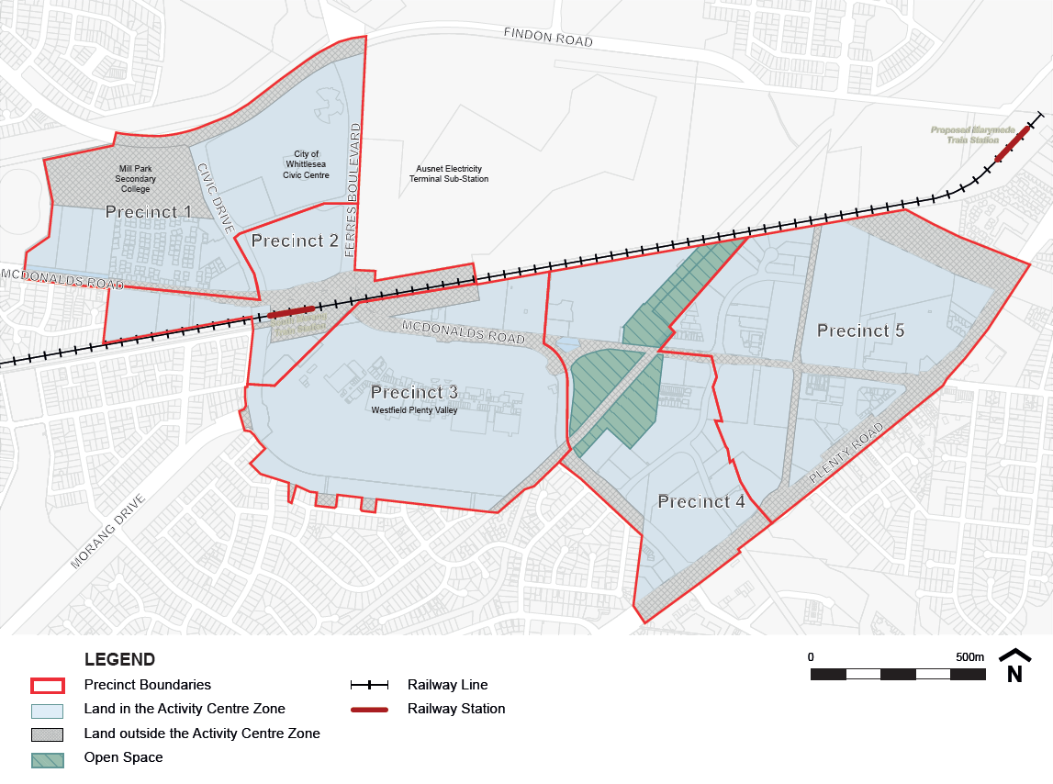
2.0 Land use and development objectives to be achieved
DD/MM/YYYY
Proposed C204

- To support the Town Centre to perform its role as a vibrant, accessible and attractive activity centre for the region.
- To support the development of each precinct in accordance with its intended function while facilitating the integration of the precincts as a single activity centre.
- To ensure new development is of quality urban design, high amenity, environmentally sustainable and contributes positively to the public realm.
- To encourage a diversity of employment opportunities and an integration of mixed uses and activities.
- To encourage additional housing, including social and affordable housing, close to services, facilities and public transport in the Town Centre.
- To provide a permeable street and pedestrian network that supports all modes of transport while encouraging a shift in the mode split to public transport, walking and cycling.
- To provide a network of public squares and parks linked by pedestrian routes.
- To protect and integrate River Red Gums into development to enhance the landscape character and amenity of the Town Centre.
3.0 Table of uses
DD/MM/YYYY
Proposed C204
Section 1 - Permit not required
Use | Condition
Accommodation (other than Caretakers house, Camping and caravan park, Corrective institution, and Dependent person’s unit, Host farm, Residential hotel) | If located in sub-precinct 2b, 3a, 3b and 4b must be above ground floor level, except for entry foyers.  Must not be in Precinct 5.
Cinema | Must be in sub-precinct 2b or 3ba
Cinema-based entertainment facility | Must be in sub-precinct 2b or 3ba
Convenience Restaurant | Must be in Precinct 4, 5 or sub-precinct 3a, 3b.
Dependent person’s unit | Must be the only dependent person’s unit on the lot.
Education centre
Exhibition Centre
Food and drink premises (other than Convenience Restaurant, Hotel, and Tavern) | If located in Precinct 5, the leasable floor area must not exceed 100 square metres.
Home occupationbased business
Hotel | Must be in Precinct 3, 4 or sub-precinct 2b, 3a or 3b.
Industry (other than Materials recycling, Rural industry, Transfer station) | Must be in Precinct 5.  Must not be a purpose listed in the table to  Clause 52.10.
Informal outdoor recreation
Library
Office
Place of worship | The gross floor area of all buildings must not exceed 250 square metres.
Postal agency
Residential hotel | Must be in Precincts 1, 2, 3, or 4.
Restricted retail premises | Must not be in Precinct 1 or 2.
Retail premises (other than Food and drink premises, Gambling premises, Market, Postal agency, and Primary produce sales, Shop, Trade supplies) | Must be in Precinct 5.
Shop (other than Adult sex product bookshop, Bottle shop, Restricted retail premises and Supermarket) | If located in Precinct 5:  - The combined leasable floor area for all shops (including a supermarket) must not exceed 500 square metres.  - The site must adjoin, or have access to, a road in a Road Zone.
Supermarket | If located in Precinct 1, 2a, 3c,b or 4:  - The leasable floor area must not exceed 1800 square metres  Must not be in Precinct 5.
Tavern | Must be in Precinct 3, 4 or sub-precinct 2b, 3a or 3b.
Tramway
Minor utility installation
Railway
Warehouse | Must be in Precinct 5.  Must not be a purpose listed in the table to 52.10.
Any use listed in Clause 62.01 | Must meet requirements of Clause 62.01.

Section 2 - Permit required
Use | Condition
Accommodation (other than Camping and caravan park, Corrective institution,, Dependent person’s unit, Host farm, Residential hotel, and Dwelling) – if the Section 1 Condition is not met. | Must not be in Precinct 5 other than a caretaker’s house).
Adult sex productbook shop | Must be at least 200 metres (measured by the shortest route reasonably accessible on foot) from a residential zone, land used for a hospital, primary school or secondary school or land in a Public Acquisition Overlay to be acquired for a hospital, primary school or secondary school.  Must not be located in Precinct 1.
Bottle shop | Must be at least 200 metres (measured by the shortest route reasonably accessible on foot) from a residential zone, land used for a hospital, primary school or secondary school or land in a Public Acquisition Overlay to be acquired for a hospital, primary school or secondary school.  Must not be located in Precinct 1.
Brothel | Must be in Precinct 5.
Gambling premises | Must be in sub-precinct 2b, 3a or 3b or 5.
Industry (other than Materials recycling, Refuse disposal Rural industry, Transfer station) | Must not be a purpose listed in the table to  Clause 52.10 except in Precinct 5.
Leisure and recreation (other than Informal outdoor recreation and Motor racing track)
Market
Nightclub | Must be in sub-precinct 2b or 3a.
Place of assembly (other than
Carnival, Cinema, Circus, Exhibition Centre, Library, Nightclub and Place of worship)
Service station | If located in Precincts 1, 2 or 4:  - The site must adjoin, or have access to a road in a Road Zone.Must be in Precinct 3 or 5.
Service industry | Must not be a purpose listed in the table to  Clause 52.10.
Shop (other than other than Adult sex bookshop, Bottle shop, Restricted retail premises and Supermarket) if the Section 1 Condition is not met.
Timber yard | Must be in Precinct 5.
Trade supplies (other than Timber yard) | Must be in Precinct 3 or 5.
Transport terminal (other than Airport and Road freight terminal)
Utility installation (other than Minor utility installation and Telecommunications facility)
Warehouse (other Fuel depot) | Must be located in Precinct 5.  Must not be a purpose listed in the table to 52.10.
Any other use not in Section 1 or 3
Section 3 – Prohibited
Use
Agriculture (other than Animal keeping, Animal training, Horticulture)
Airport
Camping and caravan park
Corrective institution
Earth and Energy resources industry
Freeway service centre
Fuel depot
Host farm
Industry (other than Research and development centre and Service industry)
Materials recycling
Motor racing track
Pleasure Boat Facility
Primary Produce sales
Refuse disposal
Road freight terminal
Rural industry
Saleyard
Transfer station

4.0 Centre-wide provisions
DD/MM/YYYY
Proposed C204

4.1 Use of land
DD/MM/YYYY
Proposed C204

A permit is not required to use land for the purpose and services of Local Government or Transport providing the use is carried out by, or on behalf of, the public land manager.
4.2 Subdivision
DD/MM/YYYY
Proposed C204

None Specified.
4.3 Buildings and works
DD/MM/YYYY
Proposed C204

A permit is not required to:
- Install an automatic teller machine.
- Construct or carry out works normal to a dwelling.
- Buildings and works for the purpose of Local Government or Transport providing the buildings and works is carried out by, or on behalf of, the public land manager.
- An alteration to an existing building façade provided:
- The alteration does not include the installation of an external roller shutter.
- At least 80 per cent of the building façade at ground level is maintained as an entry or window with clear glazing.
4.4 Design and development
DD/MM/YYYY
Proposed C204

Building Height
The preferred building height requirements are specified in Clause 5.0 of this Schedule.
Any application which proposes to exceed the preferred building height set out in Clause 5.0, must demonstrate that:
- the development delivers a community benefit in the form of at least 5% of dwellings as social housing or an area of public land greater than 5% of the site area to the satisfaction of the Responsible Authority;
- the building is of high quality architectural design and contributes positively through urban design to the public realm;
- the building is not sited within 40 metres of a residential zone;
- the building height does not cause any unacceptable overshadowing, overlooking or amenity impacts to surrounding residential properties; and
The building height should not exceed a maximum building height of 28 metres35 metres in sub-precinct 2b or 3b and 28 metres in all other precincts.
Building height does not include architectural features or plant and service equipment.
Where a building is less than the preferred minimum building height the structure of the building should must be designed so as to be able to accommodate additional building structure and height.
Other Built Form Standards and Outcomes
New development should meet the Standard specified for each relevant Design Element and must meet the Built Form Outcomes specified in the Table below:
Design Element | Standard | Built Form Outcomes
Street wall height | Should be:  - no more than the preferred building height, or  - Should be no more than 21 metres (≈ 6 storeys) on an arterial road or connector road, or.  - Should be no more than 14 metres (≈ 4 storeys) on any other road,  whichever ever is less.. | - Street wall height is to ensure:  - daylight and views of the skyline are preserved from the street,  - minimal impacts of overshadowing,  - an appropriate sense of enclosure, and  - a human scale.
Upper level street setbacks | Where a building height exceeds the street wall height set out in this clause, upper levels should be setback a minimum 5 metres from the street wall. | - Setback upper levels to ensure:  - larger buildings do not visually dominate the street or public spaces,  - minimal impacts of overshadowing,  - minimal impacts of overlooking, and  - a consistent street wall scale is maintained.
Front Street Setback | Should Encouraged to be as per the preferred setback specified in the Precinct Maps included in Clause 5.  Where no setback is specified, the building setback should be consistent with adjoining buildings or a maximum of 7 metres, whichever is the lesser. | - Buildings are to be sited to ensure;  - passive surveillance and activation of the street,  - a consistent street wall for a pleasant pedestrian environment, and  - where applicable, an adequate landscape buffer to soften industrial and commercial uses.
Setback(s) from side boundary | Where a building height exceeds the street wall height set out in this clause, upper levels of a building should be setback a minimum 5 metres from a side boundary. | - Buildings are to be setback from side boundaries at upper levels to ensure:  - provision of adequate light and privacy from habitable rooms, for both existing and proposed developments,  - provision of adequate light to narrower local roads,  - minimal impacts of overshadowing, and  - minimal impacts of overlooking.
Setback(s) from rear boundaries | Where a building height exceeds 10.5 metres, upper levels should be setback a minimum 5 metres from the rear boundary.  Where the rear boundary of a site is a non-sensitive interface (e.g. railway line or utility easement) no rear setback applies. | - Buildings are to be setback from side boundaries at upper levels to ensure:  - provision of adequate light and privacy from habitable rooms, for both existing and proposed developments,  - provision of adequate light to narrower local roads,  - opportunities for passive surveillance of areas which are a non-sensitive interface,  - minimal impacts of overshadowing, and  - minimal impacts of overlooking.
Sensitive interfaces | Where the side or rear boundary is a sensitive interface, buildings should be setback a minimum 9 metres from the property boundary adjoining the sensitive interface. Upper levels should be setback an additional 1 metre for every metre of height over 7 metres.  Where an inconsistency occurs between this standard and any other standard in this Table, this standard prevails to the extent of any inconsistency. | - Buildings and upper levels are to be setback from property boundaries to ensure:  - provision of adequate light and privacy from habitable rooms, for both existing and proposed developments,  - opportunities for passive surveillance of areas which are a non-sensitive interface,  - transition to the height of adjoining areas,  - minimal impacts of overshadowing, and  - minimal impacts of overlooking.
General built form guidelines
New development should:
- Actively and sensitively address all street frontages and orient buildings towards public spaces, open space areas, utility easements, waterways.
- Maximise survellience of the public realm through translucent windows at ground level and balconies facing public streets and open spaces.
- Address streets, public squares and open spaces with:
- Finer grain uses to increase activation at street level.
- Façade treatments and articulation which provide a pedestrian environment, activates the street and creates visual interest.
- Individual entries to buildings including ground floor apartments, accessed from the street.
- Building entry points which are highly visible and accessible.
- Ensure development at ‘gateway locations’ and sites identified for ‘key marker buildings’, are prominent and Iincorporate high quality architectural forms and features at ‘gateway locations’ and sites identified for ‘key marker buildings’,.
- Locate service areas, storage and refuge areas, loading areas and bins where they are less visible from the public realm and screened by buildings, landscaping buffers or visual screening.
- Minimise the amount of retail access from internal pedestrian paths in favour of retail access and frontage to external streets and external pedestrian paths, where practicable.
- Ensure that any enclosed pedestrian paths are well designed to integrate with external areas, have open sections, have high levels of natural light and are well ventilated.
- Ensure large format retail and commercial developments and car parking are ‘sleeved’ with smaller scale buildings and/or uses along the street, where practicable.
- Provide for high quality landscaping including the provision of canopy trees where appropriate.
- Minimise the number and widths of crossovers per site and maximise the retention of on street parking and mature trees.
- Ensure that signage is designed to be compatible with the building design, scale, material and colour and sensitively integrated with the surrounding environment.
- Retain and protect remnant River Red Gums on public land in open space, tree reserves or road reserves.
Environmentally Sustainable Design (ESD)
New development should be designed to:
- Reduce greenhouse gas emissions, compared to minimum building standards.
- Conserve potable water supplies, improve stormwater quality and protect waterways.
- Maximise access to solar and daylight opportunities.
- Maximise access to sustainable transport modes.
- Ensure waste avoidance, re-use and recycling during construction and operation.
- Achieve a healthy indoor environment.
5. 0 Precinct provisions
DD/MM/YYYY
Proposed C204

5.1 Precinct 1: Civic
DD/MM/YYYY
Proposed C204

5. 1-1 Precinct map
DD/MM/YYYY
Proposed C204

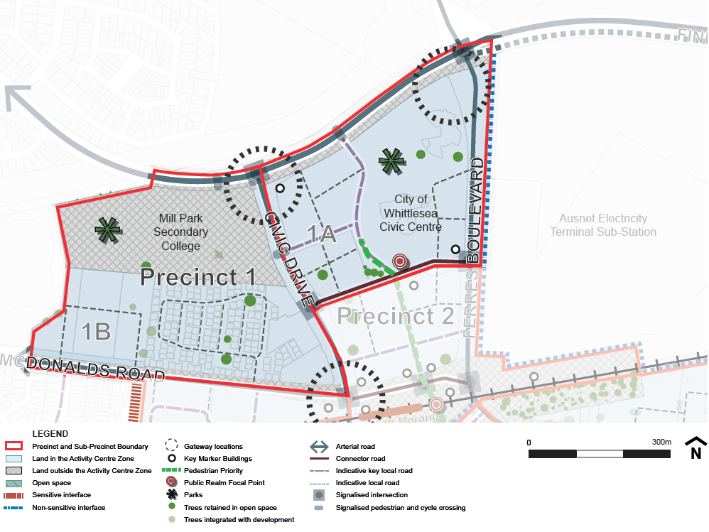
5.1-2 Precinct objectives
DD/MM/YYYY
Proposed C204

- To develop the precinct as the community and civic focus of the Town Centre.
- To encourage the development of higher density residential integrated with other compatible uses throughout the precinct.
- To encourage the provision of social and affordable housing in the precinct.
- To protect and enhance the visual and physical connections between the Town Centre and the Quarry Hills Regional Park.
- To strengthen the direct pedestrian and cycling connections between the transport hub and the precinct.
5.1-3 Precinct requirements
DD/MM/YYYY
Proposed C204

Sub-precinct | Preferred Building Height | Preferred Street Setback
1A | Up to 21 metres | 0m
1B | Up to 14 metres | Less than 3m on arterial roads.
Key corner siteGateway Location | 9 - 28 metres
5.1-4 Precinct guidelines
DD/MM/YYYY
Proposed C204

- Development along the central pedestrian priority route is toshould provide for community, civic and other ‘fine grain’ commercial uses at the ground floor of multi-storey buildings.
- Key viewlines from public spaces to the Quarry Hills Regional Park should be preserved.
- Development is toshould actively address and overlook public streets, squares and open space areas.
- Development of sub-precinct 1A is tomust provide for a highly permeable street network to promote convenient, direct and legible pedestrian movements.
- New residential developments should integrate 5% of dwellings as social housing and 10% of dwellings as affordable housing.

5.2 Precinct 2: Transport Hub
DD/MM/YYYY
Proposed C204

5.2-1 Precinct map
DD/MM/YYYY
Proposed C204

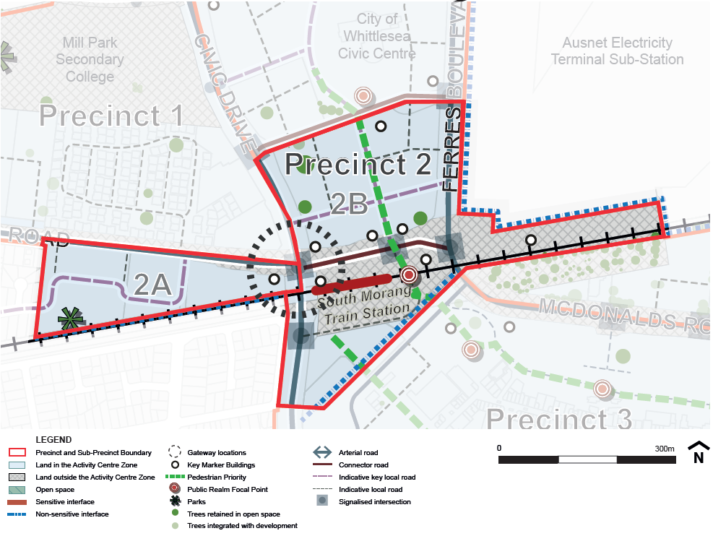
5.2-2 Precinct objectives
DD/MM/YYYY
Proposed C204

- To develop the Precinct as a vibrant and concentrated hub of activity integrated around the South Morang Train Station and transport interchange.
- To cluster high density development in proximity to the transport interchange.
- To provide for the provision of social and affordable housing as part of key residential developments in the precinct.
- To provide for a pedestrian oriented and prioritised urban realm.
- To protect and develop key pedestrian and cycle routes and ensure barriers including roads, utility easements and the railway line can be crossed in multiple locations.
5.2-3 Precinct requirements
DD/MM/YYYY
Proposed C204

Sub-precinct | Preferred Building Height | Preferred Street Setback
2A | Up to 28 metres | Less than 3m on arterial roads
2B | 9 - 28 metres | 0m

- New residential developments in Precinct 2A which exceeds 13.5m in height are tomust integrate 5% of the additional dwellings as social housing and 10% of the additional dwellings as affordable housing.

5.2-4 Precinct guidelines
DD/MM/YYYY
Proposed C204

- Development along the central pedestrian priority route in sub-precinct 2A is toshould provide for retail and ‘fine grain’ commercial uses at the ground floor of multi-storey buildings.
- Development is toshould provide for a human scale and pedestrian and cycle connectivity at ground level.
- Land is toshould be developed at a density which capitalises on the proximity to the transport interchange.
- Active uses such as cafés are encouraged to extend trading onto footpaths and public squares where appropriate.
- The visual impact of transmission pylons is toshould be mitigated through the strategic placement of buildings and landscaping.
- Development in sub-precinct 2B is tomust provide an appropriate interface with the railway line and transition to a lower scale adjoining existing residential areas.
- Parking should be provided in multi-level facilities with active ground floor uses, rather than in at-grade parking areas.
5.3 Precinct 3: Central Shopping
DD/MM/YYYY
Proposed C204

5.3-1 Precinct map
DD/MM/YYYY
Proposed C204

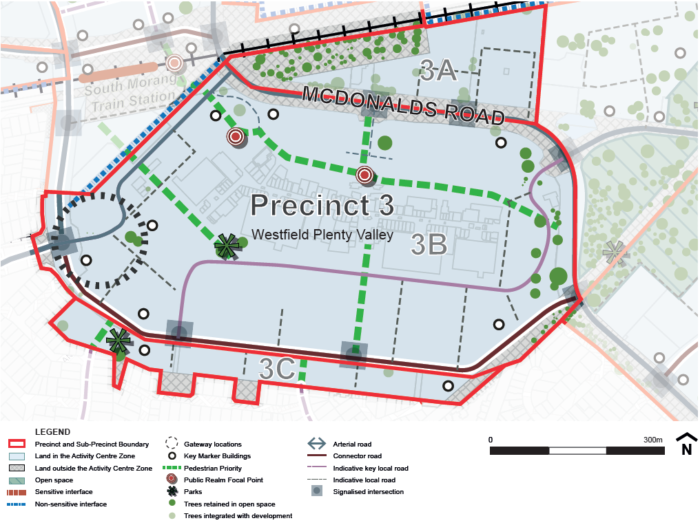

5.3-2 Precinct objectives
DD/MM/YYYY
Proposed C204

- To develop the Precinct as a vibrant retail, commercial and leisure centre.
- To encourage the diversification of the retail centre to provide greater range of facilities, services, commercial opportunities.
- To provide encourage opportunities for housing in the precinct, including social and affordable housing.
- To encourage uses which activate retail strips into the evening.
- To provide for a safe, accessible and activated n east west external pedestrian prioritised street path north of the existing shopping centre.
- To support mixed use development above and adjoining existing buildings and over existing car parking.
5.3-3 Precinct requirements
DD/MM/YYYY
Proposed C204
Sub-precinct | Preferred Building Height | Preferred Street Setback
3A | Up to 21 metres | 0m
3BA | Up to9 - 21 metres | 0m
3CB | Up to 21 metres on land north of Civic Drive  Up to 14 metres on land south of Civic Drive | 0m
Gateway Location or site adjoining non-sensitive interfaceKey corner site or site with non-sensitive interface. | 9 - 3528 metres | 0m
5.3-4 Precinct guidelines
DD/MM/YYYY
Proposed C204

- Civic Drive is to be extended though the precinct between Morang Drive and Bush Boulevard as an east west boulevard connector road with cycling infrastructure.
- SAafe, accessible and n external activated east-west pedestrian street links is tomust be provided through the shopping centre siteprecinct linking connecting the transport interchange through the precinct to Masons PointTransport Hub and Live and Work precincts.
- Any pedestrian links which are enclosed must be well designed to integrate with external areas, have open sections, have high levels of natural light and be well ventilated.
- Outdoor public squares activated by surrounding uses, are toshould be provided as part of new entertainment and leisure developments and at key entry points to the shopping centre.
- Development on McDonalds Road and Civic Drive should address and activate the street and pedestrian path to the extent practicable.
- Active uses such as cafés are encouraged to extend trading onto footpaths and public squares where appropriate.
- Where possible, parking should be provided in multi-level facilities with active ground floor uses, rather than in at-grade parking areas.
- Where proposed, Rresidential development in sub-precinct 3A and 3B is toshould be provided above ground floor with active uses such as retail and commercial provided on the ground floor.
- Development in sub-precinct 3A is tomust provide an appropriate interface with the railway line where applicable.
- Development of sub-precinct 3B is tomust provide for a permeable street network for vehicle and pedestrian movements.
- Development in sub-precinct 3B is toshould provide for a higher density residential and mixed used neighbourhood and must transition to a lower scale adjoining existing residential areas.
5.4 Precinct 4: Live and Work
DD/MM/YYYY
Proposed C204

5.4-1 Precinct map
DD/MM/YYYY
Proposed C204

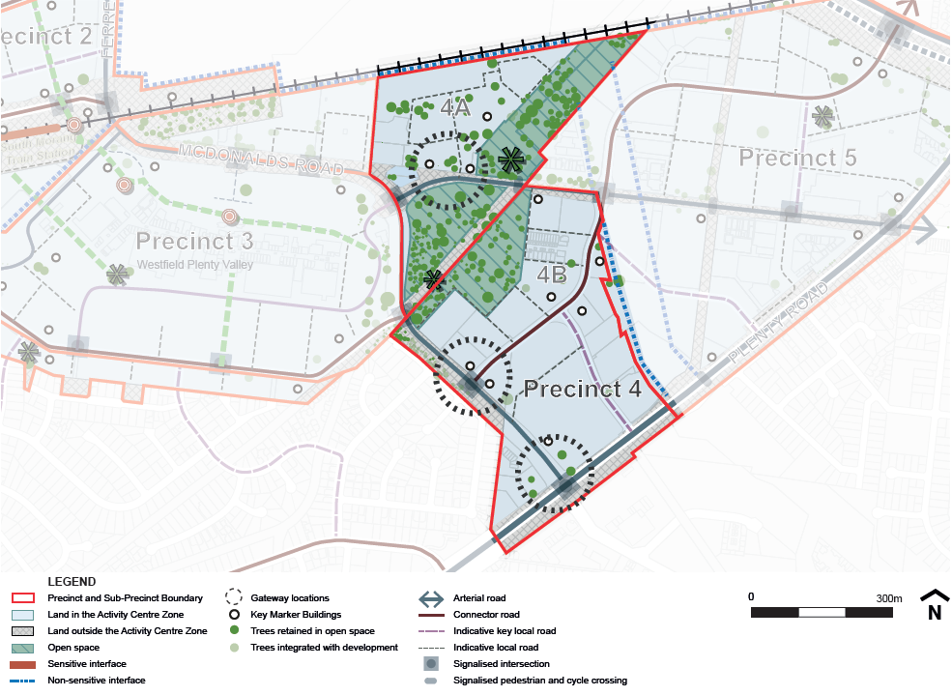
5.4-2 Precinct objectives
DD/MM/YYYY
Proposed C204

- To develop the Precinct as a high amenity mixed use residential, commercial and office precinct.
- To support a range of compatible residential, commercial, office and limited retail land uses.
- To ensure that buildings actively address streets, parks, waterways, easements and conservation reserves.
- To provide a permeable movement network appropriate for the mixed use focus of the precinct with a priority on pedestrian and public transport movements.
- To enhance the amenity and environmental values of waterways, conservation reserves and land containing remnant River Red Gums.

5.4-3 Precinct requirements
DD/MM/YYYY
Proposed C204
Sub-precinct | Preferred Building Height | Preferred Street Setback
4A | Up to 21 metres | 0m on arterial roads
4B | Up to 21 metres | 0m
Gateway Location (in sub-precinct 4B only)Key corner site. | 9 - 28 metres (in sub-precinct 4B) | 0m
5.4-4 Precinct guidelines
DD/MM/YYYY
Proposed C204
- A local road connection between Oleander Drive and Plenty Road is to be provided as part of new development.
- Development is toshould actively address and overlook streets, parks, waterways, easements and conservation reserves.
- Mixed use developments are toshould provide for ground floor activation.
- A 6m wide landscaping strip is toshould be provided for development in front-setback areas along McDonalds Road to create an attractive streetscape.
- River Red Gums are to be retained, protected and sensitively integrated into the development of sub-precinct 4A.
- Development in sub-precinct 4A is toshould provide active ground floor uses to the McDonalds Road street edge.
- Development in sub-precinct 4A is tomust provide an appropriate interface with the railway line and pipe track reserve.

5.5 Precinct 5: Employment
DD/MM/YYYY
Proposed C204

5.5-1 Precinct map
DD/MM/YYYY
Proposed C204
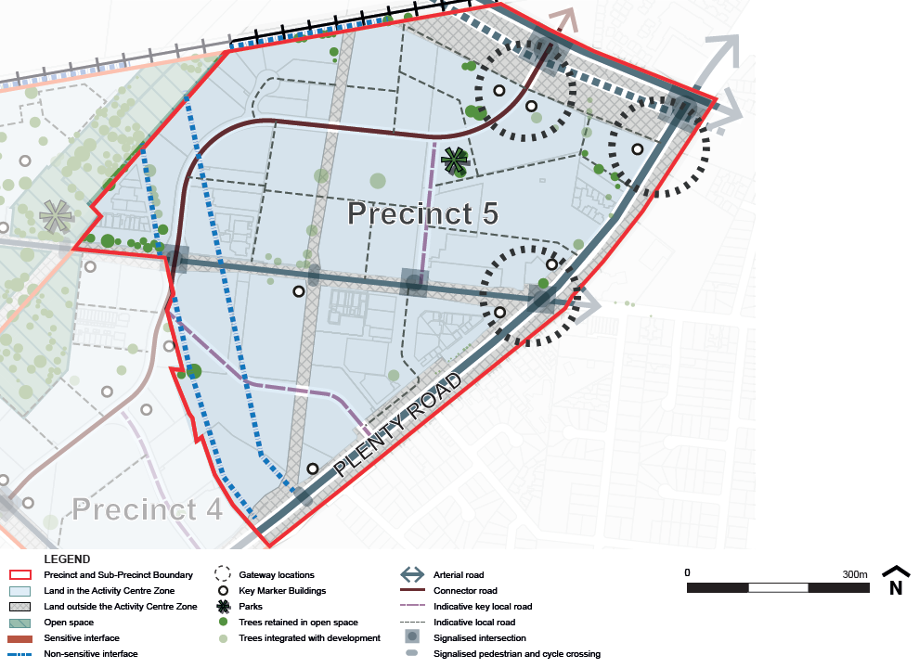
5.5-2 Precinct objectives
DD/MM/YYYY
Proposed C204

- To develop the Precinct as an attractive employment precinct.
- To promote the intensification of commercial land uses to provide greater employment opportunities.
- To support a range of employment generating land uses such as office, small scale manufacturing, services.
- To encourage development above and adjoining existing buildings or proposed ‘big box’ buildings.
- To encourage development to respond to the proximity of the Marymede Train Station.
- To provide a high quality streetscape along McDonalds Road.
5.5-3 Precinct requirements
DD/MM/YYYY
Proposed C204

Sub-precinct | Preferred Building Height | Preferred Street Setback
5 | Up to 14 metres | Less than 25m on McDonalds Road.  Less than 3m on other arterial or connector roads.
Site with non-sensitive interface. | Up to 21 metres. | Less than 25m on McDonalds Road.  Less than 3m on other arterial or connector roads
Key corner siteGateway Location | Up to 28 metres. | 0m
5.5-4 Precinct guidelines
DD/MM/YYYY
Proposed C204

- Buildings should be located close to the street, rather than significantly setback from the street frontage.
- Car parking should be located to the rear of buildings. Where parking is located in the front setback it should be screened by high quality landscaping.
- A 6m wide landscaping strip (6m wide on McDonalds Road and 4.5m wide on other streets) is toshould be provided for development in front-setback areas where parking is provided in the front setback along McDonalds Road to create an attractive streetscape.
- Office and retail uses are toshould be located where they are able to activate the street.
- A local road connection between Oleander Drive and Plenty Road is toshould be provided as part of subdivision or development of the subject land. new development.
- Development is toshould address and provide for the survellience of open spaces and utility easements.
- The visual impact of transmission pylons is toshould be mitigated through the strategic placement of buildings and landscaping.
- Development along Findon Road is toshould provide a consistent built form edge.
- HAvoid high security fencing around the perimeter of commercial and industrial uses should be avoided, and where such fencing is required, it must be screened it with landscaping.
- Water Sensitive Urban Design treatments are toshould be incorporated into Heaths Court Drain (where retained as an open waterway) and the environmental values enhanced as part of the development of adjoining land.
6.0 Application requirements
DD/MM/YYYY
Proposed C204

The following application requirements apply to an application in addition to those specified in Clause 37.08 and elsewhere in the scheme and must accompany an application, as appropriate, to the satisfaction of the responsible authority:
- A Waste Management Plan which demonstrates, as appropriate:
- Strategies for waste minimisation during the construction phase.
- Likely waste generation by users of the building
- Provision and allocation of bins for garbage, recycling, green waste, etc.
- The location and dimensions of bin storage areas, chutes etc., including access points for collection.
- The proposed method and frequency of waste collection.
- Provision of signage to ensure that waste is disposed of correctly and that contamination is minimised.
- For all applications over three storeys in height, a 3D massing model which shows:
- The potential overshadowing impact of the development on the open space and habitable rooms of adjoining properties and within the proposed development; and how the development design minimises impacts and ensures maximum solar access internally for dwellings, to neighbouring properties and the public realm.
- The potential impact of the development on the public realm adjacent to the proposal ensuring that overshadowing of major pedestrian routes, parks and other public spaces is minimised; and that specifically, overshadowing of footpaths on the south side of east-west streets is avoided for at least three hours between 9:00am and 3:00pm on the Equinox. Reasonable solar access should also be maintained to the ground floor of buildings opposite in winter.
- How the design (including building height and setbacks) contributes to the public realm of the Town Centre whilst having regard to the adverse effects of visual bulk.
- A Sustainable Design Assessment or Sustainability Management Plans in accordance with the following:
- For developments of 5–9 dwellings or 500–2,000 square metres of commercial, educational or community floorspace, a Sustainable Design Assessment demonstrating how sustainability measures have been incorporated into the design.
- For developments of 10–29 dwellings or 2,000–5,000 square metres of commercial, educational or community floorspace, a Sustainability Management Plan showing how the development achieves a medium to high level of ESD performance.
- For developments of more than 29 dwellings or more than 5,000 square metres of commercial, educational or community floorspace, a Sustainability Management Plan showing how the development achieves a high level of ESD performance.
- Sustainable Design Assessments and Sustainability Management Plans should be completed using an appropriate rating tool, and are required to address the following categories:
- Energy efficiency,
- Transport,
- Climate change adaptation,
- Integrated water management,
- Waste management,
- Urban ecology,
- Indoor environment quality,
- Building materials,
- Site and ongoing building management, and
- Innovation.
- A certified access and inclusion report for applications for use or construction of a publicly accessible building confirming that the development complies with relevant standards on mobility and accessibility.
- An application for use or development for accommodation immediately adjoining the Mernda Rail Line must be accompanied by a noise, vibration and light spill report prepared by a suitably qualified person, to the satisfaction of the Responsible Authority. The report shall consider potential amenity impacts from the rail operations and include any recommended mitigation measures. The report must demonstrate that the design of the use or development will ensure that internal noise levels in bedrooms is less than 65 dB LAmax and 40 dB Leq9h at night from 10pm to 6am.
Licensed premises
- For all applications to use land to sell or consume liquor under Clause 52.27 a:
- Cumulative Impact Assessment prepared in accordance Practice Note 61 Licensed Premises: Assessing Cumulative Impact, which must also have regard to the cumulative impacts of existing packaged liquor outlets and licensed premises within the whole of the activity centre.
- Detailed social and economic impact analysis to the satisfaction of the responsible authority.
- Venue Management Plan that identifies, as appropriate:
- Proposed trading hours
- Venue design measures to maximise safety and minimise potential harms as identified in the Design Guidelines for Licensed Venues, Department of Justice 2009 including: entries, exits and queuing areas; footpaths, laneways, car parks and public spaces; patron activity areas; toilets; outdoor drinking, dining and smoking areas; and common areas.
- Mechanisms to address potential risks including patron management mechanisms, security measures such as CCTV and staff training; communication between management, staff, patrons, local residents and police during day to day operation and / or in the event of complaints.
- Venue maintenance arrangements.
7.0 Notice and review
DD/MM/YYYY
Proposed C204

An application for the use of a brothel, bottle shop, gambling premises, hotel, nightclub or tavern is not exempt from the notice requirements of Section 52(1)(a), (b) and (d), the decision requirements of Section 64(1), (2) and (3) and the review rights of Section 82(1) of the Act in accordance with Clause 37.08-8 of the Activity Centre Zone.
An application to construct a building or construct or carry out works is not exempt from the notice requirements of Section 52(1)(a), (b) and (d), the decision requirements of Section 64(1), (2) and (3) and the review rights of Section 82(1) of the Act in accordance with Clause 37.08-8 of the Activity Centre Zone if:
- the proposed development exceeds the preferred building heights in Clause 5 of this Schedule, or
- the land is within 40 metres of a residential zone and the proposed development reduces the setback standards contained in Clause 4.3 of this Schedule.
8.0 Decision guidelines
DD/MM/YYYY
Proposed C204

The following decision guidelines apply to an application, in addition to those specified in Clause 37.08 and elsewhere in the scheme. The decision guidelines must be considered, as appropriate, by the responsible authority:
- The extent to which the development implements objectives, strategies and directions in the Plenty Valley Town Centre Structure Plan.
- The protection and integration of remnant River Red Gums as part of the use and development.
- The manner in which the development activates street frontages and addresses public spaces, open space areas, utility easements, waterways and the rail corridor.
- The manner in which the development responds to its context and its effect on the public realm.
- The extent to which the development prioritises walking, cycling and public transport use and ensures that car parking is well designed and does not dominate streetscapes.
- The amenity impact of overshadowing and overlooking on surrounding residential properties.
- For applications on sites identified in gateway locations and for key marker buildings, the built form and articulation features incorporated into the design.
- For applications for licensed venues, the likely social and amenity impacts of the proposal on the surrounding area.
- Advertising signs
DD/MM/YYYY
Proposed C204
Advertising sign requirements are at Clause 52.05.
    - All land within sub-precincts 2b and 3a and all other land is in Category 1.
    - All land within Precincts 4 and 5 and sub-precinct 3b is in Category 2.
    - All land within Precinct 1 and sub-precinct 2a is in Category 3.
10.0 Other provisions of the scheme
None specified.
119.0 Reference document
DD/MM/YYYY
Proposed C204
Plenty Valley Town Centre Structure Plan 2017

Document 5

