Road and Public Transport Plan
Responding to the challenges of travel and transport in the City of Whittlesea
Creating vibrant self-sustaining communities together

Foreword
The City of Whittlesea’s rapid population and housing growth has resulted in a congestion crisis on our roads and overcrowding on our public transport. Addressing the issue is complex and requires Council to take a strategic long-term approach. This Road and Public Transport Plan will be used to guide Council’s work as we advocate and work with key stakeholders to ensure our community can enjoy access to an efficient and effective road network and have better public transport corridors.
In 2016 Council adopted a ‘Community Building’ approach to our work to ensure that there is a close connection between the needs and aspirations of our community and the work of Council. Accordingly, in developing our Road and Public Transport Plan we identified the travel and transport needs of our residents today and into the future and have prioritised transport projects based on those that will make the most difference for our community. Some of these projects are long term and require significant Victorian and Federal Government funding. Others are short-term solutions that build upon opportunities arising across our City such as improving our network of bicycle and pedestrian paths, reducing people’s reliance on private cars and enhancing our road connectivity.
There is no simple or easy way to fix traffic congestion. But our community can be certain that Council is committed to improving the situation so that our residents will be able to move more freely around our municipality whether it is by public transport, car, on foot or on a bike.
Mayor, Cr Ricky Kirkham

Contents
Foreword 2
Preamble 3
Executive Summary 4
A growing municipality 5
The transport story so far 7
How we will meet the challenges 12
Arterial roads 14
Collector roads 18
Intersections 19
Public transport 23
Cycling 31
Walking 32
The way forward 35

Preamble

The City of Whittlesea’s congestion crisis has a significant impact on the day to day lives of our community. The hours our residents spend stuck in traffic steals time from family life and community life.
“…presenting huge challenges for the many families like the Suratwala’s of Epping North, a new suburb around 25 kilometres from the CBD. Meera Suratwala gets up at 6am every weekday morning. The 33-year-old dresses fast so she’ll have time to help her husband, Hiren, get the kids ready. He works as a chef at the Grand Hyatt in the city and sometimes gets home at 4.30am to the Aurora estate where they live.
‘I know, it is crazy’ he laughs, and Meera laughs with him. ‘Crazy’ is their catch-all word to describe the logistics and lengthy commutes required to earn a living and raise a family on Melbourne’s fringe. Meera leaves home at 7am. On a good day the drive to her accountant’s job in Blackburn, in the city’s east, takes fifty minutes, on a bad day an hour and twenty minutes or more.
Hiren only sees his daughter on two weeknights and two weekend mornings. His precious time with Nandini is further squeezed because he must leave for work before his shift. After six years in Australia they are both citizens and glad to be here, but life is not easy. As Meera says, with an edge in her voice, the days when the family can be together without commitments number ‘just five days of the year’.
Modern Australia has many stories like the Suratwala’s - people who have to commute for a long time to earn a living, putting pressure on family life. More than a quarter of all commuters in Australia’s big cities spend more time commuting than with their children. People with very long commute times have the worst reported work-life balance of any group in Australia.”
City Limits - Why Australia’s Cities are Broken by Jane-Frances Kelly and Paul Donegan

“Doing Edgars Road is more important to provide an exit out. It takes me 30 minutes to get to TRAC in Thomastown because I need to go through the congestion around Epping Plaza”.
Andrew

Executive Summary
Our residents face significant transport issues daily. Congested road networks steal time from families, affect the cohesiveness of our community and lead to poorer health outcomes compared to residents living in the inner suburbs of Melbourne.
This Road and Public Transport Plan is an outline of the issues, actions and possible solutions to move more people, more often within, to and from the City of Whittlesea. It is not only a planned response to the immediate challenges of travel and transport, but also a chance to strategically address the long-term challenges of developing transport networks in an urban growth context. This pressure for much-needed infrastructure has increased with the recent approval of the Quarry Hills, English Road and Wollert Precinct Structure Plans. Addressing current issues of congested roads, overcrowded public transport, disconnected and unfinished walking and cycling networks are critical to providing a liveable city for residents of today and the future.

A summary of our priorities
The City of Whittlesea has established priorities for transport infrastructure to ensure the needs of our rapidly expanding municipality are addressed in both established areas and growth areas over the short and long term.
Significant investment in transport infrastructure, in combination with the creation of local jobs is urgently required and essential to unlocking the congestion which exists across the city. While recent Victorian Government commitments to the Mernda Rail extension, O’Herns Road interchange and Plenty Road widening improve the capacity of the city’s transport network, substantially more investment in the development of the arterial road network is essential to further address existing congestion and accommodate future growth. Major arterial road projects such as the extension and the duplications of Epping Road and Bridge Inn Road and the extension of Edgars Road are urgent priorities.
Intersection upgrades are also important with priority projects being:
- Plenty Road and Bridge Inn Road
- Findon Road, Epping Road and O’Herns Road
- Findon Road, Ferres Boulevard and the Lakes Boulevard.
Further investment in the City’s public transport network is critical, with priority projects being the development of the Wollert rail corridor, the expansion of bus services in growth corridors and the extension of Tram Route 86 to Plenty Valley Town Centre.
Incomplete local connector roads also need to be delivered so that developing areas are connected to major destinations, public transport and arterial roads.
The completion of strategic cycling links, including improved connections to train stations and upgrading the footpath network to improve accessibility to shopping centres, is an important part of improving mobility.
“Growing pressure building amongst the Epping community…. Delays on High Street, Epping including O’Herns Road roundabout!”
Anthony

A growing municipality

Geographic and historical context

The City of Whittlesea is one of the fastest growing municipalities in Victoria and Australia.
The City’s estimated population is currently 209,100 people. Over the past decade, from 2007 to 2017, the number of residents increased by 76,180 people. By 2037 the City’s population is forecast to increase to almost 353,910 people (an increase of almost 145,000 or 66 per cent).
This increase will be concentrated in the Epping/ Wollert growth corridor, which comprises Donnybrook, Epping North, Wollert, Beveridge, Quarry Hills and Woodstock. Population growth through the development of high density housing is also planned for established areas.
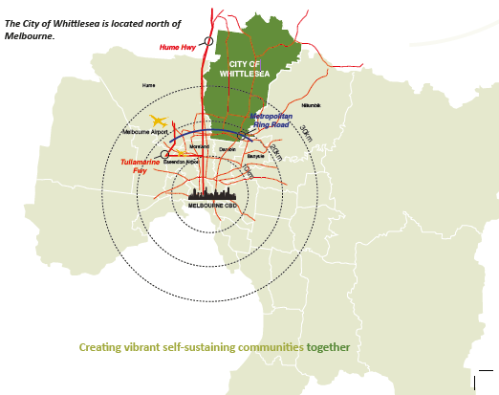

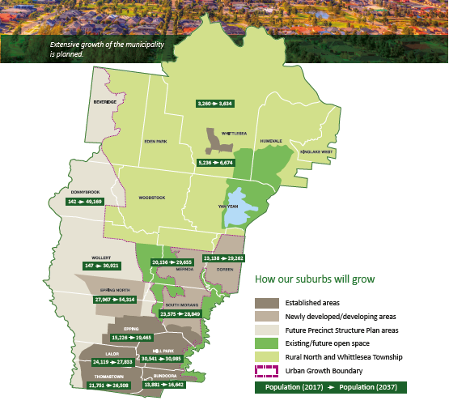

The transport story so far
The travel and transport patterns in the City of Whittlesea identify many issues and challenges.
Residents are heavily reliant on private motor vehicles for transport.
- Traffic congestion is the primary community concern.
- Traffic congestion and a lack of access to public transport are more critical to residents in the northern part of the municipality than the south.
- Infrastructure provision has not kept pace with population growth and development.
- Current public transport provision is insufficient to meet people’s needs; this is in terms of frequency, reliability and general access.
- Trains are the most popular form of public transport but only for a small percentage of the population.
- Public transport usage suffers from a lack of accessibility and infrequency of service.
- Cycling is moderately popular as a form of recreation.
- Walking is very popular as a recreation activity.
- Residents walk to amenities and facilities when they are within walking distance, if footpaths are adequate and there are pedestrian crossings.
- Better footpaths and more bike lanes or off-road paths are needed to encourage more cycling and walking in the municipality.
- Rat-running through local residential streets by motorists seeking alternatives to clogged arterial roads impacts adversely on resident’s local amenity.

Household survey
The City of Whittlesea conducts a Household Survey every year to gather a snapshot in time of the municipality. The survey in both 2015 and 2016 indicates that addressing transport issues is the most significant concern for residents. Four of the top five issues were transport-related:
- traffic management
- roads maintenance and repairs
- public transport
- parking.
Concerns regarding traffic management doubled in 2016.

Transport network
Travel in the City of Whittlesea is framed by three north-south corridors; the Plenty Valley corridor, the Epping Road/High Street corridor and the Yan Yean Road corridor.
Capacity of these three corridors fall well short of accommodating the City’s existing population at peak travel periods. Urban growth in the Epping North/ Wollert and Mernda/Doreen areas will result in significantly more congestion along these corridors. Recent Victorian Government commitments to the Mernda Rail extension and the O’Herns Road interchange (with Federal Government assistance) will improve the City’s transport network, although further infrastructure is required.

Projected traffic congestion
In 2015, transport modeling of the City of Whittlesea’s road network was undertaken with the purpose of identifying road transport infrastructure needs and to indicate priorities over the next 20 years. Not surprisingly, this analysis showed that projected population growth and changes to land use would result in significantly more traffic congestion in the municipality if the road network and transport system was not improved. The model highlighted insufficient capacity along the north-south transport corridors and east-west roads such as Cooper Street as seen in the map below.
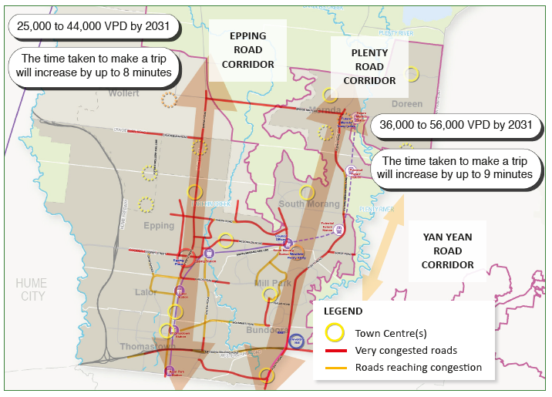

Established areas
The existing transport network in the established areas is overused and needs to be improved for the City to cope with the expected population growth
This is due to the increased numbers of trips from infill development and from through-trips as people travel to work and access shopping and entertainment precincts in established suburbs from the outer growth area. The forecast growth of 145,000 residents will create a further 450,000 trips per week which will traverse the existing networks.

Economic development
High levels of population growth are projected to continue, particularly in the north of the municipality. The challenge for growth areas is to match this rate of development with appropriate infrastructure provision. Job creation is likely to be slower than population growth, highlighting the need to address transport capacity issues in line with population growth to provide access to employment. During morning and evening peak times, journey to work trips stretch the capability of the network in both growth and established areas with congestion highest along Cooper Street and the Epping Road/High Street corridor.
Employment in the municipality is concentrated in the Cooper Street employment area in Epping (near the Hume Freeway), in Epping Central and South Morang and in the Thomastown industrial area adjacent to the Metropolitan Ring Road. The majority of existing jobs generated are from small businesses, with 25 per cent of all businesses involved in manufacturing. The growth of local employment is key to addressing traffic congestion within the City. Local jobs take the pressure off congested road networks, particularly those that are centred around public transport hubs such as Epping Central, Plenty Valley Town Centre and the future Mernda Town Centre.
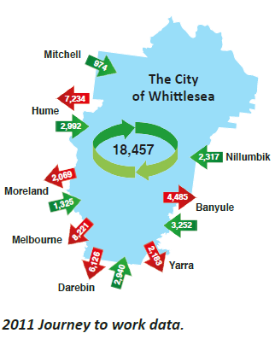

Social impacts
The social and health impact of long commute times as a consequence of traffic congestion is a significant issue in the City of Whittlesea. Residents fare worse in a range of indices on health, community engagement and work-life balanced compared to the Victorian average. The impacts of long commute times in the municipality are projected to get worse if the provision of transport infrastructure and services are not improved.

How we will meet the challenges
The City of Whittlesea has undertaken a number of strategic initiatives to meet our future travel and transport needs.

Integrated Transport Strategy
The City’s forward strategic direction is outlined in the 2014 Integrated Transport Strategy. The Strategy identified a need for more sustainable transport with a significant move towards sustainable transport modes, planning and a timely implementation of transport actions in order to deliver the economic, social and environmental outcomes sought by the community.
The Strategy recognises the importance of planning and timely funding to enable the delivery of transport infrastructure to keep pace with residential growth and growing areas such as Wollert, Donnybrook and Woodstock.
The transport system comprises many modes, each with its own strengths and weaknesses. Actions are required to improve the delivery of all transport modes while giving priority to preferred modes. The Strategy supports the most sustainable modes that meet the needs of the community and businesses, while maximising transport choices. A holistic approach is required to enable all modes to deliver transport requirements in alignment with land-use objectives, including the need for improved:
- road network connections, both arterial and collector roads plus intersections, to ease congestion and aid the free flow of vehicles
- public transport infrastructure and services, particularly rail and bus
- walking and cycling connections as a priority.
This integrated approach means that all Council objectives are addressed by key transport projects. Health and wellbeing is promoted through active transport (walking and cycling) and equity is encouraged by providing a choice of modes that enable an accessible and engaged community.

Local jobs
Jobs placed closer to where people live creates more convenient trips to work and places less pressure on already congested roads and public transport. Creating local jobs is integral to meeting our transport challenges. In turn, jobs and investment growth is achieved by enabling journeys to work, ensuring accessibility of freight movement, and creating great spaces and places that result in human scale movement and accessibility. Sustainability is delivered by lessening the negative impacts of motor vehicles and through good planning and better governance.

A growing city
The City of Whittlesea has inherited an existing rural arterial road network in the growth areas that needs alteration to accommodate more urban trips such as walking, cycling, public transport; and shorter, slower car journeys. The capacity of the road network can be enlarged by dealing with traffic flow through intersections.
One of the major ways to take pressure off peak hour congestion and move large numbers of people is through improved public transport provision.
Council works with developers to provide infrastructure for new developments and surrounding areas. Timely provision of this infrastructure assists with local connectivity via paths and roads, thereby building community cohesion and creating economic activity and local job opportunities. Good local transport infrastructure also encourages the use of local facilities, creates efficiencies for Council’s facilities and lessens the burden on major transport infrastructure.

Prioritising projects
Transport improvement projects within this document have been prioritised based on a matrix which includes evaluation against the following criteria:
- moving people
- benefits including time savings
- moving freight
- road space allocation
- safety
- strategic intent including sustainability, place, health and wellbeing.

“Seriously, Yan Yean Road is backed up from Mitchells Run to Bridge Inn Road as early as 6.30am each morning. That is not good enough.”
Tim

Arterial roads
The City of Whittlesea has a lack of capacity in its north-south road corridors and a lack of east-west connections. Council is seeking to address these deficiencies by advocating for increased capacity of arterial roads in two key ways:
- urbanisation of previously rural roads allowing all modes to safely utilise the infrastructure
- increasing capacity of road networks by providing additional lanes.
The relative timing and sequence of projects and actions is indicated by a priority of high or very high.

Bridge Inn Road urbanisation and duplication
Priority: Very High
Transitioning rural roads to roads that are suitable for an urban area is part of developing growth areas. Urbanising Bridge Inn Road in Mernda will help improve the flow of all modes of traffic by upgrading facilities for all road users, as well as improving the footpath network. It will also assist to ease congestion in Yan Yean Road. The long-term needs will be duplication of the road.

O’Herns Road interchange
Priority: Very High
Committed: Due 2018/19
Access to residential estates in Epping North and the Cooper Street employment area is currently limited to High Street-Epping Road and Cooper Street via the Hume Freeway.
The construction of the O’Herns Road interchange will enable Epping North residents and the Cooper Street employment area much improved access to the Hume Freeway. It will also decrease congestion on the local road network including Epping Road, Cooper Street and Miller Street.

Edgars Road extension, Willandra Drive to O’Herns Road
Priority: Very High
Edgars Road is a north-south arterial road from Mahoneys Road in Thomastown to Cooper Street in Epping that also connects to the Metropolitan Ring Road. A missing link exists between Cooper Street and O’Herns Road that could provide connectivity to the Cooper Street employment area and the residential estates north of O’Herns Road.
The extension will provide an alternative north-south arterial connection to Epping Road as this section of Edgars Road would redistribute traffic through Epping and Epping North. It will reduce congestion on High Street, Epping Road, Miller Street and Cooper Street and increase peak period capacity along Epping Road and Cooper Street. Wider benefits include bus, walking and cycling connections from the residential estates to Epping Central and the Cooper Street employment area to provide an increased level of accessibility for the community. Improved employment opportunities in Epping Central will also arise.

Yan Yean Road: Duplication
From Kurrak Road to Bridge Inn Road and urbanisation to Arthurs Creek Road
Priority: Very High
Duplication of Yan Yean Road from the end of the current duplication project at Kurrak Road to Bridge Inn Road and its urbanisation to Arthurs Creek Road will complete the arterial road network. This will enable Doreen and Mernda residents to have improved access to employment and transport hubs at Greensborough and Eltham.

Epping Road duplication: Findon Road to Craigieburn Road
Priority: Very High
Epping North and Wollert are growing exponentially, with the combined population expected to grow from 28,114 to 40,154 residents by 2021, and 70,240 residents by 2031. This growth is increasing traffic volumes in the north-south corridor along Epping Road. Duplication of Epping Road from Findon Road to Craigieburn Road is required to reduce congestion and improve access to local community destinations, Epping Central and employment hubs to the south of the municipality. Council is advocating for the Victorian Government and VicRoads to prioritise delivery of this project.

Plenty Road widening: McKimmies Road to Bush Boulevard
Priority: High
Committed: Due 2017/18
An additional lane in Plenty Road from McKimmies Road to Bush Boulevard will increase the capacity of Plenty Road, which is the most congested road in outer Melbourne. Council is working with VicRoads to enable its timely delivery.

E6: Hume Freeway to M80
Priority: High
Construction of the E6 within the existing easement from the Hume Freeway to M80 Ring Road will provide a fourth north-south corridor and improve capacity and access to regional employment areas from the northern growth areas.
The form of the E6 is subject to further community consultation and traffic modelling.

Koukoura Drive: O’Herns Road to Craigieburn Road
Priority: High
Construction of an arterial road connecting Epping to Wollert is required to link the Cooper Street employment area for freight and journey to work trips.

Craigieburn Road: Epping Road to Hume Freeway urbanisation and duplication
Priority: High
Duplication and the urbanisation of this connection will provide an important east-west link for Wollert residents, improving access to the Hume Freeway and employment hubs such as Broadmeadows and Melbourne Airport.

Findon Road extension: Williamsons Road to Plenty Road
Priority: Very High
The extension of Findon Road from Williamsons Road to Plenty Road will create the only continuous east-west link across the City, linking the existing north-south transport corridors Hume Freeway, Epping Road/High Street and Plenty Road. Improved regional access will be realised through this project, as well as improved local access to the proposed Marymede Station and the Danaher employment precinct. Council has committed to the construction of the crossing of the rail corridor as part of the Mernda Rail extension. Duplication of Findon Road and its declaration as an arterial road will be required in the near future.

Donnybrook Road: Epping Road to Hume Freeway urbanisation and duplication
Priority: High
Donnybrook will grow from almost 150 residents to almost 50,000 in the next 20 years. This project will service the growing population by providing an upgraded arterial road connection to the Hume Freeway and employment in the town centres and employment areas to the west.

Plenty Road additional lane: Bush Boulevard to Bridge Inn Road
Priority: High
Committed: Due 2019/20
Many trips generated in the Mernda-Doreen growth corridor are destined for Plenty Valley Town Centre and/or employment areas to the south of the municipality. Adding an additional lane to Plenty Road from Bush Boulevard to Bridge Inn Road was recently announced in the Victorian Government budget and will increase road capacity to address these trip patterns. Council is working with VicRoads to enable its timely delivery.

Childs Road duplication: E6 corridor to High Street
Priority: Very High
The duplication of Childs Road, from the E6 corridor including the bridge construction across Darebin Creek will provide continuity of the duplicated road network and eliminate lengthy delays at localised bottlenecks.
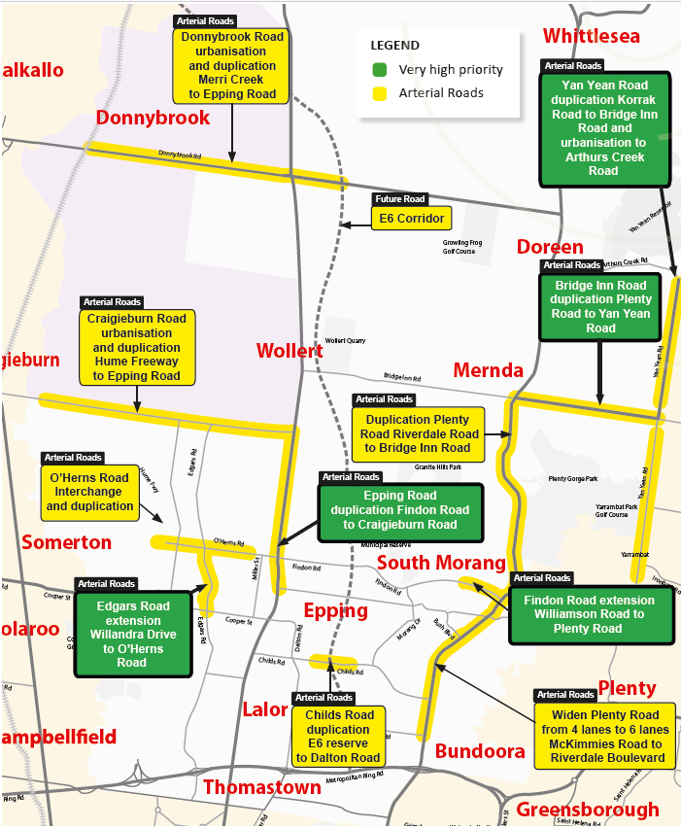

Collector roads
The function of a collector road is to provide connections and links for all modes of transport between residential areas, local facilities and destinations as well as provide connections to arterial roads and public transport networks for longer regional journeys. The completion of many of these links is necessary to create optimal circulation in local street networks. Collector roads in growth areas require working with developers to enable delivery via Developer Contribution Programs or direct developer funding.

Links to local destinations
- Riverdale Road (Mernda Town Centre) provides a connection linking residential estates to public transport, the Mernda Railway Station and Mernda Town Centre.
- Priority: Very High
- Civic Drive extension provides a link between Morang Drive and Bush Boulevard and better access to Plenty Valley Town Centre.
Priority: Very High
- Sissinghurst Parade is a key link providing a ring road of Mernda Town Centre facilitating movement circulation.
Priority: High
- Coulstock Street is a major road that will provide the ability to move more easily through Epping Central.
Priority: High
- Berry Lane provides circulation within and to the Mernda Town Centre.
Priority: High
- Coolgardie Road will provide a direct link from Doreen South to the Mernda Town Centre for walkers, cyclists, buses and motorists.
Priority: High

Links to arterial road network
- Edgars Road – O’Herns Road to Rockfield Street links activity centres in the growing area of Epping North and Wollert to arterial roads.
Priority: Very High
- Cotters Road – O’Herns Road to Rockfield Street will be a key link allowing circulation from residential areas to the arterial road network.
Priority: High
- Painted Hills Road links to both the arterial road network and the public transport corridor. It is a key link in the local movement network by providing more options for travel to local destinations for the Mernda residential area and unlocking the local street network.
Priority: Very High
- Hayston Boulevard – Harvest Home Road
to the south provides a permeable road network in a growth area.
Priority: High
“Long delays on Epping road this morning!”
Anthony

Intersections
To free up the capacity of the road network, Council advocates for and/or undertakes major intersection upgrades. The capacity of the road network is greatly enhanced by unlocking intersections that cause delays to trips.
Dalton Road and Childs Road, Epping
Priority: Very High
Under Construction
Traffic signals at this intersection to replace the current roundabout are critical. Cyclist and pedestrian movements are perceived as unsafe and motor vehicle traffic is delayed during morning and evening peaks. The Victorian Government has recently committed to funding this project.
O’Herns Road, Epping Road and Findon Road; Epping North
Priority: Very High
Committed: DUE 2017
This intersection creates a critical bottleneck along the High Street and Epping Road corridor, more pronounced over recent years due to urban growth in Epping North. An upgrade of the roundabout to traffic signals will improve traffic flow.
Findon Road, Ferres Boulevard and The Lakes Boulevard; South Morang
Priority: Very High
An uneven flow of motor vehicle traffic causes significant delays at this intersection. Traffic signals are required to increase the capacity of the current road network and minimise queue lengths in The Lakes Boulevard.
O’Herns Road and Gateway Boulevard, Epping North
Priority: High
Establishment of a new employment estate near this intersection will create a need to provide access for jobs and freight. Traffic signals at this intersection will improve its functionality, especially for accessibility to the employment area.
“9.30am this morning… Traffic blocked up even further back as far as Bunnings. It is a disgrace.”
Harold
Plenty Road, Wallan Road and MacMeikan Street, Whittlesea
Priority: High
Conflicting traffic flows and pedestrian movements are needed to be regulated by traffic signals at this intersection to improve both safety and function.
Plenty Road and Bridge Inn Road, Mernda
Priority: Very High
Traffic lights and four lane divided roads to replace the roundabout are critical in helping to address congestion in Mernda. The upcoming development of the Mernda Town Centre (and Mernda Station) will place significantly more pressure on this already congested intersection. Excellent pedestrian connections and an attractive streetscape will be an important contributor to the town centre environment.
Dalton Road and Settlement Road plus Dalton Road and Wood Street, Thomastown
Priority: High
The flow of traffic along Dalton Road is interrupted by these ineffective roundabouts. Pedestrian movements are restricted and difficult for those less ambulant.
Bridge Inn Road, Independence and Painted Hills Roads, Mernda
Priority: Very High
Delivered May 2017
The flow of traffic along Bridge Inn Road causes major delays for those wishing to enter from Independence and Painted Hills Roads. The installation of traffic lights has improved traffic flow along Bridge Inn Road reducing major delays.
Bridge Inn Road and Yan Yean Road, Doreen
Priority: Very High
Improve intersection to ease traffic congestion and to assist with flowing traffic. Provide pedestrian amenities to allow convenient movements across the road(s).
Needs in growing areas
As development continues in the City of Whittlesea’s growth areas, there are an increasing number of intersection works needed. These include:
- Bridge Inn Road and Sissinghurst Parade, Mernda
- Plenty Road and Everton Drive, Mernda
- Bridge Inn Road and Mernda Village Drive, Mernda
- Craigieburn Road and Koukoura Drive, Wollert
- Craigieburn Road and Edgars Road, Wollert.
“By the time I drop off the kids at school and get to work my blood pressure is through the roof.”
Lucy (City of Whittlesea Facebook page)

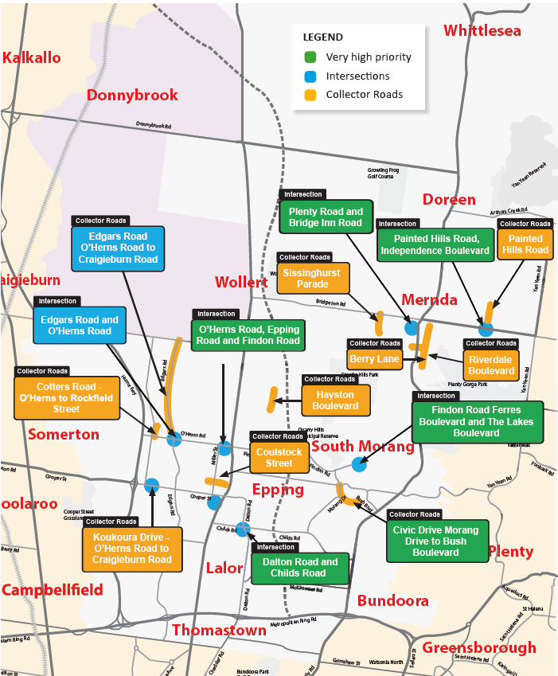

Public Transport
The City of Whittlesea has a lack of coverage, reliability and frequency of service in the current public transport network. Expansion of the network must occur so that services meet the demands of the community including:
- rail network
- bus network
- tram/light rail network
- interchanges and amenities.
The relative timing and sequence of projects and actions are indicated as either high or very high in priority.

Rail network
Mernda Rail extension
Priority: High
Committed: DUE 2019
Expansion of the metropolitan rail network from the current terminus at South Morang to the future town centre at Mernda is required to improve the accessibility for the 45,000 residents of the Mernda and Doreen growth areas. Provision of public transport has been out of reach for the majority of residents (prior to the bus rollout) being more than 400 metres from services. The extension will enable residents who use train services to access community facilities at Plenty Valley Town Centre and employment hubs at South Morang and the CBD.
Rail improvements to growth areas
Priority: High
The Network Development Plan – Metropolitan Rail released by Public Transport Victoria in December 2012 identified and prioritised a number of metropolitan heavy rail projects to expand the network and service Melbourne’s growth areas. These projects seek to either increase and improve the quality and the capacity of the existing network or expand the network. They include:
- Donnybrook Railway Station upgrade
- Clifton Hill signalling upgrade (to enable more frequent and reliable services to Mernda and Wollert)
- Wallan electrification and extension of metropolitan train services to growth areas
- Somerton flyover (to enable Wallan electrification)
- Lockerbie Railway Station.
Wollert public transport corridor
Priority: Very High
Land has been reserved for a public transport corridor from Lalor Station to the Wollert Town Centre with over 80 per cent of the required corridor either secured or strategically reserved. A public transport corridor through Epping North and Wollert will enable improved access to jobs, education and services. It will service up to 83,000 residents, provide access to approximately 35,000 jobs forecast in Epping Central and the Cooper Street employment area and better connect the City of Whittlesea to the inner Melbourne employment market. The project will also act as a catalyst for development in planned activity centres with train stations planned at the town centres of Aurora South, Aurora North and Wollert.
Council is advocating for this public transport corridor to extend from Lalor Railway Station to Wollert Town Centre and accommodate a fixed-route public transport service.
While the development of the heavy rail is the key objective, interim measures such as a rapid bus service could be a viable interim measure. A feasibility study is recommended in the draft Victoria’s Infrastructure Strategy that would identify timing and scope requirements.
Train station parking
Priority: High
The provision of adequate car parking at train stations should be made to cater for commuters that drive to access train services. Currently residents are unable to find parking after 7am at most stations.

Bus network
Mass transit to jobs
Priority: High
Currently the most congested route for residents travelling to work is along the Plenty Valley corridor. A high frequency public transport service connection from Mernda and Doreen linking the Latrobe employment cluster and Heidelberg with Mernda and Doreen is required. The feasibility and planning of the networks including transport technologies called for in the draft Victoria’s Infrastructure Strategy will identify viable options. SmartBus services utilising an upgraded Plenty Road are a reasonable interim measure.
Activity centre accessibility
Priority: High
Activity centres are the second main destination by City of Whittlesea residents. Major points of traffic congestion occur at activity centres. A review of bus routes will pinpoint how public transport services can provide levels of service to improve accessibility thus lessening congestion.
Epping North and Wollert bus services
Priority: Very High
Delivered January 2016
Expansion of the bus network to Epping North and Wollert occurred in 2016. With the population of Epping North expected to reach over 54,000 by 2037, continuing expansion of the bus service in terms of frequency, span of service and coverage is required. Council plans to work with the Victorian Government and Transport for Victoria to ensure these services are provided in a timely manner.
The expansion of bus services in this corridor, from one route to three routes is a need identified by Public Transport Victoria.
Mernda and Doreen bus services
Priority: High
Delivered Min-2016
Improving bus coverage to the growth areas of Mernda and Doreen will improve access to the local school network, the Plenty Valley Town Centre, South Morang Station and employment hubs such as the Latrobe National Employment Cluster and University Hill. Future corridors to Mernda Town Centre, with co-ordinated train services, will be critical. This has been identified as a priority by Public Transport Victoria.
Bus network expansion
Priority: High
Council is advocating for a review of existing services to improve reliability, frequencies, span of service and more direct routes to help build utilisation of the bus network. There are opportunities to service popular destinations, such as activities centres and transport hubs, by building on popular routes and increasing frequencies on key routes such as the Plenty Road corridor. For example, popular destinations such as the Austin Hospital are not directly serviced by existing bus routes. Increased frequencies are needed along key north-south routes by building on popular routes in these corridors such as the 555 Epping to Reservoir.

Tram/light rail network
Tram: Route 86 extension
Priority: Very High
The extension of Tram Route 86 from University Hill to the Plenty Valley Town Centre will improve access to local employment hubs, rail services at South Morang, local community destinations in University Hill and Plenty Valley Town Centre and regional education services at La Trobe and RMIT Universities Bundoora campuses. Land has been set aside along Plenty Road, Bush Boulevard and McDonalds Road. An extension of the tram would improve accessibility to 13,500 residents.
A feasibility study is being undertaken for Tram Route 86 to be extended from McKimmies Road to the Plenty Valley Town Centre.
A further extension of Tram Route 86 from Plenty Valley Town Centre via The Lakes Boulevard to Plenty Road has been identified and requires further community input.
Tram: Route 86 interchange
Priority: High
Council has been working with state agencies to facilitate the provision of an upgraded interchange at the current terminus at RMIT/University Hill. Where transfers are required between modes and or between vehicles, it is imperative that this be made as continuous and comfortable as possible.
Tram: Route 86 E Class trams
Delivered January 2017
Advanced E Class trams, which have 46 seats and carry 210 passengers, are now providing service for customers along Tram Route 86. The Victorian Government is introducing 70 E Class Trams into service by 2018.

Interchanges
Priority: High
Amenities
Where transfers are required between modes and/or between vehicles it is essential that this transfer be facilitated to be as seamless as possible. Co-ordinating timetables to facilitate mode to mode trips is critical, as is safe and comfortable transfer interchanges. The provision of Wi-Fi on vehicles and especially at interchanges would enhance the comfort of users.
Bus and tram stops
Council will work with Victorian agencies to continue the rollout of effectively located and fully accessible bus and tram stops. This will ensure that people are able to access bus and tram services in a comfortable and safe manner as hard stands, shelters, tactile tiles and connecting footpaths are provided as close as possible at both destination and origin.
Priority treatments
Council will also ensure the provision of bus and tram priority treatments, such as bus lanes are included in the delivery of all road construction projects.
“When is something going to be done about Plenty Road? It is a joke!”
Frank
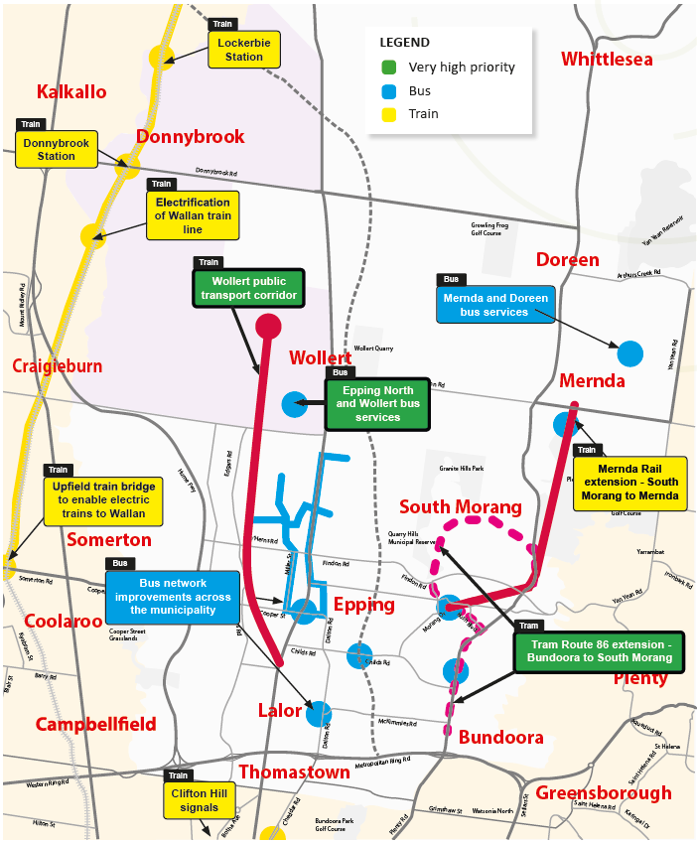

Cycling
One of the key actions of the Integrated Transport Strategy was to develop the Whittlesea Bicycle Plan. Based on extensive analysis, the plan outlines our approach to cycling.
Darebin Creek corridor
Priority: High
- Darebin Creek Trail, M80 Ring Road to Findon Road
- Yan Yean Pipe Track, M80 Ring Road to Childs Road
- Dalton Road shared path, Parklands Drive to Wood Street
Plenty Valley corridor
Priority: Very High
- Plenty Road shared path, McKimmies Road to McDonalds Road
East west connectors
Priority: Very High
- McDonalds Road shared path, High Street to Civic Drive
- Priority: High
- Childs Road shared path, High Street to Plenty Road.
High Street corridor
Priority: Very High
- High Street Bicycle Lanes, Keon Parade to Kingsway Drive
Priority: High
- High Street shared path, Childs Road to Rufus Street.
Train station links
Priority: Very High
- Shared user paths in connecting to new Mernda Rail extension stations
- Improved local on road lanes and shared user paths to train stations
- Improved secure bicycle storage facilities at stations.
Northern Regional Trails Strategy
Priority: High
A regional strategy has been developed that focuses on delivering regionally significant trails that connect multiple municipalities and regionally significant features. The priority trails identified for the City of Whittlesea include Edgars Creek Trail, Whittlesea Rail Trail, Yan Yean Pipe Trail, Plenty Road shared path and Merri Creek Trail link.

Walking
A number of studies have been conducted into the needs of pedestrians in the City of Whittlesea. The Missing Links Program identified many gaps that exist in growth areas and developed a schedule of projects to address these deficiencies. Closing gaps in walking networks around schools is also a priority. Structure Plans for town centres have also identified infrastructure needs to improve accessibility, permeability and connectivity for pedestrians to and within activity areas. Route analysis has identified needs along major transport corridors and these investigations can be grouped into key outcomes.
Behaviour change
Priority: High
Council is undertaking some key initiatives to encourage active travel:
- travel plan fact sheet
- school travel kits
- safety and security
  - urban design
- liveable streets
  - effective design
  - sustainable planning.
Connections to growth areas
Priority: High
- Epping Road between O’Herns Road and Craigieburn Road
- Bridge Inn Road between Plenty Road and Yan Yean Road
- Plenty Road between Wealthiland Drive and McDonalds Road.
Missing footpath priorities
Priority: Very High
- Epping Road between Lyndarum Drive and Craigieburn Road
- Epping Road between The Mill and Tulum Lane
- Bridge Inn Road between Towerhill Avenue and Plenty Road
- Harvest Home Road between Epping Road and Subiaco Road
- Epping Road between Harvest Home Road and Numurkah Common.
- Priority: High
- Harvest Home Road between Champions Parade and Epping Road
- McDonalds Road between Bush Boulevard and Oleander Drive
- Epping Road between Zoe Drive and Harvest Home Road
- Yan Yean Road between Coolong Terrace and Clark Avenue
- Epping Road, Fletcher Street pedestrian signals
- Plenty Road, Pipers Lane to Bridge Inn Road
- Bridge Inn Road between Painted Hills Road and Yan Yean Road.
Connections to activity centres
Priority: Very High
- Epping Central green walkway to High Street (includes Davisson Street and Coulstock Street footpath widening)
- High Street revitalisation, Epping.
Priority: High
- Epping Central High Street activation
- Lalor Activity Centre – streetscape improvements program
- Highlands Place, Thomastown – streetscape improvements
- Thomastown Activity Centre – new pedestrian crossing at Central Avenue and High Street.

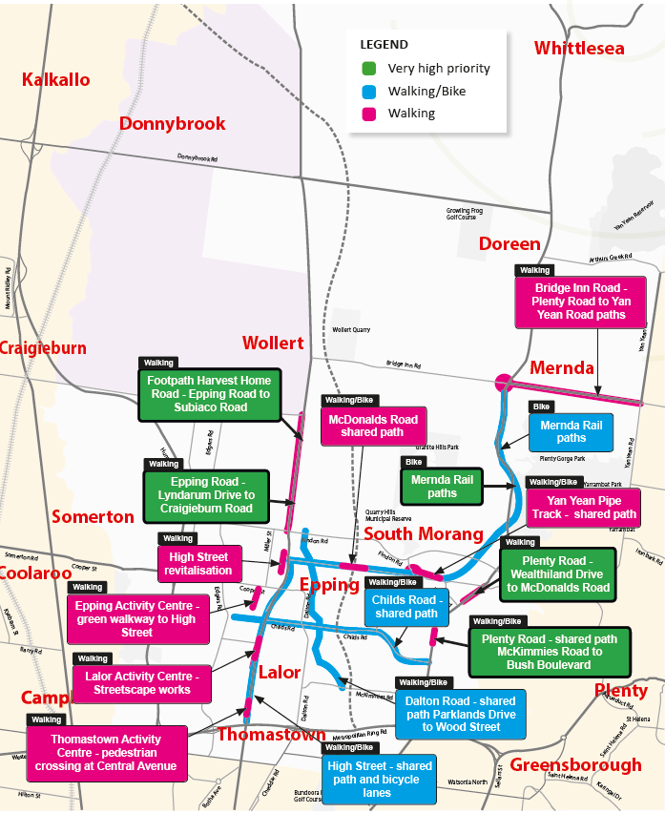

The way forward
Council will continue to:
- communicate and work with residents and community groups to ensure that all needs are identified and that they have the opportunity to inform the prioritisation of projects
- advocate to local Members of Parliament outlining the need to address transport and travel priorities
- advocate to government agencies such as Infrastructure Victoria, Infrastructure Australia, Transport for Victoria, Public Transport Victoria and VicRoads for project development and funding
- collaborate with Victorian Government agencies to continue the rollout of needed infrastructure
- undertake careful land-use planning to promote higher residential densities along and around public transport corridors
- foster job creation within the City of Whittlesea to reduce commuting distances and times for residents
- set aside sufficiently wide road reserves in growth areas to future proof the need to provide duplications, including bus lanes
- proactively monitor the efficiency and effectiveness of transport infrastructure and undertake minor improvements where necessary
- review and identify changes to travel patterns and prepare plans, projects and programs that
- address emerging transport infrastructure requirements to enable advocacy, facilitation and opportunity taking
- continue to collaborate and work with the development sector to deliver road network
- improvements within the growth corridor neighbourhoods
- continue to gather transport and land-use
- information, surveys, statistical data, scenario testing.

Glossary
CoW – City of Whittlesea
TfV – Transport for Victoria
PTV – Public Transport Victoria (State Government)
VicRoads – Victorian Government roads authority
Infrastructure Victoria – Statutory authority to advise Victorian Government about needs and priorities
LXRA – Level Crossing Removal Authority
DCP – Developer Contribution Plans
OSAR – Outer Suburban Arterial Roads program
VPD – Vehicles per day

References
City Limits: Why Australia’s cities are broken and
how we can fix them by Jane-Frances Kelly and Paul Donegan, Melbourne University Press
City of Whittlesea 2015, Community Building Strategy (accessed on 31 January 2017)
https://www.whittlesea.vic.gov.au/media/1552/ community-building-strategy-pdf.pdf
City of Whittlesea 2015, Annual Household Survey 2015 (accessed on 23 January 2017)
https://www.whittlesea.vic.gov.au/common/~/ media/Files/About%20Whittlesea/Annual%20 Household%20Survey%20-%20Full%20Report.pdf.
Commonwealth of Australia, 2014, City of Whittlesea Population Forecasts, Prepared by profile id, (accessed on 20 January 2017)
http://forecast.id.com.au/whittlesea/home
Infraplan 2015, Traffic Model – Part 2, (commissioned by the City of Whittlesea).
City of Whittlesea 2016, Whittlesea Bicycle Plan https://www.whittlesea.vic.gov.au/about-us/our-city/research-reports/
Northern Regional Trails Strategy (commissioned by the Councils of Banyule, Darebin, Hume, Moreland, Nillumbik and Whittlesea)
https://www.bicyclenetwork.com.au/media/ vanilla_content/files/Northern%20Regional%20 Trails%20Strategy_Final.pdf

City of Whittlesea
Civic Centre: 25 Ferres Boulevard, South MorangOffice Hours: Monday to Friday, 8.30am to 5pm
Mail: Locked Bag 1, Bundoora MDC 3083
Telephone: 9217 2170 (24 hours)
TTY: 9217 2420 Fax: 9217 2111 Email: info@whittlesea.vic.gov.au
Web: whittlesea.vic.gov.au
Team Leader Strategic Transport, City Design and Transport
Louie D’Amore 9217 2350

