

NILLUMBIK Banyule

THE R E E l'li W E D G E SHIRE



***Plenty Gorge***

***Precinct Emergency Management Agreement***

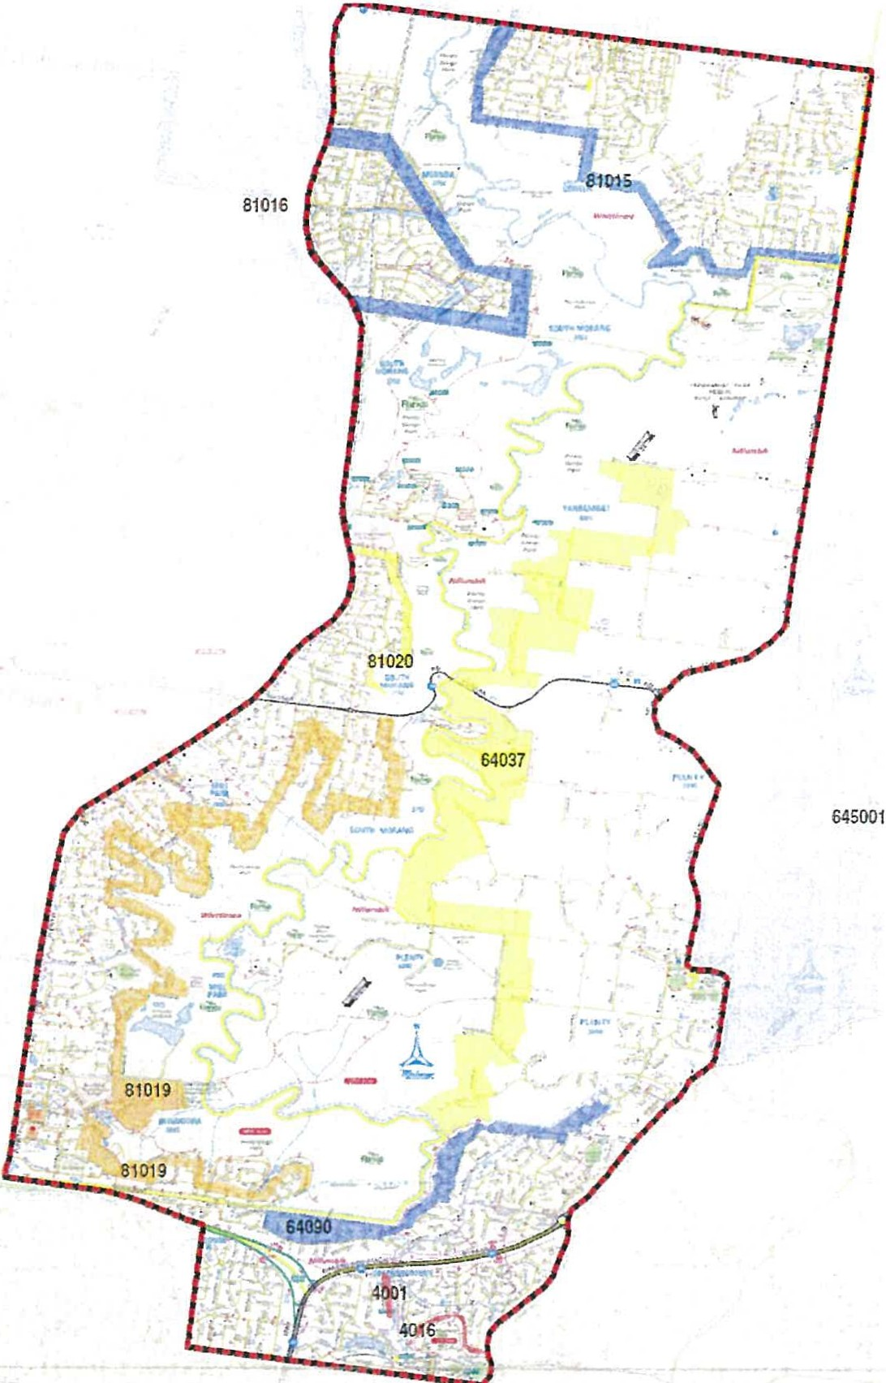*2021-2026*

   

Document Summary

|  |  |
| --- | --- |
| Item | Author |
| Authors | Norman Golgerth- Nillumbik FMPO  Justin Murray - Nillumbik Council Emergency Manager |
| Title | Plenty Gorge Precinct Fire Management Committee |
| Date | 22nd August 2011 |

|  |  |
| --- | --- |
| Item | Author |
| Authors | Norman Golgerth- Nillumbik FMPO  Gavin Wright – Ops Commander Diamond Valley / Whittlesea Group  Snr Sgt Wayne Spence – Officer in Charge Diamond Creek Police |
| Title | Plenty Gorge Precinct Fire Management Committee – 2016 - 2020 |
| Replaces | Plenty Gorge Precinct Fire Management Committee |
| Date | 12th April 2016 |

|  |  |
| --- | --- |
| Item | Author |
| Authors | Snr Sgt Wayne Spence APM – Officer in Charge Diamond Creek Police |
| Title | Plenty Gorge Precinct Emergency Management Committee – 2021-2026 |
| Replaces | Plenty Gorge Precinct Fire Management Committee 2016 - 2021 |
| Date | 12th October 2021 |

Version Control

|  |  |  |  |
| --- | --- | --- | --- |
| Item | Date | Status | Description |
| V1.0 | 12/10/2021 | Draft | V1.0 – Update of title to Plenty Gorge Precinct Emergency Management Committee 2021 -2016; inclusion of other emergencies to reflect ‘all hazards’ in planning and response |
|  |  |  |  |
|  |  |  |  |
|  |  |  |  |

# Plenty Gorge - History of Major Fires

**25/12/63 - Fire occurred late morning and burnt south from near Kurrak Rd, on wind change burnt fiercely towards Bella Vista Crt/River Ave area of Plenty. Size U/K**

On Christmas Day 1963 a fire started on the South Morang side of the Plenty River. The fire burnt on the west side of the River for some time until late morning when the high temperatures and strong winds brought it rushing towards Plenty. A number of trucks in­ cluding Plenty, Diamond Creek and Wattle Glen were working on a ridge above the Gorge on a track that is now known as Bella Vista Court. The crews were trapped as the fire rushed at them and Captain Stone from Diamond Creek and Bill Upton steadied the crews and had them spray water over themselves and the trucks to stay alive. The Wattle Glen crew sustained burns to their hands, face and ears.

Ian Dunne was a 16 year old member of Plenty Brigade at the time and recalls his experi­ ence of the fire.

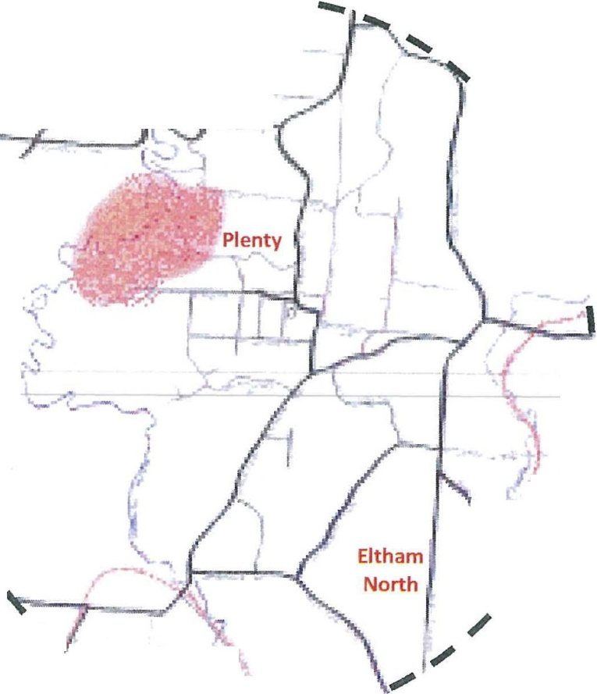

_ _,_ .. --

/

*,j;* ' · -1i-_

uth \

orang ·-:_.,

'

\

**Diamon**

**Creek** \

\

I

*I*

\}/

. *I*

'

**' l** -:::. - - _,_

**reenkborough**

*We were down the ridge at the end of*

*Bellavista Court, before there were any*

*houses in the end section of that road.* /

### It was a very hot day and a fire was

*burning down near the Plenty River.* . *I was with the Plenty truck, but became* /'" *separated from the other bf okes when*

***l***

### the fire moved quickly up to the track on( the ridge. Fortunately I married up with the Panton Hill truck. We couldn't drive out. The fire burnt the bush all round

*us, but their captain kept good order* - \

### had us breathing through wet handker- \

- \

*It was very, very hot and very frighten-* \

### ing, but we all came through un-

*scathed.*

*I think we all owe our lives to that cap­*

*tain; he did a great job.*

##### 11/03/65 - Fire started in yard of home at intersection of River Ave and Bella Vista Crt Plenty and burnt under strong northerly until stopped at edge of Greensborough. The fire burnt through the eastern edge of what is nowYellowgum Park and burnt the farmhouse that stood approx. 5km west of the intersection of Mackelroy and Oat­ lands Rds. The fire also burnt around the Bells property in Happy Hollow Drive and the farming property that eventually became the Apollo Parkways housing estate.

**Size 500Ha approx.**

The 1965 fire started from hot coals placed in a garden at the corner of River Avenue and Bella Vista Court and spread very rapidly to the south under a strong northerly wind. John Lierse was working in his poultry sheds on the family1s property in Oatlands Road when the fire suddenly approached. Sprinklers in the garden saved the home but over 500 hens were lost in the heat and smoke as the fire raced passed. The fire destroyed a farm house on a large property to the west of the end of Mackelroy Road and continued on to Greensborough where hundreds of volunteers

rallied to stop the fire at the railway line and keep it from entering the main street of Greensborough.

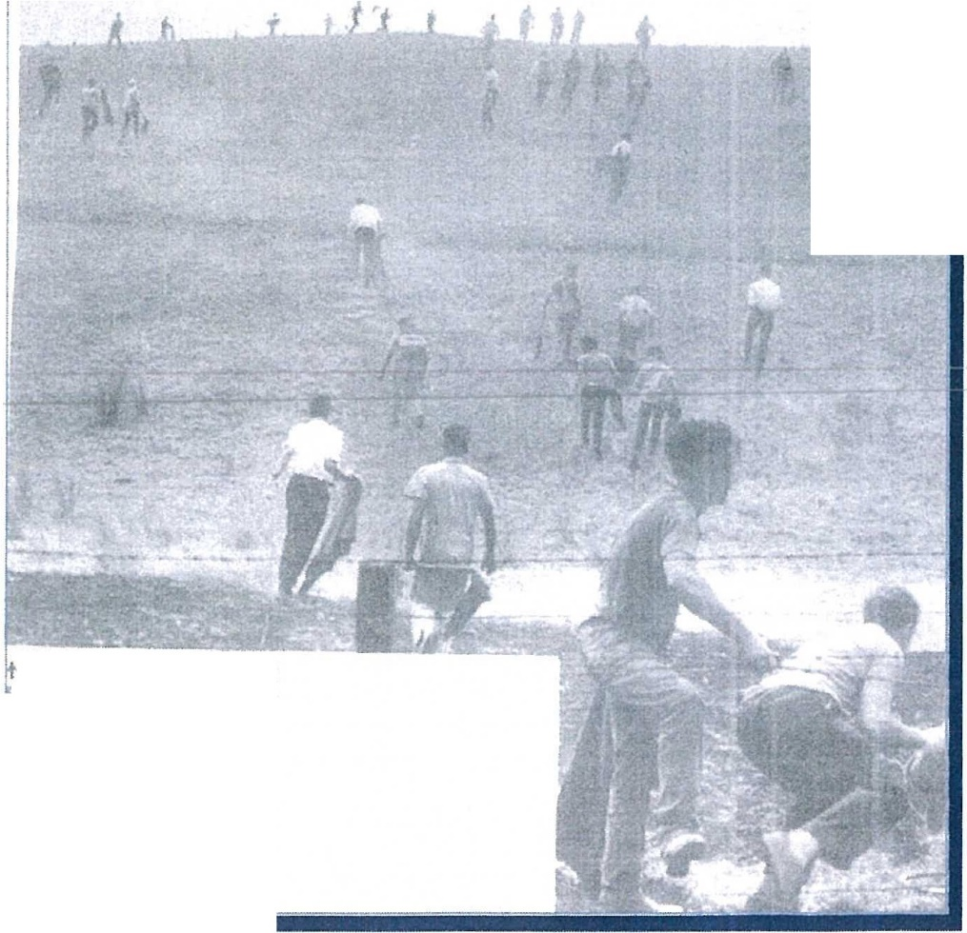

***7he***

**l\'11:'WS** - **f"U,TOIUA.I.**

***Sunl***

VOLU HTE ( Fi:!., .. c.c vp a h1:U a

lll Jl,t h·om CtNa'll,or-ou,r.h 1n th•

, •..- ficht nut r•J.UrdJty ._.,..u th•

''°'"'" h'>OI r..1t,f t flrf'f

.,..hf' du'"""''' p,1clua .. ,1,1 ,..,i....

• .. ·•, ••cu d b .fl'- ff' l'\Goc, ,., f,.. , .,.,°'" "

Jt.,J Dllll'>CH• (rc:,(o: br *"i1.1n* ,,,fr

t l.oto 51•H•h 1u GN;1ff Ju!!

#### Local resources were stretched on this day as seri­ ous fires also broke out at Warrandyte and Eltham.

~~--~~

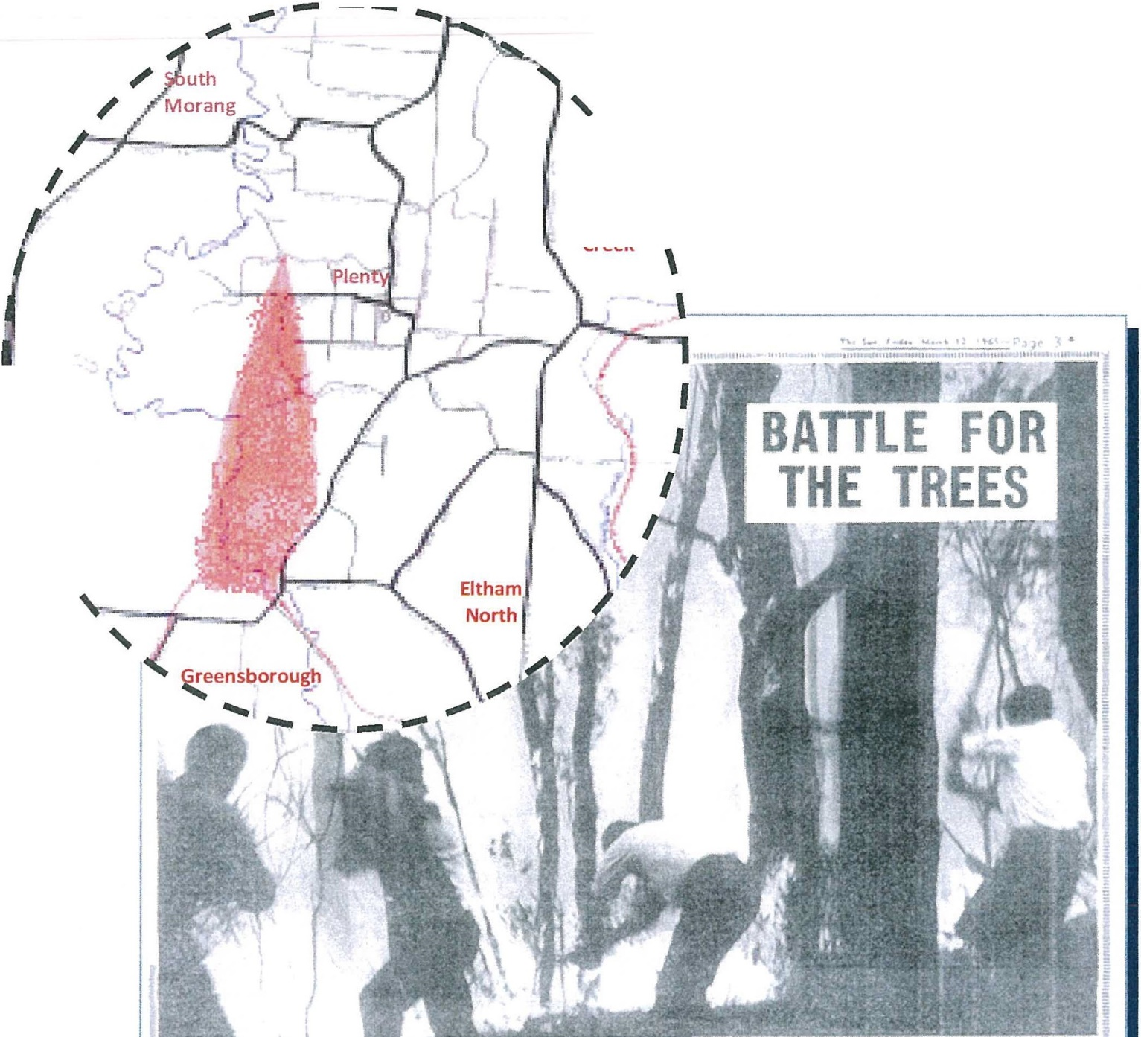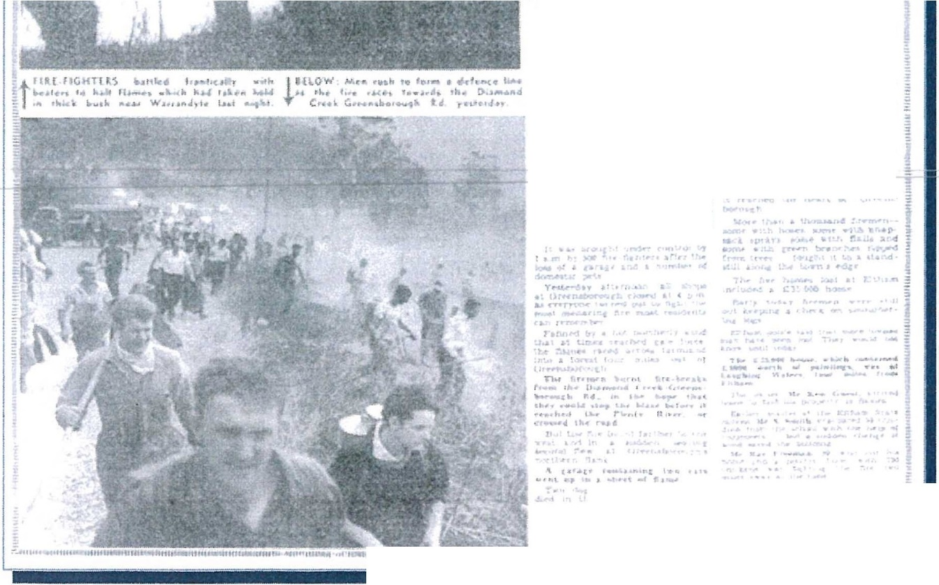

' \

Diamon d\

Creek

\

\

\

\

\

**Six houses go**

**in two s burbs**

T

HE t irclc of fir ers round M lboiurnf! ye •

t rJ.;,y burnt fiy., hou s" s nt Eltha n1, one­

*at* W rr .:mdy1.e.. ami very nc-nrly dc tr oycd

&n:-.-mboT'Ol.l',:t,.

u.Jir Uu n•t►• , w .., .-.-i *i* uN

.u •.H ..&l ..n. ""' ' JT'f ltlot c...,..,

, .... >.n lo.o.-,11 "" ''"i · "" , ,

, iw. , ,r

. ... L,... ,_.,.. 1- -·- ,... ::

## Sleepless town waited, P. 4§

n u 11... 10 1 ut r tM ,. 11n 111-.. . ·t ...-11Uf MIIIUt-tt 1u-. 1,u ....,u1u-. 1mt11rRUI 1,11 • 11.. u11 • .,.,u, •11• ,1 ,,

**20/02/80 - Fire started at end of Gordon's Rd South Morang and burnt through the Gorge to the south. Was eventually stopped at Namitjira Avenue Plenty. 7 homes lost in Gordons Lane, Clarkes Rd and Charlesville Rd. Size 172Ha**

At 3pm on Wednesday the 20th of February 1980 two youths started a fire at the Nioka Scout Camp in Gordons Road South Morang. The fire spread rapidly in the steep gorge and within 40 minutes had burnt to Kurrak Road where it damaged the wooden timbers on the bridge over the Plenty River. Max McLean, Jason Caine, Doug Bird and Adrian Hen-

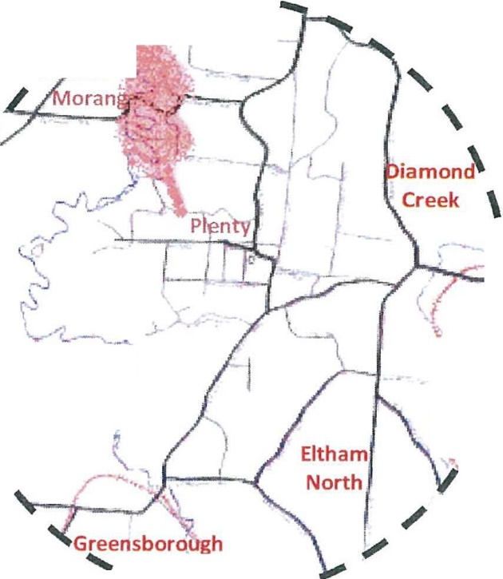

ning were on the new Acco anker and were ***f--!,r*** - ,

pursuedbythefireasthew1thdrewfrom · 1 •. - - --

Clarkes RoadYarrambat. The fire carried on to th '

Charlesville Road where three homes were de- strayed. The Acco crew and John and Ian Upton in the Brigade's new International Unit then cut

***t***

through paddocks from Browns Lane to Na- *I* mitjira Avenue where they attempted to halt I the fire as it came up the steep slope from the I

River. The bulk of the fire was stopped at this \ location with the exception of a small area of \ fire that ran to through the open paddocks to

River Avenue where it was rounded up. A total \ of 48 CFA tankers fought the fire -31 from Re-

gion 14 and 17 from Region 13.

*j*

I·

1 < .

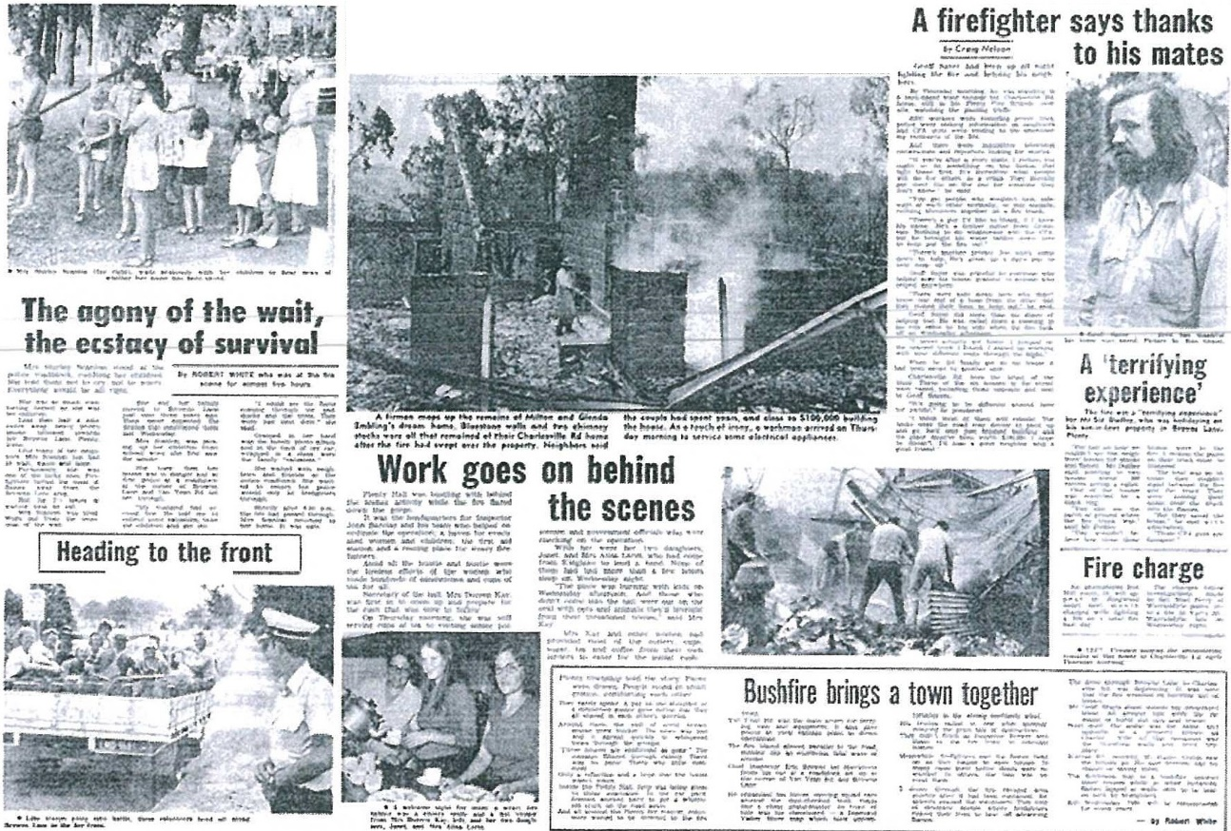

:--- **::I**

I

- l /

. *I*

**Jhe traged-y**

**f _·p • nty**

...... -· - --

**01/01/78 - Fire started on east side of Plenty Rd between Mill Park and South Morang and burnt in a southeasterly direction and entered southern part of gorge. Size 222Ha**

A fire that broke out at 1.10pm on New Years Day 1978 caused major concern for Plenty Brigade. A car accident the previous day in South Morang had damaged a power pole and under strong winds on January 1st an SEC low voltage fell to the on to a wire fence and started three fires along Plenty Road. Brigades from the area rushed to the scene and quickly brought two of the fires under control but the third raced under the influence of a westerly wind through paddocks and quarry holes into the Plenty Gorge.

In the early stages of the fire Plenty sent its tanker over to assist but it then rushed back to Plenty when the fire entered the Gorge. The fire threatened to burn towards homes in Apollo Parkways and Happy Hollow Drive before a wind change and cooler weather helped bring it under control. The Police helicopter was used to track the extent of the fire which proved valuable in the rugged areas along the river. Don Brereton's bulldozer was brought in to push tracks through the scrub so tankers could get in and black out the area. These tracks are still in place today and are used as access routes by the Brigade for fires in the Plenty Gorge Park.

' \

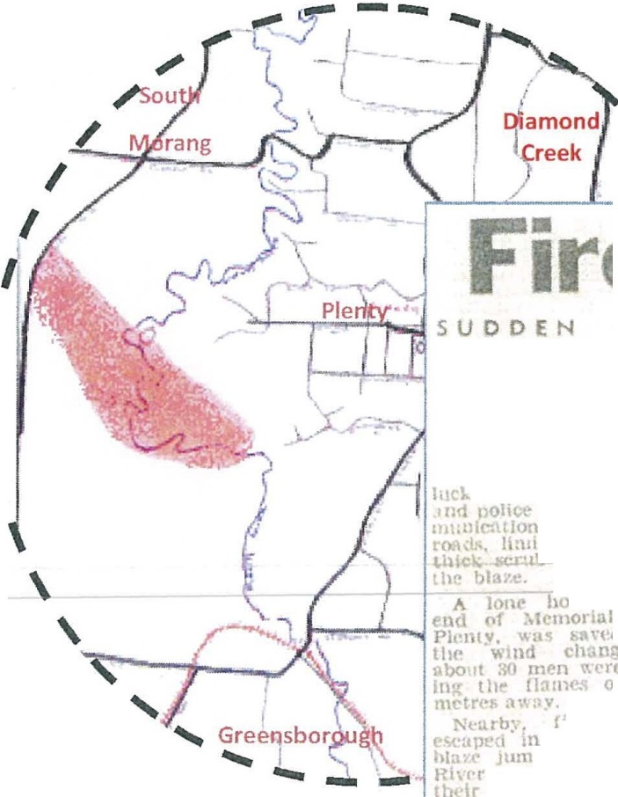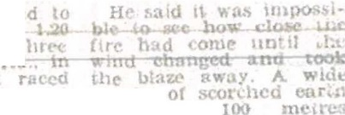

*I* **w i n d**

**ch an9e s tw ic e saved**

I

**F- -.- ..J,,.. l...J outer suburban homes**

**as *a* bushfire roared**

I

**threa**

**ous**

**through tf,e Pl e nty**

**Gorge yesterday.**

**By BR IA N BUCHA NA N**

**n• nd 11 .rh. d**

H

m•I1•·

H '• *:,.,* n ult•·rnoon "r

\

·v r,:1!. · Un ,1,r..1

**0\ t r UIC rt"ltll­** H ,Ul"rru·. b, <I 11cd 1:<t•.s :111<1

**wu;..,**

* .to hold

I ·,·t1 :1\ 3llC btforr s m 1d 'Yo

1111!<1 •·ool cllan • brou t, C< <' Jnr th

**0 111•• h0V,t:r *!* kt"**

Tit,. tin• l!; l>e\lf.'H

**j *e-*** •"-

J**p**)**h**.l**t**l**c**l**c**.**c;**

st l**;,;.:.:;.;;_.,.;..,..,.._.**

**,. ,.'t'rl--,,,1'm- :tk**

u• h

**Ori\'C,**

I,, .,a·haf'ns

S<l!l l1l It

**do'II** n Into tile •orgc " ,

J1tm!)£J lhe Plcnt, R Jl·<:1 • a only

!ii:llt-

11ly 100

,,.,. Clrt>tnrn

**Wind pushed**

**blaze**

**ll'll'llY**

Rot t rc.-,i,.,. on II o m,tcer w th 1JII' Plcn CF'A l>rt •1ulr, i;.1 tl ti 'Ga

un· ,vhto tlw -

II m1r cle both :Ire,..

hau

p• d lh Pl1•nty

: ml ru:in:d 1 s1

**A** norll1 Y.U\11 pwrlwd th1• bllllA' lOl\llrd1 th•

bu•11 1mn><I ••Jt would

hav( 1)('1·n rcall b.1d ,I

rt

tn1cl· l\ll lhey r«c<.'d

polio hou. •ni: e tnt

the: , In

hnd n •

up tllf' hill.

"ll JUtn[>Cll tht' nvrr

nno I ht II l' ('l d Ull hcsidt·

n, ,,r Or 1L1borough, but

11 Mopp<d &00 111c!re

**short.**

i un. d t". i<' .• he " •d

Fort,· u•,H frM1 a;. r:.1 nv. y ns .Ii MllC'edon

\I • HIid } Ohlll Bro•·n. ol

n,am(>IHl Cr1-<l:. nnf' o!

Th(' n tl,t"

**'II**

Ind

**and •1th \V n";,d** •

lwlPt b t tit th bla·

111., ti'£' "W,• fought our th'•• • <'lll 011 lh!' t l\H k , nnd mudt> It."

Th<' r,re llar<'d on Lhe

•"C'Olld Ol IW t.Ot.111 **fi re**

h. n d:l\·. when M<'l-

**bourn,·· t u p** -. i **.1 1 re**

'\\il(''Wd to lh(' so 1th :inti TI1!' l'f'.\ ud<1 ln f th•• fire threat ned 111 ht th,ae Jrnd I ,,n "' hOll!;{'S on I he Pll'lllY ldt' r ll' s ,.,. I< r<lny !l nd 30 on unt11 lt . 1ddc-nly dlOJ p<'d ·:iturd·,, bol'l Irv (;( Ron Ew r wa., nt oh! rm• llan tl 111

Cri"nd',s ho"'" \\ha·n Pl<-1 n· ri ,. I ' on It rt' !)rr,kn ,Ill or t



**31/01/90** - **Fire started in Plenty Gorge Park on west side of Plenty River opposite Hamish Crt at approximately 3.55pm. Burnt south and stopped near Kariboo Gve. Size 50Ha**

Late January 1991 saw a fire break out in bushland between Janefield and Apollo Park­ ways. A crew on the Diamond Creek tanker had a narrow escape when the fire jumped the Maroondah Aqueduct and scorched the side of their t ruck. The fire burnt 50 Ha and 40 units from the CFA and MFB fought the fire.

**Bushlan bu---- i**

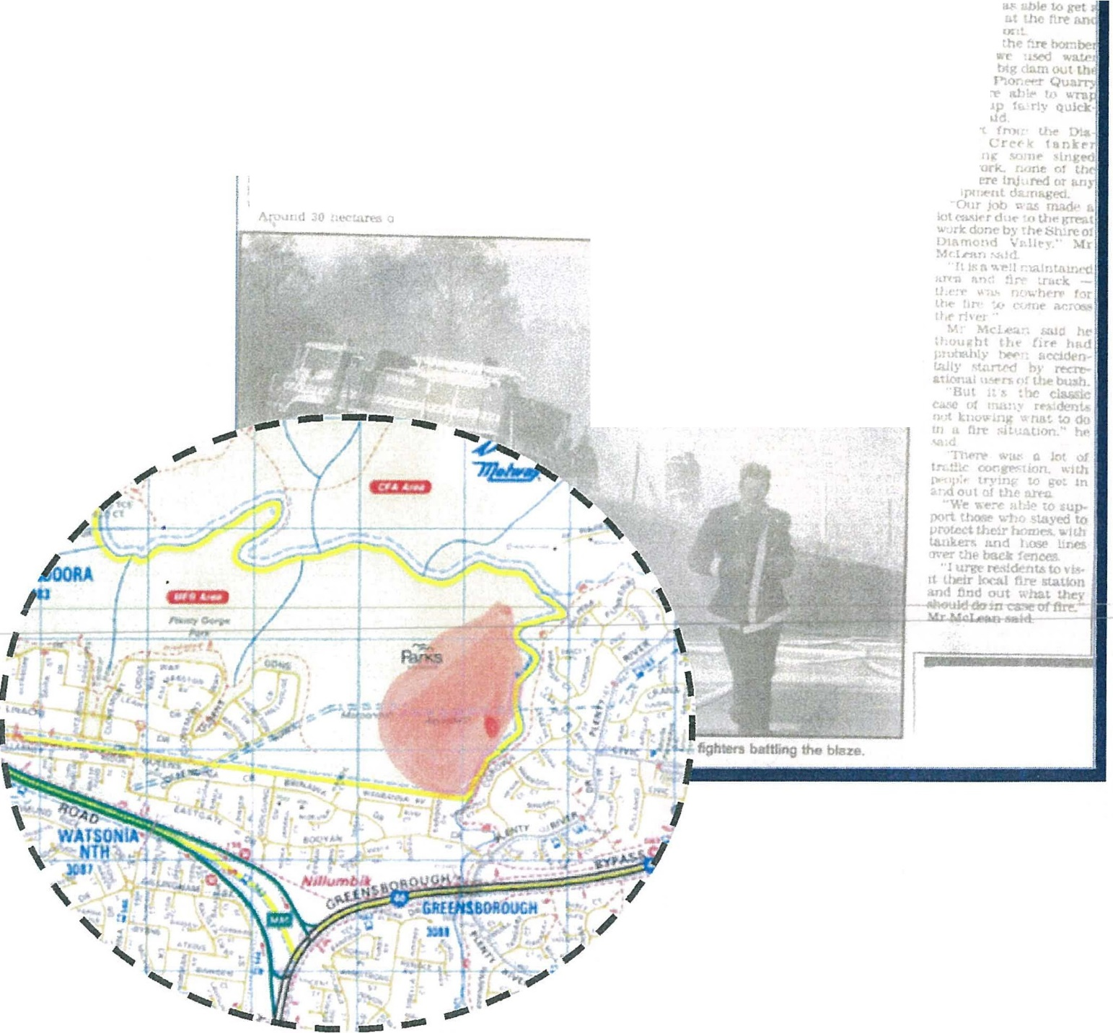

**m jor fire outbreak**

**GREENSBO­**

***By*** Gill COOPER

n)' 2 3n a.rn \\'cdn s-

"" ha\· , ot.hm,:: b

U! IUJd *a:*

**ROUGH r !dents**

*m·*it,f in !';:;

praiY!°)t U,.,rt- *r* KU}':'\.

ll'JOOIOCll:.

**ha.cl their tin;t l"('l\] encounter ,;\Ith bu.•h!lres !or the sununer w1 h Cl ma­ jor outbrenl<** in **Corowa Crescent l t,,..1.'t.**

It **..,M lal** llrd I , 1il' ,rsi *t* '" mcr"l Jv-i out• lJ?t&Jc.a tn Vkt.ort dut- 0(& lMl-or day of s,-ar,n lt"at and£:Ull} nortt:r-rly

"oel,

b..c-,'wlnd !'l,nt) Rt,rr .l't' burnt ou.i, l>u: I.he c,-,a.blned MI' ll

,md CF,\ *t.n-* err :ir,,-,

\.t"rtte-d W1e bllL21e from ren.chlnc **hon,.,.** in • "' **tunL**

&note bll.lowtd I rom

t.tf' bl"enr and mrr m.1

denUaJ W>d bUalntt.ll a,,

,...,. or Grn·r.'\l>or<Alrl

'Mlf' tli,;1 Mrtropc,l!w.

*n....*

Bngndt to noach th•

Ort *Kt'rl'°·* Uie i, ii,)(t­

,.tcnr; • untt ll'r1rd

1..-t I.(, o:,nwr. lh

::re

th';:.:/f,;. J;;.,rrar

rtUllr r *•""'""* bn,llfC t I Jlo Rl:Uon M tl>t- nC'

A :..pnke-unan tor

n-1us>'!"b!.A:m't" MP'R eont""

,'ndfod *ic* elfctu 01-"Crl

**nlttr hrrn t,1rrr..**

'Tl t C'f, A v-oria d

,,,,den ?:'C OC. ho,

a.ho: 1Rpni lt:lth ir!ut 1.-cclt Olcln t **r,..,,** u:.Ul

Plt!flt\· CP' C!l.lf!f .I.JL

**Mrt,an «>-on11nu..a** '-'I

P:'blwtl..'I M tl'VI t,; seen,:

l"Wtuni.te ***'f*** *\.h* **11,in** l

11,-n.,; n!X aa bw1 u. 1 :ad

41'"'("n Tlil"J' 1, thr (1 l'

·11>< ru-,, Jum;>'<I , .,._ M

md&h Aq K"d c• an.:,;

* tiat rJo• ed It do..-n h

d.

*We* \\'l"n" a k· to .u a a· f'J,d , K:11rlh :_.-, ore -• a,1d ,cl.It uou1 th('

chV t("UJllf"

Mrl,,fcI n w....u, HP u

..& •kW' fro: •

.r.·brn rhr *n-*

rrl\l11

''" ct oru,

•"d *"*

L Inc, •J

h'" ?Jl·"'DJd

**A,•**

, c r,a

*tit•*

p,aintw

n en.,. 1

•-qu

t r.t>u..:\ 2- f. :,m Tucd;,

f'N'"l *\,\: 1* n.'ln•­

ln t, wd

Iii,Cf**A**ocmtrol hell "'P

t"''"W".l't nra aeon...,.."

##### Background

The Plenty Gorge Precinct is an area of high bushfire risk that spans three municipalities, two fire districts and multiple land tenures. The level of risk prompted the development of the *"Plenty Gorge Fire Prevention Strategy".* The strategy was developed by a committee with representatives from local community members, The City of Banyule, City of Whittlesea, Nillumbik Shire Council, Country Fire Authority (CFA), Fire Rescue Victoria (FRV) (formerly Metropolitan Fire Brigade), Parks Victoria (PV) and Victoria Police (VICPOL). This committee is deemed to be a subcommittee of the Banyule, Nillumbik and Municipal Emergency Management Planning Committees.

The Committee members agree that there is a need for ongoing monitoring and review of the effectiveness of implemented risk treatments. The impact of changes in the environment and use of land within and outside the park also needs to be monitored.

This document has been developed to formalise this agreement and to ensure that the monitoring and review of the risks associated bushfire and other emergencies within the Plenty Gorge Precinct is integrated with current fire and emergency management planning structures.

##### Purpose:

The purpose of this agreement is to:

* Document the commitment of all parties to continue to work together to manage the bushfire and other emergency risks associated with the Plenty Gorge Precinct
* Provide a sustainable forum for the effective collaboration of community, local government and emergency management agencies which share the responsibility for managing fire and other emergency risks in the Plenty Gorge Precinct.

##### Scope:

This agreement refers to the management of bushfire and other emergency risks within Plenty Gorge Park and the area surrounding the park which is:

Fire related:-

* Likely to be impacted by a bushfire originating in the park
* In a location where if a fire originated it would be likely to impact on the park.

Other Emergency

* Involving activities or in locations likely to cause injury / death requiring a response from emergency services

This total area is known as the "Plenty Gorge Precinct" (Refer attached map). This agreement refers to the management of the following risks:

* There is a risk that a fire originating within the Plenty Gorge Park, could lead to loss of life, injury and destruction of assets.
* There is a risk that a fire origination close to the Plenty Gorge Park could extend into the park leading to loss of life, injury and destruction of assets.
* There is a risk of members of the public engaging in activities or be at locations within the Plenty Gorge Precinct that could lead to loss of life or injury.

##### Administration:

##### Victoria Police will chair the meetings and maintain the plan, with Nillumbik Shire Council providing administrative support for the facilitation of meetings.

##### Meetings:

Meetings will occur at least twice a year (one pre and one post summer). Other meetings will be convened as required.

Representatives of non-member organisations will be invited to meetings as required.

To record actions required and taken an minutes will recorded and disseminated at each meeting.

**Communications:**

Members are responsible for communicating any relevant issues to their own organisations and other relevant emergency management committees. Relevant committees include but are not limited to: The Municipal Fire Management and Emergency Management Planning Committees of Banyule, Nillumbik and Whittlesea and the Northern and Western Metropolitan Strategic Fire Management Planning Committee.

Communication with the community and other stake holders will be done with due consideration of other initiatives and processes undertaken at the organisational and committee level.

##### Members and Signatories:

|  |  |
| --- | --- |
| City of Whittlesea |  |
| Shire of Nillumbik |  |
| City of Banyule |  |
| FRV |  |
| Parks Vic |  |
| CFA Whittlesea/Diamond Valley Fire Brigades Group |  |
| Local Community |  |
| Victoria Police | S/Sgt Wayne Spence (OIC Diamond Creek) |
| CFA North & West Region |  |
| Plenty Fire Brigade |  |
| Doreen Fire Brigade |  |
| South Morang FRV |  |
| Yarrambat Fire Brigade |  |

For further information contact Nillumbik / Whittlesea / Banyule Municipal Fire Prevention Officers on 9433 3167, 9217 2506, 9490 4222

##### Action Plan:

I **ity**

|  |  |  |  |  |  |  |
| --- | --- | --- | --- | --- | --- | --- |
| **Objectives** : **Actions** | | **Measure** |  | **Time** | ; **Responsibil** | **Progress** |
|  | I  ;  I |  |  | **Frame** | : | |
| * Malicious/Arson   / Unauthorised | Fire Prevention  patrols within the | % Reduction  in fire | | Throughout  FOP | VicPol and  Parks Victoria |  |
| Fires | Plenty Gorge | ignitions | |  |  |
|  | Precinct and its | caused by | |  |  |
|  | surrounds | human | |  |  |
|  | All fires to be reported to VicPol which will ensure | activity | |  | VicPol, CFA, Parks Victoria |
|  | full investigations |  | |  |  |
|  | and prosecutions |  | |  |  |
|  | of all offenders  Patrols of the Plenty Gorge Precinct throughout the summer period |  | |  | VicPol and Parks Vic |
| * Future growth/develop | This committee is to be advised of | Level of engagement | | Throughout each year | Whittlesea and Nillumbik |  |
| ment | proposed | with | |  | Councils |
|  | developments | committee | |  |  |
|  | within the Plenty |  | |  |  |
|  | Gorge Precinct to |  | |  |  |
|  | enable |  | |  |  |
|  | assessment of the |  | |  |  |
|  | risk(s) |  | |  |  |
|  | implications of |  | |  |  |
|  | such development |  | |  |  |
| * Weed Control | Weed control and eradication programs to be included in planning of fuel reduction  strategies | Assessment of weed infestion within the Gorge Precinct |  | Annually | Whittlesea and Nillumbik Councils  Parks Vic |  |
|  |  |  | .... |  |  |
| * Community Awareness - | Community Fire Awareness | % Reduction in fire | |  | CFA FRV,  Nillumbik |  |
| Education | session to be | ignitions | | Council, |
|  | conducted in the | caused by | | Whittlesea |
|  | lead up to the | human | | Council, |
|  | Declared Fire Danger Period | activity | | VicPol |
|  | Whittlesea |  | |  |
|  | Council attend the |  | |  |
|  | Community Fire |  | | Whittlesea |
|  | Awareness |  | | Council with |
|  | Meetings in |  | | CFA |
|  | conjunction with |  | |  |
|  | the CFA in the |  | |  |

|  |  |  |  |  |  |
| --- | --- | --- | --- | --- | --- |
|  | lead up to the FDR  Doreen CFA Summer Fire Safety session at Laurimar CAC  Plenty 'Fire Ready Vic' meetings |  | 10th, 16t \  17th December 2015 | CFA  CFA with VicPol | Session held - 5 residents attended. 350+ flyers sent out. |
| * Bush Fire   Mitigation works | Fire Hazard Inspections begin | Fire Prevention | October-  May | City of  Whittlesea | On track |
|  | October and are | notices are |  |  |  |
|  | continuous until | issued on |  |  |  |
|  | the end of the Fire | properties in |  |  |  |
|  | Danger Period | and around |  |  |  |
|  | The frequency of | Plenty Gorge |  |  |  |
|  | grass cutting in |  |  |  |  |
|  | Council's |  |  |  |  |
|  | neighbourhood |  |  |  |  |
|  | parks is every 21 |  |  |  |  |
|  | days but this can |  |  |  |  |
|  | change |  |  |  |  |
|  | Slashing works within Parks Vic controlled assets |  | November- December | Parks Vic |  |
|  | have been |  |  |  |  |
|  | planned. **See** |  |  |  |  |
|  | **attached map** |  |  |  |  |
| * Access/egress | * Signage at points of entry warning of bushfire danger. * Signage at locations of danger of injury * Limitation of access to park by the community on designated days FDR> Severe * Traffic Management Plan developed for   the precinct |  | November | Parks Vic  Parks Vic  Parks Vic  VicPol |  |

•

Water Supply

CFA with MFPO's

August to October

Annually

Maintenance of current equipment and installation of new assets

managed

Knowledge of locations of new water supply assets

increased.

Expansion of reticulated water supply within new developments to be mapped with locations of hydrants highlighted.

Water supply assets within Plenty and Yarrambat to be assessed annually for readiness

and reviewed annually. (