Nature Strip Garden Guidelines

Effective 1 October 2023

Introduction
Nature strips play an important role in the aesthetic, environmental and social health of a city. The traditional, and default, nature strip within the urban areas of our city consists of grass and a Council provided street tree, however the City of Whittlesea does support alternative nature strip treatments.
This document provides guidelines for the establishment and maintenance of modified nature strips along Council managed public roads in urban areas. Requirements for unmodified nature strips are defined in Council's local law..

Defining ‘nature strips’
Victoria’s Road Safety Road Rules 2017 defines nature strip as an area between a road and adjacent land but does not include the shoulder of a road or a bicycle path, footpath or shared path.
More generally speaking it’s that strip of land out the front of your home, and the side if you live on a corner block, that usually starts out as a strip of grass and a street tree.\
Figure 1 below shows the nature strip within the context of the full road reserve and reflects the most common situations across the city's urban areas, not a design preference. Standards relating to the configuration of road reserves can be found in the 'Engineering Design and Construction Manual for Subdivisions in Growth Areas' (EDCM) and/or the 'City of Whittlesea Neighbourhood Design Manual.
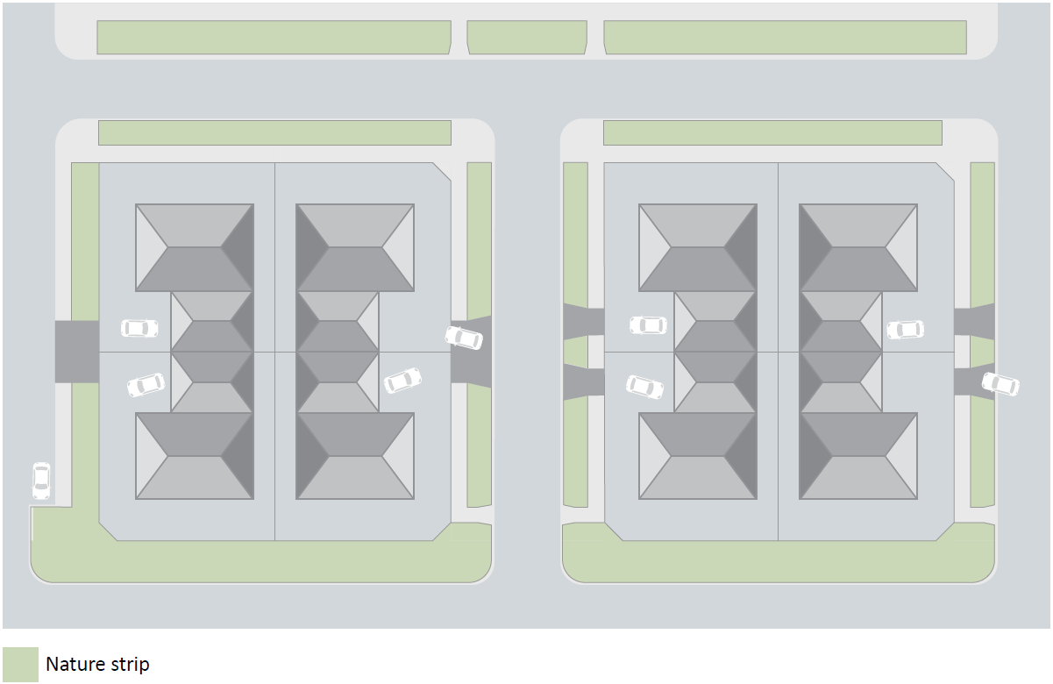
Figure 1 Nature strip in context
It is the responsibility of residents/owners or management bodies to maintain the nature strip adjacent their property through activities including but not limited to regular mowing, pruning (excluding street trees), weeding, and the removal of litter.
Did you know that a well-maintained nature strip actually increases the value of your property?

Purpose of nature strips
Nature strips are an important part of Whittlesea’s functional urban environment.
- They provide visibility, especially at intersections or curves in the road and near driveways
- They allow for pedestrian spill-over from a footpath when the need arises and movement along the roadside where no footpaths exist
- They allow Council to plant trees for shade and cooling
- They allow for door opening space and access between parked vehicles and the footpath
- They are a part of the city’s wider drainage network
- They accommodate above and below ground services and utilities (such as electricity, water, drainage, gas, sewage, telecommunications/data, streetlights, post boxes, fire hydrants, etc.)
- They provide a flat space for the location of household waste and recycling bins
- They function as, or contain, public bus stops.
Victoria’s Road Safety Rule 197 (1) states that a driver must not stop on a path, dividing strip, nature strip, painted island or traffic island, making it illegal to fully or partially park a vehicle on the nature strip.

Benefits of nature strips
Compared with fully paved areas, nature strips offer a range of practical, environmental, and aesthetic benefits including:
- Improving stormwater quality and reducing run-off
- Contributing to the cooling of urban areas
- Fauna habitat
- Visually softening the effect of the harder surfaces of road, footpath and driveway paving, fences, and buildings.
Enhancing a nature strip through additional planting brings further benefit such as:
- Colourful and diverse streetscapes
- Complementing existing natural settings of a neighbourhood such as street trees and home gardens, and allowing healthier private and street trees
- Seed propagation and increased spread of native plants
- Increased cooling benefit and support for local fauna
- Compensating for a lack of private garden.

Legislation and authority
Council’s authority to manage roads is provided through the Victorian Road Management and Road Safety Acts and their related regulations.
Council maintains a register of all public roads within the City of Whittlesea.
See the ‘Related information’ section at the end of these guidelines for more details.

Nature strip surface treatment
While grass remains the City of Whittlesea’s default nature strip surface, Council supports and encourages the modification of nature strips in accordance with these guidelines. These guidelines provide direction for the planning, establishment, and maintenance of modified nature strips, and will be enforced under Council’s local law.

Inclusions
These guidelines are applicable only to nature strips in urban areas that are located on Council managed public roads.
Residents/owners or management bodies seeking to modify an existing nature strip not on a Council managed public road should contact VicRoads.

Exclusions
- These guidelines are not applicable in rural areas
- The maintenance requirements outlined in these guidelines are not relevant to unmodified nature strips (see Council’s local law)
- Where the nature strip is on a declared arterial road or a public road considered by Council to function as a gateway or entrance boulevard, a developer may submit plans outside of the requirements of these guidelines for approval through a separate planning process.

Responsibilities
This section outlines the responsibilities involved in planning, establishing, and maintaining a modified nature strip.

Rights and responsibilities
The following points define the rights and responsibilities in relation to the modified nature strip adjacent to your property.
- Maintaining a modified nature strip in a safe and tidy condition is the responsibility of the resident/owner or management body. Maintenance activities must ensure that a modified nature strip continues to be fit for purpose (as defined in the introduction section), meets the detailed design requirements, and does not become unsightly or detrimental to the general amenity of the neighbourhood.
If rubbish is dumped on the nature strip adjacent to your property, please report it to Council’s customer service team on 03 9217 2170 as soon as possible.
- Council is responsible for the planting and maintenance of street trees. The planting of street trees in accordance with Council's formal planting programs, or to satisfy developer obligations in new housing and industrial estates, takes precedence over all modifications
- The resident/owner or management body must have a valid Permit before carrying out any modifications on the nature strip adjacent their property
- The resident/owner or management body should confirm with their insurer that they have adequate Public Liability insurance to cater for claims that may arise:
  - during modification works; or
  - as a result of any modifications
- From time to time access to infrastructure located in, on, or above the nature strip may be required. Whilst a grass nature strip would be reinstated by the responsible authority with ‘topsoil and seed’, reinstatement of modified nature strips is the responsibility of the resident/owner or management body
- Council will not contribute to the cost of maintenance, reinstatement, or modification
- Council reserves the right to remove inappropriate or unsafe modifications, and to recover any related costs from the resident/owner or management body in accordance with the Local Government Act 2020
- Council accepts no occupational health and safety liability related to works carried out by the public
- Suitable safety precautions such as fencing, signage, and other public safety measures must be in place during works. These measures are not to interfere with pedestrian or vehicle access and are the responsibility of the resident/owner or management body
- The resident/owner or management body is liable for all damage to infrastructure located in, on, adjacent to, or above the nature strip caused during works carried out by them, or on their behalf.

Compliance
Council’s local law provides for the enforcement of these guidelines. Failure to comply may lead to one or more of the following outcomes:
- A notice to comply with design guidelines and/or maintenance requirements may be issued
Council will seek to work with residents/owners or management bodies to achieve compliance
- Council may carry out works where there is either an imminent risk to the public or a failure to comply with directions. Costs will be recovered from the resident/owner or management body
- The resident/owner or management body may be required to reinstate the nature strip to the default grass surface at their own cost
- Infringement notices may be issued and/or court prosecutions may occur.

Application and approval
The following process will be applied when seeking and granting permission to carry out modifications, and approving completed works. Simple flow chart showing the application and approval process. Detailed description included in the body of the document.
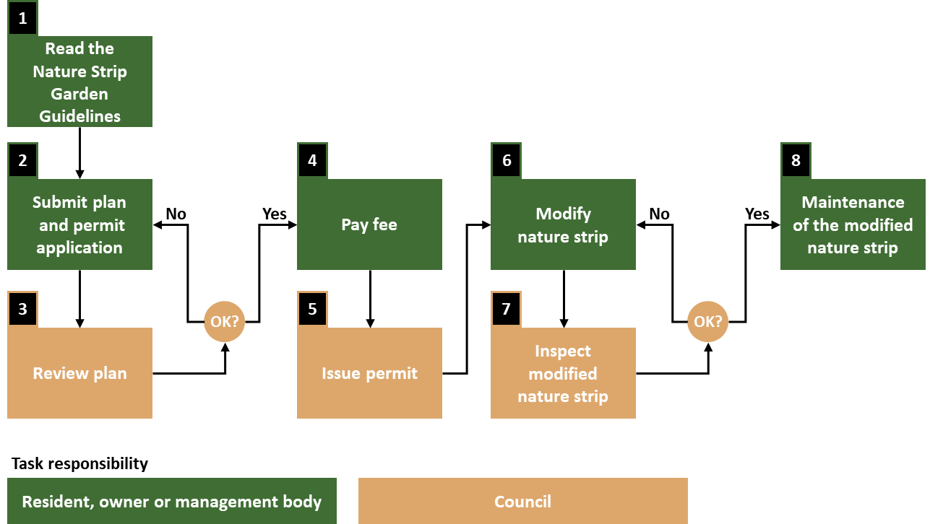
Figure 2 Nature strip modification application and approval process.
- The resident/owner or management body must read these guidelines
- The resident/owner or management body submits a Nature Strip Modification Permit application (see the Related Documents section) and a modification plan showing:
  - The nature strip layout including the location of street tree(s) and any other above ground assets
  - The proposed modifications including a list of materials and plants
  - A plan showing the safety precautions that will be in place
- Council reviews the plan against the requirements of these guidelines
If the plans are not compliant, the resident/owner or management body will be asked to revise as required and re-submit
- If the plans are compliant, an invoice is issued and the resident/owner or management body pays the required permit fee
- After the resident/owner or management body pays the required permit fee the Nature Strip Garden Permit is issued
- The resident/owner or management body carries out the modification works as per the approved plan
- Council inspects the modified nature strip
If the modifications are not compliant, the resident/owner or management body will be asked to alter the nature strip as required
- If the modification works are compliant, the application / approval process ends, and the ongoing maintenance of the modified nature strip begins.
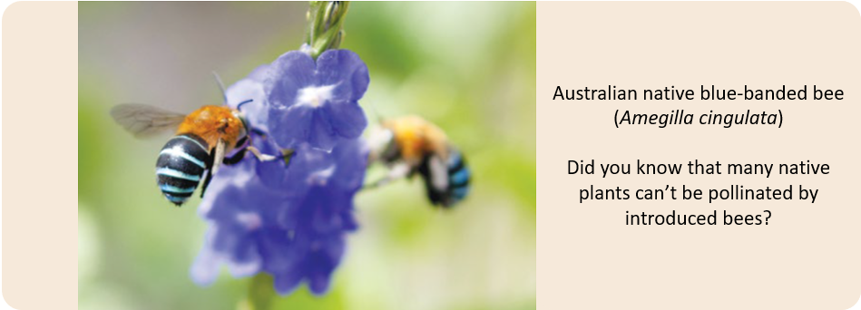
When planning your modifications please take the following steps:
- If renting, gain the approval of the property owner or management body
- Consider suitability of your design; consistency with neighbourhood character; and your ability to maintain it - now and in the future
- Consult with your neighbours
- Check with Before You Dig Australia
- Identify any assets within the nature strip and ensure the requirements of the relevant asset owner are catered for.
These guidelines are retrospective. Unless otherwise noted, nature strips modified prior to the implementation of these guidelines will require alterations if they are not consistent with the guidelines.
Council recognises that there have been some changes regarding the use of synthetic grass and compacted sand/toppings. Where required, Council will work with the resident/owner or management body to achieve an outcome that is reasonable for all parties.

Design requirements
This section provides important information regarding the design of a modified nature strip.
The subjects covered are:
- Existing infrastructure
- Nature strip layout
- Design materials (suitable and prohibited)
- Plant selection.
The requirements in these guidelines have been specified in consideration of the following:
- Visibility - lines of site for vehicles and pedestrians using the road reserve
- Walkability - risk of slip/trip incidents caused by nature strip material on the footpath
- Personal injury - trip hazards, soft fall areas, and other risks
- Asset damage - impact on existing assets by excavation, attachment, or placement
- Street tree health - impeding growth and/or contributing to unhealthy trees or tree death.
- Storm water management - materials increasing run-off or entering the drainage network
- Environment - materials that are not environmentally sound or cause adverse outcomes.
Existing nature strip infrastructure
Some nature strips contain existing infrastructure to enable the delivery of public services and utilities. Please read the following to understand how this impacts your situation:
- If the nature strip contains a service or utility asset such as a Telstra on-street exchange; NBN Co Fibre Distribution Hub; electricity substation / mini pillar; fire hydrant; or access pit, you will need to contact the relevant authority directly to ensure that any required off-sets or exclusion zones are appropriately catered for
- Where the nature strip contains a bus stop, no modifications are allowed within a 9 metre area starting from the bus stop post and flag as shown in the figure below
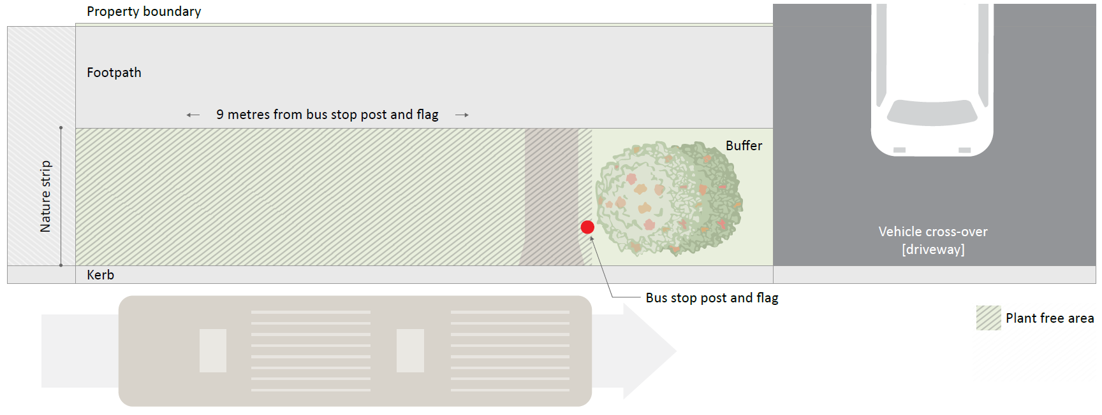
Figure 3 Nature strip containing a bus stop.

- Drainage swales/channels and water sensitive urban design (WSUD) treatments are a Council drainage asset:
  - If the nature strip contains a drainage swale/ditch, only general maintenance activities such as mowing of grass can be carried out by the resident/owner or management body. No modifications are allowed on these nature strips
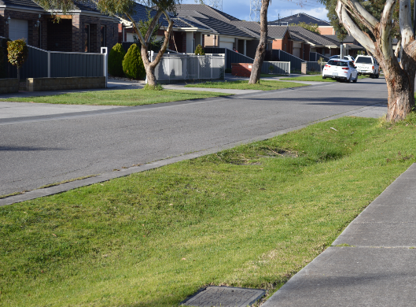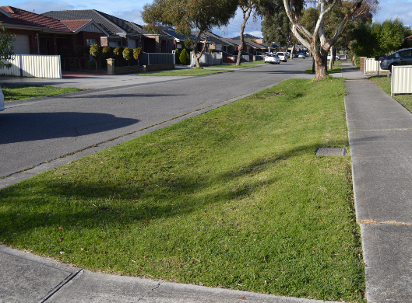
Figure 4 Examples of drainage swale/channels.
  - If the nature strip contains a water sensitive urban design (WSUD) treatment the resident/owner or management body must not interfere with it in any way, this includes general maintenance activities. No modifications are allowed on these nature strips.
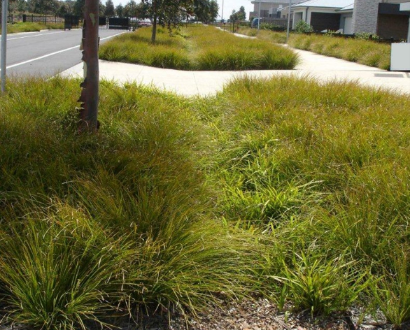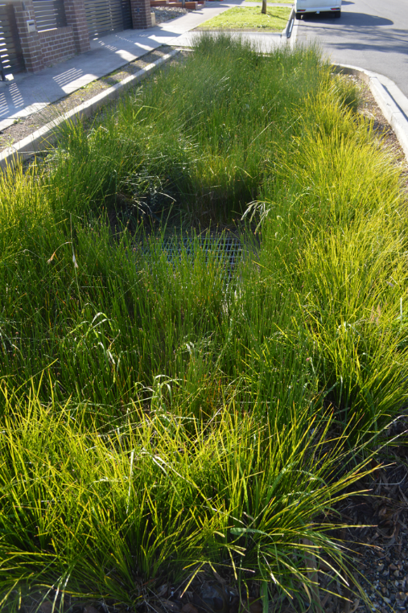
Figure 5 Examples of water sensitive urban design treatments.

Nature strip layout
The following pages show the general requirements for a modified nature strip.
The layout of the area between a property boundary and the kerb is not consistent across the City of Whittlesea. If the following diagrams do not reflect your situation, or if you need further clarification, please contact Council’s Customer Service team on 03 9217 2170 and ask to speak to the Asset Protection Unit, or email info@whittlesea.vic.gov.au
Neighbourhood layout
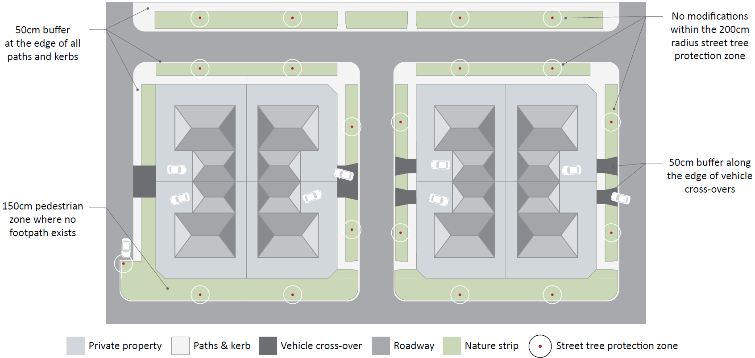
Figure 6 Example of various urban neighbourhood layouts showing road reserve elements and nature strip buffer zones and reflects the most common situations across the city's urban areas, not a design preference. Standards relating to the configuration of road reserves can be found in the 'Engineering Design and Construction Manual for Subdivisions in Growth Areas' (EDCM) and/or the 'City of Whittlesea Neighbourhood Design Manual'.
Did you know nature strips, median strips, and round-a-bouts have been estimated to account for up to 30% of a city’s green spaces?
Nature strip layout
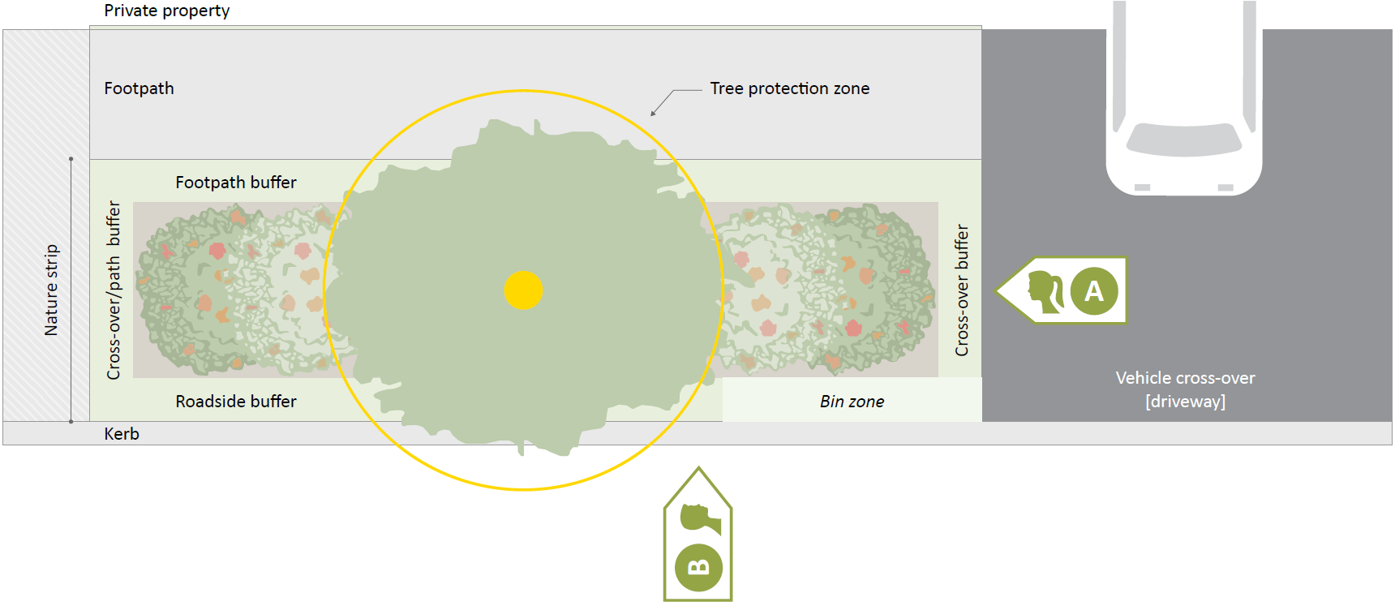

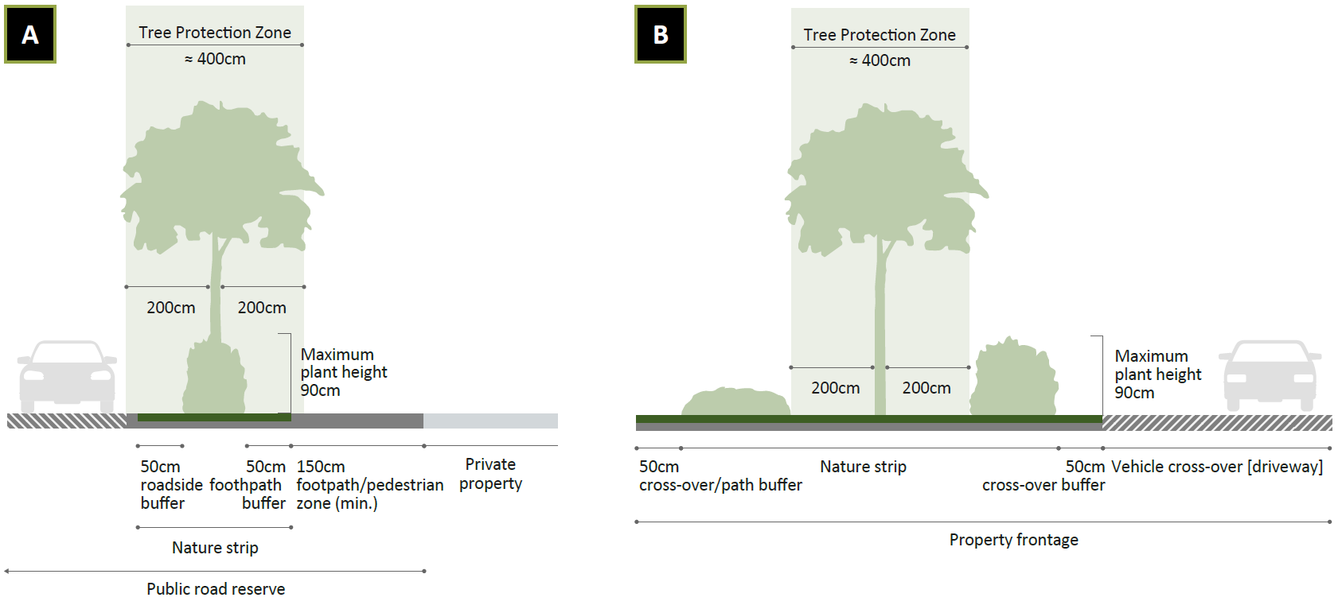
Figure 7 Example of an urban nature strip showing layout requirements

Design materials
In order to ensure that a nature strip fulfils its functional and aesthetic purpose, Council has defined what is and what is not suitable for use within a modified nature strip. In making these decisions, Council has considered issues such as visibility, walkability, personal injury, asset damage, street tree health, storm water management, and environment.

Suitable materials
- Grass maintained to a maximum height of 20 cm
- Native grasses maintained to a maximum height of 90 cm
- Plants consistent with the plant selection section of these guidelines and maintained to a maximum height of 90 cm.
- Planter boxes centred within the nature strip’s plantable area and in keeping with the character of the neighbourhood.
Planter boxes must have a sealed base, be removable, no larger than 120cm x 60cm, and be at least 40cm in height.
When choosing your planter box height keep in mind the maximum allowable plant height of 90cm which is measured from the nature strip surface to the top of the plant
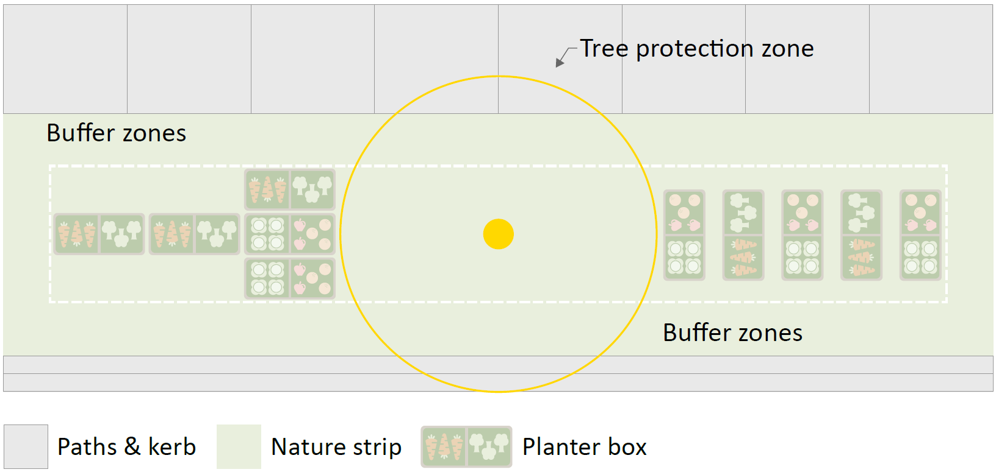
Figure 8 Example of a nature strip that includes planter boxes
- Small logs / tree branches placed in the centre of and fully contained within a garden bed
- Organic mulch such as graded bark or vegetative mulch to a depth of 7.5 cm and used in conjunction with plantings

- Crushed rock or toppings / granitic sand with a maximum particle size of 1 cm, well compacted to a minimum depth of 7.5 cm and used in conjunction with plantings as per the examples below
The use of crushed rock or toppings / granitic sand across the entire nature strip is not permitted
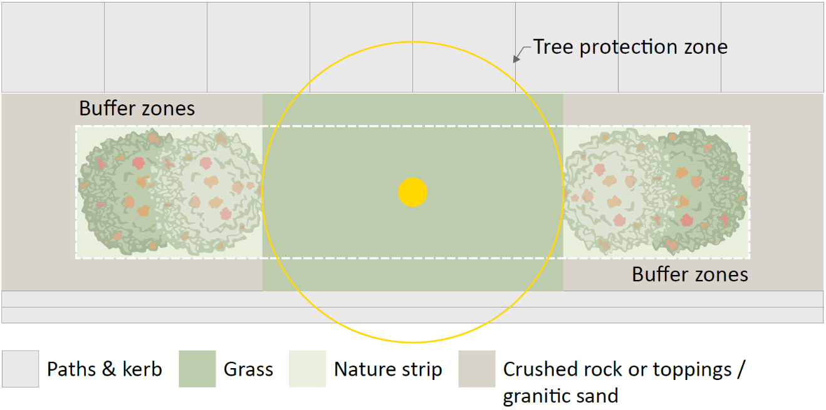
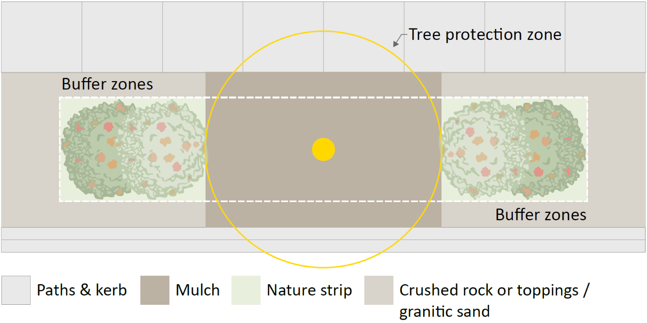
Figure 9 Example of nature strips that include crushed rock / granitic sand and mulch
- Street tree (planted and maintained by Council). The planting of street trees in accordance with Council's formal planting programs or to satisfy developer obligations in new housing or industrial estates, takes precedence over all resident modifications.
Please note that:
- Edible crops must be grown in planter boxes
- Height will be measured from nature strip surface to the top of the plant
- The only material that can be placed within the tree protection zone is organic mulch
- If your design includes something that does not appear in the list above, it will not be considered compliant with these guidelines.

Prohibited materials
- Synthetic grass and plants
The installation of synthetic grass is not permitted effective 1 October 2023. Existing installations with a valid permit may remain in place, however Council reserves the right to undertake any modifications or remove existing synthetic grass to facilitate any Council objectives or requirements at Council’s discretion including non-Council works provided by utility and service providers.
Synthetic grass that remains in place must meet the original guideline requirements of being green and properly secured with no loose edges. It must continue to form an even surface that is level with all surrounding infrastructure such as kerbs, footpaths and vehicle crossings, be kept free of weeds and contained within the nature strip area.
Did you know that synthetic grass can increase surface temperatures by
up to 11º and increase air temperature over a metre away by up to 3º ?
Synthetic grass that no longer meets the original guideline requirements must be removed and replaced with a compliant treatment.
Council will require the reinstatement of synthetic grass nature strips which were modified without a valid permit.
- Compacted rushed rock or toppings / granitic sand
The use of compacted crushed rock or toppings/granitic sand across the entire nature strip is not permitted effective 1 October 2023. Existing installations with a valid permit may remain in place, however Council reserves the right to undertake any modifications or remove existing material to facilitate any Council objectives or requirements at Council’s discretion including non-Council works provided by utility and service providers.
Council will require the reinstatement of compacted crushed rock or toppings/granitic sand nature strips which were modified without a valid permit.
- Weed barriers and plastic sheeting
- Scoria, pebbles, stones, or rocks - loose or fixed
- Uncompacted crushed rocks and sands
- Organic mulch where no planting is undertaken
- Straw or chip bark
- Hard surfaces such as concrete, asphalt, bricks, pavers, bluestone pitchers, etc.
- Rubberised surfaces
- Bollards, stakes, and star pickets
- Retaining walls, sleepers, and raised edging
- Spikey plants
- Plants noted as weeds in Agriculture Victoria’s ‘Consolidated list of declared noxious weeds and pest animals’ which have been planted directly or propagated through a lack of maintenance
(see the link under Plant selection)
- Sporting equipment such as basketball hoops and hoop stand systems
- Irrigation systems and water features
- Lights and other electrical devices
- Letter boxes (which must be placed on private property)
- Street Libraries
- Ornamental statues such as gnomes, etc.
- Synthetic plants
- Advertising signage installed without a valid Planning Permit
- Parking bays (if you would like to discuss indented parking bays please contact Council’s Customer Service team on 03 9217 2170 and ask to speak to the Traffic and Transport Unit or email info@whittlesea.vic.gov.au)
- Any other material not listed in the Suitable Materials section.

Plant selection
When choosing your plants please ensure that you consider the following:
- Plant growth habit:
  - How tall is the plant expected to grow? Will it exceed the maximum plant height of 90 cm?
  - How quickly will it grow and spread? Some plants will require regular maintenance to ensure they do not spread beyond the allowed planting areas
- The general theme of the surrounding streetscape?
- What others are doing in your street. What, if anything, are your neighbours planting? Are your choices consistent?
- Weed or not? Though some plants may have a pleasant appearance and a history of use in private gardens, they may still be classified as weeds. Check the Agriculture Victoria website (www. agriculture.vic.gov.au search for ‘declared noxious weeds and pest animals’) to make sure your selection is not listed
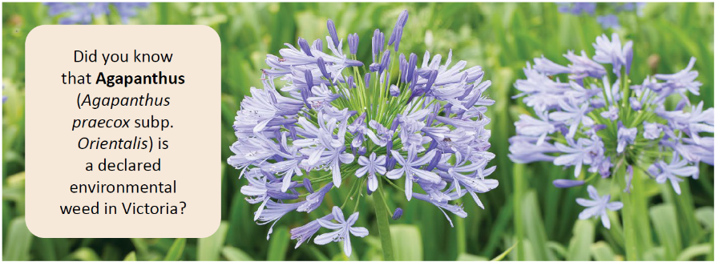
- Council encourages the use of native plant species and considers that native wildflowers and ground-covers, correctly maintained, would be suitable.

Related information
Documents available from the Council web site - whittlesea.vic.gov.au/
- Nature Strip Garden Permit
- City of Whittlesea Register of Public Roads
- City of Whittlesea Your Indigenous Garden booklet
- City of Whittlesea Home Harvest booklet
- City of Whittlesea Weeds and Pest Plant Fact Sheets
- City of Whittlesea Community Gardens Guidelines
- City of Whittlesea Local Law.
Legislation available from the State Government website - legislation.vic.gov.au/
- Road Management Act 2004
- Road Management (Works and infrastructure) Regulations 2015
- Road Management (General) Regulations 2016
- Road Safety Act 1986
- Road Safety Road Rules 2017
- Local Government Act 2020.

Contact us
If you wish to discuss these guidelines with a Council Officer, please contact Council’s Customer Service team on 03 9217 2170 and ask to speak to the Asset Protection Unit, or email info@whittlesea.vic.gov.au

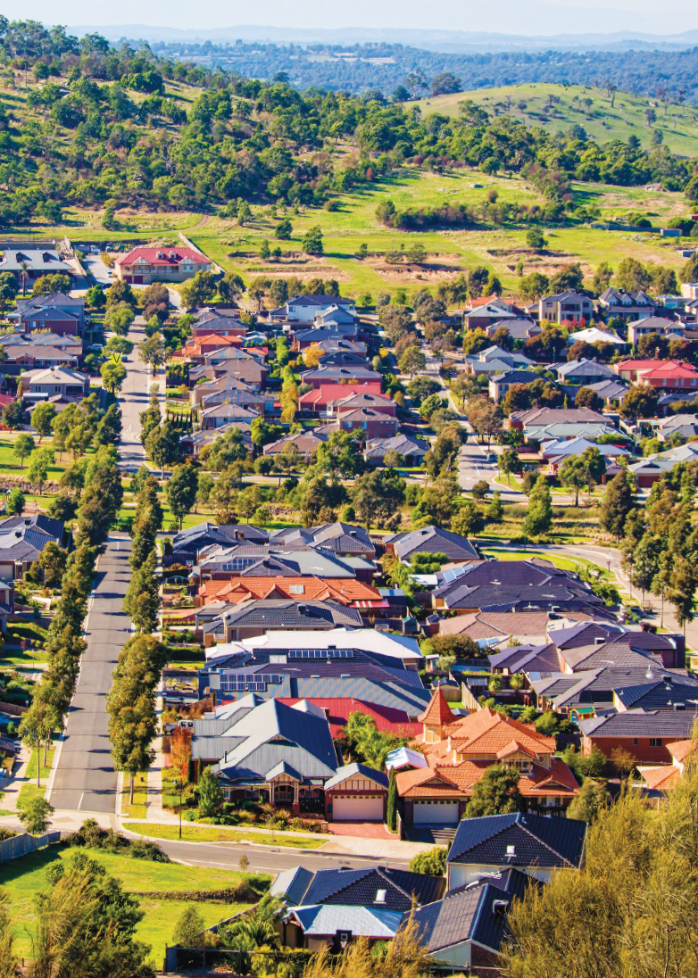

Council’s Register of Public Roads is available at whittlesea.vic.gov.au/

