Road Management

Plan

1 June 2021

Acknowledgement of Traditional Owners

The City of Whittlesea recognises the rich Aboriginal heritage of this country and acknowledges the Wurundjeri Willum Clam as the traditional owners of this place.

We acknowledge and respect their unique ability to care for Country and deep spiritual connection to it. We honour Elders past and present whose knowledge and wisdom has ensured the continuation of culture and traditional practices.

Document Control
Amendment Date | Scope of Amendment | Authorised By
June 2021 | Amended and updated | Manager Maintenance and Operations
June 2017 | Amended and updated | Manager City Design and Transport
May 2013 | Amended and updated | Manager Engineering and Transportation
June 2009 | Amended and updated | Manager Engineering Services
November 2005 | Amended and updated | Manager Engineering Services
December 2004 | First published | Manager Engineering Services

Certified by –
Debbie Wood
Director Infrastructure and Environment, City of Whittlesea

Table of Contents
1 Introduction 6
1.1 Purpose of Plan 6
1.2 How to Achieve the Plan’s Objectives 6
1.3 Stakeholders 7
1.4 Duty of Road Users 7
1.5 Relationship with Budget 8
1.6 Relationship with Council Plan and Asset Management Policy 8
1.7 Suspension of Road Management Plan 10
1.7.1 CEO Decides on Suspension and Reinstatement of Plan 10
1.7.1 Responsible and Senior Officers May Recommend Suspension and Reinstatement of Plan 10
2 Road Asset Description 11
2.1 Overview 11
2.2 Assets covered 11
2.3 Assets not covered 12
2.4 Register of Public Roads 12
2.5 Municipal Road Map 14
2.6 Principles 14
2.7 Demarcation and Agreements with other Authorities 15
3 Road Infrastructure Hierarchy 18
3.1 Road Hierarchy 18
3.2 Pathway Hierarchy 20
4 Performance Standards 21
4.1 Objectives 21
4.2 Defect and Condition Inspections 21
4.3 Emergency Response 22
4.4 Defects Intervention Levels 24
5 Management System 28
5.1 Computer Systems 28
5.2 Overview of Management System 28
5.3 Managing Works within Road Reserve 29
5.3.1 Significant Roadsides 30
5.4 Guidelines for Claims 30
6 Review of Road Management Plan 32
Referenced Documents 33
Appendix – Definitions 34

1 Introduction
The Road Management Act 2004 (the “Act”) has established a statutory framework for the management of public roads in Victoria. The Act applies to road authorities including the City of Whittlesea.
Under Part 4, Division 5 of the Act, Council elected to make a Road Management Plan in accordance with the Code of Practice for Road Management Plans (1 October 2004).

1.1 Purpose of Plan
The purpose of this Road Management Plan (the “Plan”) is to ensure Council has in place a plan that helps Council to achieve the following objectives:
1. Ensure that a safe and efficient network of municipal public roads is provided primarily for travel and transport.
2. Meet the statutory requirements of the Road Management Act Section 50, Road Management Regulations (the “Regulations”) and relevant Ministerial Code of Practice (the “Codes”).
3. Provide a structure for a road asset management system which will ensure that the public roads in the municipality:
- Are capable of functioning as they were built to function; and
- Continue to meet the needs and expectations of the community and other key stakeholders.
4. Within that structure, advance Council’s asset management practice that is to achieve the strategic objectives of Council’s Whittlesea 2040: A Place For All and the objectives of Council’s Asset Management Policy.
5. Adhere to good practice of achieving an appropriate level of road maintenance, inspections and servicing.

1.2 How to Achieve the Plan’s Objectives
To achieve the above stated objectives, this Plan provides details in the following key management areas that are central to Council’s role as the road authority for municipal public roads:
- Provide descriptions of the types of road and road-related infrastructure assets covered including assets not covered. The details are in Section 2, Road Asset Description;
- Set up a road and pathway hierarchy classification to facilitate the setting of performance standards. The details are in Section 3, Road Infrastructure Hierarchy;
- Set relevant performance standards to help with the discharge of Council’s duties. The details are in Section 4, Performance Standards; and
- Set details of the management system to be implemented to help with the discharge of Council’s duties. Please refer to Section 5, Management System.

1.3 Stakeholders
Stakeholders who will be affected by this Road Management Plan in the City of Whittlesea include:
- The community - ratepayers, residents, business, industry, education.
- Road users such as pedestrians, bicyclists, motorcyclists, public transport passengers and vehicle drivers and passengers.
- Transport service providers - transport operators, bus operators and service providers supporting the delivery of transport service.
- Emergency services.
- Utilities such as water, sewerage, drainage, gas, electricity, telephone, telecommunications, cable TV, pipeline and other like services under the authority of an Act of Victoria or the Commonwealth.
- Land and property developers and their respective consultants and contractors.
- Road authorities/agencies of State and Federal governments.
- Other road authorities such as neighbour Councils, Department of Sustainability and Environment, Parks Victoria, Melbourne Water Corporation, Country Fire Authority, etc.
- Private road owners such as farms, business, industry, body corporate.
- Federal and State government departments and agencies.
- Special interest groups such as RACV, ratepayer associations, Chambers of Commerce, industry-representing bodies and like community groups.
- Elected representatives.
- Council staff and consultants and contractors.

1.4 Duty of Road Users
Whilst Council has certain duties and responsibilities, this Plan is predicated on the basis that the road users also have certain obligations and responsibilities including but not limited to; keeping a proper lookout and exercising due care for their own safety, to drive safely according to the prevailing conditions, to have regard to the rights of other road users, the community and infrastructure managers, and to avoid damaging infrastructure.
The roles and responsibilities of road users are outlined under the following documents:
- Section 17A, Road Safety Act 1986 (or as amended); and
- General Municipal Law, City of Whittlesea.
A copy of the General Municipal Law is available from Council’s web site at www.whittlesea.vic.gov.au under About Us > Local laws and legislation > Whittlesea local laws.

1.5 Relationship with Budget
The annual budget has been developed within an overall financial planning framework that guides Council in identifying community needs and expectations over the short, medium and long term. In preparing the annual Budget, funding requirements for each year are linked with the objectives contained in the Whittlesea 2040: A Place for All.
In relation to road and road-related infrastructure assets that provide road transport service, Council recognises the importance of balancing appropriate performance standards with what the communities are able to afford and sustain. In balancing the funding level for the inspection, maintenance, repairs, upkeep, rehabilitation and renewal of road and road-related infrastructure assets, Council gives regards to the following key considerations:
- Its role and obligations under the Road Management Act 2004;
- Preservation of existing assets in an appropriate and safe working condition;
- Ability to acquire additional infrastructure assets to serve new growth;
- Market constraints in staffing, plant and equipment, building materials and contractors; and
- Budget / financial constraints.
The performance standards set in Section 4 of this Plan reflects such balance.

1.6 Relationship with Council Plan and Asset Management Policy
Whittlesea 2040: A Place For All is the “Council Plan” for the purpose of Section 90 of the Local Government Act 2020, which states that ‘Every resident is able to get where they need to go with ease’. It is available to the public on Council’s web site www.whittlesea.vic.gov.au.
In addition, Council’s Asset Management Strategy, which provides guiding principles to achieve the following objectives in the management of assets used for providing services:

- Promote effective and efficient service delivery outcomes via asset management;
- Promote the safe and responsible use of assets;
- Recognise that the costs of operation, maintenance and renewal of assets require an appropriate funding base;
- Provide assets for present service delivery needs while sustaining resources for future communities; and
- Support the strategic objectives of Council’s Community Plan and other objectives of social planning and service strategies of Council.
Diagram 1.1 below outlines the ‘full circle’ relationship of Whittlesea 2040: A Place For All, Council’s Asset Management Strategy and Council’s Road Management Plan, operating within the statutory framework of the Act.

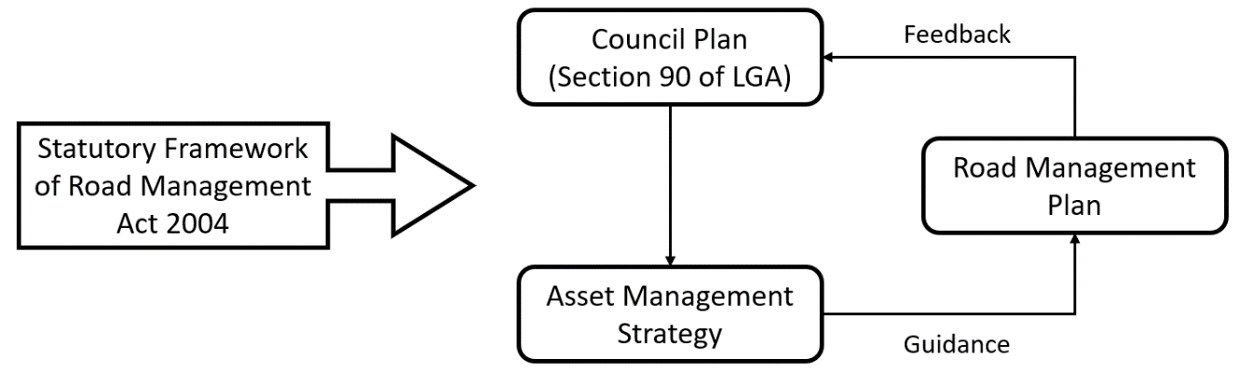
Diagram 1.1 – Council Plan, Asset Management Strategy and Road Management Plan

Further to the Council Plan and Asset Management Strategy, are other strategic documents and policies that support and guide some of the objectives and implementation of the Plan.
Council documents such as the Whittlesea Bicycle Plan 2016 consider the maintenance objectives in the Plan in the context of cycling and active travel and include action items that relate to the Plan. These action items work to close the feedback loop and ensure the performance standards being implemented are adequate in maintaining a high quality bicycle network.
Other Council and external policies and strategies which help guide the Plan are mentioned throughout and referenced in the Referenced Documents.

1.7 Suspension of Road Management Plan
Council will implement the Plan as from the date of its adoption. However, if exceptional circumstances arise, Council may suspend the Plan (either in whole or part) for the duration of those circumstances.
Exceptional circumstances could include (without limitation) matters such as natural disasters, fires, floods, health pandemics, unavailability of Council staff or suitably qualified contractors, or other resourcing limitations.

1.7.1 CEO Decides on Suspension and Reinstatement of Plan

Council’s Chief Executive Officer (CEO) has the responsibility to decide whether to suspend, or reinstate, the Plan. Either the whole Plan, or specified aspects of it, can be suspended or reinstated, as determined by the CEO.

In determining whether the Plan should be suspended or reinstated, the CEO should consider (among other things) the principles in section 83 of the Wrongs Act 1958 (Vic), and any advice or recommendations from Responsible or Senior Officers. The CEO is not obliged to act in accordance with any such recommendations or advice, and such recommendations or advice are not preconditions to the CEO’s determinations.

Upon resolving to suspend or reinstate the Plan (as the case may be), the CEO must advise the Senior Officer in writing of the date of the suspension or reinstatement.

1.7.1 Responsible and Senior Officers May Recommend Suspension and Reinstatement of Plan
In this clause:

- Responsible Officer means any Council officer with responsibilities related to activities covered by the Plan (for example, the Manager Maintenance and Operations, or Senior Infrastructure Engineer);
- Senior Officer means the senior Council officer for the time being with responsibility for implementing and overseeing the Plan (which at the date of adoption of this Plan is the Director of Infrastructure and Environment).

If a Responsible Officer considers that circumstances have arisen which may, or will, affect Council’s capacity to comply with the Plan, the Responsible Officer should make a recommendation as follows:
- The Responsible Officer should advise Council’s Senior Officer of the circumstances, and any recommendation.
- If a Senior Officer determines that the circumstances will affect Council’s capacity to comply with the Plan, the Senior Officer must notify the CEO of the Senior Officer’s determination together with any recommendations.
- Where the Senior Officer receives written notification from the CEO that the Plan is or will be suspended, the Senior Officer shall cause a notice of the suspension to be posted on Council’s website and social media channels.
- Where the Senior Officer receives written notification from the CEO that the Plan is being reinstated, the Senior Officer shall cause the notice of suspension to be removed as from the date of reinstatement.
- Where the Plan has been suspended in accordance with a recommendation of the Senior Officer, the Senior Officer shall notify the CEO of the cessation of the `circumstances referenced in the recommendation.

2 Road Asset Description
This section provides the details of road infrastructure and road-related infrastructure assets that are being covered under this Road Management Plan. It also outlines asset not covered under this Plan.

2.1 Overview
The Municipality covers an area of approximately 490 square kilometres with a population of approximately 223,600 people. The City’s population is expected to reach 383,600 by the year 2040.
The local network of public roads is expanding through the subdivision of land. For the financial year 2019/2020, the local road network had grown by about 8.4 percent. The key measurements are:
- 1,409 kilometres of public roads (urban and rural, sealed and unsealed roads);
- 1,123 kilometres of pathways (constructed footpath, bicycle path and shared path);
- 82 bridges and major culverts; and
- 2,195 kilometres of kerb and channel.
For the year ended 30 June 2020, the Total Replacement Cost is estimated at $1.741 billion and the Depreciated Replacement Cost (DRC) is $1.380 billion.

2.2 Assets covered
The road and road-related infrastructure assets covered in this Plan are as outlined in the Act.
A copy of the Road Management Act 2004 can be found on the Victorian State Government website at www.legislation.vic.gov.au > Victorian Law Today.

2.3 Assets not covered
This Plan does not cover the following assets:
- Road and road-related infrastructure assets that are the responsibilities of other road authorities, utilities and/or other infrastructure managers. For example, Department of Transport (formerly VicRoads), Department of Environment, Land, Water and Planning, Parks Victoria, Melbourne Water Corporation and the like;
- Road, road-related and non-road infrastructure assets owned, managed and/or operated by private organisations, on private land or which interface on public land or within road reserves. Such private organisations would include shopping centres, educational institutions, body corporate subdivisions and the like;
- Non-road infrastructure in, on, under or over a municipal public road, which is the responsibility of other organisations. Non-road infrastructure would include gas pipes, water pipes, sewerage pipes, stormwater pipes, pits, electricity poles, cables, tram wires, rail infrastructure, bus shelters, public telephones, mail boxes, roadside furniture and fences erected by utilities;
- Subdivisional roads under construction and prior to the date the road became a public road;
- Assets such as vehicle crossings (also known as cross-overs, driveway crossings, driveways), pathways and house drains in road reserves that provide services to land and properties abutting a road. The owner, occupier, manager or operator of such asset is responsible for the condition and maintenance of that asset;
- Pathways that have not been constructed by a responsible road authority, e.g. unconstructed pathways such as a foot (human or animal) trodden pathways;
- Roadways that have not been constructed by a responsible road authority, e.g. an unconstructed track such as a vehicle or motorcycle trodden roadway;
- Fire priority roads to be maintained by notification in accordance with Appendix D of City of Whittlesea, Municipal Fire Management Plan 2020-2023 and any corresponding updates.
- Temporary road signs used in road works; and
- Any other road, road-related or non-road infrastructure asset not listed in the Section 2.2, “Assets covered” or not listed in the Register of Public Roads.

2.4 Register of Public Roads
Council keeps a copy of the Register of Public Roads (the “Register”) in accordance with Section 19 of the Act. The Register is updated every six months (or as required) and lists all the roads, for which Council is the coordinating and / or the responsible road authority, including details specified in Schedule 1 of the Act.
A copy of the Register is available for inspection at Council’s municipal office, located at 25 Ferres Boulevard, South Morang (Melway Ref 183 A10).
The Register of Public Roads includes the following information:
- The name of each public road or, if unnamed, an identifiable description;
- Classification of the public road in accordance with road hierarchy classification outlined in Section 3;
- If a road becomes a public road after 1 July 2004, the date on which the road became a public road;
- If a public road ceases to be a public road, the date on which the road ceased to be a public road;
- Further description, such as road segments details, where Council considers appropriate;
- The name of Responsible Road Authority; and
- Any ancillary areas designated under Section 18 of the Act.
In addition, the Register includes information in relation to:
- Arterial roads in respect of which Department of Transport (formerly VicRoads) is the Coordinating Road Authority;
- Road management clarification – public roads, non-public roads and structures in respect of which the Council seeks to clarify the road management responsibility;
- Melbourne Water Corporation’s structures (e.g. bridge or culvert over aqueduct) which form part of public roads, in respect of which the Council and Melbourne Water Corporation have separate road management responsibilities;
- Ancillary areas which contain public access roads, car parks, footpaths, shared footways and off-road bicycle paths;
- Discontinuance of Roads;
- Demarcation arrangements under which the boundaries of a public road and/or ancillary area is fixed or varied;
- Management arrangements, made in accordance with section 15 of the Act, under which road management functions in respect of any part of a public road and/or ancillary area is transferred or delegated to or from the City of Whittlesea, in relation to other road authorities;
- Pathway (footpath, bicycle path and shared path) which have been classified with Pathway Hierarchy 1 and 2; and
- Private roads in respect of which a body such as a body corporate, university, company and the like, is responsible to ensure the private road is safe for its users.
Roads that will not be included in the Register are:
- Unused or leased roads for which the Council has not accepted responsibility; and
- Roads set out on plans of subdivision, until such time as the Council accepts responsibility for those roads.
In respect to a road, which Council acquired as a result of subdivision development, Council becomes the Co-ordinating and Responsible Road Authority from the date the road became a public road, which is normally the Date of Practical Completion unless otherwise stated.

2.5 Municipal Road Map
The Municipal Road Map is stored on the Council’s Geographic Information System and is updated as new public roads are added. It shows the locations of all the roads listed in the Register of Public Roads with the following information:
- Road segment ID No.;
- Road names;
- Road segments;
- Road hierarchy classifications; and
- Pathway hierarchy classifications.
The Municipal Road Map may be viewed at Council’s municipal office located at Ferres Boulevard, South Morang (Melway Ref 183 A10).

2.6 Principles
In deciding which road is a municipal public road, Council will consider the following principles and situations:
- Whether an area of land is a “public road” according to the following matters and reasonably required for public use:
- The City of Whittlesea is capable of being both the coordinating road authority and the responsible road authority;
- Road infrastructure exists on that area of land;
- There is no restriction to public use;
- The land is not under title to or managed by a body corporate as part of an estate; and
- The land is deemed to be an ancillary area to an adjacent public road.
- The need for establishment of a through-road in line with the definitions for link, collector and access road classifications.
- The need to have access facility between adjoining land and a road reserve, via a link, collector or access road.
- There is no need to unnecessarily continue multiple points of access to isolated properties.
- Some road reserves may not be needed for access and could be closed.
- Some existing roads, which provide unnecessary duplication of access, may be considered for closure.
- The standard of construction of a road and who should pay for any road upgrade (if this is required or requested) is a separate issue from whether the road is required as a municipal public road.
- Where roads, or road segments, do not service ratable property and are not Link or Collector roads then Council may elect not to place these roads on the Register or carry out maintenance works on them. However, Council may agree to carry out works under agreement or contract to another Coordinating Road Authority for such roads or road segments.
- The ownership of the land on which a road is constructed does not affect whether the road may be considered as a municipal public road in the following circumstances:
- Crown road reserve;
- Crown land not on a road reserve;
- Crown reserve; and
- Municipal reserve.
- Residual land of a completed subdivision where the title has not yet transferred to the City of Whittlesea (generally applies to subdivisions completed prior to 1989).
- Further to Item 8 (above), private ownership of land in the cases of commercial, industrial or residential land (including by a body corporate) would not have municipal public roads on such land unless special circumstances apply, such as in the case of through roads.
- Demarcation guidelines as set out in the Code of Practice for Operational Responsibility for Public Roads.

2.7 Demarcation and Agreements with other Authorities
Demarcations refer to the boundaries of a public road (points of transfer) where the City of Whittlesea assumes responsibility, or relinquishes responsibility, for its care and maintenance.
The Register of Public Roads contains the agreed demarcations between the City of Whittlesea and other authorities; including Department of Transport (formerly VicRoads), adjoining municipalities, Department of Sustainability and Environment, Parks Victoria, Melbourne Water Corporation, and public transport operators.
Specific information regarding the interface of road authorities is available in the Road Management Act Code of Practice – Operational Responsibility for Public Roads.
The Register also defines the general demarcations between private assets and Council assets. Where the City of Whittlesea enters into an arrangement with another organisation to carry out works on other public roads, the responsibility of the City of Whittlesea is limited to the terms of that agreement.
Diagram 2.1 outlines the “tests” used to help determine who is responsible for a road. Where it is a public road, that body becomes the coordinating road authority.
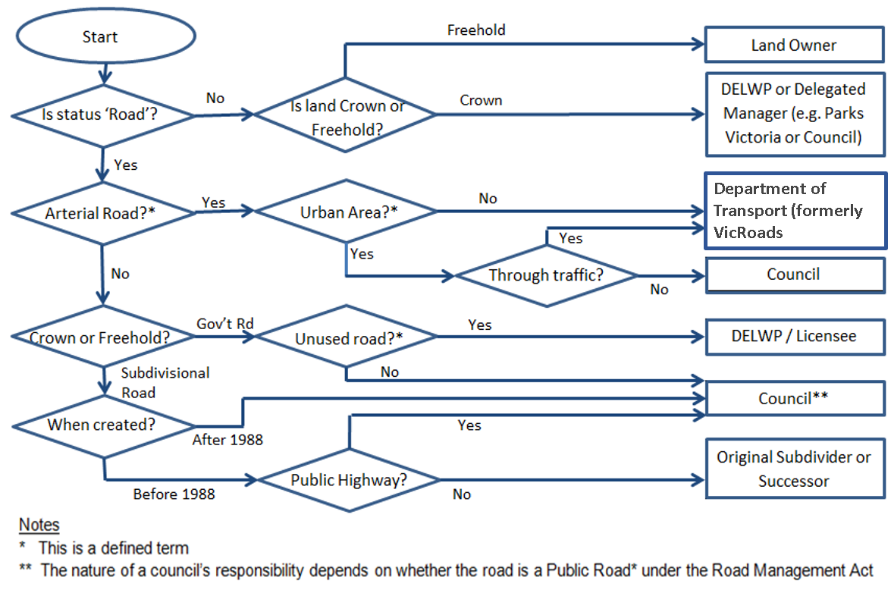
Diagram 2.1 – Road Responsibility

3 Road Infrastructure Hierarchy
This section describes the hierarchy classification adopted in this Plan. A hierarchy classification for roads and pathways assists in determining relevant performance standards for key maintenance areas such as inspection, maintenance, repairs and intervention levels. It also assists in other management activities such as allocating resources and specifying design and construction standards.
Classification of a road as a freeway or an arterial road is declared by VicRoads (DoT) in accordance with Section 14 of the Act. VicRoads (DoT) is both the coordinating road authority and the responsible road authority for freeways and arterial roads. Arterial roads include roads formerly known as State Highways or Declared Main Roads.

3.1 Road Hierarchy
A hierarchy classification is used to group roads and pathways based on the service levels that they provide in a road transport network. The hierarchy system considers service requirements such as traffic (vehicular and pedestrian) volumes, safety speed, riding quality and pavement durability.
For municipal public roads, a three-tier hierarchy classification has been adopted. Roads are classified as Link, Collector or Access.
- Link road
Roads of this classification provide linkages between places and arterial road network; or linkages among places. Examples of places are township, suburb, shopping precinct, major sporting venue, industrial area, agricultural area, tourist attraction and any places of interest. This type of road has an identifiable origin and destination. In general, a Link road gets its traffic from multiple Collector roads.
- Collector road
Roads of this classification primarily provide a route between and through residential, industrial, commercial and agricultural areas. They convey traffic from Access roads to the Link road and/or Arterial roads.
- Access road
Roads of this classification includes a road, service road, street, court, laneway or extended driveway, which primarily provide direct access for abutting residential, industrial, commercial and rural properties. They ‘feed’ traffic to Link, Collector or Arterial roads. There is minor to no through traffic in Access road.
Sub-classifications of Links, Collectors and Access are based on their respective traffic volumes, and physical attributes such as: service road, court, through road, right of way (ROW) or ‘extended driveway’ that provides access to two or more properties. Further details of sub-classifications are provided in Register of Public Roads.
The road hierarchy adopted for municipal public roads is summarised in the following Table 3.1.

Table 3.1 Road Hierarchy
COORDINATING ROAD AUTHORITY | ROAD TYPE | HIERARCHY CLASSIFICATION
Department of Transport (formerly VicRoads) | Freeways | Refer to VicRoads Road Management Plan (April 2014)
 | Arterial roads
City of Whittlesea | Municipal public roads | Link road
 |  | Collector road
 |  | Access road
DELWP, Parks Victoria, Melbourne Water, etc. | Other State roads | Not applicable

3.2 Pathway Hierarchy
A pathway hierarchy classification is different to that adopted for the roadway. The pathway hierarchy classification gives regards to the anticipated volumes of pedestrians, for example, in the vicinity of a public transport interchange, and busy shopping centres.
The following pathway hierarchy, Table 3.2, has been adopted to assist in setting performance standards in terms of inspection, maintenance, intervention levels and repairs.
Table 3.2 Pathway Hierarchy
PATHWAY HIERARCHY | PEDESTRIAN ENVIRONMENT | PEDESTRIAN SERVICE LEVEL
1 | (a) Shopping areas  (b) Council paths in the streets around –  - Epping Plaza shopping centre  - Plenty Valley shopping centre, South Morang  - Lalor Shops  - Thomastown Shopping precinct  - Aurora Shopping Precinct  - Lyndarum Shopping Precinct  - Bundoora Shopping  - University Hill Shopping Centre  - Etc.  (c) Council paths around public transport interchanges at:  - Epping Railway Station  - Lalor Railway Station  - Thomastown Railway Station  - Keon Park Railway Station  - South Morang Railway Station  - Middle Gorge Railway Station  - Mernda Railway Station  - Plenty Road Tram Terminus at McKimmies Road | High
2 | All other areas | Low
Note: For pathways of classification Pathway Hierarchy 1, please refer to the maps included in the Register of Public Roads.

4 Performance Standards
In this Section, Council sets the performance standards for the following operational functions in roads and pathways:
- Defect Inspection;
- Condition inspection;
- Defect intervention levels;
- Emergency response time; and
- Defects exceeding intervention level response time.

4.1 Objectives
The objectives of setting performance standards:
- To address public safety issues by ensuring any defects are within reasonable tolerance levels – achieved by regular Defect Inspections and being responsive to notification of defects and potential hazards by the public, including emergency situation like traffic crashes; and
- To allow for long term planning of the management of road infrastructure assets – achieved by regular Condition Inspections that assist Council in the strategic planning and budgeting of the road assets to ensure best use and maximize their potential lifespan.

4.2 Defect and Condition Inspections
Performance standards for Defect Inspections are derived from balancing available resources. They are summarised in the following Table 4.1 and 4.2, respectively. These formal inspection processes are supplemented by inspections generated reactively through reports received from the public and through internal infrastructure maintenance programs.
Condition Inspections of Council’s assets are generally carried out over a period of 4 years for the whole network. The purpose of these inspections is for long term planning and budgeting of major asset upgrades and to assess the effective lifespan of the assets. These inspections are not intended to identify specific defects as this is completed via the Defect and Reactive Inspections.
TABLE 4.1 PERFORMANCE STANDARDS FOR DEFECT INSPECTIONS
ROADS
Asset Hierarchy | Defect Inspection
 | Day Time | Night Time
Link | Every 4 weeks | Every 1 year
Collector | Every 12 weeks | Every 1 year
Access | Every 1 year | Not applicable

TABLE 4.2 PERFORMANCE STANDARDS FOR DEFECT INSPECTIONS
PATHWAYS
Asset Hierarchy |  | Defect Inspection
 |  | Day Time |  | Night Time
Hierarchy 1 | 6 monthly |  | Not applicable
Hierarchy 2 | At intervals not exceeding two years |  | Not applicable

4.3 Emergency Response
The aim of Council’s response to an emergency incident is to safeguard the public. This will be followed up with any necessary repairs.
An emergency situation is to include incidents such as bushfires, flooding, vehicle crashes, road wash away, damaged bridges, livestock on road, material spillage from large vehicles, etc.

Table 4.3. Performance standards for Emergency Response Times
Asset Hierarchy | Response | Emergency Response Time
Roads
Link | Inspect and provide appropriate warning or rectify if possible  OR  Provide appropriate warning and notification if asset is the responsibility of a utility, other road authority, private owner, or public transport provider | Within 2 hours  of notification
Collector |  | Within 3 hours  of notification
Access |  | Within 4 hours  of notification
Pathways
1 | Inspect and provide appropriate warning or rectify if possible  OR  Provide appropriate warning and notification if asset is the responsibility of a utility, other road authority, private owner or public transport provider | Within 1 working day of notification
2 |  | Within 1 working day of notification

4.4 Defects Intervention Levels
Table 4.4 Defects Intervention Levels
Defect Description | Defect Intervention Level | Defect Response Time
 |  | Link | Collector | Access
SEALED PAVEMENT
POTHOLES | Potholes in traffic lane >300mm dia. and 50mm deep | Rectify within 7 days | Rectify within 10 days | Rectify within 28 days
WHEEL RUTS AND DEPRESSIONS | When ruts or depressions >25 mm depth measured with 1.2 m straightedge transverse, or under a 3 m straightedge longitudinal. | Rectify within 3 weeks | Rectify within 5 weeks | Rectify within 8 weeks
CRACKS  Seal and fill cracks and joints, excluding “crocodile” cracking, | When cracks >30 mm width. | Rectify within 3 weeks | Rectify within 5 weeks | Rectify as resources come available
SURFACE TREATMENT – LOSS OF AGGREGATE, BLEEDING OR FLUSHING | When –  (a) stripping has >50% loss of aggregate for an area >5 m²;  (b) bleeding / flushing for an area >5 m²; | Rectify within 3 weeks | Rectify within 5 weeks | Rectify within 8 weeks
PAVEMENT CLEANING – REMOVAL OF DEBRIS | When accumulation of aggregate, dirt or debris over a 5 Square Metre area prevents the free drainage of the pavement. | Rectify within 8 weeks | Rectify within 8 weeks | Rectify within 8 weeks
EDGE BREAK | When edge break exceeds 75 mm laterally over at least a 1 m length from the nominal seal line. | Rectify within 2 weeks | Rectify within 4 weeks | Rectify within 8 weeks
SHOULDER
UNSEALED SHOULDER - REPAIR | When drop off is > 50 mm depth measured over a 20 m length. | Rectify within 3 weeks | Rectify within 5 weeks | Rectify within 8 weeks
UNSEALED SHOULDER - REPAIR | When potholes, scouring or roughness is >50 mm depth measured with a 1.2m straightedge, or when there is ponding of water. | Rectify within 4 weeks | Rectify within 8 weeks | Rectify within 8 weeks
UNSEALED ROAD
UNSEALED ROAD - REPAIR | When potholes, scouring or roughness >100 mm depth measured with 1.2m straightedge. | Rectify within 4 weeks | Rectify within 5 weeks | Rectify within 10 weeks
 | When continuous corrugations over 20 m exceeding 50 mm in depth. | Rectify within 5 weeks | Rectify within 5 weeks | Rectify within 16 weeks
VEGETATION
LONG GRASS AT ROADSIDE AREAS | Grass length kept to an average 125 mm in urban roadside areas  (a) 3 m behind the line of guideposts or kerb (and balance of median if remaining width is less than 5 m);  (b) 30 m in advance of all road approaches and departures; | Rectify within 3 weeks for urban areas. Other areas slashed during the summer months for fire prevention | Rectify within 3 weeks for urban areas. Other areas slashed during the summer months for fire prevention | Rectify within 3 weeks for urban areas. Other areas slashed during the summer months for fire prevention
INTRUSIVE TREES AND SHRUBS | Cut and remove tree and shrub growth within roads, drains, clear zones, shoulders and verges to maintain –  (a) a minimum 4.5 metres high clearance over roads and shoulders for Declared Arterial Roads, Link and Collector roads and 4.0 metres for Access roads.  (b) maintain clear lines of sight on rural roads for a distance of 1.0 metre behind the kerb line or, if there is no kerb, the outer edge of the road shoulder.  (c) maintain vertical clearances of 2.5m over footpaths, walkways and nature strips. | Rectify within 4 weeks | Rectify within 4 weeks | Rectify within 4 weeks
ROAD FURNITURE
SIGN REPAIR – DAMAGED OR DIRTY | Replace when damage renders ineffective.  Clean sign and delineator faces when reflectivity is reduced due to accumulation of dirt. | Rectify all signage within 2 weeks | Rectify Warning and Regulatory Signs within 3 weeks. Others within 3 months | Rectify Warning and Regulatory Signs within 3 weeks. Others within 3 months
DAMAGED GUARD FENCE AND WIRE ROPE SAFETY BARRIER | Repair when damaged to such an extent that it has become ineffective | Rectify within 8 weeks | Rectify within 8 weeks | Rectify within 8 weeks
SIGN AND LINE/PAVEMENT MARKINGS – WORN OR MISSING | Signs and line/pavement markings which are not visible from 150m at night, on low beam.  Replace if missing. | Rectify within 4 weeks | Rectify within 4 weeks | Rectify within 12 weeks
DAMAGED PEDESTRIAN SAFETY FENCING | When integrity of fencing is not effective. | Rectify within 9 weeks | Rectify within 9 weeks | Rectify within 12 weeks
STRUCTURE
BRIDGE MAINTENANCE -CLEANING | When any accumulation of materials causes interruption to the escape of drainage water, or the operation of expansion joints. | Rectify within 12 weeks | Rectify within 12 weeks | Rectify within 6 months
BRIDGE MAINTENANCE –REPAIR OF PARAPETS | When detected or made known. | Rectify within 12 weeks | Rectify within 12 weeks | Rectify within 6 months
BRIDGE MAINTENANCE – REPAIRS NOT INCLUDED ABOVE | As per bridge inspection program. | Refer to Bridge Inspection | Refer to Bridge Inspection | Refer to Bridge Inspection

Table 4.5 Defects in Pathways
Defect Description | Defect Intervention Level | Defect Response Time
 |  | Pathway Hierarchy
 |  | 1 | 2
VERTICAL AND HORIZONTAL DISPLACEMENTS | Pedestrian area with a step of >25mm or a crack with an opening >30mm | Rectify within 28 working days | Rectify within 3 months
UNDULATIONS / DEPRESSIONS | Pedestrian area –  Rise or Depression >50 mm under 1.2 m straightedge. | Rectify within 5 weeks | Rectify within 3 months

5 Management System
This section describes the ‘management system’ that facilitates Council to fulfil the role of a road authority. The ‘management system’ is a combination of people, equipment, communications, computer systems, performance standards, guidelines and procedures.

5.1 Computer Systems
The local road network is divided into road segments of manageable lengths for asset management purpose. It is a site-based approach and has been chosen because it can be easily understood by all stakeholders. Assets such as road pavement, kerb and channel, footpath, etc. are ‘itemised’ according to the road segment in which they are installed. The setup of computer systems, therefore, reflects this road segment approach.

5.2 Overview of Management System
The key feature of Council’s ‘management system’ is to assist people through the use of technology and computer systems, in particular, helping officers to deliver service to the community within the statutory framework of the Road Management Act.
The following Diagram 5.1 provides an overview of the ‘management system’ showing how people aided by computer systems interface. The diagram illustrates the workflows, information flows, interactions among customers and officers and how all of these processes are being aided by computer systems.

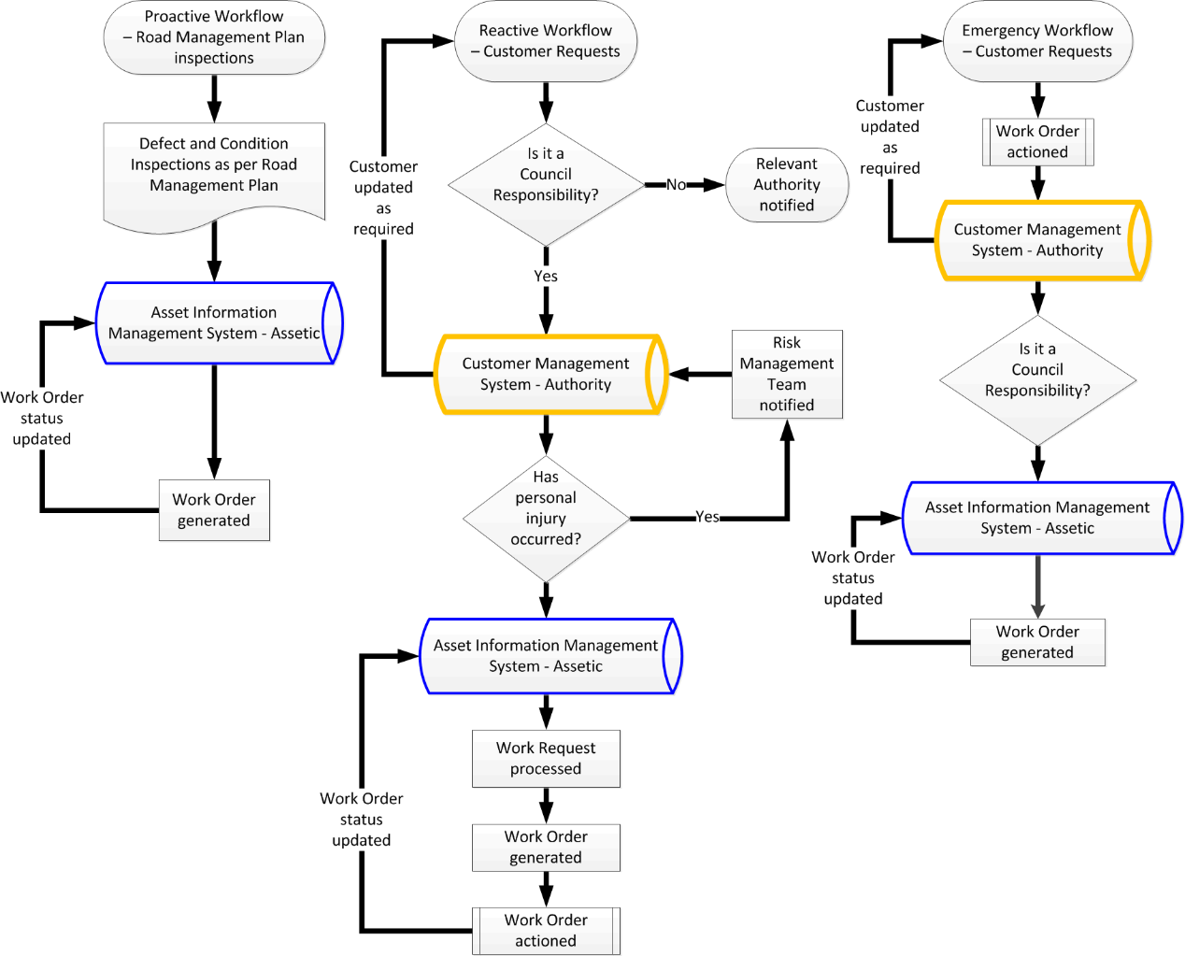
Diagram 5.1 – Overview of Management System

5.3 Managing Works within Road Reserve
Anyone who intends to conduct works within a road reserve must obtain consent from the Co-ordinating Road Authority, unless exempt under the Road Management (Works and Infrastructure) Regulations 2005, Version No. 004. In general, Council is the Co-ordinating Road Authority for all the public roads in the municipality.
To simplify the process for customers, Council uses the state-wide consent process. The process applies to everybody including, but not limited to – property owners, occupiers, tradesman, builders, contractors, developers, building surveyors, utility companies, fire authorities, water authorities, telecommunication carriers and road authorities.
More information about the consent process is contained in A Guide to Working In the Road Reserve, July 2015, jointly developed by VicRoads, Municipal Association of Victoria, Victorian Water and Energy Safe Victoria.

5.3.1 Significant Roadsides
In the municipality, some roadsides are considered as Significant Roadside Areas. These are areas that contain significant native grass, flora and fauna that need protection. Such an area may be signed with “Significant Roadside Area” signs and/or “No Disturbance No Mowing” environmental markers.
Anyone who intends to conduct works within a Significant Roadside Area, must contact Council’s Environmental Planner. A planning permit may be required from City of Whittlesea to destroy, lop or remove any indigenous vegetation in a Significant Roadside Area.
Further information is available from Council’s City Design and Transport Department in relation to application for consent to conduct any works within a road reserve.

5.4 Guidelines for Claims
Any person who wishes to commence legal proceedings in relation to an incident arising out of the condition of a public road or infrastructure for which Council is the responsible road authority, must follow the Claims Procedure specified in Part 6, Division 5 of The Act. Diagram 5.4 below outlines the claim procedure for City of Whittlesea.

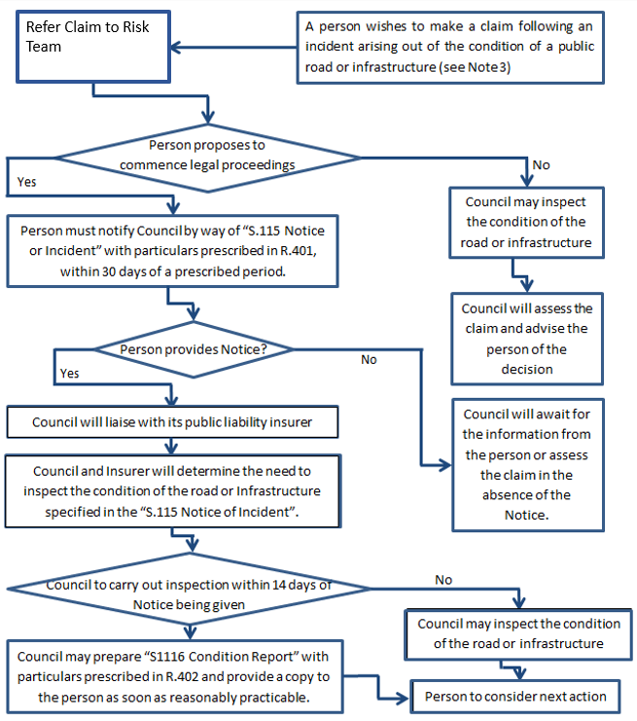Diagram 5.4 – Claims Procedure
Notes
(1) S110, S115 and S116 mean Sections 110, 115 and 116 of the Road Management Act 2004.
(2) R401 and R402 mean Regulations 401 and 402 of the Road Management (General) Regulations 2016.
(3) If it is a property damage claim, Council is not liable for damage where the value is not greater than the Section 110 threshold amount.

6 Review of Road Management Plan
The next review of this Road Management Plan is scheduled to commence by 1 August 2024 and be completed by 30 June 2025, unless otherwise directed by the relevant Road Minister or directed by the Council and Chief Executive Officer.

Referenced Documents
- Road Management Act 2004 (Version 059, incorporating amendments as at 6 April 2020).
- Road Management (General) Regulations 2016 (S.R. No. 11/2016, Version No. 002, incorporating amendments as at 1 January 2020).
- Road Management (Works and Infrastructure) Regulations 2015 (S.R. No. 61/2015, Version No. 001, authorized version as at 20 June 2015).
- Code of Practice for Operational Responsibility for Public Roads (published in Government Gazette, No. S 174 Tuesday 30 May 2017).
- Code of Practice for Clearways on Declared Arterial Roads (published in Government Gazette, No. S 202 Thursday 16 September 2004).
- Code of Practice for Road Management Plans (published in Government Gazette, No. S 201 Thursday 16 September 2004).
- Code of Practice for Management of Infrastructure in Road Reserves (published in Government Gazette, No. S 117 Thursday 28 April 2016).
- Code of Practice for Worksite Safety – Traffic Management (published in Government Gazette, No. S 351 Tuesday 31 August 2010).
DRAFT
- Road Safety Act 1986 (Version 175, incorporating amendments as at 12 April 2017).
- VicRoads, A Guide to Working In The Road Reserve, July 2015.
- City of Whittlesea, General Municipal Law No. 1 of 2014, Reprint No. 2 – October 2008, incorporating General (Amendment) Local Law No. 2 of 2008 and including Building Site Code (published in Government Gazette, No. G51 Thursday 20 December 2007 and No. G42 Thursday 16 October 2008).
- Whittlesea 2040: A Place for All Council Plan 2018-2022 (made for Section 90 of Local Government Act 2020).
- City of Whittlesea, Municipal Emergency Management Plan (made for Section 20 of the Emergency Management Act 1986).
- City of Whittlesea, Municipal Fire Management Plan 2020-2023 (made for Section 20 of the Emergency Management Act 1986; and deemed to fulfill Section 55A of the Country Fire Authority Act 1958).
- City of Whittlesea, Shire of Nillumbik, City of Banyule, Parks Victoria, Plenty Gorge Precinct Integrated Fire Prevention Strategy 2016-2020.
- City of Whittlesea, Asset Management Strategy 2018.
- City of Whittlesea, Register of Public Roads 2020 (or as amended).
- City of Whittlesea, Street Tree Management Plan 2016.
- Whittlesea Bicycle Plan 2016 (or as amended)

Appendix – Definitions
access facility |  | means—  (a) a physical means of entry or exit for vehicles between adjoining land and a road reserve -- example: a driveway on adjacent land; or  (b) infrastructure on a road reserve which provides, or a part of roadway which facilitates, entry or exit  for traffic between the access facility referred to in paragraph (a) and the roadway -- example: a driveway on adjoining land which extends into the road reserve to connect the driveway to the roadway or an acceleration or deceleration lane of a roadway which connects to an entry or exit to adjoining land.  [Source: clause 2(7), schedule 2, Road Management Act 2004, Version No. 035, 5 December 2012]
ancillary area |  | means an area designated as ancillary area by the coordinating road authority under section 18 of the Road Management Act 2004.  Example  Any area which is a "park and ride" carpark, rest stop or scenic lookout could be designated as an ancillary area.  [Source: section 3(1), Road Management Act 2004, Version No. 035, 5 December 2012]
arterial road |  | means a road which is declared to be an arterial road under section 14.  [Source: section 3(1), Road Management Act 2004, Version No. 035, 5 December 2012]  means a road which immediately before 1 July 2004 is declared as—  - a forest road; or  - a main road; or  - a State highway; or  - the King-Street Bridge; or  - a tourists' road—  is deemed to have been declared as an arterial road under Road Management Act 2004.  [Source: clause 1(2), schedule 9, Road Management Act 2004, Version No. 035, 5 December 2012]
condition report |  | means a report of the inspection of the condition of any public road or infrastructure conducted by Council (as the responsible road authority) in response to a notice of incident prepared under section 115 of the Act. The inspection of condition must be carried out, and the corresponding condition report must be prepared, in accordance with section 116 of Road Management Act 2004 and Regulation 402 of Road Management (General) Regulations 2005.  [Source: sections 115 and 116, Road Management Act 2004, Version No. 035; and Road Management (General) Regulations 2005, Version No. 004, 10 April 2013]
coordinating road authority |  | in relation to a road, means the road authority which has coordination functions as determined in accordance with section 36 of the Road Management Act 2004.  [Source: section 3(1), Road Management Act 2004, Version No. 035, 5 December 2012]  in relation to Road Safety Act 1986 –  coordinating road authority, for a road or road related area or highway (a Road Safety Act road), means the coordinating road authority (within the meaning of the Road Management Act 2004) for the road (within the meaning of that Act) that consists of or includes the Road Safety Act road.  [Source: Regulation 4, Road Safety (Traffic Management) Regulations 2009, Version No. 003, 19 December 2012]
date of practical completion |  | means—  in relation to AS4000-1997:  - the date evidenced in a certificate of practical completion as the date upon which practical completion was reached; or  - where another date is determined in any arbitration or litigation as the date upon which practical completion was reached, that other date.  [Source: sections 1, AS4000-1997, Australian Standard - General Conditions of Contract]  in relation to AS2124-1992:  - the date certified by the Superintendent in a Certificate of Practical Completion issued pursuant to Clause 42.5, to be the date upon which Practical Completion was reached; or  - where another date is determined in any arbitration or litigation as the date upon which Practical Completion was reached, that other date.  [Source: section 2, AS2124-1992, Australian Standard - General Conditions of Contract]  Also see “Practical Completion”.
defect |  | means the visible or measurable evidence of failure or undesirable condition of a road or road-related infrastructure asset.  Example: pothole, damaged pit cover, damaged road safety barrier (guard rail). Defects below the stated intervention level are considered reasonable tolerable defects not requiring repair.
emergency |  | means, without limiting the generality of the foregoing—  - an earthquake, flood, wind-storm or other natural event; and  - a fire; and  - an explosion; and  - a road accident or any other accident; and  - a disruption to an essential service;
function |  | in relation to Part 6 Civil Liability of Road Management Act 2004 –  function includes a power, authority or duty.  [Source: section 97, Road Management Act 2004, Version No. 035, 5 December 2012]
highway |  | means road or road related area.  [Source: section 3(1), Road Safety Act 1986, Version No. 151, 30 March 2013]
infrastructure |  | means road infrastructure and non-road infrastructure.  [Source: section 3(1), Road Management Act 2004, Version No. 035, 5 December 2012]
infrastructure manager |  | means—  - in relation to road infrastructure, the responsible road authority under section 37; or  - subject to section 3 and subsection (5), in relation to non-road infrastructure, the person or body that is responsible for the provision, installation, maintenance or operation of the non-road infrastructure.  [Source: section 3(1), Road Management Act 2004, Version No. 035, 5 December 2012]
intervention level |  | in relation to asset maintenance and repairs, an intervention level is the point at which the magnitude of a defect (or defects) is considered to warrant some form of intervention action or treatment.
maintenance |  | the preservation of any road and infrastructure including execution of all works of any description required to keep the road or infrastructure in the state of utility determined in accordance with the Road Management Act.
municipal public road |  | means a municipal road which is also a public road within the meaning of section 17 of Road Management Act 2004. Also see “public road”.  Also see “municipal road” and “public road”.
municipal road |  | means any road which is not a State road, including any road which –  - is a road referred to in section 205 of the Local Government Act 1989; or  - is a road declared by VicRoads to be a municipal road under section 14(1)(b): or  - is part of a Crown Land reserve under the Crown Land (Reserves) Act 1978 and has the relevant municipal council as the committee of management.  [Source: section 3(1), Road Management Act 2004, Version No. 035, 5 December 2012]
night |  | means the period between sunset on one day and sunrise on the next day.  [Source: section 3(1), Road Safety Act 1986, Version No. 151, 30 March 2013]
non-road infrastructure |  | means infrastructure in, on, under or over a road which is not road infrastructure.  Note: See the definition of "road infrastructure".  Examples: Non-road infrastructure would include gas pipes, water and sewerage pipes, cables, electricity poles and cables, tram wires, rail infrastructure (including boom gates, level crossings and tram safety zones), bus shelters, public telephones, mail boxes, roadside furniture and fences erected by utilities.  [Source: section 3(1), Road Management Act 2004, Version No. 035, 5 December 2012]
pathway |  | means a footpath, bicycle path or other area constructed or developed by a responsible road authority for use by members of the public other than with a motor vehicle but does not include any path –  - which has not been constructed by a responsible road authority; or  - which connects to other land.  [Source: section 3(1), Road Management Act 2004, Version No. 035, 5 December 2012]
practical completion |  | in relation to AS4000-1997 –  means is that stage in the carrying out and completion of WUC (work under Contract) when:  - the Works are complete expect for minor defects:  - which do not prevent the Works from being reasonably capable of being used for their stated purpose;  - which the Superintendent determines the Contractor has reasonable grounds for not promptly rectifying; and  - the rectification of which will not prejudice the convenient use of the Works.  - those tests which are required by the Contract to be carried out and passed before the Works reach practical completion have been carried out and passed; and  - documents and other information required under the Contract which, in Superintendent’s opinion, are essential for the use, operation and maintenance of the Works have been supplied.  [Source: section 1, AS4000-1997, Australian Standard - General Conditions of Contract]  In relation to AS2124-1992 –  means is that stage in the execution of the work under the Contract when—  - the Works are complete except for minor omissions and minor defects —  - which do not prevent the Works from being reasonably capable of being used for their intended purpose; and  - which the Superintendent determines the Contractor has reasonable grounds for not promptly rectifying; and  - rectification of which will not prejudice the convenient use of the Works; and  - those tests which are required by the Contract to be carried out and passed before the Works reach Practical Completion have been carried out and passed; and  - documents and other information required under the Contract which, in the opinion of the Superintendent, are essential for the use, operation and maintenance of the Works have been supplied.  [Source: section 2, AS2124-1992, Australian Standard - General Conditions of Contract]
public road |  | means a public road within the meaning of section 17 of Road Management Act, which sets out a road is a public road if it is —  - a freeway; or  - an arterial road; or  - declared under section 204(1) of the Local Government Act 1989, or  - declared under section 61 or 93H of the Melbourne City Link Act 1995; or  (da) declared under section 143 of the EastLink Project Act 2004; or  (db) the Peninsula Link Freeway; or  - a road to which subsection (3) applies; that is –  Subject to section 14(7), the relevant coordinating road authority must register on its register of public roads a road in respect of which the road authority has made a decision that the road is reasonably required for general public use.  Example:  A road set aside as a road in a plan of subdivision registered under the Subdivision Act 1988 is not a public road for the purposes of this Act unless and until a decision is made under subsection (3).  - a non-arterial State road declared under section 14(1) by VicRoads; or  - a municipal road declared under section 14(1) by VicRoads.  [Source: sections 3(1) and 17, Road Management Act 2004, Version No. 035, 5 December 2012]
renewal (asset renewal) |  | activities include the following –  - resurfacing of sealed roads to maintain a waterproof layer and to maintain a surface which has sufficient skid resistance for traffic movements.  - rehabilitation of failed sections of road, such as major patching with asphalt, pavement stabilisation, reconstruction of pavements, adding extra layers on top of a pavement, correction of wheel rutting or surface roughness, correction of pavement shape to enable rainwater to drain off to the side and not ponding on the surface;  - gravel re-sheeting of unsealed roads; and  - rehabilitation of other road-related infrastructure assets, such as replacing unserviceable sections of kerb and channel or pathways.  Also see “maintenance”.
repair |  | means the taking of any action to remove or reduce a risk arising from a defect in a roadway, pathway or road-related infrastructure, including –  providing a warning to road users of a defect in a roadway, pathway or road-related infrastructure –  but does not include the upgrading of a roadway, pathway or road related infrastructure.  Examples  Filling a pothole in a roadway, resurfacing the roadway and erecting a warning sign would be actions to repair the road.  [Source: section 3(1), Road Management Act 2004, Version No. 035, 5 December 2012]
responsible road authority |  | means a person or body specified in or under section 37 of Road Management Act 2004.  [Source: section 3, Road Management Act 2004, Version No. 035, 5 December 2012]  In relation to Road Safety Act 1986 –  responsible road authority, for a road or road related area, means the responsible road authority (within the meaning of the Road Management Act 2004) for the road (within the meaning of that Act) that consists of or includes that road or road related area, and  includes—  - the Link corporation; and  - the Extension corporation; and  - the Freeway Corporation; and  - the Peninsula Link Freeway Corporation.  [Source: Regulation 4, Road Safety (Traffic Management) Regulations 2009, Version No. 003, 19 December 2012]
road |  | in relation to Road Management Act 2004 –  road includes –  - any public highway;  - any ancillary area;  - any land declared to be a road under section 11 of Road Management Act 2004 or forming part of a public highway or ancillary area.  [Source: section 3(1), Road Management Act 2004, Version No. 035, 5 December 2012]  in relation to Road Safety Act 1986 –  means—  - an area that is open to or used by the public and is developed for, or has as one of its main uses, the driving or riding of motor vehicles; or  - a place that is a road by virtue of a declaration under section 3(2)(a)—  but does not include a place that is not a road by virtue of a declaration under section 3(2)(a).  [Source: section 3(1), Road Safety Act 1986, Version No. 151, 30 March 2013]  Note:  In relation to Road Safety Road Rules 2009 –  a reference in Road Rules (except in Part 1, Division2) to a road, does not include a reference to any shoulder of the road.  [Source: Rule 12(2), Road Safety Road Rules 2009, Version No. 009, 11 December 2012]
road authority |  | means a person or body specified in or under section 37 of Road Management Act 2004.  [Source: section 3(1), Road Management Act 2004, Version No. 035, 5 December 2012]
road infrastructure |  | in relation to Road Management Act 2004 –  means –  - the infrastructure which forms part of a roadway, pathway or shoulder, including—  - . structures forming part of the roadway, pathway or shoulder;  - materials from which a roadway, pathway or shoulder is made;  - the road-related infrastructure—  but does not include—  - if the irrigation channel, sewer or drain is works within the meaning of the Water Act 1989, any bridge or culvert over an irrigation channel, sewer or drain, other than a bridge or culvert constructed by a road authority; or  - a bridge or culvert over a sewer or drain constructed under section 132 of the Melbourne and Metropolitan Board of Works Act 1958;  Examples  Materials such as asphalt, bitumen, gravel, lane markers and lines would be materials from which a roadway, pathway or shoulder is made.  [Source: section 3(1), Road Management Act 2004, Version No. 035, 5 December 2012]  In relation to Road Safety Act 1986 –  road infrastructure includes—  - a road, including its surface or pavement; and  - anything under or supporting a road or its surface or pavement and maintained by a road authority; and  - any bridge, tunnel, causeway, road-ferry, ford or other work or structure forming part of a road system or supporting a road; and  - any bridge or other work or structure located above, in or on a road and maintained by a road authority; and  - any traffic control devices, railway or tramway equipment, electricity equipment, emergency telephone systems or any other facilities (whether of the same or a different kind) in, on, over, under or connected with anything referred to in paragraphs (a)–(d); and  - anything declared by the regulations to be included in this definition;  but does not include anything declared by the regulations to be excluded from this definition.  [Source: section 3(1), Road Safety Act 1986, Version No. 151, 30 March 2013]
road-related infrastructure |  | means infrastructure which is installed or constructed by the relevant road authority for road-related purposes to —  - facilitate the operation or use of the roadway or pathway; or  - support or protect the roadway or pathway.  Examples  A traffic control sign, traffic light, road drain or embankment would be road-related infrastructure.  A noise wall, gate, post or board installed on the road reserve by the relevant road authority for road-related purposes would be road-related infrastructure.  [Source: section 3(1), Road Management Act 2004, Version No. 035, 5 December 2012]
road reserve |  | means all the area of land that is within the boundaries of a road.  [Source: section 3(1), Road Management Act 2004, Version No. 035, 5 December 2012]
road user |  | means all users of a road including pedestrians, bicyclists, motorcyclists, public transport passengers and vehicle drivers and passengers.  [Source: clause 6(3), Code of Practice for Management of Infrastructure in Road Reserves, published in Government Gazette, No. S 269 Monday 6 October 2008]
roadside |  | means any land that is within the boundaries of a road (other than the shoulders of the road) which is not a roadway or a pathway and includes the land on which any vehicle crossing or pathway which connects from a roadway or pathway on a road to other land has been constructed.  Example: any nature strip, forest, bushland, grassland or landscaped area within the road reserve would be roadside.  [Source: section 3(1), Road Management Act 2004, Version No. 035, 5 December 2012]
roadway |  | means—  - in the case of a public road, the area of the public road that is open to or used by members of the public and is developed by a road authority for the driving or riding of motor vehicles;  - in the case of any other road, the area of the road within the meaning of road in section 3(1) of the Road Safety Act 1986—  but does not include a driveway providing access to the public road or other road from adjoining land.  [Source: section 3(1), Road Management Act 2004, Version No. 035, 5 December 2012]
shoulder |  | means the cleared area, whether or not constructed or sealed, next to a roadway that provides clearance between the roadway and the roadside but does not include any area that is not in the road reserve.  [Source: section 3(1), Road Management Act 2004, Version No. 035, 5 December 2012]  The shoulder of the road means an area (not being part of the road) adjoining the road that is open to or used by the public for driving, riding or parking motor vehicles and to which a parking control sign does not apply.  [Source: Rule 12(3), Road Safety Road Rules 2009, Version No. 009, 11 December 2012]  Note:  In relation to Road Safety Road Rules 2009 –  a reference in Road Rules (except in Part 1, Division2) to a road, does not include a reference to any shoulder of the road.  [Source: Rule 12(2), Road Safety Road Rules 2009, Version No. 009, 11 December 2012]
Sign |  | includes any associated support structure.  [Source: clause 5(2), Code of Practice for Operational Responsibility for Public Roads, published in Government Gazette, No. S 267 Friday 17 December 2004]
significant roadside area |  | means roadside that contains significant native vegetation including native grasses, shrubs and trees that need protection. Such areas may be signed with “Significant Roadside Area” signs and/or “No Disturbance No Mowing” environmental markers. Refer to the Roadside Conservation Map for the locations.  [Source: City of Whittlesea Roadside Management Handbook, 1999]
substance |  | means substance in any form (whether gaseous, liquid, solid or other) and includes material, preparation, extract and admixture.  [Source: section 3(1), Road Safety Act 1986, Version No. 151]
traffic |  | includes vehicular, pedestrian and all other kinds of traffic.  [Source: section 3(1), Road Management Act 2004, Version No. 035, 5 December 2012]
unused road |  | a government road that was officially set aside for public traffic but never constructed or used.
urban area |  | an area identified as an area intended for an urban purpose.
utility |  | means—  - an entity (whether publicly or privately owned) which provides, or intends to provide, water, sewerage, drainage, gas, electricity, telephone, telecommunication or other like services under the authority of an Act of Victoria or the Commonwealth;  - any person who under the Pipelines Act 2005 is the holder of a license to construct and operate a pipeline;  [Source: section 3(1), Road Management Act 2004, Version No. 035, 5 December 2012]
vehicle crossing |  | (also known as: cross over, driveway, driveway crossing, driveway access)  means that area designed to facilitate the entry of vehicles onto, and the exit of vehicles from, adjacent premises, being an area extending from the property line of the premises to the nearest point of the adjacent roadway.  [Source: section 1.8(1), City of Whittlesea, General Municipal Law No. 1 of 2008, Reprint No. 2 – October 2008, incorporating General (Amendment) Local Law No. 2 of 2008 and including Building Site Code]
works |  | includes any kind of activity conducted on or in the vicinity of a road or proposed road in connection with the construction, maintenance or repair of the road or the installation, maintenance or repair of any infrastructure in, on, under or over a road and without limiting the generality of this definition includes —  - excavating or breaking up the surface of a road;  - erecting a structure in, on or over a road;  - removing or interfering with any structure or marking on a road;  - planting or removing a tree or other vegetation;  - tunneling under a road;  - connecting a road to a road;  - installing pipes, drains, cables, poles, buildings, shelters or other structures on a road reserve;  - erecting any obstruction on a road or otherwise impeding the use of a road for the purpose of conducting any works.  [Source: section 3, Road Management Act 2004, Version 035, 5 December 2012]  does not include emergency works.  [Source: clause 6(2), Code of Practice for Management of Infrastructure in Road Reserves, published in Government Gazette, No. S 269 Monday 6 October 2008]
worksite |  | has the meaning as generally used in the Australian Standard AS 1742.3 – 2009: Manual of Uniform Traffic Control Devices, Part 3: Traffic Control for Works on Roads, being ‘an area which includes the work area(s) and any additional length of road required for advance signing, tapers, side-tracks, or other areas needed for  associated purposes’.  [Source: clause 5(2), Code of Practice for Worksite Safety – Traffic Management, published in Government Gazette, No. S 351 Tuesday 31 August 2010]

City of Whittlesea
Civic Centre: 25 Ferres Boulevard, South Morang
Office Hours: Monday to Friday, 8:30am to 5:00pm
Mail: Locked Bag 1, Bundoora MDC 3083
Telephone: (03) 9217 2170 (24 hours)
TTY: 9217 2420 Fax: 9217 2111 Email: info@whittlesea.vic.gov.au
Website: www.whittlesea.vic.gov.au
Manager Maintenance and Operations, City of Whittlesea
Anthony Kyrkou (03) 9401 0501

