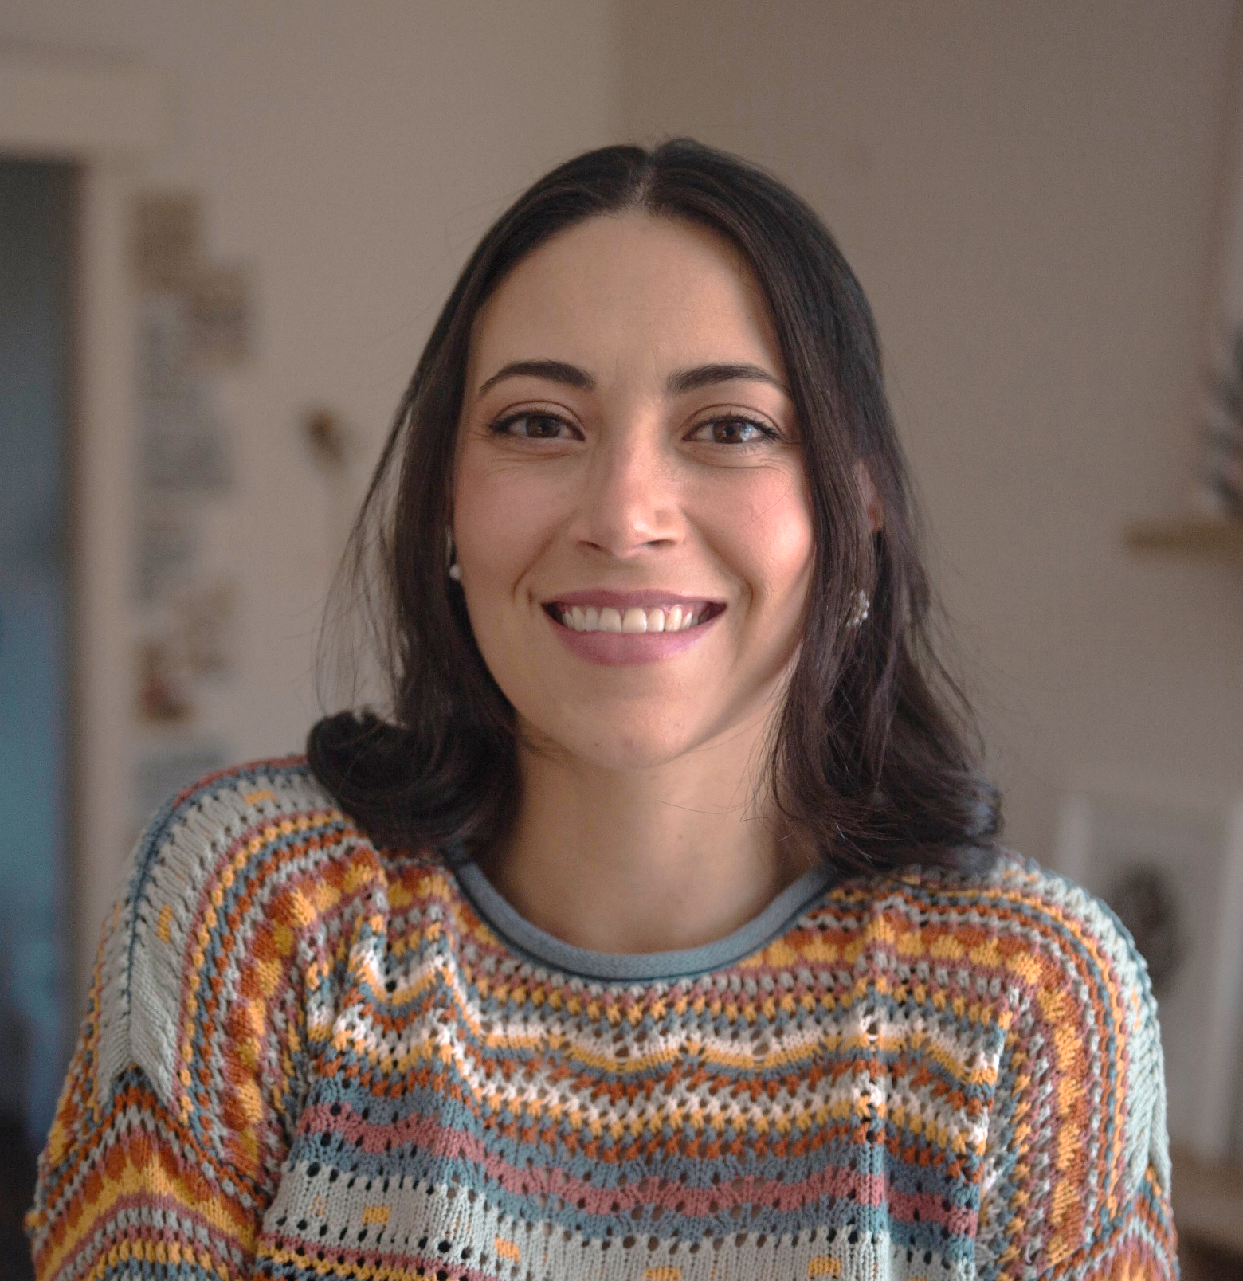 |  | alejandra  sierra Buitrago  FAMILY DAY CARE EDUCATOR  CITY OF WHITTLESEA
Profile  OPEN:  Monday to Thursday 7.00am to 7.00pm  School holiday available  Casual care and weekends by request  YEARS IN CHILD CARE SECTOR: 5 Years in the Education sector 5 years in the infant Health sector  QUALIFICATIONS:  Parent-infant and child Montessori  facilitator  Diploma of Early Childhood and Education  Bachelor of Respiratory Therapy  Diploma of Nursing  SUBURB: Bundoora  Contact  PHONE:  0415 561 412  WEBSITE:  https://www.whittlesea.vic.gov.au/community-support/children-and-families/family-day-care/  For more information about Family Day Care phone 9404 8870 or email famdaycare@whittlesea.vic.gov.au. |  | about me  I am a health professional as a Nurse and Respiratory Technician and during my five years of healthcare experience, I worked in critical care units for newborns and paediatric patients. This experience ignited my passion for working with children and families, so upon my arrival to Australia six years ago I decided to pursue my dream and completed a diploma in Early Childhood Education and Care. For the last three years I have worked in multiple centres and colleges, working deeply with the Montessori methodology.  ABOUT MY SERVICE  I have developed a model that integrates experiential approaches and enhances children’s individual capabilities. My service is based in the following pillars:  ✓ Respect for the individuality and different learning pace of each child  ✓ Construction of a safe and healthy space that promotes exploration and development of abilities and talents.  ✓ Methodology that promotes the integral and harmonious development of body, mind and spirit.  ✓ Intentional activities that strengthen life skills.  My program includes:  ✓ Thematic local visits  ✓ Excursions to natural environments  ✓ Activities aimed at reading, writing and diverse artistic expressions  ✓ Stimulating and creative experiences as a learning enhancer.  ABOUT MY FACILITIES  Growland is a prepared environment for Children, ensuring beauty, order and accessibility of space. It feautures a sequenced range of hand-on learning materials and activities, where children can learn with real-world objects and get real life skills.

