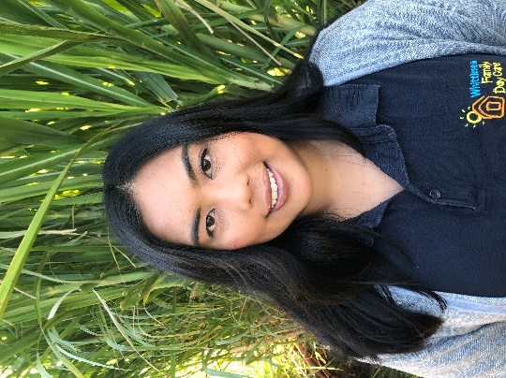
AYEN NADER

FAMILY DAY CARE EDUCATOR

CITY OF WHITTLESEA

PROFILE
OPEN: Tuesday to Friday, 6.30am - 6.30pm
YEARS IN CHILD CARE SECTOR: 6.5+ years
QUALIFICATIONS:
Diploma of Early Childhood Education and Care
First Aid training
Anaphylaxis training
Asthma training
Working with children check
National police check
SUBURB: Wollert

ABOUT ME
I have been working in the childcare sector for 6.5+ years. It was in the year 2018 when I had decided to start transforming our home into a warm, educational, and nurturing space for Family Day Care. I realised the importance and effectiveness of focusing on a small group of children at a time and running a day care that is aligned with my beliefs and expectations.
I am passionate about helping children develop their confidence and kindness. Being a part of their journey to reach their developmental milestones, along with their parents is my goal. I believe that working in partnership with families is key to creating positive outcomes for both the child and the family. Children are treated equally and fairly, regardless of their background and abilities. I create learning environments that help encourage children to develop their social, emotional, cognitive, and physical skills.
I have been married since 2016 and we have been residing in Wollert since 2017. Growing up in a large family helped shape the person I am. My husband and I are family oriented and enjoy the company of family and friends. Some of my hobbies include, cooking, baking, crabbing, camping and collecting cactus and succulents.
The activities that are a part of my curriculum are:
- Excursions (e.g. Bunnings warehouse)
- Nature walks
- Story-time at the library
- Parks
- Playgroup

ABOUT MY FACILITIES
I offer an open-plan spaced area, dedicated room for sleeping, cosy outdoor area enclosed alfresco, surrounded by fully landscape edible garden, which the children are always curious to learn about.
I drive a car that is a 9-seater people mover.

CONTACT
PHONE: 0434 055 996
WEBSITE: https://www.whittlesea.vic.gov.au/community-support/children-and-families/family-day-care/
For more information about Family Day Care phone 9404 8870 or email famdaycare@whittlesea.vic.gov.au

