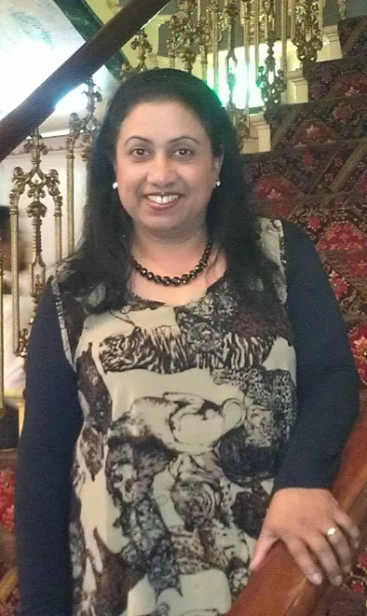
DOROTHY HATROTE

FAMILY DAY CARE EDUCATOR

CITY OF WHITTLESEA

PROFILE
OPEN: Monday to Friday: 7.00am to 6.00pm
YEARS IN CHILD CARE SECTOR: 21+ years
QUALIFICATIONS:
Certificate III in Early Childhood Education and Care
Diploma of Early Childhood Education and Care
SUBURB: South Morang

ABOUT ME
I have worked 21+ years as a family day care educator. I decided to become a family day care educator as I loved working with children and being able to do this in my own home was an added bonus. I have a very supportive and well settled family of my own. I have an encouraging husband who is residing with me and two sons who are settled in their own homes. I am a grand mother of two lovely grandchildren.
My hobbies include sewing, cooking, and going for walks.

ABOUT MY SERVICE
As an educator, I believe each child is unique and I value their different and similar cultures and traditions.
I am always positive in my approach and aim to meet the individual needs of all children in my care, form strong attachments with them and design tailored programs that meet the child’s learning, development and well-being.
My program covers:
- Story time at libraries
- Activities at local parks
- Nature walks
- Attending Playgroups

ABOUT MY FACILITIES
I consider my home to be a friendly, safe and secure environment. I provide a clean and spacious place indoors and outdoors for children to explore endless opportunities to expand their development, knowledge and skills.

CONTACT
PHONE: 0421 315 184
WEBSITE: https://www.whittlesea.vic.gov.au/community-support/children-and-families/family-day-care/
For more information about Family Day Care phone 9404 8870 or email
famdaycare@whittlesea.vic.gov.au.

