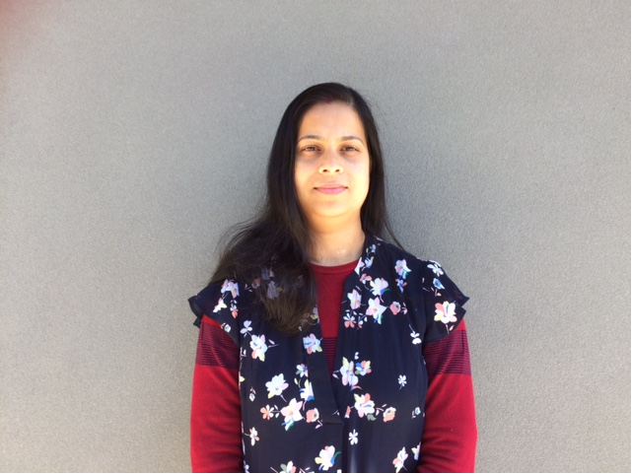
MONI DAS

FAMILY DAY CARE EDUCATOR

CITY OF WHITTLESEA

PROFILE
I am committed to providing quality care, ensuring a safe, secure and friendly environment. I focus on children’s needs, interests and wellbeing as a top priority. I share my experience, skills and thoughts with parents / guardians to achieve the best outcomes for children.
OPEN:
Monday: 8.00 AM to 6.00 PM
Tuesday: 8.00 AM to 6.00 PM
Wednesday 8.00 AM to 6.00 PM
Thursday 8.00 Am to 6.00 PM
Friday 8.00 Am to 6.00 PM
(School Holiday Care available)
YEARS IN THE FIELD: 14 years
QUALIFICATIONS: Diploma in Early Childhood Education and Care

ABOUT ME
I have been working in Family Day Care for 14 years. The first 5 years I worked with Darebin Family Day Care service, and later, joined Darebin’s Early Childhood Management Service.
I love children and enjoy their company. It brings me joy being a part of their holistic development. I enjoy working in small groups.
I have an admirable relationship with children and their families, which is such a great feeling. It feels like they are my extended family. Children’s love, hugs and trust-worthy relationship is the most enjoyable part of my job.
I have a loving and caring family consisting of my husband and three daughters. My husband is an accountant and my children are 15, 10 and 2 years old. I love gardening, travelling and cooking in my spare time.

ABOUT MY PROGRAM
- A safe and secure place with quality care
- Aim to make the child’s day enjoyable and healthy
- A friendly and welcoming environment
- We attend play group and ‘Story Time’ at Reservoir Library
- Nature walks and visits to local park

ABOUT MY FACILITIES
I have a brand-new home which is located only 11 km from CBD. It provides more than enough space for small groups of children (4), with an attached bathroom which makes it easy to monitor all children at all times, ensuring their safety and care. My backyard is spacious and filled with kid’s toys to keep the children active.

CONTACT
PHONE: 0422 355 547
WEBSITE: https://www.whittlesea.vic.gov.au/community-support/children-and-families/family-day-care/
For more information about Family Day Care phone 9404 8870 or email famdaycare@whittlesea.vic.gov.au

