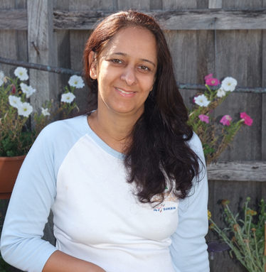
NIVEDITA BHAMBRI

FAMILY DAY CARE EDUCATOR

CITY OF WHITTLESEA

PROFILE
OPEN: Monday to Friday 8.00am to 6.00pm.
(flexible according to care requirements)
YEARS IN CHILD CARE SECTOR: 11 years
QUALIFICATIONS:
Certificate III in Early Childhood Education and Care
Diploma of Early Childhood Education and Care
SUBURB: Reservoir

ABOUT ME
I have been a Family Day Care educator since 2009. My academic qualification consists of a Bachelor of Science, followed by Certificate III in Children’s Services and a Diploma in Children’s Services.
Providing children with a facility in which they can grow and develop is extremely important to me, as I believe the early years of childhood are integral to their development and life-long journey. This has been the greatest and most important factor for me to become an early childhood educator and creating many meaningful connections with children and their families.
I am person of varied hobbies and interest which include gardening, painting, drawing, cooking, badminton and music.

ABOUT MY SERVICE
I believe everyday should be new and exciting for children.
I acknowledge that all children have right to grow and develop in a warm, safe, supported and secure environment. I believe every child should be stimulated to develop and learn in as many areas and ways as possible suited to the needs and strengths and interests of each individual child. I aim to encourage children to make their own choices, solve problems through their own exploration and play.
Some activities include:
- Playgroups
- Nature walks
- Story time at the Library
- Excursions (e.g. Bundoora farm, Melbourne Zoo, Melbourne Museum etc.)

ABOUT MY FACILITIES
I always aim to create an environment that is friendly, interesting and well organized. It is also important for me to be flexible so that it can incorporate and respond to children interest, experiences and needs.
I am to provide a warm and caring atmosphere where children and parents feel welcomed. I uphold the values of children Being, Belonging and Becoming within a caring environment.

CONTACT
PHONE: 0433 213 380
WEBSITE: https://www.whittlesea.vic.gov.au/community-support/children-and-families/family-day-care/
For more information about Family Day Care phone 9404 8870 or email famdaycare@whittlesea.vic.gov.au.

