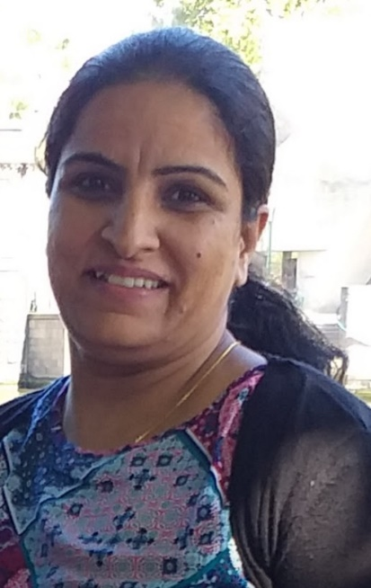
RAMANPREET BHALLA

FAMILY DAY CARE EDUCATOR

CITY OF WHITTLESEA

PROFILE

OPEN: Monday to Friday: 7.00am to 5.30pm
YEARS IN CHILD CARE SECTOR: 3 years
QUALIFICATIONS: Cert III Early Childhood Education and Care
SUBURB: Wollert

ABOUT ME
I am a qualified educator with a Certificate III in Early childhood Education and Care. I hold valid certificates for First Aid training, and I hold both Working with Children check and a National Police check. I have also been working in the child care sector since 2017. I speak English, Punjabi and Hindi. As a family day care educator I enjoy spending time with children and find it rewarding when helping them learn through play, and providing a fun and creative environment.

ABOUT MY SERVICE
I believe in nurturing an environment where children can express their interests and be encouraged to learn through play. I aim to encourage children to be creative, imaginative, confident, take on challenges and be an involved learner. Some activities the children have access to are: excursions, playgroups, visits to parks and outdoor activities.
Some activities I enjoy with the kids are making play dough, painting , art and craft, outdoor activities such as water play, sand play and other.

ABOUT MY FACILITIES
I provide an engaging environment where children feel safe, cared for and enjoy learning. I have both large indoor and outdoor spaces at my home. My home is pet free and smoke free, and each week, I alter the set up of play area to keep things different for the children.

OTHER INFORMATION
I provide care for children aged from 6 months to 12 years. I also provide full-time care, part-time care, casual care, school holidays care.

CONTACT
PHONE: 0405 085 626
WEBSITE: https://www.whittlesea.vic.gov.au/community-support/children-and-families/family-day-care/
For more information about Family Day Care phone 9404 8870 or email famdaycare@whittlesea.vic.gov.au.

