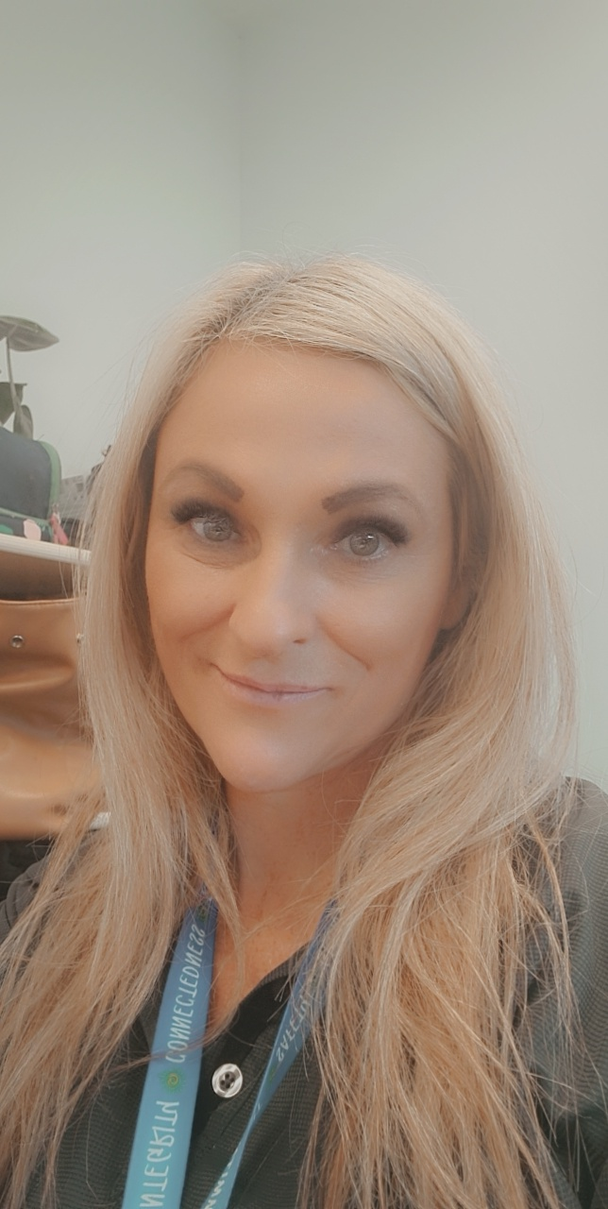 |  | Nikki Clarke  FAMILY DAY CARE EDUCATOR  CITY OF WHITTLESEA
Profile  OPEN: Monday to Friday 8.00am to 5.00pm  YEARS IN CHILD CARE SECTOR: 19+ years  QUALIFICATIONS:  Certificate III in Children’s Services  Diploma of Children’s Services  First Aid Certificate  Asthma  Anaphylaxis  CPR  Food Handler’s certificate  Working with Children’s Check  Police Check  Car restraint training  SUBURB: Mill Park  Contact  PHONE:  0412058767  WEBSITE:  https://www.whittlesea.vic.gov.au/community-support/children-and-families/family-day-care/  For more information about Family Day Care phone 9404 8870 or email famdaycare@whittlesea.vic.gov.au. |  | about me  My name is Nikki and my passion for child care started 19+ years ago.  In 2012 I opened my own Family Day Care business. I have a wonderful husband Chris and together we have 3 beautiful children, Ethan 20, Jasper 10 and Tia 8 that inspire me to not only be a better person but to become a better educator each day.  In 2018 I decided to spread my wings and go into long day care. I soon changed my mind, realizing that Family Day Care is where my passion is.  Some of the fun things i like to do in my own time is dancing, gym and spending time with family and friends  ABOUT MY SERVICE  I believe in creating an environment where children feel a sense of belonging as well as feeling safe, secure and supported. I try to do this by encouraging families to be part of the environment, whether it be providing a family photo or having a parent/family member bring their skills and knowledge to the curriculum. I believe having families be involved is a vital part of each child’s learning story and helps to give them a better sense of identity and belonging as they grow.  A tailored program will be provided for each child’s individual needs that fosters creativity, spontaneity, and develops a sense of community within their learning environment.  I believe in a sustainable environment where I will encourage children to learn about their natural surroundings and resources and how to care for the environment.  By encouraging children to learn independence, teach them about common hygiene practices, it encourages them to imitate these actions, as seeing is a great way for children to learn and at such a young age, they are like sponges.  ABOUT MY FACILITIES  I live in a single dwelling in Mill Park that is warm and inviting. I have a large pergola area outside where the children can play all year round. I also have a toy shed in the backyard that is full of lots of toys and resources although I love to use a lot of natural materials.  other information:  I provide each child with a portfolio that will be full of photo’s, learning stories and observations that they can take home at the end of the year. I also have a business page on Facebook as well as a private Facebook group that only the parents of the children in my care are in.

