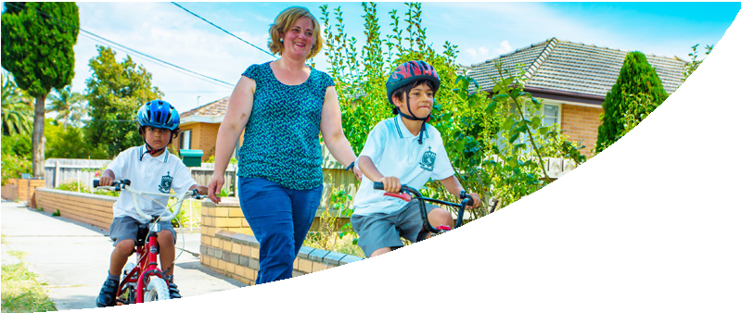
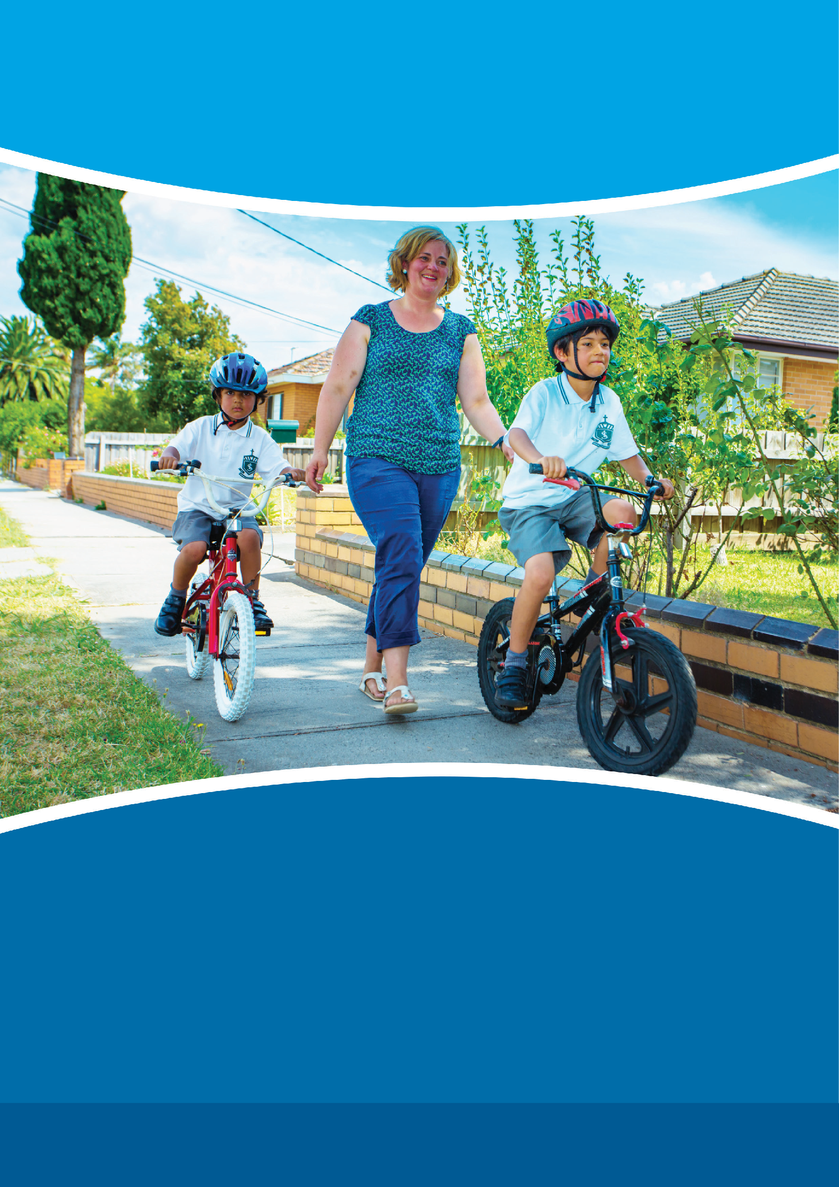
Logo to go here

School Travel Plan

School name here
School Travel Plan

Contents

Contents 2
Introduction 3 The (Insert School Name) Travel Plan 3 Overview of (Insert Name of School) 4 Location 4 Site map 4 Distribution of Students and Staff 4 The Current Situation 5 Student Survey Data 5 Parent Survey Data 6 Staff Survey Data 7 Sustainability of the Travel Plan 8 (Insert Name of School) Approach 9 Vision 9
Objectives 9
Targets 9 Action Plan 10 Budget 14

Introduction
(Insert School Name) Travel Plan Contact Details
Include details of the lead person responsible for implementing the School Travel Plan.

Name: Address: Contact No:
Your introduction should include a rationale for your School Travel Plan. For example:
- What is a School Travel Plan?
- Why does the school need one?
• How does the School Travel Plan fit with school strategic plans, business plan?
- How will the school use its School Travel Plan in the coming years?
- The introduction can also include a summary of the key data arising from the surveys.

(Insert School Photos here)

Overview of (Name of School)

Describe the location of the school, the nature of the community and any other relevant information. The over- view should give someone unfamiliar with the school a brief background. Include the school’s philosophy and values.

Location
Include a brief description of where the school is located and nearby schools and facilities. (Insert a map with nearby schools and facilities)

Site map
Include a school site map, depicting key transport features as identified in site audit including the following:

- the main entrance and access gates
- pedestrian and school crossings
- other road crossing points
- drop off areas
- car parking including staff
- bicycle/scooter parking
- public transport routes and stops/stations
- walking and cycling paths
- roads

Distribution of Students and Staff
Include statistics and/or a map of student and staff trip origin points as an indication of possible travel behaviour. (The City of Whittlesea can assist with mapping if required).

The Current Situation

Using the data collected from your school surveys, provide a summary of how students and staff currently travel to and from your school.

This can include statistical analysis from travel surveys, data collected each term and other consultations the school may have completed.

It should include current impediments to active travel.

Student Survey Data
- Include how many students were surveyed and when they were surveyed
- Include statistics/graph showing current travel methods of students to and from school
- Identify whether travel methods were different between younger and older students
- Include any Ride2School day or Walk to School day data that has been collected in the past
- Include a graph on how students would like to get to school each day compared to current methods
- Include statistics/graph that indicates the main reasons that stop students from actively travelling to school
- Include specific comments from students on parts of their journey that they find dangerous or difficult (e.g. naming and details of specific roads, intersections or other areas around the school that students find dangerous).
- Include a list of other key statistics or comments from the surveys (e.g. what would encourage students to travel to school independently or with their friends often? What would students like to see happen in or around your school to make walking and bike riding easier?)

Parent Survey Data
- Include how many parents were surveyed and when they were surveyed
- Include information on who decides how their children travel to and from school
- Include statistics/graph or comments on the main reasons why parents don’t allow their child(ren) to use active travel to get to or from school or why parents usually drive their child(ren) to school
- Include a graph on how parents would prefer their child(ren) to travel to and from school
- Include a graph/statistics on whether parents would let their child walk or cycle to school
- Include a list of other key comments on what parents would like to see implemented in or around their child(ren)’s school to make active travel an option.

Staff Survey Data
- Include how many staff were surveyed and when they were surveyed
- Include statistics/graph showing current travel methods of staff to and from school
- Include a graph on how staff would like to get to school each day compared to current methods
- Include statistics on why staff travel to work the way they do
- Include information on where staff usually park if driving to school
- Include a list of other key statistics or comments from the staff surveys

Sustainability of the Travel Plan
Discuss how the School Travel Plan will remain a live document, beyond its initial implementation. This could include linking it to one of your objectives or listing it as a school policy.

  - Include who is in your working group and how the school will maintain the group.
  - Identify the resources that are required to maintain and continue to implement your School Travel Plan over time, and how these will be obtained.
  - Include details of the monitoring and review processes will be undertaken, when and by whom. This can include follow up surveys and ongoing data collection. Be specific with dates (Eg. Week 3, 6 and 9 of each term) to keep things on track.
  - Include how the data collected will be used to assess the success of actions and targets in the Action Plan.
  - Include dates of when your School Travel Plan will be updated.

(Insert School photos here)

(Name of School) Approach
After identifying key issues around the site, surveying current travel habits and consulting with your school working group your school will need to outline a vision, objectives, targets and actions based on desired travel patterns.

Vision
Confirm and state the Vision of the school and the School Travel Plan. A number of dot points can be used here to outline the overall school vision.

For example:
  - “Emmanuel College (Junior Campus) provides a school culture that supports active travel to and from school”.

Objectives
Confirm and state three clear objectives of the School Travel Plan. These objectives will help shape the pro- posed actions.

For Example:
  - “Work with the local community to improve bicycle and walking facilities and infrastructure in and around the school to support active travel”
  - “Build a school culture that supports active travel by motivating, educating and encouraging our school community”
  - “Create a safer, healthier and more orderly environment around the school during pick up and drop off times by promoting safer driver behaviour and reducing the number of motor vehicles

Targets
State at least three targets the school wants to achieve through implementing a School Travel Plan. It is impor- tant to set targets that are ‘SMART’ – Specific, Measurable, Achievable, Relevant, Timed. Include both short term and long term targets.

For example:
  - “By Week 10 of Term 2, 2015 the school has a finalised School Travel Plan ready to be implemented upon endorsement from City of Whittlesea”.
  - “By Week 5 of Term 4, 2015, 40% of the school community are actively travelling to and from school”.
  - “By Week 8 of Term 2, 2016, 50% of Years 3 to 6 students are actively travelling to and from school”.
  - “By Week 6 of Term 1, 2016, 35% of Prep to Grade 2 students are actively travelling to and from school”.

Action Plan
The Action Plan is where your school identifies and lists a range of proposed actions and activities to under- take in order to reduce traffic congestion and increase the number of staff and students choosing to travel actively to and from school. It is important to provide as much detail as possible and ensure each proposed action/activity has a clear link to the objective it is listed under. Also include the timeline for each action/activity, who is responsible, the anticipated costs, progress update which will indicate how the success will be meas- ured and what domain of a whole school approach the proposed action/activity fits into. Refer to the resource document titled ‘Activities and Ideas for Overcoming Common Barriers to Active Travel” to assist your working group to develop the action plan.

Examples of proposed actions/activities can be seen in the tables below:

Objective 1: “Work with the local community to improve bicycle and walking facilities and infrastructure in and around the school to support active travel”

Item | Proposed Actions/Activities | By When | By Who | Anticipated Costs | Progress Update (Measure of Success) | Whole of School Approach Domain
1.1 | Upgrade bicycle and and scooter parking facilities so that it is undercover and lockable | Term 3, 2015 -  Planning  Term 4,  2015 -  Implementation | - School council  - Active travel working group  - Community working bee | $2500 | Sarah is researching options (August 21, 2015) and will report back to the working group on  September 1, 2015 | Healthy Physical Environment
1.2 | Install Active Path markers/signage  on preferred walking and cycling routes to school | Term 3, 2015 | - Bicycle Network  - Active travel working group  - Students  - Parents  - School council  - City of Whittlesea | $2000 | Chris to contact Bicycle Network to discuss options and will report back to the group on September 1, 2015 | Healthy Physical Environment
1.3 | Connect missing footpath near the Western entrance | Term 4, 2014 | - Active travel working group  - City of Whittlesea | TBC with City of Whittlesea | NA | Healthy Physical Environment
1.4 | Insert more actions here – add as many lines as needed

Objective 2: “Build a school culture that supports active travel by motivating, educating and encouraging our school community”

Item | Proposed Actions/Activities | By When | By Who | Anticipated Costs | Progress Update (Measure of Success) | Whole of School Approach Domain
2.1 | Establish an Active Travel working group made up of student leaders, principal, parents | Term 1, 2015 | - Lead person  - Principal  - Student Leaders  - Staff | None | Active Travel Working Group established in Week 3 Term 1,  2015. | Engaging children, young people, staff and families
2.2 | Educate parents about active travel (e.g. benefits, what it is) through regular facts and statistics in the school newsletter/social media pages | Begin Term 3,  2015 and include a stat/fact in each newsletter during each term. | - Student leaders  - Active Travel working group  - Lead person | None |  | Engaging children, young people, staff and families
2.3 | Develop and Implement an inquiry unit focused on active travel and road safety for each year level (P-6) | Term 3, 2015  - develop inquiry unit  Term 1, 2016  - Implement across the school | - Lead person Teachers  - Student leaders  - Victoria Walks  - VicRoads | Resources and printing  - $400 |  | Learning and Skills
2.4 | Insert more actions here – add as many lines as needed

Objective 3: “Create a safer, healthier and more orderly environment around the school during pick up and drop off times by promoting safer driver behaviour and reducing the number of motor vehicles”

Item | Proposed Actions/Activities | By When | By Who | Anticipated Costs | Progress Update (Measure of Success) | Whole of School Approach Domain
3.1 | Inform families of preferred/acceptable drop off points and parking locations through the newsletter and social media | Term 3, 2015 and ongoing | - Principal  - Leading Teachers | None |  | Engaging children, young people, staff and families
3.2 | Develop and display a map that indicates preferred drop off points and walking and riding routes into the school | Plan Term 4,  2015  Implement Term 1, 2015 | - Active travel working group  - Students | $300 |  | Engaging children, young people, staff and families
3.3 | Review and/or develop a school physical activity policy to ensure the School Travel Plan is represented in policy. | Term 1, 2016 | - Active travel working group  - School Council | None |  | Healthy Policies
3.4 | Insert more actions here – add as many lines as needed

Budget
Include each anticipated cost that has been noted in your Action Plan, including any other ongoing costs. Include whether the action will be financed by an Active Travel Grant, other sources, or if funding is yet to be sourced.

Item | Anticipated Costs | Ongoing costs | Where is the money coming from?
Relief teacher costs to cover time for surveying and data analysis | $600  2 days @ $300 | None | Active Travel Grant
(Action 1.1) Upgrade bicycle and scooter parking facilities to provide an undercover and lockable area | $2500 | Estimate $200 per year | $1500 committed from Active Travel Grant.  $1000 from  School Council, fundraising, or a Grant from Bicycle Network
(Action 1.2) Install Active Path markers/signage on preferred walking and cycling routes to school | $2000 | None | Active Travel Grant
(Action 2.3) Develop and Implement an inquiry unit focused on active travel and road safety for each year level (P-6) | $400 | $400 for printing resources each year | Active Travel Grant funding in 2015 and school budget for ongoing years
(Action 3.2) Develop and display a map that indicates preferred drop off points and walking and riding routes into the school | $300 | Replace map every 2 years  - $150 annually | School budget
Insert more budget items here – add as many lines as needed

(Insert School Photos for back cover)

(Insert school website)

