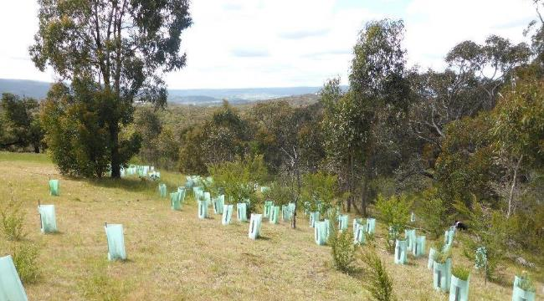

Environmental Works Grant Program

Application Guidelines

Contact for further information

Mark Williams
Rural Land Management Officer
e: mark.williams@whittlesea.vic.gov.au
w: www.whittlesea.vic.gov.au/rural
p: (03) 9217 2471
m: 0408 544 145

Updated: 10 August 2022

Contents
Environmental Works Grant Program 1
Application Guidelines 1
Contact for further information 1
What is the Environmental Works Grant Program? 4
Key Dates 5
Application details 5
Who can apply? 5
What can be funded? 5
Maximum grant amount 7
Who cannot apply? 8
What cannot be funded 8
Decision making 9
Program Priorities / Assessment criteria 9
Assessment process 9
Next Steps 10
How to apply 10
What if successful 11
What if unsuccessful 11

Cover image:
Revegetation enhancing remnant vegetation, Beveridge

Acknowledgement of Traditional Owners
The City of Whittlesea recognises the rich Aboriginal heritage of this country and acknowledge the Wurrundjeri Willum clan as the Traditional Owners of this place.

What is the Environmental Works Grant Program?

Within the City of Whittlesea, the vast majority of our remaining native vegetation is on private land in the rural areas. The Environmental Works Grant Program (EWGP) provides a financial incentive to rural landowners to conduct works on their land that protect and enhance Whittlesea’s remnant vegetation and support local wildlife. The Program also provides assistance for projects that support sustainable land management practices.
The EWGP prioritises supporting projects that will protect remnant vegetation through the erection of permanent stock-proof fencing.
The EWGP is an incentive program, and applicants should be aware that not all costs associated with the project will be covered by the grant. Landowners are expected to provide matching funds either through cash contributions or in-kind labour.
The EWGP is strongly aligned with the Whittlesea 2040: a place for all (2018) goal of a Sustainable Environment and the City of Whittlesea’s Biodiversity Strategy’s overarching goal to protect and improve local biodiversity.

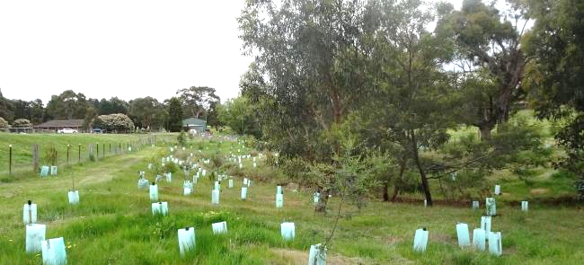
Revegetation enhancing scattered remnant vegetation along a creek line, Eden Park.

Key Dates

1 September to 31 October | Applications open
September to November | Site inspections
December to January | Applicants notified of outcome
30 September | Project completion
30 September | Project acquittal completed
September to November | Project inspections

Application details

Who can apply?
To be eligible to apply for the Environmental Works Grant Program, the property must be:
- Located in the City of Whittlesea.
- 2 hectares (~5 acres) or greater in size.
- Land zoned for rural purposes (Green Wedge Zone, Green Wedge A Zone, Rural Conservation Zone). For properties with multiple land use zoning, the project site must be within one of the zones listed above.
Landowners can apply for a grant in consecutive years, provided that previous projects are completed prior to a new application being submitted.

What can be funded?
Council provides funding for a range of environmental projects including:
Funded Item | General Conditions
Indigenous plants for revegetation | - Only indigenous species will be provided  - Proposed plantings must be a minimum width of 10m and include tree and understory species (unless deemed not required by Council)  - Shelterbelt establishment must consist of 3 rows of plants, planted 3m apart  - Species lists for all projects will be developed in consultation with Council’s Rural Land Management Officer  - Plants will be bulk ordered by Council and provided to landowners.
Environmental weed control within good quality vegetation or control of high threat weeds* | - Council’s Rural Land Management Officer will coordinate the works with a suitably qualified environmental contractor  - Funds for environmental weed control will be transferred to the landowner’s bank account by EFT.
Nest boxes for wildlife | - Nest boxes will be ordered by Council and provided to the landowner  - Once installed by the landowner, a Council Officer will GPS their location. Nest boxes will be included for inspection on Council’s nest box inspection program.
Funding for fencing:  - To protect remnant vegetation (i.e. patches of bush and paddock trees) with permanent stock-proof fencing  - To establish shelterbelts with permanent stock-proof fencing  - To protect farm dams from livestock access | - Must be constructed so that it is permanent and cannot be damaged by livestock. Fencing must include properly constructed corner and end assemblies.  - Fencing must not include barbed wire  - Fencing around paddock trees must extend a minimum of 3m outside of canopy drip line  - Fencing around farm dams must extend a minimum of 4m from the top of the dam bank  - Fencing for shelterbelts must be a minimum of 10m wide  - Funds for fencing projects will be transferred to the landowner’s bank account by EFT.
Livestock-guards (approx. 1.2m tall wire mesh guard) to assist with establishing / protecting seedlings in grazing paddocks | - Livestock guards will be ordered by Council and provided to the landowner.  - Three steel star pickets will be provided with each guard
Minor erosion mitigation works | - Materials will be ordered by Council and provided to the landowner.
Ecological survey of good quality remnant vegetation | - Funds will be provided to the landowner to engage a suitably qualified environmental consultant to undertake the ecological survey

* High threat weeds are weeds of limited distribution with potential to rapidly expand and are new and emerging weeds in the region (i.e. not established weeds)

Proposals to undertake works along waterways (e.g. fencing, weed control and revegetation) should first be discussed with Melbourne Water. The Liveable Communities, Liveable Waterways Program can provide funding for activities along priority waterways identified in the Healthy Waterways Strategy (2018).
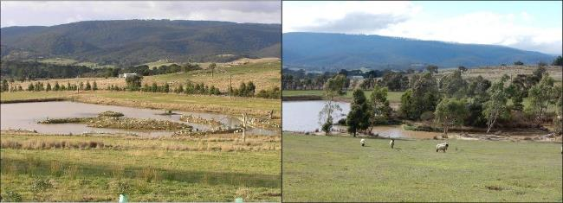
Ten-year-old revegetation around a farm dam, Whittlesea.

Maximum grant amount
Funding available is reflective of the relative importance of the activity as it relates to the EWGPs overall purpose to protect and enhance Whittlesea’s remnant vegetation and support local wildlife.
Proposals may include more than one activity, for example establishing a shelterbelt may include fencing and revegetation, or erosion works may include providing geotextiles and plants for soil stabilisation. These combinations are generally permitted to apply up to $1000.
If a proposal includes fencing of remnant vegetation and revegetation these can be funded up to $1500. Other proposals can be discussed with Council’s Rural Land Management Officer prior to applying.

Activity | Unit price | Max. funding (ex. GST)
Fencing remnant vegetation | $15 / metre | $1500
Fencing farm dam with remnant vegetation | $15 / metre | $1500
Revegetation | $3.30 / plant (incl. stake & guard | $1000
Environmental Weed Control | $500 / treatment | $1000
Nest boxes | $75 / box | $1000
Ecological survey | NA | $1000
Erosion mitigation | NA | $1000
Livestock Guards | $45 / guard (incl. 3 star pickets) | $1000
Fencing to establish vegetation | $10 / metre | $1000
Fencing farm dam (no remnant vegetation) | $10 / metre | $1000

Who cannot apply?
There are a range of reasons a property of the eligible size and land use zoning may not be able to apply for funding, these include:
- Community groups.
- Landowners who have not complied with acquittal requirements for any of the City of Whittlesea’s other grant programs.
- Landowners who have not completed a previously funded project to the satisfaction of Council.
- Landowners who have not satisfactorily maintained previous works as per the Project Agreement
- Properties with unresolved contraventions of the Whittlesea Planning Scheme.

What cannot be funded
- Removal of indigenous vegetation.
- Boundary fencing or internal paddock fencing.
- Revegetation with non-indigenous plants.
- Remediation works associated with planning enforcement action.
- Control of weeds prescribed as noxious under the Catchment and Land Protection (CaLP) Act or City of Whittlesea General Municipal Law. Landowners have a legal responsibility to manage those weeds.
- Control of foxes and rabbits. Landowners have a legal responsibility to manage pest animals under the Catchment and Land Protection (CaLP) Act.
- Projects / works that have begun or been completed prior to funding approval.

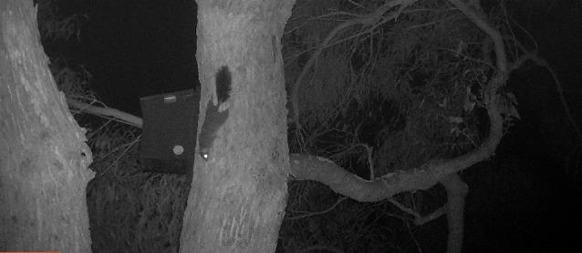
Installing nest boxes can provide critical habitat for local wildlife including the threatened Brush-tailed Phascogale. Image courtesy: Suzi Duncan.

Decision making

Program Priorities / Assessment criteria
The City of Whittlesea gives priority to projects that will protect and enhance Whittlesea’s remnant vegetation through fencing to exclude livestock, environmental weed control and revegetation.
Applications are prioritised on how closely they align with the purpose of the Environmental Works Grant Program. Priorities for funding are listed below from highest to lowest:
- Protection of remnant vegetation through erection of permanent fencing, including patches of remnant bush, isolated paddock trees and around farm dams containing remnant vegetation
- Environmental weed control to reduce threat to remnant areas from weeds
- Revegetation to enhance remnant vegetation. Can be around paddock trees or within /adjacent to bush areas
- Establishing new vegetation and fencing that vegetation, i.e. shelterbelt establishment, boundary plantings, fencing farm dams and planting around them. If boundary plantings complement remnant roadside vegetation given higher priority. Also, establishing habitat for local wildlife (i.e. nest box installation) at this level
- Minor erosion control works to protect areas of remnant vegetation.

We will also give priority to projects specifically in areas:
- Identified as having significant habitat values as nominated in the NEROC Report: Sites of Significance in North East Melbourne (contact us on 9217 2471 for further advice).
- Identified as being part of a habitat link as nominated in the NEROC Report where revegetation can link or strengthen habitat corridors.
Applications from landowners who have demonstrated an ongoing commitment to sustainable land management practices will be viewed favourably.

Assessment process
Review of eligibility
Following submission, all applications are assessed to determine if they meet the eligibility criteria of property size and land use zoning.

Property visit
A Council Officer will arrange to meet landowners whose project meets the eligibility criteria at the property. The property meeting may result in changes to your proposed project, with any changes to be agreed upon by both parties. If there are agreed changes, the application will be amended in SmartyGrants to reflect this by the Council Officer.
The amended application will used in the next stage of the assessment.

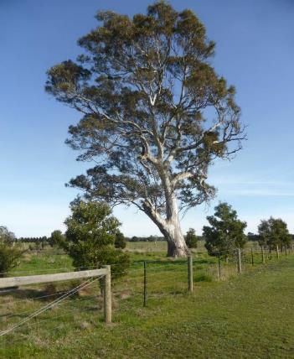
Review of application against the Program’s priorities
Council’s Rural Land Management Officer will assess each application on its merits against the priorities / assessment criteria for the Environmental Works Grant Program.
Note- Applications for properties within the Bushfire Management Overlay (BMO), or where there may be increased fire risk to an adjoining property, may be discussed with Council’s Municipal Fire Prevention Officer to determine if the project is supported.

Recommendations
Recommendations are submitted to the Manager Sustainable Environment who provides the final approval of projects to be funded by the City of Whittlesea.
Paddock tree fencing and revegetation, Whittlesea

Next Steps

How to apply
Each round of the EWGP is delivered as an open competitive funding round. Interested landowners must apply online through SmartyGrants and are required to have an email address to register as a SmartyGrants user. The link to apply is provided on Council’s website. Landowners who have difficulty with the application process can contact Council’s Rural Land Management Officer for assistance on 9217 2471.
Landowners are welcome to discuss their project with Council’s Rural Land Management Officer prior to applying, however this is not a mandatory requirement.

What if successful
Successful landowners being required to enter into a Project Agreement with the City of Whittlesea. The Project Agreement sets out the conditions placed on the landowner in accepting the grant and clearly identifies the project area on their property. Once the Project Agreement is signed and returned to Council, materials and / or funds will be distributed to successful applicants.
Works must be completed by 30 September. An online project acquittal will be required to be completed by this date in SmartyGrants, with receipts / invoices and photographs of completed works to also be provided. Once an acquittal has been lodged, a Council Officer will make contact to arrange an inspection of the completed project.
Grants must be used in accordance with the terms outlined in the Project Agreement or funds will be required to be repaid to the City of Whittlesea.

What if unsuccessful
If your application is unsuccessful, you will receive a letter from the City of Whittlesea outlining the reason(s) why. An unsuccessful application will not hinder any future applications.

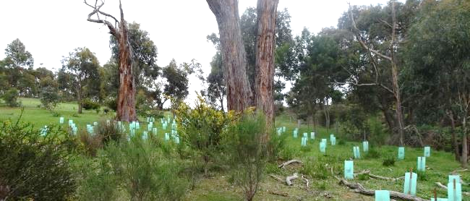
Revegetation complementing remnant vegetation and connecting large isolated trees to a well vegetated creek corridor, Beveridge.

