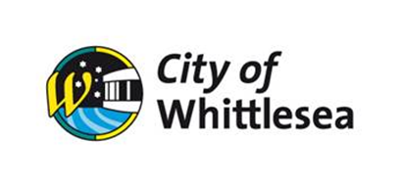

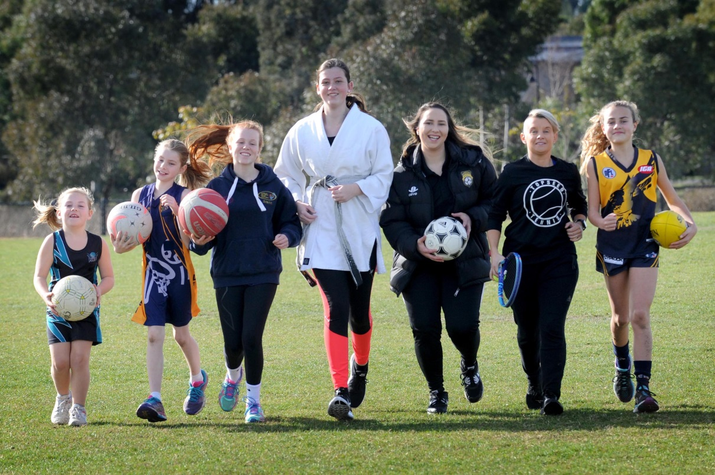

Female Inclusion in Sport
Grant Program
Grant Guidelines

Contents
Introduction 3
What is the Female Inclusion in Sport Grant Program? 3
Maximum grant value 3
Key Dates 4
Gender Equity Workshop 4
Female Inclusion in Sport Online Support Sessions 4
Who can apply 4
Who cannot apply 5
What can be funded 5
Project ideas and costings 6
What cannot be funded 8
Assessment process 8
Assessment criteria 9
How to apply 9
Recommended resources 10
Complimentary projects 10

Acknowledgement of Traditional Owners
The City of Whittlesea and DPV Health Ltd recognise the rich Aboriginal heritage of this country and acknowledge the Wurundjeri Willum Clan and Taungurung People as the Traditional Owners of lands within the City of Whittlesea.

If you have any questions, please contact:

Leisure Inclusion Officer
Phone: (03) 9217 2170
Email: leisure@whittlesea.vic.gov.au
Grants Team
Phone: (03) 9217 2397
Email: community.grants@whittlesea.vic.gov.au

Introduction
The sporting field is often regarded as a space where differences are put aside in the pursuit of fair play and “having a go”. But when it comes to fairness, statistics show that women and girls are underrepresented in sport, both as players and leaders. In fact, only half of Victorian women are sufficiently active.
Women and girls experience many barriers that make participating in physical activity difficult. These barriers are varied and sometimes complex, however we know that gender inequity is at the basis.
Research from VicHealth’s 2012 ‘This Girl Can’ campaign found two in five women feel embarrassed exercising in public, and one in three believe sporting clubs are not welcoming to them. This is despite most clubs believing they are welcoming and provide a sense of community and belonging.
Sport plays a significant role in our national identity, with sports clubs considered important social institutions where community attitudes and behaviour norms are shaped. With 98% of Victorians expecting that their local community sporting clubs provide a welcoming and inclusive environment for women and girls, it’s safe to say that sports clubs have an important role in levelling the playing field and committee rooms.
<Include Fair Access Policy/ Legislation comment here>

What is the Female Inclusion in Sport Grant Program?
The Female Inclusion in Sport Grant Program is co-funded by the City of Whittlesea and DPV Health. The program aims to financially support projects that are accessible and safe for women and girls from all experiences and backgrounds and create a positive impact or break down barriers for participation.
Objectives of the Female Inclusion in Sport Grant Program are to:
  - Increase the level of physical activity for women and girls
  - Increase opportunities for women and girls in sport
  - Increase the number of women involved at a decision-making level in sport
  - Increase the number of women coaching and officiating
  - Provide environments where women and girls feel valued and respected
  - Create a club culture where the capabilities of women and girls in sport are not limited
  - Assist sports clubs to provide meaningful long-term opportunities for women and girls in sport
  - Raise awareness and education on gender equity and its impacts

Maximum grant value
The maximum grant amount is $3,000 (ex GST) per club. Applications seeking smaller amounts are also encouraged.
Applicants can undertake multiple activities (as outlined in the application form). However, only one application per club will be accepted.
Applications can include equipment purchases. However, equipment purchases cannot exceed more than 50% of the funding request* and must be associated with funded activities.
* If applying for the ‘Club kits’ project 100% of the funding request may be used to purchase a club kit exclusively for use by women and/or girls.

Key Dates
Applications open | Wednesday 15 November 2023
Applications close | Friday 19th of January 2024
Applicants notified of outcome | Approximately 6 weeks after submission*
Gender Equity Workshop | TBC
Female Inclusion in Sport Online Support Sessions | March, April, May and June.
Acquittal due date | 6 months after successful outcome notification
* Applications will be assessed at the end of each month (February – May) and applicants notified of the outcome of their application shortly thereafter.

Gender Equity Workshop
All successful grant applicants must send a club representative to attend a Gender Equity Workshop. The date and time for this workshop are yet to be confirmed. Not attending this session may affect your club’s eligibility for future grants.

Female Inclusion in Sport Online Support Sessions
As an added support, Council’s Leisure Inclusion Officer will facilitate a series of online support sessions with successful recipients. These sessions will allow clubs to seek support for their funded activities and learn from the experiences of other clubs in attendance. Attendance at these sessions is encouraged.

Who can apply
To be eligible for funding, clubs must:
- Be a registered not-for-profit sports club located within the City of Whittlesea
- Be registered with their relevant State Sporting Body/Association
- Have acquitted all previous grants with the City of Whittlesea
- Commit to a representative attending a Gender Equity Workshop
- Be incorporated or partnered with (auspiced by) an incorporated organisation. The incorporated organisation will manage the funds and be responsible for the delivery and acquittal of the project.
- Have an Australian Business Number (ABN) or qualify to submit a Statement by Supplier
- Hold current public liability insurance appropriate to the activity outlined in the application

Applications from previously successful clubs are welcomed, however applicants who have not received funding in the past 12 months will be prioritised for funding.

Clubs must discuss their project idea with the Leisure Inclusion Officer before beginning an application.

Who cannot apply
- Schools, religious organisations, community support groups
- Health services or for-profit operations (e.g. businesses)
- Professional sporting bodies and elite sport teams
- Clubs who have not complied with acquittal conditions from previous Council funding
- Individuals
- Clubs of a political nature.

What can be funded
The following pages provide a list of project ideas that can be implemented to support an increase in women and girl’s inclusion in your sports club. Estimated project cost is provided as a guide only.
The project ideas have been divided into 4 key areas of focus:
  - Strategy and Governance
  - Leadership Development
  - Player Recruitment and Development
  - Welcoming Club Culture
Clubs can choose to undertake multiple projects from one or more of the key areas listed above. If selecting more than one project, clubs must be confident that they have the capacity and resources to deliver all selected activities.
How your club will deliver this project (project plan) and where money will be spent (budget) will need to be addressed in the application. Clubs will be required to provide quotes, for items costing $500 or more (ex GST), as part of the application process.

What cannot be funded

Clubs previously funded under this initiative can not receive funding for the same/similar project idea previously funded.

Project ideas and costings
Please note the ‘project idea’ your club will undertake. The project idea will need to be selected within the application form.
Project idea | Description | Estimated project cost
 | STRATEGY & GOVERNANCE
Review governance | Review and update constitution, code of conduct, policies etc to remove gender-based language and make them more inclusive. | Up to $1,000
Showcase | Showcase the involvement of women and girls in your club including volunteers, coaches, players, officials and committee members.  (photographer/videographer etc) | Up to $1,500
Diversify options | Diversify your offerings (PT classes/Walking group) | Up to $3,000
Consultation | Consult existing and/or potential club members about:  - The club’s culture  - Increasing women and girl’s involvement in the club | Up to $3,000
 | LEADERSHIP DEVELOPMENT
Role modelling | Provide opportunities for women in your club to speak at committee meetings, speak with junior players, speak at events, run training sessions. | Up to $1,500
Men’s coaching development | Coaching development for men who coach women and girls | Up to $2000
Women’s coaching development | Development opportunities for women and girls who coach | Up to $3,000
Committee development | Capacity building for women who are, or could be, a part of the club’s committee (current or potential committee members) | Up to $3,000
 | PLAYER RECRUITMENT & DEVELOPMENT
Team establishment | Establishment of programs and/or teams for women and girls | Up to $1,000
Come & Try | Hold an event which is open to the wider community (e.g., come and try day, bring a friend day, bring your sister day) | Up to $1,000
Player development | Invest in player development (leadership, skills etc) for women and girls | Up to $2,000
Teen program | Provide programs specifically for teen aged girls | Up to $3,000
Social sport | Establishment of social sports programs for women and girls (e.g., SoccerMums, Rock up Netball, Social Sixes) | Up to $3,000
Skills program | Free skills program/development sessions/skills sessions for women and girls | Up to $3,000
Reduced cost | Reduced memberships/uniform/fees/sign on costs | Up to $3,000
Club kits | Club kits available exclusively for use by women and/or girls | Up to $3,000
Participation pathways | Provide a seamless pathway for participation of women and girls in sport.  (i.e., juniors to seniors) | Up to $3,000
 | WELCOMING CLUB CULTURE
Social aspect | Provide a social aspect to participation, that encourages connection between potential and current members and provides a supportive environment. * This must be directly linked to participation and does not include celebratory events, and themed morning teas for campaigns etc | Up to $1,000
Club workshop | Have club members attend workshops that address:  - Gender equity  - Engaging women and girls in sport  - Inclusive club culture  - Bystander workshops  - Sexism  - Prevention of violence against women  - Toxic masculinity  - Respectful relationships | Up to $3,000

What cannot be funded
- New building projects, capital works, maintenance or renovation projects
- Core operational or day-to-day running costs
- Catering costs where provision of food is not considered integral
- Non-portable equipment (e.g., fixed goal posts)
- Gift vouchers, gifts, prizes, trophies, scholarships, donations, sponsorship, other grant programs, air travel or accommodation
- Activities that:
  - Do not comply with relevant Department of Health and Human Services directions (e.g., physical distancing/density requirements)
  - Are the responsibility of other levels of Government
  - Are started or completed before funding is granted
  - Do not take place within the City of Whittlesea
  - Promote gambling, drugs and/or alcohol

Assessment process
Applications are reviewed for eligibility
A panel assesses eligible applications based on how well the proposed activity meets the assessment criteria.
Applications recommended by the assessment panel are reviewed by management for approval.
Applicants are advised of their outcomes.

To increase your application’s chance of success, we encourage applicants to:
- Read these guidelines carefully
- Check your club is eligible to apply
- Provide:
  - Your group’s incorporation number
  - Letters of support
  - Quotes for items costing $500 or more (ex GST)

Please note: Applications submitted without appropriate quotes (for items costing $500 or more excluding GST) will be marked as incomplete and therefore ineligible.

Assessment criteria
If your club and project meet eligibility criteria, your project will be considered according to how well it meets each of the assessment criteria. The percentages are provided as a guide to the importance of each question in the assessment process.
Project delivery (60%)
Has the applicant provided:
- Clearly defined aims and outcomes
- A clear project plan (including timeline)
- A clear understanding of the need for this specific project for their club
- A commitment to providing opportunities for women and girls
Community involvement (20%)
Has the applicant:
- Addressed issues of equity, access and inclusion
- Identified a realistic group/s of expected participants
- Considered how they will engage participants from diverse backgrounds and experiences
- Provided a clear understanding of how the project will remove barriers to participation
Ongoing benefits (15%)
- Has the applicant demonstrated how this project could provide ongoing benefits to those involved (project participants, the club and the wider community)?
Budget (5%)
- Is the budget reasonable and does it add up?

How to apply
1. Ensure you have carefully read and understood these guidelines before completing your application.
2. Applications for the FISG are submitted online at https://whittlesea.smartygrants.com.au/FISG_23-24

Please note: to apply on-line you will need an email address. If you cannot access the internet or require printed forms, please contact the Community Development Grants Officer (details on Page 2).
If you have difficulties logging into an existing account or registering a new account, please contact the SmartyGrants helpdesk (9am to 5pm Monday to Friday) on (03) 9320 6888.

Recommended resources
Change the story through sport – The resource illustrates the important role that sport can play in promoting gender equality and respect to help change the story about violence against women in Australia
This Girl Can - Resources provided to assist clubs and organisations to engage women to get active – however, wherever and whenever they choose, without being judged.
Inquiry in women and girls in sport – This report sheds light on gender inequality in Victorian sports and recreation. The report outlined a way forward, helping change and improve sport and recreation for all involved
Recruitment and retention: Guidelines for women in sport and recreation – Simple and practical guidance and strategies to ensure women and girls have rewarding experiences, making them more likely to stay on at a club
Women in sport communication and marketing strategies – This document has been developed in partnership with the Victorian Equal Opportunity and Human Rights Commission (VEOHRC) to assist community sport and recreation organisations looking to develop inclusive communication and marketing practices
AusPlay focus women and girls delves into the participation of Australian women and girls in sport and physical activity and the difference between male and female patterns of behaviour.

Complimentary projects
Whether or not your application is successful, you may like to consider undertaking one or more of the following projects to support women and girls to feel welcome and increase their participation in your club.
- Have committee members and coaches commit to reading at least two resources from the list above
- Contact a club who is committed to women and girls’ participation and discuss the things that have or haven’t worked for them
- Sign up as a This Girl Can supporter and engage with their resources
- Create and promote a mission statement for women and girls’ participation within the club
- Create and promote a club policy which supports an environment where there is zero tolerance for sexism or homophobia
- Form a sub-committee dedicated to women and girls’ participation
- Use imagery and messaging (on socials and in the club rooms) which promotes involvement of women and girls at your club
- Ensure women’s and girls’ teams are featured and promoted across all your social media channels
- Contact your State Sporting Association for support to complete a gender equity audit
- Consult with women and girls regarding training options and their needs
- Schedule women’s and girls’ games and training sessions on the main playing area and in prime timeslots
- Have a contact person available to introduce women, girls and their families to your club. Provide a consistent and familiar face with a supportive nature.

