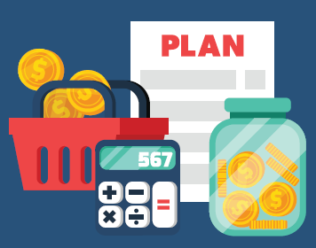
Money Plan

Money Plans are a great way to help you track, plan, and prioritise where your money is going. Following a money plan or spending plan can also help to keep you debt free or help to work your way out of debt if you are currently in debt. Below is a simple Money Plan tool that you can use.

INCOME | $AMOUNT | $AMOUNT | $AMOUNT
Your take-home pay
Your partners take-home pay
Bonuses/overtime
Centrelink Benefits
Family Tax Benefit
Child support received
TOTAL INCOME A

HOME AND UTILITIES | $AMOUNT | $AMOUNT | $AMOUNT
Rent
Electricity
Gas
Water
Internet
Pay TV
Home phone
Mobile
Other
Insurance and Financial
Car insurance
Home and content insurance
Health insurance
Car loan
Credit card payments
Personal loan
Pay day lender loans
Interest free loans
Money owed to family
GROCERIES
Supermarket
Butcher
Deli and bakery
Pet food
PERSONAL AND MEDICAL
Cosmetics and toiletries
Hair and Beauty
Medicines and Pharmacy
Glasses and eye care
Dental
Doctors and Medical
Hobbies
Clothing and shoes
Jewellery and accessories
Computers and gadgets
Sports and gym
Entertainment and Eat out
Coffee and tea
Lunches bought
Take away and snacks
Cigarettes
Drinks and alcohol
Bars and Clubs
Restaurants
Books
Newspaper and magazines
Movies and music
Holidays
Holidays
Celebrations and gifts
Transport
TOTAL EXPENDITURE B

 | $AMOUNT | $AMOUNT | $AMOUNT
INCOME A
- EXPENDITURE B
= BALANCE

