**City of Whittlesea**

**Street Activities Guidelines**

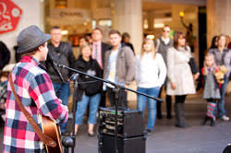 

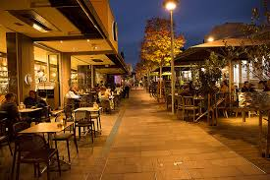

**October 2019**

1. **Introduction**

The Street Activities Policy was developed to maintain the balance between commercial, fundraising or community benefit activities whilst providing a safe and unobstructed access for all people to move through the municipality.

These Guidelines have been developed to support the Street Activities Policy and provide applicants with the necessary information to determine if they need a permit for their proposed activity, what restrictions may be in place and what information is required to successfully apply. They have been developed by Council in consultation with the local community to ensure the chosen activity is in keeping with the use and management of Council land.

Council will encourage activities that contribute to the amenity and character of our streets whilst at the same time ensuring that a safe and unobstructed access is maintained for people to move along footpaths to meet the requirements of the *Disability Discrimination Act 1992.*

The policy and guidelines do not cover Council sanctioned events such as festivals, markets or fairs. Council’s Events Policy will apply in these circumstances.

**What is street activity**

Street activity involves the use of public footpaths and land for both commercial and charitable purposes.

Commercial purposes can include the placement of advertising signs (A-frames), display of goods, tables and chairs, planter boxes, screens, umbrellas, awnings / blinds and busking.

Charity purposes include activities such as fundraising through sale of goods or raffles and highway collections.

**Why have street activity**

Street activity can be a valuable use of public space and can add a vibrancy to shopping strips. It supports the local economy and provides businesses an opportunity to expand their available space and advertising. It also allows for community groups and charitable agencies to engage with the local community.

1. **Objectives**

Council has the following objectives when considering street activity applications:

1. **Public safety:** footpaths are safe and have an unobstructed passage for all pedestrians and safe and unobstructed vision for road users
2. **Accessibility:** footpaths provide clear and unobstructed access for pedestrians of all abilities
3. **Economic benefit:** assist in developing thriving and prosperous business and shopping areas
4. **Amenity:** any activity will fit with the overall street character maintaining an attractive and clean visual amenity
5. **Interaction:** activity supports interaction leading to social benefits, street trading and alfresco dining as enjoyable activities
6. **Public Health:** enhance the outdoor environment by providing shelter from the sun and limiting the impact of tobacco smoke

These objectives will be achieved by:

1. A formal permit application process so Council can consider what the activity offers the area and whether it supports local business and community groups
2. Permits must be issued prior to any activity occurring (some fees maybe waived)
3. A clear set of permit conditions highlighting the responsibilities of the permit holder
4. Council will monitor compliance with this policy and the conditions of relevant permits
5. A breach or non-compliance with the permit or failing to obtain a permit will
6. Enforcement measures being taken
7. **Application Process**

*New application*

Applicants should read the Street Activity Policy and Guidelines prior to making an application to Council. All activities listed in this Guideline require a permit however the fee structure is varied.

It is important that applicants understand all responsibilities, legal obligations and potential costs involved in establishing their activity. Staff are available to assist with enquiries prior to any formal application being made.

So that all applications can be assessed as quickly as possible, applicants should ensure they include the following unless directed otherwise on the application form:

* Complete and sign the appropriate application form
* Current certificate of currency in relation to public liability insurance (minimum amount stipulated on application form)
* Site plan of proposed activity drawn to scale including any Council assets (seats, bins, trees, signage etc.)
* Photographs of the site
* Details of proposed outdoor furniture or display cases
* Details of proposed advertising signage
* Copy of any required planning / building permits
* Current registration to serve food under the *Food Act (Vic) 1984*
* Copy of liquor licence if intending to serve alcohol
* Payment of required fee

Application forms can be located on the website at [www.whittlesea.vic.gov.au](http://www.whittlesea.vic.gov.au)

An Authorised Officer may visit you to discuss and assess the application if clarification is required. Failure to submit all required documentation may result in delays in approving the application.

*Assessment and Decision making*

Council will take into account a number of factors when assessing the application including:

* All required documentation is provided
* What the activity offers to an area
* The suitability of the proposed location including access for people with disabilities
* Location of existing public infrastructure
* Proximity to roads and parking bays
* Driver and / or pedestrian sight lines
* The type and proximity of nearby businesses
* Proximity to residents
* Other possible safety hazards

1. **Permits**

Permits will be issued on an annual basis or for a set period depending on the activity applied for.

All annual permits will expire on the 30th September unless otherwise specified.

A permit is granted on the understanding that the applicant will adhere to all requirements of the policy and conditions applied to the permit.

A permit for any street trading purposes must be displayed clearly in the shop window and must be current. Failure to display the permit is a breach of the permit conditions.

A permit expires if:

* The permit holder ceases to be the proprietor of the business
* Any of the permit conditions or requirements of the policy cease to be met by the permit holder

*Transfer of Ownership*

Permits issued under this Policy are for the person / company / association listed on the permit and cannot be transferred to another trader.

*Renewal of an existing permit*

Existing annual permit holders will receive a renewal notice one month prior to the expiry date. It is the responsibility of the permit holder to ensure all renewals including updated public liability information and fee payments are made to Council before the due date.

*Legislative requirements*

Depending on your activity permit holders must adhere to other relevant legislation and their requirements including but not limited to:

* Food Act 1984 – provision of food and beverages
* Tobacco Act 1987 (Amended 2017) – smoking in outdoor dining areas
* Planning and Environment Act 1987 – sale of liquor
* Victorian Commission for Gambling and Liquor Regulation – sale of liquor on conduct of fundraising activities

1. **Fees**

There are a variety of fees associated with street activities and these are determined by Council on an annual basis. The permit type may determine the month within that financial year where renewals of permits are due.

Charities and not for profit community organisations will generally be exempt from payment or receive a reduced rate.

A schedule of the fees is on Council’s website [www.whittlesea.vic.gov.au](http://www.whittlesea.vic.gov.au).

An Authorised Officer of Council may liaise with traders during the application period and visit the premises to provide advice and ensure the policy conditions can be met.

Officers will assist traders to comply with the Local Law and guidelines by offering constructive advice and support.

1. **Public Liability Insurance**

Any business applicant for street activity must have a valid Public Liability Insurance Policy to the value of at least $20 million for the duration of the permit.

The Policy shall extend to cover Council in respect to claims for personal injury or property damage arising out of negligence of the permit holder.

A copy of the Certificate of Currency will be required at the time of application and a new copy provided in the event it lapses during the permit period.

Small community groups or not for profit groups will be assessed on a case by case basis to determine the level of coverage required.

1. **Footpath Zones and requirements**

Footpaths and public walkways in shopping centres are divided into four zones,

1. **Pedestrian walkway**

The pedestrian walkway must be a minimum of 1.5 metres wide to provide unobstructed pedestrian movement. No furniture or displays are permitted within the pedestrian walkway.

1. **Kerbside zone**

The kerbside zone must be a minimum of 0.6 metres wide to allow for the overhang of cars or opening of car doors. No furniture or displays are permitted within the kerbside zone. In instances where cars park perpendicular to the kerb, a greater set back is recommended to ensure the safety of your patrons and footpath furniture.

1. **Trading area**

The trading area is the area remaining after setting out the minimum widths for the pedestrian walkway and kerbside zones.

1. **Access way**

Access ways are the gaps required to be provided to allow pedestrians to move from the roadway or carpark to the pedestrian walkway. Access ways must be a minimum of 1 metre wide and must be provided every 6 metres. Where an access way aligns with the property boundary of two shops, the width of the access way is to be shared.

Footpaths less than 2.5m wide will not be considered for footpath trading activity as it will prevent a continuous accessible path for people of all abilities as required by the *Disability Discrimination Act 1992.*



1. **Access for Works and Special Events**

The issuing of a permit to trade is on the understanding that Service Utilities, Authorities or Council may require the access to a site to undertake works within the footpath. If such access is required or there is a scheduled special event, festival or parade requiring the footpath to be clear:

* Traders will be given as much notice as possible
* All items must be removed by the trader in the given timeframe
* In an emergency sites may need to be cleared immediately
* Traders will be responsible for any costs associated with the relocation of all items

1. **Footpath / Street Cleaning**

All furniture, signage and displays must be removed from the footpath at the completion of their normal trading hours to allow Council staff to complete their cleaning duties between 11.00pm and 7.00am the following day unhindered. Shop owners (especially dining) are encouraged to maintain their outdoor areas regularly during operating hours to encourage regular customers.

1. **Existing Street Furniture and Signage**

A Trader may apply for the relocation of Council infrastructure as part of the permit application process. If approved, any cost associated with the removal and/or relocation will be paid for by the Trader. Any request for relocation must be accompanied by a site plan showing the proposed relocation of the item and letters of no objection from the owner and occupier of the premises adjacent to which the item is proposed to be relocated.

*Delineation Markers*

It is the permit holder’s responsibility to ensure any furniture or goods remain within the Trading Zone. The Trading Zone is the area left between the pedestrian zone and the kerb zone.

Under certain circumstances (e.g. repeated breaches), Council may consider installing markers in the footpath to clearly identify the area permitted for trading. Any placement outside of these markers may lead to any goods being impounded and / or fines being issued.

1. **Activity Standards**

***11.1 A-Frame Signs***

* Businesses can apply for **one** A-Frame per ground floor property.
* Applications for an A-Frame for businesses located upstairs, downstairs or to the rear of the property will be considered. It is unlikely more than one A-Frame per premises where multiple tenants share common access will be approved unless exceptional circumstances allow.
* Properties located at intersections can apply for one A-Frame for each street frontage.
* Can only be placed in the Trading Zone of the footpath or the nature strip during the trading hours of the business
* Must not exceed 0.90m wide and 1.1m high
* Must be in good repair
* Must be secured with appropriate weights or fixing devices placed so as not to cause any tripping hazard
* Placement not permitted on roundabouts or median strips

[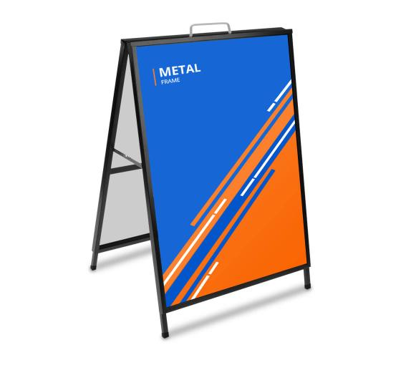](https://www.google.com.au/url?sa=i&url=https%3A%2F%2Fwww.bannerbuzz.com.au%2Fmetal-a-frame-signs%2Fp&psig=AOvVaw1nmMjrXVD28em7ejmzd-dZ&ust=1595305233746000&source=images&cd=vfe&ved=0CAIQjRxqFwoTCOiQmKD92uoCFQAAAAAdAAAAABAI)[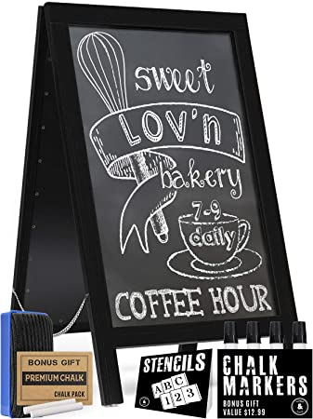](https://www.google.com.au/url?sa=i&url=https%3A%2F%2Fwww.amazon.in%2FHandcrafted-Frame-Chalkboard-Sign-Advertising%2Fdp%2FB07X27SBPL&psig=AOvVaw1nmMjrXVD28em7ejmzd-dZ&ust=1595305233746000&source=images&cd=vfe&ved=0CAIQjRxqFwoTCOiQmKD92uoCFQAAAAAdAAAAABAO)

*Figure 1: Metal A-Frame Figure 2: A-Frame with changing message*

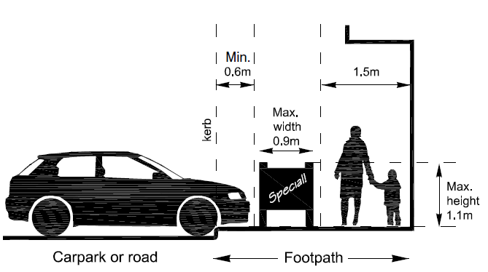

**Tips and Advice**

***Use your A-frame sign to Advertise daily specials and promotions – a sign with changing message will attract attention***

***11.2 Tear Drop Banners & Flags***

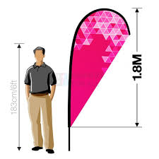Tear drop banners or flags will be considered as an alternative to A-frame signs to advertise the name of a business.

Businesses applying for a permit to place a banner or flag on the footpath/nature strip must adhere to the following conditions:

* Must be secured with appropriate weights or fixing devices placed so as not to cause any tripping hazard
* Any footpath fixings must be *fully concealed* within the pavement and not create a trip hazard when not in use. Council approval is required prior to installing fixings into the footpath as not all footpath treatments are suitable.
* Banners must be located within the Trading Zone and must not be fixed to any building, asset, pole or any other structure.
* The banner or flag must not protrude into the Pedestrian Zone or Kerb Zone and must be removed at the close of trading hours

**Tips and Advice**

***Advertising signage on private property or attached to buildings maybe subject to Planning regulations. Applicants should contact the Planning Department on 9217 2170 to clarify whether a planning permit is required.***

***11.3 Awnings / Blinds***

* A building permit is required for awnings attached to buildings or verandas
* Horizontal awnings must have a vertical clearance of at least 2.4 metres from the ground to the underside and must not extend over the roadway or carpark
* Vertical awnings are not recommended. For situations where a vertical awning is the only option available, a vertical clearance of at least 2.4 metres must be maintained
* Permission will not be granted for installing awnings if they obscure traffic and parking signs or interfere with the line of sight for drivers.

[](https://www.google.com.au/url?sa=i&url=https%3A%2F%2Fapolloblinds.com.au%2Fstraight-drop-awnings%2Fshop-front-awnings%2F&psig=AOvVaw0IyALebq90zkt1A6ER9w-K&ust=1595305977477000&source=images&cd=vfe&ved=0CAIQjRxqFwoTCIiA54KA2-oCFQAAAAAdAAAAABAK)

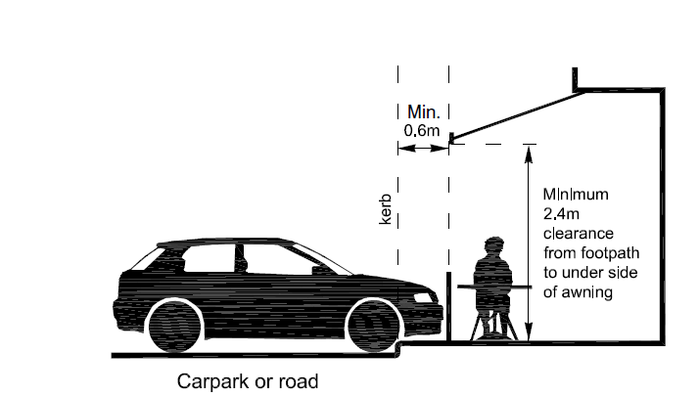*Figure 1: Horizontal awning example Figure 2: Vertical awning example*

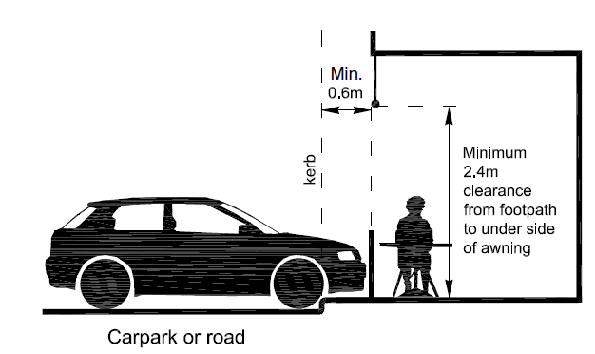  
*Horizontal awning example Vertical awning example*

**Tips and Advice**

***Call Council’s Building Services Unit (Ph: 9217 2170) for assistance with preparing a Permit application.***

***There are a variety of awning products available. Try to use products that maintain access to natural light whilst also providing protection from the weather***

***11.4 Busking / Street performance***

Busking is defined as playing a musical instrument and/or singing, conjuring, juggling, mime, dance, puppetry, performance art and other appropriate theatrical and visual forms.

* Busking or street performance requires a permit if conducted on Council land.
* Performers will keep the 1.5m of the footpath adjacent to the building line clear
* Groups are permitted but must not cause an obstruction.
* The area and times where the activity can take place maybe restricted
* Any litter generated by the activity needs to be managed and disposed of by the performer
* Amplified music needs to be kept to an acceptable and safe volume that does not adversely impact surrounding operations
* Pedestrians or vehicle movements are not to be impeded
* No explicit, profane, defamatory or offensive language or material
* Performers must leave a location upon direction from the police or an authorised officer

**Tips and Advice**

***Performers should have a wide repertoire of material to avoid excessive repetition***

***Council may require performers to provide references or samples of their work as part of their application.***

***11.5 Flyers / Pamphlets***

Distributing flyers or pamphlets on Council land still requires a permit. By applying Council can monitor activities occurring on its land ensuring no more than one activity is occurring at a time in the same location.

* The fee will be waived if there is no selling involved with the activity.
* To distribute leaflets on privately owned land, permission should be obtained from either the Body Corporate or Centre Management.
* The information distributed must not be obscene, defamatory or offensive.
* Leaflets must not be posted on car windscreens no matter where they are parked.

**Tips and Advice**

***Offenders may receive a fine for littering under the Environment Protection Act 1970. Any litter generated by the applicant must be removed once the activity is ceased. Council litter bins are not to be used for the disposal of excess or leftover materials.***

.

***11.6 Footpath Dining***

Council encourages a diversity of outdoor dining to positively contribute to the local area and encourage more people to visit and spend time in the area.

It is important that traders consider all legislation in addition to Council requirements before establishing an outdoor space.

**Café / Barrier screens**

Café screens can be used to define outdoor eating areas and provide some protection from the wind and weather.

*Fixed Screens*

* Before installing a permanent screen, applicants will need to apply for a planning permit
* Permanent safety glass
* No other structures are to be attached to the posts
* All glazing should be permanent safety glass
* The permit holder will be responsible for any costs to reinstate the footpath if the barriers/screens are removed.

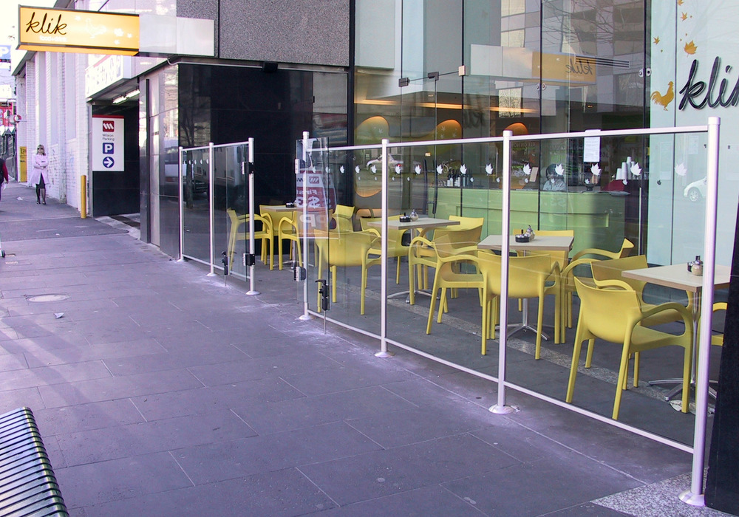

**Tips and Advice**

***Applicants should contact Council’s Planning & Building Department on 9217 2170 to discuss the application (form available on the website)***

***All café screen suppliers will be able to provide the necessary compliance certificate***

*Temporary*

Council will consider approval of temporary barriers on a case-by-case basis and assessed according to available space, streetscape, pedestrian activity and traffic conditions.

* Barriers must not be more than 1.2m in height and be self-supporting
* May only be placed during the normal trading hours
* Branding and advertising should take up no more than 25% of screen space

[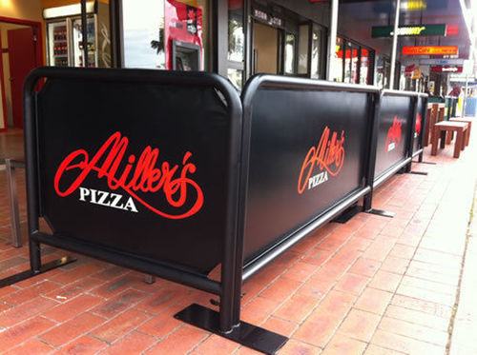](javascript:void(0))

**Tips and Advice**

***The use of sandbags or other weights to keep screens in place is***

***discouraged. A sleeve in the ground is recommended to avoid tripping hazards and improve occupational health and safety for staff***

**Chairs and Tables**

Permits will only be issued to businesses that hold a registration as a Food Premises.

Businesses must ensure that all outdoor tables, chairs and benches are:

* Positioned minimum of 1.5 metres from shop front to allow the flow of pedestrian traffic
* Positioned minimum of 0.6 metres from the road or car park edge
* Of design and construction that will not easily deteriorate or discolour
* Only placed out the front of their business
* Must provide a 1 metre gap between footpath trading areas to allow pedestrian access from the road to the shops
* Placed so people sit facing parallel to the direction of pedestrian traffic
* Easily relocated into the premises for storage when the business is closed



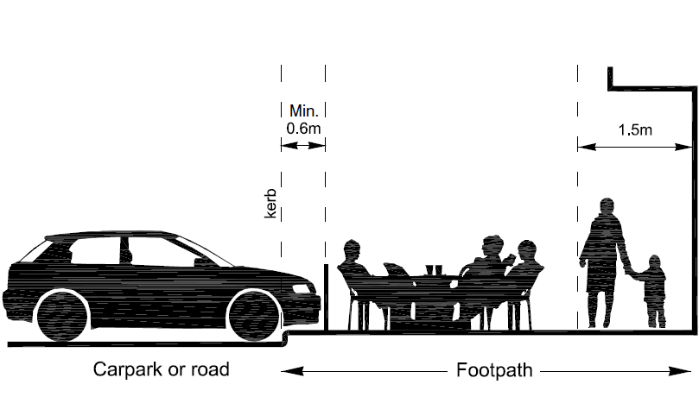

**Tips and Advice**

***Consider the comfort of your customers by***

* ***Providing shade***
* ***Have adequate room between table and chairs***
* ***Keep pavement and tables clean***

***Where there is direct parking into the kerb you may require a***

***greater set back to ensure the safety of your customers and the furniture***

**Outdoor Heaters**

Outdoor heaters can create a more comfortable experience for those eating outdoors but they can also cause safety issues if not placed and treated correctly.

* The use of portable heaters must comply with Australian Standard AS1596.
* If using gas then a fixed line supply is preferred
* If portable they must be 2.1m high, have a low centre of gravity so they are stable and have safety guards to ensure hot elements, controls and gas lines are not openly accessible to patrons.
* Permanent heaters must comply with Energy Safe Victoria requirements and may require either a planning or building permit. They must be installed by a licensed and registered installer with the Victorina Building Authority.
* The operators’ public liability policy needs to cover the use of outdoor heaters.



*Figure 1: Portable gas heater*

[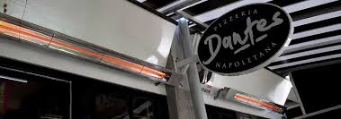](https://www.google.com.au/url?sa=i&url=https%3A%2F%2Fwww.infratechheaters.com.au%2Fcommercial-outdoor-heating-business-owners%2F&psig=AOvVaw3BiZ6TDfBeDSp6dVBqaJhH&ust=1595307262261000&source=images&cd=vfe&ved=0CAIQjRxqFwoTCJj80ueE2-oCFQAAAAAdAAAAABAS)

*Figure 2: Permanent heaters*

**Tips and Advice**

***Search for a product that maximises efficiency and minimises energy use***

**Planter Boxes / Pot Plants**

Planter boxes and choice of plants when well-maintained can add to the amenity of the area and the streetscape generally. If Traders wish to have planter boxes, they must ensure:

* Must be located in the Trading area
* The box and plants must be no higher than 1.4m
* They should be easily removable / relocatable but with wheel locking devices to keep them in place
* They must be kept free of all litter and cigarette butts
* Plants should be evergreen, drought tolerant, non-toxic, low pollen producing and not prickly
* No plastic plants should be utilised to impersonate real plants and / or greening. These are in conflict with state government policy to reduce plastic consumption and waste.



**Tips and Advice**

***Planter boxes can assist in defining areas and adding colour and character to the streetscape.***

***Please ensure you contact the body corporate or appropriate authority to obtain the necessary approval first***

**Umbrellas**

Council supports *Sun Smart* activities and permits the use of umbrellas providing

* Have a clearance of 2.4m on the underside to minimise risk to pedestrians
* Are not used under verandas
* Do not extend beyond the Trading Zone
* Include an appropriate securing device in the footpath that does not provide a trip hazard when removed ***(Council approval required)*** or has appropriate mechanisms to secure if free standing
* Are removed during unsuitable weather conditions such as excessive wind
* Does not include advertising to promote cigarettes or alcohol

[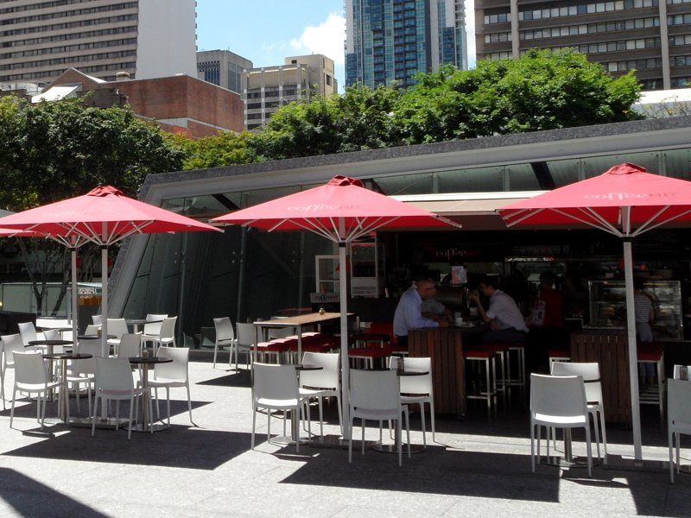](https://www.google.com.au/url?sa=i&url=https%3A%2F%2Fwww.daydreamleisure.com.au%2Fproduct%2Fultrashade-home-entertainercafe-centrepost-umbrellas%2F&psig=AOvVaw3vhuVbkjhrSwp00mviuicT&ust=1595309130000000&source=images&cd=vfe&ved=0CAIQjRxqFwoTCIiopOKL2-oCFQAAAAAdAAAAABAM)

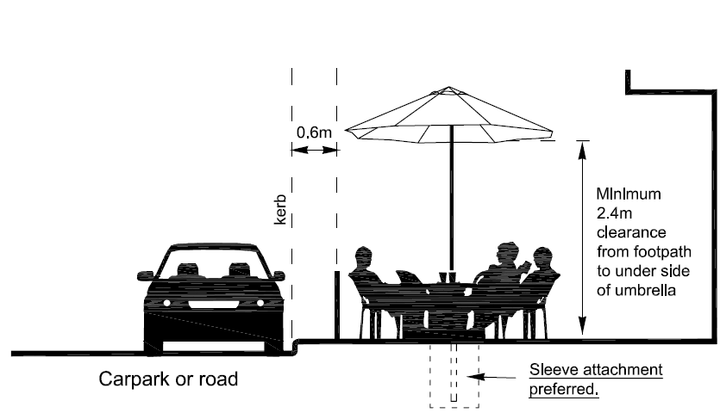

**Tips and Advice**

***Consider lighter coloured material to reflect summer heat***

***A lockable socket and sleeve are preferable to using weights and***

***sandbags. Please contact Council for the necessary standards.***

***11.7 Fundraising***

Council receives a high number of requests to conduct fundraising activities within the municipality. As a result, criteria were developed to ensure that organisations that benefit the Whittlesea community are given preference to fundraise within the community.

* Not for profit organisations benefitting the Whittlesea community are exempt from paying the application fee but must submit an application.
* Third party entities acting on behalf of individual charities will be charged for the street activity.
* For any fundraising activity on privately owned land permission should be obtained from either the Body Corporate or Centre Management.

**Appeals / Pledges / Raffles**

* Council does not permit activities such as spruiking or canvassing.
* To conduct pledge programs charities / organisations must not actively approach members of the community to make them stop unwillingly.
* To sell raffle tickets charities / organisations must be aware of and adhere to any requirements of the Victorian Commission for Gambling and Liquor Regulation.

**Community Food stalls and sausage sizzles**

* Community groups and charities will require a permit for food stalls and sausage sizzles conducted on Council land. The application must include permission from any business owner outside which the activity will occur.
* Any stall selling food must obtain the relevant Streetrader permit. You can contact Council’s Environmental Health Unit on 9217 2170 for any questions or assistance.
* Commercial operators will be considered Street Selling under this policy.

**Highway Collections / Tin Shakes**

* Only not-for-profit, non-political organisations are permitted to conduct tin shakes following the issue of a permit.
* Permits will not be issued during the month of December.
* The maximum number of collections per organisation per year is four and applications will not be considered for any collections more than six months prior to the proposed date of collections.
* Highway collections are subject to Victoria Police final approval if permission has been granted by Council. For more information visit the Victoria Police website.

***11.8 Goods Display***

Goods displayed must be for sale and not just outside for storage purposes.

* Displays must be positioned at least 1.5 metres from the shopfront to not block the footpath
* The display cases and product must be no more than 1.5m high, 1.8m long and 0.75 m wide
* Displays must be secured by an appropriate locking device and not tied to or leant against Council street furniture and/or trees.
* Vending machines, illuminated revolving, spinning or flashing displays are prohibited from the footpath and power cords are not permitted across the footpath.
* Displays can be no longer than 6 metres with a 1 metre gap between to allow pedestrian access from the road to the shops
* All displays must be removed from the footpath at the close of each business day

[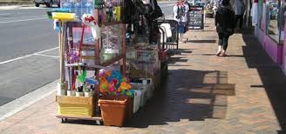](https://www.google.com.au/url?sa=i&url=https%3A%2F%2Fwww.gleneira.vic.gov.au%2Fmedia%2F2918%2Ffootpath-activities-guidelines-2019.pdf&psig=AOvVaw15WfY0HzEJw4uXJ1YZE7qr&ust=1595310141912000&source=images&cd=vfe&ved=0CAIQjRxqFwoTCJCrsNaP2-oCFQAAAAAdAAAAABAE)

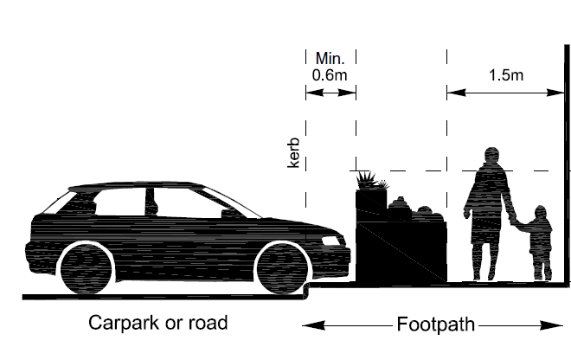

**Tips and Advice**

***Do not overload your area with goods***

***Keep items to eye level to encourage more buying***

***Keep your shelving in good repair***

***Make sure all aisles are wide enough for prams and wheelchairs***

***Maintain a clear view from inside the shop to limit theft***

***Allowing gaps between displays will allow customers to access your shop***

***11.9 Real Estate Signs (Auction and Open for Inspection****)*

Real estate agent signs/boards promote open inspections and auctions in residential streets. Permits are needed to place these signs/boards on public land.

* The permit allows agents to temporarily position signs abutting the properties for sale and at the nearest intersection as directional, that are open for inspection and on auction days.
* Each branch of a real estate agency requires its own permit (these are non-transferable between stores or branches).
* Boards cannot be placed:
  + On the road
* On any roundabout, traffic island, garden bed or median strips
* Where it creates any hazard to pedestrian or vehicle activity
* Signs/Boards can be placed out on the day of the activity being advertise. Signs/boards may be placed out, (two hours before), the activity commencing and must be removed within two hours of the activity concluding.
* The signs/boards are not to be attached to any Council asset.
* The size of the signs/boards shall not exceed 600mm x 500mm.
* All signage must include the name of the real estate agent and contact details.



***11.10 Roadside Trading*** ***(Food Trucks, Coffee Trucks, Followers, Fruit Trucks etc)***

Council will support street selling by businesses (local businesses given preference) where the activity enhances the vibrancy of the area and encourages business not in direct competition with other nearby traders.

* You will require a permit for Roadside Trading activities.
* The permit holder must have current public liability insurance with at least $20,000,000 indemnity. (Please check with your insurance provider which cover suits your activity best).
* Litter must be cleared at all times from in and around the Roadside Trading site by the operator. The site must be left in a clean and tidy manner.
* Appropriate rubbish bins must be provided by the operator in numbers adequate to service the needs of patrons and the operation and must be disposed of by the permit holder in an appropriate manner.
* Litter generated must not be swept into the street gutter and must be picked up and deposited within the operator’s own bins.
* Trade waste must not be placed in public street bins.
* Roadside Trading can only operate in the location specified on your permit for the duration of period as specified on your permit.
* The preparation, handling and serving of food and drinks to patrons must be conducted in accordance with the requirements of the *Food Act 1984* and Council’s Environmental Health Department.

[](https://www.google.com.au/url?sa=i&url=https%3A%2F%2Fwww.istockphoto.com%2Fphotos%2Ffood-truck&psig=AOvVaw0J7JEUq_5_4anhAbu8S7qF&ust=1586234347535000&source=images&cd=vfe&ved=0CAIQjRxqFwoTCOCv3Mj90ugCFQAAAAAdAAAAABAE)

**Tips and Advice**

***Note, there will be nominated areas throughout the municipality which will be specifically designated for Roadside Trading.***

***For those vendors selling food the appropriate food handling licences or Streatrader permits apply***

**12. Compliance and Enforcement**

Council Authorised Officers monitor the compliance of the Street Activities Policy and the conditions attached to relevant permits. Any breaches of Council’s Local Law, Policy or permit conditions will be investigated and if necessary, enforcement action taken.

Officers from other departments (e.g. Environmental Health Team) may refer cases to the City Safety and Amenity department to review a permit based on breaches to the *Food Act (Vic) 1984* or the *Tobacco Act 1987.*

Council will adopt the approach of engaging and educating the permit holder and enabling the permit holder sufficient time to make a decision on whether to meet the permit conditions. Enforcement action will only be taken if the permit holder chooses not to comply with the requirements of the permit or this policy.

Enforcement action may include:

* Notice to Comply
* Official Warning
* Suspension of the permit
* Cancellation of the permit
* Goods / items impounded
* Infringement issued
* Court prosecution (for failure to pay fines or repeated acts of non-compliance)

Prior to suspension or cancellation of a permit, the permit holder will have an opportunity to make comment to the Manager City Safety and Amenity on the proposed cancellation. Where a permit is suspended or cancelled, refunds will not be available.

Council reserves the right to cancel, suspend or amend a permit where the street activity detracts from or is detrimental to the safety, accessibility or amenity of an area or negatively impacts the wider community.

***For more information:***

For more information on Street Activities/Footpath Trading in Whittlesea,

please call Council on 9217 2170 or visit [www.whittlesea.vic.gov.au/footpathtrading](http://www.whittlesea.vic.gov.au/footpathtrading).