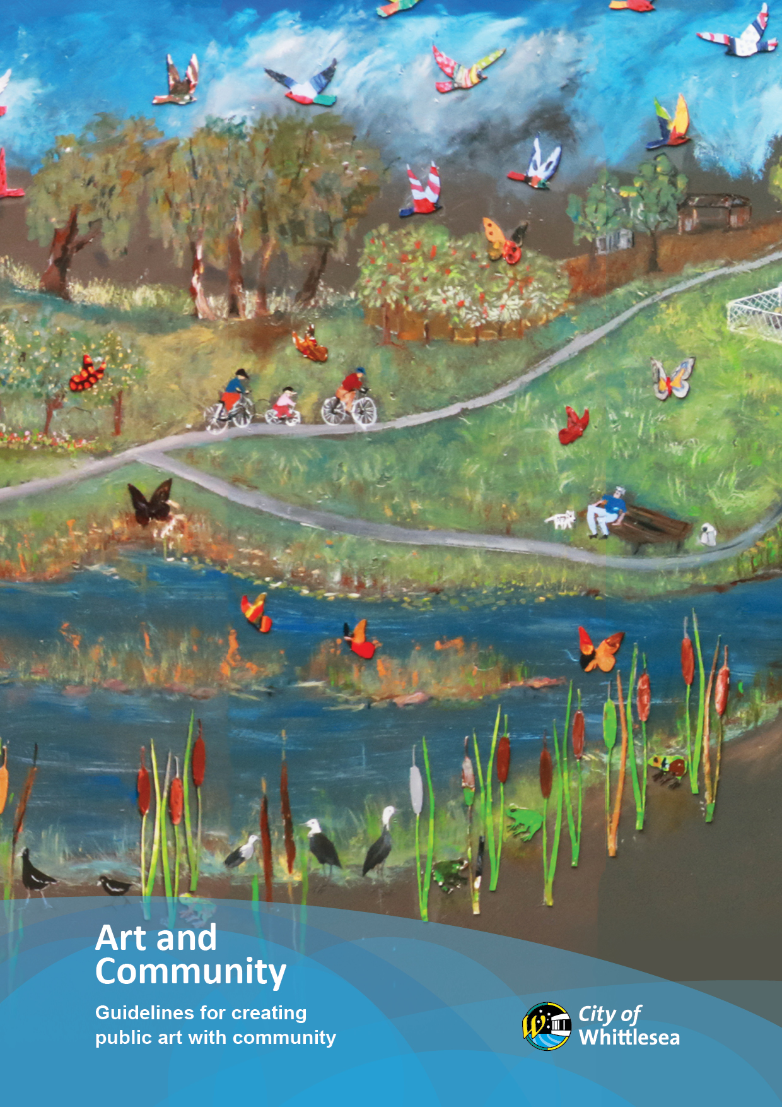

Acknowledgement of Traditional Owners

The City of Whittlesea recognises the rich Aboriginal heritage of this country and acknowledges the Wurundjeri Willum Clan as the Traditional Owners of this place. We pay our respect to their elders past and present and extend that respect to all Aboriginal and Torres Strait Islander peoples today.

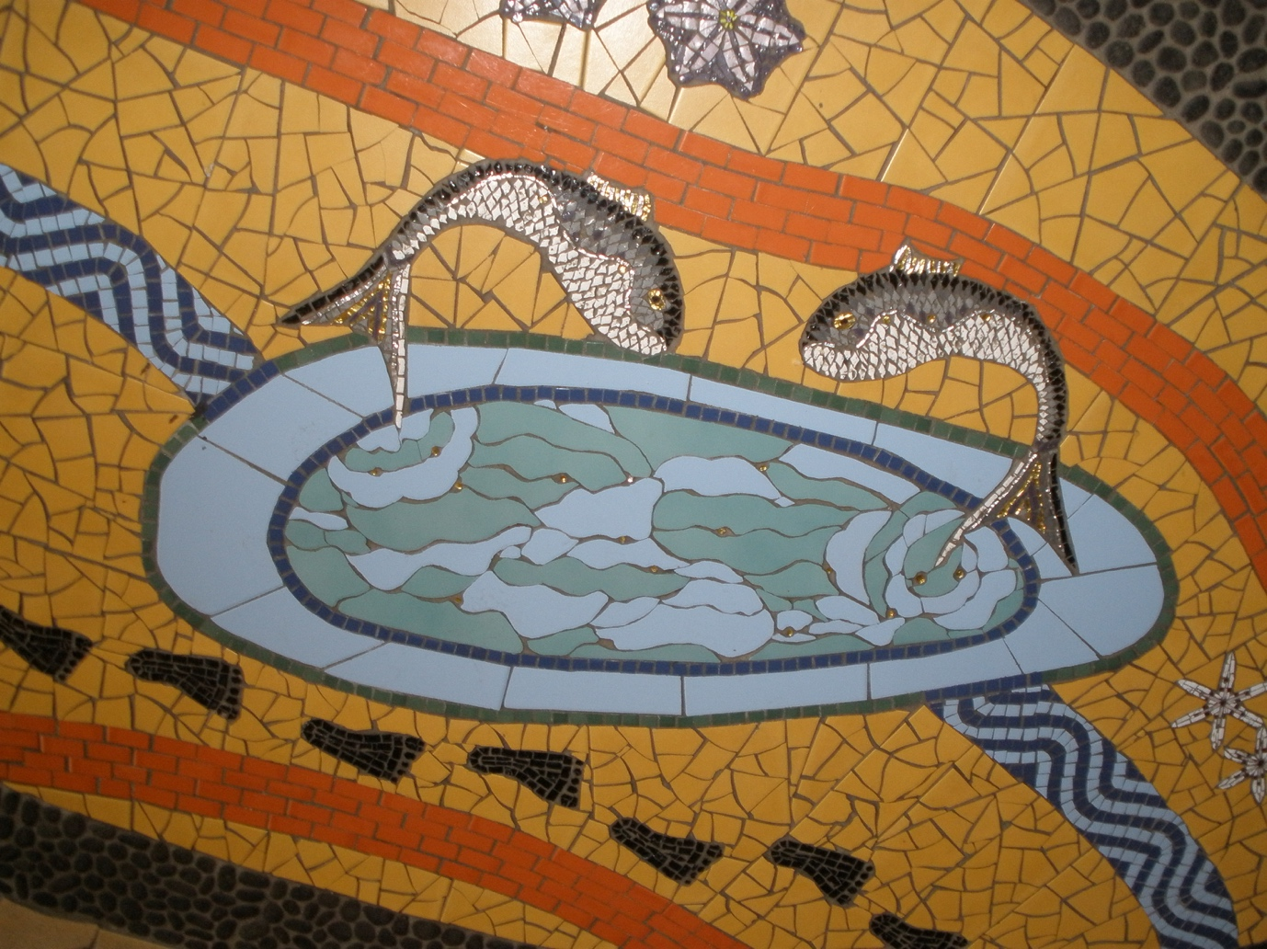

Cathy ADAMS and Libby McKINNON
Billabong (detail), 2002
Ceramic and glass tiles
Designed in consultation with the Kulin Nation Cultural Heritage Organisation.
Located in the Riverside Community Activity Centre Foyer

Front Cover Image
Catherine BLAKEY design & lead artist
with assistant artists Lee McGILL and Gay CHATFIELD
Water for All, 2019
Acrylic (exterior house) paint, exterior plywood
Relief work on mural created with wooden cut outs painted by community.
[Community arts] foster a strong sense of confidence, pride and belonging; provide an avenue for learning new skills; and for some – participants and artists alike – can open up new career pathways.
Hon Heidi Victoria MP
Minister for the Arts, 2013

Public Art & Community
Broadly put, community art is any artistic activity based on, made for, or made by the community. Sometimes this is done with the aid of a professional artist and often through collaboration with people who may not usually engage with the arts.

Public art that is made by, with or for the community can take many forms. These types of art projects are generally defined by a physical object and include (but are not limited to) items such as paintings, sculpture, tapestry, mosaics, installations and murals. Art can also take the form of ephemeral or immaterial mediums, such as sound, digital or video art. Because of the diversity of mediums and methods that can be used to make public art with community, there is no one set model that can be used for its creation. However, the series of questions and considerations in this document can act as a general guide towards creating community led public art projects.

Writing down your plan can help clarify issues for your group and ensures that you have thought through the important matters.

Les FUTO
Recycled, 2012
Recycled cigarette lighters
In conjunction with the City of Whittlesea Community Festival

1. The purpose of your art
Why are you planning to make this artwork?
What do you aim to achieve with the work?

2. The stakeholders
The creation and installation of visual art will likely involve professionals in a variety of fields from the artists themselves to the tradespeople who may be needed for parts of the fabrication of the work or potentially to install the work etc.

It is suggested that you write out a plan clearly identifying the various stages involved in the creation of the work. Who will be involved in the:
- Planning process
- Design process
- Installation of the artwork

3. Selecting an artist or team of artists
Having the right artist or team of artists can not only help you better realise your vision, but also aid in the practicalities of creating and installing your artwork. It’s important to find the right artist/s, so that their style of work suits your project and your ideas. It can be beneficial if the artist/s live, work or are connected to the municipality in some way.

Finding an artist/team of artists, to work on your project can be done in a number of ways, including:
- Contact Council’s Arts Heritage & Events team. They can offer advice based off how they find suitable artist/s to work on their community projects.
- Advertise in local newspapers or arts-based magazines.
- Via the internet
  - Arts Hub: www.artshub.com.au
  - The Loop: www.theloop.com.au
- Via Facebook groups
  - Arts opportunities, jobs and advice:
www.facebook.com/groups/artopportunities
  - Australian artists amid Covid-19:
www.facebook.com/groups/867638387034820
  - Arts and creative industry support:
www.facebook.com/groups/669197597161146
  - AC/ACM opportunities & events forum:
www.facebook.com/groups/acacmforum
  - Arts jobs, call for entries, residencies & #ArtistOpportunities #VisualArts:
www.facebook.com/groups/1592211484404009

When selecting an artist or team of artists, you need to ensure that they have the skills and experience required to achieve the result you want.
- Ask to see documentation of the artist’s previous work (e.g. photos, articles).
- Ask if they have worked on art projects involving community input before.
- Ask the artist for two referees. The referees should be people the artist has previously worked for on similar projects.
- Ask to see a sample design drawing or small scale model of the proposed art work. If the artist needs to create these especially for your project then remember the artist (like any other profession) should be paid an agreed fee to create the design or small scale model.
- Ask if the artist plans to use archival-quality materials and techniques to ensure the longevity of the artwork.
Ensure that the methods or materials used will not have a detrimental environmental impact, either immediately or once the materials start to degrade.

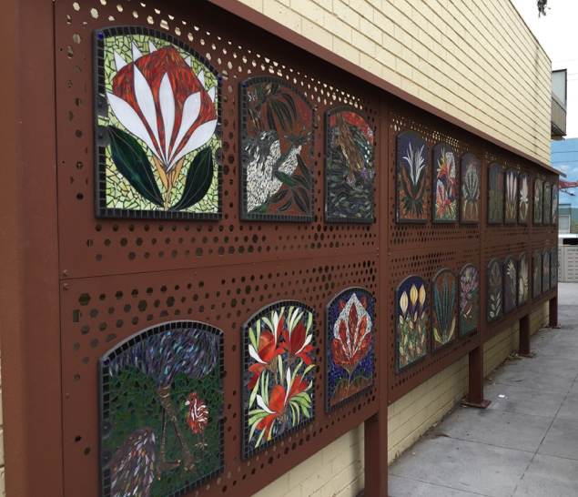

Sandra BAIN and Bundoora Secondary School students
Dennison Street Mosiacs
Corten steel, glass tiles

4. The timeline
What is your expected time frame for the development, construction and installation of your artwork? This will vary according to the nature of the artwork, size, permit (if required), funding arrangements, artist’s availability and workload.

As a general guide, you may need at least a month for initial planning and consultation, a further month for refinement of the design and more consultation and potentially another month or two for addressing structural issues including preparation of the site.

The actual creation of the artwork itself may take days, weeks or months. If it is an outdoor work consider that weather is a factor that may delay the creation or installation process.

Note: obtaining funding from government sources generally needs a long lead time. Many funding rounds are annual or bi-annual, so they need to be considered about a year ahead.

5. The Design and its Impact
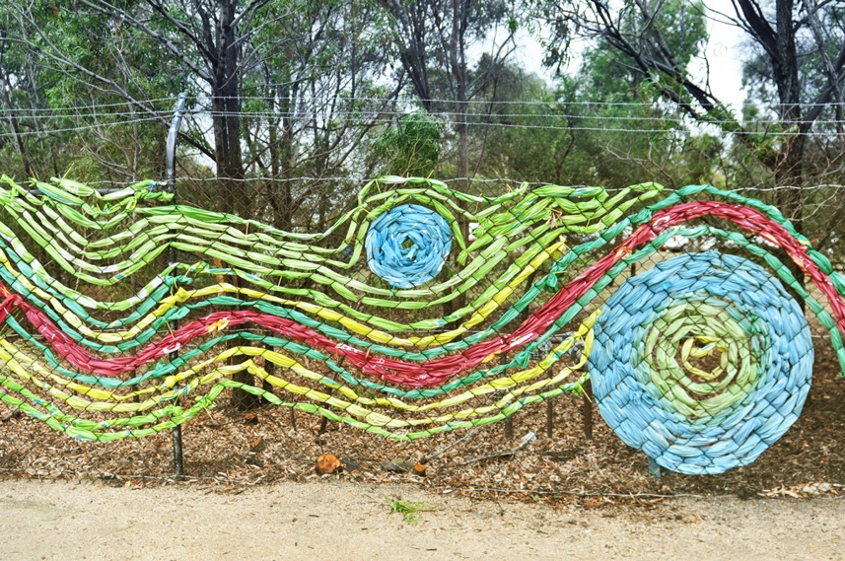
Since your work will be situated in and reflect the community, it is important to engage with the key stakeholders and the community about the project, so that they feel connected to and part of the project. There may be a group or individuals who have differing opinions on the design you intend to use. If there are then you need to work out\ how to manage those different views. Keeping the community informed and engaged in the development of the ideas and design of the project usually helps resolve any concerns.

Community stakeholders can include:
- Specific sections of the community that your artwork may impact, especially if certain symbols or themes are significant to that group
- Local residents
- Local organisations
- Schools
- Parents’ committee
- Staff members from your organisation
- Council’s Arts Heritage & Events team

There are a variety of ways to consult with community stakeholders, such as:
- Social Media (eg. Facebook, Community Hub Groups, Organizational Groups)
- Personal phone calls
- Letters or emails
- Community newsletters
- Pop up Consultation sessions in the area
- Public meeting

In general, Council does not support the appropriation of spiritual and cultural themes or language and imagery significant to Aboriginal and Torres Strait Islander communities. Similarly, Council does not support inappropriate or insensitive treatment or use of artistic and cultural material (e.g. visual symbols) of from any culture.

Paul BLACKMAN
Woven Fence, 2013
Mixed media
Created with the support of festival volunteers from the City of Whittlesea Community festival
6. Funding: How Will the Artwork Be Paid For?
Fees will vary, depending on the size and complexity of your Project. It is important to cost all the processes involved not only the artwork design. This will include but is not limited to, site preparation, construction, installation, artists’ fees, materials, delivery and transport (if required). You may also need to include the cost of Public Liability Insurance and graffiti protection costs (where applicable).

It is essential to ask the artists applying for the job to prepare a budget showing the costs for all aspects of the project that they are asked to deliver, including a maintenance schedule. This is an estimate of what type of maintenance the artwork will require on an annual basis and an estimate of costs associated with maintenance of the artwork over a period of some years.

If you need to seek funding for your project there are a range of different options available. Some of options are listed below.

- Government (guidelines for these are available in local libraries)
  - Creative Victoria: www.creative.vic.gov.au/grants-and-support/programs/vicarts-grants
  - Australia Council:
www.australiacouncil.gov.au/funding
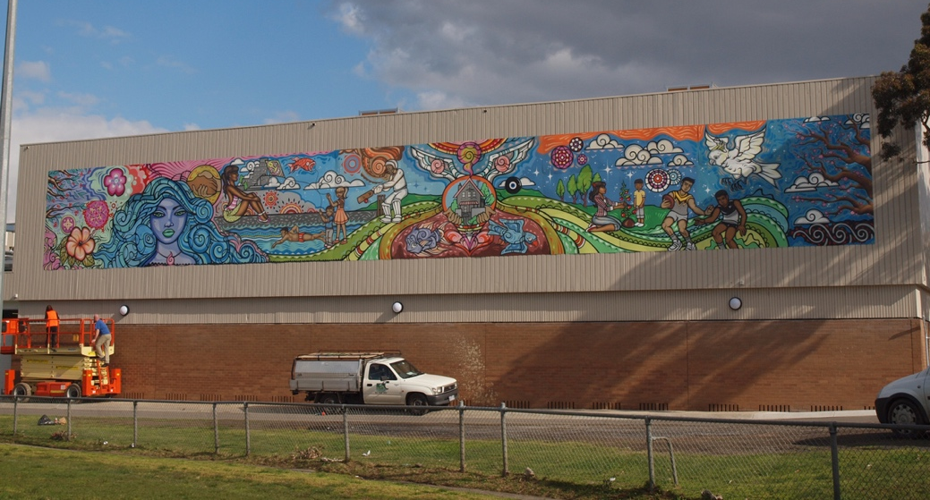
  - Our Community:
www.ourcommunity.com.au/findgrants
  - Victorian Health Promotion Foundation:
www.vichealth.vic.gov.au/funding
  - Regional Arts Fund (only applicable to certain areas of the municipality):
www.rav.net.au/funding-opportunities/regional-arts-fund/
  - City of Whittlesea’s Community Grants Scheme. Contact Council’s Community Grants Officer for details.
- The Grants Hub:
www.thegrantshub.com.au
- Grant Guru:
www.grantguru.com.au/browse/community-grants
- NAVA: www.visualarts.net.au/nava-grants
- Probono Grants:
www.probonoaustralia.com.au/grants
- Crowdfunding
  - ACF: www.australianculturalfund.org.au
- Sponsorship by local business or service club
- The Australian Guide to Philanthropy (available in local libraries)
- Creative Learning Partnerships:
www.creative.vic.gov.au/grants-and-support/programs/creative-learning-partnerships
- There may be Council grant rounds that you can apply for from Council. Please contact Council’s Arts, Heritage & Events staff for more information.

As this is a community-focused work, demonstrating its need, relevance and benefit for the community can aid in grant approval.

Deb FINEBERG and
Tim DE HAAN
Local Scroll, 2010
aerosol paint
Themes and design
informed by students
from Thomastown West
Secondary College.
Located on rear facade of TRAC (overlooking Main Street Ovals)
7. Permits
A variety of permits and permissions may or may not be required prior to installation. It is recommended that you research before starting a project.
- You must attain written consent from Council if the building or site belongs to them.
- The owner’s permission is required if the building or site is privately owned.
- Contact the Arts, Heritage & Events team by phoning 9217 2174 for more information.

8. Insurance
Artists and other workers (volunteer and paid) must be covered by insurance as they undertake work on any site. It is important to ensure that all people working on the project are covered by Public Liability Insurance. The artwork itself may also require insurance.

For advice and assistance with insurance for your project contact the Municipal Association of Victoria on 9326 6859 or visit the following links:
- Arts Law: www.artslaw.com.au/information-sheet/liability-and-insurance
- Guildhouse: www.guildhouse.org.au/artist-toolkits/insurance-for-artists
- NAVA – National Association Visual Artists:
www.visualarts.net.au
- RAV – Regional Arts Victoria:
www.rav.net.au/members-and-networks/join-us/public-products-liability-insurance-faqs

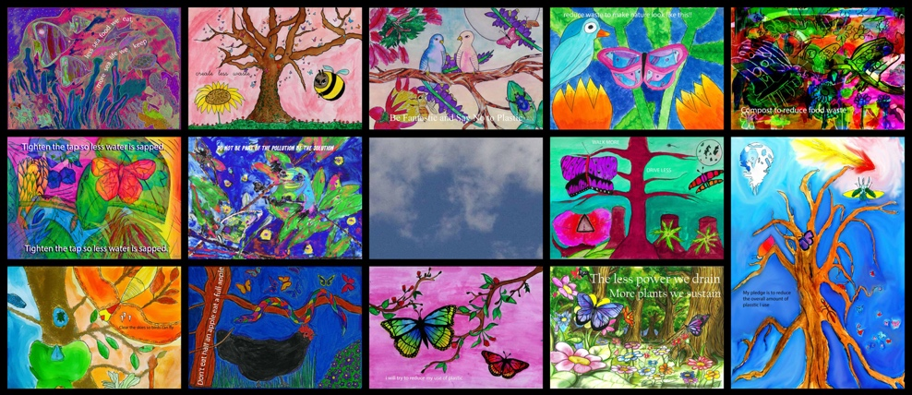
9. Occupational health and
safety issues
Artworks must be designed so that they are safe for the general public. They cannot have sharp edges, be a potential trip hazard or be climbable. They must be strong and professionally installed. It is important to identify any potential risks and consequences for the artist, installers, general public and for the environment during the lifetime of the artwork. Steps should be taken to eliminate all potential risks.

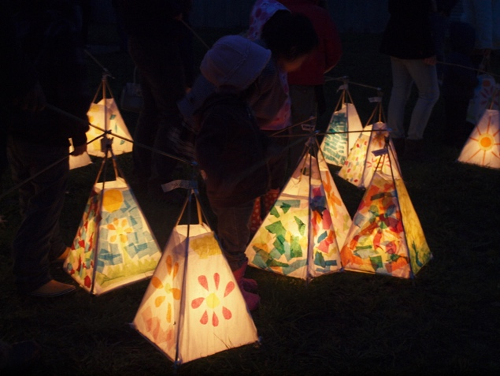

Attribution
Lanterns made by children for the 2011 Into the Light Festival
pahang cane, gaffer tape, tissue paper, PVA glue, candles

Mill Park Secondary College
Collectively Caring for Climate (detail), 2020
digital print on aluminium, steel, vinyl
Located in the Mill Park Stadium

10. Installation of the Artwork
Ensuring that your artwork is properly and securely installed is important for public safety. The artwork is to be secured and made structurally safe in the site where it is installed. For example, a mural needs to be secured to the wall or the structure selected to house it in. If you are attaching an artwork to a building or other structure, or if you are installing a free standing sculpture in a public place you may require an engineering assessment. This ensures that the artwork is safe and won’t fall off a wall or fall over and potentially injure someone. It also means that the community can enjoy the artwork during its lifetime, in the way it was intended.

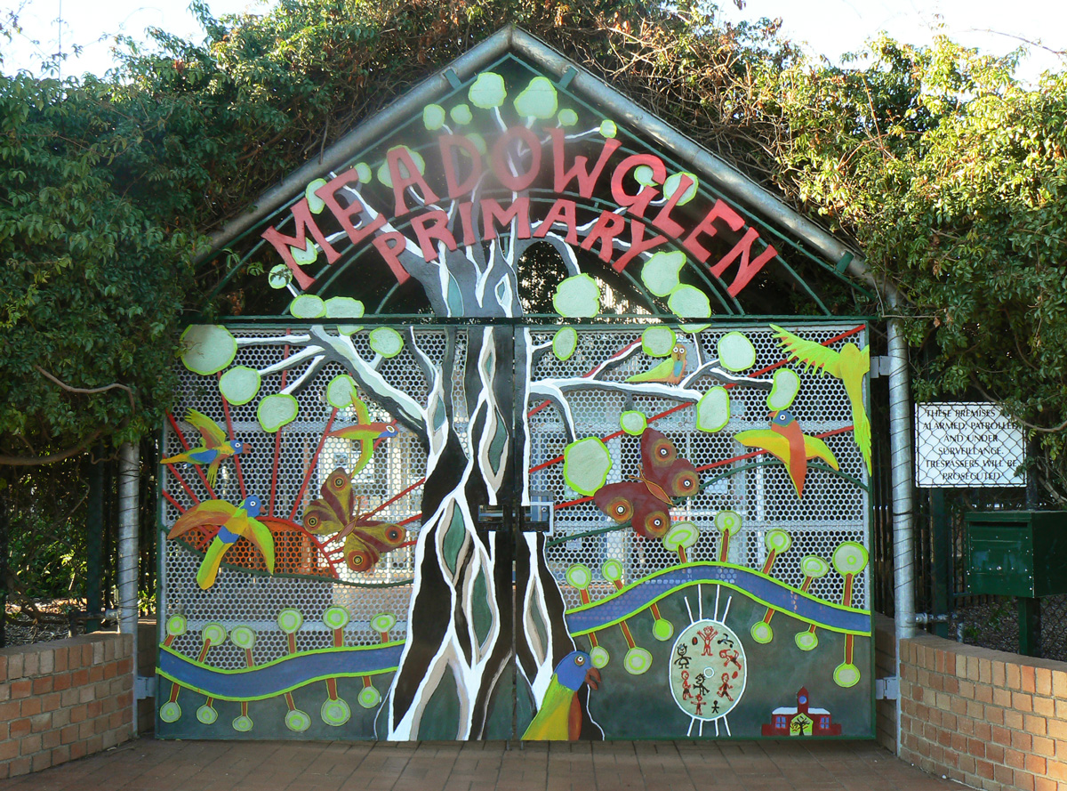
11. Documenting the final artwork
Properly documenting the artwork after it has been installed will provide you and/or your organisation with a detailed record on the artwork to refer to in the future. This will help if and when the artwork needs maintenance, in order to keep it in a good condition. Answering the following questions is best done in conjunction with the artist and the installers.
- Do you have high-definition photographs of the final work?
- Do you have details documenting how it will be installed in case you ever need to remove or relocate the artwork?
- What materials were used in the creation of the artwork and where were they sourced? Keep a list of all materials used, brands and product codes.
- Do you have a statement from the artist/s about the design of the artwork and the themes that are reflected in the work?

Simon NORMAND
Meadowglen Gates
steel, exterior acrylic paint
Meadowglen Primary School, Epping

12. Continued Maintenance
Works in outdoor environments will eventually degrade or may get damaged. Answering these questions will help in determining how best to maintain your artwork.
- If damaged, have you kept the artist/s and installers contact details in case you need them to assess the condition of the work and/or maintain the work?
- Who will repaint, repair or re-coat the artwork if it is damaged or worn? The artist should be contacted and consulted about any planned maintenance or repairs to their work.
- How will maintenance be paid for?
- Have you included an anti-graffiti coating (if required) in your planning and budgeting?
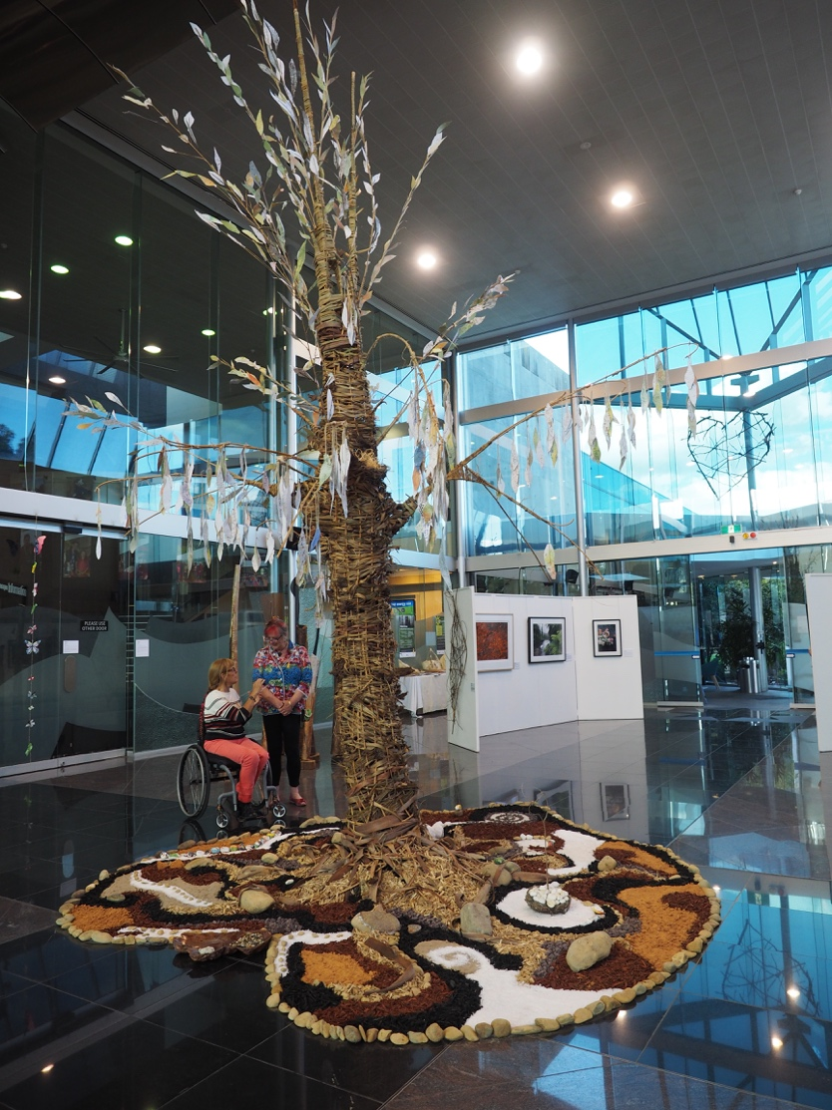
- Who will remove graffiti, dirt, etc. from the artwork?

13. Celebration
Creating and installing artwork is a massive undertaking and a celebration at its unveiling is a great way to thank all those involved, and to help inform the community about the artwork. It will help the community develop a sense of ownership of the artwork and encourage them to value it and help protect it.

14. Acknowledgement
Acknowledgment of the artist/s and key participants can be done by displaying a notice or installing a plaque in a reasonably prominent position next to the artwork. This is important in recognising the various stakeholders involved in the artwork. Plaques can also be used to acknowledge sponsors, funding bodies, staff, volunteers, advisers and participants.

15. Evaluation
Evaluating the entire process of getting your artwork funded, created, installed and documented can help you and/or your group or organisation to reflect upon the success of the project, and on your processes. It and may also help you by providing evidence for future grant funding applications.

A guide to evaluating your project can be found here: www.creative.vic.gov.au/resources/a-guide-to-evaluating-community-arts-and-community-wellbeing

Catherine BLAKEY, Gay CHATFIELD, Lee McGILL
The Tree of Love, 2019
cane, reed, grass, jute string, sand, salt, rocks, soil
Centerpiece of Looking Forward Looking Back, an exhibition
marking the 10th anniversary of the 2009 Bushfires

We’re here to help!
We understand that after reading this guide you may have more questions about your project. Council’s Arts, Heritage & Events team can help provide advice regarding all aspects of developing, planning and organising a community art project. If you have any further questions please contact Council’s Arts, Heritage & Events Team by phoning 9217 2174 or email:
cultural.collection@whittlesea.vic.gov.au

Contact us
T: 03 9217 2170
TTY: 133 677 (ask for 03 9217 2170)
F: 03 92217 2111
E: info@whittlesea.vic.gov.au

Office hours
Monday - Friday 8:30am – 5pm

Postal address
Locked Bag 1, Bundoora MDC VIC 3083

Council offices
25 Ferres Boulevard
South Morang

whittlesea.vic.gov.au

Free telephione interpreter service

131 450

