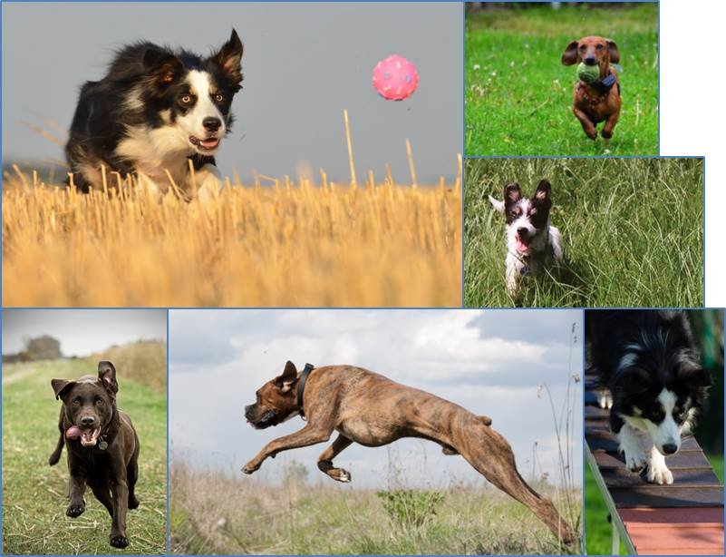

Dog Off-leash Area

Policy & Management Plan
2016 to 2026

Version 1 - Adopted by Council 30 August 2016
Table of Contents

Purpose 3
Background 3
Current Situation 4
Scope and Authority 6
Drivers 6
Plan Overview 7
Off-Leash Area Establishment 7
Off-Leash Area Land Allocation and Planning 10
Off-Leash Area Design Guidelines 17
Off-Leash Area Operational Guidelines 19
Definitions 20
Related Documents 20
Appendices 21
Appendix 1 - Dog Population & Existing Off-Leash Areas 21
Appendix 2 - Regions and Confined / Structured Areas 23
Appendix 3 - Equitable Access Considerations 24
Appendix 4 - Future Off-Leash Areas 25

Purpose
The Dog Off-Leash Area Management Plan provides direction for the establishment and operation of Off-Leash Areas within the Municipality.

Background
Off-Leash Areas have become a recognised amenity catering for the health and wellbeing of both dogs and their owners. When properly established and managed Off-Leash Areas represent a valuable asset providing physical and mental health to the community derived from physical exercise, social interaction and pet kinship. Whittlesea recognises the importance of amenities such as these and aims to establish them against a consistent set of principles and manage them in a safe and environmentally sustainable manner.
A recently published list of benefits for Off-Leash Areas includes the following.
Benefits for dogs
- Physical and mental exercise for dogs - provide opportunities where dogs can get physical and mental exercise. Well exercised dogs are less likely to behave in a destructive or annoying way such as excessive barking.
- Socialisation for dogs - provide opportunities for dogs to have frequent interaction with other dogs and people. Dogs that are well socialised and exercised are healthier and happier as well as less likely to be aggressive.
- Safe environment for dogs to play - provide a secure environment where dog owners can exercise their dogs off-leash and not encounter cars, bikes and other obstacles. Dog parks can provide an outlet for natural dog behaviours such as running, chasing, playing and barking with the result that the dog is less likely to engage in such nuisance behaviour at home.
Benefits for people
- Outlet for dog owners to socialise - provide a public space where dog owners can interact with each other and form community bonds. It has been established that pets act as a lubricant for social contact and pet owners are more likely to exchange favours with neighbours, to be involved in community issues and to have higher levels of social capital. Some dog park users have established face book sites for their parks including Mernda Off Leash Dog Park Community.
- Seniors and disabled owners have an accessible place to exercise their dogs - provide people with limited access, such as the elderly and disabled, with opportunities to exercise their dog and provide ongoing social contact.
- Places for people to connect - provide a space where dog owners can feel connected with other community members improving their mental and emotional health.
Benefits for the community
- Responsible dog ownership - reduce the likelihood of conflict with other users of open space through dog owners letting their dogs off-leash in other recreational areas, and provide opportunities to educate dog owners about animal health and welfare.
- Affordable recreation option - A trip to the Off-Leash Area is a free, outdoor activity where the family can take both their children and their pet.
- Resting place for travelling community - provide a safe resting spot for those owners travelling with their pets, pet friendly holidays.

Current Situation
Order No. 1 of Whittlesea City Council [1 September 2009] requires all dogs to be under effective control by means of chain, cord or leash held by the owner and attached to the dog while it is in a reserve or public place other than a designated Off-Leash Area. A designated Off-Leash Area must be gazetted in the Victorian Government Gazette.
At the time of establishing this plan there were 6 Off-Leash Areas within the City of Whittlesea:
- 30W Fitzwilliam Drive, Doreen (gazetted).
- Lyndarum Wetland, 27W Manor House Drive, Epping (gazetted).
- Delacombe Park, 5W Delacombe Drive, Mill Park (gazetted).
- Whittlesea Public Gardens, 158 Barry Road, Thomastown (gazetted).
- Creek Park, 2W Perry Street, Mernda (gazetted).
- Whittlesea Park, 35 Beech Street, Whittlesea (gazetted).
These existing sites are noted on the following plan and are shown in relation to residences that have a registered dog. See Appendix 1 for the location and aerial images of each individual existing Off-Leash Area.
The sites above were provided to meet a growing community demand. They were developed with the goal of providing quality amenities for the community. However, with the exception of Whittlesea Park whose establishment coincided with the development of this document, each was established independently and without a consistent vision of what the expectations for an Off-Leash Area should be or how they should come together to form a network of Off-Leash Areas that provide equitable community access.

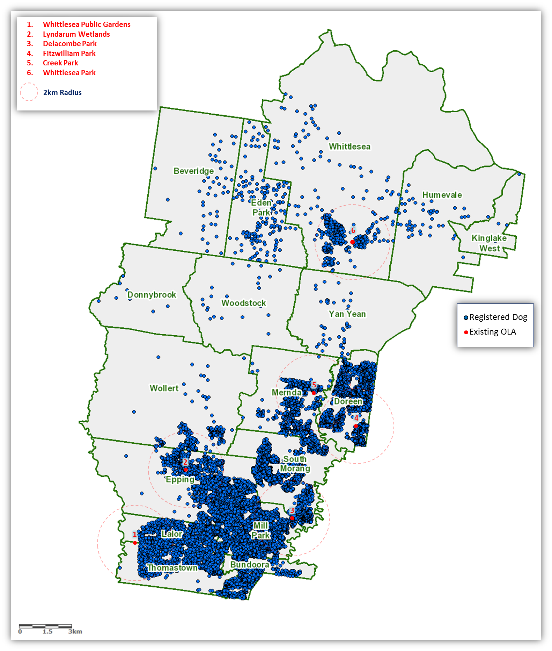
The map below shows the location of existing Off-Leash Areas and registered dogs across the municipality.

Scope and Authority
This plan covers the provision of formally declared Off-Leash Areas within the City of Whittlesea. It is applicable to Off-Leash Areas that are constructed by:
- Council
- Other parties, such as developers, for subsequent hand-over to Council.
Any instructions or rules of use contained in this document relate only to formally declared Off-Leash Areas and can be superseded by General Municipal Laws, Orders at Council, and State or Federal legislation.
Authority for the preparation and implementation of the plan lies with the Director Infrastructure. Defined areas of Department responsibility are noted in Appendix 5.

Drivers
There are a number of drivers for the establishment of Off-Leash Areas.
- As at August 2016 there were approximately 16,900 registered dogs in the City of Whittlesea (≈21% of households with at least 1 registered dog).
- The absence of a strategic approach to the provision of Off-Leash Areas to provide equitable community access, and the lack of a consistent approach to the design and management of individual Off-Leash Areas.
- Growing recognition that walking/exercising a dog off-leash is a valid and beneficial form of recreational activity.
- Community interest as evidenced by:
  - Community open space survey responses (late 2013) where:
    - 11% of respondents nominated ‘dog walking’ as the main reason for visiting open space within walking distance.
    - 8% of respondents listed ‘dog socializing/walking’ as their reason for visiting open space beyond walking distance.
    - 4% of respondents noted additional dog Off-Leash Areas as suggested improvements to open space.
    - 1% of respondents listed not enough Off-Leash Areas as their reason for not visiting open space.
    - 8% of all comments provided related to the provision and/or use of Off-Leash Areas.
  - In early 2015 when Council asked its residents “What would you like to change about the City of Whittlesea?” via the Community Voice web site, 24% of suggestions related to off-leash dog walking.
  - Community lobbying for the establishment of an Off-Leash Area at Whittlesea Township.
- Provision of consistent responses to community requests for Off-Leash Areas.
- Application of consistent approaches to the:
  - Design and provision of amenity for Off-Leash Areas.
  - Appropriate use of open space.
- Parameters for management of Off-Leash Areas.
- City of Whittlesea Domestic Animal Management Plan.
- City of Whittlesea Future Direction 4: Places and Spaces to Connect People.
- City of Whittlesea Council Future Direction 5: Health and Wellbeing.
- City of Whittlesea Future Direction 7: Good Governance.

Plan Overview
The following statements set direction and provide a guide for decision making with regard to provision of Off-Leash Areas within the City of Whittlesea.

Mission
To provide residents and their dogs with safe and sustainable off-leash opportunities that can be accessed equitably, while considering the needs of all open space users.

Vision
Creating vibrant self-sustaining communities together.

Core Principles
Strategic:
- Protection of open space assets, natural habitats and wildlife takes precedence over Off-Leash opportunities.
- Prudent allocation of land for Off-Leash Areas from the limited stock of available open space, especially in established areas.
- Equitable access to Off-Leash Areas across the community.
- Manage the interests of all open space users to ensure that the provision of Off-Leash Areas does not detract from the level of use and enjoyment of any user group.
Operational:
- Dog owners are expected to contribute to the success of Off-Leash Areas by adhering to all relevant Council Orders, Municipal Laws, Legislation and specific site use rules which include but are not limited to, correct disposal of all waste and controlling dogs at all times.
- Safety of open space users and dogs takes precedence over Off-Leash opportunities.
- Minimise the potential for conflict amongst users of open space.
- Dog owners / walkers (including commercial dog walkers) are responsible for their dog(s) and any injuries or damage caused by their dog(s).
- Individuals who choose to use Off-Leash Areas do so at their own risk.

Off-Leash Area Establishment
Off-Leash Areas will be established in either of the following manners:
- Developing Areas.
Existing open space planning activities within the planning and development process (Precinct Structure Plans through to Subdivision Landscape Plans).
- Established areas.
Future Off-Leash Areas identified in the Land Allocation and Planning section of this Plan, delivered through Council’s annual New Works Program.
- Where negotiations with developers do not secure an Off-Leash Area.
Gap analysis at the time of this Plans review with identified opportunities delivered through Council’s annual New Works Program.
Regardless of the information contained in this document, the type, size and amenity of an Off-Leash Area will ultimately depend on available funding.

Types of Off-Leash Areas
This plan considers the following three types of Off-Leash Area.
- Open Unstructured.
No constructed barrier to provide separation from other reserve users. Caters for dogs off-leash and play where facilitated by existing landscapes.
Open Unstructured Off-Leash Areas will be considered where the host site has sufficient space to accommodate the minimum size requirement and where there are existing features which enable clear delineation of the Off-Leash Area.
- Confined Unstructured
Constructed barrier provides separation from other reserve users. Caters for dogs off-leash and play where facilitated by existing landscapes.
Confined Unstructured Off-Leash Areas will be located as close as possible to concentrations of registered dog ownership.
- Confined Structured
Constructed barrier provides separation from other reserve users. Caters for dogs off-leash and structured play facilitated by existing or modified landscapes and/or play/agility equipment.
Confined Unstructured Off-Leash Areas will only be considered on a regional basis and will ideally be placed in an accessible point within the target region.
Notes:
- ‘Dog population density’ is a calculated value based on the dog population surrounding a specific point and is used to determine the relative density of registered dogs across the municipality.
- A 2 kilometre catchment provides dog owners with the opportunity to walk to an Off-Leash Area within 20 minutes.

Number of Off-Leash Areas
The total number of Off-Leash Areas to be provided by the City of Whittlesea for the life of this document is guided by the following.
Confined Unstructured Off-Leash Areas will generally be limited to 1 per suburb. However, the following items may result in more than 1 of these Off-Leash Area types per suburb:
- Multiple dog population hot spots within a single suburb leading to possible overcrowding & overuse
- Connectivity/access issues, such as path networks and road/waterway barriers.
Where a dog population hotspot is not covered by a Confined Unstructured Off-Leash Area, Open Unstructured Off-Leash Areas will be provided to close the gaps and maintain an equitable level of access for owners within a 2 KM [20 minute walk] catchment.

Confined Structured Off-Leash Areas will be provided on a regional basis (see Appendix 2) and would ideally be incorporated into a precinct plan or, at a minimum, a site master plan. The number of Confined Structured Off-Leash Areas within the Municipality would be capped at four. However, of the five existing Off-Leash Areas located within the two southern regions, four are Confined Structured Off-Leash Areas. These four sites are well position to cater for the southern regions and will continue to be maintained at their current standard. Whittlesea Park in Whittlesea Township is currently a Confined Unstructured site but is nominated as the North East region Off-Leash Area and will be upgrades based on future demand, this upgrade will not occur during the life of this Plan. One additional confined Structured Off-Leash Area is proposed to be provided in conjunction with future development of the North West region.
Given these circumstances, the number of Confined Structured Off-Leash Areas for the life of this Plan will be capped at five. A pre-existing Confined Off-Leash Area within a suburb will not automatically exclude that suburb from hosting a regional Off-Leash Area.

Off-Leash Area Land Allocation and Planning
This section describes the approach taken to identify the specific sites to be included in Whittlesea’s Off-Leash Area network.

Equitable Access
The extent of Whittlesea’s Off-Leash Areas under this Plan will result in a network of sites that provide equitable access across the existing residential areas. The objective of equitable access is to allow the majority of dog owners to walk to an Off-Leash Area within 20 minutes. This is achieved by:
- Siting Off-Leash Areas as close as possible to areas of high dog population density.
- Allocating each Off-Leash Area with a 2 kilometre catchment to ensure adequate coverage of existing residential areas.
- Considering access barriers such as major roads and waterways.
See Appendix 3 for a current illustration of these elements.

Identification of Off-Leash Area Network
Using Council’s six existing Off-Leash Areas as a starting point, service gaps within the extent of the Municipality’s existing residential areas were identified. Sites meeting the attribute requirements, and in close proximity (within 2 kilometres) of the highest points of density within the gap area were identified as future Off-Leash Areas. Individual site characteristics were used to determine the type of Off-Leash Area.

Site Attributes
- The minimum size for an Off-Leash Area is 0.3 hectares.
- In general Off-Leash Areas will be excluded from
  - Defined sports fields and hardstand sports areas (fenced or unfenced).
  - Designated Conservation Reserves.
  - Areas of significant environmental value.
- Off-Leash Areas will not be located within:
  - 20 metres of a playground or barbeque area.
  - 50 metres of any main or collector road (Open Unstructured only).
Considering the exclusions above, preference should be given to sites that have limited potential for other uses given their size, shape, or natural features.

Site Assets
Existing assets can reduce the total cost of implementation and influence patronage of an Off-Leash Area, and they have been taken into account when determining a suitable site. Assets that have influenced the location of an Off-Leash Area include:
- Path network.
- Supply of drinking water and related fixtures.
- Natural and constructed shade areas.
- Seating.
- Tables.
- Landscape features that facilitate play/agility.
- Car parking.

Securing Sites
Off-Leash Area sites can be secured via the:
- Subdivision process.
- Allocation of existing Council owned open space.
Specific circumstances and available funds will determine which of these options is applicable on a case by case basis.

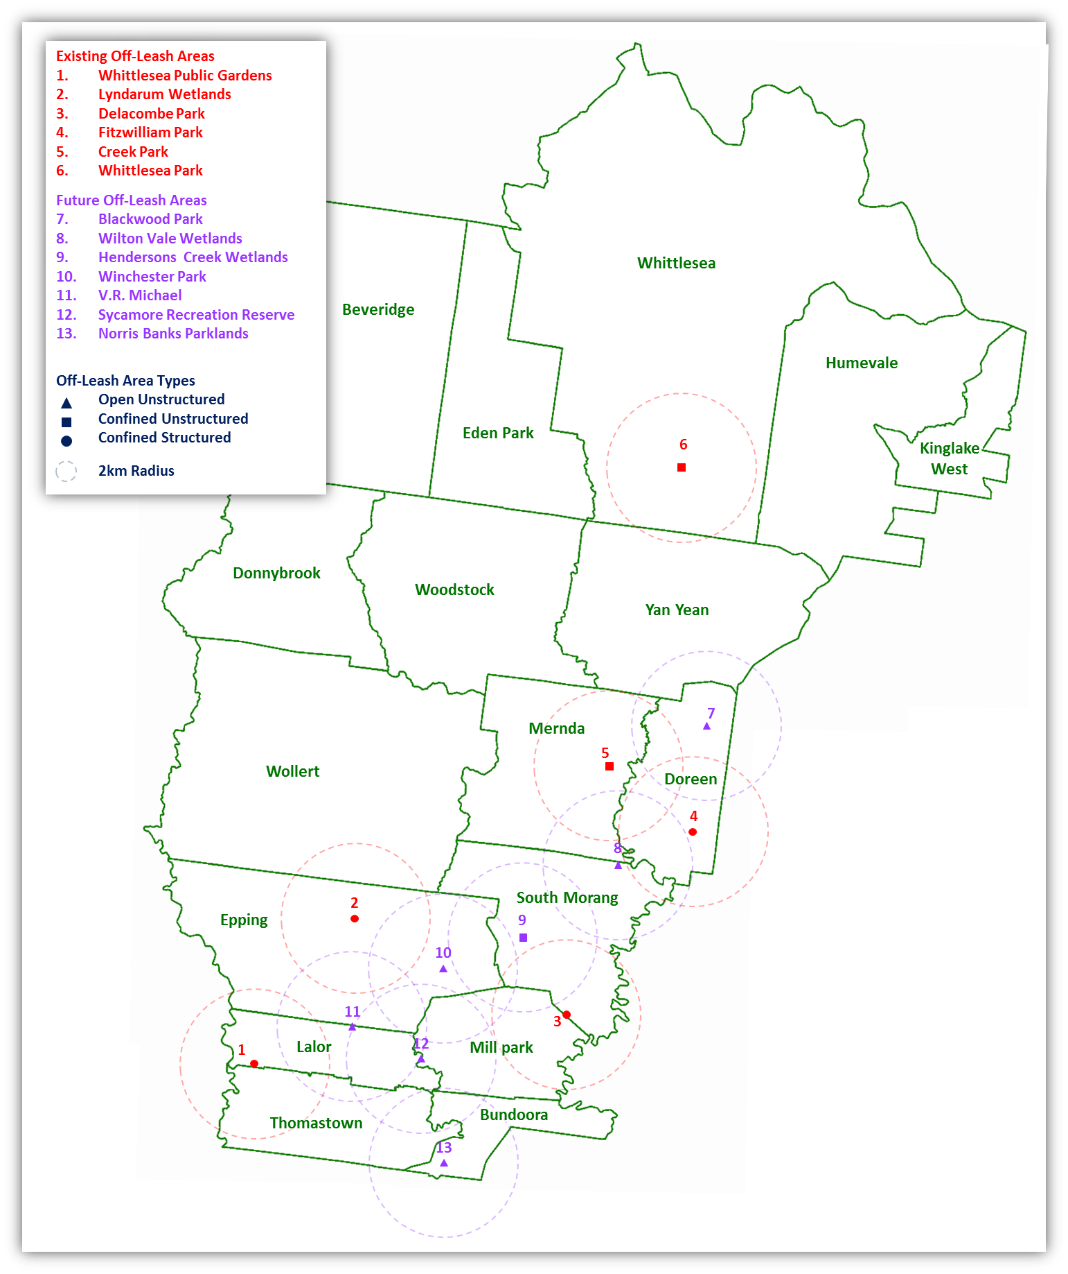
The following map shows the location of existing Off-Leash Areas, and the location and type of future Off-Leash Areas proposed to be delivered by Council throughout the life of this document. The need for additional Off-Leash Areas will be considered when this Off-Leash Area Management Plan is reviewed in 2026 and the map updated accordingly.

Sites within developing areas will be identified during the subdivision process.

Future Off-Leash Area Details

Blackwood Park, Doreen
Type: Open Unstructured,
Comments: 0.3135 hectares located within a 2.5 hectare site, well serviced by existing path network with some off-street parking [indented bays] available on adjacent residential streets.
Indicative Cost: $6000

Wilton Vale Wetlands, South Morang
Type: Open Unstructured,
Comments: 0.61 hectares located within a 4.7 hectare site, well serviced by existing path network with some parking on adjacent residential streets.
Indicative Cost: $6000

Hendersons Creek Wetlands, South Morang
Type: Confined Unstructured,
Comments: 0.82 hectares located within a 17.8 hectare site, serviced by existing path network with some parking on adjacent residential streets and off street parking at nearby Hillsview Recreation Reserve.
Indicative Cost: $60,000

Winchester Park, Epping
Type: Open Unstructured
Comments: 0.44 hectares located within a 3 hectare site, accessible mainly via the road network with off-street parking on site and some parking on adjacent residential streets.
Indicative Cost: $6000

V.R. Michael Reserve, Lalor
Type: Open Unstructured
Comments: 1.353 hectares located within a 7.1 hectare site, accessible mainly via the road network with off-street parking on site and some parking on adjacent residential streets.
Indicative Cost: $6000

Sycamore Recreation Reserve, Mill Park
Type: Open Unstructured
Comments: 1.933 hectares located within a 9 hectare site, well serviced by the Darebin Creek/ Hendersons Creek path, with off-street parking on site.
Indicative Cost: $6000

Norris Banks Parklands, Bundoora
Type: Open Unstructured
Comments: 0.99 hectares located within a 10 hectare site, accessible mainly via road network and Darebin Creek Path, with off-street parking on site and some parking on adjacent residential streets. Off-Leash Area to be incorporated into site master plan during 2016/2017.
Indicative Cost: $6000
See Appendix 4 for site aerials.

Prioritisation of Proposed Future Off-Leash Areas
The table below illustrates the delivery priority of proposed future Off-Leash Areas. The priority is determined by assessing the proposed site against a range of criteria such as:
- Proximity to highest points of dog population density.
- The level of community interest.
- The extent of existing amenities available to service the proposed site.
- The level of expected effort given the type of Off-Leash Area and the existing amenities.
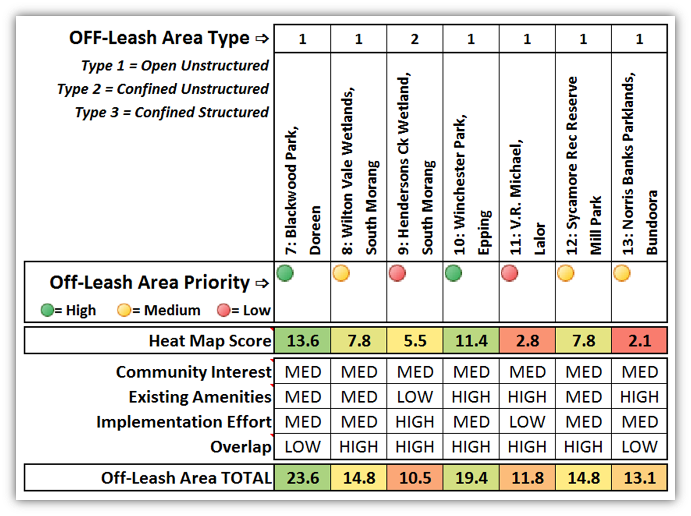
- The level of overlap with surrounding Off-Leash Areas, both existing and proposed.

The priority allocation in the table above indicates the preferred delivery sequence for future Off-Leash Areas with delivery to be completed during the life of this plan.
This information will be used as input to the ongoing management of the New Works Program. Changing dog population densities, community interest, available budget and organisational priorities may influence the eventual type, actual location, size and implementation sequence of new Off-Leash Areas.

Off-Leash Area Design Guidelines

Development Standards
Attribute | Off-Leash Area Treatment
 | Open Unstructured | Confined Unstructured | Confined Structured
Delineation | - Existing constructed assets.  - Existing landscape features.  - Bollards. | - Purpose built fence 1200mm high, black powder coated chain mesh with top and bottom rails.  - Double gated entry/exit.  - Self-closing/latching gates. | - Purpose built fence 1200mm high, black powder coated chain mesh with top and bottom rails.  - Double gated entry/exit.  - Self-closing/latching gates.
Surfaces | - Existing. | From:  - Existing.  - Grass.  - Granitic sand. | From:  - Existing.  - Grass.  - Granitic sand.
Agility / play | - Existing landscape features only. | - Existing landscape features only. | - Existing / modified landscape features.  - Equipment provided.
Drinking water | - Min 1 fountain with attached dog bowl.  - Adjacent to the area. | - Min 1 fountain with attached dog bowl.  - Within the enclosure. | - Min 1 fountain with attached dog bowl.  - Within the enclosure.
Seating | - Existing. | - Standard bench seats.  - Quantity determined by size of enclosure. | - Standard bench seats.  - Quantity determined by size of enclosure.
Tables | - Existing. | - Not provided within the enclosed area.  - May be provided in adjoining open space. | - Not provided within the enclosed area.  - May be provided in adjoining open space.
Shade | - Existing. | - Existing. | - Natural or artificial as required.
Waste Bin | - Minimum 1 bin adjacent to area. | - Minimum 1 bin adjacent to each entry/exit.  [externally located, internally accessible] | - Minimum 1 bin adjacent to each entry/exit.  [externally located, internally accessible]
Bag Dispenser* | - Not provided. | - Not provided. | - Not provided.
* Dog owners are expected to carry bags with them at all times when walking dogs in public areas. If this expectation is met there is no requirement to provide bags.
Car Parking | - Existing. | - Existing. | - Existing.
The design process must consider all mitigation actions required to maintain the enjoyment and safe use of adjacent open space areas.
The information above must be considered in conjunction with any site specific regulatory requirements, such as those applicable to transmission easements.
Whilst the above considerations will guide the design of Off-Leash Areas, the final design will be dependent on planned reach [e.g. regional] and available funding.

Signage
Prominent highly visible signage consistent with current corporate standards and branding requirements is to be placed at each entry point. The minimum information to be provided includes:
- Standard Off-Leash Area use rules.
- Site specific use rules where applicable.
- Hours of operation where applicable.
- Local Laws contact information.
- Emergency contact information.
Additionally the following should be considered where relevant:
- ‘Entering/leaving Off-Leash Area’ at points surrounding Open Unstructured Off-Leash Areas.
- ‘Pathways are always on-leash’ on high traffic paths with a potential for conflict.
- Way finding signage at various points throughout the open space network.

Pathways
Entrance to a Confined Off-Leash Area must be provided via a constructed path.
This path may be:
- Existing or provided specifically for the Off-Leash Area.
- Constructed of either granitic sand or concrete.

Parking
Parking will be dependent on availability at the host site. No Off-Leash Area specific parking will be provided, however an assessment should be carried out to determine the impact any additional parking demand may have on existing facilities and surrounding areas (such as adjacent streets).

Stakeholder Engagement
Formal Community Engagement processes will be employed to ensure that stakeholder input is appropriately considered during the design process.
Relevant stakeholders may include:
- Facility users (sporting clubs, early years and community facility users, etc.).
- Residents.
- Community groups/clubs (dog clubs, special interest groups, etc.).
Where an Off-Leash Area is to be adjacent to:
- A defined sports field/facility, Manager Leisure and Community Inclusion must be included in any consultation activities.
- An early years facility, Manager Family Children & Young People must be included in any consultation activities.

Funding of Council Works
Development and management of an annual/rolling four year works program will be incorporated into the New Works Program to ensure suitable funding is available for the establishment of new Off-Leash Areas and the refurbishment of existing Off-Leash Areas.

Off-Leash Area Operational Guidelines

Rules and Regulations
The standard rules below are reflective of Council Order No1 (1 September 2009), and applicable to all Off-Leash Areas:
- An owner must carry a chain, cord or leash sufficient to bring the dog under control by placing the dog on a chain, cord or leash if the dog behaves in a manner which threatens any animal or person.
- An owner must remain in effective voice and or hand control of the dog and be within constant sight of the dog so as to be able to promptly bring the dog under control by placing the dog on a chain, cord or leash if that becomes necessary or desirable to avoid any wandering out of control or to avoid any threatening behaviour or attack.
- An owner must carry a bag, receptacle or other means of picking up, and removing from the designated area, any of their dog’s faeces.
- The owner must not allow their dog to worry or otherwise threaten any person or animal, and must not allow the dog to attack any person or animal.
Notwithstanding anything else in this section an owner must keep the dog under effective control by means of a chain, cord or leash held by the owner if the dog is within 20 metres of:
- An area where an organized sporting event or the practicing thereof is taking place.
- A children’s playground.
- An area where a public meeting is being held.
- A permanently designated barbeque or picnic area.
Dangerous dogs, restricted breeds and greyhounds (excluding Greyhound Adoption Program dogs) are not permitted in Off-Leash Areas.
Additional site specific rules may be required, however they must be consistent with existing Council Orders and General Municipal Laws, and be enforceable.

Commercial Activity

Obedience Training
- Registered Domestic Animal Businesses must seek formal approval from Local Laws to conduct sessions in Off-Leash Areas.
- Granting of approval will be recorded.
- Evidence of approval must be provided to Council Officers on request.

Mobile Vendors
- No sale of products is to be carried out within an Off-Leash Area.

Enforcement and Education Strategies
Council employs a range of activities aimed at promoting and encouraging responsible pet ownership. These include:
- Council website.
- Regular press releases.
- Prompt proactive and reactive enforcement activities.
- Providing information through various Council and industry publications.
- Pro-active patrols of parks and reserves for wandering dogs.

Stakeholder Engagement
Where the evaluation process recommends significant changes to, or potential closure of, an existing Off-Leash Area, formal Community Engagement processes will be carried out in order to inform the final decision. Internal stakeholders are to be included as per the corresponding Design Guidelines item.

Definitions
Off-Leash Area (OLA)
A designated area where dogs are allowed off-leash under full control of the owner. The site may be fenced, partially fenced or unfenced.
No Dog Area
Areas from which dogs are excluded for reasons of public health and/or safety. These areas are: school grounds; playgrounds; sports fields; golf courses; cemeteries; wading or swimming areas; any other area where dogs are specifically or indirectly prohibited by posted signs. Dogs are permitted on pathways only if kept under control at all times on a short leash and to the left of the path.
Owner
The person responsible for bringing the dog(s) into the public domain. This does not need to be the registered owner.
General Municipal Laws
A set of laws specific to a particular Municipal area and enforceable under the [Victorian] Local Government Act.
Council Orders
An authoritative direction or instruction of Council. In the context of this document it relates to an instruction issued and enforceable under the Domestic Animals Act 1994.
Responsible [Officer]
The role within Council responsible for initiating an action and managing it to its suitable completion.
Primary Support [Officer]
The role within Council expected to provide substantive support to the completion of a specific action.

Related Documents
Open Space Strategy
General Municipal Laws [quantity; nuisance; excrement; noise]
Council Orders [animal control; faeces; designated Off-Leash Areas]
Domestic Animal Management Plan

Appendices

Appendix 1 - Dog Population & Existing Off-Leash Areas

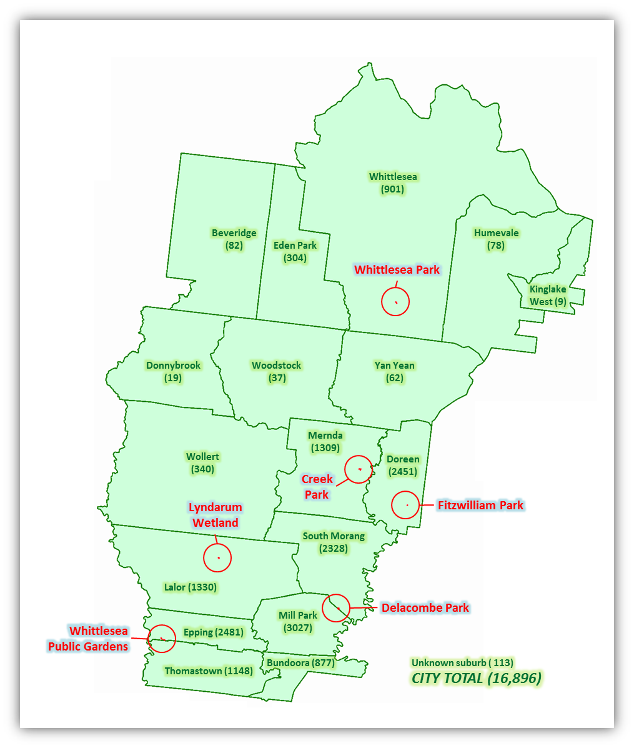
Dog Population and location of existing Off-Leash Areas.

Figures as at 21 August 2015

Existing Off-Leash Areas

The Off-Leash Area images shown above are approximately relative in size.
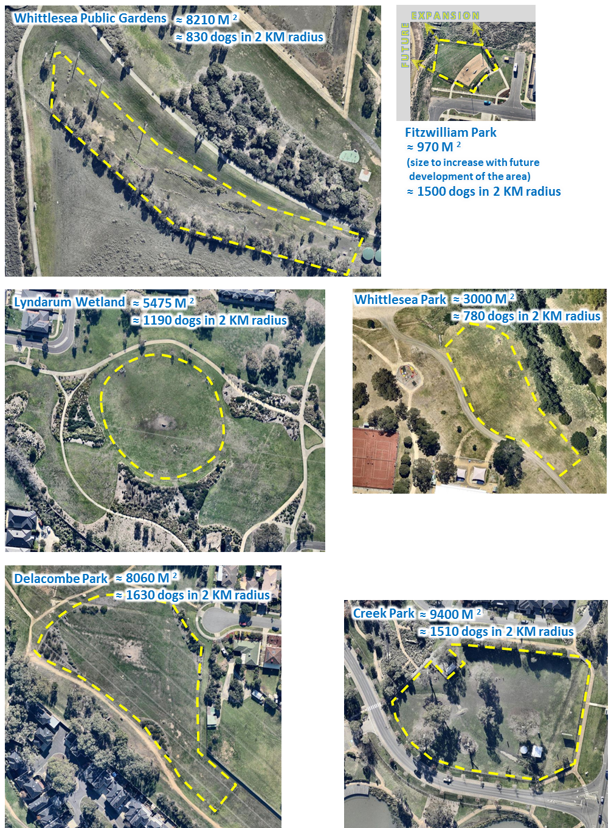

Appendix 2 - Regions and Confined / Structured Areas

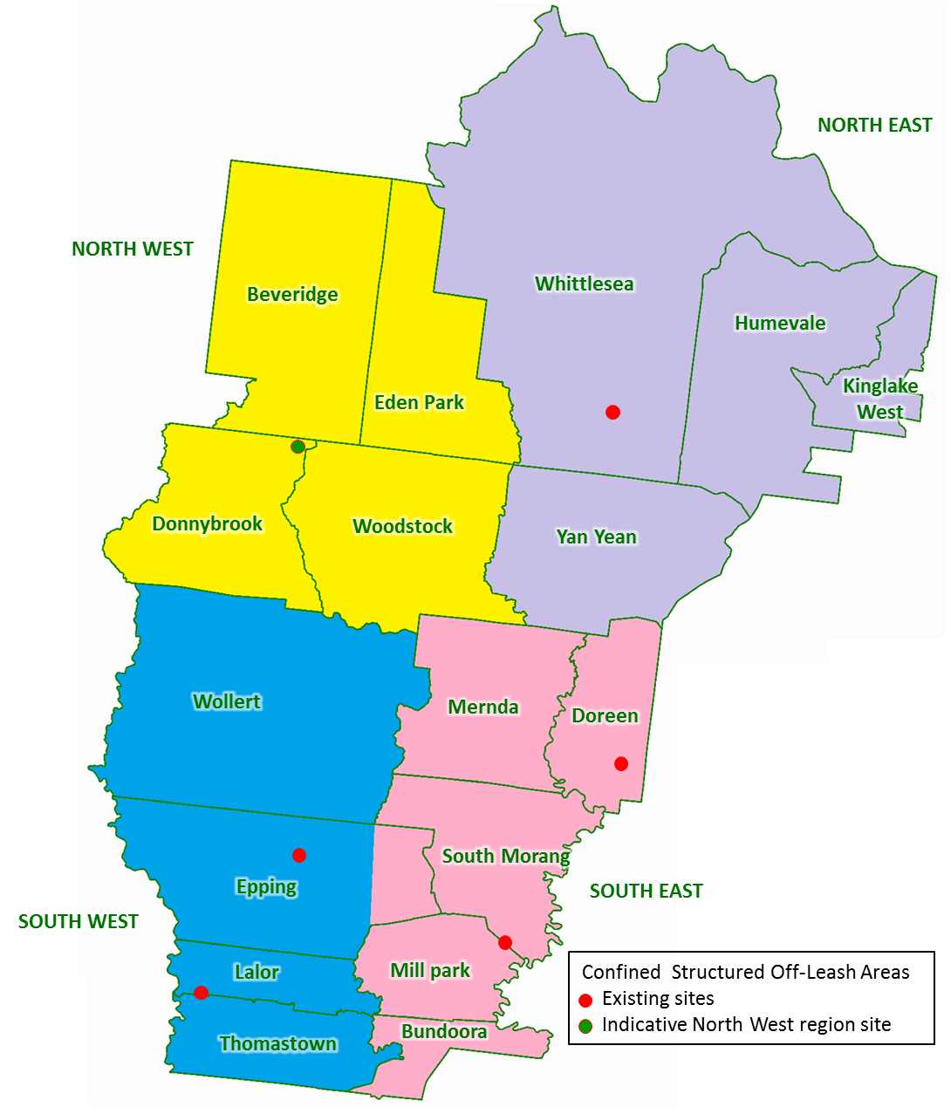

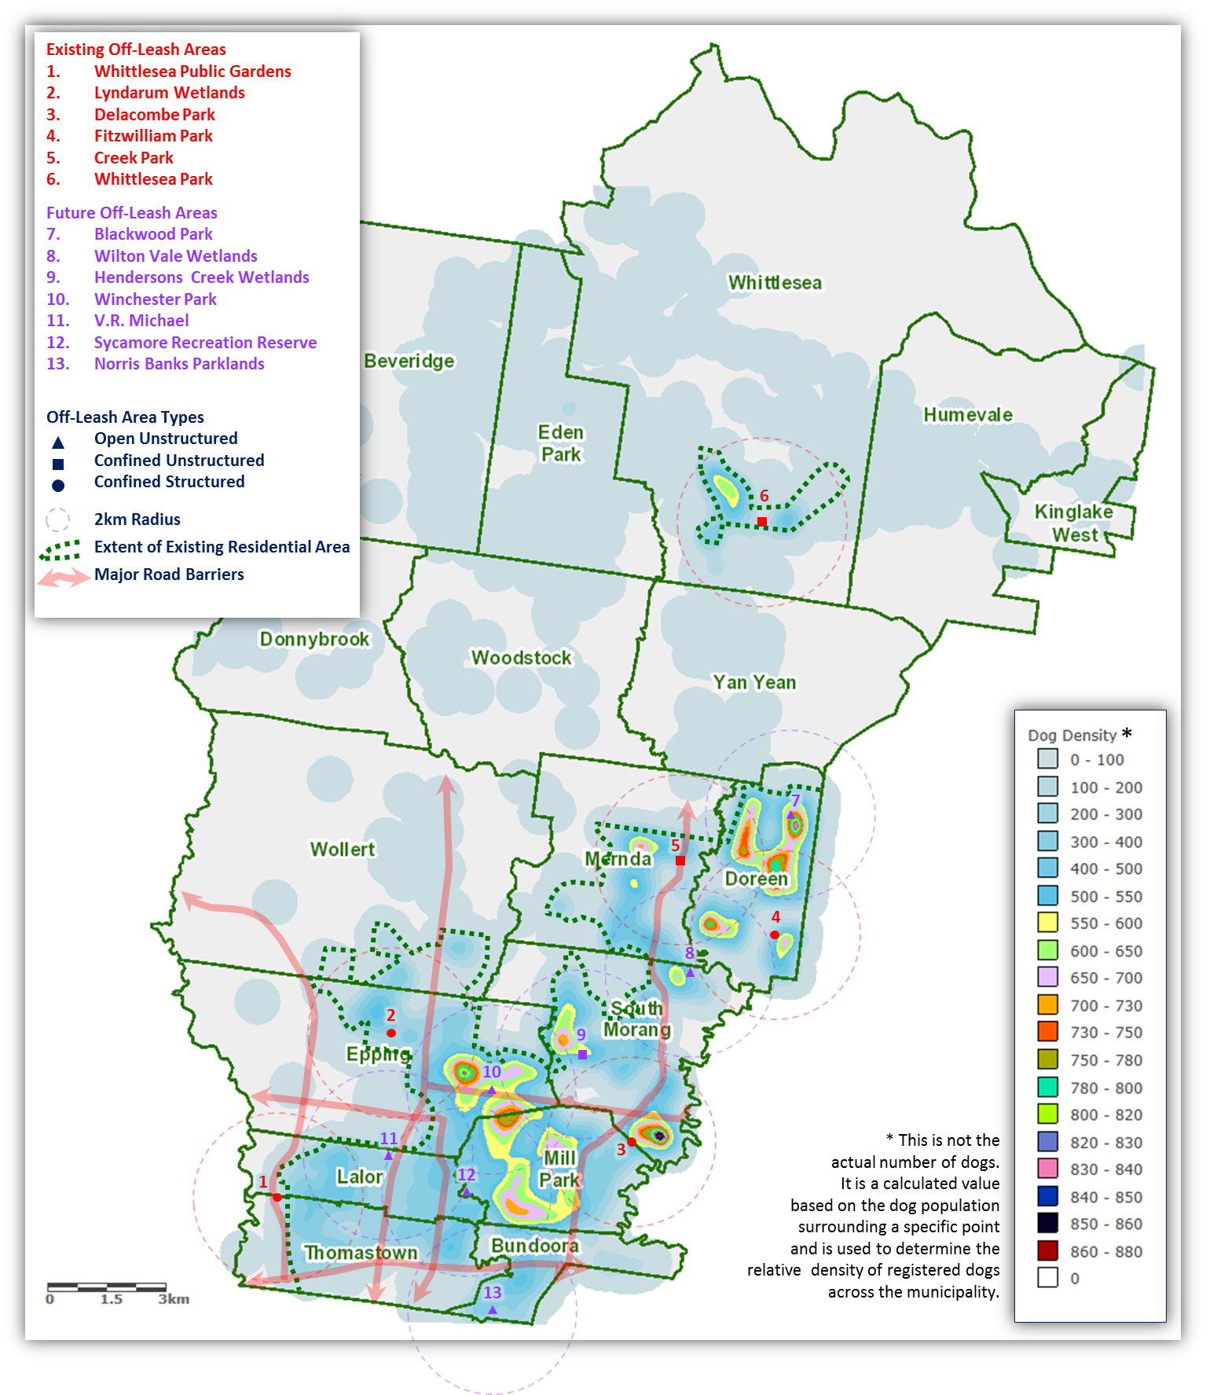
Appendix 3 - Equitable Access Considerations

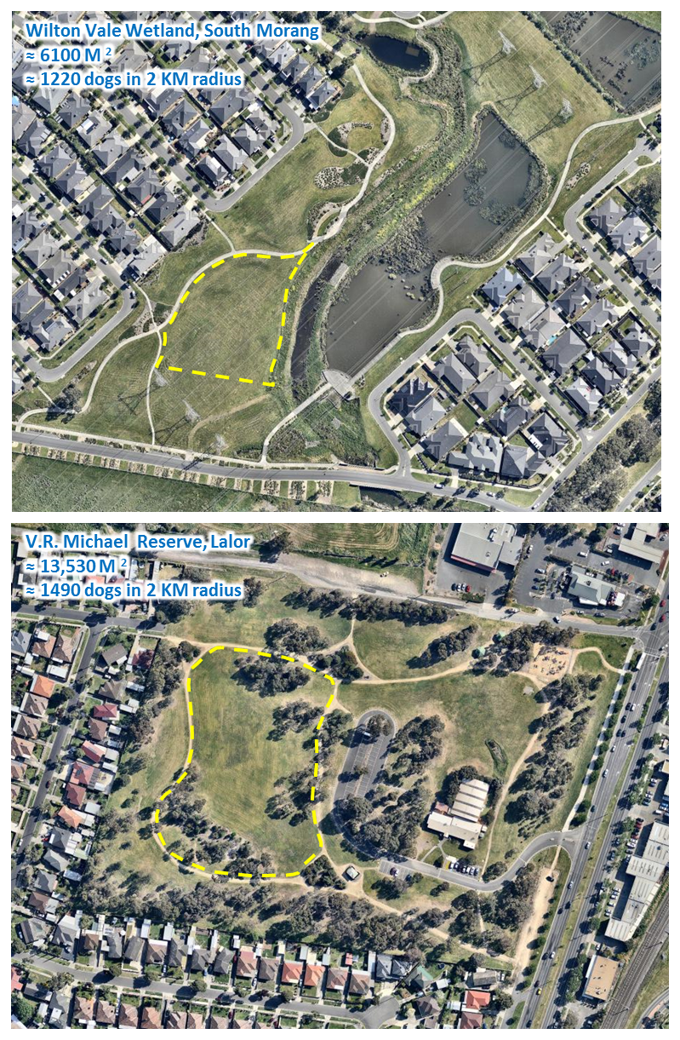
Appendix 4 - Future Off-Leash Areas

The Off-Leash Area images shown above and on the following page are approximately relative in size.

