Thomastown Industrial Area
Plan 2018-2038
A vibrant and sought after business location

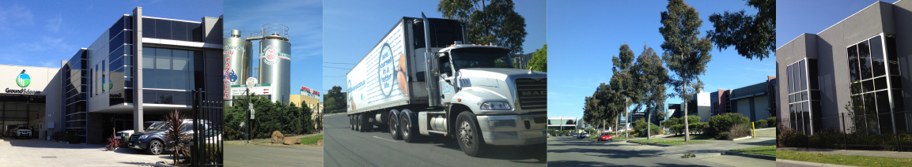

March 2018
Contents

Foreword ii
Section 1 – Introduction 1
Section 2 – Vision and Plan Aims 2
Vision 2
Plan Aims 2
Section 3 – Strategic context 4
Policy Context 4
Strategic Strengths 5
Section 4 – Objectives and strategies 7
1. Identity and economic development 7
2. Land use and development 8
3. Transport, access and infrastructure 9
4. Environment and sustainability 10
Section 5 – Precinct Plan and Opportunity Areas 11
Fact Sheet 1 – Trawalla Avenue Precinct 12
Fact Sheet 2 – Mahoneys Road Precinct 14
Fact Sheet 3 – High Street West Precinct 16
Fact Sheet 4 – Keon Park Station Precinct 18
Fact Sheet 5 – Dalton Road Homemaker Precinct 20
Fact Sheet 6 – Settlement Road East Precinct 22
Fact Sheet 7 – Dalton Road North Precinct 24
Fact Sheet 8 – McKimmies Road Precinct 26
Section 6 – Actions and Implementation 28
Section 7 - Delivery 28
Section 8 - Monitoring and Evaluation 29
Acknowledgements 30
Glossary 31
Appendix 1: Plan Melbourne 32
Appendix 2: Action Plan 33

Foreword

Mayor’s message

The Thomastown Industrial Area is a major economic generator for the City of Whittlesea and the northern region. It is a key location for local employment and commercial activity within a region that is recognised for having the manufacturing skills, educational capacity and know-how to become a leading employment hub.

The area is strategically well located with convenient access to major transport arterials such as the Metropolitan Ring Road and Hume Freeway. It is also benefits from close proximity to Melbourne Polytechnic and the Melbourne Wholesale Fruit and Vegetable Market in Epping. There exists a significant opportunity for Council to apply a strategic and coordinated approach to future development in the Thomastown Industrial Area to further encourage investment, ensuring economic growth and job creation.

The Thomastown Industrial Area Plan will provide a clear direction for the area to allow existing businesses and developers in the area to plan and invest with greater certainty. It also sets out how Council will assist in improvement works and advocate for infrastructure that will make positive changes for business and employees.

It is through this plan Council provides a commitment to work with businesses, developers, community and the State Government to ensure the Thomastown Industrial Area continues to thrive.

It is my pleasure to endorse the Thomastown Industrial Area Plan. I’m confident this plan will ensure that the area continues to be a success in our fast-paced changing global economy.

Cr Kris Pavlidis
Mayor
City of Whittlesea

Section 1 – Introduction
The southern part of Thomastown emerged as a major industrial location during the 1970s and has progressively developed over the past 40 years in response to market demands. The completion of the Metropolitan Ring Road in 1999 and the establishment of the Dalton Road homemaker precinct have further enhanced the accessibility and economic importance of this employment area in more recent times.

Today, the Thomastown Industrial Area (shown in Figure 2) provides business and employment opportunities for residents of the City of Whittlesea and the broader northern metropolitan region. It is home to an estimated 1,800 businesses, contributes an approximate $1.1B to the economy and employs close to 11,000 people. Accordingly the area is recognised as being of State significance as an employment area in the recently published Metropolitan Strategy Plan Melbourne, where it is identified as being part of the Northern Industrial Precinct.

This Plan seeks to develop a long term vision for the Thomastown Industrial Area. It addresses important issues relating to identity and economic development, land use and development, infrastructure provision and environmental sustainability. It will set a framework for land use and development and provide certainty and confidence for existing and future business investment. The principle aim of this plan is to ensure that the industrial area continues to be attractive for investment and provide local jobs for communities.

This document begins by setting out the Strategic Context of the area by highlighting the importance of the area from a State and Local Government level. The Aims and Visions for the area are outlined in Section 3 of the document and Section 4 provides a precinct map that divides the study boundary into eight areas. Each precinct is separated and provided with an analysis of existing characteristics, its future role, function and development potential. This leads to the relevant actions that will seek to provide an outcome so the intention of the precinct.

It is important to note that the Plan is not a statutory document and will not be incorporated into the Planning Scheme. Rather it is a guiding advisory document that identifies actions and advocacy projects that are to be implemented by a variety of Departments within Council.

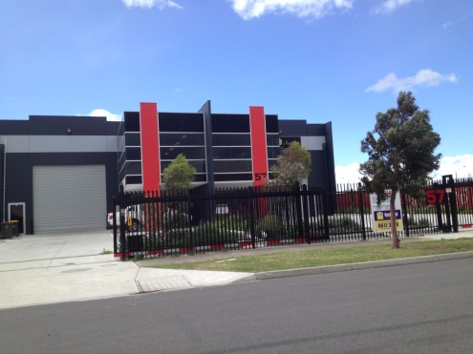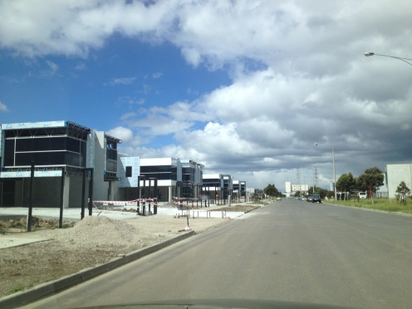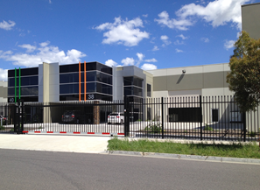
Figure 1: Recent developments at Meridian Business Park, Thomastown

Section 2 – Vision and Plan Aims
The purpose of the Thomastown Industrial Area Plan is to support investment, improve the amenity and image of the area, provide direction in relation to the role and function of the area and outlines infrastructure needs for the area. Set out below are the principle aims of the plan and these will define how success will be measured.

It will set a framework for land use and development and provide certainty and confidence for existing and future business investment. The principle aim of this plan is to ensure that the industrial area continues to be attractive for investment and provide local jobs for communities.

Vision
To build upon the Thomastown Industrial Area successes as a sought after business hub and to facilitate employment growth through innovation and collaboration with stakeholders.

Plan Aims
- To support economic investment.
- To provide a framework for land use and to improve the image of the area to create an attractive environment for business investment.
- To support regional transport connections and improve internal access, safety and connectivity through public transport, walking, cycling and vehicular infrastructure upgrades.
- To improve the amenity and environmental conditions of the area through enhancements to the open space network, waterways and landscaping.

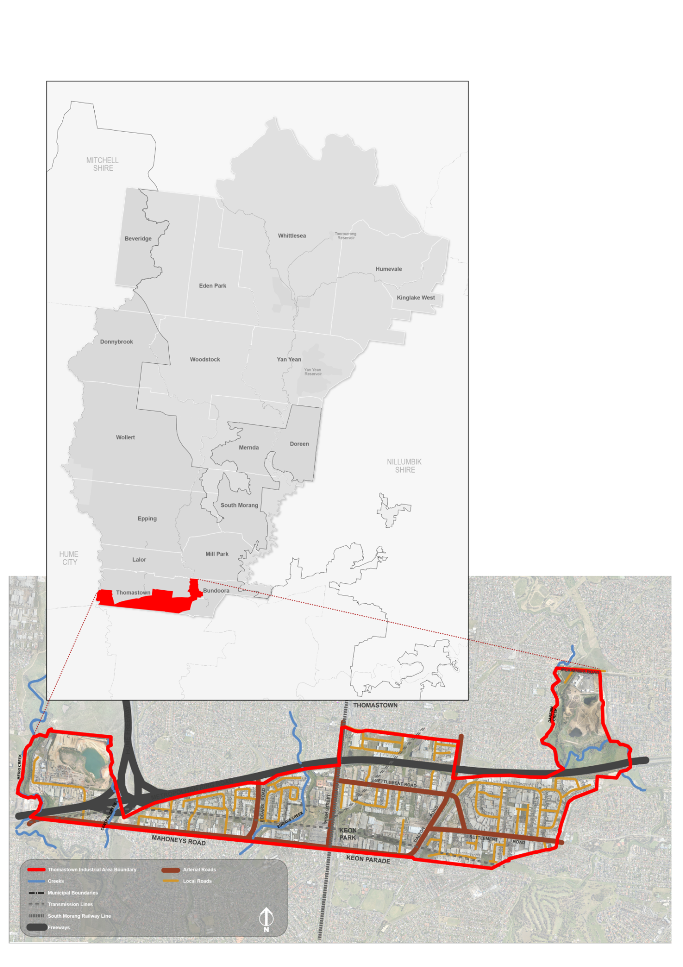
Figure 2: Thomastown Industrial Study Area

Section 3 – Strategic context

Policy Context
This section outlines State and Local documents that are relevant to the Thomastown Industrial Area. They were used to inform this Plan as they apply strategic methods of improvements to the area. From a State level, it creates the connection between the Plan and the overall Vision and Economic function in Melbourne. They set the framework for the key drivers in the plan that is important for its implementation. The policies assisted in establishing the overarching strategic bases for the plan.

Council’s Economic Development Strategy set out five key directions to achieve its vision to achieve 10,000 new jobs in five years. These directions include:
- Strive to build a healthy, prosperous and resilient community.
- Foster an environment that encourages the development of a vibrant local economy.
- Capitalise on the city’s human, natural and built resources to maximise local employment.
- Promote the municipality as an attractive destination to invest in, work, visit and enjoy.
- Collaborate with community, business and government to deliver resources and opportunities.

Plan Melbourne sets out the Victorian Government’s vision for the city to 2050. It contains a number of directions relating to the delivery of investment and jobs by creating a city structure that drives productivity, supports investment through certainty and creates more jobs. The Thomastown Industrial Area is identified within the Northern Industrial Precinct which is one of the metropolitan area’s three identified State Significant Industrial Precincts. A number of potential urban renewal sites are identified in the Plan including Keon Park Station, which is within the Thomastown Industrial Area.

The Whittlesea Planning Scheme guides land use and development within the municipality. There are several provisions in the scheme that are relevant to this Plan. In addition, zones, overlays, particular and general provisions affect land use and development. The Thomastown Industrial Area is identified in the Scheme as strategically significant industrial and employment precinct in the municipality.

The Whittlesea Council Plan 2013-2017 outlines a number of key initiatives and programs to make the City of Whittlesea a better place to live. A key strategic objective is Growing our Economy so there are a diverse range of local employment opportunities, under the Plan strategies encourage new business investment so local jobs are supported.

Other Council related strategies include:

Environmental Sustainability Strategy – sets policy direction for building fit outs and actions for Sustainable development assistance programs.

Open Space Strategy – identifies areas in the Thomastown Industrial Area for new local spaces as well as improvements to local pipe tracks to improve connections.

Whittlesea Bicycle Plan 2016-2020 – provides policy to increase cycling participation at the City of Whittlesea by providing safety improvements, promotional initiatives and improvement to the current network. Identified cycle paths have been included in the Plan and will be implemented in accordance with the bicycle plan.
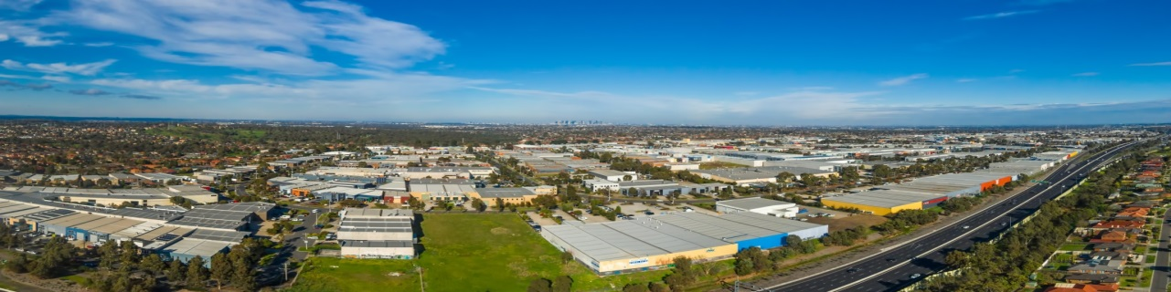
Figure 3: View of Industrial Area from the north
Purpose
With the overarching principles set by the above policies, the following gives an overview as to why Thomastown Industrial Area was identified as a precinct in need of a Strategy. It was considered by Council and relevant stakeholders and agencies that a framework was required in order to:

- Strengthen employment opportunities.
- Create more diverse job opportunities.
- Strengthen the functional and strategic strengths of the area that continue to generate new development and investment.
- Provide for new and increasing demand from industry migrating from inner areas.
- Provide direction for redevelopment of recent sites and older buildings where there are opportunities for investment.
- Support future industry investment opportunities in industrial services, light manufacturing, wholesale and office developments.

Strategic Strengths
Locational and infrastructure advantages
- Excellent access to the regional, metropolitan and national freeways.
- Access to major economic assets such as Melbourne Wholesale Fruit and Vegetable Market, Melbourne Airport and Port of Melbourne and proximity to a range of major tertiary institutions including RMIT (Bundoora), La Trobe University and Melbourne Polytechnic.
- Metropolitan passenger rail service with train stations at Keon Park and Thomastown as well as connecting bus services.
Range of uses and types of sites and built form
- A high proportion of functioning businesses and comparably low vacancy rate for existing buildings (5.7%) across the wider industrial area (industrial precincts typically averages 6% to 12%).
- Increased global competition and industry restructuring has provided opportunities outside the traditional manufacturing sector and a more diverse growth in industries has occurred.
- Opportunities available for a variety of businesses with a range of sites and building formats, together with good separation from sensitive land uses via main road boundaries.
- Where businesses of the same product/industry have been clustered together, it has provided agglomeration advantages for business operators.
- Large developers have been attracted to invest in new and higher quality industrial estates in some locations, improving amenity and increasing business and employment activity.
Employment capacity
- Employment intensity varies between 21 and 42 jobs per hectare and there is the capacity to increase employment densities through development and redevelopment of vacant or underutilised land.
- Situated within an area that has an established residential community with a growing catchment of workers providing job opportunities close to where people live and provides advantages for businesses.
Environment
- Creek environs provide quality amenity and opportunities for improved accessibility throughout the precinct.
- The creeks also provide separation from sensitive uses such as residential providing a distinct boundary for the area.

Section 4 – Objectives and strategies
The section aims to provide the basis for the plan aims identified in Section 2 and inform the approach for the precincts and opportunity areas in Section 5. These together set out how the vision for the area will be achieved.

1. Identity and economic development
Aim | To support economic investment.
Objectives | - Create an environment where businesses can grow and innovate to ensure more people have access to local job opportunities.  - Facilitate opportunities for local services for employees to provide places to meet or socialise and service local businesses.  - Create a positive impression and attractive identity for the area and entrance to the municipality through a functional public realm, streetscape improvements and gateway treatments.  - Foster an environment that attracts expanding businesses from Melbourne’s Inner North.
Directions | - Undertake regular collection of data through a Census of Land Use and Employment to understand development and market activity as well as employment trends to enable informed decisions.  - Strengthen and improve the profile and image of the area through enhancements to public realm including streetscape improvements.  - Encourage provision of landscape enhancements or other visual amenity improvements in prominent locations such as corner sites or gateway areas.
Benchmarks | - Retain existing businesses and increase the diversity of employment in the Thomastown Industrial Area.  - The improved visual amenity of all gateway areas as development occurs.
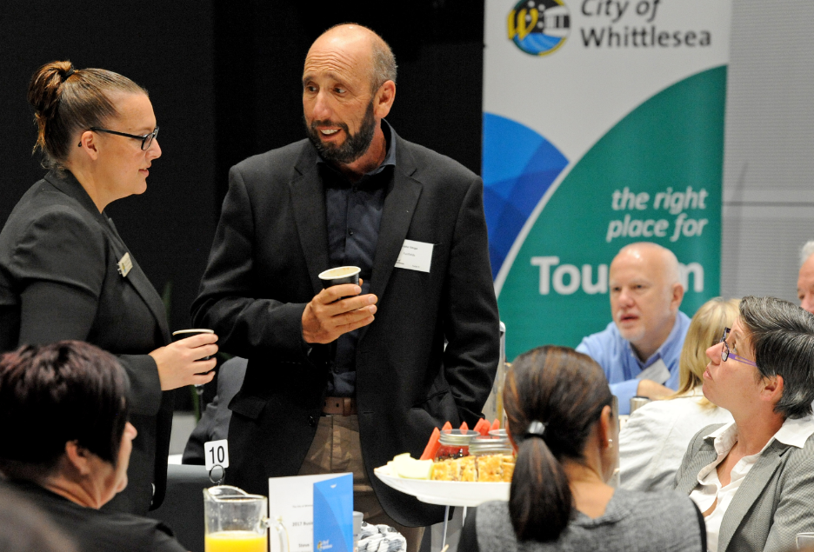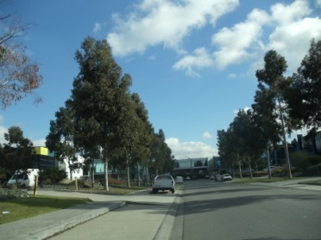

2. Land use and development
Aim | To provide a framework for land use and to improve the image of the area to create an attractive environment for business investment. | 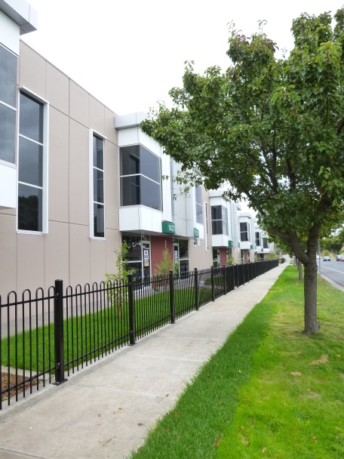  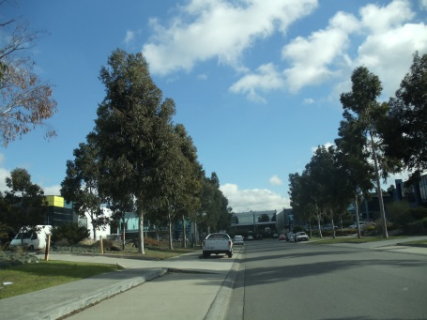  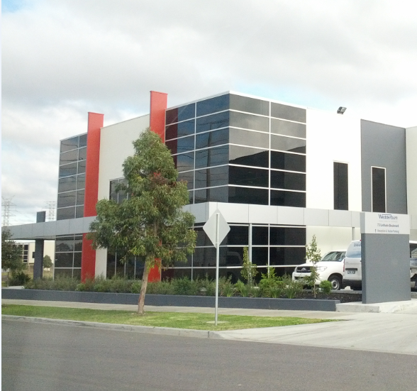
Objectives | - Maintain and protect the industrial area’s existing and future function as an employment precinct and manage the encroachment of sensitive uses.  - Support development with increased employment densities in appropriate locations to facilitate diverse employment opportunities.  - Improve the area’s visual appearance through high quality developments, urban design treatments and landscaping.
Directions | - Support and encourage land uses such as general manufacturing, light industry, warehousing, storage, and modern industrial estates as well as service-based employment activities.  - Encourage a greater diversity of land uses around Keon Park Station through a master planning exercise to integrate transport and land uses.  - Streamline appropriate development applications.  - Require high quality site planning and design.  - Undertake proactive compliance and education programs to ensure permit conditions are implemented and to maintain high levels of amenity to maintain an attractive investment environment.
Benchmarks | - An increase in the use of the State VicSmart Planning Process for applications of buildings and works up to $1M in industrial areas.  - Net increase in employment floor space in the in the Thomastown Industrial Area.  - Greater diversity of employment uses in the Thomastown Industrial Area.  - Successful monitoring of amenity through the Proactive Compliance Program.

3. Transport, access and infrastructure
Aim | To support regional transport connections and improve internal access, safety and connectivity through public transport, walking, cycling and vehicular infrastructure upgrades.
Objectives | - Maintain and strengthen access and connections to existing and future major road and freight networks.  - Facilitate improved connections throughout the precinct for walking and cycling and accessibility to public transport.  - Maintain and improve transport, drainage and broadband infrastructure to support businesses and new development in the precinct.
Directions | - Support an attractive and more connected urban environment through advocating for the removal of level crossings through grade separation.  - Create improved connections through local footpath network improvements, redevelopment of larger sites and by utilising utility easements.  - Create improved cycle connections throughout the area in accordance with the priorities set in the Whittlesea Bicycle Strategy (2015) and Open Space Strategy (2016).  - Upgrade and strengthen the existing road network through road capacity and safety improvements at identified intersections and key locations.  - Improve transport delivery or freight accessibility through the road network, focussing on improvements to identified critical access locations.  - Support improved public transport services in Thomastown including bus services and connections particularly east-west connections.  - Support businesses within the precinct to access broadband infrastructure.  - Achieve zero net impact on existing drainage infrastructure and receiving waters with the implementation of Best Practice stormwater initiatives.
Benchmarks | - Delivery of priority infrastructure program in accordance with Council’s infrastructure plan.  - Increased patronage of Keon Park Station and Smart Bus routes.
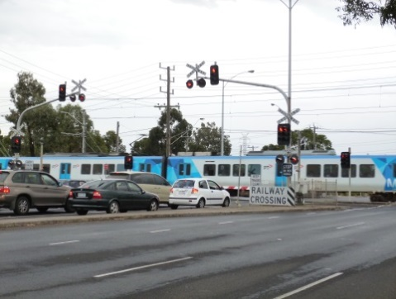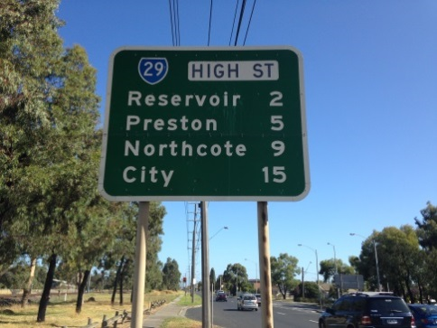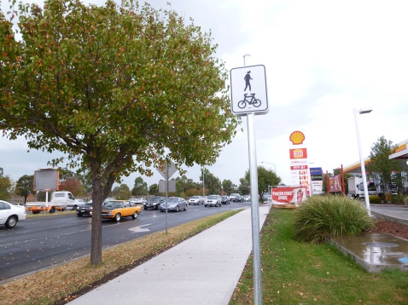

4. Environment and sustainability
Aim | To improve the amenity and environmental conditions of the area through enhancements to the open space network, waterways and landscaping.
Objectives | - Encourage sustainable built form in all industrial and commercial development, practices and activities.  - Improve the quality of runoff entering waterways from the area and prevent contamination by improving stormwater quality and drainage, remediating contaminated land and reducing impacts from poor business practices.  - Enhance the waterways by creating usable and accessible open spaces and improving stream health and environmental values.
Directions | - Support further sustainable development opportunities for business (including green roofs, on-site renewable energy including bulk purchase solar photovoltaic panels, and stormwater and runoff water capture and reuse).  - Encourage the provision of well-located storage for equipment, stock, vehicles and waste to ensure efficient business operation and avoid contamination of sites and stormwater.  - Encourage innovative water sensitive urban design to reduce and minimise local and downstream flooding and contamination impacts.  - Restore and rehabilitate Edgars Creek between Mahoneys Road and the Metropolitan Ring Road to improve connectivity and create new open space in accordance with the Open Space Strategy (2016).  - Support the restoration and rehabilitation of Merri Creek in accordance with the Merri Creek Park Strategy.
Benchmarks | - An increased number of street trees in the Thomastown Industrial Area.  - An increased number of development applications meeting Sustainability Design Assessment in the Planning Process (SDAPP).
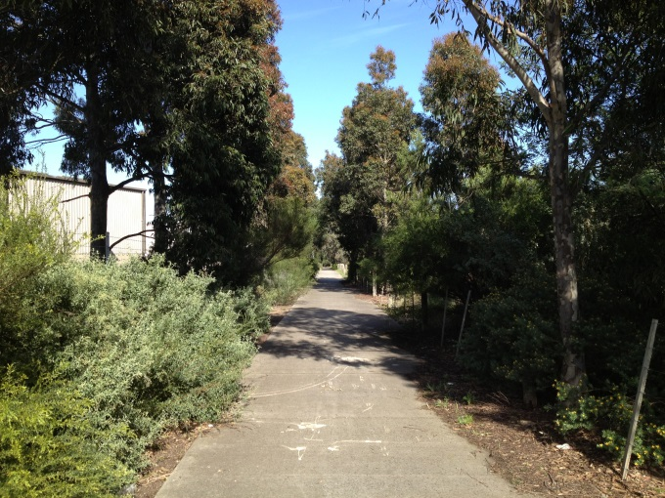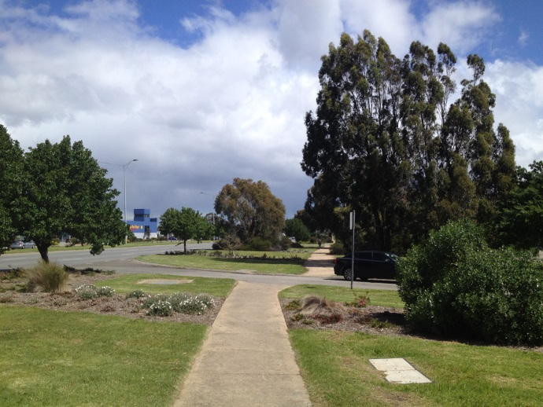

Section 5 – Precinct Plan and Opportunity Areas
This section sets out the preferred role and function for each of the identified precincts in the industrial area. In many precincts there are areas that have significant opportunity for development and change. Guidance and direction is provided for these areas along with actions for implementation. The location of each precinct is shown in Figure 4.

There is capacity for increased industrial activity within the Thomastown Industrial Area. The development of existing vacant sites as well as the redevelopment of properties with minimal capital improvements will maximise the Area’s productivity. Sites fronting arterial roads have the potential for contemporary industrial and commercial developments that can assist in raising the profile and improving the image of the industrial area and increase employment densities upon redevelopment.

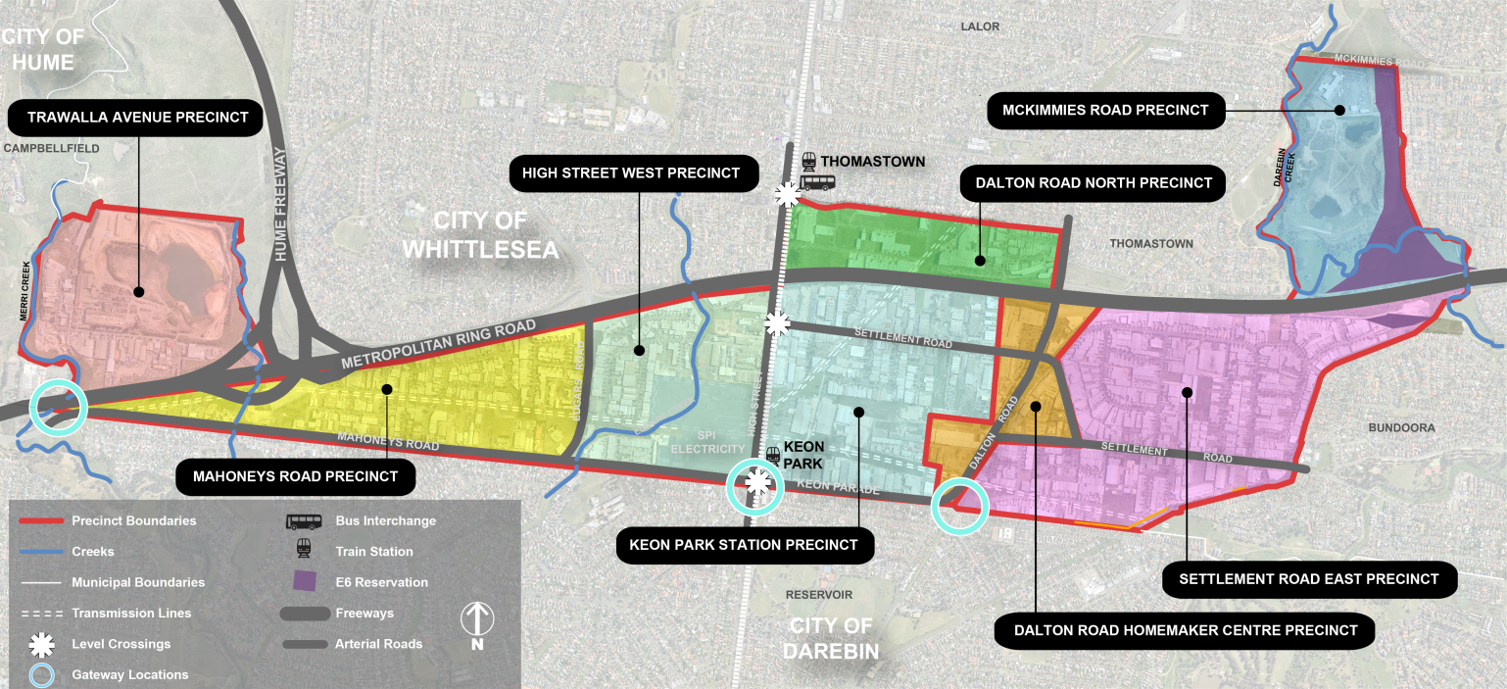
Figure 4: Precinct locations
Through the implementation of this Plan, identified opportunity areas and/or sites that require detailed master planning will be defined and specific planning controls implemented through planning scheme amendments. In many instances development plans or design and development overlays may be necessary to achieve the preferred outcomes within these areas and rezoning of land will not always be required.

Council will only take the initiative to rezone land where unacceptable interface issues between industry and residents need to be resolved or rezoning is required to achieve a specific land use outcome identified in this Plan. In all other situations rezoning requests would need to be lodged by a landowner, and the direction outlined in this section and the vision for the area will be used to assist with assessing the rezoning request.

Detail relating to each of the precincts is outlined in the fact sheets below.

Fact Sheet 1 – Trawalla Avenue Precinct
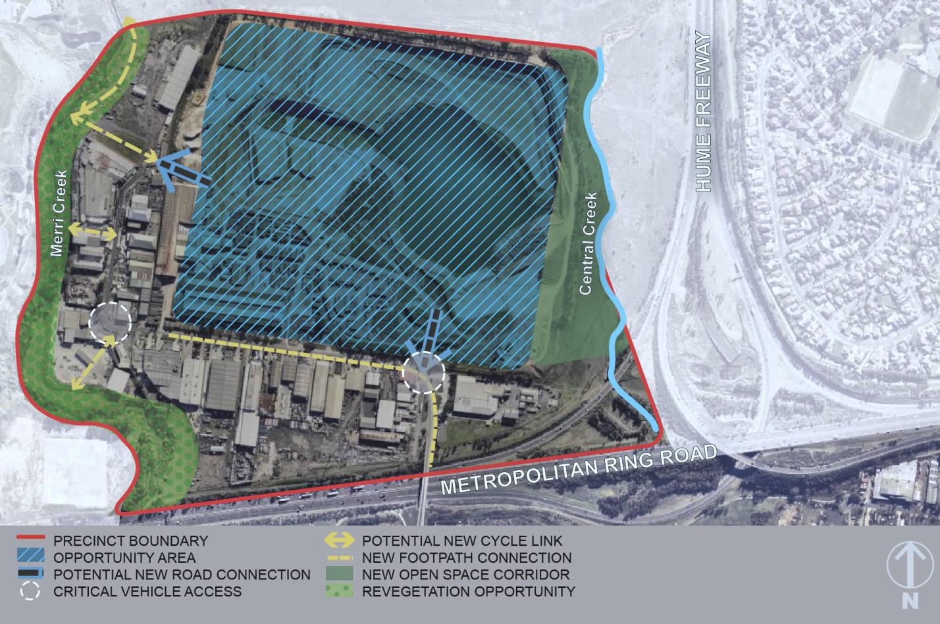

Description: This area forms the western edge of the industrial area and is bound by Merri Creek, the Hume Freeway and the Metropolitan Ring Road. The Merri Creek Parkland Galada Tambore is located immediately to the north. Quarrying, brick manufacturing and food manufacturing dominate this precinct. Access from Mahoney’s Road is limited to a single road (Industrial Avenue).

Role and Function: This precinct will continue to support land uses that generate significant employment such as industry and warehousing. The high value of this precinct is that it is contained and impacts from non-industrial uses on the ability of the precinct to support traditional industrial operations should be minimised.

Opportunity areas: The precinct contains a large strategic site that is currently being used for extractive industry. Following the cessation of quarrying operations this site is likely to become available for redevelopment. Opportunities exist to achieve environmental and open space outcomes in addition to economic investment. Central Creek also provides an opportunity to provide open space/recreation opportunities.

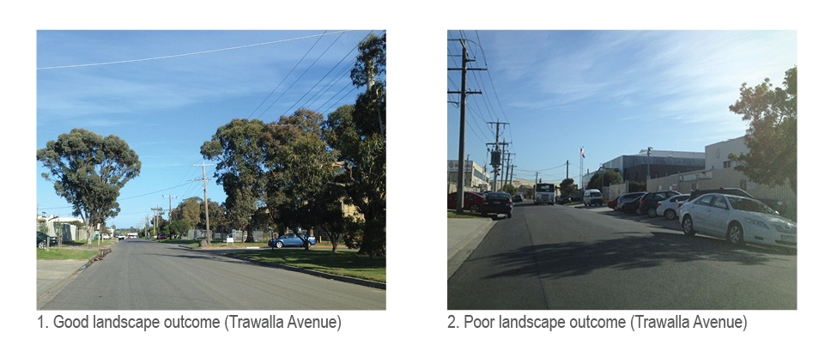
1. Good landscape outcome (Trawalla Avenue) | 2. Poor landscape outcome (Trawalla Avenue)
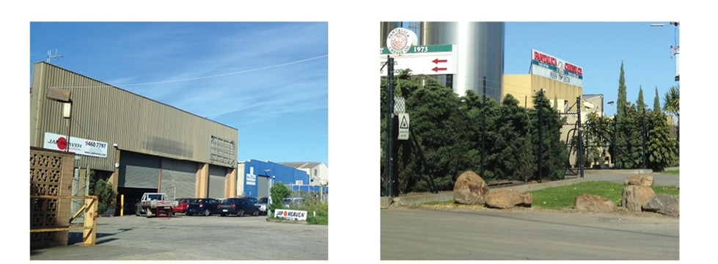
3. Typical industrial use – car recycling | 4. Typical industrial use – food manufacturing

Figure 5: Key features in Trawalla Avenue Precinct

Principles for development:
- New buildings and subdivisions should accommodate larger format buildings in preference to speculative warehouse, smaller industrial lots/units or the provision of offices.
- New development should provide appropriate design treatments to secondary frontages such as the Merri and Central Creeks and Galada Tamboore parklands and major roads.
- New development should be designed and oriented to maximise access to, and passive surveillance of, the street, open space, waterways and other pedestrian areas.
- A loop road through to Trawalla Avenue should be provided as part of redevelopment of the quarry site to improve internal connectivity and remove the ‘dead end’ arrangement.
- Opportunities should be sought to improve connections through to Merri Creek Parklands as part of redevelopment or subdivision of land.
- Pedestrian links should be provided within developments when large sites are subdivided to improve access and connectivity.

Fact Sheet 2 – Mahoneys Road Precinct
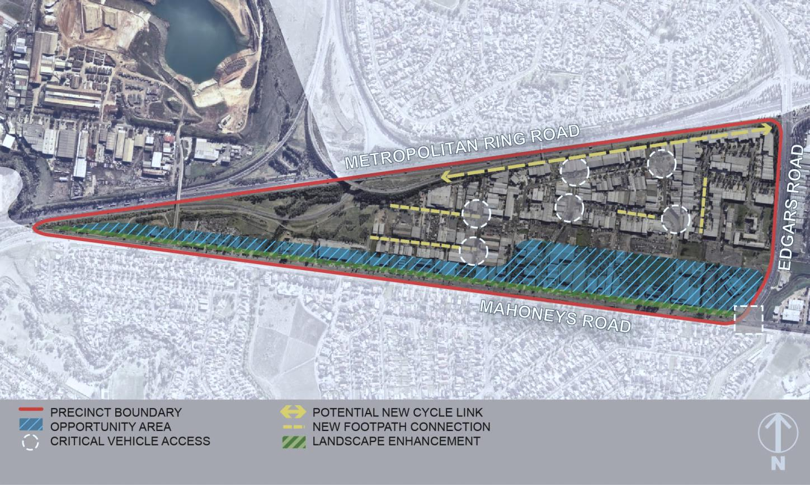

Description: Situated predominately to the west of Edgars Creek this precinct includes the land south of the Metropolitan Ring Road and north of Mahoneys Road. Residential properties exist to the southern perimeter, across the six lane Mahoneys Road. This precinct generally contains more traditional industrial uses including metal fabrication, food manufacturing, wholesale trade and automotive services. Smaller loop road catchments are typical. Entrance into the precinct is available from either Mahoneys or Edgars Roads.

Role and Function: The precinct can continue to support a range of industrial and employment-generating land uses. Mahoneys Road provides the greatest opportunities for improved amenity outcomes due to its proximity to residential areas. Many large sites along Mahoneys Road with side street access are suitable for office/warehouse uses. There are also some limited opportunities for industrial showrooms and large format retail given its frontage to Mahoneys Road. The northern portion of Mahoneys Road the precinct envisaged to continue to support, and be protected, for a range of land uses including industry, warehousing and service-based employment activities.

Opportunity areas: Sites with old building stock and minimal capital improvements together or vacant sites offer opportunities for development or urban renewal in this precinct. Contemporary industrial and commercial development, particularly along Mahoneys Road, will provide opportunities to improve the visual appearance, raise the profile of the industrial area and provide increased employment densities.

- High quality landscape and pedestrian environment (newer part of the precinct)
- Two storey built form (newer part of the precinct)

3. Good parking and landscaping outcome in  Blaxland Avenue | 4. Loss of street planting to accommodate additional  parking in Lawson Crescent

Figure 6: Key features in Mahoneys Road Precinct

Principles for development:
- New subdivisions should be designed to allow for a range of lots.
- Flexible new building design should be encouraged to accommodate expanding and contracting business and minimise obsolescence of sites so a range of businesses and industries can be supported.
- Developments should be designed to provide appropriate interface treatments to secondary road frontages, including the Metropolitan Ring Road and Edgars Road, to improve the presentation of the area from these thoroughfares.
- Maximise the passive surveillance of easements and other public areas to improve safety and encourage public use of these spaces.
- Existing industries should be encouraged to invest and upgrade facilities to improve the image and amenity of the area.
- Redevelopment of large sites should provide for the creation of new open space or equivalent functions, including provision of usable, landscaped and well-maintained communal outdoor areas in new industrial subdivisions.

Fact Sheet 3 – High Street West Precinct
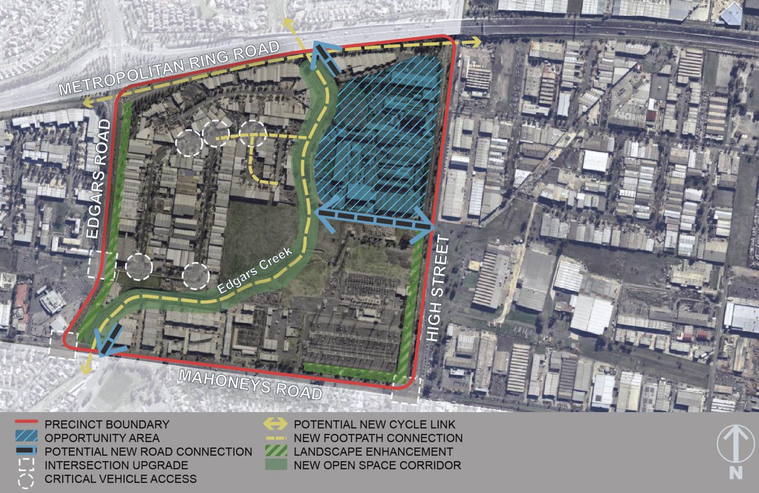

Description: This precinct is situated between Edgars Creek and High Street. Bounded to the north by the Metropolitan Ring Road and Mahoneys Road to the south. The Electrical Terminal Station covers a significant proportion of this precinct with the remainder predominately comprising large lots containing warehouse and industrial buildings. Frontage and primary access to all sites is available via High Street. To the west of Edgars Creek is an established industrial area with one entry point available from Horne Street connecting to Edgars Road.

Role and function: The precinct can continue to support a range of industrial and employment-generating land uses, particularly within consolidated precinct to the west of Edgars Creek. The eastern side of this precinct has significant potential to change in the short to medium term. There are opportunities to improve the interface with High Street through enhanced landscaping and quality design. The precinct also has some of the most significant opportunities to improve the amenity of the area by increasing accessibility through to the Edgars Creek corridor and providing an open space corridor.

Opportunity areas: Sites immediately to the north of the Electrical Terminal Station are considered to have the greatest capacity for change. Opportunities exist for a greater mix of higher intensity employment uses and greater height of buildings towards High Street. Larger and/or consolidated sites offer the opportunity to establish their own level of internal amenity through a business/industrial park environment incorporating landscaping, good internal circulation, including appropriate interface with the creek, and facilities for workers such as cafes.

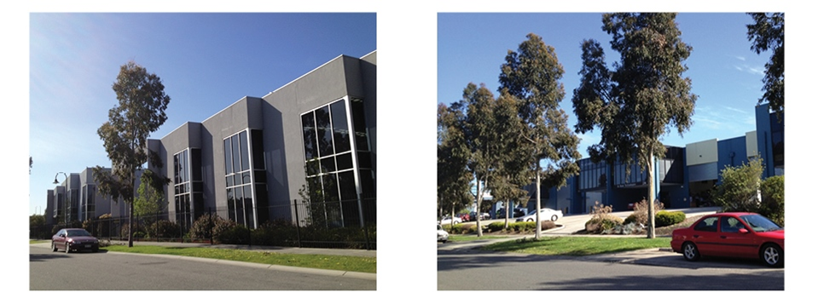
1. Good quality two storey built form | 2. High quality landscaping
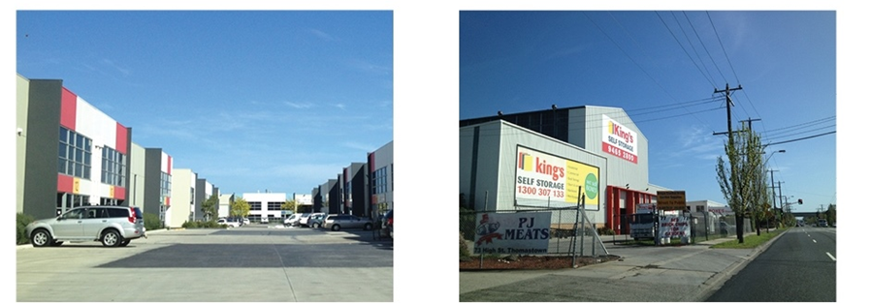
3. Limited landscape in the new development along Mahoneys Road
4. Poor pedestrian amenity along High Street

Figure 7: Key features in High Street West Precinct
Principles for development:
- The visual appearance of High Street as a major gateway to the municipality should be enhanced through generous landscaped setbacks to allow for quality landscaping treatments.
- Development should address both High Street and Edgars Creek so a well-defined and high amenity precinct is created.
- Consolidation of sites should be encouraged to enable an integrated approach to the redevelopment in this precinct.
- Provision of a road along the creek corridor/frontage to improve access and allow surveillance of the area.
- Connectivity to Edgars Creek should be maximised through a boulevard connector street from High Street with strong landscaping to provide a main point of entry that terminates at the creek.
- New development and subdivisions should provide generous landscaping strips to improve amenity and provide treatments to screen car parking from at the street.
- Flexible new building design should be encouraged to accommodate expanding and contracting business and minimise obsolescence of sites so a range of businesses and industries can be supported.
- Potential re-zoning of land for sensitive uses will need to incorporate Ministerial Direction 1 – Potentially Contaminated Land.
- Facilitate opportunities for recreation and connections to the Edgars Creek path by
  - Setting aside areas along creek corridors and creation of adjacent open space on sites traversed by Edgars Creek.
  - Provision of usable, landscaped and well-maintained communal outdoor areas in new industrial subdivisions.
  - Provision of lower order roads to improve access in master planning in opportunity areas.

Fact Sheet 4 – Keon Park Station Precinct
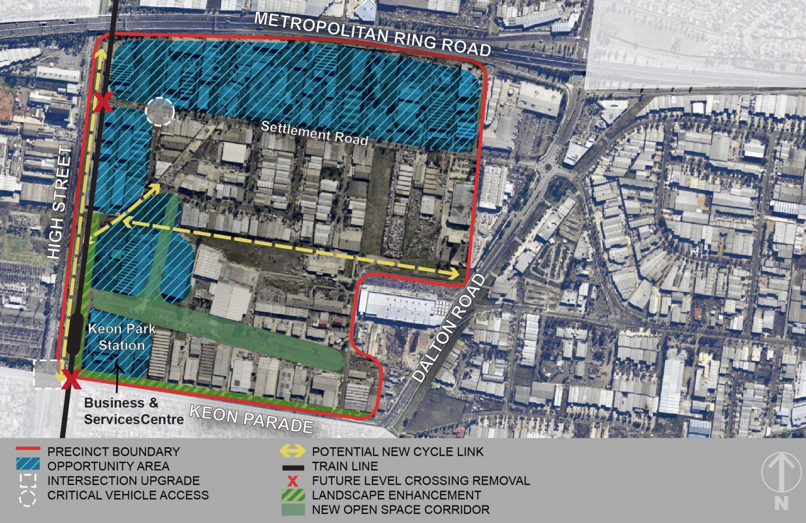

Description: Located on the northeast corner of High Street and Mahoneys Road, this precinct forms one of the main entryways into the City of Whittlesea. Extending to the Metropolitan Ring Road to the north this is a large precinct that contains a variety of industrial and warehouse activities. Keon Park Station is located within this precinct, with associated car park. Electricity reserves are are a key feature in this precinct. Level crossings exist at Keon Parade and Settlement Road.

Role and function: The precinct will continue to support a range of industrial and employment generating land uses. Development sites along Settlement Road provide the opportunity for more intensive warehouse/office development. Focussed around Keon Park Station, more intensive employment outcomes may be achieved. Opportunities for a greater diversity of uses including some offices, medical and health services, together with some convenience retail such as a small supermarket and cafes/ takeaway food outlets could be considered. These would need to be supported by detailed economic assessments and consideration of appropriate phasing of development over time.

Opportunity areas:
Keon Park Station: The areas proximate to Keon Park Station precinct have good access to public transport. Larger sites with older building stock provide opportunities for urban renewal and increased employment densities. The removal of at grade level crossings through grade separation would significantly improve road safety and capacity issues. It would also provide improved opportunities for people to access jobs within short distance of public transport and support urban renewal in this location generating greater economic returns from investment and significantly improving the amenity and profile of the area. The establishment of a business and services centre within the area would be expected to improve the market perception of the area and provide further employment opportunities. As such, this precinct has potential to significantly change the character and visual appearance of the area.

Settlement Road: More intensive industrial activities could also be supported along Settlement Road. Modern office/warehouse developments on larger sites along Settlement Road could be supported. These are likely to occur in the shorter term, particularly upon larger vacant sites. Larger sites also offer the opportunity to establish their own level of internal amenity through the development of a business/industry park environment and with high quality landscaping, good internal circulation and a cafe/take away food premises to service businesses within and adjacent to the development.

Principles for development:
- Ensure use and development does not compromise the operation of existing and future businesses and the function as an industrial and employment precinct.
- Support a greater diversity of uses immediately adjacent to, or above, Keon Park Station and along Keon Parade through a business and services centre that provides a range of higher skilled occupations including business services establishing within a small office suite development, and a range of health and medical services.
- Developments should provide passive surveillance opportunities along the railway line reservation, high voltage transmission line easements and open space areas.
- Outlook to easements, public transport corridors and other public areas to provide passive surveillance and increase opportunities for public use of these spaces should be provided.
- Redevelopment of land containing high voltage transmission line easements should provide for shared path links, open space and landscaping.
- Vehicular and pedestrian entry from Temple Drive should be utilised to create improved pedestrian connectivity throughout this precinct, maximising connections to the train station.
- A central public open space corridor should be encouraged as part of major redevelopments to provide amenity for workers and improve connectivity.
- Developments should be designed to provide appropriate interface treatments and landscaping to secondary road frontages, including the Metropolitan Ring Road, to improve the presentation of the area from these thoroughfares.
- Storage areas should be designed to minimise visual impact from the street.
- Flexible new building design should be encouraged to accommodate expanding and contracting business and minimise obsolescence of sites so a range of businesses and industries can be supported.
- Existing industries should be encouraged to invest and upgrade facilities to improve the image and amenity of the area.
- Appropriate interface treatments along Keon Parade for those opposite residents.

Fact Sheet 5 – Dalton Road Homemaker Precinct
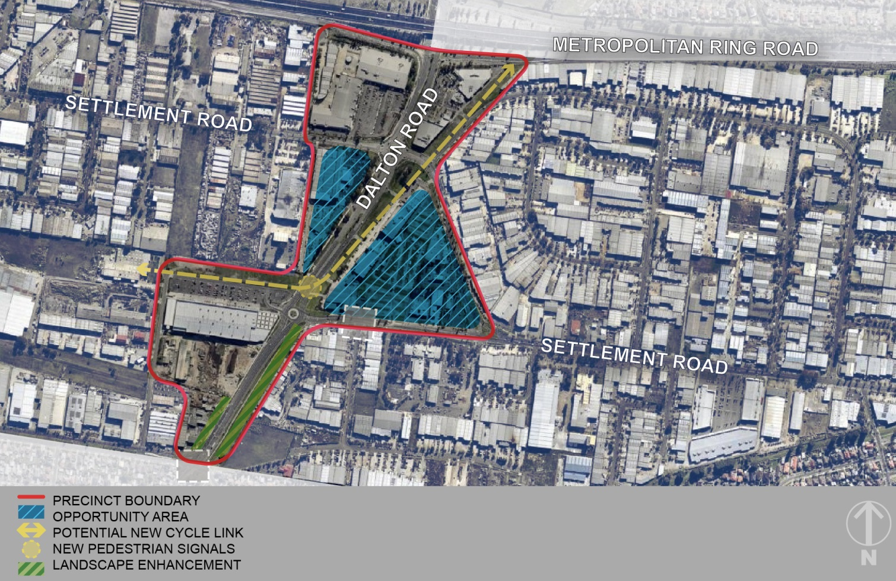

Description: The precinct is located to the south of the Metropolitan Ring Road and is divided by Dalton Road, a six lane divided arterial road. The Thomastown Homemaker Centre anchored by Harvey Norman occupies the north- west corner of the precinct, The Good Guys store in the north-east corner and Bunnings to the south of the precinct has a different character to the remainder of the industrial area. Comprising a mixture of Commercial 2 and Industrial 1 zones the fragmented nature and poor connectivity of this area impacts on the attractiveness of this location as a retail destination.

Role and function: This precinct is not expected to support any significant expansion of bulky goods retailing. This is demonstrated by the existing mix of businesses within Settlement Road which is predominantly trade supplies. This precinct is likely to continue to provide a greater mix of business types and development types and can continue to support industrial showrooms along the Settlement Road and Wood Street frontages with small scale office/warehouses across the remainder of the area.

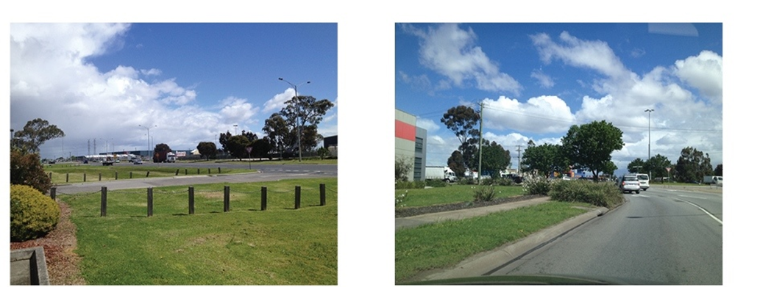
1. Underutilised easement on Dalton Road | 2. Difficult pedestrian crossing (Settlement and Dalton Roads)
Figure 8: Key features in Dalton Road Homemaker Precinct

Opportunity areas: The sites to the south of the precinct, along Dalton Road, that are currently zoned Commercial 2, offer the greatest potential for new development. These properties are generally underutilised with minimal capital improvements and should provide an active frontage to the street.

Principles for development:
- Development should provide an active frontage to Dalton Road to improve the visual appearance.
- Developments should be designed to provide appropriate interface treatments to secondary road frontages, including the Metropolitan Ring Road, to improve the presentation of the area from these thoroughfares.
- Outlook to easements, public transport corridors and other public areas should be provided passive surveillance and increased opportunities for public use of these spaces should be provided.
- New crossovers to major roads should be minimised in order to ensure the ongoing optimal operation of these roads and opportunities for streetscape upgrades.
- Storage areas should be designed to minimise visual impact from the street.
- Flexible new building design should be encouraged to accommodate expanding and contracting business and minimise obsolescence of sites so a range of businesses and industries can be supported.
- Existing industries should be encouraged to invest and upgrade facilities to improve the image and amenity of the area.
- Adaptation of buildings should be encouraged where quality outcomes can be achieved.

Fact Sheet 6 – Settlement Road East Precinct
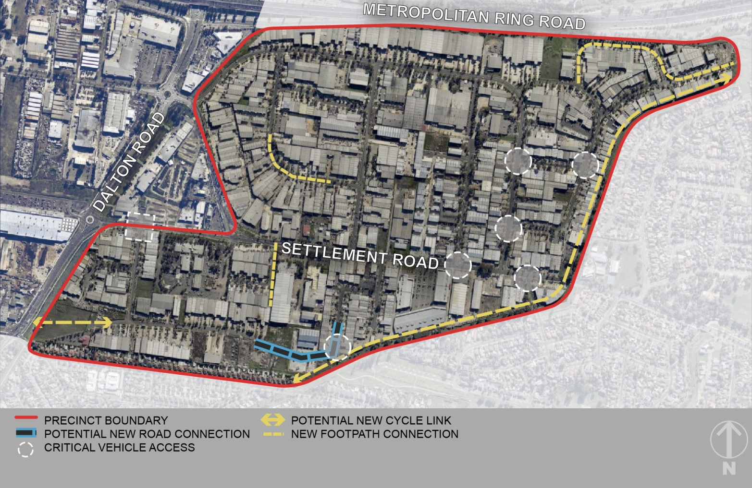

Description: Settlement Road East predominately forms the areas to the east of Dalton Road and south of the Metropolitan Ring Road. The amenity of this part of the industrial area is mixed. The newer industrial subdivisions to the north of Settlement Road provide a greater amenity than the older southern parts. Generally traditional industrial uses including metal fabrication, food manufacturing and wholesale trade predominate in this location, with more commercial activities such as retail trade supplies located along Settlement Road. Smaller loop road catchments are typical with major road access available from either Dalton or Settlement Roads.

Role and Function: The precinct can continue to support a range of industrial and employment generating land uses and the precinct will be protected for a range of land uses including industry, warehousing and service-based employment activities. Use and development proximate to residential development, in particular along Holt Parade and Spencer Street should be responsive to their sensitive residential interfaces.

Opportunity areas: In the short term development is likely to be low intensity, focussed on refurbishment of existing buildings and consolidation of existing uses and operations. There are limited strategic redevelopment sites and major development and urban renewal in this precinct is likely to occur in the longer term. This will occur largely on sites along Settlement Road and where building stock is older and have become obsolete and no longer meet modern business needs. Larger sites also offer the opportunity to establish their own level of internal amenity through the development of a business/industry parks and with high quality landscaping and good internal circulation. Opportunities to develop a shared path within the Maroondah Pipetrack reservation (which forms the boundary of the precinct and residential properties) will need to be further investigated.

- Generous landscaping inside the front setback area (Inglewood Drive)
- Good landscape outcome (Merchant Avenue)
- Good landscape outcome (Commercial Drive)

- Large setbacks provide extra landscape opportunities and planting of canopy trees (Inglewood Drive)

Figure 9: Key features in Settlement Road East Precinct

Principles for development:
- New buildings subdivisions should be designed to allow for diversity in the size of lots.
- Flexible new building design should be encouraged to accommodate expanding and contracting business and minimise obsolescence of sites so a range of businesses and industries can be supported.
- Developments should be designed to provide appropriate interface treatments to secondary road frontages, including the Metropolitan Ring Road, to improve the presentation of the area from these thoroughfares.
- Outlook through active frontages should be provided to easements and other public areas to create increased opportunities for public use of these spaces and passive surveillance.
- Existing industries should be encouraged to invest and upgrade facilities to improve the image and amenity of the area.
- Adaptation of buildings should be encouraged where quality outcomes can be achieved.
- Require new industrial developments proximate to sensitive uses, particularly along Holt Parade, provide design solution and management arrangements to minimise any adverse amenity impacts.

Fact Sheet 7 – Dalton Road North Precinct
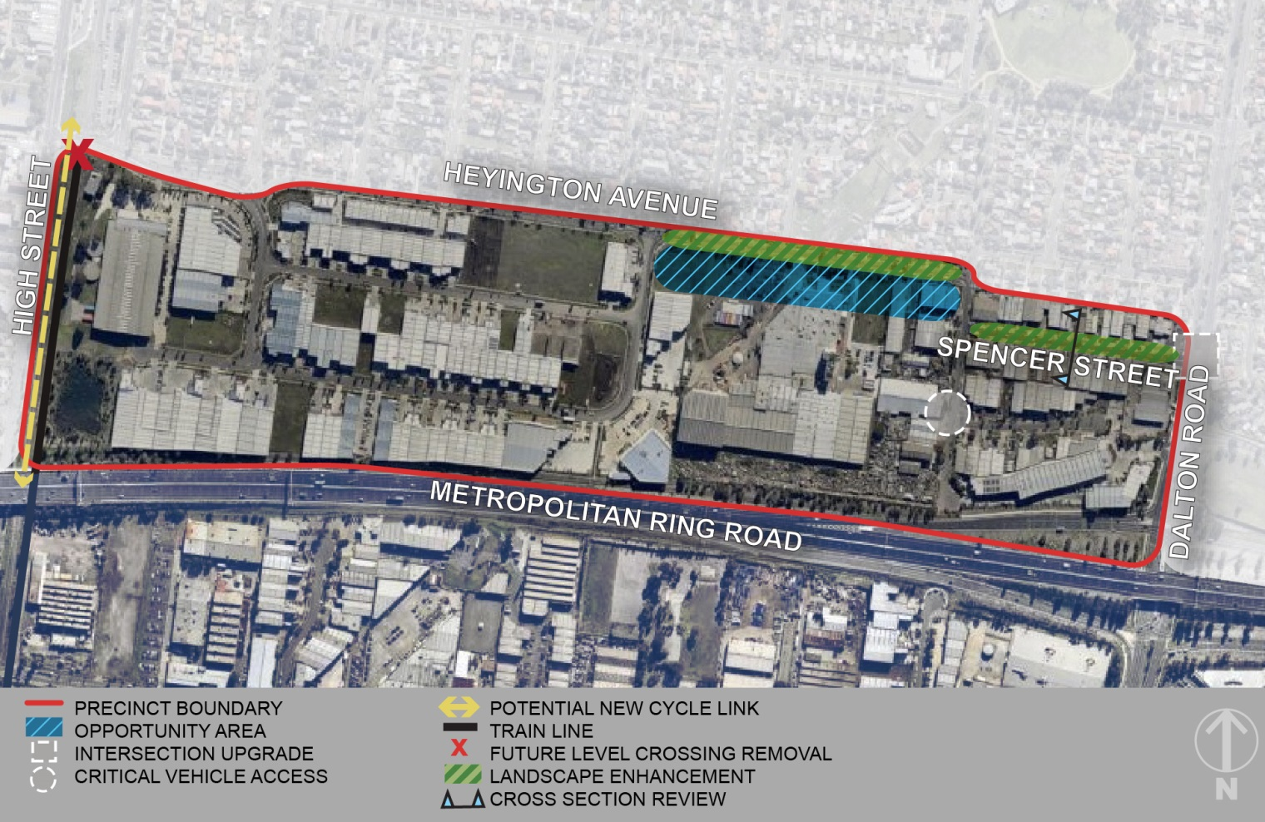

Description: Dalton Road North forms the area to the north of the Metropolitan Ring Road, between High Street, Dalton Road and Heyington Avenue. The newly developed Meridian Business Park is situated to the west, while the older building stock to the east contains more traditional industrial activities including service industries. Smaller loop road catchments are typical, with major road access available from either Dalton or Settlement Roads.

Role and Function: The precinct will continue to support a range of industrial and employment generating land uses and the precinct will be protected for a range of land uses including industry, warehousing and service-based employment activities. Use and development proximate to residential development, in particular along Holt Parade and Spencer Street should be responsive to their sensitive interfaces.

Opportunity areas: In the short term development is likely to be low intensity, focussed on refurbishment of existing buildings and consolidation of existing uses and operations. Long term opportunities exist to improve the interface with residential properties to the north along the eastern end of Heyington Avenue. Connections between Dalton Road and Spencer Street will improve accessibility and safety of this intersection.

1. Limited landscape and car parking on the verge  along Spencer Street | 2. New development on the corner of Metropolitan  Ring Road and Dalton Road
3. High fences | 4. Cars parking on the verge along Spencer Street
Figure 10: Key features in Dalton Road North Precinct

Principles for development:
- New buildings subdivisions should be designed to allow for a range of size of premises and lots.
- Flexible new building design should be encouraged to accommodate expanding and contracting business and minimise obsolescence of sites so a range of businesses and industries can be supported.
- Developments should be designed to provide appropriate interface treatments to secondary road frontages, including the Dalton Road, to improve the presentation of the area from these thoroughfares.
- Outlook through active frontages should be provided to easements and other public areas to create increased opportunities for public use of these spaces and passive surveillance.
- Existing industries should be encouraged to invest and upgrade facilities to improve the image and amenity of the area.
- Adaptation of buildings should be encouraged where quality outcomes can be achieved.
- Require new industrial developments proximate to sensitive uses, particularly along Spencer Street and Heyington Avenue, provide designs solutions and management arrangements to address any adverse amenity impacts.

Fact Sheet 8 – McKimmies Road Precinct
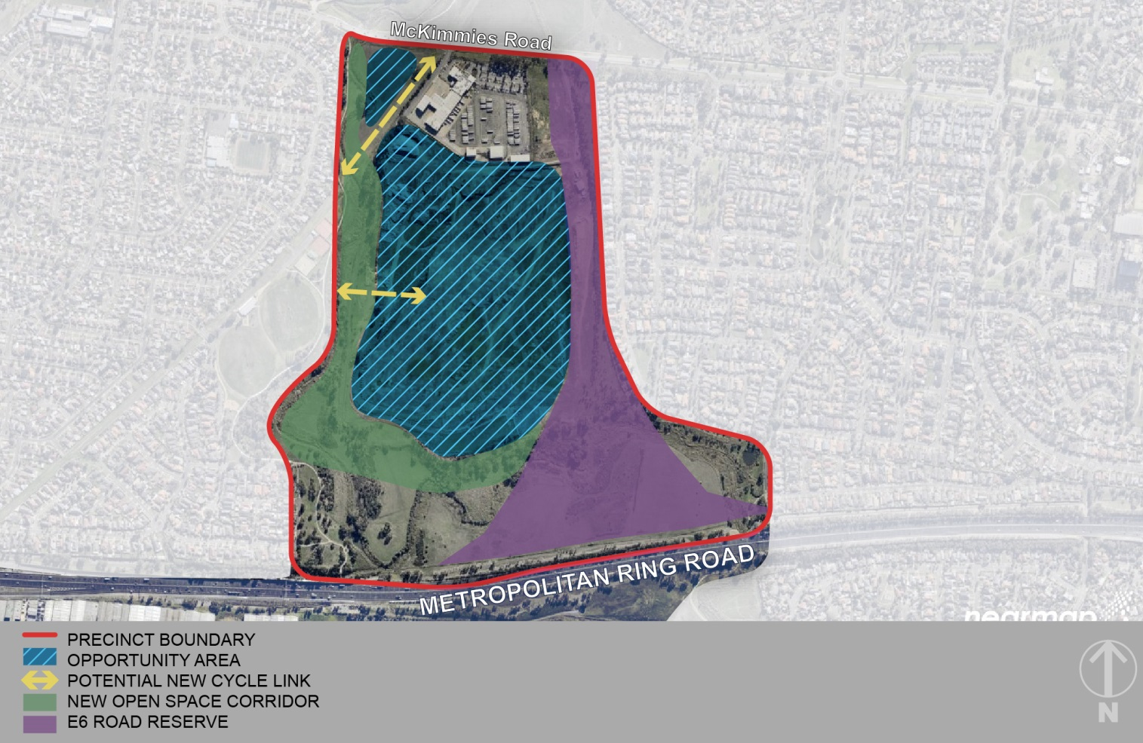

Description: Located north of the Metropolitan Ring Road this is an isolated precinct within the wider industrial area boundary. Access is only available from McKimmies Road. A bus depot and the landfill operation rehabilitating the former quarry site are the predominate uses. The E6 road reservation connections through the eastern side of this precinct with residential to the west.

Role and function: This precinct is not expected to support industrial development in the long term given the availability of better located sites, including industrial land in the Epping corridor. The potential for ‘high-tech’ activities is also limited given the ability for businesses to access engineering professionals to the extent that other locations within Melbourne, particularly the south-east region are able to. The conversion of this industrial land to an alternative use would not represent a loss in terms of existing economic activity or employment based on the current use. Therefore, considering the broader context of the area, opportunities for alternative uses are recommended.

Opportunity areas: The precinct is largely underutilised and once rehabilitation works are completed a large proportion of this precinct may become available for development subject to geotechnical and contamination considerations. Appropriate detailed assessments of access arrangements, impacts of existing Dyson Depot, environmental implications (protected vegetation and species and flooding impacts) and any associated geotechnical and risk of potential contamination will be required when considering an alternative land use such as residential or mixed use. Any mixed use or residential development would also need to incorporate elements of social and affordable housing. The E6 corridor will remain protected as part of any future development scenarios.

- Concrete recycling area
2. Dyson Bus Company Sheds
- Dyson Bus Company

Figure 11: McKimmies Road Precinct

Principles for development:

- The preferred approach for any redevelopment within this precinct is that a coordinated approach to the redevelopment, detailed master planning undertaken with key parties, including landowners, Council and key agencies to agree a set of guiding principles for development. Appropriate planning controls and tools can then be determined and implemented to facilitate the future use and development of the land.

Section 6 – Actions and Implementation
The Action Plan provides a framework which sets out how the vision and plan aims will be achieved and how projects will be delivered. This is predominately through the implementation actions which contain priority projects, and key land use and infrastructure requirements that have been identified to implement the Vision.

Delivery and timing of all projects outlined in the Action Plan will be subject to business case, endorsement from the Executive Leadership Team and budget approval for specific works by Council. The plan outlines the resourcing sources for each action. For the purposes of the Action Plan, the following timespans are provisionally anticipated:
• Short: 0–4 years
• Medium: 5–10 years
• Long: 11+ years

The Action Plan will be reviewed as part of the ongoing monitoring and evaluation to determine priority actions and projects. The Action Plan is outlined in Appendix 2.

Section 7 - Delivery
The implementation framework outlines the financial resourcing requirements of each of the actions.

The financial resourcing column in the implementation plan broadly outlines where funding for action/projects will come from. Predominantly, projects will be overseen by relevant Council departments either as new projects or as part of existing programs.

A significant proportion of the outcomes outlined in the Plan are dependent on the private sector for delivery, particularly in relation to new industrial and commercial development. Council will need to commit officer time in order to help facilitate the outcomes as part of development proposals. Some additional resourcing or funding for administrative costs or technical assistance may be required to assist Council officers for certain projects. Some works such as missing footpaths and street tree planting may be able to be delivered as part of existing funding programs.

The timing of this will also be dependent on economic conditions including the availability of development finance through the market. The plan sets out a strategy for the area over a 20 year period and therefore is intended to be flexible enough to enable private sector development at all stages of the economic cycle, without undermining the vision and objectives.

Council will encourage dialogue between service providers and developers and financial contributions will be sought towards infrastructure where there is a clear nexus between the development and contributions required to service development and its future occupants and/or mitigate the impact of development proposals. Where appropriate opportunities arise, the colocation of services and joint delivery of infrastructure by service providers will be supported.

Council will be pro-active in seeking State and Federal funding opportunities for implementation of the Thomastown Industrial Area Plan. In addition to advocating for government investment in the through informal channels, grant funding opportunities will also be sought.

Section 8 - Monitoring and Evaluation
The delivery of this Plan will be monitored through a framework of performance indicators and periodic reviews of the infrastructure schedule.

The table below sets out the framework of performance indicators and includes targets where appropriate. The review of the infrastructure indicators will require ongoing engagement with various agencies responsible for their delivery, often through advocacy initiatives led by Council.

Theme | Aim | Indicator | Measure
Economic Development | To support economic investment. | Retain existing businesses | CLUE data
 |  | Increase the diversity of jobs | CLUE data
Land Use and Development | To provide a framework for land use and to improve the image of the area to create an attractive environment for business investment. | Net increase in employment floor space | CLUE data
 |  | Number of applications processed via Vic Smart | Development Assessment planning application data
Transport, access and infrastructure | To support regional transport connections and improve internal access, safety and connectivity through public transport, walking, cycling and vehicular infrastructure upgrades. | Delivery of infrastructure program in accordance with works programme | Number of projects completed
 |  | Increase patronage of Keon Park Station and Smart Bus Routes | Public Transport Victoria patronage data
Environment and sustainability | To improve the amenity and environmental conditions of the area through enhancements to the open space network, waterways and landscaping. | Number of applications meeting Sustainability Design Assessment in the Planning Process (SDAPP) | Development assessment planning application data
 |  | Increase in number of street trees | Parks and Open Space street tree data

Acknowledgements
The City of Whittlesea would like to thank the members of the following organisations for their participation and input into the preparation of the Plan through the Thomastown Industrial Area Advisory Group:

Department of Economic Development, Jobs, Transport and Resources
Fueltreat Australia Pty Ltd
Hi Lux Technical Services Pty Ltd
Hip Pocket Work Wear and Safety Northern Pty Ltd
Hume City Council
La Trobe University
LAS Investments
MAB Corporation
Metropolitan Planning Authority
National Estate Agents
Regional Development Australia (Northern Melbourne)
Northlink
Plenty Food Group
Property Council of Australia (Victoria)
RMIT University
VicTrack

Glossary
Accessibility The degree to which a place, service or environment is available to as many people as possible. (Plan Melbourne)  Activity Centre Suburban centres that provide a focus for services, employment, housing, transport and social interaction.  Bulky goods/Large format retail Physically large retail establishments that are usually part of a chain and may sell general dry goods or may be limited to a particular specialty.  Business and Services Centre A small precinct with some convenience retail such as a small supermarket and cafés/food services, together with a range of supporting business services. This may include small office suite development and/or a range of health service providers and community service organisations.  CLUE Census of Land Use and Employment  Commercial Consist of offices and appropriate manufacturing and industrial and limited retail uses that do not affect the safety and amenity of adjacent, more sensitive uses.  Critical vehicle access Area identified as have restricted manoeuvring ability for large vehicles.  Environment Physical surrounds, including land, waters, atmosphere, climate, sounds, odours, animals and plants, as well as aesthetics.  Established areas Areas of municipality including Thomastown, Lalor, Bundoora, Epping, Bundoora, Mill Park, parts of South Morang and Whittlesea Township.  Gateway Major points of passage at which the industrial area may be entered.  Grade Separation aligning a junction associated with rail level crossings to minimise traffic disruption and flow. This may also enable urban renewal opportunities and better connect communities.  Growth areas Locations on the fringe of metropolitan Melbourne designated in planning schemes for large-scale transformation, over many years, from rural to urban use. | Heavy industry Involves the manufacturing of large and heavy products, equipment and facilities.  Infrastructure Basic urban facilities and networks needed for the functioning of a local community or broader society such as drains, roads, street trees, nature strips, footpaths, telecommunications and utility facilities.  Light industry The manufacture of small or light articles and is usually less capital intensive than heavy industry.  Office Land used for administration, or clerical, technical, professional or other like business activity. No goods or materials intended for manufacture, sale, or hire can be stored on the land.  Open Space Includes land reserved for natural landscape, parklands, recreation and active sports, as well as waterways and bays.  Opportunity Areas Nominated sites or locations that offer significant opportunities for development and renewal.  Plan Melbourne The Victorian Government’s metropolitan planning strategy that will guide the city’s growth to 2050.  Precinct Areas with similar uses and similar built form that allows greater detailed planning and direction to be provided.  Private realm Land solely in private ownership.  Public realm Areas of land utilised and created for the community that is publically accessible.  Strategic Site Nominated sites that have the potential for significant major development.  Warehouse Land used to store or display goods. It may include the distribution and the wholesale selling of the goods.  Whittlesea Planning Scheme Controls land use and development within the City of Whittlesea.  Urban Renewal Opportunity An area created that truly reflects the needs and demands of businesses and provides an efficient use of land in highly accessible locations.

Appendix 1: Plan Melbourne
Plan Melbourne identifies the Thomastown industrial precinct as having state significance.
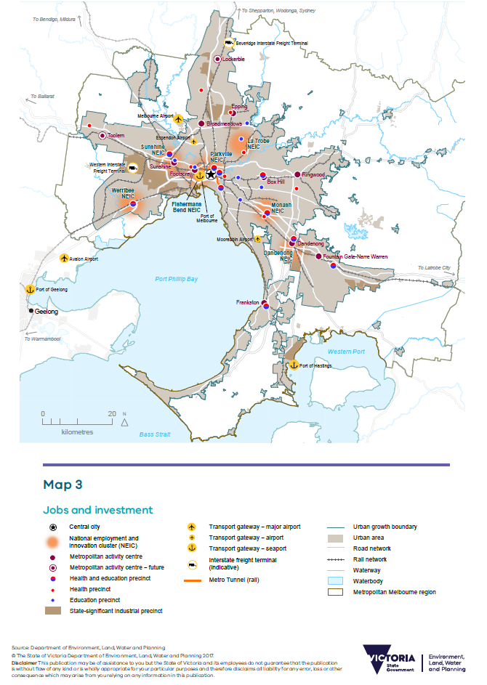

Appendix 2: Action Plan
- Identity and Economic Development identifies approaches for attracting investment and stimulating development opportunities or redevelopment and key recommendations to improve public realm.
No. | Action/Project | Role/purpose/objective | Responsibility | Timing | Department | Financial Resourcing
1.1 | CLUE | Extend Census of Land Use and Employment collection area to capture data for the Thomastown Industrial Area. | Council | Short/  Ongoing | Strategic Planning and Design | Biennial funding required, inclusive amongst other data collection
1.2 | Investment Attraction | Ensure Thomastown is highlighted in the development of future municipality wide investment attraction materials. | Council | Medium | Advocacy, Communications & Economic Development | Officer time
1.3 | Landscape/  visual amenity improvement program | Undertake landscape enhancements or other visual amenity improvements at gateway locations or other key sites including brand identity and signage, public art, buffer screening or barrier treatment opportunities. | Council | Medium/  Ongoing | Parks and Open Space | Include funding as part of landscaping programs (P&OS)
1.4 | Public realm improvements | Prepare design concepts for streetscape upgrades and improvements | Council | Medium | Major Projects | Officer time
 |  | Implement streetscape improvements | Council | Medium-Long | Major Projects/City Design and Transport | Funding as part of = streetscape improvement programs

2. Land Use and Development identifies planning scheme changes to give statutory effect to the Strategy
No. | Action/Project | Role/purpose/objective | Responsibility | Timing | Department | Financial Resourcing
2.1 | Planning Scheme | Prepare an update to the Municipal Strategic Statement and Industrial Development Local Policy within the Whittlesea Planning Scheme to provide certainty about the role and function of the precinct as an employment location and direction for future development. | Council | Short | Strategic Planning & Design | Officer time. Budget required for a Planning Scheme Amendment if required.
2.2 | Industrial guidelines | Update older municipal wide guidelines for industrial developments or prepare new industrial development design guidelines for Thomastown Industrial Area. | Council | Short | Strategic Planning & Design | Officer time.  Budget required for a Planning Scheme Amendment if required.
 |  | Introduce guidelines for industrial and commercial buildings based on the Sustainable Design Assessment in the Planning Process framework. | Council | Short | Strategic Planning & Design | Officer time
2.3 | Master planning | Undertake review of land titles and ownership arrangements to identify opportunities for consolidation and redevelopment. | Council | Short-medium | Strategic Planning & Design | Officer time
 |  | Identify sites that require a master planned approach and site specific requirements to be achieved via a planning scheme amendment such as development plan or design and development overlays. | Council/  Landowners | Medium – Long | Strategic Planning & Design | Officer time. Budget required for a Planning Scheme Amendment if required.
 |  | Realign the flood zone along the Edgars Creek corridor to provide clear and consistent zoning including updating/correcting the flooding and inundation provisions in the planning scheme. | Council/  Melbourne Water | Long | Strategic Planning & Design | Officer time. Budget required for a Planning Scheme Amendment if required.

- Transport, Access and Infrastructure identifies infrastructure and service requirements, including road network, drainage, public open space and information technology and key recommendations to improve public realm
No. | Action/Project | Role/purpose/objective | Responsibility | Timing | Department | Financial Resourcing
3.1 | Intersection upgrade Edgars and Mahoneys Rd | Advocate and work with VicRoads for upgrades to intersection with additional left turn lane at north approach and extension to right turn lane on east approach. | Council in consultation with VicRoads | Short | City Design and Transport | VicRoads & Officer time
 |  | Advocate and work with VicRoads for signalised slip lane at north west approach. | Council in consultation with VicRoads | Short | City Design and Transport | VicRoads & Officer time
 |  | Advocate to implement road safety upgrades. | VicRoads | Short-Medium | City Design and Transport | VicRoads & Officer Time
3.2 | Intersection improvements Cheddar Rd/ Dalton Rd/ Keon Pde | Advocate and work with VicRoads and City of Darebin for intersection improvements through signalling updates. | Council in consultation with VicRoads | Short | City Design and Transport | VicRoads & Officer time
 |  | Advocate to implement signal reprogramming. | VicRoads | Medium | City Design and Transport | VicRoads
 |  | Advocate and work with VicRoads and Department of Justice to develop solutions to improve road safety for right turn movements from Dalton Rd to Keon Pde. | Council in consultation with VicRoads | Short | City Design and Transport | VicRoads,DoJ & Officer time
 |  | Advocate to implement road safety solutions. | VicRoads/Dept of Justice | Short | City Design and Transport | VicRoads
3.3 | Intersection improvements Mahoneys Rd/ Keon Pde/ High St | Advocate and work with VicRoads for signalised pedestrian crosswalk. | Council in consultation with VicRoads | Short | City Design and Transport | Officer time
 |  | Advocate to implement road upgrades road safety solutions | VicRoads | Medium | City Design and Transport | VicRoads
3.4 | Intersection upgrade  Dalton Rd/  Spencer St | Advocate and work with VicRoads for upgrade to intersection to improve intersection safety. | Council in consultation with VicRoads | Short | City Design and Transport | Officer time
 |  | Advocate implement road upgrades road safety solutions. | VicRoads | Medium | City Design and Transport | VicRoads
3.5 | Intersection improvements Settlement Rd/ Wood St | Upgrading line marking at intersection. | Council/  VicRoads | Short | City Design and Transport | VicRoads & CD&T
3.6 | Intersection improvements and upgrades  Wood St/  Hanrahan St (Holt Pde) | Investigate improved intersection safety and accessibility solutions through installation of signals including pedestrian signals or the provision of new road link along Holt Parade. | Council in consultation with VicRoads | Short | City Design and Transport | Officer time
 |  | Advocate and work with VicRoads on road safety and accessibility upgrades. | Council in consultation with VicRoads | Short | City Design and Transport | Officer time
 |  | Advocate to implement road upgrades and safety solutions. | VicRoads or Council/  Developer/  Landowner | Short or Medium | City Design and Transport | VicRoads
3.7 | Intersection improvements and upgrades  Edgars Rd/Horne St | Advocate and work with VicRoads for upgrade to intersection with traffic signals to improve intersection safety. | Council in consultation with VicRoads | Short | City Design and Transport | Officer time
 |  | Advocate to implement traffic signals. | VicRoads | Short-Medium | City Design and Transport, Strategic Planning and Design | VicRoads
3.8 | New road connection  Trawalla Avenue | Provide road connection as part of future subdivision of quarry site to remove ‘dead end’ arrangement in Trawalla Avenue. | Through redevelopment of sites | Long | City Design and Transport | Developer
3.9 | New pedestrian and cycle connections | Prioritise pedestrian and cycle connection projects at the following locations in line with existing strategies, programs and development in the area:  - Extension to Shared Path along Merri Creek Trail  - Extension to Metropolitan Ring Road Trail on the southern side through to High St  - Construction of Shared Path on eastern side of High St  - Construction of on-road bicycle lanes along Mahoneys Rd/Keon Pde  - Construction of Shared Path along Melbourne Water Pipe Track  - Construction of Shared Path connection between Holt Parade to connect with pipe track. | Council | Short | City Design and Transport | Funding as part of cycle path programs.  Developer.  Government Funding
 |  | Easement path Keon Park Station to Temple Drive | Through redevelopment of sites | Long | Development Assessment | Developer
 |  | New link through private land between High Street to Dalton Road | Through redevelopment of sites | Long | Development Assessment | Developer
3.10 | Footpath ‘missing link’ upgrades | Prioritise footpath missing link upgrades in line with existing strategies, programs and development in the area:  - Trawalla Ave  - Lawson Cr (Mahoney Rd to Blaxland Ave)  - Dalton Rd (Settlement Rd to Wood St  - Industrial Ave (Trawalla Ave to Mahoneys Rd)  - Wentworth Crt (Blaxland Ave to end)  - Norwich Ave (Aylward Ave to Lipton Dr)  - Wolseley Pl (South of Lucknow Cr)  - Strong Ave(Chaffey St to Pelmet Cr)  - Pelmet Cr (South of Strong Ave)  - Centofanti Place(Settlement Rd to bend)  - Macquarie Dr (Inside of bend)  - Mercedes Dr (Commercial Dr to Longview Crt)  - Longview Crt (Mercedes Dr to end) | Council/  VicRoads | Ongoing | City Design and Transport | Funding as part of missing footpath programs.
3.11 | Improvements at identified critical access locations | Improve vehicle accessibility for transport delivery (freight) in the following locations:  - Trawalla Ave (east end)  - Trawalla Ave (west end)  - Cnr of Blaxland Ave and Wentworth Crt  - Cnr of Blaxland Ave and Lawson Cr  - Cnr of Aylward Ave and Norwich Ave  - Cnr of Aylward Ave and Lipton Dr  - Lipton Dr (bend at east end)  - Cnr of Norwich Ave and Lipton Dr  - Cnr of Strong Ave and Horne St  - Cnr of Horne St and Chaffey St  - Cnr of Strong Ave and Kenneth St  - Cnr of Strong Ave and Chaffey St  - Cnr of Strong Ave and Pelmet Cr  - Cnr of Settlement Rd and Abruzzo Cr  - Cnr of Brock St and Ivanhoe Crt  - Cnr of Green Str and Settlement Rd  - Cnr of Settlement Rd and Norris Cr  - Cnr of Northgate Dr and Commercial Dr  - Cnr of Northgate Dr and Merchant Ave  - Cnr of Commercial Dr and Merchant Ave  - Nevin Dr (end) | Council in consultation with landowners, business operators and transport operators | Ongoing | City Design and Transport | Officer time
3.12 | Public transport | Advocate and work with PTV to determine bus and train service improvements including frequency, span and coverage to provide greater accessibility for workers. | Council/PTV | Short | City Design and Transport | PTV and Officer time
 |  | Advocate with PTV for improvements to lighting and other passenger amenity at Stations. | Council/PTV | Short | City Design and Transport | Officer time
3.13 | Infrastructure technology | Provide leadership and facilitation role to guide and assist businesses to work with service providers for the installation of information technology infrastructure to improve internet speed, access and services for businesses. | Facilitated by Council | Short/  Ongoing | Advocacy, Communications & Economic Development | Officer time
3.14 | Grade separation | Undertake an assessment of impacts, including traffic, safety, economic impacts, efficiency and urban renewal and development phasing opportunities, associated with the removal of level crossings at Keon Pde, Settlement Rd and Heyington Ave | Council | Short | City Design and Transport | Officer time
 |  | Advocate to the State government to increase the priority for level crossing grade separation and upgraded station and facilities | Council | Short-medium | City Design and Transport/ Advocacy, Communications & Economic Development | Officer time
 |  | Facilitate a coordinated approach to advocacy for grade separation and urban renewal opportunities in the north region and with neighbouring Councils. | Council, other councils | Ongoing | City Design and Transport/ Strategic Planning and Design | Officer time

- Environment and Sustainability identifies approaches and recommendations relating to requirements for regular monitoring and ongoing compliance
No. | Action/Project | Role/purpose/objective | Responsibility | Timing | Department | Financial Resourcing
4.1 | Sustainable development assistance program | Investigate programs that would help businesses implement energy and water efficiency activities, including alternative funding models and precinct-scale collaborative projects. | Council | Short | Major Projects  Sustainability Planning  Advocacy, Communications & Economic Development | Officer time
4.2 | Revegetation and open space along Edgars Creek | Provide new open space opportunities along Edgars Creek between the Metropolitan Ring Road and Mahoneys Road including rehabilitation and revegetation of the creek environs. | Council, in consultation with Melbourne Water | Long | Parks and Open Space | Project Funding Required. Potential application for Living Rivers Funding.

- Monitoring and compliance identifies approaches and recommendations relating to requirements for regular monitoring and ongoing compliance
No. | Action/Project | Role/purpose/objective | Responsibility | Timing | Department | Financial Resourcing
5.1 | Sensitive interface treatments | Monitor and assess future need for intervention in areas with sensitive interfaces. | Council | Ongoing | Development Assessment | Officer time
5.2 | Compliance | Review and update the proactive compliance program for the industrial area to ensure amenity of the area is maintained. | Council | Short | Development Assessment | Officer time

