Administrator Expenses

The Local Government Act 2020 requires Council to reimburse Administrators for expenses incurred whilst performing their duties as an Administrator. Council is also required to adopt and maintain a Policy in relation to the reimbursement of expenses for Administrators, and a new policy was adopted by Council under Section 41 of the Local Government Act 2020 on 4 August 2020. The Expenses, Reimbursement and Support Policy provides guidance for the payment of reimbursements of expenses and the provision of resources, facilities and other support to the Administrators to enable them to discharge their duties. Council publishes the details of the expenses, including reimbursement of the Administrators by Council, in its Annual Report.

The details of expenses for the period of 1 April 2024 to 30 June 2024 (Quarter 4) is set out in table below.

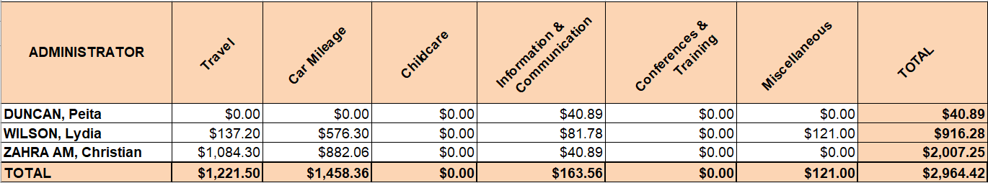

Expense Categories
1. Travel
This category covers expenses associated with supporting an Administrator to meet the transport costs incurred in attending conferences, meetings, functions and other commitments relating to Council business. This category also covers the use of taxi service, car parking fees, the provision of car parking permits and airfares.

2. Car Mileage
This category covers reimbursements to an Administrator for the use of their private vehicle while conducting Council business.

3. Dependent Care
This category covers reimbursement of the cost of necessary carer expenses incurred by an Administrator in the course of carrying out their duties. This includes childcare and other forms of care needed to support dependent family members.

4. Information and Communication Technology
This category covers the cost associated with equipment such as mobile phone, data usage and home office equipment ensuring that Administrators are accessible and able to communicate with constituents, stakeholders, other Administrators, Council Officers and family members while conducting Council business.

As of September 2022, Administrators have been utilising their personal mobile for Council related issues with no reimbursement of charges.

5. Conferences and Training
This category covers registration fees associated with attendance by an Administrator at conferences, seminars and one-off or short-term training courses. These are normally held by local government related organisations, professional bodies and institutions, educational institutions and private sector providers on subjects which impact on the role of an Administrator and the City of Whittlesea in general. These expenses also covers costs associated with accommodation and meals for any interstate conference or training session.

6. Miscellaneous
This category covers items that do not fall within the above five (5) main categories above.

