Electric Line Clearance

Management Plan

2024-2025



**Contents**

1 Management Plan Particulars 3

2 Revision List / Document Control 3

3 Definition of Terms 4

4 Preparation of Management Plan 5

5 Part 2, Division 1 & 2 of the Code of Practice for Electric Line Clearance. 20

Clearance Responsibilities – Cutting and Removing Trees 20

6 Part 2, Division 3 of the Code of Practice for Electric Line Clearance. 23

Clearance Responsibilities - Notification, Consultation and Dispute Resolution 23

7 Part 2, Division 4 of the Code of Practice for Electric Line Clearance. 24

Clearance Responsibilities - Additional Duties of Responsible Persons 24

8 Appendices

9 Reference Documents

# Management Plan Particulars

|  |  |
| --- | --- |
| Document Name: | Electric Line Clearance Management Plan |
| Version Number: | 2024.1 |
| Authorised by: | Mark Corea |
| Date of authorisation: | 29/3/2024 |

# Revision List / Document Control

The following Revision List records the issues and revisions of the document. For convenience, the nature of the revision is briefly noted. Revisions to the Electric Line Clearance Management Plan (ELCMP) are made as required to reflect changes upon which this plan is based.

Revisions are made by replacement of single pages, sections or re-issue of the complete ELCMP as required.

|  |  |  |  |
| --- | --- | --- | --- |
| **Section** | **Issue** | **Revision Details** | **Date** |
| Section 8 Appendices | 1.0 | Updated Appendices developed | 2024 |
| Section 9 Reference Documents | 1.0 | Updated References | 2024 |

# Definition of Terms

**ESV** – Energy Safe Victoria.

**GIS –** Geographic Information System providing the capacity for electronic data capture and management.

**HBRA** – Hazardous Bushfire Risk Area – An area that a fire control authority has assigned a fire hazard rating of “high” under section 80 of the Act; or an area that is not an urban area and has not been assigned a fire hazard rating of “low” under section 80 of the Act.

**Indigenous –** A species of Australian origin and found to be self-sewn in the wild within the City of Whittlesea.

**LBRA –** Low Bushfire Risk Area - An area that a fire control authority has assigned a fire hazard rating of “low” under section 80 of the Act; or an urban area.

**MAV –** Municipal Association of Victoria.

**Native –** a species of Australian origin.

**Protected tree -** a remnant tree listed in a planning scheme or on a register to be of ecological, historical, aesthetic, cultural or environmental significance.

**Suitably qualified arborist –** An arborist who has the qualification of National Certificate III in Arboriculture including the “Perform a ground-based tree defect evaluation” unit of competency, or an equivalent qualification; and at least 3 years of field experience in assessing trees.

**The Act** – Electricity Safety Act 1998.

**The Code –** Code of Practice for Electric Line Clearance as defined in the Schedule of the Electricity Safety (Electric Line Clearance) Regulations 2020.

**The Plan** –Electric Line Clearance Management Plan.

**The Regulations** - Electricity Safety (Electric Line Clearance) Regulations 2020.

**The Service Provider** – Citywide.

**TRAX** – A mobile GIS used to audit and track work and assessments conducted by its crews. TRAX has an office-based general user interface called Intramaps which provides a reporting mechanism for auditing purposes for staff. For the purposes of clarity, both programs will be referred to as ‘TRAX’.

**Tree Officer –** City of Whittlesea contracted personnel.

**WiGIS –** City of Whittlesea Geographic Information System general user interface which provides a reporting mechanism for auditing purposes for staff and is available for all staff to access.

# Preparation of Management Plan

The following sections address the requirements of Regulation 9 of the Electricity Safety (Electric Line Clearance) Regulations 2020.

A responsible person that is not a major electricity company, before 31 March in each year, must prepare a management plan relating to compliance with the Code for the next financial year.

The scope of works for this ELCMP is to inspect, manage and maintain clearance of vegetation from SP Ausnet electricity networks, including notification, consultation and negotiation with affected persons in accordance with the Electricity Safety Act 1998 and the Electricity Safety (Electric Line Clearance) Regulations 2020, while maintaining the Council’s tree assets.

The responsible person named in (4a) will ensure that Council’s ELCMP is prepared before 31 March each year and submitted to ESV within 14 days of request.

## Name, address and telephone number of the responsible person

|  |  |
| --- | --- |
| **Name of Council:** | City of Whittlesea |
| **Address:** | 25 Ferres Boulevard SOUTH MORANG, 3752 |
| **Chief Executive Officer:** | Craig Lloyd |
| **Telephone:** | 03 9217 2170 |
| **Email:** | [info@whittlesea.vic.gov.au](mailto:info@whittlesea.vic.gov.au) |

## Name, position, address and telephone number of the individual who was responsible for the preparation of the management plan

|  |  |
| --- | --- |
| **Name:** | Debbie Wood |
| **Position (Unit Director):** | Director Infrastructure and Environment |
| **Address:** | 25 Ferres Boulevard SOUTH MORANG, 3752 |
| **Telephone:** | 03 9217 2170 |
| **Email:** | Debbie.Wood@whittlesea.vic.gov.au |

## Name, position, address and telephone number of the persons who are responsible for carrying out the management plan

|  |  |
| --- | --- |
| **Name:** | Mark Corea |
| **Position (Unit Manager)** | Unit Manager, Parks and City Forest |
| **Address:** | 25 Ferres Boulevard SOUTH MORANG, 3752 |
| **Telephone:** | 03 9217 2441 |
| **Email:** | Mark.Corea@whittlesea.vic.gov.au |

## The telephone number of a person who can be contacted in an emergency that requires clearance of a tree from an electric line that the responsible person is required to keep clear of trees

|  |  |
| --- | --- |
| For emergencies, the City of Whittlesea’s main phone number diverts to the On Call Officer after hours | |
| Telephone: | 03 9217 2170 (monitored 24/7) |
| Position: | On Call Officer |
| Name: | According to roster |

## Objectives of the plan

The following are identified as the key objectives of this plan to fulfil Council’s commitment to maintain the space between the vegetation and powerlines (clearance space) under its control and fulfil its duties as set out in the Electricity Safety (Electric Line Clearance) Regulations 2020.

* Compliance with the Electricity Safety (Electric Line Clearance) Regulations 2020 and the prescribed Code of Practice and provisions;
* Electrical safety;
* Minimise fire starts as a result of contact between vegetation and electricity network;
* Continuity of electricity supply to customers;
* Public Safety;
* Provision of a safe workplace for employees and service providers;
* Vegetation management systems to maximise environment and amenity value of the Council’s trees;
* Protection of areas of important vegetation which may be deemed as such, on the basis of those areas containing botanically, historically or culturally important vegetation or vegetation of outstanding aesthetic or ecological significance, and/or the habitat or rare or endangered species; and
* Community satisfaction with the manner in which the necessary works required are carried out.

Relevant processes will be monitored/audited by the responsible person to ensure that the objectives of the plan are being implemented and actioned.

## The land to which the management plan applies (as indicated on a map – Appendix 1)

The City of Whittlesea is located approximately 20 kilometres to the north of Melbourne and covers an area of approximately 50,000 hectares. The landscape itself is diverse including established suburban areas to the south (housing the bulk of the City’s existing population), basalt plains to the west, Kinglake National Park and the hilly rural hinterland to the north and east, and central environs of the Plenty River and Plenty Gorge. Approximately 80% of the northern area is rural with townships located sporadically throughout.

## Any hazardous bushfire risk areas and low bushfire risk areas in the land referred to in paragraph (f) (as indicated on a map)

The area to which the Plan applies has been Declared in the Victorian Government Gazette and covers both LBRA and HBRA regions. The area can be described as beginning at the southern boundary of the municipality in Bundoora extending toward the north approximately 6.8 kilometres and east and west, laterally across the majority of the municipality. The powerline bushfire risk area boundaries (LBRA/HBRA) will be checked each year during preparation of the Plan. Council’s GIS team, the Municipal Fire Prevention Officer and the CFA will be consulted on the currency and review of those boundaries, and Councils WiGIS system and maps herein updated as required.

Though the majority of the Declared Area is serviced by overhead electric lines there is a significant area (approximately 30%) with underground power east of Edgars creek. The area to which the Plan applies, and the location of overhead electric lines are shown on the map titled “Declared Area, Electric Line Distribution and LBRA” (Appendix 2).

## The location of each area that the responsible person knows contains a tree that the responsible person may need to cut or remove to ensure compliance with the Code and that is:

For trees defined within the following three categories; Council will, as far as practicable, not cut a tree more than is necessary to comply with the Regulations. We will not remove any of these trees unless it is required to ensure compliance or make an unsafe situation safe. We may remove one of these trees if a suitably qualified Arborist has assessed the tree and advise trimming the tree would make the tree unhealthy or unviable. These conditions apply to all known trees that are identified here and any further trees that may be found to meet the criteria during the period of this plan.

Citywide will be provided an annual copy of the ELCMP to be viewed by all relevant employees. Citywide arborists are to be qualified in Certificate II in ESI Powerline Vegetation Control whilst inspecting vegetation clearance from power lines or performing vegetation clearance works.

*i.* **Indigenous:**

Council define Indigenous Vegetation, for the purpose of the Electricity Safety (Electric Line Clearance) Regulations 2020, as Vegetation that is indigenous to the Area.

Our list of trees that that are indigenous to the Whittlesea region are listed in the table below.

|  |  |
| --- | --- |
| **Botanic Name** | **Common Name** |
| *Acacia dealbata* | Silver Wattle |
| *Acacia implexa* | Lightwood |
| *Acacia mearnsii* | Black Wattle |
| *Acacia melanoxylon* | Blackwood |
| *Acacia pycnantha* | Golden Wattle |
| *Allocasuarina littoralis* | Black Sheoak |
| *Allocasuarina verticillata* | Drooping Sheoak |
| *Bedfordia arborescens* | Blanket Leaf |
| *Banksia marginata* | Silver Banksia |
| *Correa lawrenciana* | Mountain Correa |
| *Eucalyptus camaldulensis* | River Red Gum |
| *Eucalyptus cypellocarpa* | Mountain Grey Gum |
| *Eucalyptus dives* | Broad-leafed Peppermint |
| *Eucalyptus macrorhyncha* | Red Stringybark |
| *Eucalyptus melliodora* | Yellow Box |
| *Eucalyptus obliqua* | Messmate |
| *Eucalyptus polyanthemos* | Red Box |
| *Eucalyptus radiata* | Narrow-leaved Peppermint |
| *Eucalyptus regnans* | Mountain Ash |
| *Eucalyptus rubida* | Candlebark |
| *Eucalyptus viminalis* | Manna Gum |
| *Exocarpos cupressiformis* | Cherry Ballart |
| *Hedycarya angustifolia* | Austral Mulberry |
| *Lomatia fraseri* | Tree Lomatia |
| *Zieria arborescens* | Stinkwood |

Table 1 - Trees indigenous to CoW - [Whittlesea's native vegetation - Whittlesea](https://www.whittlesea.vic.gov.au/waste-environment/rural-land-management/whittleseas-native-vegetation/)

Council has an inventory of trees it clears for Powerline clearance. Species detail is recorded on Council’s WiGIS mapping system to ensure it is aware of which trees need to be managed under this section of its management plan. This list is updated annually and provided to the Contractor.

*ii.* **Listed in a planning scheme to be of ecological, historical or aesthetic**

**significance:**

**and**

*iii.* **A tree of cultural or environmental significance:**

The tree population within the area to which the Plan applies is predominantly a mixture of street trees planted on nature strips and planted park trees with a balance of native and exotic species.

There are several locations within the Declared Area where a significant tree resides, these are identified within the relevant Vegetation Protection Overlay (VPO) listed in the City of Whittlesea planning scheme (Appendix 3).

There are currently approximately 25 significant trees within the Declared Area that may be affected by vegetation management activities around overhead electric lines; these are shown on the map titled “Significant Trees, Declared Area, Electric Line Distribution and LBRA” (Appendix 3). The trees are identifiable to work crews because they are registered as a ‘Significant Tree’ in the asset management system and within the systems used by crews conducting work on these trees.

## The means which the responsible person is required to use to identify a tree specified in paragraph (h)(*i,ii,iii*)

Primarily a tree specified in Regulation 9(4)(h) affected by the Plan is identified within the City of Whittlesea Planning Scheme. According to the planning scheme definition, a tree of cultural or environmental significance means a tree that is -

* + included in the Heritage Register within the meaning of the Heritage Act 1995; or
  + included in the Victorian Aboriginal Heritage Register established under section 144 of the Aboriginal Heritage Act 2006; or
  + flora or a habitat of fauna listed as threatened in accordance with section 10 of the Flora and Fauna Guarantee Act 1988; or
  + flora listed in the Threatened Flora List with a conservation status in Victoria of "endangered" or "vulnerable"; or
  + a habitat of fauna which is listed in the Threatened Invertebrate Fauna List with a conservation status in Victoria of "vulnerable", "endangered" or "critically endangered".

The trees identified in the above Acts, Lists or Registers are reviewed at least once every 3 years by Council’s Planning Department to ensure their accuracy. For access to the lists please see the websites listed in the table below. In addition, the annual review of this Plan includes review of the sources listed to ensure information pertaining to locations of important trees is current.

|  |  |
| --- | --- |
| **Document** | **Source** |
| *List of flora or habitat of fauna listed as threatened in accordance with section 10 of the Flora and Fauna Guarantee Act 1988* | <https://www.environment.gov.au/biodiversity/threatened/species> |
| *Heritage Register* | <https://vhd.heritagecouncil.vic.gov.au/> |
| *Victorian Aboriginal Heritage Register* | <https://www.aboriginalvictoria.vic.gov.au/victorian-aboriginal-heritage-register> |

Table 2 - Websites containing lists of trees or fauna of cultural or environmental significance.

The City of Whittlesea also identifies protected trees located within public open space that fall into this category during its annual Significant Tree Health and Safety audits.

The location of each tree that may be affected by the Plan which has been identified by the means above is plotted within the City of Whittlesea GIS and labelled as a ‘Significant Tree near powerlines’

## The management procedures that the responsible person is required to adopt to ensure compliance with the Code, which must include/specify details of the methods to be adopted for:

### Managing trees and maintaining a minimum clearance space as required by the Code

The City of Whittlesea has opted to manage the trees affected by the Plan through a combination of proactive, programmed maintenance and reactive maintenance visitation. Council has identified that there are twenty (20) of these areas which require management of vegetation in the vicinity of powerlines within the Declared Area.

The City of Whittlesea ensures compliance with the Code by appointing an open space contractor to provide tree maintenance services. The contract obliges the contractor to maintain appropriate clearance space around Council managed trees in the areas affected by the Plan at all times.

The current contractor (Citywide) is required to deliver two separate pruning programs to ensure Council meets its tree management responsibilities around powerlines, a two-yearly and annual program of work. Trees are nominated to be on these programs as part of an annual review and are identified in Council’s Asset Management System (Assetic) with a specific Asset Sub-type suffix; ‘Restricted Category 1 or 2” respectively. These proactive programs ensure that each tree within the Declared Area is inspected, assessed with regard to overhead electric line clearance and worked on (if required) within specified time frames. Work is undertaken on the trees to the satisfaction of Council and to the requirements of AS 4373, as far as practicable.

The current service provider uses a GIS called TRAX to record the location of all trees under overhead electric lines which references Assetic. This spatial system utilises a GPS connected to a portable computer to locate, map and record details of each tree asset, including outcomes of inspections and work conducted. Council has access to TRAX and uses this system and the pruning program schedules to track the progress of pruning work. TRAX stores auditing and pruning events against each asset and the pruning history is intended to exist in perpetuity.

Implementation of tree management procedures outlined in Section 2(e)(i) requires adherence to the requirements specified in Schedules 1 and 2 of the Regulations, known as the “Code of Practice for Electric Line Clearance” and “Applicable distance” clearance space graphs and figures within Schedule 2 respectively. Section 3 of the Plan (below) outlines how Council will adhere to these requirements.

### for the purposes of determining a minimum clearance space in accordance with Division 1 of Part 3 of the Code—

### must specify the method for determining an additional

### distance that allows for conductor sag and sway; and

### may provide for different additional distances to be

### determined for different parts of an electric line span;

To maintain the clearance space required by the Code, Tree Officers who are suitably experienced and trained assess each tree to determine whether it requires pruning to comply with the Code, specifically Part 3, Division 1, Clauses 23 – 29 and associated clearance space graphs and figures within Schedule 2. The assessments are made in accordance with the Vegetation Clearance Inspection Process outlined in Appendix 11.

The determination to prune (or otherwise manage a tree) is based on whether it is observed that a tree requires pruning from the clearance space at the time of inspection (as defined in the Code for the observed voltage) or considered likely to grow into the clearance space between the current and subsequent programmed inspections. The genus, species, amount of re-growth observed since the last pruning event and the normal environmental conditions likely to be experienced between programmed maintenance visits is also considered at this time.

In determining the requirements for additional clearance distances to allow for cable sag and sway, Council will consult with the relevant Electricity Supply Network Operator as required. Any advice provided by Electricity Supply Network operators regarding additional allowance for sag and sway will be kept on record for a period of at least 5 years as a comment against the affected assets in the tree inventory.

## The procedures to be adopted if it is not practicable to comply with the requirements of AS 4373 while cutting a tree in accordance with the Code

The Municipal Association of Victoria advises Council to ensure the latest version of AS4373 is being referenced. In addition, Council Parks Officer maintains membership with Council Arboriculture Victoria. Notifications of new or amended standards are forwarded to the Council Parks Officer when they are released.

City of Whittlesea requires contractors to meet the pruning standard set out in AS4373 as far a reasonably practicable while completing cutting activities to clear vegetation from electrical assets.

Reasonably practicably in relation to AS4373 means that which is, or was at a time, reasonably able to be done in relation to ensuring continued tree health and future tree safety, considering and weighing up all relevant matters including:

1. The likelihood of the hazard or the risk concerned occurring – will the action create a defect, hazard, loss of tree health or aesthetic value in the present or future.
2. The degree of harm that might result from the hazard or the risk - what will the impact be on the tree or future safety of the public.
3. What the person concerned knows, or ought reasonably to know about:
4. The hazard or the risk – must have adequate knowledge to determine the hazards/risks
5. Ways of eliminating or minimising the risk – must have adequate knowledge in relation to alternative measures
6. The availability and suitability of ways to eliminate or minimise the risk – are other resources or techniques available to complete works to the standard.
7. After assessing the extent of the risk and the available ways of eliminating or minimising the risk, the cost associated with available ways of eliminating or minimising the risk, including whether the cost is grossly disproportionate to the risk – does the cost required to complete works to the standard grossly outweigh the value of the tree.

Contractors completing pruning works are required to complete all works to AS4373 as far as reasonably practicable which includes not removing more than 30% of foliage, not removing large structural limbs, using top/bottom cut method to prune to eliminate bark tearing. Where this cannot be achieved the site or trees are to be referred to Council’s Trees Management Team to make an assessment on whether it is reasonably practicable to deviate from AS4373.

**Qualified and Trained Personnel**

Council requires contractors undertaking vegetation management activities to have sufficient knowledge, qualifications, training, authorisation and experience appropriate for the task they are to perform to ensure tree activities are conducted in a safe and environmentally responsible manner.

All powerline vegetation workers must complete Certificate II in ESI Powerline Vegetation Control. This course provides competencies for planning and carrying out vegetation control at and above ground level near live electrical apparatus.

Where a person performs multiple roles, they shall undertake the mandatory training for each of those roles. To operate High Risk Plant and equipment (e.g. EWP) the operator shall have the applicable High Risk Licence issued by WorkSafe Victoria.

Where pruning to achieve clearance will not allow compliance with AS4373, City of Whittlesea may elect to:

* Increase the pruning frequency to minimise the required pruning.
* Remove scaffold/ parent limbs initially to minimise future required pruning.
* Remove trees where the resulting pruning would leave trees unsuitable for retention.

Where the above situations occur, the Parks Officer at City of Whittlesea is to be notified. Where trees are to be removed, the Service Provider will inform the relevant resident in person or by a written notification card.

**Plant and Equipment.**

The Service Provider must select the appropriate plant and equipment to perform electrical line clearance of vegetation given the following considerations:

* Access to site
* Voltage of overhead conductors - equipment suitably insulated and tested.
* Proximity of vegetation to conductors.
* Configuration of equipment
* Reach/ height of equipment.
* Cutting tools proportional to material to be cut.

Once each of these points has been considered, the best fit for the task should be selected. Availability may also be a defining factor, where the best fit is not available other options may be considered, however must still be able to achieve acceptable pruning standards in a safe manner.

All items of plant and equipment (including contractor’s plant) utilised on the contract must undergo a plant risk assessment/initial audit and all safety risks must be appropriately controlled prior to use of any plant or equipment on site. This can take the form of a Health and Safety Audit or an approved Plant Risk Assessment from a qualified supplier.

Daily Plant Pre-Start Safety Checks are compulsory for all plant on site and must be undertaken at the beginning of each work shift prior to use or operation of the plant by the relevant operator. Specific Daily Plant Safety Checklists relevant and appropriate to the item of plant are to be used for this purpose.

**Auditing**

Council and the Service Provider shall conduct regular inspections of work sites to ensure that cutting or removal is done in accordance with industry standards, including AS4373 (Pruning of Amenity Trees) and that the Service Provider continually demonstrates compliance with the prescribed safety and environmentally responsible aspects of the industry.

Council is responsible for auditing of the vegetation management process including compliance to the requirements of this Plan. The Council and Service Provider use the Collector and Survey 123 programs (Appendix 7) to inspect and document pruning works for clearance compliance. The trees audited are randomly generated by Councils GIS department following zone pruning works. The data is collected to ensure compliance to Council standards and the requirements of this plan. The Council officer or Service Provider conducting the audits will schedule works for any trees that do not conform to the prescribed standards.

Primary audits, such as OHS Systems, Environmental Management Systems, Quality Control, Traffic Management Procedures, etc., are targeted at the verification of systems of management and risk mitigation. These are further supported by field verification and compliance monitoring audits.

Primary audits are conducted by personnel who have suitable audit training and background. External specialist resources, which are experienced and have appropriate expertise in the relevant field, may be engaged to assist. Where appropriate Council and contractor’s management are directly involved in these audits.

The audit schedule is reviewed annually to address any changes in business requirements, concerns from previous years, and the contractor’s performance history. There are broadly four different types of audits within the schedule, relating to;

* Health and Safety – Safe work methods (e.g. General work methods, working near powerlines and tree clearing methods), equipment vehicles and plant, inductions, training and authorisation, traffic management.
* Compliance – General inspection and cutting compliance with programs, hazardous trees, stakeholder and defect management.
* Procedure/Work Instruction – Policies, work instructions, procedures, customer notification, data management and accuracy, reporting and documentation.
* Environmental – Important or significant vegetation, chemicals, weeds, noise, pruning technique and quality.

The audit process considers actual performance and outputs and then compares them against planned performance and expected outputs. Where a variation occurs, the item is noted and followed through to ensure corrective actions are taken and improvement opportunities are factored into plans to enhance future performance.

In addition to the audits carried out above, a Code Compliance Audit is conducted annually by Council. This audit is designed to ensure Council’s compliance with the Code of Practice for Electric Line Clearance (the Code) contained in the Schedule to the Electricity Safety (Electric Line Clearance) Regulations 2020.

The focus of the audit is on Council’s systems, records and processes that have been designed and are used to manage Council’s electric line clearance obligations. Any non-conformances identified will be addressed within agreed timeframes and with agreed methods. If a non-compliance is found to be a result of the Service Provider not meeting its contractual obligations, the breach of compliance may be deemed by the Unit Manager as a breach of contract and may result in termination of the contract.

The annual review of the ELCMP will ensure that the latest version of AS4373 is being applied.

When vegetation pruning methods are unable to comply with the requirements of AS4373, the Parks Officer is to be notified. AS 4373 and the definition of “as far as practicable” will be outworked to personnel at the induction. Every action will be taken to ensure that vegetation pruning methods taken minimise the extent of pruning and the effects of such pruning on vegetation. The process above is not required when a tree is being trimmed back to established practices for that tree.

**Rectifying Unacceptable Works**

If tree cutting is identified as not complying with AS4373 where it is audited or assessed that the standard should have been complied with, the cause of the non-compliance will be assessed and the inspector or cutting crew will be disciplined and further training undertaken as deemed necessary. Penalties may apply as per the Contract agreement. The Parks Officer will arrange to carry out remedial works where possible or required.

## A description of each alternative compliance mechanism in respect of which the responsible person has applied, or proposes to apply, for approval under clause 31 of the Code

This clause is not applicable to Council at this time. If an alternative compliance mechanism is required in the future, this ELCMP will be updated to reflect proper process to be followed.

## The details of each approval for an alternative compliance mechanism

### i. that the responsible person holds

This clause is not applicable to Council at this time. If an alternative compliance mechanism is required in the future, this ELCMP will be updated to reflect proper process to be followed.

### ii. that is in effect

This clause is not applicable to Council at this time. If an alternative compliance mechanism is required in the future, this ELCMP will be updated to reflect proper process to be followed.

## A description of the measures that must be used to assess the performance of the responsible person under the management plan

The Parks Officer will conduct regular audits as per the Audit Program to ensure that inspection and cutting has been completed in accordance with industry standards, including Electricity Safety (Electric Line Clearance) Regulations 2020, AS4373:2007 Pruning of Amenity Trees and best practice methods according to the schedule.

If provided, non-compliance sites and outages data provided by Electricity Network Operators are reviewed at the scheduled meetings. Utilising this historical data, a range of benchmarks for intervention of non-compliance has been established.

* For internal audits a 100% compliance benchmark is in place for powerline clearance. Scoring less than this threshold requires investigation, the program will not be recorded complete until additional works are completed, and a new audit conducted. This process is performed by the Parks Officer. A range of performance related penalties apply within our externally contracted service, while works by internal staff are subject to individual performance management. This allows mechanisms and incentives for improvement.
* Analysis of work types, job numbers and works priorities completed each year are also used to give insight into the number of trees reaching intervention levels between pruning cycles. Review of works completed over consecutive visits can show trends in the performance of the current ELCMP. An increase in high and urgent priority works of greater than 10% triggers an investigation by the Parks Officer to investigate causes and implement improvement strategies where required.
* If supplied, compliance and outage results from Electricity Network Operators are used to help monitor the performance of this plan. This will be measured on a number of events basis/month or year. Significant increases between periods would also warrant investigation.

Every action will be taken to ensure that vegetation pruning methods taken minimise the extent of pruning and the effects of such pruning on vegetation.

## Details of the audit processes that must be used to determine the responsible person's compliance with the Code

**Sample Sizes for auditing**

The City of Whittlesea undertakes line clearance audits with randomly selected tree assets within pruning zones. The City of Whittlesea requires 100% line clearance compliance. If this requirement is not met the Service Provider is required to return to the site and complete required pruning in line with the Service Contract. Where non-compliance of electrical line clearance has occurred, the City of Whittlesea will determine whether further investigation and or process improvement or discipline improvement is warranted. This will involve analysis of non-compliance data, previous work practice audits and other field observations. Our Service Provider contract discipline process will be used to ensure compliance is achieved. Stakeholder concerns and feedback from our work crews will also be considered. As part of the audits, we may undertake more detailed sampling to focus on a particular geographical area or expand more broadly across the Declared Area. Where biennial pruning is not achieving the required clearance distances, the tree assets affected will be considered for the Annual pruning cycle. If annual pruning is insufficient in maintaining clearance distances the affected trees will be considered for removal and replacement with suitable tree species.

**Control of Non-Conformances**

The root cause for the non-conformances is identified and monitored. Recurrence of the same non-conformance will be reviewed to determine the root cause of the problem. Non-conformances that are likely to result in a safety hazard or not complying with a regulation are considered critical and must be dealt with immediately. Non-conformances that are not critical are reviewed at the Operations meetings and annual review and may result in further training and revision of this plan. Non-conformances may be treated as a breach of contract and as such, the contract may be terminated at the discretion of the responsible officer.

Electricity Network Operators conduct inspections and may report trees to Council that it has recorded as non-compliant to the regulations. These items will be reviewed, and items identified as not complying with the clearance requirements will be programmed to be cleared.

Any non-conformances identified by Council will be addressed within the timeframes that ensure compliance is maintained. The potential risk of a non-conformance can vary greatly and this will be evaluated.

**Annual Review and Continuous Improvement**

The Quality Monitoring System (QMS) will assess contractor performance against specifications, as well as other quality measures that will help Council determine how the Service Provider is performing. The Service Provider is to allow for adequate staffing and equipment to undertake the quality monitoring requirement of the Tree Maintenance Contract.

To ensure a level of impartiality, the Service Provider shall engage a suitably qualified independent auditor (as approved by the City of Whittlesea) to undertake quarterly audits. The aggregated independent audit site score will be added to the quarterly site scores generated by Council and the Service Provider, with the designated weighting applied to provide a final quarterly site score.

Programmed pruning activities must be such that there is a maximum of 24 months between attendances of the individual 26 geographic regions, with an understanding that some areas may require an annual attendance. At the beginning of each 24 month period, the Service Provider will be required to submit a report detailing a program for the forthcoming 24 months for approval by the City of Whittlesea. This program will need to comply with the commitments stated within the Council’s Electric Line Clearance Management Plan.

The Service Provider’s representatives will be required to meet fortnightly with the City of Whittlesea representative in an open forum to discuss relevant matters related to the service provision. The Service Provider will also be required to meet on a monthly basis with the service provider of the Parks Maintenance separable portion of the contract and Council’s Parks management representative in an open forum to discuss relevant matters relating to the service’s provision. All meetings shall be recorded in writing.

## The qualifications and experience that the responsible person must require of the persons who are to carry out the inspection, cutting or removal of trees in accordance with the Code

No person shall perform tree clearing work in the vicinity of live electrical apparatus unless the person:

Has completed a training course approved by ESV; and

1. has a standard of qualifications, proficiency and experience that enable the person to safely perform the work; and
2. has been endorsed in writing by the organisation (e.g. the employer) to perform the work; and
3. has documented a hazard identification and risk assessment; and
4. has implemented a risk management process to control hazards associated with the work; and
5. complies with ‘Electrical Safety Rules for Vegetation Management Work near Overhead Powerlines by Non-Electrical Workers’, as published or amended from time to time by Energy Safe Victoria.

In the Electricity Safety (General) Regulations 2019 r.617 a qualified person means a person who holds a current certificate that is approved by Energy Safe Victoria specifying satisfactory completion of a training course in tree clearing along with specific requirements outlined in “The Blue Book” when working on or near high voltage electrical equipment.

All vegetation workers must complete Certificate II in ESI Powerline Vegetation Control and ESV annual refresher training. This course and refresher training provides competencies for planning and carrying out vegetation control at and above ground level near live electrical apparatus. Council will review the ESV training requirements prior to the development of each ELCMP.

As specified in the Tree Maintenance Contract, the Service Providers assessing Arborist must have a tertiary qualification in Arboriculture or Horticulture to a minimum AQF level 5. Qualifications approved by ESV and experience in the performance of electrical line clearing assessment and associated activities.

Records of all training and refresher training are kept by the Service Provider. These must be supplied to the City of Whittlesea on request for audit purposes.

The service provider will ensure that all contract personnel are fully conversant with the work they are required to perform under the contract and that, before any work commences, they are qualified, trained, and/or suitably experienced and are competent to carry out their duties.

Refresher training is required for some compliance training modules and its purpose is to provide the employee with an opportunity to recall and reinforce their previously acquired knowledge and skills. At this opportunity, it is usual that a competence assessment is completed which may include a verbal, written and practical assessment. Refresher training may also include changes in legislation, changes to guidance material and information.

Induction training of all Council employees and contractors shall be undertaken prior to commencing work. All employees and contractors must be inducted into the safety requirements for the contract and the site prior to being permitted to undertake works on the site.

As a minimum, the Council/Contract Induction topics shall cover:

* Council Induction requirements
* Council Safety, Quality and Environmental Policies
* Site Management

Any persons who commence work during the life of the contract must undergo the same site induction training prior to commencing work on site.

Any employees or contractors identified to not have current training, qualification or authorisations as required will be stood down from working on the Program and will only be permitted to return to work for the Council when the deficiencies are rectified and at the Unit Manager’s discretion.

## Notification and consultation procedures

Council provides information on the City of Whittlesea website as to when a zoned area will be pruned. Residents can input their postcode into the system and are informed as to when pruning works are due to occur. Notification of Council’s program of works will be undertaken in accordance with the Electricity Safety (Electric Line Clearance) Regulation’s 2020. Where Council intends to cut or remove a tree where the tree is of cultural or environmental significance Council as the responsible person will give notice of the intended cutting or removal to all affected persons in accordance with the regulations.

The Service Provider is required to prepare and deliver works notifications to all relevant authorities for all programmed maintenance activities. These include, but are not restricted to, cable clearance or tree work over/next to roadways. Responsive (emergency) maintenance activity will require notification to property owners/residents as directed by the City of Whittlesea. The Service Provider is responsible for notifying all relevant Authorities, obtaining information and arranging for all service shutdowns or safeguarding.

Prior to commencing any works under the Contract, the Service Provider is to identify all potential works situations which may cause or necessitate disruptions to power supplies.

The Service Provider will notify all residents or businesses at a minimum of forty-eight (48) hours prior to any scheduled disruptions to power supplied in the given works area.

The Service Provider will coordinate with the Power Authorities and Public Transport Operators on all aspects of power supply shutdown and re-connections. Any costs associated with shutdown will be borne by the Service Provider.

Where the tree intended for cutting or removal is a tree of cultural or environmental significance, notice will include the impact of the cutting or removal of the tree and the actions to be taken to minimise that impact. The Service Provider is to seek permission from the Tree Officer as to intended cutting of trees with cultural or environmental significance.

By maintaining the Inspection and cutting program and allowing for growth for individual species, no urgent pruning or clearing should be required. In the case of urgent cutting or removal being required, Council will ensure that the process identified under “**Emergency Cutting and Pruning**” is followed, in accordance with the requirements of the Code.

## Dispute resolution procedures

In regard to trees that are part of a dispute, if the vegetation is identified as being non-compliant, the vegetation will be treated and cleared as per the urgent pruning process.

All enquiries should be managed to avoid disputes or complaints if reasonable to do so and the City of Whittlesea’s Charter shall be complied with. Disputes should be resolved as per the following process however at any stage an affected person may choose to raise a complaint via Whittlesea’s Customer Service Charter: https://www.whittlesea.vic.gov.au/about-us/contact-us/our-customer-charter/

For the purposes of dispute resolution, the following Responsible Person may be connected in conformance with the requirements set out in this section.

|  |  |
| --- | --- |
| **Position:** | Customer Service |
| **Address:** | 25 Ferres Boulevard SOUTH MORANG, 3752 |
| **Telephone:** | 03 9217 2170 |
| **e-mail:** | info@whittlesea.vic.gov.au |

Any customers who consider they have been poorly treated under this process are welcome to approach the Energy and Water Ombudsman (EWOV) for recourse. The EWOV is the last industry advocate available to settle tree related disputes. Further recourse may be available through the legal system.

|  |  |
| --- | --- |
| **Name:** | Energy Safe Victoria |
| **Address:** | PO Box 262 Collins Street West VIC 8007 |
| **Telephone:** | 1800 800 158 |
| **e-mail:** | info@esv.vic.gov.au |

|  |  |
| --- | --- |
| **Name:** | Energy and Water Ombudsman (Victoria) Ltd |
| **Address:** | GPO Box 469 Melbourne 3001 |
| **Telephone:** | 1800 500 509 |
| **e-mail:** | ewovinfo@ewov.com.au |

The dispute resolution procedure is available for inspection at Council offices during normal business hours. The procedure is also published on Council’s website.

|  |  |
| --- | --- |
| **Address of Principle office:** | 25 Ferres Boulevard  SOUTH MORANG VIC 3752 |
| **Normal business hours:** | Monday to Friday: 8:45am to 5:00pm |
| **Telephone:** | (03) 9217 2170 |
| **Weblink:** | http://www.whittlesea.vic.gov.au |

**Obligations Relating to the Management Plan – Regulation 10**

The following sections are as per Regulation 10 of the Electricity Safety (Electric Line Clearance) Regulations 2020.

**A responsible person must ensure that a copy of the current management plan is published on the responsible person’s Internet site**

The plan published on the City of Whittlesea’s website is to be used as the current version of the plan.

The Electric Line Clearance Management Plan is published on Council’s website at http://www.whittlesea.vic.gov.au/. The Unit Manager will provide the City of Whittlesea IT department with any revisions and the updated copy of the ELCMP prior to 31 March of each year and will ensure it is available and superseded revisions are removed.

**Exemptions – Regulation 11**

The following sections are as per Regulation 11 of the Electricity Safety (Electric Line Clearance) Regulations 2020.

**2a. A responsible person who receives an exemption must ensure that a copy of the exemption is published on the responsible person’s Internet site**

This clause is not applicable to Council at this time. There are no exemptions in place. If an exemption is required in the future, this ELCMP will be updated to reflect proper process to be followed. The exemption will also be published on the Council website and a link provided.

**2b. A responsible person who receives an exemption must ensure that a copy of the exemption is available for inspection at the responsible person's principal office in the State during normal business hours**

This clause is not applicable to Council at this time. There are no exemptions in place. If an exemption is required in the future, this ELCMP will be updated to reflect proper process to be followed. The exemption will also be available at the principal Council office for inspection.

|  |  |
| --- | --- |
| **Address of Principal office:** | 25 Ferres Boulevard  SOUTH MORANG VIC 3752 |
| **Normal business hours:** | Monday to Friday: 8:45am to 5:00pm |
| **Telephone:** | (03) 9217 2170 |

# Part 2, Division 1 & 2 of the Code of Practice for Electric Line Clearance.

# Clearance Responsibilities – Cutting and Removing Trees

**Exception to minimum clearance space for structural branches around insulated low voltage electric lines**

**Insulated low Voltage Electric Lines (Structural Branches)**

- incorporating Electricity Safety (Electric Line Clearance) Regulations 2020, Part 2, Division 1, Schedule 4

**Responsibility**

Exceptions to the required minimum clearance space for Insulated Low Voltage cables may occur in the City of Whittlesea’s Declared Area. The Parks Officer is responsible for managing and implementing all stages of this procedure.

**Procedure**

Where a branch is wider than 130mm at the point at which it enters the minimum clearance space, and the branch is more than 300mm from the line of Insulated Low Voltage Electrical Lines the vegetation may be eligible to be classified as an E4.

For existing vegetation classified as E4; Prior to the commencement of the Inspection for the current year, all existing Exception 4 classed vegetation will be provided to the inspector for re-inspection to determine if the trees still meet the requirements and will maintain the requirements for a further 12 months. If the tree/s will not continue to meet the requirements for 12 months, the pruning works will be included in the current year program to ensure compliance is maintained at all times.

For new trees identified as E4 during inspections, the inspector will record “E4” on the Work Instruction Sheet where a branch is wider than 130mm at the point at which it enters the minimum clearance space and the branch is more than 300mm from the line of Insulated Low Voltage Electrical Lines.

The City of Whittlesea is separated into 26 pruning zones (See Appendix 9). The Service Provider conducts proactive inspections of Council trees on the Biennial Inspection and Maintenance program (Appendix 8a). In this program Council trees are assessed for approved clearance distances and pruning works are logged for trees that do not meet the required distances as determined by Council standards and ESV. Fast growing tree species that require more intensive pruning to maintain clearance distances are placed on the Annual Inspection and Maintenance Program (Appendix 8b). All Service Provider inspectors and those working in the vicinity of power lines are ESI qualified.

**Clearance Assessments**

Trees are assessed by a suitably qualified Arborist who will visually estimate the current clearance and apply an additional distance for estimated growth.

**Exception Audits**

Vegetation managed under this process will be audited concurrently with Inspection Quality Audits. The Auditor will visually assess the tree from the ground and ensure that he / she is satisfied that the clearances specified in the assessments are satisfactory and an appropriate safety outcome has been achieved.

## (a) Exception to minimum clearance space for small branches around insulated low voltage electric lines

**Insulated low Voltage Electric Lines (Small Branches)**

- incorporating Electricity Safety (Electric Line Clearance) Regulations 2020, Part 2, Division 1, Schedule 5

**Responsibility**

The Service Provider is responsible for managing and implementing all stages of this procedure.

**Procedure**

City of Whittlesea will refer to its tree database date records when pruning works are undertaken. Branches will not be required to be cleared where an inspection identifies the presence of branches that meet the requirements for exception as outlined in Schedule 1, Part 2, Section 5 of the Code:

* Are less than 10 millimetres wide at the point where it entered the minimum clearance space, and
* Vegetation clearance works were recorded in the previous twelve months.

## Exception to minimum clearance space for structural branches around uninsulated low voltage electric lines in low bushfire risk areas

**Uninsulated low Voltage Electric Lines**

- incorporating Electricity Safety (Electric Line Clearance) Regulations 2020, Part 2, Division 1, Schedule 6.

**Responsibility**

The Service Provider is contracted to maintain the minimum clearance space for Un-insulated Low Voltage cables within the City of Whittlesea’s declared area. There are currently no exemptions to the required minimum clearance space for Uninsulated Low Voltage cables within the City of Whittlesea.

## b. Responsible person may cut or remove hazard tree

- incorporating Part 2 Division 1 Schedule 8

A hazard tree is a tree that:

* a suitably qualified arborist has assessed the tree in regard to foreseeable conditions and advised the tree or part of the tree is likely to fail and will contact an electric line if this occurs.

All identified hazard trees are to be cleared to ensure compliance is maintained and in a time that prevents the tree from entering the clearance space. Hazard trees are to be cleared only when it is safe to do so and if a Hazard tree cannot be removed in a timely manner, Electricity Network Operators are to be contacted to discuss other means of removal or Powerline disconnection.

As part of the scheduled inspection the Service Provider will seek to identify vegetation infringing on clearance space within the declared area. The Inspection includes the Hazard Space outside the clearance and regrowth spaces. Any trees within the Hazard Space deemed to contain significant faults and an immediate risk to the public will be cleared without further assessment.

In situations where the Service Provider identifies a tree that is likely to fall onto or otherwise come into contact with an electric line that is not urgent or a risk to the Public, the Service Provider is to inform the City of Whittlesea in which a suitably qualified Council arborist will assess the tree. Note: For the purpose of this Plan, a hazard tree is a tree that possesses hazardous faults which if not actioned, will negatively impact distribution assets. These trees may possess characteristics such as large cavities, severe decay, major cracks etc.

In situations where the arborist's assessment confirms the likelihood of contact with the electric line having regard to foreseeable local conditions including weather and around instability, Council will remove or cut the hazard tree as per the Code. In the event of a hazard tree being identified as a culturally significant, environmentally significant or habitat tree, Council will where possible minimise the impact on the tree or fauna as previously outlined, to ensure compliance with the requirements of the code, the schedule to the code or to make an unsafe situation safe.

Hazard trees that are found to NOT be the responsibility of Council will be reported to Electricity Network Operators by phone or email.

Trees reported by residents or other authorities will be recorded on Councils CRM system. Trees reported that are Council’s responsibility will be actioned as required by this plan. Trees that are not Council’s responsibility will be recorded and forwarded to the relevant Electricity Network Operator.

## c. Cutting or removal of:

* indigenous trees
* trees listed in a planning scheme to be of ecological, historical or aesthetic significance
* trees of cultural or environmental significance must be minimised

This requirement is covered in Section 4h.

## d. Cutting or removing habitat for threatened fauna

The Service Provider utilises suitably qualified arborists for tree inspections who can identify whether a tree is native, indigenous or exotic. The City of Whittlesea utilise planning overlays to help protect the habitat of threatened fauna in areas of cultural, historical, botanical, ecological or habitat significance. Planning controls are used in the form of the Environmental Protection Overlay that requires residents to obtain permits to cut or remove remanent vegetation on their own properties.

Mature River Red Gums, *Eucalyptus camaldulensis*, in an open plains grassland environment are generally recognised as the most important visual and environmental feature of the City. Remnant River Red Gums are protected by the City of Whittlesea Planning Scheme, specifically, Clause 22.10. This clause has enabled the City of Whittlesea to retain as many River Red Gums as possible. The specific tree protection guideline applicable to River Red Gums, endorsed by the Department of Environment, Water, Land and Planning, has proven effective in protecting these trees throughout the subdivision development of the City.

If a habitat tree is identified within the vicinity of electric lines, it will be recorded on City of Whittlesea’s GIS Mapping system. This data is accessed and provided to the Inspector.

All trees are inspected before any works are undertaken. In the event a significant tree is identified during inspection, no pruning shall occur without further consultation with Council. If contractors haven’t already been alerted to a tree by Council as per Section 4h, they are to contact Council if any site indicates that a tree may have significance.

# Part 2, Division 3 of the Code of Practice for Electric Line Clearance.

# Clearance Responsibilities - Notification, Consultation and Dispute Resolution

## Responsible person must publish notice before cutting or removing certain trees

This requirement is covered in Section 4q.

# Part 2, Division 4 of the Code of Practice for Electric Line Clearance.

# Clearance Responsibilities - Additional Duties of Responsible Persons

## Duty relating to the safety of cutting or removal of trees close to an electric line

SP Ausnet is the Network Owner and Operator located within the City of Whittlesea declared areas.

Where concerns are raised in relation to the safety of maintenance activities associated with maintaining vegetation clearances inside of the declared area, Council will contact Network operator to discuss concerns. Final recommendations will be provided by the relevant Council Liaison Officer in an email to be recorded in Council’s electronic data capture system.

# Appendices (1 – 12)

# *Appendix 1 –City of Whittlesea Area*

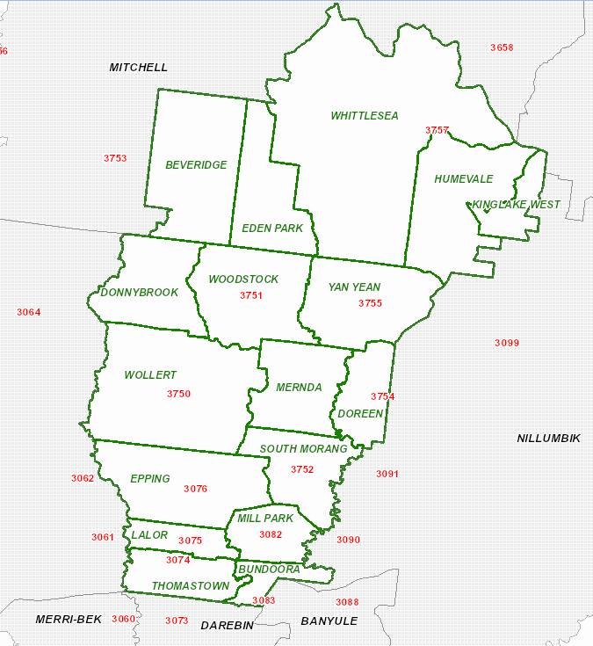

**Appendix 2 –Declared Area, Electric Line Distribution and LBRA**

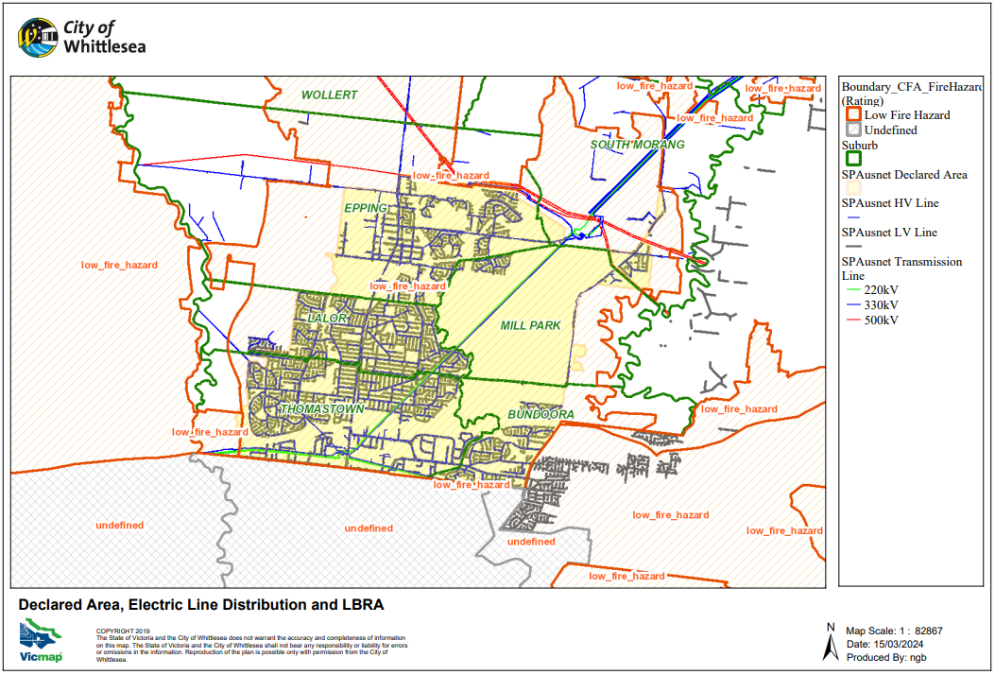

**Appendix 3 – Significant Trees, Declared Area, Electric Line Distribution and LBRA**

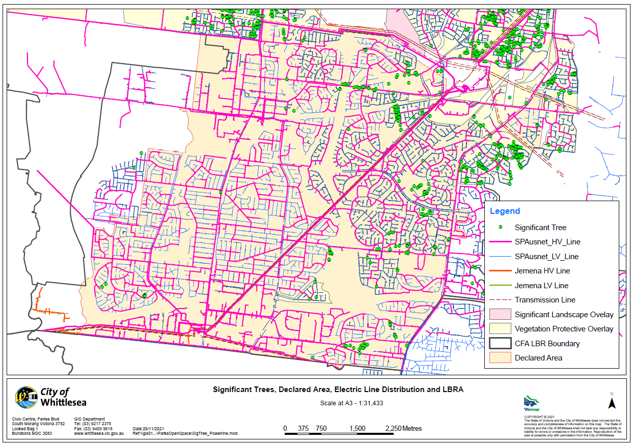

**Appendix 4 – Significant Tree Audit**

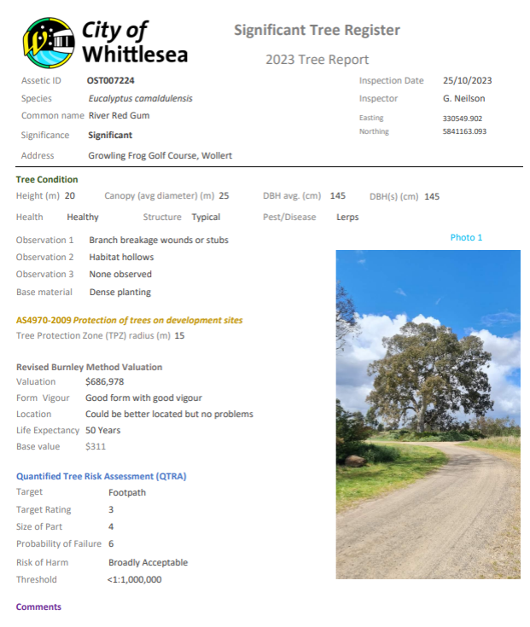

**Appendix 5 – TRAX System**

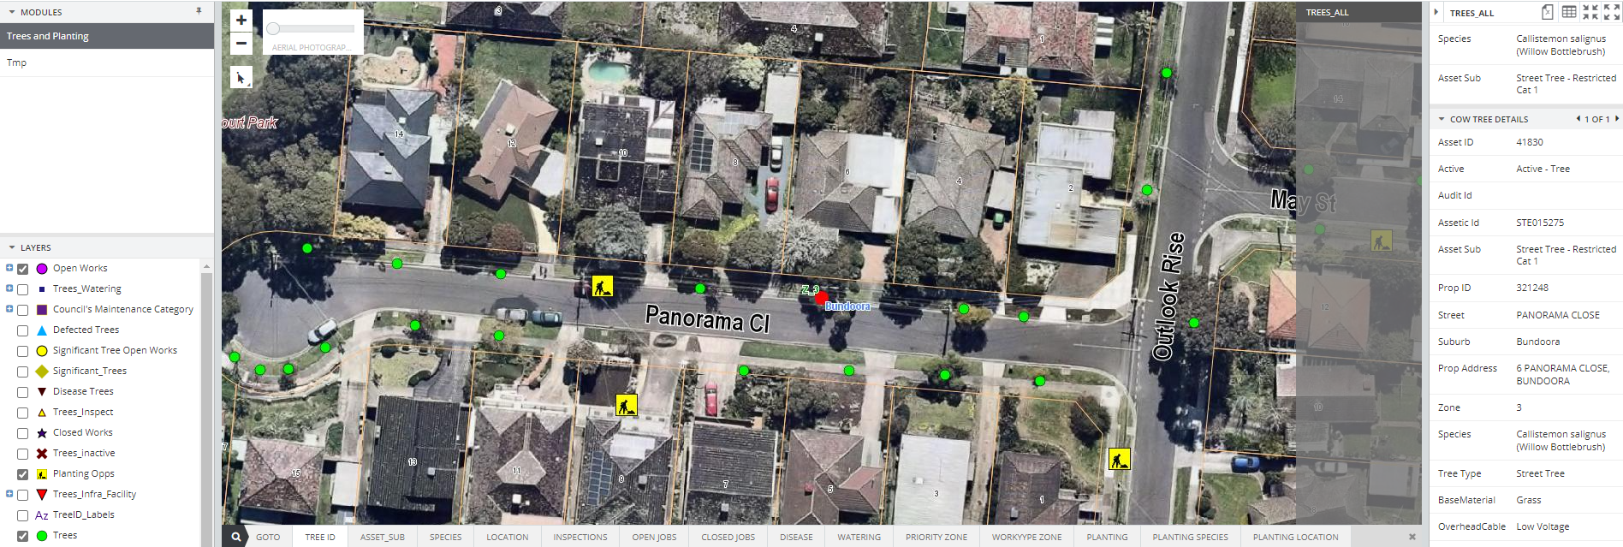

**Appendix 6 – Authority Reactive Works Request**

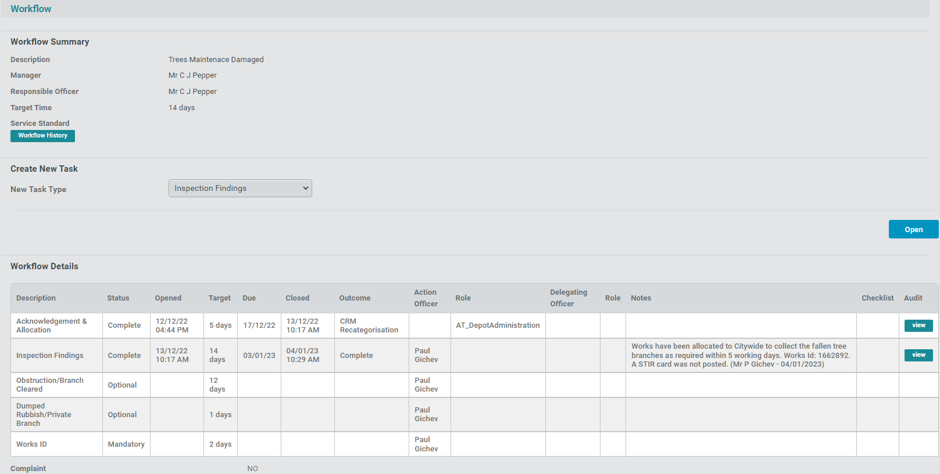

**Appendix 7 – Quality Audit Form**

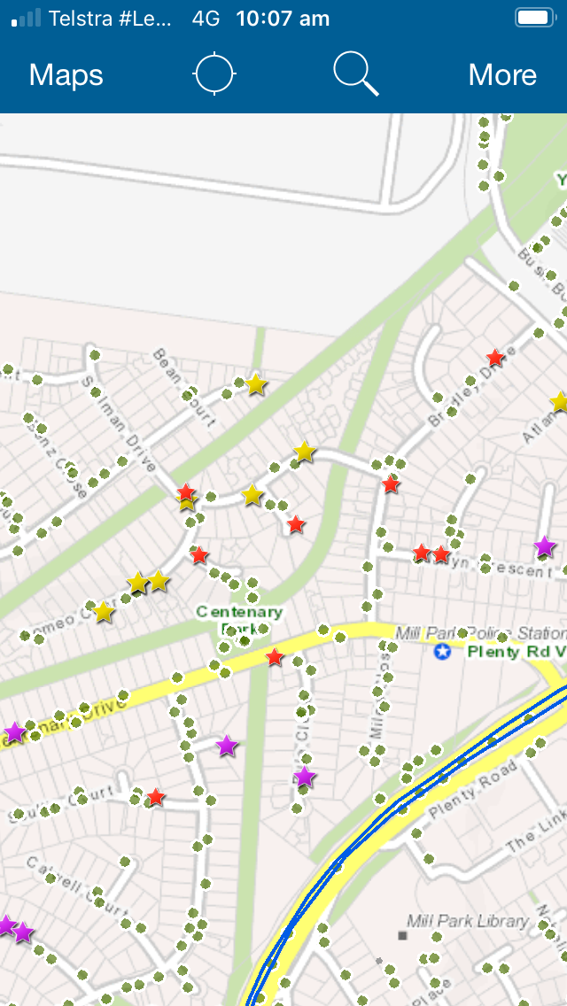

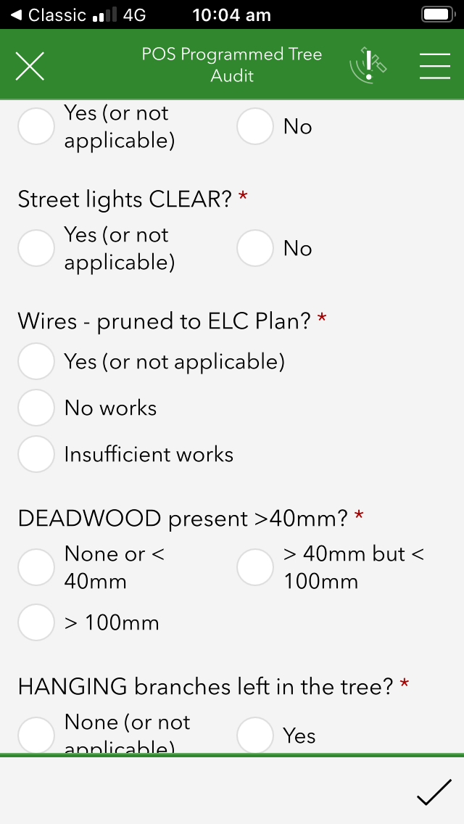



**Appendix – 8(a) –Programmed Biennial Maintenance Pruning Schedule**

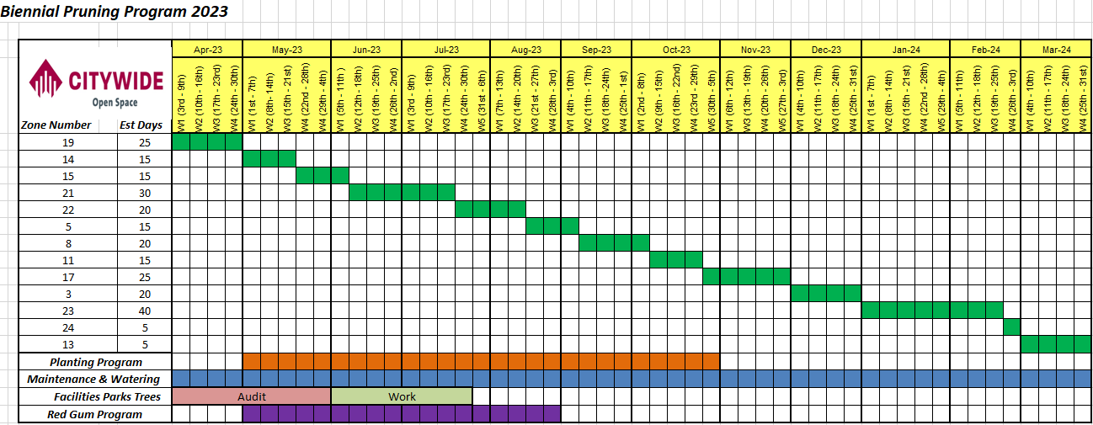

**Appendix – 8(b) – Programmed Annual Maintenance Pruning Schedule**

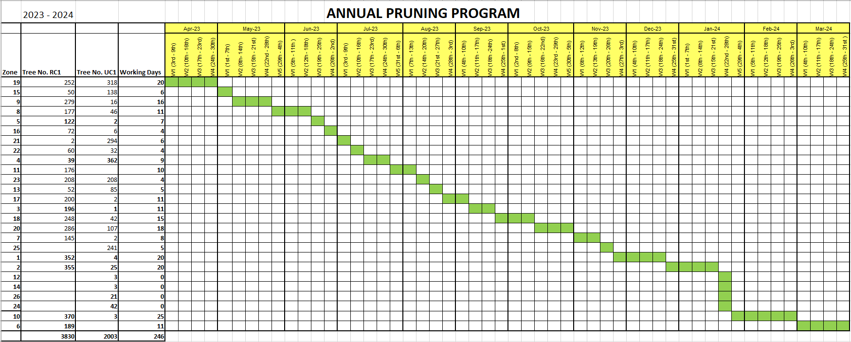

**Appendix 9 – Urban Tree Inspection and Pruning Zones within the Declared Area**

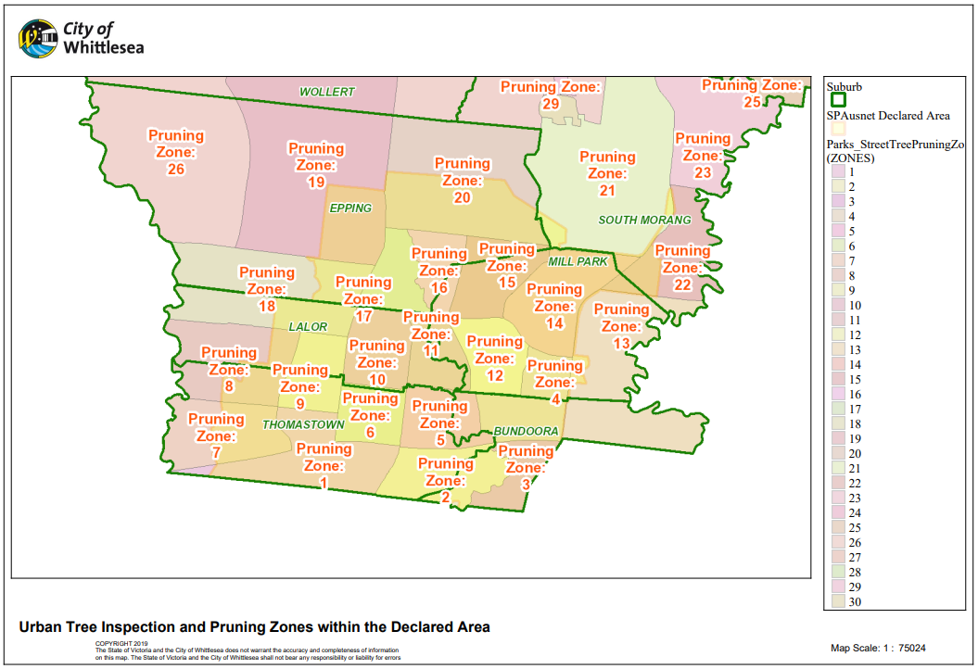

**Appendix 10(a) – Public Notifications 2024 – COUNCIL WEBSITE**

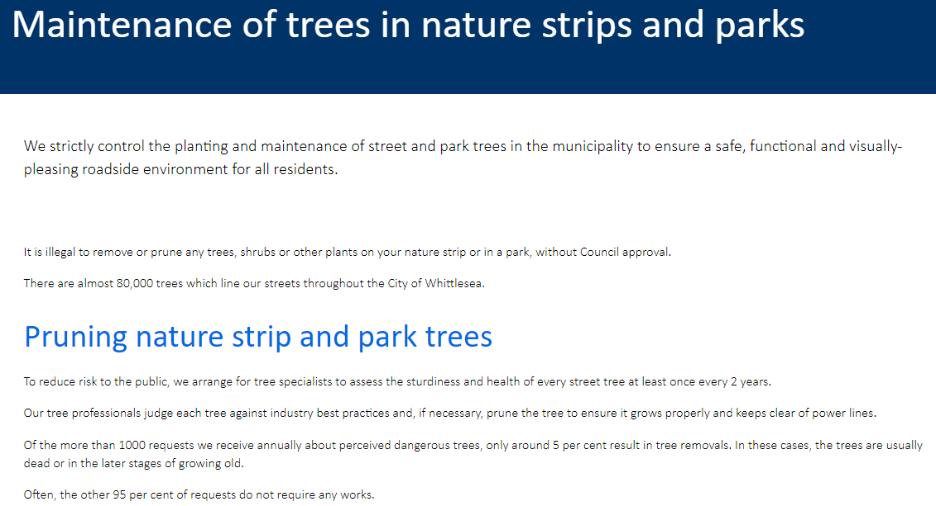

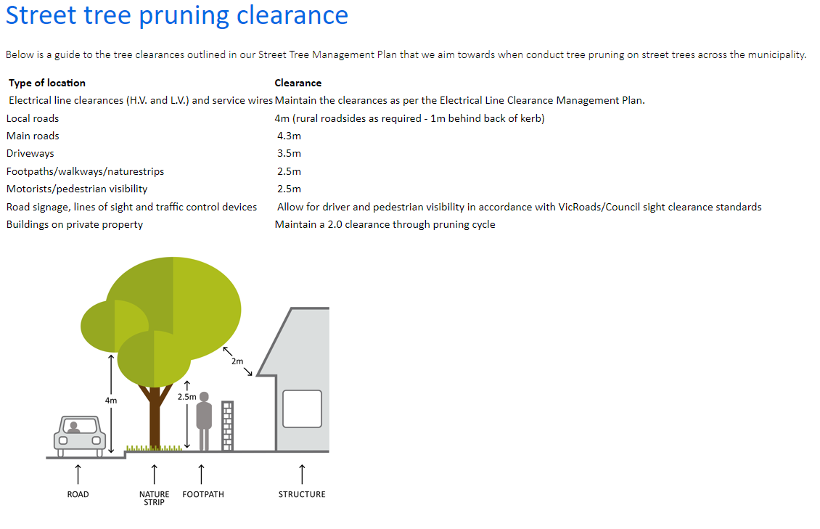

**Appendix 10(b) - Public Notifications – Local Newsletter (example)**



**Appendix 11 – Vegetation Clearance Inspection Process**

**Appendix 12 – On-site Random OHS audit template**



Source: Whittlesea\data\CITY\PARKS\OPERATIONS MANAGEMENT\PARKS\Contracts\2016-201 Tree Maintenance Part B\10_Safety\OH&S_contctor site audits

# Reference Documents

The following is a list of Council documents that include information relating to or referencing the Plan. They are also available upon request for viewing at Council’s Civic Centre with assistance from a member of the Parks and Urban Design department Monday to Friday during normal working hours (excluding public holidays). Should you wish to view them in person please call Council so we can schedule an appointment time.

|  |  |
| --- | --- |
| **Document** | **Availability** |
| [Complaint Handling - Policy](http://sharepoint.whittlesea.vic.gov.au/cor/gov/info/_layouts/15/DocIdRedir.aspx?ID=YHFEY55RSAEW-1117995323-93) | Upon request |
| ‘Greening Our Streets’ - Street Tree Management Plan (2019-2029) | Council Website |
| Municipal Fire Management Plan 2020- 2023 | Council Website |
| Programmed Maintenance Pruning Schedule | Council Website |
| Roadside Management Strategy (July 2014) | Council Website |
| Significant Tree Audit Results | Upon request |
| Tree database (Forestree) | Upon request |

Further references with details of the technical standards that the responsible person will apply or have regard to in connection with electric line clearance work can also be found in;

* Electricity Safety Act 1998
* Electricity Safety (Electric Line Clearance) Regulations 2020
* [Managing trees near powerlines | Energy Safe Victoria (esv.vic.gov.au)](https://www.esv.vic.gov.au/industry-guidance/electrical/line-clearance/managing-trees-near-powerlines)
* Electrical-Safety-Performance-Reporting-Guidelines-Rev-05072022.pdf

Should the links above be changed, copies of the above documents are available from ESV and downloadable online at:

<http://www.esv.vic.gov.au>

For further information visit www.legislation.vic.gov.au