HOUSING
DIVERSITY
STRATEGY
2013-2033

FOREWORD
Council is delighted to present the Housing Diversity Strategy for the established suburbs of the City of Whittlesea.
The established suburbs of Lalor, Thomastown, Epping, Mill Park, Bundoora, parts of South Morang and Whittlesea Township have experienced considerable change over the last few years. Our population has increased significantly and residents reflect a more diverse range of backgrounds. This changing demographic has also meant an older population and fewer people living at home.
To accommodate this change it is essential that Council ensures the right infrastructure and services are in place and that different types of housing are available to meet people’s different needs, both now and in the future.
Council’s first Housing Diversity Strategy for the established suburbs of the City of Whittlesea will ensure that housing growth occurs in the right way and in appropriate locations.
The Strategy builds on feedback we received from the community and outlines our vision for managing housing growth in our established suburbs. It identifies the areas that can accommodate change, including Activity and Neighbourhood Centres, and identifies areas that will be protected from further development.
Council’s Housing Diversity Strategy will ensure a balanced approach is taken to managing housing growth ensuring it happens in the right locations, makes efficient use of existing resources and infrastructure, meets current and future housing needs and enables the established suburbs of the City to remain as places where residents want to live and enjoy.

CONTENTS
Foreword 02

SECTION 01 – INTRODUCTION 06
What is the Housing Diversity Strategy? 06
Where does the Strategy apply? 08
Why do we need the Housing Diversity Strategy? 10
What has the process been so far? 11
What is meant by diverse housing types? 13
Why should we direct diverse housing into specific locations? 16
Community consultation 18

SECTION 02 – POLICY CONTEXT 22
What is Council’s role in managing housing growth? 22
What is the State Government’s direction for planning and managing residential growth? 23
What planning provisions does Council currently use? 24
Reformed Residential Zones 25
How will the Strategy address policy gaps in the Whittlesea Planning Scheme? 28

SECTION 03 – DISCUSSION OF KEY ISSUES 29
Who lives in our established suburbs? 29
What is our current housing stock? 33
What is the forecast demand for different dwellings and from whom? 36
What is our forecast housing supply? 37
What planning decisions are being made? 38
Where has medium and higher density housing occurred previously? 39
What are the key design issues with current residential developments? 41

SECTION 04 – HOUSING CAPACITY ASSESSMENTS 44
What is the capacity of our established suburbs to accommodate more growth? 44
Primary capacity criteria 45
Other capacity considerations 49
Housing Capacity Assessment findings 53

SECTION 05 – POLICY DIRECTION 56
Policy 01: Housing Diversity 58
Policy 02: Preferred Locations for Housing Growth 58
Policy 03: Housing Change Areas 59

SECTION 06 – IMPLEMENTATION 79
How will the Strategy be implemented? 79
Further strategic work 81
Evaluation and monitoring 82

INDEX

DIAGRAMS
Diagram 1: Housing Diversity Strategy Process 12
Diagram 2: Different Dwelling Types 13
Diagram 3: Benefits of the Housing Diversity Strategy 17
Diagram 4: Housing Diversity Strategy Consultation Process 18
Diagram 5: Whittlesea Planning Scheme 24
Diagram 6: Forecast Household Types 32
Diagram 7: Housing Capacity Assessment Findings 53
Diagram 8: Implementation of the Housing Diversity Strategy 79

GRAPHS
Graph 1: Forecast Age Structure 2011 to 2031, Established Areas 31
Graph 2: Dwellings by house type, Established Areas, 2006 34
Graph 3: All Dwellings, City of Whittlesea, 2006 35
Graph 4: Residential Planning Applications Received by Council, City of Whittlesea, 2012 38

MAPS
Map 1: Established Areas in the City of Whittlesea 09
Map 2: Medium and High Density Housing 40
Map 3: Walkable Catchments from the Principal Public Transport Network 46
Map 4: Walkable Catchments from Shopping Centres/Activity Centres 48
Map 5: Community Services and Facilities 49
Map 6: Residential Lot Size 50
Map 7: Residential Dwelling Age 52
Map 8: Housing Change Areas 60
Map 9: Urban Renewal 63
Map 10: Neighbourhood Renewal 66
Map 11: Neighbourhood Interface 69
Map 12: Suburban Residential 72
Map 13: Township Diversity 75
Map 14: Township Residential 78

Section 01:
INTRODUCTION

What is the Housing Diversity Strategy (HDS)?
The City of Whittlesea is currently experiencing significant housing growth and change. Much of the growth and change is in new growth areas¹. Yet, there is increasing pressure to manage residential development within the established urban areas of the municipality.
Increasing the availability of well located medium and higher density housing within the established areas will be important as the City changes. It is particularly an issue as household size declines. Different types of housing will ensure greater choice for residents as they move through life’s different stages and their housing needs change.
Over the next 20 years the demographic profile of the municipality’s established suburbs is forecast to change, resulting in the need for a greater range of housing types.

The Strategy:
- Sets out a strategic framework to assist with managing housing growth and change in the established suburbs of the municipality.
- Seeks to increase the availability of housing in the established areas of the municipality. More housing includes appropriate medium and higher density housing. The Strategy must respond to the changing demographic profile of the City and shifts in household preferences.
- Will guide the future location and diversity of housing. It will identify areas of housing growth and change, including areas where future housing growth will not be supported.

Footnote 1: This study excludes the growth areas of Mernda, Doreen, Epping North, Wollert, Donnybrook, Eden, Beveridge, Woodstock, Laurimar.

What the Strategy will do:
- Identify the appropriate housing mix to meet the community’s existing and future housing needs.
- Determine the capacity of the established suburbs to accommodate the forecast housing growth.
- Establish preferred locations for housing growth. This includes guiding higher density housing in areas close to public transport and activity and neighbourhood centres and limiting housing growth where access to services is poor.
- Identify areas where different levels of housing change will be supported, thereby giving greater certainty to the community.
- Identify preferred housing types and designs in terms of residential density and amenity.

What the Strategy will not do:
- Encourage more high density housing. This project will manage the change that is already occurring in locations that are appropriate and well serviced.
- Set specific height limits and car parking rates. Council will undertake further work to set specific planning controls and design guidance.
- Specifically address affordable housing. Council has prepared a Social and Affordable Housing Policy to address this.
- Say “No Change”. All areas across Melbourne will
be responsible for accommodating a certain level of housing growth. As housing types change it is inevitable that our existing suburbs will also change.
- Force people to move house or develop their land. Council will also not develop the land but guide preferred locations for growth close to services and facilities.
- Direct all new housing growth into higher change areas. Each Housing Change Area will need to play a role in accommodating sufficient supply of housing and contribute to housing diversity.

Where does the Strategy apply?
The Strategy will only affect the established residential areas of the municipality (and some mixed use and commercial areas contained within activity centres).
The Strategy is a long term plan that sets out how residential development should occur in the established suburbs of:
- Bundoora
- Epping (not Epping North)
- Lalor
- Mill Park
- Parts of South Morang
- Thomastown
- Whittlesea Township.
The Strategy excludes the growth areas of the municipality. The growth areas are currently guided by other strategic planning documents, for example, precinct structure plans and development plans.

Map 1: Established Areas In the City of Whittlesea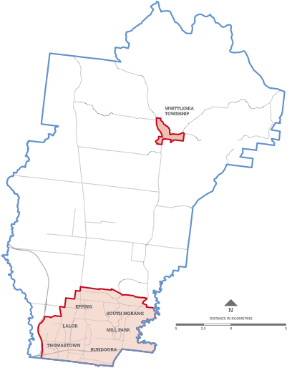
Established Area Boundry
Whittlesea Municipality

Why do we need the Housing Diversity Strategy (HDS)?
Housing is a fundamental human need. It plays an important role in people’s wellbeing by contributing to their physical and mental health.
Housing choice enables people to remain in the municipality. Our homes should cater for changing household needs such as when starting a family, or kids grow up and leave home, changing jobs or working from home.
The Housing Diversity Strategy has been prepared to ensure there is housing choice for all residents as they move through different life stages and their housing needs change. As the makeup of our households change, it is inevitable that our existing suburbs will undergo a level of change.
Council cannot prevent this growth. We will limit growth in some areas but we can’t prevent growth from occurring. However the Strategy can help to ensure a balanced approach to housing growth. The approach will identify different locations and levels of change based on proximity to services and facilities.

The Housing Diversity Strategy will:
- Effectively manage housing growth in the most appropriate parts of our established areas.
- Respond to changing demographic and housing trends including an ageing population, changes to household and family types and changing preferences for housing types, styles and design.
- Respond to a mismatch of housing to current and forecast housing need.
- Prevent planning applications for medium and higher density housing being granted in an ad-hoc and inconsistent manner.
- Transition to Reformed Residential Zones have been announced by the State Government, and a transition to these zones will need to be completed by July 2014.
The Strategy will ensure that this change is carefully managed to ensure that our established suburbs continue to be places where we want to live.
The Strategy recognises the importance of providing high quality housing and design to ensure:
- The amenity of both existing and future residents is maintained
- The quality of life for residents is improved
- The attractiveness of our suburbs is enhanced.

Changing household preferences
The Grattan Institute (2011) found that “contrary to myth and assumptions, Australians want a mixture of housing choices” – not just a detached house on a large block². There is a growing trend for people wanting to live in townhouses or in apartments in locations that are close to family, friends or shops.
The housing people would choose is much more diverse than what the City of Whittlesea’s housing currently provides. Existing housing in the municipality is dominated by detached three bedroom houses and little has changed over the last few decades.
Footnote 2: Kelly, Jane- Frances, Grattan Institute, Getting the housing we want (2011), pg. 1.

What has the process been so far?
This project is being undertaken in 3 stages. Preparation of the Housing Diversity Strategy (this document) forms part of Stage 2.

Stage 1: Background Analysis
This stage included the preparation of a Briefing Paper which provides a summary of the changing demographic profile of the established suburbs and discusses how population growth and a declining household size will have implications for the type, size and density of housing needed in the coming decades. Stage 1 Community Consultation was undertaken in April to June 2010.

Stage 2: Housing Diversity Strategy
The Housing Diversity Strategy forms part of Stage 2, and outlines the future strategic direction of housing growth in the established suburbs. Stage 2 Community Consultation was undertaken in response to the preparation of the Draft Housing Diversity Strategy (2012) from March to May 2013.

Stage 3: Implementation
This stage will include two Planning Scheme Amendments. The first amendment will be to implement the Change Areas into the Whittlesea Planning Scheme in the form of the Reformed Residential Zones. Following this, preparation of planning controls and residential design guidelines will inform variations to the Schedules of the Reformed Residential Zones.

Below is Diagram 1: Housing Diversity Strategy Process

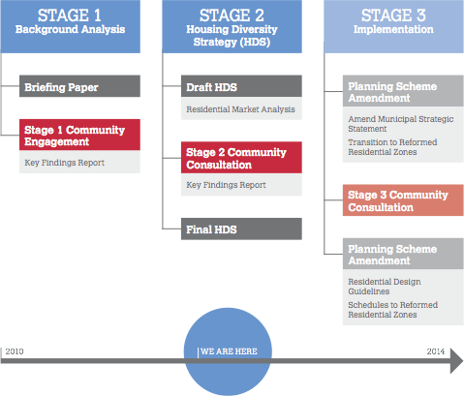

What is meant by diverse housing types?
Diverse housing types means: Detached housing, dual occupancies, townhouses, multi-units, shop-top housing and apartments.
Different tenure types including: rental, mortgage and owned properties.
Different sizes: of external and internal floor space, and number of bedrooms.

Different dwelling types could include:

DETACHED DWELLING:
A single dwelling on a single lot, separated from other dwellings.
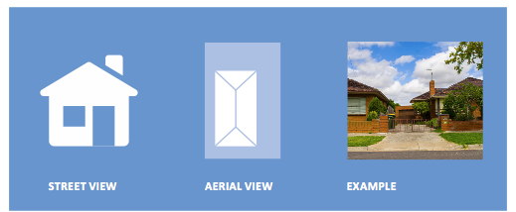

DUAL OCCUPANCY
Two dwellings on a single lot, generally one behind the other.
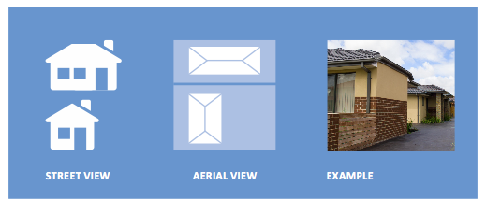

DUPLEX
Two dwellings on a single lot, attached side by side.
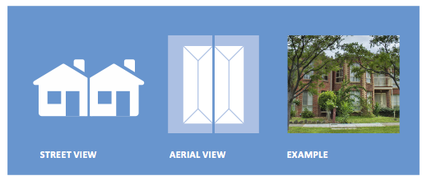

TOWNHOUSE (often referred to as semi-detached)
Typically attached to one or more dwellings or separated by a small distance (less than half a metre). Generally with private grounds and no dwellings above or below.
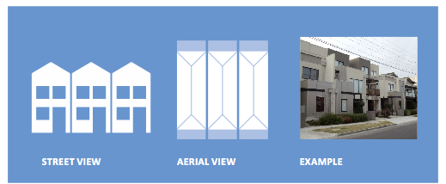

MULTI-UNIT
Several dwellings on a single or consolidated lot with private grounds, detached and generally with a shared area for car parking and access.
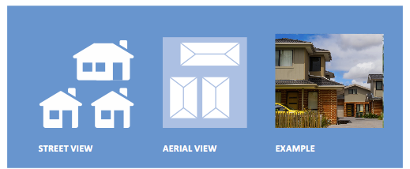

APARTMENT
Several dwellings within the same building footprint. Typically without private grounds but with a shared common entrance foyer or stairwell.
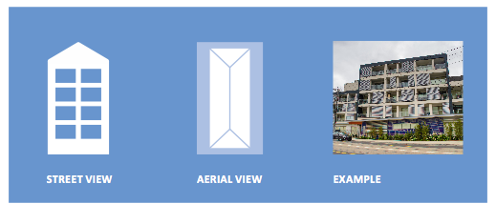

Shop-Top Housing
A house attached to a shop, usually above.
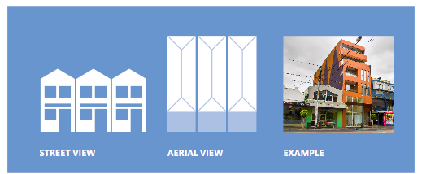

Why should we direct diverse housing into specific locations?
We know that the ways in which we live are changing. We also know that our cities continue to grow. If managed well this growth could lead to improved infrastructure, more and better services, more liveable and vibrant centres and a more sustainable urban form.
The types of houses we live in and their location is of fundamental importance to us. These factors affect our everyday lives in a number of ways:
- The length of our daily commute
- Whether we can walk to work, shops, parks and use public transport
- How often we see our family and friends
- Choices about how we bring up our children and whether we can remain living in the same area where we grew up.
Our housing also helps to build sustainable communities where people do not need to rely on the car to get around. It also provides the basis for an active, healthy lifestyle.
Please refer to Appendix 01 for a full discussion of the environmental, social and economic considerations for managing housing growth.

Benefits of the Housing Diversity Strategy
Below is Diagram 3: Benefits of the Housing Diversity Strategy

ENVIRONMENTAL
- Reduction in the outward expansion of our City by creating greater housing choice within the established suburbs.
- Increased proximity to services and facilities creating opportunities for reduced car use.
- Better access to public transport helping to reduce traffic congestion and greenhouse gas emissions.
- The preservation of productive agricultural land and other highly valued natural environments.

SOCIAL
- Greater social diversity by providing a wider range of housing types.
- Fosters more opportunities for social interaction through the provision of mixed use developments.
- Provides opportunities for access to social, community, educational and health services.
- Fosters healthier communities through the development of ‘walkable’ communities.
- Reduced social disadvantage caused by rising fuel prices and transport costs.
- Satisfies a growing trend for apartment style living.

ECONOMIC
- More efficient use of existing infrastructure and investment.
- Promotes an increased labour force mix.
- Increased productivity as a result of reduced journey to work times.

Community Consultation
Council developed the Strategy only after extensive consultation with the community. This helped to provide an understanding of housing issues, particularly as they relate to demand. It also enabled Council to identify community priorities and issues.
Council has undertaken community consultation throughout the development of the Strategy. The consultation included focus groups, design workshops, pop up workshops, drop in sessions, meetings with community groups, radio broadcasts, newspaper articles, Whittlescene articles, online drop in sessions… to name a few.
Below is Diagram 4: Housing Diversity Strategy Consultation Process

Stage 1: April to June 2010
We asked community members to identify their housing needs and aspirations. Residents provided their housing design and location preferences. This feedback was incorporated into the Draft Housing Diversity Strategy.

Stage 2: March to May 2013
We sought feedback on the Draft Housing Diversity Strategy, and in particular the Housing Change Areas. This feedback was fed into the final version of the Strategy.

Stage 3: 2014 onwards
We will be seeking feedback on variations to the schedules of the Reformed Residential Zones and residential design guidelines.

What did the community say?

Difficulties accessing housing:
- Many residents expressed lack of housing choice in the municipality.
- During both stages of consultation, the community expressed difficulties accessing housing in terms of physical accessibility and suitability.
- During consultation, the community identified a shortage of good quality rental accommodation.
- Housing affordability, both in terms of rental accommodation and home ownership was identified as a concern for Culturally and Linguistically Diverse Communities, as well as younger people, older households and single parent families.
- Housing designed for universal accessibility was also an important consideration for new developments.

Preferred locations for housing growth:
- The majority of residents were supportive of housing growth being directed into well serviced locations in activity and neighbourhood centres and close to public transport.
- Some residents felt that parts of the established suburbs should be protected from housing growth.
- The existing neighbourhood character and development density should be maintained where possible.

Preference for different housing types:
- Almost all residents supported greater housing diversity.
- Preference for smaller housing was common amongst younger person households, single parent families and older person households.
- Downsizing is a consideration for many older residents in the next 10 - 20 years.
- Affordable housing close to tertiary facilities and public transport was favoured by students.
- Preferences for larger homes (4+ bedrooms) was common among larger newly arrived migrant families and multi-generational households.

Important design elements:
- Landscaping to soften the appearance of medium and high density developments.
- Shared and communal spaces in medium and higher density developments. Usable, well designed (and not necessarily large) private open space.
- Good quality design and architecture.
- Provision of parking for medium and higher density developments.
- Increased building height in appropriate locations.
- Front and side setbacks to create building separation and landscaping.
- Environmentally Sustainable Design.
- Accessible design.
Over the two stages of consultation there has been broad support for:
- Increased housing density close to public transport
- A limit on further housing growth where access to transport is poor
- Greater housing diversity with smaller, as well as larger, housing.
The consultation outcomes of Stage 1 are documented in House This. The Key Findings Report provides a summary of the feedback received as part of Stage 2.

Community concerns and council responses
“I will be forced to move or develop my property.”
Council response: The Strategy will not force any owners to alter their property. However if you wish to develop your property to include additional dwellings, a planning permit will
still be required and Council will consider whether the application fits in with the vision of the proposed Housing Change Area.
“Council will purchase my land.”
Council response: Council will not purchase land for the purpose of private development. Council’s role is to guide future development and assess planning applications. In the first instance, further work will need to be done to prepare planning controls and residential design guidelines.
“More housing will result in strain on resources and infrastructure.”
Council response: By consolidating urban development in the established urban areas where there is existing infrastructure, the need to extend infrastructure networks is reduced and more efficient use of existing services can be achieved.
However it is true that further infill development also places additional demand on existing infrastructure and services.
Council will continue to advocate for improved infrastructure and prepare new strategic documents
(such as structure plans) to guide new infrastructure
and advocacy.
“I won’t be able to develop my property in the low change areas.”
Council response: Council will need to consider whether additional dwellings and subdivision complies with the vision of the Housing Change Area. Lower Change Areas will not be suitable for substantial housing change as they are poorly serviced in terms of access to the Principal Public Transport Network and services.
“The Strategy will result in traffic congestion.”
Council response: The Strategy hopes to relieve traffic congestion in the municipality by directing housing growth to locations in close proximity to public transport in order to encourage residents to use alternatives to the car. At a minimum this will help to reduce traffic congestion.
“Apartments will be developed right next to me.”
Council response: Ultimately the Strategy will allow building height to increase in areas in close proximity to public transport and commercial areas to allow a greater diversity of housing types. However high density does not necessarily mean high rise. The ultimate height of new buildings will be determined by what Change Area they are in, and the impact on adjoining properties. Further strategic working will be undertaken to determine specific design detail, such as height limits.
“I don’t want my suburb to change.”
Council response: Some parts of the established suburbs will need to continue to accommodate housing growth, both as a normal part of population growth and to cater for the community’s changing household needs. However as the makeup of households and their housing needs change, it is inevitable that the existing neighbourhood character will also change. The Strategy will need to carefully manage this change to ensure that our established suburbs continue to be places where we want to live. Council also has to have regard to State Government direction on where future housing growth should be located.
“The multi units are so poorly designed.”
Council response: Council understands there is ongoing community concern about the quality of medium and high density housing and the impact of new developments on the existing local character. Following adoption of the Strategy into the Whittlesea Planning Scheme detailed planning controls will need to be prepared to ensure medium and high density housing are high quality, with active street frontages, attractive landscaped areas, high quality public realm and parking.

Section 02:
POLICY CONTEXT

What is Council’s role in managing housing growth?
The role of Council is to provide strategic direction to guide the future mix, location and design of housing throughout the established residential areas of the municipality.
While the issue of housing growth is linked with the planning and provision of infrastructure and services, Council’s role is limited to:

Planning, Regulation and Policy Development
- Ensuring the housing needs and priorities of existing and future residents are met within the existing legislative framework and Victorian Planning Provisions.
- Developing policies and structure plans to identify preferred locations for new housing.
- Preparation of planning controls and design guidelines to influence the way new housing is designed.

Advocacy
- Liaising with the development industry and State and Federal Government to promote desired housing outcomes such as housing affordability and accessibility and the provision of infrastructure and services.
- Negotiating with the development industry to facilitate the design of new development by ensuring that they are of high quality, appropriately serviced by infrastructure and offer high levels of amenity for residents.

What is the State Government’s direction for planning and managing residential growth?
State Planning Policy requires Council to:
- Increase and ensure an adequate supply of housing in existing urban areas by facilitating increasing housing yield in appropriate locations.
- Locate new housing, in particular high density housing in or close to activity and neighbourhood centres and employment corridors.
- Ensure an adequate supply of redevelopment opportunities within an established urban area with access to a range of services, in particular good access to public transport.
- Ensure housing matches changing and future demographic profiles and facilitate more affordable housing closer to jobs, transport and services.

Plan Melbourne
The (draft) Plan Melbourne – Metropolitan Planning Strategy was released by the State Government in October 2013, seeking public comment by 6 December 2013. It elevates the status of Epping Central to a Metropolitan Activity Centre (previously a Principal Activity Centre); one of nine across metropolitan Melbourne.
Some key directions relating to housing include:
- Increasing the density and diversity of housing in walkable catchments of Activity Centres.
- Encouraging different housing types in strategic locations, so that more people can live closer to jobs and services.
- Improving the quality and amenity of residential apartments.
Plan Melbourne estimates that 57 per cent of all new dwellings (required by 2050) will be accommodated in Melbourne’s established suburbs.
Once finalised, Plan Melbourne will replace Melbourne 2030 and Melbourne @ 5 Million.

Melbourne 2030/ Melbourne @ 5 Million
Melbourne 2030 (released in 2002) is the State Government’s strategic plan for metropolitan Melbourne referenced within Clauses 11 and 16 of the State Planning Policy Framework. Melbourne @ 5 Million (released in 2008) was prepared to guide the ongoing implementation of Melbourne 2030 in the context of unanticipated population growth.
Epping Central was recently identified in the State Government’s Plan Melbourne as a Metropolitan Activity Centre because of its good public transport networks and services including providing a diverse range of jobs, activities and community facilities and services.
Refer to Appendix 02 for a full discussion of state and local planning policies pertaining to housing.

Below is Diagram 5: Whittlesea Planning Scheme
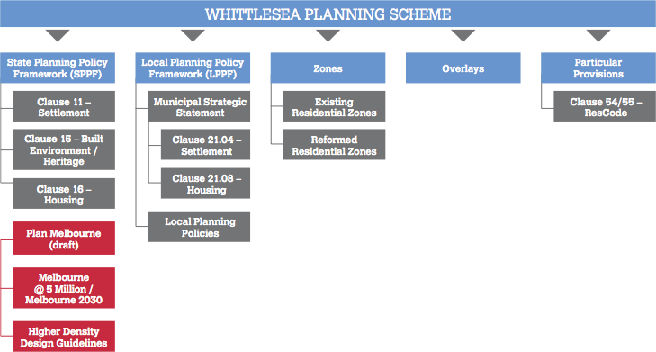

What planning provisions does Council currently use?
The Whittlesea Planning Scheme (WPS) guides land use and development within the municipality. Two components in the WPS are:
- The State Planning Policy Framework:
This provides the strategic basis for the application of zones, overlays and particular provisions.
- The Local Planning Policy Framework:
This sets a local and regional strategic planning context and contains a Municipal Strategic Statement (MSS) and specific local planning policies (LPPs).
There are several provisions in the Whittlesea Planning Scheme that relate to the Strategy. In addition, zones, overlays, particular and general provisions affect development.

State Planning Policy Framework (SPPF)
Clause 11 – Settlement: References Melbourne 2030, and specifically encourages the concentration of major retail, residential, commercial, administrative, entertainment and cultural developments into activity centres which provide a variety of land uses and are highly accessible to the community.
Clause 15 – Built Environment and Heritage: Seeks to ensure that developments contribute positively to the local urban character and sense of place and minimises detrimental impacts on neighbouring properties.
Clause 16 – Housing: Seeks to increase the supply of housing in existing urban areas of metropolitan Melbourne by facilitating housing in appropriate locations close to Activity and Neighbourhood Centres and employment corridors that offer good access to services and transport. It also aims to achieve well designed medium density housing which respects the neighbourhood character, improves housing choice and makes better use of existing infrastructure.
Clause 54/55 – ResCode: Comprises a set of development objectives and standards which must be used when assessing planning permits for residential developments.
The Higher Density Design Guidelines: Sets out design principles that must be taken into account in the design of residential developments more than five storeys.

Local Planning Policy Framework (LPPF)
The Local Planning Policy Framework (LPPF) of the Whittlesea Planning Scheme contains the Municipal Strategic Statement (MSS) and Local Planning Policies (LPPs).
Clause 21 – Municipal Strategic Statement (MSS): The MSS establishes the strategic framework for the municipality and shows how it supports and implements the SPPF.
It provides the basis for the use of zones and other land use controls within the Scheme.
Clause 21.04 – Settlement/Clause 21.08 – Housing: The strategic planning framework identifies ‘Housing’ as one of nine key land use planning objectives. Its aim is to ‘promote the establishment of increased diversity and quality in housing provision to meet the needs of existing and future residents of the City of Whittlesea in a manner which contributes positively to local character and sense of place’.
Specifically Clause 21.08-2 Housing Diversity and Affordability identifies completion of the Housing Diversity Strategy.

Reformed Residential Zones
In July 2013 the State Government introduced Reformed Residential Zones, which include:
- Residential Growth Zone
- General Residential Zone
- Neighbourhood Residential Zone.
The Reformed Residential Zones will provide Councils with the ability to identify preferred locations for housing growth (including locations where intensification should not occur) and apply local zone schedules to different areas to articulate preferred built form outcomes.
Currently residentially zoned land in the City of Whittlesea falls under either the Residential 1 Zone or Residential 2 Zone.
The timeframe for transition to the Reformed Residential Zones (to replace current Residential 1 & 2 Zoning) is by 1 July 2014. Council’s approach to transition in the Reformed Residential Zones is discussed in Section 6 – Implementation.

Features of the Reformed Residential Zones
The features of the Reformed Residential Zones are discussed in the table below.
 | Zone | Where will it be used? | What sort of housing can be expected?
ACTIVITY CENTRE ZONE (existing) | Enables consolidated community services, shops, offices and housing in Activity Centres. | In Melbourne’s Activity Centres and major regional town centres | High density housing
COMPREHENSIVE DEVELOPMENT ZONE (existing) | Enables a range of uses and development including new housing and jobs growth in redevelopment areas. | Redevelopment sites such as former industrial land, underutilised urban areas and identified urban renewal locations where significant change is sought. | High and medium density housing
MIXED USE ZONE (improved) | Enables new housing and jobs growth in mixed use areas. | In areas with a mix of residential and non-residential development. In local neighbourhood centres undergoing renewal and around train stations, where appropriate. | High and medium density housing
RESIDENTIAL GROWTH ZONE (new) | Enables new housing growth and diversity. | In appropriate locations near activity areas, train stations and other areas suitable for increased housing activity. | Medium density housing
GENERAL RESIDENTIAL ZONE (new) | Respects and preserves urban character while enabling modest housing growth and housing diversity. | In most residential areas where modest growth and diversity of housing is provided, it is consistent with existing neighbourhood character. | Single dwellings and some medium density housing
NEIGHBOURHOOD RESIDENTIAL ZONE (new) | Restricts housing growth in areas identified for urban preservation. | In areas where single dwellings prevail and change is not identified, such as areas of recognised neighbourhood character, environmental or landscape significance. | Single dwellings and dual occupancies
TOWNSHIP ZONE (improved) | Provides for residential and other uses in small towns. Enables modest housing growth. | In townships. | Single dwellings and some medium density housing
LOW DENSITY RESIDENTIAL ZONE (improved) | Enables low density housing. | On the fringe of urban areas and townships where sewerage may not be available. | Single dwellings
Source: Department of Transport, Planning and Local Infrastructure, 2012

How will the Strategy address policy gaps in the Whittlesea Planning Scheme?
The Strategy will need to address provide clear policy guidance in relation to:
- Preferred locations for housing growth
- Changing neighbourhood character
- Housing design.

Guidance on preferred locations for housing
The current Municipal Strategic Statement (MSS) identifies the need for housing diversity to some extent. Specifically it looks at medium density housing to cater for demographic changes. However, recent planning decisions illustrate there is an absence of specific guidance in the Whittlesea Planning Scheme for identifying preferred locations for housing growth.
The Strategy seeks to address this by identifying suitable locations for density within the established residential areas. It also identifies areas that are not suitable for increased housing growth.
Amending the MSS to outline the local response to managing change and responding to the community’s needs will help achieve greater consistency in decision making.

Guidance around changing neighbourhood character
Some parts of the City of Whittlesea’s established residential areas will need to continue to accommodate housing growth, both as a normal part of population growth and to cater for the community’s changing household needs. However as the makeup of households and their housing needs change it is inevitable that the existing neighbourhood character will also continue to change.
The Housing Diversity Strategy ensures that the impact of this change is carefully managed to ensure that our established suburbs continue to be places that we want to live in.

Guidance on housing design
There is ongoing community concern regarding the quality of medium and higher density development. Mostly, concerns centre around the need for development to compliment the existing neighbourhood character and, where appropriate, assist in shaping a preferred character.
The HDS recognises the importance of providing high quality built form and design outcomes to ensure that:
- The amenity of both existing and future residents is considered
- The quality of life for all residents is improved
- The attractiveness of our suburbs is enhanced.
Changes are required to the existing local planning policy framework to guide high quality design for new residential developments. The Reformed Residential Zones currently released by the State Government, will assist in guiding preferred built form outcomes implementing this policy framework.

Section 03:

DISCUSSION
OF KEY ISSUES

Who lives in our established suburbs?
The characteristics of current and future residents need to be understood to efficiently plan for the quantity, type and location of housing needed over the next 20 years¹. Increasing the availability of housing options within the established urban areas, particularly medium and higher density housing, will be important to respond to the changing demographic profile of the City and the shifts in housing preferences.

Population growth
In 2011 the population of the established areas was approximately 113,000 persons. This is forecast to increase by 18,600 over the next 20 years to 2031.
In the 15 year period from 1996 to 2011, 75 per cent of population growth in the City of Whittlesea occurred in growth areas outside the established areas.
Despite the dominance of growth area residential development driving population growth, population growth in the established areas between 2006 and 2011 (760 persons per annum) was considerably higher than the population growth rate between 2001 and 2006 (150 persons per annum). This trend suggests ongoing demand for new residential development in established areas.
Despite the overall forecast increase of 18,600 persons in the established areas over the next 20 years, the established areas is forecast to decline from 69 per cent of the total population in 2011 to just 44 per cent in 2031.

Household growth
It is estimated that the number of new households which need to be accommodated in the established suburbs over the next 20 years is 8,200 dwellings, which is approximately 410 new households every year.
Decline in the average household size as a result of changing household types, combined with forecast population growth, is expected to generate ongoing strong demand for new dwellings in the established suburbs.
Refer to Appendix 03 for a complete Demographic and Housing Profile.

Footnote 1: This section includes text from the Residential Market Analysis prepared by Essential Economics in 2012. Other data has been collected from:
- the Australian Bureau of Statistics 2006 and 2011 Census data,
- the City of Whittlesea Community Profile, and
- Population forecasts prepared by .id consulting (2012).

Household size declining in established areas
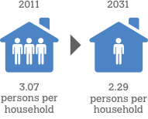
Source: Essential Economics, Residential Market Analysis, 2012

Household types
A need for smaller dwellings is being driven by a changing demographic profile.
Currently almost half (45 per cent) of all households in the established suburbs are categorised as couples with children. However recent Census data shows that over the period 2011 to 2031, the established suburbs are forecast to have:
- A declining share of couples with children. This household type will account for just 18 per cent of additional households in the period 2011 to 2031.
- The percentage of couples without children and lone person households is expected to increase.
Over the next 20 years, couples without children and lone person households will comprise 65 per cent of the total forecast additional households in the established areas. Such a change highlights the changing drivers of dwelling demand in the established residential areas.

Age structure
Over the coming decades, the portion of older residents in the established areas is expected to increase. Between 2011 and 2031, the number of persons aged 60 years and over will increase from 18.99 per cent to 23.05 per cent, with the strongest growth in those aged 70-84.

Below is Graph 1: Forecast Age Structure 2011 to 2031, Established Areas.

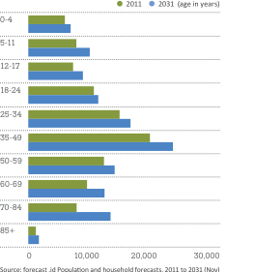

Source: forecast .id Population and household forecasts, 2011 to 2031 (Nov)

Forecast household types
Diagram 6: Forecast Household Types
Household types |  | CURRENT  HOUSEHOLD  TYPE (2011) | FUTURE  HOUSEHOLD  TYPE (2013) | SHARE OF ADDITIONAL  HOUSEHOLDS FROM  2011 TO 2031
Couples with children  Traditional family type with two parents and children. |  | 45% | 40% | 18%
Couples without children  For example young couples who have not had children yet or chosen not to have children compared to older “empty nester” couples whose children may have left home. |  | 25% | 27% | 38%
Lone person  Single person living alone. |  | 13% | 15% | 27%
Single parent families  Single parent family with children. |  | 14% | 14% | 14%
Other  Other families, group households. |  | 3% | 4% | 3%
Source: Residential Market Analysis (2013), Essential Economics

What is our current housing stock?

Dwelling types
A gap has been identified between the established areas’ existing housing stock and the housing needs of the community.
A significant shortfall exists in the supply of smaller housing in the municipality.
In 2011, detached dwellings accounted for 90.2 per cent of all dwelling types in the established suburbs. Semi-detached housing (i.e. townhouses) accounted for only 4.3 per cent.
In 2006, 3 and 4 bedroom homes accounted for the majority (93 per cent) of the municipality’s housing.
However dwelling preferences are changing and detached dwellings accounted for just 68 per cent of new dwellings in the established areas between 1996 and 2011. During this period, 32 per cent of new dwellings were semi-detached or units/apartments.
The increasing share of semi-detached housing or units and apartments suggests a growing acceptance and demand for medium and higher density housing types. However, in contrast to other middle ring suburbs in Melbourne, this figure is quite low. Semi-detached dwellings account for the majority of dwelling growth in Moreland (76 per cent), Darebin (64 per cent) and Whitehorse (84 per cent).

Key statistics – 2006
36 per cent of three bedroom dwellings in the municipality were occupied by only two people, and similarly a large percentage of the four or more bedroom dwellings were occupied by only two or three people.
80 per cent of studio apartments were occupied by three or more people which suggest difficulties accessing affordable housing. Clearly, there is a mismatch between household needs and available housing.

Below is Graph 2: Dwellings by house type, Established Areas, 2006
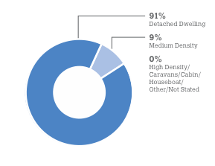

Below is Graph 3: All Dwellings, City of Whittlesea, 2006

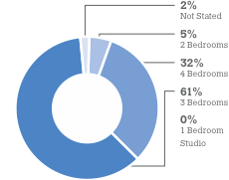

Source: ID Consulting, 2012

What is the forecast demand for different dwellings and from whom?
It is expected there will be demand for 8,200 new dwellings over the next 20 years. This includes:
- 3,690 detached dwellings
- 2,860 semi-detached dwellings
- 1,650 apartments and units.

Demand for smaller housing types
Demand for housing in the established areas will be driven by smaller (one and two person) household types. This is a different household profile from that which influenced dwelling demand in the established suburbs over the past 50 years, and which has been dominated by couple with children households.
The demand for townhouses, units and apartments, is forecast to increase steadily over the forecast period, primarily due to the growing population of this housing type with couples without children and lone person households.

Demand for detached dwellings
However, demand for detached dwellings will continue to be the most dominant housing type in 2031 and will account for 81.2 per cent of total housing in the established areas, despite the shift in housing preferences.
Families with children who desire a detached dwelling have significant supply available in parts of the established suburbs in Whittlesea’s growth areas, including Mernda and Epping North, as well as, for at least the next 20 years. The established areas are also able to accommodate a share of families with children, as these people are increasingly seeking higher-density housing close to public transport and other infrastructure.

What is our forecast housing supply?
The potential supply of additional housing in the established areas over the next 20 years to 2031 is estimated at 13,390 dwellings. This demonstrates that the established areas can accommodate different dwelling types to meet the forecast housing demand of 8,200 households over the next 20 years. The estimated surplus supply is therefore 5,190 dwellings.
Please refer to the Residential Market Analysis, by Essential Economics, 2012.
Fewer residents will want or need 3-4 bedroom homes. Instead, there will be a need for different housing types to suit our changing population.
 | Detached | Semi-detached | Units/Apartments | Total
Total Dwelling Demand | 3,690 | 2,850 | 1,660 | 8,200
Total Dwelling Supply | 4,135 | 3,145 | 6,110 | 13,390
Surplus | 445 | 295 | 4,450 | 5,190

What planning decisions are being made?
The number of planning and building permits being issued for medium and higher density housing in
the established suburbs is increasing.
Between 2007/2008 and 2010/201³, applications for medium density developments more than doubled.
Below is Graph 4: Residential Planning Applications Received by Council, City of Whittlesea, 2012
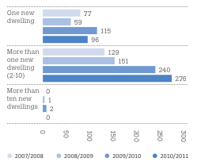

Footnote 3: The Planning Permit Activity Report for 2011/2012 was not available at time of report writing.
Issues in relation to planning applications include:
- A higher percentage of objections are made in relation to medium and higher density applications.
- Many planning applications are being appealed to Victorian Civil and Administrative Tribunal (VCAT).
- Approvals are granted without consistent strategic direction and regard to preferred locations for medium and higher density housing.
- Without policy guidance on the preferred character of the established suburbs, VCAT decisions have been based on existing neighbourhood character which can lead to a varied and inconsistent built form.

Where has medium and higher density housing occurred previously?
The City’s planning provisions provide minimal strategic direction about preferred locations for more diverse housing outcomes. This is particularly so for medium and higher density developments. As a result, planning applications for such developments have been granted in an ad-hoc basis throughout the municipality.
Higher density developments have generally occurred on regular shaped lots that are in close proximity to rail stations, such as those found in Epping Central, Lalor and Thomastown.
Refer to map on next page.

Map 02: Medium and High Density Housing In the City of Whittlesea
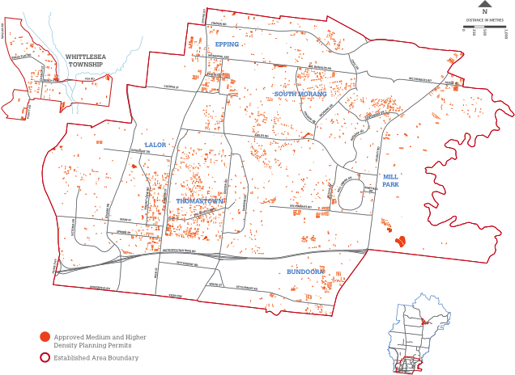

What are the key design issues with current residential developments?
Council recognises there is ongoing community concern over the scale and quality of medium and high density residential developments. A major concern is that new housing may not complement what already exists and not help in shaping a preferred neighbourhood character.
A common perception and a frequent planning objection is that the existing neighbourhood character is under threat. The challenge for the future is to provide residential development that:
- Respects the amenity of neighbouring residents,
- Enhances the appearance of our established suburbs.
Down the track we’ll develop residential design guidelines and planning controls (Stage 3: Implementation).
Here are some examples of issues that have been identified with medium and high density housing in the municipality.
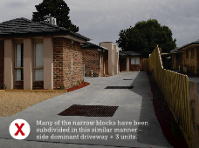

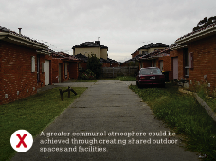

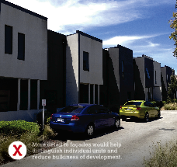
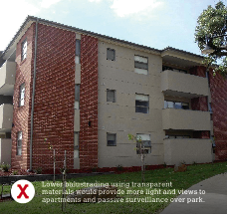
Section 04:

HOUSING CAPACITY ASSESSMENTS

What is the capacity of our established suburbs to accommodate more growth?
Until recently, planning applications for medium and higher density housing have occurred throughout the established suburbs of the municipality and in areas remote from public transport, services and facilities.
This Strategy aims to provide guidance on appropriate locations for housing growth by assessing the capacity and suitability of each suburb to accommodate future developments. These include existing and proposed land use features, locational and site characteristics.
Housing Capacity Assessments were undertaken to:
Identify those areas that have the capacity to accommodate additional housing development.
Identify those areas that have limited capacity for additional housing development.
Identify constrained land where there is minimal or no capacity for residential development.

Methodology for assessing dwelling capacity
A set of criteria used to assess capacity was identified in Stage 1 (Background Analysis and Stage 1 Community Engagement).
All of the criteria was mapped and analysed in conjunction with each other to determine areas of high, medium and low capacity.
Some of the criteria used to assess capacity include:
- Locational criteria (e.g. proximity to activity and neighbourhood centres, local and major shopping centres, public transport, open space, tertiary facilities, health and community facilities).
- Site characteristics (e.g. lot frontage, lot size, solar orientation, dwelling size, age of housing).
- Existing planning provisions (e.g. zones and overlays).
- Land ownership (e.g. vacant lots, government owned land, single dwelling covenants, rear laneways).
- Subdivision patterns (e.g. grid based vs. curvilinear subdivision patterns).

Those areas remote from these important elements (generally greater than 800 metres) were considered inappropriate locations for increased housing growth.
Refer to Appendix 03 for a full copy of the Housing Capacity Assessment.

Primary Capacity Criteria
Proximity to the Principal Public Transport Network (PPTN) and activity and neighbourhood centres was identified as the primary considerations for guiding future housing growth.

Proximity to trains, trams and smart buses
It is generally accepted that 800 metres (about a 10 minute walk) is the maximum distance people will walk to high quality public transport (such as trains) compared to 200 metres for lower service modes, for example local buses.
The City of Whittlesea’s Principal Public Transport Network Includes:
- Train (South Morang rail line)
- Tram (Route 86 along Plenty Road )
- Orbital Smart Bus (Route 901 and 902, travelling east-west)

What is a walkable catchment?
Given a choice, most people will only walk a certain distance to public transport or shops.
Walkable catchments make assumptions about how far people are generally willing to walk based on the level of service provided. For example, the distance people would be willing to walk to public transport would be determined by the mode of transport, reliability and frequency of service, network structure, stop spacing and hours of service.
Walkable catchments have been used using Geographic Information System (GIS) to measure the walking distance along the street, not the straight line measured on a map. This approach is necessary because the layout of paths and roads affects the distance and time it would take to walk to a destination.

Map 3: Walkable Catchments from the Principal Public Transport Network (PPTN)

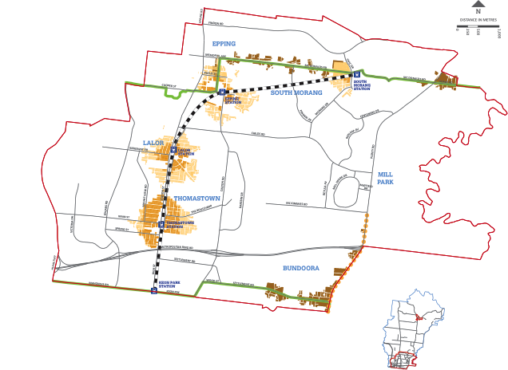
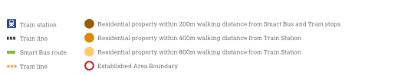
Note: Whittlesea Township has been excluded as it is not serviced by the PPTN.

Distance to Metropolitan, Activity and Neighbourhood Centres, local shopping centres
By virtue of their status, activity centres are considered ideal locations for additional housing growth.
Walkable catchments differed across the hierarchy of centres – based on the size of the centre. Larger catchments were measured for the Metropolitan, Activity and Neighbourhood Centres, compared with the smaller local neighbourhood shopping centres.
The State Government’s (draft) Plan Melbourne has identified the following activity centres in the established areas:
- Metropolitan Activity Centre: Epping Central (previously a Principal Activity Centre under Melbourne 2030)
- Activity Centre: Plenty Valley (previously a Major Activity Centre)
- Neighbourhood Centre: Lalor, Thomastown and Bundoora (previously Neighbourhood Activity Centres)
- Health and Education Precinct: University Hill (previously a Specialised Activity Centre)

What is an Activity Centre?
“A vibrant hub where people work, meet, relax and live. Usually well serviced by public transport, they range in size and intensity of use from local neighbourhood strip shopping centres to universities and major regional shopping centre”.
Source: Department of Transport, Planning and Local Infrastructure, 2013.

Map 4: Walkable Catchments from Shopping Centres/Activity Centres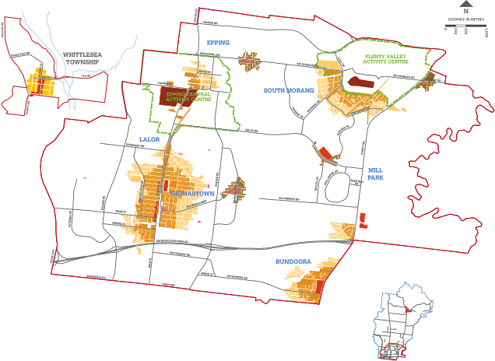
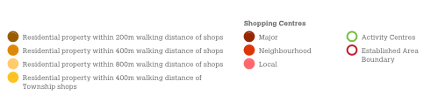

Note: Whittlesea Township has not been included in this analysis.

Other capacity considerations
Several other criteria were considered in the capacity assessments. Some are discussed below but refer to Appendix 03 for a comprehensive list.

Community Services and Facilities
Health, education and community facilities are generally dispersed throughout the established areas. Those areas with clustered services have been used to determine future housing growth areas, as opposed to single purpose facilities only. Activity and Neighbourhood Centres contain the greatest concentration of facilities and services.

Map 5: Community Services and Facilities

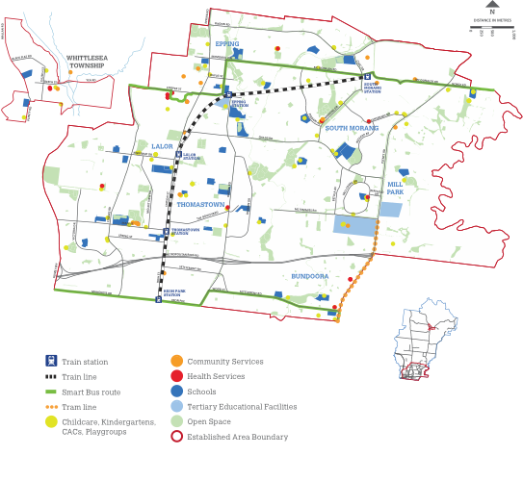
Lot size
There is broad consistency between the size of a lot and its development potential. In Lalor and Thomastown there is a concentration of moderate sized lots (650-1000sqm) and larger lots in Epping Central and parts of South Morang (greater than 800sqm).
A concentration of smaller lots in Bundoora, South Morang and Epping are generally indicative of medium density developments that have been constructed and subdivided in the past.

Map 6: Residential Lot Size (sqm)
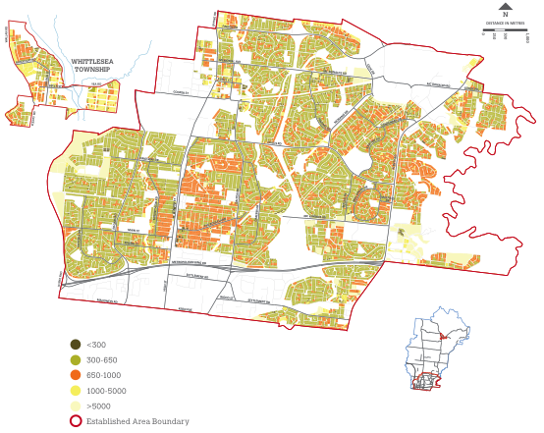

Subdivision pattern
The subdivision pattern of the established areas impacts on its ability to increase density. For example, the layout of streets and lots can determine the connectivity of an area for both pedestrians and vehicles and the size of a lot will influence how many dwellings can be accommodated.
The established areas can generally be divided into two parts:
- The older grid based pattern in Lalor, Thomastown, and Epping where large, regular lots are attractive to developers.
- The curvilinear subdivision of Bundoora and Mill Park with irregular-shape lots that are more difficult to build multi-unit developments on.

Dwelling age
The age of housing can influence the redevelopment potential of a site. Redevelopment potential also depends on the value of the land and the need for repairs or maintenance to the house. Housing age gives an indication of what existing housing may potentially be redeveloped into new housing. Generally, houses which are older than 30 years are more likely to be demolished or redeveloped to incorporate additional housing.
Post war housing is concentrated along the High Street corridor of Thomastown, Lalor, and Epping. Many houses in Thomastown and Lalor have been demolished to allow for the construction of new dwellings. To the east of the municipality (Bundoora, Mill Park, and South Morang), there is mostly newer housing.
Whittlesea Township contains a number of properties built prior to 1949. However, most development is more recent (less than 20 years old) particularly in the residential areas to the north, south west and east of the Township.

Map 7: Residential Dwelling Age

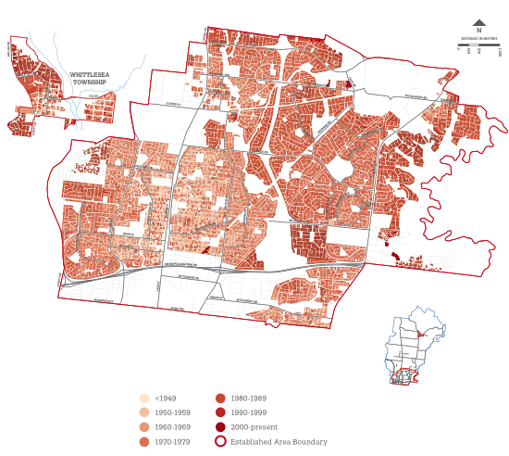
Housing Capacity Assessment findings
The capacity analysis suggests that there are significant areas within the established suburbs of the City which are not appropriate for further housing growth. This may be because of site or location characteristics. However significant opportunities also exist to accommodate the changing needs of the community in those areas well serviced by the Principal Public Transport Network (PPTN) and Metropolitan, Activity and Neighbourhood Centres.

High capacity areas
Areas nominated for higher levels of change have good access to Metropolitan, Activity or Neighbourhood Centres and the PPTN. Areas located adjacent to employment, public transport, community services and facilities are deemed to have a high degree of accessibility. Therefore they have a greater capacity to accommodate higher rates of residential change to meet the needs of future occupants.
In general all centres will be considered locations for future growth. However, the Neighbourhood Centres (Lalor, Thomastown, Bundoora) were considered to have less capacity in terms of scale and intensity, compared to the Epping Central Metropolitan Activity Centre and Plenty Valley (South Morang) Activity Centre.

Metropolitan and Activity Centres
It is the Metropolitan and Activity Centres that best show that they could accommodate growth. Based on their proximity to the PPTN, activity centres containing employment, community services and infrastructure are considered suitable to accommodate higher densities (apartments and mixed use developments) without detrimental impacts on the established residential areas.

Below is Diagram 7: Housing Capacity Assessment Findings

High Capacity
- Close proximity to the PPTN or within Metropolitan, Activity or Neighbourhood Centres
- Higher provision of community services and facilities, tertiary facilities
- Larger lot sizes
- Grid based subdivision pattern
- Older housing stock
- Larger numbers of vacant lots
- Supportive planning controls (e.g. structure plans).

Moderate Capacity
- Moderate proximity to activity centres and PPTN
- Direct frontage or immediate proximity to Lalor Plaza, Stables, Gorge Road and Greenbrook Shopping Centres.

Minimal Capacity
- Limited access to Metropolitan, Activity and Neighbourhood Centres and PPTN (greater than 800m to train stations or activity centres, greater than 200m from tram stops)
- Remote from regional community facilities and services
- Newer housing stock
- Smaller housing lots and high site coverage
- Smaller lot frontages
- Poor subdivision pattern.

Larger lots and high land vacancies in these centres also provide an ideal opportunity for development that provides for a range of dwelling types.
Detailed structure plans have been prepared by Council or are in the process of being prepared to guide the preferred scale, intensity and mix of residential development, and to address matters such as infrastructure capacity and design.

Neighbourhood Centres
Significant residential development can occur in Neighbourhood Centres given their location and site characteristics. However, because of the smaller scale of these centres, development needs to be sensitive to their existing neighbourhood role and function.
Some change in the Neighbourhood Centres was considered appropriate because of their proximity to services and public transport. Additional structure planning may be required for Lalor, Thomastown and Bundoora to provide a more detailed framework to better guide development in and around these centres.

Moderate capacity areas

The periphery of Neighbourhood Centres
These areas are within comfortable walking distance to either Activity or Neighbourhood Centres or the PPTN. Being on the periphery of the high capacity areas, they act as a buffer to the sensitive interface with lower capacity areas. Growth is therefore encouraged in these areas but at a lesser scale.
Moderate capacity was also identified around a number of smaller localised centres where additional housing in the form of shop-top housing or small scale multi-unit developments could work.

Minimal capacity areas

Residential areas outside Metropolitan, Activity or Neighbourhood Centres
Areas remote from the PPTN and Metropolitan, Activity or Neighbourhood Centres (generally greater than 800 metres) are considered inappropriate for additional housing growth and change. These areas normally have newer housing and are on smaller lots and with higher site coverage. Increasing the number of houses in these areas would lead to more households being dependent on private motor vehicles, with the obvious implications. Medium and high density housing is not encouraged in these locations.

The Whittlesea Township
A different approach to achieving additional housing growth and diversity should be considered for the Township (compared to the other established suburbs of the municipality).
Although surrounded by vast tracts of undeveloped land devoted primarily to pastoral activities, the Whittlesea Township is heavily constrained where new urban development is concerned.
The Township is surrounded by hills and ridgelines that provide an important backdrop to the town. Combined with the floodplains of Plenty River which bisects the existing Township, these features somewhat limit options for future residential expansion.
In addition to this, the Whittlesea Township is considered to have limited capacity for further infill development due to its remote location from the PPTN. Although a bus service is available within the Township, car based transport will continue to predominate given the area’s remote location from higher order retail, employment and community services and facilities.
The Township is characterised by older housing and boasts a distinctive rural character which should be protected and enhanced.
The small scale of housing, housing type and the established vegetation are elements which should be maintained. However, the Township does need to accommodate some additional growth of more diverse housing types to respond to changes in demographic profiles. It is considered that along the main road entering the Township (Laurel Street) and closer to its centre (Church Street) there is some capacity to accommodate infill residential development.
These streets have greater capacity compared to the remainder of the Township to accommodate a more substantial built form that will not compromise the rural character of the Township. Such development on these streets will also play a role in activating the shopping centre core and the gateways into the Township.

Section 05: Policy Direction
Increasing pressure to redevelop our established residential areas with medium and higher density housing, forces us to consider how we want our suburbs to change over time. This change should be managed carefully to ensure the diverse needs of our residents are met, while our suburbs continue to be vibrant, attractive places to live.
Some areas within our established suburbs of the municipality will need to continue to accommodate change, both as a normal part of growth and to cater for the community’s changing housing needs. The ability to manage how our neighbourhoods will grow depends on:
- Housing being directed to areas that can accommodate increased densities and diversity.
- The maintenance of more conventional housing densities in areas that are remote from services and facilities and the PPTN.
- An incremental level of change to provide a suitable transition and buffer between high and low change areas.
This Strategy sets out the strategic framework for future residential development in the established urban areas. It seeks a balanced approach to managing housing growth. It is an approach that recognises the different housing needs and expectations of the community regarding acceptable levels of change.
Ultimately the Strategy will provide the community and development industry with greater certainty regarding the types of buildings to be expected over the next 20 years.
What has informed the Housing Diversity Strategy?
- Community feedback
- State Government direction
- Housing Capacity Assessments
- Changing preferences for housing types
- Increasing development pressure.
It will identify ‘high’, ‘incremental’ and ‘minimal’ areas of change and will incorporate the appropriate Change Area Profiles to guide how these areas will change over time having regard to:
- Preferred density and level of housing growth and change
- Key design principles
- Preferred housing types.

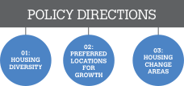

POLICY 01: HOUSING DIVERSITY
Changes in demographic and household structures suggest a growing demand for smaller houses, as well as larger homes (with four or more bedrooms.) This policy objective supports a range of different housing types in relation to size, density, scale and location. The benefit is that people have greater housing choice and can remain living in their community throughout various stages of their life.

Objective 1: To encourage a more diverse housing stock.
Strategy 1.1: Encourage a greater diversity of housing and dwelling sizes to include both smaller and larger housing.
Strategy 1.2: Encourage adaptable and accessible housing to enable the community to ‘age in place’.

POLICY 02: PREFERRED LOCATIONS FOR HOUSING GROWTH
The degree of change expected for the established suburbs will not be the same for all locations and areas. This objective seeks a balanced approach to housing which encourages growth in areas with good access to the Principal Public Transport Network (PPTN), services and facilities, and limits change in those areas with poor access.

Objective 2: To direct housing growth into locations which have the capacity to accommodate change.
Strategy 2.1: Guide housing growth into areas in proximity to the PPTN and Metropolitan, Activity and Neighbourhood Centres.
Strategy 2.2: Minimise housing growth within areas where access to the PPTN and Metropolitan, Activity and Neighbourhood Centres is limited, or where it has been identified as having limited development potential.

POLICY 03: HOUSING CHANGE AREAS
The Housing Change Areas are based on a capacity assessment of accessibility to services and facilities, as well as physical and site attributes. This objective identifies Housing Change Areas to outline the level and type of housing growth and change for each area. These Change Areas have been developed to provide guidance to Council and greater certainty to the community and development industry regarding the types of housing growth and change to be expected in different parts of the municipality.

Objective 3: To accommodate varying levels of housing growth and change in the established residential areas of the municipality.
Strategy 3.1: Implement the Housing Change Areas as detailed below:
- Urban Renewal
- Neighbourhood Renewal
- Neighbourhood Interface
- Suburban Residential
- Township Diversity
- Township Residential
Strategy 3.2: Rezone existing residentially zoned land to the Reformed Residential Zones in accordance with the Housing Change Areas

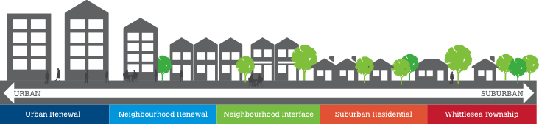

Map 8: Housing Change Areas

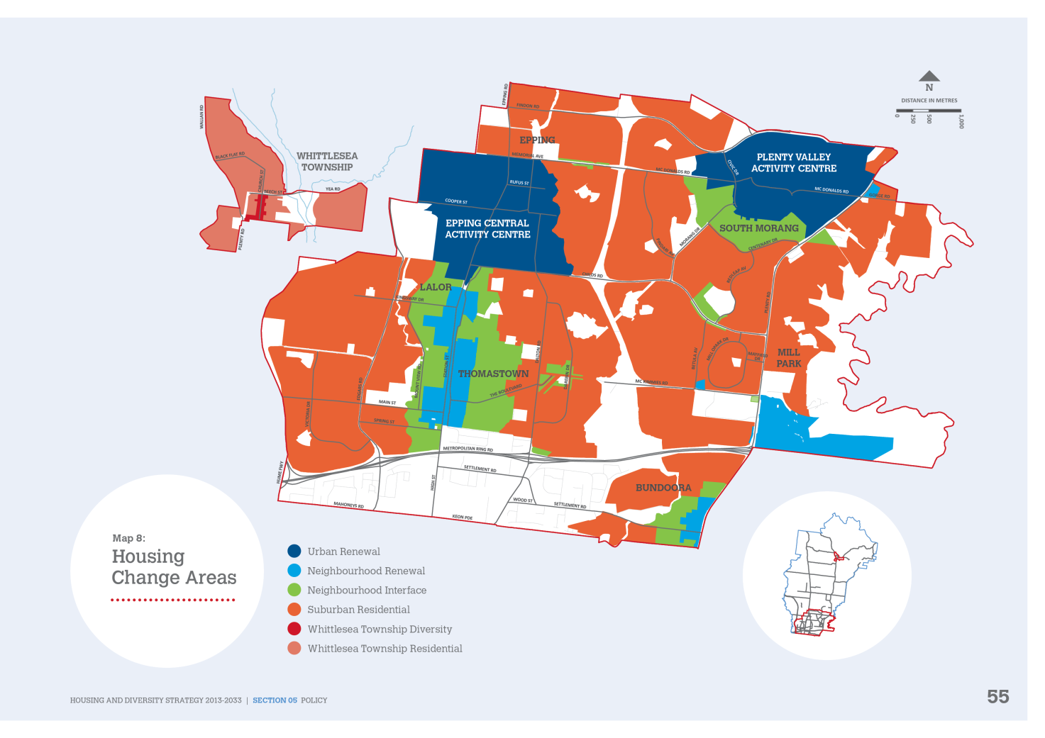
Urban Renewal

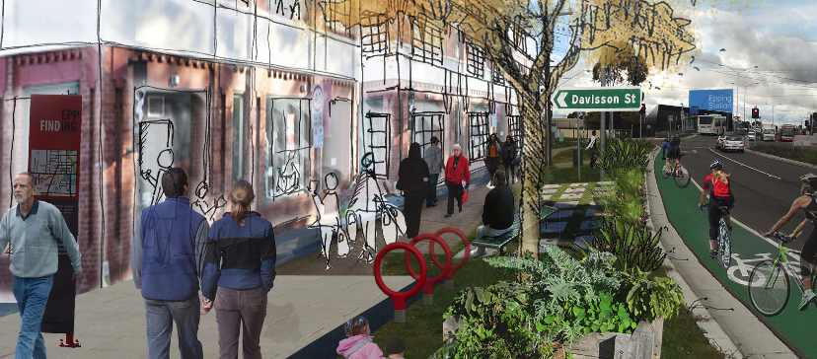
Proximity to transport and services:
within 400m
Preferred block and housing types
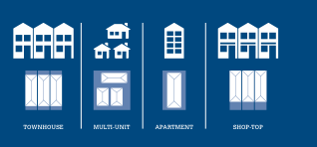

Preferred Density
- Encourages higher density housing.

Proximity to Services and Facilities
- Epping Central is a Metropolitan Activity Centre and Plenty Valley (South Morang) is an Activity Centre.
- Both centres have good access to public transport, employment, health and community facilities and services.

Preferred Housing Types
- Townhouses
- Multi-units
- Small and large scale apartments
- Shop-top housing and mixed use developments.

Key Design Principles

Height
- A range of medium to high building heights that support increased density.
- Higher built form oriented towards main streets, public spaces, open space, creeks or important views.

Setbacks
- Minimal or no front setbacks to encourage activation of the street.
- Minimal or no side and rear setbacks that has regard to surrounding amenity.
- Building separation between ‘tower’ elements to ensure solar access, landscaping and visual separation.

Site Coverage
- Higher site coverage to facilitate increased densities.

Private Open Space
- Usable private open space, balconies and communal shared spaces.

Landscaping
- Landscaping to complement higher density built form.

Map 9: Urban Renewal

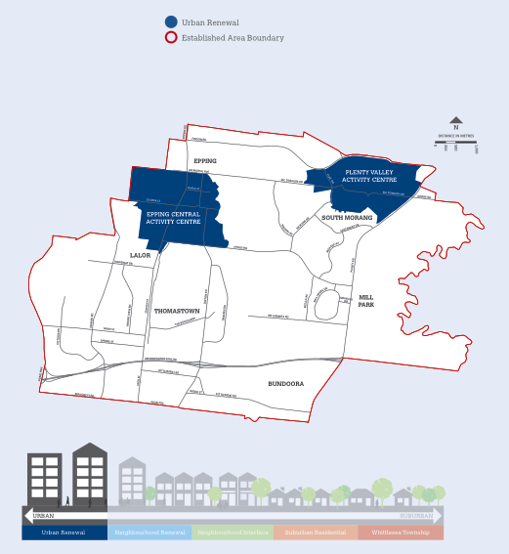
Neighbourhood Renewal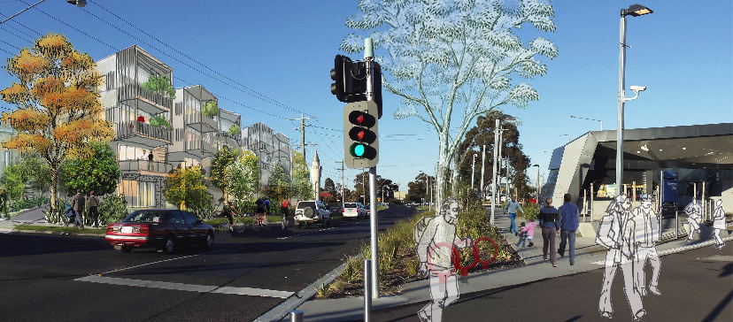
Proximity to transport and services:
within 400m
Preferred block and housing types

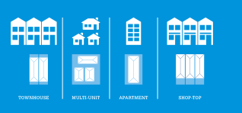
Preferred Density
- Encourages medium and higher density housing.

Proximity to Services and Facilities
- Close proximity to the Lalor, Thomastown and Bundoora Neighbourhood Centres.
- Close proximity (5-10 minute walk) to public transport and in particular the train and tram.
- Good mix of community services and facilities.

Preferred Housing Types
- Townhouses
- Multi-units
- Small scale apartments
- Shop-top housing and mixed use development

Key Design Principles

Height
- A range of medium building heights that allow street enclosure along main streets.
- Building heights that allow for all levels to achieve passive surveillance.
- Building heights that are of a human scale and integrate well with existing housing stock.

Setbacks
- Reduced front setbacks to encourage activation of the street, whilst still allowing sufficient space for low level landscaping.

Site Coverage
- Medium-higher site coverage to facilitate a balance between increased densities and landscape opportunities.

Private Open Space
- Usable private open space, balconies and communal shared spaces.

Landscaping
- Landscaping to complement medium to higher density built form.

Map 10: Neighbourhood Renewal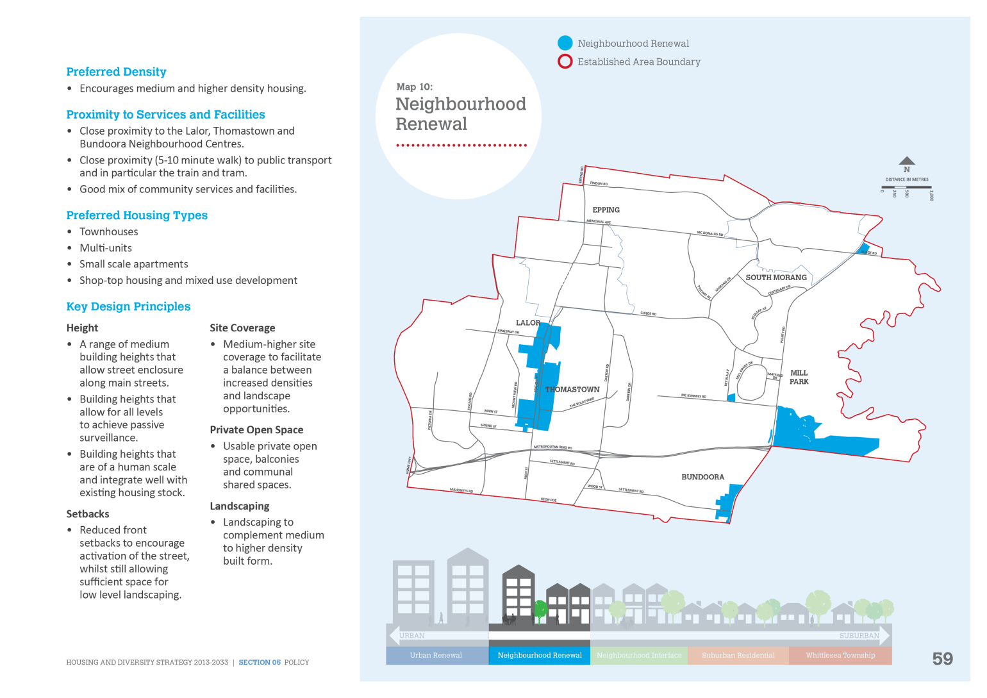

Neighbourhood Interface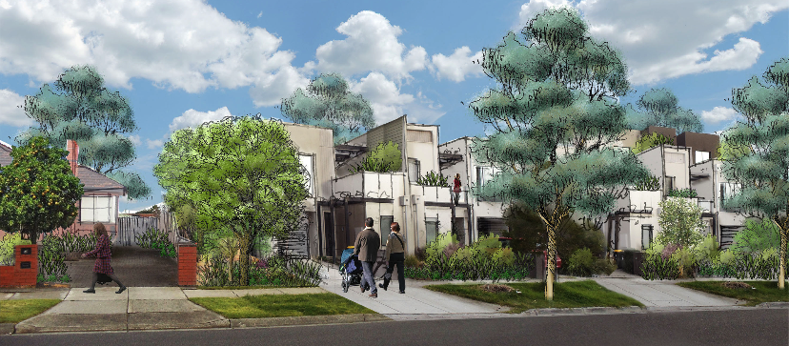
Proximity to transport and services:
within 800m
Preferred block and housing types
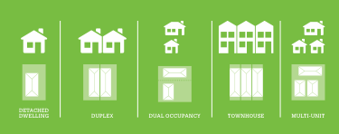

Preferred Density
- Encourages medium and standard density.

Proximity to Services and Facilities
- Moderate proximity (10-15 minute walk) to public transport and activity centres.
- Local neighbourhood shopping centres undergoing renewal.

Preferred Housing Type
- Detached dwellings
- Dual occupancies/Duplexes
- Townhouses
- Multi Units.

Key Design Principles

Height
- A range of low to medium building heights that support some housing diversity.
- Building heights that integrate well with existing housing stock.

Setbacks
- Moderate front setback to provide sufficient space for landscaping and a medium canopy tree.
- Sufficient side and rear setbacks to allow for some landscaping and external access to the rear.

Site Coverage
- Medium site coverage to facilitate a balance between increased densities and landscape opportunities.

Private Open Space
- Usable private open space.

Landscaping
- Landscaping to complement medium density built form.
- Medium sized canopy trees in the front setback.
- Large canopy tree in rear setback.

Map 11: Neighbourhood Interface 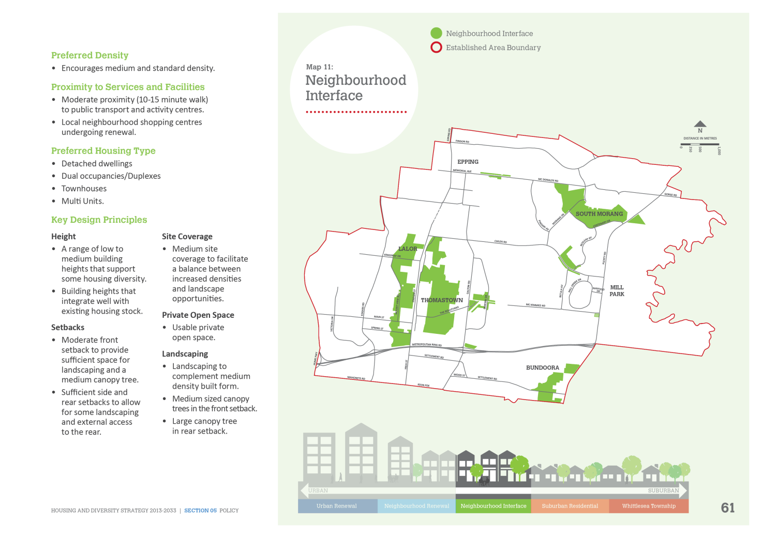

Suburban residential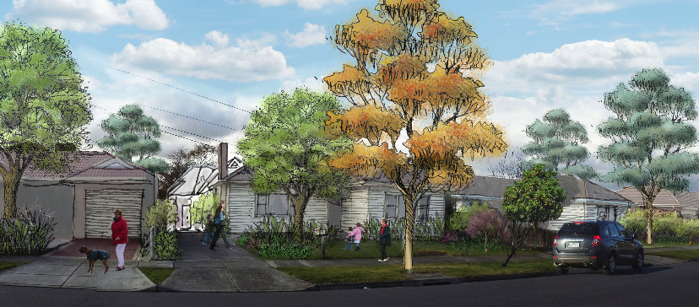
Proximity to transport and services:
800m+
Preferred block and housing types
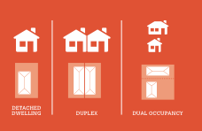

Preferred Density
- Encourages standard density.

Proximity to Services and Facilities
- Typically in proximity (15 minute plus walk)
to public transport and activity centres.

Preferred Housing Types
- Detached dwellings
- Dual occupancies/Duplexes.

Key Design Principles

Height
- Low building heights to reflect the existing suburban scale and character.

Setbacks
- Front setback to allow for significant landscaping and large canopy trees to create a sense of openness to the street.
- Increased side and rear setbacks to provide for building separation and landscaping.

Site Coverage
- Standard site coverage to facilitate landscape opportunities.

Private Open Space
- An increased area of private open space to allow for significant landscaping.

Landscaping
- Large canopy tree in the front setback.
- Extra-large canopy tree in the rear setback.

Map 12: Suburban Residential 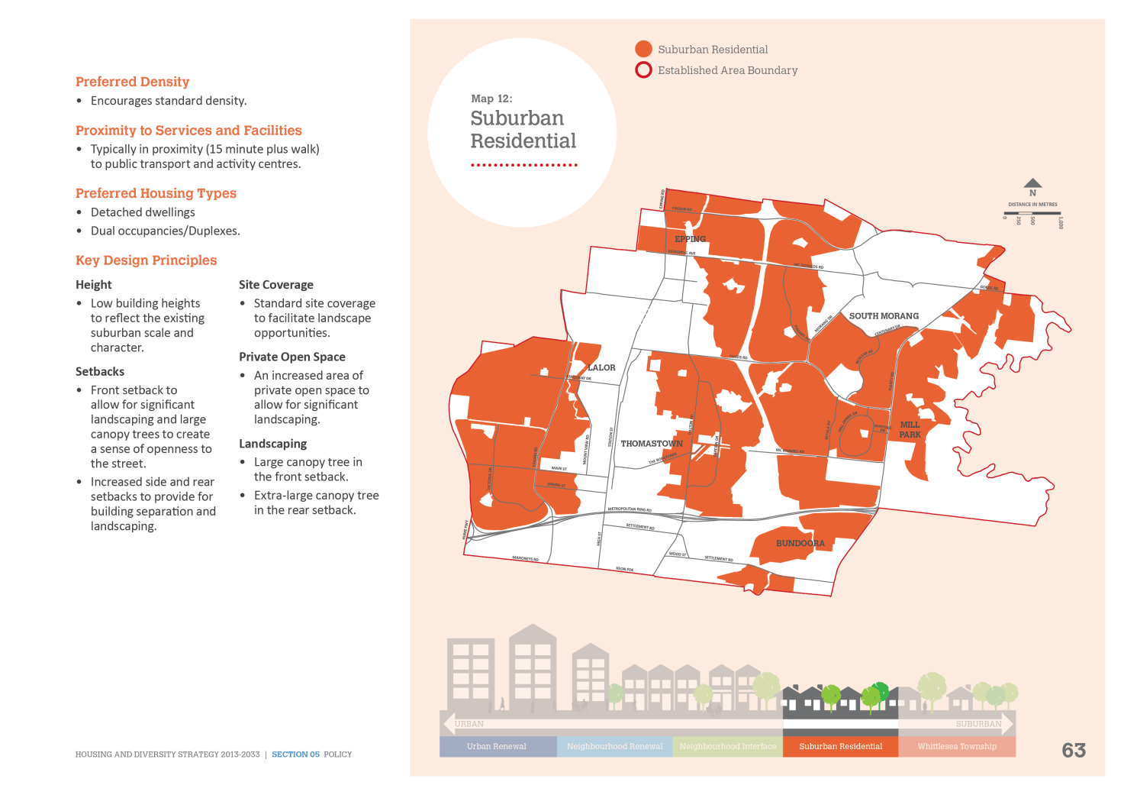

Whittlesea Township (township diversity)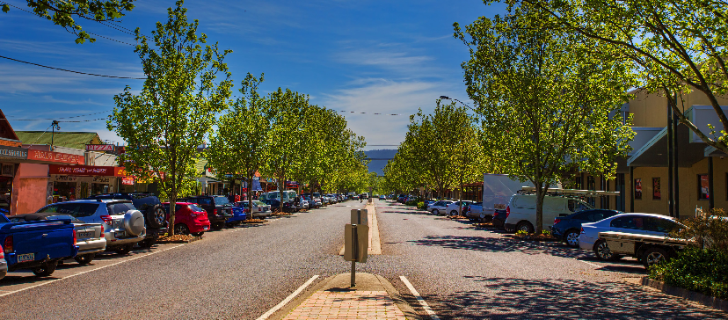
Unique rural township setting
Preferred block and housing types
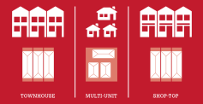
The Township has two Housing Change Areas:
- Township Diversity
- Township Residential

Township Diversity

Preferred Density
- Encourages medium and standard density

Proximity to Services and Facilities
- Applies to the commercial mixed use areas of Church and Laurel streets.

Preferred Housing Type
- Shop-top housing
- Townhouses
- Multi Units.

Key Design Principles

Height
- A range of low to medium building heights that support some medium density housing along main streets.

Setbacks
- Minimal or no front setbacks to encourage activation of the street.
- Minimal or reduced side and rear setbacks.

Site Coverage
- Medium-higher site coverage to facilitate a balance between increased densities and landscape opportunities.

Private Open Space
- Usable private open space, balconies and communal shared spaces.

Landscaping
- Landscaping to enhance the rural Township character.

Map 13: Township Diversity

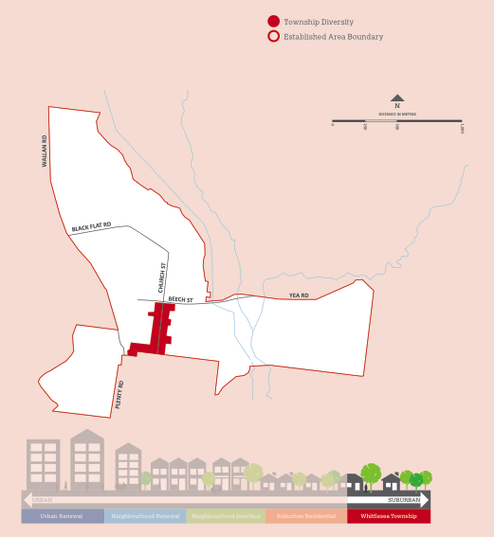
Whittlesea Township (Township Residential)
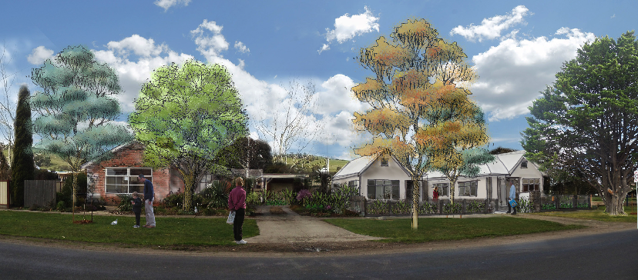
Unique rural township setting
Preferred block and housing types
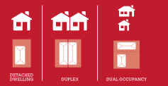

Preferred Density
- Encourages standard density

Proximity to Services and Facilities
- Applies to the residential areas of the Township

Preferred Housing Types
- Detached dwellings
- Dual occupancies/Duplexes.

Key Design Principles

Height
- Low building heights to reflect the Township scale and character.

Setbacks
- Increased side and rear setbacks to provide building separation and landscaping.
- Front setback to allow for significant landscaping, a large canopy tree and sense of openness to the street.

Site Coverage
- Standard site coverage to facilitate landscape opportunities.

Private Open Space
- An increased area of private open space to allow for significant landscaping.

Landscaping
- Large canopy tree in the front setback.
- Extra-large canopy tree in rear setback.

Map 14: Township Residential
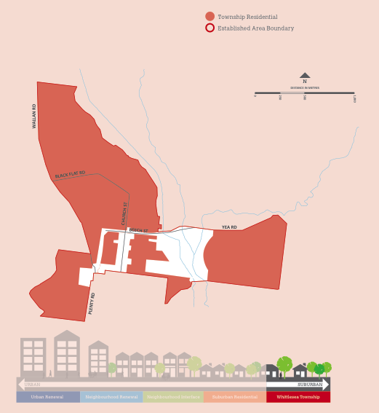

Section 06: IMPLEMENTATION

How will the Strategy be implemented?
To implement the key directions of the Strategy a series of actions will be required. These actions will include an amendment to the Whittlesea Planning Scheme and transitioning to the Reformed Residential Zones.
Implementation will take place in two stages:
Below is Diagram 8: Implementation of the Housing Diversity Strategy
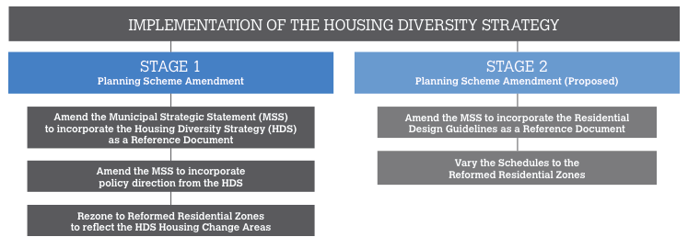

Stage 1: Planning Scheme Amendment

Amend the Municipal Strategic Statement/ Local Planning Policy
The Municipal Strategic Statement (MSS) establishes the strategic direction and policy context for the City of Whittlesea.
The first Amendment will implement the policies and objectives contained in the Strategy into the MSS to create a high level policy direction for infill residential development in the established areas.
Key points for inclusion are:
- Encouraging a larger portion of housing growth to occur in preferred locations as identified in the Strategy
- Improving the diversity of housing opportunities to meet the needs of the community
- Increasing the amount of accessible housing
- Guiding housing growth into locations where there is adequate infrastructure, services and transport to meet the needs of the community.
The Planning Scheme Amendment will outline a concise description of each Housing Change Area in terms of preferred character. It will also identify preferred locations for housing growth in the established urban areas of the municipality.

Transition to the Reformed Residential Zones
Councils have 12 months (from July 2013) to transition the new suite of residential zoning into their planning schemes. The transition to the Reformed Residential Zones is below.

Translation to the Reformed Residential Zones includes:
Change Area | Proposed Reformed Residential Zone
Urban Renewal | Activity Centre Zone
Neighbourhood Renewal | Residential Growth Zone for residential areas and Mixed Use Zone for commercial areas
Neighbourhood Interface | General Residential Zone
Suburban Residential | Neighbourhood  Residential Zone
Whittlesea Township Residential | Neighbourhood  Residential Zone
Whittlesea Township Diversity | General Residential Zone  for residential areas and Mixed Use Zone for commercial areas

Stage 2: Planning Scheme Amendment
Preparation of Residential Design Guidelines and Schedules to Reformed Residential Zones
Council will prepare Residential Design Guidelines that will be informed by urban design testing of each Housing Change Area.
The purpose of this testing will be to identify the most suitable built form having regard to the design principals of the Change Area and existing conditions. These guidelines will be used in conjunction with existing and future planning provisions.
The Planning Scheme Amendment for this stage will take place following the preparation of the Residential Design Guidelines and will include public exhibition of the draft planning controls.
It is anticipated that this Amendment will consist of the following changes to the Whittlesea Planning Scheme:
- Variation to Schedules of the Reformed Residential Zones to implement specific design objectives (such as setbacks, height, site coverage and front fences) in keeping with the preferred character of the Housing Change Areas.
- Introduction of the Residential Design Guidelines as a Reference Document in the Whittlesea Planning Scheme.
- Further changes to the MSS to introduce specific design objectives and strategies for each of the Change Areas.

Further strategic work
Preparation of Structure Plans for Neighbourhood Centres
The successful implementation of this Strategy will also require the preparation of structure plans for those centres identified as being suitable for growth. A structure plan has been prepared for Epping Central, the City of Whittlesea’s Metropolitan Activity Centre and one is currently being prepared for the Plenty Valley Activity Centre. Structure Plans may be required for Whittlesea Township, Lalor, Thomastown and Bundoora Neighbourhood Centres. These structure plans will further refine the recommendations of the Strategy and will likely result in further amendments to the Whittlesea Planning Scheme to ensure their specific recommendations are implemented.
Suggested project delivery for structure plans
(in order of priority):
- Whittlesea Township Structure Plan
- Thomastown and Lalor Structure Plans
- Bundoora Structure Plan. Bundoora Shopping Centre is currently subject to a master plan process.

Evaluation and Monitoring
To keep pace with emerging housing issues and needs in the established urban areas of the municipality, and current best practice, the Strategy will be reviewed regularly. The review will assist Council to monitor the progress and effectiveness of its strategic direction.
To measure the outcomes of this Strategy, Council will review and assess the following information:
- Updated population and demographic profile
- Dwelling structure by household and family composition
- Dwelling type breakdown
- Number of new dwellings produced each year
- Details of the locations of new dwellings in relation to the Housing Change Areas
- Number of new dwellings and project scale
(small, medium or large)
- Analysis of planning applications to determine whether they align with the Housing Change Area profiles
- Analysis of decision making and alignment with the Housing Diversity Strategy at VCAT
- Any other emerging housing trends and demographic changes.
Collection of this data will ensure that the Strategy can be reviewed and improved over time. Monitoring of the Strategy will commence following completion of Residential Design Guidelines and changes to Reformed Residential Zone schedules.

The Housing Diversity Strategy will ensure a balanced approach to housing growth in the established areas of the municipality. It will ensure that housing goes in the right locations, makes efficient use of existing services and infrastructure, meets current and future housing needs, and continues to make the established suburbs of the City of Whittlesea an attractive and enjoyable place to live.

