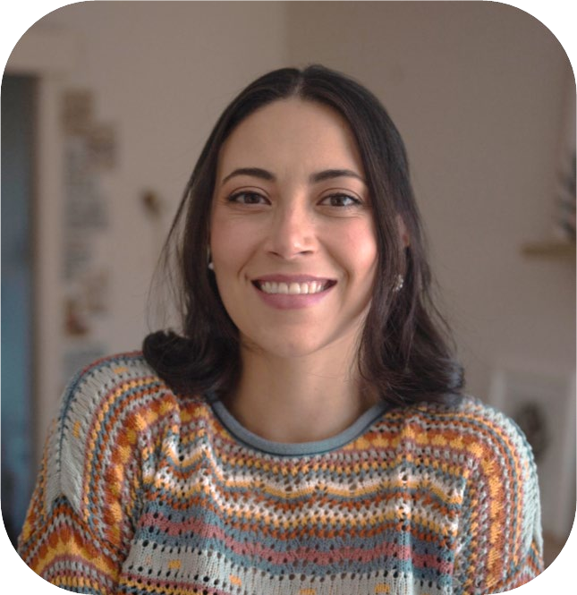

# PROFILE

## OPEN:

Monday to Thursday 7.00am to 7.00pm School holiday available

Casual care and weekends by request

## YEARS IN CHILD CARE SECTOR:

6 Years in the Education sector 5 years in the infant Health sector

## QUALIFICATIONS:

Parent-infant and child Montessori facilitator

Diploma of Early Childhood and Education

Bachelor of Respiratory Therapy Diploma of Nursing

SUBURB: Bundoora

# CONTACT

## PHONE:

0415 561 412

## WEBSITE:

[www.whittlesea.vic.gov.au/Services/](http://www.whittlesea.vic.gov.au/Services/) Support-for-people/Children-and- [families/Family-Daycare](https://www.whittlesea.vic.gov.au/community-support/children-and-families/family-day-care/)

[For more information about Family Day](mailto:famdaycare@whittlesea.vic.gov.au) Care phone 9217 2170 or email [familydaycare@whittlesea.vic.gov.au.](mailto:familydaycare@whittlesea.vic.gov.au)

ALEJANDRA SIERRA BUITRAGO

FAMILYDAYCAREEDUCATOR CITY OF WHITTLESEA

# ABOUT ME

I am a health professional as a Nurse and Respiratory Technician and during my five years of healthcare experience, I worked in critical care units for newborns and paediatric patients. This experience ignited my passion for working with children and families, so upon my arrival to Australia seven years ago I decided to pursue my dream and completed a diploma in Early Childhood Education and Care. For the last four years I have worked in multiple centres and colleges, working deeply with the Montessori methodology.

# ABOUT MY SERVICE

I have developed a model that integrates experiential approaches and enhances children’s individual capabilities. My service is based in the following pillars:

* Respect for the individuality and different learning pace of each child
* Construction of a safe and healthy space that promotes exploration and development of abilities and talents.
* Methodology that promotes the integral and harmonious development of body, mind and spirit.
* Intentional activities that strengthen life skills.

My program includes:

* Thematic local visits
* Excursions to natural environments
* Activities aimed at reading, writing and diverse artistic expressions
* Stimulating and creative experiences as a learning enhancer

# ABOUT MY FACILITIES

Growland is a prepared environment for Children, ensuring beauty, order and accessibility of space. It features a sequenced range of hand-on learning materials and activities, where children can learn with real-world objects and get real life skills.