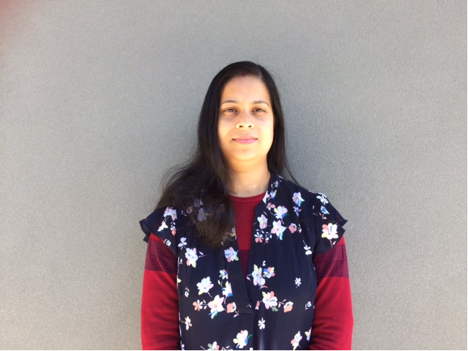
MONI DAS

FAMILY DAY CARE EDUCATOR

CITY OF WHITTLESEA

PROFILE
I am committed to providing quality care, ensuring a safe, secure and friendly environment. I focus on children’s needs, interests and wellbeing as a top priority. I share my experience, skills and thoughts with parents / guardians to achieve the best outcomes for children.
OPEN:
Monday: 8.00 AM to 6.00 PM
Tuesday: 8.00 AM to 6.00 PM
Wednesday 8.00 AM to 6.00 PM
Thursday 8.00 Am to 6.00 PM
Friday 8.00 Am to 6.00 PM
(School Holiday Care available)
YEARS IN THE FIELD: 18 years
QUALIFICATIONS: Diploma in Early Childhood Education and Care

ABOUT ME
I have been working in Family Day Care for 18 years. The first 5 years I worked with Darebin Family Day Care service, and later, joined Darebin’s Early Childhood Management Services .I also worked with Gateway family daycare service and later involved myself with City of Whittlesea Family daycare team .
I love children and enjoy their company. It brings me joy being a part of their holistic development. I enjoy working in small groups.
I have an admirable relationship with children and their families, which is such a great feeling. It feels like they are my extended family. Children’s love, hugs and trust-worthy relationships are the most enjoyable part of my job.
I have a loving and caring family consisting of my husband and three daughters. My husband is an accountant and my children are 21 , 16 and 7 years old. I love gardening, travelling and cooking in my spare time.

ABOUT MY PROGRAM
- A safe ,secure and friendly environment with welcoming space to give little mind feel like home .
- Aim to make children's day enjoyable , happy and healthy
- Provide child's education and quality of care followed by educational program and practice
- Kids' health, safety and wellbeing is the top most priority ..

- Showing love and respect, and maintaining trust relationships with children and families.
- Nature walks and visits to local park

ABOUT MY FACILITIES
I have a brand-new home which is located only 11 km from the CBD. It provides more than enough space for small groups of children (4), with an attached bathroom which makes it easy to monitor all children at all times, ensuring their safety and care. My backyard is spacious and filled with kid’s toys to keep the children active.

CONTACT
PHONE: 0422 355 547
WEBSITE: www.whittlesea.vic.gov.au/Services/Support-for-people/Children-and-families/Family-day-care
For more information about Family Day Care phone 9217 2170 or email familydaycare@whittlesea.vic.gov.au

