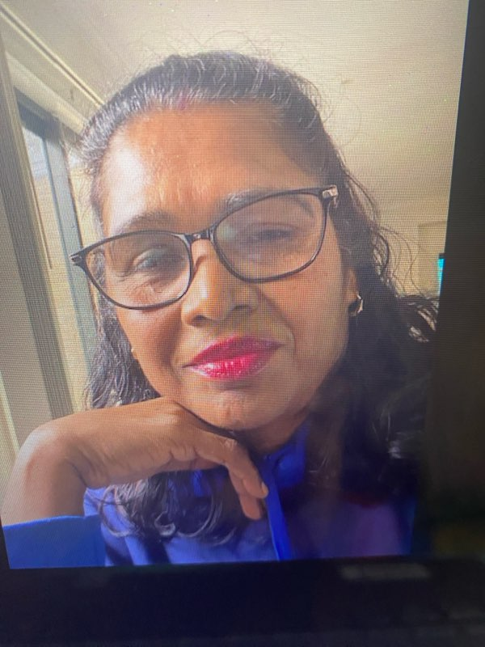
RAJ KALI SHANKAR

FAMILY DAY CARE EDUCATOR

CITY OF WHITTLESEA

PROFILE

OPEN: Tuesday to Friday (8am to 6pm)
YEARS IN CHILD CARE SECTOR: 16+ years
QUALIFICATIONS:
Cert III in Early Childhood Education and Care
Diploma of Early Childhood Education and Care
SUBURB: Mill Park

ABOUT ME
- I have been working in the childcare sector for over 16 years
- I choose to be an educator as I love the joy I get from spending time with children and helping them develop
- The thing I love about my job the most is seeing children build a firm foundation which helps build success for their future
- I am happily married with two older daughters
- My hobbies include creative cooking and watching suspense movies. I also enjoy going to the gym, practising yoga and visiting spiritual sites.

ABOUT MY SERVICE
I value children’s individuality and as an educator I help children reach their age appropriate holistic development through fun play. Programs are drafted and implemented with the help of: observation of children, family input, other educators, my family and the staff coordination unit. It is always reviewed and new goals are set. Items covered in flexible daily routine include: kinder runs, excursion programs, play groups and library story times.

ABOUT MY FACILITIES
I provide care in a safe, hygienic and child-friendly home-based environment. I have both a number of large indoor and outdoor areas. Children have access to resources and experiences of their choice. The various areas and large backyard with cubby house, kids play area and various toys, books and age-appropriate material allows children to develop in a fun play and learning environment.

OTHER INFORMATION
Parents require assurances to trust educators being around their precious children. My approach is to always be empathetic, thorough and have open communication. Parents can visit anytime, and I also regularly send pictures of the children’s daily activities, experiences, utilizing recourses and engaging with other children. They can also view monthly programs and children’s portfolio via Harmony Web online access.

CONTACT
PHONE: 0414 957 960
WEBSITE: www.whittlesea.vic.gov.au/Services/Support-for-people/Children-and-families/Family-day-care
For more information about Family Day Care phone 9217 2170 or email familydaycare@whittlesea.vic.gov.au.

