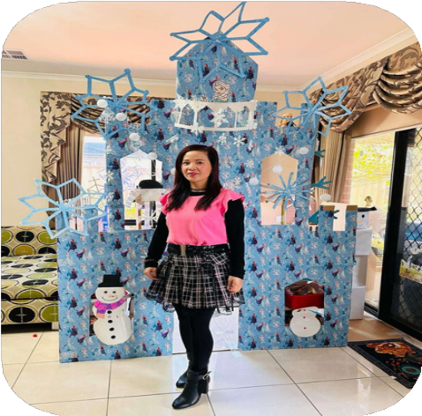

# Family Day Care Educator city of Whittlesea

**TINA**

## PROFILE

#### OPENING HOURS:

Monday – Friday: 6am – 6pm

#### YEARS IN CHILD CARE SECTOR:

10+ Years

#### QUALIFICATIONS:

* Cert. III in Early Childhood Education and Care
* Diploma of Early Childhood Education and Care
* Excellence Award in Diploma of Children’s Services

#### SUBURB:

South Morang

## CONTACT

### PHONE:

0406 081 581

### [WEBSITE:](https://www.whittlesea.vic.gov.au/community-support/children-and-families/family-day-care/)

[www.whittlesea.vic.gov.au/Services/Support-](http://www.whittlesea.vic.gov.au/Services/Support-) for-people/Children-and-families/Family-day- care

For more information about Family Day [Care phone](mailto:famdaycare@whittlesea.vic.gov.au) **9217 21710** [or email](mailto:famdaycare@whittlesea.vic.gov.au) [familydaycare@whittlesea.vic.gov.au.](mailto:familydaycare@whittlesea.vic.gov.au)

# ABOUT ME

I have been working in the childcare sector for 10 years, but every day is a new exciting experience. It feels as if I just started yesterday!

Being an educator is all about sharing my love, enthusiasm and creativity with children, whilst providing them with a nurturing and educational environment.

One of the most rewarding aspects of my job is developing long-lasting

relationships with families as I watch their children flourish and grow up as

individuals I am married with two children, and I am extremely grateful for my family's support.

My hobbies include nature walks, music and cooking with family

# ABOUT MY SERVICE

From my past experience, my daughter found it difficult to engage with larger group settings at a young age.

It was quite challenging for me to see her unhappy all the time, especially when I would pick her up.

That's the reason why I started to open my own Family Day Care. With smaller groups settings, children can settle in easier and develop meaningful

relationships in a familiar home setting.

My service is a multicultural and welcoming environment, providing childcare for families across the City of Whittlesea.

I believe that I provide a place of belonging with our families and a happy, healthy and hygienic environment that is fostered by children’s interests,

hobbies and motives. My program covers a wide variety of activities, including:

Bush Playgroup

Children are involved in jumping in muddy puddles, climbing trees, building treehouses, hunting for mini beasts and nature depending on the season etc.

Story-time at the library

Children learn to sit, listen and engage within a larger group setting. Various stories, singing and dancing, arts and craft activities are held.

Multicultural Celebrations

Children are immersed in different cultural celebrations such as:

Christmas, Lunar New Year, NAIDOC Week, Mother's Day, Halloween etc.

Regular Outings and Excursions

Children engage with their community at unique venues such as: Local Playgrounds where children participate physical outdoor play Past excursions include Bundoora Farm, Melbourne Zoo etc.

# ABOUT MY FACILITIES

We have several large spaces (inside and outside) dedicated to providing open- ended experiences that allow children to use their imagination.

We also have dedicated areas for meals, naps and quiet time activities. Our service has a large focus on nature and sustainability.

In our backyard, we have a fishpond built from recycled wood where children can feed the fish under supervision.

We also have our own sandpit and water play area for children to enjoy. All of these spaces are showcased on the next few pages.

Our Indoor

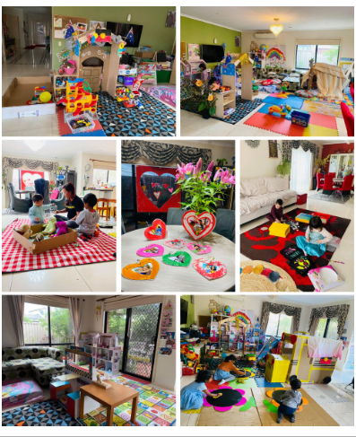Settings

Our Outdoor

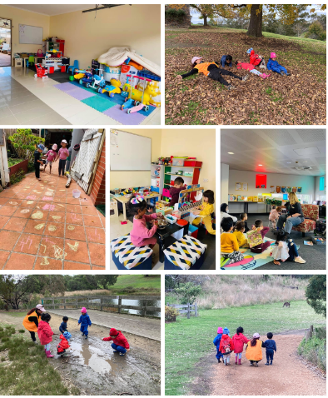Adventures