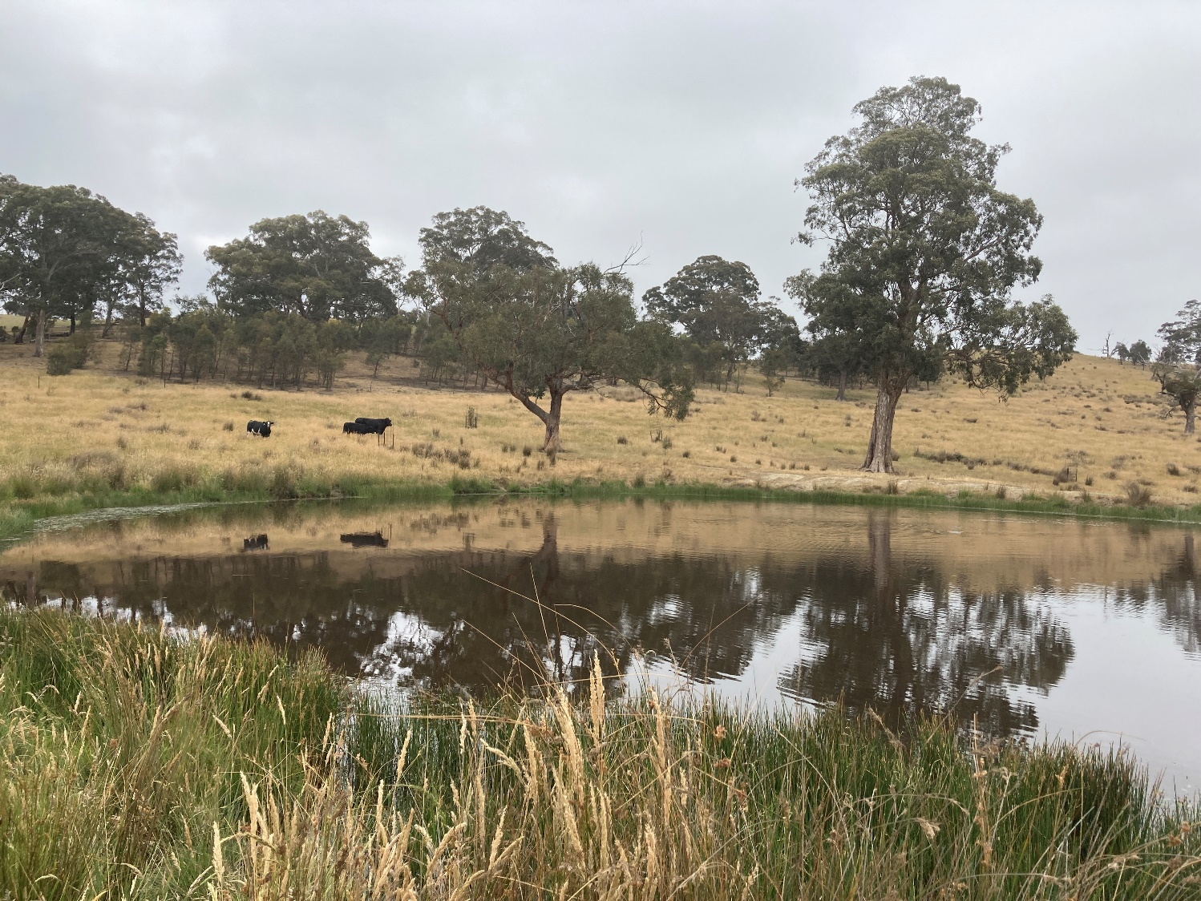

# Sustainable Land Management Rebate Scheme

# Application Guidelines

**Updated: 20 August 2024**

Table of Contents

What is the Sustainable Land Management Rebate Scheme? 3

What does the Rebate Scheme offer? 3

To be eligible for the Rebate Scheme, a property must be: 3

What if I have more than one property within the municipality? 3

To be eligible for the Rebate Scheme, the applicant/s must: 4

Which Properties are not eligible? 4

What are the assessment criteria? 5

Noxious and environmental weed control 5

Protection and/or enhancement of remnant native vegetation 6

Integrated pest animal control 7

Soil Erosion and/or Salinity 8

Protection and/or enhancement of waterways / wetlands 9

Other ineligible activities under the Sustainable Land Management Rebate Scheme: 9

How to apply 10

What is the process for tenanted or leased land? 11

What happens if I don’t comply? 11

Where to go for further specialist advice and assistance? 11

**Acknowledgement of Traditional Owners**

The City of Whittlesea recognises the rich Aboriginal heritage of this country and acknowledge the Wurrundjeri Willum clan and Taungurung People as the Traditional Owners of lands within the City of Whittlesea.

# What is the Sustainable Land Management Rebate Scheme?

The Sustainable Land Management Rebate Scheme (Rebate Scheme) is an incentive program which is designed to support and encourage responsible land management on private properties. It provides a rate rebate to eligible ratepayers for two consecutive years.

The Rebate Scheme aims to enhance and protect agricultural and environmental values in the rural areas by working in partnership with local landholders. It seeks to encourage an ongoing commitment to more sustainable land management practices, aiming for an overall improvement on properties and in the environment.

# What does the Rebate Scheme offer?

The Rebate Scheme provides eligible landowners with an incentive in the form of a rate rebate to undertake and/or maintain land management works that will improve the quality of land and water resources, maintain or enhance local biodiversity, and address land degradation issues.

The level of rate rebate is determined by property size:

* For properties 50 hectares (approximately 124 acres) or greater in size, the rebate is 30% of the General Rate / Farm Rate payable on the property.
* For properties 8 hectares (approximately 20 acres) or greater but less than 50 hectares in size, the rebate is 20% of the General Rate / Farm Rate payable on the property.

# To be eligible for the Rebate Scheme, a property must be:

* Within or partly within the Green Wedge A, Green Wedge or Rural Conservation Zone in the City of Whittlesea. Properties partly within any of these zones are only eligible when the area of the property within the zone is 8 hectares or greater, and when the zone covers the majority of the property.
* 8 hectares or greater in size, or be an aggregation of land at least equal to the minimum size, which is in one ownership and contiguous, i.e. adjacent to each other.
* Properties that are operated for commercial primary production, e.g. registered primary producers, or managed as hobby / lifestyle farms or for environmental purposes, e.g. bush blocks are eligible to apply under the Scheme.

## What if I have more than one property within the municipality?

* You may apply for the Rebate Scheme for more than one property if they meet the eligibility criteria.
* Where the land is contiguous, i.e. adjoining, and individual properties are under 8 ha in size, only one application form is required.
* All properties greater than 8 ha in size require a separate application.
* Generally, an application must be submitted for each property that receives a separate rates notice, unless the properties are contiguous and the individual properties are under 8 ha in size.

# To be eligible for the Rebate Scheme, the applicant/s must:

* Submit and online application within the application period
* Allow Council’s Rural Land Management Officers or representative to undertake a property inspection as part of the assessment process within a nominated timeframe set out by Council.
* Landowners and /or someone else acting on their behalf must be present during the inspection.

Prior to the inspection landowners must inform Council officers of any potential risks i.e. electric fences, herbicides which may have been sprayed etc.

* Demonstrate a commitment to agreed outcomes
* Commit to undertaking a minimum of 2 land management works / actions on the online application form, one of which must be noxious and environmental weed control.
* Address high priority / significant land degradation issues during the period of the agreement. It is acknowledged these works can often span beyond the 2 year agreement, in which case, they may be commenced but not completed.
* Address nominated works / actions as agreed with Council’s Rural Land Management Officer or representative.

# Which Properties are not eligible?

* Properties where unauthorised activities relating to land management/environmental degradation have been undertaken in breach of the City of Whittlesea’s Planning Scheme and which are not consistent with best land management practice, e.g. depositing of fill or soil, de-rocking, earthworks or native vegetation removal, and non-rural land uses.
* Properties which have outstanding environmental planning permit requirements, e.g. Land Management Plans (until the matter is resolved to the satisfaction of Council).
* Properties which are non-compliant with Council’s Pest Plant Local Law i.e. issued with a direction, fines and /or court action (until the matter is resolved to the satisfaction of Council).
* Properties that are unmanaged and/ or where the landowner/s is not willing to meet the Scheme’s guidelines (refer to Section 5 for assessment criteria) and the SLM Rebate Application Forms.
* Properties where an extractive industry is operating, e.g. quarry.
* Properties owned and/ or managed by mining, quarrying and urban-development companies and non-rateable properties.
* Where contact with a landowner cannot be made or a property inspection cannot be undertaken in a prescribed timeframe.

# What are the assessment criteria?

Throughout the 2 year period landowners must demonstrate an on-going commitment to maintaining and improving the quality of their land in the following key areas:

## Noxious and environmental weed control

Weeds pose a significant threat to farming productivity and native vegetation. Active weed control and monitoring of infestations are vital. Integrating weed control methods is often the most effective strategy for long-term control.

The planting or cultivation of species which are noxious or known environmental weeds (Willows, Topped Lavender and some non-indigenous wattles) is not consistent with best land management practice and is not supported by the Rebate Scheme. Rebate Scheme participants are required to remove these types of pest plants.

For further information about weed identification, practical and sustainable weed control techniques and handy hints, Council’s Seasonal Guide to Weed Management and complementary Weed Fact Sheets and Invasive Plant List are available upon request.

### Which weeds are priority weeds?

Artichoke Thistle, Blackberry, Chilean Needle Grass, Gorse, Paterson’s Curse, Spear Thistle/ Scotch Thistle, Serrated Tussock, St John’s Wort, Ragwort and Sweet Briar.

These weeds must be controlled on properties where they occur, as they are Prescribed Pest Plants within the municipality.

These weeds are also declared noxious weeds in Victoria. In accordance with the Catchment and Land Protection (CaLP) Act 1994, landowners are responsible for the management of most declared noxious weeds proclaimed under the CaLP Act.

### Eligible weed control techniques:

* Chemical control, slashing, ,mulching, chipping, ploughing, burning
* Improved pasture/ paddock management strategies, e.g. rotational/ cell/ strip grazing, in conjunction with pasture replacement / improvement strategies.
* Replacement strategies, e.g. re-sowing pastures, cropping, revegetation. Re-sowing may only be selected if pastures are degraded and actions are directly related to long-term weed control.
* Soil fertility improvement, e.g. liming, application of fertiliser / soil conditioners.

### Ineligible weed control techniques:

* The use of inappropriate weed control techniques that removes / destroys remnant (naturally occurring) native vegetation, e.g. boom spraying a broad-spectrum, non-selective herbicide in grasslands or de-rocking to remove woody weeds.
* Earthworks that breach the City of Whittlesea’s Planning Scheme, the Planning and Environment Act 1987 and other legislation, e.g. ploughing and bulldozing that removes / destroys remnant native vegetation, including grasslands and rocky knolls.
* The importation of fill or soil to cover existing soil levels and weed infestations.
* The application of chemicals not registered for use for the nominated weeds or application method.
* Grazing in isolation to other weed control and replacement strategies. Over-grazing must be avoided to minimise erosion and weed invasion.

## Protection and/or enhancement of remnant native vegetation

There are many factors that influence the type of vegetation that will grow and / or currently exists on your property. Natural factors, such as soil type, topography, geology and local climatic conditions all influence plant distribution. Variations in these factors result in different plant communities and habitats occurring naturally throughout the municipality.

Unfortunately, past land management practices and land clearing has severely altered these natural systems. Significantly smaller patches of remnant native vegetation now persist, and many of these are in decline due to a range of threatening processes, including poor land management. The value of this vegetation cannot be overstated. It provides important habitat for local fauna species, particularly birds, which control pest insect populations. It helps to bind soil and prevent erosion, and keeps groundwater levels down. It can also provide important shelter and windbreaks for stock, which can assist to increase farm productivity.

Council’s Rural Land Management Officer can provide a property map showing the different vegetation communities that were once present. A list of common plant species tailored to suit the conditions on your property can also be developed upon request.

### Eligible land management practices to protect and / or enhance native vegetation:

* Protective fencing
* Livestock, machinery and vehicle exclusion
* Weed control
* Tree planting / revegetation works
* Pest animal control
* Ecological burning

### Ineligible native vegetation management practices:

* The removal of remnant native vegetation, including grasslands which breach the City of Whittlesea’s Planning Scheme, the Planning and Environment Act 1987, and other relevant legislation.
* Using live remnant vegetation as fencing posts, e.g. wrapping fencing wire around trees instead of using fencing posts.
* Earthworks in close proximity to native vegetation or under the canopy of remnant native trees.
* Grazing livestock in bushland areas.

## Integrated pest animal control

Pest animals such as rabbits and foxes can be highly destructive, contributing to the loss of agricultural productivity and environmental values, and the deterioration of land quality. When planning for pest animal control, remember to apply the following management principles:

* Integrate control methods
* Reduce numbers
* Prevent reinvasion
* Consider working with your neighbours
* Remove harbour, i.e. places to shelter and hide, such as woody weeds and building waste and material.

### The following pest animals should be controlled:

* Rabbits, wild dogs, feral goats, foxes, feral cats, deer, feral pigs

### Eligible pest animal control techniques:

* Baiting
* Fumigation
* Shooting- must be done in conjunction with other control methods
* Destruction of warrens/burrows, e.g. ripping or imploding.
* Construction of rabbit proof fencing.
* Harbour removal, e.g. woody weeds, rubbish.

Pest animal control will only be considered an eligible activity for your application where it is evident that these pests are causing land degradation. Where pest animal control is agreed upon, receipts as proof of works, other than those issued for fox/ wild dog bounties MUST be submitted when renewing your Rebate Scheme application.

### Ineligible pest animal control techniques:

* The control of native animals.
* The use of control techniques which breach the Prevention of Cruelty to Animals Act and other legislation.

## Soil Erosion and/or Salinity

Soil erosion and salinity are both forms of soil degradation. Soil erosion refers to the loss of soil caused by water or wind and is often exacerbated by tree clearing, soil disturbance by humans or animals, and overgrazing. Soil erosion negatively affects land use, reduces land productivity, and increases the sediment load in local streams and rivers. Soil erosion problems often occur along drainage-lines and on slopes. The various forms of soil erosion include stream bank, gully, tunnel, rill, sheet and land slips. When planning for erosion control on your property, remember to apply the following management principles:

* Prevent existing erosion from expanding by stabilising soil.
* Rehabilitate eroded sites with indigenous vegetation or other species if appropriate.
* Monitor sites that are vulnerable to erosion to prevent future erosion.

### Eligible erosion control techniques:

* Ripping.
* Tree planting/revegetation works.
* Laying mulch, jute matting, hay-bales, coir logs/.
* Earthworks e.g. to reduce gradient of creek banks that is approved by Melbourne Water and Council.
* Pasture improvement / reseeding.
* Improved pasture/paddock management strategies, e.g. rotational/cell/strip grazing, in conjunction with pasture replacement/ improvement strategies.

May only be selected if pastures are degraded and actions are directly related to long-term measures to minimise erosion threats and improve soil health

* Destocking or not grazing erosion-prone areas.

### Ineligible erosion control techniques:

* The importation of fill or soil. This often does not address the causes of erosion and these works may require a planning permit.
* Earthworks to watercourses that do not have Melbourne Water or Council approval.
* Planting of species which are noxious or known environmental weeds (e.g. Willows, Poplars, Tamarisk/ Athel Pine) is not consistent with best land management practice and is not supported by the Rebate Scheme.

Soil salinity refers to the movement and concentration of salt in the soil which has occurred largely as a result of human activities modifying the natural distribution of salt in the landscape.

The reason for most salinity problems has been a rise in the level of saline water tables, bringing salt to the soil surface. The effects of salinity include reduction in productive capacity of affected land, degradation of the environment and wildlife habitats, loss of water quality for stock and domestic water supplies, and damage to roads and infrastructure. Salinity often crosses many property boundaries and therefore may require a collective approach to management.

### Eligible salinity control techniques:

* Pasture improvement- re-sowing only. May only be selected if pastures are degraded and actions are directly related to long-term measures to minimise salinity threats and improve soil health
* Tree planting / revegetation works.

## Protection and/or enhancement of waterways / wetlands

Maintaining water quality and the health of waterways and wetlands is vital to both the environment and farm productivity. Many of these natural assets are severely threatened by erosion, vegetation loss and poor water quality. If you are fortunate enough to have a local waterway or wetland on your property, it is important you manage this area appropriately to minimise any potential impacts downstream of your and other people’s properties.

### Eligible land management practices to protect or enhance waterways/ wetlands for:

* Fencing of waterways or dams
* Livestock exclusion
* Weed control
* Pest animal control
* Tree planting / revegetation works using indigenous (locally native) plants
* Allowing natural regeneration to occur

### Ineligible practices for waterway/ wetland management:

* Planting of non-indigenous plants.
* The importation of fill or soil to address erosion. This often does not address the causes of erosion and these works may require a planning permit.
* Earthworks to watercourses that do not have Melbourne Water or Council approval, including damming waterways.

## Other ineligible activities under the Sustainable Land Management Rebate Scheme:

* Construction and/ or maintenance of boundary fencing and driveways.
* De-silting or maintenance of dams.
* Establishment and maintenance of domestic gardens i.e. vegetable gardens and orchards.
* Establishment / maintenance of fire breaks.

# How to apply

Eligible landowners are invited to apply to the scheme annually, however all applications must be received by 31 August to be considered for that rating year. An online application must be submitted through Smartygrants.

All applicants under the scheme will be contacted by either Council’s Sustainable Land Management Officer or representative to arrange a mutually suitable time to visit the property to discuss the application. This will form part of the assessment process and will help determine eligibility under the Scheme. It will also be an opportunity to learn about other programs and funding opportunities that may be of assistance.

If the application is successful under the scheme, the rebate will be received for 2 concurrent rating years. All applicants will receive notification of the outcome of the assessment process and if deemed eligible for the scheme, an amended rates notice will be forwarded. In addition, over the 2 year period for which the application applies, Council’s Rural Land Management Officers may visit the property or undertake roadside inspections to assess progress of nominated actions and to provide assistance and advice where needed.

At the end of the 2 year period, applicants will be required to provide an online acquittal through Smartygrants which provides evidence of the nominated land management works undertaken, as detailed in the ‘successful application’ letter from Council.

Participants are strongly encouraged to keep photographic records of nominated works to submit with their online acquittal. Keeping a photographic record is also useful for personal property planning purposes. Where it is not possible to assess from photos whether the agreed works have been undertaken, copies of receipts showing purchases associated with the agreed works must be retained and submitted as evidence of works completed, where appropriate.

If problems are envisaged or encountered in implementing any proposed works, Council strongly encourages participants to discuss the situation with Council’s Sustainable Land Management Officer. Council understands that circumstances may change over the 2 year time period and may consider amending the original proposal where difficulties have arisen or where the action is no longer deemed appropriate.

The rebate is to be viewed as an incentive for the application of sustainable land management practices. It is not intended to cover the full cost of works detailed in the application form. However, any positive land management works undertaken are likely to improve property value and provide a direct benefit to the landowner.

## What is the process for tenanted or leased land?

Applications under the Rebate Scheme can only be made by property owners. For tenants and property owners currently leasing land that may be eligible under the scheme, please read the following carefully:

* Tenants leasing land that may be eligible for the rate rebate are encouraged to contact the property owner to discuss a potential application under this scheme.
* Landowners leasing land can apply for the rebate, however, they will need to comply with the requirements of the Scheme and negotiate agreed land management outcomes with the tenant.
* The owner of a property below the minimum property size of 8 ha, but who is also leasing an adjoining rateable property may aggregate the properties to make up the minimum property size of 8 ha. However, the rebate of 20% will only apply to the property owned.
* It is the responsibility of the landowner to give adequate notification to tenants of any property inspection organised with Council officers and /or representative.

# What happens if I don’t comply?

Landholders must be able to adequately demonstrate their commitment to implementing sustainable land management practices for the 2 year period of the rate rebate. Submitting photos of works undertaken with the Works Completed/ Renewal form is encouraged.

Failure to implement sustainable land management commitments in line with the scheme’s guidelines will mean not being eligible to apply for the rebate for 2 consecutive years.

The Local Government Act 1989 Section 169 requires that rebates must be repaid to Council if the terms on which the rebate was granted have not been complied with.

During the 2 year period where unauthorised activities breaching the City of Whittlesea’s Planning Scheme or other relevant legislation are identified on participating properties, such as filling, de-rocking, earthworks and native vegetation removal, the rate rebate will be cancelled and the property will not be eligible for the rebate until the matter is resolved to the satisfaction of Council.

# Where to go for further specialist advice and assistance?

For more information about the Sustainable Land Management Rate Rebate Scheme, including property eligibility and the application process, as well as assistance in completing the application form, please contact Council’s Rural and Environmental Planning Team on 9217 2170.