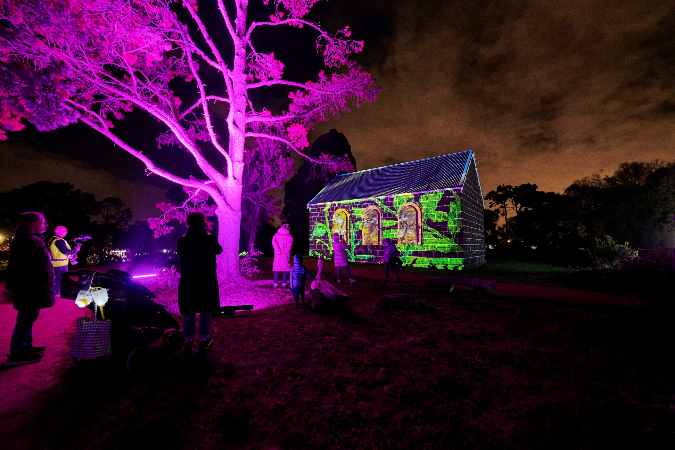

Public Artwork

Walking Thomastown Projection – Lutheran Church

# CALL FOR EXPRESSIONS OF INTEREST (EOI)

# Applications Close: 28 March 2025

1. **The Project**
   1. **Project Overview**

The City of Whittlesea is seeking to commission an artist to design, develop and deliver a projection artwork that will be showcased at the signature council annual event, Walking Thomastown. The canvas and site for the work will be the Lutheran Church located in a reserve in Thomastown’s Westgarthtown Pioneer Precinct.

The artist will work with Little Projection Company who will map the building for the proposed artwork, provide necessary technical support and project the artwork on the evening of Walking Thomastown in late August 2025. Sound can also be an important feature of the projection and supported technically.

The proposed artwork should take into consideration the site, its connection to the community and other relevant factors, while also being an expression of the artist’s practice. The commissioned artwork will become part of the City of Whittlesea Cultural Collection.

* 1. **Project Background**

**Event** - Walking Thomastown is a night-time walking event from Main Street Recreation Reserve, along Edgars Creek, through Ziebell’s Farm and the pioneer precinct at Westgarthtown. It includes neon artwork, projection, live music and entertainment, cultural performances, lantern making, food trucks, magic shows and more. People will first see the Church projection from the walking path on the East side of Edgars Creek through the trees and then as they progress along Mount View Road into German lane and enter the reserve. The event in 2024 had over 5000 attendees and continues to grow each year.

**Site** – (Appendix 1) In 1850, German immigrants started to arrive in Victoria. Notably the German ship, The Pribislaw, brought half the original Germans and Wends who settled at Westgarthtown. These immigrants would purchase land that would establish this area.

In 1855 a Lutheran school opened in the still-to-be completed bluestone Lutheran church. The church was dedicated in 1856 and is now the second oldest Lutheran Church building in Australia. For over 100 years, the church served as a unifying force and focal point for Westgarthtown's activities. All major social events centered around the Lutheran Church. As well as religious festivals such as Christmas, Easter and Harvest Festival, celebrations and feasts associated with baptisms, confirmations and weddings were frequent, particularly in the early days, when there were many young families.

* 1. **Artist selection process**

**Expression of Interest – DUE DATE – 28 March 2025**

Suitably qualified artists are invited to submit an Expression of Interest (EOI). All submissions will be assessed against the EOI criteria and one artist will be chosen to deliver the project.

**How to apply – Fill in the online form and provide**

1. An artist CV – maximum 2 pages
2. Examples of previous artworks (maximum 10 images)
3. Relevant links to previous projection work
4. Links to website and socials
5. A short-written Concept Statement outlining vision and intent. Max 250 words

We do not expect fully realised designs at this stage, but we want an idea of what you plan to do, why you plan to do it and your experience in similar projects.

No fee is offered for this part of the EOI phase. If the City of Whittlesea needs further elaboration on a concept from artists before being selected appropriate renumeration will be given.

**Selection criteria for EOI**

The selection criteria for the EOI process will include:

• Demonstrated professional experience

• Capacity to respond to brief and context

• Artistic merit

Assessment panel makeup

Note that the Assessment panel may comprise the following people:

* + - Relevant City of Whittlesea Staff and Community Members delivering Walking Thomastown 2025

1. **Budget**

**Project Budget**

The artwork will be commissioned for $10,000. This includes all costs associated with the design, development and delivery of artwork, including site visits, meetings with Little Projector Company and attendance of the launch of Walking in Thomastown.

**Project Timeline**

|  |  |
| --- | --- |
| **28 March 2025** | Applications due |
| **4 April 2025** | Successful artist notified |
| **28 April 2025** | Artist to attend site visit with Little Projector Company and Council |
| **6 June 2025** | Draft artwork and concept design due |
| **11 July 2025** | Final artwork supplied |
| **Late August 2025** | Walking Thomastown event and projection launch |

For additional enquiries, please contact:

Jonathan Crowther

Cultural Collections Curator

City of Whittlesea

[Jonathan.Crowther@whittlesea.vic.gov.au](mailto:Jonathan.Crowther@whittlesea.vic.gov.au)

**Appendix 1 - Images of the site**



