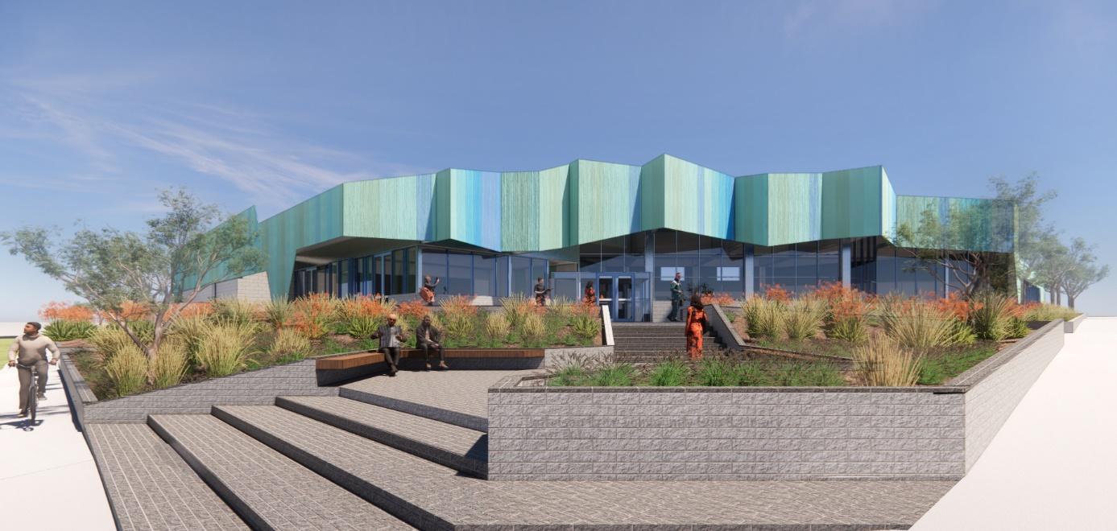

Public Artwork
Murnong Community Centre Internal Mural

CALL FOR EXPRESSIONS OF INTEREST (EOI)

Applications Close: 4 April 2025

- The Project
  - Project Overview

The City of Whittlesea is seeking an artist to design and install a mural in the newly built Murnong Community Centre that engages with and compliments the diverse and growing community.

The artwork and its design will speak to the broad theme of diversity informed by community engagement and consultation. A more detailed brief will be supplied to the successful artist.

The artwork will cover approximately 35m2 and be installed on an internal wall above a prominent entry and exit point in the public community lounge. See Appendix 1 for building details.

  - Project Background

The Murnong Community Centre will be located in the Olivine Estate in Donnybrook. The multi-purpose facility will deliver essential services to this fast-growing community.

It will cater for the rising demand for three and four-year-old kindergarten programs in the fast-growing north. The Centre is set to include two modern kindergarten rooms, complementing the single room kindergarten next door at Donnybrook Primary School.

There will also be a Maternal and Child Health Service, a community hall and kitchen, two meeting rooms for hire and a public community lounge with mini-branch library. The mural will enhance the public community lounge space.

The selected artist will be required to
    - Attend community consultation/workshops
    - Present a draft concept design
    - Clean, prime and paint a mural
    - Attend the launch

  - Artist selection process

Expression of Interest – DUE DATE – 4 APRIL 2025

Suitably qualified artists are invited to submit an Expression of Interest (EOI). All submissions will be assessed against the EOI criteria and one artist will be chosen to deliver the project.

How to apply – Fill in the online form and provide
- An artist CV – maximum 2 pages
- Examples of any previous murals/ public artworks (max 10 images)
- Relevant links to website and social
- Include evidence of Insurances that include; Public Liability $20M
- Have or be willing to obtain Working at Heights ticket
- A short-written Concept Statement outlining vision and intent ( max 250 words)

We do not expect fully realised designs at this stage, but we want an idea of what you plan to do, why you plan to do it and your experience in similar projects.

No fee is offered for this part of the EOI phase. If the City of Whittlesea needs further elaboration on a concept from artists before being selected appropriate renumeration will be given.
Selection criteria for EOI
The selection criteria for the EOI process will include:
• Demonstrated professional experience
• Capacity to respond to brief and context
• Artistic merit

Assessment panel makeup

Note that the Assessment panel may comprise the following people:
    - Relevant City of Whittlesea Staff form the Murnong Community Centre Project Working Group

- Budget
Project Budget

A budget of up to $15,000 has been set for the final design and installation of this artwork for the selected artist.

This is to include all costs associated with the design and documentation of the final public artwork, including design, priming of wall, painting of mural, and clean-up of work area.

Indicative Project Timeline – Final timeline will be confirmed with selected artist

4 April 2025 | Expression of interest due
2 May 2025 | Successful artist notified
June/July 2025 | Community consultation/workshops
August 2025 | Draft artwork and concept design due
September 2025 | Final artwork installed

For additional enquiries, please contact:
Jonathan Crowther
Cultural Collections Curator
City of Whittlesea
Jonathan.Crowther@whittlesea.vic.gov.au

Appendix 1

