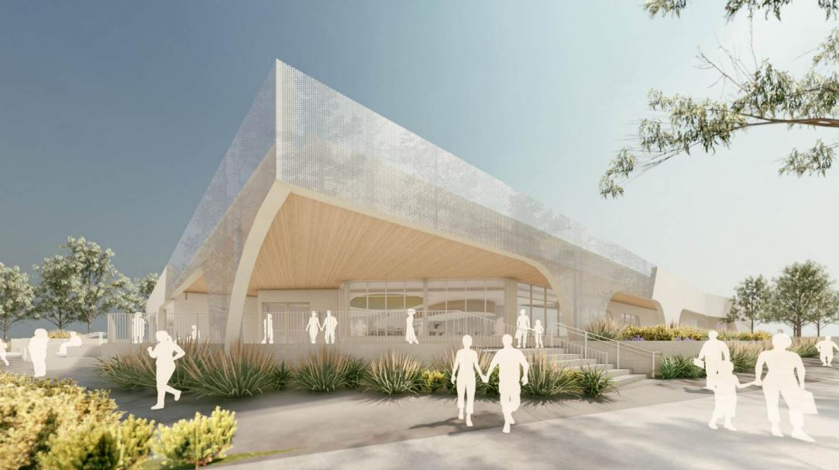

*N.B. Architect artist impression*

Facade Public Artwork

West Wollert Community Centre

# CALL FOR EXPRESSIONS OF INTEREST (EOI)

# Applications Close: 21 March 2025

1. **The Project**
   1. **Project Overview**

The City of Whittlesea is seeking an artist to develop an artwork that will be implemented into the façade of the soon to be built West Wollert Community Centre. The artwork will complement the rest of the architectural design and its intentions, creating a new cultural asset for the community.

The goal of the artwork is to reflect and relate to the natural surroundings, creating a congruence between the built form and the environment it sits in. This can be both representational or abstract in its delivery. While the original artwork can exist in any medium ( ie digital, drawing, photography, painted etc) , the final work developed and submitted by the selected artist will be digital in format that can be rendered successfully onto the chosen façade material of perforated metal.

**Important** – This is a commission for the **artwork only**, not the installation or fabrication of the façade. The successful artist will work closely with the City of Whittlesea but the City of Whittlesea will be responsible for managing other aspects of the project in conjunction with the architects and contractors.

* 1. **Project Background**

Located in the Rathdowne residential estate, adjacent to local parks, government and independent schools and a shopping precinct, West Wollert Community Centre will provide a space where people of all ages and abilities can learn, participate, access services, and improve their mental social, and physical wellbeing.

The Centre will include a kindergarten, maternal and child health consulting/program rooms, community hall and kitchen, flexible meeting/activity rooms, mini branch library and community lounge, landscaped outdoor spaces and accessible amenities.

* 1. **Artist selection process**

**Expression of Interest – DUE DATE – 21 March 2025**

Suitably qualified artists are invited to submit an Expression of Interest (EOI). All submissions will be assessed against the EOI criteria and one artist will be chosen to deliver the project.

**How to apply – Fill in the online form (link below) and provide**

1. An artist CV – maximum 2 pages
2. Examples of previous artwork (maximum 10 images. N.B this does not have to public in nature)
3. Links to relevant socials and website
4. A short-written Concept Statement outlining vision and intent (Max 250 words)

[**Access EOI Submission Here**](https://au.openforms.com/Form/a85fbdb7-bb7c-4713-b93d-93af66f76b8c)

We do not expect fully realised designs at this stage, but we want an idea of what you plan to do, why you plan to do it and your professional experience.

No fee is offered for this part of the EOI phase. If the City of Whittlesea needs further elaboration on a concept from artists before being selected appropriate renumeration will be given.

**Selection criteria for EOI**

The selection criteria for the EOI process will include:

* Demonstrated professional experience
* Capacity to respond to brief and context
* Artistic merit

Assessment panel makeup

Note that the Assessment panel may comprise the following people:

* + - Relevant City of Whittlesea Staff form the West Wollert Community Centre Project Working Group

1. **Budget**

**Project Artist Fee**

A set artist fee of $15,000 has been set for the development of the draft and final design. This will be outlined in a schedule of fees for the successful artist.

This is to include all costs associated with the design, documentation and delivery of the final artwork.

**Indicative Project Timeline –** **Timeline will be confirmed with selected artist**

|  |  |
| --- | --- |
| **21 March 2025** | Expression of interest due |
| **28 March 2025** | Successful artist notified |
| **18 April 2025** | Draft artwork and concept design due |
| **16 May 2025** | Final artwork supplied |

For additional enquiries, please contact:

Jonathan Crowther

Cultural Collections Curator

City of Whittlesea

[Jonathan.Crowther@whittlesea.vic.gov.au](mailto:Jonathan.Crowther@whittlesea.vic.gov.au)